Impact of Employee training and development on organizational productivity within UK hospitality industry Post Brexit: a case of study Marriot International Inc.

Candidate for master’s degree
Author: Plamen Peev
Student’s number: 1815104

Supervisor: Rexon Nting
Director of Studies (DoS):
Dr Gladius David Kulothungan
Table of Contents
List of Tables 4
List of Figures 5
Abstract 6
CHAPTER 1: INTRODUCTION 7
1.1 Introduction 7
1.2 Background of Study 7
1.3 Problem Statement 8
1.4 Research Justification 9
1.5 Research Objectives 9
1.6 Research Questions 10
1.7 Significance of Study 11
1.8 Limitation of Study 11
1.9 Research Layout 12
Chapter 02: LITERATURE REVIEW 14
2.1. Literature Introduction 14
2.2 Employee Training and Development in the Hospitality Industry 14
2.3 Impact of Employee Training and Development on Organizational Productivity 17
2.4 UK Hospitality Industry Post Brexit 21
2.5 Organizational Productivity and Employee Training at Marriot International Inc. 24
2.6 Chapter Summary 27
CHAPTER 3: METHODOLOGY 28
3.1 Introduction 28
3.2 Research Design 28
3.2.1 Philosophy of Research 28
3.2.2 Research Strategy and Approach 30
3.2.3 Sampling Technique 31
3.2.4 Research Ethics 31
3.3 Data Collection 31
3.4 Data Analysis 32
3.5 Limitation of Methodology 32
3.6 Chapter Summary 32
CHAPTER 4: RESEARCH FINDINGS AND RESULTS 33
4.1 Introduction 33
4.2 Quantitative Data Analysis 33
4.2.1 Demographic Information 34
4.2.2 Survey Questionnaire 37
4.3 Importance of Training and Development for Marriott International Hotel UK. 59
4.4 Discussion 61
4.4.1 Research Objective 1: 61
4.4.2 Research Objective 2: 62
4.4.3 Research Objective 3: 64
CHAPTER 5: RECOMMENDATIONS, AND CONCLUSION 67
5.1 Conclusion 67
5.2 Recommendation 68
CHAPTER 6: REFERENCES 71
CHAPTER 7: APPENDICES 76
Appendix 1: Vacancies for hospitality jobs are record high. 76
Appendix 2: People in work in the UK by nationality (overall number and percentage of the total), 2010 to 2016 77
Appendix 3: The decline in EU immigration and net migration from 2016 to 2020 77
Appendix 4: Questionnaire 78

List of Tables

Table 2.1. % Change in the workforce over time
Table 2.2. Examples of crises that had an impact on the international tourist
Table 5.1. Age of Participants
Table 5.2. Department Serving
Table 5.3. Experience in Hospitality Industry
Table 5.4. Training as a part of organizational strategy
Table 5.5. Preferred Kind of Training
Table 5.6: Training influences the organisational productivity
Table 5.7. Duration of Conducting Training Program
Table 5.8. Training is Compulsory for Hospitality Industry
Table 5.9. Development is important to tackle changes in the workplace
Table 5.10. Training Help to Develop Relationship
Table 5.11. Training influences the organisational productivity
Table 5.12. Training improves employee motivation
Table 5.13. Improve productivity of both quantity and quality
Table 5.14. Most Important Reason for Present Labour Shortage in the United Kingdom
Table 5.15. Diversity in the UK labour market
Table 5.16. Brexit influence labour availability within the UK market
Table 5.17. Selection procedures of employees for training
Table 5.18. Improving employee productivity
Table 5.19. Challenges during training courses
Table 5.20. Development of leadership skills and teamwork
Table 5.21. Competitive advantage
Table 5.22. Improve the Necessary Skills for Specific Job

List of Figures

Figure 2.1. Number of organisations having positions that are difficult to fill (%)
Figure 2.2. Research onion
Figure 4.1. Age of Participants
Figure 4.2. Gender of Participants
Figure 4.3. Department Serving
Figure 4.4. Experience in Hospitality Industry
Figure 4.5. Training as a part of organizational strategy
Figure 4.6. Preferred Kind of Training
Figure 4.7. Training influences the organisational productivity
Figure 4.8. Duration of Conducting Training Program
Figure 4.9. Training is Compulsory for Hospitality Industry
Figure 4.10. Development is important to tackle changes in the workplace
Figure 4.11. Training Help to Develop Relationship
Figure 4.12. Training influences the organisational
Figure 4.13. Training improves employee motivation
Figure 4.14. Improve productivity of both quantity and quality
Figure 4.15. Diversity in the UK labour market
Figure 4.16. Brexit influence labour availability within the UK market
Figure 4.17. Selection procedures of employees for training
Figure 4.18. Improving employee productivity
Figure 4.19. Challenges during training courses
Figure 4.20. Development of leadership skills and teamwork
Figure 4.21. Competitive advantage
Figure 4.22. Improve the Necessary Skills for Specific Job

Abstract

The method used to provide new or existing skills required to do jobs is called training. The most general definition of development is the improvement of an employee's current skills to assist them in addressing new needs or preparing for a new role. As the hospitality industry is labour intensive, well-trained, qualified human resources are a prerequisite for satisfactory customer service—understanding how training and development impact organizational productivity is the main objective of the current research.
Training is crucial to any company or sector's human resources development program. Equally, its significance in the tourist industry is expanding daily, and we cannot undervalue it. Most of the research has provided a thorough understanding of the efficiency of training and development in the hotel or tourist industries. While development is learning that goes beyond today's job and has a more long-term emphasis on ways the viewpoint of the job orientation in the hospitality industry, training is an activity aimed at giving learners the information and skill development needed for the job. The current report highlights the relevance of training and development in the tourist industry.
A case study was employed in the research on this topic. The results demonstrate Marriott's commitment and dedication to diversity, which is reflected in its corporate policies and international projects. Marriott, as a global company, helps to create mentoring programs in different regions and job possibilities worldwide. As Marriott is a fast-expanding company, it must continue to update its practices, training, and development programs to continue to remain inclusive for associates and their guests.

Keywords: diversity, hospitality industry, associates, training, development, Marriott, programs, skills, well-trained, orientation

CHAPTER 1: INTRODUCTION

1.1 Introduction
The case study-based research study attempts to analyse Marriott International Inc. as a representative of the overall hospitality industry of the United Kingdom. The study also examines the impact of training and skill development on the productivity of the hospitality sector. Over the past few decades, the hospitality industry has been the leading private sector in the United Kingdom, creating huge employment opportunities (Portes, 2022). The United Kingdom is a welcoming destination for people across the globe, and its hospitality sector contributes to its economic development. According to the World Tourism Organization, tourism made up about 9% of the world's GDP in 2014 (Thommandru et al., 2021). The hospitality industry has different inner sections, including hotels, bars, lodging and recreation, tourism, and travel. The industry is based on employees’ skills, so training and development are critical parts of such a job description.
The hospitality sector includes a wide range of jobs, including sanitary workers, drivers, storekeepers, security, hotel management, and kitchen and hotel personnel. The individual types of jobs need specialised workforces and training programs to effectively develop their employees (Portes, 2022). The present study is focused on the case study of Marriott International hotels and their human resource strategies focused on improving their employees' skills. The study analyses the job market in the hospitality industry after Brexit and the impact of employee development programs on overall organizational productivity. The present chapter encompasses the background of the study; problem statement; research objectives; research questions; the significance of the study; and its limitations.

1.2 Background of Study
In the late 20th century, the implementation of the Schengen Treaty led to the foundation of freedom of movement in the European Union (Koikkalainen, 2021). The people of the European Union are free to move across European countries, and they have access to the healthcare system, educational system, and rights of residence in any country they choose to live in (Marzocchi, 2022). The freedom of movement across the countries of the European Union has led to a positive change in the hospitality industry. The increase of European immigrants in the United Kingdom has been halted with the Brexit deal in which the United Kingdom gets parted from the European Union. The UK’s hospitality industry has faced a setback from the new employment policies for the European people working in the United Kingdom (Pappas, 2019). The shift in national policy further worsens the labour market for the hospitality industry.
Marriott International, Inc. is an international chain of hotels headquartered in Bethesda, Maryland in the United States. Marriott Hotels have luxury designs targeting modern travellers. The hotels offer lavish venues for business and social meetings and thoughtfully appointed rooms for their guests. Marriott has many offerings for their guests that include the Bonvoy program, luxury rooms, suits, a range of amenities, and an ideal location (Marriott International, 2021). The Marriott Hotel chains are mostly reliant on EU employee migrants living in the United Kingdom. Because the hospitality industry is based on employee retention, every organisation wants to keep and train employees with innovative technologies and skills to improve organisational performance.
EU migrants leaving the country create a skilled labour shortage in the UK’s market. The hospitality industry has been badly impacted by the labour shortage in recent years. Different economic sectors are struggling to catch up with the pace after COVID-19, and so is the hospitality industry (Sumption, 2022). The shortage of skilled labour is hammering different organizations. The newly hired employees need training and skill development programmes to fully comply with their job descriptions. In such conditions, the retained employees and the strong training and development strategy can only navigate the hospitality industry.

1.3 Problem Statement
The hospitality industry in the United Kingdom is facing challenges regarding the right talent hunt and the availability of skilled labour in the market. During the past few years, the COVID-19 pandemic and the Brexit deal have profoundly impacted the country's hospitality industry. As COVID-19 made it difficult for organisations to maintain the workforce, most of the hospitality sector downsized their staff and workforce, which after the revival of the market made it harder for the industry to cope with the increased demand (Colás, 2019). The UK’s market is highly competitive, and the hospitality sector faces a labour shortage as skilled labour is unavailable for high-end franchises. To sustain the labour shortage issue and cope with the high demand for labour in the market, the only solution is to maintain and train the existing staff. Organizations like Marriott International are focused on their employees' training and development to gain a market competitive advantage (Colás, 2019). The significant diverse issues faced by the hospitality industry are the lack of skilled labour and the poor productivity of the labour force. Human resource management is a critical part of the hospitality industry, and effective training and development of employees can improve the organization's performance. The employee’s productivity is the factor associated with the productivity of the organisation; the present study is aimed at assessing the employee’s development and its impact on organisational productivity.

1.4 Research Justification
The current study will lead me through the market dynamics of the hospitality industry while also allowing me to hone my skills in research designs and analytical tools. The research will provide critical insight into the labour market and hospitality industry of the United Kingdom. However, the current topic is aimed at and based on the labour issues confronting the hospitality industry following Brexit, indicating an interest in the field. The critical outcomes expected from this research are ways to overcome the issues and manage the current crisis with the available resources. The research will be a significant contribution to the academic literature and provide policy-level conclusions for organisations to sustain such conditions. The research topic stresses multidisciplinary skills that should be used to encompass all aspects of the research. Organisational performance and employees training are the factors associated with the sustainability of the overall business; such measures can guide organisations to control their operations with the least available resources (Iqbal & Ahmad, 2021). The outstanding nature of the research topic and its association with the current crisis forced me to choose this topic and develop my skills in this field.

1.5 Research Objectives
The present research aims to examine the development and training of employees in the hospitality industry and their impact on organisational performance. Organizational development and profitability are the points of reference that show the impact of training and development of employees on organisational performance. The study is based on the case study of Marriott International UK and encompasses the training and development programmes associated with the employees. The present study specifically focused on the labour conditions after Brexit and its impact on the hospitality industry. The following are the secondary objectives listed that are developed to achieve the primary goals of the research work.HR programs are designed for employees’ training and development and how they can improve employee productivity.
- The importance and need for employees’ training and development in the hospitality sector after Brexit.
- The HR strategies of Marriott International UK after Brexit to cope with the changing labour market of the country are available.
- The significance of employees’ training and development in the success of Marriott International Inc.
- To access the tourism industry of the United Kingdom and how it has been impacted by the labour shortage in recent years.
- How employees training and development can motivate employees to achieve organisational goals

1.6 Research Questions
Research questions are the major points that a researcher tries to investigate and find research on. Agee (2009) explains that research questions serve as research guides and navigate the research in particular directions. The research questions tell us what to shortlist and what to ignore in a research process. The topic of the present research is the basic research question; further research questions targeting specific domains are developed to answer it. The present research is based on the following research question:
“Impact of employee training and development on organisational productivity within the UK hospitality industry after Brexit: A Case of Marriot International Inc."
The following are the sub-questions that are raised to answer the primary research question:
- What are the HR strategies practised to enhance the employees' skill sets in the UK’s hospitality industry?
- What is the impact of employees' training and development on organisational productivity after Brexit?
- What are the HR strategies and practices that Marriott International, Inc. employs to improve their employees' skill sets, and how does that impact their productivity?
- What is the impact of Brexit on the hospitality industry and the UK’s labour market conditions and its implications for the hospitality industry as a whole?

1.7 Significance of Study
The significance of the research highlights the information and action that take place in the research and the knowledge developed in the field of research. The present research is based on the UK’s hospitality industry and encompasses the role of employees' training and development on organisational productivity. The study is based on the case study of Marriott International Hotels and their HR strategies are evaluated along with their organisational performance. The study is a significant contribution to the UK’s hospitality industry and provides critical insight to organisations dealing with inefficient organisational processes. The sustainability of the hospitality industry in the United Kingdom is based on the availability of trained and skilful employees who have knowledge and skills for their specific job type. The study makes critical recommendations for new entrants into the country's hospitality market following Brexit, as labour and market conditions change abruptly. The study provides a critical view of the HR operations of Marriott International and its practices for training its employees.

1.8 Limitation of Study
The study is limited to the hospitality industry of the United Kingdom and provides only critical knowledge in that specific sector. The present research focuses on employees' training and development in the hospitality industry and its impact on organisational productivity after Brexit. The study encompasses several details of different service industries associated with the hospitality industry, but the discussion is limited to the scope of the present research. The study is limited to the case study of Marriott International Inc., as the other brands may follow similar techniques. The study solely aims to analyse the hospitality industry and the human resource development section.

1.9 Research Layout
The present research is developed into five chapters that are detailed in order. The following is the layout of the present research.
- Chapter 1: Introduction
The Introduction chapter is the first chapter of the dissertation that outlines the introduction of the topic, background, and aims of the study. The chapter is further divided into parts including, the research background, justification of research, aims and objectives, the significance of the research, limitations, research questions, and research layout.
- Chapter 2: Literature Review
The second chapter of the research is based on the literature survey that provides the foundation for the actual research topic. The literature sections tell us what is known and what to find in quantitative research. The literature survey provides secondary data available on the specific topic. The secondary data provides available research on the topic, including theories, research findings, and opinions. The secondary data provides the basis for developing and testing the hypotheses in the discussion section. The literature chapter is further divided into sections that include an introduction; employees' training and development in the hospitality industry; the impact of employees' training and development on organisational productivity; the UK’s hospitality industry after Brexit; and organisational productivity and employee training at Marriott International, Inc.
3. Chapter 3: Research Methodology
The research methodology is the third chapter of the present research that explains the research design and the research processes. This chapter aims to detail all processes and methods to perform the entire research in a structured manner. The methodology provides clarity to the overall research process and helps distinguish between primary and secondary data and how to collect them. The methodology chapter provides a rationale for every process and procedure involved in the research study. The following are the sub-sections of the methodology chapter, including data collection instruments and procedures; analytical procedures; research ethics; research philosophy; research approach; research strategy; and limitations.
4. Chapter 4: Results, analysis, and discussion
This is the most important chapter of the present research because it includes findings from the primary data and their comparison with the secondary data collected from the literature section. The chapter presents the primary and secondary data formation in the form of concluding results. The findings are developed through extensive data collection from primary and secondary data. The section includes findings of results, analysis of findings, and discussion of results.
5. Chapter 5: Recommendations and Conclusion
The last chapter of the thesis concludes the overall results and suggests recommendations based on those results. The recommendations are made considering findings, analysis, and discussion.
The rest of the work is organized in the following way. The literature review is covered in Chapter 2. Chapter 3 presents the data and research methodology. Data analysis and research findings are discussed in part 4. Then, Section 5 contains suggestions for additional research.

Chapter 02: LITERATURE REVIEW

2.1. Literature Introduction
The present chapter is based on reviewing previous literature by considering the relevant studies over the past few years. The first section of this chapter highlights the importance of employee training and development within an organisation and the impact of training on productivity enhancement. The next chapter is based on role-based employee training in the hospitality industry of the UK. Furthermore, this chapter elaborates on the labour market conditions in the UK after Brexit and the hospitality industry's staff availability. In the end, this chapter elaborates on the training and development strategies highlighted in previous literature about Marriot International Inc.

2.2 Employee Training and Development in the Hospitality Industry
Many studies highlight the importance of employee training and development in improving organisational performance, and it is observed that the training and development of employees are significantly important to gaining a competitive advantage over other companies in the market. Employee training and development have emerged as a critical part of organisational strategy in the past few years (Page-Tickell, 2014). The company's leadership considers training and development as an investment in developing human capital that provides motivation to the staff and creates a highly skilled workforce. Armstrong emphasises that training and development are slightly different concepts (Armstrong, 2016).
Training programmes for employees focus on precise and measurable results, like learning specific skills to perform a job (Schniepp, 2013). On the other hand, development programmes include acquiring diverse skills that can be applied to different working environments and situations (Armstrong and Taylor, 2020). Obtaining use describes the collective efforts of an organisation to improve employee performance, job satisfaction, and retention by using an array of educational programmes and methods. According to Armstrong (2016), training is a procedure of teaching necessary skills to employed staff that are required at the workplace. However, training is not just focused on basic skills; it involves the development of competencies and capabilities of employees. Training and development are formal ways to change an employee's behaviour through learning from education, instructions, and their own experience.
The hospitality industry is highly competitive, and the workforce is the main driving factor for gaining a competitive advantage in the market (Zikic, 2015). Hospitality companies are not only competing for market share; organisations also compete for employees. Employees are the most important assets of any hotel who works for an employer that upgrades their skills and provides job security (Kusluvan et al., 2010). The workforce within the hospitality industry is remarkably diverse and includes distinct levels and departments with different educational competencies. Each employee, including restaurant servers, cleaning personnel, check-in clerks, managers, and the workforce, reflects the hospitality culture, and it is important to train everyone from top to bottom on specific standards and values. According to Baharin and Hanafi (2018), many hospitality workers start in entry-level positions and develop their careers into higher-level jobs with proper training and development. The necessary skills for the hospitality industry include communication and working with teams from diverse backgrounds.
It is studied that employee turnover is significantly higher in the hospitality industry (Blomme et al., 2010). The higher turnover indicates a higher cost in recruiting and training new people. Training and development are important tools to improve job satisfaction and retention in the workplace. Training helps the employees do better at work, keeps them satisfied and organises the workforce for the organisation (Armstrong and Taylor 2020). Training in the hospitality industry is also important to resolve problems at work in a positive way to ensure a satisfactory guest experience (Hyasat et al., 2022).
According to Frye et al., (2020), professionals working in the hospitality industry highlight the importance of employee retention, training, and development due to a shortage of skills in candidates for job openings. Businesses need to participate in community partnerships to build long-term connections for talent creation. It is observed that many organisations avoid professional development programmes due to limited resources, budget, lack of senior management support, lack of time and shifting business priorities (CIPD, 2020). With rapidly growing competition and a labour market, companies need to invest in human capital to build the talent required in the workplace.
Training and development programmes are associated with the creation of a learning culture within an organization (Kissack and Callahan 2010). The learning culture is much needed at present because it enables the employee to demonstrate the ability to adapt to new environments, shifting market demands, and new protocols. Training is a critical part of organisational strategy, and employers must focus on developing a strategy that aligns individual goals with the organisational objectives (CIPD, 2021). Studies reflect that employers are concerned that employees with knowledge and training will leave and take their knowledge elsewhere. On the other hand, many studies advocate that training and development improve employee retention, and with a secure working environment, employees are willing to work for organisational benefits (Jehanzeb and Bashir, 2013).
Colas (2019) identified three major types of training in the hospitality industry, including on-the-job training, off-the-job training, and online training. On-the-job training is the most popular method; employees learn by doing the job. The trainee participates in real work to perform specific jobs and learns the appropriate skills, knowledge, and competence to perform tasks in the workplace (Bafaneli and Setibi, 2015). This kind of training is important in the hospitality industry to prepare employees for job roles and organisational changes. On-the-job training involves job instructions, refresher training, job rotation, apprenticeships, internships, and coaching and mentoring (Jehanzeb and Bashir, 2013).
Company-sponsored off-the-job training is away from the usual place of work, and such training programmes are aimed at developing new skills and knowledge among employees (Ju and Li, 2019). The UK government requires that all employees take off-the-job training for at least 20% of their working hours, which is important for preparing the workforce (GOV.UK, 2017). Employees of the hospitality industry are mostly taken to training centres and hospitality schools to attend training that includes case studies, special courses, role-playing, transactional analysis, behavioural modelling, etc. Online training provides essential technical knowledge to staff using software applications on a computer (CIPD, 2021).
The hospitality industry aims to provide services that lead to an amazing guest experience (Tesone, 2010). Organizational leaders must instil the goal in their employees. Customer experience is the key driving force of the hospitality industry. In real life, things could go wrong, and problems may arise while handling the guests. In some cases, problems may arise due to guests needing to be resolved positively and in a friendly manner. Employee development plays a role in problem-solving and services that enable the employee to provide an enjoyable experience to the guests. A positive customer experience strengthens the brand image and makes sure the customer will return (Colás, 2019).

2.3 Impact of Employee Training and Development on Organizational Productivity
Employee productivity is a measure of the effectiveness of service delivery and is scaled as an individual's output. The organisation’s employee productivity is output against the per-head input of the economy (CIPD, 2015). Paposa and Kaur (2019) recommend that all organisations offer training to their staff members because it is helpful for both the staff members and the company overall. If one person performs poorly, it will have an impact on the entire company. Employees can learn new skills and broaden their knowledge base through training and development. Continuous training and development of employees enable them to improve work quality and productivity. Employees with proper training at the workplace are aware of safety practices and procedures to carry out basic tasks.
The training and development of employees provide essential insight into the time teammates take to complete specific tasks and aim to remove the hurdles within processes by helping other team members. According to Rodriguez and Walters (2017), "Productivity in the workplace is an important aspect of every company, and when top management understands this concept, success is just around the corner." Training and development of employees is a continuous process that addresses the whole organisation and motivates the employees to improve job performance (Salas et al., 2012). Training and development positively enhance employee productivity by setting clear expectations and goals, following up on the targets, and encouraging employees to share the challenges and roadblocks with team members (Aleem and Bowra, 2020). Mentoring and coaching employees provides job satisfaction and security for the organization.
The impact of training and development on organisational productivity is a multidimensional concept as it involves behaviours toward teamwork, customers, and work role employment. Ameeq-ul-Ameeq and Furqan Hanif (2013) explore and advocate the impact of training and development on the productivity and performance of employees. It is revealed that for long-term competitive advantage, organisations need to focus on the training and development of employees. Paposa identifies and demonstrates the relationship between training and development, job satisfaction, and employee performance that influences job retention among newly recruited employees (Paposa and Kaur, 2019) The study found a positive relationship and concluded that training and development help in improving employee retention among newly recruited employees, job satisfaction, and job performance.
Karim et al., (2019) advocate that employees are the key asset of any organisation, and organisations require well-trained professionals to perform business operations efficiently. The hotel business is highly dependent on employee performance. Employee training and development is the key method to improving employee performance that enhances organisational productivity (Hutchinson, 2013). S. Maity studied the involvement of modern technologies and the role of employee training and development in sustainable businesses. With the advent of modern technologies and faster communication, organisations need to keep their staff upskilled and able to adopt modern changes. According to the survey by Maity (2019), 92.6% of HR professionals believe that companies require knowledge management practices to conduct training and development, 62% believe that personal learning is important, and a few argue that intuitive e-learning is a helpful tool that improves employee productivity. Karim et al. (2019), conclude that training provides essential knowledge to employees, employees are aware of training programs, training motivates employees, and training and development improve employee performance in the workplace.
Training and development programmes influence organisational goals and objectives (Tracey and Swart, 2020). Training and development are crucial to enhancing an employee's commitment and potential (Hutchinson, 2013). Training and development improve organisational productivity and provide employees with the fundamental skills required to perform all tasks more competently (Rodriguez and Walters, 2017). The organisational perspective of training and development is that it is an investment in human capital. Training and development programmes require significant funds to train the employees. In return, the trained employees work more professionally and productively to generate higher revenue. The organisational productivity of a company could be enhanced with a viable and proficient workforce.
Modern developments and increased competition demand increased business or organisational effectiveness. Things are moving to more advanced versions and the hospitality industry involves extreme luxury for its guests. To improve organisational effectiveness, an organisation needs to improve its working practices and adopt the most advanced methods to do the jobs. With proper employee development, an organisation can gain a competitive advantage over other organisations in the market (Johnson et al., 2018). The workforce is identified as the most important asset of an organisation, and the hospitality industry is dependent upon the workforce which is growing fast (Table 2.1).

Table 2.1: % change in the workforce over time.
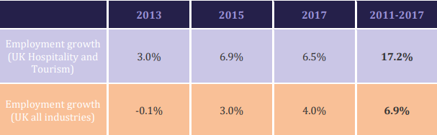
Source: (GOV.UK, 2019)
The HR department of hotels continuously struggles to develop the best employees to perform business operations. On the other hand, career development is a continuous process, and a good worker seeks better opportunities to grow professionally. The organisation retains employees through guidance about choosing a career path and offering a perfect working environment. The development of employees throughout their careers improves job satisfaction and productivity (Proudfoot et al., 2009)
The training and development are different in each organisation, and it is studied that most employees are reluctant to work at entry-level jobs for an extended period (Brown, 2017). The training aims to keep the employees interested in their jobs and provide opportunities to grow within the organization. Employees consider training a source of promotion, and an increasing number of individuals show interest in training programmes. One of the key roles in the hotel's popularity is played by the staff, the most vulnerable and unstable component of the success of the hotel business. The reputation of the hotel seriously depends on the human factor. Without qualified staff, the hotel could be inactive, no matter how beautiful its interior is (Johnson et al., 2018). You can arrange a guest in a perfectly cleaned, luxurious room, but if at the same time he is poorly served, he will not be back again. Therefore, the well-known slogan "Cadres decide everything" can be called the motto of the hotel business.
The hotel industry includes many services for people of different professions (Doyle, 2022). Concierges greet visitors at the entrance. Guests are accommodated in rooms, with reception associates communicating directly with them. The household is kept clean by the housekeeping department associates. Chefs, bartenders, and waiters work around the clock, whose job is to provide an unforgettable experience during the stay of their guests. Together, they create an atmosphere of hospitality. Each hotel has its standards for service staff, which are based on the hotel's category, the market niche in which it competes, the additional services it offers, the effect of seasonality, the level of competition, and a staff management system that chooses not only employees but also a type of enterprise management model (Ohunakin et al., 2020).
Management should be simple and flexible, ensure efficiency and competitiveness, and focus on selecting and placing personnel and developing the enterprise's workforce (Ahmad et al., 2019). Different hotels have their standards for service personnel, determined by the class of the hotel, the market segment in which it operates, the range of additional services, the seasonality factor, competition, and a personnel management system that not only selects personnel but also selects an enterprise management model (Saputr et al., 2020).

2.4 UK Hospitality Industry Post Brexit
Since the separation of the United Kingdom from the European Union (EU) referendum vote in June 2016 (GOV.UK, 2016), employment growth has slowed within UK markets and the number of vacancies is still remarkable high (Appendix 1). People from EU nations dominated the UK labour markets before Brexit (Appendix 2). As a member of the European Union, the UK accepts migrant workers from other member countries. With the commencement of Brexit, people from EU countries require travelling visas, and many EU citizens have moved back to their countries (Appendix 3). Brexit causes a labour shortage in UK markets that causes recruitment difficulties for employers. Finding overseas staff has become more difficult for employers, and the UK is less attractive for migrant workers from EU countries (Filimonau and Mika, 2019).
The hospitality industry is one of the highly influenced businesses due to Brexit. The impact of Brexit on the UK hospitality industry has been studied by many researchers, and it includes both the long-term and short-term impacts of Brexit (Sumption, 2017). The short-term impact is observed as the loss of a substantial number of employees from the hospitality business due to the change in the law. The UK government is focused on the development of the local workforce and encourages UK citizens to fill the vacancies. Furthermore, according to Ruiz (2004), immigration from the EU does not hurt the economy, even though it may "fill a gap" in the UK's labour shortages. Given the shortage of skilled labour and workers, Brexit has not diminished firms' interest in hiring EU migrant workers (CIPD, 2022).
The hospitality industry always struggles with staff shortages as people always consider it a career choice, however, according to Sumption, the attitude toward the hospitality industry is changing. In the long term, the UK hospitality industry has been scrutinised by political and commercial (Sumption, 2017). As society is continuously demanding from the hospitality sector, it is found that the UK hospitality industry requires innovation and reform in staffing to solve the staffing crisis caused by Brexit. The COVID-19 crisis also played a role in driving the UK labour market. It is observed that COVID restrictions limit the recruitment process and employment growth has significantly decreased during the past 2-3 years (Filimonau and Mika, 2019). Figure 2.1 shows that there are now more difficult-to-fill positions than in prior years.

Figure 2.1: Number of organisations having positions that are difficult to fill (%)
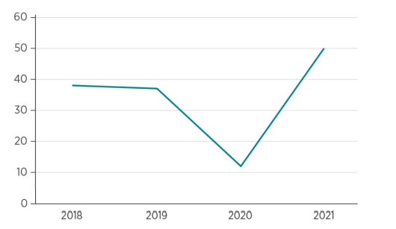

Source: (CIPD, 2021)

The impact of Brexit on the UK hospitality industry was studied by Burnett and Johnston (2020) who concluded that the hospitality industry is unstable and is impacted by both natural and artificial forces as a sample of crises (Table 2.2).

Table 2.2: Examples of crises that had an impact on the international tourist
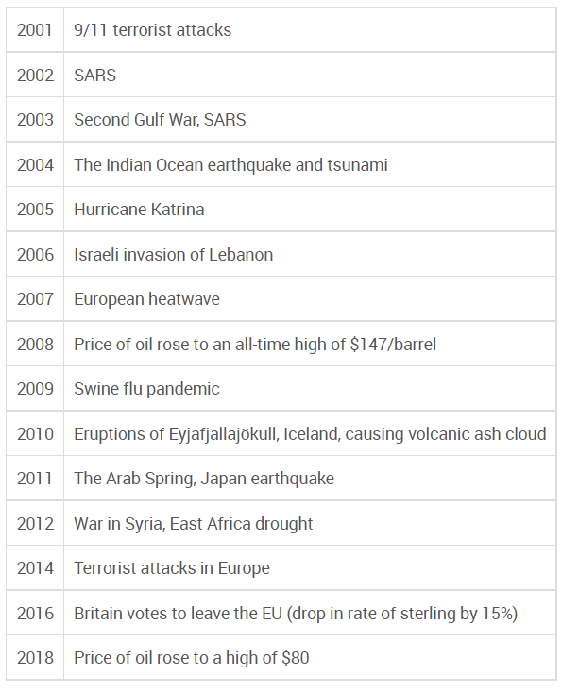

Source: (Burnett & Johnston, 2020)
Due to the implication of Brexit, employers need to recruit overseas talent as permanent employees (Filimonau and Mika, 2019). Recruiting employees from other countries is much more expensive and time-consuming for both potential employees and employers.
Labour availability and employee retention are the key factors for the sustainable operations of hospitality companies. After Brexit, the UK is facing a labour shortage that includes a shortage of hotel workers, cleaning staff, drivers, waiters, and kitchen staff. According to a survey conducted by CGA and Fourth, the hospitality and transport industries have suffered from a shortage of workers (Ferris et al., 2018). It is observed that the supply chain is the backbone of the hospitality industry and a delay in the supply chain will halt the whole business operations. The UK market is facing a driver shortage for the supply networks of hotels, and it is seriously affecting the hospitality industry. Many employers are demanding the government relax the immigration rules to solve the present crisis of labour shortages (Filimonau and Mika, 2019).
Ferris et al (2018) investigated methods to mitigate the impact of Brexit and labour shortages in UK markets, concluding that investing in existing employees is the best way to deal with the labour crisis. Staff retention and preparing existing employees to perform their best are beneficial for the UK hospitality industry. Retaining the workforce involves human resource management based on the business and individuals involved in company operations. According to research, organisations are increasingly focusing on employee management innovation and improvement to attract a skilled workforce. Although the UK labour market is not supportive of the hospitality industry, researchers and organisations are looking for ways to manage human capital effectively to increase productivity with a smaller workforce (Baur, 2019).

2.5 Organizational Productivity and Employee Training at Marriot International Inc.
Marriott International, Inc. is a multinational organisation that helps create jobs around the world and conducts several mentor programmes in different countries to attract the maximum number of individuals to be a part of the organisation. Marriott International is a fast-paced company that continues to recruit a diverse workforce and update workers' skills to provide a joinable experience to customers across the world (Marriott International, 2022). According to Arne Sorenson, President, and CEO (Chief Executive Officer) of Marriott International, the company invests heavily in the development of each employee by providing training opportunities (Mehta, 2020).
The company is offering an orientation program for new hires to ensure that inexperienced staff has the necessary skills to perform the job effectively (Hotel Management, 2010). The company's orientation program is critical for introducing newcomers to organizational culture, brand, and regions of operation. The program known as VOYAGE offers resources and support for future leaders of the company across the hotel brands (Marriott University Programs, 2017). Marriott International offers training sessions daily to each employee, which is aimed to provide necessary knowledge about hotel operations, including purchasing, room operations, culinary, and others. For non-management employees, the company offers gateway programs that are designed to train specific skills and discipline for individual positions, including sales, PR (Public Relations), loss prevention, IT (Information Technology), and finance.
The organisation is also focused on training and development sessions for managers. The managers are responsible for carrying out organisational procedures to achieve the desired goals. The management staff plays a vital role in organisational productivity, and Marriott managers participate in more than 20 training programmes. Management training and development involve courses taught by certified professionals and trainers. Some courses are based on online learning. Other activities include self-directed, hands-on activities, action planning, and test evaluation. The management programmes are focused on improving employee productivity as the managers evaluate the overall work of junior staff (Kim et al., 2021)
To address the labour shortage and present market conditions in the UK, the hotel-based programmes at Marriott with 15 modules are offered to employees, including coaching for great performance; hiring the best; communicating for success; training and developing your associates; Marriott management; building top-performing teams; managing conflicts; conducting performance appraisals; juggling time; creating experiences; business basics; goal setting; effective daily meeting; stress management; you and your career. Each module has been shown to influence employee productivity and performance. The learning experience of the company is designed to improve individual competencies and train the employees according to Marriot’s culture, procedures, and policies (Ross, 2018). That is why HRM's primary aim is to improve employee contribution while raising organisational productivity.
The core competencies to be developed by employees are managing execution, leadership, generating organisational capacity, building relationships, learning, and applying personal expertise and functional results of the business. To understand the brand positioning, services and product standards, effective food, and beverage, pricing strategy and creating a hotel action plan, the organization provide an international training program to the General managers and assistant managers. Marriott develops a diverse workforce that includes people from different demographics, educations, and levels of understanding of the hotel business. Today the company is recognized as one of the top employers and possesses one of the most inclusive and diverse workforces (Marriott International, Inc, 2022). Ross (2018) argues that diversity is significantly essential for the hospitality industry, and it improves the motivation and level of job performance among employees. The organisation's training and development efforts are centred on creating a workforce capable of performing organisational operations more efficiently. According to studies, trained employees perform much better than employees who did not attend training sessions. The organisation faced a significant labour shortage due to Brexit and the COVID-19 crisis, and at present, the organisation is investing heavily in employees to create a perfect working environment for employees that leads to an exciting experience for the guests.
Employee productivity at Marriot International is promoted by teaching the employees more about their job roles, responsibilities, rights, behaviours, and values within the organisation. Employees and employers have a mutual relationship with each other. Employees are beneficial to employers, and employers are beneficial to employees (Klonoski, 2016). With increased emphasis on human capital, Marriott International is focused on the individual needs of employees and designing programmes to address the problems of employees (Ross, 2018). A satisfied employee can put more focus on doing business operations and motivation can provide high productivity from employees. The training and development programmes of Marriott International Inc. highlight the benefits that employees can get through company policies and provide necessary information about services like parking, internet facilities, tours around the building, and the location of different offices and rooms. Training at Marriot significantly improves employee skills, including telephone skills, customer service, up-selling training, brand standards of the company and food safety training. These skills enhance the interaction of employees with guests, and employees respond more confidently in the workplace (Lytle et al., 1998).
Group discussion is another important development tool that significantly contributes to improving productivity at Marriot International Inc. Group discussions include staff members from various positions that are working in teams and discussing the business and operational issues of the company. The discussions are further aided by presentations, video clips, and images that enhance the learning of employees. The development of employees' interests at work is the most critical factor identified by studies, and it is advocated that increased employee engagement at work leads to improved productivity. The effectiveness of training and development is evaluated through questionnaire feedback and the performance of employees at work.

2.6 Chapter Summary
The literature chapter is divided into sections that include an introduction; employees' training and development in the hospitality industry; the impact of employees' training and development on organisational productivity; the UK’s hospitality industry post Brexit; and organisational productivity and employee training at Marriott International, Inc. This chapter highlights the literature related to the study.
The research showed above how Brexit affects the UK labour market and currently highlights a labour shortage. It is well known that the UK is experiencing a labour shortage, which impacts the hospitality industry. The literature review concludes that Brexit is leading to significant labour shortages for businesses operating in the UK. The current labour shortages substantially impact the hospitality sector, and research indicates that demand for associates has grown significantly in recent years. As a presenter global hospitality company, Marriott is facing issues recruiting new associates in the UK post-Brexit. Therefore, of the labour shortage, the human resources department is looking for a new strategy to retain existing employees through additional training and development programs.

CHAPTER 3: METHODOLOGY

3.1 Introduction
The present chapter aims to develop a research design and data collection method employed to conduct and complete the present research. The present chapter introduces employees' data collection tools and sampling techniques that are used to collect quantitative data. The demographic and socioeconomic characteristics of the respondents are recorded, and these details are used to focus on the research. The present research is based on both qualitative and quantitative data, as the findings are based on quantitative data and their validation is made through qualitative data being analysed and summarised in the literature section. Gorman and Clayton (Qualitative research for the information professional: a practical handbook, 2005) argued that the research objective is the discovery or creation of knowledge; the development of theories; the testing, confirmation, revision, and refutation of knowledge and theories; as well as the analysis of a problem to make decisions.

3.2 Research Design

3.2.1 Philosophy of Research
The research methodology aims to present data in a presentable format. The research design is based on the systematic analytical tools being employed by other researchers that are verifiable (Saunders et al., 2019). Every research methodology is based on specific assumptions, and these assumptions are referred to as research philosophy. The research assumptions further guide the procedures and strategies of data collection. The research philosophy may differ from study to study, as they are based on the researchers' own will and ways of doing work. The knowledge and skill set of the researcher are the key elements of the research philosophy, as a successful research philosophy can only be made by technically accomplished researchers. The present study involves both qualitative and quantitative research approaches that are based on the philosophy of positivism and interpretivism.
According to Cooper and White (2012), quantitative knowledge is not subjective; it should be verifiable, testable, numerical, and systematic. The research philosophy also narrates that the researcher should not have any knowledge of results, and if they have any idea, it should not impact the overall results. The conclusion of the research should also focus on the observations made, and the researcher should be passive in this case. The statistical results should determine the acceptability and rejection of the hypothesis. Whereas qualitative research is based on the subjective knowledge of the topic. According to interpretivism, people's experiences and perceptions shape their interpretation of reality, making truth and knowledge subjective as well as historically and culturally placed (Ryan, 2018).
The qualitative results are based on the opinions of people who can be biased. This provides the foundation of the positivist research approach. It can be argued that the methodology can be valid for both individual philosophies based on the nature of the work and its objectives. It is also argued that a qualitative research approach can be verified by comparing the results of similar research and can be acceptable to the research community (Chowdhury, 2014). The interpretivism approach is used most of the time, and it is less common in research designs as interpretivism is less reliable. It has also been observed that in some cases, the quantitative approach yields no results, leaving researchers with no choice but to consider the positivist approach. It is also evident that the positivism approach can generate critical results and can provide critical assumptions for quantitative data analysis. Based on the philosophy of interpretivism and positivism, the following are the research hypotheses:
1. Hypothesis 1: European migrant workers are critical to the UK’s hospitality industry.
2. Hypothesis 2: Employees' skill development programmes profoundly impact their skills and overall organisational productivity.
3. Hypothesis 3: The HR strategies of Marriott International, Inc. are aligned with their organisational growth policy.
4. Hypothesis 4: The Brexit deal has impacted the UK’s hospitality industry, and employee training is critical to business sustainment.

3.2.2 Research Strategy and Approach

The research strategy and approach are critical to analysing a specific problem and devising solutions by developing comparable variables that can generate results. The organisation of approaches and systems that are available to the researcher is made clear by the research onion model. The profitable model, Research Onion, combines the unusual condition of hugeness with the intellectual enjoyment of the entire research process (Alturki, 2021). Figure 2.2 shows the several layers of the research strategy recommended by Alturki.
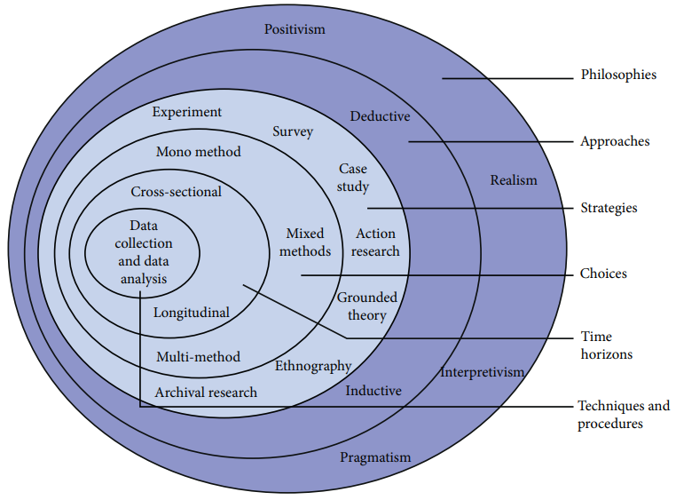
Figure 2.2: Research onion

Source: (Alturki, 2021)
The research design should be coherent with the research strategy. The present research is based on both qualitative and quantitative research approaches. The qualitative data is collected from the literature survey and provides the basis for further research. The quantitative data collection includes a survey questionnaire being filled out by people related to the hospitality industry. The questionnaire survey was conducted through online tools of social communication and interaction. The random sampling of the overall population can provide critical data that can help us predict the overall condition of organisational activities after Brexit.

3.2.3 Sampling Technique
The sampling of the respondents is done through an online shortlisting of people that are associated with the hospitality industry and the Marriott International staff working in different localities. The participants are contacted online and shortlisted based on their association with the UK hospitality industry, specifically Marriott International Inc. The participants are randomly chosen and asked to fill out the questionnaire survey. The willing participants are shortlisted, and the sampling is done keeping in mind the overall representation of the hospitality industry. The online surveys are easy to conduct and manage, and the present study also focused on online survey results. To ensure gender representation in the sampling, all gender types are welcome to participate, and willing people are shortlisted.

3.2.4 Research Ethics
1. The research has no personal belongings with any participants, and their details like job descriptions and salaries are not asked for or shared.
2. The participants are free to answer any question they want, and they are also free to leave any question unanswered.
3. Personal data like job type and organisation name are not mandatory, so the participants can answer what they want.
4. The data collected is not shared with any third party for any reason.

3.3 Data Collection
The data collection technique is a fundamental component of any research that uses both subjective and quantitative methods. The questionnaire developed to collect the primary data is based on the research questions and was posted online to the selected candidates (Chapter 7: Appendix 4). The data collected from these survey forms are further subjected to analysis and deduction of results. The secondary data is collected from the literature survey being done in Chapter 2. The secondary data is used for the comparisons in the discussion section. The pilot test is also performed before posting the questionnaire survey to the audience, as it guides the researchers to the actual meaning of their research work (Saunders & Lewis, 2012).

3.4 Data Analysis
The questionnaire survey is developed to guide the study’s overall results. The data collected from the survey is further subjected to statistical analysis and results are developed. The software used for the descriptive statistical presentation of the data is IBM’s statistical analysis software, SPSS.

3.5 Limitation of Methodology
The present study is aimed at focusing on the UK’s hospitality industry and its ways to train its employees for improved efficiency and productivity in the organisation. The methodology is limited to randomly selected respondents based on their association with the industry. The issue of skilled labour availability in the hospitality industry is recent, so the secondary data is not enough. The deep primary data collection helps overcome the issue of the least data available online. To minimise the issue of limited responses, the questionnaire survey is also distributed to general labour associated with the different sectors of the hospitality industry. Time management is a critical issue for the present research, but the issue is resolved by employing on and offline distribution of the survey questionnaire.

3.6 Chapter Summary
The research study adopts a mixed approach that includes both positivism and interpretivism approaches. The research aims to analyse the hospitality industry of the United Kingdom by analysing the human resource practices of Marriott International, Inc. The qualitative data is collected in Chapter 2 and the results are developed from that section. The quantitative data is further collected from the questionnaire survey that aims to collect primary data for further analysis. The questionnaire survey is developed to answer the research questions, and the data is collected and subjected to statistical analysis. The questionnaire was filled out by twenty-five respondents, and the data was collected from them. In conclusion, the present research is based on a mixed approach, including qualitative and quantitative research approaches.

CHAPTER 4: RESEARCH FINDINGS AND RESULTS

4.1 Introduction
The present chapter aims to analyse, access, and interpret results and quantitative data subjected to descriptive statistics. The study is based on quantitative data collected through a survey questionnaire. The study uses quantitative data to conclude the findings, and the evidence from qualitative research is included to validate the analysis. The quantitative data is further divided into groups addressing the research questions. The online survey questionnaire is used to target the audience related to the hospitality industry. The findings of the survey questionnaire are further explained and analysed in this chapter.

4.2 Quantitative Data Analysis

The data collected from the survey questionnaire is subjected to analysis, and the findings are compared for conclusions. The hospitality industry has a diverse range of jobs and requires multiple skill types to achieve its organizational procedures seamlessly. The questionnaire survey was made available to associates working for Marriott International hotels in the UK. The research aims to analyse the results of 50 skilled workers working in the hospitality sector of the United Kingdom, but only 25 people filled out the survey questionnaire. The responses were strictly taken from the selected audience working at Marriott hotels in the UK. The responses are enough to analyse the hospitality industry in the United Kingdom. The participants were searched on LinkedIn and social media sites, and randomly selected people were asked to participate in the survey. The probability model is used randomly to collect from the available audience. The sample size varies because of the unavailability or unwillingness of professionals to participate in the survey. The participants were requested on a personal level, and emails were dispatched to individual participants. The following is the analysis of survey results based on the data collected from the respondents.

4.2.1 Demographic Information

The respondents of the present survey are professionals working in the hospitality industry. The respondents are of diverse origins, and it is observed that 6 out of 25 are aged between 18 and 30. About 11 out of 25 respondents are aged between 30 and 40 years, 6 respondents are between 41 and 50 years, and only 1 is above 50 years. It is also observed that the target population is a mix of different genders. About 13 out of 25 respondents are male and the remaining 12 respondents are female. The following are the figures (4.1 and 4.2) and tables (5.1) demonstrating the age and gender of the respondents.

Figure 4.1: Age of Participants
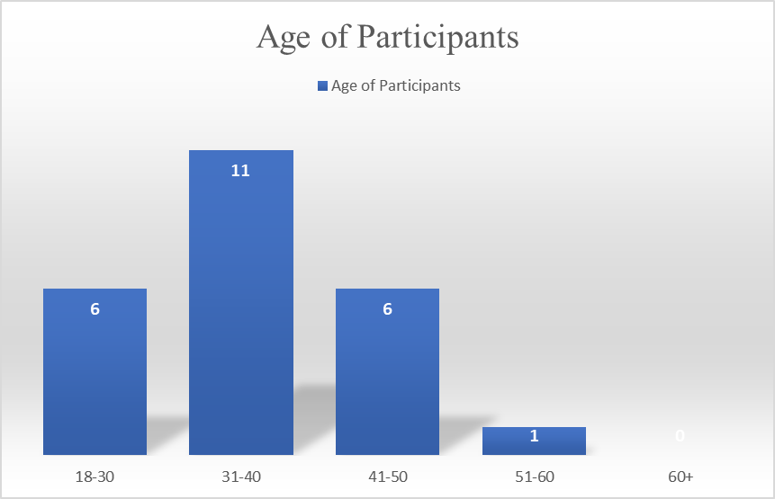
(Source: Compiled by author)
Table 5.1: Age of Participants
Age of Participants | Count
18-30 | 6
31-40 | 11
41-50 | 6
51-60 | 1
60+ | 0
(Source: Compiled by author)

Figure 4.2 Gender of Participants

(Source: Compiled by author)
Figure 4.3 shows that the participants are diverse and belong to different hospitality industry sectors. The results will help the researcher analyse every hospitality industry's distinctive sector. Table 5.2 shows that the different sectors have their representation in the set of respondents randomly chosen for the present research.
Figure 4.3 Department Serving
(Source: Compiled by author)

Table 5.2 Department Serving
Department | Response Count
F&B (Food & Beverage) | 9
Learning and Development | 5
HR | 2
Sales and Marketing | 4
Finance and Administration | 5
(Source: Compiled by author)
Figure 4.4 shows participants' experience serving the UK hospitality industry. It can be observed in table 5.3 that 14 respondents have experience of more than 10 years, three have 1 to 3 years, one has 2 to 5 years and only five respondents have 1 year of experience in their respective job types.

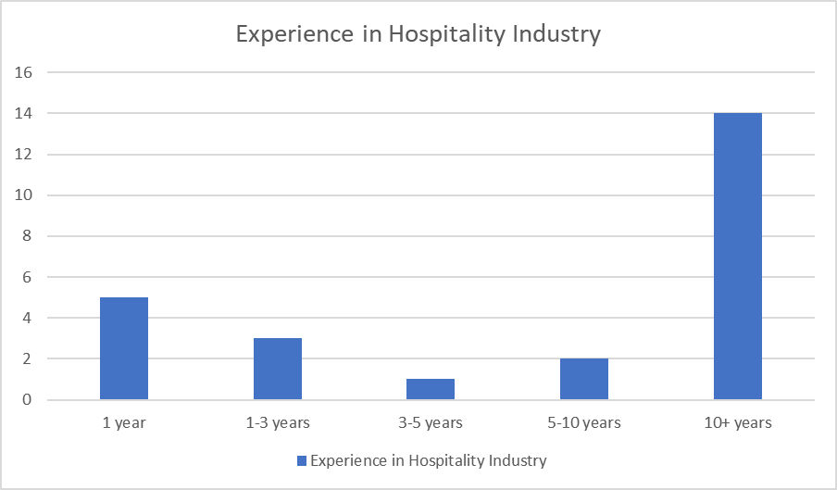
Figure 4.4: Experience in Hospitality Industry

(Source: Compiled by author)

Table: 5.3 Experience in Hospitality Industry
Experience in Hospitality Industry | Count
1 year | 5
1-3 years | 3
3-5 years | 1
5-10 years | 2
10+ years | 14
(Source: Compiled by author)

4.2.2 Survey Questionnaire

- Does the organization include employee training as a part of its strategy?
The HR department of the hospitality industry includes employee training as a part of the organisational strategy to improve employee retention and motivation at the workplace. The results demonstrated in figure 4.5 and table 5.4 show that most of the participants strongly agree to include staff training as a part of organisational strategy and there is an increased need to play strategically to gain a competitive advantage in the UK hospitality industry. The adaptation of training and development as a key part of the organisational strategy involves the workforce in continuous growth along a career path that is related to organisational growth.
Figure 4.5. Training as a part of organizational strategy

(Source: Compiled by author)
Table 5.4 Training as a part of organizational strategy

Training as a part of Organizational Strategy
Attribute | Frequency
Strongly Agree | 12
Agree | 8
Slightly Agree | 4
Disagree | 1
Strongly Disagree | 0
(Source: Compiled by author)

Several kinds of training include on-the-job training, off-the-job training, and mixed methods. The HR departments of the hospitality industry involve practices to improve the workforce’s skill set. Results revealed that mixed training methods are preferred, including on-the-job and off-the-job training. On-the-job training involves the skills related to performing job roles while off-the-job training methods include learning soft skills like communication and the development of general work behaviours. Figure 4.6 and Table 5.5 demonstrate the response of participants. Fifteen participants argued that they would prefer both methods, 9 participants preferred on-the-job methods and one individual preferred only off-the-job methods.
Figure 4.6. Preferred Kind of Training

(Source: Compiled by author)
Table 5.5 Preferred Kind of Training
Preferred Kind of Training
Methods | Frequency
On the Job Methods | 9
Off-the-Job Methods | 1
Both | 15
(Source: Compiled by author)

To further investigate the role of different training methods in improving organizational productivity, the study identifies four important HR (Human Resource) practices that are linked to organizational productivity. The results are demonstrated in figure 4.7 and table 5.6. It is observed that mixed methods are adopted by HR in the UK hospitality industry to improve the workforce’s skill set. The hospitality industry is based on customer experience, and training in the hospitality industry is aimed at providing excellent customer service. A high number of participants argue that on-the-job training has a high impact on organizational productivity. Audio and visual materials provided to employees for training and development also play a role in organizational productivity. Off-the-job training has little or no influence on organizational productivity.
Figure 4.7. Training influences the organisational productivity

(Source: Compiled by author)
Table 5.6 Training influences the organisational productivity

Training influences the organisational productivity
Methods | Frequency
The Job training | 8
Off the Job training | 0
Lectures | 1
Audio-visuals | 2
All of them | 14
(Source: Compiled by author)
Considering the above results, on-the-job training is significantly essential for the hospitality industry. The best practices that should be included in improving organisational productivity are enhancing professional behaviour toward work, audio-visuals, lectures, and career guidance for the employees.
The duration of training programmes for employees in the hospitality industry is extremely important, and organisations must adopt the optimal duration of training programs. It is studied that hospitality organisations within the UK conduct either monthly, quarterly, after six months, or yearly training for the employees. According to the results demonstrated in figure 4.8 and table 5.7, most participants (64 per cent) support monthly training programs. Twenty per cent of the participants consider quarterly training as the optimal duration, and only 8% consider six months and a year as the optimal duration of training programmes. Frequently conducting training programmes is effective to keep the staff updated about the recent market trends and skills to handle the customers and perform better at the workplace.
Figure 4.8. Duration of Conducting Training Program
(Source: Compiled by author)
Table 5.7 Duration of Conducting Training Program
Duration of Conducting Training Program
Monthly | 16
Quarterly | 5
After six months | 2
Yearly | 2
(Source: Compiled by author)
It is important to understand that the hospitality industry's training programmes and practices are compulsory. The participants were asked to highlight the importance of the training programme for the organisation’s strategic development. Figure 4.9 and Table 5.8 demonstrate the responses, and it is observed that 52% of participants strongly agree that training is compulsory for hospitality organizations; 32% of participants agree; 12% slightly agree, and only 4 % disagree with the need for training within the hospitality industry.
Figure 4.9. Training Is Compulsory for Hospitality Industry
(Source: Compiled by author)
Table 5.8 Training is Compulsory for Hospitality Industry
Training Is Compulsory for Hospitality Industry
Strongly Agree | 13
Agree | 8
Slightly Agree | 3
Disagree | 1
Strongly Disagree | 0
(Source: Compiled by author)
Employee development is a continuous process involving developing skills, behaviours, practices, and attention toward work. With the changing market conditions and labour shortage within UK markets, it is essential for management to identify, analyse, plan, and forecast changes required by the organization. The development programmes play an essential role in defining the changes needed and preparing the staff to handle the changes in working conditions. Management and human resource departments that lead all organisational training and development activities are directly involved in development activities. The findings are represented in fig. 4.10. and table 5.9. The results show that 75% of the participants argued that development is significantly essential for management to identify, analyse, plan, and forecast chain organisational change size 25% of participants refuse the statement that development is essential for the organization.
Figure 4.10. Development is important to tackle changes in the workplace

(Source: Compiled by author)
Table 5.9 Development is important to tackle changes in the workplace

Development is important to tackle changes in the workplace
Yes | 18
No | 6
(Source: Compiled by author)
- What is the impact of employee training and development on organizational productivity after Brexit?
The above results demonstrate that training and development are significantly important and should be included as a key part of organisational strategy. Training and development are directly associated with organisational productivity. It is studied that employee training and development are highly promoted after Brexit due to the low availability of hospitality staff. Training and development impact organisational productivity in several ways, and this section addresses the impact of training and development on employee productivity within UK markets after Brexit
Figure 4.11 and table 5.10 show that training helps employees and employers develop strong relationships. A strong relationship between employer and employee enhances communication and brings clarity to organisational operations. It is observed that 96% of participants support the argument that training is helpful to develop a relationship between employees and employers. Employees' confidence is built through training and development activities that allow them to express their thoughts about their jobs.
Figure 4.11. Training Help to Develop Relationship

(Source: Compiled by author)
Table 5.10 Training Help to Develop Relationship
Training Help to Develop Relationship
Yes | 23
No | 1
(Source: Compiled by author)
Organizational productivity is the sum of the efforts made by each employee, and improvement in organisational productivity means increased profits. Figure 4.12 and Table 4.11 demonstrate the survey responses about the influence of training on organisational productivity. It is observed that the maximum number of participants strongly agree that training influences organisational productivity. There is a slight difference between the number of participants arguing strongly agree and agree with the influence of training on productivity. The results demonstrate a powerful connection between organisational productivity and training programs. Few participants disagreed that training does not influence productivity. A significant percentage of participants agreed with the statement, and it is also studied in the literature that training programmes impact the productivity of the organization.
Figure 4.12. Training influences the organisational productivity

(Source: Compiled by author)
Table 5.11 Training influences the organisational productivity
Training influences the organisational productivity
Strongly Agree | 12
Agree | 10
Slightly Agree | 2
Disagree | 1
Strongly Disagree | 0
(Source: Compiled by author)
Training and development are significantly important to motivating employees in the workplace. 88% of participants consider training a valuable tool to improve employee motivation (Figure 4.13 and Table 5.12). Motivated employees perform better for both the organisation and themselves. Employee motivation is also highlighted as a key part of the hospitality industry, and with the changing market conditions, it is necessary to motivate the employees to provide an exceptional customer experience and promote the business of the organization. Organizational productivity is linked with employee motivation. An employee without motivation has no goals to achieve, and that makes the individual only concerned about job-related tasks. The motivated employee is willing to learn other skills and can work within different departments that bring effectiveness to organisational operations.
Figure 4.13. Training improves employee motivation
(Source: Compiled by author)
Table 5.12 Training improves employee motivation
Training improves employee motivation
Yes | 22
No | 3
(Source: Compiled by author)
The results demonstrate that training and development helped improve productivity in quantity and quality. Productivity could be measured as the increased quantity of work done by the employees, and it could also include the quality level of the tasks done by employees. Figure 4.14 and Table 5.13 demonstrate the responses of participants about the impact of training and development on the quantity and quality of production. 48% of respondents strongly agree and 24% agree that the quantity and quality of services in the UK hospitality industry improve with training and development programs. Improvement in quantity and quality results in enhanced customer satisfaction and provides sustainable business for the organization.
Figure 4.14. Improve productivity of both quantity and quality.
(Source: Compiled by author)
Table 5.13 Improve productivity of both quantity and quality.
Training and development helped to improve the productivity of both quantity and quality.
Strongly Agree | 12
Agree | 6
Slightly Agree | 4
Disagree | 2
Strongly Disagree | 1
(Source: Compiled by author)
Training and development positively impact organisational productivity after Brexit, and the results reveal that training and development provide employee motivation and build relationships between employees and employers. The hospitality industry in the UK is focused on recruiting foreign employees and creating a diverse workforce. The country is facing a labour shortage, and organisations are focus on retaining employees and developing human capital. Training and development play a key role in improving employee satisfaction, including employees in business operations and decision-making, and developing a more professional workplace to gain a competitive advantage over other organizations.
- What is the impact of Brexit on the hospitality industry and the UK’s labour market condition and its implications for the hospitality industry as a whole?
The hospitality industry within the UK is facing a labour shortage. The hospitality industry is based on customer service, and each employee represents the whole organisation. The secondary data analysis demonstrates that Brexit is the most important reason for the present labour shortage in the United Kingdom. The results of the secondary data analysis are demonstrated in table 5.14. It is important to note that the second major cause of labour shortages is the impact of changing employment contracts. Due to Brexit, the employment contracts for all European nationals changed in the UK, and they now require a valid visa to enter the country. Therefore, a high number of European workers moved back to their countries, leaving vacancies in the market.
Table 5.14 Most Important Reason for Present Labor Shortage in the United Kingdom
Most Important Reason for Present Labor Shortage in the United Kingdom
Variables | % Contribution
Brexit | 45%
Unfavourable working environment | 11%
Low wages | 3%
Changed employment contract | 41%

(Source: Compiled by author)
The survey results demonstrate the nationality of participants working in the hospitality industry within the UK. Figure 4.15 and Table 5.15 present the results. It is observed that the UK hospitality industry is diversified with people from different nationalities and ethnicity working together.
Figure 4.15. Diversity in the UK labour market
(Source: Compiled by author)

Table 5.15 Diversity in the UK labour market
Diversity in the UK labour market
UK native | 1
European | 8
Asian region | 10
African | 4
American | 2
(Source: Compiled by author)

The results show that the maximum number of participants are from the Asian region, including labour from India, Pakistan, the Middle East, Bangladesh, and others. European nationals are the second most significant contributor to the UK workforce. By comparing the results with the secondary data, before Brexit, Europeans were the significant contributors to the workforce within the UK, but after Brexit, the number of European workers decreased, and companies are recruiting more workers from the Asian region. The HR department plays a key role in managing a diverse workforce at the workplace. Training employees has proved to be an effective method to educate the workforce, bridge the gaps, and improve teamwork.
The participants were asked about Brexit’s positive or negative impact on labour availability within UK markets (Figure 4.16 and Table 5.16). 75% of respondents answered that Brexit negatively influenced labour availability within UK markets. At present, the hospitality industry is facing a shortage of drivers for supply chain networks, workers, cleaners, high-skilled workers, and management staff.
Figure 4.16 Brexit influence labour availability within the UK market
(Source: Compiled by author)
Table 5.16 Brexit influence labour availability within the UK market

Does Brexit influence labour availability within the UK market (positively or negatively)?
Negatively | 75%
Positively | 25%
(Source: Compiled by author)
Human capital is the main driving force for business and the economy. The UK hospitality industry needs to retain productive employees and develop the necessary skills to further enhance the organisation's productivity. Employee satisfaction in the workplace is an essential factor in determining employee retention. The survey results are demonstrated in figure 4.17, showing that 71% of participants are satisfied with selecting employees for training. The elevated level of satisfaction results in improved productivity and the dedication of employees toward building the brand image.
Figure 4.17. Selection procedures of employees for training

(Source: Compiled by author)
Table 5.17. Selection procedures of employees for training
Are you satisfied with the selection procedures of employees for training?
Yes | 17
No | 7
(Source: Compiled by author)
Brexit influenced the whole hospitality industry of the United Kingdom. The hospitality industry’s workforce includes a diverse team with diverse backgrounds, including management staff, technical individuals, labour and worker staff, front-office staff, and supports staff. All the team members represent the brand, and it is essential to gain a competitive advantage over other companies. Brexit negatively influenced the availability of labour and reduced the number of visitors from European countries. As a result, the UK market has become more competitive for existing players. As a response, companies are more concerned about employee retention and workforce planning. Low wages are not the main reason for employees to leave a company. The working environment and attention paid by the organisation to employees are essential to retaining the maximum number of employees. With a low level of labour availability, organisations need to prepare their existing staff to perform multiple tasks at the workplace. A workforce with a diverse skillset could handle business operations more effectively. Companies are focused on training and development to develop various skill sets. Extensive training is offered to newly recruited employees to develop the required capabilities in a professional working environment. Further training and development programmes guide the employees through their career paths.
- What are the HR strategies and practices that Marriott International Hotel employed to improve their employee’s skill set, and how does it impact their productivity?
Marriot International Hotel adopted several HR strategies and practices to improve employee skills. The history of improving human capital at Marriot hotels dates to the establishment of the company. Apart from providing a pay package to employees, the organisation is also focused on providing a good work-life to employees. The company emphasises non-monetary factors like good leadership, work-life balance, a friendly working environment, growth opportunities, and training. Marriot employees stayed longer at Marriot hotels, and guiding principles significantly influenced the HR practices of the company, including recruitment and selection, workforce planning, employee retention, training and development, and welfare initiatives. New hire orientation programs, international hourly training, core management training, gateways, and essential skills for managers and supervisors’ programmes are examples of training and development programs. Training and development programmes focus on product and service standards, brand positioning, adequate food and beverages, pricing strategy, and creating specific action plans to achieve organisational goals. Over time, training programmes have evolved from classroom teaching to high-level interactive multimedia training. Newly recruited individuals at Marriott Hotel going to through eight hours of daily training where they learn about the overview of individual roles and the overall company. Mentors guide the trainees through organisational processes and a three-month training period is followed to develop professional ethics in the workplace.
The survey results demonstrate that training plays a significant role in improving the employee productivity of Marriott International employees. Figure 4.18 shows that 64% of participants strongly agreed that training is positively related to employee productivity. Only 4% of participants disagree with the positive impact of training on productivity. The significance of training and development is highlighted for Marriot International.
Figure 4.18. Improving employee productivity

(Source: Compiled by author)
Table 5.18. Improving employee productivity
Training plays a significant role in improving employee productivity
Strongly Agree | 16
Agree | 6
Slightly Agree | 2
Disagree | 1
Strongly Disagree | 0
(Source: Compiled by author)
Managers and training staff are responsible for designing and conducting training sessions. The problems in conducting training programmes negatively influence organisational productivity. The survey results demonstrate that 60% of participants identified challenges during training programs, while 40% responded that they do not face any specific challenges in conducting training courses (Figure 4.19 and Table 5.19). It is found that resistance to change is a major challenge that is faced by organisational management. Employees are reluctant to adopt new methods of work and are based on conventional practices in the hospitality industry. Marriot International Hotel designed the training courses to continuously direct the employees toward growth. The HR department is responsible for keeping the employees motivated at work and developing strategies and action plans to overcome the challenges faced during training programmes. Training and development improve the productivity of the organisation, and, in response, the organisation requires fewer hires and retains the top talent within the organization. The increased productivity means that the organisation requires fewer individuals to carry on the business operations.
Table 5.19. Challenges during training courses
Do the managers or officers face specific challenges during training courses?
Yes | 15
No | 10
(Source: Compiled by author)
Figure 4.19. Challenges during training courses

(Source: Compiled by author)
Leadership skills and teamwork are crucial for Marriot International Hotel to gain a competitive advantage over other companies. Leadership skills enable employees to make decisions and guide others to the right way of doing things. Service in the hospitality industry is linked with teamwork. Without synchronisation between different departments, delivering a good customer experience is impossible. With proper employee training and development, Marriott hotels aim to resolve workplace issues and promote teamwork to strengthen the brand image. 83% of participants responded that training at Marriot hotels aims to develop leadership skills and promote collaboration (Figure 4.20 and table 5.20).
Table 5.20. Development of leadership skills and teamwork
Does the Training program focus on the development of leadership skills and teamwork?
Yes | 20
No | 4
(Source: Compiled by author)
Figure 4.20. Development of leadership skills and teamwork
(Source: Compiled by author)
Training and development are important for Marriott International to gain a competitive advantage over other organizations. Human capital is the main resource for any organization. Training and development are aimed at improving the productivity of employees. With the increased productivity of Marriott employees, the organisation can enhance the customer experience and strengthen its brand image. According to the survey results, 52% of participants strongly agree that training and development are important to gain a competitive advantage, 36% responded to agree, 8% slightly agree, and only 4% disagree (Figure 4.21 and Table 5.21). The strong agreement of the participants demonstrates the importance of training and development programmes for the HR department of Marriot International Hotel.
Table 5.21. Competitive advantage
Training and development help the organization gain a competitive advantage.
Strongly Agree | 13
Agree | 9
Slightly Agree | 2
Disagree | 1
Strongly Disagree | 0
(Source: Compiled by author)
Figure 4.21. Competitive advantage

(Source: Compiled by author)
After recruiting, the company must prepare the new hires for the workplace and give them the tools they need to feel comfortable in the workplace. Training is significantly essential for newcomers and the training programmes of Marriot International hotels are primarily offered to new employees. The purpose of extensive training during an initial period of employment is to develop skills that are required in the workplace. The survey results demonstrate that training programmes improve skills needed for specific jobs (Figure 4.22 and Table 5.22). 14 respondents strongly agree with the statement; 6 participants agree; 4 participants slightly agree, and only one individual disagrees that training improves the necessary skillset.
Table 5.22. Improve the Necessary Skills for Specific Job
Training Programs Improve the Necessary Skills for Specific Job
Strongly Agree | 14
Agree | 6
Slightly Agree | 4
Disagree | 1
Strongly Disagree | 0
(Source: Compiled by author)
Figure 4.21. Improve the Necessary Skills for Specific Job

(Source: Compiled by author)

4.3 Importance of Training and Development for Marriott International Hotel UK.

The importance of training and development for Marriot International hotel is highlighted by participants in terms of written notes that are further analysed and evaluated to derive key points that are important about the training and development programmes of Marriot International hotel. All the respondents argued that training and development programmes are significantly important for the organization, and the company should be focused on developing programmes to retain employees, gain a competitive advantage, and achieve organisational goals. Training and development (T&D) of employees refer to educational activities within the organisation to enhance the skills and knowledge of employees while providing details on performing specific jobs and tasks.
Training is crucial in developing our competitive advantages. People have so many hotels to choose from, and so many hospitality employers exist. Marriott is known for its focus on people and development. Thus, we need to continue using this to differentiate ourselves as an employer of choice and as a service provider of choice for our guests, as everyone can provide rooms—it is the people who make a difference. To train the employees effectively, it is argued that Marriot needs to create more particle training and develop professional behaviours. T&D are important to reduce risks in the workplace. It helps companies gain and retain top talent; it improves productivity and learning, and development help companies earn more profit. The training addresses the essential skills and knowledge areas, such as culinary, room operation, and purchasing, that employees must master to do their jobs. Training brings about less supervision. Employee training and development are important to management and the growth of the entire organisation because it reduces supervision. When employees receive the training that they need, they become so well-versed in their jobs that they do not need as much supervision as before.
Training and development help associates grow their knowledge, confidence, and skills, which are key aspects for associates to build their careers. Therefore, T&D is crucial for Marriott to develop new associates to prepare the company’s future leaders. This way, more people will join Marriott in the future because they know that with Marriott they apply for a future career, not just a job. 50% of Marriott general managers (GMs) worldwide have started in entry-level jobs (waiters, commis chefs, KP's, etc.) and become GMs because of the company’s development opportunities. Training and development are extremely important to ensure employees are confident at work with the correct skills to perform their jobs to maintain and enhance the brand standards of Marriot International hotels.
Training and development are essential for Marriot hotels to retain employees as the present conditions are not favourable to hunting talent within the UK market. The UK market is highly competitive and facing a labour shortage after Brexit. The organisation needs to focus on existing employees to handle the present labour shortage issues. The employees must be provided with sufficient knowledge and skills that are required in the workplace. The organisations are scared that people will learn from them and leave to join other companies, but the studies revealed that proper guidance through career paths and diverse training plays a critical role in retaining employees. Training and development programmes are important to understand multiple roles in the workplace and enable employees to move into new positions or prepare for additional responsibilities.
An apprenticeship is training that allows newcomers to start as trainees and gain a permanent position within an organization. It is observed that COPID-19 and Brexit significantly influenced the working conditions within the UK. More than 80% of employees were shifted to remote work, and the hospitality industry faced a shortage of labour to work with changed methods of hospitality. Training and development provide opportunities for employees to learn new tools and methods to accommodate the increased need to maintain distance and provide an excellent customer experience. Training presents a prime opportunity to expand the knowledge base of all employees, but many employers find the development opportunities expensive.
Another important aspect of training and development is reduced absenteeism and greater dedication to work. Employees with developed professional behaviour at work are much more productive than other employees. Marriot needs to adopt modern training and development methods, including on-the-job and off-the-job training. The training involves learning and knowledge about advanced tools used in the workplace; software and digital platforms to handle customers; lectures, audio and video content, and practice to perform the daily tasks effectively. This allows individuals to develop their job-specific skills along with management skills. Training also offers an opportunity to network and connect with like-minded people. It is one of the most important parts of the company as they know how important it is to have a well-trained team and they like to see their employees develop and grow.

4.4 Discussion

4.4.1 Research Objective 1:
HR programs are designed for employees’ training and development and how they can improve employee productivity. How employees' training and development can help them motivate them to achieve the organizational goals.
Considering the data compiled in the survey results and the literature review section, Brexit has profoundly impacted the skilled labour available to the hospitality industry in the United Kingdom. The hospitality industry needs diverse labour that can handle the tasks; the development of skills is a key factor for human resource management. As new skilled labour is not available in most sectors, the importance of skill development and employee training has increased in recent years.
Colas (2019) concluded the recommendations to amend the employee training programmes for the sustenance of the hospitality industry. The study also shows that the hospitality industry is the most impacted after Brexit. Human resource management faces challenges in hiring new skilled staff as extensive training of employees are needed to maintain the quality and efficiency parameters of performance. Ohunakin et al. (2020) explained the employee retention rate is a major concern for human resource management; the hospitality industry faces challenges in retaining skilled staff. The topic is not well established in the present literature, as several aspects of employee training and organisational productivity after Brexit are still unknown. Due to the scarcity of available literature on the subject, the current study's findings are based on quantitative data analysis.
It is evident from the results that 24 out of 25 participants agreed with the statement that organisations should consider employees training as a strategy and culture. In the conditions of labour shortage after Brexit, the impact of employees' training and development is more prominent than ever. The results show that all participants agreed to start extensive training programmes for human resource development as it plays a critical role in organisational productivity. The employee’s training and the development of specific skills are a pathway of career development that helps employees stick to their job position. Both the employees and the organisation have mutual benefits at stake, so both will sustain a cooperative bond. It is evident from the results section that most participants agreed with the statement that training is important for employees to perform their duties efficiently. The shortage of labour can only be sustained by retaining the current staff and developing their careers through training and development. The skill development plans for employees create a culture of employee development. The individual skill set of the employee should also be shared by other employees by organising workshops. As per the primary data analysis and the evidence from the secondary research, it is concluded that hypothesis 1 is accepted, that is:

"Hypothesis 1: Employees' skill development programmes profoundly impact their skills and the overall organisational productivity."

4.4.2 Research Objective 2:
The importance and need of employees’ training and development in the hospitality sector after Brexit. Access the hospitality industry of the United Kingdom and how it is impacted by the labour shortage in recent years.
In the second research objective, the researcher intends to highlight the need for employee training after Brexit. The labour shortage is the major issue facing the hospitality industry, as European employees are leaving the country. Because the hospitality industry relies heavily on foreign workers from various European countries, Brexit has significantly impacted labour availability in the market. The hotel chains are in desperate need of employees these days, as the business revival after Brexit increases demand, and on the other hand, workforce availability is a major concern. The skill is important for the hospitality industry, as the nature of work is complex and demanding, and the employee should be trained to multitask. The evidence from the result section elaborates on the working environment for the employees, as the employee retention rate in the hospitality sector is declining. The important reasons for employee shortage are Brexit, as 45% of respondents voted for it; 11% argued the unfavourable working environment as a core issue related to employee shortage 41% argued that change in the employment contract is the major issue facing them. European employees are the backbone of the UK’s hospitality industry, as the shared culture of different hotel chains with European themes allows a greater number of European professionals to work in the United Kingdom. The enormous number of people working for the large hotel chains are still doing their jobs and they are satisfied with the working environment, but the limited number of skilled workers in their home country forced most of the low-wage employees to change their jobs. The direct impact of such low-wage labour is drastic for small organizations, as they are based on the cost of employees. Thus, European migrants are a critical part of the hospitality industry in the United Kingdom. Based on primary data, we accept hypothesis 2, that is:

“Hypothesis 2: European Migrants are critical to the UK’s hospitality industry.”
It is evident from the data that employees left their jobs after Brexit, which impacted the UK’s hospitality industry. The role of employees in the sustainable hospitality setup can be seen in the primary data that shows training is the backbone of business development. Employees can benefit from any training type developed by the human resource department. It is observed that 72% of the participants agreed that the employees' training can help improve the quality and productivity in the workplace. The employees can have a balance between affiliation with their subordinates and the leadership that can help them communicate in a better way. The employees can trust the organisational strategies as they help them develop their careers in their respective fields. The market conditions after Brexit are alarming for new business start-ups as the employees hiring, training, and retention are the critical issues most hotels face. In such conditions, large organisations could retain their employees by allowing them to develop their skills and careers. It is observed that human resource management should develop a strategy to maximise employee motivation at work, and it is also evident from the primary data that most participants term training as a motivation to perform at the workstation. The employees that are paid less and can have opportunities in their home country are leaving the United Kingdom, so the pressure on the labour market is imminent. The evidence from primary and secondary data suggests that hypothesis 3 is accepted, that is:
“Hypothesis 3: The Brexit deal impacted the UK’s hospitality industry, and employee training is critical to business sustainment.”

4.4.3 Research Objective 3:
The HR strategies of Marriott International UK after Brexit to cope with the changing labour market of the country. The significance of employee training and development in the success of Marriott International Inc.
It is evident from the literature that most of Marriott International's workforce, specifically in the UK, consists of European immigrants. It can be estimated that the administration and human resource management of Marriott International is dependent on the international workforce. Brexit has changed the working environment for the European workforce in the United Kingdom, as most employees are uncertain about their rights after Brexit. The enormous number of employees residing in the UK have been working for decades, making them secure in the Brexit terms of working in the United Kingdom. Most employees of Marriott International are working for the organisation and settled in the UK, which may help them sustain the new work policies in the current labour market conditions. It is also evident from the results section that many management positions are covered by employees that are of European origin. The sustainability of business in the United Kingdom is not an issue for Marriott, as the organisation has many skilled employees that have been working for years. The only issue faced by the management is the development of a skill programme for newly hired employees with little to no knowledge of the working environment and skills needed.
The hospitality industry's business leaders voiced their concerns about workplace labour shortages after Brexit, as the employees of European origins feel not welcome about Brexit and the new rules in place by the UK government. Marriot International's European workers are noticeable confident and satisfied as the organisation has unique plans to develop its workforce in the wake of COVID-19 and Brexit. Employees are concerned with the future of their employment, but the issue can be minimised by developing a comprehensive employee training and development programme that can help develop their careers in the field. The survey results show that Europeans are a significant part of the UK hospitality industry, and Marriott and other hotel chains are eager to retain their employees by providing better career development opportunities.
In general, the hospitality industry does not attract UK nationals, as the sector's lack of opportunities for new entrants and the sector’s image in ordinary people’s eyes are significant issues. The developments made in recent years have also encouraged professionals with key skills in specific fields. The literature and the survey results conclude that the employees of Marriot International Hotels are satisfied with their job type. The organisation has a well-established system of providing its employees with the best career opportunities in the market. Overall, the skill shortage is an issue, but long-term resource planning may result in new ways of effectively managing available resources. Based on the literature and results, hypothesis 4 is accepted, and that is as follows:
“Hypothesis 4: The HR strategies of Marriott International Inc. are aligned with their organizational growth policy.”
It is unclear what the organizations' future will be to deal with the labour demand. Employee retention through training and development is critical to managing human resources. The employees' collaboration, communication, and satisfaction can only be managed through training and by motivating their employees for performance. The present research and discussion conclude that employee training and development can help the hospitality industry develop untapped resources by making them skilled through training. The current staff can only be retained through training and career development. The leading industrial giants in the hospitality industry are less impacted by Brexit and labour shortage, but the small start-ups are facing challenges that can only be managed through the training and development of their employees for better organisational performance and efficiency.

CHAPTER 5: RECOMMENDATIONS, AND CONCLUSION

5.1 Conclusion
The hospitality industry and the hotel chains are facing issues related to excessive costs of operations, labour shortages and security fears. The purpose of this research is to examine the impact of Brexit on the hospitality industry in the United Kingdom, as well as the impact of labour shortages on organisational productivity. The study is focused on employee training and development, its importance in coping with the labour shortage in the market, and its impact on organisational performance. The study aims to estimate the role of employees' training and development in the organization's performance after Brexit. The study also considers the case of Marriott International as a point of reference for the HR practices and the strategies employed.
The present study determines the gap between the UK’s labour market after Brexit; the HR operations of organisations in the wake of hunting for fresh talent and retaining the existing ones. It is concluded that Brexit has profoundly impacted the skilled labour market of the United Kingdom, and the hospitality industry is the most impacted. Employee training and career development are critical strategies for organisations to retain their skilled workers and hire fresh graduates. It is estimated that employees have a critical role in the sustainable operations of the hospitality industry, and the HR department is solely responsible for the employees' training and motivation for better efficiency and productivity.
As concluded in the literature review, cost overrun is the major issue faced by small organizations, as is employee training and development. This is a costly strategy for small organizations. It is evident from the literature that uncertainty after Brexit creates issues for organizations, and the labour market is shrinking. The large-scale involvement of European employees in the hospitality industry makes it difficult for employers to accommodate large-scale organisational change. Employers are keen to retain their existing talent and train them for better productivity and efficiency. It is evident that local talent is not interested in the less skilled jobs, and most low-wage jobs are filled with European people. The issue can only be managed by hiring fresh staff and training them for better performance in the workplace.
It is concluded that more efforts from human resource policymakers are required to make strategies for the recruitment of talent. The less skilful talent can be hired on reasonable wages and trained for better performance and efficiency. For large franchises competitiveness is the core issue and can only be sustained by developing new talent in the wake of shrinking European talent in the market. Innovation in the future roadmap of the hospitality industry can help create new strategies and plans for sustainable operations. The HR department is responsible for retaining and hiring skilled talent across hotel operations.

5.2 Recommendation
Brexit and the labour shortage are critical issues for most hospitality chains facing in the United Kingdom. Along with the challenges, Brexit offers benefits to large organisations developing their skill pool. Large organisations like Marriott can invest in their employee’s development and training, which can give them a better market position in the coming years. The following are the strategies and recommendations that must be applied or improved to gain a competitive edge in the hospitality industry.
- The human resources department should consider the underrepresented group of native people who can serve the organisation for a more extended period. It is also evident that locals are not interested in the hospitality industry jobs, but the underrepresented group of people that have a higher age or less skill for a job position can be entertained. The organisations should devise a training and development strategy for such resources to make them skilful. There is a potential opportunity in the present training and employment plans that can guide people to consider the hospitality industry as a top priority. It is a forward-thinking roadmap that is aimed at targeting the future employment strategy.
- Marriott International started a new apprenticeship program for young talent that is graduated from the UK’s universities. The plan aims to develop the organisation's recruitment system and hunt for young talent. The Marriott hotel seemed serious about investments in employee training, as they have developed a plan to attract local talent to work in the hospitality industry. The present program should be extended to all skill types to help generate the local talent pool for the hospitality industry.
- The hospitality industry should raise its voice in front of the Migration Advisory Committee and the British Hospitality Association to make them aware of the challenges that the hospitality industry is facing. So, the hospitality industry should be considered before making any new policies for the sector.
The following are further recommendations that are based on the current survey research being done by the author.
- The present survey results suggest that the hospitality industry should consider low-skilled workers, for instance, to cope with the labour shortage and should develop a training programme for the new talent. The training and development programmes should be delivered to the employees, and their performance should also be monitored; this will help select talented people out of all recruited employees. Talented employees can also be subjected to advanced-level training for specified jobs. The training programme can help retain the employees for a longer period and will also impact the employee’s productivity and organisational efficiency.
- Human resource departments in hospitality organisations should research the migration policy to ensure consistency in recruitment and training plans.
- HR should build a comprehensive strategy that can improve the quality of management of employees, find the right talent out of mixed employees, and develop a network of communication that can lead to sustainable organisational performance. Organizational investors and partners should invest in talent acquisition programs, and organisations should initiate skill development plans for recent graduates and low-skilled workers.
- Organisations affiliated with the hospitality industry should allocate funds from the government-based national productivity investment funds to support skill development and career training.
- The employees should be engaged in the training and development programmes at all levels of their career development, which will help make them productive and work with the leadership coherently. The employees should have a clear communication method that can guide them at any level of their job activity in the organisation. As the hospitality industry is facing a shortage of skilled employees, organisations need to motivate their employees to serve the organisation in a better way, and this can only be done through training and development.

CHAPTER 6: REFERENCES

Agee, J. (2009). Developing qualitative research questions: a reflective process. International journal of qualitative studies in education, 22(4), 431-447.
Ahmad, A., Kura, K. M., Bibi, P., Khalid, N., & Jaaffar, A. r. (2019). Effect of compensation, training and development and manager support on employee commitment: the moderating effect of co-worker support. Journal on Innovation and Sustainability, 10(2), 39-55.
Aleem, M., & Bowra, Z. A. (2020). Role of training & development on employee retention and organizational commitment in the banking sector of Pakistan. Review of economics and development studies, 6(3), 639-650.
Alturki, R. (2021). Research Onion for Smart IoT-Enabled Mobile Applications. Scientific Programming, 2021, 1-9.
Ameeq-ul-Ameeq, & Hanif, F. (2013). Impact of Training on Employee's Development and Performance in Hotel Industry of Lahore, Pakistan. Journal of business studies quarterly, 4(4), 68-82.
Armstrong, M. (2016). Armstrong's handbook of management and leadership for HR: developing effective people skills and better leadership and management (Fourth ed.). London: Kogan Page.
Armstrong, M., & Taylor, S. (2020). Armstrong's handbook of human resource management practice (15th ed.). London: Kogan Page.
Bafaneli, S., & Setibi, G. (2015). The Impact of on-the-Job Training on Employee Performance: The Case of Riley’s Hotel. Journal of Business Theory and Practice, 3(2), 239-251.
Baharin, N. L., & Hanafi, W. W. (2018). Effects of Talent Management on Employee Retention: A Case Study of Hospitality Industry. Global business and management research, 10(3), 697.
Baur, P. (2019). Analysing the impact of BREXIT on artists' careers within the United Kingdom by examining the market for “fine art”. African Journal of Hospitality Tourism and Leisure, 8(4), 1-23.
Blomme, R. J., van Rheede, A., & Tromp, D. M. (2010). The use of the psychological contract to explain turnover intentions in the hospitality industry: a research study on the impact of gender on the turnover intentions of highly educated employees. International journal of human resource management, 21(1), 144–162.
Brown, K. G. (2017). The Cambridge Handbook of Workplace Training and Employee Development. Cambridge: Cambridge University Press.
Burnett, M., & Johnston, T. (2020). Brexit anticipated economic shock on Ireland’s planning for hospitality and tourism: resilience, volatility and exposure. Tourism review (Association internationale d'experts scientifiques du tourisme), 75(3), 595-606.
Chowdhury, M. F. (2014). Interpretivism in Aiding Our Understanding of the Contemporary Social World. Open Journal of Philosophy, 4(3), 432-438.
CIPD. (2015, July). Productivity: Getting the best out of people. London: Chartered Institute of Personnel and Development. Retrieved August 4th, 2022, from https://www.cipd.co.uk/Images/productivity_2015-getting-best-out-of-people_tcm18-10313.pdf
CIPD. (2020, June). Learning and skills at work. London: Chartered Institute of Personnel and Development. Retrieved August 2nd, 2022, from https://www.cipd.co.uk/Images/learning-skills-work-report-1_tcm18-79434.pdf
CIPD. (2021). Addressing skills and labour shortages post-Brexit research report. London: Chartered Institute of Personnel and Development.
CIPD. (2021). Digital learning in a post-COVID-19 economy: a literature review. London: Chartered Institute of Personnel and Development.
CIPD. (2021). Learning and development strategy and policy. Retrieved August 3rd, 2022, from https://www.cipd.co.uk/knowledge/strategy/development/factsheet#gref
CIPD. (2022). Brexit impact on workforce trends. Retrieved August 2nd, 2022, from https://www.cipd.co.uk/knowledge/brexit-hub/workforce-trends#52114
Colás, A. (2019). Internationalism Under Platform Capitalism: Brexit and the Organisation of UK Fast Food Workers. The Political Quarterly, 90(4), 620-628.
Coope, K., & White, R. E. (2012). Qualitative research in the post-modern era: contexts of qualitative research (1st ed.). London: Springer.
Doyle, A. (2022). Hospitality Careers: Options, Job Titles, and Descriptions. Retrieved August 4th, 2022, from https://www.thebalancecareers.com/hospitality-job-titles-2061496
Ferris, K., Cameron, D., Jenkins, A., & Marson, J. (2018). The consequences of the Brexit vote on management attitudes to recruitment in the hospitality industry. Business Law Review, 39(4), 110-119.
Filimonau, V., & Mika, M. (2019). Return labour migration: an exploratory study of Polish migrant workers from the UK hospitality industry. Current issues in tourism, 22(3), 357-378.
Frye, W. D., Kang, S., Huh, C., & Lee, M. J. (2020). What factors influence Generation Y’s employee retention in the hospitality industry?: An internal marketing approach. International journal of hospitality management, 85, 102352.
Gorman, G. E., Clayton, P., Shep, S. J., & Clayton, A. (2005). Qualitative research for the information professional: a practical handbook (2nd ed.). London: Facet Publishing.
GOV.UK. (2016). EU referendum. Retrieved July 29, 2022, from https://www.gov.uk/government/topical-events/eu-referendum
GOV.UK. (2017, June 26). Apprenticeships: off-the-job training. Retrieved July 28th, 2022, from https://www.gov.uk/government/publications/apprenticeships-off-the-job-training
GOV.UK. (2019, June). Hospitality and Tourism workforce landscape. Retrieved August 5th, 2022, from https://assets.publishing.service.gov.uk/government/uploads/system/uploads/attachment_data/file/827952/Hospitality_and_Tourism_Workforce_Landscape.pdf
Hotel Management. (2010). HR: Marriott employee training and development program. Retrieved July 28, 2022, from https://www.hotelmanagement.net/human-resources/hr-marriott-employee-training-and-development-program
Hutchinson, S. (2013). Performance management. London: Chartered Institute of Personnel and Development.
Hutton, G. (2022). Hospitality industry and Covid19. Retrieved August 1st, 2022, from https://researchbriefings.files.parliament.uk/documents/CBP-9111/CBP-9111.pdf
Hyasat, A. S., Al-Weshah, G. A., & Kakeesh, D. F. (2022). Training needs assessment for small businesses: the case of the hospitality industry in Jordan. GeoJournal of tourism and geosites, 40(1), 20-29.
Iqbal, Q., & Ahmad, N. H. (2021). Sustainable development: The colours of sustainable leadership in a learning organization. Sustainable development, 29(1), 108-119.
Jehanzeb, K., & Bashir, N. A. (2013). Training and Development Program and its Benefits to Employee and Organization: A Conceptual Study. European Journal of Business and Management, 5(2), 243-252.
Johnson, K. R., Park, S., & Bartlett, K. R. (2018). Perceptions of customer service orientation, training, and employee engagement in Jamaica’s hospitality sector. European journal of training and development, 42(3/4), 191-209.
Ju, B., & Li, J. (2019). Exploring the impact of training, job tenure, and education-job and skills-job matches on employee turnover intention. European journal of training and development, 43(3/4), 214-231.
Karim, M., Choudhury, M. M., & Latif, W. B. (2019). The impact of training and development on employees’ performance: an analysis of quantitative data. Noble International Journal of Business and Management Research, 3(2), 25-33.
Kim, J. (., Milliman, J. F., & Lucas, A. F. (2021). Effects of Internal and External CSR on Supportive and Harmful Employee Attitudes. Cornell hospitality quarterly, 193896552110631.
Kissack, H. C., & Callahan, J. L. (2010). The reciprocal influence of organizational culture and training and development programs: Building the case for a culture analysis within program planning. Journal of European industrial training, 34(4), 365-380.
Klonoski, R. (2016). Defining Employee Benefits: A Managerial Perspective. International Journal of Human Resource Studies, 6(2), 52-72.
Koikkalainen, S. (2021). Borderless Europe: Seven Decades of Free Movement. Retrieved July 30, 2022, from https://www.migrationpolicy.org/article/borderless-europe-free-movement
Kusluvan, S., Kusluvan, Z., Ilhan, I., & Buyruk, L. (2010). The Human Dimension: A Review of Human Resources Management Issues in the Tourism and Hospitality Industry. Cornell hospitality quarterly, 51(2), 171-214.
Lytle, R. S., Hom, P. W., & Mokwa, M. P. (1998). SERV ∗OR: A managerial measure of organizational service-orientation. Journal of retailing, 74(4), 455-489.
Maity, S. (2019). Identifying opportunities for artificial intelligence in the evolution of training and development practices. The Journal of management development, 38(8), 651-663.
Marriott International. (2021). Powerful Partnerships. Made Here. Retrieved July 31, 2022, from https://hotel-development.marriott.com
Marriott International. (2022). Developing The Future Together. Retrieved August 21st, 2022, from https://www.hotel-development.marriott.com
Marriott International, Inc. (2022). Diversity and Inclusion. Retrieved August 5th, 2022, from https://www.marriott.co.uk/diversity/diversity-and-inclusion.mi
Marriott University Programs. (2017). Opportunities for postgraduates. Retrieved July 17th, 2022, from https://university.marriott.com/post-graduates/
Marzocchi, O. (2022, May). Free movement of persons. Retrieved July 30, 2022, from https://www.europarl.europa.eu/ftu/pdf/en/FTU_4.1.3.pdf
Mehta, J. D. (2020). Career management: aligning employee aspirations to organization objectives. EPRA International Journal of Research and Development (IJRD), 5(3), 268-273.
Ohunakin, F., Adeniji, A., Ogunlusi, G., Igbadumhe, F., Salau, O. P., & Sodeinde, A. G. (2020). Talent retention strategies and employees’ behavioural outcomes: empirical evidence from the hospitality industry. Verslas: teorija ir praktika, 21(1), 192-199.
Page-Tickell, R. (2014). Learning and Development. London: Kogan Page Ltd.
Paposa, K., & Kaur, K. (2019). Impact of Training and Development Practices on Job Satisfaction: A Study on Faculty Members of Technical Education Institutes. Management and labour studies, 44(3), 248-262.
Pappas, N. (2019). UK outbound travel and Brexit complexity. Tourism Management, 72, 12-22.
Portes, J. (2022). Immigration and the UK economy after Brexit. Oxford review of economic policy, 38(1), 82-96.
Proudfoot, J. G., Corr, P. J., Guest, D. E., & Dunn, G. (2009). Cognitive-behavioural training to change attributional style improves employee well-being, job satisfaction, productivity, and turnover. Personality and individual differences, 46(2), 147-153.
Rodriguez, J., & Walters, K. (2017). The Importance of Training and Development in Employee Performance and Evaluation. World Wide Journal of Multidisciplinary Research and Development, 3(10), 206-212.
Ross, K. (2018). Putting People First Is the Marriott Way. Human Resource Planning Society, 41(4), 66.
Ruiz, Y. (2004). Skills shortages in skilled construction and metal trade occupations. Labour Market Trends, 112(3), 103.
Ryan, G. (2018). Introduction to positivism, interpretivism and critical theory. Nurse researcher, 25(4), 14-20.
Salas, E., Tannenbaum, S. I., Kraiger, K., & Smith-Jentsch, K. A. (2012). The Science of Training and Development in Organizations: What Matters in Practice. Psychological science in the public interest, 13(2), 74-101.
Saputr, P., Lorensa, D., Asriani, & Saida, Z. Z. (2020). The influence of training and development on employee performance. International Journal of Economics, Business and Accounting Research (IJEBAR), 4(1), 133-140.
Saunders, M. N., Lewis, P., & Thornhil, A. (2019). Research methods for business students (Eighth ed.). Harlow: Pearson.
Saunders, M., & Lewis, P. (2012). Doing research in business and management: an essential guide to planning your project. London: Financial Times Prentice Hall.
Schniepp, S. J. (2013). The elements of training: establishing a well-defined training program that ensures employees have the appropriate combination of knowledge, skills, and experience to perform their job functions is a crucial activity for any organization. Pharmaceutical technology, 37(9), 22.
Sumption, M. (2017). Labour immigration after Brexit: questions and trade-offs in designing a work permit system for EU citizens. Oxford review of economic policy, 33(1), S45-S53.
Sumption, M. (2022). Shortages, high-demand occupations, and the post-Brexit UK immigration system. Oxford review of economic policy, 38(1), 97–111.
Tesone, D. (2010). Principles of management for the hospitality industry (1st ed.). Butterworth-Heinemann is an imprint of Elsevier.
The Migration Observatory. (2022). Net migration to the UK. Retrieved August 5th, 2022, from https://migrationobservatory.ox.ac.uk/resources/briefings/long-term-international-migration-flows-to-and-from-the-uk/
Thommandru, A., Espinoza-Maguiña, M., Ramirez-Asis, E., Ray, S., Naved, M., & Guzman-Avalos, M. (2021). Role of tourism and hospitality business in economic development. Materials today: proceedings.
Tracey, B., & Swart, M. P. (2020). Training and development research in tourism and hospitality: a perspective paper. Tourism review (Association internationale d'experts scientifiques du tourisme), 75(1), 256-259.
UK Parliament. (2017). Adapting the UK labour market. Retrieved August 2nd, 2022, from https://publications.parliament.uk/pa/ld201719/ldselect/ldeconaf/11/1106.htm
Zikic, J. (2015). Skilled migrants' career capital as a source of competitive advantage: implications for strategic HRM. International journal of human resource management, 26(10), 1360-1381.

CHAPTER 7: APPENDICES

Appendix 1: Vacancies for hospitality jobs are record high.
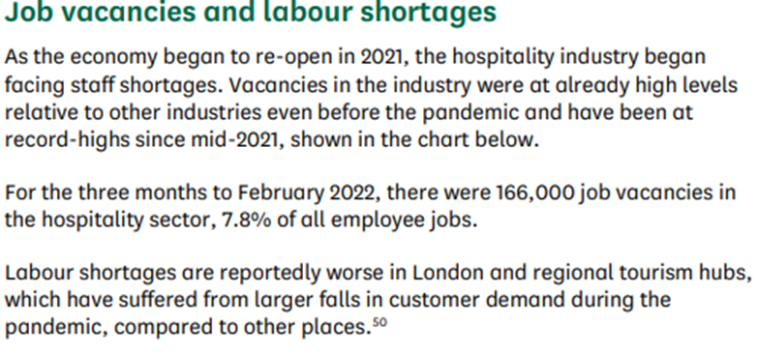

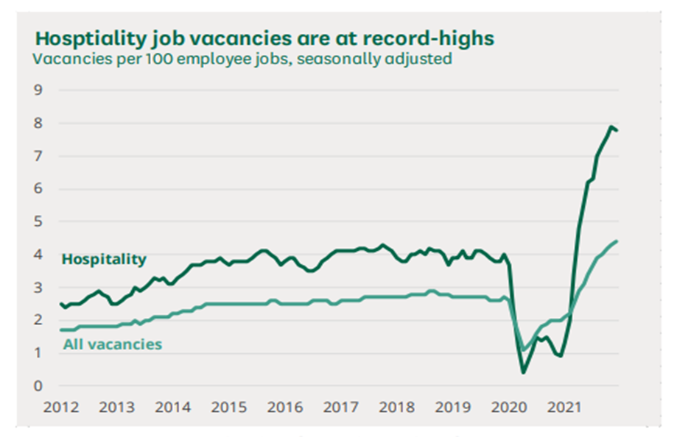

Source: (Hutton, 2022)

Appendix 2: People in work in the UK by nationality (overall number and percentage of the total), 2010 to 2016
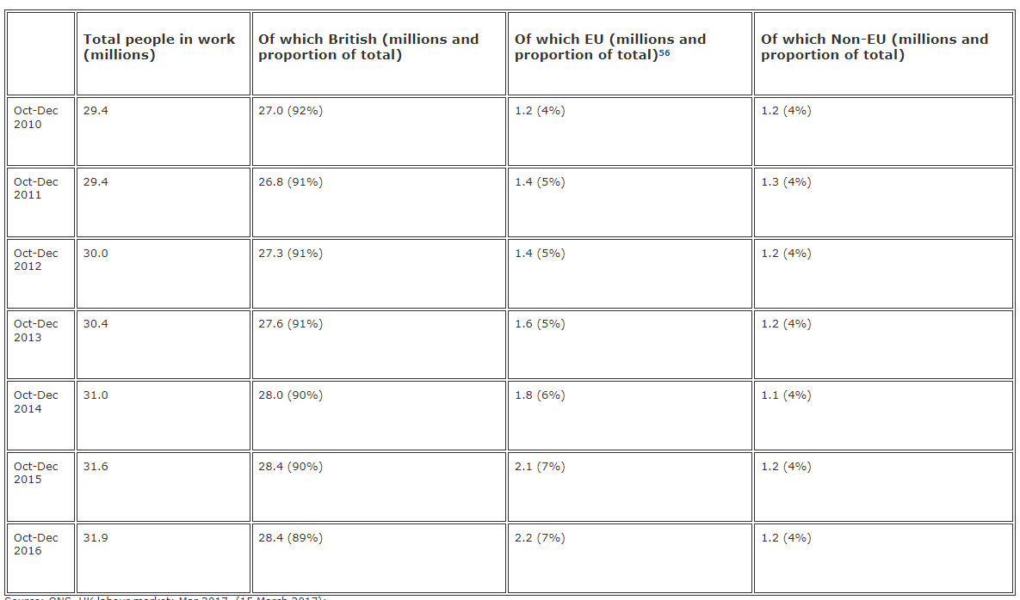
Source: (UK Parliament, 2017)

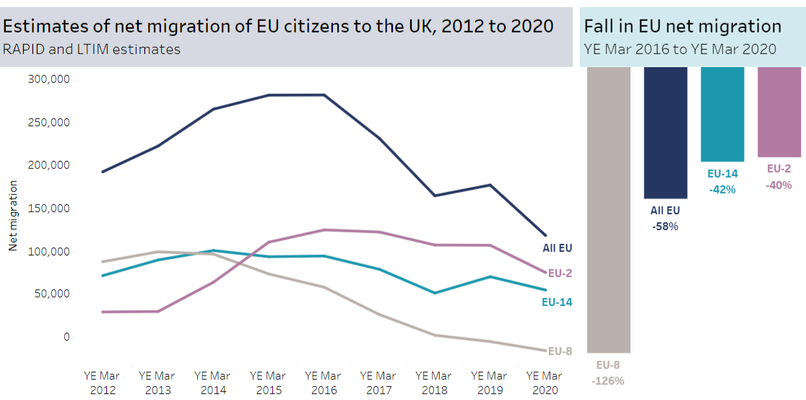
Appendix 3: The decline in EU immigration and net migration from 2016 to 2020

Source: (The Migration Observatory, 2022)

Appendix 4: Questionnaire

- Age:
- Gender:
- Department:
- Position:
- Contact No.:
- Experience in Hospitality Industry:

- Does your organization include employee training as a part of the strategy?

- Training helps both employees and employers to develop a strong relationship.
- How a well-planned induction training influence organisational productivity?
- What kind of training methods do you prefer?
- What kinds of training methods are provided by your organisation to train the employees?
- How often has your organization conducted a training program?

- Does the motivation level of employees increase with training?
- Training plays a significant role in improving employee productivity.
- Are you satisfied with the selection procedures of employees for training?
- Training and development helped to improve the productivity of both quantity and quality.
- Does the managers or officers face specific challenges during training courses?
- Does the Training program focus on the development of leadership skills and teamwork?
- Development is important for management in identifying, analysing, planning, and forecasting changes required by the organization in the HR area.
- Training and development help the organization gain a competitive advantage.
- Do you feel training is compulsory for the hospitality industry?
- Would you consider that training programs improve the necessary skills for a specific job?
- How do you think training and development are important for Marriott International Hotel UK?

