An analysis of importance of pricing policies in the retail industry. Case study: Jack’s
By Dorota Kruk
P147746
BA (Hons) Business Management 2019
Supervised by Ian Jackson

Dorota Kruk (P147746)



DECLARATION

This work has not previously been accepted in substance for any degree and is not being concurrently submitted in candidature for any degree.

Signed……………………………………………

Date………………………………………………

STATEMENT 1

This dissertation is being submitted in partial fulfilment of the requirements for the degree of BA.

Signed…………………………………………….

Date………………………………………………

STATEMENT 2

This dissertation is the result of my own independent work/investigation, except where otherwise stated.

Other sources are acknowledged by footnotes giving explicit references. A bibliography is appended.

Signed……………………………………………

Date………………………………………………

STATEMENT 3

I hereby give consent for my dissertation, if accepted, to be available for photocopying and for interlibrary loan, and for the title and summary to be made available to outside organisations.

Signed………………………………………………

Date…………………………………………………

STATEMENT 4

I hereby give consent for my dissertation, if accepted, to be available on the university’s IT system to those who have consent to use the system.

Signed………………………………………………

Date…………………………………………………

Acknowledgements
I would like to thank my friends and family for supporting me though the process of completing this dissertation. It was a difficult journey therefore all support was much appreciated.
I would also like to thank my supervisor Ian Jackson for inspiring me to research this topic and Caroline Jawad for helping me to complete this dissertation and help me make through to the end of it.

Abstract
This dissertation was undertaken as a part of undergraduate bachelor’s degree in Business Management, and it analysed the importance of pricing policies in retail industry focusing on the launch of Tesco’s new discount store Jack’s.
An analysis in literature review look at the existing pricing policies, models, and theories establishing variety of themes. The findings in the literature review have been used to create a quantitative research that could be applied to this study. An online questionnaire was distributed to Tesco customers and colleagues.
The main findings of the research were that location and convenience are the most important factors when they choose where they do their shopping. The outcome was unexpected as the researcher predicted that the dominant factor would be price.

Table of Contents
Abstract 6
1.Chapter One- Introduction 9
1.1 Background 9
1.2 Rationale 10
1.3 Aims and objectives 11
1.4 Research 12
1.5 Structure 12
2.Chapter 2- Literature review 14
2.1 Complexity of pricing strategy 14
2.2 Importance of pricing policies 15
2.4 Pricing policy within the retail industry and supermarkets 19
2.5 Microeconomic pricing model 21
2.6 Price strategies in discount stores 21
2.7 Jack’s 22
Conclusion 23
Chapter 3- methodology 24
Introduction 24
3.Research methodology- research onion 24
3.1 Research philosophy 26
3.1.1 Approach 28
3.1.2 Strategy 28
3.1.3 Choice 28
3.1.4 Time Horizon 29
3.2 Collection and analysis 30
3.2.1 Collection 30
3.2.2 Questionnaire design 30
3.2.3 Pilot study 31
3.2.4 Analysis 32
3.2.5 Sampling 32
3.2.6 Reliability and Validity 33
3.3 Limitations 33
3.4 Ethical considerations 34
Conclusion 34
Chapter 4- analysis of data 35
4.1 Demographics 36
4.1.1 Age 36
4.1.2 Gender 36
4.1.3 Colleague or customer status 37
4.2 Awareness and importance of pricing policies 38
4.3 Store choice and customer satisfaction 41
4.4 Shopping at discount stores 43
4.5 Attitudes towards Jack’s 48
Conclusion 53
Chapter Five- implication of main findings and conclusions 54
5.1 Implication of the main findings 54
5.2 Limitations 56
5.3 Further Research 57
Conclusion 57

List of Figures

Figure 1 The Research Onion Saunders Et Al (Scott, 2012) 26
Figure 2 Bar graph representing age frequency 37
Figure 3 Bar graph representing gender frequency 38
Figure 4 Bar graph representing Colleague and customer frequency 39
Figure 5 Bar graph representing Likert scale results of pricing policy awareness 40
Figure 6 Table representing pricing policy awareness percentage 41
Figure 7 Pie chart representing results of importance of pricing policy 42
Figure 8 Bar chart representing Likert scale results of factors on which customers choose to shop 43
Figure 9 Bar chart representing satisfaction of pricing 44
Figure 10 Table showing discount shopping frequency based on gender 45
Figure 11 Table demonstrating quality of goods in supermarkets against discount stores 46
Figure 12 Table showing age against frequency of shopping in discount stores 47
Figure 13 Table showing age and gender and frequency of shopping at discount stores 48
Figure 14 Bar graph showing awareness of Jack's 50
Figure 15 Bar graph showing on what factors would customers shop in Jack's 51
Figure 16 Table demonstrating the importance of locality to customers 51
Figure 16 Table demonstrating the importance of locality to customers 52
Figure 17 Pie chart demonstrating if participants would shop in Jack's over Tesco 53

1.Chapter One- Introduction
The purpose of this research is to evaluate and analyse the success of discount stores focusing on the introduction of new discount store Jack’s, which is launched by Tesco. This dissertation will help to establish whether, the new store will be able to fill the gap between quality and value for money and whether they will be able to offer something original from the competitors (Hammett, 2018). To further the understanding of increase in opening of discount stores, there will be detailed analysis of pricing policy within the supermarket industry.
This chapter will provide background to research, rationale to why is it necessary to complete this research and aims and objectives of the chosen research.

  - Background
According to Cundiff and Still (1988) price policies provide the guidelines within which pricing strategy is formulated and implemented. Price policies are of various types. Pricing policies can be divided into four classes: based on price level, based on flexibility. Based on speciality and based on geographical conditions (Kumar, 1998).
According to Berends (2004), definition of pricing strategy argues that pricing strategies include the multiple pricing methods used to set product pricing to maximise your profit, with every sale price having complex pricing strategy that is created out of simpler pricing strategies. This definition agrees with the one made by Smith (2012), who states that pricing strategy focusing on the aim to maximise firm’s profit mainly through creating and capturing customers. He states that pricing strategy addresses pricing decisions and provide comprehensive approach to managing price decisions. Bhasin (2018), agrees with the definitions of previous authors writing that pricing strategy and price of the product is one of the most important factors influencing decision making. He states an example that suggest that customers always check the price tag of the item they buy and make their decision on that information, therefore if the product is too expensive the customer is more likely to choose not to buy it. However, if the price is too low the store might loose on its image due to low priced products. Understanding of the correct definitions of pricing policies is important for achieving the aim of this research which is evaluating pricing policies within supermarket industry.
Meehan, Simonetto and Montan (2011), state that effective pricing strategy should reflect integrated pricing framework that supports business objectives by value of offering relative to its rivals and customer demand. They also state that strategy should guide organisational behaviour and external communications to all pricing-related actions. Effective pricing strategy should start with detailed analysis of facts such as collective data about customers, competitors, market dynamics and historical transactions. Customer and product segmentation allow to develop prices that are specific to buyers and products, this also suggests that pricing structure reinforce price positioning and reflect the variations in the value. Effectiveness of pricing policies is one of the objectives of this research.
Tesco’s release of its new discount chain Jack’s aims to tackle German discounters such as Aldi and Lidl, their main focus is to be the lowest cost for customers, the first store opened in Chatteris, Cambridgeshire, between 10 and 15 stores are planned for new locations. Jack’s has been built to compete with the well-established discount stores which have disrupted much of Tesco’s core business. (Jordan, 2018).
Price is always king in the end, despite how many value investors go to downplay its importance. The total return of equity security depends on the change in price from purchase to sale and the dividends paid in the interim, therefore the dividend matter but price is king (Brown, 2013). Tesco has taken this into consideration explaining why Britain’s biggest supermarket looks to take on the German discounters by offering the customers “bespoke” experience. Jack’s is offering 1,800 products which are under Jack’s branding, but with one proposition, good value and outstanding product quality. This proposition is stated to be driven by what customers say they want in the UK. The source is stating that the scale of Tesco and the lower operating cost of Jack’s is what allows them to be cheaper (Lyons, 2018). Discounters continue to grow market share however Tesco’s attempt to stem its falling market share in comparison to German discounters such as Aldi and Lidl have not yet been successful, as the launch of its discounter concept will not impact Tesco’s market share without a significant expansion. Tesco’s current market share is 27% with only 0.9% change in comparison to combined Aldi and Lidl with 15% share and 25% market change over 2017-2018-year period (Stevens, 2018).

1.1.1 Jack’s
Tesco has started a battle with well-established discount stores by opening its own discount store called Jack’s named after its founder Jack’s Cohen. According to chief executive Dave Lewis the chain is promising to sell low- priced predominantly British food and appeal to economically challenge. In comparison to Tesco’s 25,000 products Jack’s will only stock 2,600 products similarly to Lidl and Aldi. 700 of those products will be branded lines. Although Jack’s will check prices against local rivals it is claiming to be the cheapest in town stating their customers will always pay the lowest grocery prices (Butler, 2018)
Fraser McKevitt stated that Jack’s would have a little immediate impact on Aldi and Lidl as they cover over 13% of UK’s marketshare. Jack’s will be offering food and non- food bargains similar to its rivals and will try to attract customers by offering Fresh Five fruit and veg offer. Jack’s will be offering the pricing that is in between of Aldi and Lidl offering 45p for white sliced bread in comparison to 40p in Aldi and 49p in Lidl or 29p for baked beans in comparison to 23p in Aldi and 29p in Lidl (Jordan, 2018)

1.1.2 Value perception
According to Yin and Huang (2014) a price discount is a prevalent marketing strategy to atrract customers by providing extra value or incentive, which encourages customers to a purchase. Price increases both perceived quality and perceived sacrifice of paying more. When price is high consumer assume that the quality is high, effectively meaning highly discounted products are of lower quality (Lee, 2018). This will be important for the research to evaluate influence of pricing on value perception as one of the objectives.
  - Rationale
Pricing policy in discount stores focuses on stimulating sales of products, there are different types of pricing strategies that target different types of customers, some customers perceive lower prices as lack of product’s value therefore appropriate discount strategy is important to make sure that customers respond quickly (Gleeson P. , 2018). Heil (2018) states that there are different types of pricing policies such as cost based pricing, which looks at all fixed costs and variables. Value based pricing which states that selling price reflects product’s service, demand-based pricing however they are not concerned with costs and focus on characteristic of products and service.
According to (Gupta, 1988) brand choice and purchase quantity decision is conditional on the time of the purchase therefore in stochastic modelling tradition brand choice probability is modelled as a function of that week’s market condition in which the customer decides to make a purchase. This research will allow to analyse effectiveness of pricing policies focusing on the discount stores. The focus will be on new discount store Jack’s and why Tesco decided to launch their own discount chain, and whether it is going to be a fail or success in comparison to successful German store Aldi and Lidl, which are a competition to supermarkets such as Asda or Tesco. According ITV News (2014) Aldi is UK’s fastest growing retailer increasing its sales by 35%, over 51% of UK’s shoppers visit a discount store each month 12% using discount store to do their main shop. The article is also proving that customers are still paying attention to the quality of the products as 78% of customers shopping in discount stores stated the quality has improved.
Supermarkets are trying to fight the competition by improving their service. This research will aim to help Jack’s with the corporate strategies which according to Puranam (2016) means it’s a strategy that business corporations use to compete as collection of multi- businesses. There is plenty of research on pricing policies, however there is a gap that doesn’t give a straight answer of why some people chose discount stores, how supermarkets can adjust their pricing policy to take over the competition and what effect the new store Jack’s will have on the highly competitive retail market showing there is not enough research in this topic. This research will be referring to some key literature such as Porter, used of recent articles from the periodical and journals

1.3 Aims and objectives
The aim of this research is to evaluate pricing policy within the supermarket industry focusing on launch of the new discount store Jack’s
This study will show impact of customer’s loyalty to the popular discount stores and what affects customer’s decisions to shop there. The main objectives of this research are;
•To identify and analyse the effectiveness of pricing policies within the retail industry.
•To critically evaluate the influence of pricing on value perception by the customer.
•To make possible recommendations for new discount store Jack’s on adoption of new pricing policies.

1.4 Research
The researcher will conduct online questionnaire using an online survey software Qualtrics. This will be distributed to participants who are interested to take the survey mainly targeting Tesco customers and colleagues. This is an appropriate method of research as it allows to collect a large amount of data in short period of time in economic way (Saunders, 2009). The use of questionnaire will allow the researcher to analyse it efficiently and make links of large amount of data effectively plodding patterns that will help this research plot patterns and discover the effectiveness of pricing policies and influence of price on value perception.

1.5 Structure
In order to achieve the aims and objectives Chapter Two will examine the available literature concerning pricing policies especially focusing on discount store sector and retail industry such as supermarkets. The chapter will analyse relevant theories, concepts, models and research that apply to the aim and include pricing policies. Therefore, any relevant literature will be included.
Chapter Three identifies appropriate philosophy and methodology selected leading to discussion of the process of creating questionnaires and the analysis. The chapter will focus on the used procedures used in order to conduct the research such as analysing ethical considerations and validity of the research.
Chapter Four will provide analysis of the online questionnaire, such as tables and graphs which will allow to make links to the aims and objectives of the research by coming up with the conclusion of what the research has helped to discover.
Chapter Five is the discussion of the results stating how and whether the aims and objectives of the research has been achieved. Effectively leading to limitations of the research and providing potential recommendations for further research of the topic. This will provide a greater understanding of the importance on pricing policies.

2.Chapter 2- Literature review
There is a substantial amount of information about pricing strategies the topic has a wide field of information and there are plenty of theories that support variety of different arguments relation to pricing policies and strategies across different types of business. This chapter will include crucial information about different types of pricing strategies explaining the definition, complexity of pricing strategy, the importance of pricing strategy within a business, complexity and in-depth explanation of pricing strategy within the retail industry. This chapter will also include critical point of view with a close study of pricing strategy theory of variety of different authors. The current literature review is primarily academic theories and models that apply to variation of existing pricing policies.

2.1 Complexity of pricing strategy
Pricing strategy is a complex topic which Schindler (2012), states to understand the logic of pricing policies and strategies it is important to first understand the difference between the price and the cost. The price is what business charges and cost is what a business pays, therefore the cost could include how much it costs for the product to be put out on the shelf by an employee and what is the cost for the building, lighting and advertising. Hudson (2019), agrees with the previous points by saying cost of goods include cost of any direct labour to produce the item and the expenses are related to the operating business including advertising, rent and marketing, this also links the objective of influence of pricing on value perception. Hudson also states that before the business choses the pricing strategy it should determine the right price for the product and consider products direct costs. There are two key elements such as cost of goods and operating expenses.
Pricing relies on cost of the product and raw materials meaning the supplier sets the starting price level. Customers are possibly the biggest source of insight to setting a correct pricing strategy it is important to have the understanding why the customers buy more of certain product than others (Long, 2019).Understanding the customer will help the objective of analysing the effectiveness of pricing policies. According to Zuponcic (2019) distributors operate within a complex pricing environment which is defined by number of SKU’s customers and markets or channels. The reasons for why so many firms struggle with complexity of price strategies is that firms have large number of stocks keeping units therefore, large number of products make it complex. It is also important to consider additional factors such as competitive pressure or risk of missing the pricing market which also link to the aim and objectives of this research.
Complexity theory is the study of nonlinear dynamic systems. It is a useful conceptual framework which reconciles the essential unpredictability of industries with emergence of distinctive patterns (Catwright, 2007). Complexity theory suggests functions can give rise to complex and unpredictable behaviour ad shows that complexity can order and pattern therefore this gives insight on how organisations adapt to their environment and population ecology (Levy, 2000)
Complexity is everywhere which was stated by March and Simon (1958). Organisation is a complex system and managers in the organisations can only hope to design strategies to cope with the complexity. Complexity theory helps to explain the dynamics of the organisational life, which continuously evolve and learn. Organisations have complex adaptive system which is in constant search of improving the efficiency, knowledge and their interactions (The Journal of Professional Pricing, 2012). Understanding the complexity of pricing policies will help to fine impact on which customers choose to shop in discount stores.

2.2 Importance of pricing policies
Toni (2013) suggests pricing strategy is one of the most important decisions to make for a business as it affects profitability and the position the business holds in the market compare to other companies. Managers involved in the process of establishment must understand the difficult process of developing a correct pricing strategy and understand the pricing strategy will affect how the customers perceive the price they pay for the value of the product. Nagle and Holden, (2003) argue that difference between conventional price setting and strategic pricing consists of setting prices by reacting to the market conditions and being at the sole purpose to extend most profitable pricing by generation value for customers without obligation of increasing the sales volume. Important of pricing policies will be one of the key themes in this dissertation and chosen method of research and will also help to reach the aim of the research which is evaluating effectiveness of pricing policies.
There is some existing knowledge on setting price strategies effectively however there are many factors that needs to be taken into consideration when setting up appropriate pricing strategy such as targeting the customer, the financial strategic product and brand marketing objectives and the business objective. The pricing strategy matrix shows different levels of price and quality combined to form four commonly used pricing strategies such as skimming, premium, economy and penetration (Tools, 2018). Stiving (2011), argues that the main pricing strategies are not the only ones and it’s better to look at pricing strategies by looking at strategies to define general levels of pricing, this will also help to analyse the effectiveness of pricing in this research.
Setting correct pricing strategy is important due to the changes in spending patterns and the economics Bhasin (2018), suggests that changes in competition have a high effect in pricing strategies. Every product has a price range therefore it is important to look at the competitors pricing and decide where the firm fit on that price range this is important as customers use existing price as a guide (Griffin, 2018) this will support part of the aim of the study which analyses impact of pricing on customers. Competition is high and Griffin and Bhasin both agree on the statement that price environment determines level of control over the competitive pricing. Higher level of competition means more similar products and little price control by individual companies; therefore, the company need to focus on unique goods, services and price control.
Davies (2017) research suggests changes in the spending patterns is another reason for the importance of setting a correct pricing strategy which supports the aim and objectives of this study, most products are heavily marketed or branded which increases the cost of products. Average weekly household spending rose to £554.20 in financial year of 2017 this information is based using classification of individual consumption by purpose categories and does not include all payments such as capital mortgage. Mankiw (2015), agrees with the previous point by stating in his book that changes in income affect consumer choices as when the income rises the most common reaction is to purchase more goods although how much more each person buys depends on the personal taste, effectively this leads to increase in product demand as increase of income means that individuals can afford more expensive choices. This shows that changes in pricing influence customer choices by people generally focus on consuming less of higher price this is important for meeting the part of the aim which discusses factors that impact customer’s loyalty. Mankiw outlines two effects first one being substitution effect when price change and consumers choose less of the product with higher price and more goods with lower price. Second is the income effect which means buying power of income has been reduced which leads to buying less of the goods.
2.3 Pricing policy and pricing strategy
Taking into consideration the aim of this dissertation of evaluating pricing policy according to Schindler (2012) pricing policy and strategy is a generally similar topic however there is a significant difference between the two, pricing policy refers to how company sets their prices of its products and the service based on the cost, value and demand and competition. Pricing strategy however focuses on how a company uses pricing policy to achieve its strategic goals such as offering lower price due to an increase in sales volume. Regardless of the differences in definition of pricing policy and strategy overlap. This is the point where management develop pricing strategies based on company’s pricing goals and profits (Droege, 2019 ). Prices are often designed though the life cycle of a product in order to add any prestige or quality to the new product. High prices are often known as motivation for purchasing products especially buyers of luxury brands, as they gain satisfaction and prestige from purchase of an expensive product (Nesim Hanna, 1995) this information will help to identify effectiveness of pricing policies. Due to the difficulty of understanding the pricing policy there are some considerations involved in formulating a pricing policy. Shivam (2019) suggests competitive situation is an important factor to be taken into consideration he states that pricing policy is set in the light of competitive situation in the market. Therefore, it is important for the business to be aware of weather they are facing perfect or imperfect competition as pricing strategy only has significance under imperfect competition. Shivam also suggests that pricing policy should be flexible enough to meet the economic changes and various of customers’ needs.
Regarding to price segmentation there are different levels, fixed charge pricing gives open access to product or service that is bought by a single price such as meal in a restaurant. The effect of this price segmentation is that the more use the customer makes of it the lower the price.
Two-part pricing involves fixed charge and a per unit charge such as payment of a fixed amount for rent plus the additional expenses. This pricing segmentation is mostly aimed at customers who by buying more units pay lower price per unit, this is often used by retailers.
Peak load pricing defines demand fluctuations that occur during the predictable period of selling of service. This means that prices are often higher during the peak demand. Peak load demand is most often used in the organisations such as cinema or theatre.
Nesim and Hanna (1995) Also argue some key theories regarding to pricing policies: the theory of maximising profits makes the assumption that the purpose of the business organisation is the maximisation of the profits also the assumption that in competitive industries it is a normal goal to seek profit maximisation, therefore profit maximisation becomes a desirable object. Friedman cited in Hillebrand also talks about profit maximisation by stating that profit maximisation is a tantamount to stealing shareholders’ money, additionally stating that corporate managers lack competence in addressing social issues and problems in corporations (Hillebrand, 2006). This theory will support the achievement of objective analysing price on value perception. Chand disagrees with the profit maximisation theory and states that the theory has been severely criticised by the economist stating that the theory of maximisation can only be based on assumption that the firms are certain about levels of their maximum profits, therefore it is not possible for firms to maximise their profits under any level of uncertainty. Chand, (2019) also states another criticism which states that profit maximisation hypothesis is based on assumption that all firms have perfect knowledge about their own costs and revenues, however in reality firms do not possess sufficient information about the conditions under which they operate, as the most they may know is about their own cost of production, however they can never define their market curve, meaning operating under the conditions of uncertainty this could be important when making recommendations for Jack’s.
Sales maximisation theory is work of American economist William Jack Baumol, it draws a framework to understand strategies that help to operate in competitive market. Ozyasar, (2019) explains that profit sales maximisation theory allows the business to focus on maximising either revenue or profits, but not both. Therefore, to maximise the profits the company needs to sell the product at relatively high profit margin, meaning it must charge more than what it actually cost to deliver product or service this also will help to evaluate influence of pricing on value perception. However, it is important that the business cut prices therefore some business choose to sell at loss to build up customer loyalty which is one of the main benefits of business maximisation. Maximum revenue in higher output levels can help to reduce cost over the long term. Chand (2019) states some criticism towards Baumol’s sales maximisation theory by suggesting that Rosenberg has shown that constant use of sales maximisation can make it difficult to specify exactly what the relevant profit constrains for the firm. Theory of maximisation will play an important factor when analysing pricing policies in discount stores in this research. Another author stated in Chand’s work suggested that if the firm is engaged in any form of none price competition such as customer service or advertisement this will affect the demand curve which effectively means it will work in favour of the profit maximisation theory. Effectively both authors Baumol and Williamson argue that revenue and profit maximisation yield the same results on company however Williamson stated that sales maximisation and profit maximisation result in the difference of the effect on the company which again links to influence of price on value perception.
There are several of different pricing strategies that focus on attracting the customers and increasing profits. First of them is premium pricing and as Maguire (2019), states it is also known as “image” or “prestige” pricing. The definition of this strategy is to price a product above normal market value, so customers think that the product or service is more valuable. Although the price may put some buyers off the main point of this theory is for the ricing proponents to believe that higher costs will create perception that will bring in more revenue. Some marketing experts refer to premium pricing as “skim pricing” however the two cannot be confused (Maguire, 2019) . Presstholdt, (2017) defines price skimming when company sets artificially high price for product or service, but knows that competitors will soon enter the market, therefore the product must be unique to be fist of the kind this is also important for reaching objective of making recommendations for Jack’s. Presstholdt states that premium pricing differs by applying this strategy to luxury or higher value products such as first-class airline tickets, therefore premium pricing is not useful for commodity goods this also has impact on influence of pricing on value perception.

2.4 Pricing policy within the retail industry and supermarkets
Zentes, Morschett and Schramm-Klein (2007) suggest pricing in general and price promotions are important marketing instrument in retailing, price has always been playing an important role in retail marketing which support the general aim of the study. In many countries retailer profit margins are very low and in food retailing it is only about 1% of sales. This means that product that is sold for 1.00 EUR leaver the retailer with profit of 1% this means that increasing the price by 1% could double the profit. Especially if the consumers continue buying same amount of the product. They also suggest in comparison food hard discounters usually follow very aggressive every-day-low-price strategy with prices up to 20% to 30% below the conventional supermarkets. However, they offer a small selection of items and therefore they are referred to as limited line stores or limited- assortment stores. This type of store has a basic assortment of food items and has a high rate of turnover and only few sizes and brands are offered per each product category examples of this sort of retailers are Lidl and Aldi this can also have impact on objective of price and value perception.
Pricing policy in the retail industry are mostly driven by the idea of increasing the profitability, author outlines eight most common pricing strategies that can be used in the retail industry which are: discount, bundle, price lining, and odd pricing, below competition, MSRP, dynamic and high low. Majority of the retailers use POS systems to monitor and analyse their various pricing strategies, however based on study completed by software Advice 94% of retailers are using at least five of their strategies and 76% are using all eight previously mentioned strategies. Gordon Russell, CEO and founder of cloud-based Point of Sale (POS) system states that different pricing strategies are used to meet different goals for example strategy of incremental discounts increase the number of items purchased and can be used to sell more units of products (Guinn, 2019). McCormick (2017), suggest her own list of the main competitive pricing strategies in retail. She partly disagrees with Guinn and states that one of the most important strategies is psychological pricing which is based on choice of an attractive price which is mostly based on needs and wants of the target customer. This strategy appeals to customers emotional rather than rational side. The example of this is an idea that higher price often means higher quility. Another example of this would be psychological pricing strategy is charging £9.99 instead of £10.00 as this means that customers associate the price to be closer to £9.00 rather than £10.00 this will help to achive part of aim of impact of customer’s loyalty to discounters.
Retail objectives have significant impact on pricing goals. This also means that if the retail objectives are opporsie to pricing goals may be significantly more difficult to manage the store effectively. In retail there may be at least four pricing goals: achieving certain sale volume, receiving a certain specified amount of profit, establishing expextations regarding return on investment and generating cash flow, therefore it is critical to determine how and in what way the price is gong to pay a role (Samli, 1998). Pricing strategies have a big impact on the future and retailers need to stay on top of the new tactics to keep up with the competition. According to the e-commerce forecasts online retail sales in USA in 2018 suspass 461.582 million dollars this shows 9.32% of growth in comparison to the year before this is important for making recommendations to Jack’s. This shows how much of an impact technology has on pricing, sales and spending patterns according to Competera (2017) fixed pricing will be more inferiour to dynamic pricing as pricing has to correspond to the real time changes in market to meet customer’s expectations on cost of goods. The source also suggests online shoppers have a massive effct on pricing strategies as they know exactly how much a product should cost so retailers need to learn how to influence the customers price perception, which once again links to the objective of evaluation is price has an impact on value perception by customers.
The retail industry has seen numerous of changes in the industry such as movement of numerous aggressive, volume orientated/ low price retailers for example chain stores, supermarkets and discount stores. The retail life cycle model has beeen advanced to describe and explain the reasonng for these changes. This model is based on predictions of the institutions progression through the states of birth, growth, maturity and decline. Etgar (1984) states expalins that changes in retail is the cause of rivalry between new and the already established retailing institutions (Findlay, 2002). To survive in the competative environment retail stores need to apply some adaptation throught the life cycle therefore it is important to understand all stages. Glass (2018) goes though all states such as introduction/ birth stage is the beginning of any business charactarised by innovation and industry expansion for example a new product. Growth phase is the state at which the profits increse and customers are exited to try out the new brand, the most important part of this stage is to keep innovationg enough to keep the business exciting for new customers. Maturity phase is making sure that the sure is fully supplied for the loyal cusomers. At this point the store also need to keep up with the competition. The final state of decline is to sufficiently keep the business new and fresh however it may start seeming borring to existing customers.

2.5 Microeconomic pricing model
Microeconomic model is characterized by discrete jumps in individual prices. The aggregation of discrete pricing policies into smooth path for aggregate price level. The theory states that historically determined nominal prices can lead to inertia in the aggregate level of prices (Sheshinski, 1993). According to Banton (2019) theory of price is a microeconomic principle that uses concept of suply and demand to determine appropriate price point for good or service. The purpose of it is to achievethe equilibrium where qualtity of the good match the demand of the corresponding market and its ability to acquire the good. This relates to supply and demand theory, the author implies that supply is the number of products the market can provide, whilst the demand pllies to market’s desire for the item this will help will aim of evaluating pricing policies. Demand can fluctuate as its dependable on factors such as wheather the product or service is still needed. Pricing is important as is the price is too high the customers may avoid the product, price theory helps to find selling price as close as to equilibrium as possible.

2.6 Price strategies in discount stores
Discount pricing strategy is lowering the price of the product to stimulate sales, appropriate discount pricing strategy introduce an idea of limited price drop so the customers respond quickly. It is important that the retailers apply the correct pricing strategy as no single discount pricing strategy applies for every product. The purpose of offering a discount is to introduce new product either for a limited time or limited number of customers therefore this strategy is most suitable for those who respond the quickest (Gleeson, 2018). Discount pricing strategy will be helpful with pat of the aim which is launch of new discount store Jack’s.
There are many advantages of hard- discount strategy which is the main reason why succesful discount retailers tend to use it. Hard discounters create products that customers prefer delivering GMO free, additive free and organic products which keeps them on trend. Discount stores reduce their labout requirements and often run stores with as little as four eople, product packaging is designed for easy stocking and scan codes are on every product face to reduce checkouts time (Wyman, 2019).

With discount price strategy is it important to decrease costs and stay competitive, large retailers can demand price discount from suppliers and make discount price strategy effective as they buy in bulk. It is usually impossible to compete with these types of retailers based solely on discount pricing strategy (Unleashed, 2017). The most successful discount stores such as Aldi and Lidl have adapted hard discount strategy; the aim of this strategy is to supply customers with basic goods of daily need at the lowest possible price, whilst maintaining high-quality standards this is usually achieved by limited assortment of products, increasing the percentage of private labels offered at lowest possible price, establishing and maintaining a high quality/price ratio and efficient operations this is supporting the objective of evaluating the effectiveness of pricing policies. Offering limited assortment of products is the most crucial element of this strategy as it enables retailers to provide high volume of basic goods and help to streamline efficient operations (Sachon, 2010). As per Steenkamp and Sloot (2018), adaptation of hard discount pricing strategy resulted in Aldi operation over 11,200 stores in 20 countries with turnover over $100 billion and it is the top 5 largest grocery retailer in the world. Other retailers such as Lidl have spread globally. Hard discounters have ability to buy huge volumes per Stock Keeping Unit (SKU) which leads to much lower buying prices. Aldi and Lidl have increased their market share from 5% to13% in less than six years.

The literature review states the most popular and important existing pricing policies, with a focus on supermarket and discount store indusry. It has helped the researcher understand how pricing policies work and what effect they have on the customers. Chaper 2 has presented with a variety of theories and models that will have a big impact on this reaserch by helping to achieve aims and objectives.

Conclusion
This chapter has analysed appropriate literature, models and theories relation to pricing policies focusing on retail and supermarket industry. The literature is as up to date as possible and has highlighted the gap in the knowledge, which this study will aim to fill.
The following chapter will discuss relevant methodology methods that have been undertaken to create and collect a questionnaire to collect quantitative data.

Chapter 3- Methodology

Introduction
The aim of this research is to evaluate and pricing policy within the supermarket industry focusing on launch of the new discount store Jack’s This study will show impact of customer’s loyalty to the popular discount stores and what affects customer’s decision to shop there. The main objectives of this research are;
- To identify and analyse the effectiveness of pricing policies within the retail industry.
- To critically evaluate the influence of pricing on value perception by the customer.
- To make possible recommendations for new discount store Jack’s on adoption of new pricing policies.

This chapter will justify the research process and the methods that were undertaken to complete it. The chapter will include the main research tool The Research Onion by Saunders. This will provide further understanding to stated methodology.
This chapter will be describing the research strategy, data collection methods and data analysis techniques used in this project, in order to collect the data for the following research.
This chapter will achieve first two aims and objectives by designing a questionnaire that is relevant to the topic of pricing policies. The questionnaire will also be focused on discount stores and importance of quality and value to the customers which will help to achieve the second objective. Thirst objective will not be achieved until Chapter Five.

3.Research methodology- research onion
To undertake a research, it is important to be aware of different tools and methods of taking a research, one of them is The Research Onion by Saunders et al.
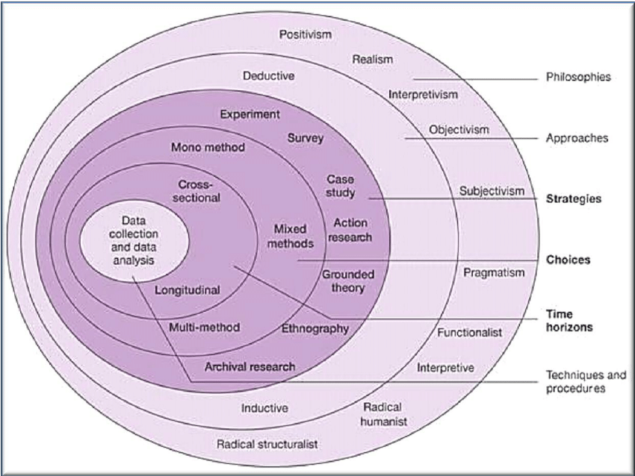
Figure 1 The Research Onion Saunders Et Al (Scott, 2012)
This chapter will explain different stages of the research onion.
The purpose of research is to discover answers to questions through the application of scientific procedures. The main aim of research is to find the truth that is hidden and had not yet been discovered. Each research study has its own purpose such as getting insight into the object, portray a particular situation or individual or determine a frequency in which something occurs (Kothari, 2012). Research compromises of defining and redefining problems formulating hypothesis or suggesting solutions by collecting and evaluating data. Research methodology gives the necessary training in gathering materials during participation in the field work when required. The importance of research methodology is to know how research is done taking into consideration following considerations. Knowledge of research methodology provides good training especially in in new research area. Knowledge of research methodology is helpful in providing tools to look at things in life objectively (Daniel, 2010).
It is important to understand the research philosophy as this allows to develop knowledge in a specific field.
Research onion is a tool used in explaining the research methodology for the chosen study with research framework adopted by Saunders & Lewis (2012). The Research Onion is made up of six layers which all need to be considered whilst undertaking a research. Each layer has its own aspect and the six layers consists of philosophy, methodological choice, strategy, time horizon and techniques and procedures. The following section will describe each of the layers in more detail.

3.1 Research philosophy
This layer is mostly focused on how the researcher views the world research philosophy deals with the source, nature and development of knowledge therefore it is a belief about the ways in which data should be collected, analysed and used. Collection of primary and secondary data allows to create new knowledge. Choice of research philosophy is often impacted by practical implications, there is a choice of positivist and interpretivist research philosophy and qualitative and quantitative data research (Dudovskiy, 2019).
Positivist approach means that usually quantitative data is collected, in this research quantitative data will be collected which directly links to positivist approach. Positivism is focused on measuring social world, social phenomena. It measures aspects such as casual relationships between different aspects of the social world and large amount of statistical analysis are often used. Positivist approach develops from objectivist ontological position that there is social reality to study that is independent of the researcher and the research subject. Distinctive features of positivism are knowledge is defined as that which can be observed by senses. Knowledge of the phenomenon is based on what can be observed rather than on understanding and the researcher is independent and has no impact on the data (Matthews, 2010).
Interpretivism is the epistemological position that has emerged and developed from understanding of social phenomena which is not necessarily observable by the sense but can be interpreted by fellow human being. The main features of interpretivist approach are knowledge gathered includes interpretations and understandings. The focus of this is on how people interpret the social world and phenomena which allows to explore different perspectives. The researcher is interpreting other people’s interpretations in terms of theories and concepts studying social phenomena through eyes of the people who are being researched (Matthews, 2010) The terms “Social actors” suggest that we play a part on a stage of human life. The researcher must adopt an empathetic stance and enter the social world of research and understand their world from their point of view. Interpretivism is highly appropriate in case of business management and fields such as organisational behaviour (Saunders, 2009).
This research will be adapting both philosophes positivism and interpretivism because it will gain factual knowledge from the research and will help to understand the customer’s point of view of why they prefer to shop at discount stores. In the online questionnaire, the closed questions will be analysed with a positivist philosophy and the open questions will be analysed with the interpretivist philosophy.

Qualitative research can vary from description to theorizing, different research has different aims and type of qualitative data (Corbin, 2008). Qualitative research concentrates on the study of social life in natural settings. There are variety of techniques because there are variety of questions to be addressed and different versions of social variety (Punch, 1998). According to Mason (1996) there are many definitions of qualitative research one of them being theat qualitative research is based on methods of data generation which are flexible and sensitive to the social context in which data is produced, standarlised or structured or removed from real life and natural context. Qualitative data can be observed and recorded and this type of data is non-numerical in nature. the data is collected through methods of observation such as one-to –one interview or conducting a focus group. Qualitative data is known as categological data as it can be arranged into differet forms of categories based on attributes, properties or phenomenon. Qualitative data is important in terms of determing frequency of traits or characteristics. Qualitative data provides the means by which observers can quantify the world around them. Qualitative data can be especially useful in understanding the emotions or perceptions of people and what they feel. Emotions are documented which allows the researcher to have a deeper understanding (Bhat, 2019).
In this research there will be some qualitative data collected as there will be two open questions in the questonaire in which the participants can talk about the emotions and feeling and can give more of an indepth answer to the question. The rest of the reasearch will be largely quantitative as the participants will be given multiple choice and closed questions.
Quantitative research gathers data in a numerical form which can be put into categories in a rank order, this type of data can be used to construct graphs and tables of raw data. The aim of quantitative data is to establish general laws of behaviours of behaviours across different settings or contexts. Quantitative data research is used to test a thery to support it or reject it. Methods to collect quantitative data include measurings things such as controlled observation or a questionaire as this produces quantitative information. This sort of data is particularly useful for decision making or for summarising data to fin out patters, relationships, connections as well as differences (McLeod, 2017). This research will be mainly forcused on quantitative data to collects patterns and relationships from collected data of participants.

3.1.1 Approach
This research will be taking inductive approach in which the researcher will be asking the participants questions to collect data and gather information which will allow to form a theory. This approach characterises in patterns in the data as there is no framework that initially informs. The data is analysed and helps to analyse weather it fits the existing theory. This method is mostly used in positivist methodology where the data is first analysed and hen the patters form general results (Banister, 2018). The purpose of an inductive approach starts with observation and theories which are proposed towards the end of research process as a result of observation. Inductive research involves development of explanations and theories through series of hypothesis. Therefore, no theories of hypothesis would apply in inductive approach at the beginning of the research. It is important to outline that the characteristic of inductive approach is that it does not imply disregarding theories when formulating research questions and objectives. This approach aims to generate meanings from collected data to build theory (Dudovsky, 2018).
In this research the approach will identify patterns that motive the behaviour of participants as this will allow to come up with a theoretical explanation and the patterns will clarify whether the theory supports the hypothesis.

3.1.2 Strategy
A strategy is a set of steps to follow up on to achieve the results which include procedure and a technique to collect the results. The strategy that will be taken in this survey is a survey. They main purpose of this is to find patterns in the data by collecting from large group of participants in a systematic way. This will allow to evaluate the data using statistical methods to identify patterns and connections. The techniques that will be used in this research will be a questionnaire. The research will be focused on collecting primary data as it will be collected by a researcher (Hinkelmann, 2018). The environment of the research will not be controlled as it will not have any impact on the results and the data collected in the questionnaires will be enough to support the aims and objectives of the study.

3.1.3 Choice
The research will only collect primary data by using only one method which is a questionnaire this means that the research choice is a mono method. Although the choice of a mixed method could possibly give more of a wider viewpoint of the participants, mono method will be efficient enough to answer the aims and objectives of the research. The reason for choice of mono method is that the researcher will be using structured questionnaires to collect quantitative data (Schwaferts, 2018). However, using a mono- method can have an impact on the validity this is because the method may seem bias depending on dependent and independent variables. Reason for the choice of questionnaire according to Gillham (2007) is that they provide a “quick fix” by providing wide range of ways of getting information from people by posting direct or indirect questions. One of the weaknesses of the questionnaires is that in some cases they may not provide enough answers just by asking a set of questions. The questionnaire given to the participants will be made up of a selection of closed questions which provide predetermined possible answers and two open questions which will allow greater level of discovery. Gillham argues that the main positives of the questionnaires are that they are a low in cost, it is easy to get information out of people very quickly it is easy to analyse the answers for the closed questions and they can provide suggestive data for hypothesis. However, the main disadvantage to a questionnaire is lack of control over order and context of answering questions and it is impossible to check seriousness and honesty of answers.

3.1.4 Time Horizon
Time horizon refers to the time the researcher undertakes the research, there are only two-time horizon choices cross-sectional which is a short-term study and longitudinal which is carried out over a long period of time. In this dissertation the research will be undertaken under a cross-sectional time horizon as the participants will be answering questions and the research will not be undertaken under a long period of time (Sahay, 2016). Cross-sectional research allows researcher to record information about their subject without manipulating the study environment. This method allows the researcher to compare many different variables at the same time such as looking at age or gender and plot patterns (Institute for work and health , 2015). Cross- sectional method will be the most appropriate for the choice of time horizon as it provides the researcher with the highest capability to achieve the aims of the research.

3.2 Collection and analysis

3.2.1 Collection
The data collected in this study will be a quantitative data. Collection of quantitative data associates with the investigations in which the researcher wants to generate the hypothesis quantitative research allows the scope and generalizability of the qualitative findings to be assessed ( Bryman,Bell, 2015). There are number of different methods for collection of questionnaires there most effectives ones include in-person interviews which can be very effective in terms of getting trust of the participant also the researcher would also be there to assist on any clarification. Telephone interviews can be cheap and assure greater standardisation and reliability however telephone interviews provide low level of anonymity (Nolinske, 2019). In this dissertation the researcher has choose to create online questionnaires which is a fast and cheap method to collect data. During the online survey the participants respond directly into the system this means that it does not reply any anyone entering the data correctly which means no human errors. Online surveys are ready to be analysed at any time and are easy to turn into graphs and export of data for further analysis. The biggest advantage is that online surveys are easy to use for participants as the participants can choose a moment that suits them best and it requires a short time for completing the survey (Debois, 2019) (Survey, 2019). Using online questionnaires will allow the researcher to gather more responses as they are more time efficient without any influences on the participants.
In this study the online questionnaire will be collected by using Qualtrics which is a tool that helps to distribute and analyse the collected data.

3.2.2 Questionnaire design
Questionnaire will consist on eighteen questions ranging in simple closed questions such as demographic questions about age and gender to questions about the frequency of shopping at discount stores, preference of discount stores over supermarkets and whether the participants would be open about the idea of shopping at Jack’s new discount store. Supercity of the questions will be close-ended, multiple choice questions as they are most suitable for measuring behaviour. Two questions will be open ended questions this type of questions do not have range of suggested possible answers and the participants are expected to answer in their own words to give their answer (Brace, 2008).
The questionnaire will also be using a Likert scale which is a way of measuring perceptions, attitudes and opinions it enables questionnaire takers to express their opinion my by choosing one of the given answer options. Likert scare characterises by offering wide range of options to choose from ranging from one extreme to another. The main purpose of this scale is to measure the attitudes and the main advantage of it is that it offers more degrees of agreement or disagreement by offering more degrees of option. This allows to receive valuable and relevant feedback from the questionnaire participants (Jovancic, 2018). Likert scale may be used to ask the informant to indicate on a scale of 1 to 5 or 1 to 7 of the level of agreement. Participants answer in levels of agreement with the statement and each question is referred to Likert item or scale of itself (Remenyi, 2011)
The questions that will be asked the participants of the questionnaire are based on aims and objectives of the research. The questions were also created based on the literature provided in the literature review. The questionnaire will aim to find out whether Tesco colleagues’ shop in Tesco more often than customers who are not colleagues. This knowledge will relate back to customers choosing the most important criteria on which they base where they shop such as price or locations. The questions will also ask about the frequency of participants shopping in discount stores and how they are feeling about the launch of Jack’s. this information will help the researcher accomplish the third objective of the research, which is providing appropriate recommendations for Jack’s.

3.2.3 Pilot study
A pilot study is a trial run of the entire study from the start to finish that increases the likelihood of success for the main study. pilot studies are conducted to test entire research process from methodological standpoint. Once pilot study is completed final revisions of the survey can be made as the survey is ready for full scale administration. Pilot study research help researcher address several issues that may affect the success of the study (Ruel, 2016).
The importance of pilot study is to uncover problematic features of the sample questionnaire such as problems that may affect the quality and validity of the results. However, the need to do a pilot study over empirical study cannot be overemphasised. The importance of the pilot study is that trying out research as planned to include data processing and analysis and drawing conclusions from participants involved in the study will reveal changes that are required if the study is to be effective and sufficient. Examples of changes can be changing the questions in the questionnaire or finding an easier way of recording the data. Pilot study should not only cover data collection as it is very important for the participants being involved in the pilot study to be particularly critical and requested on their experiences (Blessing, 2009).
The pilot study will be distributed to a small number of participants who will be able to state whether the questions in the questionnaire are clear and easy to understand. Feedback from the participants of the pilot study will be taken into consideration and appropriate changes will be put into action before the questionnaire will be distributed to the wider group of participants.

3.2.4 Analysis
The collected data will be analysed using Statistical Package for Social Sciences (SPSS) which is a package for statistical data analysis. SPSS is a powerful tool for manipulating and deciphering survey data. It allows a researcher to identify trends, develop predictive models and draw conclusions (Foley, 2018). To collect those data the researcher will be using Qualtrics which is a tool for distributing self- administrated online questionnaire. This toll will also help with data analysis as it plots graphs and conclusions based on the collected data.

3.2.5 Sampling
Sample is a group of people that is selected to participate in the study. Type of sampling can be used to create more efficient sample with more statistical power to detect key differences within a population than simple random sampling (Lavrakas, 2008). The method that is most likely to be used in this research is simple random sampling in which everyone is chosen entirely by a chance and each member of population has equal chance of being selected. Random sampling reduces selection bias. However, a disadvantage would be that there maybe not be enough participants with characteristics of interest. Part of the method of sampling will be convenience sampling as participants are selected on the availability and willingness to take part (Ben-Schlomo, 2013). The survey will be posted on a social media site which means the participants are free to decide whether they would like to take part in the research or not.
The sample of this research has not yet been clarified as the participation in the research is voluntary, therefore the researcher is unable to predict how many participants from the chosen target group will agree to take part in the research.
The sample will consist of varied proportion of customers and colleagues shopping at Tesco. The questionnaire will be distributed through the social media site Facebook it will aim to target Tesco staff by being posted on to Tesco colleagues Facebook page, with an authorisation of a senior team manager. The questionnaire will also be distributed to family and friends who are shopping in Tesco and anybody else who is willing to take part in the research. Ideal sample size would be hundred participants as this seems realistic and adequate to the given time to complete the research.

3.2.6 Reliability and Validity
During a research it is advised to be aware of the important of validity and reliability of the data. It is important to measure validity and reliability in research as reliable measure may not always be a valid measure. Therefore, examinations of reliability and validity lead to four possible conclusions as follows; both reasonable validity and reliability, low validity and low reliability, high validity but low reliability or high reliability but low validity. However, it is essential to remember that validity is more significant than reliability as test can be reliable by doing what it does multiple times but still not be valid in doing what it’s supposed to (Cargan, 2007).
Reliability means a consistency of a research study for example use of tape measure and receiving the same result each time. It is research is reliable it should shop a high positive correlation. (McLeod, 2013). Reliability of questionnaire is a way of assessing quality of measuring procedure used to collect data. Reliability refers to consistency and stability therefore this means that the methods should produce same outcomes when same individuals and conditions are used (Datt, 2016). Validity expresses the degree to which a measurement measures what is supposed to measure and refers to how accurately the measure measures it (Bolarinwa, 2015). The data gathered from the questionnaire will be both valid and reliable as the consistency ensures best possible results.

3.3 Limitations
There are many limitations that often come along with collection of primary research. Few of the main limitations are that the participants may provide dishonest answers to questions within the questionnaire for some reasons such as social desirability of protection of privacy. To stop dishonesty the researcher will make the participants aware of the data protection. Often participants may also answer the questions with unconscientious responses due to lack of understanding of the questions or reading the question thoroughly before answering sometimes participants may just fill in any answers to get the questionnaire out the way. To prevent this, the researcher will try to make the questions short and simple to understand (Debois, 2019).

3.4 Ethical considerations
When it comes to the procedure of collecting data from the participants it is essential to bear in mind some of the ethical considerations, such as taking care to avoid harming people due to regard for their privacy and respecting them as individual therefore, the data collected must be confidential (Goddard, 2001). At the start of the questionnaire there will be a statement station full confidentiality and the voluntary nature of the research. There will be no vulnerable participants in this research and all involved participants will be over the age of eighteen.

Conclusion
This chapter has identified the research methodology and the research methods used in this study. The next chapter will analyse the gathered data collected from the distributed questionnaire. The following findings such as graphs will be presented.

Chapter 4- Analysis of data
This chapter will present the results found by a researcher from a distribution of primary research which is a distribution of online questionnaire targeting Tesco customers and colleagues. The purpose of the research was to find out the general awareness of pricing policies used in retail and whether the participants would be likely to shop in Jack’s new Tesco chain if it got introduced to their local area. The qualitative data have been analysed using Qualtrics.

The aim of this research is to evaluate and pricing policy within the supermarket industry focusing on launch of the new discount store Jack’s. This study will show impact of customer’s loyalty to the popular discount stores and what affects customer’s decision to shop there. The main objectives of this research are;
To identify and analyse the effectiveness of pricing policies within the retail industry.
To critically evaluate the influence of pricing on value perception by the customer.
To make possible recommendations for new discount store Jack’s on adoption of new pricing policies.

In this chapter only the first two objectives will be achieved by analyzing the collected data and using the findings to make direct links. The last objective will not be achieved until Chapter Five.

The researcher has managed to collect 53 responses from Tesco colleagues and customers in a time of 10 days, in order to give the participants enough time to fill in the questionnaire. The data collected has been analysed using various tools such as Microsoft Excel for analysis of the Likert scale questions, SPSS software for the analysis the closed questions. The tool to collect the data Qualtrics has also been very useful for data analysis. The draft and final copy of the questionnaire can be found in the Appendix (See Appendix 1).
The questionnaire has been structure to find out and understand different demographics of the participants such as age or gender. The following questions are aiming to understand whether Tesco colleagues are more likely to shop based of the locality and the convenience and the last section of the questionnaire is purely aimed to find out the importance of pricing to the customers. How they are feeling towards discount stores in general and the idea of Jack’s being introduced into their area. To have some more insight into this information two of the questions covering this topic are open questions.

4.1 Demographics

4.1.1 Age
Question 1 asked the participants specifically what are bracket they belong to. The highest response rate was from the participants age 18-25 which was 23 people which is equivalent to 43.4%. the seconds highest response group was 25-36-year olds with 16 people and 30.2%. the smallest number of responses came from 51+ age group as only 3 people that responded were 51+.
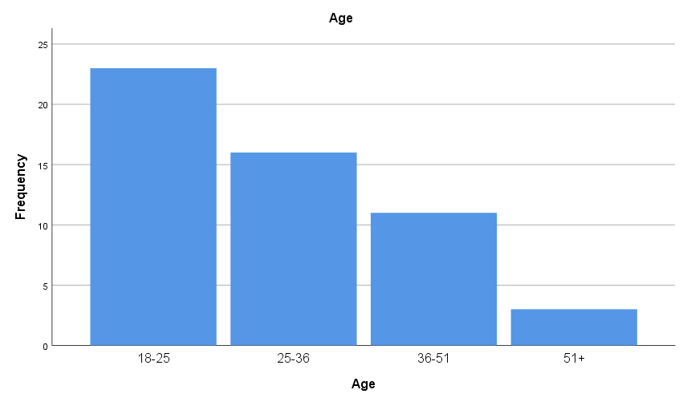
Figure 2 Bar graph representing age frequency

4.1.2 Gender
Second question asked the participants their gender. Out of the 53 participants 20 of the were male which is 37.7%, 32 participants were female which was 60.4% and the remaining 1 participants selected the option prefer not to say.

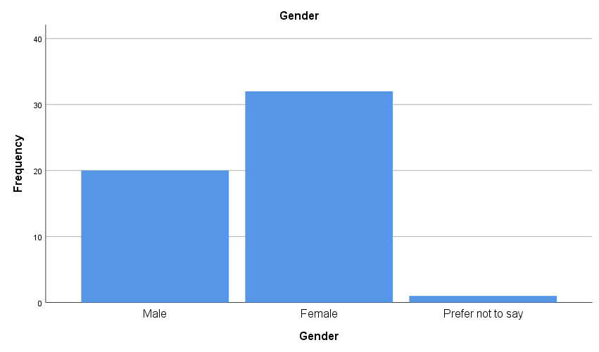
Figure 3 Bar graph representing gender frequency

4.1.3 Colleague or customer status
The following question has asked participants whether they are Tesco colleagues, customers or both. The researcher did not include neither option as the questionnaire was specifically targeted at Tesco customers and colleagues. The graph presents that 37.7% of participants were Tesco colleagues, the second highest percentage of participants were both customers and colleagues counting 35.9% the smallest number of participants were just customers with 26.4%. One of the reasons for a high number of colleagues who are also customers could be that they doing their shopping based on where they already are rather than having to go to another shop. Rather than choosing where to shop, they shop there as they are already there. This links to the objective as perhaps more important than price is the convenience, which shows lack of effectiveness of pricing policies.

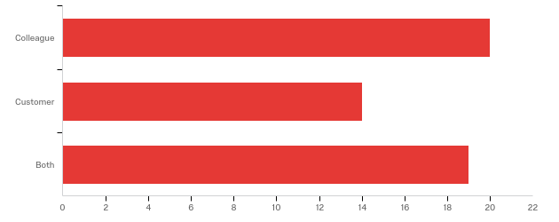
Figure 4 Bar graph representing Colleague and customer frequency

4.2 Awareness and importance of pricing policies
The participants have been asked whether they are aware of any pricing policies existing in retail industry. The following pricing policies were bundle pricing, discount pricing and price skimming. 28.3% of participants are very aware of discount pricing. The highest number of participants which is 24 and 45.3% of participants stated to be unaware of the price skimming. Pricing policies seem to be familiar to most of the participants as only four of them have stated to be definitely unaware of any of them. This is important for the objective of analysing effectiveness of pricing policies in retail.
The participants seemed to be most aware with pricing policies that would most benefit them. Bundle pricing allows customers to see the benefits of buying complementary products and buying them together at discounted price. Most participants seemed to aware with discount pricing the reason for this might be as this makes the customer feel that they have more value for the money or makes them feel satisfied when they buy products at a discounted price, which might be why customers look out for discount pricing policy. Discount pricing is effective at attracting customers and encouraging them to purchasing goods (Business Victoria , 2019)

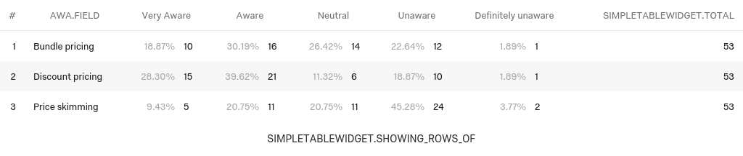
Figure 6 Table representing pricing policy awareness percentage
When it came to asking participants about the importance of pricing policies 56.60% of participants stated that pricing policies are very important. 18.87% of participants stated that pricing policies are both extremely important and moderately important. Only 1.89% of participants stated that pricing policies are not at all important. This links to the objective of effectiveness of pricing policies within the retail industry, as high awareness of participants might mean higher effectiveness. This might also mean that it is important for the retailer to use correct pricing policies and adapt them to a customer as correctly used pricing policies increase customer loyalty (Campbell, 2017). This information might be very useful especially to new retailers such as Jack’s when choosing the appropriate pricing policy, therefor it links to the third objective of the study.
How important do you think are pricing strategies?

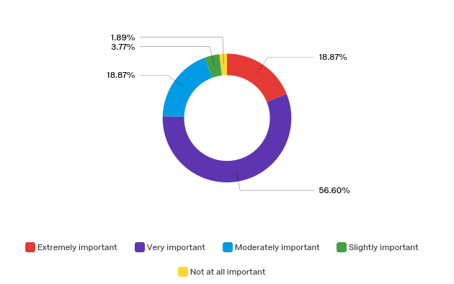
Figure 7 Pie chart representing results of importance of pricing policy

4.3 Store choice and customer satisfaction
The next set of questions is linked to what criteria customers mostly choose the shop they shop in, how satisfied they are with they are pricing of the products in the supermarkets. The participants had a choice to state whether they shop in a certain store based on price, product quality or location. 50 participants stated that they very often or often choose where to shop based on location 22 participants stated that they often shop based on product quality. This gives the impression that customers are most likely choose where to shop based on location rather than pricing on the products. Only 2 participants however stated that they rarely shop in a store based on price. Location might be such an important factor for customers dues to accessibility which links to a convenience of visiting the store, customers might also take into consideration such factors as parking and distance from home (Oppong, 2018). This shows that price does not always have impact on customer’s loyalty which is part of the aim of this research.

Satisfaction of customers based on price, product quality and location

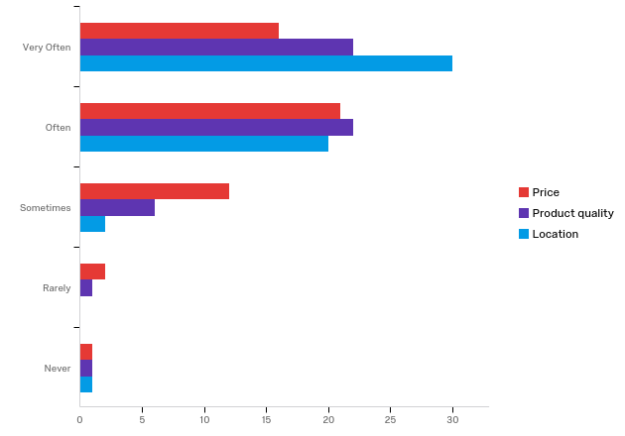
Figure 8 Bar chart representing Likert scale results of factors on which customers choose to shop
When it came to satisfaction with the pricing of the products in the supermarkets 26 which is 46.6% of participants stated that they are moderately satisfied with the pricing in the supermarkets. Seconds highest number of 16 participants and 30.19% stated that they are slightly satisfied. However only 2 participants stated that they are extremely satisfied, and 1 participant stated moderate dissatisfaction with the supermarket pricing.
Location still makes one of the most important factors of the criteria on which participants base where they decide to shop. However, product quality is also an important factor, this could be supported by evidence of supermarkets such as Tesco discontinuing Everyday value lines and substituting them with own brands such as Eastman’s (Barrie, 2018).

How satisfied are you with the pricing of the products in the supermarkets?

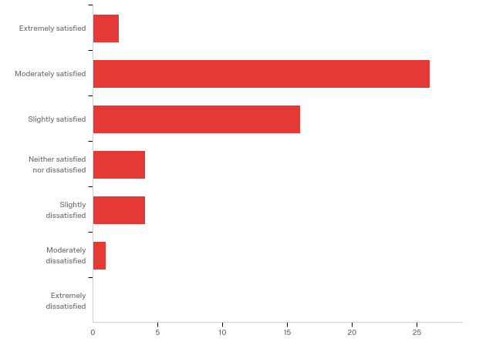
Figure 9 Bar chart representing satisfaction of pricing

4.4 Shopping at discount stores
This section is mostly focused on meeting the aim of the research in terms of evaluating the effectiveness of pricing policies within supermarket industry focusing on launch of Jack’s. Jack’s is a Tesco’s own discount store therefore; the research focuses on how often the participants shop at discount stores in preference to supermarkets. This focuses of achieving the part of aim of what affects customer’s decision of where they shop and customer’s loyalty to discount stores.

Gender * Discount shop Frequency Crosstabulation
Count
 |  | Discount shop Frequency |  |  |  | Total
 |  | More than 3 times a week | Less than once a week | Once in two weeks | Once a month | Total
Gender | Male | 3 | 6 | 7 | 4 | 20
Gender | Female | 7 | 8 | 13 | 4 | 32
Gender | Prefer not to say | 0 | 1 | 0 | 0 | 1
Total |  | 10 | 15 | 20 | 8 | 53

Figure 10 Table showing discount shopping frequency based on gender

The highest number of participants 27 which is 50.9% stated that the quality of products in supermarkets is better than in discount stores. The second highest number being 15 participants which is 28.3% stated that the quality might or might not be better in supermarkets than in discount stores. Only 4 participants have stated that the quality of product in supermarkets is definitely not better in supermarkets than discount stores. This evidence helps to achieve the objective of influence of pricing on value perception as it shows that customers thinking that they pay more for better product quality.

Do you believe that the quality of the goods in supermarkets is better than discount stores?
 |  | Frequency | Percent | Valid Percent | Cumulative Percent
Valid | Definitely Yes | 2 | 3.8 | 3.8 | 3.8
Valid | Probably Yes | 27 | 50.9 | 50.9 | 54.7
Valid | Might or might not | 15 | 28.3 | 28.3 | 83.0
Valid | Probably not | 4 | 7.5 | 7.5 | 90.6
Valid | Definitely not | 4 | 7.5 | 7.5 | 98.1
Valid | 6.00 | 1 | 1.9 | 1.9 | 100.0
Valid | Total | 53 | 100.0 | 100.0

Figure 11 Table demonstrating quality of goods in supermarkets against discount stores

This is an important factor as this means that regardless of the price the customers might still prefer to shop at supermarkets regardless of the price because quality of the products is the most important factor when deciding where to shop. Discount stores need to take that into consideration as Azeem (2012) states 90 to 95 percent of the hard discounters own manufactured brands known as private labels and they only focus on the best value for money which is not necessary product quality. Produsct quality makian important factor for the business as it builds a trust with a customer which is supported by this reasearch as customers find quality a important factor, this leads to customer loyalty. High product quality also reduct customer complaints and returns. Importance of product quality is also supported by customers like to buy products that look, feel and taste perfect (Business.com, 2018). This has an affect on the objective of wheather price has an influence on value perception by participants stating the quality of products in supermarkets is usally better than discount stores meaning that they might not consider products in discount stores, which are usually cheaper of equal quality which has effect on value perception.
Do you believe that the quality of the goods in supermarkets is better than discount stores?

This data shows that women are more likely to be shopping at discount stores than males. The overall number of women shopping at discount stores is 32 out of 53 participants where 15 of them shop at discount store between more than three times a week and less than once a week. Looking at the male side of participants 20 of them shop at discount stores, but only 9 of them shop there between more than three times a week and less than once a week. This shows that women are twice as likely to be shopping at discount stores.

Age * Discount shop Frequency Crosstabulation
 |  | Discount shop Frequency |  |  |  | Total
 |  | More than 3 times a week | Less than once a week | Once in two weeks | Once a month | Total
Age | 18-25 | 3 | 8 | 10 | 2 | 23
Age | 25-36 | 1 | 5 | 7 | 3 | 16
Age | 36-51 | 5 | 1 | 2 | 3 | 11
Age | 51+ | 1 | 1 | 1 | 0 | 3
Total |  | 10 | 15 | 20 | 8 | 53

Figure 12 Table showing age against frequency of shopping in discount stores

This table is demonstrating that the age of customers that are most likely to shop at discount stores is 36-51 as of the participants selected that they shop there more than 3 times a week. Participants ages 18-25 shop at discount stores less frequently as 18 of the participants of that age category shops there
between less than once a week and once in two weeks. Option once a month is a least popular across all age groups, which demonstrates customer’s loyalty to the discount stores.

Importance of pricing young participants age 18-25 found pricing very important. The reason for thi might because they are students and they are trying to save money when they can as when they arrive too university they are lacking basic money skills and are unaware about the basic costs of living (Bushi, 2018).

Age * Pricing * Gender Crosstabulation
Gender |  |  | Pricing |  |  |  |  | Total
 |  |  | Extremely important | Very Important | Moderately important | Slightly Important | Not at all important
Male | Age | 18-25 | 1 | 4 | 2 | 1 | 0 | 8
Male | Age | 25-36 | 1 | 3 | 1 | 2 | 0 | 7
Male | Age | 36-51 | 0 | 1 | 1 | 2 | 0 | 4
Male | Age | 51+ | 0 | 0 | 0 | 0 | 1 | 1
Male | Total |  | 2 | 8 | 4 | 5 | 1 | 20
Female | Age | 18-25 | 1 | 6 | 1 | 4 | 2 | 14
Female | Age | 25-36 | 3 | 3 | 3 | 0 | 0 | 9
Female | Age | 36-51 | 0 | 2 | 2 | 3 | 0 | 7
Female | Age | 51+ | 0 | 1 | 0 | 1 | 0 | 2
Female | Total |  | 4 | 12 | 6 | 8 | 2 | 32
Prefer not to say | Age | 18-25 |  |  |  |  | 1 | 1
Prefer not to say | Total |  |  |  |  |  | 1 | 1
Total | Age | 18-25 | 2 | 10 | 3 | 5 | 3 | 23
Total | Age | 25-36 | 4 | 6 | 4 | 2 | 0 | 16
Total | Age | 36-51 | 0 | 3 | 3 | 5 | 0 | 11
Total | Age | 51+ | 0 | 1 | 0 | 1 | 1 | 3
Total | Total |  | 6 | 20 | 10 | 13 | 4 | 53
Figure 13 Table showing age and gender and frequency of shopping at discount stores

Looking at the correlation between how important the pricing is when choosing where to shop, age and gender, 10 individuals ages between 18-25 have stated the pricing as very important factor. 9 females ages between 18-36 have stated pricing as very important in comparison to 7 males of the same category. The least number of individuals of all age and gender have stated that pricing is not at all important making it 4 individuals out of 53.
Females are more likely to shop at discount store more than three times a week than males. This might be because women tend to be planners and organisers and they are more likely to be looking out for bargains than men, women are also more likely to invest more time and energy to research and compare the products and look for the best possible value for money (Lewis, 2019).

4.5 Attitudes towards Jack’s
This section of questionnaire is aiming to analyse whether the participants are aware of Tesco discount chain stores Jack’s, whether they would shop there based on the following criteria such as customer service, product pricing and product quality. The questionnaire will also aim to establish whether participants think Jack’s has a chance of competing with well-established discount stores such as Lidl and Aldi. Lastly the questionnaire will ask participants whether if Jack’s got introduces to their local area, they would choose to shop there over Tesco. The analysis of the following data will help to reach the final objective in Chapter Five which is making recommendations to Jack’s.

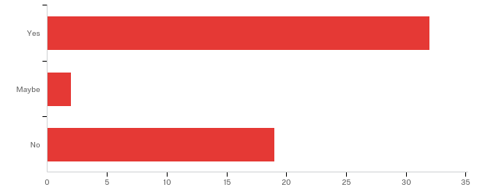
Are you aware of the new store Jack's being introduced to the UK?
Figure 14 Bar graph showing awareness of Jack's

When the participants have been asked if they are aware of the new store Jack’s being introduced into the UK 32 participants which is 60.4% have said yes and 19 participants 35.9% have answered no. The remaining number of participants have answered maybe. This is a potential marketing issue which Jack’s should take into consideration is planning to expand on the number of stores in the UK.

Do you think you would shop in Jack's if it opened in your area? (Jack's is a British discount store owned by Tesco)
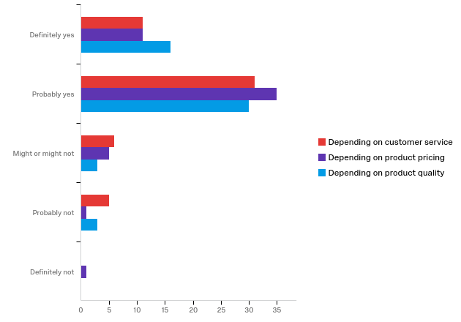
Figure 15 Bar graph showing on what factors would customers shop in Jack's
The highest number of participants which is 32 out of 53 have said that they would probably shop in Jack’s depending on the pricing. The next highest number of 31 participants have stated they would probably shop there depending on the customer service. However only 5 participants stated that they would probably not shop in Jack’s depending on the pricing. Overall participants seem to be quite positive about shopping in Jack’s if it got introduced to their area as most of the participants responded definitely yes or probably yes depending on the given criteria.
Figure 16 Table demonstrating the importance of locality to customers

Figure 16 Table demonstrating the importance of locality to customers
Participants of the questionnaire have also been asked whether they think Jack’s has a chance of competing with more popular discount stores such as Aldi or Lidl and 23 out of 53 participants responded likely following by second highest number being 11 participants. The least popular response was very unlikely of 3 participants. This shows that participants generally think Jack’s has a high chance in competing with well-established discount stores.
Looking at the other criteria such as locality of the stores the participants have been asked how important they consider the locality when it comes to choosing where they shop. 39 out of 53 participants selected the option extremely and very important. The least popular option was slightly important selected only by 1 participant.

Locality
 |  | Frequency | Percent | Valid Percent | Cumulative Percent
Valid | Extremely Important | 11 | 20.8 | 20.8 | 20.8
Valid | Very important | 23 | 43.4 | 43.4 | 64.2
Valid | Moderately Important | 10 | 18.9 | 18.9 | 83.0
Valid | Slightly Important | 6 | 11.3 | 11.3 | 94.3
Valid | Not at all important | 3 | 5.7 | 5.7 | 100.0
Valid | Total | 53 | 100.0 | 100.0
When participants of the research were asked whether they would shop in Jack’s over Tesco if it got introduced into their area none of the participants responded definitely yes. The most popular option was might or might not of 41.5% of participants the second popular response was probably yes of 30.2% of participants. This should be taken into consideration when making recommendations to Jack’s.

Do you think if Jack's got introduced to your area would you choose it over shopping in Tesco?
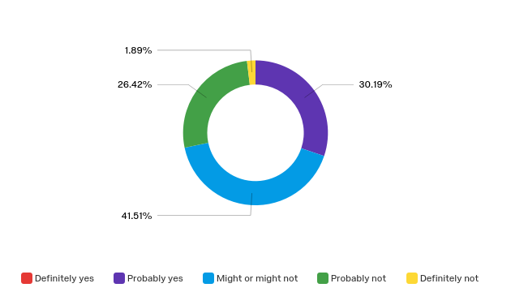
Figure 17 Pie chart demonstrating if participants would shop in Jack's over Tesco

The last section of the questionnaire consisted of open questions where the participants could give their own opinion regarding to most important factors when choosing where they shop and whether they have any other comments regarding to Jack’s and discount stores in general. The response from the participants was relatively high and most popular responses regarding to most important factors of choosing where to shop were fair price, product quality, locations of the store and convenience. However, some of the participants have stated that they also find customer service and good product set out important part of their decision making. A lot of participants have also mentioned good value for money, availability of the products and product range.
Looking at the last question regarding making any additional comments about discount stores and Jack’s most participants states they have no additional comments. Some participants did state however that discount stores have similar product range to supermarkets but at a cheaper price which makes the customers return. In general, in this section participants have stated that Jack’s may find it difficult to compete against already established discount stores, but they are interested to see how the store develops and what sort of product range Jack’s will come up with.

Conclusion
The main findings of this chapter revealed by the data collection and the analysis of the qualitative data that the main factors that have the impact on customers choice of where they choose to shop is
- Location- as most of the participants have stated that location is more important than price and when given the choice of factors which they prioritise when choosing where to shop they are most likely to choose location.
- Convenience is also a very important factors which customers take into consideration over the price. As they prefer to shop somewhere that is on the way of the daily commuting such as from school run or work, rather than having to go out their way to pick up their essentials.
- Product quality and the least important of them is product pricing. This is an unexpected result, as the researcher expected price to be the most important criteria. However, the research has supported the objective of price having an influence on value perception by the customers.

Implications of the above findings will be closer discussed in Chapter five.

Chapter Five- implication of main findings and conclusions
This chapter will focus on whether the findings in the research have supported aims and objectives obtained in chapter 2. This chapter will state the main implications of the findings, whilst stating limitations of the research and making appropriate recommendations for future academic research.
The aims and objectives of this study are:
The aim of this research is to evaluate and pricing policy within the supermarket industry focusing on launch of the new discount store Jack’s
This study will show impact of customer’s loyalty to the popular discount stores and what affects customer’s decision to shop there. The main objectives of this research are;
- To identify and analyse the effectiveness of pricing policies within the retail industry.
- To critically evaluate the influence of pricing on value perception by the customer.
- To make possible recommendations for new discount store Jack’s on adoption of new pricing policies.

5.1 Implication of the main findings
The analysis of the questionnaire regarding to the customer awareness of the importance of pricing policies within retail industry, the main factors that affect the customer’s choice on where they shop, frequency of shopping in discount stores in preference to supermarkets as well as customer’s approach of the launch of the new store Jack’s provided with a several of unexpected results.

The first objective of this research focused on identifying and analyzing the effectiveness of pricing policies within the retail industry. The analysis of the survey questions has provided with the evidence that the objective has been met. The research focused on analysing the most common pricing policies such as bundle pricing, discount pricing and price skimming. The participants of the research were least familiar with the price skimming, which is defined as when the company sets artificially high price for product or service, but awareness that new competitors will soon enter the market means that the product has to be unique and one of the kind (Presstholdt, 2017).
Evaluation of pricing policies within the supermarket industry therefore most of the research have been focused on discount stores to provide a contrast background for new discount supermarket Jack’s. According to Zentes, Morschett, Schramm-Klein (2007) pricing in general and price promotions are important marketing instrument in retailing, as price is playing an important role in retail marketing.
The aim of this research was to was evaluate pricing policies within the supermarket industry focusing on Jack’s. The aim of the research has been met by analising any relavant literature relating to Jack’s and discount stores. The research was focused on finding out if Jack’s can fill the gap between quality and value for money. The research has provided evidence that not many participants were aware of Jack’s in the first place. This might be a marketing issue, however Jack’s has stated that they will be the cheapest store in the area, and introducing its own new offers such as “fresh five” or “when its gone its gone”. There might also be lack of awareness of the new discount store due to a small number of them opening, as Tesco is currently only trialing (Flood, 2018).
One on the objectives of the research was to evaluate the influence of pricing on the value perception. The research has demonstrated that price is not the most important factor when choosing where to shop. The results of the research has stated the most criteria on which customers choose where they shop are location and convenience as often customers focus on the good acess to quickly make the purchase, customers might be inclined to Patronize convenience stores located on the path of their daily commutes (Waters, 2019).
Looking at the objective of influence of pricing on value perception, participants might not always be honest when it comes to answering questions relation to where they shop due to fear of stereotyping. Some participants might not honestly admit how often they shop at discount stores than other due to money perception. Customers love paying less than they need to, but they might not always admit it. However, this point also supports the objective of effectiveness of pricing policies as retail companies especially supermarkets try to get customers to spend as much as possible. Companies arrange they stores to optimise visual detail, carter to shopping patterns and keep customers in store if possible (Ortakales, 2018).
The last objective of this research was to make appropriate recommendation to Jack’s. Taking into consideration that the main finding of this research was that price in not the most important factor for customers when choosing where they shop, as more important are quality, location and convenience Jack’s should take these factors into consideration. Jack’s need to take on board what type of customer they want to attract. They location they want to base themselves in is very important as the research stated its one of the most important factors when customers choose where to shop. However, important point is that they need to base themselves far away from their rival. The research is also able to make recommendations for Tesco to stick to the strategy they are going with now as, in the supermarket sector they still have a big market share of 27%. They research have also proven that most customers would choose Tesco over Jack’s which could be a result of Tesco being long established creating a customer loyalty as well all the main most important factors of the research that price is not the most important factors when choosing where to shop.
The implications of this research should be taken into consideration for new starting retailers especially Jack’s. this research helped to find out the most important factors for customers when choosing where to shop. Most retailers can put this research into use and possibly make some changes to their pricing policies and product quality standards to increase the number of shoppers and effectively profits.

5.2 Limitations
The main limitation of this research is a very small sample size which does not fully reflect on all customers and colleagues, sample of 52 is simply not high enough to make definitive conclusions. The data was collected only of colleagues in one chosen Tesco store which is a limitation as colleagues from different stores might have different priorities and opinions. This links to the factor that the sample was taken in the small area meaning not enough of demographic data was used in this research which does not reflects opinions of all customers and colleagues in all of Wales.
Another limitation might be that the collected data in the research might be bias, and the participants answer how they think they are expected to answer rather than what they think. There is no guarantee that the participants of the research are saying the truth, which is a limitation, as it has a big effect on the liability and the accuracy of collected data and research.
Last limitation of the research is stereotyping, which links to the factor that some participants of the research might not want to admit to where they shop dues to the issue of being stereotyped. Some customers may pay very high attention to where they shop, and they might be purely focused on branding. An example of this could be shopping in Tesco over Lidl because Lidl is a discount store. This means that the researcher cannot truly find out whether stated frequency of shopping in discount stores is true of whether the participants do not want to truly admit how often they shop there being afraid of being stereotyped.

5.3 Further Research
In order to avoid limitations mentioned in a previous section recommendation for a further research is to collect data from different Tesco stores around West Glamorgan area rather than just focusing on one store. Further research should reconsider what method of data collection to use as use of both qualitative and quantitative research would ensure reliability of the data. Further research could also focus on factors such as popularity of discount stores over supermarkets or looking into effectiveness of one pricing policy on the customers rather than giving a broad view. This study may require further research as there is not much information about use of specific pricing policies by specific stores and there is not enough research about its effectiveness on the customer.

Conclusion
Final conclusion, states that the researcher was wrong assuming that the main factor on where customers shop is price. This study has proven that the most important factors are location and convenience. This study has achieved the aim of evaluating pricing policies in supermarket industry and has achieve the aims by stating the effectiveness of pricing policies and proving that price does have influence on value perception by customers. The study has also achieved its last objective by making appropriate recommendations to new discount store Jack’s.
Personally, I tend to shop in both supermarkets and discount stores as it gives me an overall balance between the quality and good price. If I can get something for cheaper I will, but only if it is of as good of a quality. I myself work in Tesco which is where I tend to do most of my shopping purely due to convenience I am prepared to sacrifice the price.

References
Bryman,Bell. (2015). Business Research Methods. Oxford Press.
Banister. (2018). Retrieved from Research Onion – Explanation of the Concept: Research Onion – Explanation of the Concept
Barrie, J. (2018, June). Consumer news lifestyle sport opinion. Retrieved from Tesco’s new ‘Everyday Value’ replacement brands include a fake deli called Eastman’s: https://inews.co.uk/news/consumer/tesco-new-deli-food/
Ben-Schlomo. (2013). Epidemiology, Evidence-based Medicine and Public Health (6th ed.), . Oxford.
Bhat, A. (2019). QuestionPro. Retrieved from QUALITATIVE DATA- DEFINITION, TYPES, ANALYSIS AND EXAMPLES: https://www.questionpro.com/blog/qualitative-data/
Blessing, L. T. (2009). DRM, a Design Research Methodology. Springer .
Bolarinwa, O. A. (2015). Nigerian postgraduatmedical journal. Retrieved from Principles and methods of validity and reliability testing of questionnaires used in social and health science researches: http://www.npmj.org/article.asp?issn=1117-1936;year=2015;volume=22;issue=4;spage=195;epage=201;aulast=Bolarinwa
Brace, I. (2008). Questionnaire design how to plan structure and write survey material for effecttive research . Kogan page .
Brown, J. M. (2013). The reformed broker. Retrieved from Why price is king : https://thereformedbroker.com/2013/12/22/why-price-is-king/
Bushi, R. (2018, October ). STS. Retrieved from Student Money Survey 2018 – Results: https://www.savethestudent.org/money/student-money-survey-2018.html
Business Victoria . (2019, January ). Retrieved from Discount strategies: https://www.business.vic.gov.au/money-profit-and-accounting/pricing/Discount-strategies
Business.com. (2018, Aprl). Retrieved from Elevating Expectations: 5 Ways Product Quality Impacts Your Brand: https://www.business.com/articles/5-reasons-why-product-quality-matters/
Butler, S. (2018, September). The guardian. Retrieved from Tesco opens discount store Jack's to take on Lidl and Aldi: https://www.theguardian.com/business/2018/sep/19/tesco-opens-jacks-first-discount-store-battle-lidl-aldi
Campbell, P. (2017). Why you need to review your pricing strategy today (and how to do it right. Retrieved from Price intelligently : https://www.priceintelligently.com/blog/pricing-strategy
Cargan, L. (2007). Doing Social Research. Rowman and Littlefield publishers.
Catwright, T. (2007). Planning and chaos theoy . Journal of the American planning association .
Corbin, J. (2008). Qualitative Research . Sage.
Daniel, S. (2010). Research Methodology. Kalpaz.
Datt, S. (2016). Project guru. Retrieved from Measuring reliability of questionnaires: https://www.projectguru.in/publications/measuring-reliability-questionnaires/
Debois, S. (2019). Survey anyplace. Retrieved from 10 Advantages and Disadvantages of Questionnaires (Updated 2019) : https://surveyanyplace.com/questionnaire-pros-and-cons/
Debois, S. (2019). Survey Anyplace . Retrieved from 10 Advantages and Disadvantages of Questionnaires (Updated 2019): https://surveyanyplace.com/questionnaire-pros-and-cons/
Droege, S. B. (2019 ). Reference for Business . Retrieved from Pricing policy and strategy : https://www.referenceforbusiness.com/management/Or-Pr/Pricing-Policy-and-Strategy.html
Dudovskiy, J. (2019). Research methodology . Retrieved from Research Philosophy : https://research-methodology.net/research-philosophy/
Dudovsky, J. (2018). Research Methodology. Retrieved from Inductive approach : https://research-methodology.net/research-methodology/research-approach/inductive-approach-2/
Findlay, A. M. (2002). Retailing: The evolution and development of retailing. London and New York : Routledge .
Flood, R. (2018, October ). The Sun. Retrieved from JACK OF ALL TRADES What is new Tesco store Jack’s, where will the discount stores be located and when does it open?: https://www.thesun.co.uk/fabulous/food/7295498/tesco-store-jacks-discount-supermarket-stores-open-where-new-located/#
Foley, B. (2018). Survey gizmo . Retrieved from What is SPSS and How Does it Benefit Survey Data Analysis?: https://www.surveygizmo.com/resources/blog/what-is-spss/
Gleeson, P. (2018). Chron. Retrieved from What is discount pricing strategy: https://smallbusiness.chron.com/discount-pricing-strategy-794.html
Gleeson, P. (2018, June). Chron . Retrieved from What is discount price strategy : https://smallbusiness.chron.com/discount-pricing-strategy-794.html
Goddard, W. (2001). Research Methodology: An Introduction. Juta.
Griffin, D. (2018, June 30). Chron. Retrieved from The effect of competition on pricing strategy: https://smallbusiness.chron.com/effect-competition-pricing-strategy-1109.html
Guinn, J. (2019, February ). Software advice . Retrieved from The Top Retail Pricing Strategies For Your Business: https://www.softwareadvice.com/resources/retail-pricing-strategies/
Gupta, S. (1988). Journal of marketing research. 342-355.
Hammett, E. (2018). Marketing week. Retrieved from How Tesco’s new discount chain can compete with Aldi and Lidl: https://www.marketingweek.com/2018/07/24/tesco-discount-supermarket/
Heil, K. (2018). Reference for business. Retrieved from Pricing policy and strategy : https://www.referenceforbusiness.com/management/Or-Pr/Pricing-Policy-and-Strategy.html
Hillebrand, J. (2006). The Social Responsibility of Corporations. Druck and Bindung .
Hinkelmann, K. (2018). How to choose a research methodology? University of Applied Sciences Northwestern Switzerland School of Business.
Institute for work and health . (2015). Retrieved from Cross-sectional vs. longitudinal studies: https://www.iwh.on.ca/what-researchers-mean-by/cross-sectional-vs-longitudinal-studies
Jordan, D. (2018). BBC News. Retrieved from Tesco's new discount chain Jack's takes on Aldi and Lidl: https://www.bbc.co.uk/news/business-45572731
Jovancic, N. (2018, August ). leadquizzes. Retrieved from The Ultimate Guide on How to Create a Likert Scale Survey: https://blog.leadquizzes.com/the-ultimate-guide-on-how-to-create-a-likert-scale-survey/
Kothari, C. R. (2012). Research Methodology: Methods and Techniques. New age international publisher.
Kumar, A. (1998). Managerial Economics. Atlantic publisher.
Lavrakas, P. J. (2008). Encyclopedia of Survey Research Methods. sage.
Lee, J. E. (2018). Effects of price discount on consumers’ perceptions of savings, quality, and value for apparel products: mediating effect of price discount affect.
Levy, D. L. (2000). Applications and Limitations of Complexity Theory in Organization Theory and Strategy. Boston, Massachusetts : University of Massachusetts .
Lewis, M. (2019). Money Crashers . Retrieved from Men vs. Women: Differences in Shopping Habits & Buying Decisions: https://www.moneycrashers.com/men-vs-women-shopping-habits-buying-decisions/
Long, K. (2019, February). Industrial distribution . Retrieved from https://www.inddist.com/article/2016/03/embrace-complexity-and-discover-value-your-pricing-strategy
Lyons, E. (2018, September). Marketing week . Retrieved from Tesco’s is positioning Jack’s around Britishness and being the “cheapest in town” as it shakes off concerns its new discount chain could cannibalise its own sales.: https://www.marketingweek.com/2018/09/19/tesco-jacks-discount-chain/
Maguire, A. (2019, February). Intuit quickbooks. Retrieved from What’s a Premium Pricing Strategy and Will It Work for Your Business: https://quickbooks.intuit.com/r/pricing-strategy/whats-a-premium-pricing-strategy-and-will-it-work-for-your-business/
Matthews, B. (2010). Research methods . pearson.
McLeod, S. (2013). Simply psychology . Retrieved from What is reliability : https://www.simplypsychology.org/reliability.html
McLeod, S. (2017). Simply Psychology . Retrieved from What’s the difference between qualitative and quantitative research?: https://www.simplypsychology.org/qualitative-quantitative.html
Nesim Hanna, H. R. (1995). Pricing: policies and procedures. London : Macmillan .
News, I. (2014). ITV News. Retrieved from rise of discount supermarkets: https://www.itv.com/news/2014-05-23/tonight-the-rise-of-the-discount-supermarkets/
Nolinske, T. (2019). National business research institute . Retrieved from METHODS OF SURVEY DATA COLLECTION: https://www.nbrii.com/customer-survey-white-papers/methods-of-survey-data-collection/
Oppong, T. (2018, March). Alltopstartups. Retrieved from The Importance of Location in Business: https://alltopstartups.com/2018/03/15/the-importance-of-location-in-business/
Ortakales, J. (2018, August ). Business Insider . Retrieved from I worked in retail for 6 years, and these are the subtle ways clothing stores get you to spend more money: https://www.businessinsider.com/how-stores-get-you-to-spend-money-2018-8?r=US&IR=T
Presstholdt, R. (2017, June 14). Froehling Anderson. Retrieved from Pricing Strategy for Products: Economy, Skimming, Penetration, and Premium: https://fa-cpa.com/pricing-strategy-for-new-products-4-methods/
Punch, K. F. (1998). Introduction to social research . Sage.
Puranam, P. (2016). Corporate Strategy: Tools for Analysis and Decision-Making.
Remenyi, D. (2011). Field methods for academic research- interviews, focus groups and questionnaires . Ridgeway Press.
Ruel, E. (2016). The Practice of Survey Research. Sage.
Sachon, M. (2010). IESE Insight . Retrieved from Hard Discount Retailers: The Secrets of Their Success : https://www.ieseinsight.com/doc.aspx?id=1125
Sahay, A. (2016, July ). Research Gate . Retrieved from Peeling Saunder's Research Onion: https://www.researchgate.net/publication/309488459_Peeling_Saunder's_Research_Onion
Samli, C. (1998). Strategic Marketing for Success in Retailing. London: greenwood Publishing group.
Saunders, M. (2009). Research Methods for Business Students. Essex: Pearson Education Limited .
Schwaferts, D. (2018). Applying Saunders research onion . swiss universities.
Scott, L. (2012). Research gate . Retrieved from The Research Onion : https://www.researchgate.net/figure/The-research-onion-Saunders-et-al-2012_fig2_282912642
Sheshinski, E. (1993). Optimal Pricing, Inflation, and the Cost of Price Adjustment. MIT press .
Stevens, B. (2018). Retail Gazette . Retrieved from Customers “voting with their feet” as discounters continue to grow market share: https://www.retailgazette.co.uk/blog/2018/10/jacks-fails-stem-tescos-market-share-loss-last-quarter/
Survey, S. (2019). Retrieved from 10 Advantages of Online Surveys: https://www.smartsurvey.co.uk/articles/10-advantages-of-online-surveys
The Journal of Professional Pricing. (2012). The Journal of professional pricing, 12-13.
Tools, M. (2018, March ). Mind Tools. Retrieved from the pricing strategy matrix : https://www.mindtools.com/pages/article/pricing-strategy-matrix.htm
Unleashed. (2017, December ). Unleashed . Retrieved from Discount Pricing Strategy Explained: https://www.unleashedsoftware.com/blog/discount-pricing-strategy-explained
Waters, S. (2019, April). The balance. Retrieved from Choosing a Retail Store Location: https://www.thebalancesmb.com/choosing-a-retail-store-location-2890245
Wyman, O. (2019). Retrieved from What Are The Advantages Of The Hard Discounter Business Model?: https://www.oliverwyman.com/our-expertise/insights/2017/feb/What-Are-The-Advantages-Of-The-Hard-Discounter-Business-Model.html

