Adibah Bashir
Student ID Number: 2422466
Module Code: LCHS4009
Module Title: Professional Development within Health and Social Care
Lecture’s Name: Vivian Osuchukwu
Assignment Title: Component 2 – Portfolio

Task 1: Personal Action Plan - Applying to the Role of Registered Nurse:
The position of the Registered Nurse (RN) is the core of the effective and efficient healthcare system, as it involves a set of clinical skills, proficiency in communication, critical thinking, and caring towards the patient. For this position, it is necessary to analyse my current competencies, formulate the developmental needs, and create a systematic approach towards improvement.
Some of the required skills and my ability to meet them are as below,

Clinical Knowledge and Technical Competence:
Clinical knowledge refers to theoretical, conceptual and practical data that professionals in healthcare utilize in their understanding of diseases, evaluating patients and decide what to do (Psychology, n.d.), whereas technical competence can be defined as the immediate, concrete, practical skills and abilities necessary to carry out job-related duties and make efficient and safe use of the specialized tools or equipment’s in a clinical environment (Alchemy, 2023).
Registered nurse should be able to show detailed clinical competence, such as assessment, planning, implementation, and evaluation of care (NMC, 2018). I have a solid knowledge of anatomy, physiology, and standard clinical practice. I have done acute and community placements during which I helped with vital signs monitoring, administered medication under supervision, and provided wound care.

Communication and Interpersonal Skills:
The skill of effective communication is the ability to share information and get it through words, nonverbal and written. Interpersonal skills are those skills that are applied to communicate and build relationships with others, and such skills are communication, empathy and teamwork (Blackburn, 2024).
Communication plays a key role in nursing practice, promoting therapeutic relationships, patient safety, and multidisciplinary cooperation (Boggs, 2023). I also have strong verbal and written communication skills, and I can apply empathy and active listening skills when dealing with different groups of patients.

Critical Thinking and Decision-Making:
The critical thinking is the objective analysis and evaluation of information to make a judgment, and decision-making is a process of making a choice between alternatives with uncertain outcomes (P.A. Douglas , n.d.).
Nurses often make sensitive decisions that need analytical thinking and clinical judgement. Benner (2001) explains that new practitioners need to acquire the capacity to identify patterns and the ability to make decisions. I have used systematic models like SBAR (Situation-Background-Assessment-Recommendation) in situations where handing over, and I have also used clinical reasoning to detect patient deterioration, raising and appropriately escalating the issue.

Professionalism and Ethical Practice:
Professionalism is the way of acting, behaving and having attributes that identify members of a profession and ethical practice is the practice of following moral values and principles that dictate the way of acting (sel8kyle, 2025).
Adhering to professional standards and ethical awareness are the crucial aspects of nursing practice. My values are aligned with the principles of confidentiality, dignity, and respect, which are in line with the NMC Code (NMC, 2018).

Personal Development Plan (PDP)
Development Area | Goal | Actions | Resources Required | Timescale | Review
Leadership Skills | Advanced capability to organize and manage care and administer other personnel. | Finished leadership seminar; assisted senior nurse and looked for feedback after directing small tasks. | University and healthcare, books, reading, and online available videos. | Mid November 2025 to Mid December 2025. | Review my leadership process monthly with healthcare and university seniors, assessing my confidence level in leading small tasks, and documenting reflections on leadership experiences.
Advanced Clinical Skills | Obtain competency in medication and complex wound care. | Attend clinical virtual reality simulations; request seniors to assist me during practice. | Simulation labs. | Mid Nov 2025 to beginning of March 2026. | Self-reflection regarding areas where further development is required.
Time Management | Try to manage my workload effectively and efficiently. | Use different prioritization tools to manage my workload. | Watch online videos on time management. | December 2025 to February 2026. | Take notes on how I managed things and assess the progress in dealing with competing demands.
Interview Confidence | Improve verbalization and formation of speech during interviews. | Conduct mock interviews; prepare structured responses | Attend mock interviews and look for feedback. | January 2026 to February 2026. | Record my mock interview and watch recordings of mock interviews to see what I did wrong and what I did correctly.

Interview Preparation - Possible Questions and Responses:
Question 1: Could you explain an illustration of how you delivered person-centred care?
Response: I was on placement in a rehabilitation unit and a patient who had suffered a stroke came to me complaining that he felt anxious about the loss of independence. I was obliged to offer care that would not violate their emotional needs and encourage autonomy according to the principles of person-centred. I actively listened to learn their issues in depth and cooperated with the physiotherapist to develop realistic mobility objectives. Consequently, the patient got more self-confident and involved in their rehabilitation plan showing better motivation and trust in the care process.
Question 2: “What do you do to cope with stress in the hectic clinical setting?
Response: I have frequently encountered an abrupt workload and time-constrained scenario in a busy clinical setting. The task I was to do was take care of the patient, cope with my stress, and keep providing high-quality care. I employed stress-management models to prioritize and employed effective communication to organize with other workers. The interventions helped me stay very composed, relaxed, and purposeful to provide safe and effective patient care even in times of high pressure.
Question 3: What about a situation where you are aware that a colleague is violating professional standards?
Response: On one occasion, I witnessed a colleague in an activity that was not following the set standards of the profession, and which had some risks. As per the NMC (2018) Code, my duty was to secure patient safety and handle the misconduct by responding accordingly. I talked to the colleague in an approving manner to seek clarification on my issues and give them a chance to think. This made sure that I deal in a manner which assisted in preserving the safety of patients, as well as supporting integrity and accountability among the team members.

Task 2 - The Importance of Effective Communication in Health and Social Care:
Communication is an expertise that every professional in the health and social care setting should possess. It has a central role to play in the safety, dignity, and well-being of service users, and in multidisciplinary collaboration and high-quality care delivery.
Health and social care involve verbal, and non-verbal communication between practitioners, service users, and other professionals (Kwame and Petrucka, 2021).
Verbal communication includes information exchange using spoken, or written, words like engaging in a dialogue, speaking, or writing an email. Nonverbal communication defines as the message giving by other means than words. For example, Nonverbal communication includes body language, facial expression, eye contact, gestures and even tone of voice (Willkomm, 2018).
Good communication will help practitioners to know the needs of individuals, transfer information, and establish therapeutic relationships. Health and Care Professions Council (2024) states that communication is at the core of professional competence because it facilitates shared decision-making, fosters trust, and minimizes the chances of errors.
Among the major reasons why communication is important is that it has a direct influence on the safety of patients. One of the main factors that causes negative events, slow treatment, and worsening quality of care is miscommunication. As an example, the application of structured communication systems like SBAR (Situation–Background–Assessment–Recommendation) has been proven to decrease ambiguity and facilitate correct clinical handovers (Leonard et al., 2004). By communicating concisely, especially in stressful places, the practitioners also contribute to the process of ensuring that the necessary information is conveyed between professionals without distortion and omission.
Besides facilitating safety, effective communication fosters patient-centred care, which is a major principle of contemporary health and social care practice. To gain insight into the opinion of service users, practitioners should apply active listening, empathy, and open questioning to be able to make sure the care decisions are based on the will of the users (Zechuan and Kan, 2024). As an illustration, empathy and respect that result from the help of non-verbal communication can be expressed through eye contact, facial expression, and body language, which strengthen the therapeutic relationship. Service users would become more willing to participate positively in care interventions and have better health outcomes when they feel heard and valued.
Inclusion and equality are also facilitated through effective communication since the information is made available to people with special needs. Health and social care practitioners should change their communication strategy due to their age, disability, culture, or language variations (Skills for Health, 2025). This can include interpreter use, visual aids, breaking down complex terminologies, varying tones, and speed. Inclusion increases participation barriers and enables practitioners to help everyone involved in the process of decision-making as it relates to the service they receive.
Moreover, teamwork in the context of interdisciplinary health and social care cannot be successful without communication. Different professionals should also work successfully to provide integrated support (nurses, social workers, occupational therapists, and doctors). Effective communication allows sharing the assessments, treatment plans, and progress updates, and all team members will work towards the same objective (Reeves et al., 2010). Poor communication, on the other hand, may result in repetition of services, opposed interventions, or service lapses. Therefore, professional management of teams and respectfully managing them is the key to the coordination of services.
Communication is not always easy to work with, regardless of its significance. The obstacles might be time constraints, emotional suffering, language barrier, environmental interference, or the incompatibility of professional commitments. Health and social care workers must, hence, always reflect and perfect their communication quality. Supervision, attending communication workshops, and applying reflective models like the Reflective Cycle developed by Gibbs should assist practitioners in assessing their interactions and how to improve them.

Task 3 - Critical Reflection Using the ERA Model:
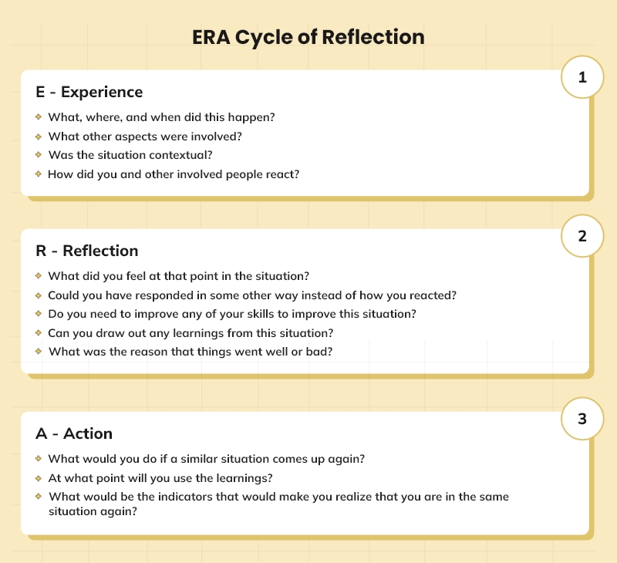
(Robinson, 2022)

Experience:
The purpose of the presentation was to show that I understood SWOT analysis, and I could use it to the advantage of my personal growth as a future practitioner in the field of health and social care. My presentation includes a description of SWOT, defining my strong and weak sides, and explaining my opportunities and threats in the industry. I also gave an action plan to demonstrate how I would shape my skills and equip myself to work in future career capacities.
In the delivery process, I was confident of the content, but I had some anxiety, especially at the start which influenced my speed and fluency in words. The feedback provided by my lecturer pointed out the fact that the content presented was appropriate and well-organized, but I needed to work on the way I delivered my presentation and slow down my speech, maintain more eye contact, and elaborate on how the SWOT analysis had a direct connection with future employability. The lecturer also noted that my slides were well organized, but there was over-dependence on reading the slides; hence, it diminished the amount of audience engagement.

Reflection:
Reflecting on my presentation, I identify the areas of improvement and strengths. My strengths, which I identified to be communication, motivation, and collaborative work, were in line with the main skills appreciated in the health and social care field. Likewise, the recognition of the weaknesses, like a lack of experience, time management, and knowledge of the work requirements, was a good move towards honest self-assessment.
Nevertheless, the comments of the lecturer also revealed some of my weaknesses in the performance. I was dependent on reading the slides, and hence, this was a limitation to my interaction with the audience. This affects the overall delivery since an effective presentation will entail a verbal explanation and not memorizing written information. Moreover, the responses indicated that I should have had more connections between every SWOT analysis and the actual needs of health and social care professions. I have indicated communication as a strength, yet I have not elaborated on how it can improve service user interactions and teamwork among the disciplines.
The emotions that I felt during the presentation also impacted my performance. I was prepared, but I got nervous, and my confidence was lowered, resulting in a rushed speaking pace, and at some point, I hesitated. This emotional dimension should be identified to do better in future assessments.
The other significant reflection is associated with the application of evidence. Although I had referenced them on the slides, the lecturer pointed out that I could have enhanced academic value by presenting part of this evidence verbally as I expounded on it. It would show greater critical involvement and increase credibility.

Action:
In the future, I will aim to develop my presentation skills as well as my academic communication. To improve delivery, I will train myself to be able to speak without reading off the slides or cue cards with short prompts and not full sentences. This will assist in keeping eye contact and make the style of presentation more interesting. I will also practice my timing and practice-controlled breathing strategies to avoid nervousness and speak in a fast manner.
Lastly, I will also ask other people to give additional feedback to me by rehearsing future presentations with other students or during skill training sessions. It is this continuous cycle of experience, reflection and action that will assist me to grow as a self-assured communicator and a future practitioner in health and social care.

Reference list:
Benner, P. (2001) From Novice to Expert: Excellence and Power in Clinical Nursing Practice. Commemorative Edition. Upper Saddle River: Prentice Hall.
Boggs, K.U. (2023) Interpersonal relationships: professional communication skills for nurses (9th edn). St. Louis, Missouri: Elsevier.
Health and Care Professions Council (2024). Standards of Conduct, Performance and Ethics. [Online] Available from: https://www.hcpc-uk.org/standards/standards-of-conduct-performance-and-ethics/ (Accessed: 12.11.2025).
Kwame, A., and Petrucka, P.M. (2021) ‘A literature-based study of patient-centered care and communication in nurse-patient interactions: barriers, facilitators, and the way forward’, BMC Nurs, 20, 158.
Leonard, M., Graham, S., and Bonacum, D. (2004) ‘The human factor: the critical importance of effective teamwork and communication in providing safe care’, Quality & safety in health care, 13 Suppl 1(Suppl 1), i85–i90.
Nursing and Midwifery Council (NMC) (2018). The Code: Professional Standards of Practice and Behaviour for Nurses, Midwives and Nursing Associates. [Online] Available from:
https://www.nmc.org.uk/globalassets/sitedocuments/nmc-publications/nmc-code.pdf (Accessed: 10.11.2025).
Reeves, S., Lewin, S., Espin, S. and Zwarenstein, M. (2010) Interprofessional Teamwork for Health and Social Care: Partnership Working In Action. [Online] Available from: https://tcsc-indonesia.org/wp-content/uploads/2012/11/ebooksclub.org__Interprofessional_Teamwork_in_Health_and_Social_Care__Promoting_Partnership_for_Health_.pdf (Accessed: 11.11.2025).
Robinson, J. (2022). Self-introspection and Improvement with ERA Reflective Cycle. [Online] Available from: https://crowjack.com/blog/strategy/reflection-models/era-cycle. (Accessed: 17.11.2025).
Skills for Health (2025). Better skills, better jobs, and better health. [Online] Available from : https://www.skillsforhealth.org.uk/ (Accessed: 09.11.2025).
Zechuan, C., and Kan, Z. (2024) ‘On Becoming a Person: A Therapist’s View of Psychotherapy’, In: The ECPH Encyclopedia of Psychology. Singapore: Springer.

