Define skill in the context of your own practice and work of two artists/makers/designers from the lecture series.
Nia Gray – 2004838
Surface Pattern Design
Julia Lockheart

This essay will discuss the skillset of a Surface Pattern Designer (SPD). Firstly, university courses will be looked at that offer surface pattern design and the modules that are taught, as well as what I have learnt. In addition, I will look at the broad range of creative skills that SPDs have. I will do this by discussing my own skills, learnt on my course as a surface pattern design student as well as identifying the desired criteria that employers in the industry as for with surface pattern jobs. Further to this the skills of two renowned textile and SPDs Dame Zandra Rhodes, and Orla Kiely will be compared. The processes of their work will be looked at, both modern and traditional, for example woodblock printing and digital adobe skill, and the principles of design, applied to practice. Finally, the essay will conclude with….

There is not one definition that defines the skill of a SPD. SPDs are artists that create “patterns and repeats, that give life, energy, character, and movement to surfaces” (Claire, 2018). “Art does not reproduce the visible but makes visible” (Klee, 1961, p. 76). This is a statement so very true about a surface pattern designer, when making a pattern, a SPD will take a motif and give it life, movement, and a story. To be a successful surface pattern designer you are open to skill, learning and adapting to change. There are many routes a SPD can take as they learn and choose as a career path, for example “Maker, Fashion or Interiors” (www.uwtsd.ac.uk, n.d.).
From the outset you will participate in a range of working methods and learning environments supported by a dedicated team: study visits, research, drawing, designing, making, digital and analogue printing methods, dyeing and colouration, tutorials, contextual practice, live projects, competitions, industry experience, exhibitions, self promotion and portfolio preparation. (www.uwtsd.ac.uk, n.d.).

The statement above appears on the UWTSD website marketing page to advertise for the SPD course, the information demonstrates that the skills taught are very broad and varied preparing the student for work in different creative jobs in the industry. As a student the skills learned to date on the course so far are textile skills which include stitch, embellishment, hemming, sewing machine skills. Print skills include, screen print, coating, and de coating a screen, transferring a design onto a screen and exposing a screen, disperse dye, devore, acid dye, discharge dye, foiling, pigment, metallic dye, and cross dyeing.

A recent job opportunity for SPD at Orchard Agency advertises for a designer with “working knowledge of CAD programs and Adobe illustrator and Photoshop” (RetailChoice.com, 2021). Photoshop and Illustrator are both design software programmes that are taught weekly. This is a skill that is required for working in the industry.

As well as the digital skills taught, colour matching, colour theory, trend forecasting are other skills taught, and highly valued. Transferable skills are useful to many aspects of life are also embedding into the programme, for example teamwork, communication skills, time management, organisation, idea presentation and professionalism. Researching into future trends is an important part of being a successful SPD to create collections for fashion and furnishings, well ahead of when they will be on the presented on the catwalk.

Trend forecasting is the process of “researching and formulating predictions on consumers future buying habits” (Flaunter, 2020) and was introduced by “James Laver in the 1930s” (Flaunter, 2020). By identifying the source, tracing the evolution, and recognising patterns of trends, forecasters can provide designers and brands with a ‘vision’ of the future. “Forecaster’s research and identify social, cultural, ethical or environmental shifts, and how they are likely to affect future consumer behaviour” (Flaunter, 2020). One trend that is constantly changing and adapting is technology, and it is being used more in surface pattern as it develops.

As technology is everchanging it is crucial for surface pattern designers to actively learn new and upcoming processes in their field of work. For example, one of the earliest surface pattern design skills was block printing and Kodatrace. Woodblock printing is where image or design is “carved in reverse on a piece of wood, leaving the image's outline on the wood, and the block is then inked and printed on a substance like paper or fabric.” (Study.com, 2019). This process can be seen in the work of renowned surface pattern and textile designer, Dame Zandra Rhodes. Whereas for example a newer and more modern process of this includes using a digital software such as Photoshop to create your pattern, printing it and then exposing it to a screen.

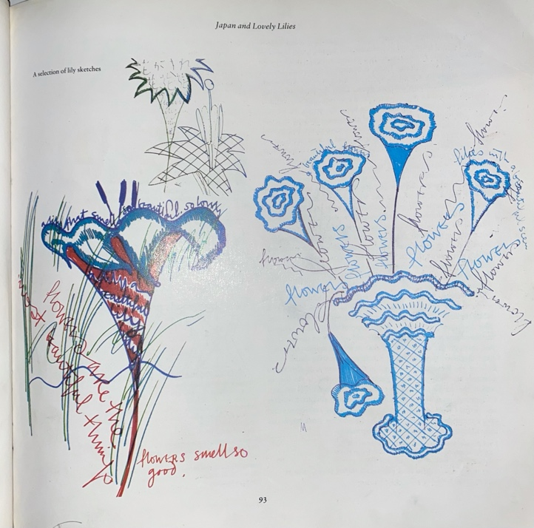

Fig.1 Lily Sketches, The Art of Zandra Rhodes

During Rhodes time in Tokyo, Japan, she started to “sketch lilies, fields of lilies, lily collars, lily petals”, see fig 1. (Zandra et al., 1984, pp.92) and finally created “A field of Lilies and Lovely Lily Flower” (Zandra et al., 1984, pp.92). She used “fresh fish, vegetables, and flowers in the market” to inspire her and start her sketches. ‘Intercutting’ was a special skilled technique Rhodes used to perfect her designs by “continually cutting and re cutting the paper and fitting it together” (Zandra et al., 1984, pp. 92). She did this to see her design, and perfect it before continuing to progress with the design.

Intercutting is a technique of cutting two pieces of paper (one directly on top of the other) at the same time so that the incorrect piece can be cut out, then lifted out, leaving a clean, exact-fitting replacement from the sheet that has been lying underneath. The design is then turned over and stuck edge to edge with Sellotape. (Zandra et al., 1984, pp. 92)

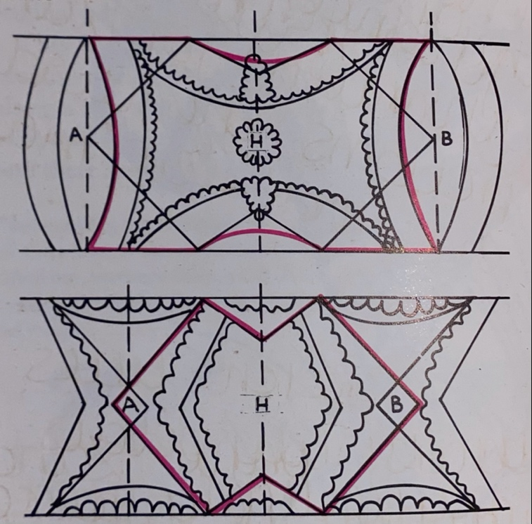
Fig.2 Motif Design, The Art of Zandra Rhodes

Rhodes “developed a way of printing by turning the screen to reverse the print” (Zandra et al., 1984, pp.94) to create her designs. Diagrams above show a comparison of how two designs that are totally different can be used using this format to create different designs. The diagram above is showing ‘Reverse Lily’ and ‘Lace Mountain’ from Rhodes collection whilst in Tokyo, being used and achieving different design outcomes.

This design is a three colour print on silk chiffon. It is a screen repeat which was later developed into a “asymmetrical, draped, taffeta dress” (Zandra et al., 1984, pp.94).

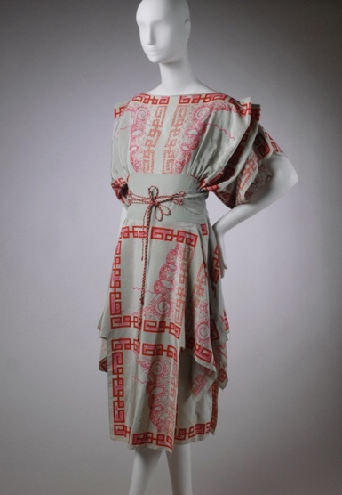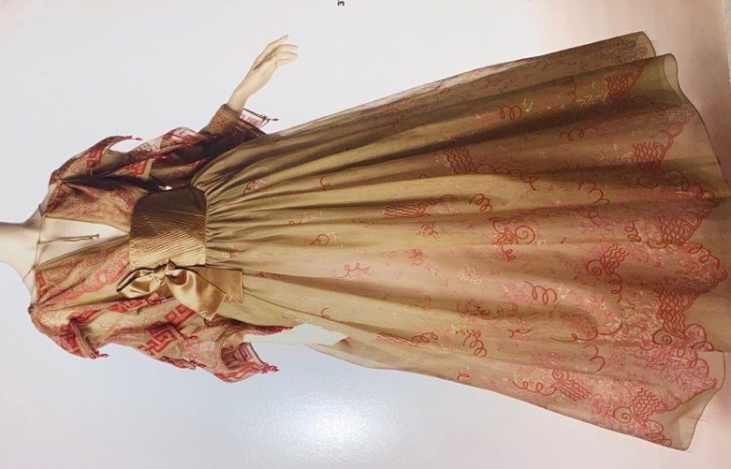

Fig.3 Blouse & Skirt, 1979, Zandra Rhodes, A lifelong love affair with textiles.

This gown is made up of a blouse and a skirt. Named ‘Chinese Squares’. The blouse was created using silk organza with pagoda sleeves in jade green and finished with the ‘Chinese Squares’ print in Chinese Lacquer red, white and pink.” (Geisel et al., 2005, pp.36) This design was created using “Kodatrace separations” (Geisel et al., 2005, pp.32). “Kodatrace is a special tracing paper made from frosted acetate and used as part of the exposure process when putting imagery onto silk screens” (Rose, 2010). To do this process the screen will be prepped by being coated in a “light sensitive” (Geisel et al., 2005, pp. 32) emulsion. The kodatrace is then carefully positioned on to the screen. Using a strong light source, the screen will then be exposed, the areas that have not been exposed to the light will then wash away leaving the mesh open for printing. The fabric is then placed on the table prepared table ready for printing, the dye will then be able to pass through this area and print the design using a squeegee.

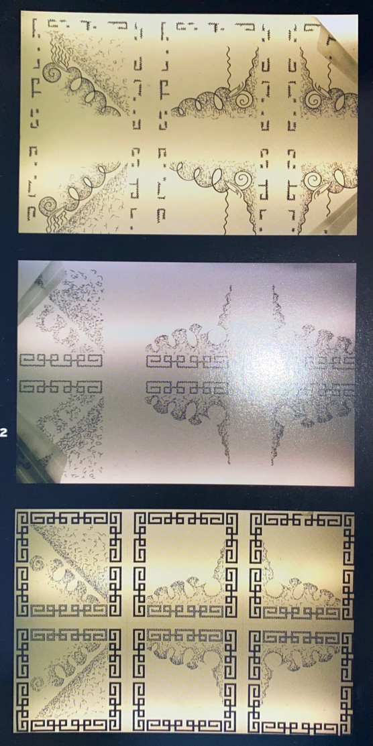

Fig. 4 Kodatrace, Zandra Rhodes, A lifelong affair with textiles

The images in figure 3 are the kodatrace transparencies that are exposed onto screens. These designs to produce the Chinese Print pattern used on the blouse and skirt in figure 3 The reason for three screens is because three colours are used to print the designs. The first screen represents the colour pink, which means when printed onto the fabric pink acid dye paste would be used. The centre screen in figure 1 is the second screen, which represents the colour white, and the third screen being red dye paste. Once these have been printed, in their order the coloured dye will sit on top of each other to create the print, this can be seen in figure.2.

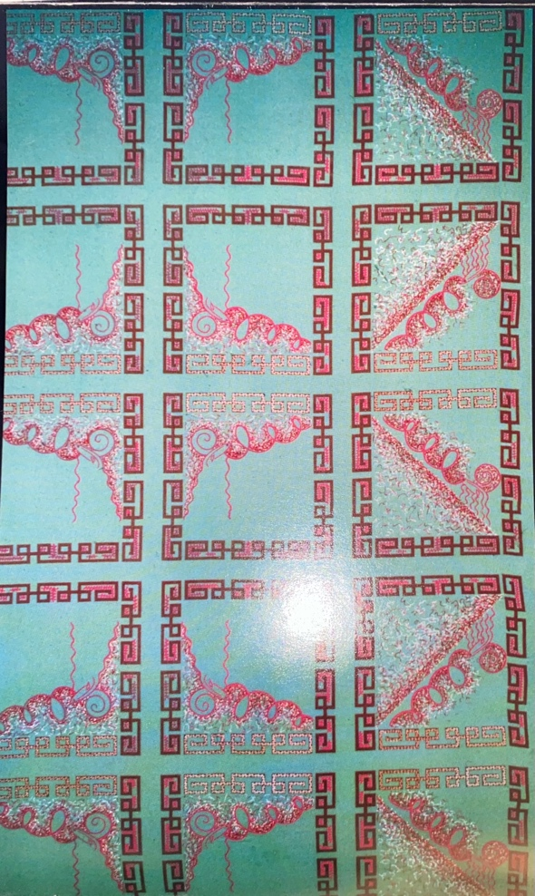

Fig.5 Chinese Sqares, Zandra Rhodes, A lifelong love affair with textiles

This is the final ‘Chinese Squares’ print on a silk crepe de chine. This design was also used to create the sleeves of another top, a “pagoda sleeve” (Zandra et al., 1984, pp. 217) was created by joining the squares of the ‘Chinese Squares’ print fig 5 together. The corners were then weighted down with “embroidered tassels”. (Zandra et al., 1984, pp. 217). As seen in Fig 3 (Zandra et al., 1984, pp.225) by Conrad Santavicca.

Orla Kiely
“Textile printing is an ancient art that can be seen in fabrics dating as far back as the 4th and 5th Centuries B.C. The earliest type of printing on fabric is block printing”. (Magic Textiles, 2016). This is a process Rhodes used in her work. However, “In the early 20th Century the modern process of screen printing arrived” (Magic Textiles, 2016), this process can be seen being used by surface pattern and textile artist, Orla Kiely.

“Few designers are as instantly recognisable as Orla Kiely, OBE, otherwise known as the “queen of prints.” (John Lewis, n.d.) Her designs are described as “Bold” (The Scotsman, n.d.), and “playful” (John Lewis, n.d.). “Kiely is a London based fashion designer originally from Ireland. She started off with only a drop of water in hand, and soon owned an ocean.” (FFD, n.d.) This itself shows the impact Kiely has on the textile and print market, which is why believe she is a great artist example to show the skill involved in my surface pattern design practice.

“Pattern is powerful and transformative, adding rhythm and movement to the sensory experience of colour and texture.” (Kiely, 2017, p.126)

Kiely has a keen interest in naturally sourced patterns. For example, “petals on a flower head, spiral shape of seashells, the crystalline form of snowflakes” (Kiely, 2017, pp. 130). This among many other things is what creates the “golden ratio” (Kiely, 2017, pp. 132), this is the basis of the “Fibonacci sequence” (Kiely, 2017, pp. 132). The Fibonacci sequence is where each successive number is the sum of the previous two, for example, 1:1:2:3:5:8. Kiely shows this method in some of her designs. Daisies, as an example often have “13, 21, 34, 55, or 89 petals, which all are Fibonacci numbers” (Kiely, 2017, pp. 132). “The ubiquity of the sequence in nature has led many to conclude that patterns based on the Fibonacci sequence are intrinsically aesthetic and, therefore, worthy of consideration in design.” (Lidwell, Butler and Holden, 2003, p.94)

Therefore, Kiely states, “Pattern is in the maths”. (Kiely, 2017, pp. 132). Kiely describes her take on nature more “abstract and graphic” to which she states she owes to “mid-century design” (Kiely, 2017, pp. 132) which is evident in figure 6.

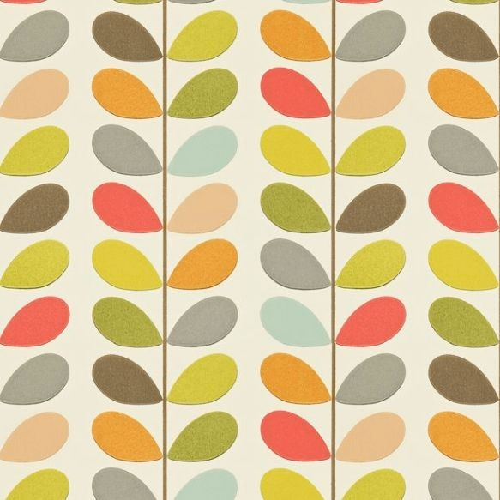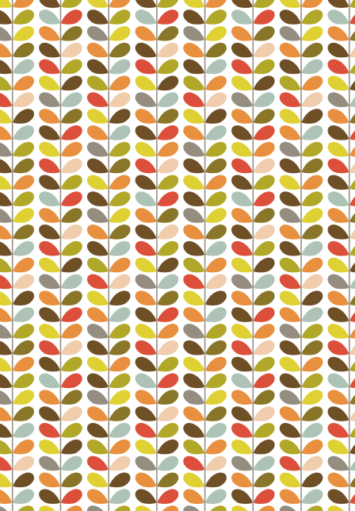

Fig.6 Multi Stem print, S/S 2008, Pattern, Orla Kiely

This is one of Kiely’s most recognisable pieces, if her name is not recognised her patterns certainly are. This pattern is a repeat print process, with every other stem repeating itself. This print is made up of stem motifs with petals, this is a self-repeating design, The Scandinavian 60s – 70s style is evident in this design, and it is apparent in most of Kiely’s work. There is a very natural feel to this print with the earthly green tones, and the vibrant pop of “Burnt Sienna” (Colour Lex, n.d.). This design is so successful, and it is transferable. This design has been applied to ceramics, wallpapers, furnishings, rugs, curtains, and even door mats. See figure 7 for reference.

The skill of alignment is prominent in Kiely’s work. Alignment is the “placement of elements such that edges line up along common rows or columns, or their bodies along a common center.” This then “creates a sense of unity and cohesion, which contributes to the design’s overall aesthetic and perceived stability”. (Lidwell, Butler and Holden, 2003, pp.24). This is one element that creates Kiely’s work so successful, that is a skill.


Fig.7 Multi Stem Print on doormat for Heal’s, Pattern, Orla Kiely

To conclude this essay, the skills of a surface pattern designer are everchanging, and do not always have to be learned or taught through the process of surface pattern. Many skills that are taught to a surface pattern design student can then be applied in many areas of the industry, similarly a mix of skills can also be used to create a surface pattern designer. With these skills you can also apply your own skillset to any pathway you choose, for example making, textiles and/ or fashion. The reasoning behind this is due to the skillset being so broad. Work by artist Dame Zandra Rhodes has been shown in this essay showing the more traditional style of surface pattern and the traditional surface pattern methods, for example kodatrace and printing. In comparison to Dame Zandra Rhodes, As previously stated, in an industry that is everchanging, with new technology being adapted?improved? there is no one definition to define the skill of a surface pattern designer.

.

Bibliography
Claire (2018). Contrado Blog. [online] Contrado Blog. Available at: https://www.contrado.co.uk/blog/surface-pattern-design/.
Colour Lex (n.d.). Burnt Sienna. [online] ColourLex. Available at: https://colourlex.com/project/burnt-sienna/.
FAMOUS FASHION DESIGNERS. (n.d.). Orla Kiely | Fashion Designer Biography. [online] Available at: https://www.famousfashiondesigners.org/orla-kiely.
Flaunter (2020). What is trend forecasting, and why is it relevant for my brand? [online] Flaunter. Available at: https://www.flaunter.com/blog/trend_forecasting/.
Ftmlondon.org. (2019). Zandra Rhodes: 50 Years of Fabulous | Fashion and Textile Museum. [online] Available at: https://www.ftmlondon.org/ftm-exhibitions/zandra-rhodes-fifty-years-of-fabulous/.
Geisel, A.S., Jamieson, S., Jones, J., Luis Da Silva and Al, E. (2005). Zandra Rhodes : a lifelong love affair with textiles. Zandra Rhodes Publications B.M. Zandra Rhodes Publications, pp.14, 21, 36, 32.
John Lewis (n.d.). Orla Kiely’s exclusive new range. [online] John Lewis & Partners. Available at: https://www.johnlewis.com/content/home/about-orla-kiely-exclusive-homeware [Accessed 24 Nov. 2021].
Kiely (2017). Pattern. London: Conran Octopus, pp.126, 132, 130.
(Klee, 1961, p. 76) Klee, P. 1961. in Spiller, J. (ed.), Notebooks, Volume 1: The Thinking Eye, London: Lund Humphries
Lidwell, W., Butler, J. and Holden, K. (2003). Universal principles of design : a cross disciplinary reference. Gloucester, Mass.: Rockport, pp.24, 94.
Magic Textiles. (2016). The History of Textile Printing. [online] Available at: https://www.magictextiles.co.uk/2016/09/11/history-textile-printing/.
RetailChoice.com. (2021). Surface designer in Manchester, Greater Manchester | The Orchard Agency - RetailChoice. [online] Available at: https://www.retailchoice.com/job/surface-designer/the-orchard-agency-job95423076?utm_campaign=google_jobs_apply&utm_source=google_jobs_apply&utm_medium=organic [Accessed 6 Dec. 2021].
Rose, E. (2010). emily-rose: kodatrace. [online] emily-rose. Available at: http://emilyrosebarnes.blogspot.com/2010/09/kodatrace.html [Accessed 23 Nov. 2021].
Study.com. (2019). History of Chinese Woodblock Printing Video with Lesson Transcript | Study.com. [online] Available at: https://study.com/academy/lesson/history-of-chinese-woodblock-printing.html.
The Scotsman (n.d.). Orla Kiely interview: one of the UK’s favourite designers on the patterns of her life. [online] www.scotsman.com. Available at: https://www.scotsman.com/lifestyle/orla-kiely-interview-one-uks-favourite-designers-patterns-her-life-141529.
www.uwtsd.ac.uk. (n.d.). Surface Pattern and Textiles (MDes, BA) | Swansea College of Art - UWTSD. [online] Available at: https://www.uwtsd.ac.uk/surface-pattern-design-textiles/ [Accessed 6 Dec. 2021].
Zandra, R., Rhodes, Z., Knight, A. and Marit Lieberson (1984). The Art of Zandra Rhodes. London: Jonathan Cape, pp.9, 11, 92, 217.
‌

List of Figures
Geisel, A.S., Jamieson, S., Jones, J., Luis Da Silva and Al, E. (2005). Zandra Rhodes : a lifelong love affair with textiles. Zandra Rhodes Publications B.M. Zandra Rhodes Publications, pp.37, 32, 33,.
Kiely (2017). Pattern. London: Conran Octopus, p.132.
McQuillan. (2011). YIELD:Zandra Rhodes – Chinese Squares. [online] Available at: https://hollymcquillan.com/2011/03/28/yieldzandra-rhodes-chinese-squares/.
Rhodes, Z. and Knight, A. (1995). Art of Zandra Rhodes. O’mara (Michael) Books, p.93.
‌

‌

