

Assessment Component 1

Lecturer Name: Diola Bijlhout

Student Name: Ronke Olomola

Student Number: 1916047

Course Name: Living with Care: The Older Person

Course Code: BMH6009

Date of Submission: May 5th 2022

Comparative report between The Elderly People in the United Kingdom and Norway



Table of Contents

Page Number

Introduction
This academic report will be critically evaluating the impact of loneliness and social isolation on the elderly population. The current based policy and provisions for care for older persons, in the United Kingdom and Norway will be focused upon. This report will examine what changes could be made to the programmes aimed at addressing the problems of loneliness among the elderly and how technology could be applied in the provision of care provision to lonely older persons. Finally, recommendations for improvements will be provided.

What does it mean to be an elderly person in the United Kingdom and Norway?
Ageing is a natural phenomenon, and it happens to very human being, as one grows older. It affects every area of one’s life such as, physical, mental, social, psychological and biological areas of the individual’s life. The British Medical Association (2016) explain that ageing could be described as growing old as been purely chronological perspective or as a biological process. In the United Kingdom once an individual reaches the age of 65 years, they are seen to be among the aging population. This is a time when individuals are slowing down in their working lives, either working part time or starting. Due to good healthcare and technology individuals are living longer and the live expectancies are increasing. It is not uncommon for individuals that become elderly often having chronic illnesses such as heart diseases, diabetes, and arthritis. The National Health Service in the United Kingdom can provide free healthcare for individuals that are born in the country. Thorlby (2020) highlights that all England residents are automatically entitled to free public healthcare through the National Health Service.
When focusing on Norway the elderly are protected and given good care, just as it is found in the United Kingdom, Qureshi et al (2022) argue that old age is often associated with functional and physical challenges that compromise the ability to perform necessary tasks required for daily living. Norway is known to have one of the best healthcare provisions especially for the elderly. Hawkes (2017) agrees with this line of thought and reports that research carried out among 30 developed countries showed that Norway was ranked first in the supporting of elderly people.
The elderly in the London is given free bus passes which are known as ‘freedom passes’, this is to encourage them to interact with the society and to travel. Transport for all (2020) highlights those individuals that live in London and are over 60 years old can apply for a free bus pass. However, in Norway there are similar incentivises for individuals to getting around however, individuals are offered at the age of 67 years old a discount of 50% for their travel.

Statistics On the Ageing Population in the United Kingdom and Norway
In the United Kingdom the following statistics were reported by Age UK (2019):
There are nearly 12 million (11,989,322) people aged 65 years and above in which:
5.4 million people are aged 75 years +
1.6 million are aged 85 years +
Over 500,000 people are 90+
14,430 are centenarians
In 50 years, times there is a possibility of those aged 65 and above to reach 8.6 million (ONS,2018)
Since the start of the 19th century in the United Kingdom has seen mortality rates decline and life expectancy increase (ONS, 2018). Appendix 2 shows the trend of the aging population over the years, both female and male in the United Kingdom.

In Norway the following statistics were reported by Ellingsen (2020):
Norwegians over 65 years are 940,000 and by the turn of the century there would be almost 2 million
The number that is 80 years or older will triple by the year 2060
In 1967 the life expectancy of Norwegian man was just 70 years but now it is 81 years and higher in women (Nikel, 2020)
In 1918 1% of the population was aged 80 or older by 2018 n figure had risen to 4% and the number is predicted to double over the course of two decades. (Engdahl et al, 2020). Appendix 3 shows how the elderly population is more than the children and teenagers. Appendix 4 shows the comparison of growths in United Kingdom and Norway from the year 2000 – 2018. United Kingdom’s growth was 2.50 and Norway was 1.93

Relevant Theories of Loneliness and Isolation
It is a common knowledge that when individuals age no matter the culture, creed, and sex there comes a time where there lives change, this could be due to health conditions, less finances due to them retiring and not having the steady income also the number of people the individual socialises with due to staying at home after retiring. The disengagement theory which was founded by Cumming and Henry in the 1950s explain that the elderly gradually withdraws from society, the society also disengage for the individual, it states that there is a mutual separation, this is because the retired individual is so engrossed with themselves and tend to withdraw from their surrounding world, and the world also withdraws from them. Asiamah and Lee (2017) explain that aging is irrevocable everybody is cable to grow old and lose glamour of being young. It is not desirable because it is associated with interrelated social, economic and health challenges. The disengagement theory unfortunately happens to a lot of the elderly in every part of the world. For example, in the United Kingdom statistics show how the elderly go on for weeks, or sometimes weeks with very little human contact and their companion most of the time is their pets or watching television. Age UK (2022) agree with this line of thought and says in the United Kingdom there are 1.4 million older people who are lonely. There are critics to the disengagement theory which state that this theory encourages the elderly to withdraw from society against their wish, also it encourages the society not to give the elderly any assistance in living a meaningful live. Tsatsou (2021) argues that the disengagement theory discourages interventions for helping the elderly and for them to disengagement for society even when they are not ready to. This theory can encourage ageism as the elderly will be set aside and discriminated upon due to their age.
Asiamah and Lee (2017) explain that the activity theory is the exact opposite of the disengagement theory, it was founded by Havighurst in 1960 this theory explains that the elderly should be active and are encouraged to undertake activities that make them happy, for example a lady who was a teacher when she was younger and now she is in her 90s she is given a book and pen to write and interact with those around her to continue to write, spell and play with words this woman will be feel happy within herself as she will not feel that she is just sitting around and not feeling despair. However, this theory has its critic which is that sometimes the elderly is not physically able to carry out the activities that the elderly is expected to do, or an elderly person who has vascular dementia may not be able to read or write so the tasks given to such individuals will not be possible. For this theory to work and be relevant the elderly individual must want to participate in the activity otherwise the activity will not be successful, and resentment may set in as it will be seen as forcing the elderly individual.

The Impact of Loneliness and Isolation on an Older Person Living Within a Care Setting

Reference
Age UK (2020), Loneliness research and resources available at https://www.ageuk.org.uk/our-impact/policy-research/loneliness-research-and-resources/ [Accessed on 26th March 2022]
Age UK (2018), Later life in the United Kingdom available at https://www.ageuk.org.uk/globalassets/age-uk/documents/reports-and-publications/later_life_uk_factsheet.pdf [Accessed on 25th March 2022]
Asiamah, N,. Lee, A,. (2017) Social engagement and physical activity: community on why the activity and disengagement theories of aging may be valid cogent medicine vol 4 available at https://doi.org/10.1080/2331205x.2017.1289664 [Accessed on 25th March 2022]
British Medical Association (2016), Growing Older in the United Kingdom a series of expert authored available at https://www.bma.org.uk/media/2105/supporting-healthy-ageing-briefings-final.pdf [Accessed on 25th March 2022]
Ellingsen, A. (2020) Norway’s Population ageing rapidly available at https://norwaytoday.info [Accessed on 25/03/2022]
Engdahl, B. L. Nielsen, S. C. Hjelivik, V. Reneflot, A. Nes, B. R. Berg, L. C. Gjertsen, F. Grinde, B. Husabo, J. K. Steingrimsdottir, A. O. Blix, S. H. Vollrath, T, M, E, M. Strand, H, B. (2019), Health among the elderly in Norway available at https://www.fhi.no/en/op/hin/groups/health-and-ageing-in-norway/ [Accessed on 25/03/2022]
Getting Around Norway Transportation Tips (2021) available at https://www.roughguides.com/norway/getting-around/ [Accessed on 25/03/2022]
Hawkes, N. (2017) Norway ranks first on supporting elderly people in UK British medical journal doi:10.11361bmj3645
Nikel, D. (2020), Norway’s ageing population problem life in norway
Office for National Statistics (2018), Later life in the United Kingdom
Office for National Statistics (2018), Living Longer: how our population is changing and why it matters: overview of population ageing in the UK and some of the implications for the economy, public services, society, and the individuals available at rahttps://www.ons.gov.uk/peoplepopulationandcommunity/birthsdeathsandmarriages/ageing/articles/livinglongerhowourpopulationischangingandwhyitmatters/2018-08-13 [Accessed on 25/03/2022]
Qureshi, A, S. Kjollesdal, M,. Gele, A,. ( 2020), Health disparities and health behaviours of older immigrants and native population in Norway PLOS One available at https://doi.org/10.1371/journal.pone0263242 [Accessed on 25th of March 2022]
Tikkanen, R. Osborn, R. Mossialos, E. Djordjevic, A. Wharton, A, G. (2020) International healthcare system profiles England the commonwealth fund
Tsatsou, P,. (2021), Aging: the two faces of janus in digital inclusion International journal of communication available at https://ijoc.org/index.php/ijoc/article/view/14220/3383 [Accessed on 26th March 2022]

Appendix 1

An old lady’s poem.
“What do you see, nurses, what do you see?
What are you thinking when you’re looking at me?
A crabby old woman, not very wise,
Uncertain of habit, with faraway eyes?
Who dribbles her food and makes no reply
When you say in a loud voice, “I do wish you’d try!”
Who seems not to notice the things that you do,
And forever is losing a stocking or shoe…..
Who, resisting or not, lets you do as you will,
With bathing and feeding, the long day to fill….
Is that what you’re thinking? Is that what you see?
Then open your eyes, nurse; you’re not looking at me.
I’ll tell you who I am as I sit here so still,
As I do at your bidding, as I eat at your will.
I’m a small child of ten …with a father and mother,
Brothers and sisters, who love one another.
A young girl of sixteen, with wings on her feet,
Dreaming that soon now a lover she’ll meet.
A bride soon at twenty — my heart gives a leap,
Remembering the vows that I promised to keep.
At twenty-five now, I have young of my own,
Who need me to guide and a secure happy home.
A woman of thirty, my young now grown fast,
Bound to each other with ties that should last.
At forty, my young sons have grown and are gone,
But my man’s beside me to see I don’t mourn.
At fifty once more, babies play round my knee,
Again we know children, my loved one and me.
Dark days are upon me, my husband is dead;
I look at the future, I shudder with dread.
For my young are all rearing young of their own,
And I think of the years and the love that I’ve known.
I’m now an old woman …and nature is cruel;
‘Tis jest to make old age look like a fool.
The body, it crumbles, grace and vigor depart,
There is now a stone where I once had a heart.
But inside this old carcass a young girl still dwells,
And now and again my battered heart swells.
I remember the joys, I remember the pain,
And I’m loving and living life over again.
I think of the years ….all too few, gone too fast,
And accept the stark fact that nothing can last.
So open your eyes, nurses, open and see,
…Not a crabby old woman; look closer …see ME!!

Appendix 2

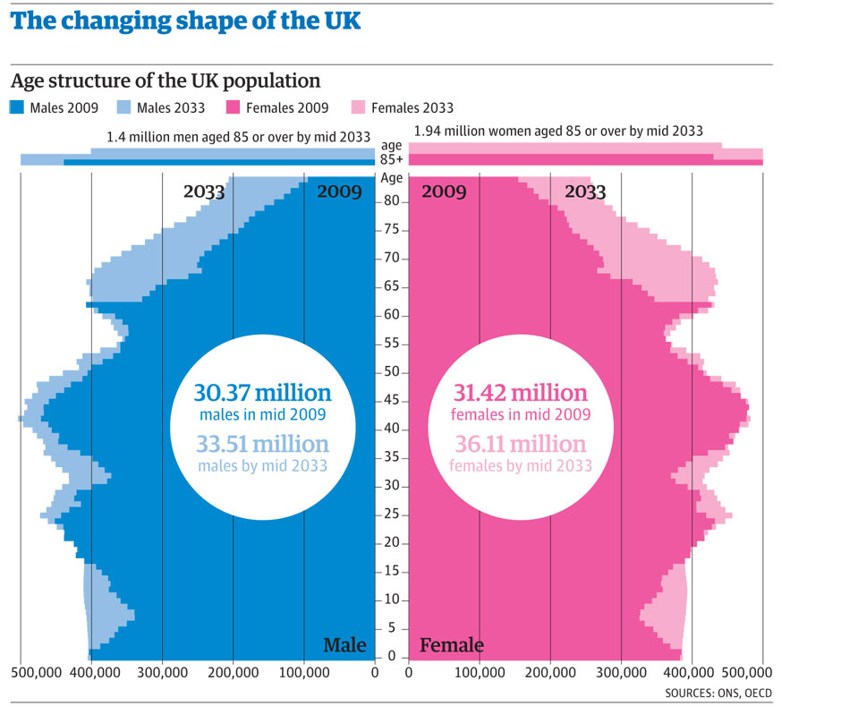

Appendix 3

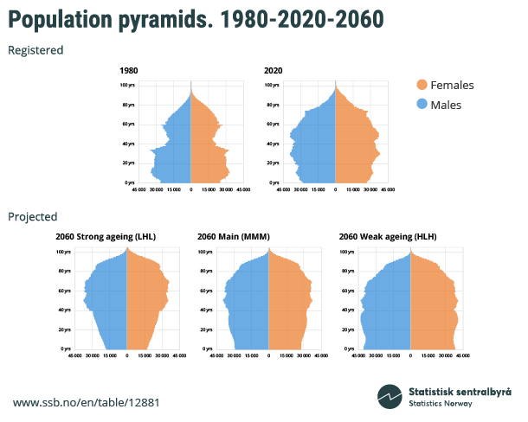
A historic Shift: More elderly than children and teenagers in Norway

Appendix 4



