MBA MARKETING MANAGEMENT (75%)
UNIVERSITY OF WALES TRINITY SAINT DAVID
TITLE: AMAZON INTEGRATED MARKETING COMMUNICATIONS
MODULE CODE LMCB7001
LECTURER: TUSHARA
NAME: TAYYABA ABDUL KARIM SHAIKH
STUDENT ID: 2131214

- Introduction
Amazon.com, Inc. is a multinational corporation engaged in online retailing, with its headquarters located in the United States. It was rated 43rd overall out of the top 100 retailers in the world in 2009, according to Holton (2009), and it is the finest electronic shop in the whole world (Interbrand, 2010). In 1994, Jeff Bezos launched this company, and the following year, in 1995, it began selling products online in an unprecedented volume. By the end of the year 2009, it had a workforce of 20,700 people and contracts totaling $24.509 billion US dollars. There were 615 million visitors to the fundamental space in the year 2008. Every one of the nations on this list, including the Brought Together Domain, China, Canada, Germany, and France, has an Amazon website that is active. It is possible to save time and money by sending different things to different nations all over the globe by using the postal service. Amazon has dynamically fanned out into the retail advancement of a wide combination of things, including music in conservative circles, DVDs and tapes, programming, client equipment, grass and nursery things, kitchen stuff, clothing, open air supplies, gadgets, watches, toys, and games, youngster things, lavish food, diamonds, prosperity and individual thought things, brilliance things, instruments, food, dress, the present day, and coherent supplies, and that is just a small selection of the things that are available on Amazon (Answers, 2010). Amazon is the finest electronic retailer on the planet, and it has a share of the whole market that is somewhere between 70 and 75 percent, or a greater proportion of the actual book deals that take place on the internet (Shatzkin, 2009). In addition, Amazon is by far the most dominant player in the market for electronic book readers (Holton, 2009).
- Background information about the company e.g. when was the company first established and who founded the company. The mission statement could also be included.
Amazon was founded in 1994 as an online retailer and has its headquarters in Seattle, Washington. "Jeff Bezos, the CEO of Amazon, viewed it as a fundamental necessity from the very beginning that the organisation should be an all-around asset for everything" (Hartman). When naming his web-based company, Bezos did not have Amazon at the forefront of his mind; as a result, the name Amazon was not his first or even second best option. He was considering calling it Cadabra, which means "moving ahead," as a possible name for it. In spite of the fact that he was warned against it, he went ahead and called it after the Amazon River, which is the longest river in the world. It is well knowledge that providing excellent customer service and being easily accessible are two of Amazon's most important strengths. Other concentrate skills include the strength of the website's content, the pervasiveness of the search tool over locating one's most favored items and cost, limitless options for assurance, exceptionally developed firms, and the predominance of the website as a whole. Amazon is strengthening its middle capabilities by enhancing its electronic market and taking into consideration the requests of its customers. In addition, Amazon employs web development to manage the financial concerns of its consumers and make their lives simpler. According to the association's middle capacity strategy, Amazon's fundamental capabilities are used in each and every piece of its structure with the only exception of one. The new focus capacities are also being made in the business areas of online business by financially collaborating themselves with web development associations like Exchange.com, Accept.com, and Alexa.com, which are emerging mechanical assemblies for the web business focus. This is one way that the new focus capacities are being made. New business sectors, such as live closeouts, contraptions, invitation cards, and fulfilling the requirements of customers, are receiving capabilities as they are developed. They are gaining an edge by increasing the services and options they provide, such as catering to readers, game players, and members of the music crowd, and this development enables them to provide a greater proportion of what their customers demand (Blakeman, R., 2018).
The explanations and vision clarifications provided by Amazon.com, Inc. have a fundamental impact on the direction that the worldwide development and electronic business association takes to achieve sustainable advancement and breakthrough. This accomplishment may be deduced from the stringent frameworks that were established in order to ensure that the vision and goal statements would be accomplished. On a more basic level, the corporate vision statement helps to promote a progressive path toward an ideal future condition for the association. On the other hand, the corporate mission statement sets business aims and advises important organisations within the association. Both of these attestations are sections of the mission statement for the company. The findings of this company investigation suggest that the satisfaction of Amazon's customers should be the primary focus of the association's mission statement. For example, the company notifies its target customers about favorable developments in the electronic business field, such as the availability of a diverse range of products and services, so that the customers may experience the benefits of these developments. The Amazon.com, Inc. SWOT analysis takes into account one of the company's business resources, which is analogous to the depth of the item mix that was presented by the company. In this instance, the mission statement of the affiliate paints a picture of an idealized future in which it has what is now happening in the electronic retail industry as well as what it had in the past with regard to human resources, the board, and workplace safety (Blakeman, R., 2018).
- Include a definition of communication
Amazon has invested in a broad variety of other online shops, ranging from companies that sell shoes and books to those that offer electronic gadgets. These investments include both large and small businesses. Amazon is most likely not at the end of its journey toward improvement at this point in time. They have achieved a great deal of success in a very short amount of time by extending their operations into new territories and developing their businesses. Amazon Prime Air is the name of a fairly new service that is currently available from the online retail giant Amazon. According to the website of the organisation, Amazon Prime Air is "a movement method from Amazon anticipated to safely carry products to customers in less than 30 minutes using robotized flying vehicles, generally called drones" (Amazon.com). They will get even more assistance as a result of the successful implementation of this system, which will, in turn, further strengthen the amazing assistance that they presently give for their customers. They have been methodically growing their network of dispersion and satisfying objections all throughout the nation, and they do not intend to stop doing so any time in the near future. They have started selling items under their own Amazon image name, and customers may buy these items right now if they want to. Things got underway with the fuel, then moved on to the resonance, and at this point, we have Alexa from Amazon (Blakeman, R., 2018).
“The Amazon communication correspondence mix is in charge of overseeing different components of the advertising mix, such as print and media advancing, discounts progressions, events and experiences, promoting, and direct exhibiting”.
When it came time to package a person's possessions, the company predicted that all a person would need to do is put all of their belongings inside an Amazon-checked box. This was due to the large volume of shipments that consistently came into and left Amazon's various offices. Amazon has developed a system that it refers to as "frustration-free squeezing," and part of this system is that some items may be sent in the same holders that they were originally packed in (green). This will result in assets in the future, both financially and in terms of time. The company came to the conclusion that the thing's packaging shouldn't worry about being especially captivating; rather, it should be strong to ensure that the thing can go from point A to point B without the things in the carton being compromised in any way. This goal was arrived at after the company came to the conclusion that the thing's packaging shouldn't mess around with being especially captivating (Chandrasekar, S. & Vethirajan, C., 2020).
- Include a diagram and briefly explain a communication model
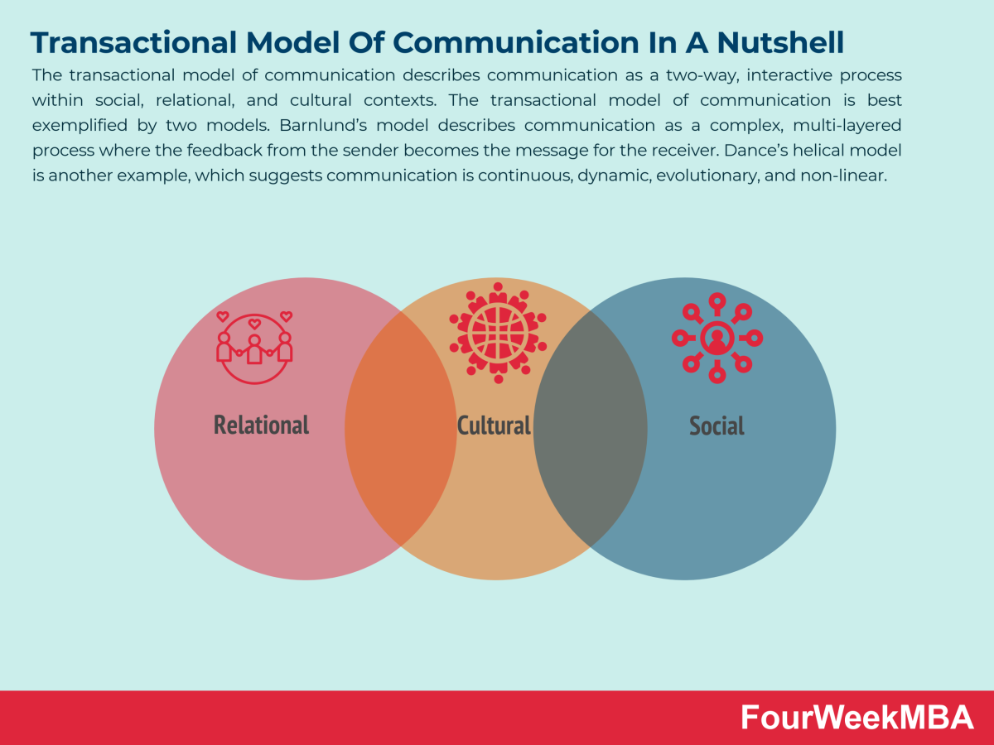
Fig 01 A Communication Model (Transactional Model of Communication)
- Integrated Marketing Communications
“Amazon's advertising communication mix is in charge of different parts of the advertising mix, such as print and media advertising, price changes, events and experiences, advertising, and direct advertising.”
The most recent trends in marketing need businesses to use a variety of strategies in order to attract customers and provide them with information on the company's reputation. The phrase "coordinated marketing correspondence" (IMC) refers to the process of using the multiple communication channels that are all acceptable to the company for the goal of advertising. This practice is also known as "coordinated marketing." In this article, an analysis of Amazon's IMC method will be provided, along with a number of hypotheses on the path that its future activities may take. Because of recent occurrences, we have come to the conclusion that the most effective course of action for us to do is to extend our viewpoints and create more place in our schedules for growing our partnerships with individuals who are a part of our customer base. We are going to start working on that right now since this is a great way to convey what we have learned about Worked with Displaying Exchanges (IMC) and how Amazon has really achieved it (Vethirajan, C., 2020).
- Explain what new promotional strategies your company can use to raise awareness of the brand
Bezos originally envisioned Amazon.com as an enhancement company that would streamline the shopping experience for consumers who were actively engaged in other tasks while using the internet. This was the goal he wanted to accomplish through Amazon.com. This was the most significant division that the company had. It was widely believed that Amazon.com would be unsuccessful, and it was also widely believed that the association would be fruitless in its primary goal of maintaining carefulness for the sale of books in the face of competitors who had purposefully planned their tasks, such as Barnes & Noble, Respectable, and Fair & Square. Both of these outcomes were widely believed to have been widely anticipated. In passing, I'd like to mention that "if everything else fails, Amazon.com swiftly grew," reach one million customer accounts by October 1997 and 180,000 customer accounts by December 1996. This occurred despite the fact that several people dissected Bezos' goals for Amazon.com and demonstrated that it was impossible to achieve such a target. Nevertheless, this occurred. According to Passage, "the organization's annual plans increased from $15.7 million in 1996 to $148 million in 1997," and ever since that point in time, they have continually developed at a pace that is higher than before. The well-known online book shop celebrated the year 1998 by expanding its obligations to include music and movies. This decision was significant for the organisation as a whole in terms of its strategy for general growth. It has previously reached a high level of success in recent times with relation to the sales of books. They did the same thing with their tactics and took them over to various commercial sectors all around the world, beginning with Germany and the Accumulated Space and expanding from there. Additionally, as of the year 1999, the company was providing its customers with apparatus, personal computer games, software, goods for the house, children's toys and games, as well as a great deal more (Way). As of right moment, Amazon is in the process of transforming itself into the "everything shop" that Bezos said the company should be. This is the location at which Bezos made the aforementioned remark. Bezos, more than anybody else, failed to keep in mind the concept that the company should have some kind of ownership position in the networks. This was the circumstance, despite the fact that other things may have presented themselves in a different light. However, the association had the assumption that it would start tracking shares in order to provide the organisation a higher degree of command over the transportation, and planning for this endeavour began in the year 1997. The affiliation speculated that it would start monitoring shares in order to provide the organisation a higher degree of command over the transportation, and it estimated that it would start doing so soon. The partnership started hunting for pariahs around the year 2000 to offer their own items straight to end buyers over the Amazon stage as a deals channel. These invulnerable people have been recruited by Amazon to sell their wares via the company's commercial centre." Since it initially began providing Amazon Online Associations in the year 2002, the association has lately provided data on web-based traffic plans, website normalcy, and other statistics for industry professionals and advertising." In addition, they offered a service that was known as the "Adaptable Figure Cloud," which enabled customers to lease access to managerial influence on PCs for either a very small amount of money or an extremely large amount of money, depending on the customer's preferences. This service was available to customers around the world. Regardless of how well these various companies were organized, the one that stood out the most was, without a shadow of a doubt, the online store that provided each and every one of the aforementioned options. Without a shadow of a doubt, this was the most important question that was asked at the meeting as a whole (Vethirajan, C., 2020).
- Include a definition of branding and brand equity
“Between the years 2007 and 2022, Brand Cash carried out several computations on Amazon in order to determine the value of brands. There have been 41 different rankings of brands that have been related with the value of the Amazon brand. These rankings include the most unexpected and significant retail brands, the greatest US brands, and the best brands overall.”

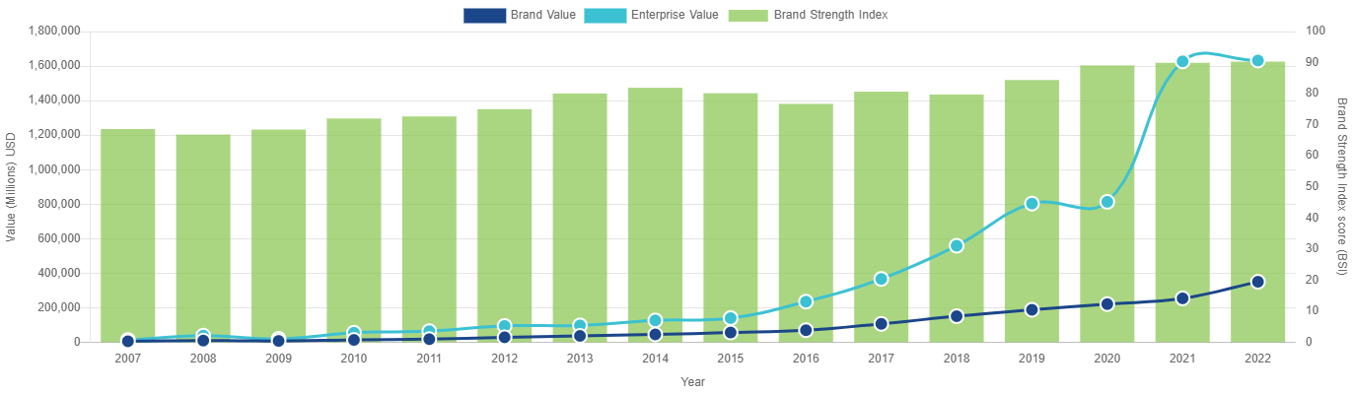
Fig 01 branding and brand equity of Amazon
- Explain and relate either Keller’s Brand Equity model or Aaker’s Brand Equity model to your company.
Because brand value as a standalone concept is sensitive, subtle, and difficult to measure, the most effective method for working toward it is to do so via measurable phases while making use of a model. The CBBE model that has received the greatest attention over the course of time is known as the Keller Model. This model was developed by Educator of Advancing Kevin Way Keller and was first communicated in a surprisingly long time as a major Key Brand called The Load Up. The Keller model is presented in the form of a pyramid, and it instructs organisations on the most effective means by which they can cultivate themselves, beginning with a strong foundation of unmistakable brand evidence and working their way up toward the sacred goal of brand esteem known as "resonation." When customers recognise that they have developed a connection with a brand that is solid enough for them to promote it to other people, it is a sign that they have reached a turning point in their collaborative efforts with a firm (Vethirajan, C., 2020).
Because one level of the pyramid is managed by the level that came before it, it is very important to check and make sure that each step of the pyramid is safe before moving on to the succeeding levels. When a brand gets closer and closer to achieving resonance, it opens up more lucrative chances to recognise and influence the loyalties and mindsets of its purchasers, regardless of whether those loyalties and mindsets are good or negative. Finding out what customers find annoying about a product or service helps a company understand how its customers feel about that product or service, which in turn allows the company to transform those frustrating experiences into ones that are exceptional.
Before their customers have ever bought the item, and maybe even before their customers are aware that they want it, sponsors are able to perceive the value in what their customers continually require. The decomposition of CBBE into Keller's four steps enables this to become a reality. There are a few different factors that have the potential to have an effect on brands. The demonstration of exhibiting has developed throughout the course of time, but there is one prevalent principle that does not seem to be disappearing in the near future: the need should always be the customer. This is a regular catch-up session for the owners and promoters of the firm. Because there is such a large quantity of it, it typically enters the maxim order. When a customer of a certain brand is happy with the service they get, the associated company sees an increase in revenue. Not only in terms of what satisfies their customers, but also in terms of how that satisfaction may be sustained, it is essential for businesses to recognise the relevance of their customer loyalty base in the present market (Vethirajan, C., 2020).
In this dangerous world that is filled to the brim with competing voices that are always clamoring for people's attention, it's possible that even supplying them with a fleeting portrayal of joy may not be enough at this moment. To ensure continued business with a customer, it is necessary to ensure that the customer is happy. This happiness should translate into an extended and painstakingly cultivated relationship (Bowers, A., 2018).
- Discuss the customer journey and customer touch points for Amazon organisation
You could include a diagram and explanation of a customer journey map for your organisation
A graphical representation of the journey that a client goes on is called an "adventure map" for that client. The following five "A's" are covered by this tool while organizing a client adventure map: being cautious, demanding, asking, and acting. In addition, there is a supporter provided. The "care" stage of the process often referred to on occasion as the time when prospective new customers investigate your company, is the period that is of the utmost importance. During this period, companies have the opportunity to promote their wares to potential customers or enhance the security measures they have in place. The solicitations are intrinsically linked to the ask, which takes place when customers investigate the brand and look for products or organisations that might suit their criteria. The solicitations and the ask go hand in hand. They might also visit a conventional shop, read reviews, or take part in open-source projects in order to get inspiration. The last stage of the customer experience is called "mobility," and it consists of the customer making purchases. In the end, the organisation now has the opportunity to advocate for itself by reaching out to previous customers, sending them an electronic card to show gratitude, mentioning that they provide analysis, or providing opportunities for research and evaluations, for example (Bowers, A., 2018).
There is no journey map that is typically acceptable; rather, each organisation will have its own travel map that is exceptional. The first step in providing assistance is to think about the channels via which customers are brought into touch with your company. This is the fundamental phase. The subsequent step is to recreate the researching and purchasing process while remembering every conceivable experience that a customer could have with your company's website, promotions, customer care delegates, or online game stages. This should be done while simulating how a customer would interact with your organisation. A common component of customer journey maps is the inclusion of areas that highlight the various customer contact centres. They have been organized in the form of a step-by-step process to demonstrate how a typical customer might feel while working with an organisation. This allows the marketing and customer service teams to discover touch points that lead to the disintegration of the client experience, enabling them to get rid of such touch points and improve the experience overall.
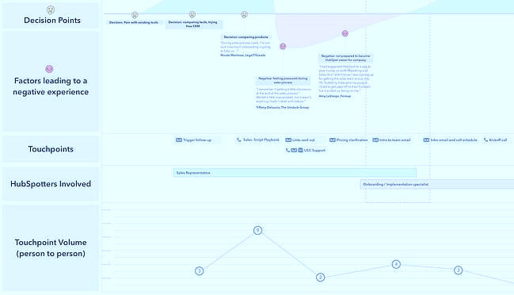
Fig 02 touch points for Amazon
- The Total Engagement Model could be explained and related to your company
It makes no difference if this is simply a tiny part of a much bigger report since it still gives us a comprehensive grasp of how essential touch points are to the process of improving and client care gatherings. In the primary message, the bits typically appeared in red to indicate regions of disagreement, but the spots typically appeared in green to highlight correspondences that are favorable. When customers are given the opportunity to make a selection, they may on occasion see yellow touches, which will ultimately result in either a green or a red area. Because of this advancement, we are now able to explore a more comprehensive picture of the different touch points that take place at various periods over the course of the customer's experience. Because of this, it is far less difficult to recognise parts of our association that might be enhanced in order to boost the amount of satisfaction that is offered to customers (Bowers, A., 2018).
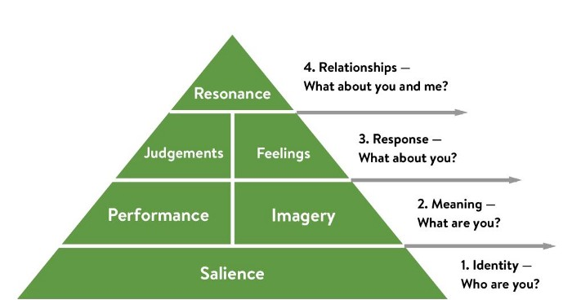
Fig 03 customer journey and customer touch points for Amazon organisation
- Conclusion
Amazon's processes may be powerful since the company has been effective in picking several customers for its setup for a long time. The majority of IMC devices give the appearance of being utilized by the company. Regardless, a variety of qualities, such as a fixation with verbal trading rather than a more thorough strategy, may generate problems with managing Amazon's image.
One theory is to conduct acts that elicit emotions that encourage purchasers to bequeath their great experiences on Amazon, such as via technological distraction. The capabilities of Amazon's IMC processes were studied in general in this article. The corporation uses numerous automated channels, such as communications, assigned promoting, a changed presentation website, and prepared engagement with bloggers, as part of its progressing strategy. These strategies work because Amazon can show the proposal to individuals and enable them to accept or reject it. The purpose is to pledge more respect for verbal commerce and channel the board to guarantee that Amazon's ideal message to consumers is adequately communicated via this channel.
- References
- Blakeman, R. (2018). Integrated marketing communications: Creative strategy from idea to implementation (3rd. ed). Rowman & Littlefield.
- Chandrasekar, S. & Vethirajan, C. (2020). A study on digital marketing – A case with spesial reference to Amazon.com. Studies in India Name Places, 40(12), 594-606.
- Quiroz, M. A. (2018). Amazon.com’s integrated marketing communications 2018. Medium. Web.
- Jeremy Clarkson sticks it to the BBC in Amazon Fire TV ad (2015) The Guardian, Available at: http://www.theguardian.com/media/mediamonkeyblog/2015/oct/30/jeremy-clarkson-bbc-amazon-fire-tv-ad-top-gear
- Soper, S. (2015) “Amazon Uses Cute Animal Videos to Woo Shoppers in Ad Uptick” Bloomberg Business, Available at: http://www.bloomberg.com/news/articles/2015-12-22/amazon-uses-cute-animal-videos-to-woo-shoppers-in-ad-uptick
- Williams, R. (2019) “Amazon quadruples digital ad spending to overtake Netflix, study finds” Marketing Drive, Available at: https://www.marketingdive.com/news/amazon-quadruples-digital-ad-spending-to-overtake-netflix-study-finds/560769/
- Perez, S. (2015). “Amazon Turns Its Boxes into Ads with First-Of-Its-Kind Marketing Deal for “Minions” Movie” Tech Cruch, Available at: http://techcrunch.com/2015/06/02/amazon-turns-its-boxes-into-ads-with-first-of-its-kind-marketing-deal-for-minions-movie/#.pjwowkj:xd4A
- Fiore, F. (1999) “Viral marketing: Spread a cold, catch a customer” Phoenix Business Journal, Available at: http://www.bizjournals.com/phoenix/stories/1999/06/28/newscolumn8.html
- Peck, M. (2013). “Amazon goes viral with new flying robot delivery service!” The Drum, Available at: http://www.thedrum.com/opinion/2013/12/05/amazon-goes-viral-new-flying-robot-delivery-service
- Bowers, A. (2018) “WHY WE LOVED AMAZON’S CELEBRITY-STUDDED SUPER BOWL AD” MCG, Available at: https://www.morriscreative.com/loved-amazons-celebrity-studded-super-bowl-ad/
- Lacy, L. (2018) “Inside the Rise and Fall of ‘Christmas in July’ Sales” AdWeek, Available at: https://www.adweek.com/digital/inside-the-rise-and-fall-of-christmas-in-july-sales/
- Amazon Platinum Mastercard (2022) Amazon, Available at: https://www.amazon.co.uk/Amazon-Platinum-Mastercard/dp/B01LSOD0ZI
- Hubbard, L. (2017). Why Is Identifying the Target Market so Important to a Company?. Retrieved from http://smallbusiness.chron.com/identifying-target-market-important-company-76792.html
- Clow, K.E., & Baak, D. (2013). Integrated advertising, promotion, and marketing communications (6th ed.). Retrieved from https://phoenix.vitalsource.com /#/books/9781323105061/cfi/6/18!/4@0.00:0.
- Jenkinson, A., & Sain, B. (2005). Amazon Bonding customers with Integrated Service. , (), 1-2
- Keller, K.L. (2013). Strategic Brand Management (2nd ed.). Retrieved from https://phoenix. vitalsource.com/#/books/9781323108826/cfi/4/4!/4/2/12/12/26/4@0:17.4

- Appendices


