University Of Wales Trinity Saint David
Franchise Success in both Movies and Video Games
A comparative report on the reception of Movies and their Licensed Video Game counterparts
Anthony McDonald: 1701752 HPAR5005
7/19/2019

Contents
- Abstract
- Introduction
- Methodology
- Product Overviews and Review scores
    - Finding Nemo
      - The Game Structure
      - My Response + Thoughts on the Scores
    - The Matrix
      - Why the different title?
      - Story Presentation
      - My Response + Thoughts on the Scores
    - Disney Pixar’s Cars
      - Remembered fondly but why?
      - ‘Minimme’ and his ‘Cars’ reaction
    - Spider-Man 2
      - One of the Greats
      - Talking with a Technical Director
- Findings
      - Results
      - Discussion
- Conclusion
- References
- Appendix
  - Appendix A
Abstract
In this report I looked at a select few movie licensed games that I played and explored the overall reception they received. Looking at those scores and then analysing why they might have been positive or negative and if by the end of my experience whether I deemed the poor reputation that movie licensed games has is deserved.
Speaking to an online reviewer of these games as well as someone who actually worked on one of the most revered movie games provided me with different perspectives alongside an understanding into how these games are made and the difficulties these developers face compared to other games that aren’t licensed to a cinematic release.
I look and discuss any trends or correlation between the success and how both critics and audiences reacted to both the movies and games and why one may be higher than the other.

Introduction
With an infamous reputation of being bad, movie licensed games are almost considered their own genre and are an interesting look into how different the two mediums of entertainment actually are. A blockbuster movie may not always translate well into a gaming format, and even if it does have potential; this potential still must be reached by the developers contracted, seemingly a tough task for many.
Some Movie games are extremely interesting to see how the cast reprise certain roles, or how members within the film lack the understanding of even what a video game is, other “Movie Games” are actually quite good and undeserving of the stigma yet get lost due to irrelevancy.
Critic reviews are the best way to gauge an overall quality of a product in both the gaming and cinematic industries and help bring in potential players or viewers. Just because a film is critically slammed doesn’t mean the videogame alongside it has to be and it’s the same with success, a phenomenal blockbuster may produce the most mundane game in history and that’s an intriguing concept to me, that success isn’t necessarily consistent between the two.
Movies and Games alike however can be loved be hated by critics and yet loved by fans and visa-versa, so in this report I decided to look at the feedback from both audiences in order to gauge a better understanding at which can be considered overall more successful the Movie or the Video Game.

Methodology
For this report I compiled a variety of Movie review scores from the website ‘Metacritic’ which averages the scores of both critic reviews but also does the same for audience submitted reviews, allowing for a wider scale of critical response. Being able to see if the movie was deemed “good” by both note-worthy critics and also regular movie goers helped provide a sense of whether the movie can be considered “good” or successful. The reason I chose Metacritic for this report was because they also review video-games via the same review system, allowing for the movies and their coinciding video-games to be reviewed and rated through the same process allowing for easier comparison and analysis. Although Metacritic has faced some criticism itself on how the sites scoring system works (See Appendix A), these concerns can be almost disregarded due to the fact that I am comparing products rated and scored on the same scale.
Although I did not explore the reception and development cycle of every single movie-licensed game to exist, I ensured that I researched a wide variety of these games; different genres, developers and target demographic. I then decided to delve deeper and specifically look at and comment on four specific games for this report. By studying this set of games I was able to maintain the common denominator of them all being movie games whilst being able to determine if there’s any patterns of success, in other words I am able to see if there is a trend of successful action movie-games compared to adventure movie-games. Another influence for picking the select few games that I did was not only due to personal first hand access but also the legacy that still surrounds them to this day and seeing whether their reputation of the time it was produced has changed since then.
To help give me insight to how one of these games came about, I reached out to Jamie Fristrom a developer of the Spider-Man games based around the Spider-Man movie trilogy directed by Sam Rami that released in the early 2000’s. I was able to set up an interview with Jamie and discuss the creative process of the games he worked on, with this knowledge I was able to then compare the thought and work that went into those games to perhaps less successful movie-games.
In preparation for this report the first thing I had to do was experience these forms of entertainment first hand, I watched all the movies required and also played a significant amount of the games linked to them. Although I did not have access to all the games I was able to research them via online videos and also through discussing them with an online personality with over 74 thousand subscribers on Youtube. Peter is known by his online alias ‘Minimme’ with a majority of his following due to his discussion and reviews of Movie Licensed games, throughout this report I will be referring to him as ‘Minimme’ as opposed to his full name for privacy reasons and the fact that his alias is the one with the reputation of playing and reviewing these games. By the time I had finished gathering all my information I had in fact consulted Peter multiple times in both an informal environment where we just discussed several of these products and also in more formal interview like situations in which I asked specific questions to understand another perspective.
If the game was released for several consoles I will be specifically recording the scores from the ‘Playstation’ platforms as they are the ones I have had personal access to and all these games are available on.

Product Overviews and Review Scores
Finding Nemo

 | Movie Production | Licensed Game
Title | Finding Nemo | Finding Nemo (PS2)
Promotional Art/Box Cover | 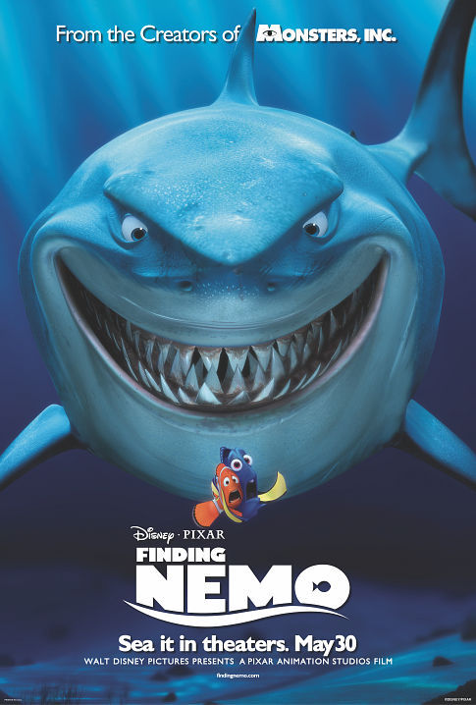  (Image Provided by IMDb) | 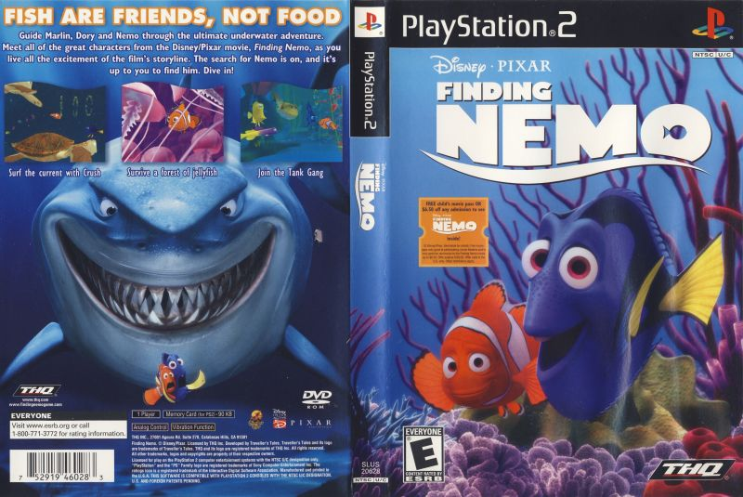  (Image Provided by Moby Games)
Date of Release | United States:  May 30th 2003(IMDb) | United States:  May 9th 2003(Metacritic)
Average User/Audience Metacritic Score |  | 
Average Critic Metacritic Score |  | 

The Game Structure
I chose this game as it was one that sprung to mind when researching these movie licensed games, it was a game and movie franchise I have many fond memories of with the movie still holding up extremely well for all ages to this very day. With this game being linked to such an iconic franchise loved by many, it was a no brainer for me to go back and experience the video game and look into its critical reception.
Finding Nemo the Video Gam follows an expansion of the movie’s plot with purpose of creating a more gameplay orientated narrative, as someone who played the game in its entirety for this report I can say this was done with good intention but the execution could have been better. The cutscenes in the game are clearly based on specific scenes in the movie but are almost reimagined using the in-game engine so there is no major feelings of inconsistency in that regard.
Some of the main cast reprise their roles but only partly with Nemo, Marlin and Dory all being portrayed by the correct actor in some scenes but not in others, most of the in-game chatter is voiced by impersonators.
As the story progresses, the narrative perspective can sometimes change, similarly to the movie, depending on the scenario you will either be playing as Nemo, Dory or Marlin.
The levels in the game have slight variations between each other but don’t tend to stray far from a linear A-B style mission or a race involving peripherals of some sort (Jellyfish for example).

My response+ thoughts on the scores
When playing the game the first thing that became apparent to me was how it can be quite hard to draw a distinct line between the two different actors for the same character, not because the impersonators are necessarily good but mainly because of the constant shifting and similar graphic quality between gameplay and cutscenes. However for the age group this game was more than likely intended for it probably went unnoticed.
The target demographic itself though is questionable, although the gameplay isn’t very complex and it’s not a massively in depth game that would keep an older audience hooked, it struggles to maintain a consistent difficulty curve with some levels being quite challenging especially for a younger child.
The plot deviates from the movie just enough to extend its lifespan and to create adventurous scenarios where there once were none, but the game as a whole was monotonous and with the random difficulty spikes it would have been hard for any age to enjoy the whole experience of the game.
Playing through again it dawned on me that the only memories I had of playing this game were of the very first few levels where the game is simple and poses no real challenge and that was it, the rest I have no recollection of playing when I was younger and that is more than likely because of the unexpected difficulty which poses no real reward to overcome as opposed to playing another game or just watching the movie itself.
With the movie receiving stellar scores and a world ripe for an interactive adventure for children it is a shame the game could not match the same quality. The game suffers on both the critical reception and also the average gamer playing.

The Matrix
 | Movie Production | Licensed Game
Title | The Matrix Reloaded | Enter the Matrix(PS2)
Promotional Art/Box Cover | 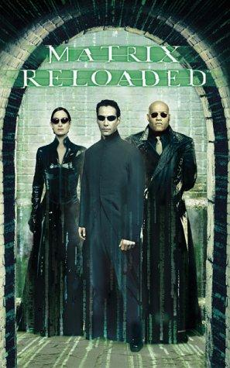  (Image Provided by IMDb) | 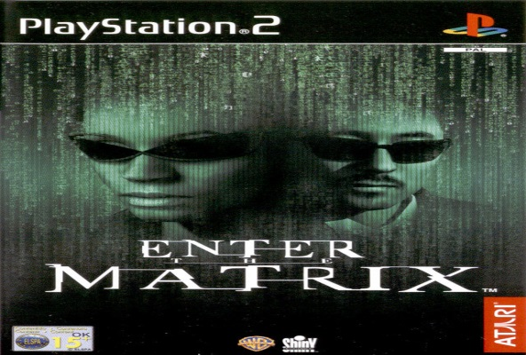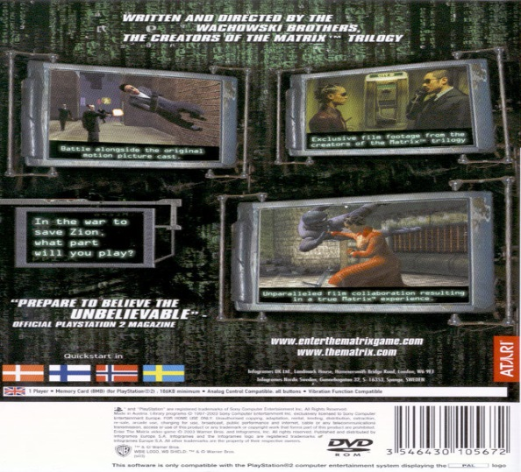  (Image Provided by Moby Games)
Date of Release | United States:  May 15th 2003 (IMDb) | United States:  May 14th 2003
Average User/Audience Metacritic Score |  | 
Average Critic Metacritic Score |  | 

Why the different title?
Unlike many movie licensed and tie in games, the title for the game is actually different from the movie it coincides with. ‘Enter the Matrix’ tells the story of the second Matrix movie alongside setting up for the final film in the trilogy, however, the game follows the journey and actions of the crew of the ‘Logos’ as opposed to the films protagonists the crew of the ‘Nebuchadnezzar’. The game explores how the actions of the ‘Logos’ and its crew intertwine with the plot of the movie and explain some details that were not fully explained in the film itself.
Story Presentation
The game makes the most of its movie license by using unseen movie footage to drive the narrative of the game. The player takes control of either Ghost or Nairobi with each having slightly different missions which consist of iconic staples of the Matrix franchise; Martial arts, Gun-fights and the ability to slow down time to perform acrobatic manoeuvres. The missions link events throughout the ‘Matrix Reloaded’ interacting with the main protagonists from time to time. The ‘Wachowski brothers’ who are credited with writing and directing the movies, took direct involvement with game development (IMDb) directing and writing the game itself making it feel authentic along with the filmed footage where the cast do a satisfactory job.
My response+ thoughts on the scores
After watching ‘The Matrix Reloaded’ I decided to play the game in order to compare the two products. ‘Enter the Matrix’ as a game is one I personally enjoy but has many flaws, the intertwining of narratives between the game and movie really provides an enjoyable experience for someone who is a fan of the franchise. Playing as characters who take a backseat in the film but clearly have an important role really makes the ‘Matrix’ plotline feel much larger than the movies are able to, not only that but fighting against adversaries such as ‘Agent Smith’ who are described as unbeatable by normal humans and then getting to experience the truth behind that really conveys the threat they pose in both the game and films alike.
Both the movie and the game received more favourable reviews from the audience as opposed to critics. The second film is more action oriented and becomes similar to a super hero film as opposed to philosophical thriller like the first. The game allows for fans to actually interact with these martial arts fights and stunt filled set-pieces without having to concentrate too hard on a deeper plot. Nonetheless if you want to get the whole picture of ‘The Matrix Reloaded’ then fans are able to get that from the almost covert ops story line taking place whilst the movie plot is ongoing.
After speaking to ‘Minimme’ on his opinions on the game to gauge another gamers reaction, he responded by saying he “enjoyed Enter the Matrix, despite its problems and the reputation it has of being a meh game. Despite its flaws, any fan of the films would find the game fun and enjoyable whilst still being authentic, this is reflected in the ‘User Scores’ compared to its critical reception.
Disney Pixar’s Cars
 | Movie Production | Licensed Game
Title | Cars | Cars(PS2)
Promotional Art/Box Cover | 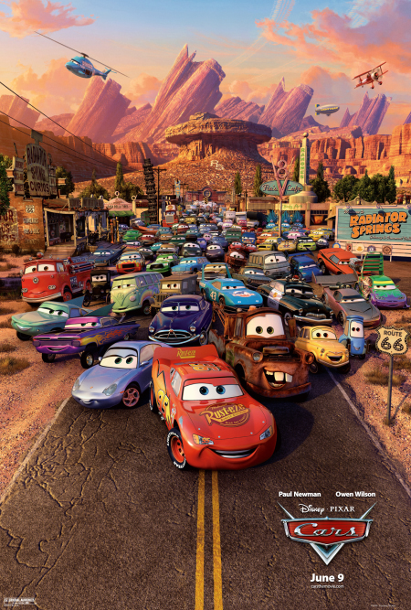  (Image Provided by IMDb) | 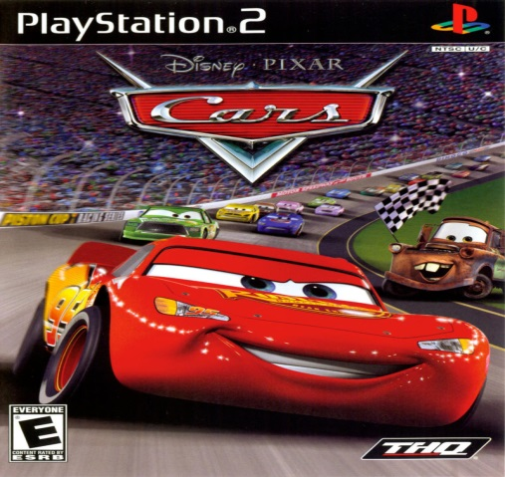  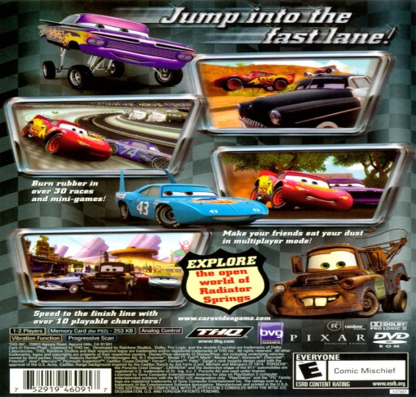  (Image Provided by Moby Games)
Date of Release | United States:  June 9th 2006(IMDb) | United States:  June 6th 2006(Metacritic)
Average User/Audience Metacritic Score |  | 
Average Critic Metacritic Score |  | 

Remembered fondly but why?
When the topic of ‘Movie games’ is brought up, Cars the video game is one of the most fondly remembered for being an overall good game. It has without a doubt succeeded to age well and be a prime example of how a movie licensed game if done right can be genuinely good if designed and developed for a similar demographic to the film. Following a brash and cocky main character who is a racer having to humble himself the movie is easily watched and fun, the exact same approach seemingly taken for the game.
The game allows the player to freely drive around the quaint town of ‘Radiator Springs’ and interact with other characters, participating in races and progressing through the story with several differences from the Movie’s plotline. The game features the characters from the movie consisting of all the original voice actors, this alone is a huge deal for a young child playing a game and feeling like they’re immersed within the world of the game they are playing. This reprisal of roles along with an original story can be a lot of fun along with its general easy difficulty and simple gameplay makes it very easy to play for any age group.
Overall the game really succeeds in making the player feel part of the ‘Cars’ world through its entirety and I think that’s why it is remembered so fondly.

‘Minimme’ and his ‘Cars’ reaction
On the online platform of ‘YouTube’ Minimme covers a variety of topics mainly revolving around more niche topics in the Gaming industry, his coverage of Movie-Licensed games became a favourite for his followers and after he explored the development and gameplay of ‘Cars’ he ended up covering all of the games linked with the franchise due to the support he received. As someone who has become almost representative of the modern day legacy the game has, I decided to ask for his opinion on the game and why it is still so highly regarded.
This was his response:
“With the film’s original writers behind it, and an experienced developer which took the time to put together an immersive open world and a fun driving model, it's no surprise that the Cars video game transports you into the world of Cars. Where it easily could've been a stock standard racer, the Cars game goes above and beyond your typical movie game with an outstanding level of care. Also noteworthy is how it combines whimsical childish adventure game tropes and storytelling with driving mechanics, making it quite unique in the open world racing genre.”(Minimme.Personal Communication, June, 2019)
When asked what specifically was his favourite aspect of the game Minimme said:
“My favourite thing is probably the fact that they had all the main original voice cast return, which is by all means an expensive cherry on top that they didn't need to do, but they did and it really helps charm you and bring the world to life”( ‘Minimme’,Personal Communication, June, 2019).

Spider-Man 2
 | Movie Production | Licensed Game
Title | Spider-Man 2 | Spider-Man 2(PS2)
Promotional Art/Box Cover | 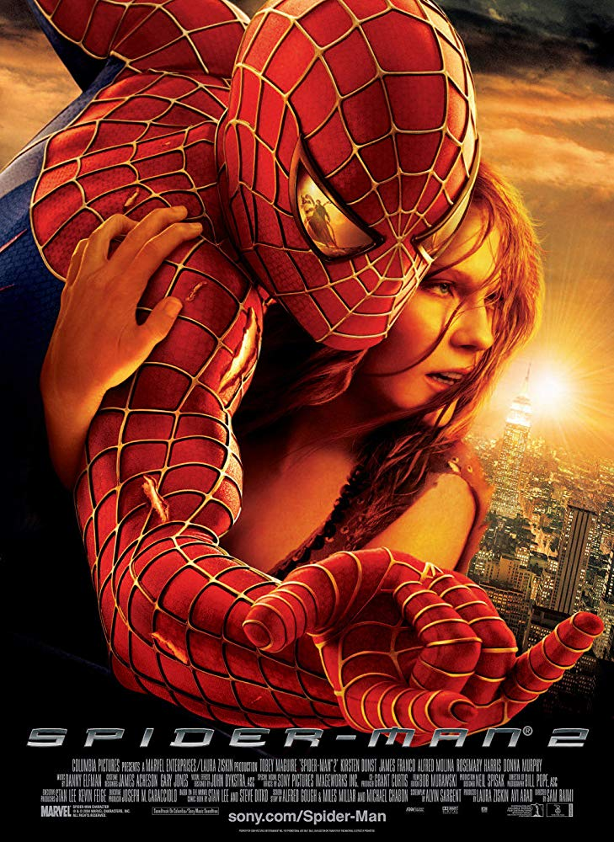  (Image Provided by IMDb) | 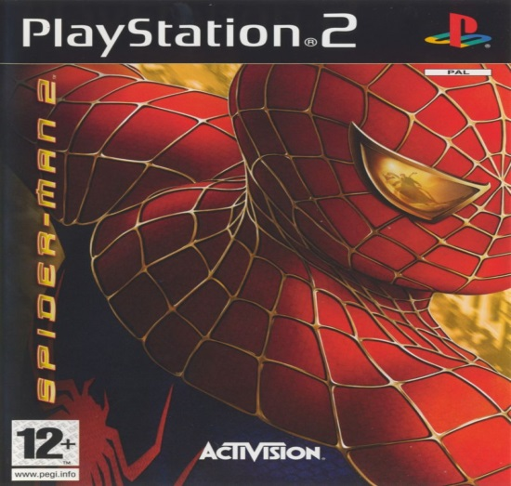  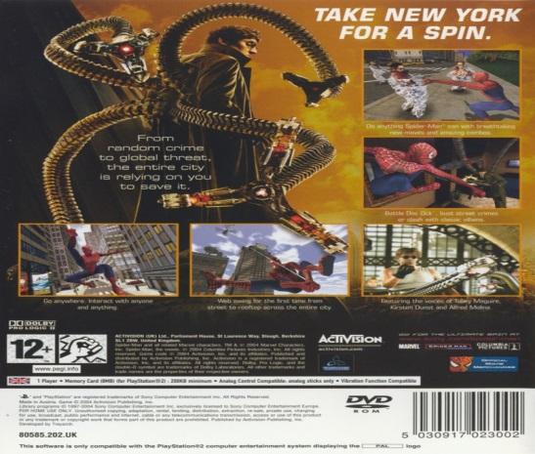  (Image Provided by Moby Games)
Date of Release | United States:  30th June 2004 (IMDb) | United States:  28th June 2004 (Metacritic)
Average User/Audience Metacritic Score |  | 
Average Critic Metacritic Score |  | 

One of the Greats
Spider-Man 2 has perhaps one of the best reputations of any movie licensed game, it is a game beloved by many gamers just as the film has held a great reputation since its release, despite the many different iterations of Spider-Man.
Even though there was a Spider-Man game to coincide with each film of Sam Rami’s early 2000’s trilogy, I chose this game as it was almost unique at the time of its release due to its gameplay style compared to earlier linear superhero games even outside of the Sam Rami directed movies.
The second Spider-Man game took a huge leap from the first implementing a free to roam New York alongside a re-invigorated web swinging system which is one of the most vital gameplay mechanics to get right with anything linked to Spider-Man. Since Spider-Man 2’s release it has been considered by many to be the set-standard of anything related to the frnahcise.
The game follows the plot and features the main villain from the film, but expands on the struggles Spider-Man faces trying to balance his life as Peter Parker and Spider-Man which is the overall moral struggle he faces in the film. The game does this by creating time trial missions where you have to reach destinations before it is too late, as well as frequent side missions that consist of helping random civilians just showing how Peter gets very little time to be anyone but Spider-Man.
Having Tobey Maguire once again portraying Peter Parker is always good to provide authenticity; having Tobey Maguire’s portrayal of Peter Parker also face off against villains never seen in the films is almost like an extension of the film itself, one that the player alone has to experience by playing through it.
The game is simple to learn but difficult to master, with a character progression system where you can learn new abilities that allow you to fight better and swing around with newer techniques, creating a sense of growth and improvement of both player and character.

Talking with a Technical Director
Speaking with Jamie Fristrom was an interesting look behind the scenes behind how these games work. It helped me understand quite clearly why Spider-Man was such a loved game and still is.
So when asked about why the second game was such a change from the first in its gameplay style Jamie explained how in the first game the time constraints to make the game so It was released with the movie, meant they had a pretty tight schedule (J,Fristrom, Personal communication, June, 2019). The plan for the first game was to make a game somewhat similar to the already successful Spider-Man game made by ‘Neversoft’, which consisted of a more standard game structure where you would play through different levels with no open world. Once the first one had been released, they were able to focus on a much more ambition project with longer development time to help create something really special, that being Spider-Man 2(J.Fristrom, Personal Communication, June, 2019).
To understand how the minds behind the game felt about Spider-Man, I asked Jamie if anyone in a creative position was specifically a fan of Spider-Man or whether they were just hired to develop a game in which they weren’t actually prior fans of the source material, Jamie proceeded to tell me that there in fact were fans of Spider-Man including himself and then told me his interests with the franchise (J.Fristrom, Personal communication, June, 2019). It was clear to see Jamie’s familiarity with the character was translated into his work, this conversation lead to the fact that they had to buy additional rights to include more villains that weren’t just in the film, this was required due to Marvel’s fragmented assets during the time.
Jamie explained how these villains were necessary to create a more fulfilling video game as opposed to just having one antagonist like in the film; a decision I believe was extremely successful (J.Fristrom, Personal communication, June, 2019).
The main talking point of our discussion was how important getting the web swinging correct was, I asked what the main priority was when it came to realism within the swinging and he responded by saying that “Realism is the wrong word” he elaborated saying that it was all about fulfilling peoples “intuitive sense” of how the action and momentum would feel (J.Fristrom, Personal communication, June, 2019). Fluidity whilst interacting well with the surrounding environment was a high priority to making a fun experience whilst allowing the player to feel like Spider-Man (J.Fristrom, Personal communication, June, 2019).

Findings
Results
If doing a more investigative look at this genre of games there are several changes I would make. I would decide to research more games and look more into their development cycles and try and speak to more behind the scene figures. The biggest comparison I would do is that of financial success and if these games are able to compete with the movies or even overtakes them.
After looking at the scores of these four games it would seem that the ratings from both critics and fans trend towards either negative or positive correlating with the ratings of the movie. The ‘Finding Nemo’ game however shows that this is not always the case by showing drastically negative reviews in comparison to its source material; if this was the only significantly different set of scores then the result would be deemed an anomaly. However, even though the ‘Cars’ movie was received fondly, the video game tie-in received significantly better scores; so much better in fact that the scores cannot be solely linked to the movies good reception and suggests that a movies success does not inevitably link success for its licensed video game.
These results show that it may not be guaranteed that fans of a franchise will ensure a good reception, with some of these games presenting a better average critic score than the average user score, for example ‘Finding Nemo’ shows that the average user did not enjoy the game than someone who may not be a fan of ‘Finding Nemo’ itself but is a fan of video games.
Overall I was able to find out that a well-received movie does not guarantee that the video game will receive the same support and reputation
Discussion
The games that seemingly appealed to the user as opposed to critics seemed to maintain their charm which has granted them good reputations- most likely because there are more casual gamers than critics, especially ones that only got the game due to the movie it was licensed off of.
When looking at these games it was clear that the ones that were designed to be a fun experience for a gamer specifically rather than just trying to transition the movies assets into a game that could be re-skinned into anything else are the better games overall. For example ‘Spider-Man 2’ is such a well-received game due to its ability to make you feel like the character in an original experience that is based on an already existing world that can be watched in a movie.
When trying to find out why many video games actually struggle to be stand-out or successful I asked Jamie why it might be and he pinned it down to how impeding the time constraints can be, having to develop a game to release despite any issues that may arise and would usually cause development to last longer must be fixed instantly or avoided altogether (J.Fristrom, Personal communication, June, 2019).
The games I most enjoyed felt like expansions of the source material, they felt like an experience I couldn’t get just from watching the movies whilst feeling clearly linked to them and just an interactive medium with different things to enjoy. In the movies the plot has to maintain you and keep you hooked, whereas the games from time to time can sometimes lack in that area to focus on engaging gameplay… The main reason someone plays a video game.

Conclusion
After doing this report it was clear to see that the reputation ‘movie games’ have is not necessarily deserved, overall they have a bad image and just by picking a select few, with only one being deemed ‘bad’ whilst the rest were at the very least fun I have found that should not be the case. I think the issue is more that many of them are just forgotten, they become lost in time, if a franchise dies or movies of a series stop being produced then that means the games alongside them also lose relevancy; including the good ones.
Some films shouldn’t be translated into the medium of video games as they either do not need to be or would struggle to even be made into one, nonetheless if they wish to succeed then the developers need to be granted some artistic license and be allowed to enforce their own creative vision onto it whether it be with plot deviations or unique gameplay mechanics, unfortunately unless companies are given a longer development time to work on the project for longer, the more riskier ideas are always going to be within the realm of backfiring.

References
Images Used
Activision Publishing, Inc/ Marvel Characters,Inc/ Columbia Pictures (2008). Spider-Man 2 The Video Game Front Cover. [image] Available at: https://www.mobygames.com/game/spider-man-2/cover-art/gameCoverId,107492/.
Columbia Pictures Industries, Inc. (2004). Spider-Man 2 Promotional Poster. [image] Available at: https://www.imdb.com/title/tt0316654/mediaviewer/rm3078822144.
Disney Enterprises, Inc/ Pixar Animation Studios (2003). Finding Nemo Promotional Poster. [image] Available at: https://www.imdb.com/title/tt0266543/mediaviewer/rm1261017088.
Disney Enterprises.Inc/ Pixar Studios (2006). Cars Movie Promotional Poster. [image] Available at: https://www.imdb.com/title/tt0317219/mediaviewer/rm3794114560.
Disney Enterprises.Inc/ Pixar Studios/ THQ, Inc.(2008). Cars the Video Game Front Cover. [image] Available at: https://www.mobygames.com/game/disneypixar-cars/cover-art/gameCoverId,100705/.
Disney Enterprises.Inc/ Pixar Studios/ THQ, Inc.(2008). Cars the Video Game Back Cover. [image] Available at: https://www.mobygames.com/game/disneypixar-cars/cover-art/gameCoverId,100706/.
Disney Enterprises.Inc/ THQ, Inc (2016). Finding Nemo Video Game Full Cover. [image] Available at: https://www.mobygames.com/game/ps2/disneypixar-finding-nemo/cover-art/gameCoverId,361302/.
Warner Bros. (2003). Enter The Matrix Back Cover. [image] Available at: https://www.mobygames.com/game/enter-the-matrix/cover-art/gameCoverId,20841/.
Warner Bros. (2003). Matrix Reloaded Film Poster. [image] Available at: https://www.imdb.com/title/tt0234215/mediaviewer/rm2235971328.
Warner Bros. / Atari Europe S.A.S.U. (2003). Enter The Matrix Front Cover. [image] Available at: https://www.mobygames.com/game/enter-the-matrix/cover-art/gameCoverId,20840/.

Sources and Product Ratings
IMDb. (2019). Cars (2006) - IMDb. [online] Available at: https://www.imdb.com/title/tt0317219/?ref_=fn_al_tt_1 [Accessed 5 Jul. 2019].
IMDb. (2019). Enter the Matrix (Video Game 2003) - IMDb. [online] Available at: https://www.imdb.com/title/tt0277828/fullcredits [Accessed 5 Jul. 2019].
IMDb. (2019). Finding Nemo (2003) - IMDb. [online] Available at: https://www.imdb.com/title/tt0266543/releaseinfo [Accessed 5 Jul. 2019].
Metacritic. (2019). Cars. [online] Available at: https://www.metacritic.com/game/playstation-2/cars [Accessed 5 Jul. 2019].
Metacritic. (2019). Cars. [online] Available at: https://www.metacritic.com/movie/cars [Accessed 5 Jul. 2019].
Metacritic. (2019). Disney/Pixar Finding Nemo. [online] Available at: https://www.metacritic.com/game/playstation-2/disneypixar-finding-nemo [Accessed 5 Jul. 2019].
Metacritic. (2019). Enter the Matrix. [online] Available at: https://www.metacritic.com/game/playstation-2/enter-the-matrix [Accessed 5 Jul. 2019].
Metacritic. (2019). Finding Nemo. [online] Available at: https://www.metacritic.com/movie/finding-nemo [Accessed 5 Jul. 2019].
Metacritic. (2019). Spider-Man 2. [online] Available at: https://www.metacritic.com/movie/spider-man-2 [Accessed 5 Jul. 2019].
Metacritic. (2019). Spider-Man 2. [online] Available at: https://www.metacritic.com/game/playstation-2/spider-man-2 [Accessed 5 Jul. 2019].
Metacritic. (2019). The Matrix Reloaded. [online] Available at: https://www.metacritic.com/movie/the-matrix-reloaded [Accessed 5 Jul. 2019].
Stuart, K. (2019). Interview: the science and art of Metacritic. [online] the Guardian. Available at: https://www.theguardian.com/technology/gamesblog/2008/jan/17/interviewtheartofmetacriti [Accessed 5 Jul. 2019].
Wingfield, N. (2019). High Scores MatterTo Game Makers, Too. [online] WSJ. Available at: https://www.wsj.com/articles/SB119024844874433247 [Accessed 5 Jul. 2019].

Personal Communication
Peter A.K.A ‘Minimme’, 06/06/2019, Online voice call via Discord
Jamie.Fristrom, 14/06/2019, Online voice call via Discord
Peter A.K.A ‘Minimme’, 02/07/2019 Online Text conversation via Discord

Appendix
Appendix A
The criticism of ‘Metacritic’s’ Rating System
Whilst trying to find out how to compare the reception of both Movies and their licensed video games, I debated using different websites to gather more scores, however I decided against this due to the fact that some domains used percentages or a ‘star rating’ system making it hard to gauge an average. After deciding to specifically use ‘Metacritic’ and its scoring system I had to acknowledge the criticism it has received from different outlets regarding said system, nonetheless I chose to stick with ‘Metacritic’ as all scores I was comparing were from the same site and then could be compared on the same scale despite the flaws of that scale.
The criticism I read and came across, were from the ‘Wall street Journal’ and ‘The Guardian’:
Stuart, K. (2019). Interview: the science and art of Metacritic. [online] the Guardian. Available at: https://www.theguardian.com/technology/gamesblog/2008/jan/17/interviewtheartofmetacriti [Accessed 5 Jul. 2019].
Wingfield, N. (2019). High Scores MatterTo Game Makers, Too. [online] WSJ. Available at: https://www.wsj.com/articles/SB119024844874433247 [Accessed 5 Jul. 2019].

