Engineering Skills
Module Code: ACHA4022A
Assignment 1
Engineering Skills Technical Report



Student Name: Leah Davies
Student Number: 2500821
Lecturer’s Name: Kerry Tudor
Word Count: 2,141
Submission Date: 14/12/25

Contents
1. Introduction 3
2. Health & Safety with Risk Assessments 4
3. Security Risk Matrix 5
4. Engineers Role in Society (max. 300 words) 7
5. Problem Solving (max. 300 words) 8
6. Team Structure (max. 400 words) 9
7. Conclusion 10
8. Reference List 11

Table 2.1 Risk Assessment 4
Table 3.1 Risk Matrix 5
Table 3.2 Risk Response 6
Table 6.1 Team Structure Positives & Negatives 9

Figure 5.1 8
Figure 6.1 9

Introduction
In this technical report, an overview of key principles that hold a large influence over the engineering sector will be provided. Starting by examining the significance of Health and Safety, and exploring the relevant legislations, a detailed risk assessment for a practical activity undertaken at the university will be presented. The report will then focus on security challenges that effect autonomous vehicles, using a risk matrix to evaluate potential threats with appropriate engineering responses being proposed.
Further on, chapters will explore the obligations that engineers hold in the profession, considering code of conducts and their relevance to sustainability in the automotive field. Approaches to problem solving used during product development will be explored through presenting suitable flow-chart examples. Finally, an analysis of team structures and their effectiveness during an account of team working is provided. Thus, the report concludes by summarising how these themes collectively can contribute to responsible and effective engineering practice.

Health & Safety with Risk Assessments
As part of the university workshop sessions, a task was to carry out basic machining processes using milling and lathe machines. Whilst doing so, strict health and safety legislations are in place to protect both student and lectures, showing the potential hazards associated with the sharp cutting tools and rotating machinery.
One example of a legislation is the Provision and Use of Work Equipment Regulations (HSE, 1998) which governs the safe use of machinery and places duties upon employers to ensure that the equipment is “constructed or adapted as to be suitable to the purpose for which it is used or provided” (legislation.gov.uk, 1999).
Below is a risk assessment for the activities completed. It is important that safety glasses, adequate footwear (“steel or composite toe-capped boots”) and protective clothing are worn in accordance with PPE regulations (HSE, 2022).
Table 2.1 Risk Assessment
Potential Hazards | People at risk and how? | Risk level | Actions already in place | Further action required
Entrapment/ entanglement in rotating parts | Operator of machine | High | Jewellery must be removed before using machines, long hair must be tied back, and safety guards must be down. “Never wear dangling chains, loose clothing, long hair” (HSE, 1998). | Larger guards could be put in place and implement extra PPE posters around the workshop as well as the entrances.
Swarf and Chips | Operator and people nearby | Medium | Safety goggles must be worn, and machine cannot run without guards down. “Never remove any safety guards” (HSE, 1998). | Consider implementing gloves and dust jackets as mandatory PPE.
Human error | Operator, nearby students or technicians | High | Training provided for students by technicians before use, students are supervised and must be signed off before using machine alone. Workshop rules are signposted in the area. | Could include step by step checklist beside each machine for safe use. A mid-term refresher training session could be put in place to reinforce safe working behaviour.
Machine malfunction | Operator | High | HSE (1998) also explains that where necessary, workshops should have emergency stop controls within easy reach of the operator, which will limit the risk of accidents should the machine malfunction. | Increase the intervals at which inspections of the machines are completed.

Security Risk Matrix
As vehicles become more interconnected with digital systems, the potential for cyber and physical threats increases.
SN Computer Science (2025) warns that autonomous vehicles (AVs) could be commandeered or hijacked remotely as a result of poor antivirus cyber security, going as far to say that “evildoers could exploit these systems’ weaknesses to carry out murder”. The ‘Journey of Economy and Technology’ (2023), noted that there are many different classes of cyber attacks in automotive systems.
A study completed by the University of California (2022) discovered that AVs can be tricked into stopping abruptly when their collision-avoidance system misinterprets ordinary objects as hazards. By simply placing objects like a bicycle or cone by the side of the road, AVs showed that they could come to a “dangerous stop in the street… creating a hazard for other motorists or pedestrians”.
In an investigation conducted by Beckers N et al (2022) on where blame lies in a partially automated vehicle crash, it is said that “drivers show difficulty in taking over control when needed… resulting in dangerous situations”. Slow reactions from the driver ultimately are the cause of crashes in AVs as drivers still can assume control of the vehicle if needed. Distractions to the driver increase during long journeys of supervising the AV, like usage of a mobile phone, become more desirable as the driver gets more bored of supervising the vehicle. Again, slowing the reaction times of the driver, increasing the likelihood of a crash as they are not paying full attention to the vehicle. A research article by Public Library of Science (2016) quotes “The success of automated vehicles will depend on drivers’ trust in them and on how people choose to use and interact with them, and the ensuing safety risk”.
A final risk of an AV is their use of lithium-ion batteries. The British Safety Council informs that the “UK fire services now tackle at least three Li-ion battery fires a day”. Now, admittedly, AVs are not the only form of transport to use this type of battery, however AVs are more likely to be involved in larger accidents where the battery can become damaged, causing a fire and thermal runaway.
Table 3.1 Risk Matrix
 | Low | Medium | High | Very high | Extreme
Rare |  |  |  |  | Fire from lithium-ion batteries.
Unlikely
Possible |  |  |  |  | Vehicle commandeered by remote hacking.
Likely |  |  | Collision-avoidance system fault.
Almost certain |  |  |  |  | Driver not paying attention whilst operating vehicle.
Table 3.2 Risk Response
Security Threat | Proposed Mitigation | Proportionate and Excessive responses
Driver distracted. | Vehicle monitoring system to detect sidetracked driver. An example of this can be seen in Volkswagen’s newer vehicles. “The Emergency Assist system monitors steering wheel activity and delivers alerts if the driver is not actively operating the vehicle”. Volkswagen (2025). | Proportionate as it targets the problem without going overboard. This system will also only activate in the case that the driver is not operating the vehicle safely.
Driver distracted. | A mandatory driver training programme could be put in place for those who buy AVs, as well as reporting of incidences where the driver is distracted to authorities or manufacturer, who could request re-training. This would enforce risks and consequences of distractions while driving autonomous vehicles. | Excessive. This response is over the top and would be hard to regulate. As cars get sold second hand, it would be hard for car manufacturers to stay up to date with who owns their vehicles.

Engineers Role in Society (max. 300 words)
Two key UK organisations that publish and maintain ethical codes of conduct for professional engineers are the Engineering Council and the Royal Academy of Engineering.
In ‘Guidance on ethical principles’ (2017) an importance of the four fundamental ethical principles of engineering is emphasised. These included: “Honesty, integrity, respect for life, law, the environment and public good, accuracy and rigour, leadership and communication”. The Engineering council (2017) declared that engineers should be held accountable for their actions and always should “act in a reliable and trustworthy manner”.
The code of conduct used by both aforementioned organisations was originally published in 2005, having a revision in 2017. The statements included in the code of conduct applies to everyone within the engineering profession, “all persons engaged in engineering at any level… should be educated and encouraged to think and work in accordance with these ethical principles.”
The statement of ethical principles from the Engineering Council, enforces a “respect for life, law, the environment and public good”. According to UK-SPEC (2020), engineers must protect their environment and also contribute to sustainable development, as part of their professional duties. This applies also in the motorsport area as engineers should manage the environmental risk when designing vehicles and should anticipate the risks of certain emissions and waste products.
The FIA (2023) published an environmental strategy with three main goals: “Accelerate net-zero transformation, foster sustainable and innovative solutions, drive sustainable change”. Furthermore, the FIA’s Environmental Policy (2022) also further states that they are committed specifically to “protecting the environment and preventing pollution within the scope of [motorsport] activities”.

Problem Solving (max. 300 words)
Engineers face lots of problems in the industry during processes like product development. An engineering team may utilise a problem-solving method which is detailed by the University of Greater Manchester (2023). It begins by defining the problem at hand, the most crucial point of solving the issue, as no progress can be made before the root of the problem is found. The second step is to accumulate information about the issue at hand. “This involves research, data collection, and consulting experts”. The more knowledge gathered, the easier it will become to solve the problem. A brainstorming session is likely to come next. This is where in the team, or individually, potential solutions are proposed. Evaluations of ideas as well as planning and designs of these are chosen wisely. Now, all that’s left is to test the solutions through prototypes of temporary measures, should these work effectively, they can be made a permanent solution to the issue.
This step-by-step method can be illustrated in a simple flow chart. This is effective as it is a visual guide for engineers on where they stand on any issues that need solving. Figure 5.1 details an ‘Engineering Design Process’ (2025) which is organised in a circle to show a continuous flow of steps, which can be revisited, should another problem arise.
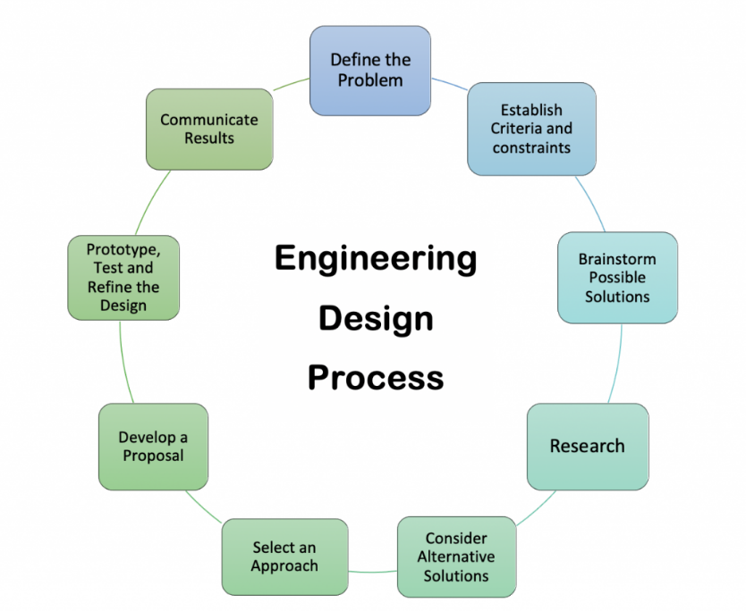
Figure 5.1

Team Structure (max. 400 words)
During my time in college, I worked in a group of students where our task was to design and build a set of ramps made only from offcuts of steel bars. Considering the lack of resources i.e. only one welding machine and a small workshop, I feel we did well to build a set of working ramps for the college’s project vehicle. I learned how to weld through constructing these ramps, however throughout the project we struggled to find a role for everyone since only person could weld at a time.
In this project, we operated under a hierarchal team structure. Chisel Glossary dictated that “A hierarchical organisational structure has a direct chain of command from the top of the company to the bottom”. This is displayed in Figure 6.1, the top icon being the “top of the company” and each person being responsible for another employee, who is then also responsible for another group of people.
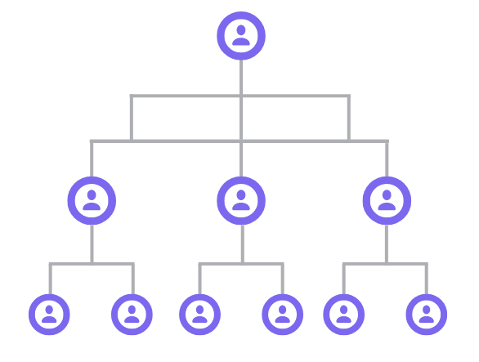
Figure 6.1
In my experience, however, there was only a single chain of command. This being the lecturer who would give us instructions and supervise, and us students who would then follow said commands during the project.
Table 6.1 Team Structure Positives & Negatives
Positives | Negatives
Through the project, there was a clear person to go to for instructions and new tasks. This was especially helpful when working with new machines, where students including myself, had questions that needed answering quickly.  If it were not for this hierarchical structure, we would not have been able to learn how to weld as a class. By having a clear point of authority to go to, requests to be taught how to weld went smoothly. In other organisational structures, like a matrix, there could have been a slower decision-making process due to multiple approvals being needed by different types of managers. | In this example, there was only one higher up in charge of a group of 9 students who were all new to a machine workshop. This meant that processes were delayed if the lecturer was already helping another group.  As there was only one task being completed in the workshop, to ensure everyone was being supervised, this resulted in a lack of jobs as there were so many students trying to complete the same job. Thus, resulting in a slow working pace, causing a lack of motivation within the group.

Personally, I think that the hierarchical structure worked perfectly, since there was only a small group of students only requiring one manager (the lecturer). For example, a divisional or multidivisional structure would not have worked as effectively here as it is “commonly used by large companies” according to the Institute of Directors (2025). Multidivisional structures are used for companies who have different sectors and divisions, like different regions the company is based in or the different areas for the products they sell. However, it must be noted that I think this hierarchical structure would be at its best, should there have been a larger group of students (20 or more) who would then report to different lecturers for different activities and tasks.

Conclusion
Within this report, areas like health and safety, security risks problem-solving and teamwork were explored within the engineering sector. Showing risk assessments, ethical codes and structured approaches and how they support a safe and effective environment.

Reference List
Beckers N, Siebert LC, Bruijnes M, Jonker C, Abbink D. (2022) Drivers of partially automated vehicles are blamed for crashes that they cannot reasonably avoid. National Library of Medicine. https://pmc.ncbi.nlm.nih.gov/articles/PMC9519957/ (Accessed: 04/12/2025)
Brian, B., UC, I (2022). Autonomous vehicles can be tricked into dangerous driving behaviour. University of California. https://www.universityofcalifornia.edu/news/autonomous-vehicles-can-be-tricked-dangerous-driving-behavior#:~:text=According%20to%20a%20UC%20Irvine%20study%2C%20autonomous,can%20cause%20the%20vehicle%20to%20stop%20abruptly. (Accessed: 03/12/2025)
Chakraborty, T. and Chen, Q.A (2024) ‘Risk Assessment for Security Threats and Vulnerabilities of Autonomous Vehicles’.
Chisel Glossary (2022). ‘What is Hierarchical Structure (vs Flat Structure)’. Available at: https://chisellabs.com/glossary/what-is-hierarchical-structure/. (Accessed: 11/12/25)
Dixit, V.V., Chand, S. and Nair, D.J (2016) ‘Autonomous Vehicles: Disengagements, Accidents and Reaction Times’, PloS one, 11(12), p.e0168054. Available at: https://doi.org/10.1371/journal.pone.0168054. (Accessed: 04/12/2025)
Engineering Council (2017). ‘Guidance on Ethical Practices’ Available at: https://devwww.engc.org.uk/resources-and-guidance/guidance/guidance-on-ethical-practices/. (Accessed: 09/12/25)
Engineering Council (2020) UK Standard for Professional Engineering Competence and Commitment (UK-SPEC). Available at: https://www.engc.org.uk/media/a1yfae02/uk-spec-fourth-edition.pdf. (Accessed: 09/12/25)
Fédération Internationale de l'Automobile (2023), FIA Environmental Report 2023. Available at: https://www.environmentalreport.fia.com/wp-content/uploads/2023/06/FIA__ENVIRONMENTAL_REPORT__2023.pdf
Fiveable Content Team (2025). ‘2.2 Problem Solving strategies in engineering’. Available at: https://fiveable.me/introduction-engineering/unit-2/problem-solving-strategies-engineering/study-guide/UYEXyBxQ3hYJaI4h. (Accessed: 11/12/25)
HSE (1998) Introduction to machinery safety. Available at: https://www.hse.gov.uk/work-equipment-machinery/introduction.htm (Accessed: 24/11/2025)
HSE (1998) Provision and Use of Work Equipment Regulations 1998 (PUWER) – overview. Available at: https://www.hse.gov.uk/work-equipment-machinery/puwer-overview.htm (Accessed: 24/11/2025).
HSE Using Personal Protective Equipment (PPE) to control risks at work. Available at: https://www.hse.gov.uk/ppe/overview.htm (Accessed: 24/11/2025)
Nasser, Dr. Ahmad MK. (2023) ‘Automotive Cybersecurity Engineering Handbook: The automotive engineer’s roadmap to cyber-resilient vehicles’. Page 46-47.
Renjith, P. N., Balasubramani, S., Ramesh, K., & Patnala, E. (2025). An Initial Risk Assessment for Multimodal with LSTM-Based Trust Evaluation Framework for Autonomous Vehicle Security. SN Computer Science, 6(2), 172. https://doi.org/10.1007/s42979-025-03703-0 (Accessed: 03/12/2025)
Simmonds A., QBE Europe (2025) ‘The hidden risks of lithium-ion batteries ‘. https://www.britsafe.org/safety-management/2025/the-hidden-risks-of-lithium-ion-batteries (Accessed: 04/12/25)
University of Greater Manchester (2023). Breaking down complex engineering problems: a step-by-step guide. Available at: https://greatermanchester.ac.uk/blogs/breaking-down-complex-engineering-problems-a-step-by-step-guide#:~:text=After%20brainstorming%2C%20it's%20time%20to,best%20aligns%20with%20your%20goals. (Accessed: 11/12/2025)
Volkswagen. (2025) Emergency Assist. Available at: https://www.vw.com/en/iq-drive/emergency-assist.html. (Accessed: 13/12/25)

