Business Plan for

Green Room Sawston

Produced By:

GROUP MEMBERS:
Student Name | Student No.
Alexandra Staicu | 2222626
Daniel Fieraru | 2232199
Ionut Alexandru Dumitru | 2232734
Nina Andriyivna Sokhan Kalashnikova | 2234899
Wazadur Chowdhury | 2222624

Dated: 10-06-2024

Module Name: Entrepreneurship
Module Code: BMIH5001
Lecturer Name: Charlotte Joyner

TABLE OF CONTENTS

 | ITEM |  |  | PAGE
1. | Executive Summary |  |  | 2
2. | The Business Idea |  |  | 3
3. | The Team |  |  | 4
4. | Market Research |  |  | 6
5. | Marketing Plan |  |  | 10
6. | Key Resources |  |  | 11
7. | Finances & Start-Up Support |  |  | 13
APPENDICES:
Appendix A |  |  |  | SWOT Analysis
Appendix B |  |  |  | PEST Analysis
Appendix C  Appendix D |  |  |  | Menus  Financial Breakdown

EXECUTIVE SUMMARY

“Green Room”, bakery vegan café is based in Sawston.
Offering artisanal bakery products and coffee the business is offering high standards services for its clients. Based on the current market trend the establishment offers along the usual products, vegan and gluten free products. Base products served include bread and sandwiches, cakes, pastries and pies along beverages.
Although there is a strong competition from supermarkets offering cheap bakery products, the customers are still looking for flour-based products served with coffee or tea. The business intent is to stand out by offering fast, high-quality services in an intimate environment while using local suppliers as much as possible.
The customer focus will be directed to all residents. With a location based in the core of the high-traffic centre, the business will be easily accessible to all residents.
The revenue will be directed from the sales of the products- cookies, cupcakes, coffee, tea, etc. The cost driver will be given by prime materials such as coffee, milk, flour, sugar as well as expenses such as utilities, rent, salaries.
Looking at the venue cost and revenue our main goal is to gain profit. However, on a short term our goals will include the retention and increase of customer flow, finding our own path and standing out with the gluten free and vegan products and gain recognition. By offering quality services, by having strong work ethics and by aiming the client satisfaction our business will become recognized and will grow its own name.
2. THE BUSINESS IDEA

The Green Room Café & Bakery is a café & bakery in Sawston dedicated to providing quality, local and organic food and a selection of artisan bakery products. The café was created with health and eco-conscious consumers in mind, focusing on quality, freshness and being environmentally responsible.

2.1 The Product/Service

Dining out in the quaint village of Sawston is the Green Room Café and Bakery, an established name within the food and beverage trade. We aim to create and market sustainable, health-conscious, and environmentally responsive restaurant concepts.

Descript, The Green Room boasts an eclectic blend of fresh, local and organic foods throughout their menu. We serve vegan and vegetarian dishes, bakery and many organic coffee and herbal teas. We have offerings for a variety of dietary needs ranging from vegan, vegetarian, gluten-free or just in your new health kit.

The highlight of our menu is the Harvest Bowl, a blend of seasonal vegetables, quinoa, and plant proteins, and the Eco-Burger, a vegan patty with a mix of organic vegetables. We have a bakery showcasing the wares of Boswell and Son offering you handcrafted cakes and pastries of distinction.

Sustainability, Freshness, and Local sources are key components of our products. They help to support local agriculture, reduce carbon footprints, and provide healthy and delicious meals. This is our unique selling point; where it is no longer just a meal, but eating with a conscience, food that complements their way of life and is beneficial to the wider world.

Its commitment to a healthy product and sustainable packaging gives The Green Room a unique point of difference in the market and attracts customers seeking delicious food and dining that also value our environment.

2.2 SWOT Analysis Summary

A swot analysis show us the possible threats and also for the upcoming challenges. We also have a clear view of what we could improve in the foreseeable future.

3. THE TEAM

3.1 Key Personnel

Wazadur - Owner:
Role and Responsibilities:
Marketing and development.
Promoting and engaging in customer satisfaction.

Alexandru - Manager:
Role and Responsibilities:
A manager must always be professional and must know the operation to run the store and offering Support where needed.
Running reports and KPI as part of Daily / weekly Cycle count.

Alexandra Barista:
Role and Responsibilities: she must be polite and positive. Baristas must know how to prepare and serve various beverages, upkeep of utensils, equipment etc, while handling all the customer’s needs, receiving and reviewing the new and old stock respectively.

Daniel – Chef:
Chef and pasty baker – Culinary presentation.

Nina – Entertainer & Barista:
Role and Responsibilities: Preparing and serving drinks, engaging customers with performances, upkeep, handling the needs of the customer (MeetYourBarista, 2020).

3.2 Skills Gaps & Key Partners
3.2.1 Additional Staff Requirements (Roles and Responsibilities):
- Sous Chef: Aiding the head chef in the consistent delivery of our sustainable menu.
- Marketing Specialist: Help create and implement marketing strategies emphasizing our sustainability efforts (Soriano, 2022).
- Sustainability Coordinator: To manage and improve sustainability efforts and maintain compliance with environmental standards and certifications.
3.2.2 Training and Development:
Training schedule:
  - Two weeks of initial training
  - Quarterly ongoing training
  - Annual reviews to aid in staff’s further development.

- HACCP Certification by accredited trainers (£300-£500 p/p): HACCP (Hazard Analysis and Critical Control Points) credentials is mandatory. As crucial a system of managing food safety and meeting health regulations, this internationally accepted system.
- Sustainable Practices by Sustainability experts (£200-£400 p/p): Training includes sustainable sourcing of local, organic and seasonal ingredients, waste management such as recycling and eco-efficient operations using green packaging.
- Culinary Skills by Culinary professionals (£500-£1000 per workshop): Staff will get detailed training on different services. This will focus on the sourcing and preparation of desired ingredients while understanding the dietary requirements of all customers.
- Customer Service Excellence by hospitality professionals (£150-£300 p/p): Encourages a warm, welcoming, and knowledgeable dining experience with the help of customer interaction skills. Which includes communication skills and conflict resolution.
3.2.3 Outsourced Support / Key Partners:

Key Partners and Outsourced Services
- Boswell and Son (Bakery Partner)
Boswell and Son, a family-run craft bakery, with artisan-made bread with hand-made products made with premium ingredients. They show our commitment to local sourcing and quality. The estimated prices depend on demand and menu requirements, ranging from £500 to £1000 per month (Boswell and Son, 2018).
- Local Organic Farms (Produce Supplier)
Fresh, seasonal produce will be supplied by several organic farms in the area. They promote pesticide and GMO free fresh raw ingredients. This collaboration helps to boost the local economy and ensure that the freshest ingredients possible will be served in the cafe (Saad Andaleeb & Conway, 2016). The cost ranges from £1000 to £1500 based on availability and menu changes.
- Waste Management Services (Eco-Friendly Waste Solutions)
Using the composter & recycler results in reduced waste, being managed by a specialised waste management company. The service will aid in reducing waste etc but also tying into the restaurant's sustainability initiatives (Saad Andaleeb & Conway, 2016). Their services are expected to be between £200 and £400.

4. MARKET RESEARCH
4.1 Market Information, Trends and External Factors
Market Information
Demographics and Population
Sawston, a large village in Cambridgeshire, has a population of approximately 7,500 people, with the wider Cambridge area hosting over 150,000 residents (Satistics, 2023). The local demographic features a mix of young families, professionals, and students. According to (Insights, 2023) the area is family oriented seeing that 30% of households in Sawston have children under the age of 18.
Economic Data
Since the pandemic, UK has seen a rise with consumer spending (Owen, et al., 2023). Cambridge, known for its high GDP per capita, provides a robust economic environment for new businesses. The average disposable income in Cambridge is higher than the national average, supporting a healthy market for leisure and dining sectors (Satistics, 2023).
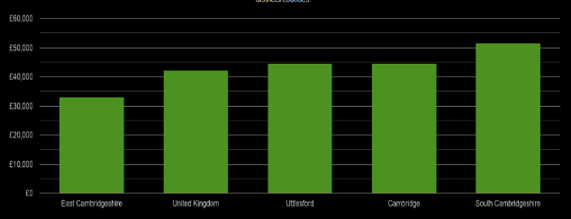

Figure 1
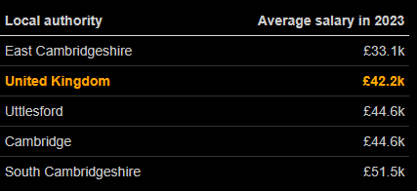
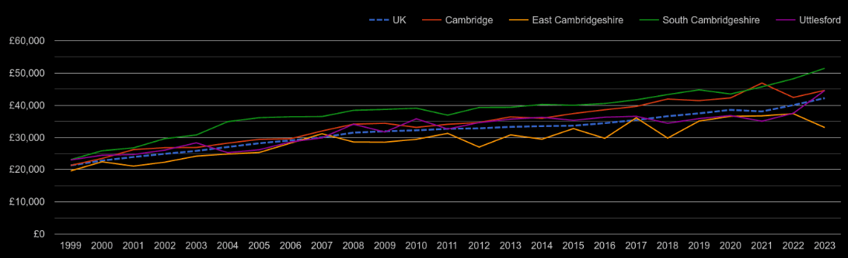
Figure 2
Figure 3

According to figure 1, figure 2 and figure 3, the data accessed online from (PlumPot, 2023), the average salary is ranging between £33.1k and £51.5k in East and South Cambridgeshire respectively and £44.6K in Cambridge. The UK average salary was £42.2k in 2023. This evidently proves that people in Cambridge have more money to dispose in comparison to other parts of the UK.

Trends
Family-Oriented Venues
There is an increasing demand for family-friendly spaces where parents can relax while their children play safely such Sawston. (Yu & Watson, 2024) The café provides a safe and engaging environment for children and a relaxed atmosphere for parents.
Health and Wellness
Consumers are becoming more health-conscious, nutritious, locally sourced food options. This trend aligns with the increasing popularity of organic and sustainable food products (Hamzaoui-Essoussi & Zahaf, 2011). The Cafe's commitment to health-focused menu options allows us to excel in this segment of the market. This will further heighten people’s desire to visit the café in Sawston.
Technological Integration
Modern consumers expect technological conveniences in cafes, such as free Wi-Fi, online booking, and contactless payment options (Statista, 2024). Implementing these technologies at the café will cater to the needs of remote workers etc.

Interesting Findings from PESTLE Analysis
Political and Economic Support: The availability of government grants and local economic stability supports the feasibility of launching The Green Room Cafe.
Social Trends: The high percentage of young families in Sawston and the growing demand for health-conscious dining options align perfectly with the cafe's concept.
Technological Expectations: Integrating modern technology will be essential for customer satisfaction and operational efficiency.
Environmental Considerations: Emphasizing sustainable practices can differentiate The Green Room Cafe from competitors and attract a loyal customer base.

4.2 Customer Profiles
Profile 1: Young Families
This group ranges with parents 25-40 and kids under 10. They seek a safe, clean space, with healthy food options consisting of highchairs etc where their children can play and relax (Issa & Bou Darwish, 2022). This demographic tends to be active in community events and values businesses that support local initiatives (Brown, et al., 2000).

Profile 2: Professionals and Remote Workers
This group ranges from ages 25-45 working remotely or in flexible job roles. They need quiet, calm, comfortable space with reliable Wi-Fi where they can work with good beverages and light meals. They are likely to use digital payment options. This group often follows and engages with businesses on social media (Wang, et al., , 2024.).

Profile 3: Health-Conscious Individuals
This group ages range is 20-50, focused on a healthy lifestyle. They are like cafes that offer organic, locally sourced, and nutritious menu options. The cafe is seen as a place to relax after physical activities (Camanzi, 2024). They share their experiences on social media and recommending places to their network (Grant, 2021).

4.3 Competitor Profiles
Competitor 1: Café A – Sweet Tea
Sweet Tea offers a diverse menu that appeals to a broad audience with a central location. However, it has limited space and healthy options for families and lacks a play area. Whereas The Green Room Cafe can attract families with its unique play zone and health-focused menu, providing a safe and engaging environment for families. Highlighting these unique features can differentiate The Green Room Cafe from the Sweet Tea Café (Porter, 2008).

Competitor 2: Victor Rolf
Victor Rolf offers an upscale formal dining experience with high-quality food. It is known for its sophisticated menu and ambiance. Their higher prices and formality setting makes it less suitable for casual family outings. In comparison the Green Room Cafe as a more affordable, casual, and a family-friendly alternative (Kim, 2005).

Competitor 3: East Roast Coffee Shop
East Roast Coffee Shop is popular among remote workers etc with strong Wi-Fi, good coffee, and a quiet atmosphere. However, it has a small space with limited seating. In comparison The Green Room Cafe has a larger space and healthy menu options to attract students and remote workers (Grant, 2021).

Unique Selling Proposition (USP) and Competitive Edge
The Green Room Cafe’s USP lies in its combination of a family-friendly play zone, health-conscious menu, and commitment to sustainability. This multi-faceted approach caters to diverse customer needs and preferences, setting it apart from competitors in the Sawston area.

5. MARKETING PLAN

5.1 Price
With the cost of production, competitor prices for similar products, we have established the price margins to cover costs. The competitive prices are reasonable to suit customer needs which will increase customer retention. Moderate pricing will induce the sense of affordability with quality products. To ensure the success on a long term we will be adapting the prices along market demands.

5.2 Product
The bakery products will be presented in a showcase by categories. The business will offer a variety of fresh quality products such as pastries and cakes with coffee, soda etc. Images of products will be included on the menu with coffee-based product images behind the counter wall. They will be served on shop personalised plating with the use of eco-friendly packaging.

5.3 Placement
The main sales of the products will be sold offline on-site for personalised customer interaction. The factor of building trust and loyalty between the customer and the brand is the needed human interaction experience. Café content will be placed on Deliveroo and Just Eat status tracking platforms. This will give them the opportunity to compare and read reviews.

5.4 Promotion
Customer service using well trained staff and quality products in conjunction with clear communication with good reception of feedback will encourage loyalty. Building an online presence in a digital era is the first step in making the brand recognisable. Content on social media sites and our website will keep the business easily accessible to clients which will allow them to express their feedback etc.
6. KEY RESOURCES

6.1 Premises
The cafe will be located at the heart of Sawston's high-traffic area so that it will get maximum customer visibility. The customer area will be included for 50% to 60% of total space where they will get an affordable layout with different equipment like chair table tools, etc. The production area will be 20% to 30% of the total space (Mileva, 2023). The preparation area will include 100 square feet ensuring proper hygiene. The rest of the areas will be included for staff areas and restrooms for employees. The rent for this shop will be £1800 to £3500 per month based on the location.

6.2 Equipment
When renting the property, we were able to rent all the equipment and furniture inside as well. Thus, we hired a commercial catering engineer who came and checked all the equipment ensuring it was within regulatory standards. We will need tableware etc and other cleaning equipment (Turner, 2022). In the inventory resources, the cafe needs to have proper storage of dry and wet goods. All these things will be sourced from local suppliers that will ensure eco-friendly and sustainable sourcing of foods and raw materials.

6.3 Key Suppliers

Supplier Name | Ingredients that will be supplied | Costs
Vegan Bird Bakery | Vegan pastries, cakes, and breads will be collected from this supplier. | £1.50 - £4.00 per pastry
Shelford Deli | Vegan and gluten-free flours will be collected from this supplier (coffeepreneur, 2019) | £1.00 - £2.50 per kilogram
Days Bakery and Food Hall | High-quality coffee beans will be collected from this supplier. | £5 - £12 per kilogram
Dairy Ingredients Company | Milk and other necessary dairy things will be collected from this supplier. | £1.50 - £3.00 per litre
Swanson Food Wholesalers | Fresh fruits, vegetables Fresh fruits, vegetables | £.50 - £3.00 per kilogram

7. FINANCES AND START-UP SUPPORT

EXPENDITURE | Year 1  £
Company Registration | 155.00
Rent/Rates | 24,000.00
Staff Wages | 116,582.40
Telephone (mobile) | 360.00
Broadband | 359.88
Utilities | 9,651.45
Marketing and materials | 100.00
Insurance | 558.72
Service of Equipment (twice a year) | 449.98
Training & Development | 2,950.00
Accounting (once a month) | 1,929.60
Outside Services | 33,197.12
Stock/Materials Purchases | 30,000.00
Office Consumables | 100.00
Loans Repayments | 14,778.72
Total Expenditure | £235,173.33
INCOME | Year 1  £
Sales (café) | 323,736.00
Capital Introduced | 10,000.00
Funding | 0.00
Loans/Borrowing | 50,000.00
Total Income | £383,736.00

YEAR ONE PROFIT/LOSS | £
Total Income | 383,736.00
Total Expenditure | 235,173.33
Profit/Loss | £148,562.67

7.1 Financial Summary

According to (Millet, 2023) small businesses use up to 25,000KWV of gas and electricity. Using online calculators (Calculator, 2024) and (Sus It, 2024) the amount per year for each was calculated. As stated by (Castle Water , n.d) a café uses almost 4500 Liters of water daily. With the use of (Switch, 2024) water for the year was calculated. All employee rates were determined with the use of (Talent.com, 2024) where the rates are cross checked with salary offerings. A loan of £50,000.00 was taken from Halifax bank and was to be paid in 4 years with approximated 8.8% APR (Bank, 2024).
In terms of January when we open its just to introduce the café to customers The festivals in the following months will allow our café to get popular. In July and August months it’s the summer vacation for students etc thus our café will be very popular during that time. In November and December, the revenue will be slightly reduced seeing that end of school time is coming along and Christmas is approaching (Martinez, n.d). There is also £10,000.00 of introduced capital and £50,000.00 from Halifax bank.

APPENDICES

Appendix A – SWOT Analysis

Strengths: Green Room Café/ Bakery: High sustainability values with an extensive array of plant-based & animal protein choices utilizing local, organic ingredients Local farm and supplier partnerships, such as with Boswell and Son, give us the high-quality product and community-based support we pride ourselves in. A strategic position in a Sawston neighborhood known for supporting green movements is the last reason why we think the Sawston air conditioner is the best in the area!

Weaknesses: A potential con might be the increased cost of getting organic and local ingredients, which in turn can increase menu prices. Also, we may be limited by our target market as being too niche may reduce our customer base. While this can also be difficult to balance over time as many other local sources of inputs are also seasonal.

Opportunities: The move towards clean eating, green eating and living overlap strongly with our values proposition. We can attract more customers by extending our marketing initiatives to highlight our green business initiatives. Running joint ventures with local businesses and appearing at local events is another way to get us seen and build reputation and repeat business. We can also refresh our product by introducing new products and seasonal menus.

Threats: there are other bistros and restaurants near the area that do not strive to do what Earth bliss Bistro does regarding sustainability; this will mean offering their products at cheaper prices. Customer spending at dine-in restaurants could also suffer during economic downturns. In our marketing, we will underscore USPs such as sustainability and quality to counteract its risks. We will also take cost-reduction steps, but without lowering quality. We will also be working with the community to establish a strong local customer base who appreciate the environmental and well-being benefits of our product.
And then, The Green Room can play on its strengths to make the best of opportunities and figure out how to resolve any threats that come — the recipe for success in the long haul.

Appendix B – PESTLE Analysis

A PEST analysis is a strategic business tool used to evaluate the external environment affecting a business. These can influence success or failure of a business. Below is a PEST analysis for the green room cafe with a play area for kids in Sawston:
Political Factors
Regulations and Compliance:
  - Health and Safety Regulations: Compliance with local health and safety standards is crucial, especially concerning food safety and children's play areas.
  - Licensing Requirements: Obtaining necessary permits for operating a cafe and a child-friendly play area.
  - Child Protection Laws: Adhering to laws related to child safety, including regular checks and certifications for the play area.
Government Policies:
  - Support for Small Businesses: Availability of grants or subsidies for small businesses and child-friendly establishments.
  - Tax Policies: Understanding local tax obligations and benefits for family-oriented businesses.
Economic Factors
Economic Environment:
  - Consumer Spending: Economic downturns can reduce disposable income, affecting spending on non-essential services like cafes.
  - Inflation Rates: Rising costs of ingredients, labour, and maintenance can impact pricing and profitability.
Local Economic Conditions:
  - Employment Rates: High employment rates can increase disposable income, leading to more visits to family-oriented cafes.
  - Competition: The number of similar businesses in the area affecting market share and pricing strategies.
Social Factors
Demographics:
  - Family-Friendly Communities: Areas with a high number of young families and children can drive demand for child-friendly cafes.
  - Lifestyle Trends: Increasing preference for family outings and child-friendly environments.
Social Attitudes and Trends:
  - Health Consciousness: Growing trends towards healthy eating influence menu offerings. So, using local produce to ensure its freshness and support small local businesses in Sawston too.
  - Work-Life Balance: Parents seeking spaces where they can relax while their children are entertained.
Technological Factors
Operational Technology:
  - Point of Sale Systems: Efficient EPOS systems for smooth transactions and inventory management.
  - Online Presence: Importance of a strong online presence, including social media platforms, to attract and engage customers.
Customer Experience:
  - Free Wi-Fi: Providing free Wi-Fi as an added value for parents and guardians.
  - Play Area Innovations: Safe and modern play equipment to attract children and ensure safety.

Appendix C – Pitch & Menus





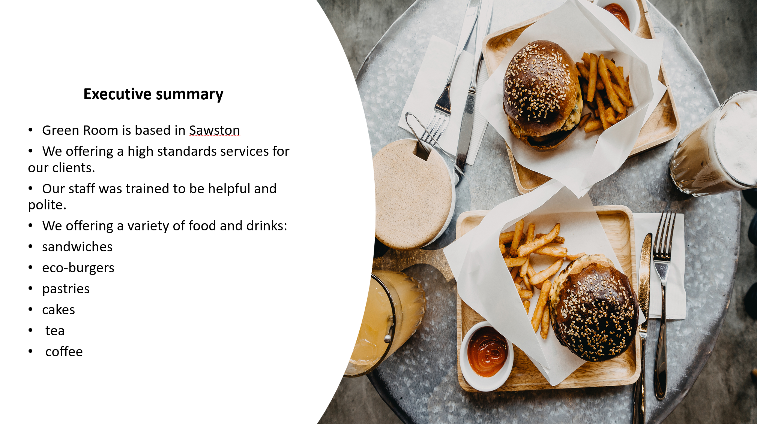

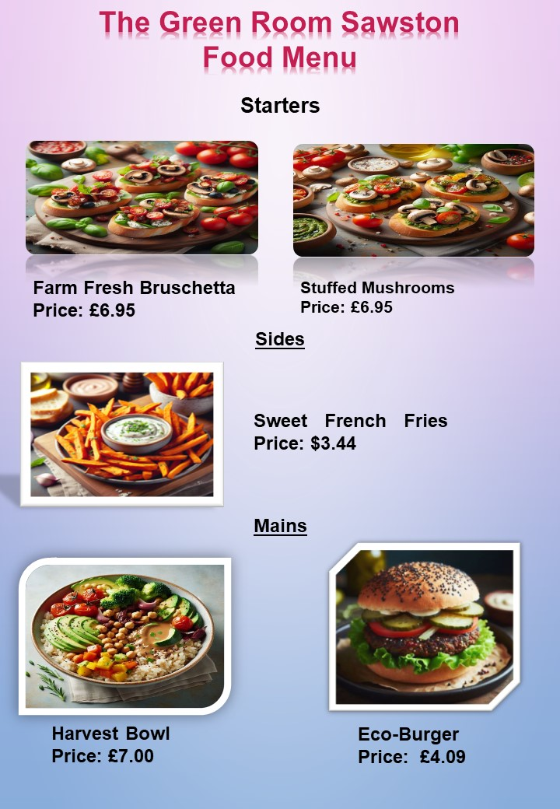

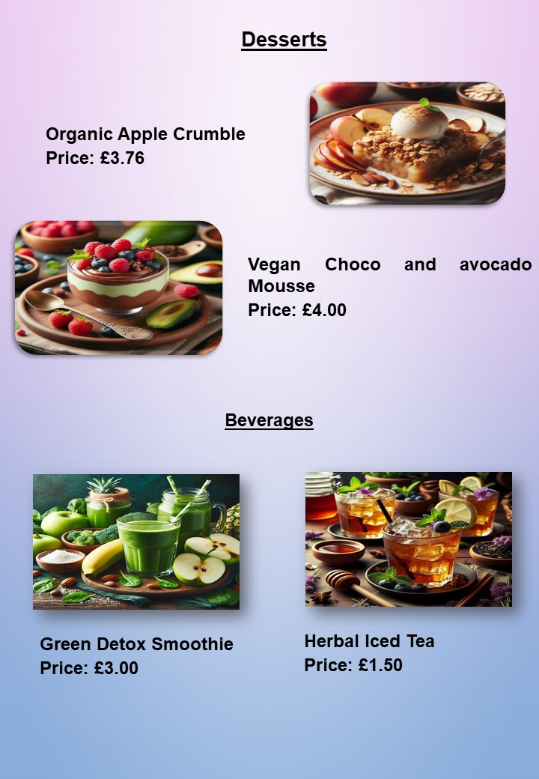
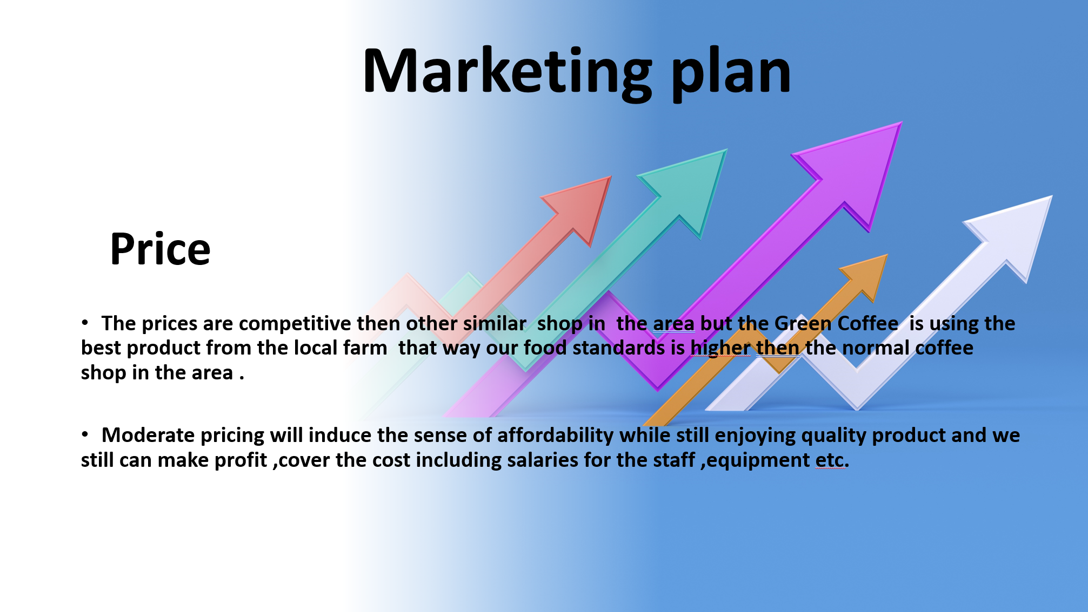
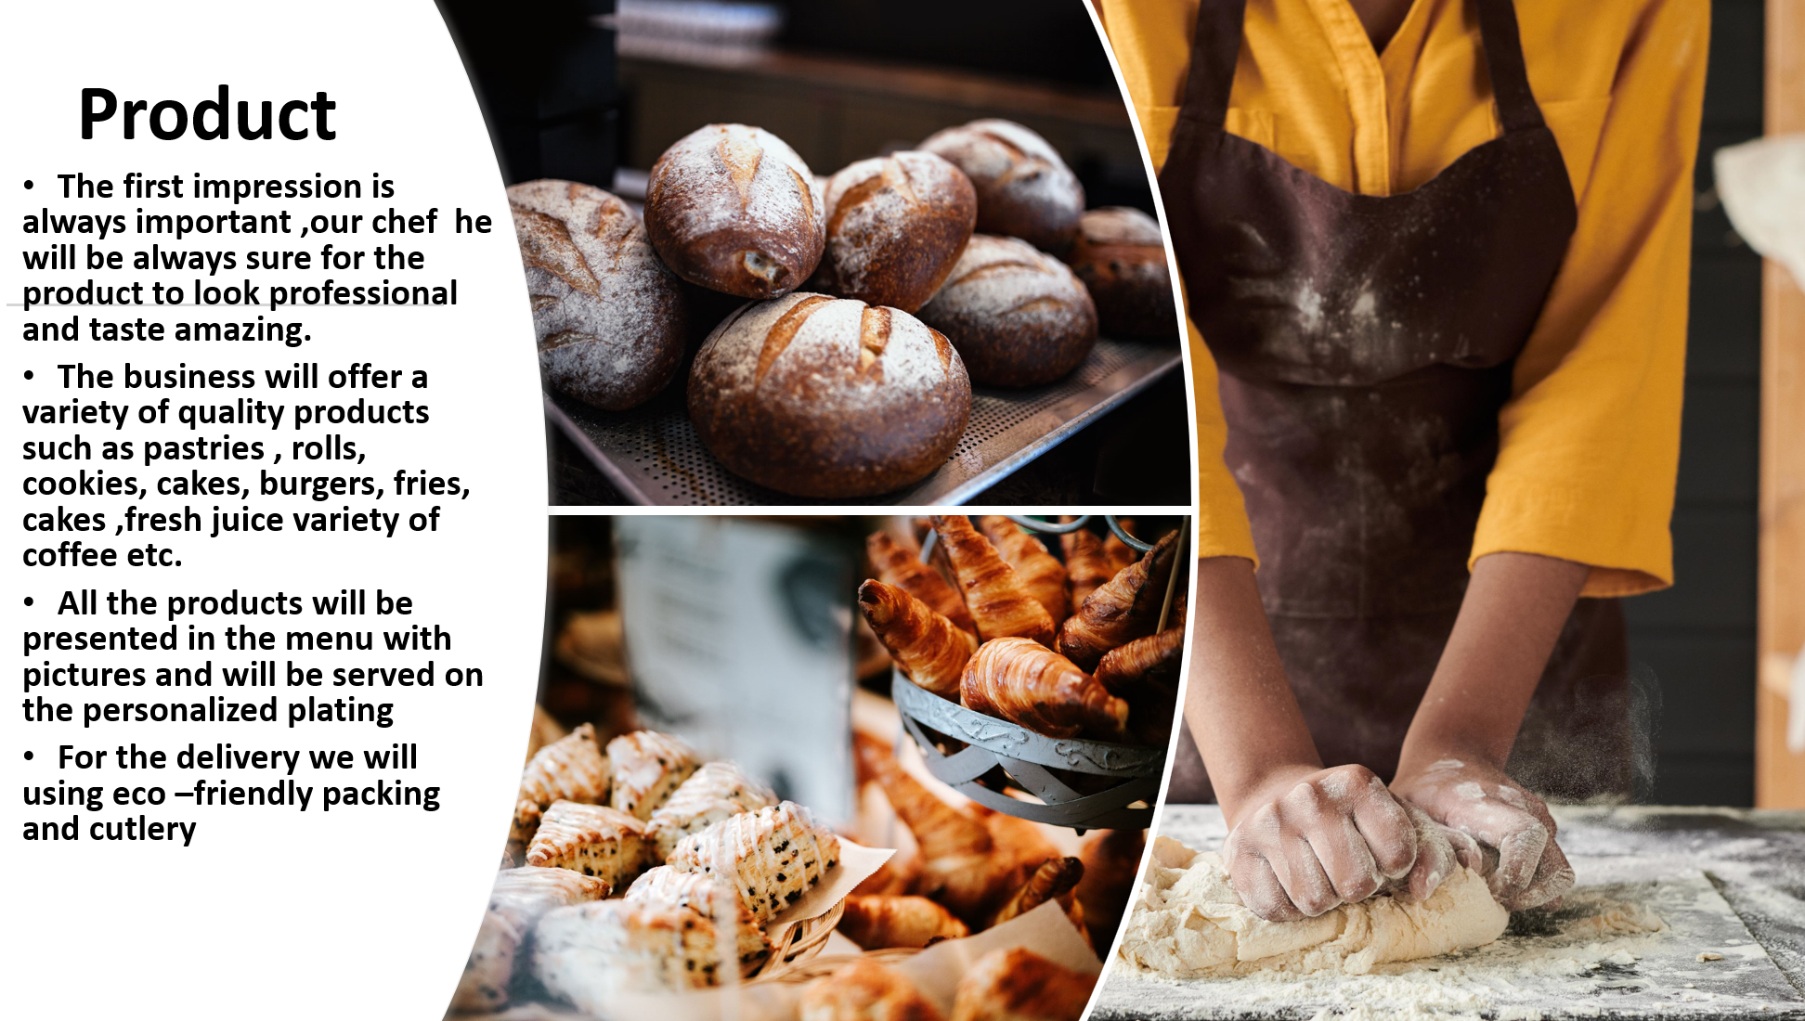
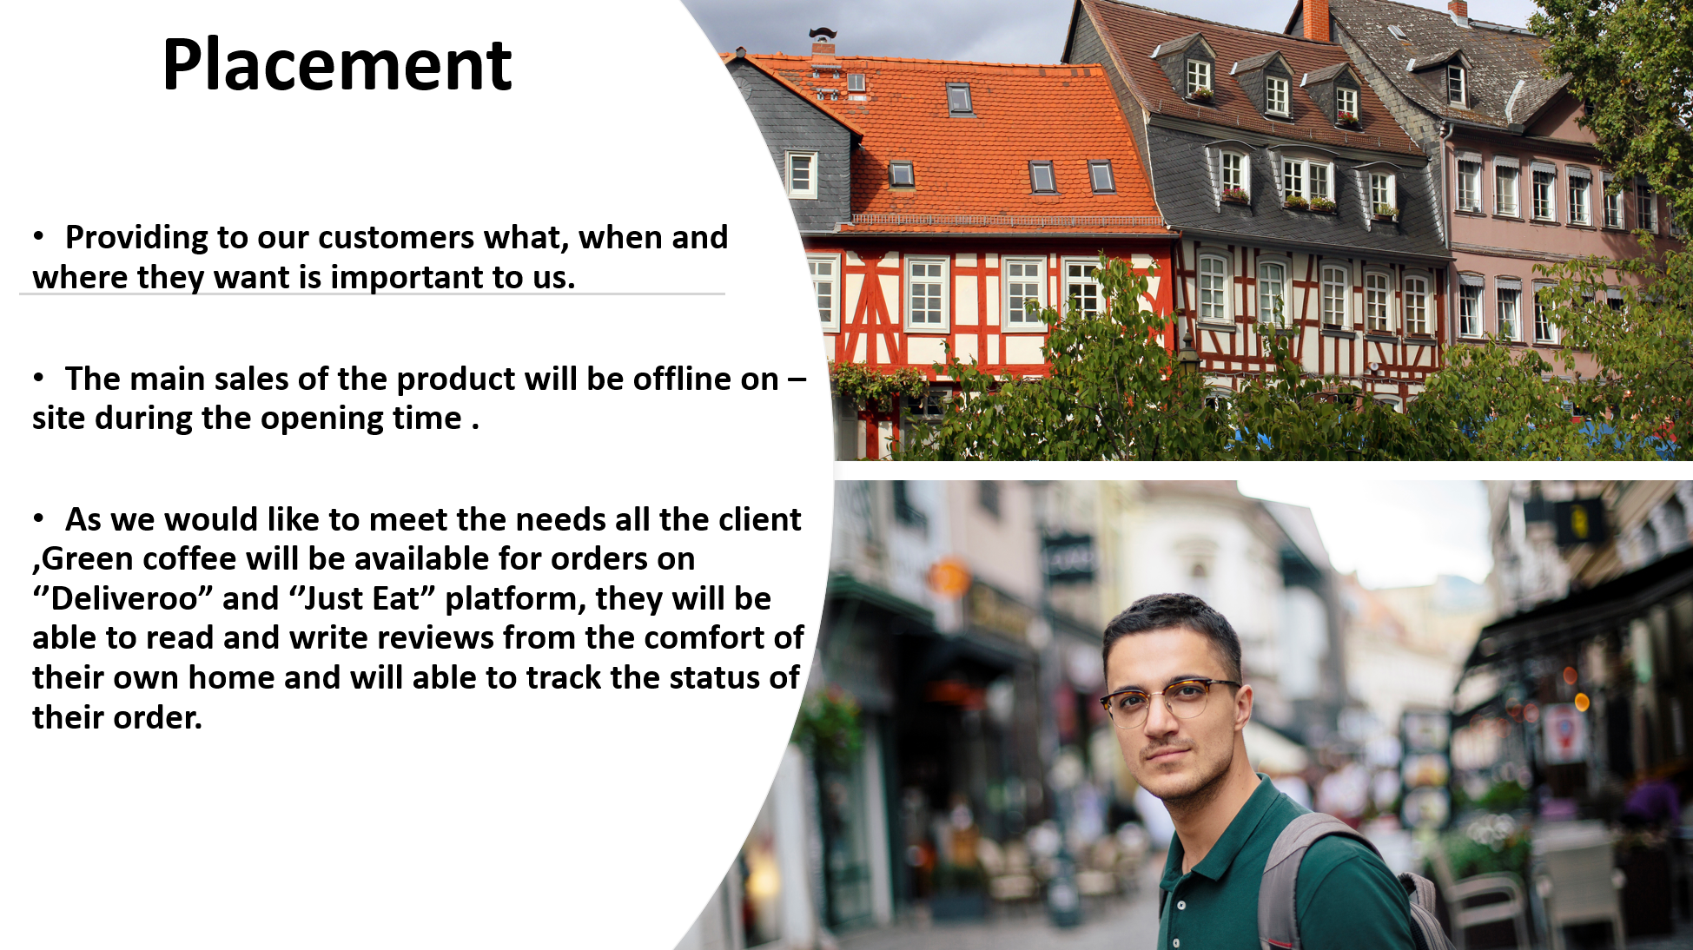

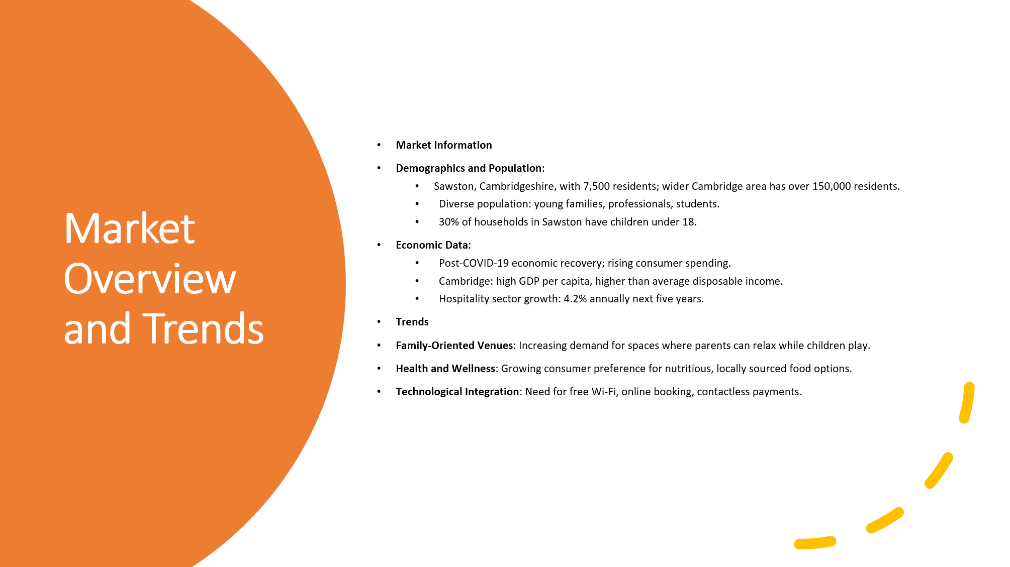
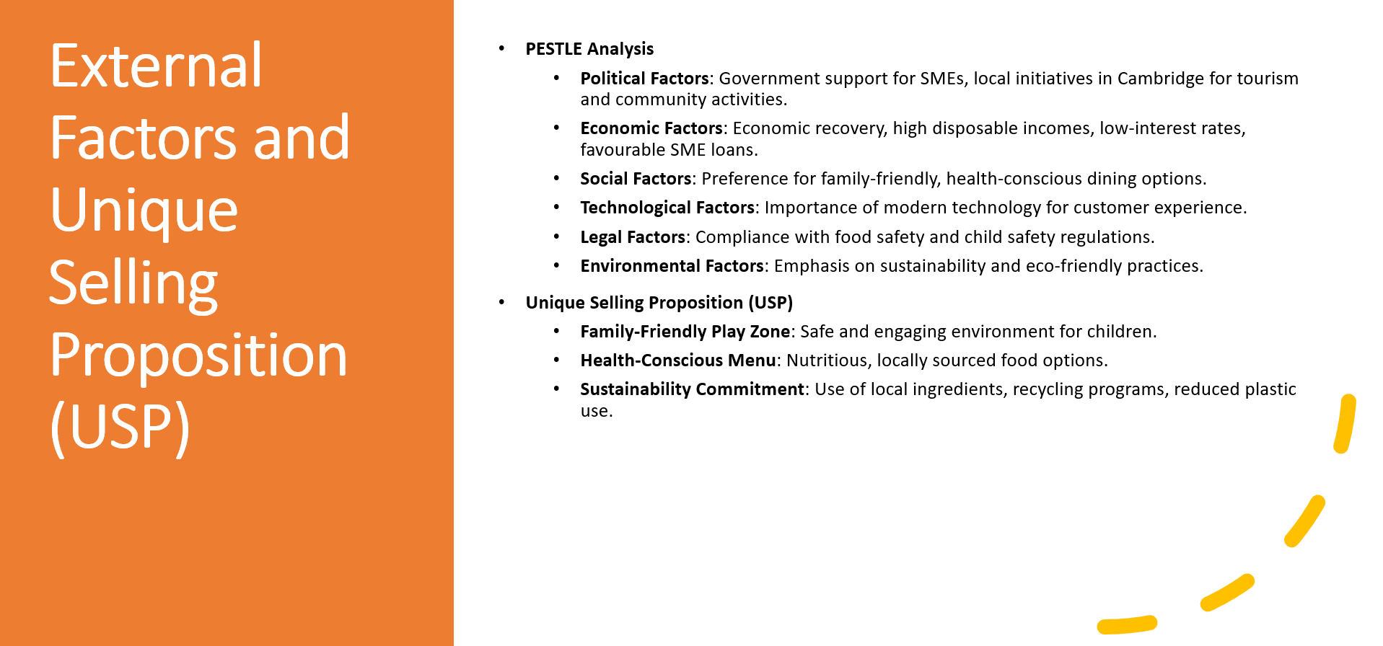
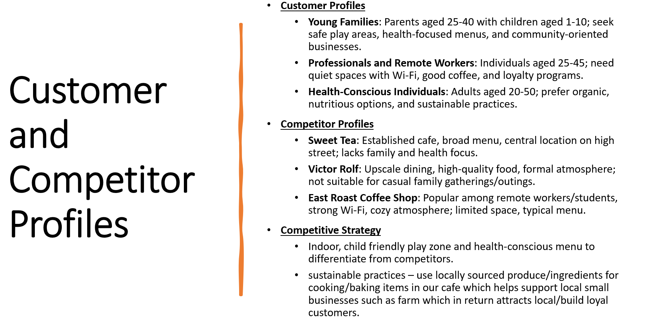

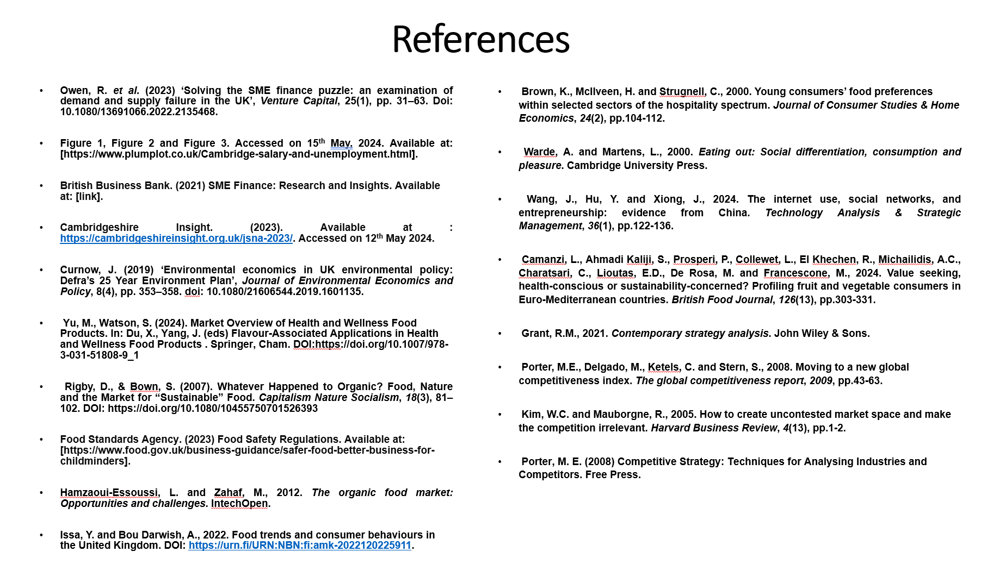
Appendix D – Supporting Financials

Picture showing: Utilities Breakdown
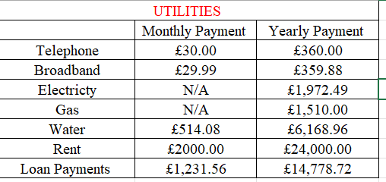

Picture showing: Short-term and long-term employees
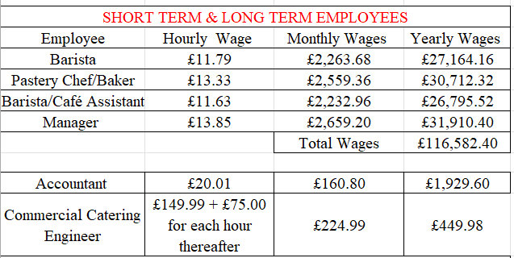

Picture showing: Outside Services
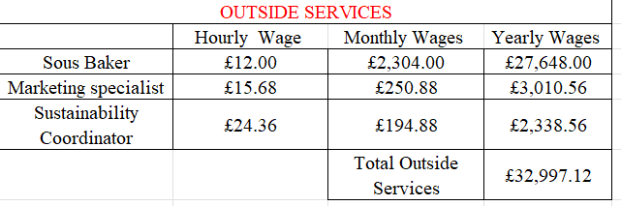

Picture showing: Insurance Breakdown
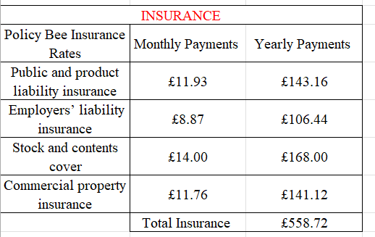

Picture showing: Training Costs
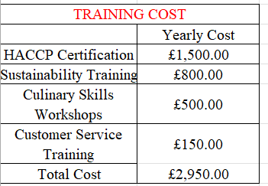

Picture showing: Training Costs
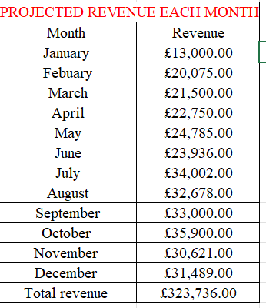

REFERENCE LIST:

Bank, H., 2024. Halifax Loan Calculator. [Online]
Available at: https://www.halifax.co.uk/loans/loan-calculator.html
[Accessed 23 05 2024].
Boswell and Son, 2018. Boswell and Son. [Online]
Available at: https://boswellandson.co.uk/
[Accessed 21 05 2024].
Brown, K., McIlveen, H. & Strugnell, C., 2000. Young consumers’ food preferences within selected sectors of the Hospitality Spectrum. 24 ed. s.l.:Journal of Consumer Studies & Home Economics.
Calculator, E. B., 2024. Your Electricity Bill. [Online]
Available at: https://www.electricitybillcalculator.com/yourbill/
[Accessed 23 05 2024].
Camanzi, L. A. K. S. P. P. C. L. E. K. R. M. A. C. C. L. E. D. R. M. a. F. M., 2024. Value seeking, health-conscious or sustainability-concerned? Profiling fruit and vegetable in Euro-Mediterranean countries?. British Food Journal, 126(13), pp. 303-331.
Castle Water , n.d. Business Water Use in the Hospitality Industry. [Online]
Available at: https://www.castlewater.co.uk/business-water-by-industry/hospitality#:~:text=A%20caf%C3%A9%20can%20use%20a,4500%20litres%20in%20one%20day.
[Accessed 23 05 2024].
coffeepreneur, 2019. Where to open a coffee shop or cafe?. [Online]
Available at: https://www.cafesuccesshub.com/where-to-open-a-coffee-shop-or-cafe/
[Accessed 03 06 2024].
Council, H. P., n.d. Regulating Healthcare and Professionals. [Online]
Available at: https://www.hcpc-uk.org/
[Accessed 21 05 2024].
Grant, R. M., 2021. Contemporary Strategy Analysis. Volume 11, p. 544.
Hamzaoui-Essoussi, L. & Zahaf, M., 2011. The Organic Food Market: Opportunities and Challenges. [Online]
Available at: https://www.intechopen.com/chapters/25733
[Accessed 21 05 2024].
Insights, C. a. P., 2023. Welcome to the overarching 2023 Joint Strategic Needs Assessment (JSNA) for Cambridgeshire and Peterborough. [Online]
Available at: https://cambridgeshireinsight.org.uk/jsna-2023/
[Accessed 12 05 2024].
Issa, Y. & Bou Darwish, A., 2022. Food trends and consumer behaviours in the United Kingdom. [Online]
Available at: https://www.theseus.fi/bitstream/handle/10024/784576/Bou%20Darwish%20Issa_Ali%20Youssef_v1%20.pdf?sequence=2
[Accessed 12 05 2024].
Kim, W. a. M. R., 2005. How to create uncontested market space and make the competition irrelevant.. Harvard Business Review, Volume 4(13), pp. 1-2.
Martinez, T., n.d. How Much Do Bakeries Make?. [Online]
Available at: 25
[Accessed 05 05 2024].
MeetYourBarista, 2020. Barista Job Description | Skills, Duties and Responsibilities. [Online]
Available at: https://www.meetyourbarista.com/barista-job-description/
[Accessed 30 05 2024].
Mileva, G., 2023. How to Design a Coffee Shop: A Balanced Blend of Tips and Strategies. [Online]
Available at: https://www.pushoperations.com/blog/how-to-design-a-coffee-shop-a-balanced-blend-of-tips-and-strategies#:~:text=Small%20Size%3A%20Aim%20for%20600
[Accessed 14 05 2024].
Millet, J., 2023. What is the average energy consumption for different UK businesses?. [Online]
Available at: https://bionic.co.uk/business-energy/guides/average-energy-usage-for-businesses/
[Accessed 20 05 2024].
Owen, R., Botelho, T., Hussain, J. & Anwar, O., 2023. Solving the SME finance puzzle: an examination of demandand supply failure in the UK. [Online]
Available at: https://www.tandfonline.com/doi/epdf/10.1080/13691066.2022.2135468?needAccess=true
[Accessed 30 05 2024].
PlumPot, 2023. Cambridge average salary comparison. [Online]
Available at: https://www.plumplot.co.uk/Cambridge-salary-and-unemployment.html
[Accessed 30 05 2024].
Porter, M. D. M. K. C. a. S. S., 2008. Moving to a new global competitiveness index.. The global competitiveness report, pp. 43-63.
Saad Andaleeb, S. & Conway, C., 2016. Customer satisfaction in the restaurant industry: an examination of the transaction‐specific model. Journal of services marketing, Volume 20, pp. 3-11.
Satistics, O. o. N., 2023. Population and migration statistics transformation, Cambridge case study: 2023. [Online]
Available at: https://www.ons.gov.uk/peoplepopulationandcommunity/populationandmigration/populationestimates/articles/populationandmigrationstatisticstransformationcambridgecasestudy/2023
[Accessed 30 05 2024].
Soriano, D., 2022. Customers’ expectations factors in restaurants: The situation in Spain. International Journal of Quality & Reliability Management, Volume 19(8/9), pp. 1055-1067.
Sus It, 2024. Gas Cost Calculator. [Online]
Available at: https://www.sust-it.net/gas-calculator.php
[Accessed 23 05 2024].
Switch, A., 2024. Business Water Rates Calculator. [Online]
Available at: https://www.aquaswitch.co.uk/blog/business-water-rates-calculator/
[Accessed 23 05 2024].
Talent.com, 2024. Your job search starts here. [Online]
Available at: https://uk.talent.com/
[Accessed 20 05 2024].
Turner, J., 2022. Coffee Shops. [Online]
Available at: https://www.ethicalconsumer.org/food-drink/shopping-guide/coffee-shops
[Accessed 14 05 2024].
Wang, J., Hu, J. & Xiong, J., , 2024.. The internet use, social networks, and entrepreneurship: evidence from China. Technology Analysis & Strategic Management, Volume 36(1), pp. 122-136.
Yu, M. & Watson, S., 2024. Market Overview of Health and Wellness Food Products. [Online]
Available at: DOI:https://doi.org/10.1007/978-3-031-51808-9_1
[Accessed 30 05 2024].
Owen, R. et al. (2023) ‘Solving the SME finance puzzle: an examination of demand and supply failure in the UK’, Venture Capital, 25(1), pp. 31–63. Doi: 10.1080/13691066.2022.2135468.
Figure 1, Figure 2 and Figure 3. Accessed on 15th May, 2024. Available at: [https://www.plumplot.co.uk/Cambridge-salary-and-unemployment.html].
Cambridgeshire Insight. (2023). Available at : https://cambridgeshireinsight.org.uk/jsna-2023/. Accessed on 12th May 2024.
Curnow, J. (2019) ‘Environmental economics in UK environmental policy: Defra’s 25 Year Environment Plan’, Journal of Environmental Economics and Policy, 8(4), pp. 353–358. doi: 10.1080/21606544.2019.1601135.
Yu, M., Watson, S. (2024). Market Overview of Health and Wellness Food Products. In: Du, X., Yang, J. (eds) Flavour-Associated Applications in Health and Wellness Food Products . Springer, Cham. DOI:https://doi.org/10.1007/978-3-031-51808-9_1
Rigby, D., & Bown, S. (2007). Whatever Happened to Organic? Food, Nature and the Market for “Sustainable” Food. Capitalism Nature Socialism, 18(3), 81–102. DOI: https://doi.org/10.1080/10455750701526393
Food Standards Agency. (2023) Food Safety Regulations. Available at: [https://www.food.gov.uk/business-guidance/safer-food-better-business-for-childminders].
Hamzaoui-Essoussi, L. and Zahaf, M., 2012. The organic food market: Opportunities and challenges. IntechOpen.
Issa, Y. and Bou Darwish, A., 2022. Food trends and consumer behaviours in the United Kingdom. DOI: https://urn.fi/URN:NBN:fi:amk-2022120225911.
Brown, K., McIlveen, H. and Strugnell, C., 2000. Young consumers’ food preferences within selected sectors of the hospitality spectrum. Journal of Consumer Studies & Home Economics, 24(2), pp.104-112.
Warde, A. and Martens, L., 2000. Eating out: Social differentiation, consumption and pleasure. Cambridge University Press.
Wang, J., Hu, Y. and Xiong, J., 2024. The internet use, social networks, and entrepreneurship: evidence from China. Technology Analysis & Strategic Management, 36(1), pp.122-136.
Camanzi, L., Ahmadi Kaliji, S., Prosperi, P., Collewet, L., El Khechen, R., Michailidis, A.C., Charatsari, C., Lioutas, E.D., De Rosa, M. and Francescone, M., 2024. Value seeking, health-conscious or sustainability-concerned? Profiling fruit and vegetable consumers in Euro-Mediterranean countries. British Food Journal, 126(13), pp.303-331.
Grant, R.M., 2021. Contemporary strategy analysis. John Wiley & Sons.
Porter, M.E., Delgado, M., Ketels, C. and Stern, S., 2008. Moving to a new global competitiveness index. The global competitiveness report, 2009, pp.43-63.
Kim, W.C. and Mauborgne, R., 2005. How to create uncontested market space and make the competition irrelevant. Harvard Business Review, 4(13), pp.1-2.
Porter, M. E. (2008) Competitive Strategy: Techniques for Analysing Industries and Competitors. Free Press.

