STUDENT NAME: Azhda Mustafa
STUDENT NUMBER: 1907558
MODULE : LCBB5004 Managing People
ASSIGNMENT 1: Managing people -REPORT 2000 words.
MODULE LECTURER: Dr. Mushfiqur Rahman

Table of contents
Table of contents 1
1. Introduction . 2
1.1 Module description 2
1.2 Aim of the Report 2
1.3 Background of the company 2
2. HR professional and CIPD profession map. 3
2.1 HR professional 3
2.2 CIPD new profession map 3
2.3 CIPD and UNILEVER 4
3. Objectives of the company and SWOT analysis. 5
3.1 Objectives 5
3.3 Vision statement 5
3.3 Mission statement 5
3.4 SWOT analysis of Unilever 5
4. HR activities, functions, theories, and UNILEVER. 6
4.1 HR Planning 6
4.2 Recruitment 7
4.3 Selecting 8
4.4 Development 9
4.3 Retaining 10
4.5 Performance management 11
4.6 Motivation and Maslow’s Hierarchy of Needs 11
5. Conclusion 12
6. References: 13

Introduction.

1.1 Module description
“Managing people” is to recognize the role of the Human Resources function within different sectors and within the small, medium, and large organizations. The changing environment of internal and external factors and how these changes impact the Human Resource Strategy.

1.2 Aim of the Report
The report provides information about the company UNILEVER, obtained through analysis. Approaches which UNILEVER take to planning, selecting, developing, and retaining appropriate skills which will drive continued company performance. The evaluation of what it requires to be an HR professional and CIPD Profession Map. The report will pay attention to the Strengths, Weaknesses, Opportunities, and Threats of the company.

1.3 Background of the company
On 2 September 1929, Unilever was founded by the merger of Margarine Unie and Lever Brothers, a British soapmaker. Unilever, with its offices in London, England, and the Netherlands in Rotterdam, is a worldwide consumer product company.
Unilever is dedicated to natural life and is a visible proof of that dedication with its logo. (UNILEVER, 2018)

LOGO OF THE COMPANY
Energy drinks, ice cream, foods and beverages, cleaning, beauty, and personal care products are among the products of Unilever. The organisation holds over 400 brands. The company's products are available in 190 countries which is one of the oldest global companies. The business is the world's largest soap producer. (Wikipedia, 2019)

HR professional and CIPD profession map.

2.1 HR professional
The hiring, screening, interviewing, and placement of staff are the responsibility of human resources specialists. They are also able to control employee relationships, payroll, benefits, and training. Human resources managers prepare, guide, and organise the administrative functions of an organisation. (Torrington, et al., 2017)
Management of human resources is a systematic, integrated, and consistent approach to the jobs, growth and well-being of individuals employed in firms and as 'all those tasks relevant to the management of company employment relationships'. (Armstrong and Taylor, 2014)

2.2 CIPD new profession map
The professional map of the CIPD stated that the HR profession is a specialised business discipline. (Armstrong and Taylor, 2014)

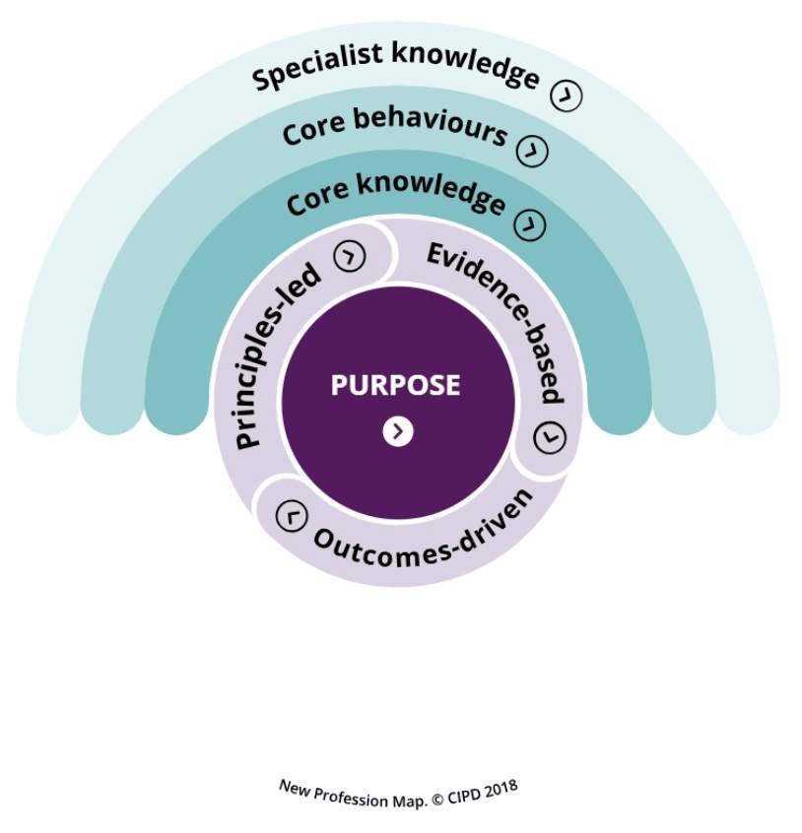

(CIPD, 2018)
Specialist knowledge | Core behaviours | Core knowledge
Employee experience | Ethical practice | Individuals practice
Employee relations | Professional courage and influence | Culture and behaviour
Diversity and inclusion | Valuing people | Business acumen
Learning and development | Working inclusively | Analytics and creating value
Organisation development and design | Commercial drive | Digital acting
People analytics | Passion for learning | Change
Talent management | Insights focused
Resourcing | Situational decision-making
Reward
(CIPD, 2018)

2.3 CIPD and UNILEVER
Customer need: A highly pragmatic dictionary that updates and matches the real-life experiences and aspirations of the entire HR team in 2006.
To encourage their thinking, Unilever gathered external perspectives from CIPD, other human resources professionals, managing search firms and the RBL Institute.
CIPD Consultants and Unilever worked together to create a comprehensive global HR Dictionary using the Insight strategy and solution component of the map as well as internal and external investigation and expertise. The dictionary is defined by seven competencies and four levels of competence and equates to a functional competence framework.

“During the creation process, we benefited from the CIPD’s multi-industry perspective. They were our ‘thinking partners’, stimulating debate and philosophising with us about how the skills would work in practice.” Julie Hudtohan Global HR for HR Director, Unilever

Result: Unilever experts define the skills dictionary as an efficient and helpful instrument that tells you how skills look in practice daily. A common language was created in the dictionary. Individuals are authorized to have their careers and choose career development in an informed manner. (CIPD, 2014)

Objectives of the company and SWOT analysis.

3.1 Objectives

All organizations now operate within clearly defined goals and objectives, performance targets and quality standards. Organizational objectives dictating how the company should allocate strengths, weaknesses, and opportunities, and they are the actions that help to achieve the goals. (Pilbeam and Corbridge, 2010, p.70)

Unilever has 50 social, economic, and environmental targets that are addressed throughout the three prime objectives: to improve health and wellbeing of one billion people; to share the ecological footprint of the group's products; and to improve the livelihoods of people in the supply chain. (Beavis, 2011)

3.3 Vision statement
Unilever’s vision is “to make sustainable living commonplace”, best long-term way and business growth. (Unilever, 2018)

3.3 Mission statement
Unilever’s mission is “to add vitality to life”, helping people feel good and look good. (Unilever, 2018)

3.4 SWOT analysis of Unilever
This analysis is an essential step for the company to take to enhance its HR strategy and function from a reactive to a proactive mode.
Strengths – The strengths of the organisation are internal factors that allow HR strategy and functionality.
- Strong brands
- Wide mix of products
- Scale savings
- Strong power on the world market
Weaknesses - Weakness also challenges the success of HR efforts at the internal level. Internally, budget restrictions and cuts are often conditions for HR, mainly as HR is not a revenue-generating department. To finance investments in HR activities, HR must rely on sound justification.
- Imitable products
- Limited business diversification
- Dependency on retailers
Opportunities- The opportunity for labour force growth because of the increasing demand in products and services in the company is one of the significant external factors for HR.
- Company diversification
- Product improvement for health
- Business development for environmental protection
- Market enhancement
Threats- In the final analysis, threats are external factors that affect the company and the HR department.
- Difficult competitive rivalry
- Imitation of products
- Increasing popularity of retailers’ home brands
(Panmore Institute, 2017) (Azcentral, 2012)

HR activities, functions, theories, and UNILEVER.

4.1 HR Planning

Human Resource Planning (HRP) aims at ensuring the attainment of the organisational goals through the development and implementation of an HR strategy. A digital picture of the organization's structure and the movement of employees in the organisation can be created by numerical indicators like labour revenue, staff counts, stability, cohort analysis together with an accurate definition of the organisational workforce structure. Human resources planning is an ongoing process in which the human resource needs of an organisation are analysed in changing circumstances and integrated with the growth of HR policies that address those demands. (Pilbeam and Corbridge, 2010)

Unilever has an impressive structure of acting in improving functional activities. The company uses Guest model, presented by David Guest, which is recognised for its HR policies to reduce all future problems that are affecting the performance of the company. It has two dimensions of human resources that are loose-tight and hard-soft. (Kaufman, 2008)
Soft HRM has excellent effects on persons and relates to movement in human relationships. It builds a strong employee relation and has proven to be efficient in strategic planning. Unilever must identify the best possible scope of operation. It also seeks to develop innovative and creative ideas on the company's success. It also concentrates mainly on the person's needs in the company. (Study.com,2019)
HRM works with the contract in the organisation, and it is made in written form. Human resource management works based on business needs, and the payment is given to the employees based on their performance. Employees work individually and collectively to achieve objectives and are the most valued assets.

4.2 Recruitment
The process of recruitment is aimed at attracting skilled applicants for a specific position from which the choice and appointment of the competent person or person are possible and practical. (Pilbeam and Corbridge, 2010)
A total of 150,000 employees were employed in 2019 worldwide. Over the past few years, the number of Unilever employees is substantially less than in 2003, when the company hired more than 230,000 people. (Statista, 2018)
Competition for their jobs is tough, so the candidates to be a successful the company has some criteria:
- Growth Mindset: Competitive leadership; encouraging, realistic, attitude to the business's future.
- Customer Focus: the ability to see Unilever’s brands through our customers’ eyes.
- Bias for Action: importance in decision-making, prepared to think things through to take risks.
- Accountability and Responsibility: accepting responsibility for your part in Unilever’s overall performance.
(Graduates First, 2019)
The online recruitment system of Unilever is a very charming approach for the applicants since it contributes to the speed and efficiency of the application but for the company and the applicants. For new candidates and students, Unilever also provides internships. Spring, industrial and summer seating programmes, stages, and apprenticeships, for example. In a variety of media, including newspapers, online magazines, Unilever publishes its vacancies and opportunities. (Unilever global, 2018)

4.3 Selecting
Selection is a process involving the application of right techniques and methods to select, appoint and induce a competent person. (Pilbeam and Corbridge, 2010)
A three-year programme designed to prepare graduates for management roles in an enterprise is the Unilever Future Leaders programme. The programme includes several courses, formal training, tutoring and a short field sales experience, within and across functions.
Unilever introduced four steps of selection method:
- Online application
- Online psychometric tests
- Video interview
- Assessment centre
(Unilever, 2019)
“Unilever: We reduced the selection process by half.” The IT-analytic at Unilever Andrey Kuzmichev said that they do not want HR to spend their nights at the office. With traditional selecting structure, they spent 1.5 months, and now they reduce to 3 weeks.
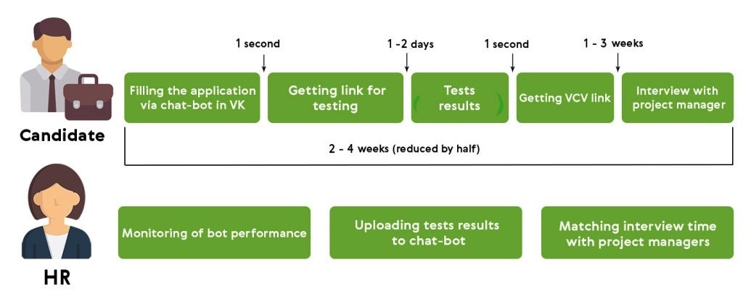(VCV, 2019)

4.4 Development
HR development can be defined as the activities involved in the organisation of individual and collective learning processes for employee and organisational development. The place of work is vital for HRD because learning is accomplished and applied in this context. Effective HRD can create a sustainable competitive advantage by encouraging employees to develop themselves and their professional lives in ways appropriate for themselves and the working environment in which they operate. (Torrington, 2017)
Development goals of Unilever are:
- Quality education
- Gender equality
- Reduced inequalities
- Decent work and economic growth
- Partnerships for the goals
The company aims to challenge and empower women to harmful gender standards.
The Stereotype Alliance is a policy of thinking and acting that employs publicity as a motive for positive change. The Alliance focuses on empowering women in all their different fields (race, class, age, capacity, ethnicity, religion, sexuality, language, education to help achieve an equal world for men.
Unilever enhances woman - entrepreneurial access to training and skills.
 43%
Of agricultural workers are women
The Doves Self-Esteem Project enhances the self-worth of young girls. The company helped over 60 million young people in 142 countries with self-esteem education during 2005-2019. And by 2030 they intend to reach 250 million. (Unilever, 2020)

4.3 Retaining
HR specialists play an essential role in the bringing outcome for retaining the talents as:
- Career development
- Jobs challenging
- Providing excellent training
- Teamwork
- Including the employees in decision-making
- Offering a perfect work-life balance
(Torrington, 2017)
The critical success of the company Unilever is collaborative and partnership approach. They are giving the employees the chance to tell their stories in LinkedIn and democratising the employer brand to let employees become their brand ambassadors. The organisation empowers people and building partnerships. (Unilever, 2015)

4.5 Performance management

The performance control system of Unilever enables its workers to identify and deliver goals that affect the challenges of the organisation. It assists employees in developing their careers and skills to achieve the goals and to advance themselves in the current and future period. (Unilever, 2018)

4.6 Motivation and Maslow’s Hierarchy of Needs
Motivation is the energy, the direction, and the sustaining force of conduct. Well-motivated people, who are ready to exercise their discretion, i.e., do more independently than is anticipated, achieve high performance. (Armstrong and Taylor, 2014)
A five-level model of human needs, often represented as hierarchical levels in a pyramid, is the motivational theory of Maslow in psychology. The requirements are physiological, safety, love, esteem and self-actualization from the bottom of the hierarchy upwards. In the hierarchy, lower needs must be satisfied before people can take care of higher needs. (Mcleod, 2020)
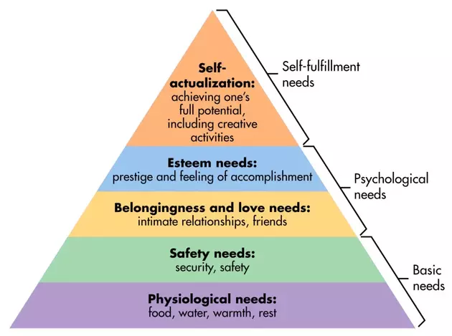
Unilever fulfils the physiological requirements of its employees: food, water, warmth, and rest. (Unilever global, 2018)
Secondly, job security, physical safety and economic safety are also part of the safety and security requirements. Here they have adequate physical security and financial security because they have a good infrastructure and a high salary. (Glassdoor, 2020)
The third need is the social need which includes social partners' feelings of belonging and affiliation. Here these requirements can be solved by organizing weekly team meetings and maintaining good relations with managers and employees.
The needs of Esteem can be meet by recognizing the contribution, achievement, success, and brilliant performance of employees.
The fulfilment of these requirements will make the employees feel important to the business and will personally benefit them. The final phase of the hierarchy is the need for self-actualization that relates to the achievement of one's full potential, including creative activities. (McLeod, 2020)

Conclusion

The research shows that Unilever has a stable HRM. Most of its employees and its subsidiaries are part of the company's reputable umbrella beneficiaries, and so the right talented and competent people are attracted by Unilever, who contributed to the company's growth and profitability.

References:

Armstrong, M. and Taylor, S. (2014) Armstrong’s handbook of human resource management practice. 13th Edition. Kogan Page. p.39

Armstrong, M. and Taylor, S. (2014) Armstrong’s handbook of human resource management practice. 13th Edition. Kogan Page. p.42

Armstrong, M. and Taylor, S. (2014) Armstrong’s handbook of human resource management practice. 13th Edition. Kogan Page. p.169

Azcentral.com. (2012). Human Resource SWOT Analysis. Available at: https://yourbusiness.azcentral.com/human-resource-swot-analysis-1288.html. (Accessed: 21 November 2020)

Beavis, S. (2011). Unilever - planning for growth and sustainability. the Guardian. Available at: https://www.theguardian.com/sustainable-business/unilever-ambition-plans-sustainability. (Accessed: 20 November 2020)

CIPD (2014) Case study, Unilever- CIPD. Available at: Unilever-case-study_tcm18-9717.pdf (cipd.co.uk) (Accessed: 20 November)

‌CIPD (2018). New Profession Map | CIPD Profession Map. CIPD Profession for the Future. Available at: https://peopleprofession.cipd.org/profession-map. (Accessed: 20 November 2020)

Glassdoor. (2020). Unilever Salaries. [online] Available at: https://www.glassdoor.co.uk/Salary/Unilever-Salaries-E3513.htm [Accessed 13 Dec. 2020].

Graduates First. (n.d.). UNILEVER Assessment 2019/2020 | Aptitude Tests | Assessment Centre | Interview | Full Guide. Available at: https://www.graduatesfirst.com/unilever-assessment-tests [Accessed 24 Nov. 2020].
‌
Kaufman, B.E. (2008). The theory and practice of strategic HRM and participative management. Human Resource Management Review, 11(4), pp.505–533.

McLeod, S. (2020). Maslow’s hierarchy of needs. [online] Simply Psychology. Available at: https://www.simplypsychology.org/maslow.html. (Accessed: 12 December)
‌
Panmore Institute. (2017). Unilever’s SWOT Analysis & Recommendations - Panmore Institute. Available at: http://panmore.com/unilever-swot-analysis-recommendations. (Accessed: 21 November 2020)
‌
Pilbeam, S. and Corbridge, M. (2010). People resourcing contemporary HRM in practice. Harlow, England ; New York: Financial Times Prentice Hall. p.91

Pilbeam, S. and Corbridge, M. (2010). People resourcing contemporary HRM in practice. Harlow, England ; New York: Financial Times Prentice Hall. p.156

Statista. (2018). Total number of Unilever employees worldwide 2003-2018 | Statista. Available at: https://www.statista.com/statistics/254366/total-number-of-unilever-employees-worldwide/. (Accessed: 23 November 2020)
‌
Study.com. (2019). Soft HRM: Employee-First Focus - Video & Lesson Transcript | Study.com. Available at: https://study.com/academy/lesson/soft-hrm-employee-first-focus.html. (Accessed: 22 November 2020)
‌
Torrington, D. et al., (2017). Human resource management. 10th Edition. Harlow; New York: Pearson. p.7

Torrington, D. et al., (2017). Human resource management. 10th Edition. Harlow; New York: Pearson. p.20

Torrington, D. et al., (2017). Human resource management. 10th Edition. Harlow; New York: Pearson. p.326

Unilever (2015). What three factors help us win and retain talent? Available at: https://www.unilever.com/news/news-and-features/Feature-article/2015/15-10-23-What-three-factors-help-us-win-and-retain-talent.html. (Accessed: 25 November)

Unilever global company website. (2018). Consumers and sustainability. [online] Available at: https://www.unilever.com/sustainable-living/our-strategy/consumers-and-sustainability/. (Accessed: 13 December)

UNILEVER (2018). Our logo. Available at: https://www.unilever.com/about/who-we-are/our-logo/. (Accessed: 26 April 2020)

Unilever global company website. (2018). Graduates & students. Available at: https://www.unilever.com/careers/students-and-graduates/ [Accessed 25 Nov. 2019].

Unilever (2019). The Unilever Future Leaders Programme | Careers at Unilever UK & Ireland. Available at: https://careers.unilever.com/uk/en/-grads-schemes-. (Accessed: 25 November 2020)

‌Unilever global company website. (2020). Enhancing entrepreneurial & life skills through our brands. Available at: https://www.unilever.com/sustainable-living/enhancing-livelihoods/opportunities-for-women/enhancing-entrepreneurial-life-skills-through-our-brands/ [Accessed 26 Nov. 2020].
‌
VCV, blog (2019). Unilever: We reduced the selection process by half. Available at: https://blog.vcv.ai/2019/04/03/unilever/. (Accessed: 25 November 2020)
‌
Wikipedia Contributors (2019). Unilever. Wikipedia. Available at: https://en.wikipedia.org/wiki/Unilever (Accessed: 22 April 2020)

