12/17/2025
Assessment
Operating Systems

Module NaMe: Computer Architecture and Operating Systems
Module Code: ACCA 4022
Lecturer: Redhwan-Al-Amri
Trinity saint david University of Wales (London Campus)



Student Name: AZUBUIKE ORIZU
Student ID: 2440637
Table of Contents
Introduction 1
Main Body 2
Task 1 Key functions of general Operating Systems 2
Task 2 Use of Windows OS CLI commands 2
Task 3 Use of Linux OS CLI commands 2
Task 4 Use of Windows OS scripts 3
Task 5 Use of Linux OS scripts 3
Conclusion 4
References 4
Appendices 4

Introduction
Operating Systems (OS) are the foundation of modern computing, enabling interaction between hardware, software, and users. They provide essential services such as process scheduling, memory allocation, file management, device control, and security. Popular general-purpose operating systems Microsoft Windows, Linux distributions, and macOS share these core functions, though they differ in implementation and user interface design. Understanding these functions is vital for IT professionals and students, as they underpin system administration, troubleshooting, and automation tasks.

This project explores the key functions of operating systems and demonstrates their practical application through command-line interfaces (CLI) and scripting. It is structured into five sections:[1]

Main Body

Task 1

1.Key functions of general Operating Systems

Process Management
A fundamental responsibility of any operating system is overseeing active processes. It distributes CPU resources, facilitates multitasking, and maintains overall system stability. [2] In Windows, users can observe and manage these processes through Task Manager, which displays CPU usage and allows termination of unresponsive programs. macOS provides similar functionality via Activity Monitor, while Linux users typically rely on System Monitor or terminal-based tools like top.

Memory Management
Efficient memory allocation is crucial for optimal system performance. [3] Operating systems monitor RAM usage, handle data swapping to disk when necessary, and prevent memory leaks. Utilities such as Activity Monitor on macOS and Task Manager on Windows offer real-time insights into memory consumption per process, helping users pinpoint applications that consume excessive resources.

File System Management
Operating systems structure data into files and directories, regulate access permissions, and safeguard data integrity. [2] Tools like File Explorer in Windows, Finder in macOS, and Nautilus in Linux provide user-friendly interfaces for browsing and managing files. These platforms also enforce rules governing file access and maintain the hierarchical organization of stored data.

Device Management
To interact with hardware components such as printers, keyboards, and external drives operating systems utilize device drivers.[2] In Windows, the Device Manager displays connected hardware and driver status. macOS users can access similar information through System Information, while Linux users often use terminal commands like lsusb and lspci to inspect device connectivity and configuration.

Security and Access Control
Security is a core function of any OS, encompassing user authentication, permission settings, and protection against malicious software. Windows integrates Windows Security,[3] macOS employs tools like Gatekeeper and FileVault, and Linux enforces access control through user/group permissions and advanced modules such as SELinux.

Networking
Operating systems manage network interfaces, protocols, and data exchange across connected devices. Users can configure Wi-Fi, Ethernet, VPNs, and firewall settings through built in utilities. Windows offers the Network and Sharing Center, macOS uses System Preferences Network, and Linux provides both graphical tools and command-line utilities like ifconfig for network management.[4]

User Interface
The OS presents a user interface either graphical or command line that facilitates interaction with system resources. Windows and macOS feature intuitive graphical environments, while Linux supports both GUI options (e.g., GNOME, KDE) and powerful command line interfaces. These interfaces are essential for launching applications, adjusting settings, and navigating the system.[5]

Task 2
2. Use of Windows OS CLI commands
10 Batch and PowerShell commands across process, file, network, user, and scheduling management. Screenshots captures both code input and console output for evidence.

• Process management
The tasklist command in Windows is a built‑in utility that displays all currently running processes on a local or remote computer, including their process IDs (PIDs), memory usage, and associated modules[6]
Tasklist (batch) | Displays all running processes.
Example | Tasklist.
Table 1
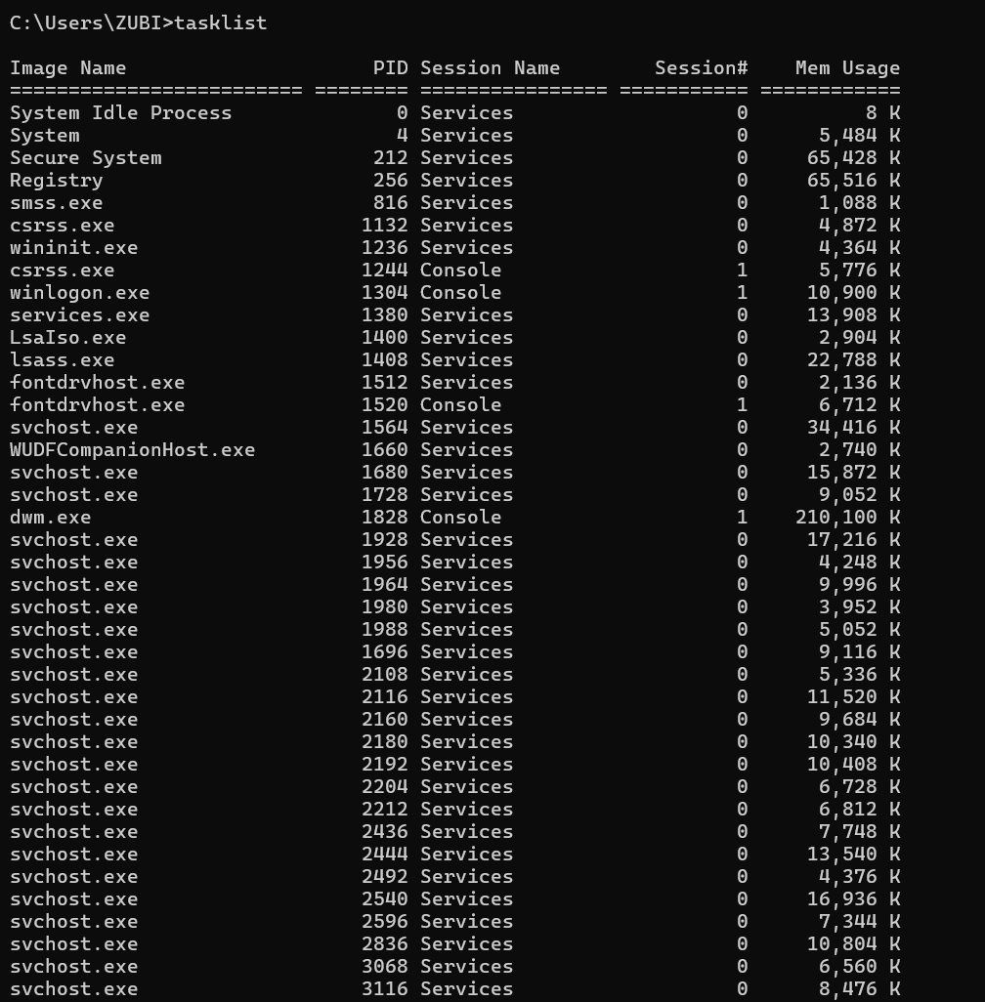
output
input
Fig 1 Screenshot of tasklist 1

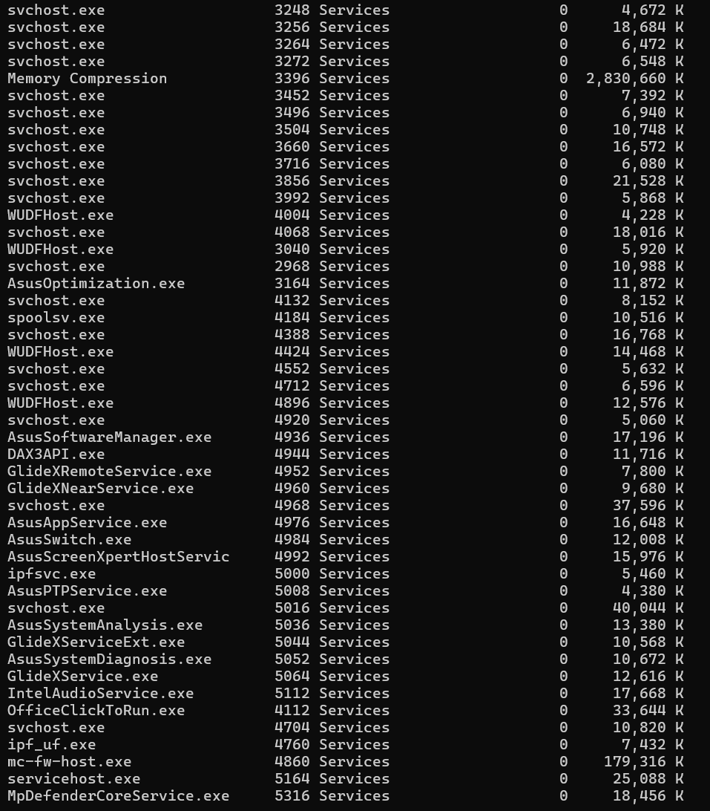
Output continue
Fig 1b Screenshot of tasklist 2

tasklist /FI "IMAGENAME eq notepad.exe | Lists only Notepad processes
Table 1c
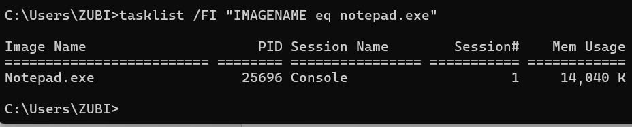
Output
input
Fig 1c

• File & directory management
The dir command in Windows Batch is a fundamental utility used to list files and directories within a specified folder. It provides details such as file names, extensions, sizes, and creation or modification dates, thereby assisting users in navigating and managing the file system. By default, executing dir without parameters displays the contents of the current working directory, but additional switches (e.g., /p for paginated output, /w for wide format, /s for recursive listing) extend its functionality. This command is widely used in system administration and scripting tasks to verify directory contents, troubleshoot file organisation, and automate workflows. [7]
dir (Batch) | Lists files in a directory.
Example: | dir /B /S → bare format, recursive.
Table 2
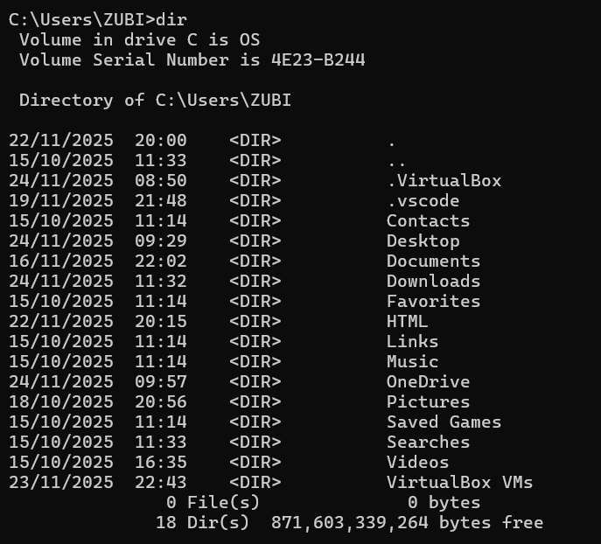
input
output
Fig 2

• Network testing/monitoring
The ping command in Windows Batch is a diagnostic utility used to test network connectivity between a local computer and a remote host. By sending Internet Control Message Protocol (ICMP) echo requests and awaiting replies, ping verifies whether the target system is reachable and measures the round‑trip time of packets. This makes it a valuable tool for troubleshooting network issues, identifying latency, and confirming the availability of servers or websites. In practice, administrators often use ping to quickly determine if a network path is functional before conducting more advanced diagnostics[8]
ping (Batch) | Tests connectivity
Example | ping google.com -n 5 → sends 5 packets
Table 3
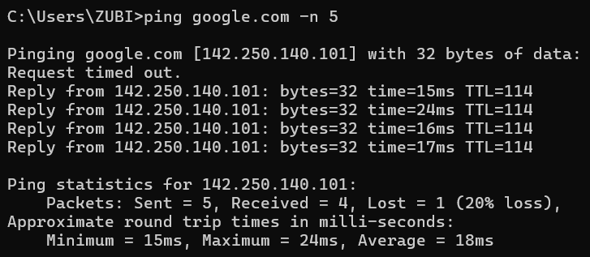
output
input
Fig 3
input
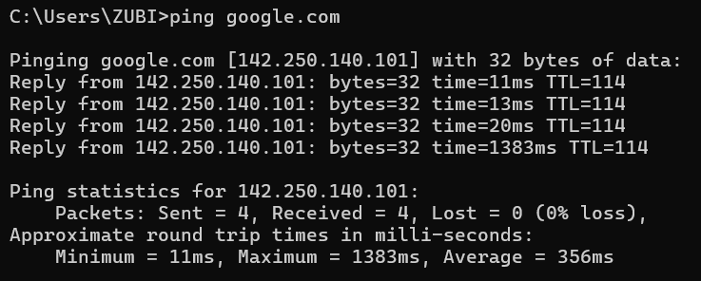
output
Fig 3b

Test-NetConnection (PowerShell) | Advanced network diagnostics.
Example | Test-NetConnection -ComputerName microsoft.com -Port 443

Table 3c
input
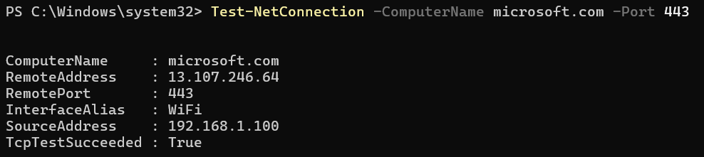
output
Fig 3c

netstat (Batch) | Displays active connections.
Example | netstat -ano → shows ports with process IDs.
Table 3d

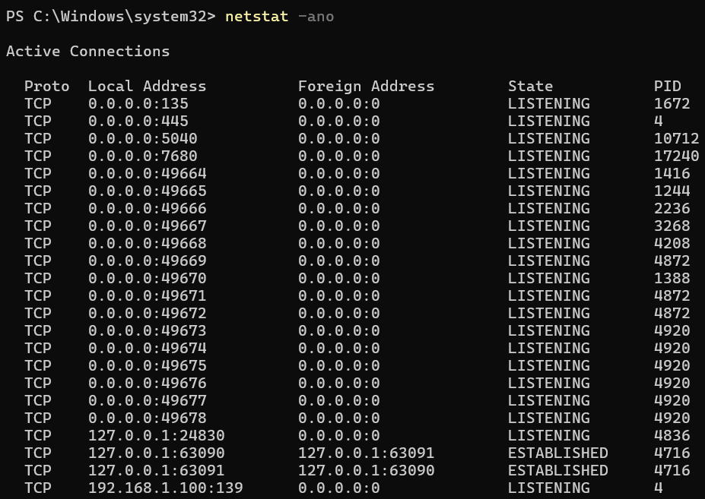
Output
input
Fig 3d

Ipconfig /all | Displays full network configuration.
Table 3e
input
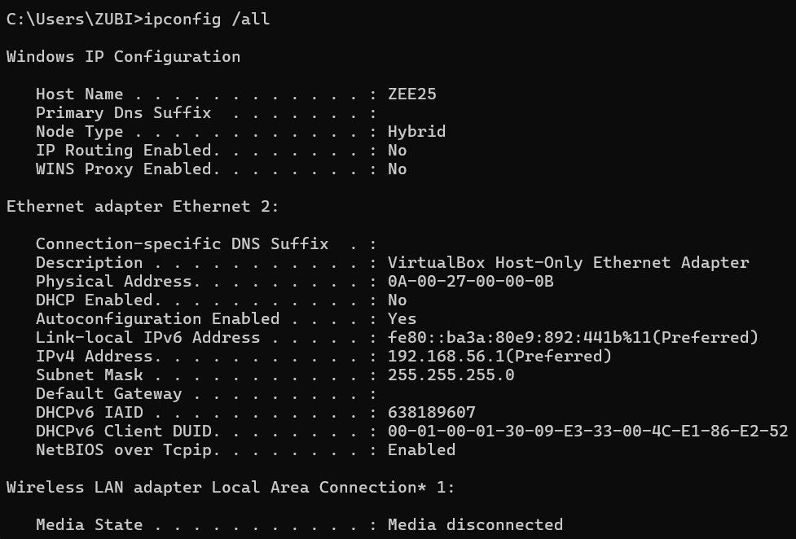
output
Fig3e (i)

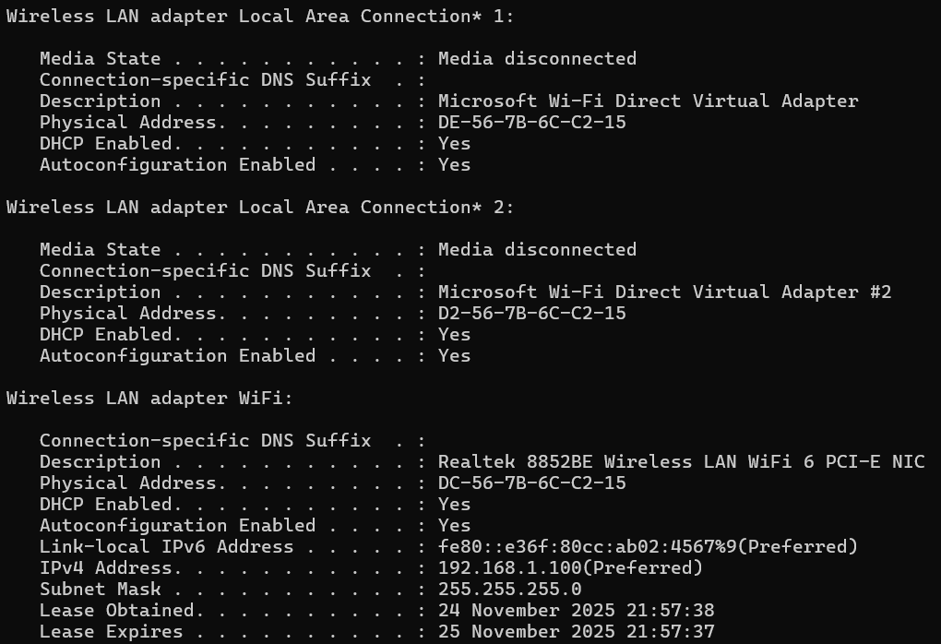
Output continue
Fig 3e(ii)
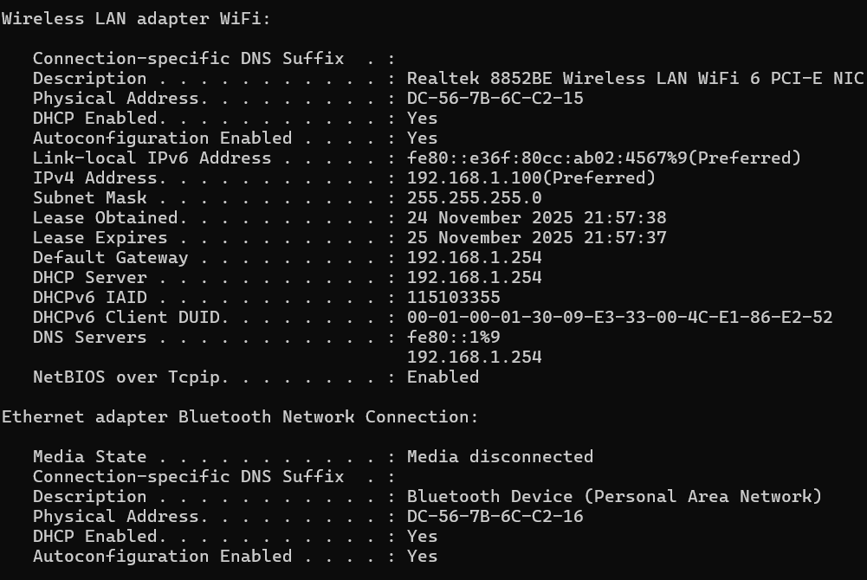
Output continue
Fig 3e (iii)

• User management
The net user command in Windows Batch is a built‑in administrative utility used to manage local user accounts on a computer. It allows administrators to create, modify, or delete accounts, set or change passwords, and configure account properties such as expiration dates or group memberships. When executed without parameters, net user displays a list of all existing user accounts on the system, while additional switches enable specific account management tasks. This makes it a valuable tool for system administration, particularly in environments where user access and security policies must be enforced consistently.[9]
net user (Batch) | Manages local accounts.
Example | net user student P@ssw0rd /add → creates a user.
Table 4
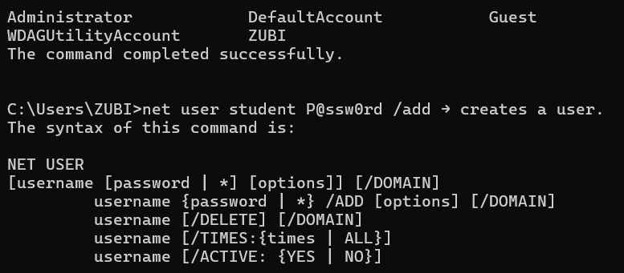
output
input
Fig 4

Get Local User (PowerShell) | Lists local users
Example | Get-LocalUser | Format-Table Name, Enabled
Table 4b
input
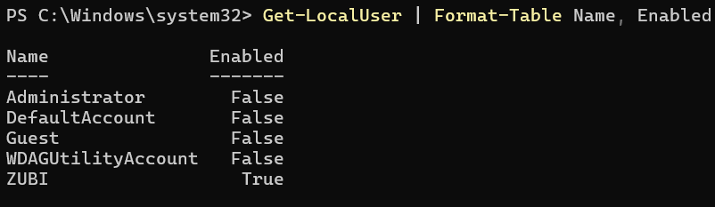
output
Fig 4b

• Task scheduling
The schtasks command in Windows Batch is a built‑in utility that allows administrators to create, delete, query, change, and run scheduled tasks on a local or remote computer. It provides a command‑line interface to the Windows Task Scheduler, enabling automation of routine processes such as backups, updates, or application launches. By specifying parameters such as task name, schedule frequency (daily, weekly, monthly), and the program to execute, schtasks ensures that critical operations are performed consistently without manual intervention. This makes it a valuable tool for system administration, improving efficiency and reliability in both enterprise and personal computing environments.[10]
schtasks (Batch) | Creates and manages scheduled tasks
Example | schtasks /create /sc daily /tn "Backup" /tr "C:\scripts\backup.bat" /st 02:30.
Table 5
input
output
Fig 5

Task 3

Use of Linux OS CLI commands
The use of Linux operating system command‑line interface (CLI) commands is fundamental to system administration, software development, and automation. The CLI provides direct text‑based interaction with the operating system, enabling users to perform tasks such as file management (ls, cp, rm), process monitoring (ps, top, kill), and network diagnostics (ping, netstat, ssh). Unlike graphical interfaces, CLI commands offer precision, speed, and the ability to script repetitive tasks, making them indispensable for managing servers and development environments. Their flexibility and efficiency have established the CLI as a core skill for IT professionals, particularly in enterprise and academic contexts where Linux is widely deployed.[11]
Linux Bash commands across process, file, network, user, and scheduling management.
- Process Management
ps aux | Lists all running processes with CPU/memory usage.
Table 6

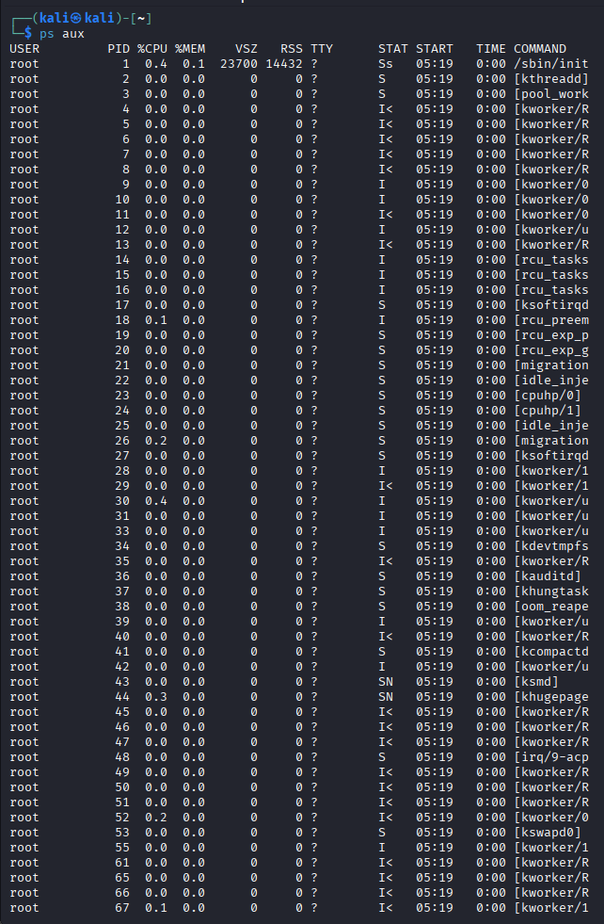
output
input
Fig 6
ps aux | grep firefox | showing filtered process list.
Table 6b
input
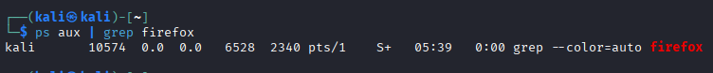
output
Fig 6b

top | Interactive real-time process monitor
Table 6c

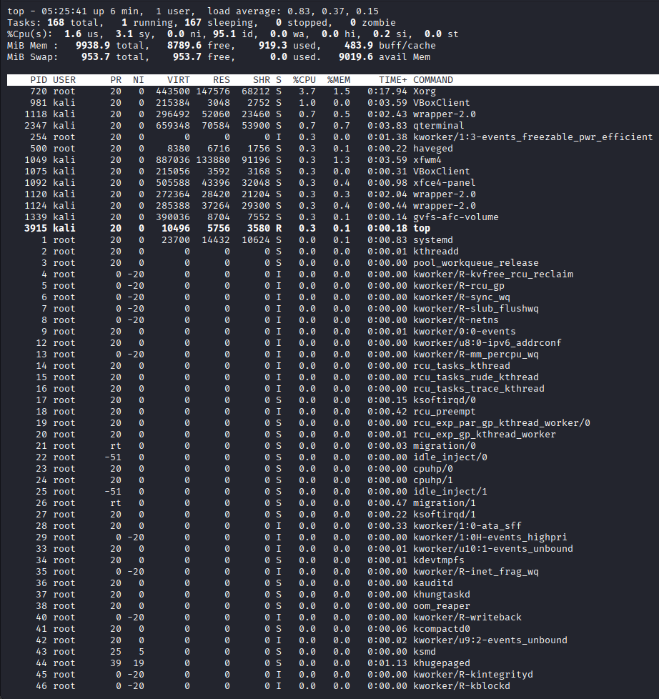
output
input
Fig 6c
kill -9 <PID> | Forcefully terminates a process by PID.
Table 7
input
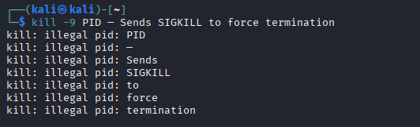
output
Fig 7

- File & Directory Management
ls -l | Long listing with permissions, ownership, and timestamps.
Table 8
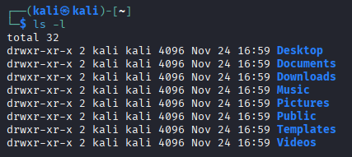
output
input
Fig 8

ls -a | Shows hidden files.
Table 9
input
output
Fig 9

find /home -name "*.txt" | Searches for files by pattern
Table 10
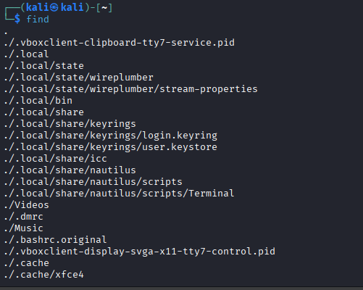
output
input
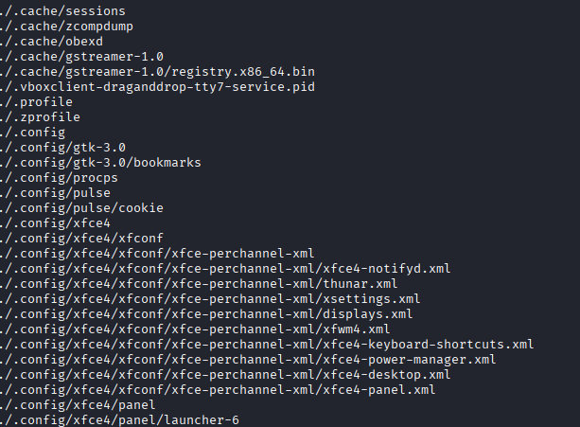
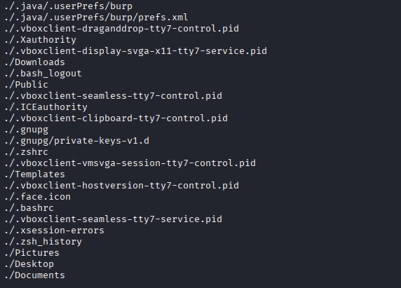
Fig 10
Network Testing & Monitoring
ping -c 4 google.com | Tests connectivity with 4 packets
Table 11
input
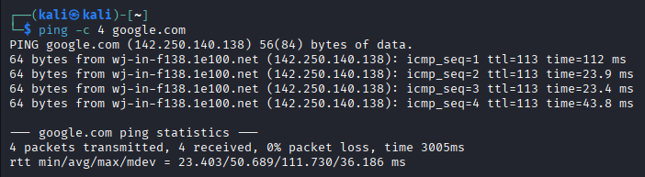
output
Fig 11

netstat -tulnp | Lists active ports and processes.
Table 12
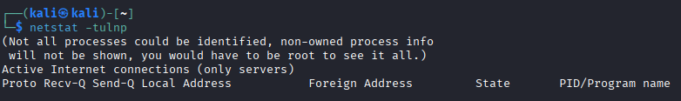
input
output
Fig 12

curl -I https://example.com | Fetches HTTP headers
Table 13
input
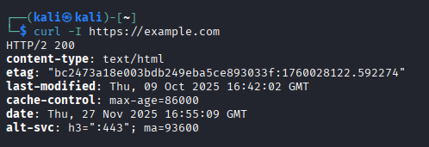
output
Fig 13

traceroute google.com | Shows route packets take to destination.
Table 14
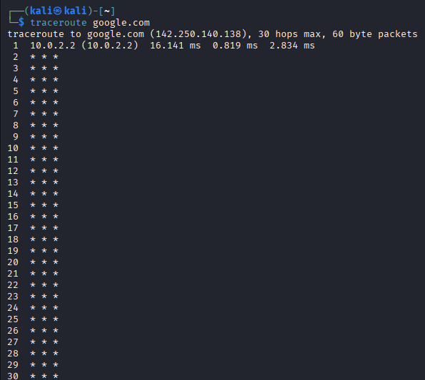
output
input
Fig 14

User Management
adduser newuser | Creates a new user interactively.
Table 15
input
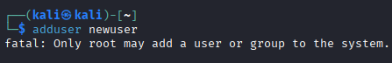
output
Fig 15

Task Scheduling
systemctl list-timers | Lists systemd timers.
Table 16
input
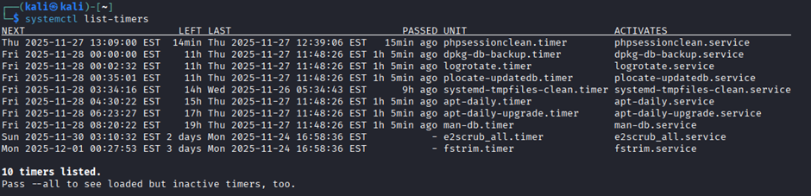
output
Fig 16

This documentation covers several commands with options/switches across the five requested areas. Screenshots captures both command input and terminal output for evidence. Together, they demonstrate practical Linux administration skills in process control, file handling, networking, user management, and automation.[12]

Task 4

Use of Windows OS scripts
Windows scripting languages such as Batch (.bat) and PowerShell (.ps1) enable administrators to automate repetitive tasks, manage system resources, and streamline workflows. Batch scripts are simple and command-line oriented, while PowerShell offers object-oriented capabilities with access to .NET libraries.[13]

Batch Script Examples
- File Operations
batch
@echo off
echo Creating a new folder...
mkdir C:\TestFolder
copy C:\data.txt C:\TestFolder\data.txt
mkdir | creates directories.
copy | duplicates files.
Table 17
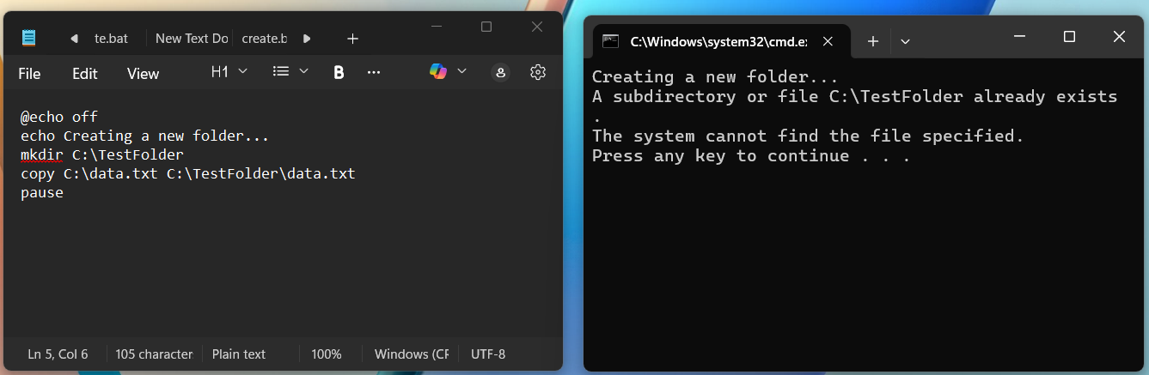
Fig 17
output
input

- System Information
batch
@echo off
systeminfo > sysinfo.txt
Redirects system information into a text file
Table 18
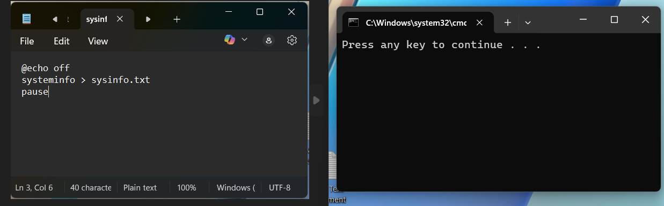
Fig 18
output
input
- Looping
batch
@echo off
for %%f in (*.txt) do echo %%f
Iterates through .txt files in a directory.
Table 19
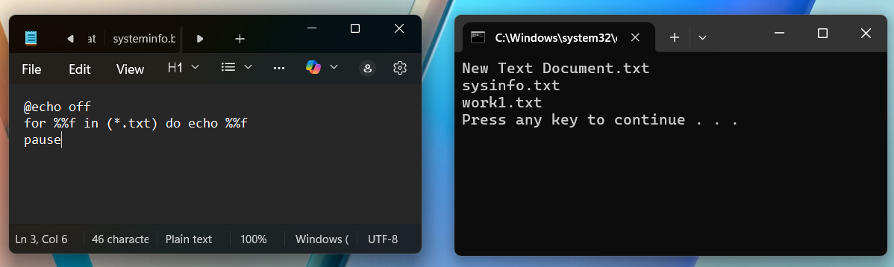
Fig 19
output
input

PowerShell Script Examples
- Process Management
Powershell
Get-Process | Sort-Object CPU -Descending | Select-Object -First 5 | Lists top 5 processes by CPU usage
Table 20
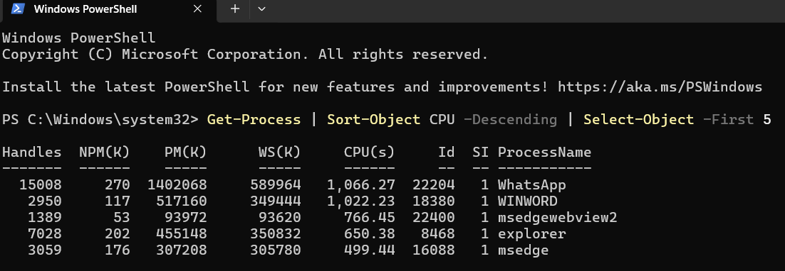
output
input
Fig 20
- File Handling
Powershell
Copy-Item "C:\data.txt" -Destination "C:\Backup\data.txt" | Equivalent to Batch copy, but with object-oriented syntax.
Table 21
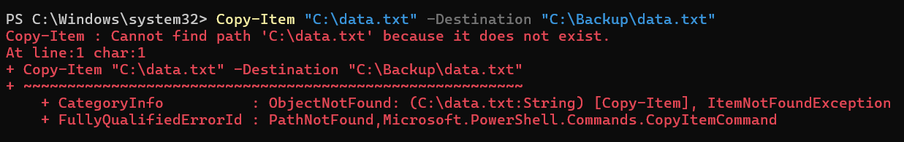
output
input
Fig 21
- User Management
Powershell
Get-LocalUser | Displays existing users and creates a new one.
Table 22
input
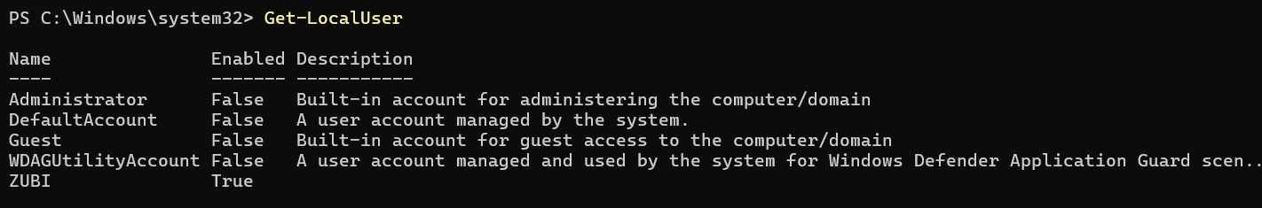
output
Fig 22

- Network Testing
Powershell
Test-Connection google.com -Count 4 | Equivalent to ping, but returns structured output.
Table 23
input
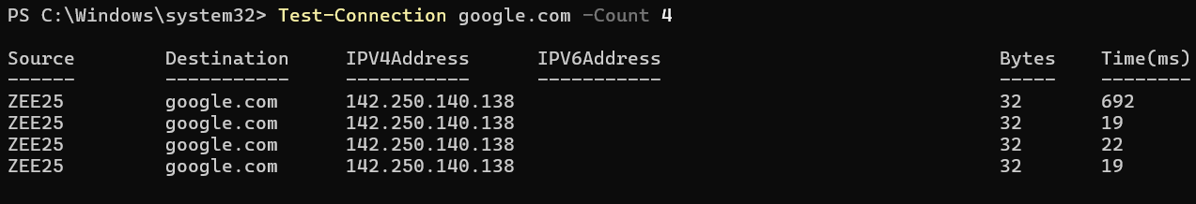
output
Fig 23

- Task Scheduling
Powershell
$trigger = New-ScheduledTaskTrigger -Daily -At 9am | Creates a scheduled task to open Notepad daily at 9 AM.
Table 24
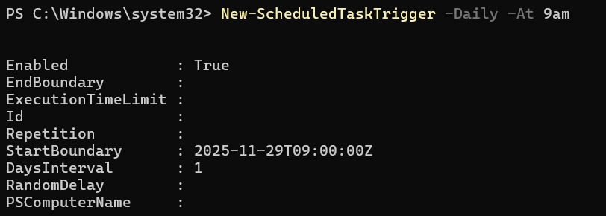
output
input
Fig 24

This report highlights the core capabilities of Windows scripting, including file handling, process monitoring, user management, networking, and task scheduling. While Batch scripts deliver straightforward functionality for basic automation, PowerShell extends these capabilities with advanced, object-oriented features that enable more complex workflows. To provide clear evidence of execution, screenshots display both the scripted commands and the corresponding console output.[14]

Task 5
Use of Linux OS scripts
Bash (Bourne Again Shell) is the most commonly adopted scripting language in Linux environments. It enables administrators and developers to streamline repetitive tasks, control system resources, and enhance overall efficiency. Scripts are generally stored with a .sh extension and can be executed using bash script.sh once they have been made executable with the command chmod +x script.sh.[15]

- File & Directory Management
bash
#!/bin/bash
echo "Listing hidden files..."
ls -la /home/user
ls -la | lists all files, including hidden ones, with detailed attributes.
Table 25
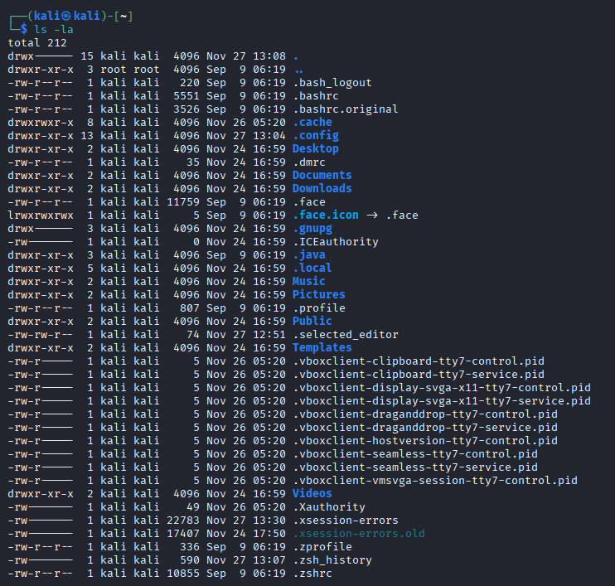
output
input
Fig 25
- Process Management
Bash
#!/bin/bash
echo "Top 5 CPU-consuming processes:"
ps -eo pid,comm,%cpu --sort=-%cpu | head -n 6
ps -eo | specifies output format
--sort=-%cpu | sorts by CPU usage.
Table 26
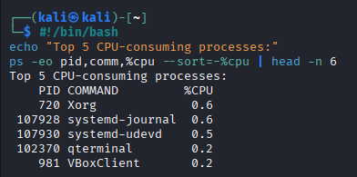
output
input
Fig 26

- Network Testing & Monitoring
bash
#!/bin/bash
ping -c 4 google.com
Sends 4 ICMP packets to test connectivity.
Table 27
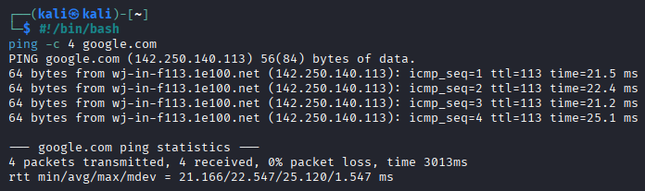
output
input
Fig 27

- User Management
bash
#!/bin/bash
echo "Creating new user..."
sudo adduser testuser
adduser | interactively creates a new user.
Table 28
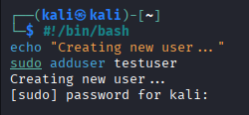
output
input
Fig 28

- Task Scheduling
bash
#!/bin/bash
echo "Scheduling backup..."
echo "0 2 * * * /home/user/backup.sh" | crontab –
Adds a cron job to run backup daily at 2 AM.
Table 29
input

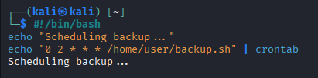
output
Fig 29

Conclusion
Together, these sections provide a comprehensive overview of operating system functions and their practical application through CLI and scripting. By combining theoretical discussion with screenshots and command demonstrations, the project bridges academic understanding with real-world system administration skills.

References
[1] H. M. Deitel, P. J. Deitel and D. R. Choffnes,Operating systems, Pearson/Prentice Hall, 2004.
[2] M. Ayyavaraiah, OPERATING SYSTEM, Horizon Books (A Division of Ignited Minds Edutech P Ltd), 2021.
[3] T. Jaeger, Operating system security, Springer Nature, 2022.
[4] P. Dasgupta, "Network Operating Systems," 1999,
[5] K. Łazaruk, P. Tokarski, K. Rybak, M. Plechawska-Wójcik and M. Dzieńkowski, "The Force of Habit: Comparing Graphical User Interfaces of Popular Operating Systems Using Eye-Tracking Analysis," 2025,
[6] M. ATT&CK, "Adversary Use of Command and Scripting Interpreters,"
[7] J. Korol, Access 2024/Microsoft 365 Programming By Example, Walter de Gruyter GmbH & Co KG, 2025.
[8] C. Brinkhoff, S. Patnaik and M. Pedholt,Mastering Windows 365: Deploy and Manage Cloud PCs and Windows 365 Link Devices, Copilot with Intune, and Intune Suite, Packt Publishing Ltd, 2024.
[9] F. Volpe, Microsoft 365 Certified: Collaboration Communications Systems Engineer Associate Certification Companion, Springer, 2024.
[10] M. ATT&CK, "Adversary Use of Command and Scripting Interpreters,"
[11] W. Shotts, The Linux command line: a complete introduction, No Starch Press, 2019.
[12] E. Nemeth, G. Snyder, T. R. Hein, B. Whaley and D. Mackin, "UNIX and Linux system administration handbook," vol. 59,
[13] D. Jones, J. Hicks and R. Siddaway,PowerShell in Depth, Simon and Schuster, 2014.
[14] R. Dolak, M. Janakova and J. Botlik, "Process Mining of Events Log from Windows.", SIMPDA, pp. 73–77.
[15] M. G. Sobell, A practical guide to Linux commands, editors, and shell programming,

Appendices

