

SYEDA AYSHA KHANOM
1814416
BMSK4001
ACADEMIC AND EMPLOYABILITY
SKILLS
SHAO-LAN YEN

TOPIC
Write a report in which you provide an analysis of relevant employability skills that you have; or need to develop in the future to gain credibility in search of employment opportunities. You need to consider the perspective of an employer trying to recruit.

2000 words from INTRODUCTION.

INTRODUCTION
Employability skill is an essential development that is attained in the duration of a career, this skill enhances and broadens your horizon of options in the working world. In the 10 weeks of this course I have regained my confidence in going back to work and realized that the skills which I came to learn I already consist of; this journey so far has fully equipped me for my career. When I initially joined this course, my aim was to return to work after a year, with more confidence and a stronger mindset, which would help me back in the management field; from where I left 2 years ago. I have been a Deputy Manager for 4 years out of my 10 years career in retail. The first 2 years in my role I was a strong candidate with a strong mindset, as my personal development was my biggest priority. I always strived to achieve targets/standards set and had a high morale in my team, this helped me to succeed in my role. After my maternity leave, I returned to work for a further 2 years and in these 2 years my priorities changed, and I believe that is where my mindset changed drastically. Work was not my priority anymore; my priority was my baby. I was always getting distracted from certain jobs and slowly my career development was also going down, my morale dropped at work. After reflecting on my performance my area manager wanted me to drop down to become a supervisor so that it would shred some responsibility from me but that completely made me give up and I decided to resign from work.

PRIORITISING
My role as a Deputy manager confined me in having many important skills, prioritizing skill being the most important in terms of decision Making, delegating jobs and completing the most important task first, daily. Diary maintenance enabled me to keep track of my daily tasks from the most important down to the least important task for the day.
‘Successful, effective people are those who launch directly into their major tasks and then discipline themselves to work single-mindedly until those tasks are complete’ Tracy, (2007).
According to Tracy , (2007) on days that I would start my shift in the morning, I felt I was more in control and the outcome of my shift was more productive; I would ensure the major tasks were delegated to the right people and were completed at the right time. This helped me structure the rest of the day accordingly, my handover to my Store/Area manager was also briefed better, as the important jobs were ticked off from the list and rest of the tasks were handed over to the evening shift to cover.
According to Covey, (1994) Time management matrix’s emergency tasks require fast and quick response, without realising; I have been following Covey’s theory at work, where certain jobs would be moved around from being urgent/important to being urgent/not important. These were adhoc situations when maybe the area manager comes for a surprise store visit, store could have a safe and legal visit or environmental health visit, these visits would be classed as a crisis/emergency which would require urgent attention and will be moved to being most urgent and important.
Similarly during this course I have realised that Covey’s, (1994), quadrant is also relevant in my personal life, which I have been following without realising; where interruptions/distactions may not be important and urgent but do still require attention i.e reading to baby or playing with baby while I am sitting to write my assignment.

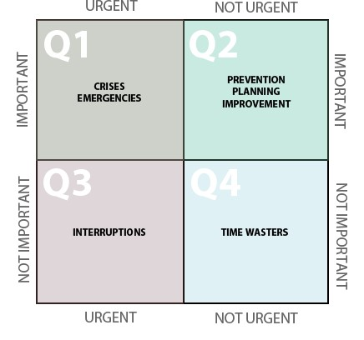

Covey, S. (1994)

My role as a manager was getting tough every day, I would have to be on call even when I was not on shift. I was spending minimal time with my baby, which made me feel distressed. I was starting to feel guilty for not watching my baby grow and was missing out on big milestones eg. her first walking steps. My work morale was on the lowest point of my career at this point and my management skills were not up to the required standard of our syllabus, my performance was completely drowning and I was failing in my role, as my priorities changed and my work mindset was completely bland.
I have now gained the extra boost from this course and have realized that I can prioritise my role as a mother and a manager accordingly. I will carry on following Tracy, (2007) and Covey, (1994) in both my work and personal life but for a change balance my priorities; Instead of thinking everything is my priority, as it is on the manager radar or mother’s chore list. I will ensure the jobs are delegated accordingly, so that I can focus on my important tasks and complete them to the highest standard and feel content and proud.

MINDSET
MINDSET - A skill I believed was my strength at a point in life when my WHY was my career.
Life was on a peak I felt I had everything under control because at that stage my mindset was so strong. I set to achieve all the success I could aim for in my career. I wanted to reach a position where I felt content, I reached that point when I became an Admin manager at Sainsburys head office for a year but was not satisfied and I felt I was fitted more in an operation role rather than the office, so I the went onto becoming a Deputy Store manager, where I felt a level of progression and was grateful. My WHY changed not very long after when I became a mother, I didn’t want to reach a higher level in the hierarchy anymore, as I felt it will affect my personal life and relationship with my daughter.
I was always under pressure to perform in my role, constantly be making decisions. Everything took a toll over me and came trumbling down at once. I felt I needed a break from work life and at that time I felt I was being targeted by my senior team and was not getting any support. This made me think why I was working so hard, leaving my daughter everyday/not spending quality time/ having sleepless nights/ waking up early/coming home late and working nearly 12 hrs a day every other day to ensure business was trading legally at all times. At the end of it all be mistreated and not feel respected by my line manager, it was at that very point were my mindset was at the lowest I decided to take the biggest decision in my career and resign.
The last 2 years since I have left work I have been the happiest and have had no regrets of not working anymore, my WHY was so important to me that I didn’t miss having my career, I have been so grateful for being able to nurture both my chidren and spend every day watching them grow.
This year I made a big decision of getting back into education to help me rebuild my career from where I
left but this time in a different field. My Why is still my children and I want to secure a brighter future for them, I feel by doing this course I am able to make rational decisions that will lead me to landing a better offer for a career, other than retail management.
‘Conflict and differences: People share so much in common yet are so magnificently different. They think differently; they have different and sometimes competing values, motivations and objectives.’ Covey, S (2004)
According to Covey, (2004) Conflict and differences have made me 2 people, I now think differently and have different values, motive and objectives in life than what I had when I was at work! This journey so far has determined me to find more success in my new motive. According to Campbell, (2003), this course is my mentor and I am working my way to succeeding as a mother and a manager in my Hero’s Journey!

REFLECTION
After leaving my career and role in management, I felt a big chapter of my life closed forever and felt a sense of failure to not have been capable in carrying out both priorities in life. At this point it was very imporatnt for me to reflect on how far I have come in life and what I have achieved till date, I lacked in the sense to feel and reflect on my journey to where I am today; Eventhough I knew it was the best decision I made to be a stay at home mum and nurture my children. I felt defeated somewhere and lost my confidence to believe I could be that great manager that I once was again!

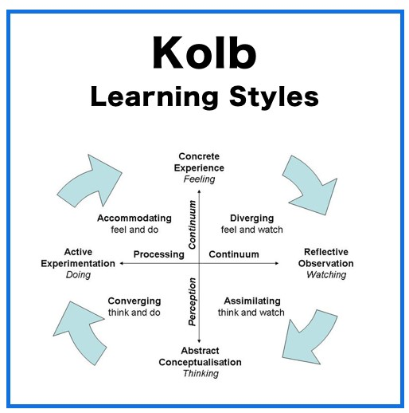 Kolb, A.Y and Kolb,D.A., (2005)

‘We introduce the concept of learning space as a framework for understanding the interface between student learning styles and the institutional learning environment’. Kolb, A.Y and Kolb,D.A., (2005)
According to Kolbs, (2005) Learning cycle, my understanding of my roles of being a manager and being a mother was set in a way that I felt I could manage both duties, however in reality it was completely opposite and I was finding it a challenge to juggle both roles; i.e attending a conference call on my day off at the same time as feeding my daughter (Active Experimentation), I planned to put my daughter to sleep and attend the call (Abstract Conceptualisation) but at the time when the call was due my daughter was still being fed before going to sleep (Converging).
‘over the years I had picked up skills, tactics, and a whole approach to human interaction that had not just helped me save lives but, as I recognise now looking back, had also begun to transform my own life.’ Voss, C. and Raz, T., (2016)
Similarly to Voss,C. and Raz,T., (2016), now that I reflect back to my career and personal life I understand that during my peak as a manager, I was only succeeding because I completely transformed myself as a manager and lived my life with that perspective and after becoming a mother I became more caring and emotional and less professional; for which I started feeling more guilty when leaving my daughter behind during work times because I transformed my life completely to fit my role as a mother.
Both these theories made me understand that i need to reflect on my learnings and experiences to go forward in life this could be in my professional or personal life.
It has come to the end of this module; I believe I have attained that confidence and strong mindset I
once consisted. I will carry on reflecting my work and experiences to justify my achievements in life. I want to balance and be able to Prioritize both work and family life together at the same time. I feel I have now made that BIG decision of returning to work and determined to succeed once again in my professional career, this time in a different field; so that I could try something new and different for a change, , I will follow my hero’s journey Campbell, J., (2003) and succeed In all aspects of my professional and personal life and express my academic and employability skills with full confidence.

REFERENCES

Campbell, J., (2003). The hero’s journey: Joseph Campbell on his life and work (Vol. 7). New World Library
Covey, S.R., (2004). The 7 habits of highly effective people: Powerful lessons in personal change. Simon and Schuster
Kolb, A.Y. and Kolb, D.A., (2005). Learning styles and learning spaces: Enhancing experimental learning in higher education. Academy of management learning & education, 4(2), pp. 193-212.
Tracy, B., (2007). Eat That Frog: 21 great ways to stop procrastinating and get more done in less time.
Berrett-Koehler Publishers
Voss, C. and Raz, T., (2016). Never split the difference: Negotiating as if your life depended on it. Random house.

