Luke Webb 24/04/2019

Computer Games Development - 1803165
Internet Technology and Security
Website Assessment

Contents
Introduction 2
Requirements 2
Implementation 3
HTML 7
CSS 11
Evaluation 11
References 12

Introduction

In this report I will be going over the contents my webpage from the requirements, implementation and evaluation of the site, I will demonstrated and discuss the purpose of the site as well as the content on the page, you will also find the materials that I used to learn how to create the site and testing show that the site is accessibility for all types of people, I will also show evidence of development and discuss things that I would like to add to the website in the future.

Requirements

A brief introduction to the website, describing its purpose and subject matter, the target audience and its relevance.

Introduction and purpose of the website:

I wanted to make my site about myself and things that I find interesting these were programming and the technologies that I like to use (C++, node.js, visual studio, etc) and art that I have made, I chose these things because both I have been doing since I was a teenager and I couldn’t live without them, I have been programming for a long time and made many things on the site I only showed a small amount but If I could I would of found I way to show off many more, one thing I would of loved to share was a node.js project for discord that I made using APIs online to scape game data that then could be used to get an advantage in game. Things like this I find really interesting as well as the problem solving that goes into it, and then other thing being art I chose because I haven’t done much with the art that I made and I wanted a nice place to display some of the best thing I’ve made, I have also made things for other people for money so I wanted to show off things that I like to make and my style of art. And if anyone was interested in getting me to make anything for them programming or art, they could use the site to email me a question or request.

Audience and relevance:

The target audience of my website would be anyone who would be interested in learning how to make interesting programs or learn what tools I’ve used to make my projects to made help them understand what’s the right tool for the job, or maybe someone who wants to just look at the art I have made and would like to know a little more about it, but I would say that it could also be used to show people like an employer what things I can make and what I am capable of, or if someone would like me to make or more information they could use the contact page that way.

I think all of this is very relevant to the webpage but I would like to example the website to give more detail when explaining the projects so I could give a more in-depth conversation about how things work the algorithms and the tools used, but to do this I would have to make a page for each project that is on the site so that would come out to 6 more pages where they would have to be filled in and I would have research links for extra information to provide context and this would just take up too much time, and that would only be for these 6 project.

Implementation
Home page:

On the home page I wanted to say a little about myself and a small amount of the other things that you can find on the site like the contact page and the art and programming pages.
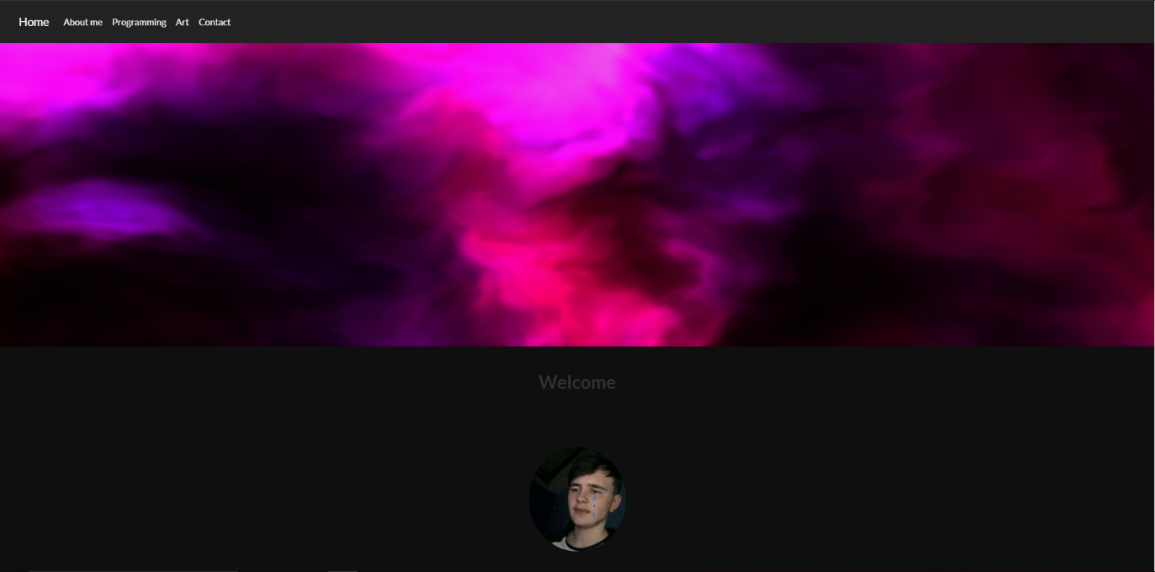

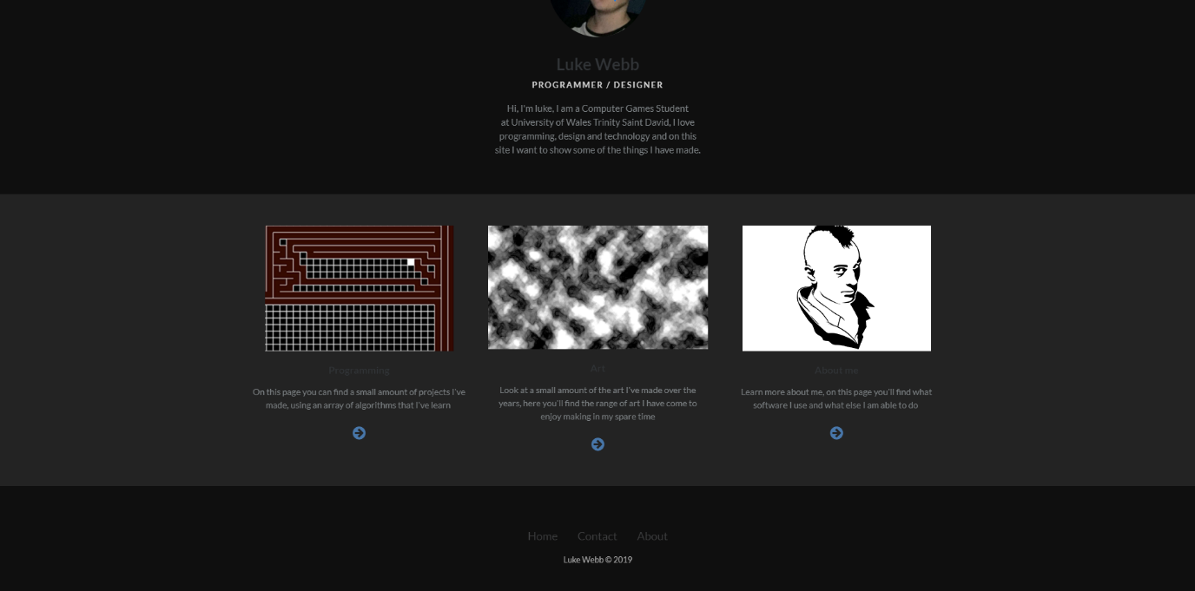
At the bottom you can see where I linked to the other pages and you can click home and it will take you back to the top of the page.

About page:

On this page I wanted to talk about my self a ill more and show the software and tools I use to make my art and my programming projects and other tools I uses for my hobbies.
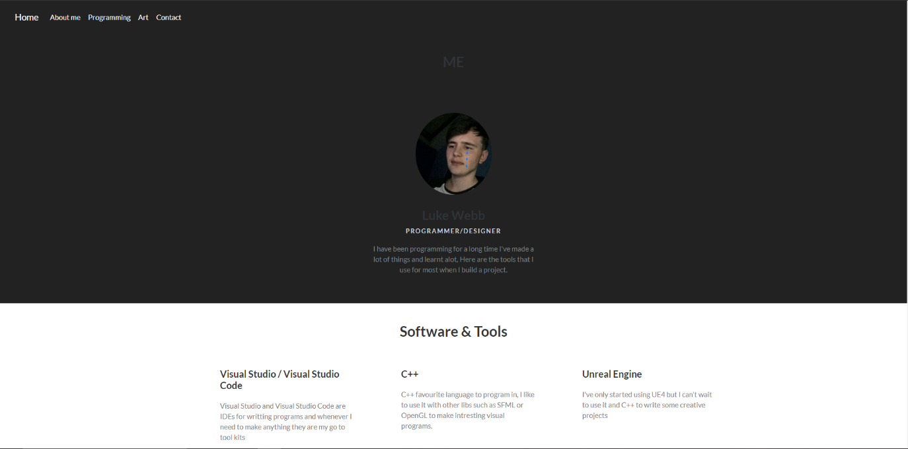

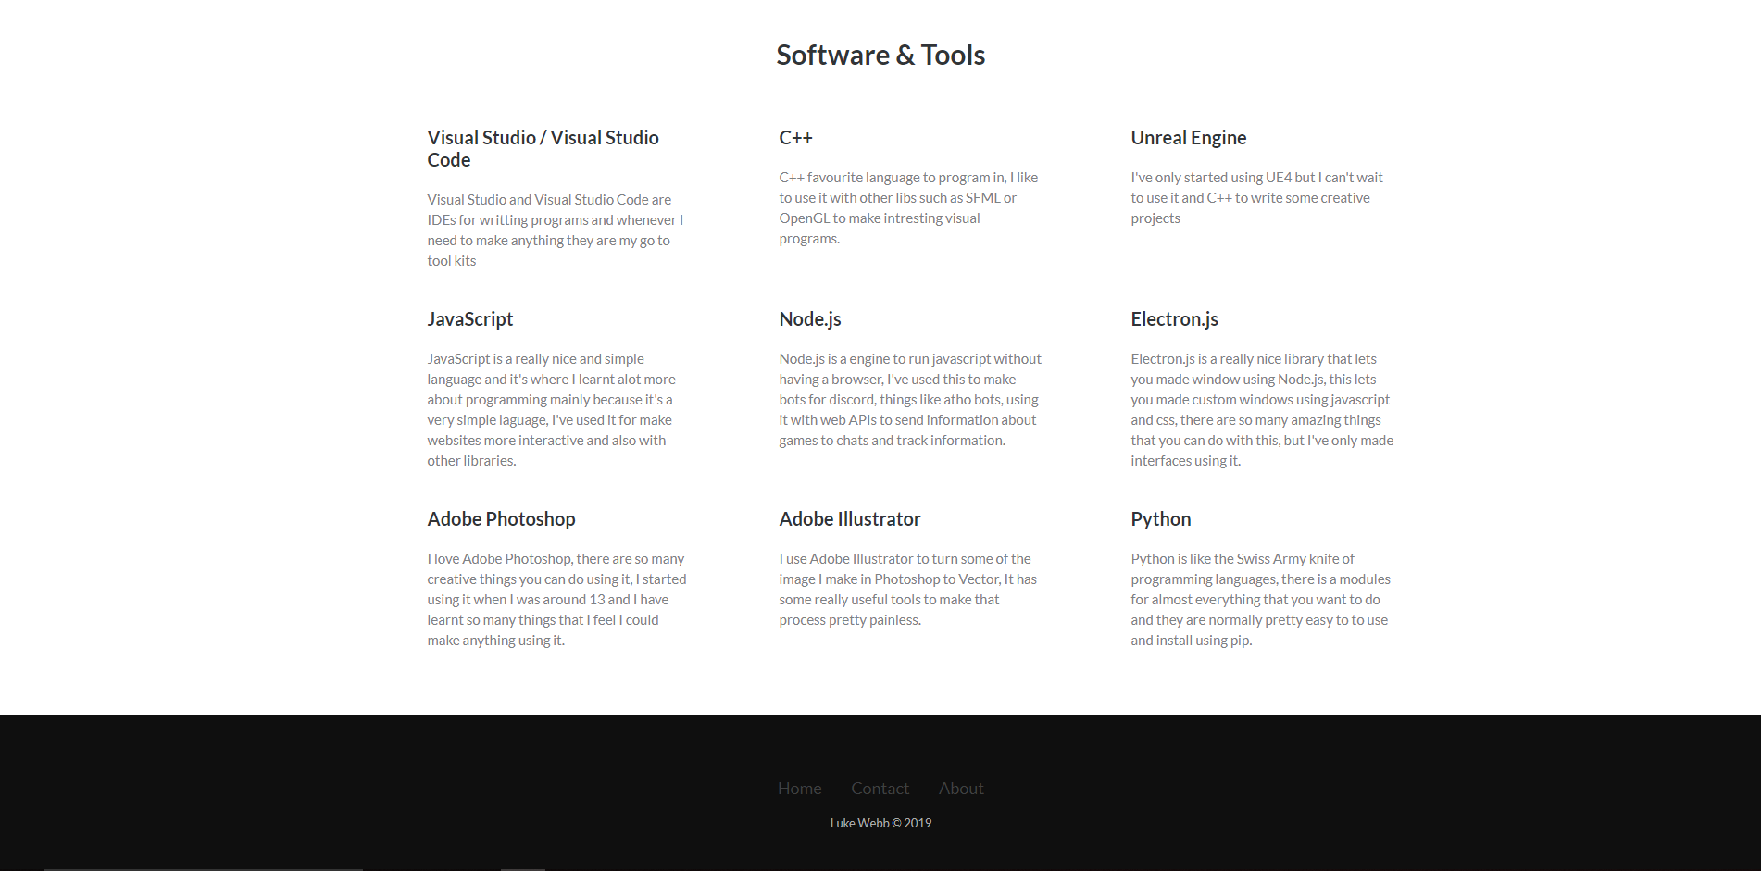
Here at the bottom I also talk about the tools more and there are links back home and to other pages.

Programming page:

On this page I talk about things that I have made as well as show what they look like and you can see some of the project that I made and think are the most visually interesting

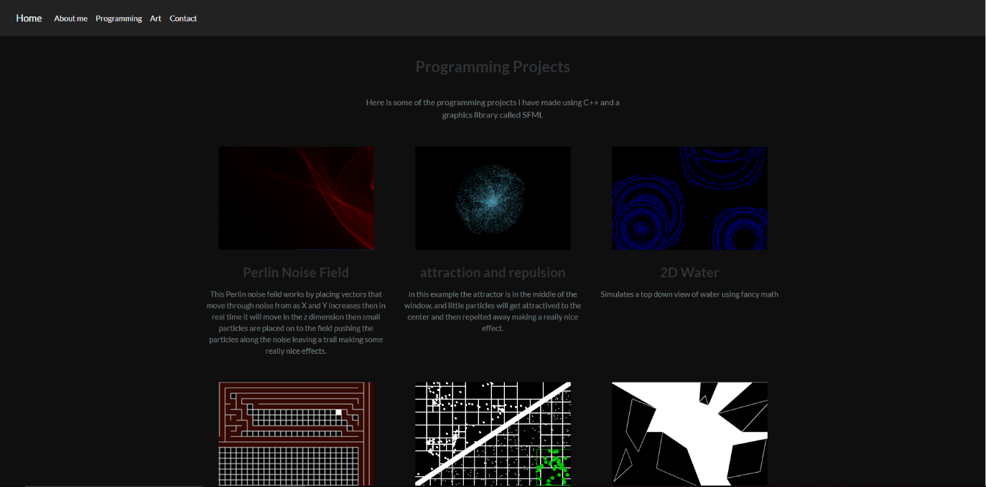

Art page:

On this page it as the same layout as the programming page and format where I talk about the art and explain a little about the art and general thoughts I had while or after making them, this page has a lot more content the programming one.

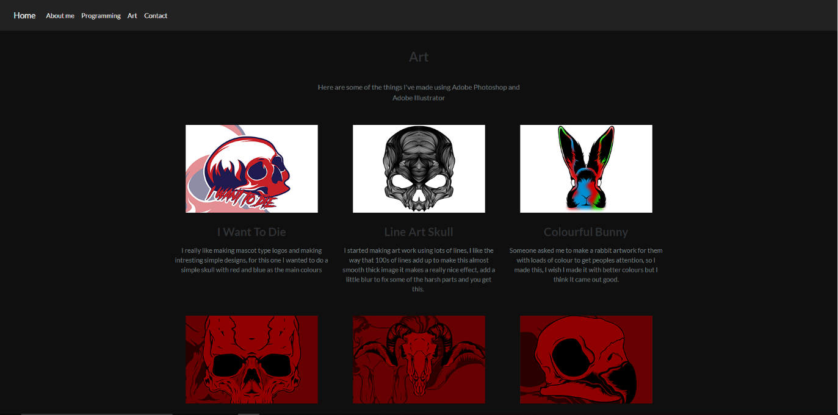

Contact page:

I wanted to have a page where people could contact me and leave me a message about my art or question on the programming projects that I have made so on this page there is a message box and a email box and an optional name so people can leave there information for me

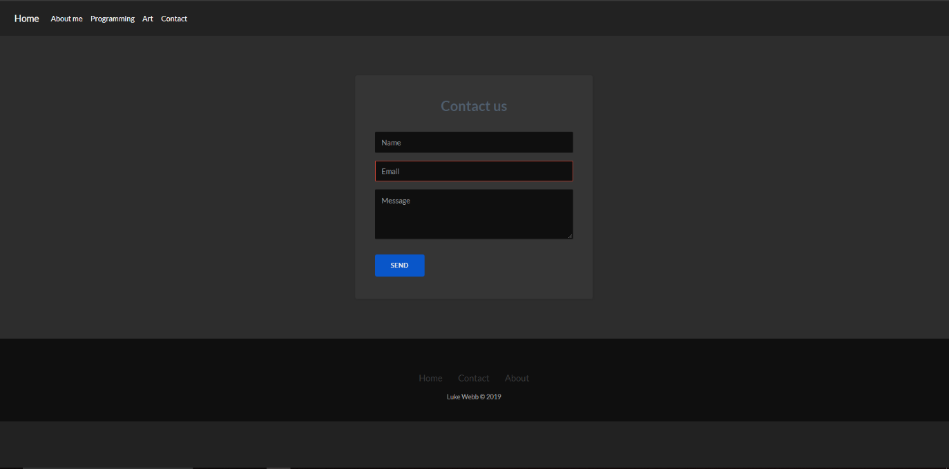

At the bottom there are also links to other pages for quick access to them when ever someone is done with there email.

HTML

Index.html

Results:

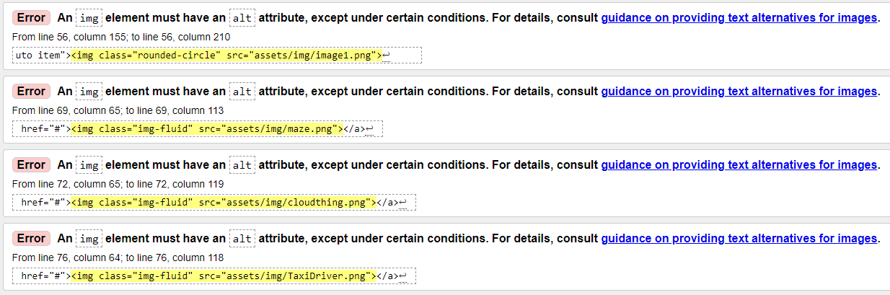
Errors:
The errors are telling me that I need to include the “alt” attribute on my img tag, this will make alternative text for the image.

Fix:
Since the error is the same for the 4 images, I’m only going to show the fix once since it’s the same for all of them, You can see at the end of the line I’ve added alt and text for the alterative text.

About.html

Results:

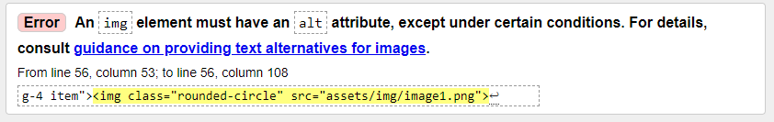

Errors:
This is the same error as on the index page, I didn’t add the alterative text alterative on the end of my img tag.

Fix:
Since I used the same header with photo for both this and the index page and just copied it this error got passed me and I fixed it in the same way by just adding “alt” at the end of the tag.

Programming.html

Result:
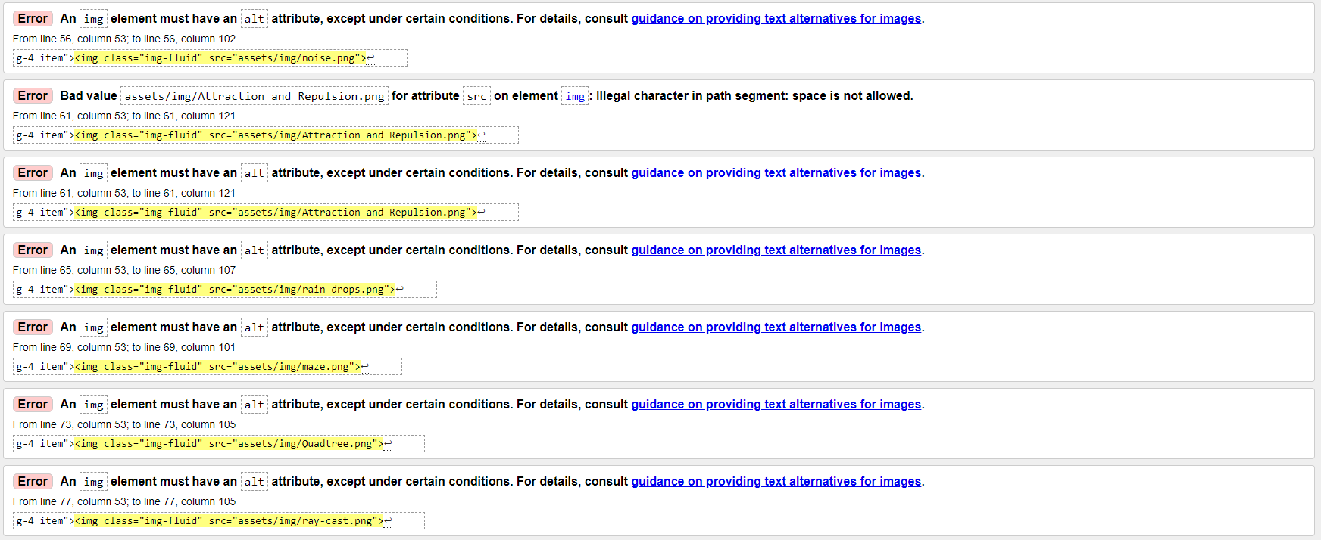

Errors:

- The alt attribute is missing from each img tag
- The page also got a bad value error, an image name has spaces in it and this has triggered an error.

Fix:

Added alt to the end of each image on the page to give alterative text.
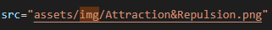
Changed the name of this file so it would no longer have spaces.

Art.html

Result:
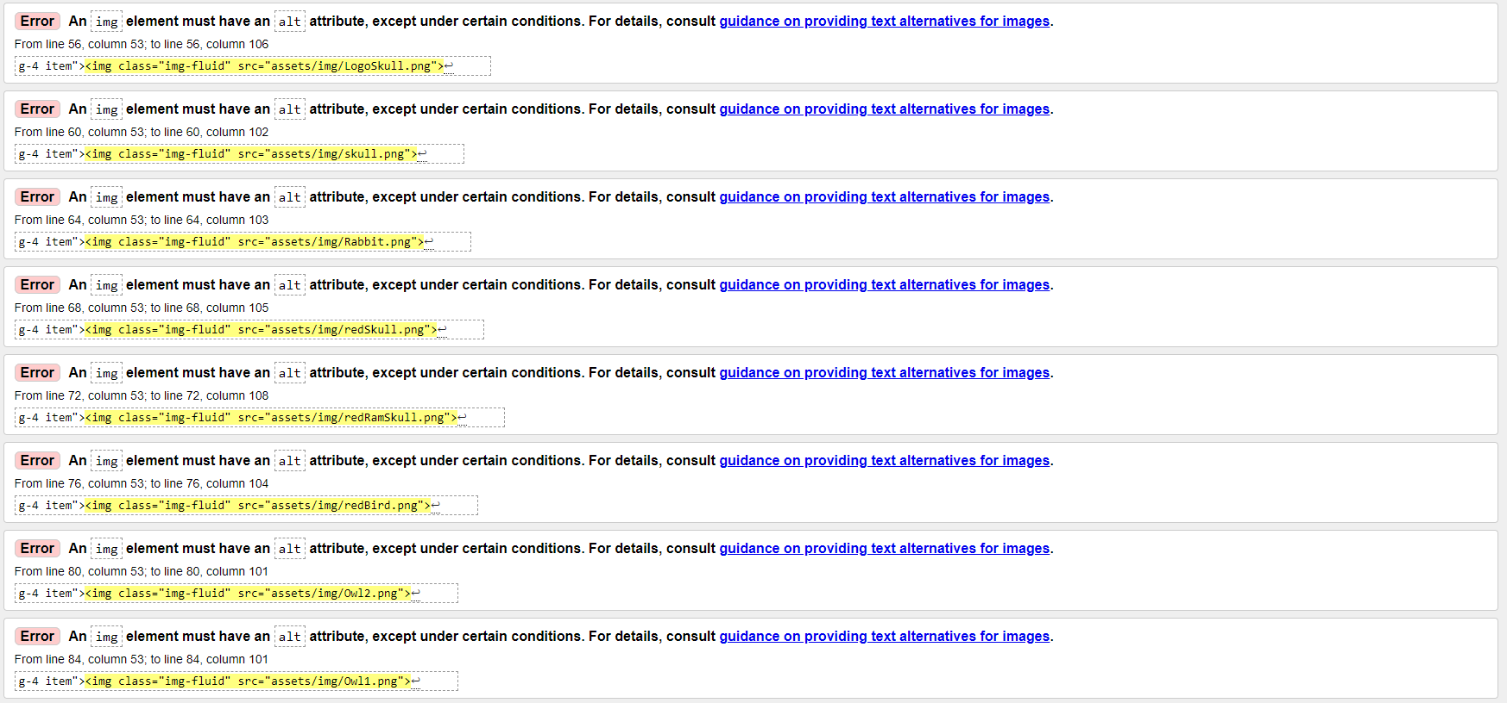

Errors:
- Missing alt attribute on every img tag.
Fix:
Added alt attribute to every image on the page.
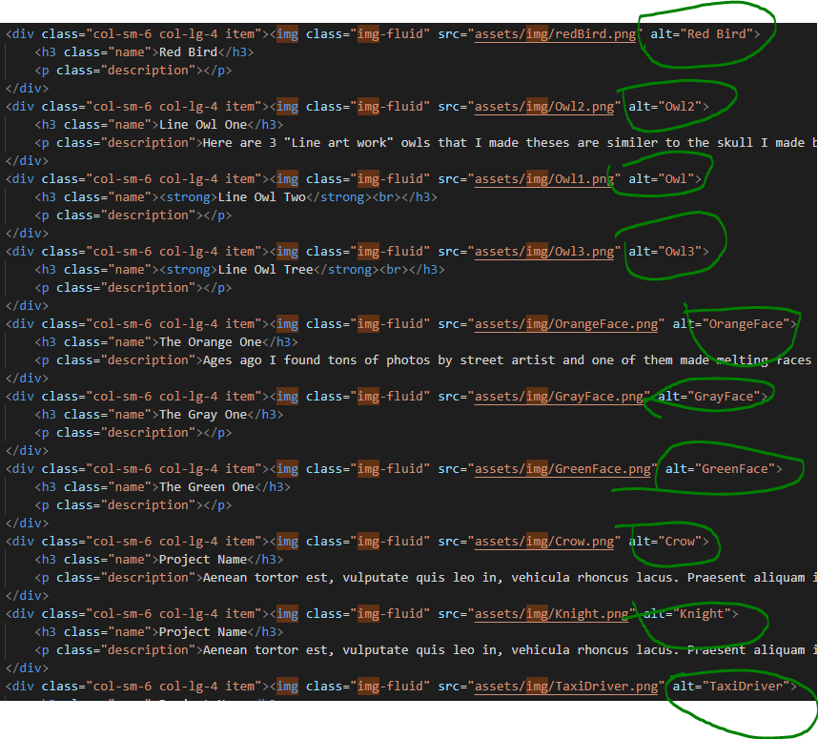

Contract.html

Results:
Errors:
There aren’t any errors but there is a warning that not all brewers support the “inputmode” attribute.

CSS:

Style.css

Results:
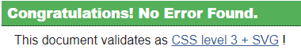
Errors:
N/A

Evaluation

- An Accessibility Evaluation of the Website.

I used Visual Studio, and the WAVE Evaluation Tool to check for Accessibility

I believe that my website has good accessibility for the following reasons, the main colour of the webpage is dark grey and because of this all text is in white making it stand out clearly against the background colour, I also made sure that the font size was a clear size so that it was easy for people to read even at a distance the size of the text also scales up and down for uses on different devices for example mobile and desktop users would see different sized texted and images. Hyperlinks are all highlighted in a bolder white to show that they are links and Icons that also have hyperlinks are coloured blue to give the impression that they can be clicked on.

I would say that the look and feel of the website is very basic and simple I didn’t want the site to be complex looking or having complex animation or any thing like that. I made the choice to make sure everything was a very flat and had simple colouring like the some greys to give the page the feel of depth I ended up using, I didn’t have many effects on the site other then one parallax effect on the home page.
My website wouldn’t have a very good SEO unless someone was looking for information about me spasticity this isn’t such a bad thing because if someone was looking for information about me then they could find it but if someone searched for something that might reference the site then it could come up.

References

I used this site from the brief to test my html code for errors.
https://validator.w3.org/
I used this site to test my CSS for errors
https://jigsaw.w3.org/
I used w3Schools to learn and brush up on things I forgot about HTML, CSS and bootstrap
https://www.w3schools.com/
I found this YouTube video showing how to use bootstrap and I used it to made the basic outline of my site and to use bootstrap electively
https://www.youtube.com/watch?v=hnCmSXCZEpU

