DS 1 Template

My Screenshots/Photos
- Please add 4–6 screenshots or photos of your digital life.
- You can use your phone or laptop.
- For each screenshot, write one or two sentences explaining what it shows.

Screenshot/Photo 1
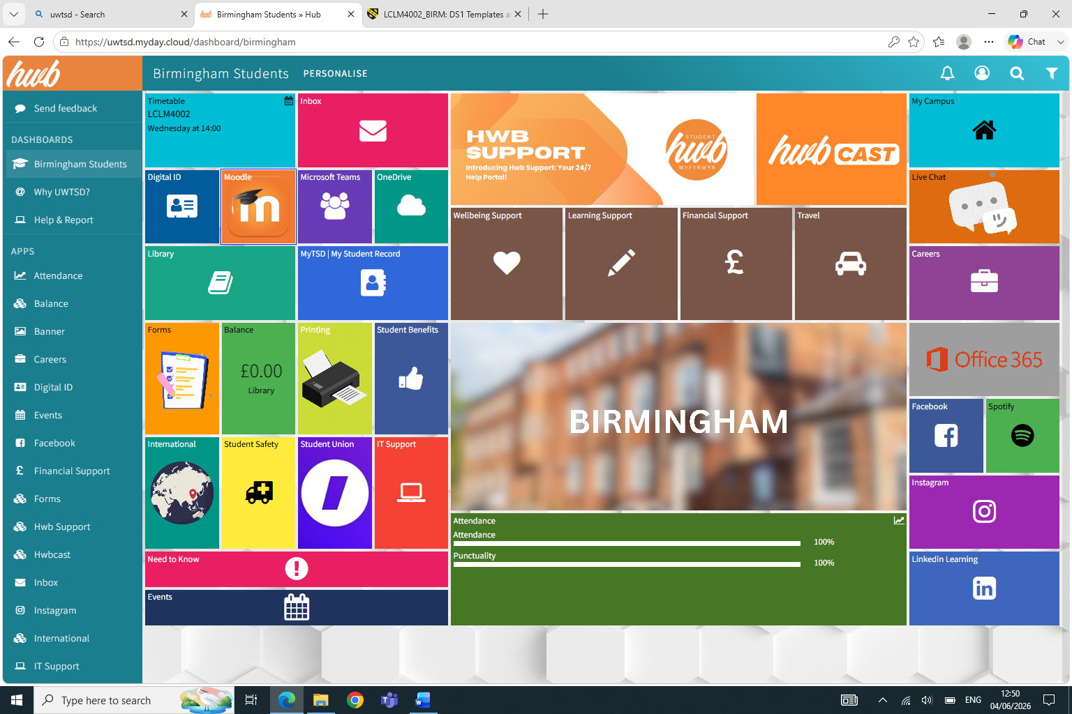
Here you can see a Screenshot of the student portal. This digital skill helps me to find out what classes I have during the week and communicate with my tutor

Screenshot/Photo 2
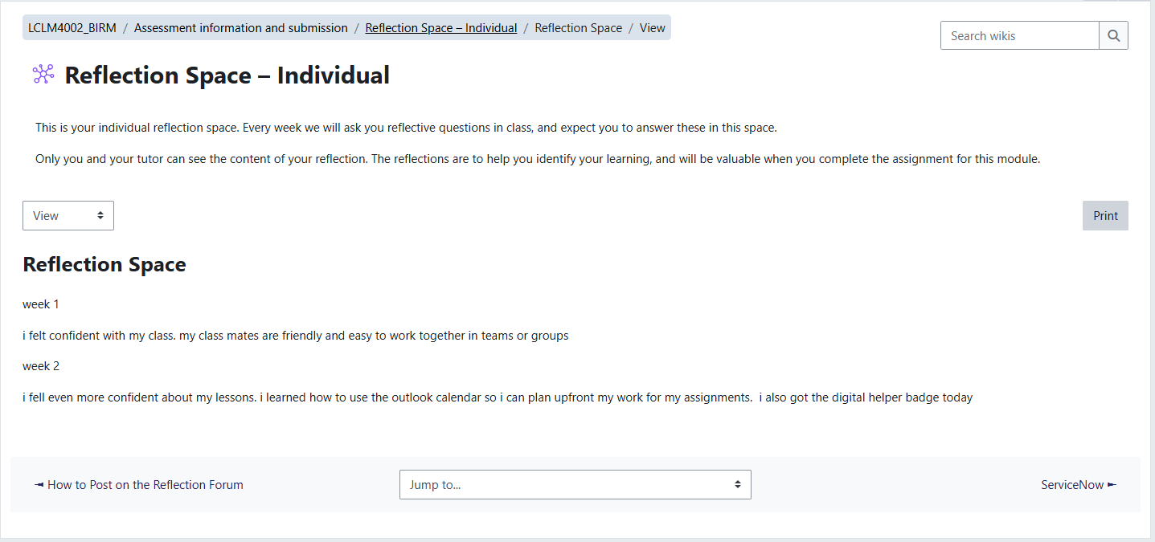
This is a screenshot of my reflection space. These digital skills help me reflect to my progress along my studies and track my progress from one week to another

Screenshot/Photo 3
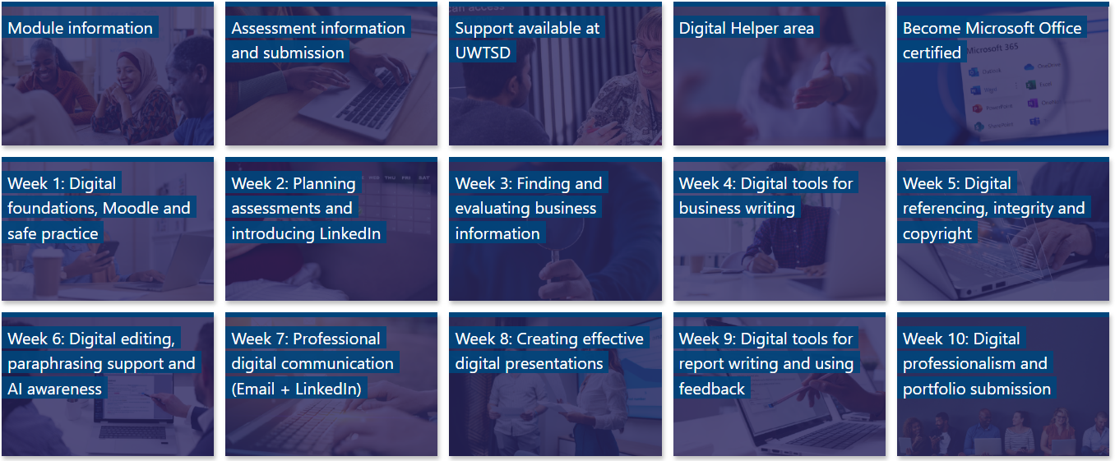
Here you can see the screenshot of my dashboard with teaching materials that we are going through weekly. It helps me recap something that I haven’t understood from class

Screenshot/Photo 4
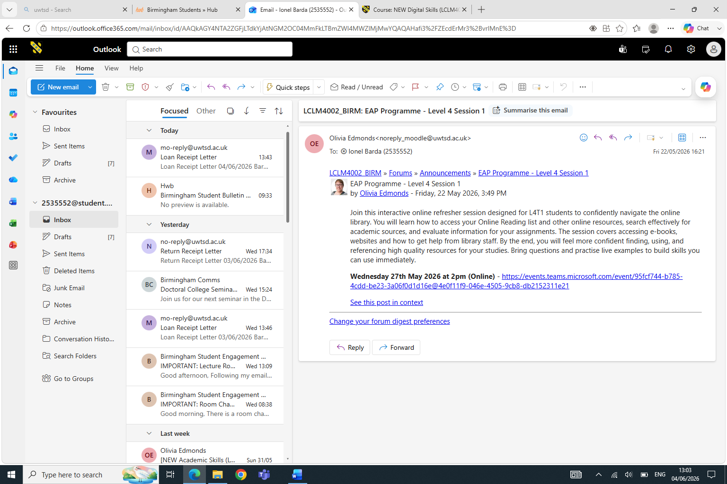
In this screen shot you can see my Outlook Imbox. Here I can track where my classes are and if there are any changes done

Screenshot/Photo 5
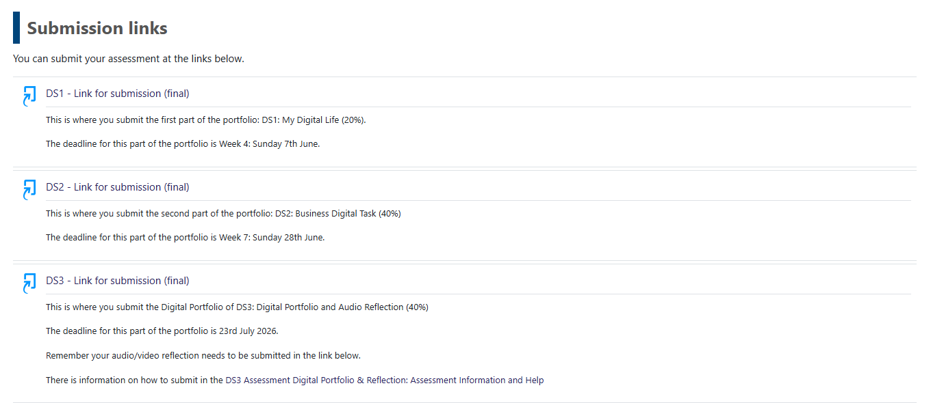
One of the most important digital skills. This screenshot shows how to upload our assignment

My Short Reflection
- Write 5–8 simple sentences about your digital life.
- You can use the sentence starters below if helpful.
My school digital life is very useful.
I use a computer and tablet for my schoolwork.
I attend classes and watch educational videos.
I use the internet to research information for projects.
My teachers share homework through digital platforms.
I communicate with classmates using text messages and email.
Technology helps me learn faster and stay organized.

Sentence starters
- I use digital tools to …
- I feel confident when I …
- I want to improve …
- I often use these tools: …
- I sometimes feel nervous about …
- I hope this module will help me …
- Digital skills are important for me because …
You can write more if you want.

Submission Checklist
Before you submit, please check:
​​​ ☐ I added 4–6 screenshots
☐ I wrote short sentences for each screenshot
☐ I wrote my short reflection
☐ My work is my own
☐ My file opens correctly
​​☐ My file opens correctly

