student name:
Assighnemet:
“How I can use the DIKW and CRAAP frameworks to confirm or refute the work of Angela Duckworth”

After teaching seventh grade math in New York City public schools for a few years, Angela Duckworth realised that her greatest pupils were not necessarily her smartest. In order to better understand the impact of core abilities like self-control and perseverance in achievement, she left her middle school teaching job to become a research psychologist. Duckworth explained grit—perseverance and passion for long-term goals—in a 2013 TED Talk. In 2019, over six years after Duckworth's TED Talk, we'll go deeper into her findings and discuss grit in the classroom.

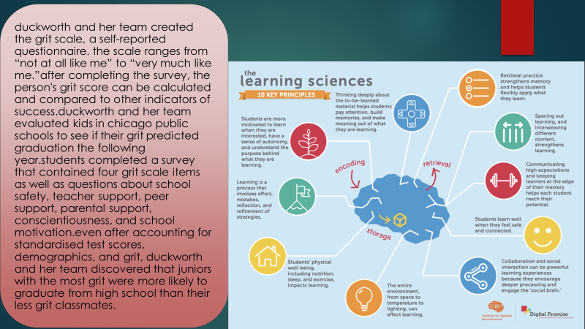
Researchers and educators must collaborate together to discover how to efficiently foster grit in students. It will take bravery and endurance. To test our finest ideas and intuitions, Duckworth said in her TED Talk. The ability to learn from mistakes and retry is essential. That is, we must grit our teeth. Duckworth emphasises that grit isn't a "no excuses" or "shame-based" strategy. In EdSurge's words: "It's human nature to avoid mistakes, confusion, and difficulties." The first step is to acknowledge that this is part of the struggle. Teachers should “provide a routine and an opportunity” for students to learn from and rectify their mistakes. In her EdSurge interview, she mentions a teacher who maintained all students' tests in a binder for easy access. Assisting pupils in being grittier is a great beginning step.

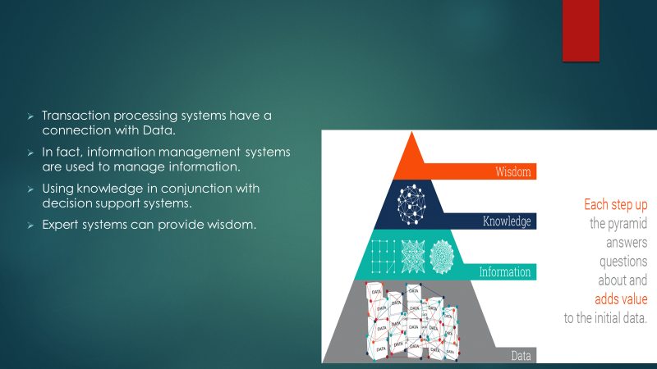

Data, information, knowledge, and wisdom are depicted in the DIKW pyramid in an iconic diagram known as the Knowledge Pyramid, Wisdom Hierarchy, and Information Hierarchy, among others.
Building components of the Knowledge Pyramid are clearly defined as data (information), information (knowledge), and wisdom (wisdom) in this situation. The further one climbs the pyramid's rungs, the more questions are asked of them. We must initially answer as many questions as possible in order to move up the pyramid. Alternatively, the better off we'll be if we can extract as much knowledge and understanding as possible from our data. As a result of this learning experience, we now have a structure for directing our efforts at the very top of the pyramid.
Using Semantic Technologies like Linked Data and Semantic Graph Databases can be a simple and rapid solution for businesses to move from data to information to knowledge and wisdom. With the help of these tools, it is possible to connect disparate data sources and derive new insights from what is already known.
Using data-driven analytics, businesses may scale the mountain of wisdom and earn a competitive advantage by supporting their business decisions and gaining a competitive advantage.
Data
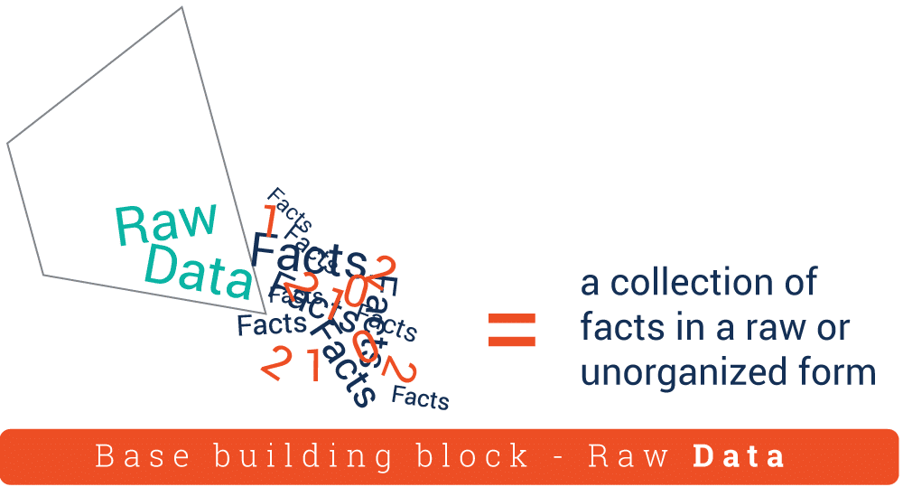

The raw or unstructured form of data, such as numbers or letters, is used to compile a list of facts.
Most of the time, data loses its value when it is isolated from its context. As an example, the digits 12012012 are just a random collection with no apparent significance. If we think about it in terms of a date, the 12th of January 2012 comes to mind. The numbers now have a higher meaning because of the context and significance they have been given. We were able to make the numbers more comprehensible by utilising this method of number translation.
Information
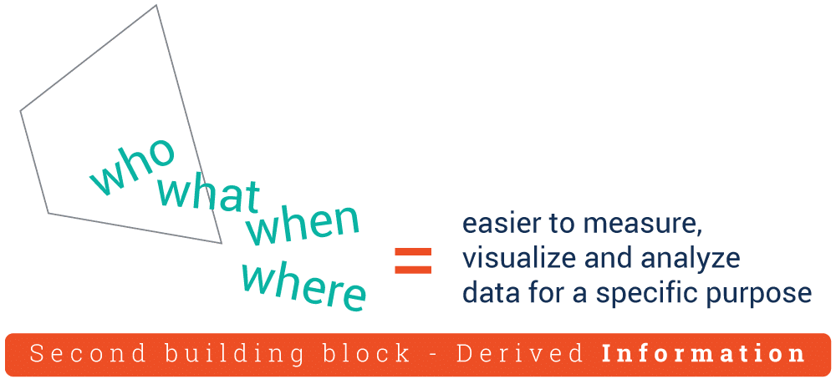
We must now include information as a component of the DIKW Pyramid in order to complete it. This data has been "cleaned" of errors and subsequently processed in order to make it easier to measure, visualise, and analyse it for a specific purpose. For example, data processing may comprise aggregation, validation, and other operations, depending on the purpose for which the data was collected and analysed in the first place. It is possible to organise our data in such a way that links can be discovered between seemingly unrelated data elements. A more detailed analysis of the Dow Jones index's performance can be accomplished by plotting data points for a selected time period based on the data collected at the end of each day's trading. If you ask the right questions, you can glean valuable information from your data. Some examples of such questions include "Who?" "What?" "Where?" and so on. Although information can be transformed into knowledge, it is the answer to the 'how' question that does the actual transformation.

Knowledge
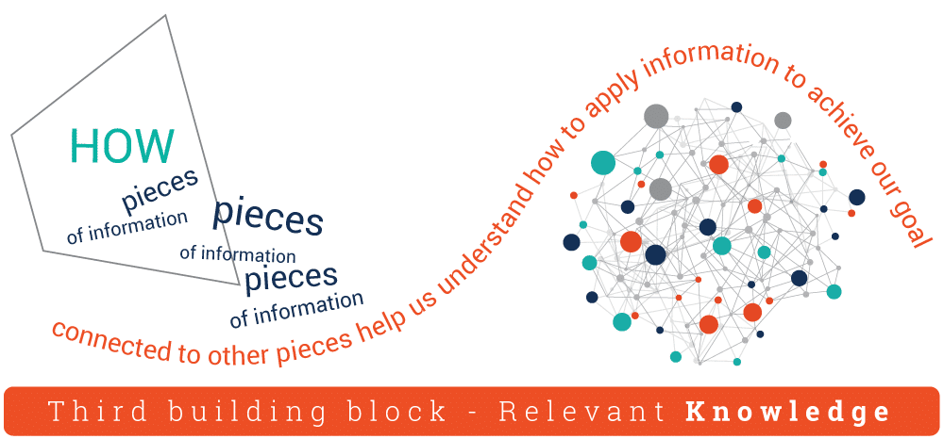

Is the information obtained from the acquired data relevant to our objectives, and if so, how? "How" are the many bits of this information connected to one another in order to offer additional meaning and value is a good question. And, maybe most crucially, "how" can we put the information to use in order to achieve our objective? When we see information as more than a record of facts gathered over time, but as something that can be used to attain our objectives, we have transformed information into knowledge. This information is frequently the competitive advantage that businesses have over their competitors. In discovering relationships that are not clearly stated as information, we gain deeper insights that allow us to progress further up the DIKW pyramid. However, it is only when we apply the knowledge and insights received from the information to make proactive decisions that we can claim to have achieved the final – and most important – stage of the Knowledge Pyramid, which is known as wisdom.

Wisdom
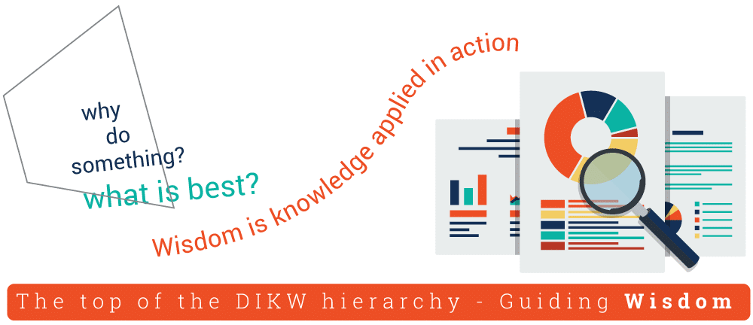

Wisdom is at the top of the DIKW hierarchy, and in order to reach there, we must be able to answer questions such as 'why do anything' and 'what is the best. ' So wisdom is information that has been put into practise.
We can also say that, if data and information are like a look back in time, knowledge and wisdom are related with what we do now and what we hope to achieve in the future, and vice versa.
Framework model

Data is collected, categorized, and then organized into information using the DIKW framework. In the process of synthesizing information into actual knowledge, wisdom is formed. Analyze the data you have and use it to help you frame and structure your challenge. Data should be gathered and analyzed before being organized properly into reports. Think on patterns and relationships in the data you've gathered. A solution can be seen and recommended using these patterns and linkages.

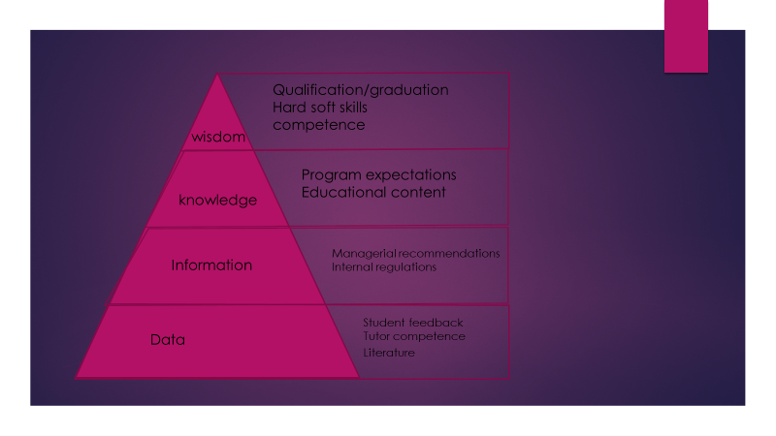
Multi layered DIKW model for education assurance
In order to guarantee educational quality, a multi-layered DIKW structure is shown in Figure. As part of the framework, HEI has four primary goals and needs: A data layer serves as a foundation for a DIKW framework pyramid in an education quality assurance system. A Literature sublayer is created by course creators, tutors, and lecturers using literature content. Libraries and the Internet are mandatory. The course authors and tutors have a Tutor Competencies sublayer on top of each other. Requirements set forth by the university: highly qualified employees Course content can be improved with the use of a sublayer called "Student Feedback." Student feedback should be incorporated within a Data layer since it has the highest decision-making risk and should be addressed sooner in the educational content production process. Open source or private survey platform regulations for handling comments. Result-based actions are included in an information layer constructed on top of a data layer. Two layers make up the Information Layer: The Data layer's results are governed by an Internal Regulations sublayer. Early decisions on educational quality can be made easier with a regulatory framework that is specific to a particular university. Requirements of the University: a legal framework and employees who can adhere to regulations. Data from the Data layer is used to generate the Managerial Recommendations layer.

To improve educational material, executives must periodically examine the educational process. University Requirements: enforce rules. Adding Data and Information Layers. This layer's data should be open and adaptive. Below the knowledge layer are: A Learning Infrastructure sublayer organises great teaching methodologies and content. University requirements: highly motivated instructors and Information Layer-compliant equipment. It formalises planned learning outcomes so that stakeholders can evaluate the educational process. The university needs a means to track stakeholder feedback. A decision about economic growth and sustainability should be based on this layer's results. Without precise job-specific skills, a successful graduate may be able to quickly modify an individual skill set for a given career or position. High basic knowledge in a topic. A Hard/Soft Skills sublayer describes a collection of skills learned in school. A graduate's talents are shaped by their education and personal traits. University requirements: close contact with external experts. QGs are highly qualified professionals capable of making judgments for both personal and professional progress. • Ability to adjust educational outcomes to their needs. Economic Sustainability is a “Crowning Element” for the DIKW initiative, not a “Layer”.
Using this page, students are able to enter their information. Using the DIKW model, information about this model will be gathered and evaluated. The economic influence of education quality on territorial growth is the basis for this notion. An important part of evaluating the relevance of knowledge to improve the quality system is developing a decision-making algorithm. The DIKW model was tested using the NAQA Criteria for Quality of Educational Programs. The multi-layered framework's scalability is demonstrated by this way. These criteria can be used to evaluate the quality of Data layer outputs formulated on the relevant sublayers, for example Access to educational program and recognition of learning outcomes, 5 "control measures, evaluation of higher education seekers and academic integrity," 6 "Human Resources," and 8 'Inner quality assurance of educational program' should be used to evaluate the outcomes. Consider using NAQA Criterion 6 "Human Resources" to assess the Managerial Recommendations sublayer's success. Quality Learning through research, teaching and learning in the educational program, educational environment and resources, and transparency and publicity. Note that the Wisdom layer is not examined by the NAQA criteria. There are two reasons for this: Wisdom layer specifics and sublayer findings are counter-operationalist in nature.
Conclusion
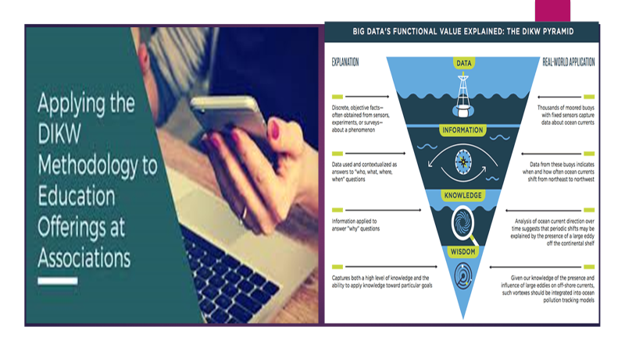
To conclude this, we can say that Enterprises have a simple and rapid way to move from data to inf A student's ability to persevere in the face of setbacks is an important indicator of their future academic achievement. Grit has a surprising number of proponents for such a fresh buzzword. Students' academic achievement can be predicted by something other than intelligence or talent: tenacity. In the quest to understand students' motivation and psychology, grit plays a significant role. As Angela Duckworth explains in her TED Talk, "grit is enthusiasm, perseverance for very long-term goals, stamina." Gratefulness emerged as a key predictor for long-term goals in that talk, which has been viewed more than 13.5 million times. "How can we instill a sense of perseverance in children?" The truth is, we don't know for sure. There is no evidence that talent makes you tough. Duckworth argues that thus far, the best idea has been the growth mindset—the belief that ability to learn isn't fixed, that it can alter with your effort. Grateful people are now being studied by educators and psychologists, who are looking more closely at the importance of grit in the classroom, and how students might use it to their advantage long term. As a previous program director of the Graduate Program in School Psychology, Dr. Laura Barbanel taught students how to become school psychologists. Barbanel is now a sole practitioner. One characteristic of those who have "grit" is a sense of optimism and self-efficacy. Semantic Technologies like Linked Data and Semantic Graph Databases can be used to gain information and wisdom. It is possible to connect and synthesize information from a variety of sources using these technologies. Businesses can scale the mountain of wisdom and acquire a competitive advantage by using data-driven analytics to support their business decisions.
Grit may be developed through setting goals, acting, and remaining positive, according to her. Grit is a character trait that may be fostered in pupils by educators and parents alike.

- First and foremost, help parents find the right balance between "doing for" their children and allowing them to take responsibility for their own actions.

- Think about how you can help a kid feel like he or she has the power to set and achieve goals.

- Create a plan of action that can be carried out. Teacher Barbanel explains, "Teachers know this, but parents sometimes forget it."Professor Caren Baruch-Feldman, a psychologist who has done substantial research into the topic of grit, says students may improve their grit by using three different approaches: changing their mentality, changing their conduct, and forming teams.

- Put your focus on what you are truly passionate about. For good reason, Baruch-Feldman notes, Duckworth talks a lot about passion and tenacity. Often, passion is left out." What can you do to get youngsters excited about something? How can they connect with it and stick with it?

- A "want to" mindset rather than a "have to" mindset is the key to success. Baruch-Feldman recommends teachers to help children understand why particular topics are essential to them. "As instructors, we sometimes overlook this stage, but it's critical." Once the foundation is in place and goals have been created, I share with educators what we've learned about how to foster grit, including optimism and a growth mentality. I show them a few examples of what that would look like. How do you maintain a positive frame of mind? Doing it, not just talking about it.

- Build grit in children by working together as a team with educators. Talking to someone who understands and empathises with your situation can help you persevere, Baruch-Feldman explains. "Nothing is as nice as talking to someone who will normalise that experience, who will pull you up and let you know you'll be OK," she says. Even if teachers can offer assistance, many students find that helping their peers is a more effective means of developing their own grit.

- "There is a feeling of purpose in the lives of the toughest people you meet. Baruch-Feldman adds that when youngsters are helping others, they're tapping into a sense of purpose. "When we help others, we feel good about ourselves and develop true connections."

- Baruch-Feldman says optimism and a growth attitude are critical, but that they must be accompanied by action. Teaching pupils the need of practise is especially critical in today's world, as individuals are accustomed to rapid gratification and may not necessarily appreciate or desire to put in the effort necessary to achieve their goals. [page needed]

Parental and educational role modelling, she continues, is crucial. For me, sharing my failures, my struggles, and how I bounced back with my kids is a really important lesson.

References

Conger, S. and Probst, J., 2014. Knowledge management in itsm: Applying the dikw model. In Engineering and management of IT-based service systems (pp. 1-18). Springer, Berlin, Heidelberg.
Frické, M., 2019. The knowledge pyramid: the DIKW hierarchy. KO KNOWLEDGE ORGANIZATION, 46(1), pp.33-46.
Rowley, J., 2007. The wisdom hierarchy: representations of the DIKW hierarchy. Journal of information science, 33(2), pp.163-180.
Aven, T., 2013. A conceptual framework for linking risk and the elements of the data–information–knowledge–wisdom (DIKW) hierarchy. Reliability Engineering & System Safety, 111, pp.30-36.
Datu, J.A.D., Yuen, M. and Chen, G., 2018. The triarchic model of grit is linked to academic success and well-being among Filipino high school students. School Psychology Quarterly, 33(3), p.428.
Kent, M., Rivers, C.T. and Wrenn, G., 2015. Goal-Directed Resilience in Training (GRIT): A biopsychosocial model of self-regulation, executive functions, and personal growth (eudaimonia) in evocative contexts of PTSD, obesity, and chronic pain. Behavioral sciences, 5(2), pp.264-304.

