McDonald's strategy analysis

Unit code and title: Strategic Management (BMMB7013)
Tutor’s name: Gareth Hughes
Student name:Jing Zhou
Student number:2006653
Table of contents
Executive Summary 1
Introduction 2
McDonald’s Business Strategy 3
McDonald’s Marketing Strategy 6
McDonald’s International Marketing Strategy 8
SWOT of McDonald’s 13
Conclusion 16
Recommendation 17
References 18

Executive Summary
McDonald's is a global fast food company which main products are hamburgers,french fries,fried chicken and so on.The first store of McDonald’s opened in 1955.Now,it has around 30,000 stores around the world. The successful operation of a multinational company is inseparable from the reasonable formulation of corporate strategies. In business strategy,McDonald's focuses on "Quality, Service, Clean and Value". For the Chinese market, McDonald's has adopted a local advertising strategy. As the based consumer changes, McDonald's has launched advertisements with different themes. In terms of marketing strategy, McDonald's uses a recognizable trademark to make consumers remember it easily. In addition to sales, McDonald's also do some social welfare to win a good reputation. In the context of the rapid development of the Internet, McDonald's uses the Internet to sell goods and expand business channels. Franchising saves management cost for McDonald's and brings more profit to the company. In its global expansion, McDonald's has taken a localization strategy, catering to local food tastes and cultural elements. But in the process, McDonald's still faced some problems: such as slower development, external competition and the concept of healthy food.Focus on this,McDonald’s should do some measures:1)cater to customers’ needs and stock culture,2)seize the development opportunity,3)improve core competitiveness to prevent external threats.

Key words:McDonald’s; business strategy; international marketing strategy

Introduction
In 1902, Ray. Crocker was born in Chicago, who is the founder of McDonald’s.Soon after, hamburgers as Americans know were unveiled at the St. Louisiana Purchase Fair in Missouri.The restaurant named "Dick and Mac McDonald" is the prototype of McDonald’s restaurant.In 1955, Ray Kroc,the chief executive, opened the first McDonald's restaurant in Illinois, the first day turnover was $366.12 and was suggested to have a McDonald's brothers franchise offer(Mallikarjun Singireddy, 2020). In 1961, Ray Kroc pay McBrothers' $2.7 million for buying their restaurant. McDonald's also has its own Hamburg University in Elk Grove, Illinois is mainly to providing courses to managers in the world(Chaowei Liu, 2017).In 1990, McDonald’s began its first international expansion.After than, McDonald's began opening stores in various countries and regions.
In summary, part one will be the introduction of the history of McDonald’s.Part two will cover McDonald’s business strategy.McDonald’s marketing strategy will discuss in part three and four.In part five,McDonald's SWOT analysis.Finally,the conclusion and recommendation will discuss at end of the report.

McDonald’s Business Strategy
"Quality, Service, Clean and Value" is the business philosophy that McDonald's has always adhered to. In different place of McDonald's, customers can enjoy products with consistent standards(Tian Yan, 2017).
1)product strategy of high quality
McDonald's regard quality as the most important of its business philosophy, which means that quality is the first thing that McDonald's could to think of in its business. McDonald's was once given a 75-page business manual that laid down instructions for every step of the way, and employees had to make food exactly as it was written(Nan Zhou, 2011). For example, the temperature of the milk is strictly controlled at 40℃, and burgers that have not been sold for more than 10 minutes will be discarded(Chaowei Liu, 2017).
2)price strategy of high quality but low price
McDonald's value standard believes that consumers should buy high quality products and services at a reasonable price, so McDonald's prices its main products at an appropriate level(Chaowei Liu, 2017). Starting in 1996, McDonald's began to expand worldwide, due to this rapid expansion of McDonald's, it is profitable for McDonald's to adopt a low price strategy under the premise of mass production(Nan Zhou, 2011).
3)clean and fast service strategy.
McDonald's production aesthetics is focus on cleanliness. With a high standard of hygiene as a guarantee, providing customers with a trustworthy hygiene space. In addition, McDonald's also conducts training on the etiquette and behavior of employees, and puts forward strict behavior requirements. After McDonald's entered the global market, it paid more attention to the improvement of efficiency and took the "fast food" business strategy as the guide.McDonald's initially used small tables, giving customers a place to eat without staying too long, to improve the operation efficiency of the restaurant(Nan Zhou, 2011).
- advertising-based promotion strategy
Advertisement as a medium that can promote products, McDonald's makes good use of it. McDonald's will first conduct market research on the target market when placing advertisements. According to the culture and market environment of different countries, adopt advertising strategies that meet consumer preferences(Liangdi Cheng,2019).
In the Chinese market, McDonald's integrates advertising creativity with Chinese cultural elements. In the first 10 years when McDonald’s entered the Chinese market, McDonald’s mainly focused on children and family as the theme and combined with traditional Chinese customs, so that consumers feel respected, thereby gaining consumers’ favor. The advertising slogans like "more choices, more merriment" and "always mirth and tasting McDonald's" all reflect the warmth of the family and the joy of children, which are deeply rooted in the hearts of the people. According to the analysis of consumer feedback data: advertisements on the theme of family warmth and children, caring for the elderly, romantic couples and traditional culture all have a good performance in the acquisition of market share(Chaowei Liu, 2017).
After 2002, the theme of McDonald's advertising has changed to young people(Chaowei Liu, 2017). By analyzing the preferences of young people, McDonald's found that young people prefer fashion and vitality. Then McDonald’s changed its advertising and marketing strategy to revolve around the concepts of "individuality", "freedom" and "fashion" and launched a series of creative ideas(Cuimin Li, 2015). For example, the more typical advertising slogans as “live as you want”, “I’m lovin’ it” and so on(Chaowei Liu, 2017). According to market feedback, the new advertising strategy positioning has achieved good results(Chaowei Liu, 2017). McDonald's new advertising and marketing strategies cover different fields such as sports, movies, and transportation high-speed rail. In 2008, McDonald’s stepped up its publicity efforts and placed advertisements on the Beijing Olympic Games. In addition, it also cooperated with other websites such as Sina.com and Renren.com to attract the attention of young people. The “Let's Get Together” launched in 2014 and the “Big Mac” launched in 2016 are all based on this advertising theme, narrowing the gap with young consumers(Liangdi Cheng,2019).

McDonald’s Marketing Strategy
Marketing strategy is very important for a company, because it is related to whether consumers are willing to accept and buy its products.The rapid development of McDonald’s is fundamentally dependent on the "S.Q.C.V".In addition, McDonald’s marketing strategies have also played an important role in its global expansion.
- Eye-catching trademark
When you see the store of McDonald's, the first thing you see is the McDonald's logo——a yellow M. Such an easily recognizable logo can be easily remembered by consumers(Qiang Zhang, 2011).Prior to this, McDonald's used the smiled face of Uncle McDonald's. Whether it's the golden M or the smiling picture of Uncle McDonald's, they all give people a relaxed and happy feeling. Uncle McDonald's even symbolizes peace and friendship, which makes people look very kind(Jingwen Huang, Wenjing Gong, Xin Lin, Yuxin Wu, 2018).
2)A good reputation
A good reputation is very important to the continuous innovation and development of an enterprise. An important factor for McDonald's to achieve today's results is that it has a good reputation, which has laid a certain foundation for the market expansion. For McDonald's, a good reputation not only comes from its promise to provide consumers with high-quality services, but also from its correct use of the company's strategy to establish a unique corporate image(Jingwen Huang, Wenjing Gong, Xin Lin, Yuxin Wu, 2018). It pays attention to social welfare undertakings, and uses part of the proceeds for public welfare undertakings every year. For example, when some natural disasters happened, McDonald's actively donated goods and materials to help the victims within its capacity so that more people understand this company.
- Internet marketing
In recent years, with the continuous development and progress of the Internet, McDonald's has also begun to use the Internet to develop its business. Picture as follow show the order procedure in WeChat, people can use their mobile phone to directly without having to go to the store to line up.
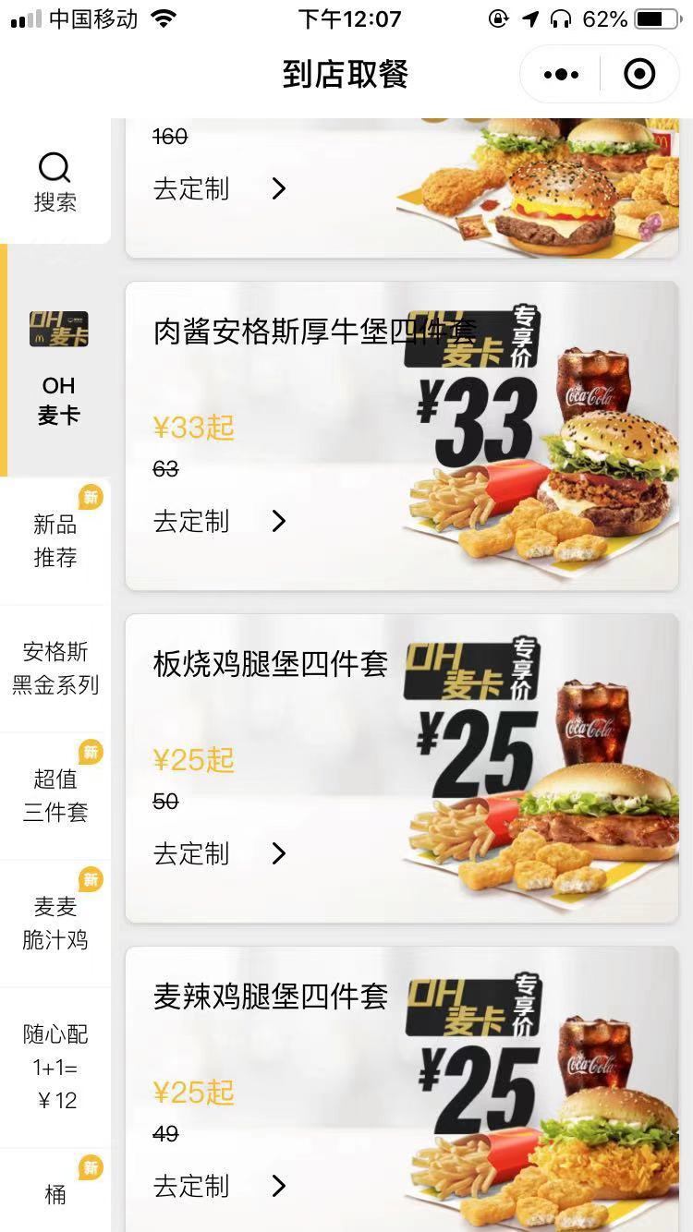
McDonald's also cooperates with the application of delivery through the online store model. In this mode, consumers can order food through a small program in the software platform, and with delivery services, consumers can enjoy their favorite products without leaving home.Picture as follow show the order page in delivery application,people can order by the application and then there will be one person deliver the order to the address chosen by the customer.
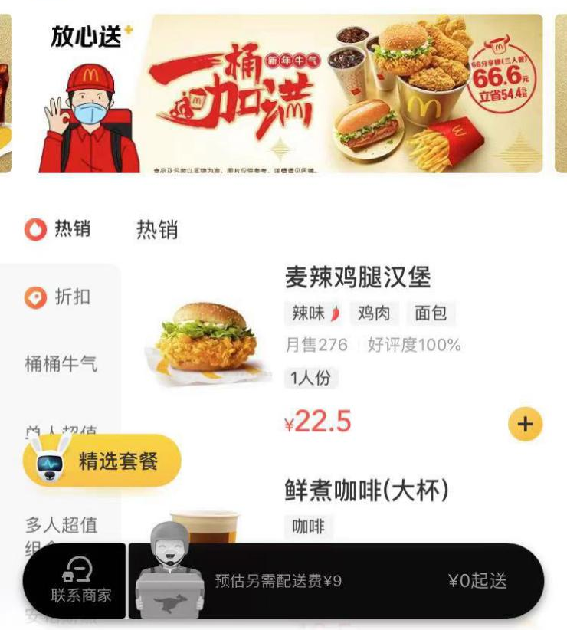
- Income portfolio
McDonald's main source of income is through franchising. In the franchise mode, franchisees need to pay a franchise fee to McDonald's and the rent will be paid by the franchisee(Jiangfei Shi, Kui Yu, 2013). In fact, the stores provided by McDonald's belong to McDonald's Real Estate, a company that specializes in buying real estate and then subletting it to franchisees for profit. In this business model, McDonald's can charge rent and franchise fees and also can obtain main business income with low management costs. Franchisees seem to be happy to join the McDonald's organization in this way, because in the early stages of business, franchisees did not have enough funds to open new stores. The McDonald's franchise model directly provides venues for franchisees to operate, and franchisees only need to focus on reasonable operation and make more income to achieve a win-win effect(Jiangfei Shi, Kui Yu, 2013).

McDonald’s International Marketing Strategy
In the context of globalization, food can be traded, but people in different countries have different preferences for food tastes, and food standards are also different under cultural backgrounds. This chapter mainly discusses the localization strategies of McDonald's in some countries based on different dietary preferences and cultural backgrounds. At the same time, the 4Ps theory is used to analyze McDonald's marketing strategy in the China.
India:If you succeed in selling your product in India then you can sell it anywhere because of the open market and many multinational operators from India(Jeon, Hyo Jin et al., 2016).McDonald's has adapted its menu to local tastes and preferences in India. There are many people in India who believe in religion. Among them, Islam does not eat pork and Hinduism does not eat beef(Racoma, 2019). Therefore, McDonald's in India replaced beef in burgers with chicken. And also, McDonald's caters to vegetarian customers with grilled Masala Veggie Burgers, McAllo Tikki and McVeggie(Mallikarjun Singireddy, 2020). So McDonald's opened its first vegetarian restaurant in India in 2013 to serve local vegetarian customers.
Japan:The advertisements in Japan are targeted at adults and children and have local characteristics(Mallikarjun Singireddy, 2020). In Japan, McDonald's initially adopted the same menu as the US. But it has slowly changed and added items to its menu to suit Japanese tastes. For example, chicken lemon and salted shrimp and cherry blossom chips during cherry blossom season or squid ink burgers on Halloween. The Japanese franchise has also introduced shrimp burgers, shrimp lumps, green tea shakes, breakfast hot dogs, mustard, ketchup and delicacies(Racoma, 2019).
China:The following analysis will be carried out through the 4Ps marketing theory.
- product:
1)Product taste differentiation
In the Chinese market, McDonald's tried to launch Chinese fast food and Old Beijing Chicken Rolls for trial sales, but they did not achieve the desired results. Later, McDonald's became more cautious on the localization. In comparison with directly launching new dishes, McDonald's prefer to regard Chinese elements as an addition(Xinyi Zhang, 2013). For example, Cheese-flavored pork burger and Fresh Vegetable Fish Cakes. In February 2016, McDonald's "To satisfy the tastes of Chinese consumers" truly launched localized products-golden steamed bread and grain chicken wheat porridge(Wenting Li, 2018). In 2019, with the popularity of the Forbidden City's IP, McDonald's also added Forbidden City’s elements to its packaging and ancillary product of toys. The "Forbidden City Barrel" and "Forbidden City Toy Barrel" received unanimous praise(Xinyi Zhang, 2013).
2)Product quality standardization
In order to ensure the freshness of food and the purity of taste, McDonald's has always adopted a set of fixed and strict quality standards in China. This highlights McDonald's business philosophy, its perseverance and pursuit of quality. Whether in China or other countries, McDonald's food has reached standardization, and all McDonald's restaurants have uniform standards for the quality of ingredients and condiments(Xinyi Zhang, 2013).
- Place
1)Localization of supply channels
At present, the chicken raw materials and packaging materials used by McDonald's in the Chinese market are all locally sourced, and the supply of these raw materials still needs to meet uniform high-quality standards. This is to be able to better manage the suppliers in the Chinese market to ensure product quality(Wenting Li, 2018).
- Localization of ordering channels
(1) Digitization of offline stores
In 2017, McDonald’s adopted the smart ordering business in physical stores and announced that its more than 1,000 restaurants in China have completed the upgrade to the "Future 2.0"(Wenting Li, 2018).It means that customers do not need to contact,just through touch-screen self-service to order in stores.For counter contact, you only need to wait for the number to be called after the electronic payment is ordered on the screen, and the new delivery service to the table is added, which reduces the waiting time for the service to the greatest extent.
(2) Open online O2O ordering mode
In recent years, O2O has been widely used in China's catering industry. Mobile payment in China has become quite popular(Wenting Li, 2018). As long as you have a mobile phone in hand, you can basically solve payment of food, housing and transportation without cash.Online ordering has become a popular way of ordering meals. By placing orders online in ordering platforms such as food delivery service applications, people can enjoy delicious food without leaving home(Wenting Li, 2018).
This is definitely not a small challenge for physical stores. If you do not seize the opportunity, you will be quickly submerged in the wave of the new era. But this also brings opportunities to McDonald's. McDonald's has successfully turned challenges into opportunities by virtue of the development of China's informatization and digitalization(Xinyi Zhang, 2013). According to the official website of McDonald's(China), McDonald's cooperated with application of WeChat and opened payment by WeChat in 2013. After two years, McDonald's announced that it had reached a cooperation with Ant Financial under Alibaba. So far, it has basically achieved full coverage of Alipay's payment functions. It means customers can use WeChat and Alipay to pay the bill of McDonald’s. Since the opening of WeChat and Alipay in Chinese stores, mobile payment methods have accounted for 45%. This scanning code payment method only requires 2 seconds, greatly improving service efficiency(Wenting Li, 2018).
In addition, McDonald's food delivery business in recent years is a new sales growth point(Xinyi Zhang, 2013). According to statistics from McDonald's China official website: 10% revenue of McDonald's Chinese stores comes through food delivery, and some stores can even reach 20%-40%. Most of McDonald's current food delivery business is cooperate with third-party food delivery platforms, but out of the desire to have a better grasp of consumption data, McDonald's is committed to developing its own App. In June 2014, McDonald's launched the food ordering app “MyLesong” in Mainland China, in that way users can quickly complete ordering via mobile phones in McDonald’s own App(Wenting Li, 2018).
- Promotion
1)Advertising under the fan economy
McDonald's marketing has always been considered more brand-oriented rather than sales-oriented. In fact, McDonald’s has almost never hired celebrity spokespersons in the Chinese market before, but facing the problem of brand aging in recent years, there is pressure from rival KFC to launch super stars who has many fans such as Han Lu and TFBOYS in China. In June 2017, McDonald’s announced Yifan Wu as the Spokesperson of the brand. Soon after Yifan Wu joined the variety show named "Chinese Hip Hop", McDonald's became the chief special sponsor of this show. With Wu Yifan, a spokesperson with a super-high commercial value, and sponsored the first stage of the phenomenon-level variety show with a broadcast volume of more than 100 million in 4 hours, McDonald's marketing can be described as a good time and place(Wenting Li, 2018).
2. Promotion on media platforms
In Chinese stage, We-media has entered our daily lives strongly, with Weibo (in China, Weibo is like Twitter, you can post what you want to share on the platform by registering an account), and WeChat has a large number of users. Weibo can integrate scattered user information on one platform. Compared with traditional physical advertisements, Weibo advertising costs are lower, but it may produce better effects. In 2014, McDonald’s launched a new ice cream product, it advertised on the Weibo platform. In just a few days, it gained more than 70 million views and respects on Weibo. It has been shared more than 500,000 times and has been on the hot search list of Weibo, which has greatly increased the attention and sales of new products(Wenting Li, 2018). Today, McDonald’s Weibo marketing is even more flexible. According to McDonald’s official of Weibo, the number of followers on McDonald’s Weibo has reached 1.49 million. On the one hand, the language organization of McDonald’s is more cordial than other brand official of Weibo, and it often interact with followers through likes, comments, etc.In this way, McDonald’s unconsciously achieve the effect of enhancing brand image and attention. On the other hand, McDonald’s official Weibo will update content in time with the launch of new products such as the recent release of Christmas-themed products so that the public can learn about McDonald's related developments for the first time, increase the visibility of new products, and achieve the purpose of attracting more consumption(Wenting Li, 2018).
4.Price
In terms of price, McDonald's (China) mainly adopts the marketing strategy of cash discount and bundled sales, which is similar to KFC and Burger King. McDonald's(China) promotes price reductions through various activities. For example, McDonald's uses "Member Exclusive Monday", that is, every Monday, customers can buy McDonald's products at a discount of about half the price to compete with KFC's "Mad Thursday" and other similar activities. At the same time, activities such as "Super Value Three-Piece Set" and "6 Yuan Breakfast" also satisfy customers who dine during the peak brunch period. McDonald's has won many customers in this way, and its market value has increased rapidly(Xinyi Zhang, 2013).

SWOT of McDonald’s
Next, through a SWOT analysis of McDonald's, it determines its competitive strength, competitive weakness, opportunities and threats, and organically integrates the company's strategy with the company's internal resources and external environment.
Strength
1)Large-scale production
The franchise model helps McDonald's gain a large-scale expansion. Extensive expansion allowed McDonald's to adopt large-scale production.Large-scale production provides convenience for low prices. With this strength, the company often fought price wars in the fierce competition in the overall market(Tian Yan, 2017). On the other hand, large-scale production and franchise can reduce the cost of producing and management than give financial support to large-scale expansion,which creates a virtuous circus.
2)Choice of store location
Since McDonald's target customers are young people, in terms of store address selection, McDonald's mainly chooses to open stores in places where populations are concentrated and young people, such as commercial districts, department stores, shopping centers, train stations and airports(Qiang Zhang, 2011). The advantages of these locations have brought McDonald's population, and in conjunction with McDonald's fast eating methods, it meets the needs of target consumers and brings operating income to McDonald's(Qiang Zhang, 2011).
3)Good product quality
McDonald's puts quality at the top of the company's operating standards, which means that McDonald's values product quality most in its marketing strategy. McDonald's guarantees the quality of the products it provides by unifying product standards, and this standard is extremely strict. McDonald's does this to give consumers confidence in the quality of its products(Tian Yan, 2017).
Weakness
1)Different cultural perceptions
In China, people's daily diet concept is "green diet", that is, eat more green food(Qiang Zhang, 2011). Therefore, most people in China believe that fried foods are unhealthy, and most foods such as McDonald's and KFC are composed of fried foods, such as French fries and fried chicken legs. This cognition has brought obstacles to McDonald's development in China to a certain extent.
2)Slower development
Compared with its competitor KFC, McDonald's is not as early and faster in the Chinese market as KFC. In terms of the number of stores, McDonald's has more than 2,800 stores in China, but the number of KFC stores has reached more than 6,000(Tian Yan, 2017). In terms of recipe products, as famous brands in the world, McDonald’s menu is very single. As a frequent item on the menu——hamburger, it is often criticized for being uninnovative(Tian Yan, 2017). In the past, it could be possible to cope with the changes, but in today, which is developing rapidly every day, this conservative approach will slowly lose customers who love the changes.
3)Global unified structure
In the initial stage of expansion, insisting on a unified global structure is conducive to unified management of the company and lower management costs. But at this stage, McDonald's adheres to the unified global structure of the United States and has not found the uniqueness of the Chinese market, so it is not perfect in terms of localization(Tian Yan, 2017).
Opportunity
1)global economic integration
At present, the global economy is in a state of increasing development. Although it has experienced economic crisis and other events during this period, it still cannot stop the pace of economic development. The national food culture of different countries is originally different, but with the integration of the global economy, the economies of each country are open to each other, forming inter-connected and interdependent organisms(Tian Yan, 2017). Different food cultures can also be quickly spread through this, which is the transnational operation of McDonald's. Provides huge development space and brings business opportunities.
2)The potential of the Chinese market
In China, the economy has developed rapidly in recent years, people's living standards have also been continuously improved, and purchasing power has also increased(Qiang Zhang, 2011).
Chart 1

According to the data from National Bureau of Statistics of China(https://data.stats.gov.cn/easyquery.htm?cn=C01), from 2014 to 2019 there is a rapid development of per capita disposable income in China, it means people have more money to support their live.The similar trend happened on per capita food consumption expenditure of residents.These developments have brought some economic support to McDonald's in the Chinese market.
3)The development of the fast food market
In a rapidly developing society, people have an increasing demand for the fast food industry. The fast food provided by McDonald's has just solved this problem. Through efficient and fast service, it saves people time and meets their dietary needs.
Threats
1)The threat of traditional Chinese restaurants
In the Chinese market, McDonald's still has a very strong competitor: traditional restaurants. Compared with other regions, China's diet structure is diversified and traditional. For some people who love traditional Chinese food, fast food like McDonald's is not attractive to them. On the other hand, with the development of the fast food sector, Chinese fast food began to appear in China. The rise of Chinese fast food has divided up those who originally belonged to McDonald's consumers(Qiang Zhang, 2011).
2)Industry competition
For McDonald's, a big competition comes from the industry(Tian Yan, 2017). In China, KFC,the McDonald's old rival, can be seen everywhere. And in recent years, fast food brands such as Dicos and Burger King have also expanded in many big cities(Wenting Li, 2018).With the development of technology of quickly cooking,some brand of fried chicken and burger is also constantly developing. Companies such as Burger King and some independent brand fried chicken stores continue to divide up McDonald's market share(Qiang Zhang, 2011).

Conclusion
Through the above analysis, it can be concluded that for the Chinese market, McDonald's chooses standardized product quality and different product tastes in its marketing strategy. In terms of product sales channels, McDonald's has opened an online store and an online O2O model in response to digital development. And adopting localization strategies in the supply channels of products. In addition to normal media advertising investment, McDonald's also adopted the We-media promotion channel under the background of the fan economy to greatly enhance the company's brand awareness. In terms of prices, McDonald's adopts market pricing strategies and at the same time cooperates with cash discounts and bundling sales to provide consumers with preferential treatment.
Under the framework of the SWOT analysis model, McDonald's has relatively large-scale production and the strengths of the franchise model. At the same time, the choice of store addresses and product quality have given the company the opportunity to attract customer groups. However, McDonald's still has some weaknesses, such as the impact of different local cultural backgrounds, slow development and excessive reliance on a global unified structure. In the context of globalization, McDonald's faces some opportunities. The development and integration of the global economy has brought McDonald's economic foundation for expansion. The potential of the Chinese market also provides possibilities for McDonald's development in China. The overall development of the fast food market can also promote the development of McDonald's. In the face of these development opportunities, McDonald’s needs to pay attention to some potential threats, such as the threat of local traditional diets under different dietary structures and competition in similar product industries.

Recommendation
In response to some of the weakness of McDonald's, the following suggestions are made: 1) Actively cater to consumer needs. Implement product localization for consumers in different regions to meet new market trends. The global unified structure model can facilitate the consumption choices of mobile consumers across regions, but it can also introduce some dishes that conform to local eating habits and taste preferences. 2) Actively cater to culture shock. In China, where the concept of green diet is the concept, McDonald's could make healthier products by adding green and more nutritious materials. 3) Seize development opportunities. In the context of the current rapid economic development, McDonald’s should vigorously innovate, devote itself to the research and development of new products, and expand rapidly when the budget is feasible. Take the Chinese market as an example. In recent years, China has increased the pace of urbanization and vigorously developed urban planning. McDonald's China can follow the pace of urbanization and expand its stores to every corner. 4) Improve core competitiveness to prevent external threats. Product quality and fast food delivery are the core competitiveness of McDonald's. In the face of external competition and competition in the same industry, McDonald's should enhance its core competitiveness, and at the same time seek out advantages that its competitors cannot surpass and seize consumer groups.

References
- Gerhardt, S., Hazen, S. and Lewis, S., 2014. Small Business Marketing Strategy Based on McDonald's. ASBBS Proceedings, 21(1), p.271.
- Mallikarjun Singireddy, 2020. “Mcdonald’s: Global Marketing”. International Journal of Health and Economic Development, 6(2), pp. 16-27.
- Azim, P. and Azim, S., 2012. Impact of Constructive Marketing Strategies on Return (Revenue & Profitability): A case study of McDonald's. Journal of Asian Business Strategy, 2(7), pp.153-169.
4. Shabbir, M.S., 2018. Innovation Strategy of McDonald Business from Historical perspectives. International journal of global business, 11(2), pp.9–28.
5. Gupta, A.K., 2019. McDonald's in India, London: Henry Stewart Talks.
6. Alice Crawford, Sarah A Humphries and Margaret M Geddy, 2015. McDonald's: A Case Study in Glocalization. Journal of global business issues, 9(1), p.11.
7. Singireddy, M., 2020. Mcdonald's: Global Marketing. International journal of health and economic development, 6(2), pp.16–27.
8. Jeon, Hyo Jin et al., 2016. Cultural Convergence in Emerging Markets: The Case of McDonald's in China and India. Journal of small business management, 54(2), pp.732–749.
9. Steve Gerhardt, Samuel Hazen and Sue Lewis, 2014. Small Business Marketing Strategy Based on McDonald's. ASBBS proceedings, 21(1), p.271.
10. Maze, J., 2014. McDonald's service push includes big digital spending. Nation's Restaurant News, 2014(12), p.12.
11. Sood, T., 2017. Glocalization in Fast Food Chains Glocalization in Fast Food Chains: A Case Study of McDonald's. In Strategic Marketing Management and Tactics in the Service Industry. IGI Global, pp. 330–347.
12. Anon, McDonald's Corporation SWOT Analysis.
13. Tian Yan, 2017. Research on McDonald’s Strategic Management and Its Enlightenment to my country’s Fast Food Chain Industry. Economic and Trade Practice, p.151.
14. Liangdi Chen, 2019. Research on McDonald's advertising and marketing strategy in China. National Circulation Economy, pp.3-5.
15. Cuimin Li, 2015. Thinking on the advertising communication of traditional fast food brands in the new media environment. News Communication, pp.48-57.
16. Jingwen Huang, et al, 2018. My Lessons from McDonald’s Marketing Strategy. Brand Research, pp.57-58.
17. Jiangfei Shi and Kui Yu, 2013. Analysis and Enlightenment of McDonald’s Franchise Mechanism. Technology and Market, pp.100-102.
18. Xinyi Zhang, 2013. Analysis of McDonald's Marketing Strategy in China. business marketing, p.71.
19. Chaowei Liu, 2017. Research on Localization of McDonald's Advertising in China. Southwest University
20. Nan Zhou, 2011. Research on Strategic Adjustment of Chain Operation Enterprises. Tianjin University of Technology.
21. Racoma, B., 2019. How McDonald's Adapts Around the World. Retrieved from Day Translations: https://www.daytranslations.com/blog/how-mcdonalds-adapts- around-the-world/
22. Wenting Li, 2018. McDonald's localization marketing strategy analysis in China. Chinese collective economy, pp.52-53.
23. Qiang Zhang, 2011. SWOT analysis of McDonald's, KFC and real kung fu. Oriental Corporate Culture, pp.43-46.

