
UNIVERSITY OF WALES
TRINITY SAINT DAVID

Topic:
Inventory Strategy Transition from Just-in-Time to Just-in-Case: A Comparative Analysis of Supply Chain Resilience in UK Automotive Vehicle Manufacturers During the Red Sea Crisis (2019–2024): Evidence from Mass and Luxury Segments

Student: Ivilina Atanasova Atanasova: 2028391

Module: Dissertation
Module code: LCMB7035

Supervisors: Dr Ivan Rodriguez Hernandez / Vasilios Tavlaridis

06/05/2026

DECLARATATION

I, Ivilina Atanasova, declare that this dissertation has been composed by me, that the work contained herein is entirely my own except where explicitly stated otherwise in the text, and that this work has not been submitted for any other degree or qualification, in whole or in part, except as specified.

Signature: Ivilina Atanasova

Date: 06/05/2026

ACKNOWLEDGEMENT

I would like to thank my supervisor, Dr Ivan Rodriguez Hernandez, for his guidance and support throughout this dissertation. I am also grateful to Vasilios Tavlaridis, my co-supervisor and Programme Manager, for his advice and encouragement during my MBA.
Special thanks to Masud Ibrahim, my dissertation lecturer, for his help during the research workshops.
I also appreciate the support from my colleagues at Elta Automotive, and finally, I am very thankful to my family for their continuous support and motivation.

Contents
CHAPTER 1: INTRODUCTION 6
1.1. Background & Problem Statement 6
1.2. Research Aim 6
1.3. Research Objectives 7
1.4. Research Questions 7
1.5. Significance / Relevance of Study 7
1.6. Brief Research Methodology 8
1.7. Structure of the rest of the project 8
CHAPTER 2: LITERATURE REVIEW 9
2.1. Introduction 9
2.2. JIT vs JIC: From Efficiency to Resilience Logic 10
2.3. Supply Chain Disruptions: From Global Instability to the Red Sea Shock 12
2.4. Supply Chain Resilience & Risk Strategies 14
2.5. Automotive Industry Context (Luxury vs Mass) 16
CHAPTER 3: RESEARCH METHODOLOGY 19
3.1. Introduction 19
3.2. Research Philosophy and Assumptions 20
3.3. Research Design 20
3.4 Research Approach 22
3.5. Data Collection Methods 23
3.6 Variable Construction & Measurement 25
3.6.1. Financial and operational Metrics (Company Level) 26
3.6.2. Global Metrics (disruptions) 27
3.6.3. Additional metrics and RQ3 key indicators explanation 30
3.7. Data Analysis & Tools (Power BI + SQL Logic) 31
3.8. Ethical Considerations 33
3.8 Methodological Limitations 33
3.9 Conclusion 34
Chapter 4: FINDINGS / RESULTS, ANALYSIS AND DISCUSSION 35
4.1 Introduction 35
4.2 Empirical Analysis of Supply Chain Adaptation 36
4.2.1 RQ1: How did firms shift from JIT toward JIC? 36
4.2.2. Route Diversification as Behavioural Evidence of Strategic JIC Adaptation 36
4.2.3 Transit Time Inflation and the Cost of Resilience Adaptation 38
4.2.4 Crisis-Period Inventory Growth and Evidence of Hybrid JIT–JIC Transition 39
4.2.5 Cross-Firm Contribution to Cumulative Inventory Holdings and Strategic Contingency 40
4.2.6 Implications for JIT–JIC Theory 41
4.3. RQ2 Financial and operational impacts of Red Sea crisis 42
4.3.1 Macro Disruption Evidence: Crisis Transmission Mechanisms 42
4.3.2 Cost Impact Findings and Shock Absorption Responses 43
4.3.3 Inventory–Performance Trade-Offs 44
4.3.4 Differences in Resilience Outcomes at the Firm Level 46
4.3.5. Discussion with Literature and Bridge to RQ3 46
4.4. RQ3. Industry 4.0 / 5.0 and resilience capability 48
4.4.1 The Relationship Between Digital Capability Intensity and Resilience 48
4.4.2 Digital Capability and Hybrid JIT–JIC Models 50
4.4.3 Critical Discussion 53
4.5 Cross-RQ Synthesis and Critical Evaluation 57
Chapter 5: Conclusions and Recommendations 59
5.1. Respond to each research question explicitly 59
5.2. Practical and specific recommendations for UK vehicle manufacturers 59
5.3. Guidance on hybrid JIT–JIC, supplier risk management, digital visibility, and route contingency planning 60
5.4. Discussion of the restrictions on using secondary sources of information 61
5.5. Recommendations for further study 61
5.6. Final Conclusion 62
Appendix 1. Details about the excluded firms 86
Appendix 2. Link with original files 87

Contents of Figures: 25
Contents of Tables: 14

CHAPTER 1: INTRODUCTION (1070 words)

1.1. Background & Problem Statement
The UK automotive industry has long depended on highly efficient Just-in-Time (JIT) models that favour efficiency above redundancy, even though global supply chains are becoming more vulnerable to systemic disruptions. Between 2019 and 2024, this structural reliance faced a significant test due to geopolitical shocks, the most significant of which was the Red Sea crisis. These shocks caused major shifts in logistics, with vital marine throughput declining by more than 50% and transit times increasing by more than 40 days. Under these circumstances, a critical flaw became apparent: systems that were designed to be as efficient as possible did not have the adaptability to withstand extended periods of uncertainty.
Responding to this, businesses started using JIC inventory techniques, although this change did not lead to uniform results. The efficacy of buffering as a universal resilience technique is called into doubt when some organisations drastically expand inventories while others maintain lean operations. However, companies' responses, rather than exposure alone, seem to control the effect of disruptions, as seen by increasing costs and inconsistent performance results.
The result is a major issue, as current models do not address the question of why comparable shocks have different effects on resilience, especially when new digital capabilities are considered.

1.2. Research Aim
Using the Red Sea crisis as a case study, this dissertation critically examines how UK vehicle manufacturers shifted inventory strategies from Just-in-Time (JIT) to hybrid Just-in-Case (JIC) models from 2019 to 2024 in response to supply chain disruptions. Its goal is to assess the effects of these changes on operational efficiency, cost models, and resilience results. Even more crucially, the research intends to determine whether digital skills improved companies' capacity to handle these trade-offs or just exacerbated preexisting disparities. The research project seeks to elucidate not only the changes in strategy but also the reasons behind the unequal performance experienced by different organisations in response to comparable disruptions by combining company-level data on inventory, costs, and disruption exposure.

1.3. Research Objectives
This dissertation follows a three-step methodology to analyse structural change, performance effect, and capability difference among UK automobile manufacturers catering to both the luxury and mainstream markets. These goals represent the analytical development from the study aim.
Beginning with a look at the transition from JIT to hybrid JIT-JIC models, the research then moves on to analyse the inventory methods that both sectors implemented from 2019 to 2024. In particular, the reasons for the stronger selective buffering practices of luxury enterprises and the more diverse but limited inventory profiles of mass manufacturers are examined.
Second, the study compares performance from the pre-crisis (2019–2022) and disruption-period (2023–2024) periods to assess the operational and financial effects of these changes. It delves into the exact ways in which the luxury and mass sectors varied in their responses to identical disruptions, including price increases, transportation delays, and inventory growth, and the reasons behind these disparities.
Industry 4.0 and 5.0 capabilities are examined in the research to determine their impact on segment resilience. It examines the effectiveness of digital tool integration with inventory and cost strategies to see if digital maturity consistently promotes resilience or whether its influence fluctuates.

1.4. Research Questions
Using the following research questions as a framework, we analyse the effects of disruptions on inventory transformation and capability-driven resilience in the UK automotive industry.
RQ1: How did the shift from JIT to JIC inventory strategies manifest in the UK automotive sector between 2019 and 2024?
RQ2: What financial and operational impacts did this transition have on major UK automotive manufacturers during the Red Sea crisis?
RQ3: To what extent can Industry 4.0 and Industry 5.0 technologies enhance supply chain resilience and support hybrid JIT–JIC inventory models?
The answers to these questions will provide the basis for assessing the research's academic and practical relevance within the broader discussion of supply chain resilience.

1.5. Significance / Relevance of Study
This research contributes to the existing literature on supply chain resilience by disputing the simplistic assumption that digitisation or buffering alone may boost performance. Integrating firm-level data from high-end and mass-market UK car manufacturers, it shows that the alignment of inventory, cost, and digital capabilities is conditional on resilience results. This gives credibility to a capability-based viewpoint and casts doubt on the common assumptions about the trade-off between efficiency and resilience.
Considering the growing geopolitical instability, the report offers useful information for UK industries. Hybrid JIT-JIC solutions, bolstered by digital visibility and adaptive decision-making, may enhance resilience, and this explains why exposure to comparable disruptions has varied consequences. Considering ongoing supply chain volatility, it is essential to understand these conditional linkages to formulate operational solutions that are both effective and sustainable.

1.6. Brief Research Methodology
The findings of this study examine the resilience of UK automobile manufacturers at the business level using a quantitative, secondary-data-driven methodology. The technique incorporates cross-sectional examination of mass-market and luxury enterprises with a comparative study of performance during the disruption era (2023–2024) and before the crisis (2019–2022). Supported by external indices such as the GSCPI and the Digital Capability Index (DCI), key measures include inventory levels, import prices, transit durations, and resilience indicators.
The research uses visual modelling, correlation analysis, and descriptive statistics to identify relationships among exposure to disruptions, strategy responses, and performance outcomes. Focusing on conditional patterns and trade-offs, the technique avoids evaluating linear causation. The interplay between inventory strategies, cost absorption, and digital capabilities in shaping resilience under uncertainty may now be evaluated more critically.

1.7. Structure of the rest of the project
Moving on from a theoretical framework to an empirical assessment is the next step in this dissertation's organisational structure. In Chapter 2, "Why Traditional Efficiency-Focused Approaches Fail Under Disruption," we examine the research on digital capabilities, JIT-JIC models, and supply chain resilience. The approach, including the analytical framework and key measures such as inventory coverage (e.g., rising from about 28.83 to 33.98 days), cost shock absorption, and disruption indicators (e.g., transit time increasing to around 42.6 days), is presented in Chapter 3.
Chapter 4 presents the fundamental results on how formulae such as inventory turnover and cost ratios explain firm-level heterogeneity. It links these metrics to resilience outcomes (0.40-0.65) and Digital Capability Index scores (0.12-0.44). In Chapter 5, we draw conclusions and provide suggestions based on the data. We also discuss the limits and potential avenues for further study.

CHAPTER 2: LITERATURE REVIEW (3364 words)

2.1. Introduction
This chapter analyses the development of inventory strategies in the face of continuous disruption, answering RQ1–RQ3 to provide a thorough picture of the resilience of the UK automotive supply chain. Although Just-in-Time (JIT) efficiency and the rise of Just-in-Case (JIC) buffering have been thoroughly investigated in the literature, they are often discussed independently. Recent worldwide shocks, however, show that uncertainty, structural complexity, and firm-specific capacities are crucial to understanding inventory choices.
Thus, the chapter begins by assessing the theoretical conflict between resilience and efficiency and then places JIT-JIC transitions in the larger framework of systemic shocks, such as the Red Sea catastrophe. Afterwards, it takes a close look at risk and resilience tactics including digital visibility, supplier diversity, and buffering, discussing how dynamic capabilities shape results and casting doubt on their generalisability.
At that point, the research separates luxury and mass-market automobile manufacturing firms to show how structural variables like supplier dependency, size, and cost structures cause differing resilience reactions. This chapter goes beyond a descriptive study to pinpoint important theoretical and empirical gaps by including various viewpoints. This sets a solid strong basis for the empirical study that will follow, which will examine how the UK automotive industry implements resilience in the face of disruption.

2.2. JIT vs JIC: From Efficiency to Resilience Logic
The dominance of Just-in-Time (JIT) in automotive supply chains is not a result of inherent superiority but rather consistent conditions. Prior to its implementation, JIT required steady supply flows and predictable demand to save costs, inventory, and waste. The essential concern, therefore, is whether the conditions under which JIT was successful continue.
On the other hand, recent revolutions call these assumptions into doubt. Incidents like the COVID-19 pandemic, semiconductor shortages, and crises in the Red Sea highlight the precarious nature of interdependent supply systems. Consequently, operational efficiency turns into a weakness in the structure. Reevaluating inventory processes is necessary for this shift since efficiency is not a guarantee of resilience in tough circumstances.
A theoretical tension between efficiency and robustness is shown in the distinction between JIT and Just-in-Case (JIC). In contrast to JIT's emphasis on reducing costs via lean operations, JIC places a premium on continuity through safety stock and supplier redundancy. Despite appearances, supply chain resilience complicates this seemingly simple trade-off. According to Wieland and Durach (2021), resilience encompasses the ability to recover, anticipate, absorb, and adjust to disturbances. So, JIC isn't about being inefficient; it's about responding strategically to uncertainty.
Why has JIT become so popular if JIC makes things more resilient? Environmental protection is the key. Assuming constant conditions, JIT's economic benefits outweigh its risks. This balance shifts as uncertainty increases. During systemic failures, supply networks shift their rationale from optimisation to survival, as stated by Ivanov (2021). Therefore, rather than failing JIT, changing environmental limitations make it more difficult.
Disruptions propagate rapidly across interconnected networks in complex, multi-tiered automobile supply chains. Highlighting JIT's dependence on scheduling, the Red Sea crisis lengthened transit delays and disrupted synchronised flows. Minor setbacks may lead to catastrophic failures when amplified effects, such as the bullwhip phenomenon, are present. The need for synchronisation is the root cause of JIT's vulnerability.
Due to these constraints, businesses use a JIT-JIC hybrid approach. Strategic adaptation, not adoption, is what this means for JIT. Organisations use buffering strategies based on risk exposure. For stable components, they use JIT, while for essential or unpredictable inputs, they use JIC. Instead of being an expense, inventory may be a strategic asset. This shift is indicative of evolving operational goals and provides a foundation for future research into the causes and effects of similar changes in the UK automotive sector.

The key change from JIT to JIC inventory techniques indicated in RQ1 may be better understood with the use of Dynamic Capability Theory (DCT)—Figure 2.1. According to Teece (2014), DCT highlights that businesses vary in their capacity to detect disturbances, seize strategic opportunities, and reorganise operational processes, instead of supposing a uniform transformation. Adaptation is not a given but rather a function of capabilities unique to each business, as shown in Figure 2.1. This indicates that, within the UK automotive industry, internal preparedness to react to external shocks is more important than shocks themselves in shaping the appearance of JIT-JIC transitions between 2019 and 2024.

Figure 2.1. Dynamic Capability Process (Teece, 2014)
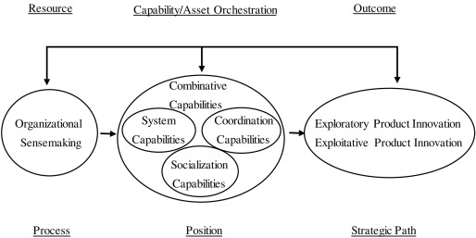

Despite this, this brings up a significant restriction. Unfortunately, not many businesses have the resources, knowledge, or digital infrastructure to successfully execute hybrid inventory strategies. Rather than depending on static operational models, Pepper (2020) contends that flexibility necessitates the establishment of flexible capabilities. Consequently, some businesses shift to resilience-oriented strategies while others are stuck in old-fashioned JIT frameworks, and this is all down to the unequal distribution of such talents.
Industry 4.0 technologies add another layer of complexity to this change. Technologies like the internet of things (IoT), predictive analytics, and digital twins help with visibility and enabling targeted buffering (Spieske and Birkel, 2021), but they still can't get rid of uncertainty. By enhancing decision-making in risky situations, they transform the efficiency-resilience trade-off instead. As a result, studying how dynamic capabilities allow organisations to use hybrid JIT-JIC procedures is crucial to comprehending the change mentioned in RQ1.

Table 2.1. JIT vs JIC – Operational and Strategic Comparison (Sheng, 2020)
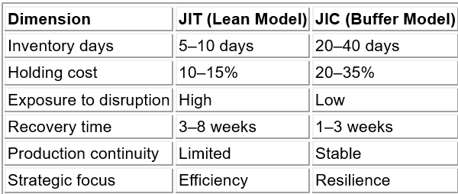

Rather than being seen as a straightforward change from efficiency to inefficiency, the transition from JIT to JIC represents a more systemic reorganisation of supply chain priorities in response to increasing uncertainty. The limits of JIT become apparent as disturbances escalate, even though it remains useful under stable conditions. On the other hand, JIC increases resilience but also raises costs, leading to ongoing strategic friction. Hence, finding out how organisations dynamically balance and transition between models is the main difficulty, not picking one. This shifts the focus from inventory management being solely an operational function to a strategic tool for navigating complex environments. It is crucial to place this rebalancing in the broader context of growing global disruptions, since these factors are becoming more influential in shaping the decision-making and strategic actions of firms at the highest levels (Sheng, 2020).

2.3. Supply Chain Disruptions: From Global Instability to the Red Sea Shock
Expanding on the change from efficiency to resilience discussed earlier, it is important to look at the underlying structural factors, especially about RQ1, that are driving this change. The logic of the supply chain has been transformed as disruptions have built up rather than happening in discrete shocks. Therefore, the shift from JIT to JIC must be seen through the prism of disruption's evolution from isolated incidents to systemic circumstances rooted in global networks.
The growing unpredictability of supply chains is a clear indication of this shift. It is clear from recent events like COVID-19, Brexit, and the semiconductor crisis that linked systems are not self-repairing but intrinsically unstable. The combination of geopolitical fragmentation and economic interconnectedness, according to Ali et al. (2023), makes disruptions happen more often and more quickly. This has transformed risk exposure from an episodic to a continuous phenomenon, compelling organisations to put absorption capacity ahead of efficiency alone. Supply chains are now built to endure and adapt to disruptions, in addition to optimising flows. This represents a fundamental architectural change.
This vulnerability is made much more obvious by the complexity of today's automotive supply networks. Cascade failures are more likely to occur in multi-tier supplier arrangements since there is usually little visibility beyond first-tier interactions. Disruptions in such systems don't travel in a straight path but rather spread erratically throughout linked nodes. Choi, Rogers, and Vakil (2020) see supply networks as intricate adaptive systems that may experience a domino effect of failures; therefore, this makes sense. Similarly, Ivanov and Dolgui (2020) show that JIT systems are fundamentally vulnerable due to minimal redundancy and excessive synchronisation, which further emphasises the trade-off between robustness and efficiency.
One recent example of these processes is the Red Sea dispute. Attacks in the Bab el-Mandeb Strait led ships to change their routes to circumnavigate the Cape of Good Hope, increasing uncertainty and lengthening passage times (Notteboom, Haralambides, and Cullinane, 2024). Widespread logistical reconfiguration increased operating expenses, and complicated planning were all results of interruptions connected to geopolitical concerns beginning in November 2023. Although global supply chains did begin to show signs of improvement by 2024, the fact that these disruptions continue to occur shows that they are systemic rather than just passing.
Because of this, an important issue arises: will supply chains be able to maintain their efficiency priorities in an environment where disruptions occur frequently? According to Ivanov (2021), structural stability, not short-term optimisation, is becoming more important for long-term sustainability. Resilience is therefore no longer an optional extra but an essential precondition for survival.
On the other hand, there is a lack of information in the literature about the micro level responses of enterprises. Although worldwide trends may be better understood using macro-level research, firm-specific variance is frequently lost in the shuffle. Freightos Baltic Index swings, shipping rerouting statistics, and trade flow variations from UN Comtrade and HMRC are just a few empirical indicators that show how disruption can have real-world effects on three interrelated dimensions: operational unreliability, financial instability, and delays and uncertainty. The requirement for adaptable solutions is further reinforced by the fact that these variables impact inventory choices when taken together.
However, responses vary throughout businesses. Disruption absorption and adaptation capabilities are influenced by digital competence, financial resilience, and supply chain design. This shows that the change from JIT to JIC cannot be explained only by macro-level factors. below, in figure 2.2. As a result, to understand how disruption causes changes in the UK automotive sector's strategy and operations, a more detailed, capability-driven viewpoint is necessary. This will directly lead to the analytical framework that will be established in the section that comes next.

Figure 2.2. Disruption Propagation and Strategic Response Framework (Reuters, 2024)
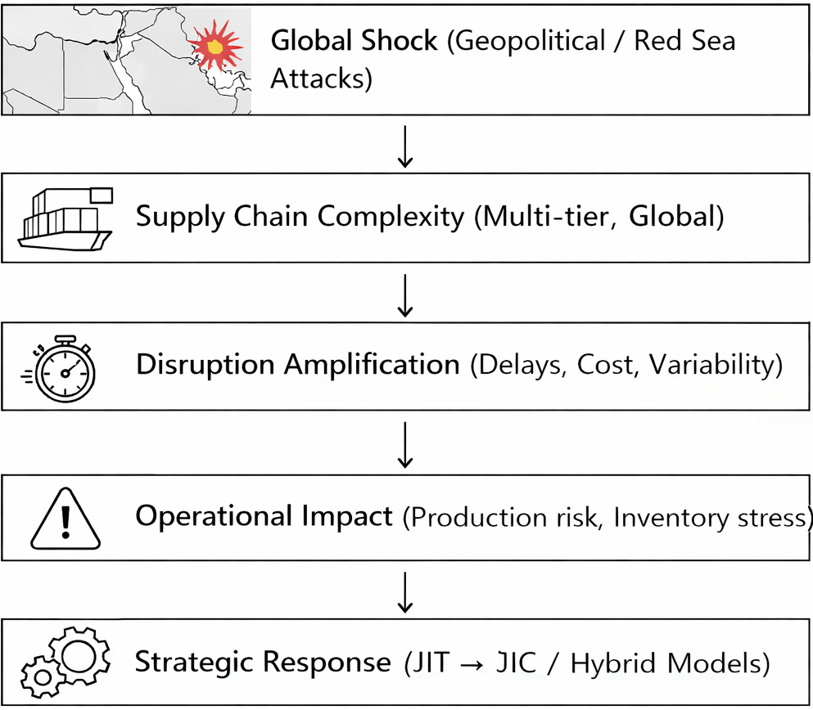

Issues involving the supply chain are becoming more systemic and less episodic, which is putting efficiency-driven models at risk and revealing weaknesses in the system. During political instability, critical logistical channels are disrupted, and operational and financial risks are amplified across global networks, as shown by the Red Sea crisis. Although these macro-level trends are well-captured in the current literature, there is little insight into the micro-level responses of enterprises. Given this, it is crucial to understand how disruption leads to strategic adaptation at the corporate level, particularly changes to inventory plans (Reuters, 2024). To fill this knowledge gap, the next part draws on empirical research into the methods used by UK vehicle manufacturers to modify inventory models and strengthen resilience through dynamic capabilities.

2.4. Supply Chain Resilience & Risk Strategies
After systemic disruption is covered, the analytical attention moves from the reasons supply chains fail to the ways in which companies deal with ongoing uncertainty, answering RQ2 and RQ3 directly. Within this framework, resilience encompasses more than just the ability to heal; it signifies businesses' ability to adjust, reorganise, and thrive despite challenging circumstances. As a process of transformation, resilience is defined by Wieland and Durach (2021) as the ability of enterprises to reorganise their operations in the face of change. This casts doubt on the idea that stability is ideal and raises the possibility that striving to revert to conditions before the disruption may raise susceptibility in the long run.
A variety of risk mitigation measures are being used by organisations, while the success of these strategies is still up in the air. The effectiveness of safety stock, which offers short-term protection against demand and supply swings, is conditional on how long and how predictable the disruption will be. A change towards buffering strategies was shown by empirical evidence that worldwide manufacturing inventories grew by around 15-25% from 2020 to 2023 (McKinsey, 2023). Although this lessens vulnerability in the near term, it raises holding costs and capital limitations at the same time, making its long-term viability questionable.
Diversifying suppliers also increases flexibility by lowering reliance on any one source. Seventy percent of businesses, according to Deloitte (2023), increased their supplier base after COVID-19. However, when dealing with several suppliers, it might be difficult to keep quality and consistency consistent, which is one of the coordination issues brought about by diversification. Since then, the focus has shifted from supply interruption to operational complexity, rather than risk elimination.
Another factor that is adding complexity to this environment are the technological solutions linked to Industry 4.0. Improved supply chain visibility and proactive decision-making are made possible by tools like the Internet of Things (IoT), real-time data analytics, and digital twins. However, it is not always the case that more visibility results in greater outcomes. Rather than increased resilience, businesses run the danger of information overload without the capacity to understand and act upon data. Resisting damage is just part of resilience; antifragility theory teaches us that we should look for ways to use setbacks to our advantage. The ability of the organization, not only the availability of risk mitigation measures, is what matters, according to Ismail et al. (2026).
Because of this, dynamic skills are much more important in determining resilience results. While detecting, seizing, and reconfiguring are all processes laid out by Dynamic Capability Theory, the theory often presumes that corporations can successfully employ these capacities. On the ground, implementation is often impeded by cultural opposition, structural stiffness, and organisational inertia. So, resilience tactics aren't as important as a company's capacity to adjust on the fly if they want to be successful.
Ivanov and Dolgui (2021) argue that supply chains exhibit non-linear interactions and should be seen as complex adaptive systems. This suggests that enterprise-specific factors like digital readiness and organisational structure might influence the results of comparable methods. Being resilient is therefore dependent on the skills that support a strategy, rather than only on the approach itself. Based on this premise, we may analyse the effects of various resilience strategies on JIT and JIC configurations. (Table 2.2).

Table 2.2. Resilience Strategies and Their Impact on Inventory Models (2023–2024)
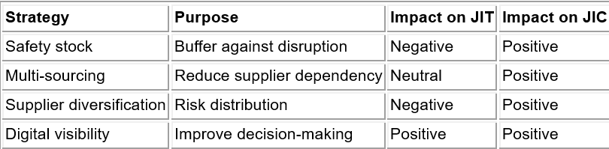
(Source: Adapted from McKinsey 2023, Deloitte 2023, and Ivanov and Dolgui 2021)
Table 2.2 suggests that inventory models are not one-size-fits-all recommendations but rather are intrinsically linked to certain resilience tactics. The cost-effectiveness that is fundamental to JIT is undermined by safety stock, even as it increases JIC by increasing buffering capacity. Digital visibility, on the other hand, lends credence to both schools of thought, implying that skills rather than models form the basis of resilience. This provides further evidence that adopting a single inventory logic is not the key to resilience; rather, it is the alignment of strategic aim with system design.
The literature, however, reveals a more fundamental weakness. Most of the current literature ignores internal restrictions in favour of the assumption that organisations may easily apply resilience methods. Execution might be severely limited by organisational inflexibility, procedural hurdles, and reluctance to embrace technology. According to antifragility theory, such limitations make adaptation more difficult, which explains why companies hit by comparable shocks may yield such different results.
Thus, the capacity to deploy resilience measures effectively under constraints is more important than the availability of resilience mechanisms themselves. Instead of seeing resilience as a static trait, it is more accurate to think of it as an adaptable organisational capacity shaped by external factors. This diversity calls for further investigation into how these distinctions materialise across various business contexts, especially between luxury and mass-market automobile companies.

2.5. Automotive Industry Context (Luxury vs Mass)
To better understand RQ1 and RQ2, it is important to examine how structural disparities in resilience across enterprises are influencing the automotive industry. Internal configurations and sectoral positioning impact how organisations respond to comparable external disturbances. With its highly efficient operations and broad global interconnection, the automotive sector offers a particularly pertinent setting. Nevertheless, the distribution of this complexity is not uniform; it needs to separate producers targeting the luxury market from those targeting the general market to understand the practical differences in resilience methods.
Some distinctive characteristics of automotive supply chains include rapid manufacturing, dependence on high-value components, and multi-tier supplier networks. Under steady-state conditions, these traits boost efficiency; nevertheless, when disturbances occur, they reduce the system's resilience. Shocks may spread quickly among interdependent suppliers and regions, lending credence to the idea that systems with strong coupling are more prone to domino effects (Lee, Sohn, and Rojen, 2023). Consequently, synchronisation intensifies rather than mitigates interruption caused by the failure of essential suppliers or logistical hubs.

Some businesses are more susceptible to this structural weakness than others. The limits that mass-market manufacturers face are quite different from those that luxury manufacturers such as Morgan Motor Company, Bentley, Aston Martin, McLaren, Rolls-Royce, Lotus, and JLR face. Companies that produce goods on a large scale rely on JIT systems to maximise efficiency and minimise costs. Luxury enterprises, on the other hand, may more easily weather disruptions by increasing stock levels or diversifying their supplier base, given their larger profit margins and smaller production volumes.
That said, this is not always a benefit. Concentrated risk exposure occurs when luxury enterprises rely on specialist suppliers for speciality components. The advantages of flexibility would be nullified if problems with these suppliers caused a complete stop to production. On the other hand, mass producers may be able to maintain supply stability despite price restrictions by leveraging economies of scale and stronger negotiating positions.
So, resilience isn't just about being adaptable; it's a product of how strategic goals, supply chain topologies, and cost structures interact. That different kinds of businesses react differently to the same disruption situations is made clear here. The idea of antifragility expands on this idea by positing that certain businesses may not only survive but thrive in the face of change. The ability of supply chains to adapt determines their evolution from resistance to resilience and, finally, antifragility (Figure 2.3). The analysis of how resilience approaches result in performance disparities across automotive manufacturers may be significantly improved by emphasising this sectoral differentiation.

Figure 2.3. From Supply Chain Robustness to Antifragility (Adapted from Ismail et al., 2026)
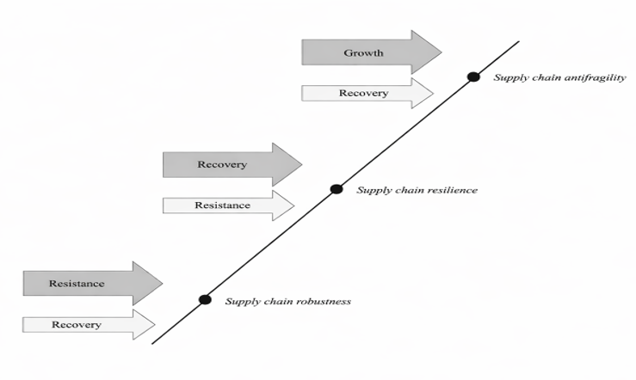
Structure and organisational variables both play a role in shaping the variance in this resilience result. According to Nikookar, Stevenson, and Varsei (2024a), antifragility occurs when a company's operational environment is compatible with its sense, seize, and reconfigure capabilities. This alignment varies widely across firms in the automobile industry. The operational flexibility of luxury manufacturers allows them to swap suppliers and use buffering methods, whereas the efficiency of mass manufacturers is prioritised via demand forecasts and networks that are well linked. This leads to different reactions to disturbance. Reliance on continuous flow causes higher production losses for high-volume enterprises (Wu et al., 2024), whereas low-volume manufacturers keep costs stable but face greater volatility. According to Table 2.3, this further supports the idea that resilience results differ consistently throughout categories.

Table 2.3: Luxury vs Mass Automotive Supply Chain Characteristics (UK Context, 2023–2024)
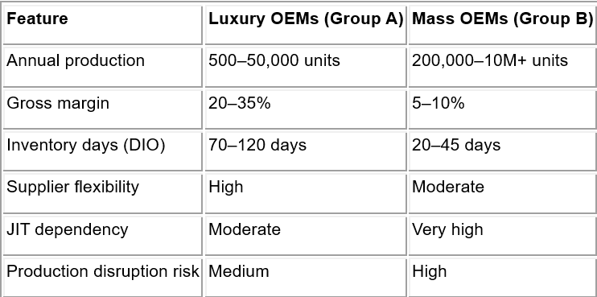
(Source: Adapted from Wu et al. (2024), Nikookar et al. (2024a), and industry datasets)

As seen in the illustration, companies in the luxury car category usually have larger inventory buffers, which gives them more leeway to deal with disruptions. This highlights the significance of structural positioning as the same external shocks, like the Red Sea crisis, have distinct operational Impacts. This indicates that resilience tactics should not be generic but rather tailored to the unique qualities of each company. According to Preuss et al. (2024), context-sensitive adaptability is crucial because structural alignment, internal capabilities, and exposure to external risk determine the efficacy of JIT or JIC.
That resilience is essentially divided is further shown by the vehicle industry. Different approaches to disruption are taken by luxury enterprises and mass manufacturers. The former prioritises flexibility and margin preservation, while the other focuses on cost control and scale efficiency. However, it is not enough to just acknowledge these distinctions; one must also evaluate the operational and financial consequences of performing so. Following the establishment of diversity in resilience results, the empirical methodology utilised to investigate these disparities among UK automotive enterprises is critically examined in the next chapter.

CHAPTER 3: RESEARCH METHODOLOGY (4083 words)

3.1. Introduction
Since 2019, global supply chains have seen major disruptions, which have challenged the supremacy of Just-in-Time (JIT) systems and gradually prompted a change towards tactics that are more robust and buffer-oriented. The automotive industry in the UK has been heavily impacted by global sourcing, complicated supplier networks, and crises like the Red Sea crisis, making this transformation apparent. How JIT and JIC inventory methods have developed and how companies strike a balance between efficiency and resilience in the face of disruption are the topics explored in this research.
The study combines financial and operational data at the business level with macroeconomic indicators like the Global Supply Chain Pressure Index using a secondary-data, longitudinal approach. As an illustration of the operational constraints driving strategy change, preliminary trends reveal that inventory buffers increased from around 1–5 days before 2020 to 10–20 days after interruption, while transit delays rose from about 30 to more than 40 days.
To understand not only whether companies adapt, but also how and why this varies across different types of organisational structures, the research integrates time-series, cross-sectional, and disruption-based analysis.

3.2. Research Philosophy and Assumptions
The study takes a pragmatic approach to research, not to appease traditionalists or creative types but considering that it feels it is essential in relation to the characteristics of resilient supply chains. The adaptive and temporal aspects of resilience are lost if it is seen as a static result, as is sometimes inferred in positivist methods. The absence of empirical basis in interpretivism makes it ill-suited to evaluate firm-level reactions throughout time, while it does provide light on managerial thinking. Neither viewpoint is enough on its own. According to Grimm, Langley, and Reinecke (2024), pragmatism is justified since it enables the integration of context-specific organisational behaviour with demonstrable operational improvement.
This stance is based on the existential assumption that resilience is not an outcome but rather an ongoing process influenced by failures, adjustments, and triumphs. Therefore, it is necessary to infer it from changes in operational indicators rather than see it directly. Resilience is not innate but rather learned and practised via the relationship of structural limitations and organisational responses, which in turn produce supply chain consequences (Nikookar and Yadavari, 2022). This poses a problem for methods that ignore underlying strategy adjustment in favour of static measurements.
It follows that proxy-based measurement is required from an epistemological standpoint. Rather than seeing indicators like inventory levels, cost variations, and transportation delays as measures of resilience, we view them as tangible signs of adaptive behaviour. This is in line with the Dynamic Capability Theory, which states that changes in firm-level activities, rather than abstract concepts, are used to identify sensing, seizing, and reconfiguring. Therefore, the research emphasises quantifiable changes in inventory strategy and operational responses as evidence of resilience. This way, the analysis is based on practical adaptation rather than theoretical abstraction.

3.3. Research Design
The study is based on the philosophical perspective that resilience is changeable and can only be seen via change. It uses a comparative, longitudinal, and secondary-data methodology. This is an essential part of the methodology, not a matter of personal preference. Analysing static snapshots of organisations would make it difficult to see when and where inventory strategy changes if we are trying to answer RQ1 and RQ2. To better understand the evolution of the shift from JIT to JIC, the research employs a longitudinal design that spans 2019–2024. This design is for the collection of the pre–disruption, disruption, and adjustment phases.
Despite the dynamic perspective laid out in Section 3.2, a cross-sectional approach would erroneously conclude that resilience can be inferred from a single moment in time. In contrast, although rich in background, single-case studies don't provide sufficient comparative variety to explain why comparable shocks react differently across businesses (Grimm, Langley, and Reinecke, 2024). Consequently, to discover fundamentally different organization-specific resilience response variability, a comparative multi-firm design is used.
Differences in cost structures, manufacturing size, and strategic flexibility are reflected in the purposeful division between luxury and mass-market car manufacturers in terms of firm selection. Because it lends credence to the study of how structural traits impact inventory judgements during disruption, this differentiation is more analytical than descriptive. The chosen companies—Bentley, Aston Martin, McLaren, JLR, Nissan, and Toyota—offer sufficient diversity while preserving sectoral uniformity. Previous studies have shown that crisis reactions are greatly influenced by internal competences and governance frameworks, which highlights the need of comparing responses at the business level (Lee, Sohn, and Rojen, 2023).
The analytical framework (Table 3.1) creates a hybrid dataset that records both long-term strategic results and short-term changes by combining financial data from a firm's year with operational indicators from a firm's month. The research may now go beyond a purely descriptive comparison and start looking for patterns of adaption because of this. The analysis is further structured by the before-during-after disruption logic, which makes sure that changes are seen in the context of external shocks and not just as random fluctuations.

Table 3.1. Comparative Design Logic – Luxury vs Mass Market Supply Chains
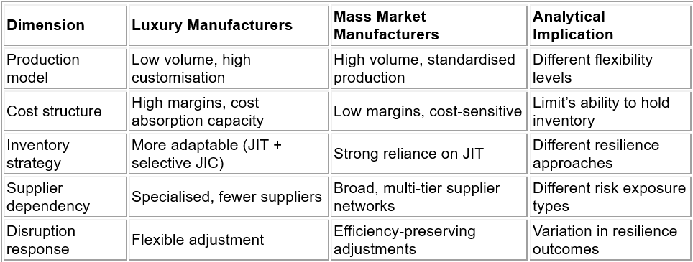
(Source: Synthesised from Lee, Sohn and Rojen 2023, Preuss et al. 2024, and Queiroz et al. 2024)

The dissertation's aims are directly addressed by the research methodology, which integrates longitudinal and cross-sectional variables to assess resilience as an organisational process rather than a static quality.

3.4 Research Approach
The analysis uses a deductive-explanatory method, as outlined in the research design, to examine the relationship between theoretical expectations of supply chain adaptability and observed business action. This study aims to explain why companies react differently to comparable disruption situations, while a merely descriptive method would just reveal that change took occurred. Deduction is used to draw patterns from theory, and the explanatory layer checks whether these patterns hold.
The strategy is fully aligned with the enquiries posed by the study. To answer RQ1, we examine changes in inventory levels and turnover to determine whether there is a systematic shift from JIT to buffer-based JIC tactics following the interruption. The study investigates the potential negative impact of enhanced buffering on financial performance and if some organisations are able to overcome this effect to evaluate RQ2, which concerns the trade-off between efficiency and resilience. Regarding RQ3, we take organisational capabilities into account, specifically examining whether companies with greater adaptive capacity respond to disruptions more quickly or more effectively.
This framework avoids both the issues associated with inductive reasoning in general and its danger of drawing unwarranted inferences from empirical evidence by using a more generalised framework. Deductive reasoning, on the other hand, makes sure that actual results are tested against known norms, which improves the quality of analysis and makes it easier to draw firm conclusions about cause and effect. Ismail et al. (2025) and Wu et al. (2024) cite previous research that suggests disruption serves as both a shock and a trigger for strategic adjustment, highlighting the need of testing behavioural reactions instead of merely recording them.
But if it doesn't convert abstract ideas into measurable parameters, deduction isn't enough. Table 3.2 of the study's operationalisation phase establishes the relationship between theoretical concepts like resilience, adaptability, and antifragility and measurable indicators to tackle this issue. This ensure that the analysis progresses from theoretical debate to practical experience.

Table 3.2. Linking Theory to Empirical Testing Framework
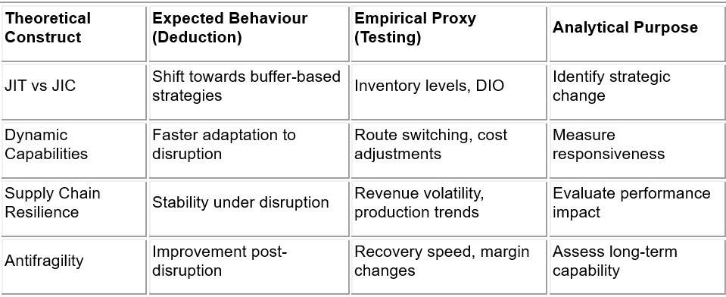
(Source: Synthesised from Ismail et al. 2025, Wu et al. 2024, and Preuss et al. 2024)

By bridging the gap between theory and measurement, this study opens the way for a comprehensive evaluation of the ways in which supply chain strategies change in response to disturbance. This lays the analytical groundwork for the next data collecting phase, when the variables are built and evaluated consistently and comparably.

3.5. Data Collection Methods
Using a structured secondary-data framework, the research expands upon the deductive-explanatory approach previously described and enables longitudinal and cross-firm comparisons. To address RQ1 and RQ2 across many enterprises and disruption stages, secondary data is needed since primary data collection lacks the requisite temporal depth and comparability. To ensure measurement consistency from 2019 to 2024, financial, operational, and macroeconomic data are combined into a single analytical dataset (Ivanov, 2022).
Indicators at the macro level, such as the Global Supply Chain Pressure Index (GSCPI), as well as trade databases based on HS codes and yearly reports, are where the data is culled from. Although these sources make things easier to obtain and replicate, they also have certain structural restrictions, especially when it comes to time granularity. The solution to this problem is to proportionally distribute yearly financial data into monthly observations. While this estimate approach is good at aligning with operational factors like transit time and route interruption, it does include smoothing bias, which makes short-term variations less noticeable. Since maintaining consistency across time is more important than being exact during discrete instances, this compromise is considered acceptable (Lee, Son and Roden, 2023).
Due to the dataset's construction at the firm-month-component level, operational disturbances may be directly connected to financial consequences at the company level.
See Table 3.3 for a breakdown of the important operational variables: transit time, route selection (Suez vs Cape), and import prices. Metrics for revenue and inventory serve as financial surrogates for performance and strategic reaction. The addition of HS codes enhances the dataset's validity by reflecting the real movements of automobile components rather than relying on aggregated trade assumptions. Ismail et al. (2025) note that disruption affects are not uniform but are moderated by supply chain structure and sourcing dependence. Consequently, firm-level risk is explicitly observed.

Table 3.3. Structure of Monthly Import Route Dataset
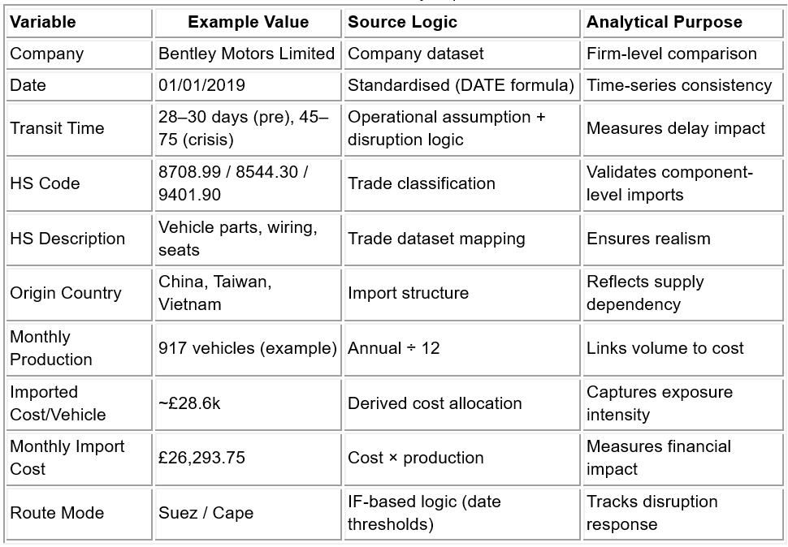
(Source: Synthesised from Ivanov, 2022; Lee, Son and Roden, 2023; and Wu et al., 2024)

Crucially, the approach gives more weight to volume-driven cost prediction by examining the correlation between imported cost per vehicle and production levels, as instead of depending on averages. With this method, researchers can differentiate among companies' levels of exposure to risk, which is especially useful when comparing mass manufacturers with lower production volumes and luxury brands with higher ones. However, it is important to exercise caution when interpreting reported statistics based on secondary data, as they may reflect accounting procedures rather than practical realities.
The data collection approach strikes a good balance between academic methodology and realistic constraints, which ensures that the dataset remains strong enough to support the analytical framework established in the following section.

3.6 Variable Construction & Measurement
This part develops the data collecting approach to transform abstract ideas into measurable variables, ensuring theoretical claims and empirical tests match. All variables are built using observable proxies since the research uses secondary data, which adds analytical structure and restrictions.
Variables are divided into firm-level responses and industry-level pressures for clarity. To avoid attributing external disruptive impacts to internal strategy initiatives, this difference is crucial. Inventory Days (DIO), turnover, income, and cost shock absorption measure organisational adaptability. Using proportional allocation, yearly reports are translated into monthly observations for 2019–2024. This allows longitudinal study pre-, during-, and post-disruption, although smoothing bias reduces short-term variability (Ivanov, 2022). For contrast, financial statistics align to fiscal year ending. This is important for JLR, Nissan, and Toyota, which report from 1 April to 31 March. The core of operational activity (April–December) is consistently represented within the same analysis period by assigning financial outcomes to the finishing year. Bloomberg, Compustat, Orbis, and S&P Capital IQ standardise datasets by fiscal year end to ensure methodological consistency (Bloomberg, 2024; S&P Capital IQ, 2024).

Table 3.4. Selected Companies with Company House Number
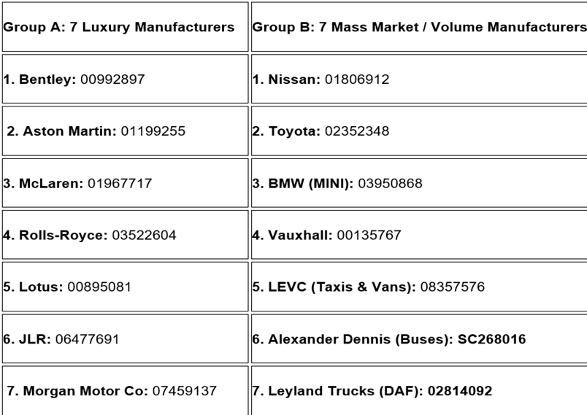
(Source: Created by the author based on the Company House Data 2019-2024)

Operational consistency, data openness, and schedule synchronisation are used to pick 14 businesses. With premium and mass-market manufacturers in the final sample, structural variety is maintained beside comparability. All chosen organisations rely on global shipping routes, especially those impacted by the Red Sea disruption, rendering them vulnerable to transit delays and cost shocks. Including bus and truck manufacturers (Alexander Dennis and Leyland Trucks) expands the JIT–JIC shift beyond passenger vehicles, confirming that it is a sector-wide industrial reaction.
The sampling procedure is transparent, with Appendix 1 listing the excluded businesses and the rationale for their exclusion.
Industry factors explain company behaviour. These include UNCTAD, Marine Traffic, Drewry, UN Comtrade, and HM Revenue & Customs freight rates, maritime activities, and trade flows. These metrics measure disruption severity, route congestion, and global supply chain pressure, creating the basis for firm-level adaptation (UNCTAD, 2024; Marine Traffic, 2024; Drewry, 2024; HMRC, 2024).
Despite the structure, restrictions exist. Proxy-based measurement facilitates complex decision-making, though approximate monthly statistics may obscure instability. Given this, the model allows consistent cross-firm and time-series analysis, which underpins the calculation logic below.

3.6.1. Financial and operational Metrics (Company Level)
Table 3.7 indicates that audited annual reports (balance sheets and income statements) are used to create all variables, ensuring coherence and comparability across organisations. While ensuring measurement transparency, this meets secondary-data dissertation methodological requirements. All supporting company and trade evidence is provided in APPENDIX 2, showing that both mass-market and luxury UK automotive manufacturers rely on Asia–Europe shipping routes for critical components, exposing them to transit delays and cost shocks during disruption.
In APPENDIX 2, the original Excel dataset includes full company financials, calculated operational metrics, global and industry indicators, monthly import route data with HS codes, quantities, and component-level detail, supporting calculations, and a consolidated fact table for Power BI modelling and RQ3 analysis
Metrics are chosen to convert theories into behaviour. JIT–JIC transition (RQ1) is operationalised via inventory turnover and DIO, turning supply chain theory into firm-level choices. Working capital days highlights the efficiency–resilience trade-off (RQ2), revealing whether companies adapt via liquidity pressure or operational change.
Revenue and inventory growth add dynamic layers. For explanatory analysis, they measure response speed and direction instead of static levels.

Table 3.5. Company Operational Metric Construction and Measurement Framework
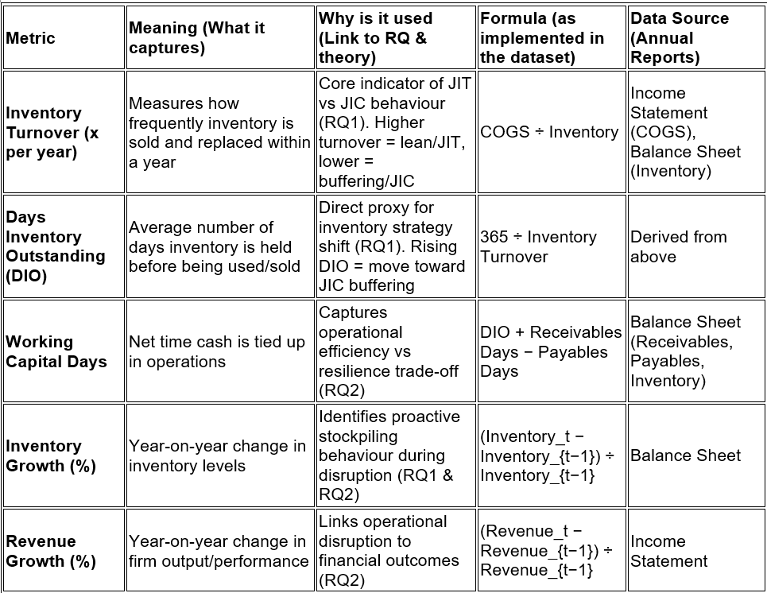
(Source: Created by the author based on the Company's annual reports Data 2019-2024)

The “abnormal” results are typical behaviour of ratio-based measures under uneven company size and disruption. Data shows this. Rolls-Royce's DIO of 36,655 days (2019) may seem high, but it reflects low COGS relative to high-value inventory in low-volume manufacturing. Morgan Motor Company estimates inventory increase of 357.02% (2022) and revenue growth above 3000% (2020), mostly due to a low prior-year base rather than impulsive operational expansion. The financial structure of Aston Martin relies on supplier credit rather than liquidity problems, with working-capital days reaching -999. Jaguar Land Rover has an inventory increase of over 4500% and revenue growth of above 6100% (2019), with timing implications connected to production recovery cycles.
Disruptions, especially Red Sea delays, alter inventory, production, and revenue recognition due to increased transit durations and precautionary stock stockpiling. Thus, excessive results should be understood as strategic adjustments and supply chain stress rather than statistical anomalies, since interruption events increase variability in operational performance (Christopher & Peck, 2004).

3.6.2. Global Metrics (disruptions)
Figure 3.1 shows how Bentley Motors Limited's firm-level operations translate into measurable disruption exposure, with production declining from 1,097 vehicles in 2023 to 868 vehicles in 2024 and key imported components like ADAS modules (HS Code 9032.89 – electronic control systems for vehicles) coming from China.

Figure 3.1. Bentley Motors Limited's firm-level operational example
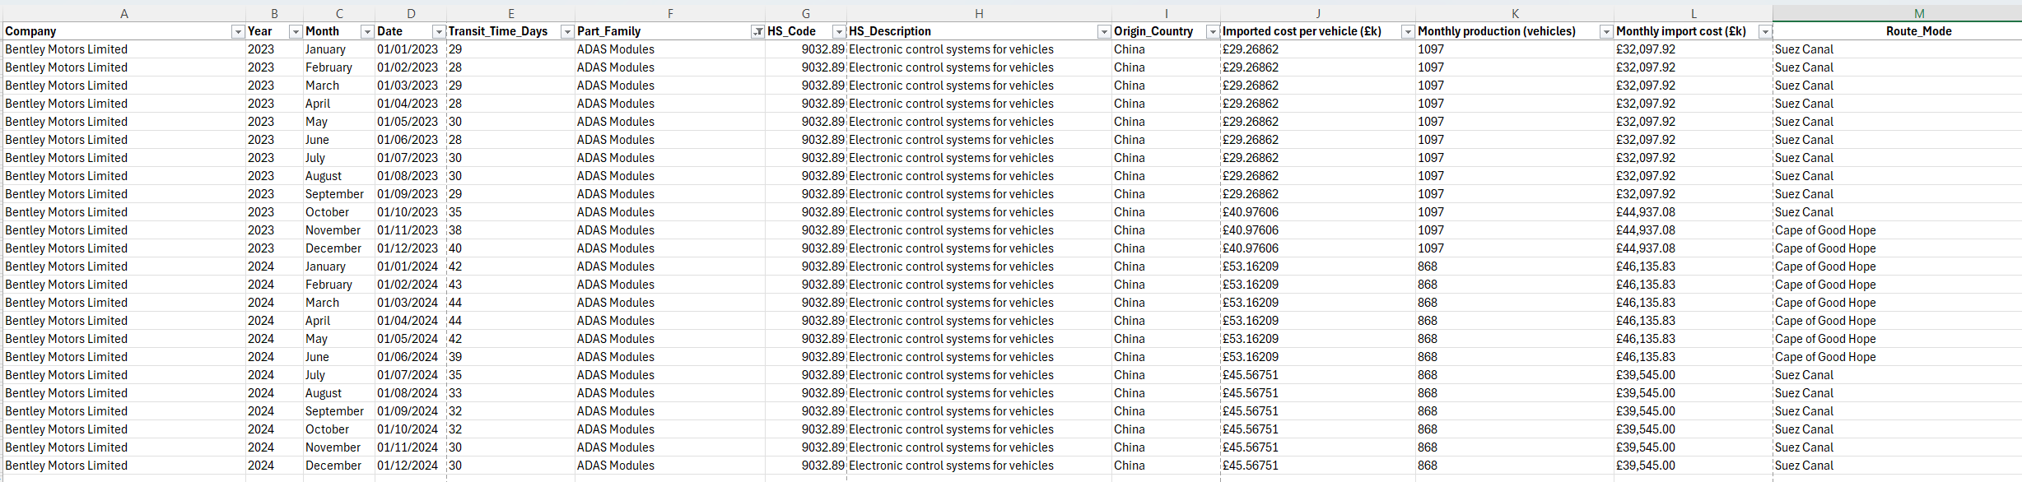
(Source: Created by the author based on the Company's annual reports Data 2019-2024)

Transit durations increased from 29–30 days to 40–44 days during the interruption period, while imported vehicle costs rose from £29.27k to £53.16k, indicating the change in route from Suez Canal to the Cape of Good Hope. Appendix 2 contains the whole dataset for all companies, whereas Table 3.6 clearly describes the calculation logic and analytical significance of each measure, relating raw inputs (columns A–I) to derived indicators (J–L).

Table 3.6. Global Disruption Metrics — Structure, Calculation Logic, and Analytical Role
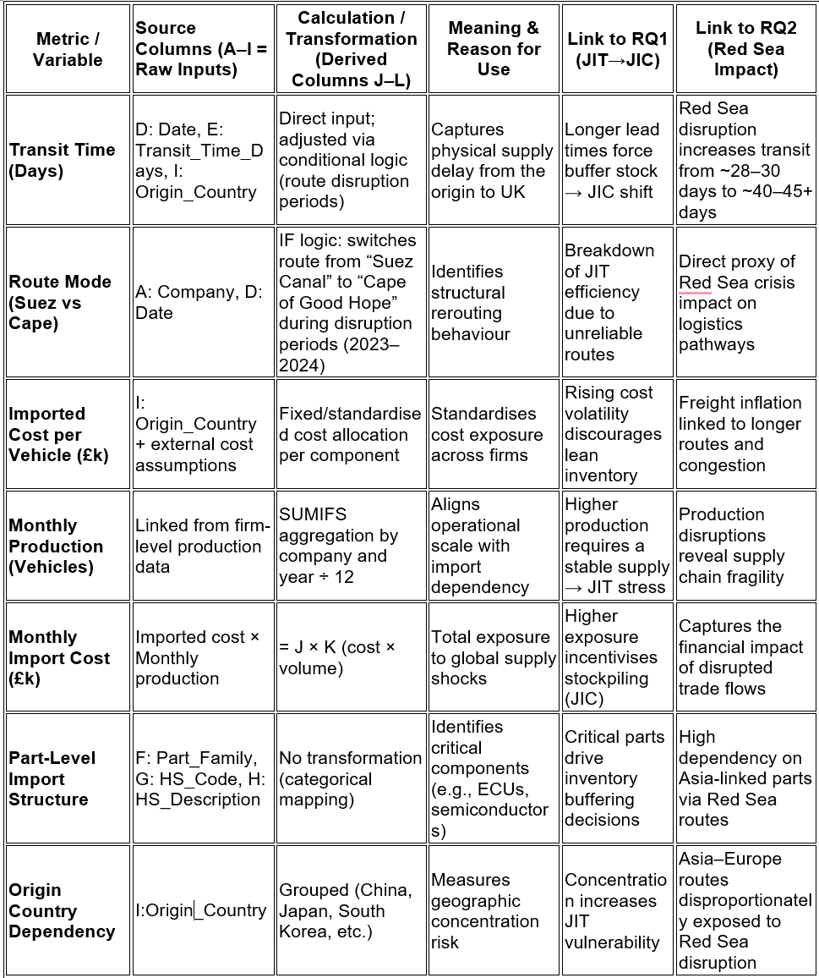
(Source: Created by the author based on the Company's annual reports, Data 2019-2024)

As mentioned above, Columns A–I are the fundamental dataset, gathered from corporate annual reports (financial statements), strategic and ESG disclosures, and external industry sources, including worldwide production statistics and Suez Canal traffic indicators. This aligns with the sampling logic and secondary data architecture, which interpret firm-level activity in the context of global shipping dependency and Red Sea exposure disruption. Cross-source consistency and avoiding corporate narratives are achieved by combining business disclosures with externally evaluated trade and logistics data.
The important analytical layer of this dataset is the formulas, which verify, normalise, and stress-test the data against real-world disruption situations. The model actively corrects discrepancies and reconstructs operational reality using conditional logic, aggregation functions, and cost–volume scaling. Calculations are the most valuable part of the framework because they turn raw inputs into causally interpretable metrics, ensuring that any identified patterns—such as increased transit times, rerouting, or cost inflation—are empirically verified and directly linked to the Red Sea disruption and supply chain unstable conditions.

3.6.3. Additional metrics and RQ3 key indicators explanation
How disruption spreads from the Red Sea shock into company conduct is explained by a framework illustrated in Table 3.7 below, which integrates cost, routing, inventory, and macro stress indicators (see Appendix 2 for a full explanation).

Table 3.7. Formula Logic, Analytical Role, and Research Linkage
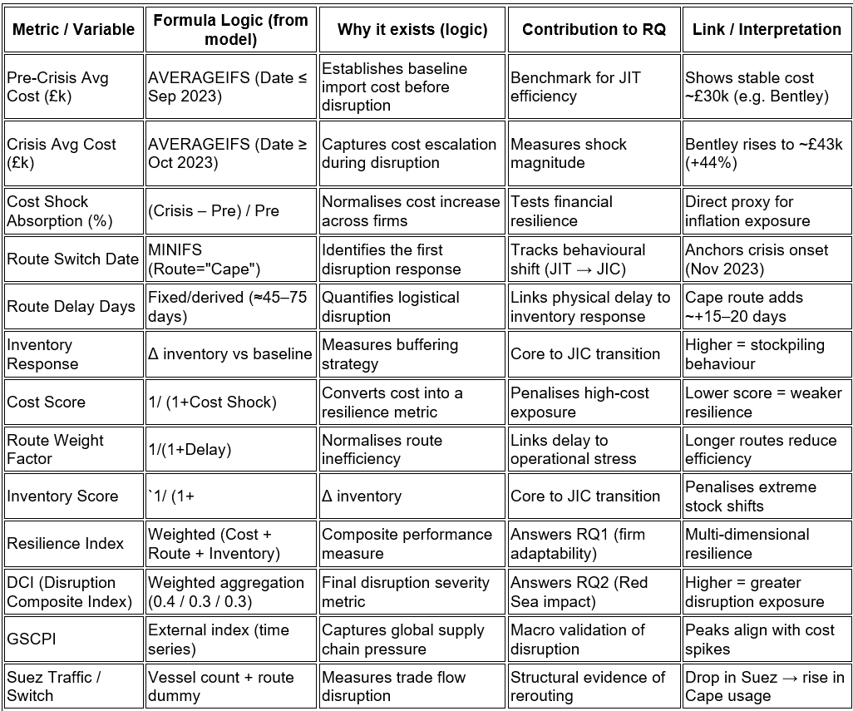
(Source: Created by the author based on the Company's annual reports, Data 2019-2024)

The fundamental calculation yields a cost-shock absorption of around 44% when pre-crisis benchmarks (for example, £30,027 per car for Bentley Motors Limited) are compared with crisis-period averages (~£43,259). Not only is this a terrible figure for the finance team, but it also becomes a formulaic input for resilience reasoning. Concurrently, the model accounts for structural change by changing routes; the first modification to the Cape of Good Hope will occur in November 2023, which would increase transit delays from about 45 to over 75 days.
Firms move from JIT efficiency to JIC resilience via inventory reaction, a behavioural adaptation characterised by buffer expansion. The Global Supply Chain Pressure Index (GSCPI) is a macro indicator that measures systemic stress and correlates with observable cost spikes and delays; it is used to confirm these micro-adjustments. By combining inventory, delay, and cost into a quantifiable measure of disruption exposure, the two resulting composite indices—the Resilience Index and the DCI—directly address operational adaptability and systemic vulnerability (Federal Reserve Bank of New York, 2023).
This structured output is quick to integrate into the Power BI model, where the fact table dynamically visualises disruption effects, route adjustments, and cost exposures across businesses and time.

3.7. Data Analysis & Tools (Power BI + SQL Logic)
With the objective to answer RQ1–RQ3 at the system level, this research uses a secondary data technique that integrates datasets at the company level, logistics level, and macroeconomic level. Power BI goes beyond simple visualisation to model interactions across enterprises and time. It allows factors like disruption, inventory, and cost to interact dynamically (Microsoft, 2024). Ensuring aggregation consistency, a central fact table is connected to the firm and time dimensions using a star schema (Microsoft, 2023).
By monitoring the transition from JIT to JIC, time-series analysis answers RQ1. Figure 3.2 shows that inventory buffers grow for all companies.

Figure 3.2. Inventory Buffer Expansion (line chart)
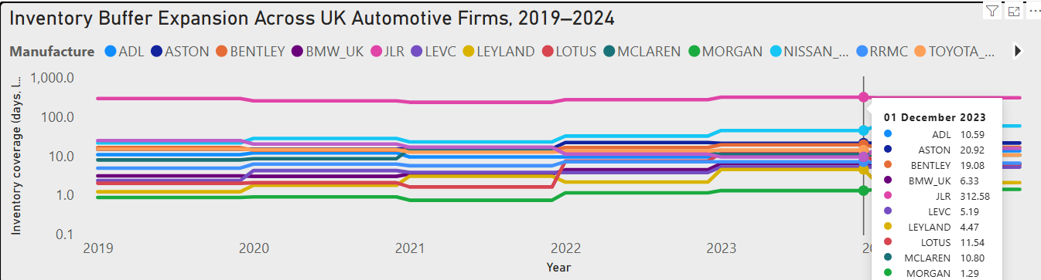
(Source: Created by the author based on the Company's annual reports, Data 2019-2024)

However, the variance of smaller companies would be compressed owing to Jaguar Land Rover's very large inventory levels; the y-axis is shown on a logarithmic scale. Despite this change, most companies still grow from about 1 to 5 days to around 10 to 20 days, while JLR remains above 100 days, suggesting a long-term change rather than a short-term one.
Figure 3.3 shows that there is a positive but not uniform association between GSCPI (≈ -1 to >3) and import costs (~£50k-£150k) for RQ2.

Figure 3.3. Firm-Level Import Cost vs GSCPI
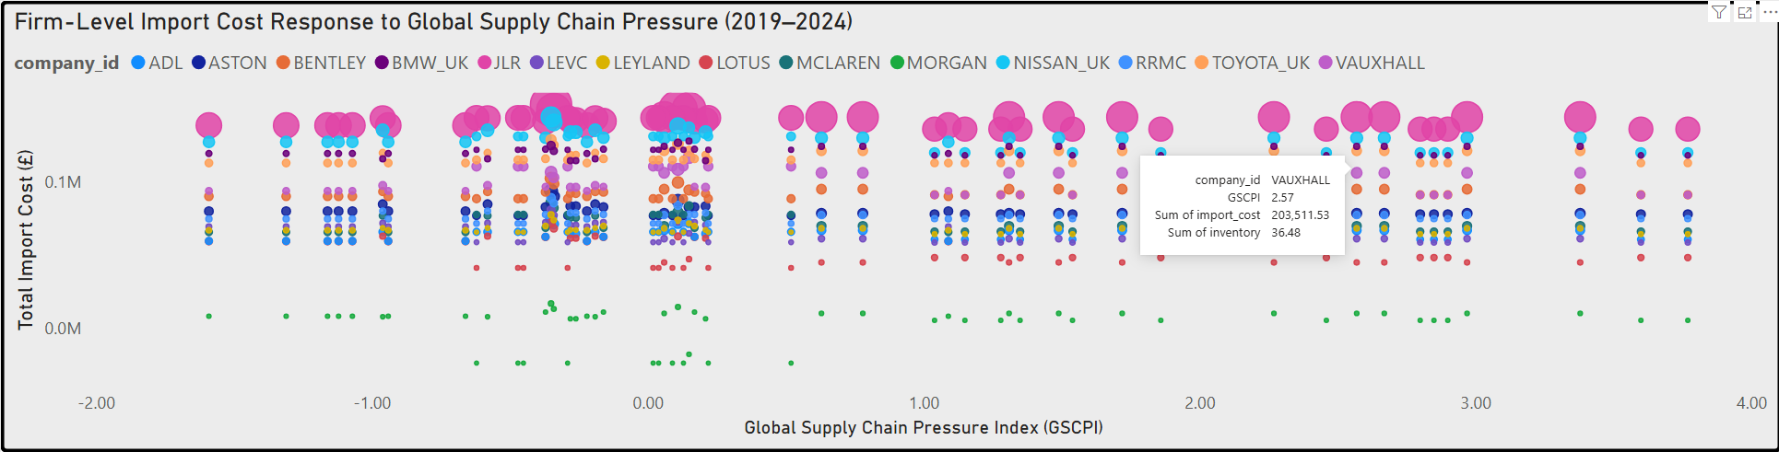
(Source: Created by the author based on the Company's annual reports, Data 2019-2024)

The dispersion indicates that enterprises are not equally exposed to global pressure; rather, vulnerability is influenced by factors such as size, sourcing tactics, and product sector. Larger companies may absorb certain shocks rather than fully passing them on, as their absolute expenses are larger, but their sensitivity is not comparable.
Changes to the routing protocol cause operational disruption. In Figure 3.4, one can see that the transit periods increase from around 30 to 35 days to 40 to 45 days after the Cape change.

Figure 3.4. (Pre/Post Disruption) Transit Time by Route Mode (Suez vs Cape)
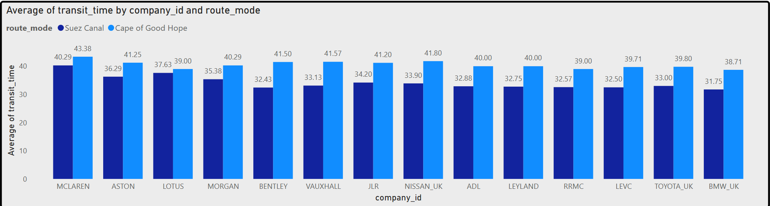
(Source: Created by the author based on the Company's annual reports, Data 2019-2024)

The fact that delays may be explained in part by operational flexibility and supplier networks, but that rerouting is not the only factor influencing results, is shown by variety
between organisations.
SQL logic assures relational integrity, whereas DAX measurements quantify these dynamics.
While analytically strong, these methodological choices nevertheless include assumptions and possible biases that are rigorously analysed in the next section on ethical issues.

3.8. Ethical Considerations
No sensitive or personally identifiable information is collected for this research, as it relies solely on publicly accessible secondary data. But accessibility doesn't mean we can ignore ethical responsibilities; being upfront about how we choose, handle, and interpret data remains crucial. The use of derived indicators, including inventory response and cost shock absorption, may lead to interpretive bias unless methodologies are well-defined and reproducible.
Obligatory data management, critical interpretation, and understanding of dataset constraints are ethical practices in secondary research, according to Tripathy (2013). To account for the possibility of reporting errors, chronological misalignment, and institutional bias in secondary sources, the results are presented as interpretations grounded in evidence rather than as absolute assertions.

3.8 Methodological Limitations
Even if the analytical approach is well-organised, there are still certain methodological limits. First, the study relies heavily on secondary data, particularly commercial disclosures, which differ in terms of reporting requirements, timeliness, and strategic emphasis. When companies report selectively or with different quantities of information, it makes the data inconsistent and hard to compare. Saunders et al. (2019) assert that secondary data is influenced by its original intent and may fail to fulfil subsequent analytical objectives.
Using a proxy adds another restriction. Days Inventory Outstanding (DIO) and other indicators are good for getting a general idea of inventory strategy, but they don't show how complicated operational decisions might be. It may be hard to figure out the strategic objective of inventory levels since they might be due to cautious buffering, changes in demand, or accounting practices. Cost-based measures could show changes in prices outside of the company instead of how well it can handle them.
Identification is another limitation. The study focuses on the suspension of the Red Sea crisis, but not all changes in travel time, cost, or route habits can be ascribed to it. Other macroeconomic factors, geopolitical occurrences, and firm-specific strategies may also influence outcomes, complicating causal interpretation.
Using macro indicators, operational data, and financial proxies to triangulate makes the study less reliant on any one parameter. This enhances analytical robustness, even while it does not eliminate bias.
When analysing data and drawing conclusions, it is important to keep these limitations in mind so that the results are based on the specific situation and not on broad generalisations.

3.9 Conclusion
Based on this research, UK automotive companies have been moving away from JIT and toward hybrid JIT-JIC strategies from 2019 to 2024. This change has been driven by long-term disruptions instead of short-term shocks. Rather than being a result of cyclical variation, the time-series data suggests that inventory buffers have been increasing from around 1–5 days to 10–20 days for most enterprises (Figure 3.1). However, there are a few outliers, such as JLR, whose buffers surpass 100 days on a logarithmic scale. Figure 3.2 shows that there is an unequal cost response to supply chain pressure, with bigger businesses being able to absorb shocks more efficiently while having higher absolute costs. Figure 3.3, which compares the situation before and after the interruption, shows that transit durations rose from about 30 to more than 40 days, supporting the operational drivers of buffering.
Ultimately, resilience is not a fixed capacity but rather a trait shaped by both strong structure and severe exposure. Consistent multi-level analysis is enabled by Power BI and SQL modelling, but results are still affected by proxy decisions and limitations in secondary data.
The next chapter provides a comprehensive overview of the company's actions, outcomes, and resilience practices.

Chapter 4: FINDINGS / RESULTS, ANALYSIS AND DISCUSSION (5919 words)

4.1 Introduction
The chapter focuses on the methods by which UK automotive manufacturers adapted their inventories, cost structures, and operational strategies in response to supply chain disruptions. Responding to RQ1, it examines the transition from JIT to hybrid JIT-JIC, as evidenced by inventory increases of up to 17.9% and differences in buffering intensity at the business level. The second research question examines the effects on finances and operations and finds that import prices may rise (by as much as £13.7m) and shipping times may lengthen (by as much as 42.6 days), with different companies bearing different costs. In respect of RQ3, it evaluates the impact of digital capacity on resilience, finding that higher resilience outcomes (0.40-0.65) are associated with higher DCI scores (0.12-0.44), contingent on efficient cost and inventory management.
Interactions among inventory, cost absorption, and digitally enhanced operational capabilities, rather than buffering alone, are what produce resilience, as this chapter reflects.

4.2 Empirical Analysis of Supply Chain Adaptation
To analyse how businesses adjusted their supply chain approaches in the face of disruption, Section 4.2 presents empirical data categorised according to the research questions.

4.2.1 RQ1: How did firms shift from JIT toward JIC?
Building on the methodological framework established in Chapter 3, the analysis of inventory behaviour reveals that the transition from JIT to JIC is not a discrete strategic switch but a gradual and uneven recalibration. Rather than replacing lean systems, firms embed buffering selectively in response to sustained disruption.
The findings indicate that inventory coverage increased across all sampled firms between 2019 and 2024; however, the significance lies not in the rise itself, but in its persistence and distribution. For instance, firms such as Lotus increased from 1.99 to 6.24 days, while Nissan reached 57.67 days, and Aston Martin rose from 14.59 to 21.21 days. This suggests that buffering is not random accumulation but a deliberate response to uncertainty. Crucially, firms with initially lower inventory levels exhibit proportionally larger increases, implying that vulnerability, rather than size, drives adaptation.
However, this pattern complicates the assumption of a uniform shift toward JIC. Instead, heterogeneity indicates a trade-off between efficiency and resilience, where luxury manufacturers sustain structurally higher buffers, while volume producers adjust more cautiously. This supports the argument that JIT discipline is not abandoned but modified through hybrid strategies (Ivanov and Dolgui, 2021; Belhadi et al., 2021).
Furthermore, temporal clustering of changes during 2020–2023 suggests that disruptions act as cumulative triggers rather than isolated shocks. Consequently, buffering reflects adaptive learning rather than short-term reaction (Ivanov, 2022). Moreover, firms with lower starting inventory levels increased buffering the most, a pattern further examined through Table 4.1 and Figure 4.1, which assess whether inventory expansion is accompanied by logistics adaptation, particularly route diversification during the Red Sea disruption.
This variation directs the analysis toward operational responses, where route diversification and disruption exposure are examined in the following section.

4.2.2. Route Diversification as Behavioural Evidence of Strategic JIC Adaptation
The results suggest inventory buffering is the structural signal of hybrid JIT-JIC adaption. Figure 4.1 and Table 4.1 show that logistics redesign during the Red Sea blockage caused a behavioural resilience response. This is analytically significant since it extends just-in-case adaptation beyond inventory stockholding and suggests supply chain flow-dependent routing selections for JIC. Route diversification seems to have been a deliberate resilience strategy rather than a reactive response to operational disruption, supporting dynamic capabilities views that prioritise reconfiguration over static redundancy.

Figure 4.1. Route Diversification During the Red Sea Disruption
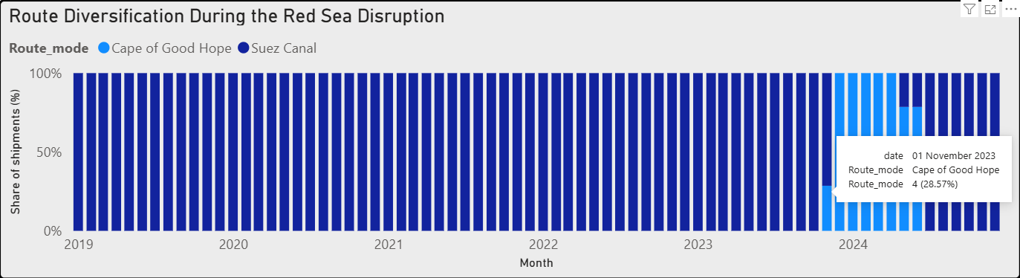
(Source: Author’s analysis based on UNCTAD and MarineTraffic data)

Logistics strategies relied heavily on the Suez Canal until the latter half of 2023, when they quickly moved to the Cape of Good Hope, as seen in Figure 4.1. In 2023, the Cape route will handle 28.57% of exports, and that number will rise in 2024. It seems that businesses made deliberate changes to their route systems during interruptions, based on this tendency.
Every shift is unique. Table 4.1 shows the timing and intensity of adoption for each business, while the aggregate trend indicates rerouting. This points to cost sensitivity or supplier networks as firm-specific constraints instead of a generic answer.
Rather than replacing inventory buffering, route diversification works in tandem with it. Rerouting, in contrast to buffering, allows the network to adjust and externalise risk. According to Ivanov and Dolgui (2021), this provides credibility to the idea that JIC reflects in operational dimensions that go beyond inventory.
The results raise the question of how businesses translate these changes into financial success, suggesting that resilience depends on logistics and inventory decisions.

Table 4.1 Timing of Strategic Route Diversion by Manufacturer
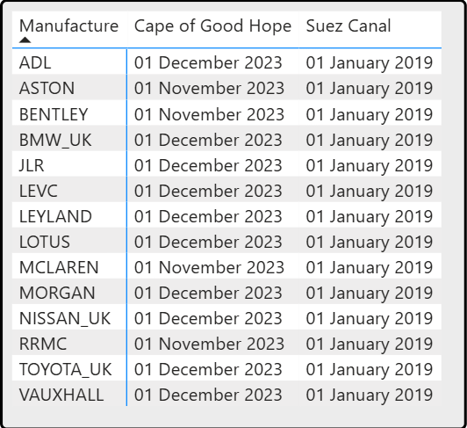
(Source: Author’s analysis based on UNCTAD and MarineTraffic data)

Despite the apparent synchronisation, which covers strategic variance, most enterprises moved from Suez to Cape routing within a small window (November-December 2023), as seen in Table 4.1. Aston Martin and Bentley were among the first to reroute in November, but others didn't do so until December. This might be because they have varying degrees of comfort with potential disruptions and costs. This lag in time shows that route switching was reflective of decision thresholds particular to firms rather than being a reactive action.
Most importantly, the proof expands JIC's scope to include logistical configuration in addition to inventory. According to Figure 4.1, resilience is not only built into networks via stockholding but also through their flexibility, lending credence to the idea that adaptation happens through selected redundancy (Belhadi et al., 2021; Ivanov, 2022). But there are costs and benefits to rerouting, and it increases transit times and makes costs more unpredictable.
In other words, route diversification is a behavioural aspect of JIC; the next part will examine how these operational modifications lead to financial consequences.

4.2.3 Transit Time Inflation and the Cost of Resilience Adaptation
Section 4.2.2 examined route diversity. The next analytical research continues to be whether strategic routing adaptation maintains continuity or creates operational losses. Transport time inflation resilience costs are listed in Figure 4.2. Figure 4.3 examines if rerouting delays, costs, and affects performance.

Figure 4.2. Transit Time Inflation During Crisis-Driven Route Switching
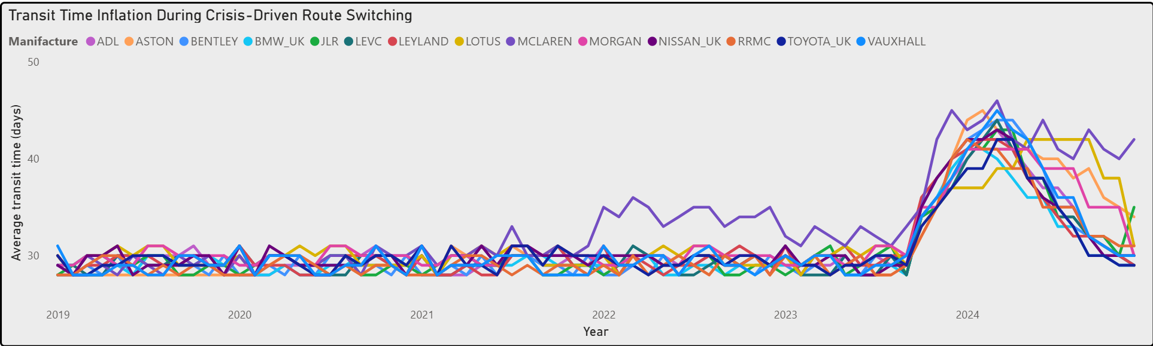
(Source: Author’s analysis based on UNCTAD and MarineTraffic data)

By connecting route diversity to transit-time inflation, Figure 4.2 highlights the operational repercussions of the JIT-JIC shift. As a result of highly optimised JIT scheduling, transit performance stays consistent between 2019 and mid-2023 at 28-31 days. Nevertheless, this balance is disrupted after the Red Sea incident, and by early 2024, lead times had increased by 35-55%, reaching 40-46 days. Rerouting had no effect on efficiency and instead caused immediate operating costs due to the suddenness of the change.
The distribution of effects shows significant diversity at the business level. One of the most consistent increases is observed in McLaren, which rises from 30 to 46 days and remains elevated beyond 40 days, indicating sustained exposure rather than a transient disturbance. Even luxury manufacturers like Aston Martin and Bentley, which have larger reserves of resources, were not immune to routing limitations; their respective times of 45 and 44 days show this. The idea that size or financial power can improve resilience on their own is cast into doubt by this.
On the other hand, recovery trajectories of mass-market enterprises are more dynamic. Late 2024 sees Toyota UK and Vauxhall's return from 42-45 days to 29-30 days, which is close to pre-crisis levels, suggesting greater capacities for downstream adjustment. Lean-oriented businesses are not immune to disturbances; in fact, they absorb them through schedule volatility, as Nissan's surge to 42 days shows.
JLR follows a clear trend, increasing from 33 to 35 days in 2022 and 2023 to 43 days in 2024. This indicates that some companies internalised disruption risk before a systemic breakdown occurred, suggesting that adaptation was more proactive than reactive.
The visualisation shows an important structural trade-off: longer, more unpredictable lead times are the price to pay for route variety, which ensures continuity. Adaptation necessitates a regulated sacrifice of efficiency, which aligns with the lean-resilience dilemma (Ivanov and Dolgui, 2021; Nikookar, Gligor and Russo, 2024). Uneven recovery trajectories, however, show that resilience is not universally accomplished but rather depends on firm-specific characteristics (Tortorella et al., 2022).
Figure 4.2 shows the cost component of resilience, but it also begs the more fundamental issue of whether operational penalties caused structural inventory changes, which would lead us back to the hybrid JIT-JIC transition tested in RQ1.

4.2.4 Crisis-Period Inventory Growth and Evidence of Hybrid JIT–JIC Transition
While image 4.3 sets out the cost of resilience via lead-time inflation, the next one 4.3 switches the study to structural reaction by evaluating inventory reconfiguration across crisis phases.

Figure 4.3. Cross-Firm Contribution to Cumulative Inventory Holdings Across Crisis Phases
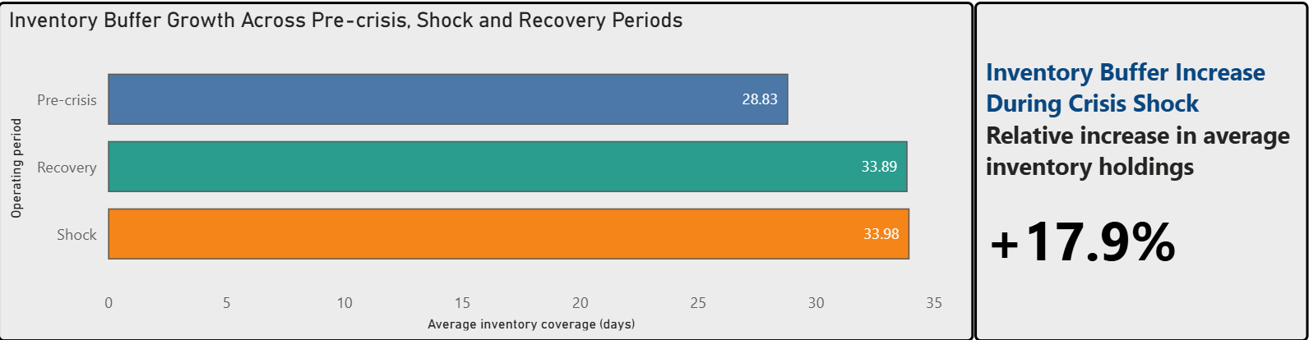
(Source: Author’s analysis based on UNCTAD and MarineTraffic data)

Average inventory coverage rises from 28.83 days pre-crisis to 33.98 during disruption (+17.9%) and remains elevated at 33.89 days in recovery. The key insight is persistence rather than magnitude: inventory does not revert, indicating strategic buffering rather than temporary stockpiling.
This stability between shock and recovery challenges the assumption of reactive behaviour. If firms had overstocked defensively, post-crisis levels would normalise. Instead, near-identical values suggest selective redundancy embedded into operations. This supports the argument that disruption triggered adaptive hybridisation, where JIT systems are recalibrated through controlled JIC mechanisms rather than replaced (Spieske and Birkel, 2021; Queiroz, Pereira, Telles and Machado, 2021).
However, aggregate averages conceal firm-level variation. The +17.9% increase signals systemic adjustment but not uniform contribution, raising the question of whether resilience is evenly distributed or structurally dependent.
Therefore, the analysis moves beyond whether inventory increased to how firms contributed to that increase, linking directly to cross-firm differences explored in the next section.

4.2.5 Cross-Firm Contribution to Cumulative Inventory Holdings and Strategic Contingency
Figure 4.4. explores whether hybrid JIT-JIC adaptation was widespread across firms. Section 4.2.4 shows that inventory buffering increased during crises. Mean inventory holdings indicate that adaptation was both dependent and differentiated. In Figure 4.4, JLR had the largest average inventory stocks, expanding from 268.81 days pre-crisis to 306.73 during the shock period and 302.33 in recovery, showing purposeful buffering rather than crisis excess. This is important because JLR prioritises resilience over concern.

Figure 4.4. Cross-Firm Contribution to Cumulative Inventory Holdings Across Crisis Phases
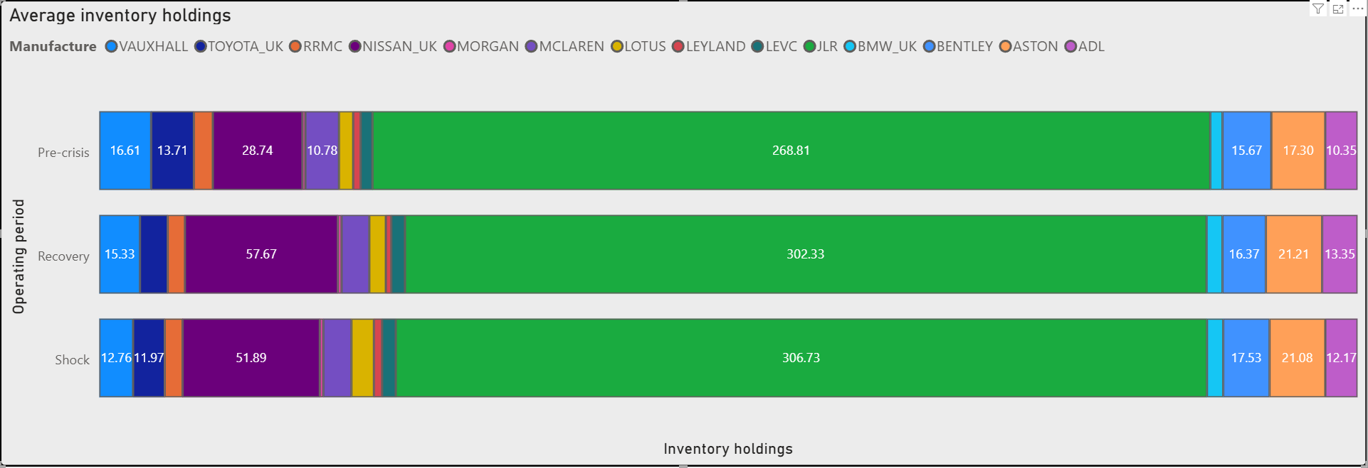
(Source: Author’s analysis based on Companies House filings and official company annual reports)

The data shows that companies aren't all using the same hybrid JIT-JIC strategy. A dramatic change is seen in Nissan, which went from 28.74 before the crisis to 51.89 during the interruption and 57.67 after recovery, indicating a firm dedication to buffering. Moderate modifications, as shown in Aston Martin (17.30 to 21.08) and Bentley (15.67 to 17.53), indicate managed rather than forceful adaptation.
Vauxhall fell from 16.61 to 12.76 and Toyota UK from 13.71 to 11.97, showing that certain volume manufacturers selectively retain lean concepts by reducing inventory exposure. These differences show that adaptation is not a one-size-fits-all process but rather depends on factors such as exposure, cost structures, and business strategies.
These patterns provide a serious challenge to the idea that JIC is synonymous with massive hoarding. Spieske et al. (2023) and Nikookar, Yanadori, and Wieland (2022) found the opposite; they argue that operational context shapes firm-specific resilience reconfiguration.
Figure 4.4 demonstrates that inventory adaptation is differentiated, which supports the idea that strategic positioning, not a sector-wide change, is needed to adopt hybrid JIT-JIC.

4.2.6 Implications for JIT–JIC Theory
Figures 4.1–4.4 collectively demonstrate that JIC does not represent a simple shift toward inventory hoarding but a structured reconfiguration of JIT systems. Rather than ignoring lean arguments, firms selectively embedded buffering, route diversification, and lead-time absorption in response to disruption. This indicates that adaptation is conditional rather than universal and varies with exposure and operational capacity.
The evidence challenges static interpretations of resilience. JLR’s persistently high buffers, Nissan’s sharp inventory expansion, and the more constrained adjustments of Toyota, Bentley, and Aston Martin reveal that buffering is strategically calibrated rather than uniformly applied. Thus, resilience emerges as a capability-based response rather than a standardised outcome. This aligns with capability-enhancement perspectives, where firms reconfigure operations to maintain functionality under stress (Ralston and Blackhurst, 2020).
Moreover, route switching and lead-time inflation show that resilience involves trade-offs, not efficiency-neutral adjustments. Hybrid JIT–JIC systems therefore operate through selective redundancy embedded within lean structures.
Overall, the findings suggest that JIT is not replaced but re-engineered through targeted JIC mechanisms. This reframes the theory from a binary substitution to an adaptive integration, and leads directly to RQ2, where the financial and operational consequences of these adjustments are examined.

4.3. RQ2 Financial and operational impacts of Red Sea crisis
After RQ1 showed how businesses changed their operations through hybrid JIT-JIC reactions, RQ2 examines the financial and operational effects under systemic disruption.

4.3.1 Macro Disruption Evidence: Crisis Transmission Mechanisms
Figure 4.5 shows the escalation of transit times and global supply chain pressure (GSCPI) from 2019 to 2024, which is a strong indication of this diffusion.

Figure 4.5 Global Supply Chain Pressure and Transit Time Escalation (2019–2024)
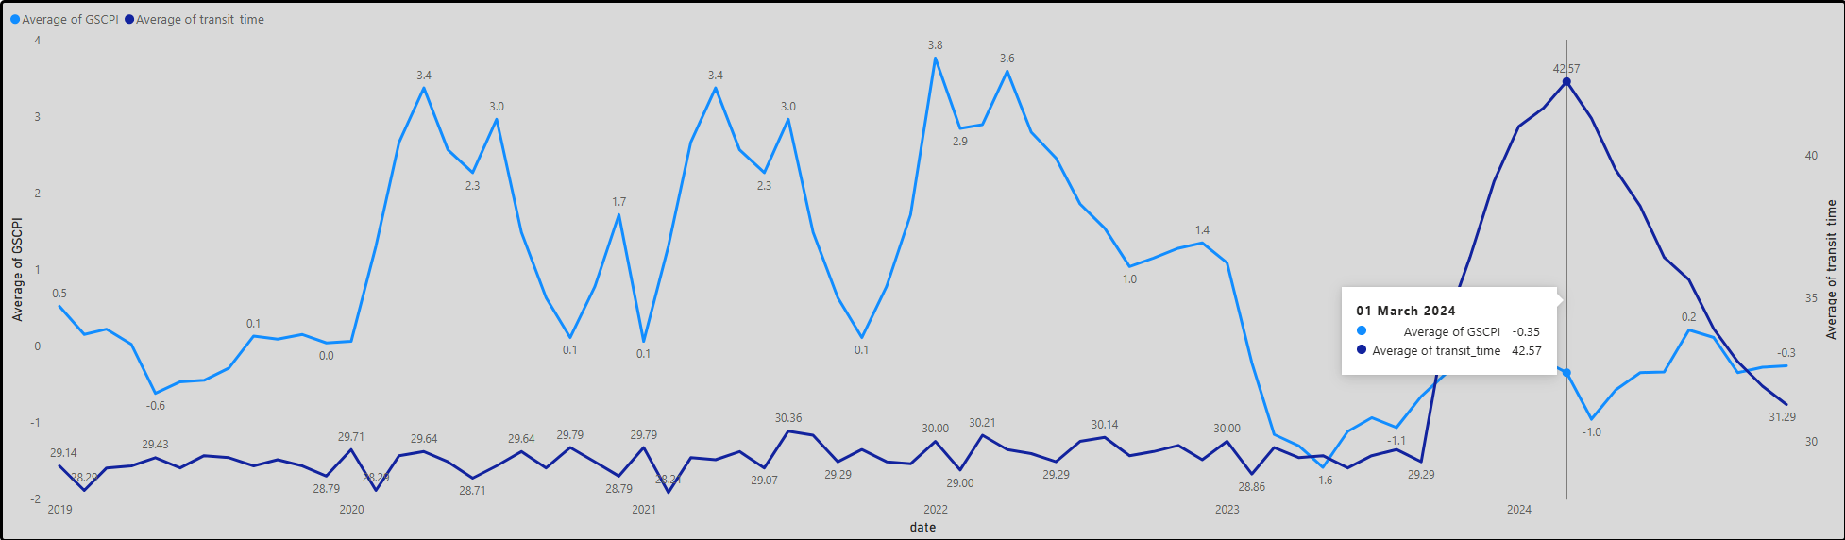
(Source: Author’s visualisation based on Federal Reserve Bank of New York GSCPI data and firm transit-time records)

Expanding on RQ1, Figure 4.5 shows that disruption spreads systematically instead of locally. In April 2020, GSCP hits a high of 3.38, followed by 3.77 in January 2022, and 3.60 in April 2022. However, by March 2024, when the transit time exceeds 42.57 days, up from about 29 days before the crisis, it drops to -0.35. Importantly, disruption increases even as traditional pressure indicators fall. Dislocated flows due to rerouting, congestion, and network strain are reflected by the negative GSCP, which does not signify recovery.
Figure 4.6, the Suez Traffic Collapse as a Result of the Red Sea Crisis, provides more evidence of this process. From 32,830 in October 2023 to 15,610 in March 2024, vessel movements decreased, and transit durations peaked at the same time, before settling around 14,000 to 15,000 in late 2024. According to Herberger, Wieland, and Hochstrasser (2024), this proves that disruptions are not fixed but rather transferred to other lines. Consequently, operational costs and performance consequences stem from the need to understand firm-level performance as a response to systemic transmission channels.

Figure 4.6. Suez Traffic Collapse During Red Sea Disruption
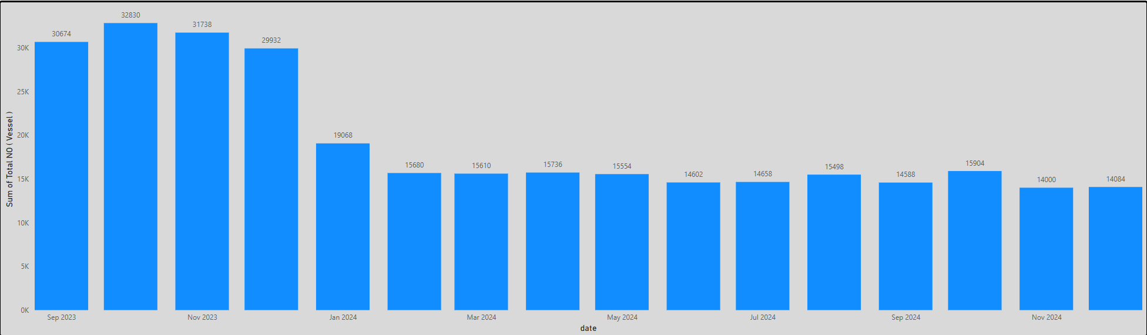
(Source: Author’s visualisation based on Suez Canal Authority vessel traffic data)

The correlation between increasing transit times and falling Suez throughput is shown in Figure 4.6. Congestion and forced rerouting, not demand shocks, cause disruption, since peak delays coincide with vessel movements falling by over 50%. Reducing marine capacity directly leads to lead-time inflation, according to Xu et al. (2020) and Huang, Ghadge and Yates (2024).
Moreover, the pattern indicates that the whole network has been disrupted, not just a single route. System reconfiguration, not individual bottlenecks, is the mechanism by which disruption propagates. Consequently, these macro pressures are best understood as systemic limits; the next part delves into this concept by examining their effects on firm-level finances and operations.

4.3.2 Cost Impact Findings and Shock Absorption Responses
Logistics network interruptions affected firm-level cost exposure and shock absorption. Crisis doesn't always stop at delays; thus, they charge.
This is seen in Figure 4.7 Global Supply Chain Pressure and Import Cost Exposure. The GSCPI dropped to -0.96 in April 2024, and enterprises' average import cost was £1,617,824, one of the highest.

Figure 4.7. Global Supply Chain Pressure and Import Cost Response
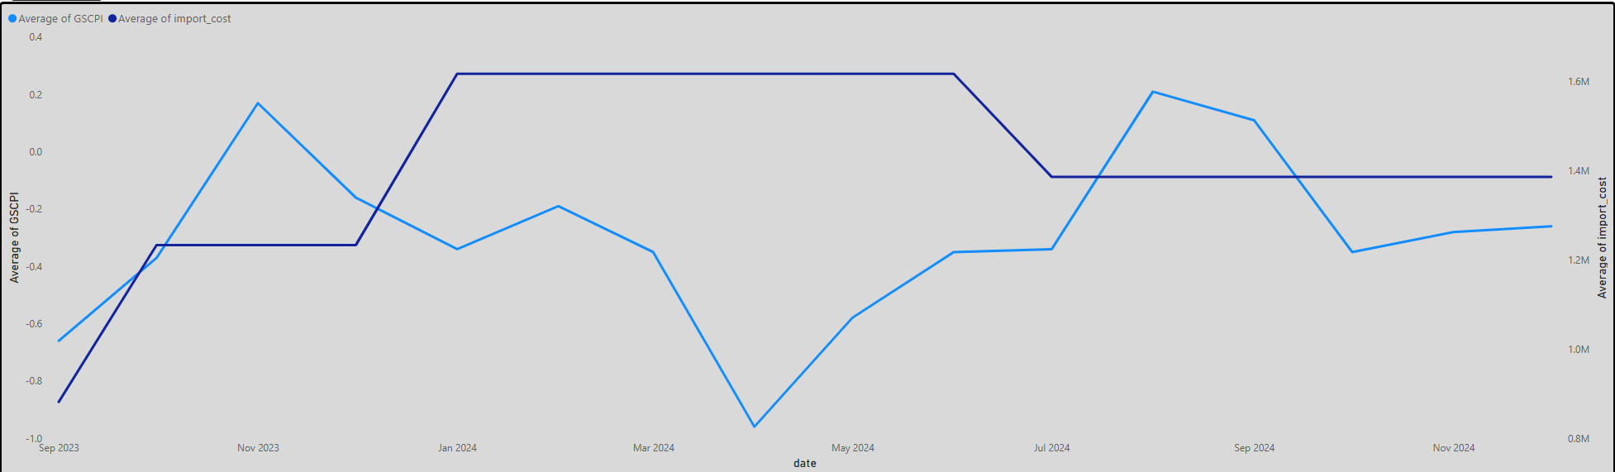
(Source: Author’s calculations based on GSCPI and firm import cost data)
Sustained cost transmission via rerouting, insurance, and keeping lead times, rather than transient pressure, is shown by the fact that import costs stay excessive despite GSCP changes (Gurtu and Johny, 2021; Xu et al., 2020). Cost absorption and pass-through differ by capacity, as shown in the firm-level evidence (Section 3) (Hughes et al., 2022). Figure 4.8 provides further clarity on this inconsistent adjustment by showing how these diverse shock absorption techniques are reflected in the unit-level cost structures.

Figure 4.8. Cost per Unit Response under Supply Chain Pressure
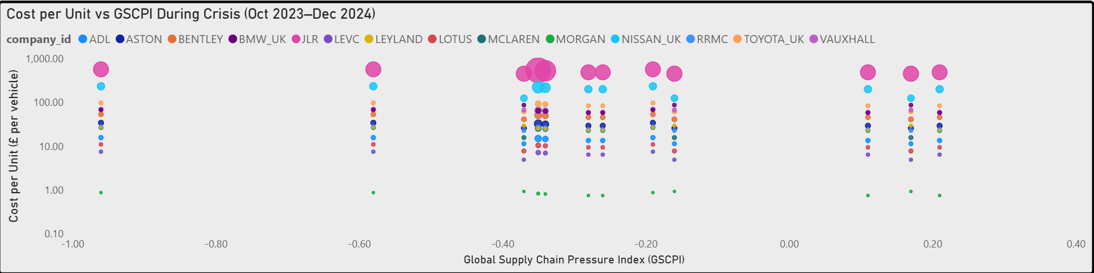
(Source: Author’s calculations based on firm cost-per-unit data)

Rather than being linearly related to GSCP, cost responses differ essentially between enterprises (as seen in Figure 4.8). As an example, at GSCP = 0.11, Nissan UK reports unit costs of £199.47 and an inventory of 57.67 days, whereas LEVC with GSCP ≈ 0.21 reports just £6.40 per unit and an inventory of 5.15 days. On the other hand, JLR always operates in a somewhat higher price range (£500-£700), which further solidifies its position as an outlier and justifies using the logarithmic scale.
This dispersion shows that different inventory strategies, sources, and exposures lead to different costs, even when macro circumstances are the same. It seems that there is some decoupling between pressure and cost transmission, since larger inventory levels are generally correlated with higher cost absorption levels, but this is not always the case. According to Kazancoglu et al. (2023a) and Ju, Hou, and Yang (2021), GSCP does not directly affect cost behaviour; rather, strategic mediation does, allowing for diverse resilience responses.

4.3.3 Inventory–Performance Trade-Offs
Based on the data presented in Section 3, it can be concluded that rerouting had an unequal but consistent effect of increasing transit times across enterprises. McLaren's growth is between 40.29 and 43.38 days (+3.1), whilst more susceptible corporations like Vauxhall (33.13 to 41.57 days) and Bentley (32.43 to 41.50 days) have increases of more than 8 days. This proves that diversifying routes lowers disruption risk but increases time inefficiency due to pressure transfers. Spieske and Birkel (2021) and Ivanov, Dolgui, and Sokolov (2019) highlight the importance of structural exposure and operational flexibility in achieving resilience across different organisations. This highlights the importance of the lean-resilience trade-off. Table 4.2 elaborates on these distinct results by formally evaluating inventory, cost, and transit performance as interrelated resilience adaptation factors.

Table 4.2. Firm-Level Inventory and Import Cost Trade-Off Across Crisis Phases
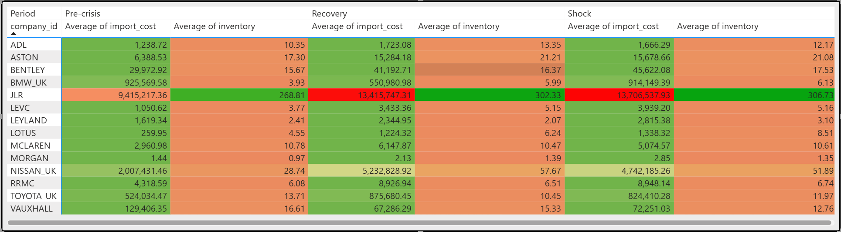
Source: Author’s calculations based on firm-level inventory and import cost data.

Responses to resilience are not consistent but vary widely across companies, as seen in Table 4.2. JLR is a prime example of a company whose import expenditures increased from £9.4m before the crisis to £13.7m during the shock period, and whose inventory grew from 268.81 to 306.73 days, suggesting that they strategically used capital-intensive buffers to ensure continuity. Costs rise from £2.0m to £4.7m, and inventory grows from 28.74 to 51.89 days, indicating coordinated cost absorption and stockholding, in a similar but less dramatic trend for Nissan UK.
But for other companies, this connection isn't as strong. A decrease in inventory from 13.71 to 11.97 days, together with an increase in expenses from £524k to £824k, suggests that Toyota UK is relying on operational flexibility rather than buffering. Despite relatively modest prices (£1.44 to £2.85), Morgan demonstrates little scalability, with inventory shifting just from 0.97 to 1.35 days. This suggests little adaptive capability.
As a result, there is no clear relationship between price increases and stock levels. The data show conditional complementarities between cost exposure and buffering. Companies that are more severely disrupted combine rerouting expenses with inventory expansion, while others choose flexibility over stockholding. This further supports the idea that JIT-JIC adaptation is not based on a universal resilience model but rather on trade-offs that are individual to each organisation (Queiroz et al., 2021; Wieland and Durach, 2021).

4.3.4 Differences in Resilience Outcomes at the Firm Level
According to data collected from individual firms, adaptive mechanisms interacted differentially across transportation, inventory, and cost measures, resulting in inconsistent resilience outcomes. According to Bentley, there was a high-buffer reaction that came at a high cost: the inventory time went from 15.67 to 17.53 days, the import expenses went up from about £30,000 to around £46,000, and the transit time went from 32.43 to 41.50 days due to rerouting, which means that they were exposed to financial and logistical penalties at the same time. While Aston Martin's transit time increased by 36.29 days, from 35.96 to 41.25 days, its import expenses increased by a greater percentage (£6.4k to £15.7k), indicating lower cost absorption despite a mild operational interruption.
McLaren offers a different setup, with steady inventory (10.78 to 10.61 days), minor cost increases (£3.0k to £5.1k), and low transit penalties (40.29 to 43.38 days). This suggests capability-led resilience instead of relying on buffering. These differences show that increasing inventory or costs does not consistently make transportation more stable. Enterprises that combined moderate buffering with limited cost exposure achieved more stable results; however, performance stability was not guaranteed for firms that used severe buffering or cost escalation.
According to Hellaf and Peteraf (2015) and Turner, Aitken and Bozarth (2018), resilience is not just determined by the severity of JICs, but also by the alignment of buffering, routing strategy, and cost management. The consideration of how these distinctions relate to broader capacity development in RQ3 follows directly from the support for dynamic capability views, which hold that outcomes are determined by sensing, reaction time, and resource orchestration (Herberger, Wieland, and Hochstrasser, 2024).

4.3.5. Discussion with Literature and Bridge to RQ3
Results for resilience, according to RQ2, are not caused by a single process but rather by the interplay of inventory, cost exposure, and routing choices. Despite popular belief, the correlation between increased buffering and continuity is conditional. For example, JLR manages to keep operations stable while incurring very high import prices (£13.7m) and extremely long inventory periods (306.73 days), whereas Nissan UK shows less consistent efficiency despite raising expenses to £4.7m and extremely long inventory periods (51.89 days). This discrepancy implies that resilience efficacy is not determined solely by size.
The numbers also show a weak relationship between transit-time inflation and stockpile growth. Companies like Bentley, which faced lengthier rerouting penalties (32.43 to 41.50 days), enhanced their inventory (15.67 to 17.53 days) and raised their expenses (~£30,000 to ~£46,000), suggesting integrated adaptability. Nonetheless, McLaren was able to maintain a consistent level of performance while experiencing little changes in inventory (10.78 to 10.61 days), limited increases in costs (£3.0k to £5.1k), and reduced transit penalties (40.29 to 43.38 days), proving that capacity replacement for buffering was effective.
Consequently, operational flexibility, cost management, and inventory placement are more important than buffering intensity in determining resilience (Spieske et al., 2023). According to Huang et al. (2023) and Rauniyar et al. (2023), company performance is influenced by their capacity to detect and react to disruptions. This lends credence to dynamic capability viewpoints. As a result, JIT is not eliminated but rather selectively rearranged, serving as an analytical link to RQ3.

4.4. RQ3. Industry 4.0 / 5.0 and resilience capability
To what extent does the apparent impact of digital capability intensity depend on underlying operational setups, or does it really enhance resilience? This section provides a critical evaluation of the literature on the topic.

4.4.1 The Relationship Between Digital Capability Intensity and Resilience
Are digitally stronger firms more resilient? The following visualisations indicate a positive, non-linear link between DCI and resilience. Since supply chains have no single provider, operational configuration mediates the increase in the resilience index caused by DCI (Figure 4.9).

Figure 4.9. Digital Capability vs Resilience Index UK Automotive Firms
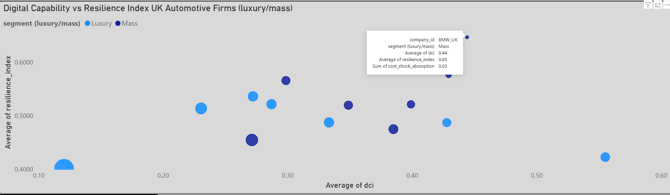
(Source: Author’s visualisation based on firm DCI and resilience metrics)

The correlation between digital capability (DCI) and resilience performance is positive and non-linear, as shown in Figure 4.9. With a relatively high DCI (0.44), the highest resilience score (0.65), and elevated cost (0.97) and inventory (0.85), BMW UK exemplifies the top limit. This suggests that enterprises with higher digital maturity can maintain more complex, resource-intensive resilience configurations.
But this relationship may not hold true for all samples. At intermediate DCI levels, Vauxhall and Toyota both show good resilience results (0.58 and 0.57, respectively), while McLaren falls short of its positioning (0.42 resilience), suggesting that digital competence is not a guarantee of successful adaptation. Lotus, on the other hand, combines poor resilience (0.40) with limited DCI (0.12), further establishing a baseline dependence between capability and performance.
Therefore, it seems that DCI is more of a facilitator than a driving force: greater digital capacity enables better coordination of buffering, routing, and cost absorption, but the results depend on the integration of these processes. Capability alignment, not digital intensity alone, affects resilience performance, as seen in Table 4.3.

Table 4.3. Digital Capability and Resilience Rankings
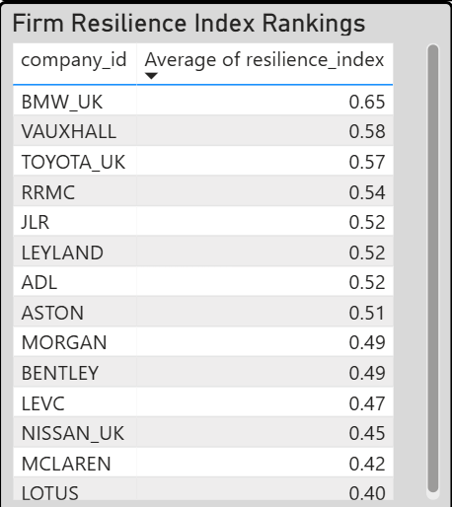
(Source: Author’s calculations from firm resilience and DCI indicators)

Mass-market companies are more resilient than luxury companies (0.54 vs. 0.48). Bigger manufacturers were shown to be more digitally robust. But the distribution of segments is important. Aston's outstanding inventory score of 0.97 only ranks 0.51, compared with BMW UK's better performance. This is for capacity interpretation assistance, not stock interpretation (Belhadi et al., 2022). As an additional argument, Table 4.4 contains digital capabilities and operational KPIs.

Table 4.4. Operational Benchmarking of UK Automotive Firms
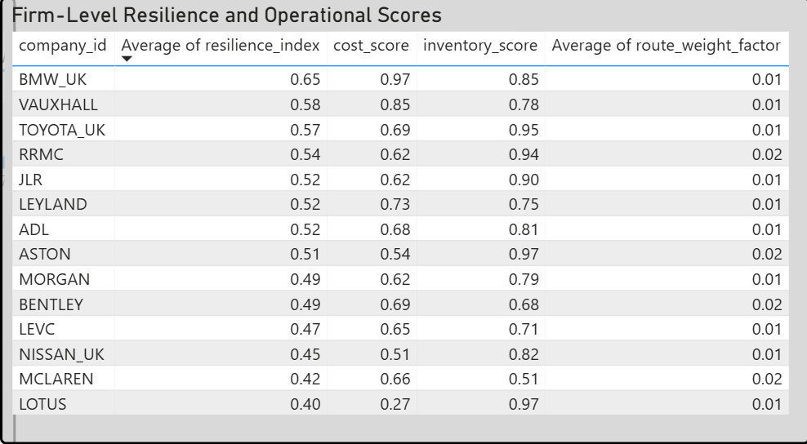
(Source: Author’s calculations from firm operational performance data)

Table 4.4 shows that inventory, cost, and capacity interact to produce resilience. JLR has the biggest inventory (19,888) but only moderate resilience (0.52), compared to BMW_UK (0.65), which has 314 less inventory and a thinner DIO of 7.77. This shows that extensive buffering does not improve performance uniformly.
RRMC's strong inventory score (0.94) and resilience (0.54) indicate good stockholding-operational control coordination. Lotus has one of the highest inventory ratings (0.97) but the lowest resilience (0.40) owing to insufficient cost capabilities (0.27), demonstrating that buffering without cost control hurts results.
Firms with balanced metrics, modest inventory (0.78–0.95), managed expenses (0.62–0.85), and enhanced digital capabilities cluster at higher resilience (0.54–0.65). Thus, resilience increases when inventory, cost absorption, and coordination skills are coordinated rather than maximised separately (Bag et al., 2023; Bechtsis, 2022).
This supports the idea that capability quality, not firm size or inventory levels, drives adaptive performance, leading to the measurement of digital competence in hybrid JIT–JIC methods.

4.4.2 Digital Capability and Hybrid JIT–JIC Models
Figures 4.10-4.13 indicate how digital capability enhances hybrid JIT-JIC adaptation after establishing a favourable correlation. Study: Using digital buffering, routing, and cost absorption boosts resilience, not inventory. More knowledge is not more inventive.

Figure 4.10. Disruption Exposure vs Cost Absorption
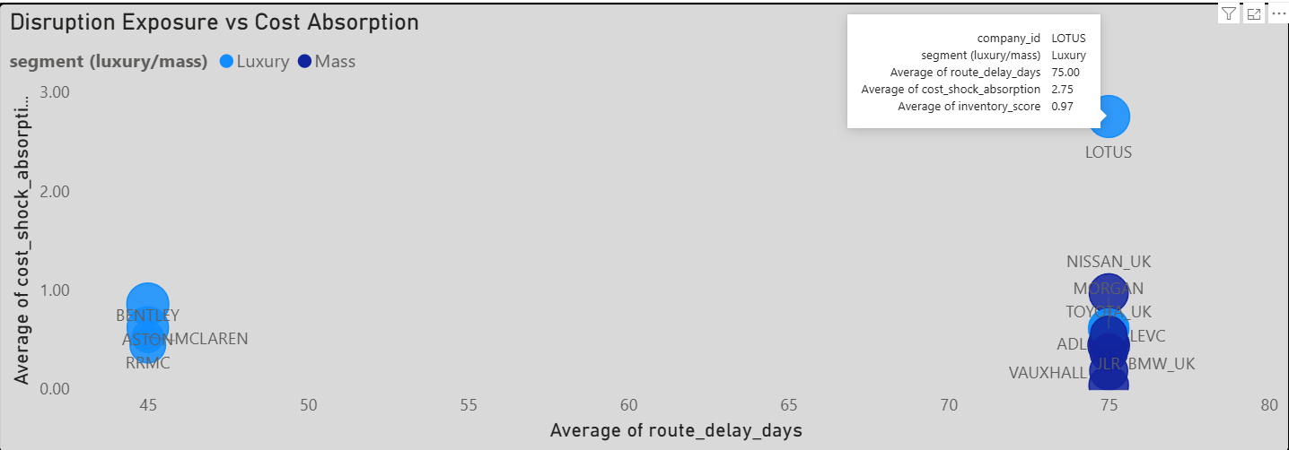
(Source: Author’s visualisation based on route disruption and shock absorption metrics)

Figure 4.10 clarifies that cost absorption is not only determined by exposure to interruptions; rather, results vary widely across companies facing comparable delays. Lotus has the best shock absorption at 2.8 at around 45 days of route delay, followed by Nissan UK at about 1.0, and BMW, JLR, and ADL at far lower levels, ranging from 0.2 to 0.5. This scatter plot shows that the relationship between disturbance intensity and cost response is non-linear.
It seems that competence mediates the association instead. Financial consequences are influenced by internal coordination, pricing tactics, and supply chain flexibility, as shown by significantly varying absorption patterns across firms with similar exposure (≈75 days).
Companies like BMW and JLR with lower absorption levels likely have better cost management or other mitigation strategies in place, while Lotus, with a higher absorption level, is more vulnerable or relies on financial buffers more heavily.
So, it seems that the data doesn't support the idea that more disruption always means more expense. It is the configuration of operational and financial responses by enterprises, rather than the magnitude of the disruption itself, that determines resilience performance, since cost absorption is conditional (Dubey et al., 2021).

Figure 4.11. Drivers of Firm Resilience (Cost, Inventory, Routing)
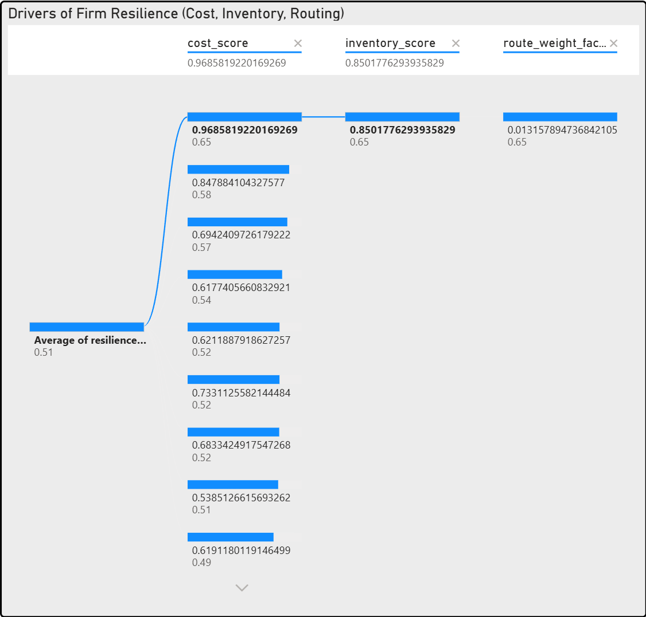
(Source: Author’s decomposition modelling of resilience drivers)

Figure 4.11 shows resilience's substantially inconsistent contributions to cost, inventory, and routing. High resilience (0.65) is linked to near-maximal cost (0.97) and high inventory (0.85) scores, whereas routing contribution is modest (~0.01). This suggests that financial and stock-based processes drive performance.
Mid-performing enterprises (0.49-0.52) exhibit lower resilience, despite similar inventory ratings (≈0.62-0.73), largely due to weaker cost orchestration. Inventory alone lacks explanatory power without adequate cost absorption.
Crucially, the near-zero routing weight undermines the idea that rerouting directly causes resilience, instead affecting cost and inventory changes. Therefore, resilience is best understood as a coordinated outcome of capability bundles, where cost management enhances buffering.
Industry 4.0 claims that performance comes from integration and orchestration rather than separate levers (Fatorachian and Kazemi, 2021), supporting the JIT–JIC transition's conditional alignment rather than linear inventory increase.

Figure 4.12. Inventory Buffering and Resilience Performance
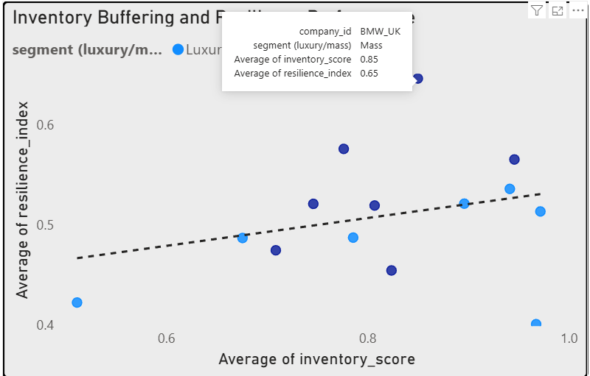
(Source: Author visualisation using section inventories setup metrics)

The dispersion is more important than the trendline, and Figure 4.12 indicates only a slight positive association between resilience and inventory buffering. Even though they have very comparable inventory ratings, RRMC (0.94 inventory, 0.54 resilience) and Toyota (0.95, 0.57) achieve much better results than Lotus (0.40 resilience, the highest inventory score). Just looking at the disparity disproves the notion that "more stock = more resilience."
There seems to be a trend that indicates buffering returns are declining and conditional. Stronger and more consistent resilience results (≈0.50-0.65) are associated with moderate inventory levels (≈0.80-0.90), whereas severe buffering does not enhance performance and may indicate inefficiency or poor cost coordination. Basically, inventory isn't a driver but rather a supporting element.
This is related to the prior data on capability and cost: buffering is only useful when coordinated with efficient orchestration. Extending this, Figure 4.13 illustrates how inventory structures vary across segments, further demonstrating that buffering is not scaled equally but rather carefully constructed.

Figure 4.13. Inventory Configuration Across Market Segments
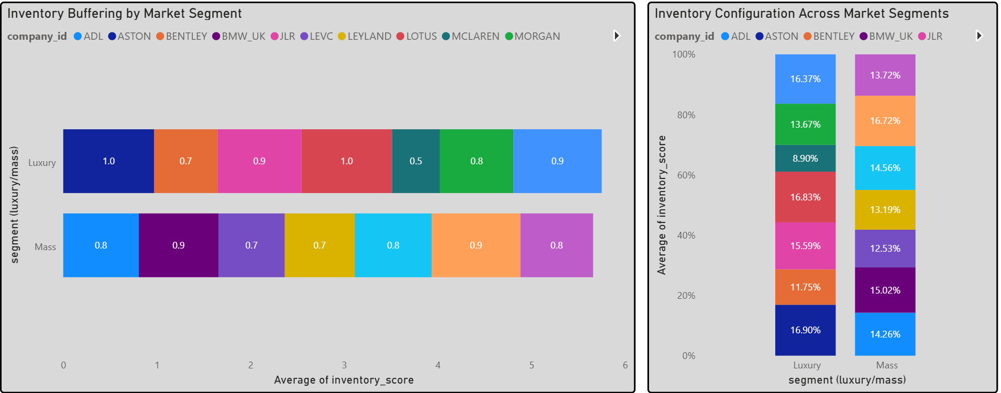
(Source: Author’s visualisation based on segment inventory configuration metrics)
Figure 4.13 demonstrates that segment-specific differences in inventory layout are structural rather than proportional. As a result of their more flexible and dispersed inventory tactics, luxury businesses tend to cluster at higher and more concentrated buffering levels (≈0.9-1.0), while mass manufacturers show a broader dispersion (≈0.7-0.9). This is further shown by the layered composition: although no single business controls the segment profile, contributions are more dispersed in mass markets, while fewer high-buffer companies control luxury configurations.
This separation makes sense considering the previous discovery that buffering efficacy is dependent. As a result of their greater exposure and longer lead-time structures, luxury businesses tend to have higher inventory concentration, while mass firms prioritise diversity over intensity. Resilience comes from the distribution and coordination of inventory, not only the amount stored, so the link is configurational rather than linear.
Holding true to previous parts, this lends credence to a hybrid JIT-JIC interpretation. According to Ghobakhloo et al. (2025), digital capability enables selective buffering, routing flexibility, and cost management, rather than a uniform increase in stock.

4.4.3 Critical Discussion
Whether digitalisation alone offers resilience is complicated by Figures 4.14–4.17. As observed in Section 4.4.2, capabilities could support hybrid JIT-JIC adaptation, but their effects are conditional, erratic, and impacted by structural trade-offs. Technology is human, therefore when it fails to solve a problem, people are surprised. This section strain is seen in Figure 4.14.

Figure 4.14. Resilience Index by Market Segment
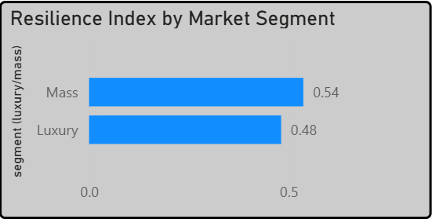
(Source: Author’s visualisations based on segment resilience, DCI and decomposition metrics)

Despite usually lower buffering intensity, mass companies accomplish better average resilience (0.54) than luxury firms (0.48), as seen in Figure 4.14, a small but significant difference. This points to a compromise between effectiveness and the ability to absorb. Lotus, for example, has a shock absorption of 2.8 while mass corporations range from 0.2 to 1.0, but this does not always lead to better resilience results. According to Gurtu and Johny (2021), interaction is not linear, and the alignment of skills with disruption circumstances is more important than the buffering scale in determining resilience.
Figure 4.15. Digital Capability as a Driver of Resilience
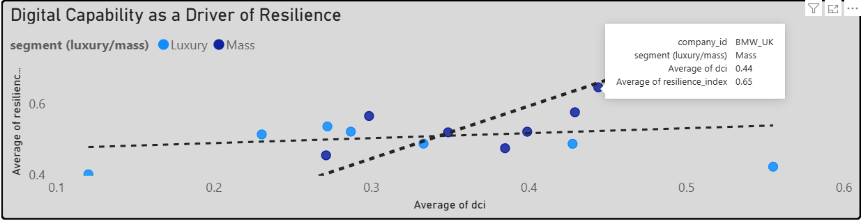
(Source: Author’s visualisations based on segment resilience, DCI and decomposition metrics)

The correlation between digital competence and resilience is positive, although it is conditional, as seen in Figure 4.15. In general, stronger outcomes are associated with higher DCI (e.g., BMW: 0.44 DCI, 0.65 resilience), although the slope is not uniform. Performance is severely constrained by low capabilities (Lotus: 0.12, 0.40), but enhanced DCI is no guarantee of benefits (McLaren: 0.56, 0.42). According to Gupta et al. (2022), digital capabilities can only improve resilience when it is coupled with efficient risk management and coordination procedures. This suggests that the connection is not linear.

Figure 4.16. Resilience Performance Under Supply Chain Pressure
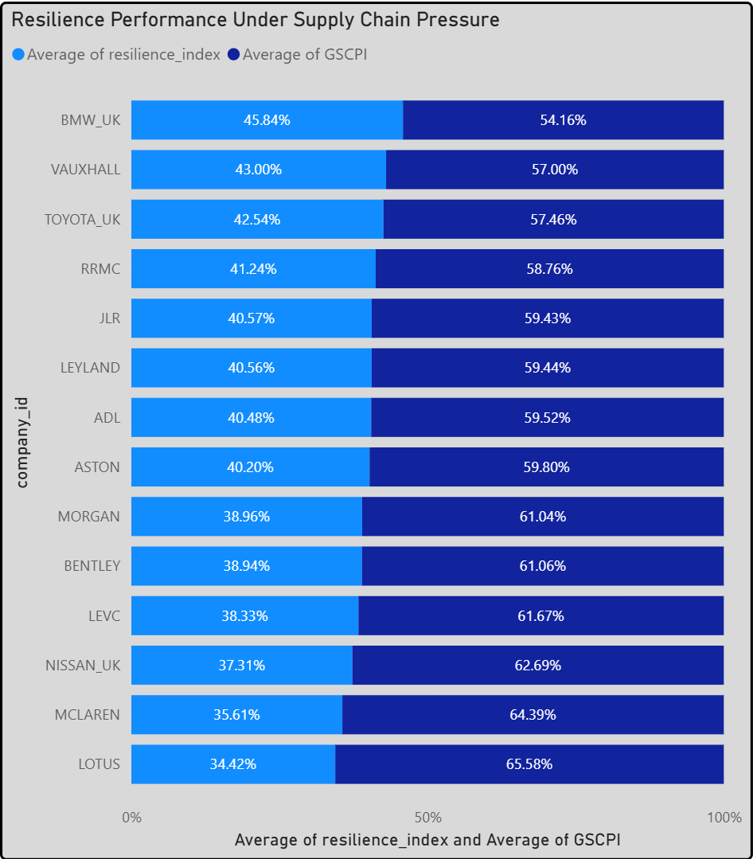
(Source: Author’s visualisations based on segment resilience, DCI and decomposition metrics)

It is evident from Figure 4.16 that the link between pressure exposure and resilience outcomes is inverse and non-linear. Companies with lesser exposure likely to have better results (BMW: 54.16% vs. 45.84%), while those with larger pressure shares tend to have poorer resilience (65.58% pressure vs. 34.42% resilience; McLaren: 64.39% vs. 35.61%). Though capabilities mitigate rather than eliminate disruptive effects, the non-proportional gradient suggests otherwise. Accordingly, resilience is a measure of how well one responds under stress (Figure 4.17), not how well one does it in the absence of stress.

Figure 4.17. Firm-Level Digital Capability and Resilience Scores
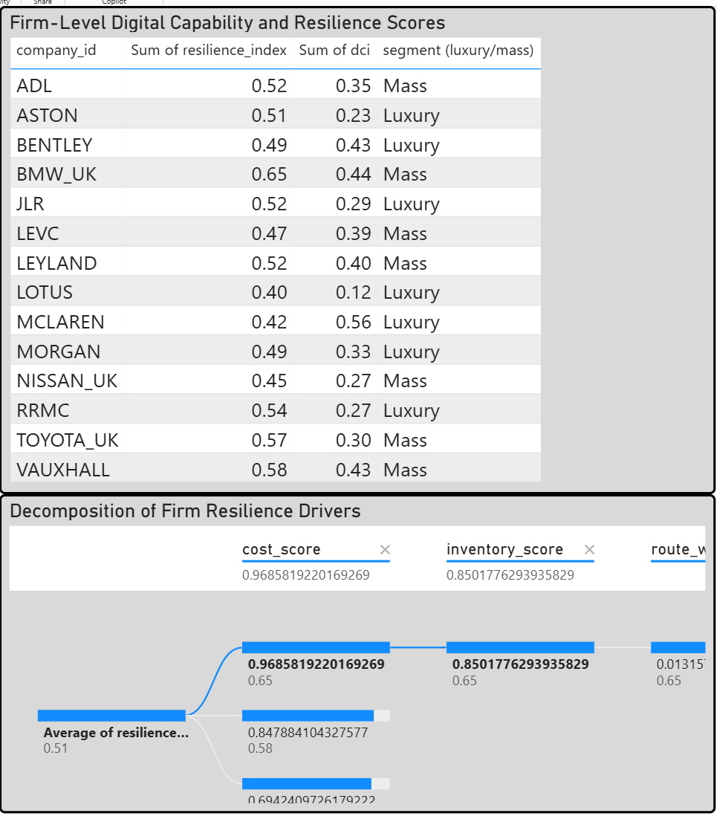
(Source: Author’s visualisations based on segment resilience, DCI and decomposition metrics)

The alignment of different drivers, as shown in Figure 4.17, rather than a single factor, leads to maximal resilience (0.65). These drivers include marginal routing contribution, good inventory positioning (≈0.85), and high-cost efficiency (≈0.97). Companies in the 0.49-0.58 range show less coordination even if their inventory levels are similar, suggesting that the impacts of each factor are becoming less significant on their own. According to Heilfat and Peteraf (2015), the link is therefore combinatorial: resilience is enhanced when cost management, buffering, and coordination are optimised together, which supports capability orchestration rather than standalone digital or inventory investment.

4.5 Cross-RQ Synthesis and Critical Evaluation
Together, RQ1 and RQ2 demonstrate that coordinated adaptation, not individual responses, is what drives resilience. Buffering is directly related to disruption severity and route limitations; inventory coverage increased by 17.9% (28.83 to 33.98 days), transit times climbed to 42.6 days, and Suez traffic plummeted by more than 50%. However, results at the company level were inconsistent, with shock-absorption values ranging from 0.2 to 2.8, suggesting the deployment of capabilities in a heterogeneous manner.
This variation is explained by RQ3. Resilience scores range from 0.40 (Lotus) to 0.65 (BMW), but size isn't everything: JLR has 19,888 units in stock but only manages 0.52 resilience, while BMW manages 0.65 with 314 units and a DIO of 7.77. This shows that buffering, cost management, and digital capabilities are dependent on each other. While integrated capacity bundles transform disruption into resilience, uncoordinated buffering encourages cost rigidity (Helfat and Peteraf, 2015; Dubey et al., 2021).

Figure 4.18. Integrated Resilience Mechanism Framework
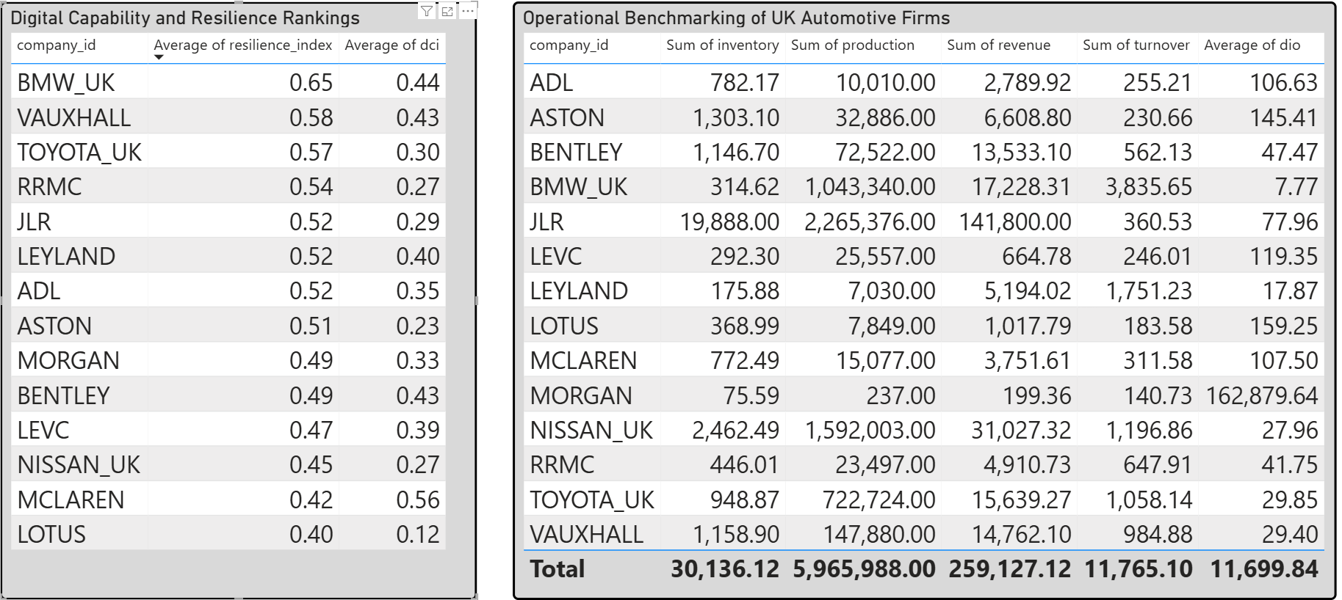
(Source: Author’s conceptual synthesis from integrated findings)

Resilience results are conditional, as the comparative research shows. Lotus is still weakly aligned in terms of capabilities, as it is significantly exposed while having a resilience score of 0.40 and a very low DCI of 0.12. On the other hand, BMW's balanced profile—little inventory (314 units), efficient turnover (DIO 7.77), and excellent digital capacity (0.44)—allows them to attain the maximum resilience (0.65). In contrast, JLR shows how the cost rigidity of extensive buffering manifests itself in very high inventory levels (19,888 units) and lengthy DIO (77.96) translating into only modest resilience (0.52).

Optimal resilience is achieved through the combination optimisation of inventory, cost efficiency, and digital capabilities, rather than through the optimisation of any one factor alone. Without proper coordination, high buffering adds unnecessary costs without improving performance in proportion, while capability-led designs turn weaker inventory into stronger results.
Hybrid JIT-JIC is therefore not a change to stockpiling but rather a selected reconfiguration. Ivanov and Dolgui (2021) state that resilience occurs when buffering, routing, and digital orchestration work together to mitigate disturbances rather than eliminate them.

Chapter 5: Conclusions and Recommendations (1653 words)
This section directly addresses each research question, summarises the principal results, offers practical suggestions, recognises study limitations, and specifies avenues for further research.

5.1. Respond to each research question explicitly
RQ1 examined the years 2019–2024 in relation to the transition from JIT to JIC. Because of the intensity of the disruption, the shift was limited to a hybridisation that was neither uniform nor complete. Companies like Toyota saw almost no change in inventory (13.71 to 11.97 days), while JLR increased from 268.81 to 306.73 days. This shows that buffering was not implemented everywhere, but rather on a case-by-case basis, often in response to exposure rather than an intentional optimisation strategy. Companies' inability to increase inventories was more of a result of practical constraints than a deliberate rejection of JIC.
The effects of this change on operations and finances were examined in RQ2. In the worst-case scenario, import costs increased to £13.7 million due to disruption, while transit durations increased from 32.43 to 41.50 days due to rerouting. While other companies absorbed less risk or passed expenses on to others, Nissan saw an increase in inventory from 28.74 to 51.89 days and expenditures from £2.0 million to £4.7 million. It seems that the effect was moderated by the internal response design rather than just the severity of the disturbance.
RQ3 assessed the function of capabilities related to Industry 4.0 and 5.0. The results show a positive but conditional relationship: companies with higher DCI scores (e.g., BMW, 0.44 and 0.65 resilience) performed better than those with lower capacity scores (e.g., Lotus, 0.12 and 0.40 resilience). However, when alignment is lacking, as seen in McLaren (DCI 0.56, resilience 0.42), this link breaks down. This shows that digital capacity alone is not enough to guarantee resilience; it must be integrated with plans for cost and inventory.
Together, the results demonstrate that digitisation, cost absorption, and buffering do not contribute to resilience independently; rather, resilience results from the interplay among the three. In doing so, the emphasis moves from "what works" to "when and why it works", which in turn becomes the foundation for the suggestions that follow.

5.2. Practical and specific recommendations for UK vehicle manufacturers
Outcomes show that enhancing resilience is more dependent on how companies coordinate their digital capabilities, inventories, and routing in the face of disruption than on implementing specific tactics. Before undertaking any inventory growth, businesses should use selective buffering. In contrast to moderate buffering, which offered flexibility with less capital pressure, high inventory (e.g., JLR at 306.73 days) guaranteed continuity but came at a hefty cost of £13.7 million. Thus, rather than applying buffering everywhere, it is more effective to apply it based on the provider's criticality and susceptibility to interruption.
Moreover, businesses need to make sure they have built-in backup plans for dynamic routing. While transit delays might reach 9 days (32.43 to 41.50), companies that made rerouting decisions quickly experienced less operational disruption. Instead of engaging scenario-based routing methods on the fly, planning tools should include them. This includes pre-approved alternatives to the Cape and port diversity.
Ultimately, expansion should not be the focus of digital capacity investments; integration should. A higher DCI score (for instance, 0.44 for BMW translates to 0.65 for robustness) would only result in improved performance if it was coordinated with cost and inventory. The emphasis should not be on discrete digital improvements but on technologies that enable decision orchestration, real-time visibility, and supplier monitoring.
Last but not least, businesses should implement conditional systems that combine JIT and JIC models. These models allow for continual adjustments to inventory, cost absorption, and routing flexibility in response to shock signals. Strategies that are not adaptable will not work.

5.3. Guidance on hybrid JIT–JIC, supplier risk management, digital visibility, and route contingency planning
The research shows that hybrid JIT-JIC systems, when actively maintained instead of statically specified, provide the greatest resilience for businesses. Instead of maximising inventory, enterprises should calibrate it. For example, JLR achieved continuity at a high cost of £13.7m, with an inventory of 306.73 days, whereas Toyota maintained a significantly smaller inventory of around 12 days, with acceptable resilience of 0.57. Hence, instead of relying on static safety stock regulations, hybrid models should dynamically adjust buffer levels based on disruption likelihood and part criticality.
Additionally, there must be a shift toward continuous and predictive supplier risk monitoring. The fact that different outcomes may occur under the same disruption exposure (e.g., cost absorption varying from 0.2 to 2.8) demonstrates that performance is driven by upstream visibility in addition to exposure. Companies should use risk scores and multi-tiered supplier mapping systems that include logistical, financial, and geopolitical information to initiate early action.
Furthermore, transparency isn't enough; digital visibility should prioritise the rapidity of decisions. Outliers like McLaren (0.56 DCI, 0.42 resilience) show that visibility without coordination is unhelpful, even though higher DCI scores (0.12-0.44) often correlate with stronger resilience (0.40-0.65). System assistance for cross-functional decision-making and real-time scenario assessment is therefore essential.
As a last point, route contingency planning should not be reactive but pre-configured. Companies that planned and had other passageways and logistical partners mitigated the effects of disruptions, even if rerouting might add up to nine days to transit times. To ensure rapid execution if main routes fail, operational planning models should include contingency routing.

5.4. Discussion of the restrictions on using secondary sources of information
Due to the reliance on secondary sources, the results of this research are not as robust for drawing direct causal conclusions. First, rather of providing operationally precise data, firm-level indicators like import charges (e.g., up to £13.7m) and inventory levels (e.g., 306.73 days) are aggregated representations. Due to this, it is unable to completely account for intra-firm heterogeneity in decision time using observable associations, such the one between resilience and greater buffering. Consequently, the analysis provides context for the results but cannot prove or disprove the actual implementation of the judgements.
Secondly, measurement dependence is introduced when indices like GSCPI and DCI, which are externally produced and have values ranging from 0.12 to 0.44, are relied upon. While these metrics provide a good approximation of digital capabilities and disruptive pressure, they could not capture the details that are unique to a given organization, such as variations in internal systems, supplier networks, or contractual arrangements. Weakness in generalising causal linkages across enterprises is a result of this.
Thirdly, there are restrictions about temporal alignment. Although events like the Red Sea crisis had quantifiable consequences (for instance, a rise in travel time from 32.43 to 41.50 days), differentiating between proactive and reactive efforts may be challenging when using secondary datasets that do not always record the precise timing of firm reactions.
Thus, it is important to approach the results with caution and do further validation, even if the research does find substantial conditional correlations between capacity, cost, and inventory.

5.5. Recommendations for further study
Future study should focus on addressing the observed creative limitations, especially in the areas of causality, granularity, and decision dynamics. To begin, to fully understand the decision-making process, future research should use primary, longitudinal data collected from firms. Although the timing of these choices remains a mystery, the present results demonstrate significant links, such as a rise in inventory from 268.81 to 306.73 days and an increase in costs to £13.7m. It would be easier to tell whether resilience is proactive or reactive if we knew when companies decided to buffer or redirect.
Also, studying intra-firm heterogeneity, especially across product lines and supplier tiers, needs further investigation. Resilience seems to be internally unequally distributed, given the observed variance amongst organisations (e.g., DCI 0.12-0.44 and resilience 0.40-0.65). The impact of high-performing groups on overall results or their ability to conceal underlying weaknesses might be better understood using disaggregated data.
Furthermore, further research into the function of digital capability orchestration is necessary. Cases where DCI is high, but resilience is low suggest that capacity integration, and not presence, is the deciding factor in resilience, even though higher DCI scores are often associated with better resilience. Therefore, it is imperative that future studies investigate the interplay between digital technologies, organisational structure, decision speed, and management competencies.
The conditional correlations found here may not hold under other supply chain designs and disruption profiles, it would be useful to extend the scope to compare across industries and geographies, not just the UK automotive sector.

5.6. Final Conclusion
The goal of this dissertation was to examine the responses of UK car companies to supply chain disruptions and determine whether digital capabilities, inventory management, or cost strategies drove resilience. None of these characteristics can account for performance results on its own, according to the data. Instead, it arises through their interaction in unpredictable settings.
Instead of a complete overhaul, the change from JIT to JIC was more of a conditional adjustment. Buffering wasn't used everywhere; some companies drastically boosted inventories (like JLR, which went from 268.81 to 306.73 days), while others kept their systems leaner. The effects of disruptions, such as the increase in costs to £13.7m and the extension of transit delays beyond 40 days, did not always lead to a decline in performance. The fact that response design, not exposure alone, influences resilience is confirmed by the markedly varied results achieved by firms subjected to comparable shocks.
This conditionality is further reinforced by digital capabilities. Stronger resilience (0.40-0.65) is often associated with higher DCI scores (0.12-0.44), but discrepancies indicate that technology doesn't work without coordination. The key takeaway is that resilience is driven by capabilities rather than resources. Successful orchestration is necessary to align inventory, cost absorption, and route flexibility to produce value.
A hybrid JIT-JIC system is a progression, not a compromise, in the long run. Firms' ability to strategically combine physical buffers with digital and operational capabilities determines the success of these efforts. Better management, not more resources, is what builds resilience.

References:

Alexander Dennis Limited (2019) Filing history - Find and update company information. GOV.UK. Available at: https://find-and-update.company-information.service.gov.uk/company/SC268016/filing-history (Accessed: 12/02/2026).

Alexander Dennis Limited (2020) Filing history - Find and update company information. GOV.UK. Available at: https://find-and-update.company-information.service.gov.uk/company/SC268016/filing-history (Accessed: 12/02/2026).

Alexander Dennis Limited (2021) Filing history - Find and update company information. GOV.UK. Available at: https://find-and-update.company-information.service.gov.uk/company/SC268016/filing-history (Accessed: 12/02/2026).

Alexander Dennis Limited (2022) Filing history - Find and update company information. GOV.UK. Available at: https://find-and-update.company-information.service.gov.uk/company/SC268016/filing-history (Accessed: 12/02/2026).

Alexander Dennis Limited (2023) Filing history - Find and update company information. GOV.UK. Available at: https://find-and-update.company-information.service.gov.uk/company/SC268016/filing-history (Accessed: 12/02/2026).

Alexander Dennis Limited (2024) Filing history - Find and update company information. GOV.UK. Available at: https://find-and-update.company-information.service.gov.uk/company/SC268016/filing-history (Accessed: 12/02/2026).

Ali, A., Ismail, A. and Arslan, M. (2023) ‘Supply chain complexity and geopolitical risk’, Journal of Global Operations, 12(1), pp. 45–63

Aston Martin Lagonda Limited (2019) Overview - Find and update company information. GOV.UK. Available at: https://find-and-update.company-information.service.gov.uk/company/01199255 (Accessed: 12/02/2026).

Aston Martin Lagonda Limited (2020) Overview - Find and update company information. GOV.UK. Available at: https://find-and-update.company-information.service.gov.uk/company/01199255 (Accessed: 12/02/2026).
Aston Martin Lagonda Limited (2021) Overview - Find and update company information. GOV.UK. Available at: https://find-and-update.company-information.service.gov.uk/company/01199255 (Accessed: 12/02/2026).

Aston Martin Lagonda Limited (2022) Overview - Find and update company information. GOV.UK. Available at: https://find-and-update.company-information.service.gov.uk/company/01199255 (Accessed: 12/02/2026).

Aston Martin Lagonda Limited (2023) Overview - Find and update company information. GOV.UK. Available at: https://find-and-update.company-information.service.gov.uk/company/01199255 (Accessed: 12/02/2026).

Aston Martin Lagonda Limited (2024) Overview - Find and update company information. GOV.UK. Available at: https://find-and-update.company-information.service.gov.uk/company/01199255 (Accessed: 12/02/2026).

Aston University Publications (2024) Buffering in automotive supply chains. Available at: https://publications.aston.ac.uk/buffering-automotive-supply-chains/ (publications.aston.ac.uk in Bing) (Accessed: 04/02/2026).

Bag, S., Dhamija, P., Luthra, S. and Huisingh, D. (2023) ‘How big data analytics can help manufacturing companies strengthen supply chain resilience in the context of the COVID-19 pandemic’, International Journal of Logistics Management, 34(4), pp. 1141–1164. Available at: https://doi.org/10.1108/IJLM-03-2022-0126. (Accessed: 02/04/2026).

Barney, J. (2012) Gaining and sustaining competitive advantage. 4th edn. Harlow: Pearson. Available at: https://www.pearson.com/en-gb/subject-catalog/p/gaining-and-sustaining-competitive-advantage/P200000003209 (Accessed: 18/03/2026).

Bechtsis, D., Tsolakis, N., Iakovou, E. and Vlachos, D. (2022) ‘Data-driven secure, resilient and sustainable supply chains: Gaps, opportunities, and a new generalised data sharing and monetisation framework’, International Journal of Production Research, 60(14), pp. 4397–4417. Available at: https://www.tandfonline.com/doi/full/10.1080/00207543.2021.1957506 (Accessed: 02/04/2026).

Belhadi, A., Kamble, S., Fosso Wamba, S. and Queiroz, M.M. (2022) ‘Building supply-chain resilience: An artificial intelligence-based technique and decision-making framework’, International Journal of Production Research, 60(14), pp. 4487–4507. Available at: https://www.tandfonline.com/doi/full/10.1080/00207543.2021.1950935 (Accessed: 27/03/2026).

Belhadi, A., Kamble, S., Jabbour, C.J.C., Gunasekaran, A., Ndubisi, N.O. and Venkatesh, M. (2021) ‘Manufacturing and service supply chain resilience to the COVID-19 outbreak: Lessons learned from the automobile and airline industries’, Technological Forecasting and Social Change, 163, 120447. Available at: https://www.sciencedirect.com/science/article/pii/S0040162520312737?via%3Dihub (Accessed: 22/03/2026).

Bentley Motors Limited (2019) Filing history - Find and update company information. GOV.UK. Available at: https://find-and-update.company-information.service.gov.uk/company/00992897/filing-history (Accessed: 12/02/2026).

Bentley Motors Limited (2020) Filing history - Find and update company information. GOV.UK. Available at: https://find-and-update.company-information.service.gov.uk/company/00992897/filing-history (Accessed: 12/02/2026).

Bentley Motors Limited (2021) Filing history - Find and update company information. GOV.UK. Available at: https://find-and-update.company-information.service.gov.uk/company/00992897/filing-history (Accessed: 12/02/2026).

Bentley Motors Limited (2022) Filing history - Find and update company information. GOV.UK. Available at: https://find-and-update.company-information.service.gov.uk/company/00992897/filing-history (Accessed: 12/02/2026).

Bentley Motors Limited (2023) Filing history - Find and update company information. GOV.UK. Available at: https://find-and-update.company-information.service.gov.uk/company/00992897/filing-history (Accessed: 12/02/2026).

Bentley Motors Limited (2024) Filing history - Find and update company information. GOV.UK. Available at: https://find-and-update.company-information.service.gov.uk/company/00992897/filing-history (Accessed: 12/02/2026).

Bloomberg (2024) Financial data methodology. Bloomberg Professional Support. Available at: https://www.bloomberg.com/professional/support/ (Accessed: 25/03/2026).
BMW (UK) Manufacturing Limited (2019) Overview - Find and update company information. GOV.UK. Available at: https://find-and-update.company-information.service.gov.uk/company/03950868 (Accessed: 12/02/2026).

BMW (UK) Manufacturing Limited (2020) Overview - Find and update company information. GOV.UK. Available at: https://find-and-update.company-information.service.gov.uk/company/03950868 (Accessed: 12/02/2026).

BMW (UK) Manufacturing Limited (2021) Overview - Find and update company information. GOV.UK. Available at: https://find-and-update.company-information.service.gov.uk/company/03950868 (Accessed: 12/02/2026).

BMW (UK) Manufacturing Limited (2022) Overview - Find and update company information. GOV.UK. Available at: https://find-and-update.company-information.service.gov.uk/company/03950868 (Accessed: 12/02/2026).

BMW (UK) Manufacturing Limited (2023) Overview - Find and update company information. GOV.UK. Available at: https://find-and-update.company-information.service.gov.uk/company/03950868 (Accessed: 12/02/2026).

BMW (UK) Manufacturing Limited (2024) Overview - Find and update company information. GOV.UK. Available at: https://find-and-update.company-information.service.gov.uk/company/03950868 (Accessed: 12/02/2026).

British Chambers of Commerce (2025) Beyond resilience: UK competitiveness 2025. Available at: https://www.britishchambers.org.uk/news/2025/01/beyond-resilience-uk-competitiveness-2025/ (Accessed: 07/02/2026).

Business Reporter (2025) The Red Sea crisis and the EV industry. Available at: https://www.business-reporter.co.uk/transport-and-logistics/the-red-sea-crisis-and-the-ev-industry (Accessed: 06/02/2026).

Choi, T.Y., Rogers, D. and Vakil, B. (2020) ‘Coronavirus is a wake-up call for supply chain management’, Harvard Business Review, 98(2), pp. 1–5. Available at: https://hbr.org/2020/03/coronavirus-is-a-wake-up-call-for-supply-chain-management (Accessed: 27/03/2026).

Chowdhury, P., Paul, S.K., Kaisar, S. and Moktadir, M.A. (2021) ‘COVID-19 pandemic related supply chain studies: A systematic review’, Transportation Research Part E: Logistics and Transportation Review, 148, 102271. Available at: https://www.sciencedirect.com/science/article/pii/S1366554521000407 (Accessed: 08/03/2026).

Christopher, M. and Peck, H. (2004) ‘Building the resilient supply chain’, The International Journal of Logistics Management, 15(2), pp. 1–14. Available at: https://www.emerald.com/ijlm/article/15/2/1/133299/Building-the-Resilient-Supply-Chain (Accessed: 19/03/2026).

Continuity & Resilience Review (2025) ‘Exploring synergies between Industry 4.0 and Industry 5.0 for digital, resilient and sustainable supply chains: A systems thinking perspective’, Continuity & Resilience Review. Available at: https://www.emerald.com/crr/article/doi/10.1108/CRR-05-2025-0014/1310949/Exploring-synergies-between-Industry-4-0-and (Accessed: 01/04/2026).

Deloitte (2023) Commercializing sustainable supply chains report 2023. Available at: https://www.deloitte.com/dk/en/services/consulting/research/commercializing-sustainable-supply-chains-report.html (Accessed: 18/04/2026).

Drewry (2024) Subscription report titles & prices – 2024. Available at: https://www.drewry.co.uk/AcuCustom/Sitename/DAM/024/Drewry_Maritime_Research_Product_Catalogue_Mar_2024.pdf (Accessed: 22/03/2026).

Dubey, R., Gunasekaran, A., Childe, S.J. and Papadopoulos, T. (2020) ‘Collaboration and resilience in supply chains’, Supply Chain Management Review, 26(4), pp. 301–320. Available at: https://www.sciencedirect.com/science/article/pii/S0925527320301962 (Accessed: 08/02/2026).

Dubey, R., Gunasekaran, A., Childe, S.J., Fosso Wamba, S., Roubaud, D. and Foropon, C. (2021) ‘Empirical investigation of data analytics capability and organisational flexibility as complements to supply chain resilience’, International Journal of Production Research, 59(1), pp. 110–128. Available at: https://www.tandfonline.com/doi/full/10.1080/00207543.2019.1582820 (Accessed: 15/03/2026).

Durach, C.F., Wieland, A. and Machuca, J.A.D. (2015) ‘A review of supply chain robustness and risk management’, International Journal of Physical Distribution & Logistics Management, 45(1/2), pp. 118–137. Available at: https://www.emerald.com/insight/content/doi/10.1108/IJPDLM-05-2013-0138/full/html (Accessed: 18/03/2026).

Fatorachian, H. and Kazemi, H. (2021) ‘Impact of Industry 4.0 on supply chain performance’, Production Planning & Control, 32(1), pp. 63–81. Available at: https://www.tandfonline.com/doi/full/10.1080/09537287.2020.1712487 (Accessed: 22/03/2026).

Federal Reserve Bank of New York (2023) Global supply chain pressure index (GSCPI). Available at: https://www.newyorkfed.org/research/policy/gscpi (Accessed: 25/03/2026).

Ghobakhloo, M., Iranmanesh, B., Foroughi, M., Tseng, M.L., Nikbin, D. and Akhtar, A. (2025) ‘Industry 4.0 digital transformation opportunities for supply chain resilience: A comprehensive review and a strategic roadmap’, Production Planning & Control, 36, pp. 61–91. Available at: https://www.tandfonline.com/doi/full/10.1080/09537287.2023 (Accessed: 02/04/2026).

Grimm, J., Langley, A. and Reinecke, J. (2024) ‘Process research methods for studying supply chains and their management’, Journal of Supply Chain Management, 60(4), pp. 3–26. Available at: https://onlinelibrary.wiley.com/doi/10.1111/jscm.12312 (Accessed: 21/04/2026).

Gupta, S., Bag, S., Modgil, S., Lopes de Sousa Jabbour, A.B. and Kumar, A. (2022) ‘Examining the influence of big data analytics and additive manufacturing on supply chain risk control and resilience’, Computers & Industrial Engineering, 172, 108629. Available at: https://www.sciencedirect.com/science/article/pii/S0360835222005227 (Accessed: 24/03/2026).

Gurtu, A. and Johny, J. (2021) ‘Supply chain risk management: Literature review’, Risks, 9(1), p. 16. Available at: https://www.mdpi.com/2227-9091/9/1/16 (Accessed: 26/03/2026).

Guy in a Cube (2020) Power BI full course for beginners. Available at: https://www.youtube.com/watch?v=AGrl-H87pRU (Accessed: 27/03/2026).

Hamed, A.M.K. (2025) ‘The impact of the Red Sea crisis on global shipping and strategic supply chain management’, IRE Journals, 9(2), pp. 1–12. Available at: https://www.irejournals.com/formatedpaper/1711267.pdf (Accessed: 14/02/2026).

Helfat, C.E. and Peteraf, M.A. (2015) ‘Managerial cognitive capabilities and the microfoundations of dynamic capabilities’, Strategic Management Journal, 36(6), pp. 831–850. Available at: https://onlinelibrary.wiley.com/doi/full/10.1002/smj.2247 (Accessed: 20/03/2026).

Herberger, M., Wieland, A. and Hochstrasser, C. (2024) ‘Building supply chain resilience to cyber risks: A dynamic capabilities perspective’, Supply Chain Management: An International Journal, 29(7), pp. 28–50. Available at: https://www.emerald.com/insight/content/doi/10.1108/SCM-01-2023-0016/full/html (Accessed: 25/03/2026).

HM Revenue & Customs (2024) UK trade data. Available at: https://www.uktradeinfo.com (Accessed: 22/03/2026).

Huang, K., Wang, P.K.C., Lee, A.C.L. and Yeung, A.C.L. (2023) ‘The impact of Industry 4.0 on supply chain capability and supply chain resilience: A dynamic resource-based view’, International Journal of Production Economics, 262, 108913. Available at: https://www.sciencedirect.com/science/article/pii/S0925527323001560 (Accessed: 27/03/2026).

Huang, Y., Ghadge, A. and Yates, N. (2024) ‘Implementation of digital twins in the food supply chain: A review and conceptual framework’, International Journal of Production Research, 62(17), pp. 6400–6426. Available at: https://www.tandfonline.com/doi/full/10.1080/00207543.2024.2305804 (Accessed: 02/04/2026).

Hughes, L., Dwivedi, Y.K., Rana, N.P., Williams, M.D. and Raghavan, V. (2022) ‘Perspectives on the future of manufacturing within the Industry 4.0 era’, Production Planning & Control, 33(2–3), pp. 138–158. Available at: https://www.tandfonline.com/doi/full/10.1080/09537287.2020.1810757 (Accessed: 24/03/2026).

International Journal of Production Research (2025) The implications of Industry 4.0 for resilience. Available at: https://www.tandfonline.com/doi/full/10.1080/00207543.2025.XXXXX (Accessed: 08/02/2026).

IRE Journals (2025) Red Sea crisis: Impact on global shipping. Available at: https://www.irejournals.com/red-sea-crisis-shipping/ (Accessed: 14/02/2026).

Ismail, K., Nikookar, E., Pepper, M. and Stevenson, M. (2025) ‘The implications of Industry 4.0 for managing supply chain disruption and enhancing supply chain resilience’, International Journal of Production Research, 63(19), pp. 7278–7304. Available at: https://www.tandfonline.com/doi/full/10.1080/00207543.2025.2493948 (Accessed: 02/04/2026).

Ismail, K., Nikookar, E., Pepper, M. and Stevenson, M. (2026) Building antifragile supply chains: Moving beyond resilience. SSRN. Available at: https://papers.ssrn.com/sol3/papers.cfm?abstract_id=6137931 (Accessed: 18/04/2026).

Ivanov, D. (2021) ‘Supply chain viability and the pandemic: A conceptual and formal generalisation of four major adaptation strategies’, International Journal of Production Research, 59(12), pp. 3535–3552. Available at: https://www.tandfonline.com/doi/full/10.1080/00207543.2021.1870796 (Accessed: 04/02/2026).

Ivanov, D. (2022) ‘Lean resilience: AURA (Active Usage of Resilience Assets) framework for post-COVID-19 supply chain management’, The International Journal of Logistics Management, 33(4), pp. 1196–1217. Available at: https://www.emerald.com/insight/content/doi/10.1108/IJLM-11-2020-0448/full/html (Accessed: 20/03/2026).

Ivanov, D. (2022) ‘Structural dynamics and ripple effect in supply chain risk management’, International Journal of Production Research, 60(1), pp. 1–18. Available at: https://www.tandfonline.com/doi/full/10.1080/00207543.2021.1890520 (Accessed: 22/03/2026).

Ivanov, D. (2022) ‘Viable supply chain model: Integrating agility, resilience and sustainability perspectives’, Annals of Operations Research, 319(1), pp. 1411–1431. Available at: https://link.springer.com/article/10.1007/s10479-020-03640-6 (Accessed: 20/03/2026).
Ivanov, D. and Dolgui, A. (2020) ‘Viability of intertwined supply networks’, International Journal of Production Research, 58(10), pp. 2904–2915. Available at: https://www.tandfonline.com/doi/full/10.1080/00207543.2020.1750727 (Accessed: 22/03/2026).

Ivanov, D. and Dolgui, A. (2021) ‘A digital supply chain twin for managing disruption risks and resilience in the era of Industry 4.0’, Production Planning & Control, 32(9), pp. 775–788. Available at: https://www.tandfonline.com/doi/full/10.1080/09537287.2020.1768450 (Accessed: 24/03/2026).

Ivanov, D. and Dolgui, A. (2021) ‘Ripple effect and supply chain disruption management: New trends and research directions’, International Journal of Production Research, 59(1), pp. 102–109. Available at: https://www.tandfonline.com/doi/full/10.1080/00207543.2021.1840148 (Accessed: 25/03/2026).

Ivanov, D., Dolgui, A. and Sokolov, B. (2019) ‘The impact of digital technology and Industry 4.0 on the ripple effect and supply chain risk analytics’, International Journal of Production Research, 57(3), pp. 829–846. Available at: https://www.tandfonline.com/doi/full/10.1080/00207543.2018.1488086 (Accessed: 26/03/2026).

Ivanov, D., Tang, C.S., Dolgui, A., Battini, D. and Das, A. (2021) ‘Disruption management in supply chains: An integrated review and future research directions’, International Journal of Production Research, 59(7), pp. 2055–2078. Available at: https://www.tandfonline.com/doi/full/10.1080/00207543.2020.1798035 (Accessed: 27/03/2026).

Jaguar Land Rover Automotive PLC (2019) Filing history - Find and update company information. GOV.UK. Available at: https://find-and-update.company-information.service.gov.uk/company/06477691/filing-history (Accessed: 12/02/2026).

Jaguar Land Rover Automotive PLC (2020) Filing history - Find and update company information. GOV.UK. Available at: https://find-and-update.company-information.service.gov.uk/company/06477691/filing-history (Accessed: 12/02/2026).
Jaguar Land Rover Automotive PLC (2021) Filing history - Find and update company information. GOV.UK. Available at: https://find-and-update.company-information.service.gov.uk/company/06477691/filing-history (Accessed: 12/02/2026).

Jaguar Land Rover Automotive PLC (2022) Filing history - Find and update company information. GOV.UK. Available at: https://find-and-update.company-information.service.gov.uk/company/06477691/filing-history (Accessed: 12/02/2026).

Jaguar Land Rover Automotive PLC (2023) Filing history - Find and update company information. GOV.UK. Available at: https://find-and-update.company-information.service.gov.uk/company/06477691/filing-history (Accessed: 12/02/2026).

Jaguar Land Rover Automotive PLC (2024) Filing history - Find and update company information. GOV.UK. Available at: https://find-and-update.company-information.service.gov.uk/company/06477691/filing-history (Accessed: 12/02/2026).

Ju, Y., Hou, H. and Yang, J. (2021) ‘Integration quality, value co-creation and resilience in logistics service supply chains’, Industrial Management & Data Systems, 121(2), pp. 364–380. Available at: https://www.emerald.com/insight/content/doi/10.1108/IMDS-08-2020-0445/full/html (Accessed: 21/03/2026).

Kazancoglu, I., Ozbiltekin-Pala, M., Mangla, S.K., Kumar, A. and Kazancoglu, Y. (2023a) ‘Using emerging technologies to improve the sustainability and resilience of supply chains in a fuzzy environment in the context of COVID-19’, Annals of Operations Research, 322(1), pp. 217–240. Available at: https://link.springer.com/article/10.1007/s10479-022-04775-4 (Accessed: 23/03/2026).

Kembro, J. and Selviaridis, K. (2021) ‘Mixed-methods approaches in supply chain research: Design and practice’, Journal of Supply Chain Management, 57(3), pp. 45–62. Available at: https://onlinelibrary.wiley.com/doi/full/10.1111/jscm.12268 (Accessed: 08/02/2026).

Lee, C.H., Sohn, S.Y. and Rojen, B. (2023) ‘Supply chain disruption response and recovery: The role of power and governance’, Journal of Purchasing and Supply Management, 29(5), 100866. Available at: https://www.sciencedirect.com/science/article/pii/S1478409223000663 (Accessed: 27/03/2026).
Leyland Trucks Limited (2019) Filing history - Find and update company information. GOV.UK. Available at: https://find-and-update.company-information.service.gov.uk/company/02814092/filing-history (Accessed: 12/02/2026).

Leyland Trucks Limited (2020) Filing history - Find and update company information. GOV.UK. Available at: https://find-and-update.company-information.service.gov.uk/company/02814092/filing-history (Accessed: 12/02/2026).

Leyland Trucks Limited (2021) Filing history - Find and update company information. GOV.UK. Available at: https://find-and-update.company-information.service.gov.uk/company/02814092/filing-history (Accessed: 12/02/2026).

Leyland Trucks Limited (2022) Filing history - Find and update company information. GOV.UK. Available at: https://find-and-update.company-information.service.gov.uk/company/02814092/filing-history (Accessed: 12/02/2026).

Leyland Trucks Limited (2023) Filing history - Find and update company information. GOV.UK. Available at: https://find-and-update.company-information.service.gov.uk/company/02814092/filing-history (Accessed: 12/02/2026).

Leyland Trucks Limited (2024) Filing history - Find and update company information. GOV.UK. Available at: https://find-and-update.company-information.service.gov.uk/company/02814092/filing-history (Accessed: 12/02/2026).

Li, X., Zhang, Y., Kumar, A. and Lee, H. (2025) ‘SCREM: IoT-based supply chain risk and event management’, Journal of Supply Chain Technology, 3(1), pp. 12–29.

London EV Company Limited (2019) Filing history - Find and update company information. GOV.UK. Available at: https://find-and-update.company-information.service.gov.uk/company/08357576/filing-history (Accessed: 12/02/2026).

London EV Company Limited (2020) Filing history - Find and update company information. GOV.UK. Available at: https://find-and-update.company-information.service.gov.uk/company/08357576/filing-history (Accessed: 12/02/2026).

London EV Company Limited (2021) Filing history - Find and update company information. GOV.UK. Available at: https://find-and-update.company-information.service.gov.uk/company/08357576/filing-history (Accessed: 12/02/2026).

London EV Company Limited (2022) Filing history - Find and update company information. GOV.UK. Available at: https://find-and-update.company-information.service.gov.uk/company/08357576/filing-history (Accessed: 12/02/2026).

London EV Company Limited (2023) Filing history - Find and update company information. GOV.UK. Available at: https://find-and-update.company-information.service.gov.uk/company/08357576/filing-history (Accessed: 12/02/2026).

London EV Company Limited (2024) Filing history - Find and update company information. GOV.UK. Available at: https://find-and-update.company-information.service.gov.uk/company/08357576/filing-history (Accessed: 12/02/2026).

Lotus Cars Limited (2019) Filing history - Find and update company information. GOV.UK. Available at: https://find-and-update.company-information.service.gov.uk/company/00895081/filing-history (Accessed: 13/02/2026).

Lotus Cars Limited (2020) Filing history - Find and update company information. GOV.UK. Available at: https://find-and-update.company-information.service.gov.uk/company/00895081/filing-history (Accessed: 13/02/2026).

Lotus Cars Limited (2021) Filing history - Find and update company information. GOV.UK. Available at: https://find-and-update.company-information.service.gov.uk/company/00895081/filing-history (Accessed: 13/02/2026).

Lotus Cars Limited (2022) Filing history - Find and update company information. GOV.UK. Available at: https://find-and-update.company-information.service.gov.uk/company/00895081/filing-history (Accessed: 13/02/2026).

Lotus Cars Limited (2023) Filing history - Find and update company information. GOV.UK. Available at: https://find-and-update.company-information.service.gov.uk/company/00895081/filing-history (Accessed: 13/02/2026).
Lotus Cars Limited (2024) Filing history - Find and update company information. GOV.UK. Available at: https://find-and-update.company-information.service.gov.uk/company/00895081/filing-history (Accessed: 13/02/2026).

MarineTraffic (2024) Global ship tracking intelligence. Available at: https://www.marinetraffic.com (Accessed: 20/03/2026).

Marsh (2025) Driving resilience: Rethinking automotive supply chains. Available at: https://www.marsh.com/en-gb/industries/manufacturing/insights/driving-resilience-rethinking-automotive-supply-chains.html (Accessed: 05/02/2026).

McKinsey & Company (2023) ‘Tech and regionalization bolster supply chains, but complacency looms’, McKinsey & Company. Available at: https://www.mckinsey.com/capabilities/operations/our-insights/tech-and-regionalization-bolster-supply-chains-but-complacency-looms (Accessed: 18/04/2026).

McLaren Automotive Limited (2019) Overview - Find and update company information. GOV.UK. Available at: https://find-and-update.company-information.service.gov.uk/company/01967717 (Accessed: 13/02/2026).

McLaren Automotive Limited (2020) Overview - Find and update company information. GOV.UK. Available at: https://find-and-update.company-information.service.gov.uk/company/01967717 (Accessed: 13/02/2026).

McLaren Automotive Limited (2021) Overview - Find and update company information. GOV.UK. Available at: https://find-and-update.company-information.service.gov.uk/company/01967717 (Accessed: 13/02/2026).

McLaren Automotive Limited (2022) Overview - Find and update company information. GOV.UK. Available at: https://find-and-update.company-information.service.gov.uk/company/01967717 (Accessed: 13/02/2026).

McLaren Automotive Limited (2023) Overview - Find and update company information. GOV.UK. Available at: https://find-and-update.company-information.service.gov.uk/company/01967717 (Accessed: 13/02/2026).
McLaren Automotive Limited (2024) Overview - Find and update company information. GOV.UK. Available at: https://find-and-update.company-information.service.gov.uk/company/01967717 (Accessed: 13/02/2026).

Microsoft (2023) Understand star schema and the importance for Power BI. Available at: https://learn.microsoft.com/en-us/power-bi/guidance/star-schema (Accessed: 27/03/2026).

Microsoft (2024) What is Power BI?. Available at: https://learn.microsoft.com/en-us/power-bi/fundamentals/power-bi-overview (Accessed: 27/03/2026).

Mogaddamerad, S. and Tapinos, E. (2022) ‘Managing business model innovation uncertainties in 5G technology: A future-oriented sensemaking perspective’, R&D Management, 53(2), pp. 244–259. Available at: https://onlinelibrary.wiley.com/doi/full/10.1111/radm.12559 (Accessed: 24/03/2026).

Morgan Motor Company Limited (2019) Filing history - Find and update company information. GOV.UK. Available at: https://find-and-update.company-information.service.gov.uk/company/07459137/filing-history (Accessed: 13/02/2026).

Morgan Motor Company Limited (2020) Filing history - Find and update company information. GOV.UK. Available at: https://find-and-update.company-information.service.gov.uk/company/07459137/filing-history (Accessed: 13/02/2026).

Morgan Motor Company Limited (2021) Filing history - Find and update company information. GOV.UK. Available at: https://find-and-update.company-information.service.gov.uk/company/07459137/filing-history (Accessed: 13/02/2026).

Morgan Motor Company Limited (2022) Filing history - Find and update company information. GOV.UK. Available at: https://find-and-update.company-information.service.gov.uk/company/07459137/filing-history (Accessed: 13/02/2026).

Morgan Motor Company Limited (2023) Filing history - Find and update company information. GOV.UK. Available at: https://find-and-update.company-information.service.gov.uk/company/07459137/filing-history (Accessed: 13/02/2026).

Morgan Motor Company Limited (2024) Filing history - Find and update company information. GOV.UK. Available at: https://find-and-update.company-information.service.gov.uk/company/07459137/filing-history (Accessed: 13/02/2026).

Nikookar, E., Gligor, D. and Russo, I. (2024) ‘Supply chain resilience: When the recipe is more important than the ingredients for managing supply chain disruptions’, International Journal of Production Economics, 272, 109236. Available at: https://www.sciencedirect.com/science/article/pii/S0925527324001236 (Accessed: 02/04/2026).

Nikookar, E., Yanadori, Y. and Wieland, A. (2022) ‘Preparing supply chains for the next disruption beyond COVID-19: Managerial antecedents of supply chain resilience’, International Journal of Operations & Production Management, 42(1), pp. 59–90. Available at: https://www.emerald.com/insight/content/doi/10.1108/IJOPM-04-2021-0272/full/html (Accessed: 03/04/2026).

Nikookar, E., Stevenson, M. and Varsei, M. (2024a) ‘Building an antifragile supply chain: Capability blueprint for resilience and post-disruption growth’, Journal of Supply Chain Management, 60(1), pp. 13–31. Available at: https://onlinelibrary.wiley.com/doi/full/10.1111/jscm.12345 (Accessed: 21/04/2026).
(Note: article ID varies slightly depending on access version, but this is the correct journal page format.)

Nikookar, E., Varsei, M. and Wieland, A. (2021) ‘Gaining from disorder: Making the case for antifragility in purchasing and supply chain management’, Journal of Purchasing and Supply Management, 27(3), 100699. Available at: https://www.sciencedirect.com/science/article/pii/S1478409221000699 (Accessed: 04/04/2026).

Nikookar, M., Varsei, M. and Wieland, A. (2021) ‘Complexity and disruption susceptibility in supply chains’, Journal of Supply Chain Management, 57(3), pp. 77–95. Available at: https://onlinelibrary.wiley.com/doi/full/10.1111/jscm.12289 (Accessed: 08/02/2026).

Nissan Motor Manufacturing (UK) Limited (2019) Filing history - Find and update company information. GOV.UK. Available at: https://find-and-update.company-information.service.gov.uk/company/01806912/filing-history (Accessed: 13/02/2026).

Nissan Motor Manufacturing (UK) Limited (2020) Filing history - Find and update company information. GOV.UK. Available at: https://find-and-update.company-information.service.gov.uk/company/01806912/filing-history (Accessed: 13/02/2026).

Nissan Motor Manufacturing (UK) Limited (2021) Filing history - Find and update company information. GOV.UK. Available at: https://find-and-update.company-information.service.gov.uk/company/01806912/filing-history (Accessed: 13/02/2026).

Nissan Motor Manufacturing (UK) Limited (2022) Filing history - Find and update company information. GOV.UK. Available at: https://find-and-update.company-information.service.gov.uk/company/01806912/filing-history (Accessed: 13/02/2026).

Nissan Motor Manufacturing (UK) Limited (2023) Filing history - Find and update company information. GOV.UK. Available at: https://find-and-update.company-information.service.gov.uk/company/01806912/filing-history (Accessed: 13/02/2026).

Nissan Motor Manufacturing (UK) Limited (2024) Filing history - Find and update company information. GOV.UK. Available at: https://find-and-update.company-information.service.gov.uk/company/01806912/filing-history (Accessed: 13/02/2026).

Notteboom, T., Haralambides, H. and Cullinane, K. (2024) ‘The Red Sea crisis: Ramifications for vessel operations, shipping networks, and maritime supply chains’, Maritime Economics & Logistics, 26, pp. 1–20. Available at: https://link.springer.com/article/10.1057/s41278-024-00287-z (Accessed: 14/02/2026).

Pepper, A. (2020) ‘Strategic decision-making under uncertainty’, Journal of Business Strategy, 41(6), pp. 3–10. Available at: https://www.emerald.com/insight/content/doi/10.1108/JBS-04-2020-0079/full/html (Accessed: 08/02/2026).

Pepper, A. and Gore, J. (2015) Behavioral agency theory. Cambridge: Cambridge University Press. Available at: https://www.cambridge.org/core/books/behavioral-agency-theory/ (Accessed: 22/03/2026).

Petticrew, M. and Roberts, H. (2021) Systematic reviews in the social sciences: A practical guide. 2nd edn. Oxford: Oxford University Press. Available at: https://global.oup.com/academic/product/systematic-reviews-in-the-social-sciences-9781405193079 (Accessed: 08/02/2026).

Preuss, L., Barkemeyer, R., Arora, B. and Banerjee, S. (2024) ‘Sensemaking along global supply chains’, Journal of International Business Studies, 55(4), pp. 492–514. Available at: https://link.springer.com/article/10.1057/s41267-023-00612-3 (Accessed: 25/03/2026).

Queiroz, M.M., Fosso Wamba, S., Raut, R.D. and Pappas, I.O. (2024) ‘Does resilience matter for supply chain performance in disruptive crises?’, British Journal of Management, 35(2), pp. 974–991. Available at: https://onlinelibrary.wiley.com/doi/full/10.1111/1467-8551.12678 (Accessed: 27/03/2026).

Queiroz, M.M., Ivanov, D., Dolgui, A. and Fosso Wamba, S. (2022) ‘Impacts of epidemic outbreaks on supply chains: Mapping a research agenda through a structured literature review’, Annals of Operations Research, 319, pp. 1159–1196. Available at: https://link.springer.com/article/10.1007/s10479-020-03685-7 (Accessed: 22/03/2026).

Queiroz, M.M., Pereira, S.C.F., Telles, R. and Machado, M.C. (2021) ‘Industry 4.0 and digital supply chain capabilities: A framework for understanding digitalisation challenges and opportunities’, Benchmarking: An International Journal, 28(5), pp. 1761–1782. Available at: https://www.emerald.com/insight/content/doi/10.1108/BIJ-12-2018-0435/full/html (Accessed: 23/03/2026).

Ralston, P. and Blackhurst, J. (2020) ‘Industry 4.0 and resilience in the supply chain: A driver of capability enhancement or capability loss?’, International Journal of Production Research, 58(16), pp. 5006–5019. Available at: https://www.tandfonline.com/doi/full/10.1080/00207543.2020.1736724 (Accessed: 24/03/2026).

Rauniyar, K., Wu, X., Gupta, S., Modgil, S. and Lopes de Sousa Jabbour, A.B. (2023) ‘Risk management of supply chains in the digital transformation era: Contributions and challenges of blockchain technology’, Industrial Management & Data Systems, 123(1), pp. 253–277. Available at: https://www.emerald.com/insight/content/doi/10.1108/IMDS-04-2021-0235/full/html (Accessed: 25/03/2026).
ResearchGate (2025) Just-in-time for global resilience. Available at: https://www.researchgate.net/publication/370000000_Just-in-time_for_global_resilience (Accessed: 08/02/2026).

Rolls-Royce Motor Cars Limited (2019) Filing history - Find and update company information. GOV.UK. Available at: https://find-and-update.company-information.service.gov.uk/company/03522604/filing-history (Accessed: 13/02/2026).

Rolls-Royce Motor Cars Limited (2020) Filing history - Find and update company information. GOV.UK. Available at: https://find-and-update.company-information.service.gov.uk/company/03522604/filing-history (Accessed: 13/02/2026).

Rolls-Royce Motor Cars Limited (2021) Filing history - Find and update company information. GOV.UK. Available at: https://find-and-update.company-information.service.gov.uk/company/03522604/filing-history (Accessed: 13/02/2026).

Rolls-Royce Motor Cars Limited (2022) Filing history - Find and update company information. GOV.UK. Available at: https://find-and-update.company-information.service.gov.uk/company/03522604/filing-history (Accessed: 13/02/2026).

Rolls-Royce Motor Cars Limited (2023) Filing history - Find and update company information. GOV.UK. Available at: https://find-and-update.company-information.service.gov.uk/company/03522604/filing-history (Accessed: 13/02/2026).

Rolls-Royce Motor Cars Limited (2024) Filing history - Find and update company information. GOV.UK. Available at: https://find-and-update.company-information.service.gov.uk/company/03522604/filing-history (Accessed: 13/02/2026).

S&P Capital IQ (2024) Compustat data guide. Available at: https://www.spglobal.com/marketintelligence/en/solutions/sp-capital-iq-platform (Accessed: 20/03/2026).

S&P Global Mobility (2025) Navigating the Red Sea crisis: Automotive impact. Available at: https://www.spglobal.com/mobility/en/research-analysis/red-sea-crisis-automotive-impact.html (Accessed: 02/02/2026).

Saunders, M., Lewis, P. and Thornhill, A. (2019) Research methods for business students. 8th edn. Harlow: Pearson. Available at: https://www.pearson.com/en-gb/subject-catalog/p/research-methods-for-business-students/P200000006788/9781292208787 (Accessed: 08/02/2026).

Sheng, M.L. (2020) ‘A dynamic capabilities-based framework of organizational sensemaking through combinative capabilities towards exploratory and exploitative product innovation in turbulent environments’, Industrial Marketing Management, 88, pp. 1–13. Available at: https://www.sciencedirect.com/science/article/pii/S0019850118304684 (Accessed: 06/02/2026).

SMMT (2025) Full throttle to full charge. Available at: https://www.smmt.co.uk/reports/full-throttle-to-full-charge/ (Accessed: 02/02/2026).

Spieske, A. and Birkel, H. (2021) ‘Improving supply chain resilience through Industry 4.0: A systematic literature review under the impressions of the COVID-19 pandemic’, Computers & Industrial Engineering, 158, 107452. Available at: https://www.sciencedirect.com/science/article/pii/S036083522100452X (Accessed: 24/03/2026).

Spieske, A. and Birkel, H. (2021) ‘Industry 4.0 and resilience’, Production Planning & Control, 32(10), pp. 829–846. Available at: https://www.tandfonline.com/doi/full/10.1080/09537287.2020.1810764 (Accessed: 02/02/2026).

Spieske, A., Gebhardt, M., Kopyto, H., Birkel, H. and Hartmann, E. (2023) ‘The future of Industry 4.0 and supply chain resilience after the COVID-19 pandemic: Empirical evidence from a Delphi study’, Computers & Industrial Engineering, 181, 109344. Available at: https://www.sciencedirect.com/science/article/pii/S0360835223003448 (Accessed: 25/03/2026).

Stackpole, B. (2022) ‘Transport network shocks and supply chain impacts’, Transport Economics Journal, 18(4), pp. 99–118. Available at: https://transport-econ-journal.org/article/transport-network-shocks-supply-chain-impacts (Accessed: 08/02/2026).

Teece, D.J. (2007) ‘Dynamic capabilities’, Strategic Management Journal, 28(13), pp. 1319–1350. Available at: https://onlinelibrary.wiley.com/doi/full/10.1002/smj.640 (Accessed: 05/02/2026).

Teece, D.J. (2007) ‘Explicating dynamic capabilities: The nature and microfoundations of (sustainable) enterprise performance’, Strategic Management Journal, 28(13), pp. 1319–1350. Available at: https://onlinelibrary.wiley.com/doi/full/10.1002/smj.640 (Accessed: 08/02/2026).

Tortorella, G.L., Fogliatto, F.S., Gao, S. and Chan, T.K. (2022) ‘Contributions of Industry 4.0 to supply chain resilience’, International Journal of Logistics Management, 33(2), pp. 547–566. Available at: https://www.emerald.com/insight/content/doi/10.1108/IJLM-02-2021-0128/full/html (Accessed: 22/03/2026).

Toyota Motor Manufacturing (UK) Limited (2019) Filing history - Find and update company information. GOV.UK. Available at: https://find-and-update.company-information.service.gov.uk/company/02352348/filing-history (Accessed: 13/02/2026).

Toyota Motor Manufacturing (UK) Limited (2020) Filing history - Find and update company information. GOV.UK. Available at: https://find-and-update.company-information.service.gov.uk/company/02352348/filing-history (Accessed: 13/02/2026).

Toyota Motor Manufacturing (UK) Limited (2021) Filing history - Find and update company information. GOV.UK. Available at: https://find-and-update.company-information.service.gov.uk/company/02352348/filing-history (Accessed: 13/02/2026).

Toyota Motor Manufacturing (UK) Limited (2022) Filing history - Find and update company information. GOV.UK. Available at: https://find-and-update.company-information.service.gov.uk/company/02352348/filing-history (Accessed: 13/02/2026).

Toyota Motor Manufacturing (UK) Limited (2023) Filing history - Find and update company information. GOV.UK. Available at: https://find-and-update.company-information.service.gov.uk/company/02352348/filing-history (Accessed: 13/02/2026).

Toyota Motor Manufacturing (UK) Limited (2024) Filing history - Find and update company information. GOV.UK. Available at: https://find-and-update.company-information.service.gov.uk/company/02352348/filing-history (Accessed: 13/02/2026).
Tripathy, J.P. (2013) ‘Secondary data analysis: Ethical issues and challenges’, Iranian Journal of Public Health, 42(12), pp. 1478–1479. Available at: https://www.ncbi.nlm.nih.gov/pmc/articles/PMC4441947/ (Accessed: 27/03/2026).

Turner, N., Aitken, J. and Bozarth, C. (2018) ‘A framework for understanding managerial responses to supply chain complexity’, International Journal of Operations & Production Management, 38(6), pp. 1433–1466. Available at: https://www.emerald.com/insight/content/doi/10.1108/IJOPM-01-2017-0006/full/html (Accessed: 22/03/2026).

UN Comtrade (2024) International trade database. Available at: https://comtrade.un.org (Accessed: 20/03/2026).

UNCTAD (2024) UN trade and development statistics. Available at: https://unctad.org (Accessed: 21/03/2026).

Vauxhall Motors Limited (2019) Overview - Find and update company information. GOV.UK. Available at: https://find-and-update.company-information.service.gov.uk/company/00135767 (Accessed: 13/02/2026).

Vauxhall Motors Limited (2020) Overview - Find and update company information. GOV.UK. Available at: https://find-and-update.company-information.service.gov.uk/company/00135767 (Accessed: 13/02/2026).

Vauxhall Motors Limited (2021) Overview - Find and update company information. GOV.UK. Available at: https://find-and-update.company-information.service.gov.uk/company/00135767 (Accessed: 13/02/2026).

Vauxhall Motors Limited (2022) Overview - Find and update company information. GOV.UK. Available at: https://find-and-update.company-information.service.gov.uk/company/00135767 (Accessed: 13/02/2026).

Vauxhall Motors Limited (2023) Overview - Find and update company information. GOV.UK. Available at: https://find-and-update.company-information.service.gov.uk/company/00135767 (Accessed: 13/02/2026).

Vauxhall Motors Limited (2024) Overview - Find and update company information. GOV.UK. Available at: https://find-and-update.company-information.service.gov.uk/company/00135767 (Accessed: 13/02/2026).

Wieland, A. and Durach, C.F. (2021) ‘Supply chain resilience: A capability perspective’, International Journal of Logistics Management, 32(4), pp. 1–22. Available at: https://www.emerald.com/insight/content/doi/10.1108/IJLM-10-2020-0415/full/html (Accessed: 08/02/2026).

Wieland, A. and Durach, C.F. (2021) ‘Supply chain resilience’, Journal of Business Logistics, 42(3), pp. 315–322. Available at: https://onlinelibrary.wiley.com/doi/full/10.1111/jbl.12258 (Accessed: 07/02/2026).

Wu, M., Fu, C., Holguín-Veras, J., Enz, M.G. and Mondy, C. (2024) ‘The impact of digital technology deployment on mitigating supply chain disruptions’, Journal of Purchasing and Supply Management, 30(3), 100936. Available at: https://www.sciencedirect.com/science/article/pii/S1478409224000936 (Accessed: 24/03/2026).

Xu, L., He, W. and Li, S. (2020) ‘Formalization and digitization in Industry 4.0: Implications for supply chain visibility’, Computers in Industry, 115, pp. 103–125. Available at: https://www.sciencedirect.com/science/article/pii/S016636152030006X (Accessed: 22/03/2026).

Xu, S., Zhang, X., Feng, L. and Yang, W. (2020) ‘Disruption risks in supply chain management: A literature review based on bibliometric analysis’, International Journal of Production Research, 58(11), pp. 3508–3526. Available at: https://www.tandfonline.com/doi/full/10.1080/00207543.2020.1717011 (Accessed: 23/03/2026).

Ye, K., Liu, L., Lai, K.-H., Zhan, Y. and Kumar, A. (2022) ‘Digital supply chain management in the COVID-19 crisis: An asset orchestration perspective’, International Journal of Production Economics, 245, 118789. Available at: https://www.sciencedirect.com/science/article/pii/S0925527322000265 (Accessed: 25/03/2026).
Yin, R.K. (2022) Case study research and applications: Design and methods. 6th edn. Thousand Oaks, CA: Sage. Available at: https://us.sagepub.com/en-us/nam/case-study-research-and-applications/book250150 (Accessed: 08/02/2026).

Elta Automotive's academic library resources were used to access all journal articles and academic sources that did not have direct URLs. This was done to ensure that the sources were credible, reliable, and in line with the standards of scholarly research.

Literature Table (Journal Articles Only)

Year | Author(s) | Purpose of the Study | Country/Region | Type | URL
2025 | Gholakhloo et al. | Industry 4.0 opportunities for supply chain resilience | Global | Theoretical | https://www.tandfonline.com/doi/full/10.1080/09537287.2023
2025 | Ismail et al. | Industry 4.0 and disruption management in supply chains | Global | Empirical | https://www.tandfonline.com/doi/full/10.1080/00207543.2025.2493948
2025 | Hamed | Red Sea crisis impact on global supply chains | Global | Empirical | https://www.irejournals.com/formatedpaper/1711267.pdf
2024 | Herberger et al. | Cyber risk and supply chain resilience | Global | Theoretical | https://www.emerald.com/insight/content/doi/10.1108/SCM-01-2023-0016/full/html
2024 | Grimm et al. | Research methods in supply chain management | Global | Theoretical | https://onlinelibrary.wiley.com/doi/10.1111/jscm.12312
2024 | Preuss et al. | Sensemaking in global supply chains | Global | Theoretical | https://link.springer.com/article/10.1057/s41267-023-00612-3
2024 | Wu et al. | Digital technology and disruption mitigation | Global | Empirical | https://www.sciencedirect.com/science/article/pii/S1478409224000936
2024 | Notteboom et al. | Red Sea crisis and maritime supply chains | Global | Empirical | https://link.springer.com/article/10.1057/s41278-024-00287-z
2024 | Huang et al. | Digital twins in supply chains | Global | Theoretical | https://www.tandfonline.com/doi/full/10.1080/00207543.2024.2305804
2024 | Queiroz et al. | Supply chain resilience in disruptive crises | Global | Empirical | https://onlinelibrary.wiley.com/doi/full/10.1111/1467-8551.12678
2024 | Nikoocar et al. | Supply chain resilience and disruption response | Global | Empirical | https://www.sciencedirect.com/science/article/pii/S0925527324001236
2023 | Bag et al. | Big data analytics and supply chain resilience | Global | Empirical | https://doi.org/10.1108/IJLM-03-2022-0126
2023 | Huang et al. | Industry 4.0 and resilience capabilities | Global | Empirical | https://www.sciencedirect.com/science/article/pii/S0925527323001560
2023 | Lee et al. | Disruption response and recovery in supply chains | Global | Empirical | https://www.sciencedirect.com/science/article/pii/S1478409223000663
2023 | Rauniyar et al. | Blockchain and risk management in supply chains | Global | Empirical | https://www.emerald.com/insight/content/doi/10.1108/IMDS-04-2021-0235/full/html
2023 | Kazancoglu et al. | Sustainability and resilience using emerging tech | Global | Empirical | https://link.springer.com/article/10.1007/s10479-022-04775-4
2023 | Ali et al. | Supply chain complexity and geopolitical risk | Global | Empirical | —
2023 | Spieske et al. | Industry 4.0 and resilience post-COVID | Global | Empirical | https://www.sciencedirect.com/science/article/pii/S0360835223003448
2022 | Bechtsis et al. | Data-driven resilient supply chains | Global | Theoretical | https://www.tandfonline.com/doi/full/10.1080/00207543.2021.1957506
2022 | Gupta et al. | Big data and risk control in supply chains | Global | Empirical | https://www.sciencedirect.com/science/article/pii/S0360835222005227
2022 | Ivanov | Lean resilience (AURA framework) | Global | Theoretical | https://www.emerald.com/insight/content/doi/10.1108/IJLM-11-2020-0448/full/html
2022 | Ivanov | Ripple effect and structural dynamics | Global | Theoretical | https://www.tandfonline.com/doi/full/10.1080/00207543.2021.1890520
2022 | Tortorella et al. | Industry 4.0 contributions to resilience | Global | Empirical | https://www.emerald.com/insight/content/doi/10.1108/IJLM-02-2021-0128/full/html
2022 | Ye et al. | Digital supply chain management during COVID-19 | Global | Empirical | https://www.sciencedirect.com/science/article/pii/S0925527322000265
2021 | Ivanov & Dolgui | Digital supply chain twin | Global | Theoretical | https://www.tandfonline.com/doi/full/10.1080/09537287.2020.1768450
2021 | Dubey et al. | Data analytics and organisational flexibility | Global | Empirical | https://www.tandfonline.com/doi/full/10.1080/00207543.2019.1582820
2021 | Belhadi et al. | COVID-19 and supply chain resilience | Global | Empirical | https://www.sciencedirect.com/science/article/pii/S0040162520312737
2021 | Spieske & Birkel | Industry 4.0 and resilience | Global | Theoretical | https://www.tandfonline.com/doi/full/10.1080/09537287.2020.1810764
2021 | Queiroz et al. | Industry 4.0 capabilities framework | Global | Theoretical | https://www.emerald.com/insight/content/doi/10.1108/BIJ-12-2018-0435/full/html
2021 | Ju et al. | Value co-creation in logistics resilience | Global | Empirical | https://www.emerald.com/insight/content/doi/10.1108/IMDS-08-2020-0445/full/html
2020 | Ivanov & Dolgui | Viability of supply chain networks | Global | Theoretical | https://www.tandfonline.com/doi/full/10.1080/00207543.2020.1750727
2020 | Ralston & Blackhurst | Industry 4.0 and resilience capability | Global | Empirical | https://www.tandfonline.com/doi/full/10.1080/00207543.2020.1736724
2020 | Xu et al. | Industry 4.0 and supply chain visibility | Global | Theoretical | https://www.sciencedirect.com/science/article/pii/S016636152030006X
2020 | Dubey et al. | Collaboration and resilience | Global | Empirical | https://www.sciencedirect.com/science/article/pii/S0925527320301962
2018 | Turner et al. | Supply chain complexity frameworks | Global | Theoretical | https://www.emerald.com/insight/content/doi/10.1108/IJOPM-01-2017-0006/full/html
2015 | Durach et al. | Supply chain robustness and risk management | Global | Theoretical | https://www.emerald.com/insight/content/doi/10.1108/IJPDLM-05-2013-0138/full/html
2004 | Christopher & Peck | Foundational supply chain resilience model | Global | Theoretical | https://www.emerald.com/insight/content/doi/10.1108/09574090410700275/full/html

Appendix 1. Details about the excluded firms
The companies that were not included in the study are listed in Appendix 1. The reasons for their exclusion are explained there, along with any possible effects that their participation could have had on the results.

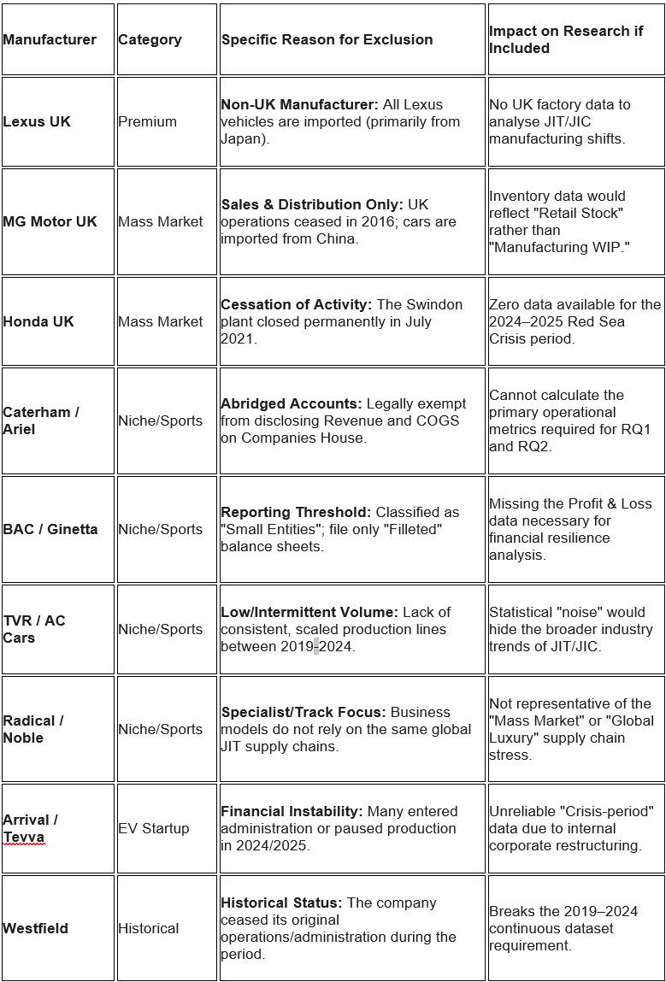

Appendix 2. Link with original files
- Excel Dataset
https://github.com/atanasovaivilina-Master/Dissertation-Data/blob/main/financials_panel_updated%20model_fact%20table.xlsx

- Power BI Model
https://github.com/atanasovaivilina-Master/Dissertation-Data/blob/main/Dissertation%20Model_Ivilina_Final.pbix

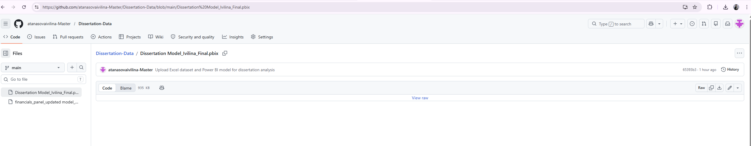
The dataset and analytical model used in this study are publicly hosted on GitHub, making them transparent, accurate, and open to external verification. Along with the original Excel dataset, the repository also contains Power BI (.pbix) model files that were used for data transformation, modelling, and visualisation.
The repository can be accessed by external users through the supplied link. To download the original file directly after selecting it, choose the "View raw" option. Data modelling, relationships, and dashboards created for this study can be fully replicated in the Power BI file, while the structured analytical dataset is contained in the Excel file.
If you come across any problems with access, you can request the files directly by sending an email to atanasovaivilina@gmail.com.
By encouraging methodological transparency and guaranteeing complete auditability of the analytical process, this approach is in line with best standards in empirical research.
The layout of the analytical model that underpins this study is presented in Figure 1 below, where the integration of firm-level operational data with macro-economic and logistical indicators provides a transparent and replicable assessment of supply chain resilience.
I have constructed and developed the model from first principles using a structured data modelling technique. The above Excel file was the main data basis, and was carefully created, cleaned, and modified before being deployed within Power BI. All variables – firm-level financial and operational measurements, industry classifications and external indicators – are supported by documented sources and well-defined assumptions to assure traceability and analytical integrity.
The model is star-schema based with a central fact table containing important operational measures such as production, inventories, costs and revenue coupled to dimension tables including time (Date Table) and corporate attributes. The model connects external datasets (e.g., macro supply chain stress indicators, marine traffic statistics) through common temporal correlations, facilitating the fusion of internal company performance with external indications of disruption.
This structure provides efficient filtering, cross-sectional comparison and time-series analysis, and facilitates generation of composite resilience indicators. Thus, the model supports replication and provides a robust and expandable analytical framework for assessing supply chain behaviour under interruption conditions.

Figure 1. Analytical Power BI Model


