Assignment 1
Network Operating systems and services
Callum Evans - 2116012
2024
Table of Contents
Introduction 2
Hypervisor 2
IP Addressing 3
Choosing a Hypervisor 3
Setting up Servers and Client PCs 4
References 12

Introduction
I have been given the task of both research and practical implementation. For the practical work, I must complete the task and document it with screenshots to show all the workings of the practical tasks. All the timestamps must be on the screenshots as this is part of the final marks' criteria. I must use an appropriate referencing style to in-text cite the research work.
I am required to build, deploy, configure, and manage a Virtualized network. I have been given the choice of virtualization, but I must consider the availability of the resources before deciding on my implementation.
I have been asked to bring up a network from both locations (Swansea and London) from looking at the topology, I have been asked to set up a virtualized network. After the hypervisor is chosen and once the network is set per the topology, I must research IP Addressing, once that is done, I must use appropriate IP addresses to configure that network, then the network must be tested to ensure that both PCs can ping to each of their servers and client to client, and server to server.

Hypervisor
www.redhat.com. (2023) talks about how hypervisors, or VMM, are software that creates and manages virtual machines, isolating them from the host operating system. The host, the physical hardware acting as a hypervisor, serves multiple VM guests, allocating and reallocating CPU, memory, and storage resources as needed. OS-level components, including memory and process managers, device drives, and security features, are essential for hypervisors to run VMs efficiently. The hypervisor schedules resources for each VM while the physical hardware executes instructions.
Virtualization, enabled by a hypervisor, allows multiple operating systems to coexist on the same hardware, a key advantage compared to non-virtualized environments. Various hypervisor options are available, with VMware’s ESXI and vSphere being popular. OpenAI. (2024).
  - Type 1 or Type 2
A bare metal hypervisor, also known as a type 1 hypervisor, directly interfaces with the underlying hardware of the host machine. Installed directly on the physical hardware without relying on an operating system, it may even be embedded in the machine’s firmware in certain instances. Amazon Web Services, Inc. (n.d.). This type of hypervisor engages directly with server hardware, assigning dedicated resources to virtual machines and accommodating flexible resource sharing based on different VM requirements.
According to Pankevych, O. (2023). A type 2 hypervisor operates on top of supported operating systems, utilizing the OS’s drivers to communicate with hardware. Examples of Type 2 hypervisors include Oracle Virtual Box and VMware Workstation. Unlike type 1, type 2 hypervisors run within the OS as an application, sharing resources with mother programs. They are designed for single computer use and lack support for clustering and certain advanced features such as virtual storage organization and multiuser access. Type 2 enables users to run additional operating system environments for specific purposes, such as a professional using virtualization on a personal laptop to run a VM with corporate applications and network access.

  - Advantages and Disadvantages of VMware and Oracle
VMware Advantages | VMware Disadvantages | Oracle Advantages | Oracle Disadvantages
Snapshots and Cloning. Vmware has something called Snapshots, which allows users to take a “snapshot” of VMs a certain times to allow the users to have a backup. | The reliability of VMware is compromised due to potential hardware incompatibilities that may not be supported. Consequently, assessing the stability of the VMware software becomes challenging. | Increased effectiveness and lower costs, According to InterviewBit. (2021). VB enables users to leverage virtualization on their personal computers at a reduced expense and higher speed. It aids users in establishing a simulation of an operating system, reducing hardware expenditures while enhancing productivity and efficiency. | Less efficient. VMs within VB exhibit inefficiency when contrasted with physical machines. Certain requests necessitate approval from the host processor, as they are executed on the host system. Consequently, this leads to slower usability.
Simplified Data centre management | High Licensing fees | Oracle VB is a general-purpose full virtualizer for x86 hardware, targeted at server desktop and embedded use. | Oracle only offers limited support for 3D graphics, whereas VMware has better and more high-level 3d graphic support with DX10.
www.ibm.com. (n.d.). States that VMware has over 500,000 customers. A network of 75,000 partners supports customers with a wide variety of add-on products and services. | VMware has a massive cost. With VMware, you need to purchase licenses, subscriptions, or support plans to use it. | Oracle VB is functional on MAC computers as VMware cannot work on MAC devices. | VB isn’t as good as VMware when it comes to using CPU and memory utilization. Geekboots (2019).

IP Addressing
  - How does data get from one computer to another on the Internet and what is the role of IP addresses in the transmission of data on the Internet?
Transmission of data across the internet involves a systematic process where information is divided into packets, each containing details about the source, destination, and its position in the data sequence. Vital to this process are IP addresses, unique identifiers assigned to every internet-connected device. IPv4 or IPv6 plays a big role in pinpointing the origin and destination of data packets.
Facilitating the communication between applications on different devices is the TCP and UDP. TCP ensures reliable, connection-oriented communication, guaranteeing accurate and ordered data delivery. OpenAI. (2024).
As data packets traverse the internet, passing through various networks and routers, their journey concludes upon reaching the destination network. At this point, the packets are reassembled into the original data by the receiving computer. The final stage involves the delivery of the data to the intended application or service on the receiving computer.
The role of IP addresses as digital identifiers is fundamental to the precise routing of data packets from source to destination, ensuring efficient and reliable communication between computers on the internet.
  - How do you think routers and switches work on the Internet to facilitate the flow of data between different networks?
Routers and switches are huge in enabling smooth data flow across the internet. Routers, operating at the network layer, intelligently route data based on IP addresses using dynamic tables and protocols. They interconnect networks globally, forming the internet backbone.
Switches, at the data link layer, forward data within networks using MAC addresses, creating isolated domains, and supporting VLANs. When these are collaborating it ensures reliability, security, and efficient data transmission. Routers facilitate inter-network communication, while switches optimize intra-network data flow.

Choosing a Hypervisor
For choosing my hypervisor for setting up the network is an easier choice than it seems. I used VMware while at work, so for me using VMware was not even a choice as it something I am more comfortable with. But there are some reasons why I prefer VMware Workstation over Oracle VirtualBox.
VMware is recognized for its great performance and stability, ensuring a reliable virtualization experience. This makes it particularly appealing for professional and enterprise applications. According to www.linkedin.com. (n.d.) VMware stands out for its extensive compatibility with diverse operating systems, encompassing Windows, Linux, Mac OD, Solaris, FreeBSD, and beyond. Its vibrant and engaged community, comprising users and developers, contributes valuable resources, documentation, and support. The platform boasts advanced functionalities like snapshots, cloning, live migration, and high availability, elevating the virtualization experience. Recognized for its stability and security, VMware is acknowledged to have fewer bugs and vulnerabilities compared to Hyper-V.
So, for these reasons, I will be using VMware Workstation 17.

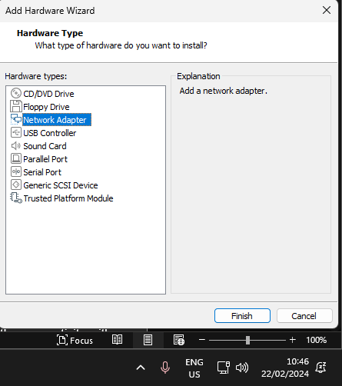
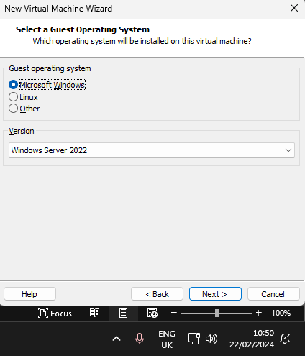
Setting up Servers and Client PCs

For the Swansea server and the London server, I will be choosing to use Windows Server 2022, this reasoning is because using up-to-date versions means that it’s the most secure and most recently updated version. When setting up the servers before anything I added another Network adapter as per the topology.
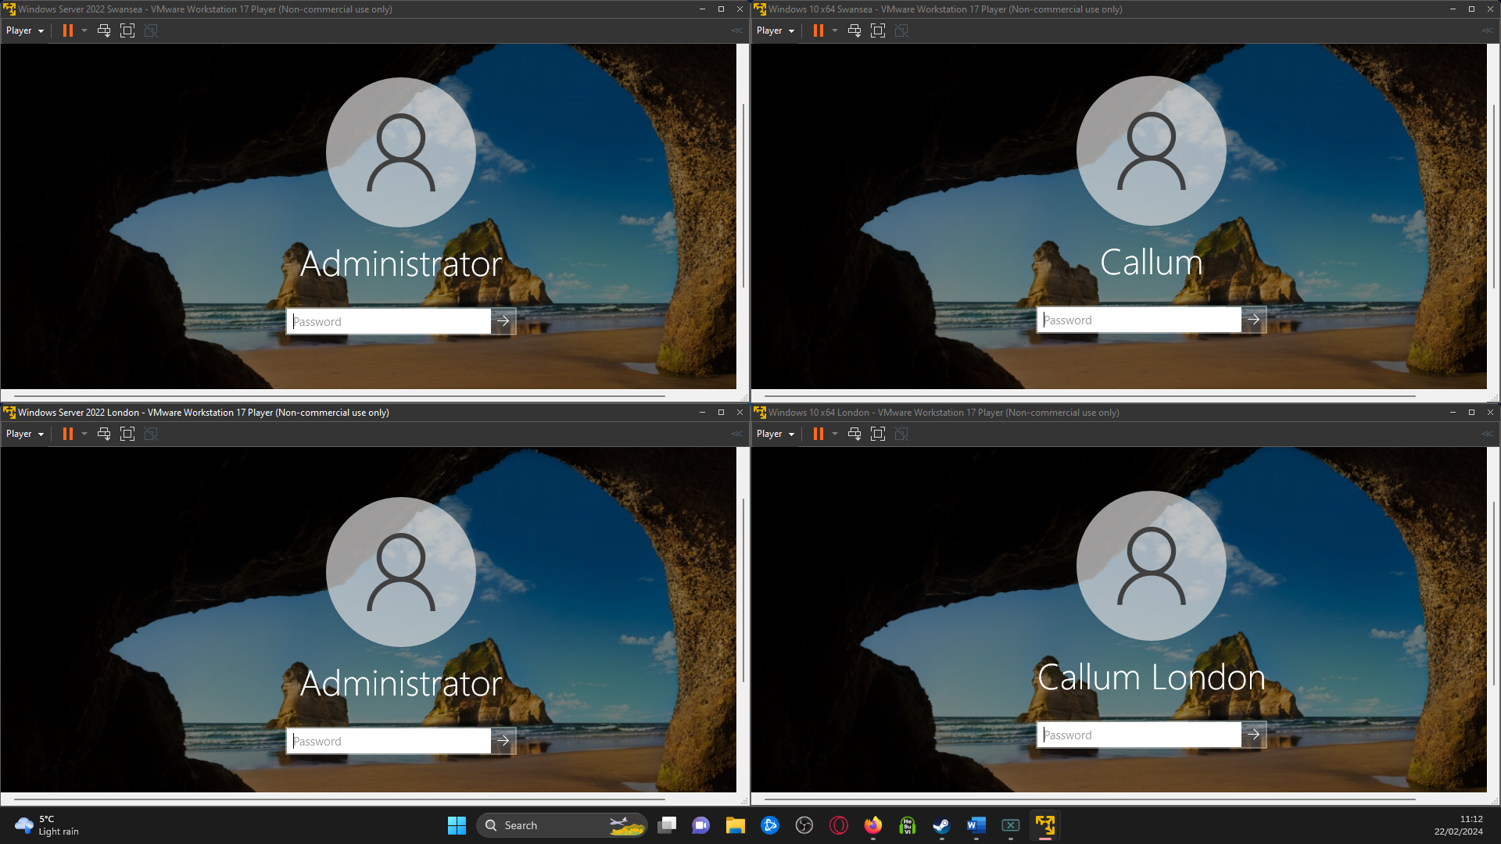
Now you can see the Servers and Client PC are set up. Both Servers (London and Swansea) are named administrators, and the Client PC for Swansea is just called Callum, and the London PC is called Callum London.
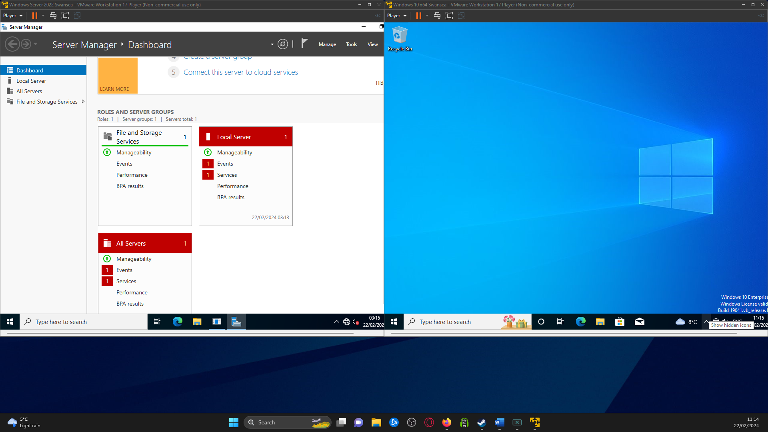
These are both the Swansea Server and Swansea Client PC. The server is on the LEFT and the PC is on the RIGHT.
Per the Topology I have to assign these two their IP addresses so they can communicate to each other.
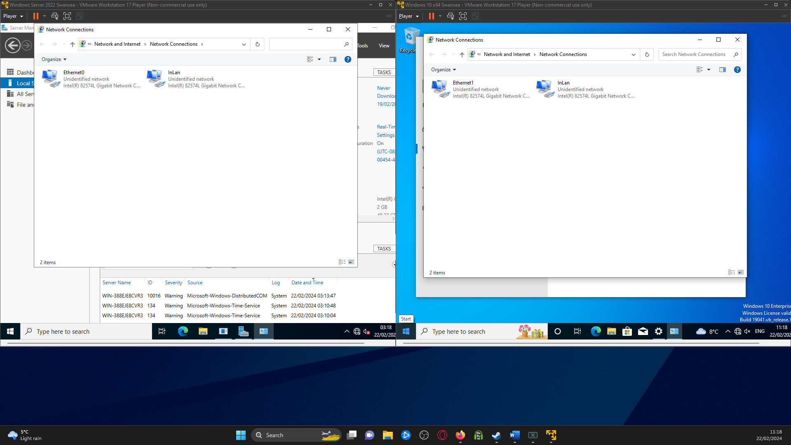
Going into the Network settings in both you can see the network adapters that I added earlier and now have changed the name of them to InLan so it is easily identifiable.
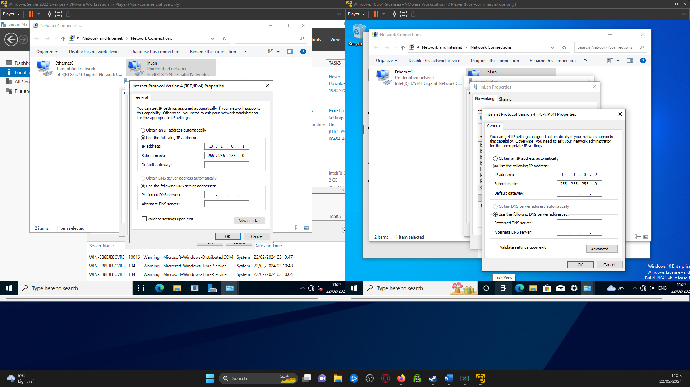
As per the topology, the InLan network adapters have both been set to 10.1.0.1 and 10.1.0.2, with both having the same subnet mask of 255.255.255.0 for the IPv4 addresses.
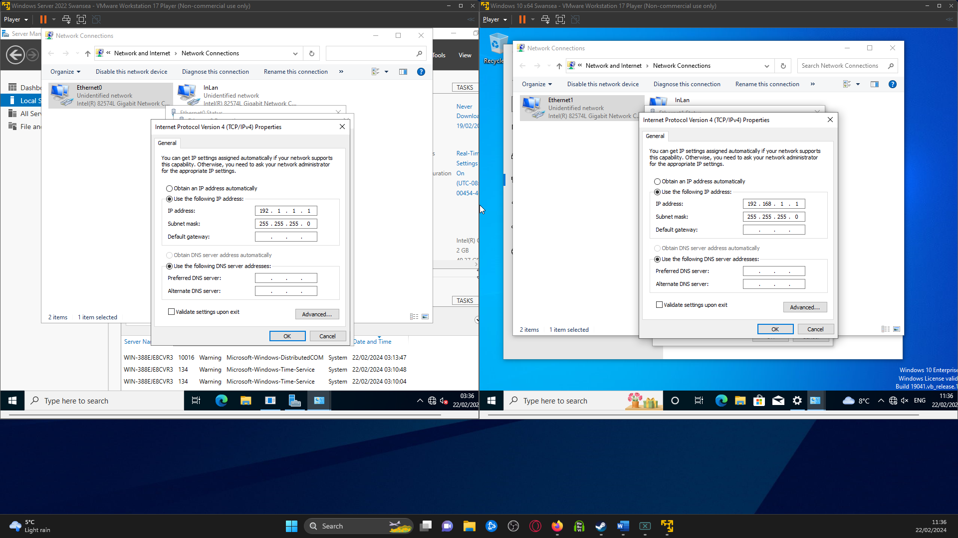
Now looking at the other network adapter these are for the 192 addresses, I wasn’t sure what 192 address to use for the Client PC so I tested using 192.168.1.1 and this seemed to work fine for what I needed it for. Of course, the server-side needed to have 192.1.1.1 as per the topology.

Now it's time to test the server pings to the Client and the Client pings to the server.
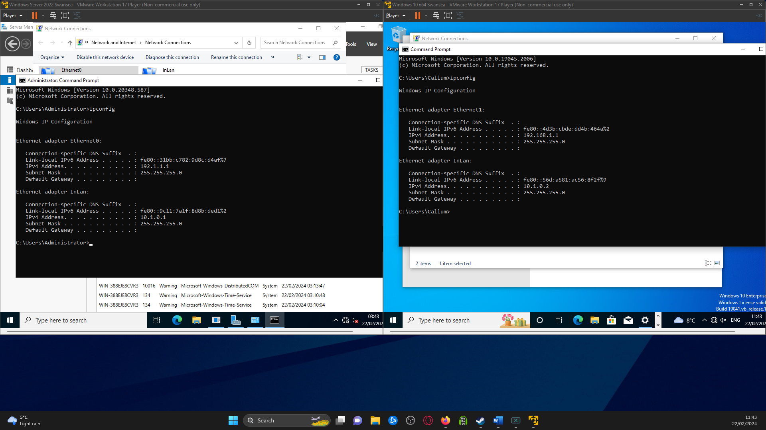
Now onto opening up the command line, and using IPCONFIG to double-check that all the IPs have been set and are correct, which you can see in the screenshots.
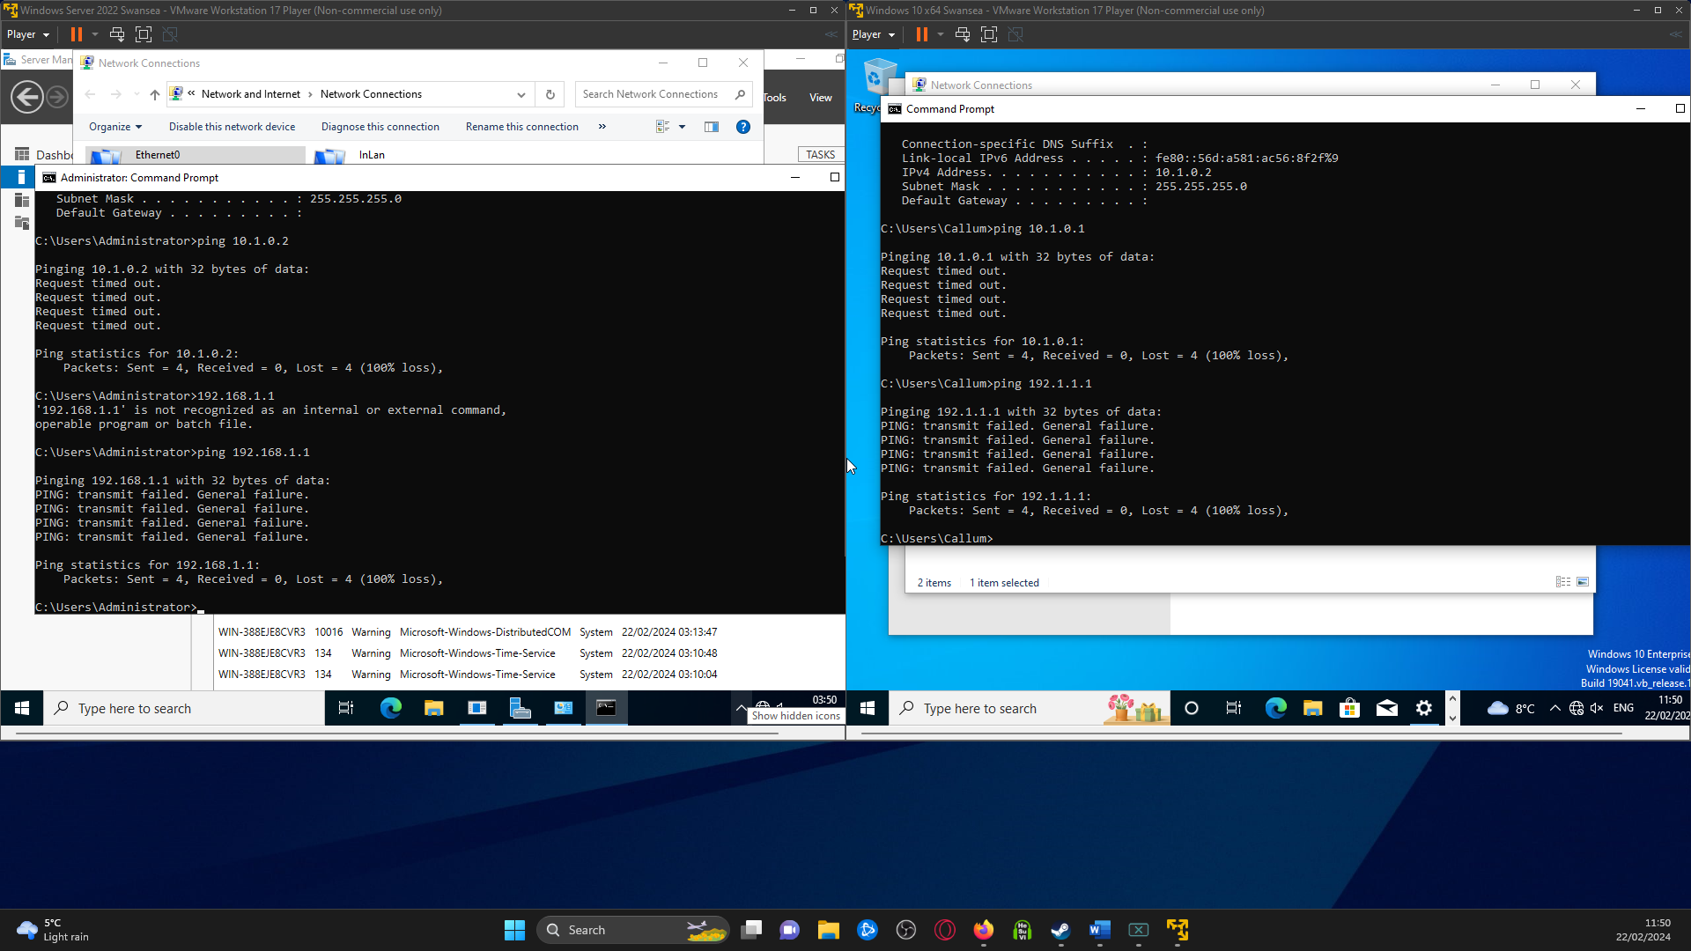
I’ve tried to ping both 10. And 192. Addresses. The 10. The address has come back on both with the request timed out and the 192. The address came back with PING: transmit failed. General failure. So, I'm going to have to troubleshoot why these cannot ping back and forth.
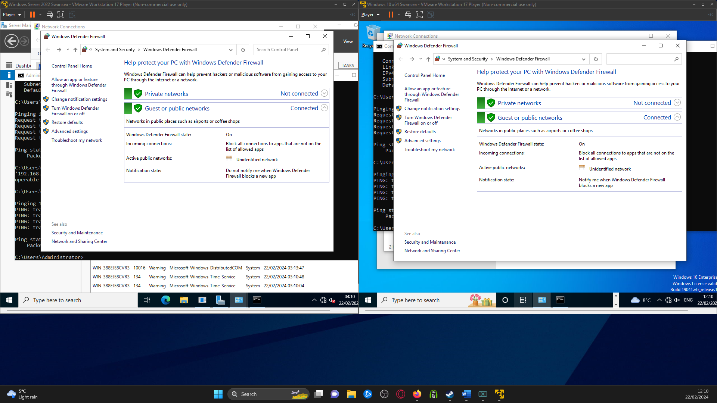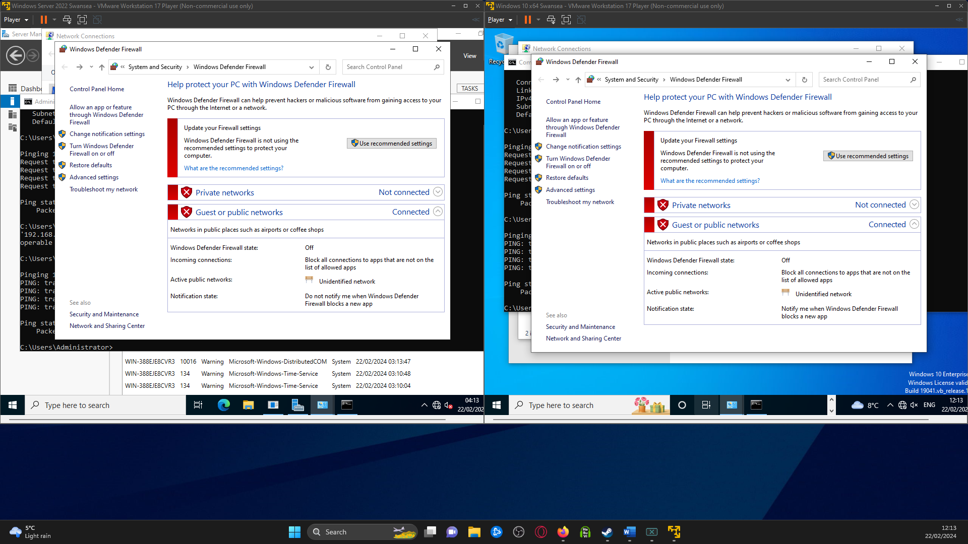
So, after trying to troubleshoot I realised that I didn’t disable the firewall for the server and the Client's PC, so I’ll disable this and try and ping back and forth again and see if that’s the reason it wouldn’t ping.
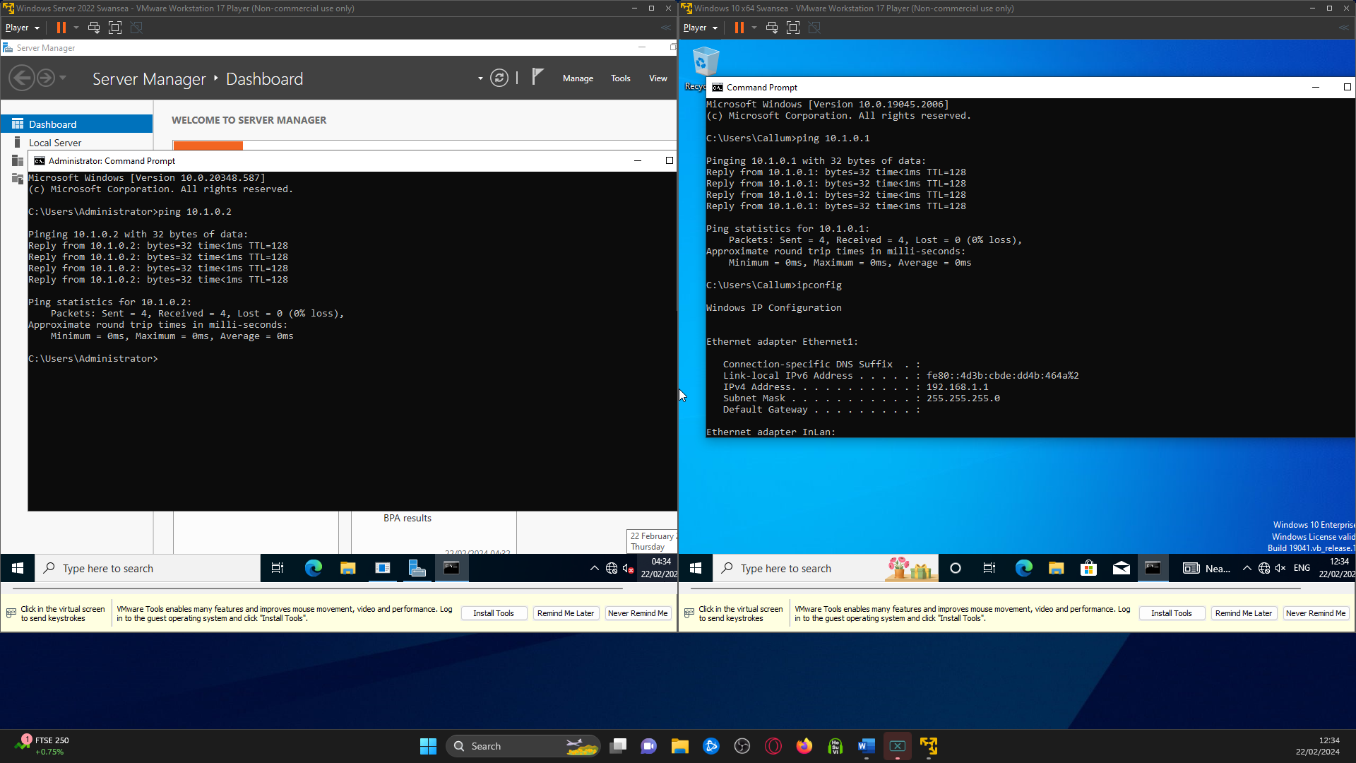
So, after turning off the firewall on the Swansea Client and Server, you can see that they both successfully ping back and forth with each other. This shows that the Swansea server and Client are both set and now need to move onto the London Server and Client
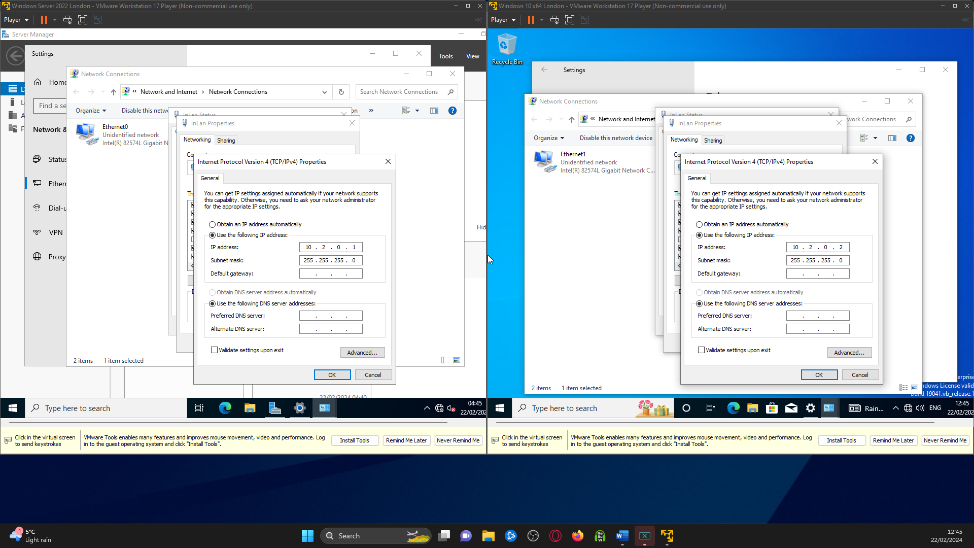
The image above shows both the London server and the London client's InLan IP addresses. Using 10.2.0.1 and 10.2.0.2.
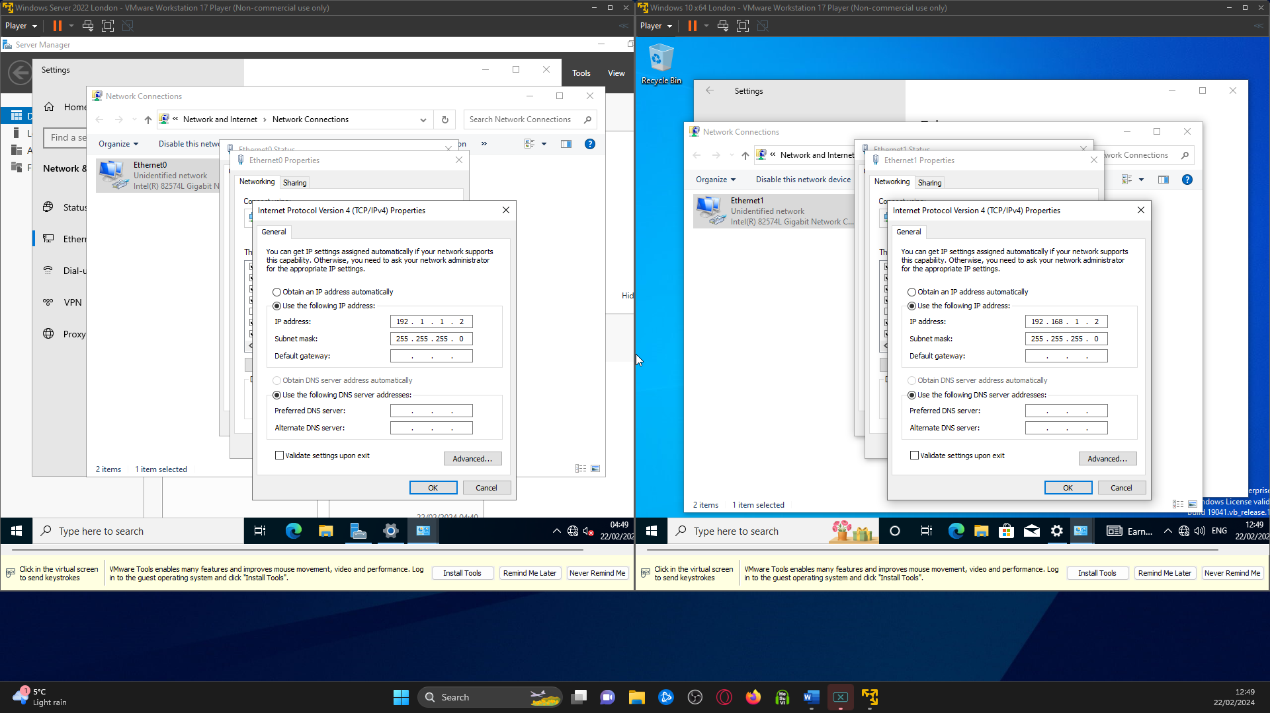
From this screenshot, it shows that the other network adapter has been set this the IP above. The 192.1.1.2 is per the topology. Now it’s time to check that the firewall is off and these can ping. 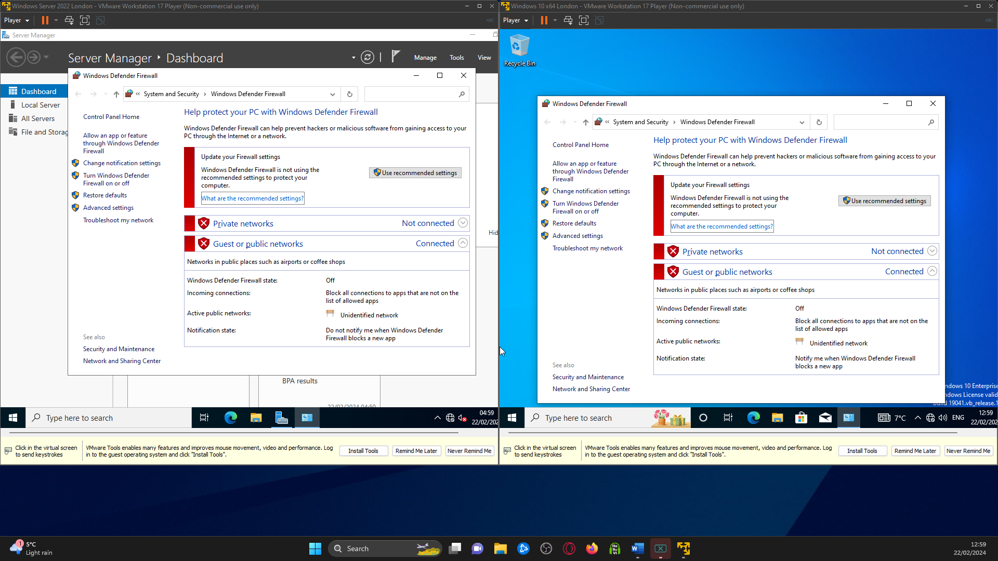
Both firewalls have been disabled and are ready to test the pings.
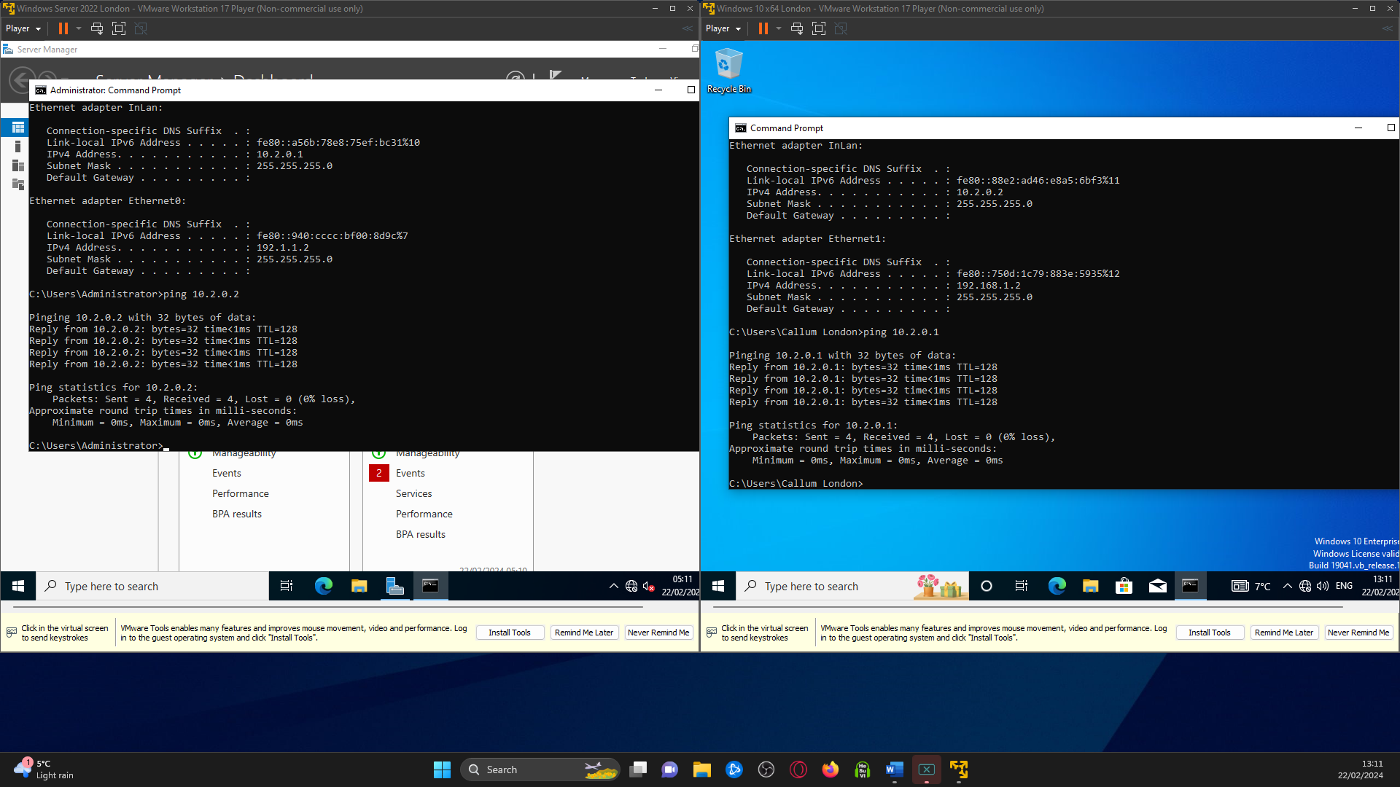
This shows that both London Server and Client have been able to ping each other. So we have both Swansea pinging and London pinging
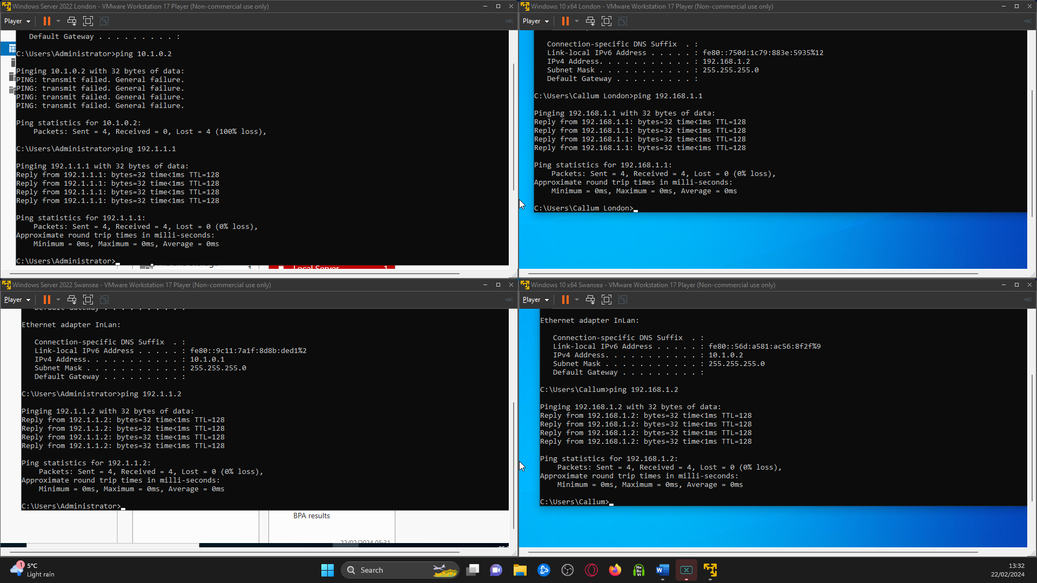
In this final screenshot, it shows that the servers can ping each other. So, the Swansea server pings to the London Server and the Swansea Client pings to the London Client
So now Servers ping to Servers, Client ping to Clients, Swansea Client pings to Swansea Server, and London Client pings to London Server

References
www.redhat.com. (2023). What is a hypervisor? [online] Available at: https://www.redhat.com/en/topics/virtualization/what-is-a-hypervisor.
OpenAI. (2024). ChatGPT (3.5) [Large language model]. https://chat.openai.com
Amazon Web Services, Inc. (n.d.). Type 1 vs Type 2 Hypervisors - Difference Between Hypervisor Types - AWS. [online] Available at: https://aws.amazon.com/compare/the-difference-between-type-1-and-type-2-hypervisors/.
Pankevych, O. (2023). Type 1 vs. Type 2 Hypervisor: What Is The Difference? [online] StarWind Blog. Available at: https://www.starwindsoftware.com/blog/type-1-vs-type-2-hypervisor-what-is-the-difference.
www.linkedin.com. (n.d.). What are the pros and cons of using VMware vs Hyper-V for Windows OS? [online] Available at: https://www.linkedin.com/advice/1/what-pros-cons-using-vmware-vs-hyper-v-windows.
InterviewBit. (2021). VMware vs VirtualBox: What’s The Difference? [online] Available at: https://www.interviewbit.com/blog/vmware-vs-virtualbox/.
Learning, G. (2022). VMware vs VirtualBox: What is the Difference? [online] Great Learning Blog: Free Resources What Matters to Shape Your Career! Available at: https://www.mygreatlearning.com/blog/vmware-vs-virtualbox/#vmware-disadvantages.
www.ibm.com. (n.d.). VMware: An Essential Guide | IBM. [online] Available at: https://www.ibm.com/topics/vmware.
Geekboots (2019). Advantages and disadvantages of VirtualBox over VMWare | Geekboots Story. [online] Geekboots.com. Available at: https://www.geekboots.com/story/advantages-and-disadvantages-of-virtualbox-over-vmware.

‌
‌

‌

‌

