BA Business Management
University of Wales Trinity Saint David

Accounting Fundamentals
Module code: LCBB4001

Student name: VALENTINA SIMONA DUROIU
Id number: 2021942

Table of Contents
Introduction 3
QUESTION-1:— 4
1.1.: KEDISON’s Statement/Sheet-related Arrangements with respect to(w.r.t.) year’s concluding date {31St Dec.,‘20} 4
1.2.: Rationalising out the obligatory “Tally” factor for the “FINANCIAL POSITION/STATUS—STATEMENT” 8
QUESTION-2:— 11
2.1.: Calculate the following ratios for Chocco plc for 2020 and 2019, showing the formulas and workings 11
2.2.: Using collected ‘CHOCCO PLC’-related data to comment about its finance-based status with performance 23
Conclusion 25
References 26

Introduction
The fundamentals of business accounting relate to the basic underlying concepts that build up the entire discipline of accountancy. Having basic accounting knowledge is very crucial and hence, this report will be focusing on this topic. This report will basically be concentrating precisely upon two questions, both of which are related to the basic understanding of business accountancy. One of the questions will be looking into the way an official financial report is constructed by PLCs using pre-recorded accounting data. Another question will be focusing on how performance-implying ratios can be correctly computed and interpreted to figure out a company’s immediate finance-related status and their pattern of performance across two periods.

QUESTION-1:—

1.1.: KEDISON’s Statement/Sheet-related Arrangements with respect to(w.r.t.) year’s concluding date {31St Dec.,‘20}
i.]: KEDISON’s Statement/Sheet Structure for—P/L STATEMENT:
P/L—STATEMENT
w.r.t. concluding date—31St Dec.,‘20
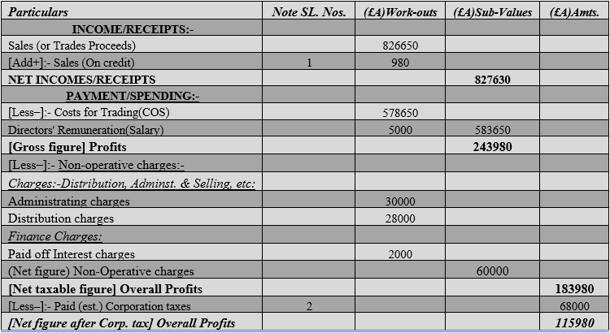

STATEMENT INSPECTION:
Here, first and foremost ‘KEDISON’ firm’s end result of their official “P/L—STATEMENT” has been designed and put forth using all the collective data pre-specified about their balances on the concluding/end date (31-12-2020). Let it be mentioned that the above-presented document is a comprehensive version reflecting their (2020) year's profits (or their losses) that have been deduced out of every undertaken money exchanging affair spread across the entire (2020) year. (The details of additional work-outs that could not be presented here will conclusively be disclosed as “Comprehensive Note Workings” right when all official documents are done being created). On in-depth inspection, ‘KEDISON’ firm seems to have done incredibly well in bringing forth good figures of conclusive profits(£115,980). This hints at the fact that it has been able to handle its spending limits whilst also bringing up good figures of turnovers(£826,650) through some productive sales. It can now be assumed that ‘KEDISON’ firm’s management board will use this extra cash for reinvestment or dividend dispersion as per their better judgements. This will entirely depend upon ‘KEDISON’ firm’s management board since the ultimate decision-making authority is held by them. A firm’s ultimate profits can be utilised in a number of ways. The firm will have to evaluate and appraise all their choices thoroughly and well before any final decision can be made. Some firms find it best and more preferable to distribute their extra profits among their equity holders. This is dividend distribution. Some other firms might think that reinvestment of this extra profit into the critical and deteriorating areas of their business will be more beneficial for them, and hence, might choose reinvestment as an option to build upon their growth.

ii.]: KEDISON’s Statement/Sheet Structure for—FINANCIAL POSITION/STATUS:
FINANCIAL POSITION—STATEMENT
w.r.t. concluding date—31St Dec.,‘20
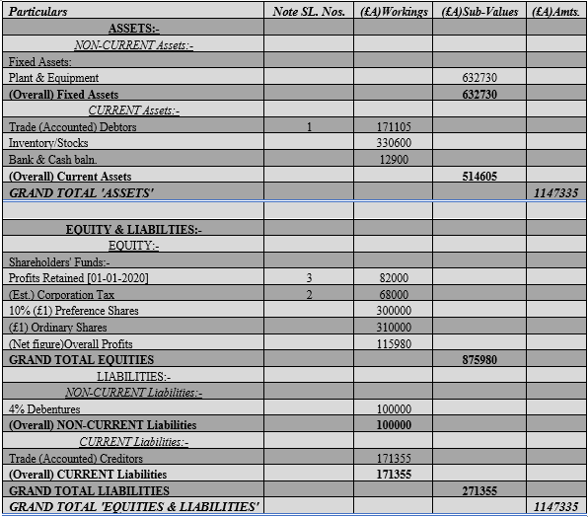

STATEMENT INSPECTION:
Here, secondly ‘KEDISON’ firm’s end result of their official “FINANCIAL POSITION—STATEMENT” has been designed and put forth using all the collective data pre-specified about their balances on the concluding/end date (31-12-2020). Let it be mentioned that the above-presented document is a comprehensive version reflecting their (2020) year’s conclusive accounted for book figures that have been deduced out of every undertaken money exchanging affair spread across the entire (2020) year. (The details of additional work-outs that could not be presented here will conclusively be disclosed as “Comprehensive Note Workings” right when all official documents are done being created). On in-depth inspection, ‘KEDISON’ firm seems to have done incredibly well in balancing out its liabilities with assets(£1,147,335). This hints at the fact that it has been able to expertly handle its overall asset figures into clearing out all its standing/arrear debts. It also means that they could set a balance on the overall debt actions they take up with the assets they already have while simultaneously capitalising on them. It can now be assumed that ‘KEDISON’ firm’s management board will continue to grow their asset possessions while limiting out their borrowings as per their better judgements. There are many ways that a firm can enrich their immediate financial standing. Building one’s entire list of wealth is one of these ways. Making one’s assets grow or increasing their value or quantity isa good measure against future repayments of loan advances or any other liabilities. If ‘KEDISON’ firm’s management board is successfully able to do this in the upcoming years, then they will not have to worry about going bankrupt or losing on its liquidity or solvency while simply repaying its loan advances and other similar borrowings. However, the firm must find a balance to growing their assets as becoming solely focused on growing assets might make them lose out on other critical aspects of their business. This might instead later end up in a bigger loss. Hence, ‘KEDISON’ must work cautiously towards maintaining their assets to liability.
‘COMPREHENSIVE NOTE WORKINGS’ for all kinds of additions done inside the components ranked under column “Note SL. Nos.”:
[1]:- Modified “ACCOUNT/TRADE DEBTORS” component (as was alike for “SALES”):
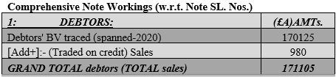
[2]:- NOTE disclosing the reasons and ways modification was made to component “(Est.) CORPORATION TAX”:
An estimate of the (2020) year’s “(Est.) CORPORATION TAX” amounting to £68000 was stated in question. This is usually deducted depending upon a firm’s taxable profit figures. Hence, once the net taxable profit was discovered, “(Est.) CORPORATION TAX” was deducted from it to get the last remaining income (inside statement—P/L). As ‘KEDISON’ is a PLC, it compulsorily abides by rule—“DOUBLE-ENTRY” for which the tax needs to be included in another place. So, it is demonstrated as an “EQUITY” item (inside statement—financial position/status).
[3]:- “PROFITS RETAINED” comprehensively modified and shown:
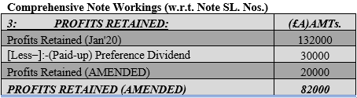

1.2.: Rationalising out the obligatory “Tally” factor for the “FINANCIAL POSITION/STATUS—STATEMENT”
“FINANCIAL POSITION/STATUS—STATEMENT”:
Before answering the question, firstly, the “FINANCIAL POSITION/STATUS—STATEMENT” needs to be thoroughly understood. This is one of the KFS or Key Finance-related Statements and is usually known to be created by business’s accountants at the absolute end. This end is commonly the concluding accountancy calendar date or simply after 12 months of business affairs have taken place (McInnis, 2019). The official document is a kind of last status report that shows how (‘KEDISON’) stands in terms of its liquidity and overall business-related solvency and hence, is considered very valuable by interested stakeholder parties. The structure basics present two columnar regions/sides containing two individual lists of ‘KEDISON’ firm’s wealth that is currently in possession (dubbed as “ASSETS”) and the obligatory borrowings that it is bound to, externally (dubbed as “EQUITY & LIABILITY”) (Hart, 2019). Under normal circumstances, these two stated lists once satisfactorily recorded, will turn out equivalent figures or book-based balances with identical likeliness. The sharing of this ‘alike’ feature originates way down from the abidance of one basic rule that rationalises this incidence.
“Bookkeeping rule—DOUBLE-ENTRY”:
The one basic rule rationalising this incidence is ‘KEDISON’ firm’s explicit abidance of rule—“DOUBLE-ENTRY”, a globally or internationally approved business bookkeeping rule. In basic sense, the rule’s concept is extremely intuitive and can be inferred from the given name (Marder, 2016). Simply stated, it hints at the fact that every money-based exchange or event compulsorily have to be penned down inside two opposing-featured sites or locations while bookkeeping is done by KEDISON’s accountant. These dual entry sites are once meant for the outward-bound cash (debit) and again meant for the inward-bound one (credit). Due to their disparate character (debit= spent money, asset rising, or equity/liability lowering; and credit= received money, asset lowering, or equity/liability rising), when duly penned, they negate or cancel-out each other (Smith, 2020).
Following an example- supposing ‘KEDISON’ firm has some business loans/borrowings that are being paid-off. Paying off loans means money will be moving out of accounts as it is a ‘spending’ and hence, is penned as debited money. This resultingly lowers KEDISON’s ‘liability’. However, this concurrently means KEDISON’s cash ‘asset’ levels are getting lowered too and by that same paid-off amount. This, thus, is penned as credited money. Hence, due to this equivalent rise and fall, its final reported balances (inside financial status statement) will tally or so-called “balance out” as well.
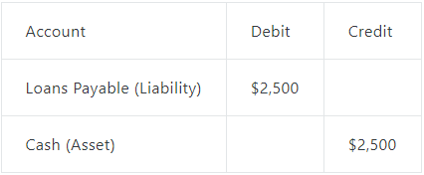
Source- (Marder, 2016)

QUESTION-2:—

2.1.: Calculate the following ratios for Chocco plc for 2020 and 2019, showing the formulas and workings
1. Calculation of ROCE (Return on Capital Employed)
ROCE formula is provided below,
ROCE = $\frac{Operated Income (EBIT)}{Capital Employed (CE)}$
ROCE of Chocco plc for the year 2020
Information needed for computation,
Operating Income = £846
Capital Employed = Total Assets – CL (Current Liabilities)
Here, Total Assets = £9736
CL = £2511
Hence, CE = £9736 - £2511 -= £7225
Application of the formula using the information,
ROCE = $\frac{£805}{ £7225}$
= £0.117 or £0.12 (Ans.)
ROCE of Chocco plc for the year 2019
Information needed for computation,
Operating Income = £730
Capital Employed = Total Assets – CL (Current Liabilities)
Here, Total Assets = £10087
CL = £3046
Hence, CE = £10087- £3046-= £7041
Application of the formula using the information,
ROCE = $\frac{£730}{ £7041}$
= £0.104 or £0.10 (Ans.)
2. Calculation of ROE (Return on Equity)
ROE formula is provided below,
ROE = $\frac{Net Earnings (NR)}{Shareholders^{'} Equity (SE)}$
ROE of Chocco plc for the year 2020
Information needed for computation,
NE = £431
SE = Equity (Grossed) – Payments of Dividends
Here, Equity (Grossed) = £3,088
Payments of Dividends = £255
Hence, SE = £3,088 - £255 = £2833
Application of the formula using the information,
ROE = $\frac{£ 431}{£ 2833}$
= £ 0.152 or £0.15 (Ans.)
ROE of Chocco plc for the year 2019
Information needed for computation,
NE = £366
SE = Equity (Grossed) – Payments of Dividends
Here, Equity (Grossed) = £2912
Payments of Dividends = £242
Hence, SE = £2912- £242 = £2670
Application of the formula using the information,
ROE = $\frac{£ 366}{£2670}$
= £ 0.137 or £0.14 (Ans.)
3. Calculation of EPS (Earnings Per Share)
EPS formula is provided below,
EPS = $\frac{Net Earbnings \left(NR\right) - Prefernce Dividends }{Outstanding Shares }$
EPS of Chocco plc for the year 2020
Information needed for computation,
NE = £431
Preference dividends Dividends=£NIL
Outstanding Shares = 206 shares
Application of the formula using the information,
EPS =$\frac{£431 - nil}{206 Shares}$
= £2.092 or £2.10 (Ans.)
EPS of Chocco plc for the year 2019
Information needed for computation,
NE = £366
Preference dividends Dividends=£NIL
Outstanding Shares = 268 shares
Application of the formula using the information,
EPS =$\frac{£366 – nil}{268 Shares}$
= £1.365 or £1.37 (Ans.)
4. Calculation of NPM (Net Profit Margin)
NPM formula is provided below,
NPM =$\frac{Net Earnings (NE)}{Total Earnings } * 100$
NPM of Chocco plc for the year 2020
Information needed for computation,
NE = £431
Total Earnings = £6738
Application of the formula using the information,
NPM =$\frac{£ 431}{£ 6738 } * 100$
= 6.396% or 6.40% (Ans.)
NPM of Chocco plc for the year 2019
Information needed for computation,
NE = £366
Total Earnings = £6,441
Application of the formula using the information,
NPM =$\frac{£ 366}{ £ 6,441 } * 100$
= 5.682% or 6.70% (Ans.)
5. Calculation of Asset Turnover Ratio
Asset Turnover Ratio formula is provided below,
Asset Turnover Ratio =$\frac{ Earnings (SALES)}{Average Assets }$
Asset Turnover Ratio of Chocco plc for the year 2020
Information needed for computation,
Earnings = £6,738
Average Assets =$\frac{ Opening assets + Closing assets}{2}$
Opening Assets = £10,087
Closing Assets = £9,736
Hence, Average Assets =$\frac{£ 10,087 + £ 9,736}{2}$
=$\frac{£ 19,823}{2}$
= £9,911.50
Application of the formula using the information,
A.T. Ratios =$\frac{£6,738}{ £ 9,911.50}$
= £0.679 or £0.68 (Ans.)
Asset Turnover Ratio of Chocco plc for the year 2019
Information needed for computation,
Earnings = £6,441
Average Assets =$\frac{ Opening assets + Closing assets}{2}$
Opening Assets = NIL
Closing Assets = £10,087
Hence, Average Assets =$\frac{£ NIL + £ 10,087}{2}$
=$\frac{£ 10,087}{2}$
= £5,043.50
Application of the formula using the information,
A.T. Ratios =$\frac{£ 6,441}{£ 5,043.50}$
= £1.277 or £1.30 (Ans.)
6. Calculation of Stock holding days
Stock holding day’s formula is provided below,
Stock holding days = $\frac{AVERAGE STOCK }{C.O.G.S. / 365 days}$
Stock holding days of Chocco plc for the year 2020
Information needed for computation,
Average Stock =$\frac{Opening Stocks + Closing Stocks}{2}$
Opening Stocks = £659
Ending Stocks = £708
Hence, Average Stock =$\frac{ £ 659 + £ 708}{2}$
=$\frac{£ 1,367}{2}$
= £683.50
C.O.G.S. = £3,235
Application of the formula using the information,
Stock holding days =$\frac{£ 683.50}{ £3,235 / 365 days}$
= $\frac{£ 683.50}{8.86}$
= 77.144 days or £77 days (Ans.)
Stock holding days of Chocco plc for the year 2019
Information needed for computation,
Average Stock =$\frac{Opening Stocks + Closing Stocks}{2}$
Opening Stocks = NIL
Ending Stocks = £659
Hence, Average Stock =$\frac{£ NIL + £ 659}{2}$
=$\frac{£ 659}{2}$
= £329.50
C.O.G.S. = £3,096
Application of the formula using the information,
Stock holding days =$\frac{£ 329.50}{£ 3,096 /365 days}$
= $\frac{£ 329.50}{8.48}$
= 38.85 days or £39 days (Ans.)

7. Calculation of debtors collection period
Debtors collection period formula is provided below,
Debtors collection period =$\frac{AVERAGED DEBTORS (AD)}{NET SALES / 365 days}$
Debtors collection period of Chocco plc for the year 2020
Information needed for computation,
Net Sales =£6,738
Average Debtors = $\frac{Opening Debtors + Closing Debtors}{2}$
Opening Debtors=£1,287
Closing Debtors=£1,249
Hence, Average Debtors=$\frac{£ 1,287 + £ 1,249}{2}$
=$\frac{£ 2,536}{2}$
= £1,268
Application of the formula using the information,
DC Periods =$\frac{£ 1,268}{£ 6,738/ 365 days}$
=$\frac{£ 1,268}{18.46}$
= 68.689 days or 69 days (Ans.)
Debtors collection period of Chocco plc for the year 2019
Information needed for computation,
Net Sales =£6,441
Average Debtors = $\frac{Opening Debtors + Closing Debtors}{2}$
Opening Debtors= NIL
Closing Debtors=£1,287
Hence, Average Debtors =$\frac{£ NIL + £ 1,287}{2}$
= $\frac{£ 1,287}{2}$
= £643.50
Application of the formula using the information,
DC Periods =$\frac{£ 643.50}{ £ 6,441/365 days}$
=$\frac{£ 643.50}{17.646}$
= 36.467 days or 36 days (Ans.)
8. Calculation of Current Ratio (CR)
CR = CA/CL
For 2020,
CA=£2,303
CL=£2,511
Application of the formula using the information,
CR =£2,303/£2,511
= £0.917 or being £0.92 (Ans.)
For 2019,
CA=£2,355
CL=£3,046
Application of the formula using the information,
CR =£2,355/£3,046
= £0.773 or £0.80 (Ans.)
9. Calculation of Gearing Ratio
Gearing Ratio = $\frac{LONG-term debt + SHORT-term debt + BANK O/D)}{SHAREHOLDERS^{'} EQUITY (S.E.)}$
For 2020,
Bank O/D = £NIL
Long-term debts=£4,137
Short-term debts=£2,511
SE = Equity (Grossed) – Payments of Dividends
Here, Equity (Grossed) = £3,088
Payments of Dividends = £255
Hence, SE = £3,088 - £255 = £2833
Application of the formula using the information,
Gearing Ratio =$\frac{£ 4,137 + £ 2,511+ £ NIL}{£ 2,833}$
= $\frac{£6,648}{£2,833}$
= £2.346 or £2.35 (Ans.)
For 2019,
Bank O/D = £NIL
Long-term debts=£4,129
Short-term debts=£3,046
SE = Equity (Grossed) – Payments of Dividends
Here, Equity (Grossed) = £2912
Payments of Dividends = £242
Hence, SE = £2912- £242 = £2670
Application of the formula using the information,
Gearing Ratio =$\frac{£ 4,129 + £ 3,046 + £ NIL}{£ 2670}$
=$\frac{£7,175}{£2,670}$
= £2.687 or £2.70 (Ans.)
10. Calculation of Interest Coverage Ratio
IC Ratio = $\frac{EBIT}{Interests Spending (IE)}$
For 2020,
EBIT=£846
IE=£226
Application of the formula using the information,
IC Ratios =$\frac{£ 846}{£ 226}$
= £3.743 or £4 (Ans.)
For 2019,
EBIT=£720
IE=£181
Application of the formula using the information,.
IC Ratios =$\frac{£ 720}{£ 181}$
=£3.977 or £4 (Ans.)

2.2.: Using collected ‘CHOCCO PLC’-related data to comment about its finance-based status with performance
This segment of question 2 has rigorously looked through the priorly discovered performance ratios to find out more about “CHOCCO PLC’s” immediate finance-based status together with its relative industrial performance. The performance disparity found here from ratios encompassed 2019-year along with 2020-year. Its return-producing deftness using accumulated equity was captured using ‘ROCE’, ‘ROE’ and ‘EPS’. All these three ratios rose in 2020-year from its prior inferior state in 2019-year. This hints at the fact that “CHOCCO PLC” must have satisfactorily and skilfully been able to put the right amounts of equities into the right and most preferable investments. Good equity or capital-steering skills that could magnify stockowners' surpluses was, therefore, seen here (Houston, 2019). “CHOCCO PLC’s” ‘net profit margin(NPM)’ has also risen well in 2020-year from its prior inferior state in 2019-year. This, further, hints at its good profitable status or its profit-producing deftness by controlling its spending ceiling and working well on making more revenue (Revolut, 2020).
“CHOCCO PLC’s” ‘Asset Turnover’, has fallen in 2020-year, while ‘Stock-holding days’ and ‘Debtor collection’ have risen during the same. These respective results hint at its deteriorating status concerning its efficiency factor. The firm was unable to preserve its deftness at making revenue from assets. It was also slacking in tightening up its credit-trading rules, and in balancing the selling and restocking of its storage items (Drakeley, 2019). Hence, “CHOCCO PLC’s” business efficiency can conclusively be stated to have dropped in 2020-year. With relative relation to understanding “CHOCCO PLC’s” liquidity, its ‘current ratio’ and ‘interest cover’ have come in handy. There was a slight rise in CR whilst there was a slight fall in interest cover. Although a rising CR is a good signal for liquidity, a falling interest cover can signal a future bankruptcy if immediately uncared for (StockEdge, 2018). However, both these ratios are way below their ideal industrial ranges and hence, means “CHOCCO PLC” will have to uplift its steer-handle on assets for clearing out borrowings. Its skilful use of revenues towards serving out all borrowings’ interests must be refined too. Hence, “CHOCCO PLC’s” business liquidity/solvency can conclusively be stated to have dropped in 2020-year. Lastly, it's slightly falling ‘gearing ratio’ hints at the fact that “CHOCCO PLC” might have turned towards managing finances conservatively. This is somewhat acceptable for a firm’s leveraging character as it is not too low or conversely, too high (Booth, 2019).
Conclusively, “CHOCCO PLC’s” liquidity and efficiency status were the only two concerning points with respect to the immediate 2020-year, which needs to be improved soon. Its profitability and leveraging performance were pretty good for the immediate 2020-year.

Conclusion
The report, so far, has demonstrated two explicit questions. One of them has demonstrated the skill of creating formal corporate financial reports. Here specifically, P/L and financial status reports have been created and discussed as was directed by first part of Q1. Its second part has critically been inspecting and finding out the most rational cause that makes a ‘balance sheet’ tally-up. These two parts of Q1 has been done for the pre-stated “KEDISON PLC”. The first part of Q2 has demonstrated a diversified knowledge of performance ratios, where ten kinds of ratios were computed by expertly applying the data as and where needed. The second part of Q2, which is also the last question of the report, has rigorously looked through all ratio results gotten in the prior question part and has used it to comment about the firm's immediate finance-related status and all-over performance. These two parts of Q2 has been done for the pre-stated “CHOCCO PLC”.

References

Booth, R., 2019. Gearing Ratios Explained – How to Use Leverage Analysis for Your Small Business. [Online]
Available at: https://www.brixx.com/gearing-ratios-explained-how-to-use-leverage-analysis-for-your-small-business-2/
Drakeley, P., 2019. How to calculate and interpret the inventory turnover ratio. [Online]
Available at: https://www.eazystock.com/uk/blog-uk/calculating-inventory-turnover-ratio/
Hart, M., 2019. The Beginner's Guide to Balance Sheets. [Online]
Available at: https://blog.hubspot.com/sales/balance-sheet
Houston, I., 2019. Return on capital employed - what it is and why it matters. [Online]
Available at: https://www.scholesca.co.uk/blog/return-on-capital-employed-what-it-is-and-why-it-matters
Marder, A., 2016. Double Entry Accounting Examples and Explanation. [Online]
Available at: https://blog.capterra.com/double-entry-accounting-examples-and-explanation/
McInnis, F., 2019. Understanding a Balance sheet (Definition and Examples). [Online]
Available at: https://bench.co/blog/accounting/balance-sheet/
Revolut, 2020. What are the three main profitability ratios and how do you calculate them?. [Online]

Available at: https://blog.revolut.com/main-profitability-ratios/
Smith, R., 2020. A Relatively Painless Guide to Double-Entry Accounting. [Online]
Available at: https://bench.co/blog/accounting/double-entry-accounting/
StockEdge, 2018. Interest Coverage Ratio: How to calculate & Definition. [Online]
Available at: https://blog.stockedge.com/interest-coverage-ratio/

