Site Set up Phases

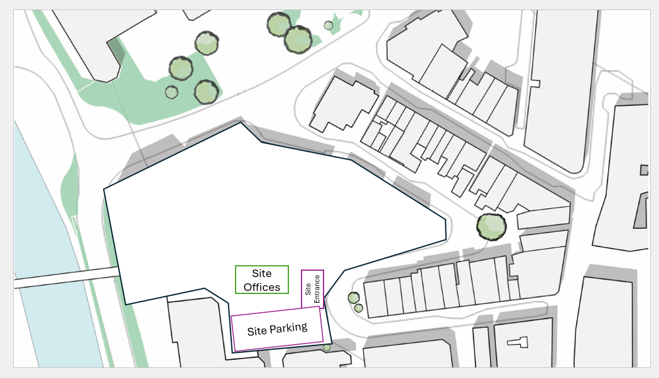

The initial site set up shows the hoarding that will be placed around the site to ensure site safety. The initial project would be for a site scrape back and clearance, following this a hard standing will be set down for site offices, site entrance and site parking. The site entrance will be to the west of the site to minimise site traffic disruption to the main roads. On site parking will be used to ensure that construction vehicles do not disturb the surrounding businesses. An overflow parking can be accessed on the other side of the river on the university campus.
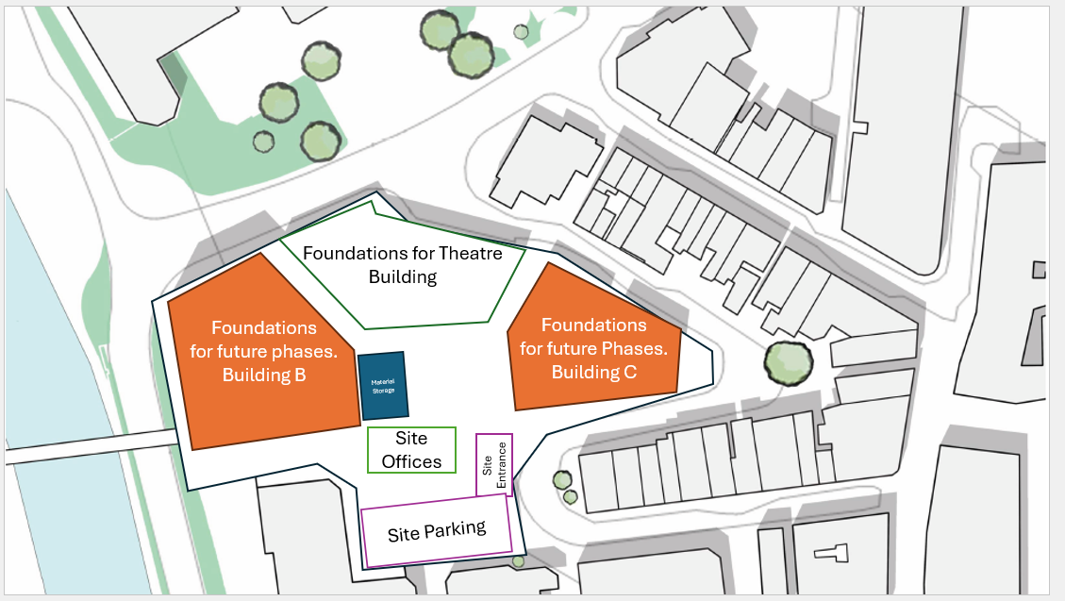

The site will remain hoarded off for the duration of the works, the hardstanding area to the site office, entrance and site parking will also remain. Foundations will be set out and extraction piles installed, stating with the theatre building. A material storage will also be set up to fence of materials for storage purposes, this will include lockable storage as well as ventilated areas.
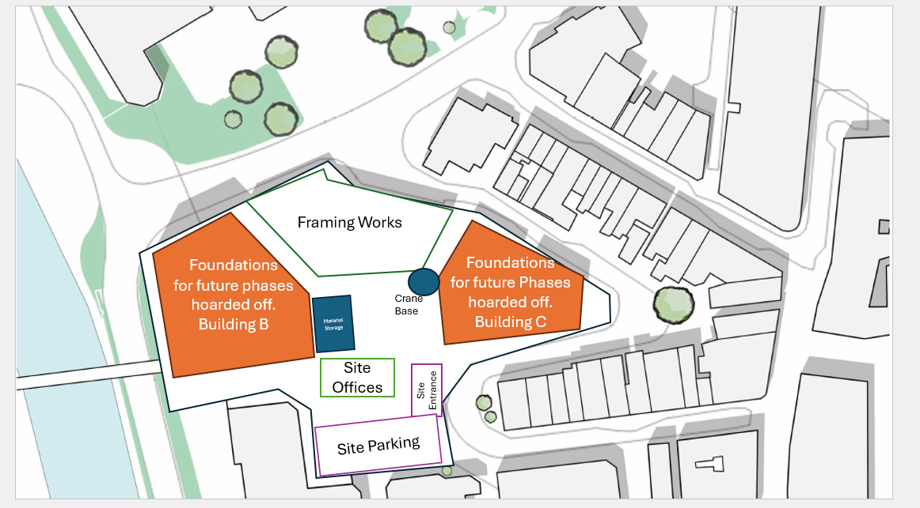

The site will remain hoarded off for the duration of the works, the hardstanding area to the site office, entrance and site parking will also remain. A crane base will be introduced to undertake the steel framing works to the main theatre building. Material Storage remaining for the duration of the project. Whilst framing works are undertaken, staff will be controlled through walkways. Movement will be controlled during the crane operation.
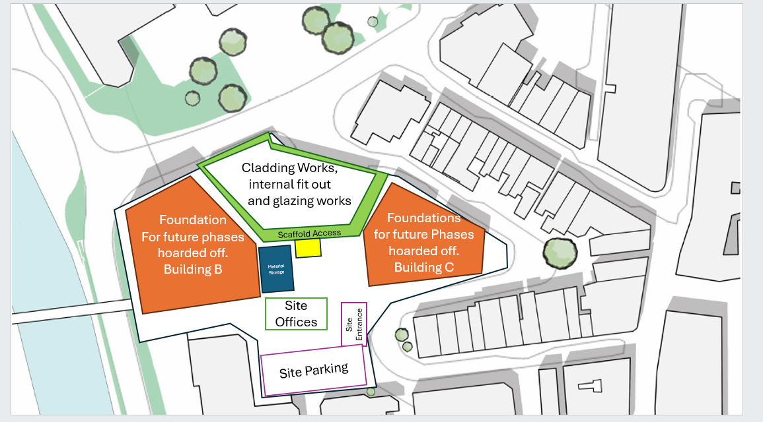

On Completion of framing works, the crane area will be removed allow for scaffold to be erected to super stricture, this will allow for the safe installation of Cor-Ten Steel Cladding. Site walkways will be installed to ensure staff can move safely around the site. A material lift (highlighted as a yellow square) will be installed next to the material storage to allow materials to me safely moved up the lifts of scaffolding. These areas will be able to be closed off during the movement of materials.
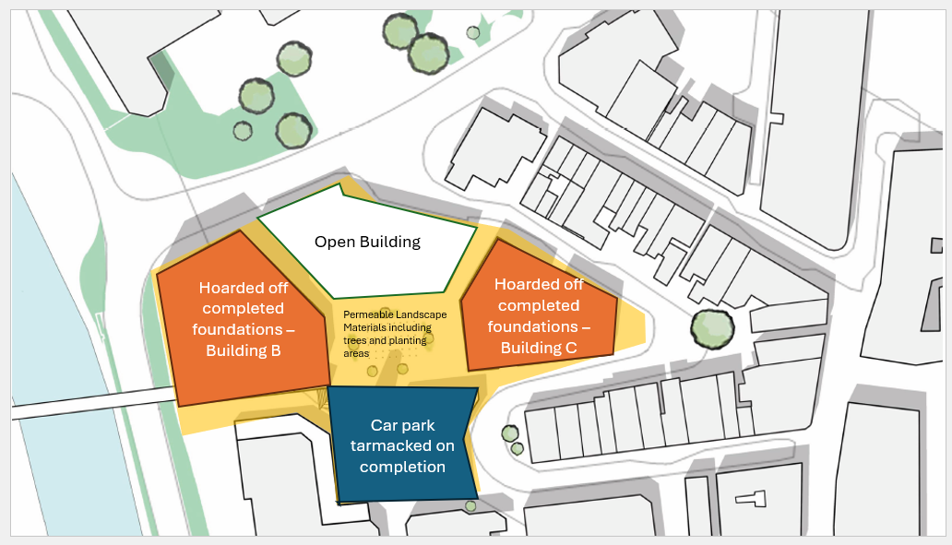

On Completion of the works, a tarmacked carpark will be located at the bottom end of the site. Steps will be installed to allow access to the top area, where a flat permeable landscaped area will be installed with the use of permeable paved areas with the combination of tress and shrubbier to create a welcoming area for people to use while building B and C can remained hoarded off to ensure that these remain safely isolated from the public until future works continue.

