Certificate of Higher Education Skills for the Workplace

Academic And Employability Skills

Module Code: BMSW4001
Student name : Elena Daniela Dumitrescu
Student id: 1918144
Lecturer name: MD. Nazmul Hasan

Task 1: Academic Report “What is the most effective way to motivate staff?”

Executive summary
Companies can implement communication, salary rise, wellness, additional vacations, prizes, and gradual promotion techniques. Several firms' motivation techniques were also aligned by the study, including Maslow's motivation theory and the X-Y approach. Unilever, ASDA, Fitflop, Tesla, and Sainsbury's were used in the report to demonstrate various types of motivation practises, which aids in understanding the importance of employee motivation through these practices and their impact on the position these companies hold within their respective market spaces. The Gibbs reflective cycle was used in the second assignment to conduct a reflective study that included the significant aspects and information from the relevant module. Finally, it has suggested a few techniques for improving employee motivation through various motivation activities.

Contents
Introduction 3
Different ways of motivating staff 3
Pay 3
Awards and Recognitions 4
Additional Holidays 5
Good Working conditions 6
Communication 6
Training 6
Work-life balance 6
Incremental Promotion 7
Recommendations and Conclusion 7
Reference List 8

Introduction
Motivation refers to the practice in response to the recognition of the job done by the staff. Employee motivation helps in influencing the level of energy, creativity, and commitment from the respective staff members of a company. This is vital in modern-day business as it helps in identifying the slacking spot and then the superior are accountable for motivating the employees regarding the slacking spot to increase the wholesome productivity from the company end (Hanaysha and Majid, 2018). Motivation helps in enhancing job satisfaction, which in return improves the commitment from the employee end towards the respective job roles, and it can help in delivering the copious amount of working output from the limited human resources (Banjarnahor et al., 2018). This report comprised of two tasks, one would help in recognising the aspects which need to be practised in order to inflict motivation within the employees and provide collective positive impact towards the wholesome company development. The second part would include the reflective statement aligned with the Gibbs cycle in order to provide the discussion regarding the research experience through group dynamics along with the learning experience of the individual throughout the relevant module learning.

Different ways of motivating staff

Pay
Pay can be a pivotal element regarding providing motivation for the employees. It helps in enhancing the commitment for the job roles from the respective employee end. This increased commitment, make the employee is more attentive towards the assigned job and the intent become to contribute to the full potential for the respective company (Ali and Anwar, 2021). This resulted in increment within both quantity and quality of the work. X – Y theory can be implied within the pay or wage aspect regarding the motivational practice. X theory suggests that in general employees are not that much interested in the job role and they resist the assorted charges and provide very little output from their work. In this context, motivation Y has been implied in terms of making the work relaxing and engaging for the employee (Pinkovetskaia et al., 2020). This influence the employee intent; employees are interested in delivering the job by themselves. To support this Y theory employers, use the wage strategy to influence the employees in giving the potential best in terms of quantity and quality towards the assigned job role (Mustafa and Ali, 2019). This increment in wage is utilised as an extrinsic payment option for the company. Elon Musk has used wages as a tactical approach for motivating the team members. The sheer increment in the wage helps in attracting the quality talent from the rival company, and the employees are happy to serve for the higher wages too. In this order, Tesla and SpaceX also can influence the reduction of the talent pool from the homogenous company and be peerless within the respective industry based on its talent acquisition (Umoh, 2017).

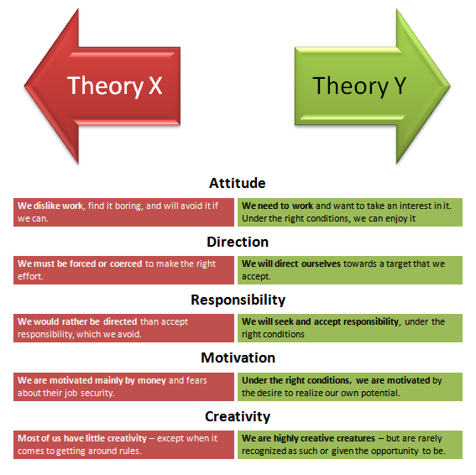
Figure 1: X-Y motivation theory
(Source: Concept taken from Pinkovetskaia et al., 2020)

Awards and Recognitions
Awards or Recognitions can be used as a tool to improve the morale of the employee. In contemporary business employees are struggling with the competition and often with the employability risks too, thus the overwhelming working condition can lead to adverse effects on the employee commitment and overall professional persona of the employees (Lyimo and Mollel, 2020). This can affect the service industry severely, as the employees need to interact with the consumers on the ground level, and the resentment towards the job can make them rude towards the customers. It can affect the brand image and experience of the consumers; these impacts would affect the future intent of the company which can include globalised expansion too. To avoid these situations, it is important to make the employees feel valued through recognising the efforts by awards. This can help increase the commitment from the whole group too, as the award can intrigue every other employee who is working hard with the intention of gaining growth (Božović et al., 2019).
Maslow’s Hierarchy of needs strategy can be aligned with this strategy, it has two parts deficiency needs and growth needs (Sharma et al., 2022). In terms of growth needs the company can utilise the rewards, like employee of the month or year to influence the workers to excel at their job position and gain the prize. These prizes are often incorporated with financial rewards, global recognitions and growth within the workplace hierarchy. Asda uses "Employee of the month awards" for keeping the employees engaged throughout the month towards their job role. This is intended to promote healthy competition amongst the employees and increase the individual intensity towards the job role. Asda also uses these for improving the confidence quotient of the employees. This strategy is very old yet; the use of this with the incorporation of money prizes, and parking space or promotion, the collective productivity is increased along with the individual engagement (asdaforbusiness.co.uk, 2022).

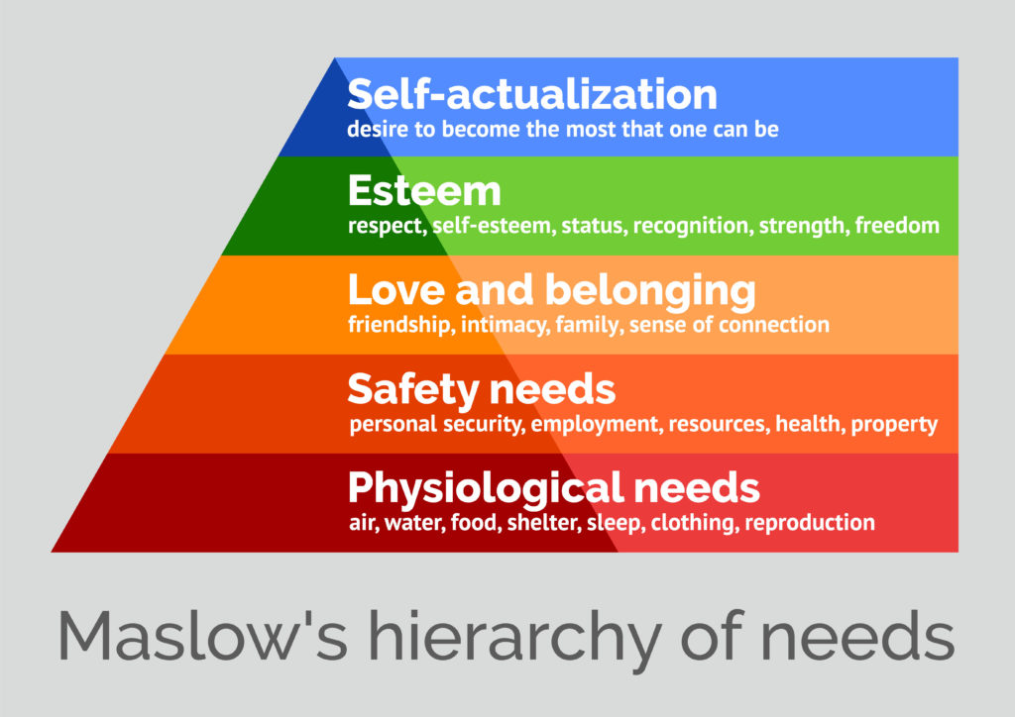

Figure 2: Maslow’s Hierarchy of needs strategy
(Source: Concept taken from Sharma et al., 2022)

Additional Holidays
Employee wellbeing has a direct linkage with professional performance. Also, the performance of a certain employee often depends on the work-life balance of the employees. Though this aspect is controlled by the employee, overwhelming working conditions or too much stress at work can hamper the balance of the work-life balance which would eventually affect the employee wellbeing within physical or mental context. To avoid this employee needs physical and mental rest. Proving holidays outside of the scheduled holidays can make the employees happy and valued, about their personal life too (Oktosatrio, 2018). Most of the time these additional holidays relate to the festivals of the different communities. According to Bourke (2020), for globalised companies, these holidays are often aligned with the regional holidays, this shows that the company respects the communal or regional preferences of the community, even for minorities these festive holidays would make the environment more diverse and inclusive, and all of these aspects would influence the employees in proving increased output as part of the result from the self-motivation. In Dublin, the hotel industry has utilised this by celebrating Chinese New Year. This has helped the brand image be more diverse and for the Asian employees, it helps in valuing through some familiar festivals (Bourke, 2020).

Good Working conditions
Good condition of working refers to the organisational culture and the environment of the internal structure of the company. This deepens on the leadership and the environment must be supportive to the individual employee. Otherwise, it can hinder the workflow of the employees (Taheri et al., 2020). This includes the interior feature of the team-building exercises. In modern business offices are incorporated with several technological devices, to help the company employees with easy access to their regular requirements. The intention is to make the workplace easy and relaxing, so the full potential effort from the employees goes towards delivering the best effort for the assigned job roles. These practices by the companies in terms of providing an accurate environment for the workers will intrigue the employee in working extra miles and extra hours for the company, thus often companies use a good and fun environment to intrinsically motivate the employees in delivering quality and productive output (Lohmann et al., 2018).

Communication
Communication is the key to evaluating and making changes within various aspects of the organisation. Thus, the companies are often interested in changing or revamping the leadership style within the organisation to increase the frequency and amount of communication within several levels. Interpersonal communication with the employees from the leadership or management helps in identifying the challenges faced by the employees in terms of delivering their job, these points must be, mitigated for increasing the employee performance. These practices are also intended to enhance employee performance by increasing employee satisfaction (Putri, 2018). In Sainsbury communication is practised between the supervisor and the employees, specifically the novice employees working the groundwork. In this way, the company can keep track of the employee requirements in order to utilise the full potential of the employees and promise them growth (sainsburys.co.uk, 2022).

Training
Self-worth valuation by the employees towards their respective company can help in increasing the commitment of the employees which is why enhancing the self-worth of the employees can be utilised as a motivation factor. This also helps in forging assertive organisational behaviour and increasing the intent of the employee output. This way, the management helps in providing a lucid image to the employees about how their designated job role or their provided service aligned with the company objectives. It will help in increasing the self-worth and confidence of the individual employee, and in a generic sense, it would help the employees in taking more reasonability or accountability towards the assigned job roles. Training also helps in developing relevant skills or updating these kills, which can be utilised by the individual in developing growth factors for the future purpose of the individual. Thus, it can be utilised as a self-motivation aspect from the employee end. Unilever has used the training and development program to help the employees in gaining lifetime skills, which would help the employees in relevant homogenous roles for future purposes. Unilever used the training program for the novice employees, to in order to motivate them and cover up the

Work-life balance
Work-life balance is very important regarding employee performance. Growth need helps in carrying on with personal needs, but the balance helps in keeping the employee-focused towards the job roles. Employee motivation through wellbeing practices can help in giving a stress-free environment for the work (Thamrin and Riyanto, 2020). Through motivation, employees can stay focused and through the stress-free situation, employees can utilise these wellbeing practices by the company. Inditex has implied motivation, innovation and teamwork combination to address the wellbeing of the employees. This has helped the company in propelling over 160,000 people towards organisational progress (inditex.com, 2022).

Incremental Promotion
Incremental promotion can be an improved version of providing motivation, as it helps in increasing the satisfaction towards the job. This also helps in enhancing the employee skills sets for the promoted position. This can help influence the employee in availing the skills in order to develop professional internal growth (Sung et al., 2020). The emotional competence towards the incremental promotion is also a very fruitful tool as utilised for employee motivation. In contemporary business incremental promotion is often being utilised for delivering the team motivation, as the success of the individual can influence the others in working hard and gaining the same spot and the extra benefits would also work as the motivational aspect.

Recommendations and Conclusion
There are several ways discussed, which are frequently used as business practices in order to increase employee motivation. There are examples of companies like Unilever, and Tesla which are the global market leaders within their respective industries, this shows that these practices are very vital and in modern business, these are essential to be practised. Thus, addressing the significant impact of motivation towards the business this report is going to recommend a few steps regarding improvement of the impact from the motivational practice by the company. This includes.
Communication is already discussed, but to be specific Interpersonal communication skills can be the forerunning quality regarding the motivation of the employees. Interpersonal skills suit transformational leadership. This is also important regarding the volatile nature of the business environment, as change is very evident for the companies (Lee, 2020). So transformational leadership can be helpful in coping with the changes and implicate change management for the company. There are two kinds of skills soft and hard skills, which can be utilised towards motivating the employees, and interpersonal and active communication can help in developing strategy regarding these skills, which eventually will dominate the enhancement of the respective service provision (Hardjati and Febrianita, 2019).
In an innovative environment, regardless of the experience, every other employee requires to be part of the motivation. There is a real-time tool, which would be implied to increase the technical skills and capability of the employees (Burnett and Lisk, 2019). These tools will help in increasing the engagement from the employees in a creative manner, and the advanced technology skills incorporation within the training program will help employees in the innovative expansion of the employee.
There is a significant mediating role between employee wellbeing and the motivation of the staff. That is why in recent times most companies, specifically with a large number of employees try to imply strategies in order to improve employee mental well-being (Khoreva and Wechtler, 2018).
This task concludes with the remarks that motivation is very important for increasing the productivity from the collective output. This has shown that motivational aspects like pay raise, communication and wellbeing can contribute towards motivation, which can eventually increase the service provisions of the employee.

Reference List
Ali, B.J. and Anwar, G., 2021. An Empirical Study of Employees’ Motivation and its Influence Job Satisfaction. Ali, BJ, & Anwar, G.(2021). An Empirical Study of Employees’ Motivation and its Influence Job Satisfaction. International Journal of Engineering, Business and Management, 5(2), pp.21-30.
Ali, B.J. and Anwar, G., 2021. An Empirical Study of Employees’ Motivation and its Influence Job Satisfaction. Ali, BJ, & Anwar, G.(2021). An Empirical Study of Employees’ Motivation and its Influence Job Satisfaction. International Journal of Engineering, Business and Management, 5(2), pp.21-30.
Pinkovetskaia, I.S., Arbeláez-Campillo, D.F., Rojas-Bahamón, M.J. and Iniesta, D.S.V., 2020. Motivation of new entrepreneurs in modern economies. Amazonia Investiga, 9(29), pp.368-373.
Mustafa, G. and Ali, N., 2019. Rewards, autonomous motivation and turnover intention: Results from a non-Western cultural context. Cogent Business & Management, 6(1), p.1676090.
Umoh, R., 2017, The tactics self-made billionaire Elon Musk uses to motivate his teams [Online] Available at : https://www.cnbc.com/2017/07/05/2-major-ways-executives-like-elon-musk-are-trying-to-stop-you-from-quitting.html[Accessed 19 March 2022]
Lyimo, B.J. and Mollel, 2020. G.L., FACTORS INFLUENCING EMPLOYEE MOTIVATION IN PRIVATE HOSPITALS IN TANZANIA: A CASE OF RABININSIA MEMORIAL HOSPITAL
Božović, J., Božović, I. and Ljumović, I., 2019. Impact of HRM practices on job satisfaction of employees in Serbian banking sector. Management: Journal of Sustainable Business and Management Solutions in Emerging Economies, 24(1), pp.63-77.
Sharma, M.K., Narasimha, S. and Singh, P., 2022. Battle of royale game: Perspective from Maslow’s hierarchy of needs. International Journal of Social Psychiatry, 68(1), pp.227-229.
asdaforbusiness.co.uk, 2022, Employee of the Month? Idea of the Century [Online] Available at : https://www.asdaforbusiness.co.uk/employee-of-the-month-idea-of-the-century/[Accessed 19 March 2022]
Oktosatrio, S., 2018. Investigating the relationship between work-life-balance and motivation of the employees: Evidences From The Local Government of Jakarta.
Bourke, R., 2020. An investigation as to how Diversity management is affecting the Performance of employees in 4 and 5 star hotels in Dublin (Doctoral dissertation, Dublin, National College of Ireland).
Taheri, R.H., Miah, M.S. and Kamaruzzaman, M., 2020. Impact of working environment on job satisfaction. European Journal of Business and Management Research, 5(6).
Lohmann, J., Muula, A.S., Houlfort, N. and De Allegri, M., 2018. How does performance-based financing affect health workers' intrinsic motivation? A Self-Determination Theory-based mixed-methods study in Malawi. Social Science & Medicine, 208, pp.1-8.
Putri, R.A., 2018. Leadership style and interpersonal communication of employee satisfaction and it’s effect on the employee performance. JPBM (Jurnal Pendidikan Bisnis dan Manajemen), 4(3), pp.101-106.
sainsburys.co.uk, 2022, Our people [Online] Available at: https://www.about.sainsburys.co.uk/about-us [Accessed 19 March 2022]
Thamrin, M. and Riyanto, S., 2020. The effect of work motivation, work environment, and work life balance on employee performance at pt. Angkasapura i (persero) sultan aji muhammad sulaiman sepinggan airport–balikpapan. IOSR Journal of Dental and Medical Sciences, 19(6), pp.40-47.
inditex.com, 2022, OUR EMPLOYEES [Online] Available at : https://www.inditex.com/our-commitment-to-people/our-employees[Accessed 19 March 2022]
Sung, S.Y., Rhee, Y.W., Lee, J.E. and Choi, J.N., 2020. Dual pathways of emotional competence towards incremental and radical creativity: Resource caravans through feedback-seeking frequency and breadth. European Journal of Work and Organizational Psychology, 29(3), pp.421-433.
Lee, Y., 2020. Motivations of employees' communicative behaviors on social media: Individual, interpersonal, and organizational factors. Internet Research
Hardjati, S. and Febrianita, R., 2019. The power of interpersonal communication skill in enhancing service provision. Journal of Social Science Research, 14, pp.3192-3199.
Burnett, J.R. and Lisk, T.C., 2019. The future of employee engagement: Real-time monitoring and digital tools for engaging a workforce. International Studies of Management & Organization, 49(1), pp.108-119.
Khoreva, V. and Wechtler, H., 2018. HR practices and employee performance: the mediating role of well-being. Employee Relations.

