Report

Art Studio Screenshots
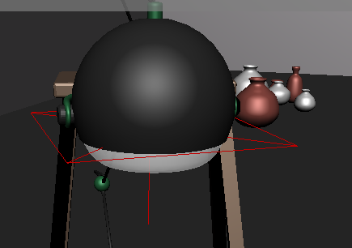
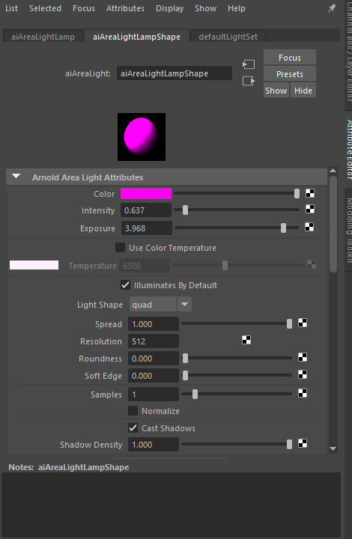
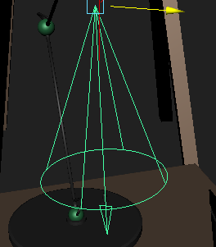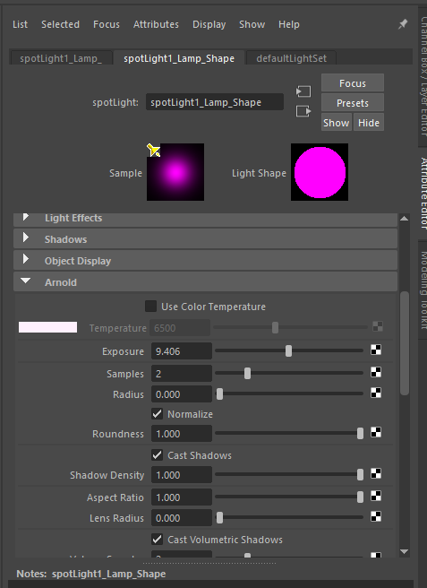
Here what I have done was, I had used an area light to make the pink glowing effect on the lamp shade, I wanted to add some extra lighting to the lamp to give the model some extra details, as well as give it some more quality of life. I also wanted to add a spotlight behind in front of the lamp, the reason being is because I wanted to show it looking like the light reflection is being drawn onto the table.
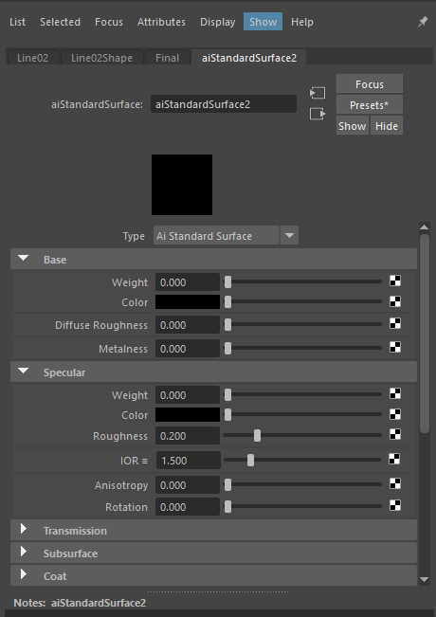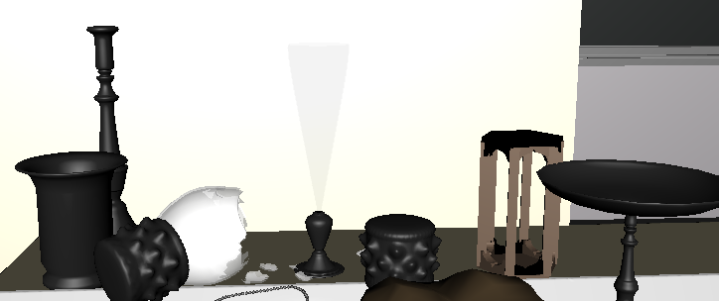
I created this glass effect with this object by using the Arnold AI Standard surface. I got rid of the weight and colour on both the base and specular, as well as increased the roughness and IOR. I then upped the weight and colour in the transmission, to get that effect. I wanted to try and make a more realistic approach to it.

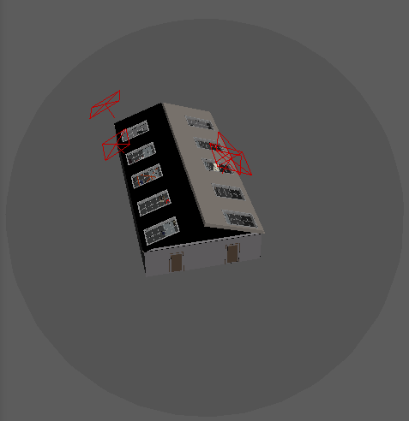
When doing lighting for the Art Studio, I decided to use a Skydome light from outside of the model. I decided to use this light, since it is usually used for interior models. I didn’t have many problems when creating and using this light, since it was able to work as normal when using the render view. I wanted to make sure that there was some sort of light coming from outside, so it would be easier to light up the interior from the inside.
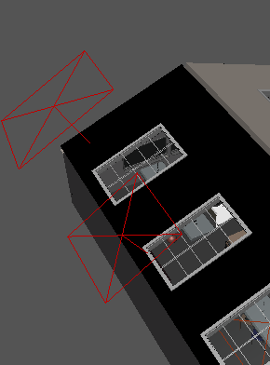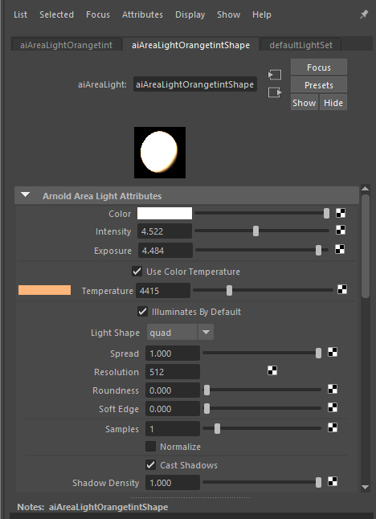
When lighting up the windows, I needed to use area lights to do them. The reason why I chose these is because they are able to light up a wider range of areas, and it is also good to allow light to come from the outside. My original idea was the use the environmental, however, even at a lower density, the light was way too bright for me to use, thus, I decided to use area lights, because I was able to control the brightness.

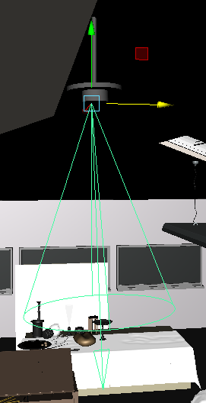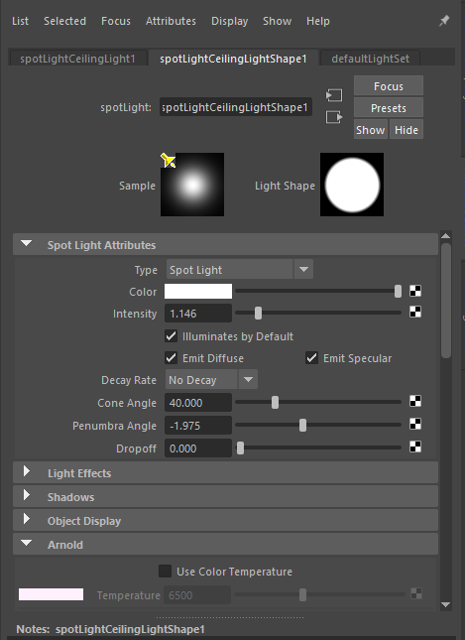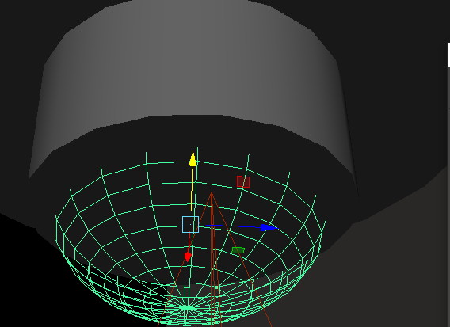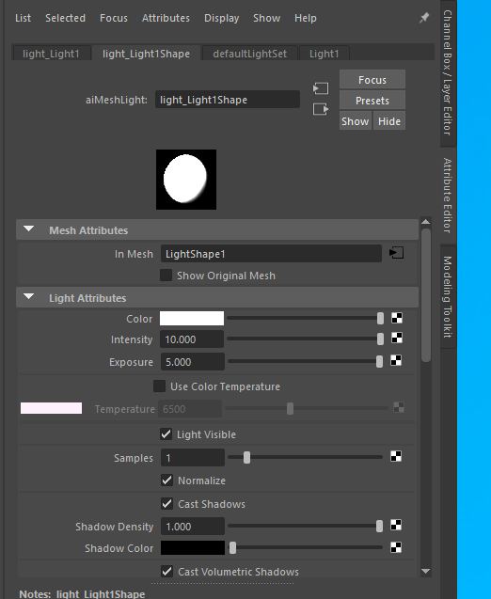
I decided to create some ceiling lights for the Art Studio and added a spotlight to shine down beneath them. The reason I decided to do this was because, I didn’t think there was enough places where light can be directed from, for example, there are mostly only windows, and while there are quite a few of them for light to come through, I wanted to create some interior lights as well, and be more creative, by creating my own light source for the light to shine down from. I had a bit of an issue with the spotlight at first, since it

wasn’t appearing at all. However, I upped some of the Arnold settings, as well as lowered the intensity for it to work

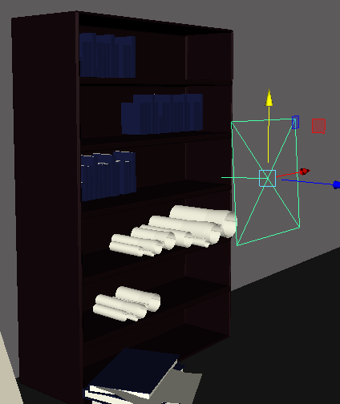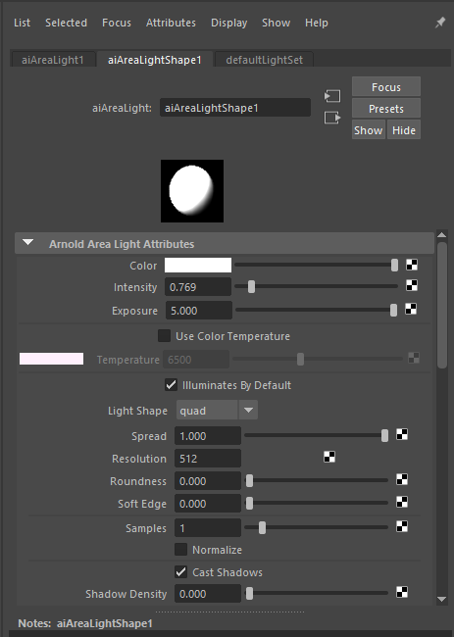
Added an area light to light up the bookcase

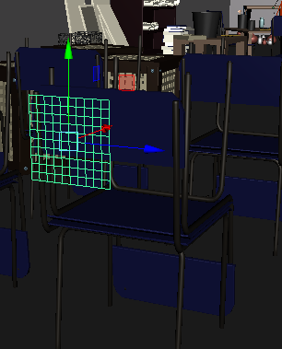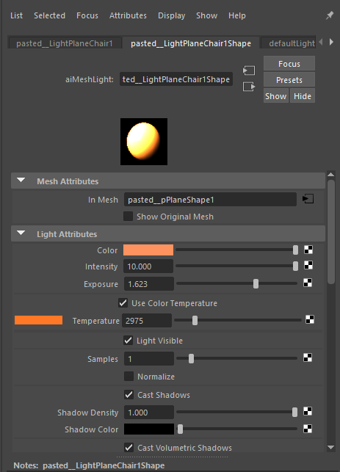
Christmas Tree Screenshots

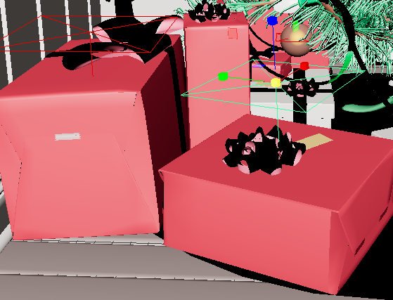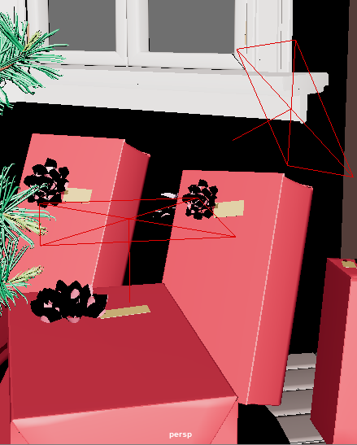
I used an area light in order to light up the top part of the presents. I wanted to make sure that the light was relatively small so that it wouldn’t overpower any of the other objects within the model, so I kept the light size relatively small, and kept the colour white to allow it to be seen easier. What worked with this was that the light was mostly only showing on the presents and wasn’t too intense so that it wouldn’t light up more areas in the room and affect the other lights around them. I didn’t want to leave the presents as it is, because I wanted to make sure that you are able to see some parts of the model clearly, and I didn’t think that it would have looked good if I had just left them the way it is.

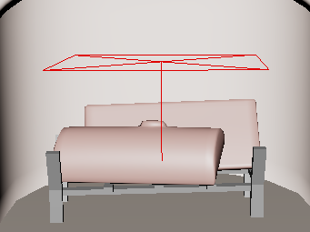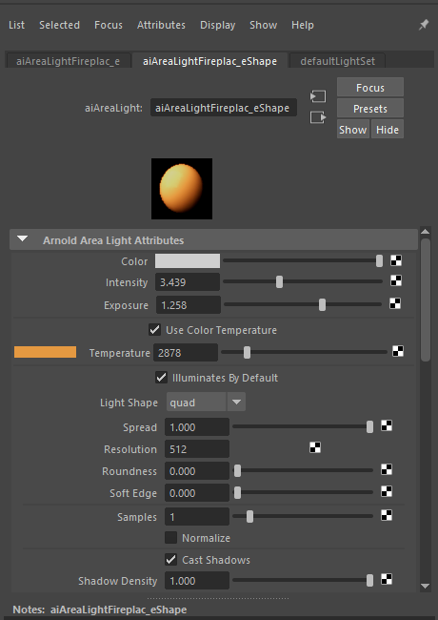
Here is an area light I have put in the fireplace, Like the presents, I wanted to make the light relatively small so that it doesn’t contradict the other lighting and be too bright for the viewer. I used a color temperature to add an orange tint, to try and represent fire. Since the fireplace inside the model was relatively small, due to the fireplace walls, having a smaller light would have fitted more, since it wouldn’t be as intense, and light up the whole room. Using an area light allowed me to only light up a more smaller area of field from inside the model.
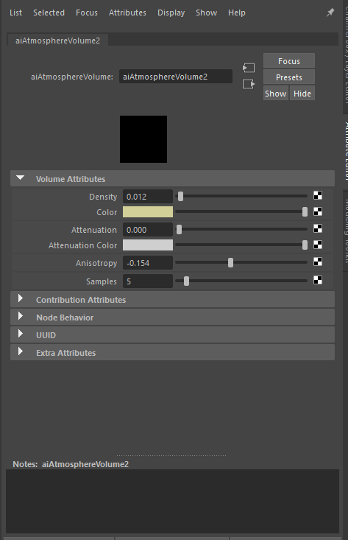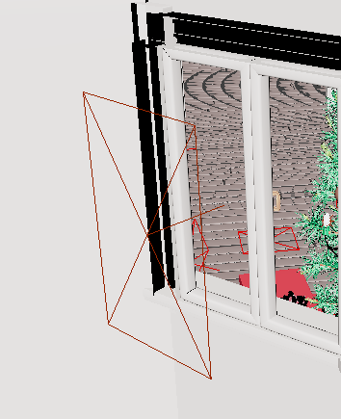
I created an environmental light for the Christmas tree model. I made it so that light the light would come in from behind the windows to show that light was coming in. I was originally going for a pinkish colour, but I changed it to gold, because I thought that the pink was too overpowering in contrast to the other lights.
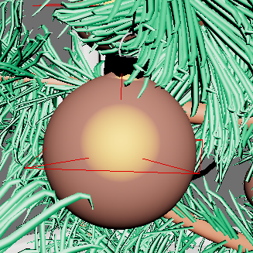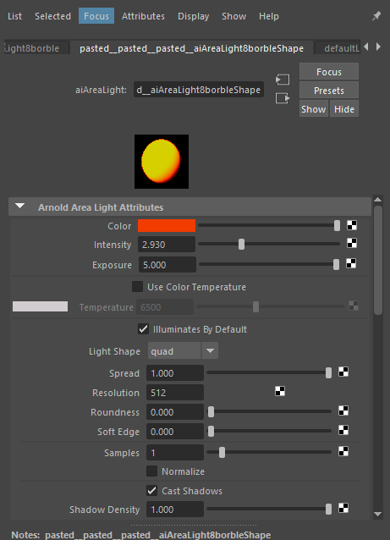
I used an area light to light up the borbles, I wanted to give them different colors to create a more colorful appearance. I originally wanted to do a mesh light, however, when putting a light onto a sphere, it wasn’t working out as well as I planned. The light wouldn’t fully light up the sphere that I placed down, and it would have always been too bright when I increased the intensity, thus I decided to just light up the middle part of the borble to create the effect. However, at some point in time, I realized that I had something unchecked when using the mesh light, and when I clicked on the option, the light started to work, and thus, able to be used. However, when using the light, it looked way too unnatural, as well as the light being way to saturated, even toning down the intensity and exposure wasn’t doing it, so thus I stuck to an area light.
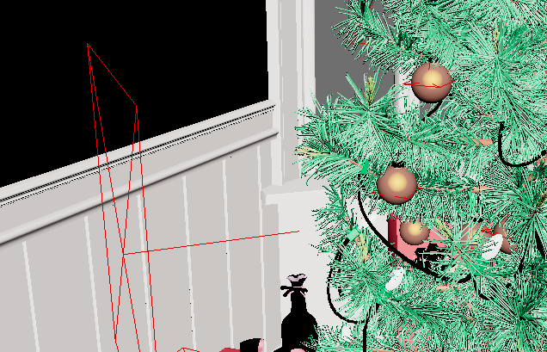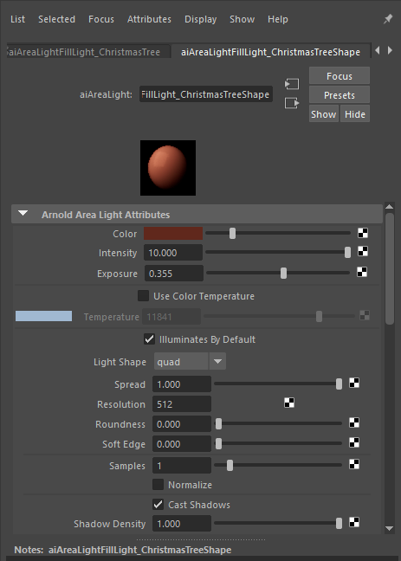
I created an area light at the side of the Christmas tree to create a darker tone of light, I upped the intensity and exposure of the light to expose the light, so it is more visible to the viewer. I didn’t want to make it too dark, or too bright, since that wouldn’t be very appealing to the viewer. The only issue I have with this is that I’m not too sure if this is very visible. And I felt that I needed to either tone some of the other lights down, or possibly increase this light, so it becomes more visible.
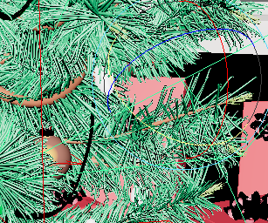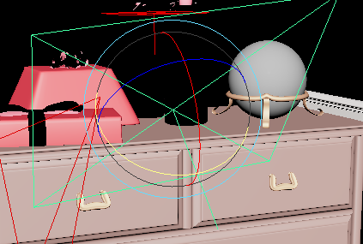
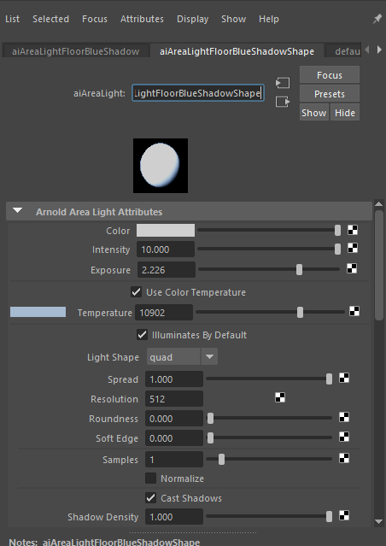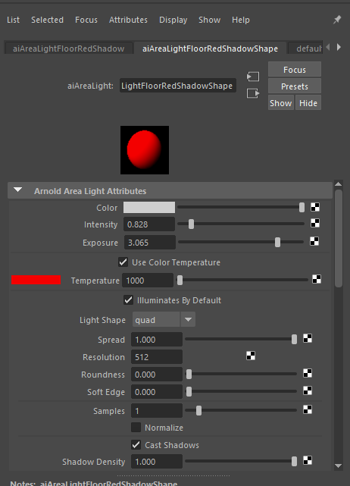
I Added two area lights pointing down at the floor, I wanted to give off a more Christmas-like effect. While I am happy with how it came out, like how you can see the reflection within the floor, I feel like It could be improved if there was an object that it is reflecting on. I used a color temperature to get the effect. The reason I chose to put area lights onto the floor is because, as looking at them through the render view, it is easier to see the reflection on the floor, and using darker colors wouldn’t allow this reflection to be seen.
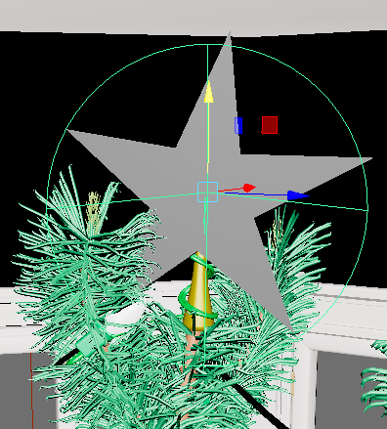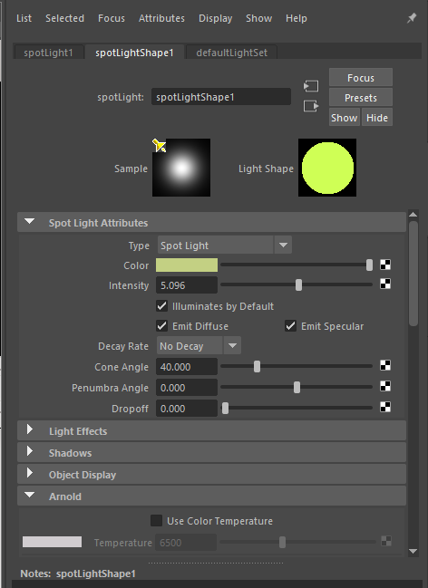
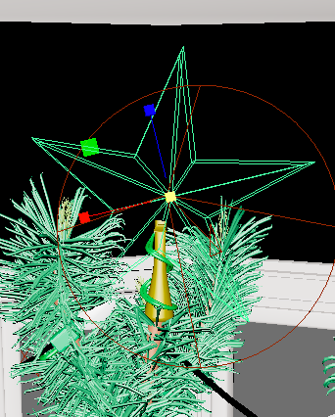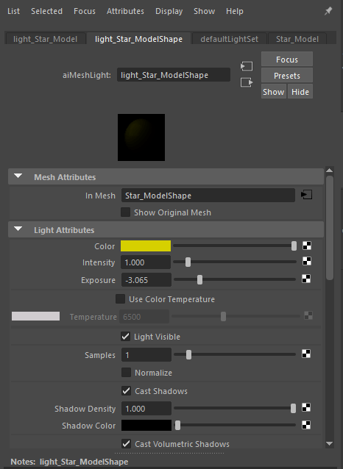
When trying to light up the star, I realized that the model didn’t have any meshes to assign a mesh light to it. So I decided to create my own star to try and use a mesh light on that. I used a mesh light on the star, so it was easier to see to the viewer. I had issues with this lighting earlier, but I realized that I had something unchecked, thus I was able to get it working. Another reason why I used this light was because, I didn’t want to let it deviant away from the spotlight that I used next to it, because I wanted to feel like the star was giving off the light itself, instead of it feeling like the light is just put there, and I didn’t want to make it look like it was there for the sake of it. I gave it a yellowish light and upped the intensity to make it look as bright as possible
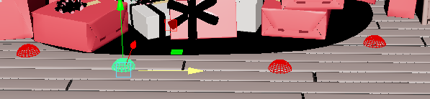
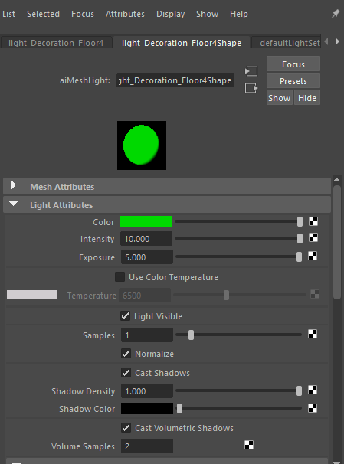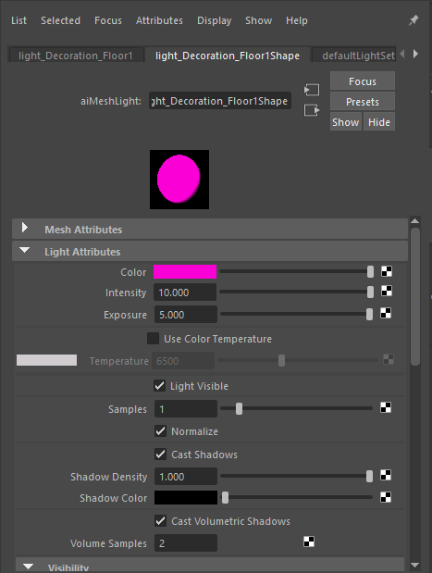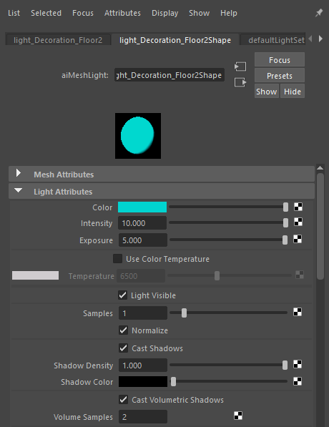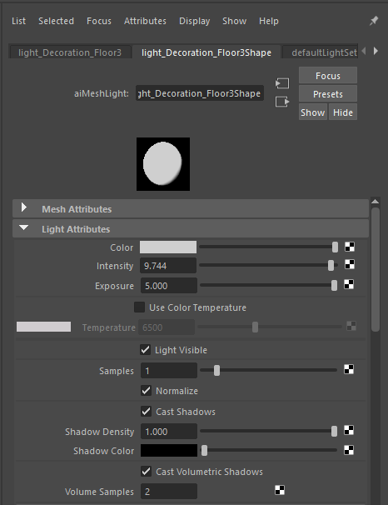
I wanted to create some mesh lights on the floor, as well as on the fireplace to just add some decorations to the model, and make it look more festive. These were mostly just for fun, since my original plan was to use it for the borbles, but it didn’t work out very well. So, I decided to spice up the place instead and try experimenting with this sort of light.
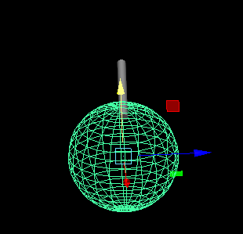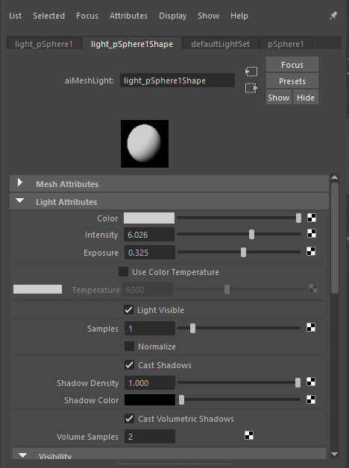
I created a ceiling light using mesh tools and added a mesh light to the bottom. I didn’t connect the mesh, since I only wanted the bottom part to glow, I wanted to add more decorations to the model.
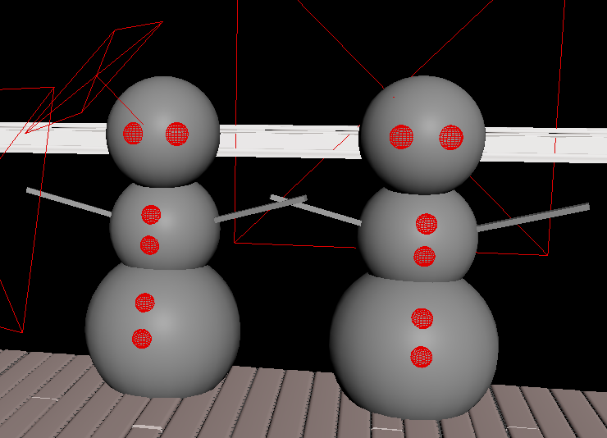
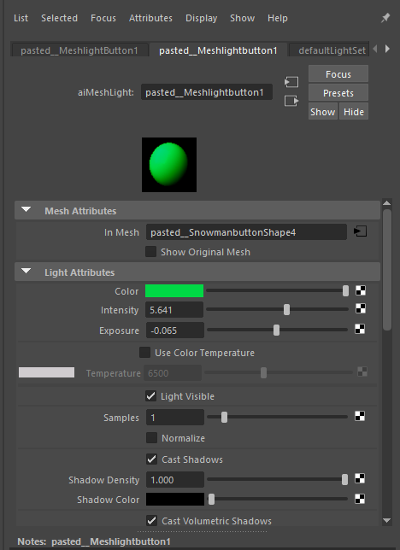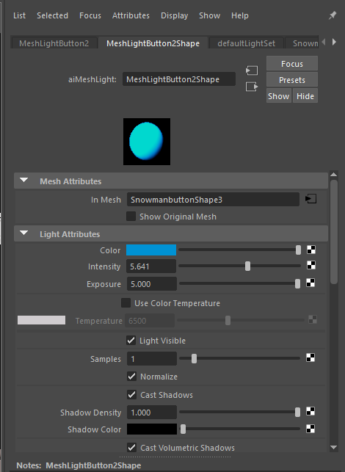
I created a snowman model and added mesh lights. The reason I did this is because I wanted to add more Christmas related objects to the scene.

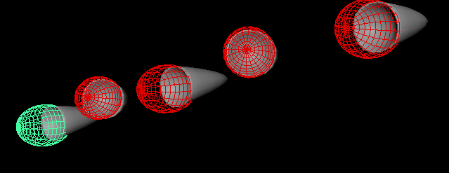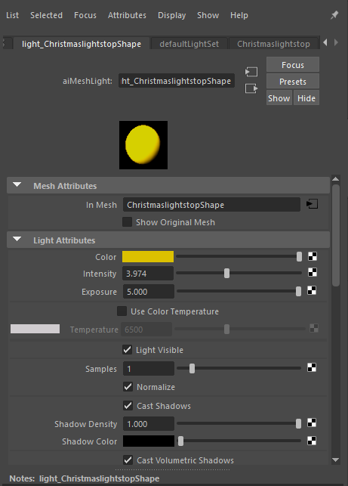
I modeled some Christmas lights to fit the theme, and experiment more regarding the lighting

Renders
When rendering out my Art Studio and Chrisstmas tree file, I had a lot of issues with maya crashing, so I needed to lower the height and width in order for it to render out. So there may be some quality differences

Christmas Tree
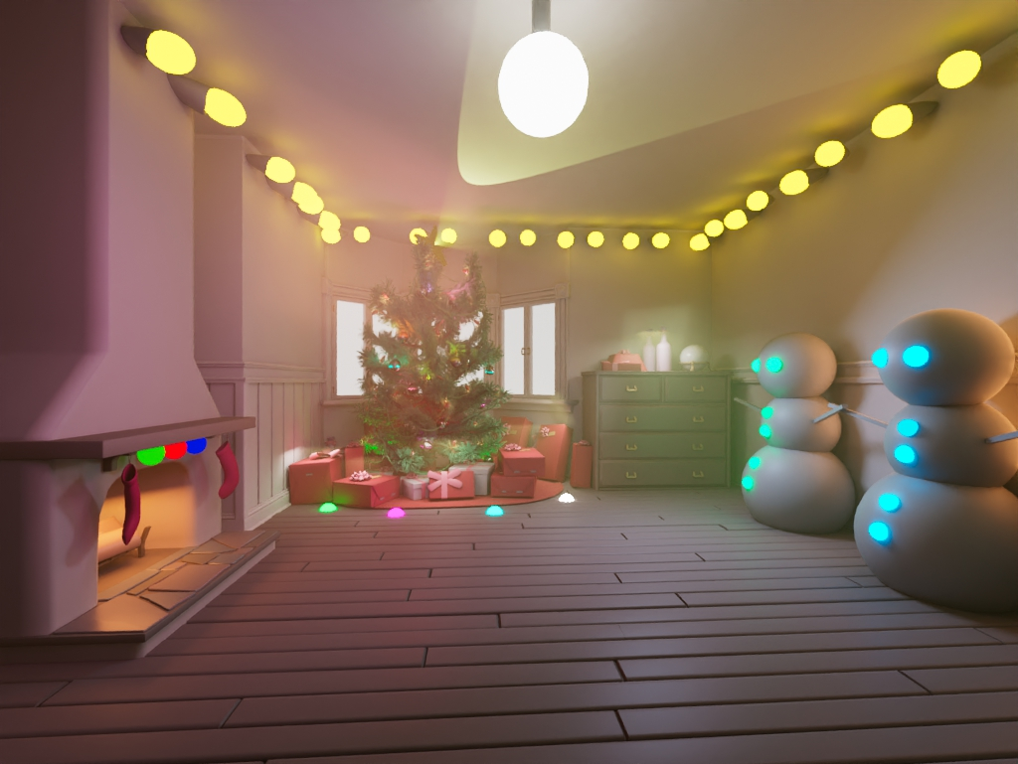
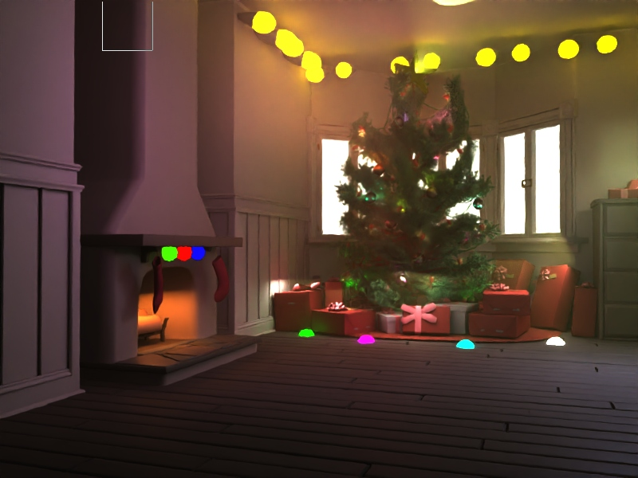
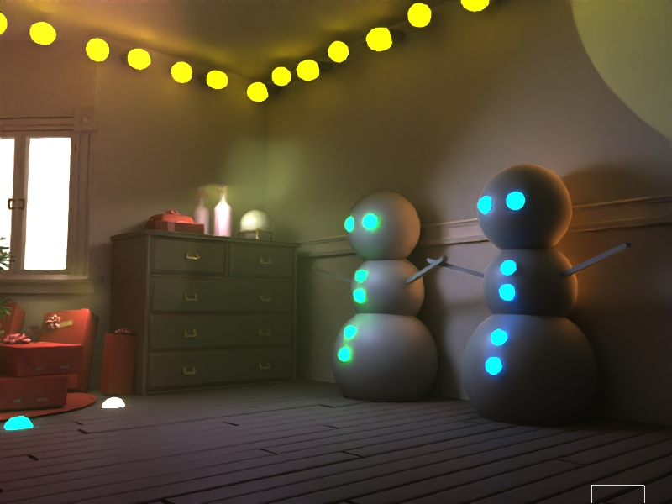
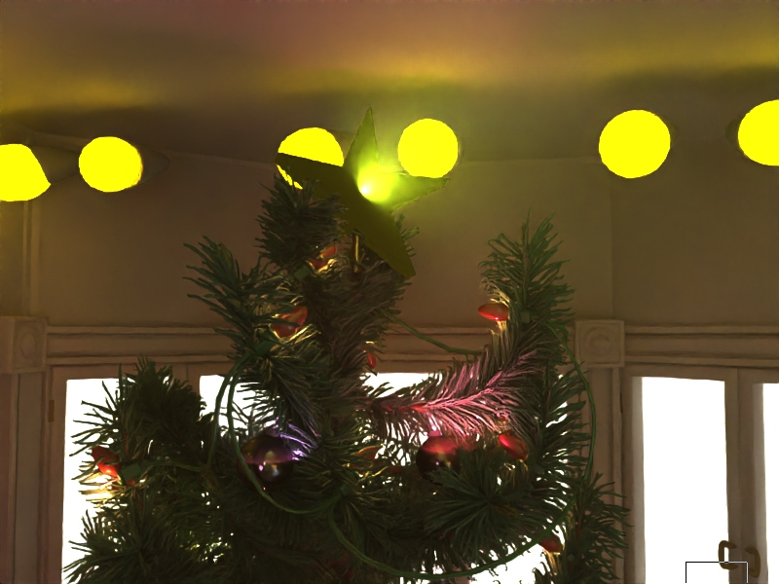
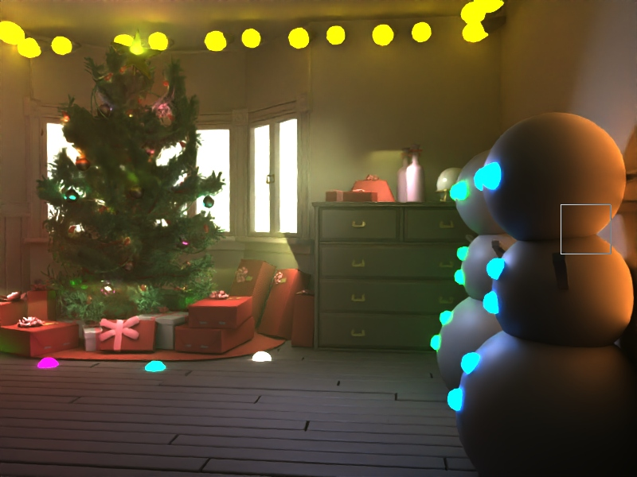
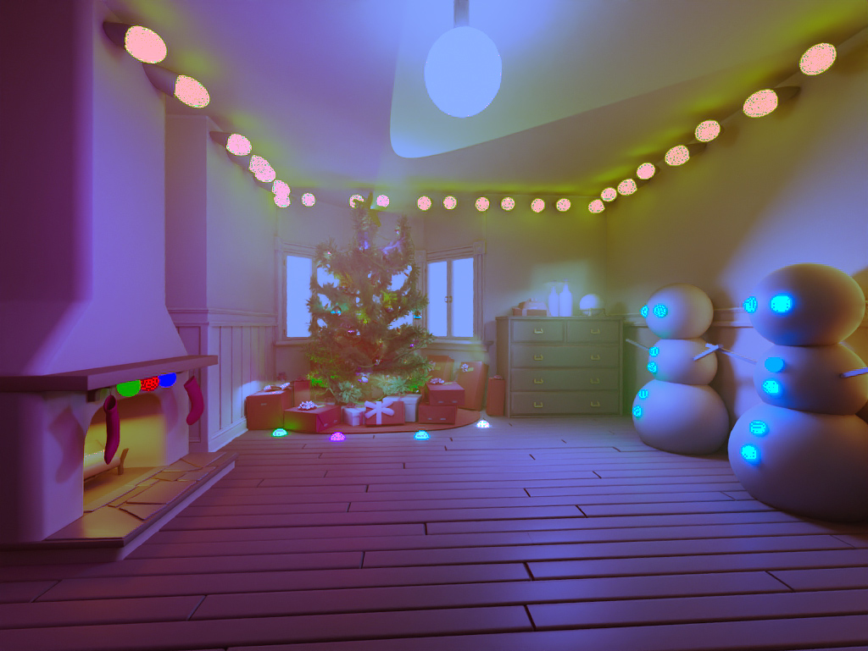
I used premier pro to change the colour of the scene in the render
Art Studio


