Reflections on early years practice
Part 2 – Reflective log
Brief description of the activity: | The activity I chose to do was based on the well-known welsh story written by Mary Vaughan-Jones which is ‘Sali Mali’. The story was read to a group of 6 three-years-old’s during ‘quiet time’ in the nursery.
Aim/Objective of the activity: | ‘Sali Mali’ is a very well-known welsh story. It contains simple pictures on each page along with sentences no longer than eight words. The story itself is repetitive. Dr Maria Montessori believed that ‘repetition is the secret of perfection’. The main aim of the activity was to encourage the children to engage in conversation about the book. All of the children had read this story several times before-hand which lead me to choose this book. I decided that reading a story which they were already familiar with may have the possibility to support Montessori’s theory.
My role during the activity: | During the activity, I was the story-teller. It was not only my role to read the story, but also to make it as child-friendly and as fun as possible, and by doing this avoiding boredom and lack of concentration. I did this by ensuring the words were pronounced correctly and used an appropriate tone of voice.
Positive aspects – why? | I believe the story chosen was an appropriate one. Each of the children contributed towards the activity by engaging in conversation. A possible reason for this could be because the children were already aware of the story – it is one that is read in the setting often and one that parents are also aware of meaning it could be read in the home. Another positive aspect to the activity is the way I read the story. According to teachingenglish.org.uk, the way in which a story is read determines whether the audience is captured or not. Whilst reading the story I varied the volume tempo and pitch of my voice as well as ensured that I exaggerated at the correct times during the story. The tone I used was clear and I used different voices for different characters, including a bird’s noise for Jac Do.  In certain parts of the story (page 10 – when there in a knock on the window) I encouraged the children to take themselves to a nearby window or door and knock on it. By doing this I feel as though it kept the children interested for longer and made them feel as though they were more involved in the activity.
Challenging aspects – why? | One aspect that I found considerably challenging is the ability to keep each of the children interested in the story at all times. As I previously stated, I chose this book due to the fact that it’s a such a popular book and I believed that they would have better knowledge of it and therefore contribute to the activity more. However, I did not consider that a story as simple as this may have been to ‘boring’ for a group of three-year-olds. A few individuals began to lose concentration by half way through the story whilst others continued to be interested until the very end. Another aspect which I found slightly challenging was the time of day in which I decided to read the story to the children. I decided to read the story after the children had their lunch which is also approximately half an hour to an hour before they are due to sleep for the afternoon. This resulted in two or three of the children beginning to get very restless which may have been the cause of their lack of concentration. A way of overcoming this is by using props for example. Mary Jo Huff (2000) states how using props such as puppets are ‘a powerful way to reach children – even a shy child will relate to a puppet’.
What knowledge was demonstrated? | To do this activity, I had to use a wide range of knowledge on the level of complexity used when telling the story. Due to the fact that I read the story to a group of children who attend the nursery that I work in and I have known them for many years I was fully aware of their capabilities and what type of story I needed to read. I knew beforehand which children can concentrate longer than others as well as if any of them had any additional needs. I chose the story after taking all of this into consideration.
What skills were demonstrated? | I used a variety of skills in order to carry out this activity. There are so many different skills which need to be considered in order to improve how an individual says a story. According to internet sources, storytelling is all about imagination and a good story always encourages the audience to participate. I did this by getting the children to knock on the nearest window or door when the story reached page 10. I also encouraged the children to use as much language as possible by asking them story-related-questions. One example of me doing this was when Sali Mali asks on page 12 ‘who is there?’ I also asked the children who they believed it could be. Part of this skill which needed to be considered was not to ask questions which were too open-ended but also not a question which would only allow a yes or no response.
Which values were demonstrated? | The main values I demonstrated throughout the activity is ensuring that equality, anti-discrimination, inclusion and diversity were focused on at all times. Even though all the children whom I read the story to were at the same level of ability I always kept in mind how it would be possible for me to adapt the activity if a child with additional needs was to join.
What could have been done differently? Why? | After completing the activity, I did think of a few things which could have been done differently. Things such as using props, the time the story was read, and choosing a different story may have helped improve the activity and its outcomes. By using props such as puppets, there are many benefits. These benefits include an improvement in social skills, supporting of emotional development, increased in confidence and they can help encourage creativity. When I next do this activity, I will plan it around an earlier time so that the children will not be as restful resulting in their concentration span being better. I will also ensure that next time I do not read the same story. Although I originally stated that I chose the story because I knew it was one that the children were familiar with I now wish that I had a chosen a story which they had not read before so that way I could’ve have their first initial reaction on it and see how well they understood what was being told to them.

Part 3 – briefing paper
How do we reflect?
There are several different models which have been put into place by a handful of different individuals which help us to reflect effectively on our practices. These models include Gibbs’, Rolfe’s and John’s.
Gibbs:
Gibbs’ model is one which is shown in the format of a never-ending cycle. It includes six points which are:
- Description – what happened?
- Feelings – What were you thinking and feeling?
- Evaluation – Good and bad about the experience.
- Analysis – What sense can you make of the situation?
- Conclusion – What else could you have done?
- Action Plan – what would you do differently next time?
Reflective Practice
What is reflective practice?
Reflecting is another work for critiquing and thinking about what you do. According to brightknowledge.org (2018), reflective practice is used in order to help individuals improve the way they work by looking at their own personal performance and experiences. Individuals who work within the early years settings will use this method of improving their own work. Reflective practice is deciding to take a step back and look at our work before discussing good and bad points and how it can be changed to be made more effectively.
You’ve heard of the saying learning from your mistakes? Well, reflective practice is another way of helping you to achieve this. It helps you realise what you did, and what you’d change,
Why do we use reflective practice?
By reflecting on our work, it helps us widen our knowledge and deepen our understanding. This gives us enough support to help us critique our work properly and identify areas which need developing. Not only this, but reflecting on your work is one of the most helpful way to encourage you to improve your performance.

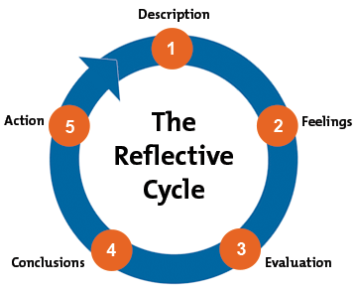

- What is the problem?
- What was my role?
- What actions were taken?
- So what does this tell me?
- So what other knowledge can I bring to the situation?
- Now what do I need to do in order to make things better?
- Now what may be the consequences of this action?
Rolfe:
Rolfe’s reflective model only concentrates on three simple questions which are what, so what and what next? However, these questions can be expanded in order to help us widen our knowledge. Other questions which can be considered are:

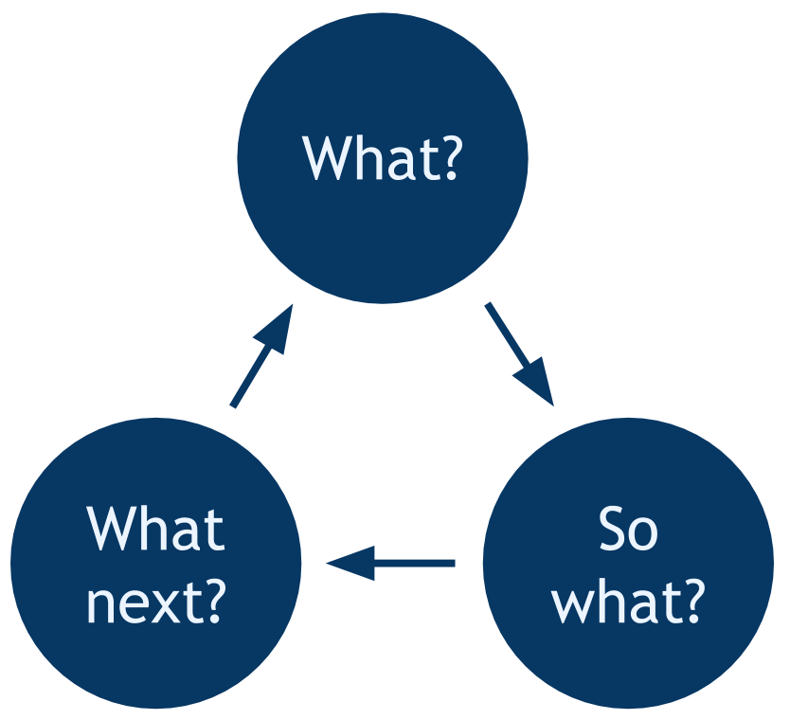

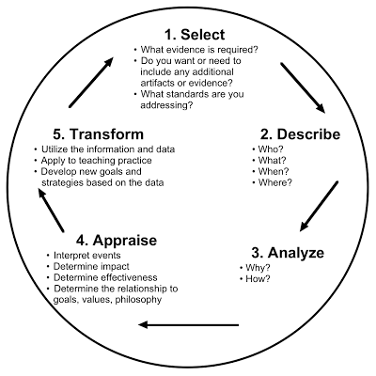
Johns:
Johns model is based on five questions which like the other models help us to break down our experiences and reflect on the process and outcomes. This model can begin at any question as there is no specific order in which they need to be addressed.

Area for further development (provide further details)  Part 4 – Personal development plan | Why? | How? | Who/Where? | When?
- Knowledge | Would like to go on after my current university degree to do a midwifery course. I need to research the different courses available as well as information regarding entry requirements and whether or not the course is available in the night as well as course. Doing the course in the night would enable me to work full-time. | - Look online at different courses as well as different degrees.  - Talking to careers advisors within the university.  - Talking to my parents (mother did nursing at Swansea University).  - Talking to my cousin Ceri who is a qualified midwife.  - Attending open days. | - Speaking to careers advisors in my university within the student services department.  - Attending open days that the different universities hold. | I intend to being researching during the summer meaning I hopefully have enough research behind me giving me time to apply before I graduate in June 2019.
- Skills | I need to become more organised. Not only with university work but with my daily routine. | - Keep a daily diary.  - Start university assignments sooner and make a plan beforehand.  - Reach a balance between work, university and a social life. | - Ensure I attend all my lectures and write a list of questions to ask if I am unaware of any aspects.  - Plan ahead with friends and family and note this in my diary. | I began keeping a diary at the beginning of 2018 so need to ensure I keep on top of this.
- Knowledge | If unable to get on to a midwifery degree, I need to ensure that I am aware of other job opportunities my chosen degree offers. | - When a new job opportunity arises, my lecturers often send me emails about these so I need to keep an eye on these emails. | - Speak to my lecturers and my personal tutor Gwyneth Davies about the different opportunities.  - Search on the Carmarthenshire County Council website for jobs available and research if my chosen degree will support me on achieving this new job. | I will begin researching the different jobs available when I’m nearing finishing my degree in June 2019.
- Knowledge | Research if there is any experience needed before applying for jobs. | - Participate in placement or work experience in a local hospital if possible.  - Talking to midwives and nurses about their job role. | - Research the different courses and look at the entry requirements. Specifically focusing on the type and amount of work experience needed or preferred.  - Talk to careers advisors. | Do this throughout my final year of my current degree so that it gives me the opportunity to gain new experiences before I enter the world of full-time work.
- Knowledge | I am aware that there are some disadvantages to being a midwife and having to deal with a death of a newborn child is one of these. I need to ensure that I am fully aware that these situations do arise and prepare myself for this. | - Talking to midwives, doctors, nurses and paramedics.  - Question myself. Will I be able to overlook my own personal emotions during a situation like this?  - Watch programmes such as ‘One Born Every Minute’. | - Talking to health care professionals whom have had to deal with this situation in the past.  - Discuss with the people who know me best whether they believe I am an emotionally strong individual. Especially my cousin Ceri as she has experienced this first had and knows me very well. | Organise meetings with the different health care professionals.

Reference List
Brightside (2018). ‘What is reflective practice?’. https://www.brightknowledge.org/medicine-healthcare/what-is-reflective-practice [Accessed: 24th January 2018].
Brown, N. (2017). ‘Reflective model according to Rolfe et al’. http://www.nicole-brown.co.uk/reflective-model-according-to-rolfe/ [Accessed: 20th January 2018].
College of Policing. (no date) ‘Rolfe relection model’. http://www.college.police.uk/What-we-do/Development/professional-development-programme/Documents/rolfereflectionmodel.pdf [Accessed: 23rd January 2018].
Huff, M. (2000). ‘Storytelling with Puppets, Props, and Playful Tales’.https://www.brilliantpublications.co.uk/frontend/views/upload/gallery/9781897675779-Storytelling-with-Puppets-Props-Playful-Tales-Sample.pdf [Accessed: 24th January 2018].
Oxford Brookes University. (no date). ‘Reflective writing: About Gibbs reflective cycle’. https://www.brookes.ac.uk/students/upgrade/study-skills/reflective-writing-gibbs/ [Accessed: 20th January 2018].
SCOPT. (2001) ‘Rolfe et als reflective framework’ http://www.scopt.co.uk/wp-content/uploads/2017/10/Rolfe-Reflective-Framework.pdf [Accessed: January 20th 2018].
Teaching English (2004). ‘Storytelling – benefits and tips’. https://www.teachingenglish.org.uk/article/storytelling-benefits-tips [Accessed: 24th January 2018].
University of Cumbria. (2016). ‘Gibbs reflective cycle’. https://my.cumbria.ac.uk/media/MyCumbria/Documents/ReflectiveCycleGibbs.pdf [Accessed: 20th January 2018].
Venture Team Building. (2015) ‘Learning through reflection’. http://www.ventureteambuilding.co.uk/learning-through-reflection/ [Accessed: 21st January 2018].

