Engineering Project – Technical Report

Student Number: 1901571
Module: Workshop and Practice
Module Number: ACHA 4011
Word Count: 2057

Contents Page

Introduction 2
Engineering Team Structure 2
Methodology – Product Development 3
Issues, Legislation & Standards 4
Conclusion and Personal Development 5
Reference List 6

Introduction
This technical report will focus on the creation of a product as part of a race team. This product that will be of focus in this project is the immediate range motocross/enduro tyre. In order for this product to be successful, this report will compromise of five sections, which focus on each individual aspect. For example, this report focuses on the different engineers and the necessary roles needed in order to create the product. It will additionally focus on the steps needed to make the product successful, such as regularly checking for technological advances. It will additionally evaluate and discuss the risk and dangers to product and engineers during the creation and operate of this product in the factory. As such, it will focus on the potential setbacks that could occur, alongside the health and safety aspects that are required for this product to operate safely and under environmental standards.
The writer of this report will take the role of the head engineering, and is the primary individual involved in numerous aspects of this report, such as the creation of this products, its sustainability and the consequences and focuses of the product on different type. They are tasked with the responsibility of the team and are the individual whose main tasks are to oversee the team.

Engineering Team Structure
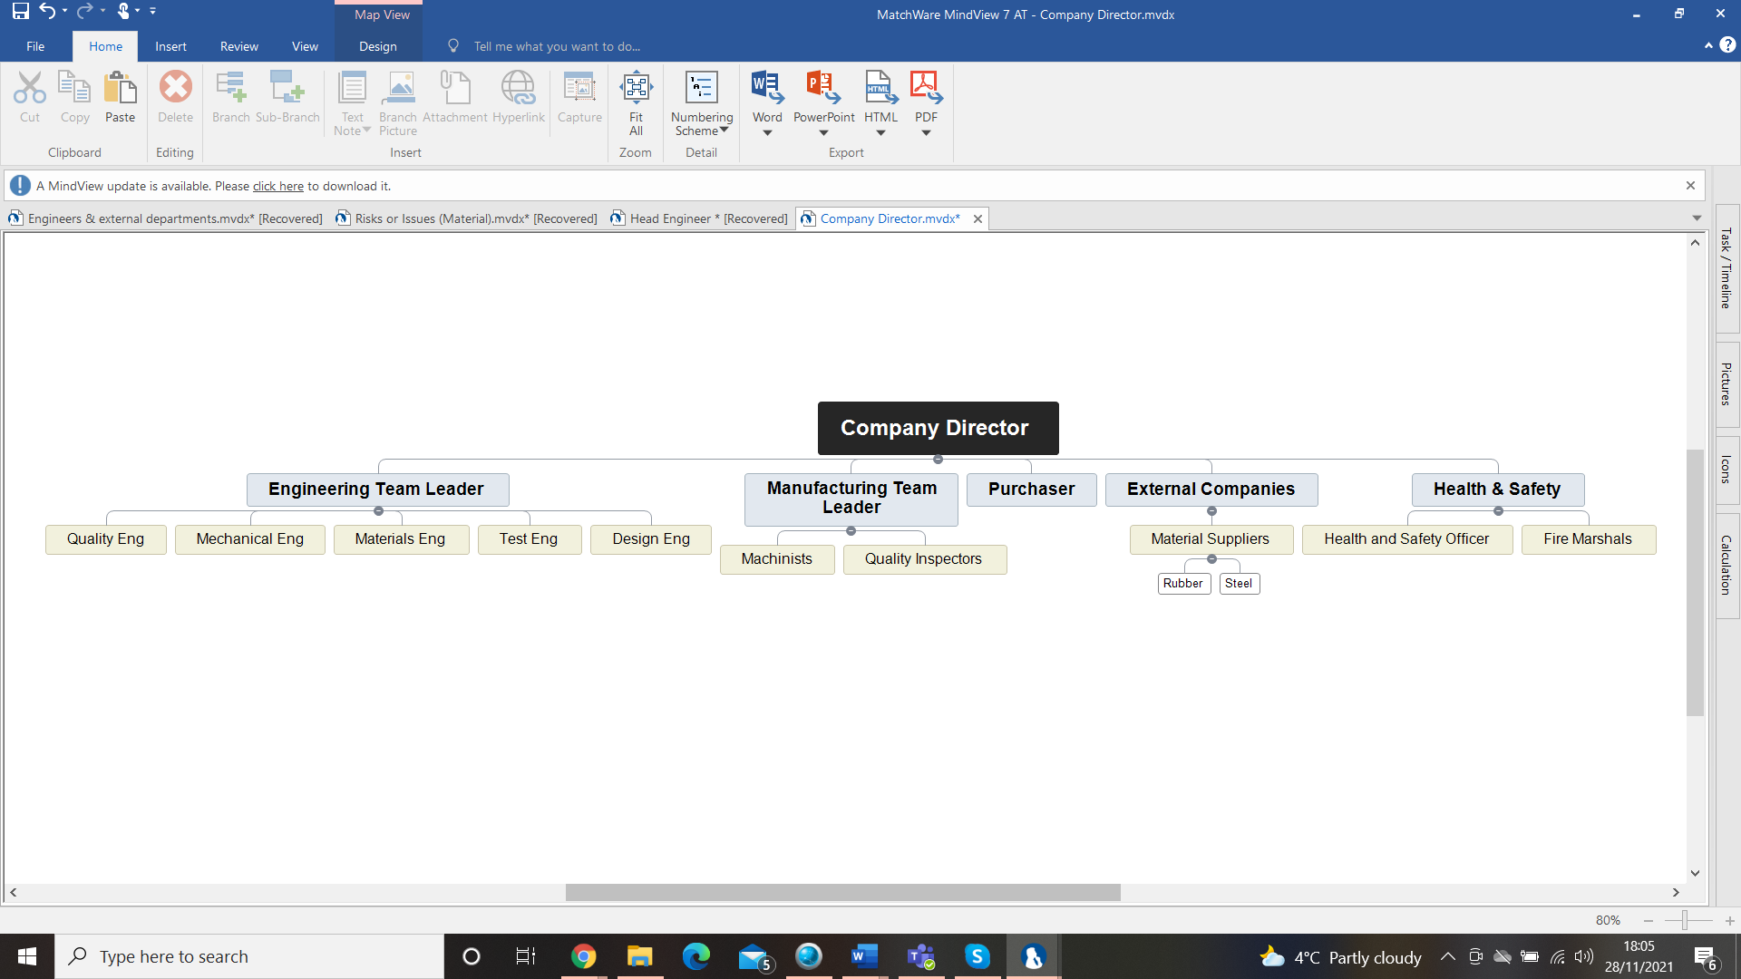
This team for this product, the Motocross/Enduro tyre, compromises of six staff members, which include the Engineering Team Leader. The individuals who form part of this team have been specifically chosen based on their specialist skills set that they have to offer. The layout of the team is highlighted below in a diagram.

Firstly, the design engineers, are tasked with researching and developing tyre designs. Due to the specifications of the required tyre the designer needs to create the tyre suitable for specific terrains examples are sandy, rocky, wet or dry surfaces. There are also there are material engineers, who specialise in the testing materials and creating newer materials. They are also required to check test each part and look for the best quality materials for the project. Mechanical Engineers is a ‘broad field’ of engineers, produce specification for design, manufacturing and the operation of machinery and/or systems (Michigan Technology University, 2020). The test engineer’s role checks the mechanical or electrical systems to check for any potential issues that may arise, alongside checking the tyres, in order to ensure that they are off high quality. Finally, the quality engineer is responsible for ensuring that materials are off good quality and is additionally responsible for ‘developing ways for improvement’ and using ‘emerging technologies’ to ‘improve business performance’ (Elshennaway, 2007).
The head engineer has additional responsibilities, as well as overlooking the engineering team. This includes regular communication manufacturing, which allow for better and more efficient products, as in theory both departments work hand in hand to create the best products, using the best manufacturing processes (Michigan Technology University, 2020). There would also be engineers who would take on additional roles, such as Fire Marshal, First Aider, and Health and Safety Officer. The head engineer would have regular communication with these individuals to ensure that all areas are safe and up to date.
The importance of these engineers should not be overlooked, and whilst these engineers are working, they must adhere to a strict code of conduct. The institute of mechanical engineers notes that this needs to be set of ‘which all members are expected to abide by’ and include standards for health and safety and ethics in all to ensure safety for all engineers and members of the public (Institute of Mechanical Engineers, 2021). These include four key principles, which include ‘acting with care and competence’, and only undertaking tasks, where there is complete competence (Institute of Mechanical Engineers, 2021). It also suggests that there needs to be ‘professional indemnity insurance’ to cover any potential risks (Institute of Mechanical Engineers, 2021). Other principles, suggested by the Institute of Engineers, include ‘We should act with integrity and in a reliable and trustworthy manner’ and avoiding misleading others, and to also 'present and review engineering evidence, theory and interpretation honestly, accurately and without bias (Institute of Mechanical Engineers, 2021). Finally, it is highlighted that all engineers should recognise the importance of sustainability, and also contribute to the ‘positive perception’ of engineering, and further support inclusion (Institute of Mechanical Engineers, 2021). These ideas are similarly suggested in other institutions and societies, such as the National Society of Professional Engineers, who equally push for further, and suggest that credit needs to be given ‘when due’ in order to the profession to progress, and to credit the individuals who created the idea, in order for there to be equal opportunities (National Society for Professional Engineers, 2019).

Methodology – Product Development
There are a variety of issues that could be arise whilst the product is being developed. In order to minimise these issues, this report has centralised a number of problems and looked at strategies to overcome these. Firstly, to minimise any confusion or lose of time, one way to keep contact is through the creation of a sign off report. This would need to be filled out by all engineers, team leaders and machinists, and will primarily compromise of a report that notes down what has happened. The report would need to be updated throughout the day and at the end of the work shift. This keeps everyone in on what is happening and what is needed to be done to get ready for the next process. For example, when the machinist has finished their section of the process and parts, they would need to fill out a sign off report, which would contain all the information of what has been done, what needs to be done and who was in charge of said operations to the product. This means any issues that happen down the product line can be dealt with swiftly without causing any panic.
As well as these reports, it would also be useful and helpful to ensure that there are weekly and monthly meetings, in order to feedback any issues that are occurring between workers, and if there are any areas that can be improved (Page, 2018). By Issues, Legislation & Standards holding these meetings, it will be able to ensure that any issues between workers, are able to be resolved quickly. It is noted by the Oxford University's Saïd Business School, that workers who are happier increase productivity by 13% compared to those who are unhappy (Bellet, De Neve and Ward, 2020). Although this test was based on call centre workers it could transfer over to many other industries such as the engineering and manufacturing (Bellet, et.al 2020). Due to the fact that both jobs are mentally demanding which can affect their work production when under a lot of pressure or being overworked (Bellet et.al, 2020). Additionally, when there is a higher level of team and work and cooperation, there will be a more professional work environment and therefore a higher standard of the product will be created.
There are also many problems in the production line that can stem from tiredness and overworking (Health and Safety Executive, 2021). However, many of these issues can be resolved through the implementation of simple methods, which include restricting working hours, and ensuring that workers take regular breaks.

Issues, Legislation & Standards
There are a number of issues that come with the production of tyres, these vary from production issues to environmental and sustainability issues. For instance, in terms of the disposal of tyres, the whole tyres themselves have been banned from landfill sites as early as July 2003 under the EU Landfill Directive (Bell and Cave, 2010). This stopped whole tyres from being taken to landfill, whilst the ban on shredded tyres in landfill came into force in 2006(Bell and Cave, 2010). Because of this there will be issues surrounding the disposal of the faulty products which can happen. However, in spite of this, there are there are many ways that a tyre can be re-used and recycled even if they cannot be used as tyres anymore on a vehicle.
There are different ways to recycle scrap rubber such are cryogenic grinding which freezes chunks of old tyres using liquid nitrogen to a temperature of -100ºc this makes it easier to crush the rubber down to finer pieces which can be used for playgrounds, which can be a lot safer for children (2g Biopower, 2020). The ground tyres are also being used by Tarmac to expand its asphalt range which has said to be recycling and reusing up to 750 waste tyres per kilometre of highway surfaced which will reduce the amount of rubber waste exported from the UK by 120,000 tonnes annually (Tarmac, 2019). Due to the impact of these tyres the company would be able to transfer the faulty products to specialist tyre recycling plants which take used or faulty tyres and use pyrolysis (2g Biopower, 2020) (Bell and Cave, 2010). These shred and heat tyres without oxygen which can be split back into different components such as oil which can be used as a partially renewable transport fuel (2g Biopower, 2020). They also take the old steel wire which was used to keep tyre in its original shape, this is a highly valuable metal which can be recycled and used for many other (2g Biopower, 2020).
There are many risks associated with working in a manufacturing industry which include injuries to all employees which can include slipping and tripping hazards to more severe injuries which can involve machinery. To help reduce accidents, a risk assessment and COSHH (Control Of Substances Hazardous to Health) assessments are created for every area so that each section is safe as safe as possible for everybody working there and visitors (Health and Safety Executive, 2021). By ensuring that all personnel are given the correct PPE (Personal Protective Equipment) when using possibly dangerous equipment, machinery or lifting/moving heavy objects (Health and Safety Executive, 2021). This also protects the company from any legal action as they have done all the can to protect them. To stop anybody from walking into the company ID cards can be used to differentiate between visitors, workers and even strangers, this will help stop ideas and products being stolen or destroyed. Carrying on from the last risk, if there are any operations or procedures that are more secretive make sure all photography or reports by visitors are limited to what they are allowed.

Conclusion and Personal Development
In order for my research product to be successful, there would need to be a at least 5 staff individuals who would be able to work on my product, which includes mechanical and quality engineers. These individuals would need to adhere to a strict professional code of conduct, as outlined by the Institute of Mechanical Engineers, in order to reduce any potential issues (Institute of Mechanical Engineers, 2021). By utilising a sign off report, it would be possible to minimise any problems whilst making it easier to fix said problems. Giving employees regular breaks as well as restricting long work hours has shown improvement in productivity and the happiness in employees. Whilst it is impossible for UK businesses to scrap old tyres there are new ways to recycle some parts of the old tyres through cryogenic grinding and pyrolysis (2g Biopower, 2020)(Bell and Cave, 2010). Different types of risk assessments such as COSHH help reduce injuries in the workplace for employees and visitors.
When looking into the future, I see myself taking part in the Motocross industry, where one of my aims is to work for one of the bigger motocross teams, who participate in MXGP or AMA Supercross and Motocross. In order to get into this position, I have currently helped to set up a motocross race team. This team has taught me and will teach me the pressures and understanding of the operation of how a race team works. After I have finished my university degree, I will look into working for smaller race teams to get a better understanding of working for a professional team, then slowly work my way up into higher ranking teams as an engineer. I believe I have a chance to get into the bigger teams as a head engineer if I keep pushing myself and improve.

Reference List

Bell, Kirsty and Cave, Suzie (2010) ‘Tyre Disposal’ Research and Library Service Briefing Note, Northern Island Assembly, Belfast, 6th October 2010 available at: http://www.niassembly.gov.uk/globalassets/documents/raise/publications/2010/environment/15910.pdf
Bellet, Clement, De Neve, Jan-Emmanuel and Ward, George (2020) ‘Does Employee Happiness have an Impact on Productivity?’ Said Business School WP, 2019-13
Elsenhennaway, Ahmad K (2007) ‘Quality in the New Age and the Body of Knowledge for Quality Engineers’ Quality Engineering 15 (5) pp603-614
Health and Safety Executive (2021) ‘Risk at Work - Personal protective equipment (PPE)’ Available at: https://www.hse.gov.uk/toolbox/ppe.htm (Accessed 20th November 2021)
Institute of Mechanical Engineers,(2021) ‘Code of Conduct Regulations – Revised 2021’ Available at: ttps://www.imeche.org/docs/default-source/1-oscar/About-us/governance/code-of-conduct-regulations.pdf?sfvrsn=2 (Accessed 28th November 2021)
National Society for Professional Engineers (2019) ‘NSPE Code of Ethics for Engineers Available at: https://www.nspe.org/resources/ethics/code-ethics (Accessed 28th November 2021)
Michigan Technology University (2005) ‘What is Mechanical Engineering?’ Available at: https://www.mtu.edu/mechanical/engineering/ (Accessed 26th November 2021)
Page, Michael (2018) ‘The importance of good communication in the workplace’ Available at: https://www.michaelpage.co.uk/advice/management-advice/development-and-retention/importance-good-communication-workplace?fbclid=IwAR1iuACx8qkZYmW1LjHEClzoLkieWsOqB7_iaqZRNAB8v0pv4qLN5MsSvI8(Accessed 27th November 2021)
Sianoja, Marjaana, Kinnunen, Ull, de Bloom Jessica, Korpela Kalevi Geurts,Sabine (2016) ‘Recovery during Lunch Breaks: Testing Long-Term Relations with Energy Levels at Work’ Scandinavian Journal of Work and Organizational Psychology 1(1), p.7. DOI: http://doi.org/10.16993/sjwop.13
Tarmac A CRH Company (2019) ‘Rubber roads pave the way for tyre recycling as Tarmac expands asphalt range’, Available at: https://tarmac.com/news/rubber-roads-pave-the-way-for-tyre-recycling-as-tarmac-expands-asphalt-range/ (accessed 10th November 2021)
Unison (2021) ‘Risk Assessment’ Available at: https://www.unison.org.uk/get-help/knowledge/health-and-safety/risk-assessment/ (Accessed 20th November)
2g BioPower (2020) ‘Using Tyres as a Resource’, Available at http://2gbiopower.com/ (Accessed 11th November 2021)

