Appendices

Contents

- Ethics Form………………………………………………………………………………….……...2
- Interview Questions……………………………………………………………………….………15
- Book scrutiny………………………………………………………………………………….…..16
- Parental Consent………………………………………………………………………………….18
- Observation schedule…….………………………………………………………………………20
- Mind map to show main themes during the interview…………………………………………21

Appendix (1)

APPLICATION FOR ETHICAL APPROVAL

RESEARCH STUDENTS
This form is to be completed by the student within SIX months for full-time students and TWELVE months for part time students, after the commencement of the research degree or following progression to Part Two of your course.

Once complete, submit this form via the MyTSD Doctoral College Portal at (https://mytsd.uwtsd.ac.uk).

This document is also available in Welsh.

RESEARCH STAFF ONLY
All communications relating to this application during its processing must be in writing and emailed to pgresearch@uwtsd.ac.uk , with the title ‘Ethical Approval’ followed by your name.

STUDENTS ON UNDERGRADUATE OR TAUGHT MASTERS PROGRAMMES should submit this form (and receive the outcome) via systems explained to you by the supervisor/module leader.

In order for research to result in benefit and minimise risk of harm, it must be conducted ethically. A researcher may not be covered by the University’s insurance if ethical approval has not been obtained prior to commencement.

The University follows the OECD Frascati manual definition of research activity: “creative work undertaken on a systematic basis in order to increase the stock of knowledge, including knowledge of man, culture and society, and the use of this stock of knowledge to devise new applications”. As such this covers activities undertaken by members of staff, postgraduate research students, and both taught postgraduate and undergraduate students working on dissertations/projects.

The individual undertaking the research activity is known as the “principal researcher”.

Ethical approval is not required for routine audits, performance reviews, quality assurance studies, testing within normal educational requirements, and literary or artistic criticism.

Please read the notes for guidance before completing ALL sections of the form.

This form must be completed and approved prior to undertaking any research activity. Please see Checklist for details of process for different categories of application.

SECTION A: About You (Principal Researcher)
1 | Full Name: |  | Alyssa Natasha Bagshaw
2 | Tick all boxes that apply: |  | Member of staff: | ☐ | Honorary research fellow: | ☐
 | Undergraduate Student | ☒ | Taught Postgraduate Student | ☐ | Postgraduate Research Student | ☐

3 | Institute/Academic Discipline/Centre: | UWTSD
4 | Campus: | Carmarthen
5 | E-mail address: | 2005688@student.uwtsd.ac.uk
6 | Contact Telephone Number: | 07947594423
 | For students:
7 | Student Number: | 2005688
8 | Programme of Study: | ECAD6010
9 | Director of Studies/Supervisor: | Jo Bamsey

SECTION B: Approval for Research Activity
1 | Has the research activity received approval in principle?  (please check the Guidance Notes as to the appropriate approval process for different levels of research by different categories of individual) |  | YES | ☒ | NO | ☐
 |  |  |  |  | Date
2 | If Yes, please indicate source of approval (and date where known): Approval in principle must be obtained from the relevant source prior to seeking ethical approval | Research Degrees Committee |  | ☐
2 |  | Institute Research Committee |  | ☐
2 |  | Other – Supervisor Jo Bamsey |  | ☒ | 28/11/2022

SECTION C: Internal and External Ethical Guidance Materials
 | Please list the core ethical guidance documents that have been referred to during the completion of this form (including any discipline-specific codes of research ethics, location-specific codes of research ethics, and also any specific ethical guidance relating to the proposed methodology). Please tick to confirm that your research proposal adheres to these codes and guidelines. You may add rows to this table if needed.
1 | UWTSD Research Ethics & Integrity Code of Practice | ☒
2 | UWTSD Research Data Management Policy | ☒
3 | - UWTSD Code of Ethics  - BERA Guidelines (2018)  - UNCRC (Unicef, 1992) | ☒

SECTION D: External Collaborative Research Activity
If there are external collaborators then you should gain consent from the contact persons to share their personal data with the university. If there are no external collaborators then leave this section blank and continue to section E.
1 | Institution
2 | Contact person name
3 | Contact person e-mail address
4 | Is your research externally funded? |  | YES | ☐ | NO |  | ☒
5 | Are you in receipt of a KESS scholarship? |  | YES | ☐ | NO |  | ☒
6 | Are you specifically employed to undertake this research in either a paid or voluntary capacity? | Voluntary | YES | ☐ | NO | ☒
7 |  | Employed | YES | ☐ | NO | ☒
8 | Is the research being undertaken within an existing UWTSD Athrofa Professional Learning Partnership (APLP)? | If YES then the permission question below does not need to be answered. | YES | ☐ | NO |  | ☒
9 | Has permission to undertake the research has been provided by the partner organisation? | (If YES attach copy)  If NO the application cannot continue | YES | ☐ | NO |  | ☒

Where research activity is carried out in collaboration with an external organisation
10 | Does this organisation have its own ethics approval system? | YES | ☐ | NO | ☒
 | If Yes, please attach a copy of any final approval (or interim approval) from the organisation (this may be a copy of an email if appropriate).

SECTION E: Details of Research Activity
1 | Indicative title: | How can self-assessment aid learning of year 3 and 4 pupils?
2 | Proposed start date: | /01/23 | Proposed end date: | /01/23
Introduction to the Research (maximum 300 words per section)
Ensure that you write for a Non-Specialist Audience when outlining your response to the points below:
- Purpose of Research Activity
- Proposed Research Question
- Aims of Research Activity
- Objectives of Research Activity
Demonstrate, briefly, how Existing Research has informed the proposed activity and explain
- What the research activity will add to the body of knowledge
- How it addresses an area of importance.
3 | Purpose of Research Activity  The purpose of this research is to conduct an explorative case study with year 3 and 4 children that will help inform my pedagogical choices in the future as a teacher. The research will explore a possible relationship between self-reflection and progress. It will also identify teachers and pupil’s views and perceptions on self-reflection and peer/self-assessment. The class I will be researching is combined with year 3 and 4 pupils so has a broad range of abilities, therefore, I will be looking into how a self-reflective student can reflect on their own progress independently and choose their own ability when a teacher differentiates.  (this box should expand as you type)
4 | Research Question  What are the perceptions of year 3 and 4 students of self-assessment as an AfL strategy?  (this box should expand as you type)
5 | Aims of Research Activity  - To find if there is a link between self-reflection strategies and resilience.  - To find whether self-reflection is linked with independence in setting own goals and identifying own ability.  - To explore how Vygotsky’s theory of ‘Zone of Proximal Development’ can build resilience and confidence in the classroom.  (this box should expand as you type)
6 | Objectives of Research Activity  - To interview students using focus groups about how they feel about, self/peer assessment, self-reflection and using a correction pen to support their learning.  - To question two teachers on their perceptions on children using self-reflection methods. This will identify the teacher’s role in providing differentiation for the children.  - To use work scrutiny to find how often children use their correction pen to reflect on their learning and choose a higher ability piece of work. This will find qualitative data and  - To research around self-reflection further to develop my own knowledge.  - To look at theory supporting self-assessment such as Black and Wiliam’s Assessment for Learning strategies and Vygotsky’s Zone of Proximal Development.  (this box should expand as you type)
Proposed methods (maximum 600 words)
Provide a brief summary of all the methods that may be used in the research activity, making it clear what specific techniques may be used. If methods other than those listed in this section are deemed appropriate later, additional ethical approval for those methods will be needed. You do not need to justify the methods here, but should instead describe how you intend to collect the data necessary for you to complete your project.
7 | Firstly, I will collect consent from the participants parents through a parental consent form that will be sent out to parents of the year 3 and 4 pupils. Once I have gained consent from the participants parents, I will gain assent from the pupils that have been given parental consent. To gain assent from the children directly I am going to write a script about the research and its intended outcomes and explain that there is an option to opt out or withdraw. I will also create ‘Emotion Fans’ for the children to express their feelings throughout the study. If the child shows the ‘sad face’ then they will opt out of the study and if the ‘green face’ is shown, then the study will continue.  Prior to conducting the research, I will also create an observation schedule to code behaviours throughout the research. This coding system will enable me to collect data effectively and observe patterns that may be significant from my research.  A questionnaire will be created to question year 3 and 4 children on their self-reflection strategies they use when they are learning.  I will conduct a series of semi-structured interviews using focus groups. These interviews will be conducted with staff and pupils. The adults will be questioned on their encouragement and implementation of using self-reflection strategies with the pupils and the children will be questioned on specific strategies that have been identified throughout the questionnaire, for example, using a correction pen within their work.  I will be using work scrutiny to see how often pupils use the self-reflection strategies in their work.  I will be storing the data in my iCloud which is protected by passwords the data will be anonymised by using Teacher 1, Child 1 etc.  (this box should expand as you type)
Location of research activity
Identify all locations where research activity will take place.
8 | The school I will be researching in is a small school in a busy village on the outskirts of a main city in Wales. They pride themselves in the opportunities they offer and place the children at the centre of everything they do. They believe that the pupil’s best is always good enough and which is reflected through the school’s encouragement to their pupil’s. Visitors to the school constantly comment on the friendly atmosphere and the excellent behaviour of the children but the school never forgets that their aim is for the children to achieve their full potential.  (this box should expand as you type)
Research activity outside of the UK
If research activity will take place overseas, you are responsible for ensuring that local ethical considerations are complied with and that the relevant permissions are sought. Specify any local guidelines (e.g. from local professional associations/learned societies/universities) that exist and whether these involve any ethical stipulations beyond those usual in the UK (provide details of any licenses or permissions required). Also specify whether there are any specific ethical issues raised by the local context in which the research activity is taking place, for example, particular cultural and/or legal sensitivities or vulnerabilities of participants. If you live in the country where you will do the research then please state this.
9 | N/A  (this box should expand as you type)

10 | Use of documentation not in the public domain: Are any documents NOT publicly available? | NO | ☒
10 |  | YES | ☐
11 | If Yes, please provide details here of how you will gain access to specific documentation that is not in the public domain and that this is in accordance with the current data protection law of the country in question and that of England and Wales.  N/A  (this box should expand as you type)

 | Does your research relate to one or more of the seven aims of the Well-being of Future Generations (Wales) Act 2015? | YES | NO
12 | A prosperous Wales | ☐ | ☐
13 | A resilient Wales | ☐ | ☐
14 | A healthier Wales | ☐ | ☐
15 | A more equal Wales | ☐ | ☐
16 | A Wales of cohesive communities | ☐ | ☐
17 | A Wales of vibrant culture and thriving Welsh language | ☐ | ☐
18 | A globally responsible Wales | ☐ | ☐
19 | If YES to any of the above, please give details:
 | (this box should expand as you type)

SECTION F: Scope of Research Activity
 | Will the research activity include: | YES | NO
1 | Use of a questionnaire or similar research instrument? | ☒ | ☐
2 | Use of interviews? | ☒ | ☐
3 | Use of focus groups? | ☒ | ☐
4 | Use of participant diaries? | ☐ | ☒
5 | Use of video or audio recording? | ☐ | ☒
6 | Use of computer-generated log files? | ☐ | ☒
7 | Participant observation with their knowledge? | ☒ | ☐
8 | Participant observation without their knowledge? | ☐ | ☒
9 | Access to personal or confidential information without the participants’ specific consent? | ☒ | ☒
10 | Administration of any questions, test stimuli, presentation that may be experienced as physically, mentally or emotionally harmful / offensive? | ☐ | ☒
11 | Performance of any acts which may cause embarrassment or affect self-esteem? | ☐ | ☒
12 | Investigation of participants involved in illegal activities? | ☐ | ☒
13 | Use of procedures that involve deception? | ☐ | ☒
14 | Administration of any substance, agent or placebo? | ☐ | ☒
15 | Working with live vertebrate animals? | ☐ | ☒
16 | Procedures that may have a negative impact on the environment? | ☐ | ☒
17 | Other primary data collection methods. Please indicate the type of data collection method(s) below. | ☒ | ☐
 | Details of any other primary data collection method:  Field notes and work scrutiny.  (this box should expand as you type) | ☒ | ☐
If NO to every question, then the research activity is (ethically) low risk and may be exempt from some of the following sections (please refer to Guidance Notes).

If YES to any question, then no research activity should be undertaken until full ethical approval has been obtained.

SECTION G: Intended Participants
If there are no participants then do not complete this section, but go directly to section H.

 | Who are the intended participants: | YES | NO
1 | Students or staff at the University? | ☐ | ☒
2 | Adults (over the age of 18 and competent to give consent)? | ☒ | ☐
3 | Vulnerable adults? | ☐ | ☒
4 | Children and Young People under the age of 18? (Consent from Parent, Carer or Guardian will be required) | ☒ | ☐
5 | Prisoners? | ☐ | ☒
6 | Young offenders? | ☐ | ☒
7 | Those who could be considered to have a particularly dependent relationship with the investigator or a gatekeeper? | ☐ | ☒
8 | People engaged in illegal activities? | ☐ | ☒
9 | Others. Please indicate the participants below, and specifically any group who may be unable to give consent. | ☐ | ☒
 | Details of any other participant groups:  (this box should expand as you type) | ☐ | ☒

Participant numbers and source
Provide an estimate of the expected number of participants. How will you identify participants and how will they be recruited?
10 | How many participants are expected? | Maximum of 32 participants.  (this box should expand as you type)
11 | Who will the participants be? | A mix of year 3 and 4 pupils and a maximum of 2 adults including the class teacher and the teaching assistant.  (this box should expand as you type)
12 | How will you identify the participants? | The participants will be in my PTE3 teaching class.  (this box should expand as you type)

 | Information for participants: | YES | NO | N/A
13 | Will you describe the main research procedures to participants in advance, so that they are informed about what to expect? | ☒ | ☐ | ☐
14 | Will you tell participants that their participation is voluntary? | ☒ | ☐ | ☐
15 | Will you obtain written consent for participation? | ☒ | ☐ | ☐
16 | Will you explain to participants that refusal to participate in the research will not affect their treatment or education (if relevant)? | ☒ | ☐ | ☐
17 | If the research is observational, will you ask participants for their consent to being observed? | ☒ | ☐ | ☐
18 | Will you tell participants that they may withdraw from the research at any time and for any reason? | ☒ | ☐ | ☐
19 | With questionnaires, will you give participants the option of omitting questions they do not want to answer? | ☒ | ☐ | ☐
20 | Will you tell participants that their data will be treated with full confidentiality and that, if published, it will not be identifiable as theirs? | ☒ | ☐ | ☐
21 | Will you debrief participants at the end of their participation, in a way appropriate to the type of research undertaken? | ☒ | ☐ | ☐
22 | If NO to any of above questions, please give an explanation
 | (this box should expand as you type)

 | Information for participants: | YES | NO | N/A
24 | Will participants be paid? | ☐ | ☒ | ☐
25 | Is specialist electrical or other equipment to be used with participants? | ☐ | ☒ | ☐
26 | Are there any financial or other interests to the investigator or University arising from this study? | ☐ | ☒ | ☐
27 | Will the research activity involve deliberately misleading participants in any way, or the partial or full concealment of the specific study aims? | ☐ | ☒ | ☐
28 | If YES to any question, please provide full details
 | (this box should expand as you type)

SECTION H: Anticipated Risks

Outline any anticipated risks that may adversely affect any of the participants, the researchers and/or the University, and the steps that will be taken to address them.

If you have completed a full risk assessment (for example as required by a laboratory, or external research collaborator) you may append that to this form.
1 | Full risk assessment completed and appended? |  | Yes | ☐
1 |  |  | No | ☒
2 | Risks to participants  For example: sector-specific health & safety, emotional distress, financial disclosure, physical harm, transfer of personal data, sensitive organisational information
 | Risk to participants:  Pupils may feel under pressure to give a ‘correct’ answer to the questions.  Safeguarding issues – A child could potentially make a disclosure.  Keeping the participants anonymity.  (this box should expand as you type) | How you will mitigate the risk to participants:  I will make it clear that the children are not under any pressure to give an answer as they can withdraw at any moment. I will have an opt out strategy in place.  Follow the school’s safeguarding policy.  Ensure the school is not identified and only share analysed data.  (this box should expand as you type)
3 | If research activity may include sensitive, embarrassing or upsetting topics (e.g. sexual activity, drug use) or issues likely to disclose information requiring further action (e.g. criminal activity), give details of the procedures to deal with these issues, including any support/advice (e.g. helpline numbers) to be offered to participants. Note that where applicable, consent procedures should make it clear that if something potentially or actually illegal is discovered in the course of a project, it may need to be disclosed to the proper authorities
 | (this box should expand as you type)
4 | Risks to the investigator  For example: personal health & safety, physical harm, emotional distress, risk of accusation of harm/impropriety, conflict of interest
 | Risk to the investigator:  Possible bias in the recording of data.  Possibility of being accused of favouritism by pupils who are not part of the focus group.  (this box should expand as you type) | How you will mitigate the risk to the investigator:  Be objective as possible in my findings based on theoretical studies relating to researcher positionality and unconscious bias.  Explain at the start that any focus groups are not based on favouritism their based-on generation of data.  (this box should expand as you type)
5 | University/institutional risks  For example: adverse publicity, financial loss, data protection
 | Risk to the University:  Not behaving in an appropriate way could impact the relationship between the school and university.  The need to uphold the good name and reputation of the university.  (this box should expand as you type) | How you will mitigate the risk to the University:  Follow all BERA guidelines, school policies and code of conduct.  (this box should expand as you type)
6 | Environmental risks  For example: accidental spillage of pollutants, damage to local ecosystems
 | Risk to the environment:  N/A  (this box should expand as you type) | How you will mitigate the risk to environment:  N/A  (this box should expand as you type)

 | Disclosure and Barring Service
 | If the research activity involves children or vulnerable adults, a Disclosure and Barring Service (DBS) certificate must be obtained before any contact with such participants. | YES | NO | N/A
7 | Does your research require you to hold a current DBS Certificate? | ☒ | ☐ | ☐
8 | If YES, please give the certificate number. If the certificate number is not available please write “Pending”; in this case any ethical approval will be subject to providing the appropriate certificate number. | 001806698438

SECTION I: Feedback, Consent and Confidentiality

1 | Feedback  What de-briefing and feedback will be provided to participants, how will this be done and when?
After the research has been conducted, the class will be gathered to share the purposes and the actual outcomes of the research in an appropriate and interesting manner. Debriefing aims to undo any harm that was caused during the research. This links to the United Nation Convention Rights of the Child as it will protects the child’s rights.

(this box should expand as you type)
2 | Informed consent  Describe the arrangements to inform potential participants, before providing consent, of what is involved in participating. Describe the arrangements for participants to provide full consent before data collection begins. If gaining consent in this way is inappropriate, explain how consent will be obtained and recorded in accordance with prevailing data protection legislation.
To gain informed consent, a letter will be sent to parents, and they will be required to sign to give consent for data to be collected about their child.

To gain assent from the children directly I am going to write a script about the research and its intended outcomes and explain that there is an option to opt out or withdraw. I will also create ‘Emotion Fans’ for the children to express their feelings throughout the study. If the child shows the ‘sad face’ then they will opt out of the study and if the ‘green face’ is shown, then the study will continue.

(this box should expand as you type)
3 | Confidentiality / Anonymity  Set out how anonymity of participants and confidentiality will be ensured in any outputs. If anonymity is not being offered, explain why this is the case.
Provide opportunities for confidential discussions. However, in line with safeguarding policies. I will also be using pseudonyms in my assignment and will not name the school.

(this box should expand as you type)

SECTION J: Data Protection and Storage

 | Does the research activity involve personal data (as defined by the General Data Protection Regulation 2016 “GDPR” and the Data Protection Act 2018 “DPA”)? | YES | NO
1 | “Personal data” means any information relating to an identified or identifiable natural person (‘data subject’). An identifiable natural person is one who can be identified, directly or indirectly, in particular by reference to an identifier such as a name, an identification number, location data, an online identifier or to one or more factors specific to the physical, physiological, genetic, mental, economic, cultural or social identity of that natural person. Any video or audio recordings of participants is considered to be personal data. | ☐ | N
 | If YES, provide a description of the data and explain why this data needs to be collected:
2 | (this box should expand as you type)
 | Does it involve special category data (as defined by the GDPR)? | YES | NO
3 | “Special category data” means sensitive personal data consisting of information as to the data subjects’ –  (a) racial or ethnic origin,  (b) political opinions,  (c ) religious beliefs or other beliefs of a similar nature,  (d) membership of a trade union (within the meaning of the Trade Union and Labour Relations (Consolidation) Act 1992),  (e) physical or mental health or condition,  (f) sexual life,  (g) genetics,  (h) biometric data (as used for ID purposes), | ☐ | N
 | If YES, provide a description of the special category data and explain why this data needs to be collected:
4 | (this box should expand as you type)

 | Will data from the research activity (collected data, drafts of the thesis, or materials for publication) be stored in any of the following ways? | YES | NO
5 | Manual files (i.e. in paper form)? | ☒ | ☐
6 | University computers? | ☐ | ☒
7 | Private company computers? | ☐ | ☒
8 | Home or other personal computers? | ☒ | ☐
9 | Laptop computers/ CDs/ Portable disk-drives/ memory sticks? | ☒ | ☐
10 | “Cloud” storage or websites? | ☒ | ☐
11 | Other – specify: | ☐ | ☒
12 | For all stored data, explain the measures in place to ensure the security of the data collected, data confidentiality, including details of backup procedures, password protection, encryption, anonymisation and pseudonymisation:
All manual files will be kept in school and anonymised using pseudonyms and any devices holding any data will be encrypted with verification codes and one-time passwords (OTP’s).

(this box should expand as you type)

 | Data Protection
 | Will the research activity involve any of the following activities: | YES | NO
13 | Electronic transfer of data in any form? | ☒ | ☐
14 | Sharing of data with others at the University outside of the immediate research team? | ☐ | ☒
15 | Sharing of data with other organisations? | ☐ | ☒
16 | Export of data outside the UK or importing of data from outside the UK? | ☐ | ☒
17 | Use of personal addresses, postcodes, faxes, emails or telephone numbers? | ☐ | ☒
18 | Publication of data that might allow identification of individuals? | ☐ | ☒
19 | Use of data management system? | ☐ | ☒
20 | Data archiving? | ☒ | ☐
21 | If YES to any question, please provide full details, explaining how this will be conducted in accordance with the GDPR and Data Protection Act (2018) (and any international equivalents, where appropriate):
All data will be encrypted and archived in a password protected cloud storage on the University Office 365 system until I pass my university module. Any USB sticks used to store or transfer data will be protected and any unnecessary raw data will be deleted or destroyed immediately. Data transfers will be encrypted, and password protected. All participants will be given a unique identifier to ensure confidentiality and this list will be kept securely in a password protected folder, The data will be stored until the completion of the project and then deleted. Follow school policies and BERA guidelines on electronic transfer. In accordance with the DPA (2018), participants will have the right to ask to see what data is held relating to them, and this data will be deleted immediately if the participant requests this, in which the data will not be used in the project.

(this box should expand as you type)
22 | List all who will have access to the data generated by the research activity:
Only the researcher will have access to raw data.
Analysed data will be shared more widely with participants, university staff and peers during bridging.

(this box should expand as you type)
23 | List who will have control of, and act as custodian(s) for, data generated by the research activity:
The researcher will have control of the data.

(this box should expand as you type)
24 | Give details of data storage arrangements, including security measures in place to protect the data, where data will be stored, how long for, and in what form. Will data be archived – if so how and if not why not.
The majority of the data will be stored on OneDrive via my UWTSD account. This OneDrive has layers of protection to authenticate access, for example, Microsoft Authentication that sends verification codes to my personal device.

Written notes will be typed up as soon as possible and then will be destroyed as soon as possible.

(this box should expand as you type)
25 | Please indicate if your data will be stored in the UWTSD Research Data Repository (see https://researchdata.uwtsd.ac.uk/ ). If so please explain. (Most relevant to academic staff)
N/A

(this box should expand as you type)
26 | Confirm that you have read the UWTSD guidance on data management (see https://www.uwtsd.ac.uk/library/research-data-management/) | YES | ☒
27 | Confirm that you are aware that you need to keep all data until after your research has completed or the end of your funding | YES | ☒

SECTION K: Declaration
The information which I have provided is correct and complete to the best of my knowledge. I have attempted to identify any risks and issues related to the research activity and acknowledge my obligations and the rights of the participants.

In submitting this application I hereby confirm that I undertake to ensure that the above named research activity will meet the University’s Research Ethics and Integrity Code of Practice which is published on the website: https://www.uwtsd.ac.uk/research/research-ethics/
1 | Signature of applicant: | A.Bagshaw | Date:

For STUDENT Submissions:
2 | Director of Studies/Supervisor: | Jo Bamsey | Date:
3 | Signature: | A.Bagshaw | Date:

For STAFF Submissions:
4 | Academic Director/ Assistant Dean: |  | Date:
5 | Signature: |  | Date:

Checklist: Please complete the checklist below to ensure that you have completed the form according to the guidelines and attached any required documentation:
☒ | I have read the guidance notes supplied before completing the form.
☒ | I have completed ALL RELEVANT sections of the form in full.
☒ | I confirm that the research activity has received approval in principle
☐ | I have attached a copy of final/interim approval from external organisation (where appropriate)
☐ | I have attached a full risk assessment (where appropriate) ONLY TICK IF YOU HAVE ATTACHED A FULL RISK ASSESSMENT
☒ | I understand that it is my responsibility to ensure that the above named research activity will meet the University’s Research Ethics and Integrity Code of Practice.
☒ | I understand that before commencing data collection all documents aimed at respondents (including information sheets, consent forms, questionnaires, interview schedules etc.) must be confirmed by the DoS/Supervisor, module tutor or Academic Director.

RESEARCH STUDENTS ONLY
Once complete, submit this form via the MyTSD Doctoral College Portal at (https://mytsd.uwtsd.ac.uk).

RESEARCH STAFF ONLY
All communications relating to this application during its processing must be in writing and emailed to pgresearch@uwtsd.ac.uk , with the title ‘Ethical Approval’ followed by your name.

STUDENTS ON UNDERGRADUATE OR TAUGHT MASTERS PROGRAMMES should submit this form (and receive the outcome) via systems explained to you by the supervisor/module leader.

Appendix (2)
Interview Questions

- Group interview with teachers across year groups

- How well does teaching develop learners through a range of suitable processes to realise the four purposes of the curriculum?
- How well do learners respond to high but achievable expectations from teachers?
- How well does teaching select the most suitable teaching approaches to support learners to progress?
- How well does assessment contribute to learning, progress and well-being?
- How well does teaching provide the right level of challenge?
- How well do learners develop the skills to reflect critically on their own work and the work of others?
- How effective is feedback in improving learners work?
- How well do learners build upon what they have learnt?
- How well does teaching enable learners to influence how and what they learn?

- Group interview with children from Year 3 and 4

- How familiar are you with assessment for learning?
- Does using the purple pen of progress help with your learning?
- If yes, how does it help you with your learning?
- Are there any other ways you would prefer to assess your work?
- Can you think of any reasons why you wouldn’t want to self-assess your work?
- Do you find the use of success criteria helpful?
- What makes you feel challenged in class?
- Does feeling challenged motivate you to learn more?

Appendix (3)
Work scrutiny

To understand the use of the purple pen of progress and self-assessment further I took 15 topic books across all year groups to identify progression and use of the purple pen. When looking at these books I aimed to ask myself some questions.
- Is progression evident across the range of topic books?
- Are any specific skills developing noticeably across the range of books?
- How often does the learner input and express their pupil voice?
- How often does the teacher respond to pupil voice?
- How well do pupils express their sense of belonging and identity when responding to feedback?
- Is it evident pupils are resilient or feel comfortable with their class teacher?

Work and Book Scrutiny Report

Name: | Alyssa Bagshaw | Subject: | Topic books | Date: | 27/01/23

Basis of the Scrutiny: | Review work in each year group – HA, LA, SEN
School Improvement Plan Priority: | To use self-assessment consistently.

Year | Evidence
Nursery and Reception | The HA children in nursery and reception use the purple pen to correct their work. LA children in nursery and reception do not use the purple pen of progress.
Year 1 and 2 | In Y1 and Y2 the majority of children use the purple pen, but they use it as a correction pen more than a dialogue.
Year 3 and 4 | All children use the purple pen of progress in Y3/4 and work towards being a “purple learner”. They use the pen for corrections and have started using it for dialogue with the class teacher, for example, teacher will provide a challenge, pupil will reply with an answer.
Year 5 and 6 | The use of the purple pen is effective in this class. The pupils use it regularly for self-assessment and dialogue with the class teacher.

Appendix (3a)
Work Scrutiny Examples

This example is a HA child in the year 3 part of the year 3 and 4 class who has started to correct her work using the purple pen and write a dialogue to respond to any comments the teacher makes.

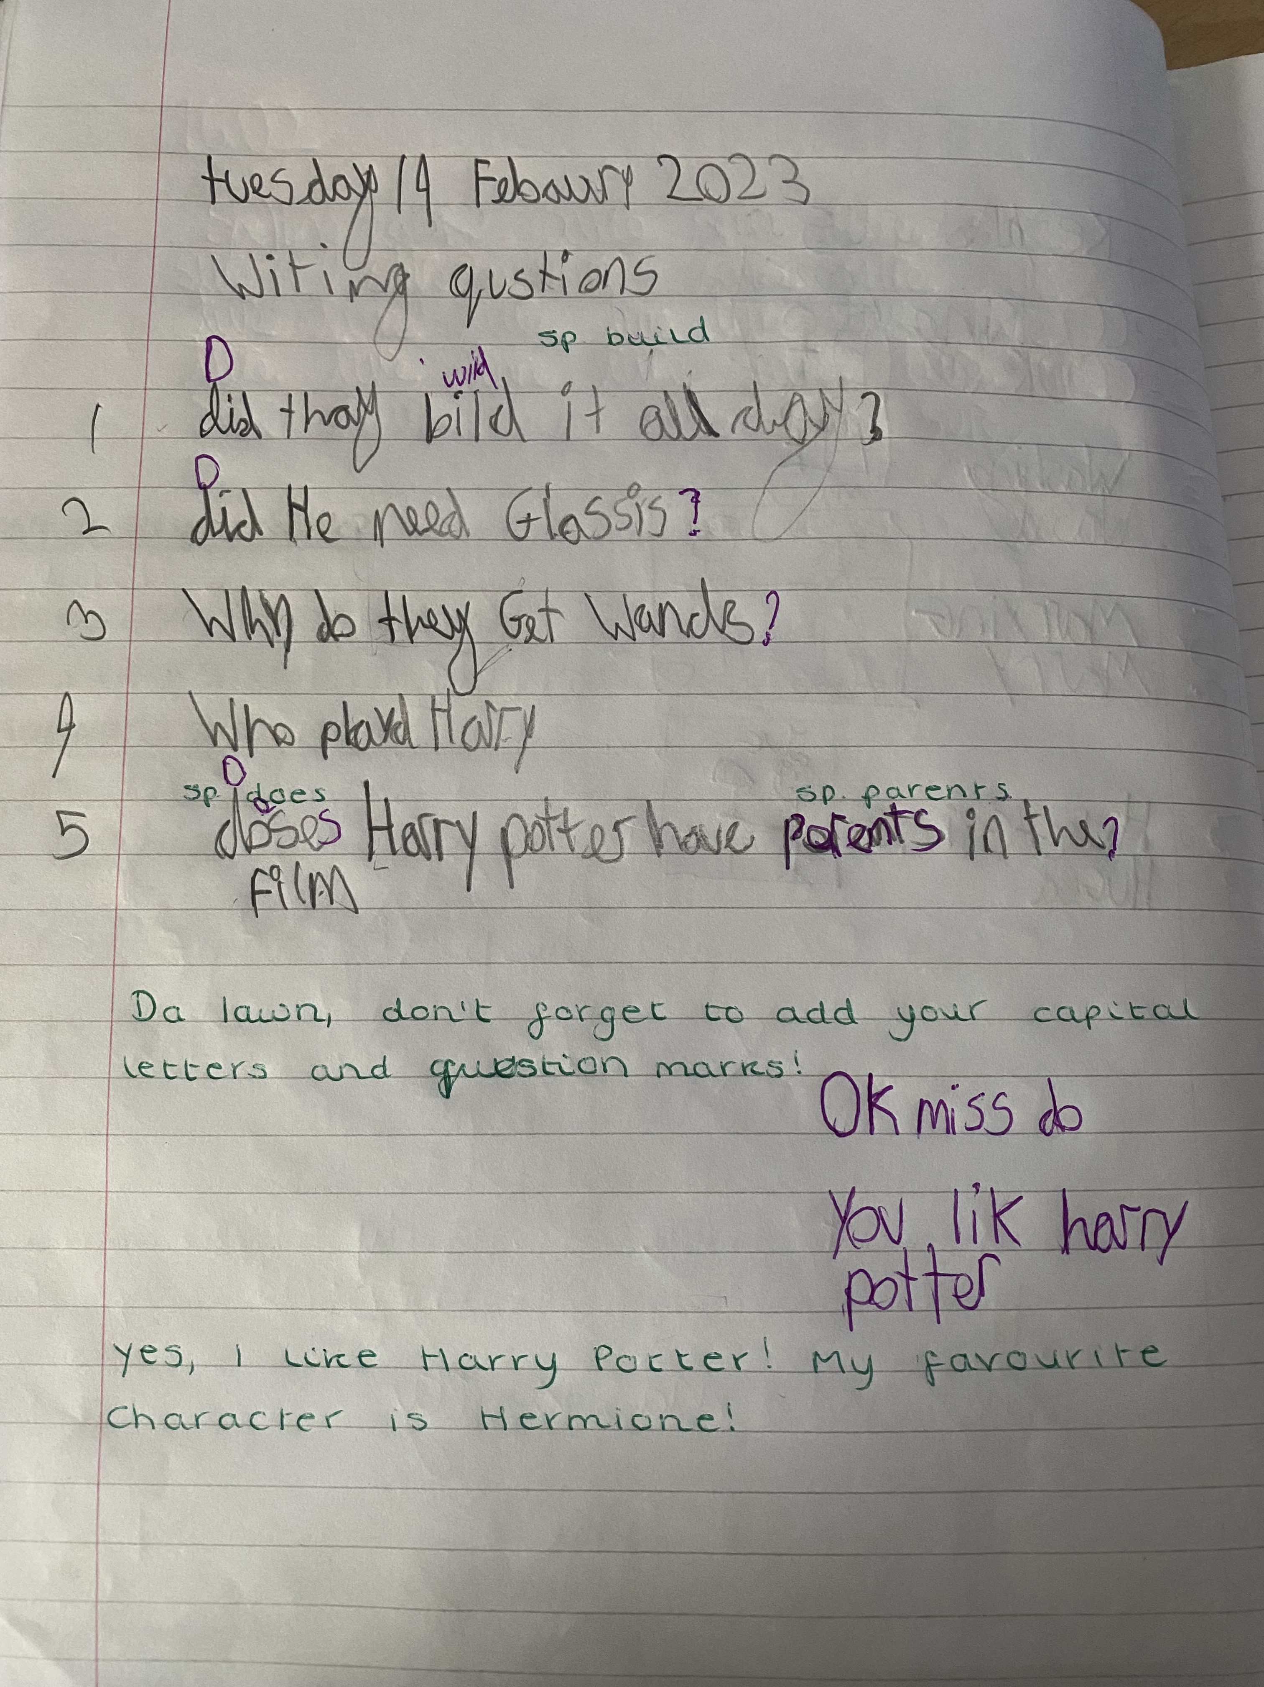

This example is a LA child in the year 4 part of the year 3 and 4 class who has started to use the purple pen of progress to answer challenge questions.

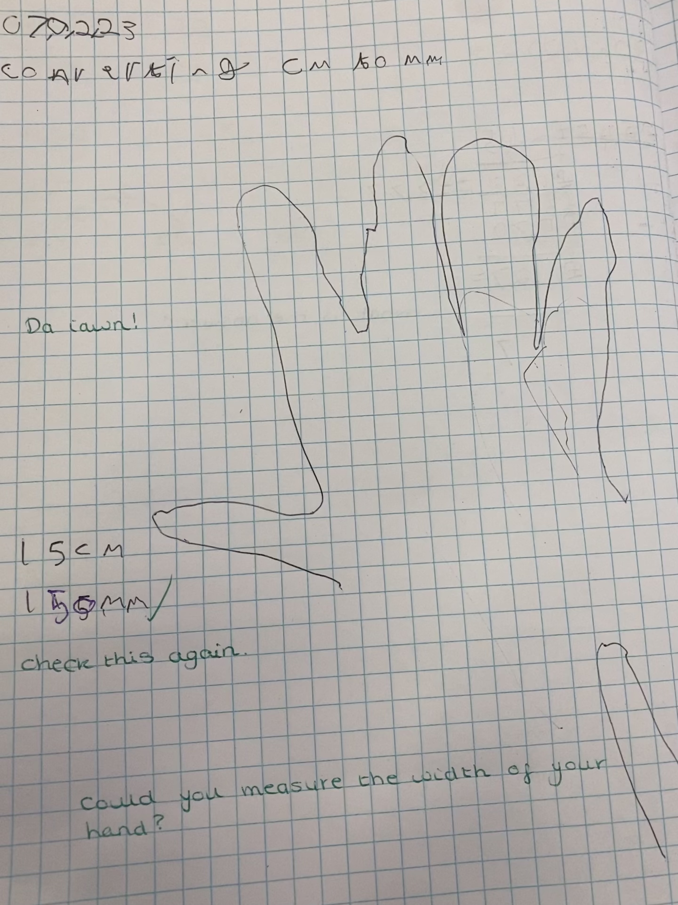

Appendix (4)
Parental Consent

CONSENT FORM (parents)

PROJECT TITLE: What are the perceptions of year 3 and 4 students on self-assessment as an Assessment for Learning (AfL) strategy?

Name of Researcher: Miss Bagshaw

Please initial box

1. I confirm that I have read and understand the information sheet for the above study.

2. I understand that my child’s participation is voluntary and that I am free to withdraw my child from the study at any time, without giving any reason.

3. I understand that my child can choose to withdraw at any time, without giving a reason.

4. I understand that the information given by my child will be used in a university assignment.

5. I understand that my child’s name will not appear at any time.

6. I agree for my child to take part in the above study.

_____________________ _____________________________ __________
Child’s name Parent signature Date

When completed, please return in the envelope provided to ………………. by the ……….. of …………….. (date)

Thank you.

Parent INFORMATION sheet

PROJECT TITLE: What are the perceptions of year 3 and 4 students on self-assessment as an Assessment for Learning (AfL) strategy?

Dear Parent / Guardian,

My name is Alyssa Bagshaw and I am studying for a BAEd qualification at Yr Athrofa, University of Wales Trinity Saint David. I am currently a student teacher within School A and am teaching in your child’s class.
I would like to invite your child to participate in my research project. The title of the project is ‘What are the perceptions of year 3 and 4 students on self-assessment as an Assessment for Learning (AfL) strategy?’ and I aim to find out if there is a link between self-assessment strategies and resilience and to identify whether self-reflection can be linked to independence. Through your child’s participation, I hope to ascertain their perspective on AfL.
All names will be kept strictly confidential and will only be known by myself and my research partner. Your child’s participation in this study is completely voluntary so you or your child can withdraw from the study at any stage. Your child will also be asked to give their assent before the beginning of the study.
After careful and precise analysis of the data obtained from the lesson observation and group interview, I would be happy to provide you with a copy of the findings at your request. The results of the research will be discussed in a university assignment that will contribute to my PGCE course. The results of this study will be stored on iCloud and all raw data will be destroyed once the assessment has been marked.
I thank you in advance for your time. If any questions do arise, feel free to contact me at your convenience.

Yours sincerely,

Alyssa Bagshaw.

Appendix (5)
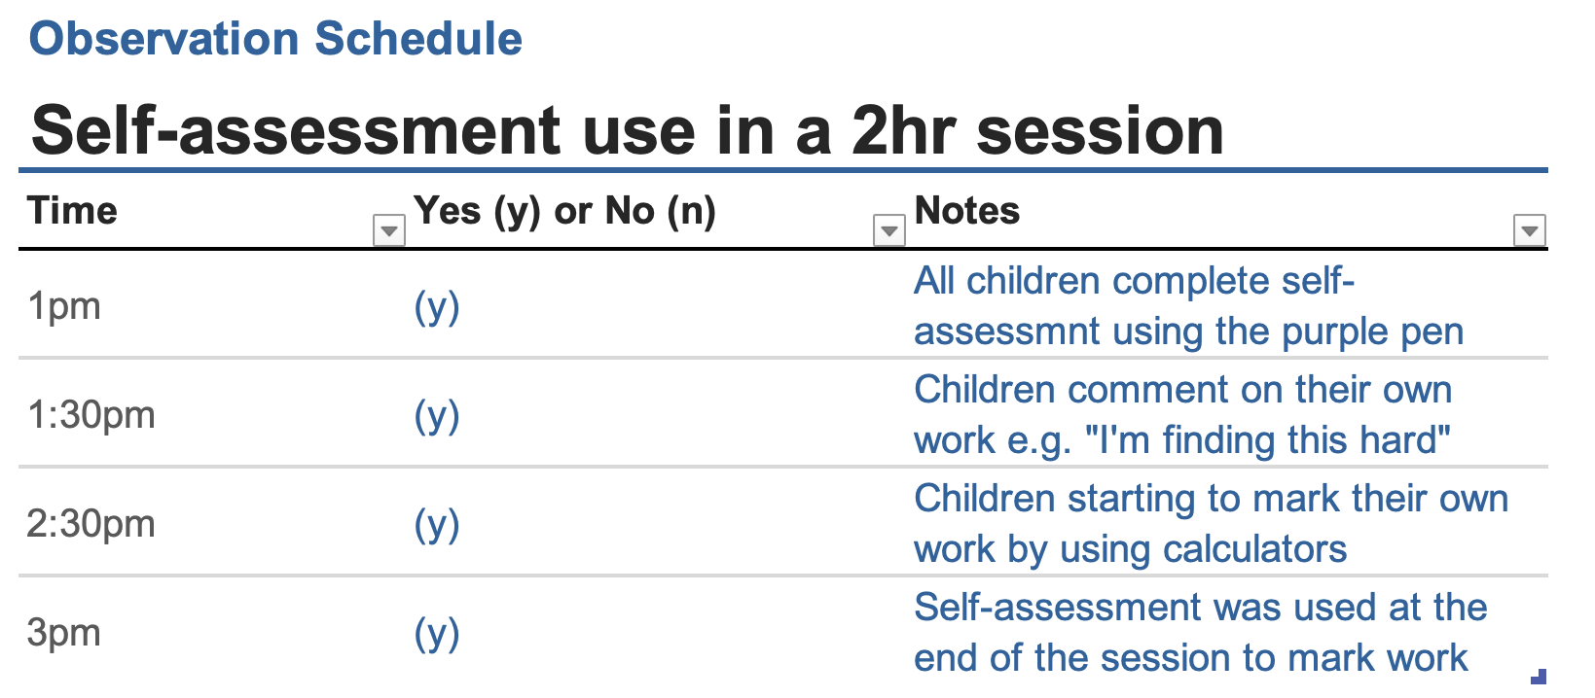
Observation Schedule

Appendix (6)

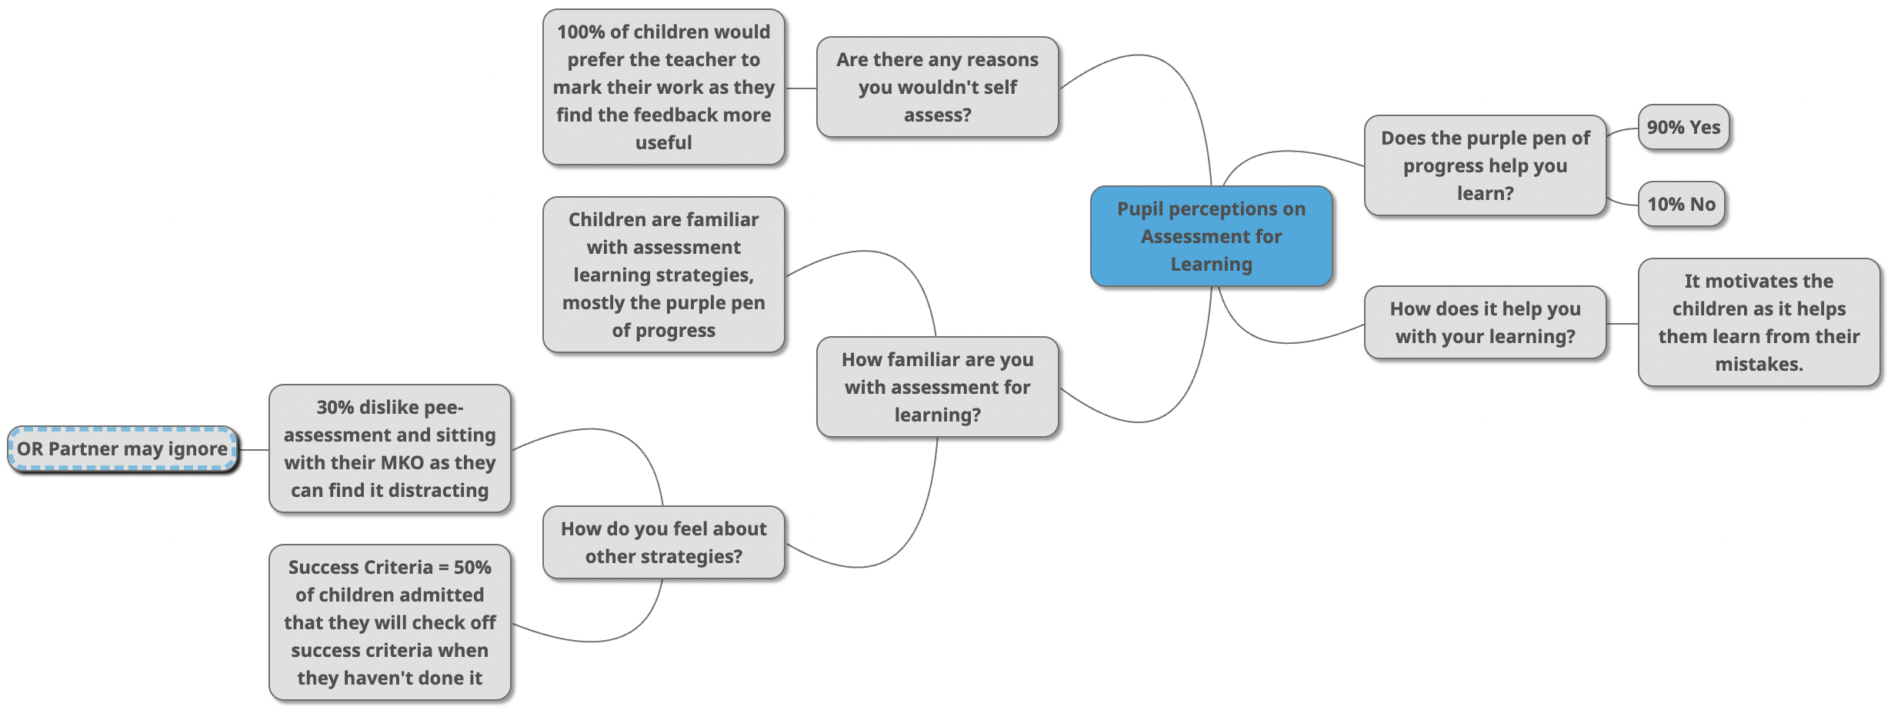
Mind map to show main themes during the interview

