The ‘Entangled’ Web: Shared artistic styles/motifs as cultural contact in tomb assemblages of the Late Bronze Age with a particular emphasis on the Cypriot sites of Enkomi and Hala Sultan Tekke
Thomas Clarke (1900472) - 12th March, 2022
Module: Entanglements: Exploring Interactions between the Aegean and the Near East (HPAH6010)
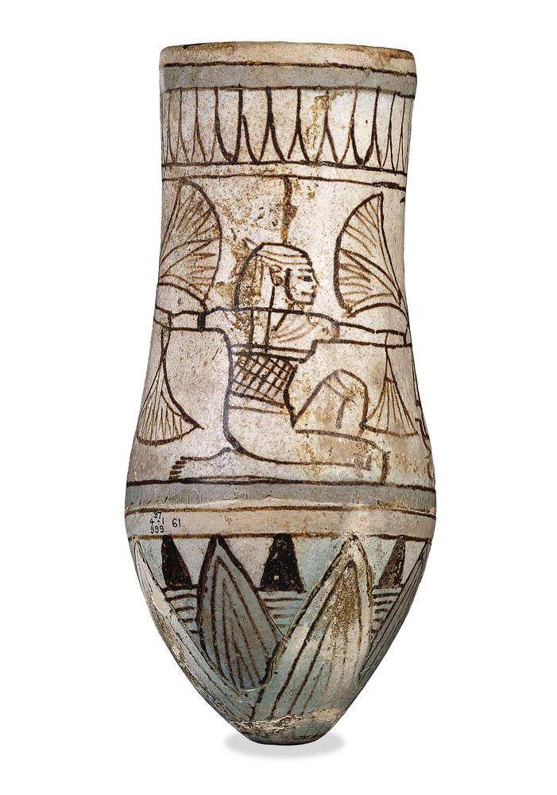
Fig. 1: ‘Faience vessel decorated with a depiction of the god Heh and lotiform patterns’ (EA 1897.0401.999), British Museum

Contents
Introduction and Theoretical Perspectives ………………………………………………………………………………. 3
Presentation of Data ……………………………………………………………………………………………………………….. 3
Table illustrating the objects observed and, where applicable, highlighting their depositional context ……………………………………………………………………………………………………………………………………. 5
Artefacts from Enkomi:
Item 1: EA 1897,0401.999 – Egyptian glazed flask depicting Heh ………………………………… 6
Item 2: EA 1987,0401.1252 -- Cypriot Base Ring Ware I alabastron …………………………….. 8
Artefacts from Hala Sultan Tekke:
Item 1: EA 1898,1201.219 - Mycaenean Stirrup Jar ……………………………………………………. 11
Item 2: EA 1898,1231.14 - Minoan (Crete) pottery sherd …………………….…………………….. 13
Conclusion ………………………………………………………………………………………………………………………….…. 15
References and Links Referenced ………………………………………………………………………………………………………………………….… 16
Image Credits ………………………………………………………………………………………………………………….…….. 21

Introduction and Theoretical Perspectives

This report discusses shared artistic motifs in the Late Bronze Age as an indicator of external cultural contact on the island of Cyprus. Attention is given to four items in the British Museum from the sites of Enkomi and Hala Sultan Tekke, chosen as they represent four cultures (Egyptian, Cypriot, Mycenaean and Minoan). I will explore how each item interacted with Cyprus, and how they may have consequently formed either new artistic conventions or ideologies. I have attempted to engage with a cross-disciplinary approach combining both archaeological evidence with anthropological thought, enhancing the understanding of why certain objects were placed in tombs, their function, and how they may have shaped human experiences and relationships. This is concomitant with a materiality perspective heralded in anthropology, but one that is also rapidly being discussed in connection with archaeology.

Presentation of Data

The objects are assessed in isolation, whilst considering the wider context of the tombs. It is important to understand the sites’ excavation history. At Hala Sultan Tekke, the site had already been partially ‘excavated’ by local villagers prior to the arrival of Henry Beauchamp Walters (in 1897), meaning many of the tombs were disturbed, often resulting in incomplete assemblages. Much information regarding the site comes not from excavation reports, but correspondence sent by Walters (who worked in the British Museum, in the Greek and Roman department). John Crowfoot, a student at the British School of Athens, excavated at Hala Sultan Tekke in 1898, sponsored by the British Museum. Crowfoot’s artefacts were delayed in being included into the British Museum catalogues, meaning some original findspots of the artefacts had been forgotten. The number of tombs excavated by Walters and recorded is grossly inconsistent. Enkomi was excavated by A.S. Murray (although likely excavated by Alexander di Cesnola prior) on behalf of the British Museum (1894-1896). At Enkomi, a similar situation to Hala Sultan Tekke occurred, in that many of the tombs had been already disturbed. Moreover, over 100 tombs had been unearthed yet few were recorded. Additionally, flood damage had affected a considerable number of tombs, and there were instances of continuous internment as part of the local populace’s funerary practices. In both cases, a driving factor behind the excavator’s intentions was for the extrication of objects deemed of ‘museum quality’.

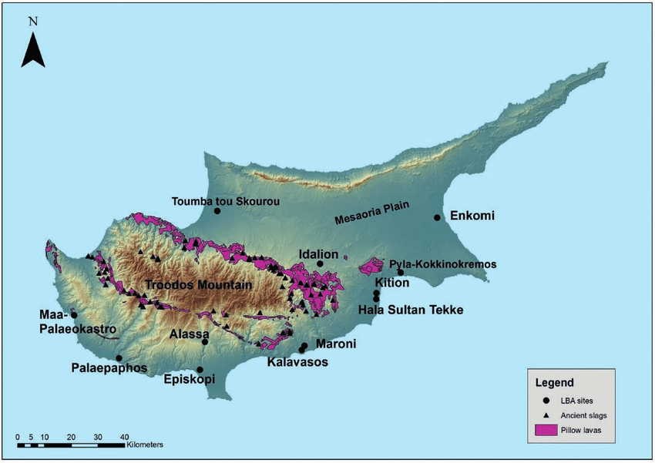

Fig.2. Map of Cyprus featuring sites of Enkomi and Hala Sultan Tekke (taken from Georgiou 2017)

Site Name: Enkomi or Hala Sultan Tekke | Object | British Museum Object Number | Date given – (some approximate) | Tomb location/findspot | Artistic style/motif | Corresponding tomb assemblage
Enkomi, Famagusta | Faience ‘kohl’ beaker | EA 1897,0401.999 | c. 18th/19th Dyn. | Tomb 61.1 | Egyptian lotiform design alongside Egyptian deity Heh | Tomb assemblage not described in Murray 1900
Enkomi, Famagusta | Clay Base Ring I ware alabastron | EA 1897,0401.1252 | 1450BC - 1340BC | Tomb 88 | Cypriot – Base Ring I Ware, prominent geometric motifs | “Porcelain Horse rhyton, Gold diadem with spiraliform patterns, porcelain bowls with rosettes with leaves in relief, porcelain ‘recumbent lion’, variegated glass vase (pomegranate shaped), sculpted female figures (Late Cypriot?), varying types of Myceneaean pottery (‘geometric on white ground’, ‘brown ware with painted white decoration’, ‘brown ware with raised patterns’ – could this be Cypriot Base Ring Ware?) and potentially 2-cylinder seals” (Murray et al. 1900)
Hala Sultan Tekke, Larnaka | Mycenaean Stirrup Jar | EA 1898,1201.219 | Late Helladic III A2 - III B (c. 1400-1200 BC) | Tomb VIII.14 | Mycenaean Type (FS184) Pyxis-type body, interesting floral motifs (elaborated further) | “Gold diadem (Palladis etc), plain gold ring, four gold spirals, green glass bead with gold tops, carnelian bead, silver ring (men on bezel), silver spiral ring, bronze butt-end of spear, terracotta figure (primitive), false amphora with pyxis body, alabaster pot, faience vase, alabaster disc, false amphora, glass vase (variegated), fragments of Myc. Vases and bronze”
Hala Sultan Tekke, Larnaka | Minoan Potsherd | EA 1898,1231.14 | Late Minoan II (c. 1500-1400 BC) | (said to be a surface find, although likely came from a disturbed tomb) | Palace Style vessel, ivy leaves depicted | Described in Åström, Bailey, Karageorghis (1976), Pl. XXXVII as: “Crowfoot’s Excavations: unplaced objects”
Table illustrating the objects observed and, where applicable, highlighting their depositional context.
Interpretation and Analysis:
Artefacts from Enkomi

Item 1: EA 1897,0401.999 – Egyptian glazed flask depicting Heh (18th – 19th Dynasty)
Fig.3. (EA 1897,0401.999) - Faience beaker depicting loti and the Egyptian deity Heh

This object has a ‘glazed composition’, described by the British Museum as a: “finely powdered quartz grains fused together with small amounts of alkali and/or lime through partial heating”. Egypt was especially suited to producing faience as silica was found in the desert, containing iron, conducive to its production. Faience was known for its visual properties, it glimmered considerably (evidenced in its Egyptian name, equating to ‘gleaming’), reminiscent of the life-giving sun. The lotiform patterns (visible on the flask) combined with the faience material exacerbates the concept of rebirth. The lotus symbolised rebirth in its nightly submergence and its subsequent re-flowering each morning. The Egyptian deity Heh was the personification of infinity, usually representing millions of years. His image, installed by rulers, conveyed wishes for extended rule or longevity. Potentially, this item formed an aspect of gift exchange emerging whereby an elite/ruler or royal court wished to impart a sense of their perceived might or longevity to the Cypriot court (although there is no royal inscription).

This may indicate an indigenous Cypriot populace assimilating with the ‘other’ (viewing EA 1897,0401.999 as an extension of the ‘cultivated’ self), where procurement of symbolic possessions reflected on the individual’s ‘world of meaning’, in hoping ‘ownership’ of Heh would bring them extended life. It could also imply evidence of transmigration of Egyptian peoples bringing closely held ideologies. Regarding ‘agency’, its imagery is decidedly Egyptian (linked to drinking vessels of the XVIII and XIX Dynasties). Haptically, agency and “thing-power” is present in both the material itself and its adornment. In line with Peltenberg, faience is not inherently suggestive of social status. I would cautiously assess faience’s value whilst conscious of its reception in culturally specific locales, recognising context. This compliments Kopytoff’s “cultural redefinition” that goods can experience and is furthered when considering findspots; and the sites in which faience appears.

The deep blue colour produced after firing resembled lapis lazuli, and this drive to imitate precious stones from distant locations like Afghanistan, projected Egypt’s status on the ‘world stage’. It is in this frame of desirability I view the context of faience in Cyprus. As Peltenberg affirms, it cannot be dismissed that faience was not produced locally, but it was mainly imported from the Near East and Egypt, and quite likely Crete (having a local industry in the Middle Minoan Period). Therefore, if it was not as common in Cyprus, it is likely that reception towards the material was greater, driven by the appeal of the ‘other’ and access to esoterica.

The tomb assemblage is not included in Murray’s excavation report, but briefly discussed in an earlier section of porcelain artefacts, where he described it as an imitation of Egyptian work. Along with Budka and Steel, I do not view the vase as an imitation, it bears strong association with contemporaneous ‘festival’ ceramics, and no evidence appears for the prominence of this specific Egyptian deity at the time. Following Knapp, Stockhammer and Steel, I perceive the flask as initialling a process in which Cypriot elites absorbed foreign iconography and (and through subsequent reimagining) reflected it back using as a springboard for their ‘reinvigorated’, outward-looking identities.

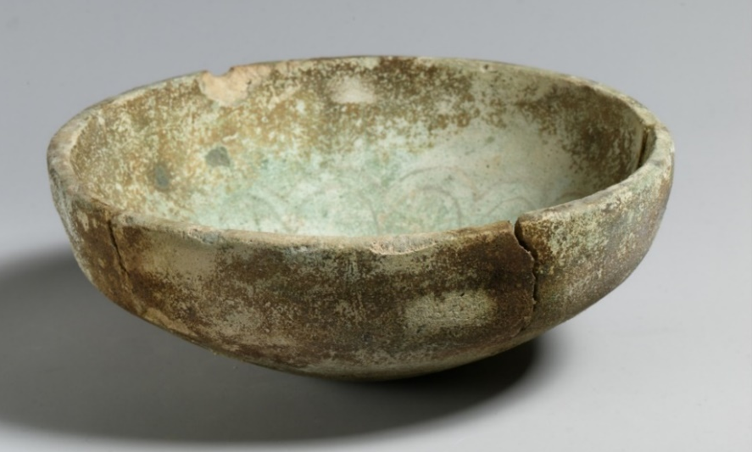
Fig.4. Late Bronze Age Faience bowl: thought to be a Cypriot imitation of a lotus bowl (MMA 74.51.5070). Here, Cyprus is further assimilating themselves to a foreign motif, it is now well-established in their ‘catalogue raisonné’. Found in a tomb at Idalion

Item 2: EA 1897,0401.1252 - Clay Base Ring I ware alabastron (1450BC - 1340BC)
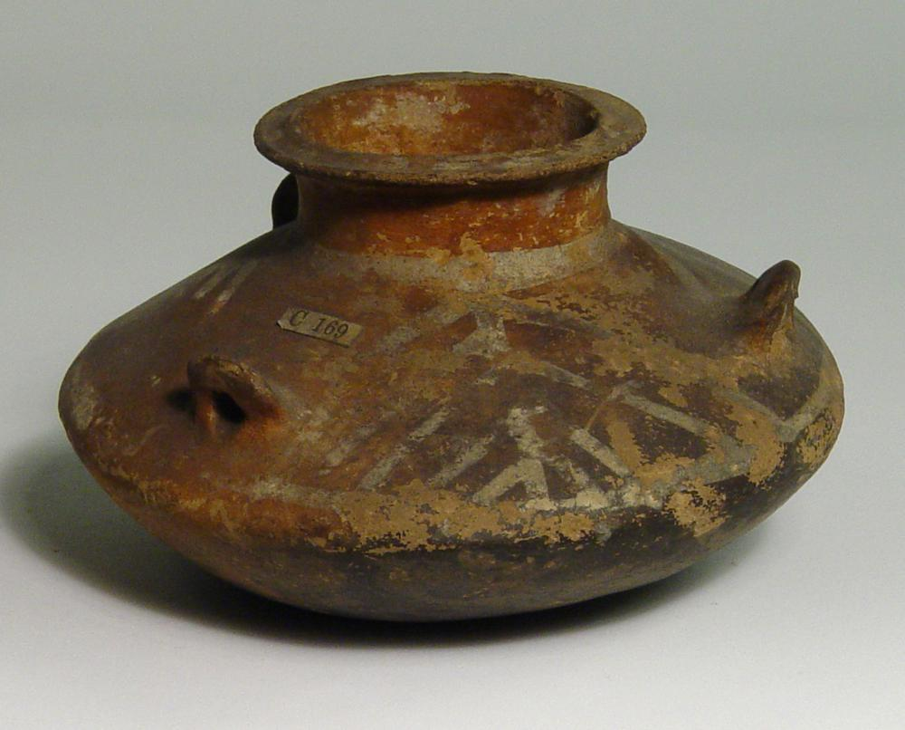
Fig.5. (EA 1897,0401.1252) Cypriot Base Ring I alabastron (Late Cypriot II) with lug handles and geometric design. Found in tomb 88 at Enkomi

Base Ring ware (BR) was produced by hand in Cyprus and is characterised by its darker colours (seen here as reddish/deep brown). This results from rapid firings in oxygen-starved environments, to oxidise, then subsequently sealed from the air. The ‘unusual’ means of firing earnt BR ware a specific identity as a commodity ‘brand’ (augmented by burnishing which exacerbated colours/invited touch), became highly desired and theoretically prominent in the gift exchange process. EA 1897,0401.1252 is thought to be part of the Base Ring I ware typology, normally characterised by the decoration either painted, incised or in relief. The main priori of BR ware appears to have been tableware, explicit in kraters, jugs and carinated cups but specialised (potentially ritualised) forms appear such as rhyta, bilbil juglets (although this remains contentious) and aksoi. It was widely traded in the Levant, with drinking sets in particular reflecting on emergent palatial practices (seen at Yarim-Lim) and renewed conceptions of personhood. A predominance of closed vessels (like EA 1897,0401.1252) found in Eastern Mediterranean contexts suggests engagement with the contents of these vessels. The squat alabastron, associated with Mycenaean design, surfaced primarily in the Late Helladic II period (contiguous to the production of Base Ring ware) occurring only on a few sites (Ayia Irini, Morphou, Enkomi). Steel addresses these sites as burgeoning settlements, indicating accumulation of material goods with a subsequent garnering of status and identity.

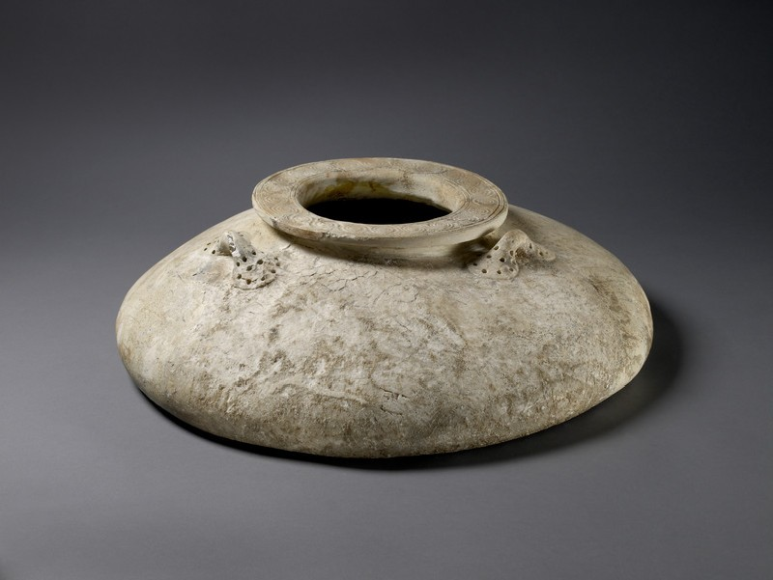
Fig 6: A Stone Alabastron found at the Royal Palace of Knossos, c. Late Minoan II period (AN1911.611), Ashmolean Museum

The significance of unguents within intra-societal status is expressed in an alabaster pyxis lid bearing the cartouche of Hyksos king Khyan, a 15th Dynasty ruler of Egypt, from Knossos. This exchange, “diplomacy by design”, marked not only by prestige imbued by inscription but also via prized material, slots into a narrative of Mauss’ ‘social contract’ between two parties. The cartouche inscription elaborates Mauss’ dissection of ‘hau’ (the owner’s soul in an object) that is retained from the original owner, even when placed in other hands. The desire for unguents and perfume was noticeably elevated in the East, with Egyptians valuing smell as a foremost sense. Its use was common, overlapping spheres of activity in ritual performances (mummification) and in societal interactions. Perfume in the Ugaritic elite sphere is indicated by the presence of an Egyptian frit perfume flask in Tomb VII at the Royal Palace of Qatna, and implies (in a postcolonial context) purposeful acquisition of ‘enchanted’ foreign goods, consequently redefining both identity and perpetuating their social imaginary. The ratio of Egyptian objects to Syrian produced items (in this tomb) suggests their prestige within Syrian elite contexts.

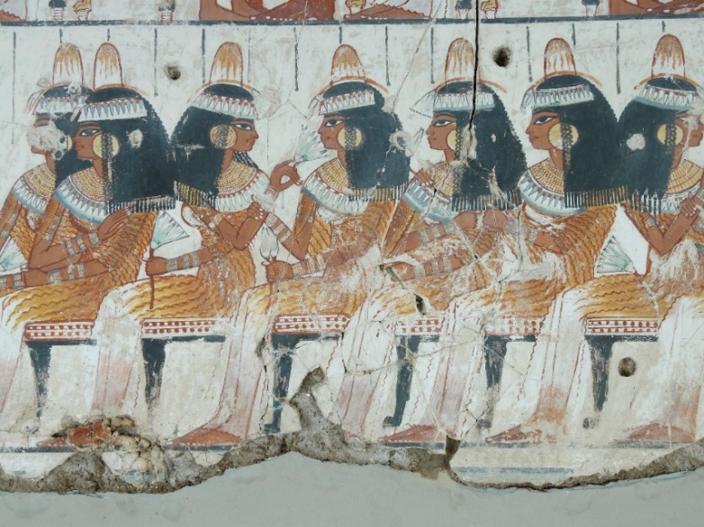
Fig 7: An Egyptian banquet scene from the 18th Dynasty Tomb of Nebamun (EA 37986). Attendees are depicted wearing unguent cones on their heads and holding lotus flowers to their noses. Displayed at the British Museum

We may question why a local handmade vessel was buried alongside a (presumably) Cypriot individual at Enkomi? This brings us neatly to the concept of prestige. I find Maran’s conception of prestige especially pertinent to the example of EA 1897,0401.1252. When classifying ‘prestige goods’, Maran feels such terminology implies a longstanding inherent value bound in objects, “irrespective of circumstances”. Maran’s reconceptualisation of prestige, moving away from the notion of prestige as a differentiating status, with typically elevated economic/symbolic connotations, is necessary for the discussion of EA 1897, 0401.1252. This item had prestige because it was local. Alongside the alabastron luxurious and geographically encompassing goods are evidenced, such as a gold diadem with heavy influence from Minoan artistic conventions alongside examples of Mycenaean ware. Indicative of an ‘international spirit’ is a variegated glass pomegranate, likely from Egypt. Pomegranates bore significant symbolism (vivid, blood-like red juice), and were highly prized in the Near East (where it originated), often consumed in banquets and used in ritual ceremonies. It was reproduced in various materials (faience, silver, glass) as pendants and amulets, and found in Egyptian royal tombs (Amenhotep II and Tutankhamun) - furthering their value. Ownership showcased awareness of the fruit and intimated participation in the elite banquets at which this fruit would be consumed. This contributes to the emergent social imaginary of Cypriot inhabitants. In the accumulation of foreign imported goods and locally manufactured items (Base Ring Ware and two sculpted female figurines), perhaps the deceased’s intention, was to convey a ‘worldly’ perspective. While looking out to the world beyond, they still very much were aware of where they stood.

Objects from Hala Sultan Tekke

Item 1: EA 1898,1201.219 - Mycenaean Stirrup Jar (Late Helladic IIIA2-IIIB)

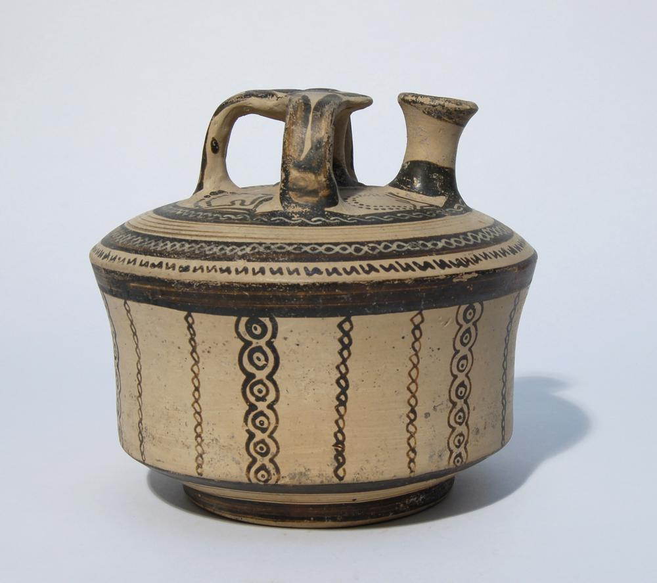
Fig.8. Mycenaean Stirrup Jar of ‘pyxis’ form (EA 1898,1201.219), British Museum

The stirrup jar, an archetypal vessel in the Mycenaean world, stored highly valued materials such as olive oil and wine. The preference for closed shapes in the Near East became apparent in changing ceramic morphologies, where Cypriot-Mycenaean (and wider) trading routes became increasingly connected, and commodity trade adopted a new significance and precedence. Targeted marketing is visible here, where during the early Late Helladic IIIA1 period the exportation of Mycenaean ceramics to surrounding regions, particularly the Levant and Egypt, grew at an increasing rate. The extent of Mycenaean involvement in the ‘international economy’ has been extensively debated. I contend Wijngaarden’s negation of a Mycenaean ‘thalassocracy’ - which Wijngaarden regards from a mainly political approach (but ‘thalassocracy’ invariably implies both a political and economic means of exertion), however, I acknowledge (as Wijngaarden and Knapp state) a complex web of trade, in which “local producers and distributors, palace-based traders and independent merchant men” worked “with objects travelling through several modes of exchange run by different participants before being deposited at their place of archaeological recovery”. The emphasis on localised Mycenaean ceramic production, alongside expansion of Mycenaean settlements and influx of mainland ceramics, peoples, skills, and ideals onto the ‘peripheral’ regions, facilitated the diversity of forms in which ‘targeted marketing’ could be achieved. Viewing the stirrup jar as a commodity is grounded in prior post-Marxist conceptions of the distinction between commodity/gift as alienable versus inalienable, where commodities were only traded for money and therefore ‘exempt’ from any imbued social ties. However, as Steel notes, this denies the agency of producer, consumer, and object, with ‘everything existing at arm’s length’. Agency played an arguably significant role in Egypt’s case, where stirrup jars are found in New Kingdom tombs, near temples and in ‘Egyptianized’ forms themselves (in exuberant materials like alabaster, faience, and stone). In line with Ayres and Pavúk, I perceive the Egyptian replication of the stirrup jar (often smaller than Mycenaean examples) as still opaque. While it may have continued its usage as an unguent container, its reduced size inhibits storage considerably. Its placement in tombs and in temples is indicative of an ‘appreciation’ by Egyptian craftspeople and its users, they consciously chose not to replicate Mycenaean imports exactly, but often included original designs. The faience stirrup jar is an example of ‘foreign international style’, it has not ‘altered’ culture but instead continues an already established practice. For Egypt, it could be argued what it represented appealed more than where it came from.

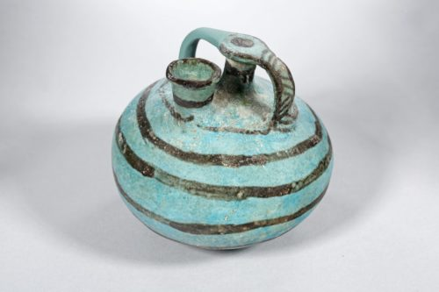
Fig 9: Egyptian faience stirrup Jar – (MFA 52.582) Museum of Fine Arts, Budapest

The shape of EA 1898,1201.219, described by Walters as “pyxis-like”, differs from usual representations of the stirrup jar (normally rounded) but may have held more relative to its size - being wider than it is tall - thus promoting its intrinsic ‘value’, defining enhanced economic capital for the distributor or consumer. Possible Minoan influence is apparent, in the ‘floral’ motifs present on the ‘top’ of the jar. Situated in tomb VIII, the stirrup jar is part of an assemblage reiterating the nature of Hala Sultan Tekke. As a trading port, there was exchange of a considerable variety of goods. Most noticeable about this assemblage is the predominance of gold and jewellery items. A carnelian bead (EA 1898,1201.194) provides further evidence of relations with Egypt. Carefully curated body adornment, hybridised usage of jewellery (alongside other tomb VIII jewellery items not discussed) enhanced and legitimised the owner’s identity, power, and societal status. The duality of the local and the foreign attracted, configured, and heightened capital.

Item 2: EA 1898,1231.14 - Minoan potsherd (Late Minoan II)

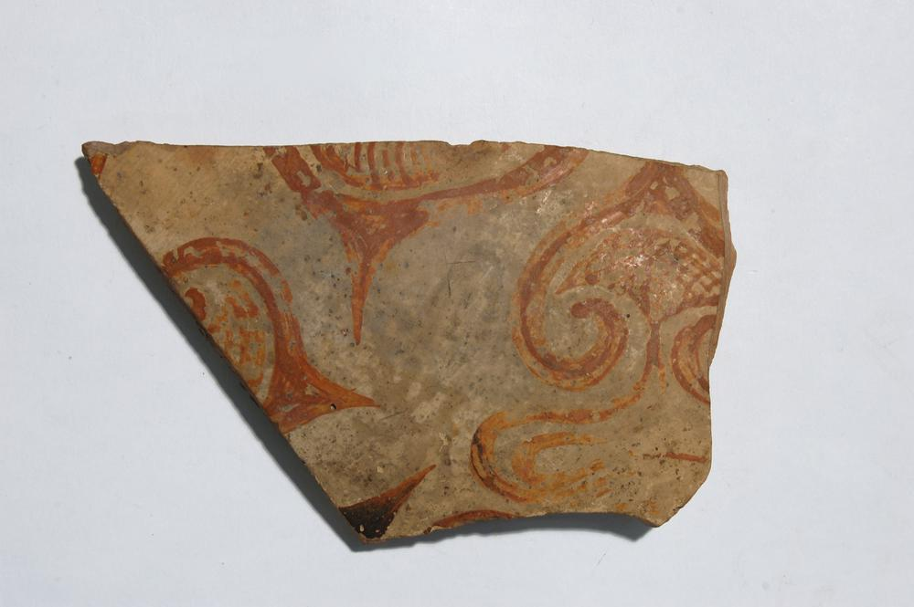
Fig.10. Minoan Potsherd. Featured is an ivy-leaf pattern with tendrils included (EA 1898,1231.14), British Museum

EA 1898,1231.14 is a fragmentary potsherd with ivy leaves represented. The islands of Cyprus and Crete were shaped by their geography, with trade routes between Crete and the Near East using Cyprus as a waypoint during voyages and vice versa. Long term intra-regional trade is documented in depositional evidence, with fragments found in varied contexts: mortuary burials, administrative buildings and palaces. Evidence pottery extended beyond commodity trade is clear in the case of Karmi-Palealona where a Kamares ware cup is found, a Cretan ceramic style renowned for its delicacy, synonymous with the highly socialised consumption of food and drink. In Hala Sultan Tekke there is evidence of Late Minoan II – IIIC ceramics as well as local imitations of Minoan wares. The development of the Minoan Floral ware (with which I identify EA 1898,1231.14) in the latter Late Minoan II period placed an emphasis on representing naturalistic elements with depictions of flowers such as lillies, crocus, and ivy-leaves. The surrounding Minoan environs influenced artistic motifs visible in the Floral and Marine Style wares. This period is often dubbed a ‘thalassocracy’ in which Minoan influence was at a zenith, fuelled by developments in maritime technology, where surrounding islands were brought even closer together. Whilst the theory of Minoan colonisation is contested, emphasis shifted towards theories of intra-elite emulation - the “Versailles effect” - and (in recent years) the cultural diffusion of Minoan iconography, religious practice and ceramic distribution evinced in material exchange is assessed. Diffusion is most explicit in the iconographical wall-paintings seen in Akrotiri and Egypt, where ‘emblematic’ symbols of each country are found to have influenced the artistic styles of the other. For example, in the ‘Blue Monkeys’ fresco at Knossos, monkeys (an Egyptian import) are depicted frolicking amongst Egyptian papyrus leaves and in the Middle Kingdom, spiraliform and ivy-leaf patterns appear on the ceilings of the tombs of officials alongside ‘Egyptianized’ border decoration. The importance of the decision to have ‘Minoanized’ frescoes on a final resting place cannot be overstated. This is, in the words of Shaw: “more than accidental”, and is clear syncretism – allegorical of a ‘shared cultural milieu’ in which artistic ‘agency’ influenced the adoption and manipulation of desired symbols, in turn, redefining both social spaces and ritual settings. The Minoan ivy leaf was a common motif replicated in ceramics, frescoes, and sculpture. Mycenaean ceramic design drew heavy influences from Minoan pottery, and often replicated the leaf, albeit in a more stylised form.

Information concerning EA 1898,1231.14’s findspot is limited. It was discovered by Crowfoot (who excavated later than Walters) and is thought to have been a surface find, though the British Museum attribute it to originating from a disturbed tomb, which I would agree with.

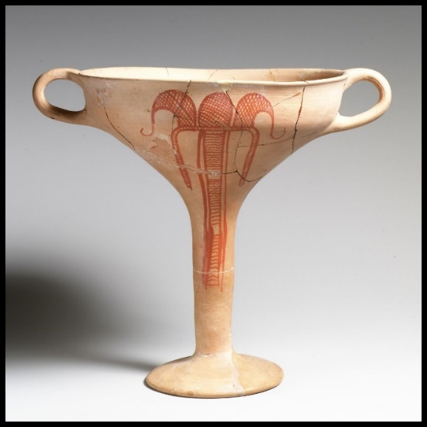
Fig.10: Terracotta kylix (Mycenaean) featuring stylised flower. (MMA 27.120.8) c. 1300-1225 BC (Late Helladic IIIB1) Found at Zygouries, near Corinth, Metropolitan Museum of Art

Conclusion

From the evidence, I would certainly regard Cyprus as a “place of encounter”. What is clear from the selected tomb assemblages is the syncretism between locally produced items and the desiderata, they are not distinguished by type but sit together within the tombs of individuals and collectively paint a picture of communication, imitation, hybridised patterns of behaviour, artistry and craftmanship. Through these items, we see recurrent themes of agency, “thing-power”, gift-exchange, social-contracts, targeted marketing, commodity trade, diffusion, a ‘shared cultural milieu’ and the attraction of the ‘other’ (all also explicit in surrounding regions). The context of Cyprus within the extensive maritime networks of the Late Bronze Age, and its position as a ‘stopping-off’/trading point, meant that an amalgam of peoples, goods, skills, and ideas was inevitable. This created a rich cultural landscape; whereby bilateral relationships instigated and sustained the discourse between the inhabitant and outsider. Not only did they desire, but they were desired themselves. Whilst the full extent of interaction is still to be unravelled, what is certainly apparent is that Cyprus participated in an ‘entangled web’.

Bibliography

Appadurai, A. (1986) ‘Introduction: commodities and the politics of value’ in Appadurai, A. (ed.) The Social Life of Things: Commodities in Cultural Perspective, Cambridge; Cambridge University Press, pg. 3-63

Åström, P. (1965), Red on Black Ware, Opuscula: Annual of the Swedish Institutes at Athens and Rome Vol. 5, Iss. 73, pg. 59–88.
Åström, P. (1980), ‘Minoan Features at Hala Sultan Tekke’ in: Proceedings of the 4th International
Cretalogical Congress, Iraklion, 29 August–3 September, 1976, Athens, pg. 35–42.
Åström, P. (1986), ‘Hala Sultan Tekke – An International Harbour Town of the Late Cypriot Bronze Age’, Opuscula: Annual of the Swedish Institutes at Athens and Rome 16, pg. 7–17.

Åström, P., Bailey, M.D. and Karageorghis, V. (eds.) ‘Hala Sultan Tekke I, Excavations 1897-1971: Studies in Mediterranean Archaeology’, Vol. XIV:I, Göteborg, Paul Åström Forlag

Ayres, N.D. (2015) ‘Egyptian Imitation of Mycenaean Pottery’ in Kousoulis, P. and Lazaridis, N. ‘Proceedings of the Tenth International Congress of Egyptologists, University of the Aegean, Rhodes, 22-29 May 2008, Orientalia Lovaniensia Analecta 241’, Leuven; Peeters Press, pg. 1935-1951

Belk, R.W. (1988) ‘Possessions and the Extended Self’ in Journal of Consumer Research, Vol. 15, Iss. 2, pg. 139-168

Bennett, J. (2010) ‘Vibrant Matter: a political ecology of things’, Durham; Duke University Press

Berg, I. (2007) ‘Negotiating Island Identities: the Active Use of Pottery in the Middle and Late Bronze Age Cyclades, Gorgias Dissertations 31’. Piscataway, New Jersey; Gorgias Press

Bergoffen, C.J. (2005) ‘The Cypriot Bronze Age Potter from Sir Leonard Woolley’s Excavations at Alalakh (Tell Atchana), Vienna, Verlag der Österreichischen Akadamie der Wissenschaften

Budka, J. (2013) ‘Festival Pottery from New Kingdom Egypt: Three Case Studies’ in Bader, B and Ownby, M.F. (eds.) ‘Functional Aspects of Egyptian Ceramics in their Archaeological Context, Proceedings of a conference held at the MacDonald Institute for Archaeological Research, Cambridge, July 24th-25th, 2009: Orientalia Lovaniensia Analecta 217’, Leuven, Peeters Press, pg. 185-217

Broodbank, C. (2000) ‘An Island Archaeology of the Early Cyclades’, Cambridge; Cambridge University Press

Broodbank, C. (2004) ‘Minoanisation’, Proceedings of the Cambridge Philological Society 50; pg. 46-91

Crewe, L (2007), 'From Lithograph to Web: The British Museum’s 1896 Enkomi excavations.', in Archaologia Cypria, vol. V, pp. 57-70.

Dohmann-Pfälzner, H. and Pfälzner, P. (2011). ‘Die Ausgrabungen 2009 und 2010 im Königspalast von Qatna: Vorbericht des syrisch-deutschen Kooperationsprojektes in Tall Mišrife/Qatna’. Mitteilungen der Deutschen Orient-Gesellschaft, pg. 143, 5–62

Evans, A. (1921) ‘The Palace of Minos: A Comparative Account of the Successive Stages of the Early Cretan Civilization as Illlustrated by the Discoveries at Knossos I. The Neolithic and Early and Middle Minoan Ages’ London; Macmillan

Ezz el-Din, D.M. and Elkasrawy, S.F. (2020) ‘Pomegranates of ancient Egypt: representations, uses and religious significance’ in Graves, C. (ed.) BEC: Proceedings of the Fourth British Egyptology Congress, 7-9 September 2018, University of Manchester, London; Egypt Exploration Society (Bloomsbury), pg. 55-69
Foster, K.P (2008) ‘Minoan Faience Revisited’ in Jackson, C.M and Wagner, (eds.) ‘Vitreous Materials in the Late Bronze Age Aegean: A Window to the East Mediterranean World (Sheffield Studies in Aegean Archaeology 9)’ Oxford; Oxbow Books, pg. 173-86

Feldman, M.H. (2006) ‘Diplomacy by Design: Luxury Arts and an ‘International Style’ in the Ancient Near East, 1400-12000 BCE’ Chicago, University of Chicago Press

Gell, A. (1998) ‘Art and Agency: An Anthropological Theory’ Oxford; Clarendon Press

Gosden, C. (2004) ‘Archaeology and Colonialism: Cultural Contact from 5000 BC to the Present’ Cambridge, Cambridge University Press

Graziado, G. (2005) ‘The Relations between the Aegean and Cyprus at the Beginning of Late Bronze
Age: An Overview of the Archaeological Evidence’ in: Laffineur, R. and Greco, E. (eds.), EMPORIA:
Aegeans in the Central and Eastern Mediterranean, (Aegaeum 25), Liège–Austin, pg. 323–332

Helms, M.W. (1988) ‘Ulysses’ Sail: An ethnographic odyssey of power, knowledge and geographical distance’, New Jersey; Princeton University Press

Immerwahr, S.A. (1989) ‘The pomegranate vase: its origins and continuity’, in Hesperia Vol. 58, Iss. 4, pg. 397-410

Kanta, A. (2001), ‘The Aegean World between East and West: Aspects of Common Cultural Elements
from the 16th to the 11th c. B. C.,’ in. Stampolidis, N.C. (ed.), Sea Routes... from Sidon to Huelva,
Interconnections in the Mediterranean 16th–6th BC, Athens: pg. 20–40.

Karageorghis, V. (1990), ‘The End of the Late Bronze Age in Cyprus’, Nicosia; The Department of Antiquities

Keswani, P. (2005), ‘Death, Prestige, and Copper in Bronze Age Cyprus’, in AJA 109, pg. 341–401.

Knapp, A.B. (1993) ‘Thalassocracies in Bronze Age Eastern Mediterranean trade: making and breaking a myth’ in World Archaeology, Vol. 24, Iss. 3, pg. 332-347

Knapp, A.B. (2006) ‘Orientalization and prehistoric Cyprus: the social life of oriental goods’ in Riva, C. and Vella, N.C. (eds.) Debating Orientalization: Multidisciplinary Approaches to Change in the Ancient Mediterranean, London; Oakville, CT; Equinox, pg. 48-65

Knapp, A.B. (2008) ‘Prehistoric and Protohistoric Cyprus: Identity, Insularity and Connectivity’ Oxford, Oxford University Press

Knapp, A. B. (2013), ‘The Archaeology of Cyprus: From Earliest Prehistory through the Bronze Age – Cambridge World Archaeology’, Cambridge; Cambridge University Press

Kopytoff, I. (1986) ‘The cultural biography of things. Commoditization as Process’ in Appardurai, A. (ed.) The Social Life of Things, Commodities in Cultural Perspective, Cambridge; Cambridge University Press, pg. 64-91

Liverani, M. (1987) ‘The collapse of the Near Eastern regional system at the end of the Bronze Age: the case of Syria’, in Rowlands, M, Larsen, M.T, and Kristiansen, K. (eds.) Centre and periphery in the ancient world (New Directions in Archaeology), Cambridge, Cambridge University Press, pg. 66-73

Maniatis, Y., Panagiotaki, M. and Kaczmarczyk, A. (2008) ‘Faience Production in the Eastern Mediterranean (Chapter 6)’ in Tite, M.S. and Shortland, A.J. (eds.) ‘Production Technology of Faience and Related Early Materials’, Oxford, Oxbow Books

Maran, J. (2012) ‘Lost in Translation: The Emergence of Mycenaean Culture as a Phenomenon of Glocalization’, in: Bennet, S.; Sherratt, S.; Wilkinson, T. (eds.), Interweaving Worlds: Systemic Interactions in Eurasia, 7th to 1st Millennia BC. Proceedings of the Conference Ancient World Systems, Sheffield, 1st–4th April 2008 in Memory of Andrew Sherratt, Oxford; Oxbow Books, pp. 282-294

Maran, J. and Stockhammer, P.W. (eds.) (2012) ‘Materiality and Social Practice: Transformative Capacities of Intercultural Encounters’ Oxford; Oxbow Books

Mauss, M. (1954) ‘The Gift: The form and reason for exchange in archaic societies’, Reprint. (1990) London, Routledge

Miller, D. (1995) ‘Consumption and commodities’, in Annual Review of Anthropology 24, pg. 141-161

Mukherjee, A.J, Roβberger, E., James, M.A., Pfälzner, P., Higgitt, C.L., White, R., Peggie, D.A., Azar, D., and Evershed, R.P. (2008) ‘The Qatna lion: scientific confirmation of Baltic amber in late Bronze Age Syria’, in Antiquity, Vol. 82, Iss. 315, pg. 49-59

Murray, A., Smith, A. and Walters, H. (1900) ‘Excavations in Cyprus’ London; British Museum

Nicholson, P.T. and Peltenberg, E. (2009) ‘Chapter 7: Egyptian Faience’ in Nicholson, P.T and Shaw, I. (2009) ‘Ancient Egyptian Materials and Technology’, 5th ed. New York; Cambridge University Press

Nicholson, P.T and Shaw, I. (2009) ‘Ancient Egyptian Materials and Technology’, 5th ed. New York; Cambridge University Press

Pavúk, P. (2018) ‘Chapter Four: A Mycenaean Stirrup Jar Fragment from TT 357’ in: The Deir el-Medina and Jaroslav Černý Collections II: Pottery, pg. 167-178

Peltenberg, E. (1986) ‘Ramesside Egypt and Cyprus’ in Karageorghis, V. (ed.) Acts of the International Archaeological Symposium, Cyprus between the Orient and the Occident., Nicosia; Department of Antiquities, pg. 149-179

Peltenberg, E. (2007) ‘Hathor, Faience and Copper on Late Bronze Age Cyprus’ in CCEC 37, pg. 375-92

Petrie, W. M. F. (1894) ‘Tell el Amarna’. London: Methuen & Co.
Pfälzner, P. (2014) ‘Royal Funerary Practices and Inter-regional Contacts in the Middle Bronze Age Levant: New Evidence from Qatna’, in Pfälzner, P., Niehr, H., Pernicka, E., Lange, S. and Köster, T. (eds.), ‘Contextualising grave inventories in the Ancient Near East. Proceedings of a workshop at the London 7th ICAANE in April 2010 and an International Symposium in Tübingen in November 2010, both organised by the Tübingen Post-Graduate School “Symbols of the Dead” (Qaṭna-Studien: Supplementa 3)’, Wiesbaden, pg. 141-156

Rochberg-Halton, E. (1984) "Object Relations, Role Models, and Cultivation of the Self," in Environment and Behavior, Vol. 16, Iss. 3, pg. 335-368

Samuels, K.L. (2008) ‘Value and significance in archaeology’ in Archaeological Dialogues, Vol. 15, Iss. 1; pg. 80

Shaw, M.C. (1970) ‘Ceiling Patterns from the Tomb of Hepfeza’ in American Journal of Archaeology, Vol. 74, Iss. 1, pg. 25-30

Shaw, J. W. (1998), Kommos in Southern Crete: An Aegean Barometer for East-West Interconnections’ in, Karageorghis, V. and Stampolidis, N. (eds.), Eastern Mediterranean: Cyprus-Dodecanese-Crete 16th–6th Cent. B. C., Athens, pg. 13–27.

Sherratt, E.S. (1982) “Patterns of contact: manufacture and distribution of Mycenaean pottery 1400-1100 BC”, in Best, J.G.P, de Vries, N.M.W. (eds.) Interaction and acculturation in the Mediterranean: proceedings of the Second International Congress of Mediterranean Pre- and Protohistory, Amsterdam, 19-23 November 1980, Amsterdam, Grüner, pg. 179-195.
Steel, L. (2013) ‘Materiality and Consumption in the Bronze Age Mediterranean; Routledge Studies in Archaeology’, London; Routledge

Steel, L. (2020) ‘Feats of Clay: Considering the Materiality of Late Bronze Age Cyprus’ in Sustainability Vol. 12, Iss. 17, pg. 1-10

Steel, L. (n.d.) Enkomi and Egypt: Exploring the Third Space in Cyprus. Archaeologies, special issue U. Matic and C. Langer (eds) Postcolonial Theory in Egyptology. Forthcoming.

Stockhammer, P.W. (2012) ‘Conceptualizing cultural hybridization in archaeology’ in Stockhammer, P.W. (ed.), Conceptualizing Cultural Hybridization: A Transdisciplinary Approach (Heidelberg Studies on Asia and Europe in a Global Context), Berlin and Heidelberg: Springer Verlag, pg. 43–58.

Thomas, N. (1991) ‘Entangled Objects: Exchange, Material Culture and Colonialism in the Pacific’ Cambridge, MA; Harvard University Press, pg.

Urbani, B and Youlatos, D. (2020) ‘A new look at the Minoan ‘blue’ monkeys’ in Antiquity, Vol. 94, Iss. 374, e9 pg. 1-5

Van Wijngaarden, G.J. (2003) ‘Use and Appreciation of Mycenaean Pottery: In the Levant, Cyprus and Italy ca. 1600-1200 BC, Amsterdam Archaeological Studies’ Amsterdam, Amsterdam University Press

Vaughan, S.J. (1991) ‘Chapter XII: Material and Technical Characterization of Base Ring Ware: A New Fabric Typology’ in Barlow, J.A., Bolger, D.A. and Kling, B. (eds.) ‘Cypriot Ceramics: Reading the Prehistoric Record, University Museum Symposium Series Vol. II, Philadelphia; University Museum of Archaeology and Anthropology, pg. 112-131

Ward, C. (2003) ‘Pomegranates in Eastern Mediterranean Contexts during the Late Bronze Age’ in World Archaeology, Vol. 34, Iss. 3, pg. 529-541

Wiener, M.H. (1984) ‘Crete and the Cylades in LM I: the tale of the conical cups’, in Hägg, R. and Marinatos, N. (eds.) The Minoan Thalassocracy: Myth and Reality, Stockholm; Svenska Institutet I Athen, pg. 17-26

Wilkinson, R.H. (2017) ‘The Complete Gods and Godesses of Ancient Egypt’, Reprint. London; Thames & Hudson (2003)

Wilson, H. (2001) ‘Egyptian Food and Drink: Shire Egyptology 9’, Buckinghamshire; Shire Publications Ltd

Zeman-Wiśniewska, K. (2020) ‘Re-evaluation of Contacts between Cyprus and Crete from the Bronze Age to the Early Iron Age’ in Electrum, Vol. 27, pg. 11-32

Links Referenced

British Museum Base Ring ware Summary: https://www.britishmuseum.org/collection/term/x14728 [Date Accessed: 10/3/22]

Colorado Department of Classics: https://www.colorado.edu/classics/2018/06/15/minoan-pottery [Date Accessed: 11/3/22]

Image Credits

Fig.1: Faience vessel decorated with a depiction of the god Heh: https://www.britishmuseum.org/collection/object/G_1897-0401-999 [Date Accessed: 9/3/22]

Fig.2: Map of Cyprus - Georgiou, A. (2017) ‘Flourishing amidst a ‘crisis’: the regional history of the Paphos polity during the transition from the 13th to the 12th centuries BCE’ in Fischer, P.M. and Bürge, T. (eds.) “Sea Peoples” Up-to-Date: New Research on Transformations in the Eastern Mediterranean in the 13th-11th Centuries BCE, Proceedings of the ESF-Workshop held at the Austrian Academy of Sciences, Vienna, 3–4 November 2014’, Vienna, Verlag de Österreichischen Akadamie Der Wissenschaften; pg. 207-229 [Date Accessed: 12/3/22]

Fig.3: Faience vessel decorated with a depiction of the god Heh: https://www.britishmuseum.org/collection/object/G_1897-0401-999 [Date Accessed: 9/3/22]

Fig,4: Cypriot Imitiation of Lotus Bowl: https://www.metmuseum.org/art/collection/search/243951 [Date 10/3/22]

Fig.5: Cypriot Base Ring I alabastron: https://www.britishmuseum.org/collection/object/G_1897-0401-1252 [Date Accessed: 9/3/22]

Fig,6: Stone Alabastron found at the Royal Palace of Knossos: https://collections.ashmolean.org/collection/browse-9148/per_page/100/offset/9300/sort_by/random/object/74295 [Date Accessed: 11/3/22]

Fig.7: An Egyptian banquet scene from the 18th Dynasty Tomb of Nebamun: https://www.britishmuseum.org/collection/object/Y_EA37984 [Date Accessed: 10/3/22]

Fig.8: Mycenaean stirrup jar of ‘pyxis’ form: https://www.britishmuseum.org/collection/object/G_1898-1201-219 [Date Accessed: 9/3/22]

Fig.9: Egyptian faience stirrup Jar: https://www.mfab.hu/artworks/egyptian-faience-stirrup-jar/ [Date Accessed: 11/3/22]

Fig.10: Minoan Potsherd. Featured is an ivy-leaf pattern with tendrils included: https://www.britishmuseum.org/collection/object/G_1898-1231-14 [Date Accessed: 10/3/22]

Fig.11: Terracotta (Mycenaean) kylix featuring stylised flower: https://www.metmuseum.org/art/collection/search/252906?ft=mycenae&amp;offset=0&amp;rpp=40&amp;pos=2 [Date Accessed: 10/3/22]

Crewe (2007) pg. 57
Crewe (2007) pg. 57
Crewe, (2007) pg. 58
The British Museum: https://www.britishmuseum.org/collection/term/x10880 [Date Accessed: 8/3/22]
Nicholson and Peltenberg (2009) pg. 186
Nicholson and Peltenberg (2009) pg. 186
Wilkinson, R.H. (2017) pg. 109-10
Rochberg-Halton (1984) pg. 335; Belk (1988), pg. 140
Budka (2013)
Bennett (2010) pg. 6
Peltenberg (2007) pg. 379
Kopytoff (1986) pg. 67
Peltenberg (2007) pg. 170
Maniatis et al. (2008), pg. 126-127
Helms (1988)
Murray et al. (1900) pg. 22
Budka (2013); Steel (2013), pg. 85
Knapp (2008); Stockhammer (2012); Steel (2013) pg. 52
Vaughan (1991) pg. 122
Steel (2020) pg. 7
https://www.britishmuseum.org/collection/term/x14728 [Date Accessed: 10/3/22]
Bergoffen (2005); Steel (2013)
Steel (2013) pg.129
Evans (1921) pg, 419, fig 304b; Steel (2013) pg. 105
Feldman (2006)
Mauss (1990); Samuels (2008) pg. 80
Mauss (1990): 14-16
Wilson (2001) pg. 9
Dohmann-Pfälzner (2011) pg. 115-116 fig. 44; Pfälzner (2014) pg. 150
Gell (1998), pg. 44
Maran (2012)
Maran (2012), pg. 283
Ezz el-Din and Elkasrawy (2020); Ward (2003) pg. 530
World Museum Liverpool (56.21.683); Petrie (1894): 30, pl. XIX, pg. 471- 473
Immerwahr (1989), pg. 400-404; Steel (2013), pg. 84
Thomas (1991) pg. 4
Sherratt (1982) pg. 183; Steel (2013) pg. 131-136
Liverani (1987) pg. 67-68; Van Wijngaarden (2003) pg. 7
Van Wijngaarden (2003) pg. 7; Knapp (1993) pg. 340-341
Steel (2013) pg. 123; Appadurai (1986) pg. 7-9; Miller (1995) pg. 144-5
Ayres (2015); Pavúk (2018)
Feldman (2000)
Åström et al. (1976) pg. 15
Peltenberg (1986) pg. 163-164
Helms (1988); Knapp (2006); pg. 57, Steel (2013), pg. 77
Zeman-Wiśniewska (2020)
Graziado (2005), 328
Shaw (1998) pg. 14
Karageorghis (1990), pg. 16; Åström (1965), pg. 79; Åström (1980), pg. 40
Zeman – Wiśniewska (2020) pg. 18; Keswani (2005) pg. 378; Knapp (2013), pg. 310.
Kanta (2001), 32; Åström (1986), 64.
I believe EA 1898,1231.14 to be a part of Floral ware and not Palace Ware as the tendrils are indicative of a naturalistic rather than stylised form (see: https://www.colorado.edu/classics/2018/06/15/minoan-pottery [Date Accessed: 11/3/22])
Broodbank (2000)
Steel (2013) pg. 16; Berg (2007): 61-9
Wiener (1984)
Berg (2007); Broodbank (2004)
Urbani and Youlatos (2020)
Shaw (1970)
Shaw (1970)
Gosden (2004); Stockhammer (2012) pg. 15-16
Stockhammer 2012; Steel; forthcoming

