BMIH6003
Hotel Placement – Managing Guest Service
Operations
LEVEL 6
Module Lead: Jessica Newport
Name: Zakaria Chowdhury

ID: 2222623

Word Count: 1370

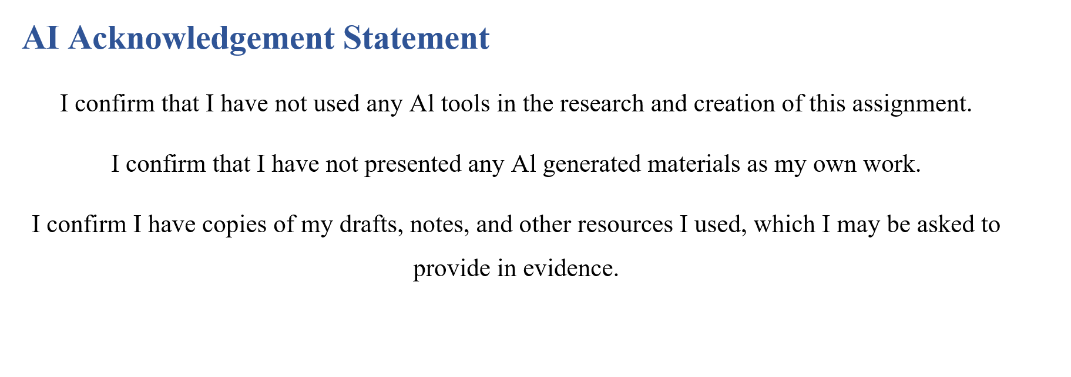

Contents
AI Acknowledgement Statement 2
Introduction 4
Section 1: Role Reflection Using Gibbs’ Reflective Cycle 4
Description 5
Feelings 5
Evaluation 6
Analysis 7
Conclusion 7
Action Plan 8
Section 2: Management Performance & Guest Service Analysis 8
Management Styles (Linked to Management & Organisational Behaviour) 8
Health & Safety Compliance 9
Marketing & Guest Experience (Linked to Marketing Essentials / Hospitality & Guest Services) 9
Section 3: Guest Service Improvement Plan 10
Identified Issue: Late Room Readiness at High Occupancy 10
Significance of the Issue 10
Three-Step Improvement Plan 10
1. Integrate Digital Task Management Software 10
2. Restructure Shift Patterns 10
3. Create a ‘Turnover Response Team’ 10
Conclusion 10
References 12

Introduction
My placement in Wivenhoe House Hotel, saw me work in the Housekeeping Department which is crucial to ensuring the cleanliness, comfort and presentation of guest rooms and public areas. The department guarantees luxury throughout the rooms including the Superior Balcony and the Classic Rooms improving the general guest experience. These experiences would allow me to achieve the three learning objectives:
1. To master the internal working dynamics and daily activity of a hotel’s housekeeping department.
2. To foster communication and teamwork skills in an actual hospitality setting.
3. To reflect on the working of leadership in a guest-oriented service context.

Section 1: Role Reflection Using Gibbs’ Reflective Cycle
Among the incidents that were most significant to my learning are two specific ones.
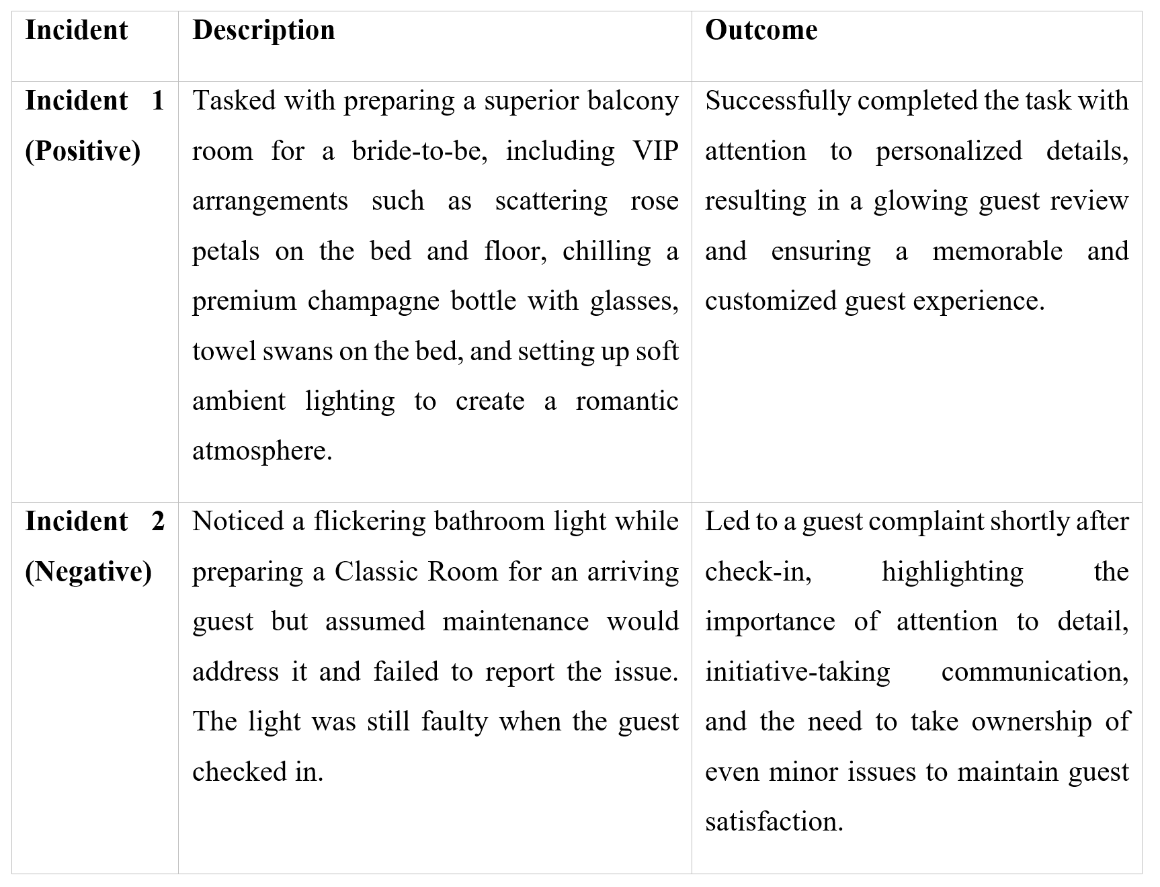
These two incidents assisted me in using Gibbs’ Reflective Cycle (1988) to be critical of my actions, feelings, and learning.

Description
I got involved in various tasks which included making beds to the specifications of the hotel, sanitizing surfaces, and restocking amenities among other tasks such as vacuuming and reporting back in case of any need for maintenance.
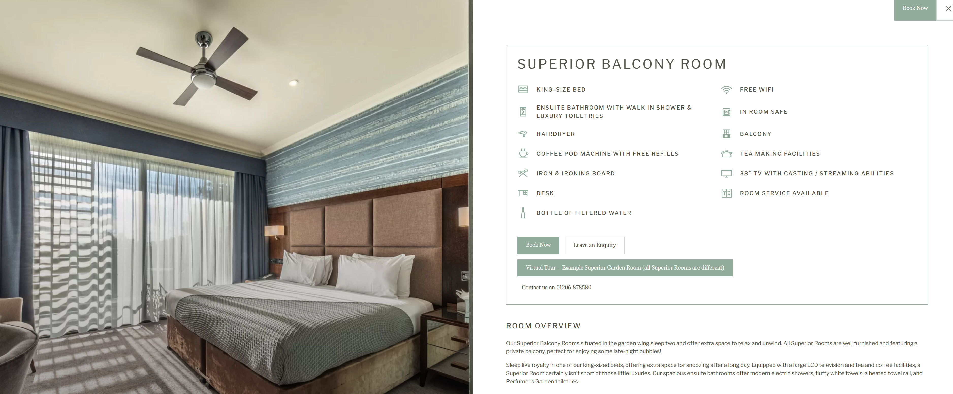
Figure 01:Superior Balcony Room
https://www.wivenhoehouse.co.uk/rooms-suites/?gad_source=1&gad_campaignid=20814522904&gbraid=0AAAAADlUhvNQUi9NWD4X49iRUGoNzELUg&gclid=CjwKCAjw24vBBhABEiwANFG7yxtZbAXTyeMPJz304mRxf-cpDnaIJzLLaHuPnxJ11oBxrJB3bBJ6YhoCz54QAvD_BwE#
I also did work preparing rooms like the Superior Balcony Room and managing the normal setups in the Classic Rooms.

Feelings
For Incident 1, I was excited yet pressed. I was aware that the Superior Balcony Room with its private balcony and luxurious fixtures was a premium accommodation. The anticipation of going beyond standards and providing an aesthetically pleasing environment stressed me, especially considering my added personal touches such as placing towel swans and amenities. In Incident 2, I felt uncertain. The flickering of the light lacked the sense of urgency and being a new team member, I held back.

Evaluation
Incident 1 had a positive outcome. The bridal guest later posted a glowing picture of the Superior Balcony Room on Instagram, tagging Wivenhoe House and raving about the attention to detail and the luxury vibe of the arrangement.
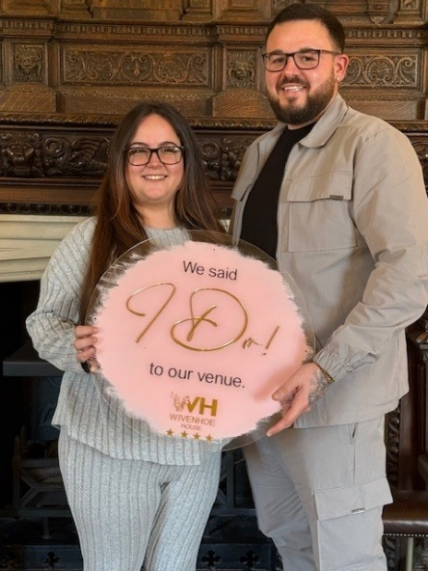
Figure 2: The Bridal Guest
Source: https://www.facebook.com/WHHWeddings
As much as I did not see the post directly; my supervisor (Mr. Beverley Johnson) had pointed it out during the morning briefing the following day and this put it in the limelight as a teamwork success. It taught me how back-of-house positions directly affect a guest’s emotional response and loyalty, in line with Lashley’s (2018) idea of emotional labour in hospitality.
On the contrary, Incident 2 was a lesson learned. The guest’s complaint about a classic room included an opinion on poor lighting and discomfort during the guest’s stay. The supervisor further reminded us of the necessity of timely reporting maintenance issues. This is in line with Bailey and Alexander’s (2021) argument that quality in housekeeping is a function of technical execution and proactive behaviour.
- Strengths: Demonstrated capability for time management and attention to detail, especially while preparing the rooms in Superior Balcony and Classic Rooms, to enable constant high standards.
- Weaknesses: Felt uncomfortable expressing thoughts during team meetings and avoided taking leadership roles, meaning that reduced active input to team decisions despite having relevant ideas.

Analysis
From Incident 1, I learned about the nature of housekeeping leadership, which took the form of a transformational style, where our supervisor motivated us to personalise guest experiences and assume responsibilities. This is consistent with the concepts said by Deng et al. (2022), who characterize transformational leadership in hospitality by its promotion of creativity and motivation to do things beyond the standard expectation.
In Incident 2, I recognised the aftermath of neglecting transactional sides of leadership in which rigid observance of such procedures as reporting defects is essential. As suggested by Mullins and Dossor (2019), transactional leadership will enable routine efficiency, particularly in operational departments such as housekeeping, where task accuracy is not tailored.

Conclusion
Such situations assisted me in thinking about my strengths and weaknesses. I showed keen attention to detail and an initiative working on the bridal suite. It came to my attention that communication is not about politeness or efficiency – it is about proactive protection of the guest experience.

Action Plan
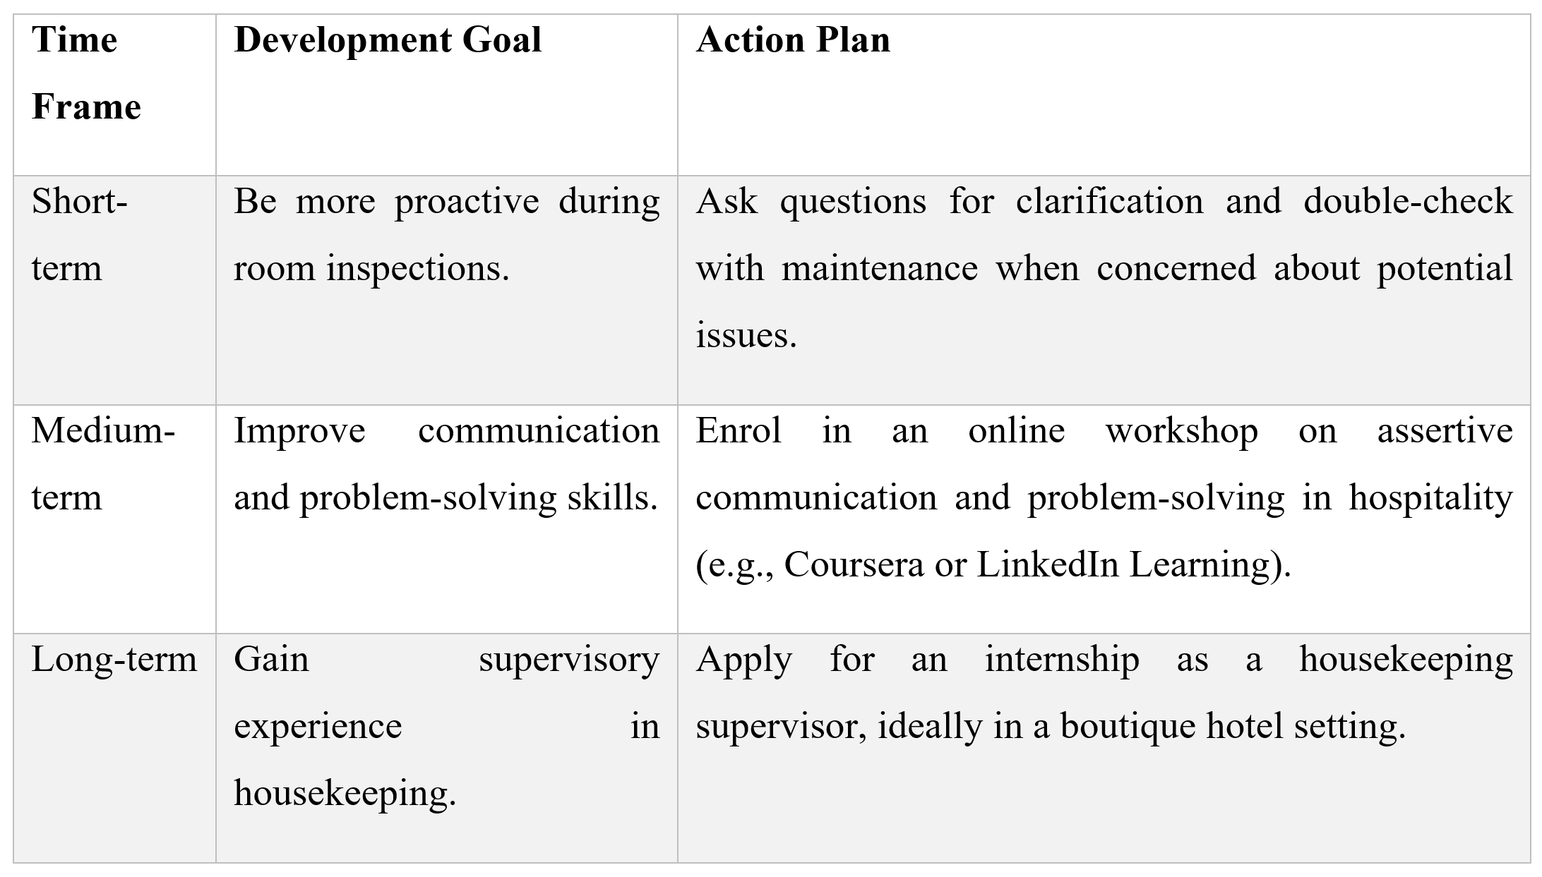

Section 2: Management Performance & Guest Service Analysis

Management Styles (Linked to Management & Organisational Behaviour)
The department showed a mixture of management styles. The housekeeping manager embraced the transformational approach through vision, feedback, and flexibility in the team members. However, in busy periods, a more transactional style was needed, which emphasized task completion and checklists. This dual style describes Fiedler’s Contingency theory which advocates that there is no single style that can work under all conditions (Mullins and Dosser, 2019), a key learning of management and organisational behaviour module.
Staff were positively influenced when supervisors took on a supportive coaching style. For example, in training, the staff were prompted to make suggestions related to room setups thus improving their morale. Inversely, during peak days when instructions became rigid some of the team members appeared disengaged. This agrees with the perspective that the primary role of leadership adaptability is motivating staff members and cohesion within the team (Yukl, 2012), which is also learned by the management and organisational behaviour module.

Health & Safety Compliance
Health and safety at the department also depended on the law of UK frameworks such as COSHH regulations which governed chemical use and manual handling regulations for heavy linen and equipment. Staff were taught to put on gloves, use “wet floor” signage, and report hazards through a digital logging system. Such practices correlate with the standards of the industry (HSE, 2022). However, on one shift, a new staff member put a trolley in a corridor in the way, which blocked access and could breach fire safety rules. The supervisor remedied this promptly but it emphasized the need for continued training and reminders about the safety protocols as provided for by UK Hospitality (2021).

Marketing & Guest Experience (Linked to Marketing Essentials / Hospitality & Guest Services)
Although housekeeping is never a marketing function, its effect on guest experience is significant. Upon room entry, first impressions are formed. At Wivenhoe, details such as towel origami and pillow scents were the physical evidence in the extended marketing mix (Booms & Bitner, 1981). This physical evidence was taught directly under the 7Ps during the marketing essentials module which I have reflected practically in this placement.
In the module on Hospitality & Guest Services, we learned, that one positive contact is capable of transforming an ordinary stay into a memorable one (Walker, 2017). Feedback cards put in rooms and follow-up emails formed part of the service recovery process, which reflected my learning during the placement.

Section 3: Guest Service Improvement Plan

Identified Issue: Late Room Readiness at High Occupancy
Delayed room readiness in the back-to-back bookings was one of the persistent issues I noted. This caused guest frustrations, especially at weddings and conferences.

Significance of the Issue
According to Kandampully et al. (2018), poor time management in housekeeping is one of the main reasons for negative service perceptions, which can decrease occupancy rates in the long term.

Three-Step Improvement Plan

1. Integrate Digital Task Management Software
Use a mobile system in such a way that information relating to room status can be updated in real time thereby eliminating problems of front desk and housekeeping miscommunication. The big hotels come with systems such as Opera PMS, for effortless housekeeping coordination (Carlton, 2019).

2. Restructure Shift Patterns
Apply staggered shifts, particularly on weekends, to match the cleaning capacity to the peak guest turnover. Flexibility in rostering enhances service delivery and prevents the staff from burnout (Ghani et al., 2022).

3. Create a ‘Turnover Response Team’
Create a floating team that has been trained to turn prompt during peak hours, with speedy room inspections or easy fixes, without creating bottlenecks. It will Increase the efficiency of operation and raise guest satisfaction ratings due to shorter check-in lines.

Conclusion
My study placement with the Housekeeping Department at Wivenhoe House helped me to implement academic theory in practice. Through Gibbs’ Reflective Cycle, I gained a better understanding of issues of communication, leadership, and operations in a luxury hospitality setting. I observed how service excellence had been sustained through teamwork, compliance with safety and attention to guests’ expectations. In future, I hope to enhance my initiative and leadership capabilities through planned development.

References
Bailey, M. and Alexander, M. (2021). Delivering Service Quality in Hospitality. 2nd ed. Routledge.
Booms, B.H. & Bitner, M.J. (1981). Marketing Strategies and Organization Structures for Service Firms. American Marketing Association.
Carlton, R. (2019). Experience Strategy Consultants. Ritz-Carlton Leadership Centre.
Deng, C., Gulseren, D., Isola, C., Grocutt, K. and Turner, N. (2022). Transformational Leadership effectiveness: an evidence-based Primer. Human Resource Development International, [online] 26(5), pp.627–641. doi:https://doi.org/10.1080/13678868.2022.2135938.
Ghani, B. et al. (2022). Employee Retention in the Hospitality Industry: A Review. Sustainability, 14(5).
Gibbs, G. (1988). Learning by Doing: A Guide to Teaching and Learning Methods. Oxford Polytechnic.
HSE, N. (2022). Control of Substances Hazardous to Health (COSHH) - COSHH. [online] Hse.gov.uk. Available at: https://www.hse.gov.uk/coshh/ [Accessed 13 May 2025].
Kandampully, J., Zhang, T. & Bilgihan, A. (2018). Customer loyalty and the hospitality industry. Int. J. of Contemporary Hospitality Management.
Lashley, C. (2018). Hospitality Management: An Introduction. 3rd ed. Routledge.
Mullins, L. and Dossor, R. (2019). Hospitality Management and Organisational Behaviour. 6th ed. Pearson Education.
UK Hospitality, N. (2021). Industry Guide to Good Hygiene Practice. [online] UKHospitality. Available at: https://www.ukhospitality.org.uk/guidance/industry-guide-to-good-hygiene-practice/ [Accessed 13 May 2025].
Walker, L. (2017). Tourism and Hospitality Management. Larsen & Keller.
Yukl, G. (2012). Effective Leadership Behaviour. Academy of Management Perspectives.

