

University of Wales Trinity Saint David School of Engineering
Heat Exchanger Lab Experiment
Reza Shafie-Pour Motlagh
1810478
Word count: 2391
Table of Contents
1. Introduction 3
1.1 Background 3
1.1.1 Heat exchanger history and technical review 3
1.1.2 Cross Flow heat exchanger 4
1.2 Data Corroboration 4
2. Methodology & Experimentation procedure 5
2.1 Experiment 1 5
2.2 Experiment 2 5
2.3 Experiment 3 5
3. Results 6
3.1 Experiment 1 Variance in Water Flow Rate 6
3.2 Experiment 2 & 3 Variance in Air Flow Rate 9
3.3 LMTD Calculation & Correction factor 11
4. Conclusion 12
5. References 13
6. Appendices 14

Introduction

Background

Heat exchanger history and technical review
Heat exchangers are devices that transfer heat from one conductor to another. An example of this is an oil cooler in an engine, which transfers heat out of the oil, through a metal thermal heat transfer device, usually a radiator, through to the air passing over it, or the coolant that is passing through it. This heat transfer occurs through the process of conduction and convection. Convection occurs when air passes over the radiator, and the heat is passed from the surface to the air, effectively cooling the liquid. (Wermac, 2020) Conduction occurs through the heat transfer from the heated fluid, into the material that makes up the heat exchanger. These units are used in countless applications to cool, or heat liquids, however the most efficient style is called a cross counterflow heat exchanger. The reason for this is that the cooling liquid enters at its lowest temperature, and it comes into the heated liquid at its highest temperature. This allows for the greatest heat transfer, in the shortest period of time. Most heat exchangers are made of metals, such as copper, aluminum, and steel, as well as composites and ceramics. Ceramics are used in applications where the temperatures are so high that a convention copper core would simply melt. Refrigerators remove heat from an area, effectively cooling, by dissipating the heat inside of the fridge, to the heat exchanger on the outside of it. Therefore, a fridge cannot cool when the ambient air temperature is too low. Conversely a gas boiler uses a heat exchanger placed in water to heat the body of liquid, by pumping a heated liquid through a heat exchanger that is submersed in the body of liquid. There are many different styles of heat exchangers, however the commonly used ones are:
Parallel Flow:
A parallel flow heat exchanger is a set up where the flow of the cooling liquid flows in the same direction as the heated liquid. This is an efficient system, however as the two liquids progress through the exchanger, the two liquids temperature approach the same temperature. When this happens the rate of heat transfer is reduced, reducing the overall efficiency of the system. This also leads to thermal stresses in the system as the differences in temperatures can create thermal fatigue.

Counter Flow:
Counter flow heat exchangers work with the cooling liquid flowing in the opposite direction of the heated liquid. This is more efficient that a parallel flow, as the rate of heat transfer is more uniform than a parallel flow. This heat transfer uniformity leads to less thermal fatigue and therefore a longer service life.
Tube and shell type:
This type of heat exchanger is the one of the most basic forms of heat exchanger. A set of tubes inside of a shell comprise the exchanger, allowing for a basic and efficient transfer of heat. This style of unit is commonly used in industrial application in a massive scale, as they are efficient and low cost to produce.

Cross Flow heat exchanger
A cross flow heat exchanger is a configuration where one fluid flows perpendicular to the other. This allows for an efficient transfer of heat, as the configuration allows for the cooling fluid to enter, at a 90-degree angle to the heated fluid, which is the best application in the condensing of vapor is the goal looking to be achieved. A very common use for a cross flow heat exchanger is radiator in a car, where a gas is used to cool a heated liquid.

Data Corroboration

As we can see in appendix 1 and appendix 2, the data that we collected and analyzed is very similar to the results given in the user manual (Techquipment, 2014), allowing the conclusion to be drawn that our experiment ran smoothly and accurately. The CpW and LMTD are within an acceptable margin of error, which can be caused by environmental conditions, and user error. We can see, that when compared to the User Guide, our data that was collected and calculated, is very similar and follows the same trends. This confirms our experiment was successful and acurate
Figure 1- User Guide Results

Methodology & Experimentation procedure

Experiment 1
- Connect and set up the standard 32 tube heat exchanger. Connect as for parallel flow and set a heater tank temperature of 60°C. Water enters the bottom of the heat exchanger and exits from the top.
- Note the ambient air pressure. Inspect the orifice and check its diameter - this is stamped on the surface of the orifice.
- Switch on the fan and use the slide valve to set the airflow to give an orifice pressure drop of 250 Pa (+/- 5 Pa tolerance).
- Switch on the pump and use the hand operated water supply valve to set the water flow to 2.25 L/minute (+/- 0.01 L/minute).
- Allow at least five minutes for the heat exchanger temperatures to stabilize, then record all readings.
- Repeat the procedure for lower water flow rates of 1.75, 1.25, 0.75 and 0.25 L/min

Experiment 2
- Follow experiment 1 section 1 & 2
- Switch on the fan and use the slide valve to set the airflow to give an orifice pressure drop of 250 Pa (+/- 5 Pa).
- Switch on the pump and use the hand operated water supply valve to set the flow to 0.25 L/minute (+/- 0.01 L/minute).
- Repeat the procedure for lower air flow rates of 200, 150, 100 and 50 Pa pressure drop

Experiment 3
1. Check connections are for parallel flow and set a heater tank temperature of 45°C. Water enters the bottom of the heat exchanger and exits from the top.
2. Repeat Experiment 2 - The Effect of Varying Air Flow Rate.

Results

Experiment 1 Variance in Water Flow Rate

Figure 1- Experiment 1 results

In order to calculate the Mass flow rates for air and water, LMTD, CEB, Qw, Qa, CpW and CpA, the density of water and air. Air density can remain constant ad the temperature does not vary due to the flow staying in equilibrium. Air density can be calculated using the formula:
$$\frac{999.839+16.952*t-7.99×{10}^{-3}*t^{2}-46.241×{10}^{-6}*t^{3}+105.846×{10}^{-9}*t^{4}-281.03×{10}^{-12}*t^{5}}{1+16.887×{10}^{-3}*t}$$
Using this equation, we can find the actual rW (kg/m³) for a given temperature. This is the same process for experiment 2 and 3. The given temperature used for this calculation is the average Tw, as stated in the User Guide. By calculating specific densities, this allows for a more accurate analysis of results, instead of using the generic 993 (kg/m³) at 4 Celsius. The density value can be used to find other values. Finding the specific heat capacity of the water flowing at different temperatures, we need to use the equation:
$$0.996185+0.0002874*(t+100/100)^5.26)+0.01116*({10}^{-.036*t})*4815.5$$
In order to find the temperature efficiencies, we need to use this equation, which can be used for air and water when ta is substituted for tw:
$$ηW= \frac{t_{w1}-t_{w2}}{t_{w1}-t_{a1}}×100$$
For mass flow rate of water the equation used is:
$$\frac{Flow (L per minute)}{60000*density}$$
For air we use:
$$discharge coeff×orifice area \sqrt{air pressure×2×air density}$$
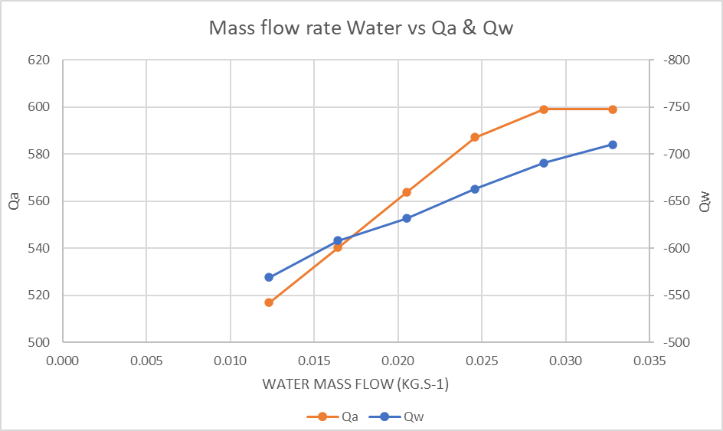
All these equations and formulas can be used for experiments 1,2, & 3.
Figure 2- water mass flow rate vs Qa & Qw
In figure 2, we can see that the result we found are expected, as the flow rate increases, the power transfer increases along with it. The heat that was release by the water, was absorbed by the air at a similar rate, leading to an assumption that the energy balance is within an expected and acceptable range. We can see that as the mass flow of .0325 kg.s⁻¹, the power transfer has reached its peak, and is starting to plateau. An assumption can be made that beyond this point, the increase in flow will not influence power transfer, it has effectively reached its limit for this set up.
In figure 3, we can see that the water temperature efficiency decreases with water flow, and the air temperature efficiency increase with water flow, which is a result we would expect to receive. We can expect to receive these results, as the temperature change for water is greater than air, and we can see in figure 3 that the mean efficiency decreases as the flow increases. At a lower flow rate, there is a greater temperature delta between inlet and outlet, as the heat transfer has more time to occur, meaning there is a limit to how quickly the heat can go from the water, through the heat exchanger, and into the air that passes over it. This is to be expected and is similar to the findings in the User Guide (Techquipment, 2014). This decrease in flow allows for a higher water
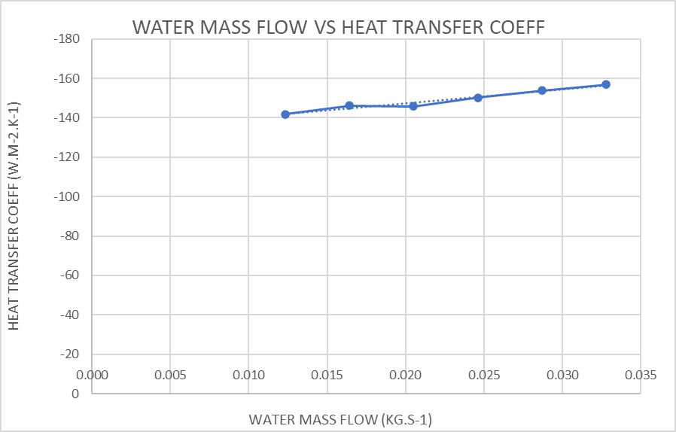
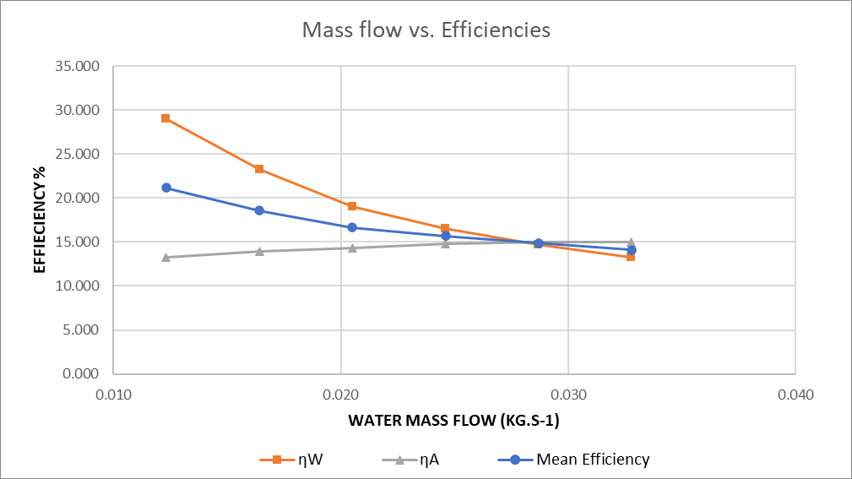
temperature efficiency, however, it also provides a lower delta in temperature between the water and air and their respective exits from the system. This has a limit, as when the temperatures become close to the same, the rate of heat transfer that can occur is greatly reduced, as shown in figure 2, where the air power is reduced at slower flow rates. This is to be expected and is similar to the findings in the User Guide (Techquipment, 2014)
Figure 4- Water mass flow vs. heat transfer coeff
Figure 3- Mass flow vs Efficiencies

In figure 4, we can see that the trends displayed in figures 2 and 3 are continued. At an initial increase in flow rate, the heat transfer coefficient increases, however it begins to plateau as the flow increases. This is because there is a limit for how much heat the air can absorb for a given size of heat exchanger. This is where efficiency levels come into play, as when selecting an appropriate heat exchanger, the size needs to be specifically calculated in an effort to not use the exchanger outside of its efficiency range.

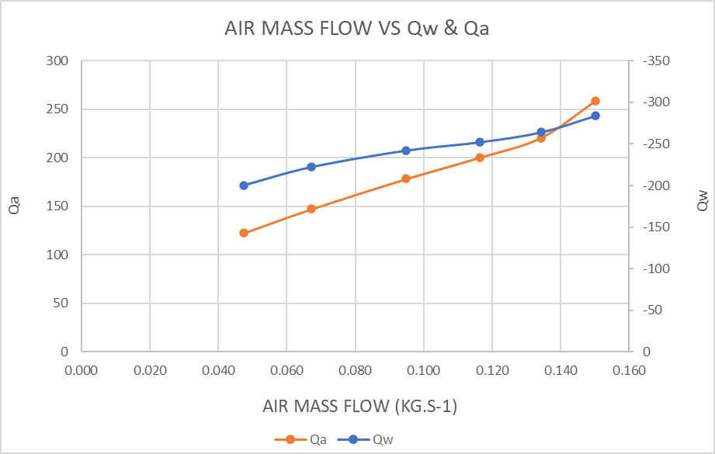
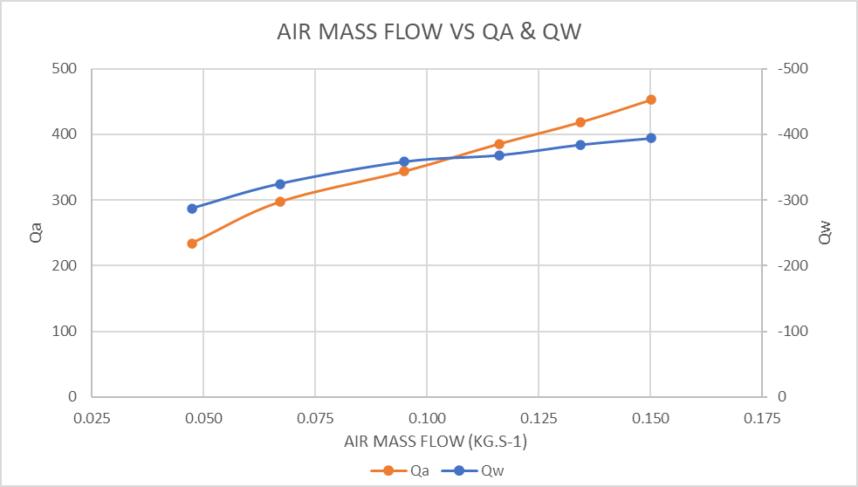
Experiment 2 & 3 Variance in Air Flow Rate
Figure 5- Exp 3 air mass flow vs Qa & Qw
Figure 4- Exp 2 air mass vs Qa & Qw
If we compare experiment 2 & 3, which vary in water temperature of 60 degrees and 45 degrees respectively, we can see that they follow very similar trend lines, with experiment 3 having a rapid rate of increasing air power at a higher flow rate. This could be an error in our experiment; however, it is a possibility that the high flow rate allows a greater volume of air to pass over the exchanger, which allows more heat to be absorbed giving a higher power calculation. Experiment 2 is slightly more linear that experiment 3, however both trend lines show that with a continual increase in flow rate, more a higher power level could be generated before it plateaus as it did in experiment 1. This is to be expected and is similar to the findings in the User Guide (Techquipment, 2014)
The air power is significantly lower on experiment 3 than 2, which is expected due to the driving for (temperature) being 25% lower between tests.
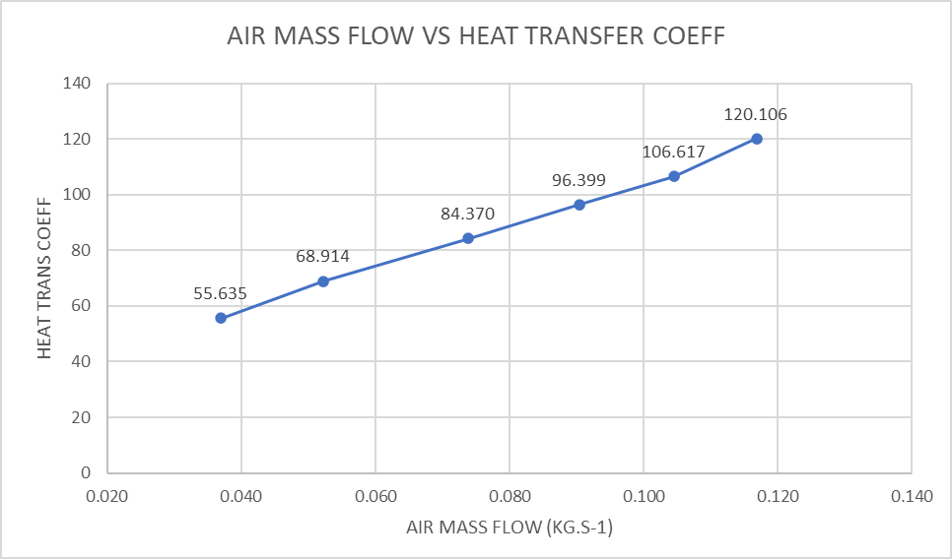
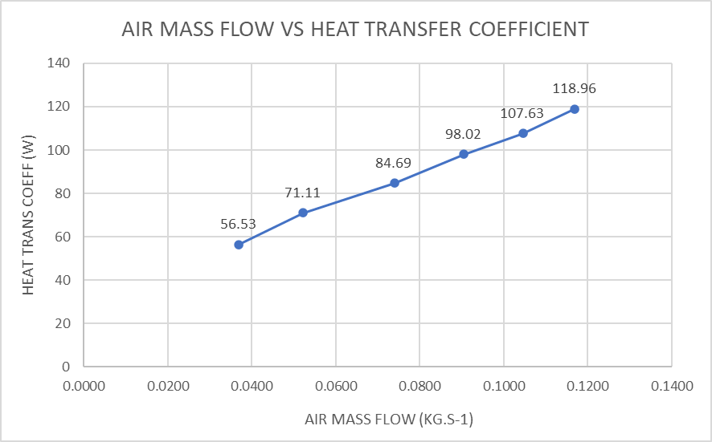
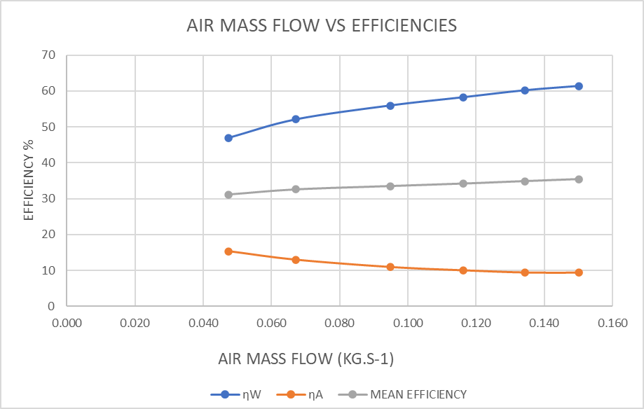
Figures 6 and 7 show that the air efficiency decreases with increase flow, and the water efficiency increases with flow. This is to be expected and is similar to the findings in the User Guide (Techquipment, 2014) the similarity between figure 6 & 7 shows that the difference in temperature does not have a great affect on the efficiency of the heat exchanger at the flow rates and temperatures that we specified. We can hypothesize that if the flow rate continues to increase, the water and air efficiencies with plateau, and will level out at the maximum level this size of heat exchanger can support.
Figure 8- Exp 2 Air mass flow Vs heat transfer coeff
Figure 9- Exp 3 Air mass flow Vs heat transfer coeff
Figure 7- Exp 3 air mass flow vs efficiencies
Figure 6- Exp 2 Air mass flow Vs Efficiencies
In figures 8 and 9, we can see that as the flow rate of air increases, the heat transfer coefficient increases with it, in an almost linear pattern. The values are very similar between experiment 2 and 3, as the temperature that the water is at doesn’t influence the heat transfer coefficient of the heat exchanger. With the linear factor of each graph, we can assume that with a continual increase in flow rate of air, we can assume that the heat transfer coefficient will continue to increase along with it, until the material and composition of the heat exchanger can no longer transfer more heat from water to air.

LMTD Calculation & Correction factor

The LMTD is a value that can be used to calculate the temperature of the driving force for a heat transfer system, such as a heat exchanger. In order to calculate the LMTD, the formula is used:

LMTD = $\frac{(\left(Tw1-Ta1\right)-\left(Tw2-Ta2\right))}{ln⁡(\left(Tw1-Ta1\right)-\left(Tw2-Ta2\right))}$
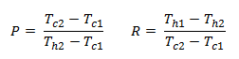
This equation is correct for counter flow, and parallel flow, heat exchangers. However, in order to use this value for a cross flow heat exchanger system, a correction factor must be applied. This correction factor, F, is a geometric factor that is primarily used in heat exchanger analysis and selection. In order to calculate the correction factor, we need to calculate P and R, R is the temperature change ratio of the hot and cold streams, while P is the temperature change of the cold fluid divided by the maximum temperature difference. (Corrected Log Mean Temperature Difference for Shell-and-Tube Heat Exchangers, 2011)
Figure 12- LMTD experiment 3
Figure 11- LMTD experiment 2
Figure 10- LMTD experiment 1

Conclusion
It is apparent that the size of a heat exchanger, and the number of tubes and fins, greatly change the ability for heat transfer to occur. More surface area will allow for a great rate of heat transfer, while allowing for the efficiencies of both water and air to increase. In experiment 2 & 3, it is apparent that the change in temperature is of lower influence when it comes to heat transfer coefficients and efficiencies, as the highest temperature was proven t o still be in the heat exchangers range to deal with. The LMTD is an important driving factor when calculating the size of heat exchanger needed, as the larger the LMTD value is, the larger the heat transfer that takes place is. We completed what we set out to do with this experiment, which was to show what the affects of varying different factors have on a heat transfer system. The experiment ran smoothly, and there was very little that needs to change. One improvement that could be made would be have more than one type of heat exchanger, which we could compare data and efficiencies.

References
Grundfos.com. 2020. Cross Flow Heat Exchanger. [online] Available at: <https://www.grundfos.com/service-support/encyclopedia-search/cross-flow-heat-exchanger.html> [Accessed 11 April 2020].
Excelcalculations.blogspot.com. 2011. Corrected Log Mean Temperature Difference For Shell-And-Tube Heat Exchangers. [online] Available at: <http://excelcalculations.blogspot.com/2011/06/lmtd-correction-factor.html> [Accessed 15 April 2020].
Wermac.org. 2020. Heat Transfer By Heat Exchangers. [online] Available at: <http://www.wermac.org/equipment/heatexchanger_part1.html> [Accessed 10 April 2020].
EnggCyclopedia. 2017. Understanding LMTD For Heat Exchanger Design - Enggcyclopedia. [online] Available at: <https://www.enggcyclopedia.com/2019/04/understanding-lmtd-for-heat-exchanger-design/> [Accessed 12 April 2020].
Woodford, c., 2020. How Do Heat Exchangers Work?. [online] Explain that Stuff. Available at: <https://www.explainthatstuff.com/how-heat-exchangers-work.html> [Accessed 12 April 2020].
Techquipment, Nottingham, 2014

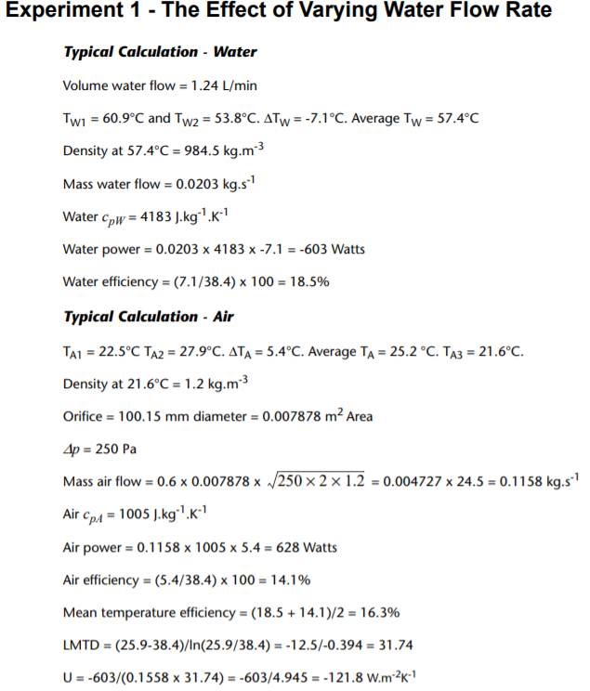
Appendices
Appendix 7- User Guide Results
Appendix 1- Results from our experiment

Experiment 2 & 3 data (2 above 3)

