University of Wales Trinity Saint David



Program: Certificate of Higher Education Skills for the Workplace (Health and Social Care)
Title: Portfolio-Two Taks
Module: Introduction to Health and Social Care
Name of Student: Asima Bibi
Student ID: 2225758
Lecturer Name: Mumtaz Ghulam

Table of Contents
Task 1 (Poster for Residential Care Home) 3
Task 2 (Short Essay: Ambulance services) 5
1. Introduction 6
2. Origins and Historical Development of Ambulance Services 6
3. Current Functioning of Ambulance Services 7
4. The Impact of the Ambulance Service on Health and Quality of Life 7
I. Life-Saving Care and Improved Health Outcomes 7
II. Emotional Reassurance and Access to Appropriate Care 7
References 8

Task 1 (Poster for Residential Care Home)






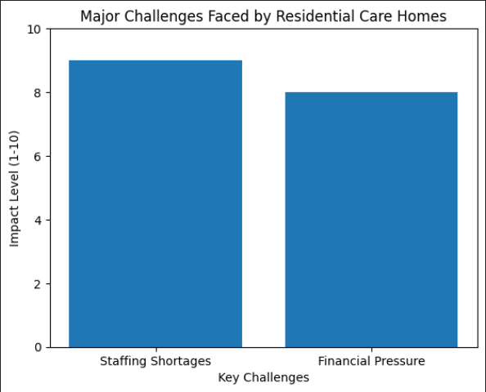

e
Staff shortage is one of the greatest challenges that residential care homes may encounter. It may also be tiring work both physically and emotionally, but the pay is usually not too high, so it is hard to find and keep qualified care personnel. The high staff turnover may contribute to the higher workload of the remaining employees, burnout among the staff and less time to care with the individualised care that can be provided to the residents which may impact the quality of service delivered to the residents.
1. Staff Shortage
Residential care homes are currently managed as controlled social care environments which offer 24-hour assistance in an organized and secure environment. The residents are assisted by the trained care staff that helps them in the day-to-day activities of life that include personal cleanliness, dressing, eating, mobility and medication administration. Homes offer food, care, recreation and social interaction as a means of facilitating wellbeing and decreasing isolation. They collaborate extensively with families, GPs and community health services in the care of the overall health of residents. In England, the Care Quality Commission inspects and regulates the quality of residential care homes to safeguard the safety, quality standards and protective measures.
19th century: The helpless and elderly were accommodated in workhouses in very simple and in most cases harsh conditions.
Early 1900s: Workhouses were slowly phased out and smaller homes, known as old people homes, had replaced them.
1948: The welfare state increased social care service as well as the establishment of National Health Service in the UK.
1960-1980s: Residential care homes were expanded by local authorities.
2000s-Present: Residential care homes are oriented to person-centred care, dignity, protection and quality regulation by the bodies like the Care Quality Commission.

Residential care home refers to social care service whereby people living in their own homes become incapable of sustaining themselves and they need 24-hours personal assistance. It is primarily targeted to older people or physically challenged individuals requiring assistance in their daily routine tasks like washing, dressing, eating, administering medication and safely moving around their environment. This is unlike the nursing homes because homes do not typically offer ongoing medical care by registered nurses, but their physical, emotional and social needs are always met by trained care staff. The principal goal of a residential care home is to build a secure, comfortable and homely environment where one can remain dignified, independent and have a good quality in life whilst they get the help they need.

How the service works?
Brief History of the Service
RESIDENTIAL CARE HOME
Two Major Challenges Faced by the Residential Care Homes
Introduction
Lifesaving Care on the Move
1) Funding and Workforce Pressures

2) Stigma and Inequality

2. Funding and Financial Pressure

Financial pressures and the lack of funds is another obstacle. Residential care facilities are faced with high operations costs that include salaries of the staffs, their food, utilities, repairs and regulation. Local government funding is however often limited, and a lot of the families do not have the means of affording the charges of the private care. Increasing living prices also add to the financial burden that may lead to low resources or curtailed services or even shutting down of care homes.

Task 2 (Short Essay: Ambulance services)

Introduction
The National Health Service (NHS) operates ambulance services as an essential component of urgent and emergency care within the UK. The services serve as initial contact for individuals experiencing life-threatening conditions like heart attacks, strokes, accidents and other life-threatening conditions. In addition to emergencies, the ambulance services offer patient transport, urgent community care and specialist medical treatment, thereby standing as a foundation of public health.

Origins and Historical Development of Ambulance Services
NHS ambulance services back to the 19th century, when ambulance services in the UK were mainly decentralised and uncoordinated. Military experience had an effect on the early ambulance services especially during wars like the Crimean War where organized mechanisms had been established to evacuate wounded soldiers at the battle fields to hospitals. During civil times, voluntary organisations like the St John ambulance, which was established in 1877 and local authorities tended to offer their services. The growth in number of accidents in the workplace and rapid urbanisation during the Industrial Revolution enhanced the need of organized means of transporting patients. Nevertheless, the quality of service and its availability in various regions was different.
The two World Wars especially World War II was very instrumental in changing the development of ambulance services. Air raid management necessitated the need to coordinate, communicate better and the emergency structures. Such experiences proved the significance of the organisation of the emergency service nationally. The development of the National Health Service (NHS) in 1948 was one of the most significant milestones in history because ambulance services were nationalized and made free at the point of consumption. Their primary purpose was to transport the patients instead of giving them specialized medical services. The development of technology, training and the creation of paramedic positions led to the turnaround of ambulances as mobile treatment centers that can provide life-saving treatment at the location over a period of time. War, industrialisation, social reform and medical innovation therefore influenced the development of NHS ambulance service which had been transformed into the current emergency medical service today.

Current Functioning of Ambulance Services
The ambulance service operates with a well-organised emergency call categorisation system that ranks the patients based on the severity of their condition. There are four levels of emergencies.
Category 1 involves life threatening scenarios like cardiac arrest or severe allergy whereby the target response is about 7 minutes since timely response is important to life.
Category 2 deals with severe cases such as chest pain or stroke with an estimated responsiveness time of approximately 18 minutes to mitigate the risk of complication or permanent injury.
Category 3 is dealing with urgent cases including major injuries or abdominal pain that need a medical evaluation but are not life-threatening.
Category 4 is associated with those conditions that are not urgent, minor infections, diarrhea or vomiting, and have a long waiting time.
This system keeps the most urgent patients under the care of the quickest system and the management of resources in the most successful way, considering the different degrees of urgency.

The Impact of the Ambulance Service on Health and Quality of Life

Life-Saving Care and Improved Health Outcomes
The ambulance service is an important aspect in improving the quality of life of service users as it offers quick response and immediate intervention of medical response to emergencies. Immediate care in case of life-threatening conditions, cardiac arrest, stroke, severe trauma, or breathing problems will largely improve survival rates and decrease the occurrence of long-term complications. Early diagnosis and on-site treatment such as oxygen and analgesics, wound treatment and stabilization avoid the deterioration of conditions before patients reach hospital. The ambulance service makes people more independent and ensures better long-term health outcomes by reducing the cases of disability, enhancing the speed of recovery, and avoiding unjust deaths.

Emotional Reassurance and Access to Appropriate Care
The ambulance service is also improving the quality of life beyond physical treatment by assuring and giving the population a feeling of security. The knowledge that there is available 24-hour professional assistance decreases anxiety especially in such groups of people as older adults and citizens with chronic illnesses. Staff working at the ambulances also make sure that they evaluate the patients and refer them to a healthcare facility that will best suit them be in emergency departments, urgent care facilities or community support. It is a coordinated practice that patients get appropriate and prompt care, which enhances the total patient experience and facilitates wellbeing.

References
- Care Quality Commission (CQC) (2023) Residential adult social care services.
- Department of Health and Social Care (2014) Care Act 2014. London: The Stationery Office.
- Department of Health and Social Care (2021) People at the heart of care: Adult social care reform white paper. London: DHSC.
- NHS (2023) Care homes.
- NHS England (2019) The NHS Long Term Plan. London: NHS England. The King’s Fund (2022) Social care in England.
- Department of Health and Social Care (2019) The NHS Long Term Plan. London: Department of Health and Social Care.
- National Audit Office (2017) NHS ambulance services. London: National Audit Office.
- NHS England (2018) Ambulance Response Programme Review. London: NHS England.
- NHS (2023) Ambulance services.
- St John Ambulance (2023) Our history.
- The King’s Fund (2022) How ambulance services work.

