BA Leadership and Management
Module: Workplace Culture and Its Impact on Organisational Efficiency

Module code: BMSW 5105

Assignment Title: Individual Written Report & Oral Performance
Understanding Workplace Culture at the University of Birmingham

Kamil Lenczowski
Student number:
2120445
Lecturer: Abdi Rahman

Contents
INTRODUCTION 3
Impact of Environmental Factors on Organizational Culture 4
Culture Creation and Maintenance 6
Learning the Organizational Culture 10
How we learn culture in organisational aspect. 11
Ethical Behaviour and Cultural Assessment 14
Organizational structure helps keep high cultural standards. 18
Creating an Ethical Organizational Culture 19
Barriers to Effective Cultural Functioning 22
Recommendations for Improving Workplace Culture 23
Conclusion 25
References 26
Appendix 28
Through groundbreaking research 32

INTRODUCTION

This report focuses on the impact of workplace culture on organisational efficiency at the University of Birmingham. It critically assesses the environmental factors that influence the university's culture and evaluates whether the culture promotes ethical behaviour among employees. The report also examines an ethical problem that could affect the university's culture and identifies barriers to effective cultural functioning. Finally, it provides recommendations to enhance the workplace culture and explains how these recommendations will positively impact organisational efficiency.
The environmental factors within the University of Birmingham, such as its history, vision, and values, shape its organisational culture. University of Birmingham Established in 1900, it is England's first civic university. With an annual influx of over 30,000 students, it has become a global institution. The person who started the university, Joseph Chamberlain, wanted all students to have the same opportunities. This idea still guides the university today. The University of Birmingham has a long history of coming up with new ideas and adding to culture. The University of Birmingham was the first university in the UK to have its own campus with a railway system connecting it to the city. They were also pioneers in including a Faculty of Commerce and a Medical School that welcomed women to study medicine. This university has always been a leader in innovation and progress.

Impact of Environmental Factors on Organizational Culture

The United Kingdom has one of the best higher education systems in the world. It offers top-quality education and affordable tuition fees, which is why it is a popular choice for students. The way things are done at the University of Birmingham is influenced by factors like competition, technology, societal trends, and rules. These factors greatly shape the university's work environment and its ability to achieve its goals.
“In this PESTLE analysis, we’ve looked at how various Political, Economic, Sociocultural, Technological, Legal, and Environmental factors are affecting higher education in the United Kingdom. With a large number of foreign students, it’s clear that UK politics play a big part in these universities’ enrolment figures. One of the most notable issues in higher education, cropping up in both the Economic and Sociocultural categories, is student debt, which may come to deter many students. Aside from this, traditional higher education is both threatened and augmented by new technologies, so it’ll be interesting to see how the industry develops over the coming years.”
According to Thomas Bush's article, the UK's higher education system is examined by considering different factors like politics, economics, society, technology, laws, and the environment. The article shows that the sector is competitive, technology is important, societal trends have an impact, and regulations must be followed. When we consider PESTEL analyses, we can see that external factors significantly impact the organizational culture and effectiveness of the University of Birmingham. Political factor can result in funding cuts for UK universities, which affects the quality of education. Disagreements and Brexit can also impact international student enrolment, potentially leading to the closure of some institutions. Economical factor UK students face high levels of debt, impacting post-graduation financial prospects. The weak job market raises concerns about the value of UK education compared to other countries. As a sociocultural fact, many students in the UK have a lot of debt, and this makes them think twice about going to university. They worry that they will not be able to find a good job after they finish studying.
Technology is changing UK higher education. Online learning, AI, and VR (Virtual Reality Society) or AR (Augmented Reality) are providing new options and improving how students learn. Legal factors generally impacting UK universities include government regulations, employment law, intellectual property rights, data protection, health and safety, and equality legislation but these are the main factors that impact any organization. Environmental factors, such as climate change, sustainability, regulations, biodiversity, transportation, and environmental research, generally impact organizations, including UK universities. These factors shape their values, practices, and responses to changing trends and regulations in the higher education sector. The culture at the University of Birmingham is influenced by external factors like competition, technology, societal trends, and regulations. These factors shape the work environment and impact the university's ability to achieve its objectives. This institution collaborates in the education sector, which is influenced by various components including competition, technology, social trends, and regulations. The University of Birmingham faces competition from other universities. Technologically, the University of Birmingham has achieved a fair level of equipment and uses technology to enhance learning and research. Social trends, such as sustainability and diversity, also have an impact on the university. The university understands the importance of regulations and follows them to maintain a safe and ethical environment.

Culture Creation and Maintenance

According to H. Bhabha culture is a complex concept and it seems to be studied by many scholars. Homi Bhabha, in his book "The Location of Culture", Homi Bhabha questions the belief that culture stays the same and does not change. He believes that culture is always changing and developing through interactions between different social groups. This includes the impact of colonialism and postcolonialism.
It is important for universities like the University of Birmingham to be open to different cultures. Bhabha's ideas highlight that culture is always changing and has an impact on our lives. This article aims to persuade the significant fact that other scholars constantly review how culture is created. For example, Mateusz Stepien and ‎Jan Bazyli Klakla, to be clearer their work delves into thoughts and study deeper in this field.
In their book "Law and Culture: Reconceptualization and Case Studies". The authors explore the relationship between law and culture and presents case studies in this field. The authors analyse how culture influences law and how law shapes culture. They look at how different parts of culture, like language, traditions, beliefs, and how people behave, affect the way laws work and the organizations that enforce them. This topic is important because a lot of people find it really interesting and want to learn more about it.
The purpose of the article is also to be considering business aspects and how to adopt appropriate cultural trends and maintenance them. As it has been proven, culture is a complex concept that influences many sectors, and aspects.
“As we will see, the field of culture provides many opportunities for the development of new concepts because it has not yet been studied enough in group, organizational, and occupational domains to have spawned new theory. It is still an evolving field.” (Edgar H. Schein).

Edgar H. Schein, another scholar who talks about culture, gives useful ideas that can be applied to the University of Birmingham, especially in business management and leadership. According to Schein, leaders are very important in shaping the culture of an organization. This means that the actions and ideas of the university's leaders have had a big effect on its culture. For instance, the interest in research, academic excellence, and community involvement may have been developed by the university's leaders over time. The University of Birmingham continues to shape its culture even when there is already one in place. The university works on improving it to be more integrated with the community.

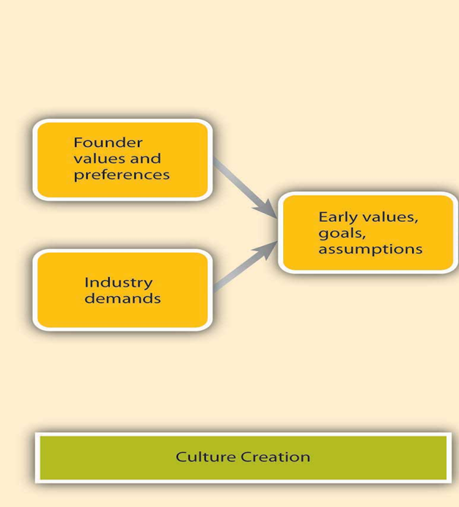
Founders hire people who think and feel like them. They teach and influence employees to do the same. Through their actions, founders make employees relate to them and adopt their beliefs.
(Figure1 Culture Creation, Schein 1996, sourced from UWTSD)
This work aims to show a link between ideas and real-life situations. It focuses on Schein's idea of creating and maintaining culture in an organization that has been around for a long time. This idea applies to the University of Birmingham, founded by Joseph Chamberlain, a visionary leader who aimed to establish a progressive university. Chamberlain wanted a team of people who shared his principles and beliefs, creating an inclusive environment where students from different backgrounds were treated equally. The university continues to uphold and value this vision, as seen on their website.
Another solid fact is his significant contributions to Birmingham, such as improving living conditions and education, show that he had a strong influence on the culture of the university. This means that he played a crucial role in shaping how students and the wider community think and what they value. Chamberlain's focus on making living conditions better and improving education matches with Schein's model's aspect of meeting industry demands. He taught and influenced employees to understand and value education, research, and regional development. This helped create a shared culture at the university, where everyone thought and felt the same way.
According to Schein, the beliefs and values of the founders play a big role in creating and maintaining culture. This means that the founders' ideas and principles have a strong influence on shaping how an organization behaves and thinks.
In the case of the University of Birmingham, Joseph Chamberlain, as the founder and visioner, played a crucial role in establishing the institution's values and goals. Chamberlain's ambitious aspirations for research and education likely inspired and influenced the employees, students who are part of this institution, also the broader community associated with the university.
They identified with his vision and adopted his beliefs and values as their own. When people accept and adopt the founder's ideas, it helps create a culture. This is the connection between Schein's concept and the University of Birmingham.

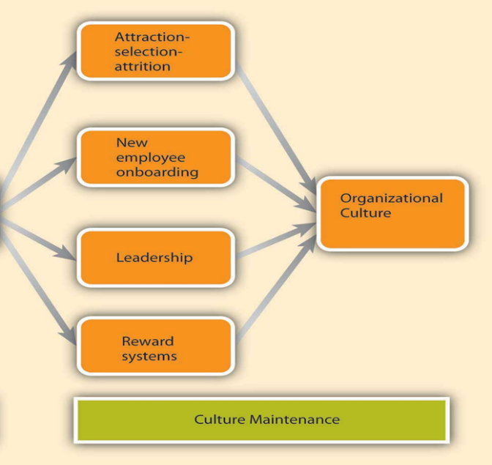
(figure2 Culture maintenance, Schein 1996, sourced from UWTSD).
The purpose of this work is to explain the importance of culture and how it is maintained. The model presented focuses on several key components.

Attraction-Selection-Attrition: The university attracts and selects individuals who share its values and vision while removing those who do not fit in well.
New Employee Onboarding: New employees are introduced to the university's culture and values, helping them become part of the community.
Leadership: The university's leaders set a good example by prioritizing research, academic excellence, and community involvement.
Reward System: The university rewards students who excel, making the academic culture even better.
By applying this model, organizations can create a positive culture that promotes employee engagement, productivity, and overall success. It helps create shared values, a feeling of belonging, and working together towards common goals. A strong culture at work makes employees happy, helps keep them in the company, and helps the organization reach its goals.
In the context of the University of Birmingham, these components work together to create and maintain its unique culture, ensuring that individuals who share its values are attracted, supported, and rewarded. Beyond everything, the University of Birmingham cares about the environment by being transparent in its commitment to environmental stewardship. It goes even further by offering courses to students that foster their development in this field.

Learning the Organizational Culture
Understanding the importance of organizational culture in learning is crucial because cultures can change, and these changes can help organizations improve.
According to an article by Sapna Rijal titled "Leadership Style and Organizational Culture in Learning Organization: A Comparative Study," good leadership and an open culture are vital in a learning organization.
Good leaders help their teams adapt and guide them in the learning process. A supportive culture promotes innovation and openness. Effective leadership and a supportive culture together build a learning organization and enhance performance.
“The concept of culture is also one of the major variables and essential ingredients in the development of a learning organization. Barrett (1995), Hershey et. al. (2000) suggest that a learning culture characterized by continuous learning from experience, experimentation, questioning and dialogue, is the only way to sustain a competitive advantage over the long term in an increasingly complex and turbulent environment.”
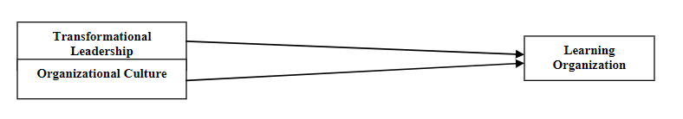
(Figure3. Conceptual Model, sourced from International Journal of Management & Information Systems –Fourth Quarter 2010Volume 14, Number 5).

How we learn culture in organisational aspect.

This work will show how employees learn the culture through a process called socialization. It follows three stage model, and it has been discussed by the MBA Skool Team (2015).

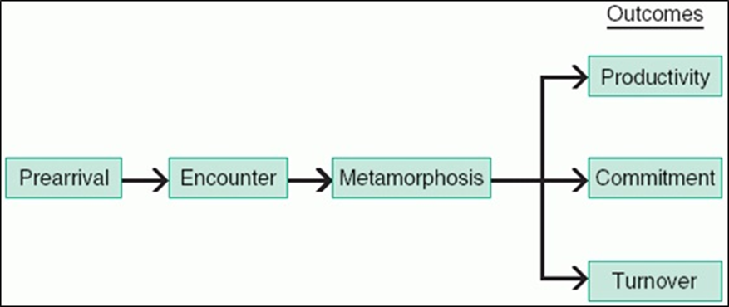
(Figure4. Stages of socialization sourced from MBA Skool Team).
This model shows three stages however, the Encounter Stage is an important part of joining an organization, where people find out if their expectations match the reality of the organization. This stage decides how well new employees adapt and impacts their productivity, dedication, and whether they choose to stay or leave.
When new employees start their jobs, they learn how to fit in, like how new students adapt to university life. This helps them improve their skills and feel more confident. Understanding the organization's culture and going through the Encounter Stage are important for creating a learning environment and boosting employee performance.

The history and heritage of the University of Birmingham offer valuable insights into its organizational culture. This can provide potential employees with an understanding of what they can expect when joining the organization. By examining the University of Birmingham's history and Joseph Chamberlain's vision give us clues about its organizational culture. Chamberlain wanted the university to be a great place for learning and research, which shows a culture of curiosity, innovation, and academic excellence.
Furthermore, it is important for the university to regulate quality and standards. At the University of Birmingham, they have a clear system in place to make sure the quality and standards of their courses are up to par. They closely monitor their providers to ensure they meet certain requirements. If there are any concerns about the quality or standards of a course, they pay even closer attention and act if needed.
They want to make sure that all students, regardless of their background, receive a high-quality education. The university is always reviewing and improving its standards to stay up to date. They want to provide the best possible education and make sure their courses meet industry standards. They also take a risk-based approach, focusing their efforts on providers where there might be problems. This shows that they take accountability seriously and want to address any issues as soon as possible.

In summary, the University of Birmingham focuses on maintaining high standards in its courses. Its culture also aligns with Handy's Power Culture ideas.
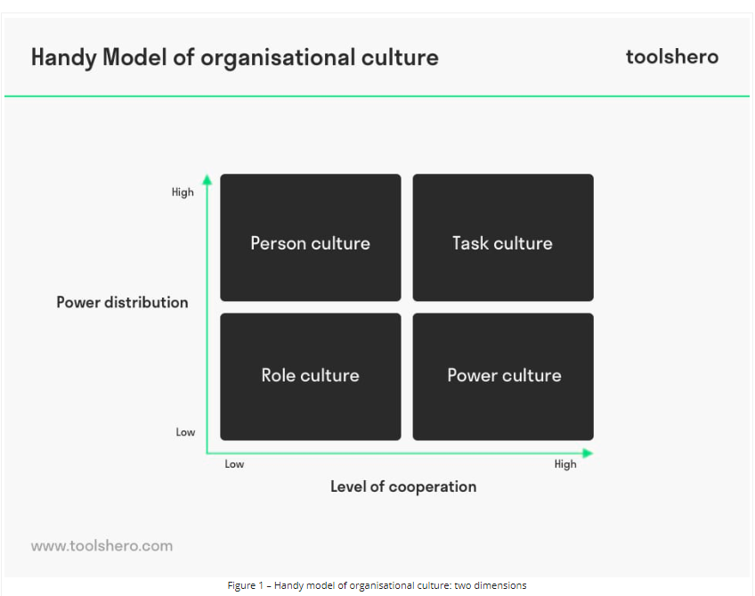(figure5 Handy Model of Organisational Culture: two dimensions sourced from toolshero).
Person Culture | The University of Birmingham values diversity and provides equal opportunities for all students.
Task Culture | The University of Birmingham collaborates with businesses, drives innovation, and promotes responsible practices.
Role Culture | The University of Birmingham has a structured organization with clear roles and hierarchical decision-making.
Power Culture | Joseph Chamberlain's vision and influence shape the culture of the University of Birmingham.

Ethical Behaviour and Cultural Assessment

“Ethics is a system of moral principles that includes ideas about right and wrong, and how people should (or should not) behave in general and specific cases.” (RSPCA).

The University of Birmingham believes in doing what is right and following ethical principles. They prioritize fairness, benefiting society, respecting individual rights, fulfilling obligations, and embracing good values. Upholding these ethical standards is important in their educational practices to ensure quality and promote positive ideals. They make sure to include these values in their educational programs, encouraging students to demonstrate ethical behaviour with kindness and integrity. By integrating ethics into its regulations, the University of Birmingham aims to create a positive organizational culture rooted in integrity, respect, and social responsibility.
Regardless of this institution, it is highly recommended to look at its Code of Ethics.
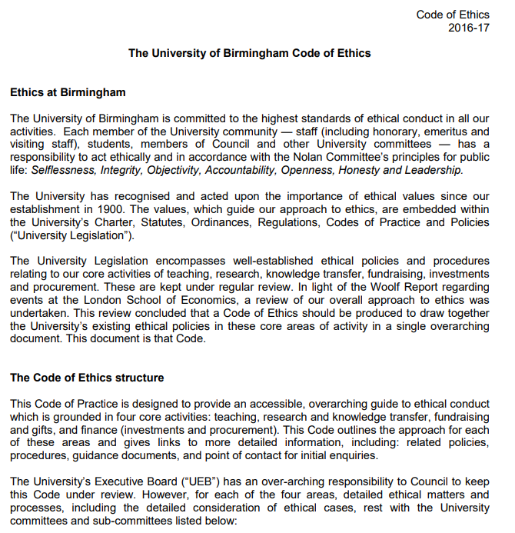
(Figure5. Part of The University of Birmingham Code of Ethics, sourced from https://www.birmingham.ac.uk/documents/university/legal/code-of-ethics.pdf).

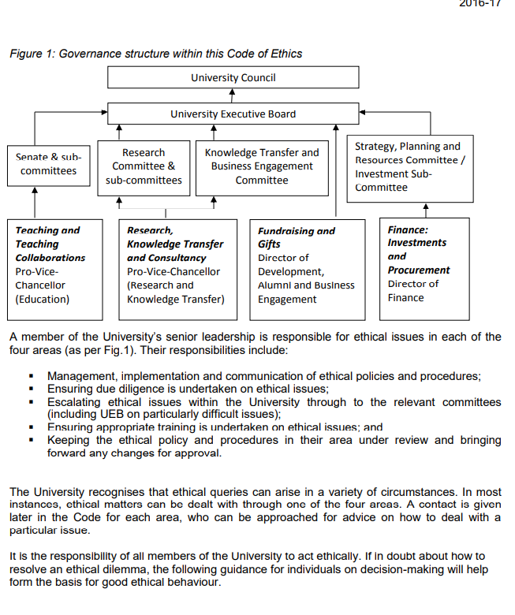
(Figure6. The University of Birmingham Code of Ethics, sourced from https://www.birmingham.ac.uk/documents/university/legal/code-of-ethics.pdf).
The University of Birmingham has a Code of Ethics that guides the behaviour of everyone in the university community. It applies to various areas such as teaching, research, fundraising, and finance. The code emphasizes important principles like integrity, accountability, and openness. It also values academic freedom and promotes equality. By following this code, the university maintains its reputation and achieves success.
In addition to the above, the University of Birmingham's Code of Ethics also addresses the ethical considerations of using Artificial Intelligence (AI) in Human Resource Management (HRM). The code emphasizes the importance of fairness, openness, and avoiding prejudice when utilizing AI in HRM tasks such as hiring and performance evaluation. It highlights the need to protect individuals' privacy and promote inclusivity. The university encourages regular assessments of AI systems to ensure compliance with ethical standards, thereby fostering a diverse and supportive academic community.

Organizational structure helps keep high cultural standards.

The University of Birmingham has a strong culture due to its power structures and organizational structures, as seen in this work.
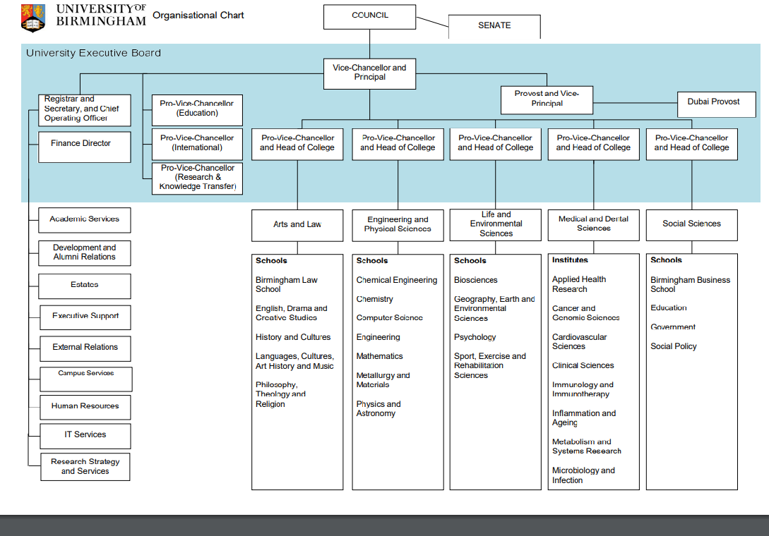
(Figure7. Organisational Chart sourced form https://www.birmingham.ac.uk/documents/university/org-chart.pdf)
The University of Birmingham has a structured organization with clear roles and responsibilities. It follows a hierarchical system where decisions are made by the Council, academic matters are overseen by the Senate, and day-to-day management is handled by the University Executive Board. The organizational structure promotes clarity, collaboration, and alignment with values, contributing to a strong cultural aspect at Birmingham University.

Creating an Ethical Organizational Culture

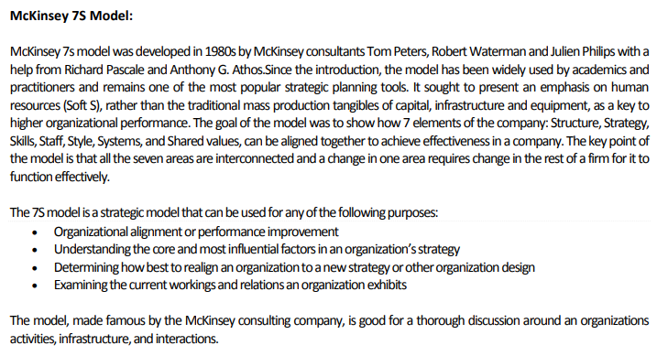

(Figure9 McKinsey7SModel, sourced from https://www.lkouniv.ac.in/site/writereaddata/siteContent/202003291621085882smitasingh_mcKinsey_7s_model.pdf ).

Creating an ethical culture in an organization is a challenging and time-consuming process. One useful framework for achieving this is McKinsey's 7-S Framework. This framework helps organizations assess and improve different aspects to promote ethical behaviour and values.
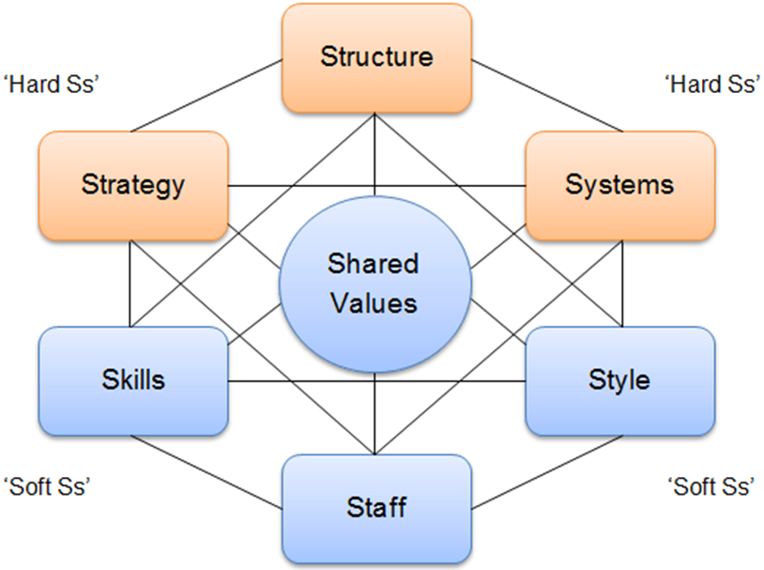
(Figure9. McKinsey’s 7’s framework sourced from UWTSD) Strategy: Decide your goals and how you want to act.
Strategy: Decide your goals and how you want to act. Structure: Organize your life and be open with others. Systems: Set personal rules for being fair and honest. Shared Values: Believe in being kind, respectful, and fair. Skills: Learn how to make good choices and solve problems. Style: Be a good example and encourage others to do the right thing. Style: Be a good example and encourage others to do the right thing. Staff: Surround yourself with friends who care about doing what is right and ask trusted adults for guidance.
By following these steps, individuals can develop the ability to make responsible and ethical decisions. These are simplified explanations to help understand the strategy. In the case of The University of Birmingham, we can explore their website to identify connections to this strategy. By researching their website, we can highlight specific elements that align with the steps outlined in the strategy.
Strategy: The university shares knowledge to achieve its goals. Structure: The university presents and displays knowledge at exhibitions. Systems: The university has mechanisms to connect academics with external partners. Shared Values The university cares about important issues and treats everyone with kindness and fairness. Skills: The university's teachers are very knowledgeable and good at working together. Style: The university's leaders support working together with others and forming partnerships Staff: The university's employees, such as teachers and researchers, demonstrate ethical behaviour in their work.
By considering these components, the University of Birmingham creates an ethical culture focused on sharing knowledge and addressing societal challenges.

Barriers to Effective Cultural Functioning

Barriers to effective functioning can hamper organizational success in various ways. Factors such as dynamic environments, lack of communication, resistance to change, and the inability to overcome obstacles can impede progress.
“In the 21st century, organizations are operating in a very dynamic environment that
demands continuous change to remain competitive (Pieterse, Caniëls, & Homan, 2012).
Similarly, organizations have become adaptive to change for the sake of their survival and
growth (Greenwood & Hinings, 1988). Whether by responding toward external affairs or
by eagerly improving businesses, organizations must consistently remain aligned with the
environment. Due to fast-changing technology, economics, consumer preferences,
government, demographics and competition, a significant question rises which is not about
embracing a change or not, rather it is about how and in which direction organizations
should change.” (Webology2021-ResistancetoChangeDecember2021 (1).pdf).
Creating a culture at the University of Birmingham can encounter various barriers, each one with own different story. However, the institution must be resilient and willing to confront these challenges, such as resistance to change, reluctance to embrace new ideas or approaches, lack of communication, hierarchical structure, their history and traditions, lack of funding.
The aim of this project is to understand the university's culture and identify potential obstacles. However, it seems that the university has already overcome most of these barriers. Common challenges institutions face includes communication issues, lack of funding, and student shortages. however, by promoting a flexible and innovative culture, the university can successfully adapt to changes, stay competitive, and achieve its goals.

Recommendations for Improving Workplace Culture
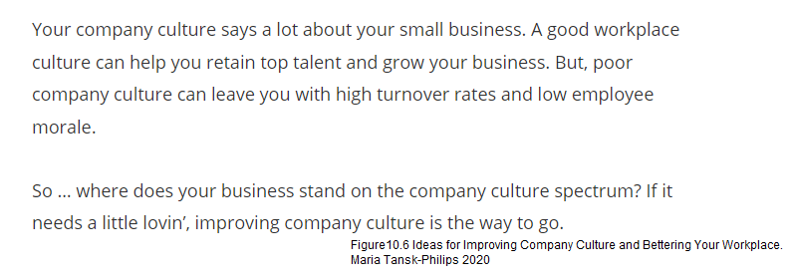
Nowadays, many businesses are affected by barriers that prevent them from operating at full capacity. According to an article by Maria Tanks-Philips titled "6 Ideas for Improving Company Culture and Bettering Your Workplace" (2020), there are six tips that can be applied to achieve a better workplace culture.
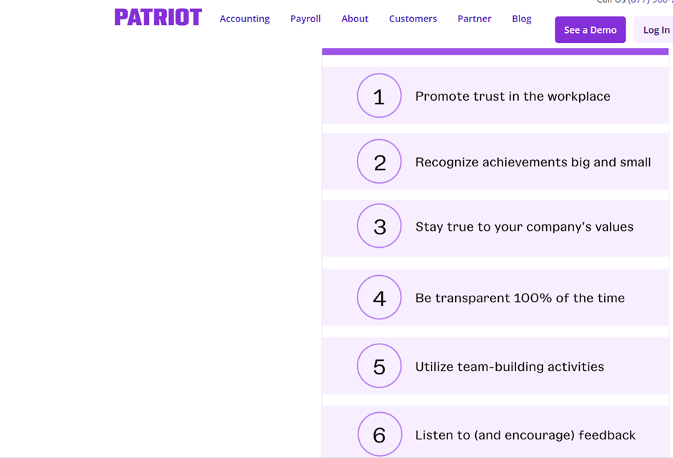
(figure11. 6 Ideas for Improving Company Culture and Bettering Your Workplace Maria Tanski-Philips 2020 sourced from https://smallbusiness.patriotsoftware.com/improving-company-culture-tips/ ).

According to Maria T. Philips the University should Ensure that important information is shared promptly and clearly with everyone through emails, newsletters, and social media. It is crucial to keep the university community informed about policies, decisions, and any changes that affect them. Conduct regular meetings led by university leaders to discuss updates and address questions. This creates an inclusive environment where everyone could express their opinions and feel involved. Involve the individuals affected by important decisions and provide them with clear explanations for why those decisions were made. Encourage feedback and make sure everyone understands the reasoning behind the choices. Promote openness regarding the university's financial matters. Share information about budgets, resources, and financial performance to help everyone understand how the university's funds are utilized. Establish an easy-to-use system for individuals to report unethical behaviour or problems. Assure those who report that their identity will be protected, and their concerns will be taken seriously. Create channels for feedback where individuals can freely share their ideas, suggestions, and concerns. Pay close attention to the feedback received and take appropriate actions based on it. The purpose of giving recommendations is to motivate to do more, however, from gathered data the institution mentioned in the report clearly stands for transparency, collaboration, and has got inclusive company culture.

Conclusion
The University of Birmingham's organizational culture is influenced by various environmental factors, including its history, vision, and values. Established in 1900, it is England's first civic university, known for championing equal opportunities for all students. The university has a rich history of innovation and contributions to society, with a focus on emerging fields such as nanotechnology and gene therapy. Its campus combines old and new architecture, creating an inspiring environment. The university collaborates with businesses, drives innovation, and promotes responsible practices. External factors such as competition, technology, societal trends, and regulations shape the university's culture and work environment. Political and economic factors impact education quality and student debt. Sociocultural aspects influence student attitudes towards higher education. Technology is transforming higher education, with online learning and advancements like AI and VR. Legal factors include government regulations, employment law, and data protection. Environmental factors such as sustainability and biodiversity also influence the university's values and practices. Culture creation and maintenance are essential aspects of the university's organizational culture. The university attracts and selects individuals who share its values, supports new employees through onboarding, and emphasizes leadership and a reward system. Understanding the importance of culture and learning is crucial in building a learning organization.

Overall, the University of Birmingham's culture reflects its history, values, and response to external factors and perfectly fits to theories and applies them effectively. It promotes inclusivity, academic excellence, and innovation, providing a high-quality education and contributing to the community. By maintaining and enhancing its workplace culture, the university can improve organizational efficiency and achieve its objectives.

References

Anonymous (2015) Encounter Stage - Meaning & Definition, MBA Skool, available at: https://www.mbaskool.com/business-concepts/human-resources-hr-terms/15253-encounter-stage.html
Anonymous (2016) Code of Ethics, University of Birmingham, available at: https://www.birmingham.ac.uk/documents/university/legal/code-of-ethics.pdf
Anonymous (2019) Useful Management Tools: McKinsey 7s Framework, Abdo Business Support Hub, available at: https://www.abdo.org.uk/wp-content/uploads/2019/07/ABDO-BSH-Management-Tools-McKinseys-Framework.pdf
Anonymous (2020) Changes to our approach, Office for Students, available at: https://www.officeforstudents.org.uk/advice-and-guidance/quality-and-standards/changes-to-our-approach/
Anonymous (2020) How we regulate quality and standards, Office for Students, available at: https://www.officeforstudents.org.uk/advice-and-guidance/quality-and-standards/how-we-regulate-quality-and-standards/
Anonymous (2021) Birmingham 2030 Strategic Framework, University of Birmingham, available at: https://www.birmingham.ac.uk/university/our-strategy.aspx
Anonymous (2021) Organizational Barriers To Communication And How To Overcome It, Harappa, available at: https://harappa.education/harappa-diaries/organizational-barriers-to-communication/#heading_1
Anonymous (2021) Our civic commitment, University of Birmingham, available at: https://www.birmingham.ac.uk/university/city-and-region/civic-commitment.aspx
Anonymous (2023) Code of Practice on Corporate Governance and Related Procedural Matters, University of Birmingham, available at: https://www.birmingham.ac.uk/documents/university/governance/code-of-practice-on-corporate-governance.pdf
Anonymous (2023) Our governance, University of Birmingham, available at: https://www.birmingham.ac.uk/university/leadership/governance/index.aspx
Anonymous (2023) What do we mean by 'ethics'?, RSPCA, available at: https://science.rspca.org.uk/sciencegroup/researchanimals/ethicalreview/whatdowemean#:~:text=Ethics%20is%20a%20system%20of,in%20general%20and%20specific%20cases
Bartram, F. (2022) 7 Organizational Structures And The Benefits And Drawbacks Of Each, People Managing People, available at: https://peoplemanagingpeople.com/culture/organizational-structure/#:~:text=Organizational%20structures%20are%20important%20because,on%20their%20roles%20and%20responsibilities
Bhabha, H. K. (1994) The Location of Culture, Routledge London and New York, available at: http://www2.tf.jcu.cz/~klapetek/bha.pdf
Bush, T. (2019) PESTLE Analysis of Higher Education in the UK, Pestle Analysis, available at: https://pestleanalysis.com/pestle-analysis-of-higher-education-in-the-uk/
Channon, D. F., Caldart, A. A. (2015) McKinsey 7S model, Wiley encyclopedia of management, available at: https://d1wqtxts1xzle7.cloudfront.net/60288568/McKinsey_7S_model20190814-24867-1nc2oau-libre.pdf?1565779746=&response-content-disposition=inline%3B+filename%3DMcKinsey_7S_Model_Channon_D_F_and_Caldar.pdf&Expires=1688939759&Signature=KOJ9bwEYTbx-FQKvRCZsb4Gltez62Ju-v06Li9sUZ2bPIdORuyoqk8ORFaOP1dC-E4hlm9lIDbbyjOrN-vO0P8TWeyiwEr4bf2VGDt-W5KoaNFUx62vo8~aQYZGsnx5iEL3C2JSb-a7fVemr5R9TGhwzVCszKXSt1PBJmhbRVq7ob7Z7mak6DQlShqCzurInAxEJx3QzQj~EaaTwX7nlILDyjDxebw~xNskmBzRiEvZFDPYZiMPZ4uDTo8~O1IgtqatWA7Jh5~eXQFnoOVzlQPFNUdLkoh0FUxbW8BKySPiLTJPIr6AWXX2ov7tHAZbFWt~4ZmISTfLcWd5PGKvJxQ__&Key-Pair-Id=APKAJLOHF5GGSLRBV4ZA
Khalid, R., Dogar, M. N., Arif, A. (2021) Resistance To Organizational Change: Barrier Or Opportunity?, Webology, available at: https://www.researchgate.net/publication/363335618_Resistance_To_Organizational_Change_Barrier_Or_Opportunity
Rijal, S. (2010) Leadership Style And Organizational Culture In Learning Organization: A Comparative Study, International Journal of Management & Information Systems –Fourth Quarter, available at: https://clutejournals.com/index.php/IJMIS/article/view/19/17
Rodgers, W., Murrat, J. M., Stefanidis, A., Degbey, W. Y., Tarba, S. Y. (2023) An artificial intelligence algorithmic approach to ethical decision-making in human resource management processes, Birmingham Business SchoolStrategy and International Business, available at: https://research.birmingham.ac.uk/en/publications/an-artificial-intelligence-algorithmic-approach-to-ethical-decisi
Schein, E. H. (2010) Organizational Culture and Leadership, Fourth Edition, Jossey-Bass, available at: https://ia800809.us.archive.org/14/items/EdgarHScheinOrganizationalCultureAndLeadership/Edgar_H_Schein_Organizational_culture_and_leadership.pdf
Stepien, M., Klakla, J. B. (2022) Law and Culture, Reconceptualization and Case Studies, Law and Visual Jurisprudence, available at: https://www.google.co.uk/books/edition/Law_and_Culture/2iVLEAAAQBAJ?hl=en&gbpv=1&dq=culture+definition&printsec=frontcover
Tanski-Phillips, M. (2020) 6 Ideas for Improving Company Culture and Bettering Your Workplace, Patriot, available at: https://smallbusiness.patriotsoftware.com/improving-company-culture-tips/
Tyler, N. (2017) Birmingham University is pioneering VR, AR, simulation and telerobotics systems, New Electronics, available at: https://www.newelectronics.co.uk/content/features/birmingham-university-is-pioneering-vr-ar-simulation-and-telerobotics-systems/

Appendix

Anonymous (2020) Birmingham In Action, University of Birmingham, available at: https://youtu.be/RR6gbE1LWyc
Anonymous (2021) Addressing Personal and Organizational Immunity to Change, University of Birmingham, available at: https://www.birmingham.ac.uk/university/colleges/socsci/bli/workshops/addressing-personal-and-organizational-immunity-to-change.aspx
Anonymous (2021) Virtual Reality Society, University of Birmingham, available at: https://www.birmingham.ac.uk/university/colleges/eps/eps-community/students/societies/virtual-reality.aspx
Anonymous (2022) Discover Global Environmental Change and Sustainability at the University of Birmingham, University of Birmingham, available at: https://youtu.be/D15RsmtMDWo
Anonymous (2022) Exhibitions at the Exchange, University of Birmingham, available at: https://www.birmingham.ac.uk/the-exchange/exhibitions
Anonymous (2022) University of Birmingham Civic Contribution, University of Birmingham, available at: https://youtu.be/696b4jaqGGI
Anonymous (2023) College Values and Behaviours, University of Birmingham, available at: https://intranet.birmingham.ac.uk/social-sciences/professional-services/coss-values-and-behaviours.aspx
Anonymous (2023) Discover Birmingham, University of Birmingham, available at: https://www.birmingham.ac.uk/university/index.aspx
Anonymous (2023) Organisational Chart, University of Birmingham, available at: https://www.birmingham.ac.uk/documents/university/org-chart.pdf
Cacciatollo, K. (2014) Understanding organisational cultures, European Scientific Journal, available at: https://core.ac.uk/download/pdf/328024696.pdf
Riley, J. (2022) Handy`s Model of Organisational Culture ,Tutor2u, available at: https://youtu.be/kRIc0W48qYY

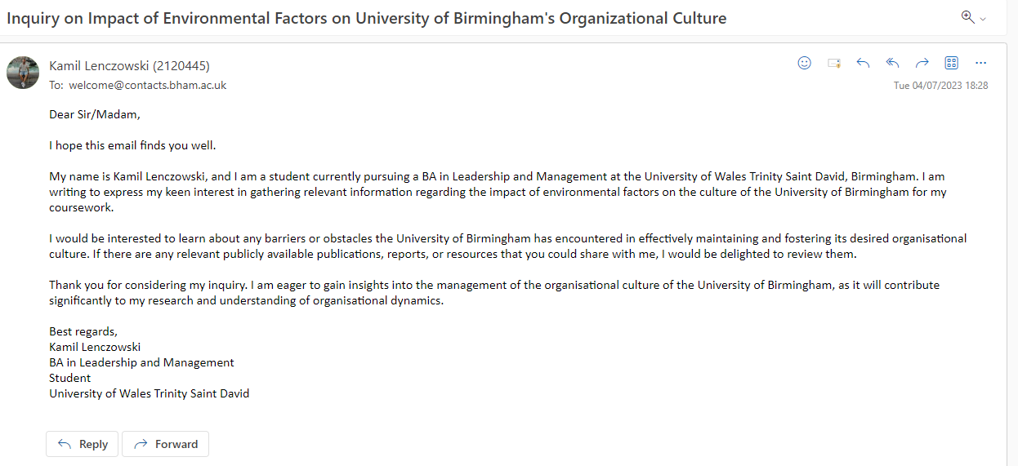

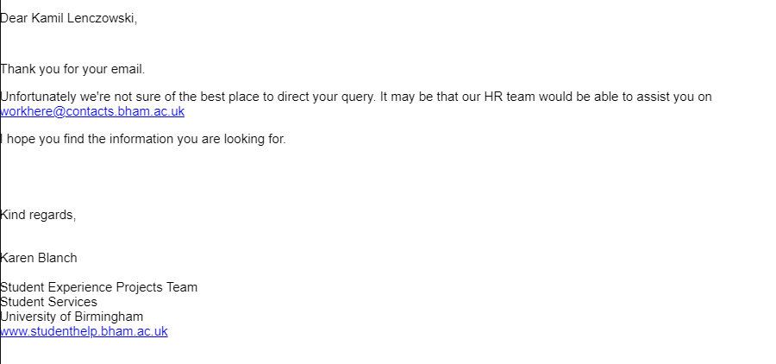
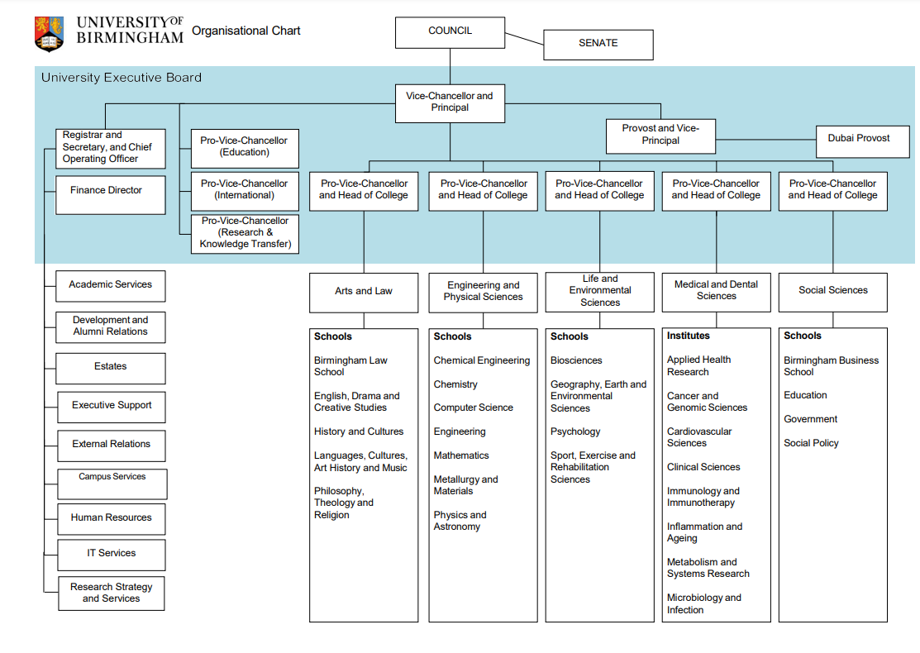

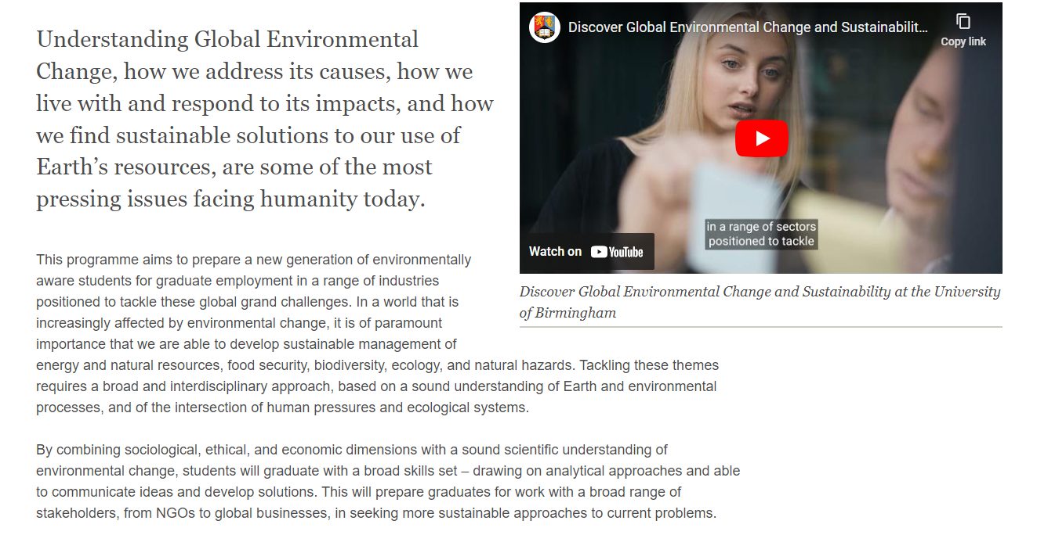

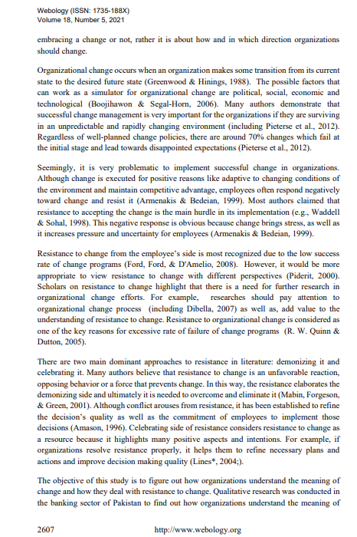

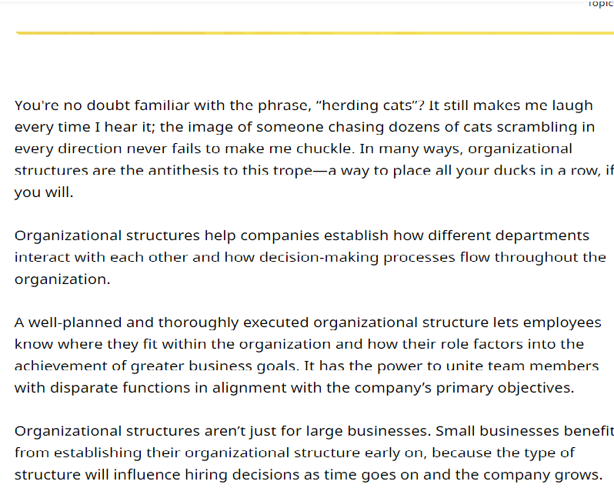
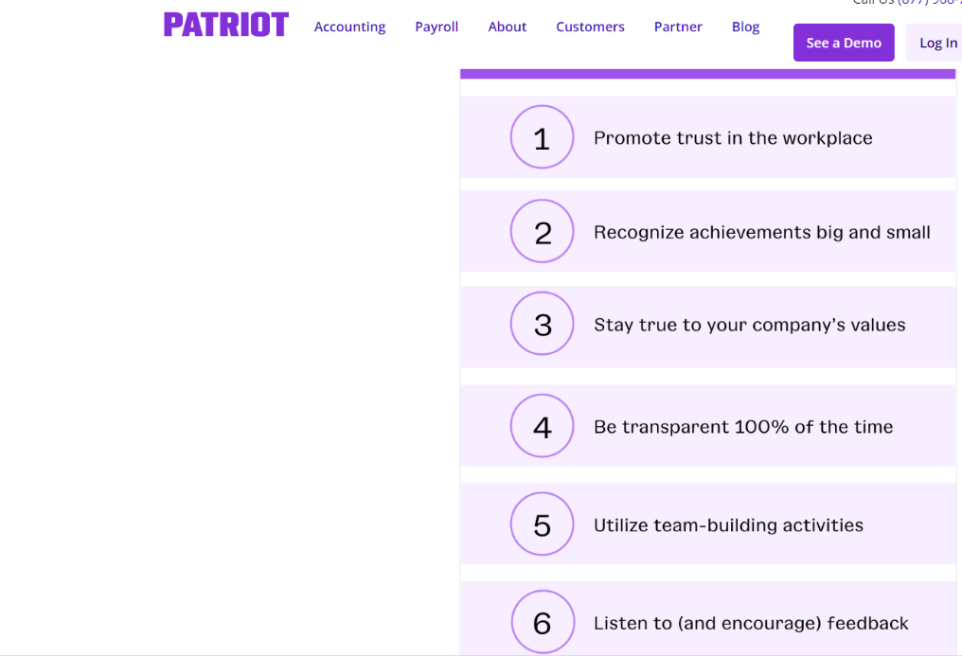

Through groundbreaking research

The University of Birmingham has made significant contributions to society, including the creation of pacemakers, plastic heart valves, and the first artificial vitamin. They are leaders in emerging fields like nanotechnology, gene therapy, robotics, and virtual reality in archaeology, showcasing their commitment to advancing knowledge.

The university campus combines old and new architecture, with the iconic clock tower known as 'Old Joe' representing its history. Modern facilities like the Teaching and Learning Building create an inspiring environment for everyone. The University of Birmingham has a significant impact outside of academia. It collaborates with businesses, drives innovation, and promotes responsible practices. By examining its culture and values, we can understand how it influences ethics and the workplace environment.
Furthermore, the University of Birmingham's status as England's first civic university, accepting students from all backgrounds on an equal basis, indicates a culture of inclusivity, diversity, and a commitment to providing educational opportunities to a wide range of individuals.

