Business Plan for

Rex Royale

Produced By:

Ayesha Amir

Dated: _____24/07/26_____

Student Number: 2306141
Module Name: Leading Restaurant Strategy
Module Code: BMGM6001
I acknowledge the use of ChatGPT (www.chatgpt.com) on 24 July 2026 to check my grammar and spelling, as well as to help me understand the assessment requirements in a simplified way to guide my research.

I used the following prompt(s):

- Please check my text for grammar and spelling errors.
- Explain the main points of the assessment in simpler terms to aid my research.

CONTENTS

 |  |  | PAGE
1. | Executive Summary |  | ………4……….
2. | The Business Idea |  | ………5……….
3. | The Team |  | ………7……….
4. | Market Research |  | ………11……….
5. | Marketing Plan |  | ………13……….
6. | Key Resources |  | ………15……….
7. | Finances & Start-Up Support |  | ………17……….
APPENDICES:
Appendix A |  |  | SWOT Analysis
Appendix B  Appendix C |  |  | PEST Analysis  Menu Pictures

1. EXECUTIVE SUMMARY
Rex Royale is a Pakistani restaurant and cafe based in Bristol, specialising in authentic Karachi-style halal cuisine. The business will offer dine-in, takeaway, and home delivery services, with a menu including traditional Pakistani meals, street food, and breakfast options, alongside vegetarian and vegan choices. Rex Royale aims to provide affordable, high-quality food within a modern, family-friendly environment.
Bristol offers a strong market opportunity due to its diverse population, large student community, and growing demand for authentic international cuisine and food delivery services. The business will primarily target families and students by combining authentic flavours, competitive pricing, and convenient service. Its unique selling proposition (USP) is offering a complete Karachi-style dining experience, including traditional breakfasts, street food, and future catering services, which differentiates it from local competitors.
Following a successful launch, Rex Royale plans to expand into private catering, events, and themed food nights to diversify revenue and strengthen brand awareness. The business forecasts first-year income of approximately £1.22 million against projected expenditure of £697,425.80, resulting in an estimated profit of £522,574.20. Start-up funding will be provided through owner investment, external funding, and business loans. The long-term objective is to establish Rex Royale as a recognised destination for authentic Pakistani cuisine in Bristol while achieving sustainable business growth.

2. THE BUSINESS IDEA

2.1 The Product/Service
Rex Royale is a Pakistani restaurant and cafe that will be in the centre of Bristol. The business will operate within the hospitality industry and specialise in authentic Karachi-style cuisine, offering customers a genuine taste of Pakistan in a modern and welcoming environment. The restaurant will serve families, students, professionals and anyone interested in experiencing traditional Pakistani food. Customers will be able to dine in, order takeaway or use home delivery services, providing flexibility and convenience. The menu will include popular dishes such as biryani, nihari, karahi, haleem, samosa chaat, pani puri, Karachi burgers, chicken tikka and traditional Pakistani breakfasts. Vegetarian and vegan options will also be available to ensure the menu appeals to a wider range of customers. Rex Royale aims to stand out by combining authentic recipes with high-quality ingredients, friendly customer service and affordable prices. Unlike many competitors, the restaurant will also introduce catering services after six months of trading for weddings, birthdays, engagements and corporate events. These services will provide customers with authentic Pakistani food alongside professional event support. The restaurant's branding will use green, gold and black to reflect freshness, quality and professionalism. These colours also help create a strong brand identity and influence customers' perceptions through colour psychology (Finshots, 2023; Empower Yourself with Color Psychology, 2018).

2.2 SWOT Analysis Summary
Rex Royale has several strengths, including its central Bristol location, authentic Karachi-style cuisine, halal menu and vegetarian and vegan options. These features help differentiate the restaurant from competitors and appeal to Bristol's diverse population. The business also benefits from strong branding and plans to expand into catering and events. However, there are challenges, including high start-up costs, increasing food prices and strong competition within the restaurant industry. To overcome these issues, Rex Royale will carefully monitor costs, maintain high food quality and invest in staff training. There are also significant opportunities for growth. The increasing popularity of ethnic cuisine, online delivery services such as Uber Eats and Deliveroo, and social media marketing can help attract new customers and increase sales. Future expansion into catering and private events will provide additional income streams. Potential threats include rising operating costs, staff shortages, changing legislation and negative online reviews. Regular customer feedback, effective cost management and continuous staff development will help reduce these risks and support long-term growth (Mullins and Dossor, 2013, pp.131–138).
3. THE TEAM

3.1 Key Personnel

Name and Company Position: Ayesha (Owner)
Skills and Experience: Strong leadership, organisational, financial management, and customer service skills, with good knowledge of Pakistani cuisine, marketing, and business operations.

Role and Responsibilities: Manage daily operations, oversee finances and budgets, supervise staff, maintain supplier relationships, lead marketing activities, ensure customer satisfaction, and support business growth.

Name and Company Position: Ahtisham (Manager)
Skills and Experience: Strong leadership and organisational skills with experience in restaurant operations, customer service, staff supervision, and financial management.

Role and Responsibilities: Manage daily operations, supervise employees, coordinate suppliers, prepare staff schedules, monitor budgets, and maintain high standards of food quality and customer service.

Name and Company Position: Head Chef
Skills and Experience: Extensive experience in authentic Pakistani cuisine, menu planning, kitchen management, food safety, and leading kitchen teams.

Role and Responsibilities: Oversee kitchen operations, manage food preparation, supervise kitchen staff, control stock, maintain hygiene standards, and ensure consistent food quality.

Name and Company Position: 2 Sous Chef
Skills and Experience: Experience in Pakistani cuisine, food preparation, kitchen supervision, and maintaining food safety and quality standards

Role and Responsibilities: Support the Head Chef, prepare meals, supervise kitchen staff, monitor food quality, assist with stock control, and maintain efficient kitchen operations.

Name and Company Position: Commis
Skills and Experience: Basic cooking knowledge with a willingness to learn, good teamwork skills, and an interest in authentic Pakistani cuisine.

Role and Responsibilities: Prepare ingredients, assist with cooking, maintain kitchen cleanliness, follow food safety procedures, and support the senior chefs during service.

Name and Company Position: 6 Waiters
Skills and Experience: Excellent communication and customer service skills with the ability to work effectively in a busy restaurant environment.

Role and Responsibilities: Responsible for welcoming customers, taking orders, serving food and drinks, maintaining the dining area, and supporting customer needs. After six months, three waiters will also support private events by assisting guests and helping the Events Manager.

Name and Company Position: 4 Kitchen Porters
Skills and Experience: Good teamwork skills with knowledge of kitchen hygiene, cleaning procedures, and safe working practices.

Role and Responsibilities: Responsible for cleaning kitchen equipment, managing waste, assisting with deliveries, maintaining hygiene standards, and supporting food preparation. Additional support will help manage larger events and reduce pressure on the kitchen team.

3.2 Skills Gaps & Key Partners
3.2.1 Additional Staff Requirements (Roles and Responsibilities):
- Events manager - An Events Manager will oversee private functions, communicate with customers, organise suppliers and staff, and ensure events run successfully. This role will support the growth of the events side of the business.
- Security - Security staff will be hired when required for larger events to maintain a safe environment, manage entrances, assist with crowd control, and support the smooth running of events.

    - Training and Development:

- Health and safety training - All staff will complete health and safety training during induction to understand safe working practices and emergency procedures. Refresher training will be provided when required (Health and Safety Executive, n.d.).
- Food and Safety Training - Kitchen staff and relevant event staff will complete food hygiene training through an accredited provider to ensure food is prepared safely and complies with legal requirements (Food Standards Agency, n.d.).
- Allergen Awareness Training: - All customer-facing and kitchen staff will receive allergen awareness training to safely manage dietary requirements and provide accurate information to customers (Food Standards Agency, 2020).
- Leadership and Management Training- Ayesha, Ahtisham, and senior staff will complete management training to develop leadership, budgeting, and team management skills to support business growth (Department for Business and Trade, 2023).
- Fire Safety Training- All staff will receive fire safety training during induction, including emergency procedures, evacuation, and the use of fire equipment. Refresher training will be provided regularly (Home Office, 2022).

    - Outsourced Support / Key Partners:

- Marketing and Social Media Support Marketing will be outsourced to promote the restaurant and events through social media and advertising, helping increase brand awareness. Cost: £416.67 per month (£5,000 per year) (Bristol Marketing Company, 2025).
- Accountant / Financial Support - An external accountant will manage bookkeeping, payroll, tax returns, and financial reporting to ensure accurate financial management. Cost: £5,000 per year (Focus Accountancy, 2018).
- Event Equipment Hire Services after 6 months of business Equipment such as tables, chairs, linen, and catering items will be hired for larger events, avoiding high upfront costs. Cost: £1,666.67 per month / £10,000 per year (Blast Event Hire, 2025).
- Entertainment and Event Suppliers after 6 months of business - DJs and other entertainment providers will be used for private events to enhance the customer experience. Cost: £1,666.67 per month / £10,000 per year (Hotshots Entertainment, 2026; Offbeat Entertainment, n.d.).
- Photography and Videography Services after 6 months of business – Professional photographers and videographers will be hired for events and marketing content. Cost: £833.33 per month (£5,000 over six months) (Live Wedding, 2025).

4. MARKET RESEARCH

4.1 Market Information, Trends and External Factors
Market research shows that Rex Royale has strong potential in Bristol’s food market. Bristol has a population of around 500,000 people, including students, young professionals, and diverse multicultural communities (Bristol City Council, 2025, p.6; Bristol City Council, 2025). This creates demand for authentic halal and ethnic cuisine, with customers increasingly seeking unique food experiences rather than standard fast food. Rex Royale can benefit from this trend through its Karachi-style dishes and breakfast menu. The growth of delivery platforms such as Uber Eats and Deliveroo provides further opportunities by attracting customers who prefer convenient dining options. Social media and customer reviews can also support brand awareness and attract new customers. The PEST analysis (Appendix B) highlights challenges such as rising food prices, rent, energy costs, and staff expenses. To manage these risks, Rex Royale will focus on cost control, effective pricing, digital ordering systems, and online marketing. Overall, Bristol’s diverse market and growing interest in cultural food experiences provide strong opportunities for the business.

4.2 Customer Profiles

- Families are one of Rex Royale’s main customer groups. Parents and children may visit for family meals, birthdays, celebrations, or casual dining. They look for good food, fair prices, and a friendly atmosphere. Rex Royale’s Pakistani dishes and sharing meals give families a chance to enjoy something different. Happy families can also recommend the restaurant to others.

- Students (18–25) are an important target group because Bristol has many students. They often look for affordable and convenient food. Rex Royale can attract them through delivery apps like Uber Eats and Deliveroo, along with discounts, meal deals, and takeaway options.
- Food influencers are another key group. They enjoy discovering new restaurants and sharing their experiences on platforms like Instagram and TikTok. Rex Royale’s authentic Karachi-style food and presentation can encourage them to post reviews, promote events, and help attract more customers.

4.3 Competitor Profiles

- Haveli The Yard (Haveli The Yard, 2023) is known for its authentic Pakistani food and comfortable dine-in experience. Its strength is its strong local reputation, while its weakness is its limited focus on Pakistani street food and traditional breakfasts. Rex Royale will compete by offering authentic Karachi-style street food, traditional breakfasts, takeaway, delivery, and event catering. Our USP is providing a wider range of services and an authentic Karachi food experience at affordable prices.
- Chaiiwala (Chaiiwala, 2026) is popular for its chai, snacks, and strong branding. Its strengths include a loyal young customer base and an active social media presence. However, its weakness is its limited menu and lack of a full dining experience. Rex Royale will compete by offering full Pakistani meals, street food, traditional breakfasts, and catering services. Our USP is a complete Pakistani dining experience with authentic Karachi flavours.
- Noshh (Noshh, 2026) serves Pakistani and Indian food in a modern setting. Its strengths are its high-quality food and good customer service, while its weakness is its limited focus on Karachi-style dishes and traditional Pakistani breakfasts. Rex Royale will compete by specialising in authentic Karachi cuisine, offering halal food, affordable prices, takeaway, delivery, and event catering. Our competitive advantage is providing greater variety and a more authentic cultural dining experience.

5. MARKETING PLAN

5.1 Price.
Rex Royale will use a competitive pricing strategy to provide authentic Pakistani food at affordable prices while maintaining profitability. Prices will be based on ingredient costs, competitor pricing, customer expectations, and market conditions. The menu will offer options for different budgets, including students, families, professionals, and children. Individual items such as snacks, desserts, and drinks will range from £1.00 to £11.50, while popular main dishes such as biryani, karahi, and nihari will be priced between £8.00 and £11.50. Larger chef specials will start from £12.99, and breakfast options will range from £6.50 to £22.99. To attract and retain customers, Rex Royale will offer family deals, student discounts, loyalty rewards, and seasonal promotions. This pricing approach will help the restaurant remain competitive in Bristol while building customer loyalty and a strong reputation for quality and value.

5.2 Product
Rex Royale’s product strategy is to provide an authentic Karachi-style Pakistani dining experience in Bristol through freshly prepared, high-quality food at affordable prices. The menu will include traditional dishes such as biryani, karahi, nihari, haleem, handi, tikka, street food, drinks, desserts, and a Pakistani breakfast menu (Appendix C). The restaurant will offer halal, vegetarian, vegan, and children’s options to meet the needs of different customers, including families, students, and professionals. Vegetarian options will include dishes such as Chana Masala, Dal Tadka, Palak Paneer, and Paneer Karahi. Rex Royale will combine traditional Pakistani flavours with a modern cafe environment, supported by attractive branding and customer-focused service. The business will also provide family deals, student discounts, loyalty rewards, and private event catering for occasions such as birthdays, engagements, and corporate events. By offering authentic food and a welcoming atmosphere, Rex Royale aims to become a trusted Pakistani dining destination in Bristol.
5.3 Placement
Rex Royale Cafe & Events will be positioned as an affordable and welcoming Pakistani cafe and restaurant in Bristol, offering authentic Karachi-style cuisine in a modern environment. Before opening, the business will conduct a soft launch with family and close contacts to test food quality, service, and customer experience before the official launch. The restaurant will differentiate itself through freshly prepared halal meals, friendly service, and a cultural dining experience inspired by Karachi. Customers will have the option to dine in, order takeaway, or use delivery platforms such as Uber Eats and Deliveroo. As the business develops, Rex Royale will expand into catering and event services for weddings, birthdays, corporate events, and other occasions. By combining authentic flavours, reasonable prices, and a welcoming atmosphere, Rex Royale aims to build customer loyalty and become a recognised destination for Pakistani cuisine in Bristol.
5.4 Promotion
Rex Royale Cafe & Events will use digital marketing, local advertising, and customer engagement to build awareness and attract customers across Bristol. Before the official opening, a soft launch will be held with family and close contacts to test the food, service, and customer experience. Feedback will help improve the business before welcoming the wider public. Social media platforms such as Instagram, Facebook, and TikTok will be used to promote the restaurant by sharing food images, cooking videos, customer experiences, and upcoming events. The business will also collaborate with local food bloggers and influencers to increase its reach. To encourage repeat customers, Rex Royale will offer promotions such as student discounts, group deals, birthday offers, Happy Hour discounts, Royal Combo meals, and seasonal offers including Eid and Ramadan specials. A loyalty programme and customer reviews on platforms such as Google, Uber Eats, and Deliveroo will help build trust and attract new customers. Traditional marketing methods, including flyers, posters, and partnerships with local businesses and communities, will also support promotion. After six months, Rex Royale will expand its marketing to promote catering and private events such as weddings, birthdays, and corporate functions. Through strong online presence, customer feedback, and community connections, Rex Royale aims to create a recognisable brand and build long-term customer loyalty.

6. KEY RESOURCES

6.1 Premises
Rex Royale will need a restaurant and café premises in central Bristol to provide dine-in services, takeaway, food preparation, storage, and manage daily operations. The premises will include a customer seating area, commercial kitchen, storage facilities, and a small area for administration. A central location will help the business attract a variety of customers, including students, families, professionals, and visitors because of the high levels of foot traffic. The business has planned a budget of around £35,000 per year for rent and premises costs. The final location will be chosen based on factors such as affordability, size, accessibility, and whether the space is suitable for running a successful restaurant. Before opening, Rex Royale will ensure all necessary licences are in place, including food business registration and a music licence for playing background music. The premises will also follow health and safety requirements by maintaining good food hygiene, carrying out risk assessments, completing fire safety checks, and ensuring safe working practices. After around six months of successful trading, Rex Royale aims to expand into external catering and event services across Bristol and nearby areas. The restaurant will act as the main base for preparing food, storing equipment, and organising events.
6.2 Equipment.
Rex Royale will invest in a mix of new and second-hand equipment to create a reliable and cost-effective setup. The main investment will focus on essential kitchen equipment, including ovens, grills, cookers, refrigerators, freezers, and food preparation areas. These will be sourced from trusted suppliers such as Currys (n.d.), Nisbets (2026), and Adexa Direct (2026) to ensure quality and reliability. The business will also purchase furniture, storage equipment, CCTV, and a modern Point of Sale (POS) system from providers such as Square (2026). The POS system will help manage orders, payments, stock control, and reporting, improving daily efficiency. For larger events and catering services, Rex Royale will hire specialist equipment such as tables, chairs, and serving equipment when required. This will reduce unnecessary costs while keeping the business flexible. A total capital expenditure budget of £60,000 will be used for equipment, technology, furniture, and operational needs.
By combining careful purchasing with equipment hire options, Rex Royale will control costs while maintaining quality service and efficient operations.
6.3 Key Suppliers
Rex Royale will work with trusted suppliers to maintain a reliable supply of fresh ingredients, packaging, and operational materials. Strong supplier relationships will help the business maintain food quality, control costs, and deliver authentic Pakistani flavours. Key suppliers will include halal meat suppliers, fresh produce providers, spice suppliers, and wholesalers. Halal meat will be sourced from Super Mashriq Halal Butchers to maintain quality standards (Super Mashriq Halal Butchers, 2019). Fresh fruit and vegetables will be purchased from Bristol Fruit Market, while specialist Pakistani ingredients will be sourced from Alfu International (Bristol Fruit Market, 2021; Alfu International, 2022). Larger suppliers such as Bidfood and Nisbets will provide additional food products and supplies (Bidfood, 2026 and Nisbet, 2026). For emergencies, essential items may be purchased from supermarkets such as Aldi and Lidl (Aldi, n.d. and LIDL, n.d.). Takeaway packaging will be sourced from The Packaging People Limited and Best Custom Boxes to support food quality and branding (The Packaging People Limited, 2022; Best Custom Boxes, 2026). After six months, Rex Royale will use external suppliers such as Bristol Catering Supplies to hire equipment for events, reducing unnecessary costs (Bristol Catering Supplies, 2026). The estimated annual stock and materials cost will be £100,000, with £25,000 allocated for external services.

7. FINANCES AND START-UP SUPPORT

EXPENDITURE | Year 1  £
Company Registration | £100
Rent/Rates | £35,000
Staff Wages | £353,825.8
Travel/Accomodation | £10,000
Telephone (mobile) | £500
Broadband | £500
Utilities | £15,000
Marketing and materials | £5000
Insurance | £3000
Capital Expenditure/Equipment | £60,000
Training & Development | £2,000
Accounting/Legal | £5,000
Outside Services | £25,000
Stock/Materials Purchases | £100,000
Bank Charges | £500
Office Consumables | £2000
Loans Repayments | £80,000
Total Expenditure | £697,425.80
INCOME | Year 1  £
Sales A – Food Sale | £350,000
Sales B - Drinks | £180,000
Sales C – Events and Catering | £270,000
Capital Introduced | £100,000
Funding | £20,000
Loans/Borrowing | £300,000
Total Income | £1,220,000

YEAR ONE PROFIT/LOSS | £
Total Income | £1,200,000
Total Expenditure | £697,425.80
Profit/Loss | £522,574.20

7.1 Financial Summary
The financial forecast for Rex Royale is based on expected income and costs from operating a Pakistani restaurant and cafe in central Bristol. Revenue will come from dine-in customers, takeaway, delivery services, and future catering and private events. In the first year, Rex Royale expects total income of approximately £1,220,000, including food sales, drinks, and event services. To support the launch, the business will use £100,000 owner investment, £20,000 funding opportunities, and £300,000 business loans to cover start-up costs, equipment, and early operations. Estimated first-year costs are around £697,425.80, with the largest expense being staff wages (£353,825.80) due to the need for skilled chefs, managers, and service staff. Other costs include stock (£100,000), equipment (£60,000), premises (£35,000), utilities, marketing, and professional services. After expenses, Rex Royale is forecast to achieve a first-year profit of approximately £522,574.20. With multiple income streams and potential funding support, the business aims to become a sustainable and successful restaurant in Bristol.

APPENDICES
Appendix A – SWOT Analysis
Strengths
- Busy Bristol location with high customer demand.
- Authentic halal food with vegetarian and vegan options.
- Strong branding and family-friendly atmosphere.
- Student/group discounts and loyalty programme.
- Online ordering and takeaway service.
Weaknesses
- High competition and operating costs.
- Expensive ingredients and busy peak hours.
- Changing customer preferences.
- Managing staff and daily operations can be challenging.
Opportunities
- Growing demand for halal and international cuisine.
- Social media and delivery apps can increase sales.
- Large student market and local events.
- Partnerships for weddings and corporate events.
Threats
- Rising food, wage, and energy costs.
- Strong competition and negative online reviews.
- Staff shortages and supply chain issues.
- Inflation and changes in regulations.

Appendix B – PEST Analysis
Political
- Follow food safety, hygiene, and halal regulations.
- Comply with employment laws and local council licences.
Economic
- Rising food, wage, and energy costs may reduce profits.
- Tourism and delivery services can increase sales.
Social
- Bristol's diverse and student population creates demand.
- Social media, reviews, and halal/vegan options influence customers.
Technological
- Online ordering, bookings, and digital payments improve convenience.
- Social media and customer feedback help promote and improve the business.

Appedices C - 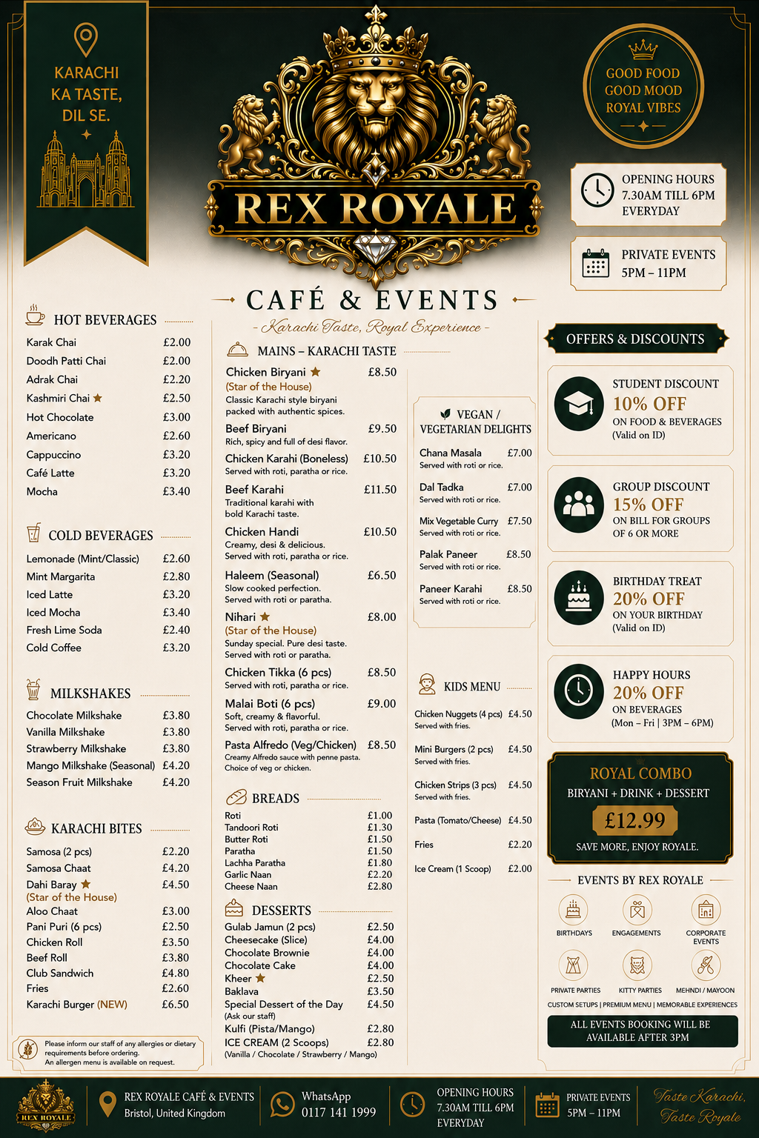
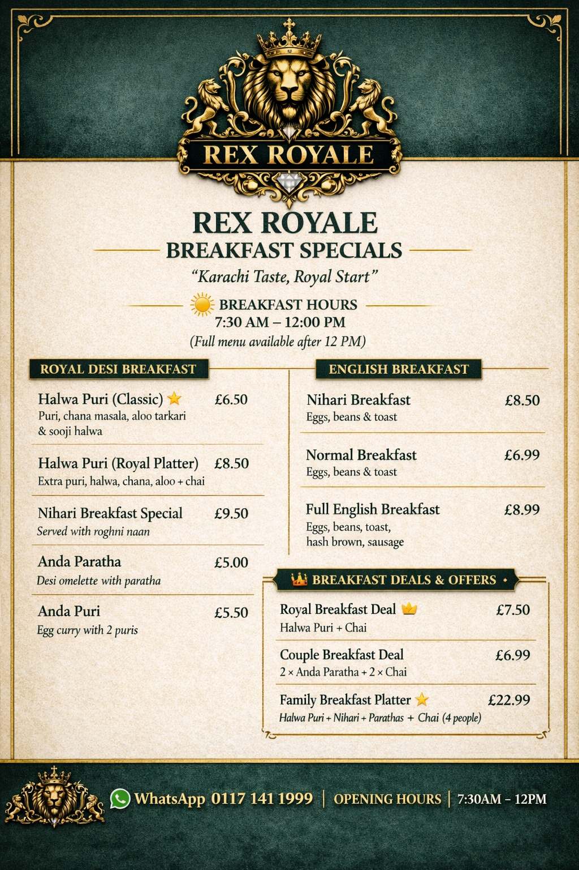

Reference list
Adexa Direct (2026). Adexa direct. [online] Adexa Direct. Adexa Direct. Available at: https://adexa.co.uk/ [Accessed 12 July 2026].
Aldi (n.d.). Aldi For Emergency food. [online] Aldi. Available at: https://www.aldi.co.uk/ [Accessed 10 July 2026].
Alfu International (2022). Alfu international Supplier. [online] Alfu International. Available at: https://www.alfu.co.uk/ [Accessed 10 July 2026].
Best Custom Boxes (2026). Custom Boxes. [online] Best Custom Boxes. Available at: https://bestcustomboxes.co.uk/ [Accessed 11 July 2026].
Bid Food (2026). Bidfood: Foodservice, Food Wholesalers, Suppliers and Distributors. [online] Bidfood. Available at: https://www.bidfood.co.uk/ [Accessed 11 Mar. 2026].
Blast Event Hire (2025). Blast event hire - complete events solutions. [online] Blast Event Hire. Available at: https://www.blasteventhire.co.uk/ [Accessed 7 July 2026].
Bristol Catering Supplies (2026). Bristol Catering Supplies. [online] Bristol catering supplies. Available at: https://bristolcateringsupplies.co.uk/ [Accessed 11 July 2026].
Bristol City Council (2025). The population of Bristol. [online] Bristol City Council, p.6. Available at: https://www.bristol.gov.uk/files/documents/9774-the-population-of-bristol [Accessed 23 July 2026].
Bristol City Council (2026). The population of Bristol. [online] Bristol City Council. Available at: https://www.bristol.gov.uk/council/statistics-census-information/population-of-bristol [Accessed 5 July 2026].
Bristol Fruit Market (2021). Home - bristol fruit market. [online] Bristol fruit market. Available at: https://bristolfruitmarket.co.uk/ [Accessed 8 July 2026].
Bristol Marketing Company (2025). Bristol marketing company - leading digital marketing agency. [online] Bristol marketing company. Available at: https://bristolmarketingcompany.co.uk/ [Accessed 5 July 2026].
Chaiiwala (2026). Chaiiwala Menu. [online] Chaiiwala. Available at: https://www.chaiiwala.co.uk/ [Accessed 1 July 2026].
Currys (n.d.). Currys Appliances. [online] Currys. Currys. Available at: https://www.currys.co.uk/appliances [Accessed 23 July 2026].
Department for Business and Trade (2023). Help to grow: Management. [online] GOV.UK. Available at: https://www.gov.uk/government/collections/help-to-grow-management?utm_source=chatgpt.com [Accessed 4 July 2026].
Empower Yourself With Color Psychology (2018). Gold in Business. [online] Empowered By Color. Available at: https://www.empower-yourself-with-color-psychology.com/gold-in-business.html [Accessed 15 July 2026].
Finshots (2023). Brand Colours and Their Hidden Meanings. [online] Finshots. Available at: https://finshots.in/infographic/brand-colours-and-their-hidden-meaning/ [Accessed 11 Apr. 2026].
Focus Accountancy (2018). Focus accountancy Ltd. [online] Focus Accountancy. Available at: https://www.focusaccountancy.co.uk/ [Accessed 6 July 2026].
Food Srandards Agency (n.d.). Food Standards Agency. [online] GOV.UK. Available at: https://www.gov.uk/government/organisations/food-standards-agency [Accessed 1 July 2026].
Food Standards Agency (2020). Allergen guidance for food businesses. [online] GOV.UK. Available at: https://www.gov.uk/government/publications/allergen-guidance-for-food-businesses [Accessed 2 July 2026].
Haveli The Yard (2023). Haveli The Yard. [online] Haveli The Yard. Available at: https://www.havelitheyard.co.uk/ [Accessed 1 July 2026].
Health and Safety Executive (n.d.). Health and safety executive HSE. [online] HSE. Available at: https://www.hse.gov.uk/ [Accessed 30 June 2026].
Home Office (2022). Fire safety legislation: Guidance for those with legal duties. [online] GOV.UK. Available at: https://www.gov.uk/government/collections/fire-safety-legislation-guidance-for-those-with-legal-duties [Accessed 23 July 2026].
Hotshots Entertainment (2026). Hotshots bristol’s premium wedding DJ & photo booth specialist. [online] Hotshots Entertainment. Available at: https://hotshotsentertainment.co.uk/ [Accessed 7 July 2026].
LIDL (n.d.). LIDL For Emergency food. [online] lidl. lidl.co.uk. Available at: https://www.lidl.co.uk/ [Accessed 10 July 2026].
Live Wedding (2025). Photography and Videography Services . [online] Live wedding. Available at: https://www.livewedding.co.uk/ [Accessed 5 July 2026].
Mullins, L.J. and Dossor, P. (2013). Hospitality management and organisational behaviour. 5th ed. [online] Harlow: Pearson, pp.131–138. Available at: https://librarysearch.uwtsd.ac.uk/permalink/44WHELF_UWTSD/177qm82/alma99100284559002421 [Accessed 28 Feb. 2026].
Nisbets (2026). Nisbets Catering Equipment – Catering Supplies & Kitchen Equipment. [online] Nisbets.co.uk. Available at: https://www.nisbets.co.uk/ [Accessed 14 July 2026].
Noshh (2026). Noshh Grill. [online] Noshh.co.uk. Available at: https://www.noshh.co.uk/ [Accessed 1 July 2026].
Offbeat Entertainment (n.d.). Offbeat Entertainment. [online] Offbeat Entertainment. Available at: https://www.offbeatentertainment.co.uk/ [Accessed 7 July 2026].
Square (2026). POS software | point of Sale systems | square POS. [online] Square. Available at: https://squareup.com/gb/en/point-of-sale [Accessed 13 July 2026].
Super Mashriq Halal Butchers (2019). Super mashriq halal butchers Bristol. [online] Super mashriq halal butchers. Available at: https://supermashriqhalalbutchers.co.uk/ [Accessed 9 July 2026].
The Packaging People Limited (2022). Packaging supplies. [online] Packaging People. Available at: https://www.packagingpeople.co.uk/ [Accessed 12 July 2026].

