
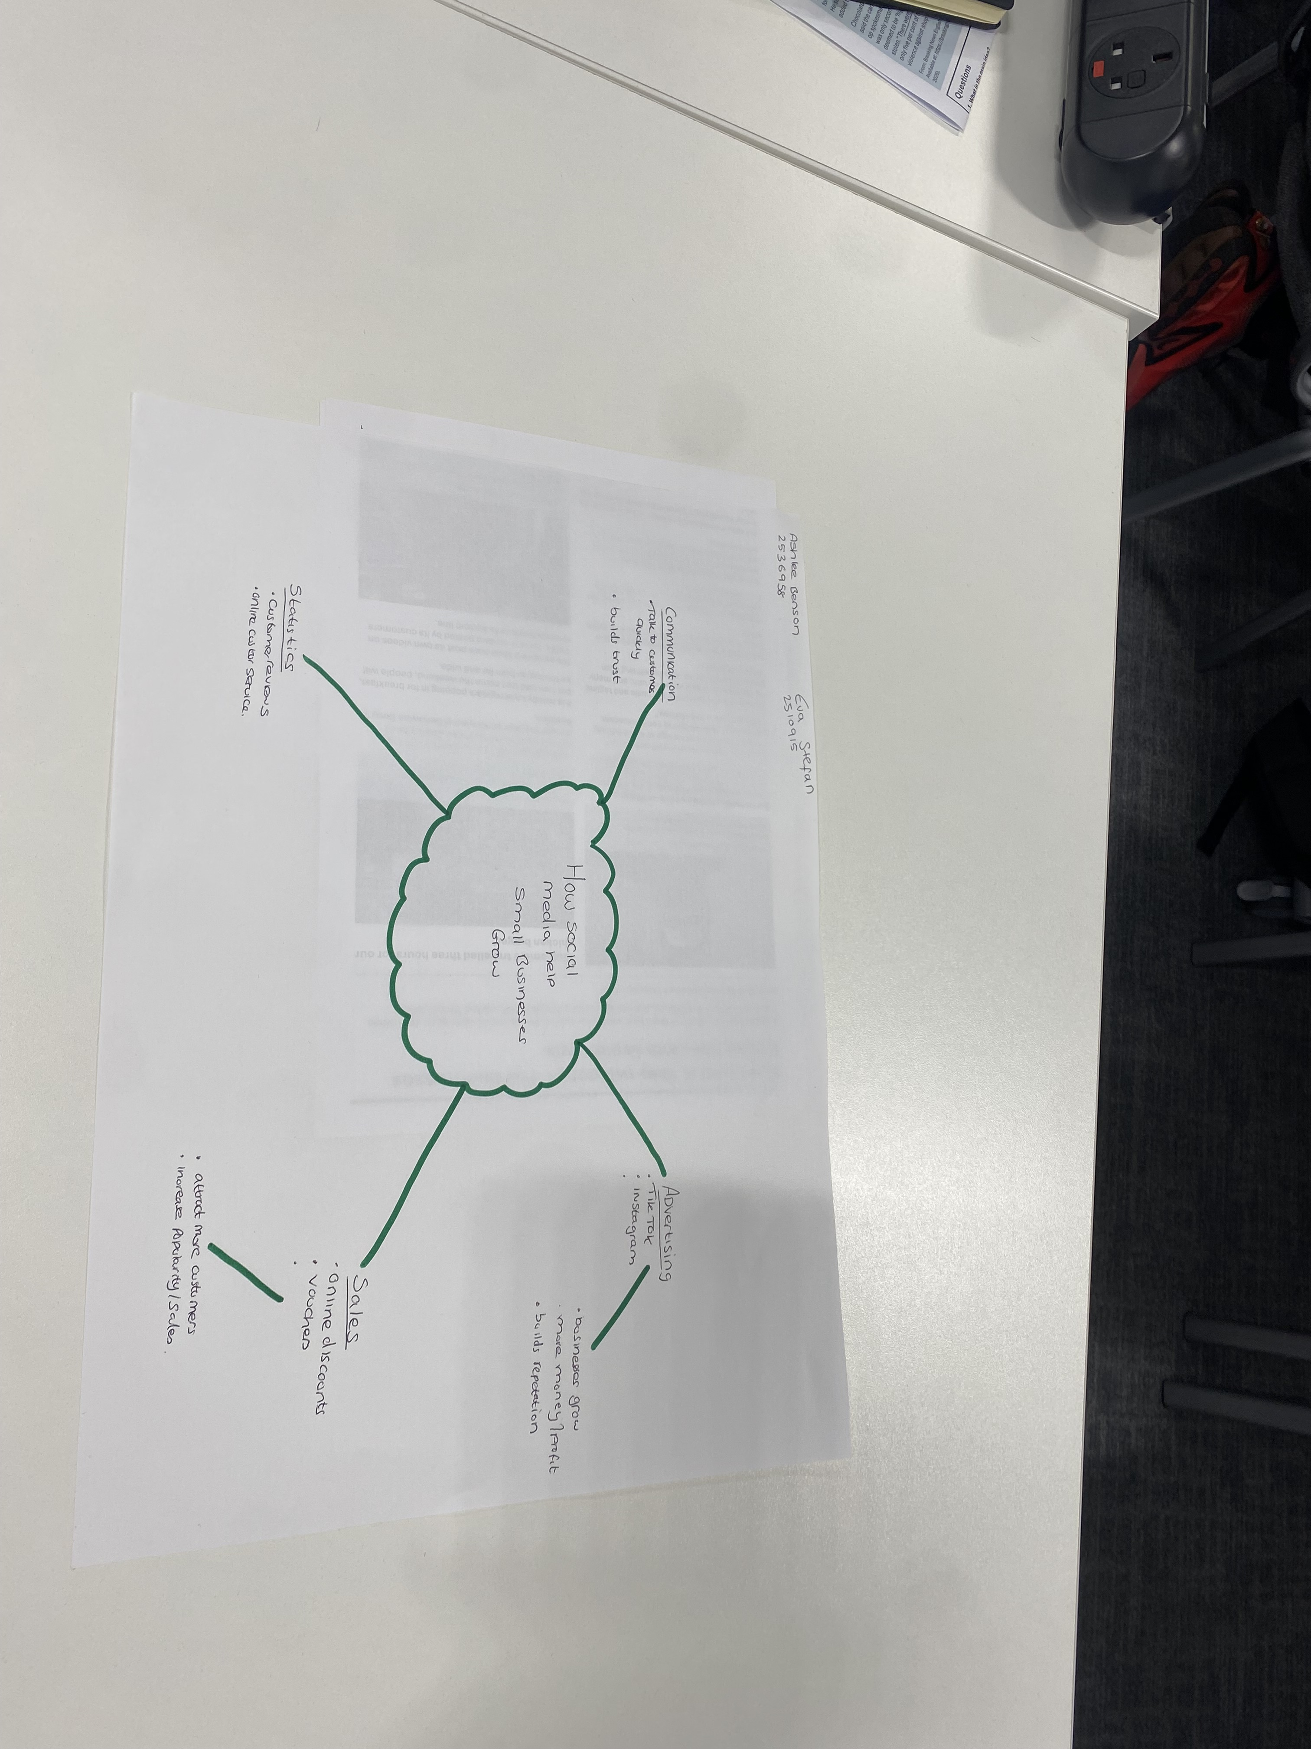
Task 1 – Reading Task Template
Upload your photo of your A3 in-class notes here:

1. Answer these questions using the sentence starters below
a. What is the main idea of the text?
The main idea is that that social media helps businesses grow and get more customers.
b. What are two key points?
One key point is that the businesses can advertise their products on social media. Another key point is that social media helps businesses it attracts more customers.
c. What part of the text did you find most important? Why?
The most important part is how social media helped him grow with his small business.
d. Was anything unclear or difficult to understand?
No!
e. How did your group help you understand the text better?
My group helped me by discussing the main ideas and explained.
3. One sentence reflection
Question: What did you find challenging about this task?
The hardest part was finding the main idea and key details.

