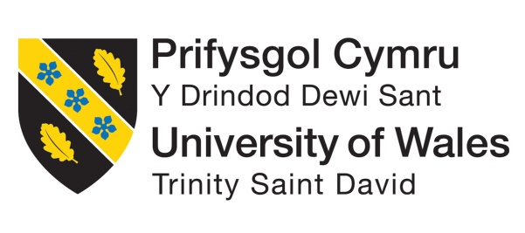

Cultural Convergence: Understanding and Managing Differences between France and England in Hospitality Leadership Report

Student Name: Maria-Victoria Lazar
Student ID: 2235531
Module Title: Foreign Languages & Cultural Awareness
Module code: BMIH5003
Lecturer: Heidi Prosser
Date: 26.02.2024

Executive Summary
This report is assessing the culture of France and England for the 5-star Inclusivity Hotel and Spa. The culture is being analysed by utilizing GLOBE project. Being honest and open is very important in England culture. Because England people are known for getting right to the point, they put a lot of value on being short and clear. On the other hand, France people tend to talk more quietly and carefully. They might be very good at reading social cues and details, focusing on what people aren't saying or how silence can be very powerful. France has a bigger power gap than England, which can be seen in the way the country is organized, with more levels of management. When it comes to politics, the England tend to follow a plan that is more divided and equal, with a shorter power distance.

Table of Contents
Executive Summary 2
1. Introduction 4
2. Key Cultural Differences between England and France 4
3. Analysis of England and France using the GLOBE Project 6
4. Challenges of Intercultural Leadership in the Hospitality Industry: 7
5. Recommendations for Overcoming Challenges: 8
6. Conclusion: 8
7. References 9

Introduction
Being moved to the 5-star Inclusivity Hotel & Spa in London, England, gave me the chance to check out the hotel chain's France website to learn more about its rules and guidelines. Based on the GLOBE Project's study on leadership and culture, this report will look at the differences in culture between France and England. It will also look at the difficulties of cross-cultural leadership in the hotel industry and suggest ways to solve these problems.

Key Cultural Differences between England and France
It is important to know the differences between the France and England cultures if a business want to be a good international leader, especially in the hotel business. These people are different in many ways, such as how they like to communicate, how they feel about their jobs, and how they think society should working (Jung et al.2018). The most clear difference between cultures is how they talk to each other. Being honest and open is very important in England culture. Because England people are known for getting right to the point, they put a lot of value on being short and clear (Cruz, 2022). On the other hand, France people tend to talk more quietly and carefully. They might be very good at reading social cues and details, focusing on what people aren't saying or how silence can be very powerful.
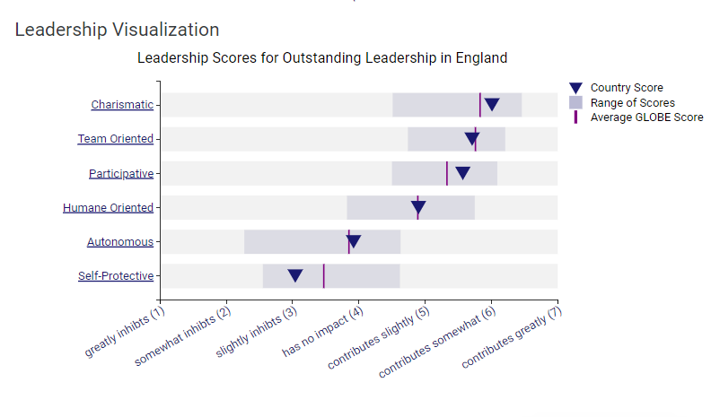
Figure 1Globe Project 2020
When it comes to work attitude and managing time, the France and England have very different ideas. The England are known for how hard they work and how much they value production and personal success. People go out of their way to be on time because they're proud of it.
On the other hand, it looks like the France value partnership and teamwork more. It's important to us to work together and make relationships, even if it means giving up some schedule freedom. In France, meetings might include more relaxed chats that give people time to get to know each other, which their England counterparts might think is useless (Danso, 2018).
Because of these differences, it might be hard to lead a group of people from different countries. An England coworker might find it annoying when a France coworker walks slowly, and the France worker might feel overwhelmed by what they see as the strictness of the England workplace.
Figure 2Globe Project 2020
When people from different countries have different ideas about who is in charge, disagreements can happen about who should make the final decision on important team decisions. In England, you might be looking forward to a more open process. In France, on the other hand, you might be used to decisions being made from the top down. To sum up, there are big differences in culture between England and France that affect how people talk to each other, how they understand leadership, and how they lead ethnic teams in the restaurant industry. To create a helpful and welcoming workplace, these differences must be recognized and fixed.

Analysis of England and France using the GLOBE Project
The GLOBE Project (Global Leadership and Organizational Behavior Effectiveness) helps us understand how different societies' cultures and leadership styles work.
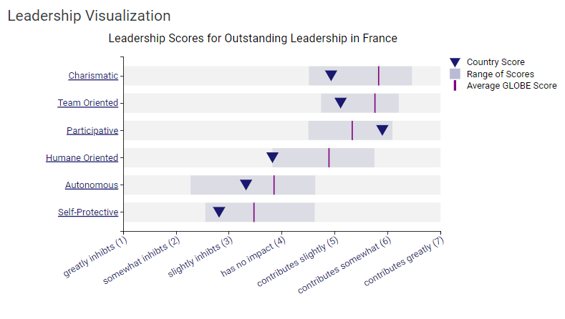
Figure 3Globe Project 2020
The France tend to be more interested in society, putting a lot of value on close relationships, working together, and getting along with others. On the other hand, England is known for putting a lot of value on freedom, independence, and personal success. Understanding different cultural views is important for managing a team well because they can have different ways of working together, making goals, and cooperating (López and Amaya, 2019).
France people tend to avoid doubt more than England people. It looks like people like places that are clearly outlined and have clear rules and guidelines. On the other hand, England people are known to be more accepting when there is doubt or confusion. The hotel business, which counts on being able to change and adapt, needs to understand and get past this split (Yang et al., 2022).
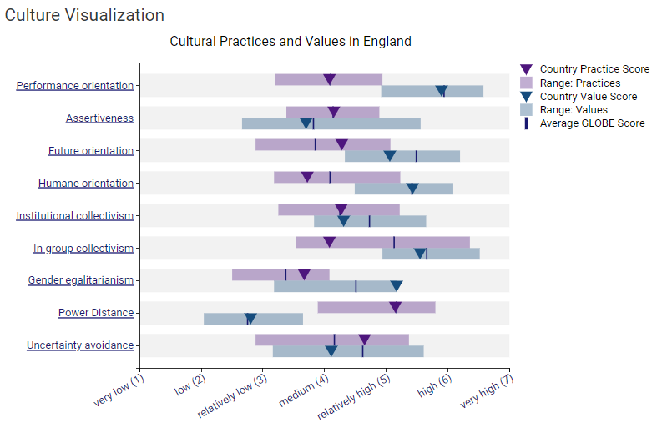
Figure 4Globe Project 2020
France leans towards a more collectivistic culture, emphasizing group harmony, collaboration, and strong interpersonal relationships. In contrast, England tends to be more individualistic, prioritizing personal achievement and autonomy. Understanding these cultural orientations is crucial for managing teams effectively, as approaches to teamwork, collaboration, and goal-setting may differ. Leaders must navigate these distinctions to create a cohesive and high-performing intercultural team.
France typically has a higher uncertainty avoidance index compared to England. This suggests a preference for structured environments, clear rules, and established norms. On the other hand, England tends to be more tolerant of ambiguity and uncertainty. In the hospitality industry, where adaptability and flexibility are essential, recognizing and bridging this gap is critical (Medberg and Grönroos 2020).

Challenges of Intercultural Leadership in the Hospitality Industry:
Intercultural leadership is important in the hotel business because teams with different backgrounds work together all the time. People who make decisions in different ways, have different ideas about how to balance work and life, or talk to each other in different ways may end up at odds (Gazzola et al., 2020). For example, it might be hard to lead a group of people whose France coworkers value teamwork and flexibility but whose England coworkers value efficiency and being on time.

Recommendations for Overcoming Challenges:
People who move between the two countries for work have to go through in-depth cultural training classes. a. These workshops should aim to help people understand each other better by talking about things like cultural differences, work standards, and different ways of communicating. To make sure the leadership team really is diverse, look for people who can speak England and France well. Because of this, decision-making might become more open and sensitive to different cultures (Elder and Johnson, 2018). Hold team-building activities on a regular basis to help people on the team talk to each other more openly and get along better. In theory, this could help people from different backgrounds work together better at work.

Conclusion:
In the hotel business, managing international teams well means knowing a lot about cultural differences, knowing how to lead well, and being able to solve problems before they happen. The Inclusivity Hotel & Spa may be able to make the workplace more welcoming and productive for its foreign workers by promoting diversity in leadership roles, encouraging team-building activities, and putting in place cultural training programs (Manoharan and Singal¸2017).

References
Cruz, M.P., 2022. Dialogical humour in evening service encounters in the hospitality industry in Seville, Spain. International Review of Pragmatics, 14(2), pp.169-197.
Danso, R., 2018. Cultural competence and cultural humility: A critical reflection on key cultural diversity concepts. Journal of Social Work, 18(4), pp.410-430.
Elder, G.H. and Johnson, M.K., 2018. The life course and ageing: Challenges, lessons, and new directions. In Invitation to the life course (pp. 49-81). Routledge.
Gazzola, M., Templin, T. and McEntee-Atalianis, L.J., 2020. Measuring diversity in multilingual communication. Social Indicators Research, 147(2), pp.545-566. Top of Form
Globe Project 2020, Results - England GLOBE Project, Globeproject.com
Jung, T.H., Lee, H., Chung, N. and tom Dieck, M.C., 2018. Cross-cultural differences in adopting mobile augmented reality at cultural heritage tourism sites. International Journal of Contemporary Hospitality Management, 30(3), pp.1621-1645.
Kroll, J.F. and Dussias, P.E., 2017. The benefits of multilingualism to the personal and professional development of residents of the US. Foreign language annals, 50(2), pp.248-259.
López, M.D.L.O.H. and Amaya, L.F., 2019. What makes (im) politeness for travellers? Spanish tourists’ perceptions at national and international hotels. Journal of Politeness Research, 15(2), pp.195-222.
Manoharan, A. and Singal, M., 2017. A systematic literature review of research on diversity and diversity management in the hospitality literature. International Journal of Hospitality Management, 66, pp.77-91.
Medberg, G. and Grönroos, C., 2020. Value-in-use and service quality: do customers see a difference? Journal of Service Theory and Practice, 30(4/5), pp.507-529.
Yang, H., Cheung, C. and Li, W., 2022. Intercultural communication competency practices in the hotel industry. Journal of China Tourism Research, 18(1), pp.162-184

