Smart and Connected Devices I
Visualisation of IoT Data
Austin Hooper (1700481)

BSc Software Engineering

09-05-2019
Table of Contents
Table of Figures 2
1. Introduction 4
2. User Accounts and Login System 5
2.1. Account Functionality 5
2.1.1. Login 5
2.1.2. Registering 6
2.1.3. Logging Out 7
2.2. Page Restrictions and Security 8
3. Data Transfer to Database 9
4. Data Visualisation 10
4.1. phpMyGraph Page 10
4.2. Google Charts Page 12
4.3. Data Filtering 14
5. Raw Data 16
6. Conclusion 17
Background Reading 18

Table of Figures
Figure 1 – Login pseudocode 4
Figure 2 - Login page 4
Figure 3 - Register pseudocode 5
Figure 4 - Regular expression checking 5
Figure 5 - Prepared statement implementation 7
Figure 6 - Data transfer file loop 8
Figure 7 - Graph generation option code 9
Figure 8 - phpMyGraph bar charts 9
Figure 9 - phpMyGraph line charts 10
Figure 10 - CSV export code 10
Figure 11 - Google Charts page 11
Figure 12 - Upper and lower quartile calculations 12
Figure 13 - Variables echoed to JavaScript 12
Figure 14 - JavaScript result 12
Figure 15 - Filter results: sensor 1 and 2, readings below 20°C, before 4AM Feb 16th 13
Figure 16 - Filter results 2: all sensors, any date, below 15°C and above 0°C 13
Figure 17 - Beginning of data filter code 14
Figure 18 - Prepared statement with a variable number of arguments 14
Figure 19 - Raw data stored in tables 15

Introduction

This report documents the development of a PHP site for data display and visualisation. Section 2 details the account system and security, section 3 describes the data transfer process and section 4 details data visualisation and filtering. Section 5 conclues the report.

User Accounts and Login System

Account Functionality

Login

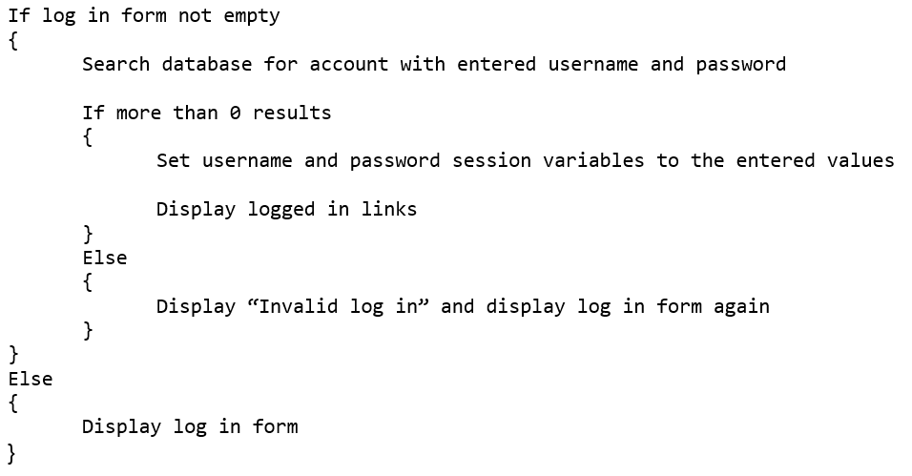
A login system was implemented using PHP session variables. The index.php page is used to log in. Its code structure can be represented using pseudocode as:
Figure 1 – Login pseudocode

See below the three possible results from this code.

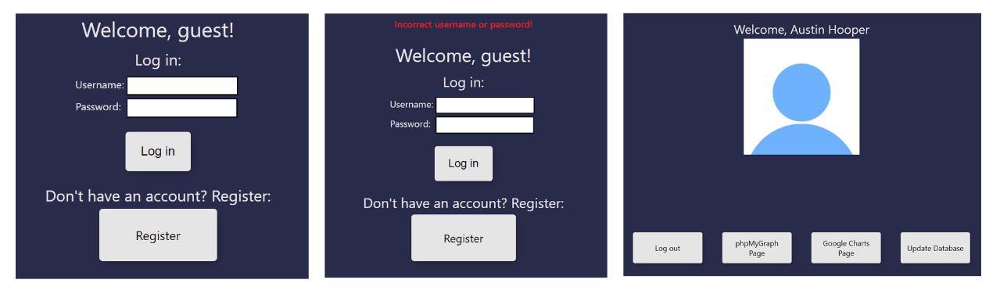
After successfully logging in, JavaScript is used to dynamically add links to the navigation bar. This is done because the check for a username is done before it is set on the page, meaning the page would otherwise need to be refreshed on first login.
Figure 2 - Login page

Registering

A register page was developed to show PHP functionality. In a real-world scenario, an administrator would have to validate each account before registration completes, for security.

The register page code structure can be represented using pseudocode as:

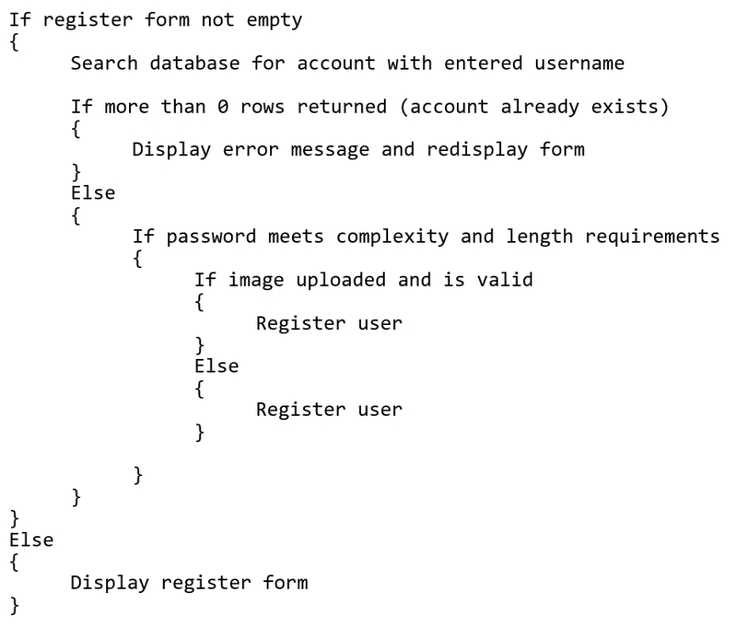

Figure 3 - Register pseudocode

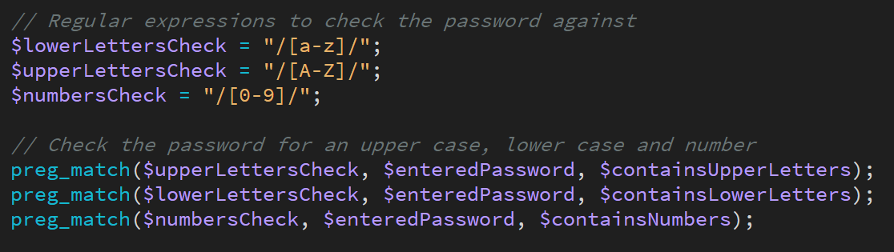
As well as checking password length, password complexity was checked using regular expressions. Booleans are used to store whether the password contains upper and lower case letters, as well as at least one number. The register function is only called if they are all true. See the use of regular expressions below:
Figure 4 - Regular expression checking
Image upload and checking code was omitted because of the amount of code.

Logging Out

Implementing a logging out system was simple. session_destroy() was used, after the username session variable was set to blank, as a precaution. This is done as soon as the logout.php page is loaded.

Page Restrictions and Security

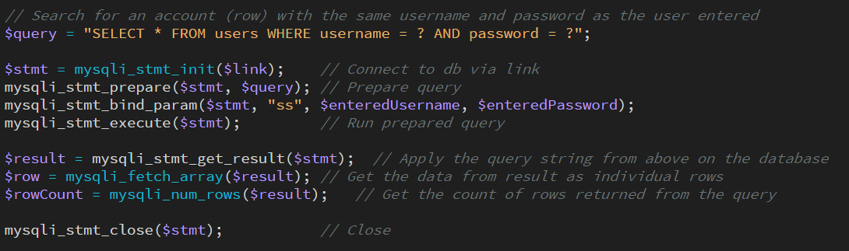
Prepared statements were used wherever user input was involved, in order to protect against SQL injection. See below an example of this from the register page.
Figure 5 - Prepared statement implementation
The query’s conditions are replaced with question marks. Parameters are then bound to these, along with a string telling the function what type of data these parameters are.
Pages are restricted to users who are logged in by checking the session username variable. If it is empty or does not exist, the page immediately redirects to the home page using ‘header(“location: index.php”)’ instead of displaying its content.
The same process occurs on each page with sensor data. For the data adding page, the code checks if the user type session variable is “admin” and if not, redirects to the home page. This effectively creates a permissions system.

Data Transfer to Database

To transfer data from a plain text file to the database, each file was first read, in its entirety, into a single variable. This variable was then exploded by new line characters to separate the data into records, and further exploded by an empty space to separate each record into fields, and trimmed to remove new line and space characters. The date and time were then joined back together to insert into the database as a timestamp.
A for loop was used to repeat this process for each file to avoid code repetition.
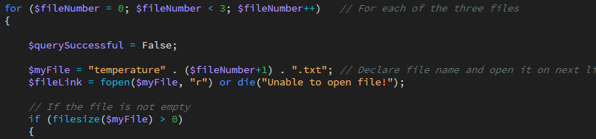
Figure 6 - Data transfer file loop
After successfully transferring a file’s contents to the database, it is then re-opened, this time in write mode. No changes are made, and the file is immediately closed. This has the effect of creating the file if it does not exist, or wiping it if it does.
Prepared statements were not used in this page because it is unlikely anyone could tamper with the sensor reading files to insert SQL commands into them. If anyone could do this, they would likely have physical access to the machine, so protecting against SQL injection would be futile.

Data Visualisation

phpMyGraph Page

The phpMyGraph page shows all of the sensor data in separate graphs.
Using the phpMyGraph5.0 library, code was produced to take a sensor ID and a graph type (chosen using radio buttons) from the URL using PHP $_GET[] and use these to generate graphs appropriately. The sensor ID GET parameter was simply passed into the SQL query. To determine graph type, the GET “type” value was checked in an if statement, running appropriate graph generation:
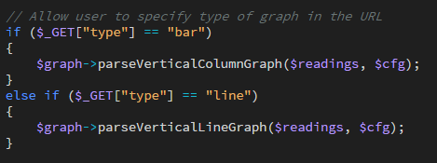
Figure 7 - Graph generation option code

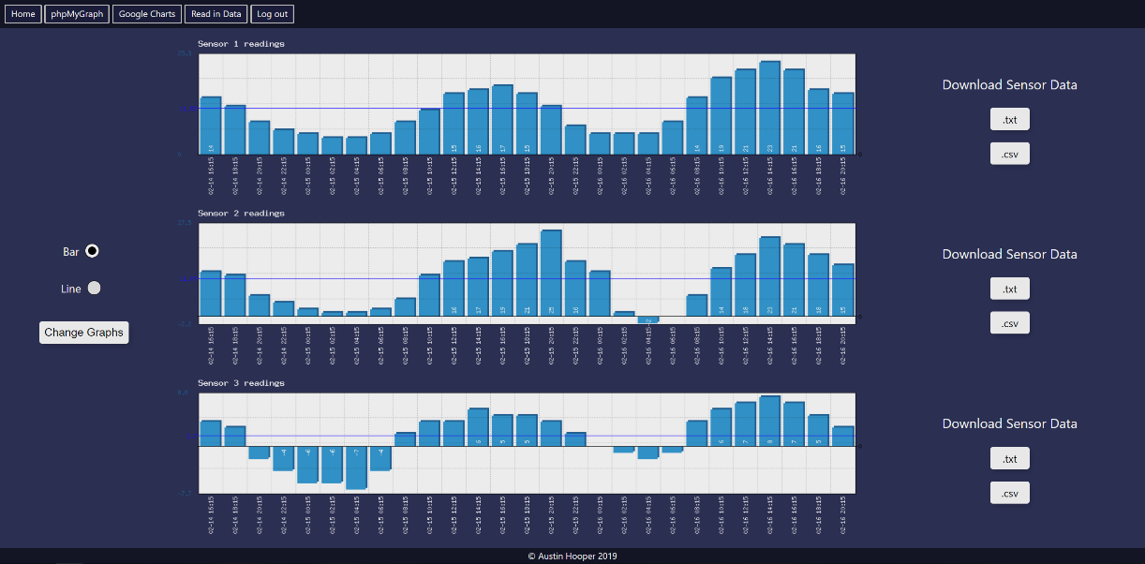
The substr() function was used to trim the timestamp values and then graphs are displayed on the page to the user, as seen below:
Figure 8 - phpMyGraph bar charts

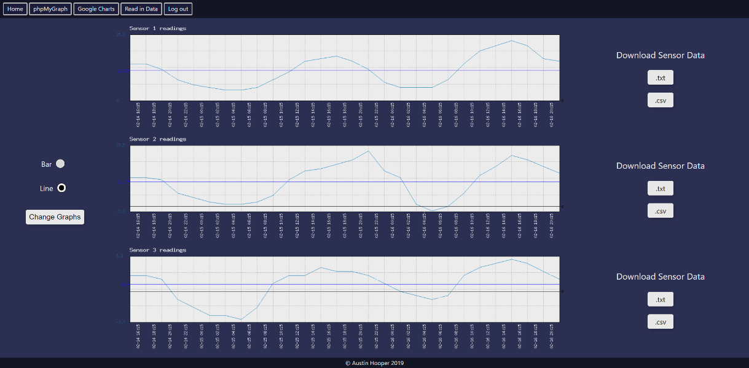
Figure 9 - phpMyGraph line charts

Though bar charts are not entirely suitable for continuous data such as the temperature data here, they were implemented to demonstrate a range of graph types.
On load of this page, a script is loaded to save the current database entries into .txt and .csv format. This allows for the data to be visualised and analysed using more specialist software, which will prove useful for the L6 Major Project.
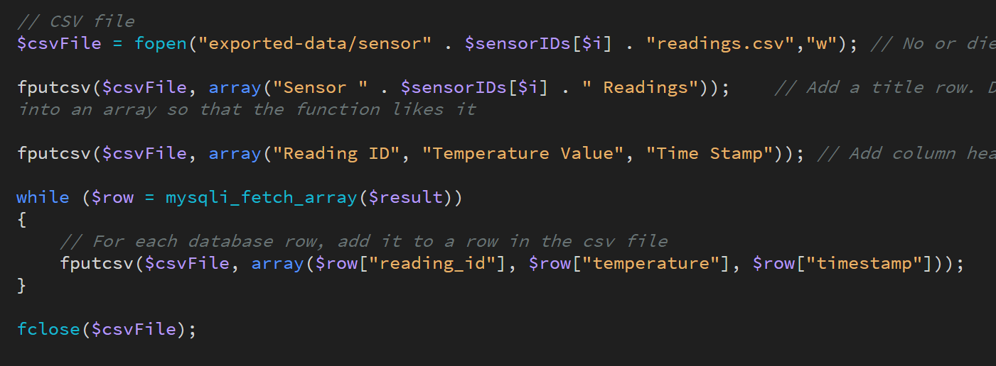
This code is repeated in a loop for each sensor in the database. See below code to save each reading row from the database to a .csv file. The code for saving to .txt was omitted as it is similar to the .csv saving.
Figure 10 - CSV export code

Google Charts Page

This page implements three forms of data visualisation, being a line graph, a ‘box and whiskers’ or ‘candlestick’ graph, and gauges, using the Google Charts JavaScript API.
A candlestick chart, often used for financial graphing, is used to show the minimum and maximum values, as well as the upper and lower quartile. The minimum and maximum values are represented by the ends of the line, which show temperature extremes. The bar in the centre of the line represents the aforementioned upper and lower quartiles, which show the middle half of the data. This is useful as it shows the extremes of the readings as well as the typical range for each sensor. For example, the candlesticks in the below screenshot show that sensor 3 has far less variance than sensor 2, but most of its readings were at the higher end of its own range as opposed to in the middle, while also having overall lower values.
Each sensor’s median, minimum, maximum and range values were calculated and displayed on screen, along with the mean and quartiles, which was displayed in a Google Charts gauge.
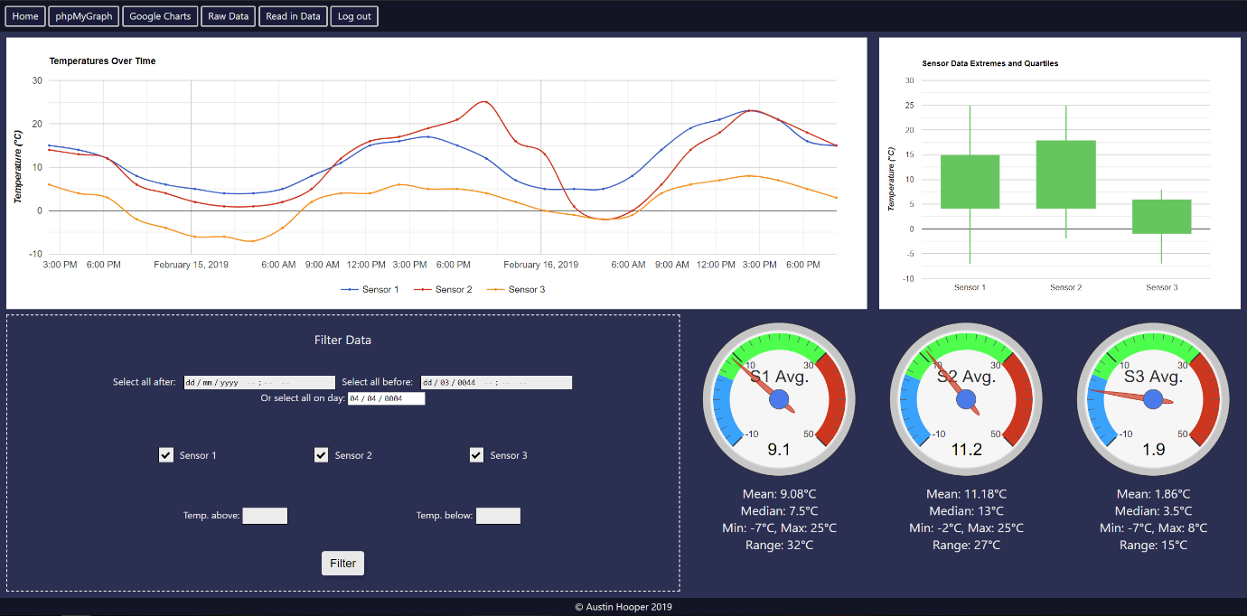
Figure 11 - Google Charts page

See the below code for calculating upper and lower quartile values:
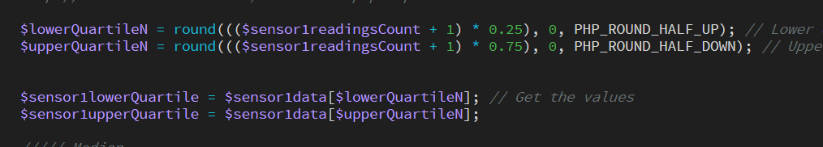
Figure 12 - Upper and lower quartile calculations

This would benefit from object-orientation, as this code is currently repeated once per sensor.
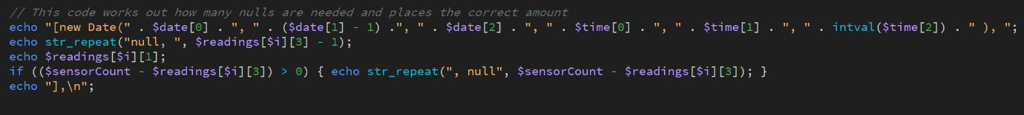
The Google Charts JavaScript has been omitted to save space, but the PHP code echoing values into JavaScript for the line chart is as follows
Figure 13 - Variables echoed to JavaScript

This produces the following result in JavaScript:
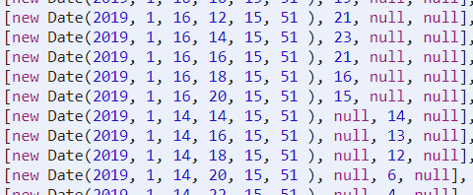

Figure 14 - JavaScript result

As Google Charts displays each data column in a different colour, each sensor has its own column for readings. This is why there are three columns for temperature and two are always empty.

Data Filtering

Three filters were implemented on the Google Charts page:
- Between two times on specific dates – To allow the user to check readings for a specific time range if they expected something to happen in that time
- On a specific date – The user specifies a date and a search is done using an SQL wildcard
- Selecting individual sensors to display – To allow users to check individual location readings, for example checking a specific room temperature
- Above and below specific temperatures – To allow the user to check all temperatures above or below certain thresholds, and check for anomalies or spikes
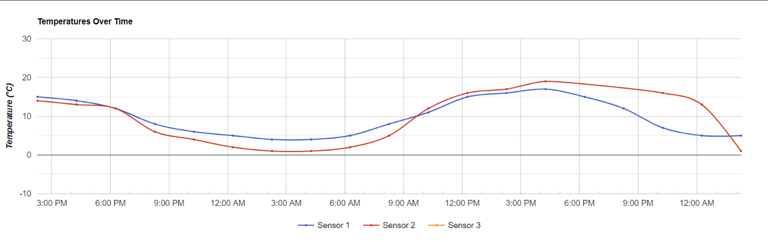
Figure 15 - Filter results: sensor 1 and 2, readings below 20°C, before 4AM Feb 16th

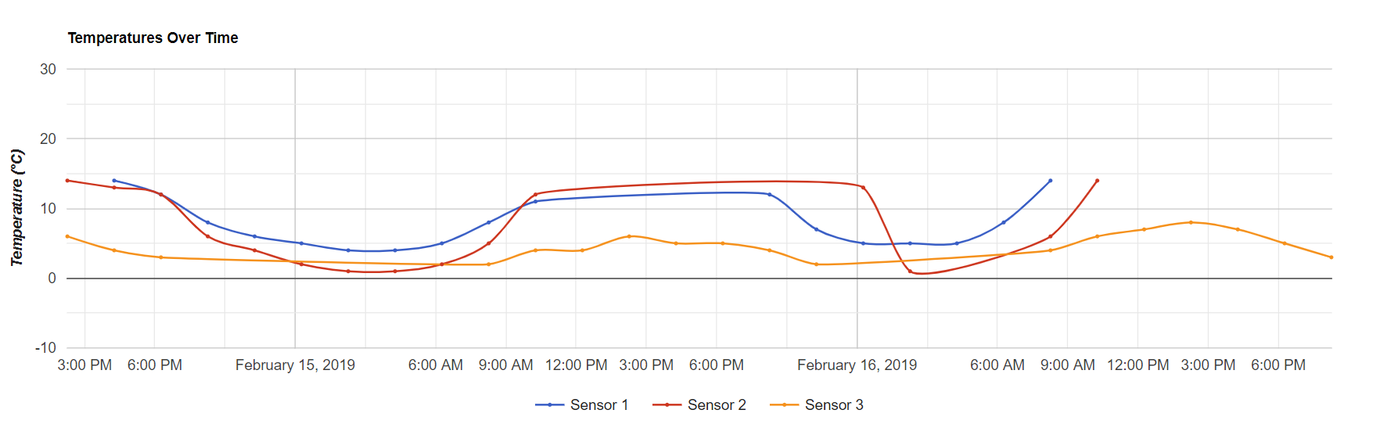
Figure 16 - Filter results 2: all sensors, any date, below 15°C and above 0°C
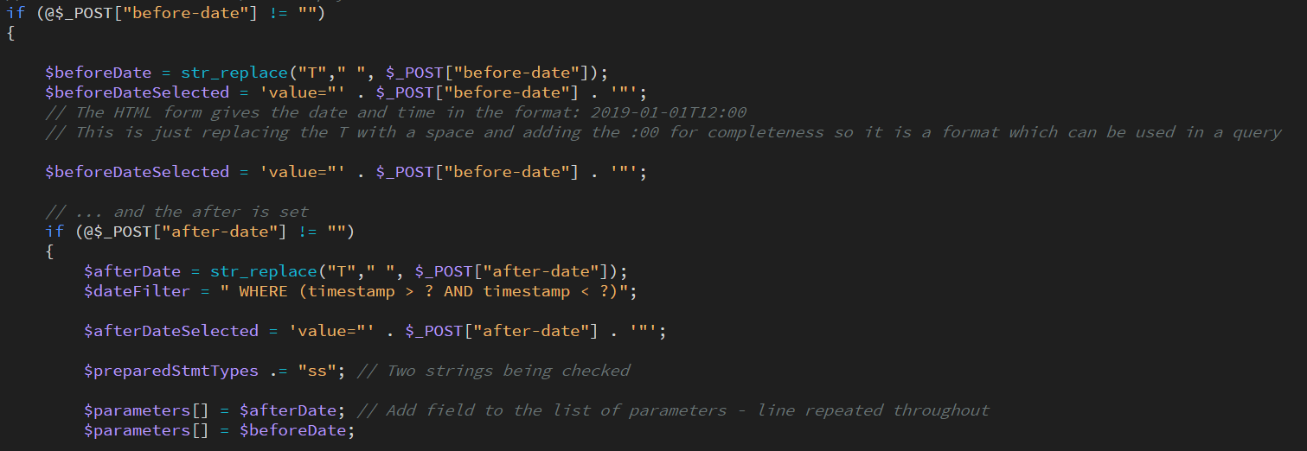
Data filters were implemented by checking each individual filter input. If it is not empty, the value to be filtered by is added to an array of variables, and the parameter types string has the appropriate type appended to the end. See an example of this process below:
Figure 17 - Beginning of data filter code
Each filter checks if a previous filter exists, in order to add an “OR,” “WHERE” or “AND” clause as needed.
Because a prepared statement is used to prevent SQL injection, and as there are an unknown number of variables to filter (dependent on what the user selects), an unknown number of parameters must be passed to the mysqli_stmt_bind_param function. This is done using the PHP “splat” operator, using three dots (“…”), and is used to provide variable amounts of arguments. This provides the function with every variable from the array of parameter variables. See below the code to achieve this:
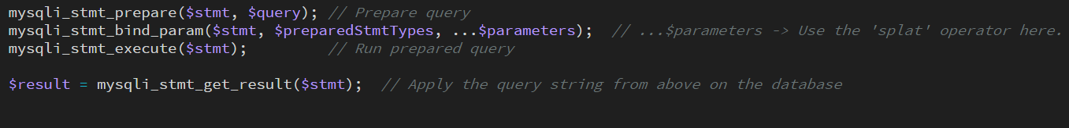
Figure 18 - Prepared statement with a variable number of arguments

Raw Data

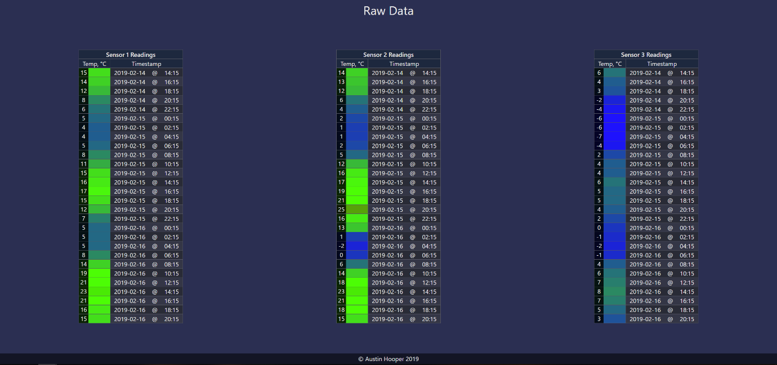
As well as graphing sensor data, it was also displayed in text form using tables. Each sensor has its own table, with each row from the database being echoed into a row of the table in a loop. An RGB colour was applied to the temperature cells dependent on the raw value. See below the raw data in tables:
Figure 19 - Raw data stored in tables

Conclusion

This report has detailed the development of accounts and security, graphing, filtering and data transfer elements of an Internet of Things web monitoring application.

Background Reading

Acunetix, “What is Cross-site Scripting and How Can You Fix it?,” 2019. [Online]. Available: https://www.acunetix.com/websitesecurity/cross-site-scripting/. [Accessed: 30-Apr-2019].
emathematics.net, “Statistics.” [Online]. Available: http://www.emathematics.net/statistics.php?tipo=cuartil. [Accessed: 22-April-2019].
Google, “Chart Gallery | Charts | Google Developers,” 2017. [Online]. Available: https://developers.google.com/chart/interactive/docs/gallery. [Accessed: 03-May-2019].
R. Bisson, “SQL injection,” ITNOW, vol. 47, no. 2, pp. 25–25, Mar. 2005.
S. Jenkins, Web Design All-in-One For Dummies, 2nd ed. New Jersey: John Wiley & Sons, 2013.
The PHP Group, “PHP: New features - Manual.” [Online]. Available: https://www.php.net/manual/en/migration56.new-features.php. [Accessed: 03-May-2019].
W3Schools, “PHP fputcsv() Function.” [Online]. Available: https://www.w3schools.com/php/func_filesystem_fputcsv.asp. [Accessed: 01-May-2019].

