LCLM4005_ECD_Assessment 2_JUNE 2026

Cert HE Business Skills for the Workplace
Module: Employability and Career Development
Module code: LCLM4005

Portfolio of written tasks

Elena-Victoria Cuceu
2442779

Job Advert 1- Dental Receptionist position
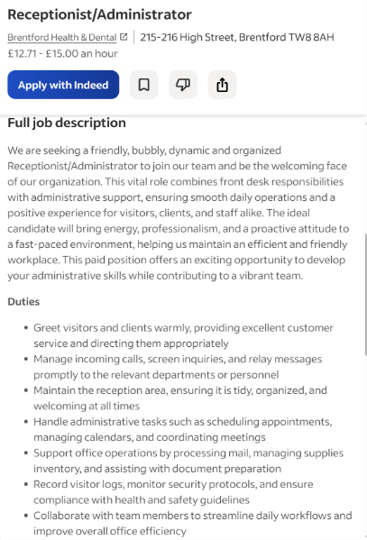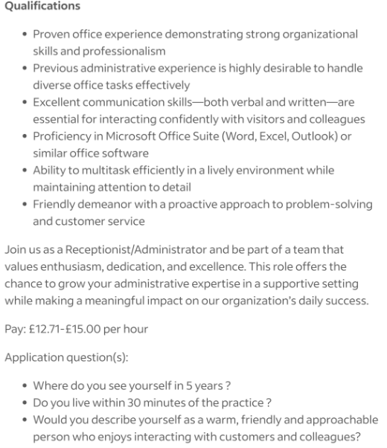
Job Advert 2 – Restaurant/ Hotel hostess
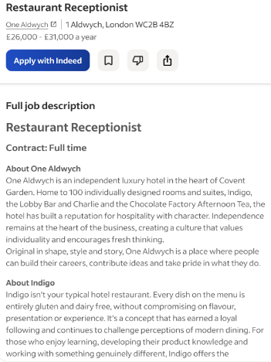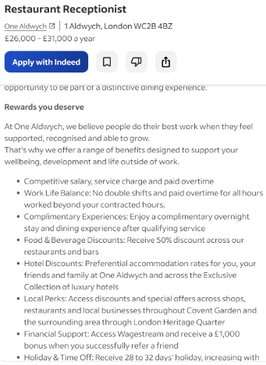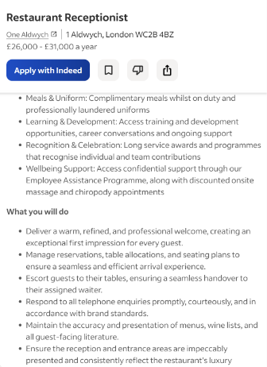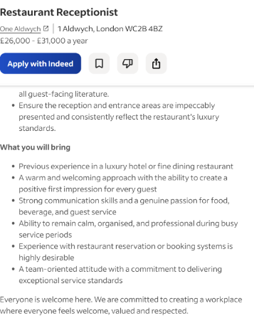

Task 1 – Comparing 2 Job adverts

For this task I have selected two job adverts as attached above: Dental receptionist and Sales executive, both roles require exceptional customer service skills as they are customer front facing roles.
Initially for the Dental receptionist listing the role requires for the employee to greet patients, answer calls and emailsand book patient appointments. key skills such as Excellent customer service, efficiency, calendar managing when booking patient appointments, organistation, time management, meeting coordinating, confidentiality,professionalism, IT skills in order to operate dental software and email platforms, and understanding of Dental procedures to be able to explain these to patients if needed.
The Hotel/ Restaurant hostess position requires the employee to welcome guests and mange table seating arrangements. Key skills include professionalism and corteousness towards all guests, bookings management when booking guest restaurant tables or offering rooms for patients, It skills to be able to operate booking software, , cleanliness, and a Luxury service understanding in order to maintain One aldwych’s standards.
In both roles an understanding of excellent customer skills is required in order to uphold the businesses profession standards and customer image, callendar management is also a skill require for both roles, in one to book patient appointments and in one to manage restaurant seatings. Skills which differ inbetween the roles are the general main responsibilities, for example, in the dental receptionist job confidentiality must be understood and closely followed in order to comply to GDC standards, and in the restaurant hostess position multitasking between hotel and restaurant responsibilities is key.
Task 2- Self assesment, Evidence of readyness

Self assesment:
SWOT Analysis
STRENGTHS | WEKNESSES | OPORTUNITIES | THREATS
Great communication/ customer service skills | Limited office experience | Completing University Degree in Business skills | High competition for receptionist positions in job market
Fast learned and adaptable in new environments | Occasional lack of confidence when in unfamiliar situations | Gaining further work experience in professional settings | Lack of experience
Experience working with different groups of people | Need of development in telephone communication | Developing administrative skills | Changes in technology ill have to adapt to
Organised and time efficient | Limited experience with specialist software | Opportunity to progress into management | Balance of university studies alongside job
Hospitality, sales and dental experience | Trouble delegating work load | Entering professional network, meeting professionals | Limited availability due to university commitments

Strengths
As one of my main strengths is communication due to my previous experience in hospitality and administration has helped me develop confidence when speaking to new people, this can positively affect my performance in both job listings. I am also adaptable meaning that whenever I have woked in a new environment I have managed to adjust to the responsibilities asked of me and the businesses working expectations, this is important especially for the hotel hosstes position as that is a job I would be fairly new to and would be able to adapt accordingly.
Time efficiency is something I manage very well due to not only my past job roles but also because of balancing University studies and a full time job, this skill will be carried onto a new job position which will give me the advantage of not feeling overwhelmed in time scrunch situations, an example of this may be a busy night at our hotel restaurant where many guests would like seating with us while we have limited available tables, I would be able to remain calm under the pressure, think though a clear method to be able to keep all guests happy and offer them a table efficiently.

Weaknesses
One of my weakness may be that I need to develop my telephone communication, as English is not my first language, when I speak to a customer on the phone- where I cant see their body languase and faial expressions, I struggle to read their tone in order to understand if they are impatient or frustrated. Developing this would be ideal in order to provide excellent service to all customers.
I would also like to develop confidence when dealing with unfamiliar situations such as any complaints. Developing this would mean can always remain clm under pressure and help every customer which may need assistance.

Opportunities
Currently, my studies in Business Skills will offer me job opportunities and career development as I will build skills and knowledge of business, communication, leadership and professional development. Managing my assignments alongside a full time job has taught me how to manage my time accordingly.

Threats
One threat I may face is the competitiveness in the job market, some applicants may have greater experience or qualifications than myself with would give them an advantage at securing the job position.
Another threat is the constantly changing technology in administrative roles such as these two, this will force me to adapt which may become stressful

Evidence of readiness-

I believe I am a strong applicant for both job positions due to my experience working in a restaurant and a dental receptionist job previously, my experience has left me with greatly developed communication, teamwork, ability to work under pressure, adaptability and time management skills.
My current unviverity course further proves my readiness, completing assignments and overall working towards my degree requires time and resource organisation, independent learning research skills and meeting deadlines.

Overall as mentioned in my SWOT analysis, I have plenty transferable skills which would be beneficial at both the dental receptionist and hotel receptionist role. While I still do need to develop some over the phone communication skills and my overall administrative knowledge. By carefully focusing on these areas of development, I can become prepared for a bigger range of job opportunities.

Task3 Employment Goals and Personal Development plan
As my short term employment plan I would like to develop more customer facing administrative positions such as Dental Receptionist or Hotel Receptionist while continuing my university studies. This is important to me as it will allow me to build on my exciting sills while developing new ones.
My long term employment plan would preferably include me progressing into management roles with greter responsibilities such as a practice manager or hotel manager. This will also allow me to practice the skills learnt at my University Business degree and develop experience in managing a team, and work towards the businesses success

Elena Cuceu 2442779

