University of Wales trinity saint David
Wales institute of science and art

Energy in a flywheel
Further science for engineers (ACHA 4007)

Daniel Burden
2405219
02/2025

Contents
- introduction…………………………………………………………………………………………………………….4
- experimental procedure……………………………………………………………………………………………5
3.0 results…………………………………………………………………………………….…………………………...…8
4.0 analysis…………………………………………………………………………….……………………………………10
5.0 conclusion……………………………………………………………………………………………………………..11
6.0 evaluation………………………………………………………………………………………………………………12
7.0 further work…………………………………………………………………………………….……………………..13
Reference……………………………………………………………………………………………………………………17

1.0 introduction
The aim of this test as to the potential energy and kinetic in a flywheel where we will be using a test kit by tecequipment (kinetic engery kit, 2012) where instead of using a spring there was string apart from that the guide was used for the rest of the step from the booklet and once the statics from that have been found out. On the theory side of it where as according to engineering toolbox “A flywheel can be used to smooth energy fluctuations and make the energy flow intermittent operating machine more uniform. Flywheels are used in most combustion piston engines” (flywheeel energy, 2005) what shows off the basic function of a flywheel and the basic equations where for more advance technical stuff “When a mass at rest is rotated it acquires kinetic energy. Slowing the mass down or bringing it to rest is achieved by removing kinetic energy. An engineered rotating mass designed specifically to store energy as a result of it motion is called a flywheel.” (roymech.org, 2020) .

2.0 experimental procedure
1.
The first of the experiments was to attach a pully block and fly wheel to a work panel making sure everything is properly attached and tight to the work board
2.
once everything is securely attach to the string and weight hanger onto the pully board and once all that is attach then align a magnetic ruler with the bottom of the work board and after that a person will apply 90g worth of weights to the weight hanger (as the hanger is worth 10g this will leave it at an even 100g) before winding it up ready for the next step
3.
once all that is done then the main work can start preferably with several people one to wind up the fly wheel ready to drop it when another person who will be holding a timer says go and then wait until the weight falls and rises where a third person is waiting until it reaches the maximum height where the person with the timer will stop the timer and the person watching will read off the maximum height they read and a four person can keep the readings in organized table. Repeat this three times to get an average
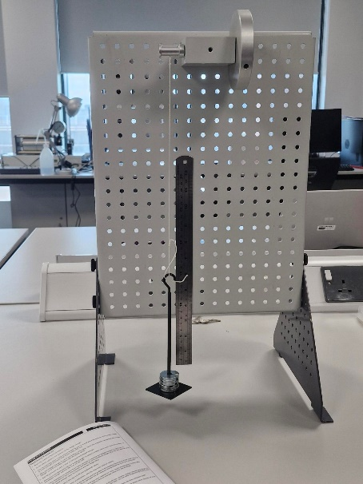
Figure 1 100g of weight bottoming out
4.
after the designed to put on 100g of extra weight to the weight hanger has put them on they will also want to wind it back up ready for the 200g test where they will repeat their previous roles in dropping it keeping time and keeping attention on how high it rises and fall making sure they have kept a good score of this to lower the chances of getting an out liar.

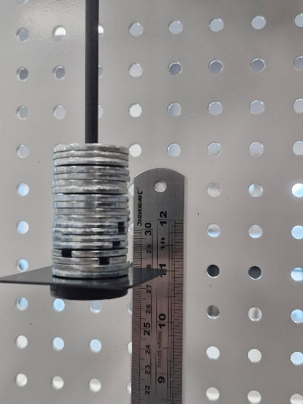
Figure 2 200g brought up to 28cm on the metallic ruler

5.
is to add another 100g grams to make it 300g and make sure everyone still does their jobs properly so lower the chance of human error as this will make the table and chart look better

6.
as in the previous steps you will want to add another 100g to make it 400g making sure the person whose job it is to keep count of the measurements is on high alert as giving the string they were given may cause bounce back giving a really uneven score
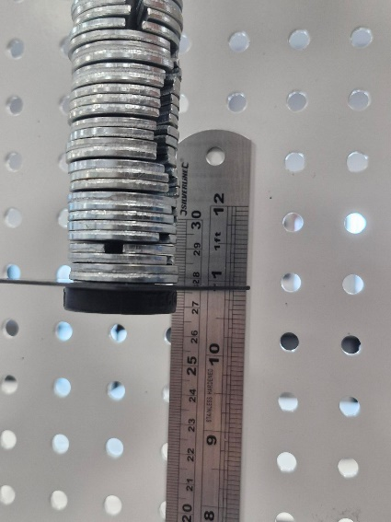
Figure 3 400g brought upto the 28cm point
7.is the final test of adding another 100g making it 500g keeping an eye on the on the time and measurement as bounce back will be highly likely at this weight and once they have done that do a final check that you have 3 results for 100g to 500g

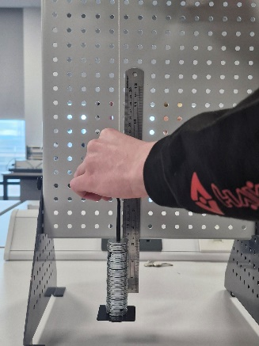
Figure 4 preparation of 500g

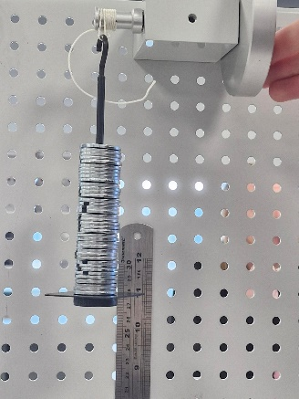
Figure 5 500g ready to be dropped for the final time
8.
once there is have three separate results for up to 500 grams someone will want to put away all the equipment making sure to keep care of it as another person gets the averages of the previous results

3.0 results
Figure 6 the physical writing of the information we retrieved
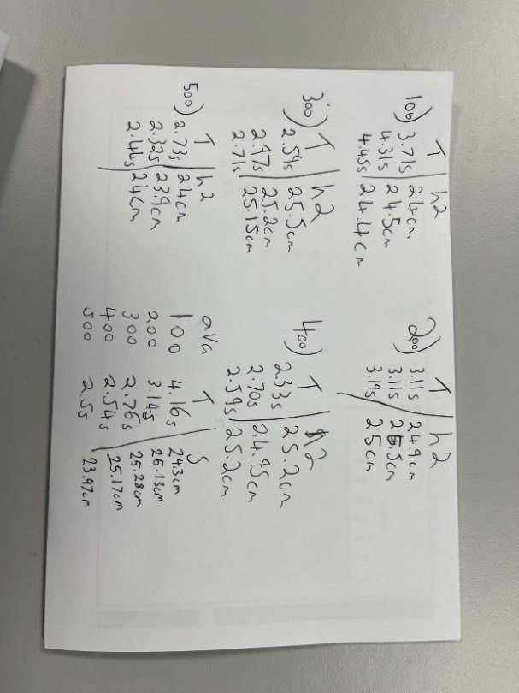
Table 1 averages of our drops including mass, time fallen and height it returned upto
mass(g) | Time fallen(s) | Height two(cm)
0.1 | 4.16 | 24.3
0.2 | 3.14 | 25.13
0.3 | 2.76 | 25.28
0.4 | 2.54 | 25.17
0.5 | 2.5 | 23.97

Table 2 A complete table of all drops including mass, time fallen and height the weight returned too
Mass (g) | Time fallen(s) | Height two(cm)
0.1 | 3.71 | 24
 | 4.31 | 24.5
 | 4.45 | 24.4
0.2 | 3.11 | 24.9
 | 3.11 | 25.5
 | 3.19 | 25
0.3 | 2.59 | 25.5
 | 2.97 | 25.2
 | 2.71 | 25.15
0.4 | 2.33 | 25.2
 | 2.70 | 24.95
 | 2.59 | 25.2
0.5 | 2.73 | 24
 | 2.32 | 23.9
 | 2.44 | 24

4.0 analysis
CALCULATIONS
The calculation were fully being able to be made from the tecequipment ​ (kinetic engery kit, 2012) as we already had height one (H1) being 0.28m as that was the height we were dropping from and the height it bounced up to being height two (H2) and we had the mass and time taken (Tt) as those were our control variable as we choose the mass to drop and as we controlling the timer the time was also something else we can find the gravity being 9.81 from these we can work out the mg being mass times gravity for example a mass of 0.1kg and gravity being 9.81 we will end up with a mg of 0.981 but for the rest of the calculations we will need the tecequipment (kinetic engery kit, 2012) booklet as from the booklet we can figure out the inertia flywheel and pully being 3.862$×$10⁻⁴ and 0.834$×$10⁻⁴ what added together end up being 0.0004696kg.m² and the other parts we can get are the radius of the pully being 0.0065m and the circumference being 0.04084 and from here we can find all of the equations from the booklet as we can learn the potential energy(PE) being $mass × gravity H1$ can hell us find our potential energy lost being $mass×gravity×\left(H1-H2\right)$ and to get potential lost adjusted we do PE x {H1/(H1+H2} and after that we worked out time fallen (Tf) what was $Tt x \{H1÷(H1+H2)\}$ and with time fallen we can work our acceleration (a) what is $2 x H1÷Tf2$and then velocity (v) is $a × Tf$ with all of this information we can start put together things like angular acceleration (α) and angular velocity (ω) respectfully being a/radius and $\frac{2×π ×v}{circumference}$ and with these we can figure out our final two equations one of with being torque what is $α x× Inertia$ and the other one being kinetic energy what is $0.5 ×I ×ω2$ and after that we can compare with our other source to make sure all the information lines up with our current calculation (flywheeel energy, 2005) (roymech.org, 2020) (kinetic engery kit, 2012)
SPREADSHEETS, DATA TABLES AND GRAPHICAL TABLE
The Data table underneath show off a clear picture of our original stats of mass, time fallen and height two and our equivalent sums based off of the answers we have given with all the answers lining up for example from 100g to 200 on all answers there is a massive rise as our time taken decreased massively and our h2 increases where as from 400g to 500g there is less of a rise what is shown in the calculation and underneath the data table is the torque to alpha graph what is equivalent to the information given from the table as shown from the massive peak from 100 to 400g as there is a massive improvement in torque and alpha but on 500g where there isn’t much of an improvement it is pretty much equal line
Table 3 all of our calculation done in an organized graph
Figure 7 a torque to alpha graph
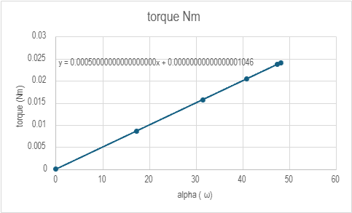

Table 4 a table of equations according to tecquipment (kinetic engery kit, 2012)
Mass (kg) | $$N/A$$
Initial pe (J) | $$Mass ×gravity ×height one$$
Time taken (s) | $$N/A$$
Height two (M) | $$N/A$$
Mass & gravity (N) | $$mass ×gravity$$
PE lost adjusted (J) | $$PE lost × \{height one(height 1 + height 2)\}$$
Time falling (s) | $$Time taken ×\frac{height one}{height one + height two}$$
Acceleration (m/s²) | $$\frac{2× height one}{time fallen^{2}}$$
Velocity (v) (m/s) | $$acceleration× time fallen$$
Velocity (ω) (rad/s) | $$\frac{2×π×velocity\left(v\right)}{circumfrance }$$
Torque (Nm) | $$inertia× alpha$$
Alpha (α) (rad/s²) | $$\frac{Acceleration}{radius}$$
Kinetic energy (J) | $$\frac{1}{2}×inertia× velocity(ω)^{2}$$
5.0 conclusion
The overall conclusion is that with more weight the quicker the time and more kinetic energy as seen exponentially growth from 100 to 300 but as when 400 came around there was an issue with the string bouncing back what did cause some issues but the kinetic energy did increase what suggest that even though human error and the string starting to fail the bigger weight increases kinetic energy and makes it a quicker time what continued with the 500 gram weight as it made the string bounce more making it harder to read in person but still despite all of it the kinetic energy still increased going from a time of 2.1s at 100 grams to a time of 1.3s but an exponential increase of kinetic energy of 0.13J to 1.8J what was a direct result of the increased weight what shows a direct relation between weight time and kinetic energy and the equation for inertia should be 0.0004696 where as ours equal 0.0005 but given there could be human error this answer is within a good range for our torque graph to be correct.

6.0 evaluation
The actions taken to minimize errors that the we doubled checked that all of our equipment was fully functional and that nothing was broken before putting it all together making sure it was on all secure and then used multiple people as if there was only one person who would have to start a timer let go of the fly wheel and keep score of what result we got where as with 2 people we could have one person job was to drop the fly wheel and write down the results and the other person job is to start and stop the timer and to watch and keep score of height it got too also to lower chances of human error we did it three times as too get an average but also be able to compare if there are any freak or unusual results as human error is always a possibility of human error.

7.0 further work
With unlimited time and money I would personally get as many test as need each mass preferably a new one every drop as this would give us results from new keeping it as easy as possible and I would get a high definition slow mo camera as too see the exact moment it hits height two but up to on the camera I would also get a high tech computer and video software as a lot of software do allow you to go to 0.001secs as this would give us an accurate time compared to our height two and my final upgrades would be a new set of a 100 grams instead of 10 10 gram weight alongside a new string as our had some serious kick back on 400 and 500 grams and with the unlimited time I would do as many drops with each new weight and test as to lower the effect any outliers may have on the test I would also spend as much time as possible watching the videos back making sure to get to the right heights and seconds as possible and I would also reset it all from the start again to make sure the results are similar then I would finally get my averages from them with the best calculator I could find

References

flywheeel energy. (2005). Retrieved from engineering toolbox: https://www.engineeringtoolbox.com/flywheel-energy-d_945.html
kinetic engery kit. (2012). Retrieved from tecequipment: https://www.tecquipment.com/potential-kinetic-energy-kit
roymech.org. (2020). flywheel basics . Retrieved from roy mech: https://roymech.org/Useful_Tables/Cams_Springs/Flywheels.html

