The Alexander Mosaic is widely believed to be a snapshot of the turning point of the battle of Issus, fought between the Persian army of Darius and the Grecian army of Alexander the Great in 333BC. The mosaic is the oldest Roman mosaic found and is a demonstration of not only extreme artistic skill, but also the importance of the figure of Alexander the Great to Roman society in 100 BC. The mosaic also offers us a look into what myths and historical legends the Romans would have found significant and interesting.

The mosaic was found at the House of Faun in Pompeii displayed on the floor between two large peristyles in the “Largest and most elaborately decorated mansion in Pompeii”. The fact that this battle was considered to be a worthy subject by owner of the house and the artist says a great deal on that which Roman society held to be important and impressive. Martin Beckman believes that the mosaic “has the potential to provide evidence of the tastes, interests and desires of the wealthy Romans during the late Republic" and uses the worn away parts of the mosaic around Alexander as evidence of where the Romans stood to focus on the mosaic the most. Alexander was a well-known and great general and he was famed for his mighty conquests and innovative battle tactics. Graeco-Roman cultures both highly valued depictions of powerful and famous generals, and often showed them in mythical settings. Alexander was clearly held to be a famous and impressive mythical subject in art. The placement of the mosaic in the atrium would have been optimal for the owner of the house to show off his wealth and knowledge of historical events to his guests.

It seems that very few Greek paintings were allowed to be done of Alexander, as noted by Pliny in his journals. These paintings were often done by famous artists of the time and were considers great works of art for their time. It is widely believed that the mosaic is a copy of such a painting done by Philoxenus. Many historians, such as Beckmann, cite Pliny as their ancient evidence that this mosaic is a copy of Greek painting. However, we also know other works of art by other artists of the time depicting the scene of the battle of Issus existed in the Hellenistic period. Since none of these paintings survive to the modern day such an assumption can’t be made with any amount of certainty as we have no detailed other detailed commentaries of the original works, aside from Pliny’s, to compare the mosaic to.

In the mosaic there are definite influences of Greek art and myth that cannot be denied. One example of this is the Grecian style armour of Alexander. The breastplate is depicted with a gorgon on the front, a Grecian symbol of protection often used to ward away enemies, seen most commonly on statues of Athena. The gorgon was also prevalent throughout Grecian myth and poetry as method of protection or punishment. This image was later taken, adapted and spread throughout the Roman empire. All in all, the mosaic “speaks to the Romans' regard for the achievement of ancient Greek art.” and its placement in the House of Faun, which widely makes use of Grecian architecture and myth shows that Roman appreciation and interest in Greek art was engrained within their society.

The mosaic itself is made of millions of extremely small tesserae and through the medium of “opus vermiculatum” the artist is able to capture extremely fine details within the scene. Even the subjects faces, and expressions can be seen in great detail. This is notable from the despair seen in the reflection of one of the Persian soldiers on the ground beneath Darius’ Chariot “He's looking at himself fallen in battle, perhaps about to die”. Here, despite the somewhat limited medium we can still see the sadness in the soldier’s eyes. His right arm outstretched towards his own image, his eyebrows raised in despair as he realises his own fate. Beckmann describes how “the Romans were particularly interested in the reflection of the Persian’s face in the polished shield, a skilful artistic device employed to highlight the pathos of the scene”

Despite the fact that “the Romans were much more interested in Alexander" The detail put into body language between Alexander and Darius is astounding. On the right Darius’ Chariot is fleeing, his horses clearly in a dynamic state of frenzy cause the chariot to spin away from the battle. Despite the turmoil of combat Darius remains caught in a moment of stillness, his hand stretched out as a pleading gesture to Alexander. “There is a look both of surprise and worry and of seeking compassion” this is perhaps a reference to Alexander’s later compassion and respect to Darius and his family. The mosaic captures this mutual respect of the two men by portraying Alexander in a quiet and calm reverie, his face portrays confidence in battle, but also an understanding for the Persian king. These two figures draw the eye as surrounded by a complex matrix of spears and soldiers, they are elevated just enough above the heads of the surrounding figures that their importance is impossible to deny.

To summarise the mosaic of Alexander shows the importance of Grecian myth, art and military legend in Roman society. The fact that the mosaic is displayed in the most expensive house in Pompeii shows how important the figure of Alexander was held to be. The mosaic’s use as a display piece for guests would have made it known that the owner of the house was not only wealthy but also understood important historical events. Its artistic skill would have also been an indicator of the hosts wealth and good taste, and it allows modern historians to understand the technical abilities of late republic artists.

Appendix
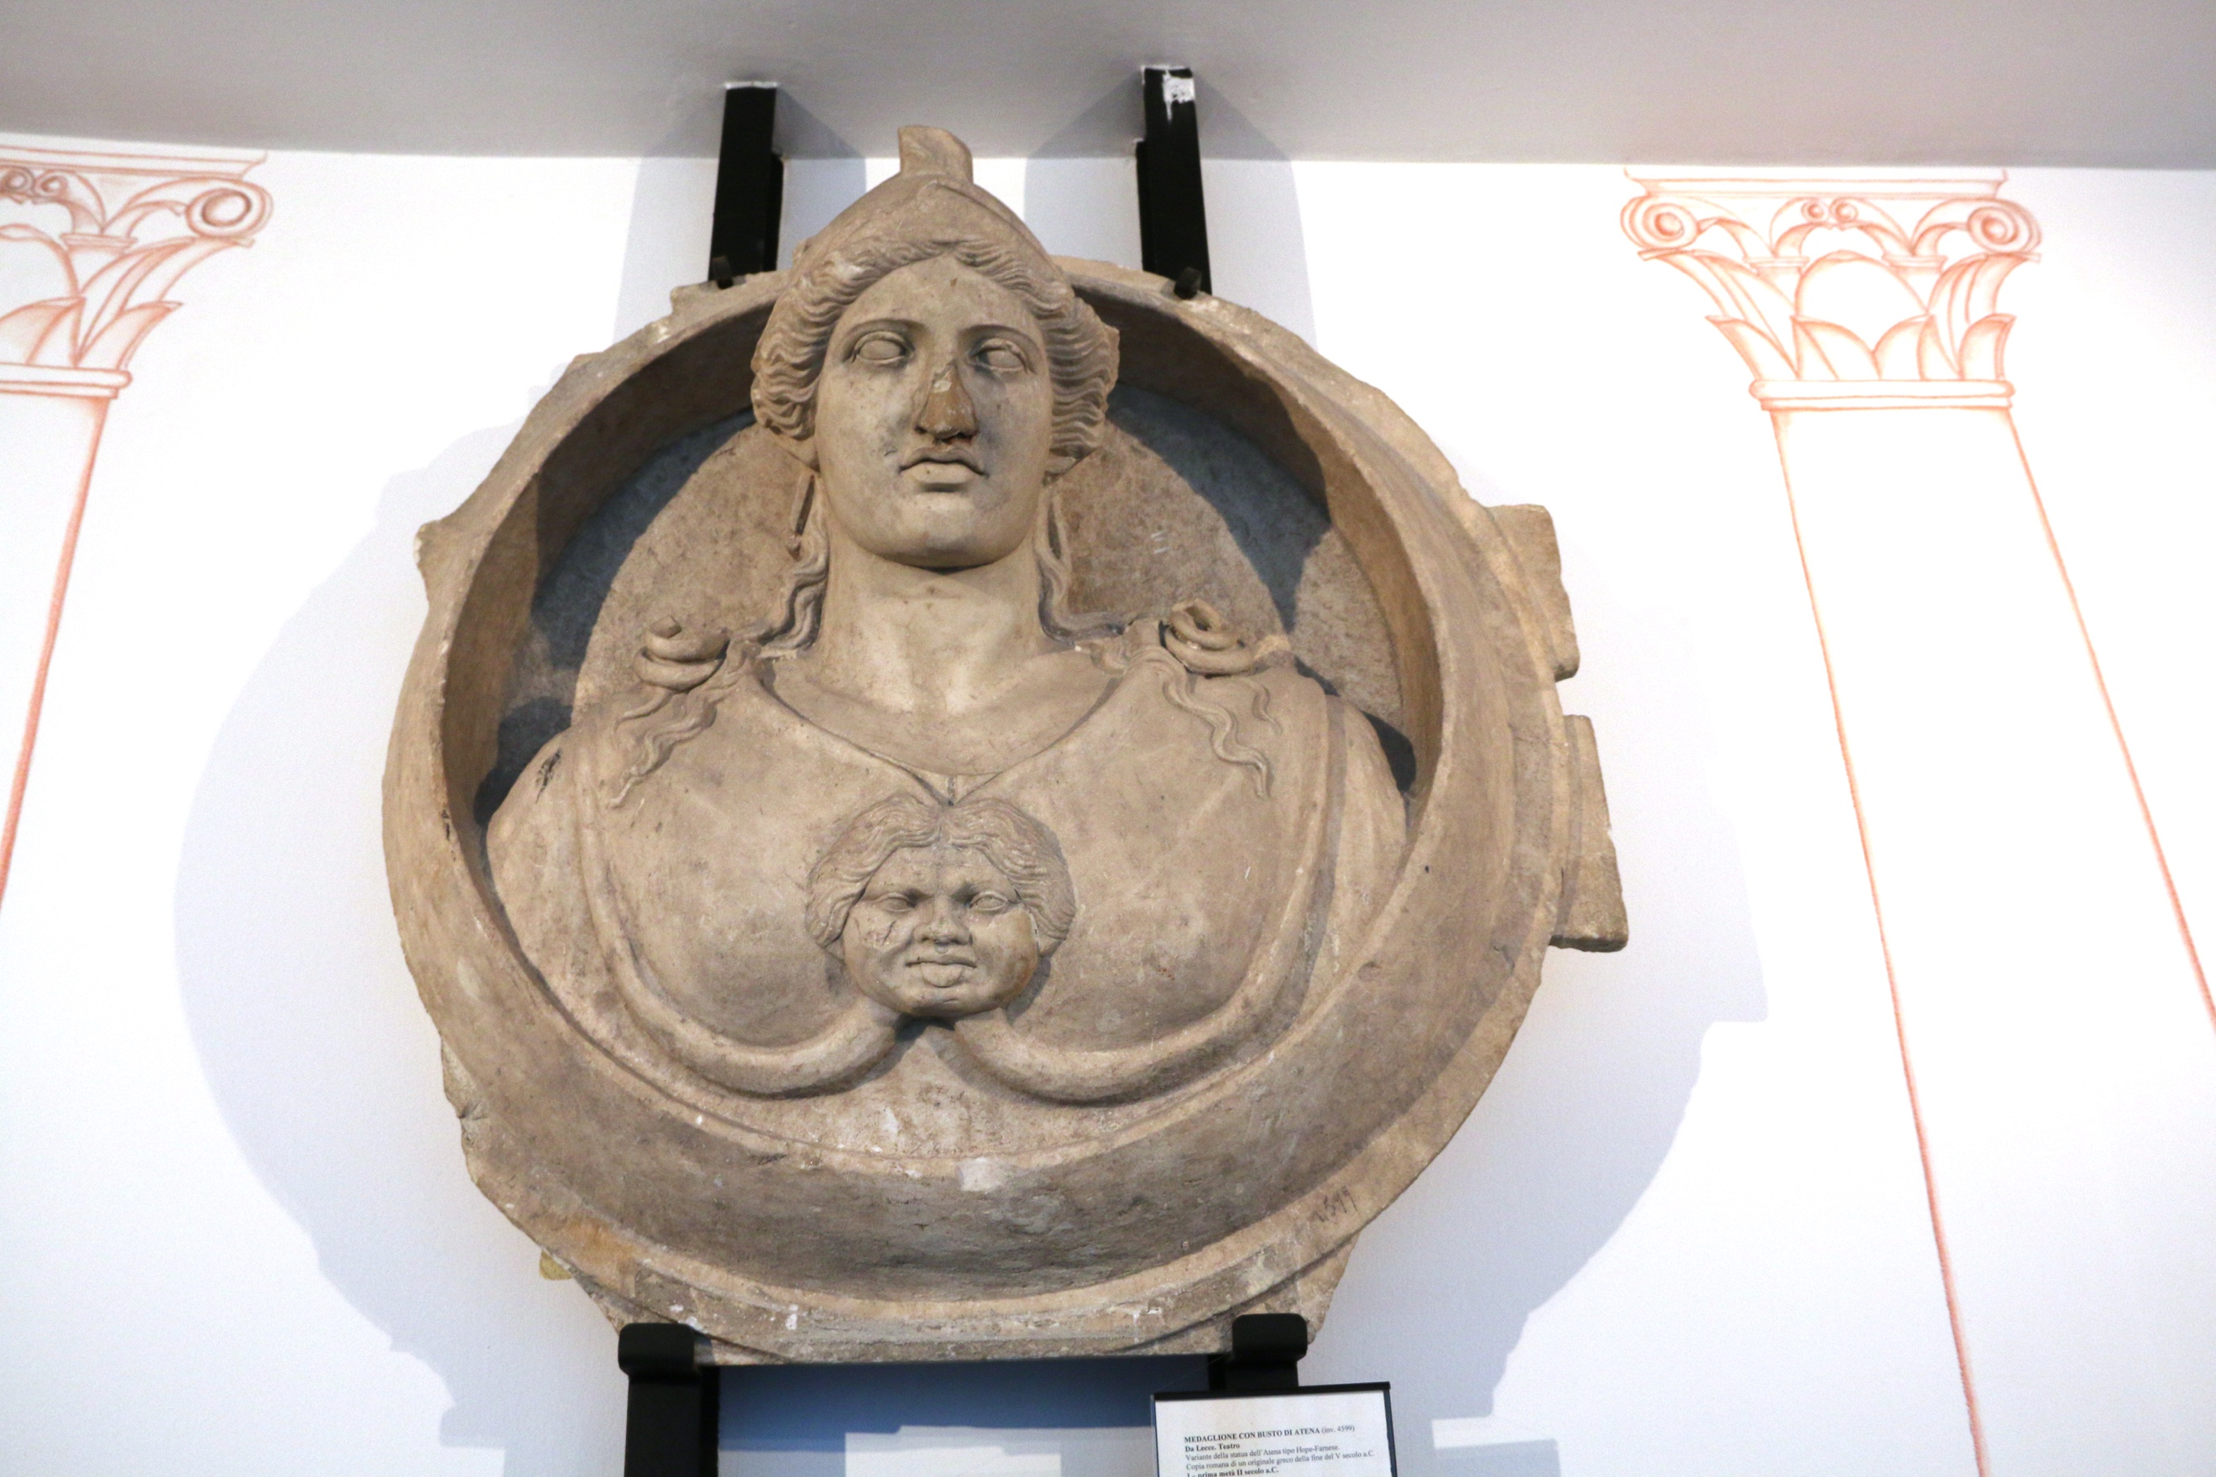
Figure 1.
Roman medallion of Athena
Archaeological museum "Sigismondo Castromediano" Lecce, Italy
2nd Century BC from the Amphitheatre of Lecce
Picture by Giovanni Dall'Orto, October 4 2015
Source: https://commons.wikimedia.org/wiki/Category:Athena#/media/File:6670_-_Medaglione_con_busto_di_Atena,_sec._II_a.C._-_Museo_archeologico_di_Lecce_-_Foto_di_Giovanni_Dall%27Orto,_10Ott_2015.jpg
Accessed 20.04.18

Bibliography

Ancient sources

Arrian, The Campaigns of Alexander, A.D.Selincourt (trans), 1971, London, Penguin Group.

Pliny the Elder, The Natural History, John Bostock (Trans) http://www.perseus.tufts.edu/
Available at: http://www.perseus.tufts.edu/hopper/text?doc=Perseus:text:1999.02.0137:book=35:chapter=36&highlight=philoxenus#note2
Accessed 18.04.2018

Websites

K. Kris Hirst, House of the Faun at Pompeii - Pompeii's Richest Residence, 2017, thoughtco.com
Available at: https://www.thoughtco.com/house-of-the-faun-at-pompeii-169650
Accessed at 11.04.2018

Museum of Naples, Battle of Issus between Alexander and Darius III, 2018, museoarcheologiconapoli.it
Available at: https://www.museoarcheologiconapoli.it/en/room-and-sections-of-the-exhibition/mosaics/
Accessed at 11.04.2018

Rossella Lorenzi, scientists figure out how ancient art was seen, 2010, nbcnews.com
Available at: http://www.nbcnews.com/id/34770241/ns/technology_and_science-science/t/scientists-figure-out-how-ancient-art-was-seen/#.Wt3vn0pSzOQ
Accessed at 15.04.2018

Video

Alexander Mosaic from the House of the Faun, Pompeii, Khan Academy, 2013, khanacademy.org
Available at: https://www.khanacademy.org/humanities/ancient-art-civilizations/greek-art/hellenistic/v/alexander-mosaic-c-100-b-c-e
Accessed at 11.04.2018

Khan Academy 2013
R. Lorenzi 2010
Plin. Nat. 35.36
Plin. Nat. 35.36
R.Lorenzi 2010
Plin. Nat. 35.36
Fig 1.
Khan academy 2013
K. Kris Hirst 2017
Naples museum 2018
Khan Academy 2013
R. Lorenzi 2010
Khan Academy 2013
Arrian. Campaigns of Alexander.4.20

