

Module Title: Psychology in Health and Social Care.
Module Number: LCHS 4010_LON.
Assignment No: ASSIGNMENT 2
Student Name: Adriana Ilona Rana-Ryng.
Student ID: 2430426
Lecturer’s Name: Muhammad Aliyu.

Report: Psychological Theories in Supporting Older Adults with Dementia in Health and Social Care Setting.

Table of Contents:
- Introduction. . . . . …………………………………………………….…...2
- Mental health practices in supporting people with dementia in home care and understanding dementia……………………………………….2 2.1. Nature of Dementia……………………………………………..……2 2.2. Chalange for Caregiving……………………………………..………2 2.3. Key elements in Care Home Dementia …………………………....2
- Context of Dementia Care………………………………………………...2 3.1. Emotional Needs…………………………………………………......2 3.2. Professional Support………………………………………………....3 3.3. Building a bond between staff and the Patient……………….……3
- Introduction to two Psychological Theories………………..……………3 4.1. Erik Erikson Development Theory……………………..……………3 4.2. Albert Bandura Social Learning Theory( of Behavior)…….………3
- Practical application of Psychological Theory and Methods in the Context of Health Care and Social Care…………………………………4 5.1.Erikson's Theory and practicing aplication…………………………..4 5.1.1. Challenges……………………………………………………………5 5.1.2. Strategies……………………………………………………………..5 5.2.Bandura's Social Learning Theory application………………………5 5.2.1. Challenges……………………………………………………………5 5.2.2. Strategies……………………………………………………………..6
- Biological and Environmental factors in home care settings…………..6 6.1. Biological Factors………………………………………………………6 6.2. Environmental Factors……………………………………………...…6 6.3. Tabela Nature and Nurture…………………………………………....7
- Critical evaluation………………………………………………..…………8
- Conclusion……………………………………………………………………8
- Reference…………………………………………………………………….9

1.Introduction.

This report examines two complementary psychological theories
Erikson's Theories of Psychological Development and Bandura's Social Learning Theory and their application in dementia care. By assessing their relevance in residential care, examples that demonstrate the importance of supporting individuals and critically discussing advanced strategies for specialized services.

2. Mental health practices in supporting people with dementia in care homes and Understanding Dementia.

2.1. Nature of dementia.
Dementia is a progressive neurological disorder that causes damage to neuronal communication in the brain. It disrupts normal memory, thinking, and functioning, leading to behavioral dementia. Personality changes, mood swings, agitation, aggression, sadness, wandering, withdrawal, and escape, along with social behavior and disorientation.

2.2. Chalange for Caregiving.
These symptoms challenge caregiving situations and pose a risk to the patients themselves, due to difficulties in judgment, a lack of anxiety, and disorientation. Various psychological theories provide frame to understand cognitive impairment and behavioral symptoms, link to needs for empathy in centre-care people with dementia is crucial.

2.3. Key elements in Care home Dementia.

- Structure and routine
- daily activity by stimulating cognitive function
(Brooker Hatman, 2016), well-being.
- Cognitive stimulation
- Structural therapy focuses on function and stability.
- Communication and engagement
- calm communication, build trust,
- modeling of behavior, positive response.
- Safe environment
- specialized structure, trained staff, dignity protection.
- Continuously Health Monitoring
- support all needs and relief families.

3. Context of Dementia Care.

3.1. Emotional Needs.
Is essential and focused on emotionally disturbed, disoriented, difficulty communication which reduces their quality of life ( Alzheimer's society, 2023 ).

3.2. Professional Support.
Trained professional staff identify pensioner needs who experience cognitive memory loss, personal changes, and functional independence, struggle with identity issues, social interaction, and locus of control and purpose. They create a safe familiar environment with routine and activities, regales stress, aggression with a calm redirection of attention - not a confrontation. Simply communicating yes/no, and maintaining a sense of belonging is fundamental.

3.3. Building a bond between staff and the patient
Essential is taking into account their life history, preference, values and what is fundamental (Kitood 1997). They offer comprehensive package, professional support, monitoring and medical care 24/7 with specialised environment, structure designed and facilities.

4. Introduction to two psychological theories.

4.1. Eric Ericsson's Development Theory.

Ericson proposed eight stages of life, each show a conflict. The stage Trusts via Mistrast, stage two Autonomic via Shame and stage eight, Integrity vs. Despair occurs in late adulthood (65+) is more relevant, older adults reflect their sense of lives, what is approved rights and good decisions, what protects their dignity, searching for meaning, coherence, acceptance and integrating with death, while fear leads to catastrophe (Ericsson 1982).
Dementia this process of integrity complicates because cognitive function deteriorates, memory loss and disorientation.
By supporting these individuals socially, we preserve their financial dignity and meaning in life. Every professional should incorporate Ericsson's theory into their practice, as it is relevant and focuses on older people and their life development.

4.2. Albert Bandura's Social Learning Theory (of behavior):
Theory involves learning, observation, imitation, and social modeling (Bandura 1977). Learning occurs through experience and observation of others. The theory is based on self-efficacy, the belief in one’s ability to succeed (Bandura 1997). People with dementia struggle with fluency and complex tasks, but they imitate behaviors when they are exploited or influenced by their environment.
These are role models, routines, reinforcement and shaping behaviors that promote well-being, as pointed out by Bandura's Theory.

5. Practical Application of Psychological Theory and Methods in the Context of Healthcare and Social care.

5.1. Erikson's Theory and practical application:
- Fostering autonomy Daily task encourage the peron to do as much can’t independently such as dressing, focus on strength and ability- Autonomic via Shame
- End-of-Life Care: Specialized and trained support for residents staff, validate experiences, reduce anxiety, and promote acceptance - maintain dignity in achieving ego.
- Meaningful Activities: Adding direction to the daily routine, like gardening, art, religious practice, can enhance a sense of self-esteem and belonging, and alleviate feelings of avoiding despair.
- Responsive caregiving reaction for physical and emotional needs individual,safety and professional emphatic care regardless of age. A sense of basic trust is all life special in periods of heightened vulnerability like lines or dependent on caregivers - Trusts via Mistrast.
- Remission therapy (psychotherapy), shadows of history: uses affirmations of one's own identity and reflections - through images, music and historical narratives, builds social integrity, strengthens life experiences, reduces losses, promotes acceptance by the environment and peers ( Coleman 2005) - integrity individuals need to feel life has meaning.
- Life Review Therapy LRT- niegratulujący versus despair (ego, purpose, process). Benefit is reducing psychological distress, increasing life satisfaction, resolving past issues.

Examples:
- Looking at familiar photos gives positive reflection about past life and reinforcing integrity whilst reducing - despair.
- Due to cognitive decline, residents may feel embarrassed and insecure when hospital staff pressure them to button their shirts, leading to a lack of self-care. Strategies for "just right" shirt fit (plastic snaps) - Autonomy versus Shame.
- Mrs Smith is calm during personal care because she recognizes her caregivers faces and kind behavior, whereas other carers she doesn’t know, leading to fear and aggression. Strategies staff prioritized so that residents can feel safe and build trust. The new employee should be in the shade previous whom Mrs. Smith trusts - Trust versus Mistrust.

5.1.1. Challenges:
- Due to cognitive impairment, verbal communication is limited, which makes reminiscences difficult.
- Traumatic memory, events can cause emotional stress,
- Due to staff shortages, there is limited time to personalise.

5.1.2. Strategies:
- Multi-neuronal sounds like music, smells or tactile objects are used to stimulate sensory perception and memories supported ( Woods in,2018).
- Trained, empathetic trauma-informed care staff builds a positive relationship between needs and the care services provided.
- Help from family members in a reminiscence session that ensures continuity of bonds and emotional support.

5.2. Bandura's Social Learning Theory application.
- Division of task and adapted environment for task, strengthening and strategy,
- Group activities, such as singing, exercise, or art classes, strengthen social bonds through observation and imitation of peers.
- Observation learning, by imitating familiar routines after demonstrating step by step.
- Positive reinforcement, such as small gifts and rewards, encourage residents to participate in activities, reduce social withdrawal and isolation.
- Staff modeling calm behavior, respectful behavior to prevent resident aggression – the Four Frames Principle ( session mirror).

Egzemples:
- Carers demonstrate handwashing before meals, pensioners will follow routine, reinforcing hygiene through observation/repetition.
- Music therapy and interaction with peers is what provides social integration.

5.2.1. Challenges:
- Older adults with advanced dementia struggle with challenging tasks that provoke stress or aggression.
- Reducing negative patterns that can irritate nursing home residents and provoke aggression.
- Difficult-to-achieve cohesion and conflict within teams require specific, targeted solutions.

5.2.2. Strategies:
- Into smaller tasks using a step-by-step approach reduces anxiety and helps to finish training.
- Continuous staff training with positive modeling and reinforcement.
- Common procedures established in advance help reduce confusion and anxiety (Kitwood,1997).

Examples in practice:
- Rooms of memories: decoration in 50s - 70s, which help support the stage of integrity in Erikson's theory.
- Music therapy in group: residents imitating singing, observing and improving their mood, well-being,and social integration,in Bandura's theory.
- Peer mentoring: enabling older adults with mild dementia to model behaviour by participating in meals with people with advanced dementia.
- Modeling staff: through alternative behaviors or calmly responding to aggressive behavior limits its escalation.
Theory-based examples demonstrate use and practical application by connecting abstract concepts with real-world interventions.

6. Biological and environmental factors in home care settings.

6.1. Biological factors.
It is related to age and changes such as cognitive decline, mood swing, continuous stress, which is a key to caregiving needs.

6.2. Environmental factors.
Social learning and psychosocial support at different ages, through emotional adaptations and social interactions, the physical environment, and the quality of care.
Erikson's "Integrity vs. Despair" Theory emphasizes the importance of a supportive environment for maintaining dignity in the face of biological changes.

Bandura's Social Learning Theory observation and reinforcement, self-efficacy can be achieved and problems can be solved. Positive modeling builds self-efficacy, while negative modeling causes stress.

The biological limitations and the supportive environment can impact the quality of life of a nursing home resident with dementia. They emphasize the need for holistic care that addresses physical health and psychological resilience.

6.3. Tabela Nature and Nurture.

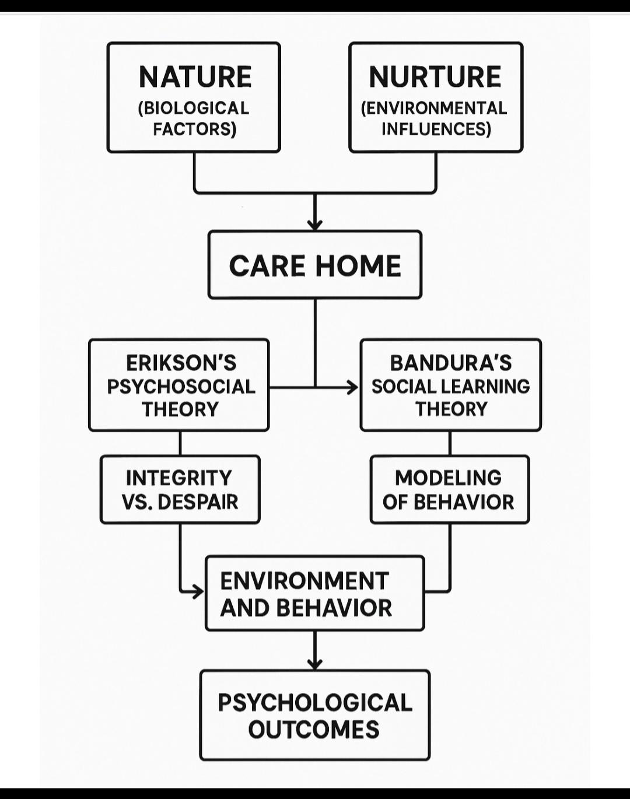

7. Critical evaluation.

Erikson's theory offers a developmental perspective and emphasizes understanding meaning and identity. However, it simplifies the concept of late adulthood and the stage of integrity. Dementia disrupts this theory and may not lead to adaptation.
Bandura's theory presents behavioral strategies and observable learning, but it also does not account for cognitive decline. The only tools we can use are imitation, small acts that can improve well-being in old age.
Two theories complement each other. Erikson's theory understands the person and their existential needs, while Bandura's theory presents practical, integrated behavioral strategies that support the emotional and behavioral development of older people and the care of people with dementia.
Integration of Both Theories.
Egzaples:
Bandura and Erikson:
1). They model calm communication (Bandura), while simultaneously supporting memory and a sense of dignity (Erikson), and propose holistic care.
2). Routine and Reinforcement: Scheduled meals and rituals act as reinforcement (Bandura) and a source of meaning (Erikson).
3). Engagement in Activities: Through cooking or listening to music, observing the student's learning (Bandura), which affirms identity and agency (Erikson).

8. Conclusions.

Health and social care professionals in residential care with dementia should integrate psychological theory with practice models to appropriately support older adults, and staff should receive professional training.
Erikson's Psychosocial Theory emphasizes the importance of personal dignity, while Bandura's Social Learning Theory mentions the role of modeling and reinforcing appropriate behaviors. Cognitive impairments and personal deficits are the primary concerns, while strategic remission therapy provides positive reinforcement. Targeted procedures streamline care, and critical and creative application of these theories can improve older adults' psychological well-being, integrity, dignity, and social connectedness.

9. Reference.
- A-Laing Erikson’s Theory in dementia communication: Nordic Journal of Nursing Research (5)
- Alzheimer’s Society Annual conference 2023.
https://www.alzint.org/news-events/events/alzheimers-society-annual-conference-2022/
- Bandura, A.(1977) Social Learning Theory. Englewood Cliffs, NJ:Prentice Hall.
- Bandura,A.(1997) Self-Efficacy: The Exercise of Control. New York: Freeman.
- Coleman, P.G. (2005) ‘Uses of reminiscence: Functions and benefits’, Aging and Mental Health, 9(4), pp.291-294.
- Erickson,E.H. (1982) The Life Cycle Completed. New York: Norton.
- Kitwood,T. (1997) Dementia Reconsidered: The Person Comes First. Buckingham: Open University Press.
- Personhood and we’ll-being in dementia care: Cambridge University Press.
- Sabat,S.R. (2001). The Experience of Alzheimer’s Disease: Life Through a Tangled Veil. Oxford: Blackwell,Woods,B.,
- O’Philbin,L., at all (2018). ‘Reminiscence therapy for dementia’, Cochrane Database of Systematic Reviews, Issue 3, Art. No.: CD001120.

