Usability Engineering
Interface design prototyping and analysis
270696 (Ed Smith)
2021
Contents
Introduction 2
Scenario 2
Usability Engineering Lifecycle (UEL) 3
Human Computer Interface (HCI) 3
Human Factors 4
Perception 4
Human Memory 4
Human Reasoning 5
Metaphor 5
Task Analysis Diagrams 5
Design Rules & Principles 7
System Design 8
Blood Kiosk User Evaluation 16
Evaluation of my feedback 18
Evaluation of feedback given 19
Software Prototype 20
Overall Evaluation 31
Conclusion 31
Bibliography 33

Introduction

The purpose of this report is to provide an in-depth overview of the fundamental design and development phases involved to develop a blood test kiosk prototype. The prototype will aim to cover all requirements as highlighted in the given scenario.

Scenario

I have been tasked with developing a blood test kiosk for quick and simple blood testing. It is required to have the capabilities to choose between different tests such as a pregnancy test, an STD test, or blood chemical analysis. Other system requirements include the ability to print a report after successful testing, allowing users to take the document to a doctor or pharmacist. The last system requirement is that all tests are individually priced and will be needed to be paid upfront by the user via credit card or cash. Initial research studies show that ‘the use of kiosks to deliver health information is growing rapidly’ (1) and it is bridging the gap between ‘people who have access to health information and communication technologies and those that do not' (1). This strengthens the importance of developing and designing the blood test kiosk.

Usability Engineering Lifecycle (UEL)

The Usability Engineering lifecycle was created by Bias and Mayhew ‘as a means to build a usability test plan’ (2). Correct implementation of the UEL into the product development cycle will allow for thorough analysis and testing. This allows you to ‘get the most out of your usability design, analysis, and testing' (2). Bias and Mayhew incorporated three phases to the UEL model that include, requirement analysis, design testing, and development and installation. Below is a diagram illustrating the life cycle model.

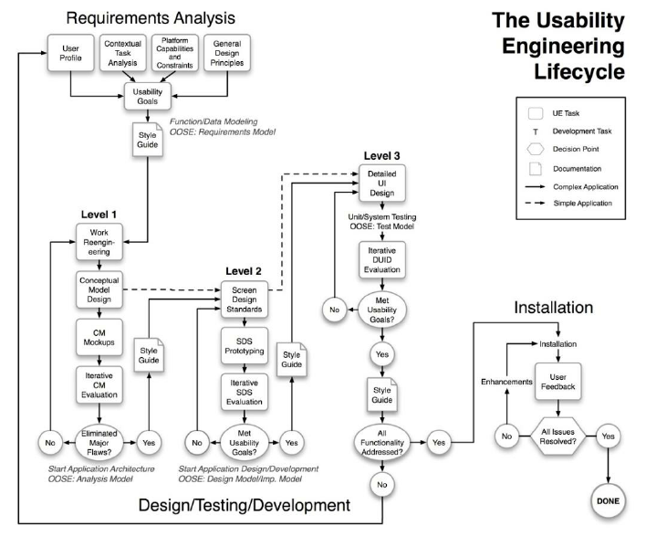(3)

- Requirement analysis – During this stage of the lifecycle user characteristics are established alongside product operation requirements. This sets the basis for the goals and guidelines of the usability study.
- Design testing and development – During this stage, the product design is created using a structured top-down approach. This stage of the project requires the most feedback from the project team.
- Installation – The final stage of the life cycle is to allow gathering of feedback from users ‘during and after the development process and share this feedback with the project team’ (2). This will allow for corrections to be made if needed.

Human Computer Interface (HCI)

Human-Computer Interface also known as HCI is the ‘study of how people interact with computers and to what extent computers are or are not developed for successful interaction with human beings' (4). The HCI is compiled of three sections, these being the user, computer, and how they interact with one another.

User -

The user can mean both individuals and groups of users. A recognition of how the users’ sensory systems relay information is crucial. Each user is also unique, having different conceptions about interactions and the way a user may learn and retain knowledge.

Computer -

Computers are any technology such as desktop computers or large-scale computer systems. A computer system for example can be the design of a website, with the website being referred to as the computer in this scenario.

Interaction -

The purpose of HCI is to ensure that the interaction between humans and machines is successful, although there are differences between the two. Usable systems are most successful when users of the systems are consulted during the design process.

Human Factors

Perception

‘Perception is the process of attaining awareness or understanding of sensory information’ (5). Perception can be both oral and visual dependent on the system/user requirements. The first perceptual process stage is selection, where we ‘limit our attention to those aspects of strangers or the situations that are essential to what we are doing’ (5). The next stage is organisation, where we select information from the outside world and form the information into meaningful patterns. The final stage is interpretation, where we attach meaning to the selected stimuli. This stage may give different interpretations of the same stimulus from the users. Design features in the system such as colour, size, depth, and brightness all affect the perceptual system, which will be carefully considered when designing the kiosk.

Human Memory
Another human factor that needs consideration for the prototype design is human memory. The first scientific approach to the studying of memory was conducted by Herman Ebbinghaus in the mid-1880s (6). ‘Memory is our ability to encode, store, retain and subsequently recall information and past experiences in the human brain’ (7). According to the interaction design foundation, human memory is made up of three types, sensory, short-term, and long-term memories. In HCI ‘interaction takes place in sensory and short-term memory’ (8). Long-term memory is not used in HCI as it increases cognitive load, meaning tasks become complicated and prolonged. The blood kiosk will aim to avoid this by using ‘familiar interaction patterns, menus, icons, and consistently placed objects’ (9).

Human Reasoning
The next human factor that will be taken into consideration is human reasoning. The term reasoning ‘is the process by which we use the knowledge we have to draw conclusions or infer something new about’ (10). The common types of reasoning used in HCI include deductive, inductive, and abductive reasoning. Deductive reasoning ‘derives the logically needed conclusion from the given premises’ (11). However, a logical conclusion is not always true, meaning deductive reasoning can be misapplied. Inductive reasoning is the generalizing of information from old scenarios and applying it to scenarios yet to be seen. Although inductive reasoning is unreliable, it allows constant learning about our environment. Finally, abductive reasoning is reasoning ‘from a fact to the action or state that caused it’ (10). This prevents users from exploring alternative theories or explanations unless evidence is provided, which can lead to problems with using interactive systems.

Metaphor
The last human factor to consider is metaphors, which are a ‘technique used to simplify interface design’ (12). With careful consideration, a metaphor can assist users of the blood kiosk to use its interface. A Desktops, files, and folders are a common metaphor, as it bridges computer language to users on how their files will be stored. The metaphors used for the blood kiosk will suggest styles of interaction, with the hope the user can ‘relate to past experiences’ (13) to allow effective and efficient use of the kiosk system.

Task Analysis Diagrams

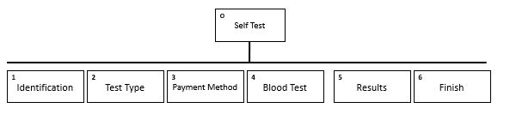
- This screenshot briefly shows the phases a user will go through to use the blood kiosk.

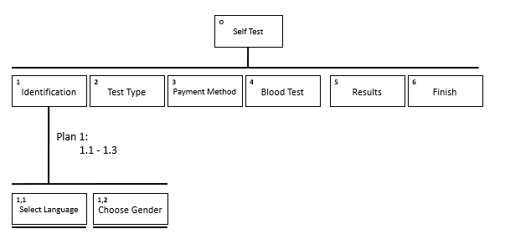
- This screenshot shows the identification process the user must complete to move onto 2. The user must select their preferred language, then gender.
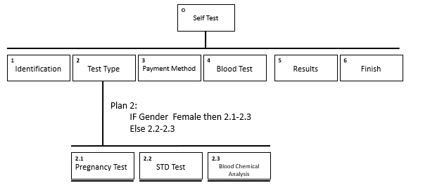
- The next screenshot shows the options of tests a user can choose from. It also shows if the user a male doesn’t show 2.1(Pregnancy test).
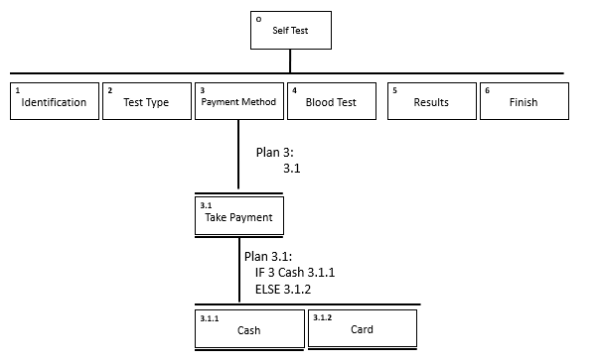
- The next stage the user must choose a payment method either cash or card to continue to the blood test.
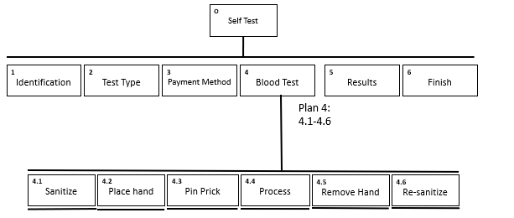
- After payment is received the user will start to conduct the blood test going through all parts of this stage from 4.1-4.6

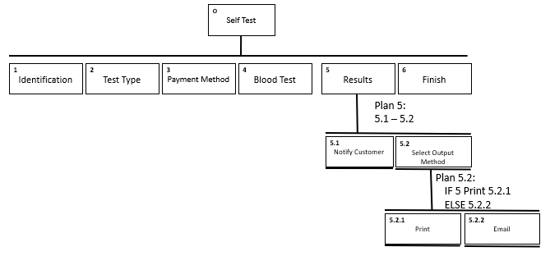
- This stage of the system the user can select their preferred choice of receipt method for results, either printing or emailed copies.
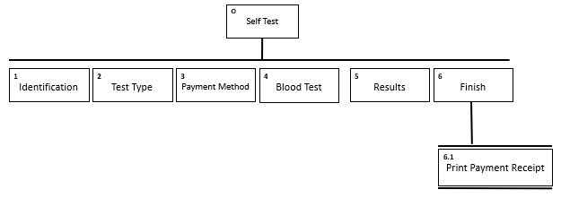
- Finally, the last stage the user will be offered a transaction receipt to be printed, then the user has completed all the stages.

Design Rules & Principles

Certain design rules and principles for interface design have been followed for both the design and implementation of the blood kiosk. These design rules and principles were manufactured by four men who go by the names of Dix, Nielsen, Schneiderman, and Norman. Although all theories cover a broad range of interface design principles Alan Dix covers the most, which is why his principles will be the basis of the comparison table below. Each of these design principles will be referenced throughout the system design and paper prototype when appropriately used.

Dix | Nielsen | Schneiderman | Norman
Learnability
Flexibility | Flexibility and efficiency of use |  | Mapping
Robustness | Flexibility and efficiency of use | Support internal locus of control | Constraints
Predictability | Match between system and real world |  | Visibility
Synthesizability |  | Design dialog to yield closure | Feedback
Familiarity | Match between system and real world | Seek universal usability | Visibility
Generalizability | Recognition rather than recall | Seek universal usability | Affordance
Consistency | Consistency & Standards | Consistency | Consistency
Dialogue Initiative | User control and freedom | Keep users in control | Constraints
Multithreading
Task migratability | Error Prevention | Prevent Errors | Constraints
Substitutivity
Customizability | Flexibility and efficiency of use | Keep users in control
Observability | Visibility of system status | Offer informative feedback | Feedback
Recoverability | Error prevention | Permit easy reversal of actions
Responsiveness |  | Offer informative feedback | Feedback
Task conformance | Help and documentation

System Design


This is the introduction screen for the blood test kiosk. The screen shows the option of having the blood test process in both English and Welsh languages which follows Schneiderman’s keep users in control as ‘users desire the sense that they oversee the interface’ (14). For a user to continue to the next screen they need to press the Press to get started button allocated at the centre of the screen. The I icon in blue is applied throughout the system, to act as a help section for confused users, this follows Norman's principle of affordance where there is a ‘link between how things look and how they’re used’ (15)

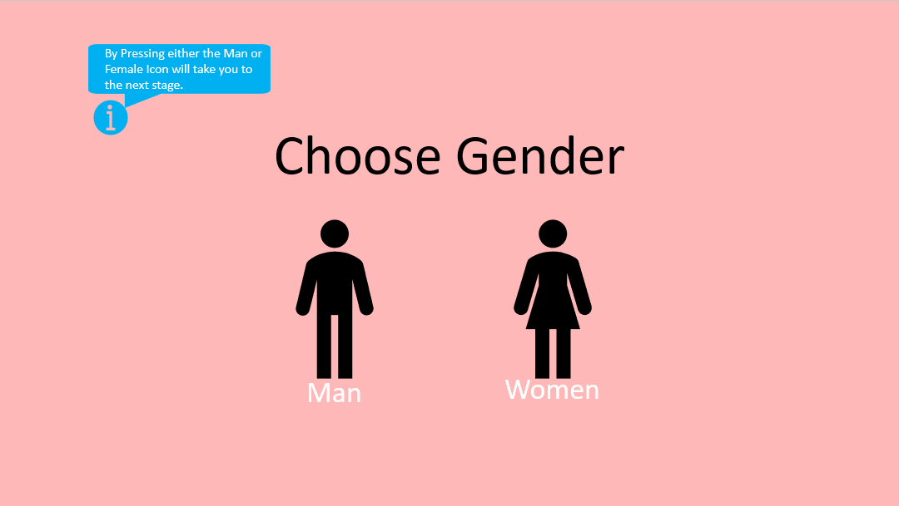
This is the next screen of the system, where users are presented with a choice. The choice is to select what gender they are, this will determine what tests are displayed on the next screen. I have decided to use the gender symbols as again it links with Norman's affordance principle as these symbols can be linked to previous experiences. As you can see there is consistency already in the appearance of the screens with the same colour scheme and information help in the top left. Consistency in user interface design is a common principle mentioned by all the theorists above. Nielsen for example believes ‘words, actions, situations, etc. should always mean the same thing’ (16).

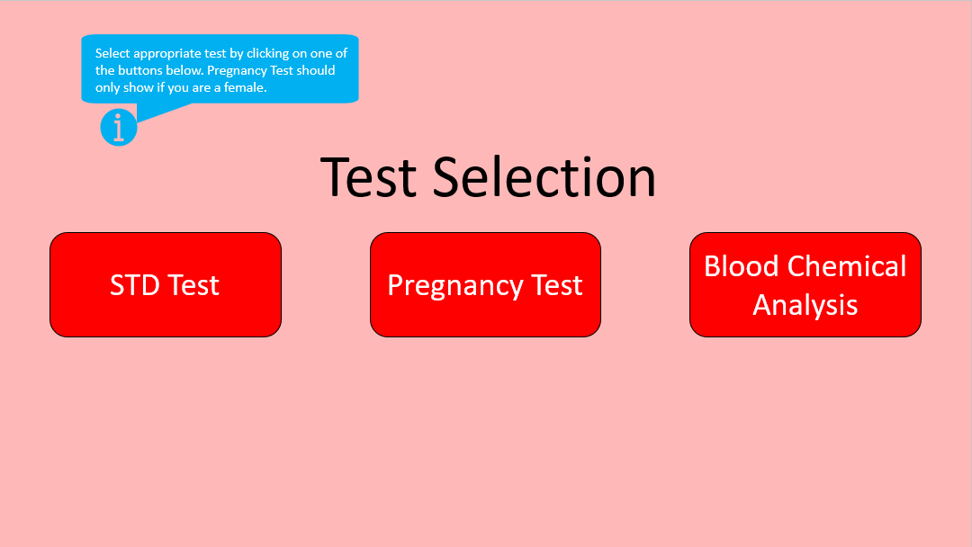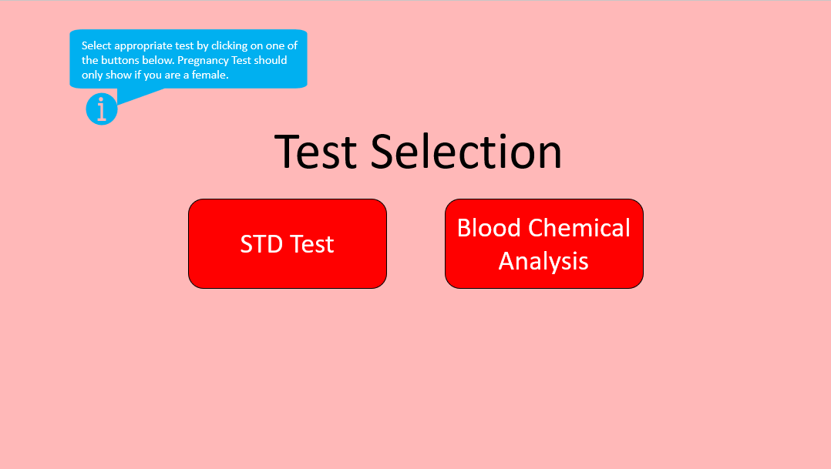
These screens are the pathways users can take determined of what gender they have chosen. Again, the information section explains to the user how to use the page by selecting the appropriate test. As you can see women will only have access to pregnancy tests, this acts as a form of constraint for the menu screen as according to Norman's principles users can ‘become overwhelmed with the range of possibilities' (15). The choices of tests available also can be supported by Dix’s principle of task conformance as the ‘system services support all the user’s tasks’ (17)
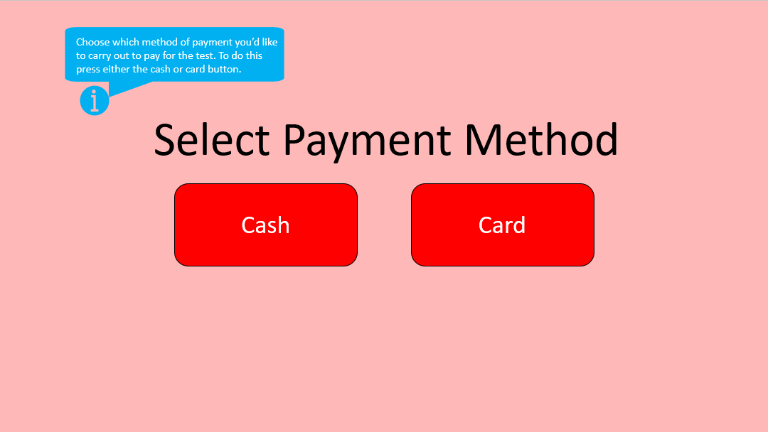
After the user has chosen the test, they will then be offered to select a payment method of choice, in this case, cash or card. Cash and card payment methods have been offered as they co-align with Dix’s principle of familiarity, this is because users will have ‘prior knowledge of system interaction’ (17) of payment methods, this again is supported by Norman's principle of affordance.

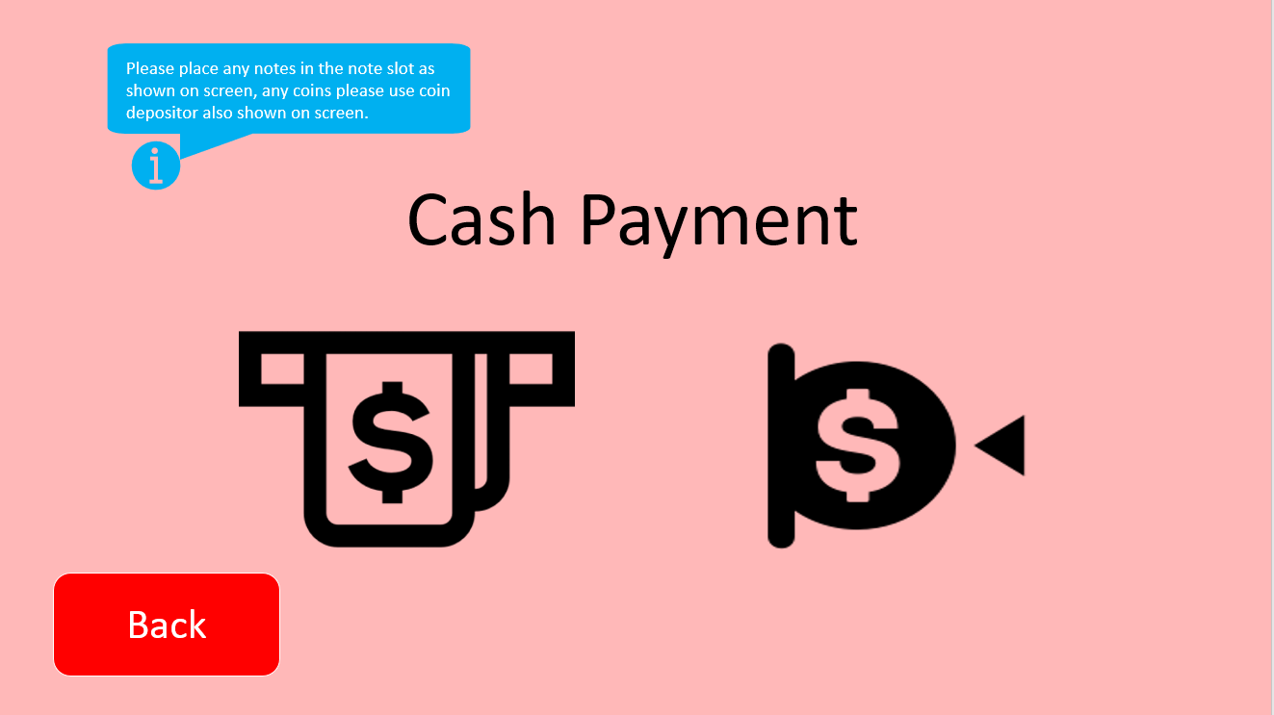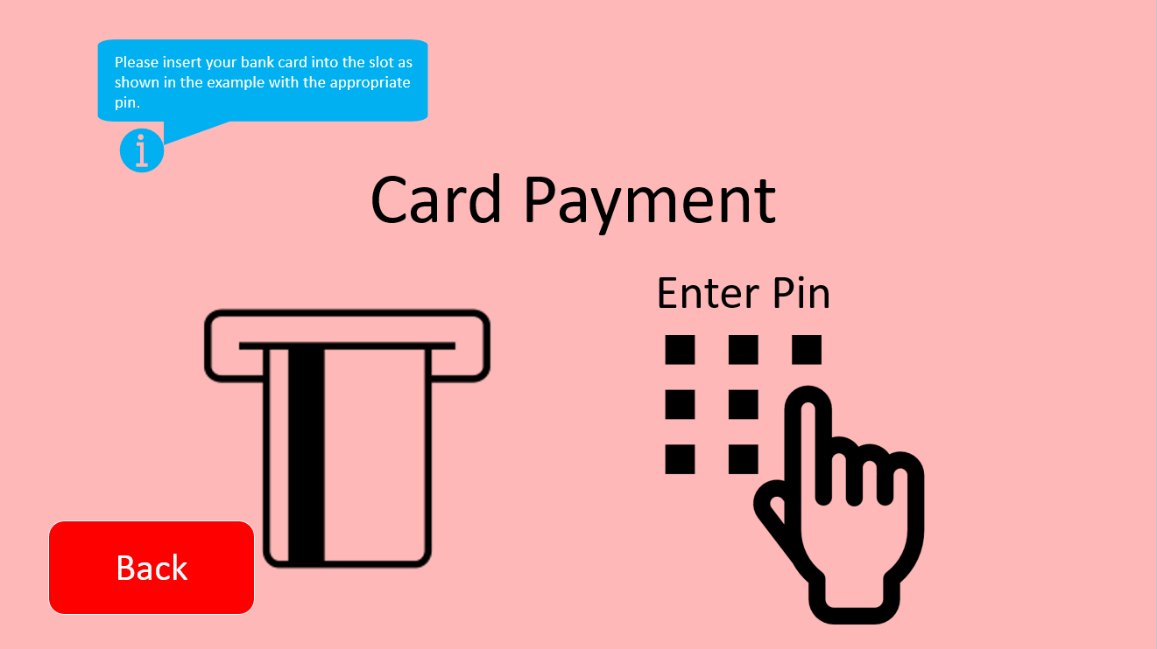

These are both the payment method screens that indicate the option chosen from the previous screens. Both screens show clear instructions on how to pay cash or card. The information bubble also provides a written explanation of how the screens should be used. As you can see back buttons have been introduced on these screens to act as way to reverse actions which Schneiderman believes ‘this feature relives anxiety’ (14), because users know errors can be reversed.
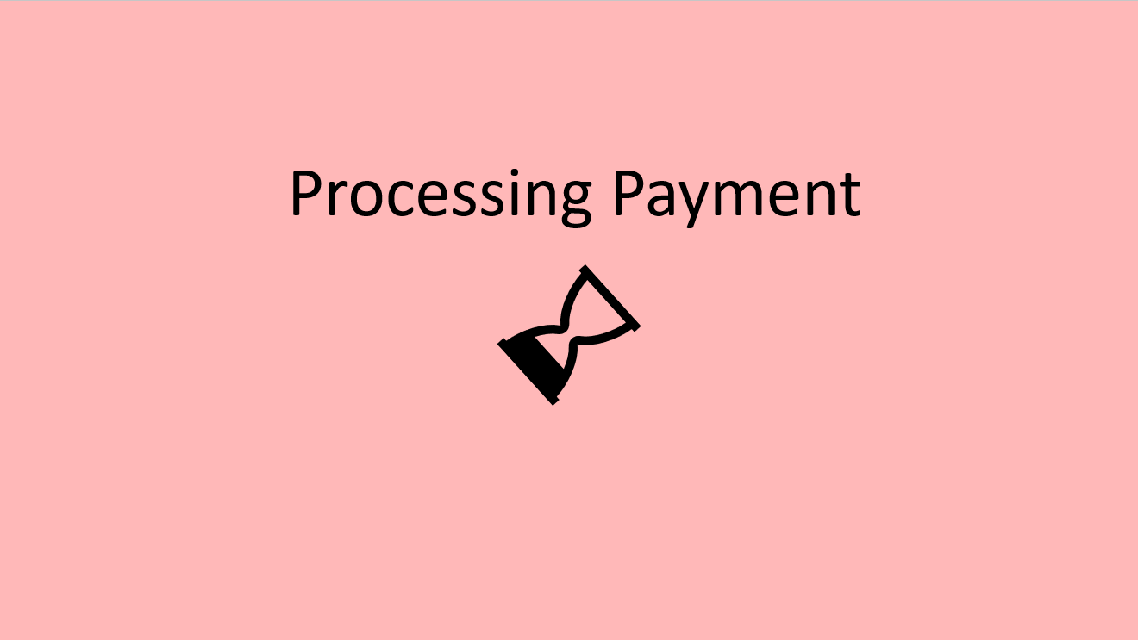
This screen is the processing payment part once the user has paid via the two methods. The reasoning behind this screen was to offer informative feedback which Schneiderman believes ‘for every user action, there should be an interface feedback’ (14). This is also supported by Norman's principle of feedback as it lets ‘them know whether or not their action was successful’ (15).


Once the processing of payment is finished the user will be informed and can continue with the test. This again supports the principles of feedback.
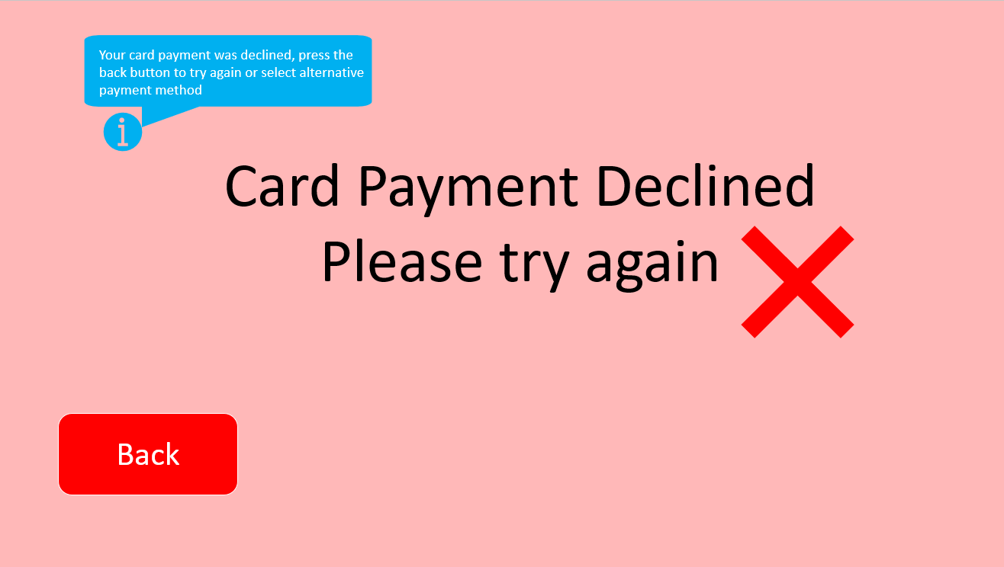
This screen will show if the card payment method is declined, based on wrong pin entered or not enough money in the bank account. This screen design is supported by Nielsen’s principle of visibility of the system’s status. The user can see what has gone wrong within ‘within a reasonable timescale’ (16). The back button has been added to this form to allow the user to retry the payment method. The button is visible which in Normans principles ‘users should know just by looking at an interface, what their options are’ (15).

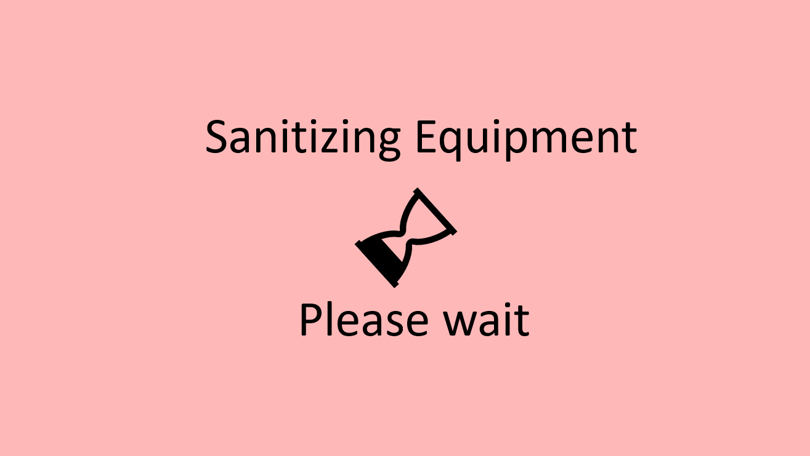
This screen starts the testing phase and sanitizes equipment before user use. Again, to inform the user what has been going on Schneiderman’s principle of feedback has been used.
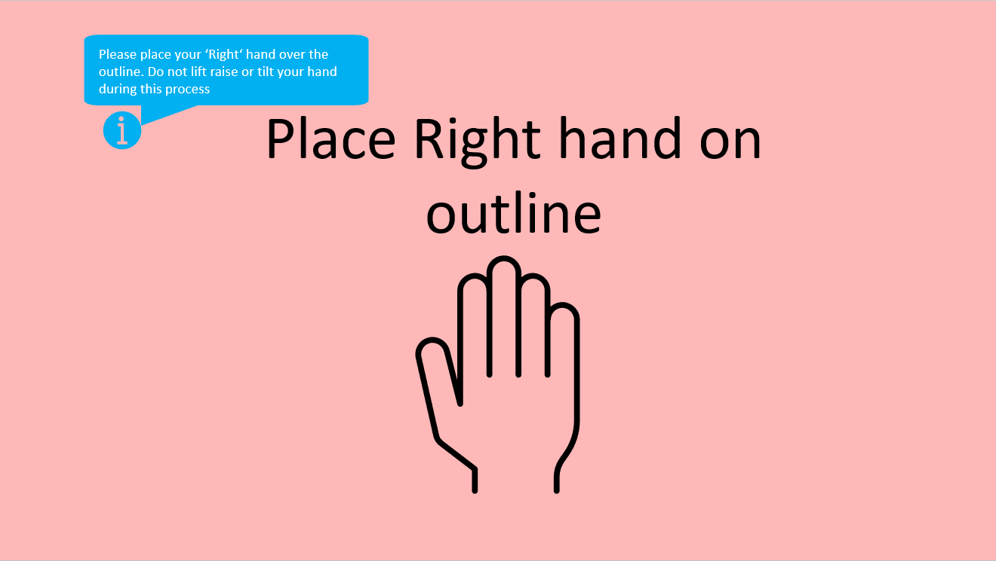
The blood test can now take place as the user has entered all the information and paid. To begin the test the user must place their right hand within the outline. The implementation of the hand outline has been used because of Dix’s principle of familiarity, about ‘guess ability and affordance’ (17). The user will know that it is required to place their right hand within the outline, due to previous experiences of other systems.

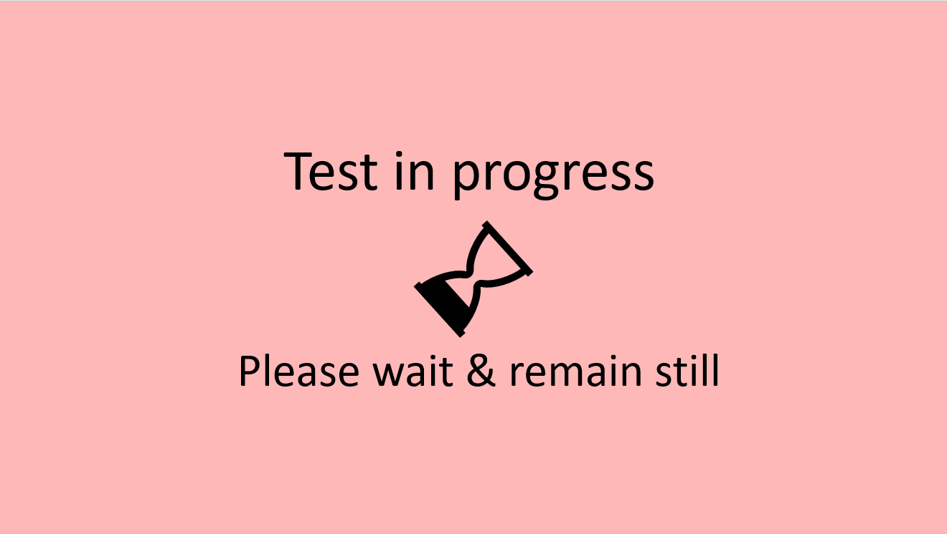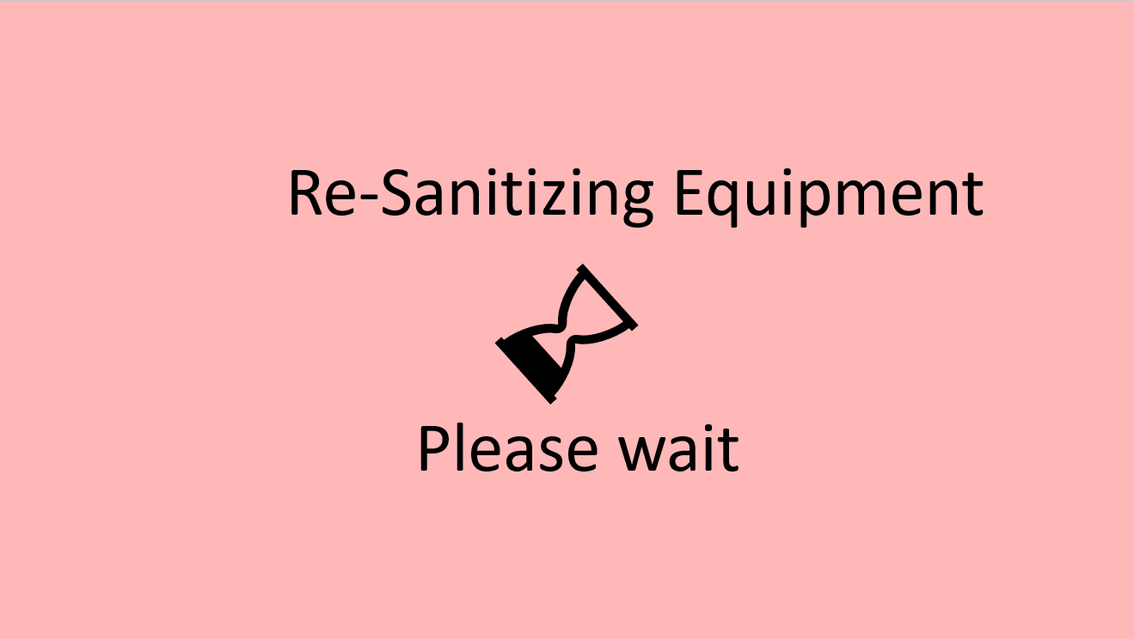
The next three screens act as feedback screens to allow the user to know that their blood test complete. The first screen tells the user to remain still and keep a hand in place, the next screen shows the test is completed allow the user to remove their hand, and finally the equipment is re-sanitized for the next use. Informative feedback here and throughout the system is necessary and follows Schneiderman’s principle as previously mentioned ‘for every user action, there should be an interface feedback’ (14).

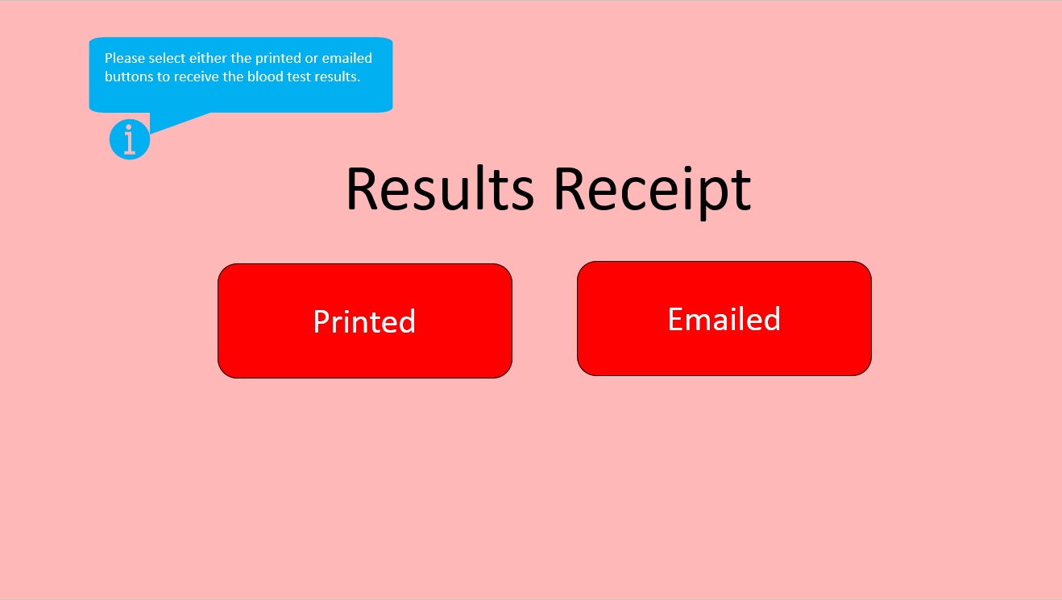
This screen allows the user to get a receipt of the test either printed or emailed. Again, this screen aims to keep a minimalistic design as Nielsen’s principle of Aesthetics and minimalist design suggests ‘dialogue should not give irrelevant or rarely useful information' (16).

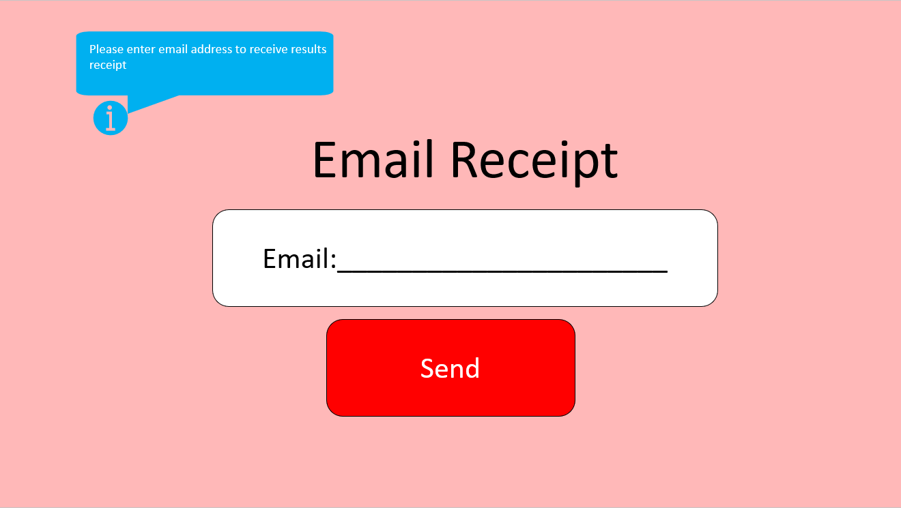
The next screens show the options selected by the user. If the user selected an email receipt they would have to enter an email address. I have used a long line to show where input is needed. This is because it provides familiarity to users, who have filled out forms in the past that text is required here. Dix’s principle of familiarity supports this design option as its considered ‘prior knowledge' (17).

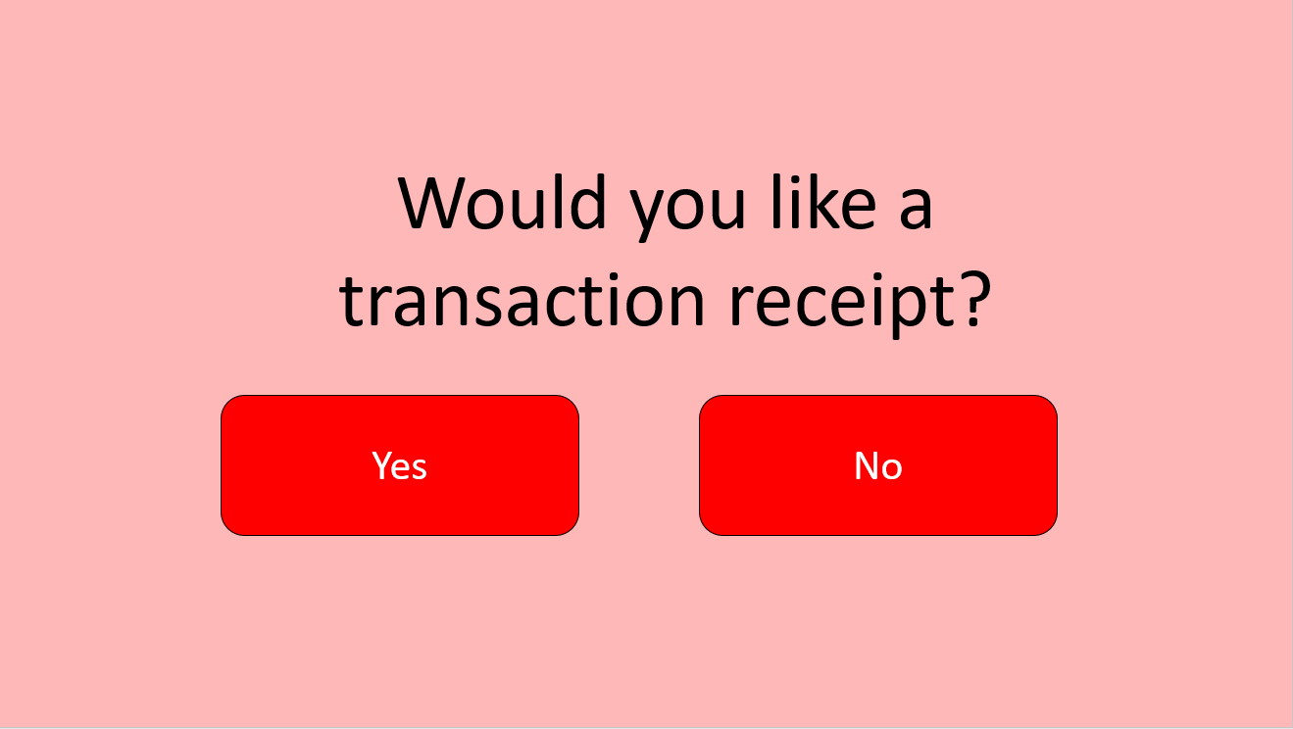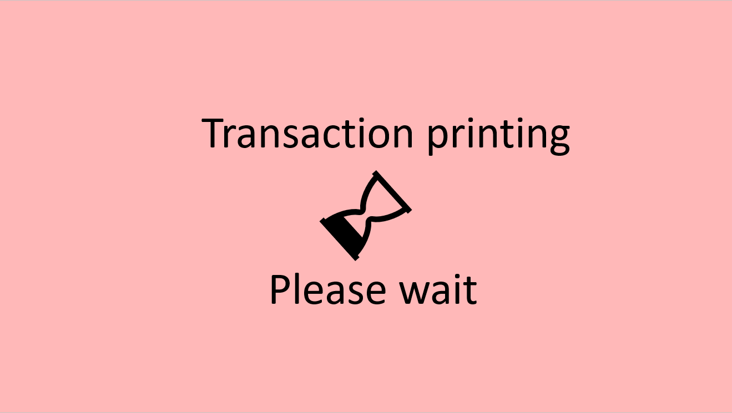
Coming to the end of the system the user will be ask if they would like a transaction receipt for the payment method of choice. Once chosen the transaction will start to print. As shown on the feedback screen.
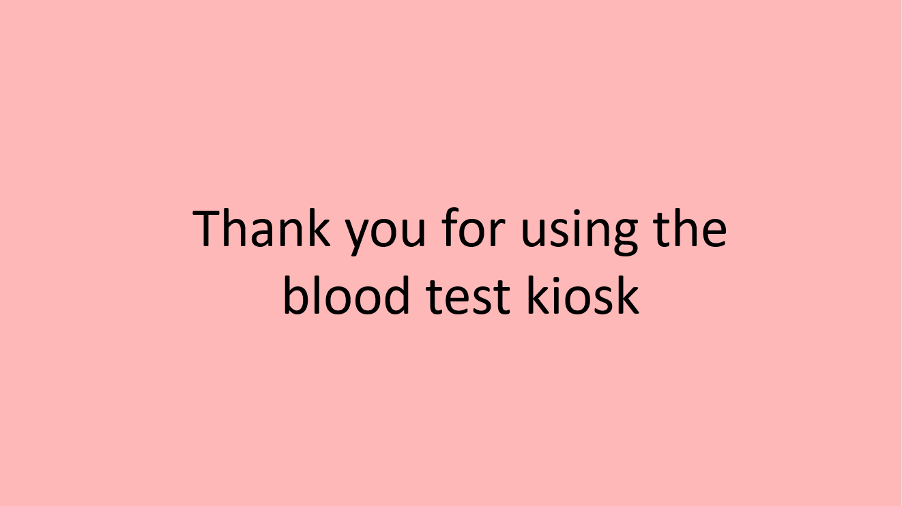
The final screen shows the user has completed every stage of the system and the next user can begin when ready.

Blood Kiosk User Evaluation

The questionnaire below was given to the user of the paper prototype walkthrough. The purpose was to evaluate the functionality and quality implemented. The questionnaire also helps me compare whether the features and principles I used from the four design principal theories were applied correctly.

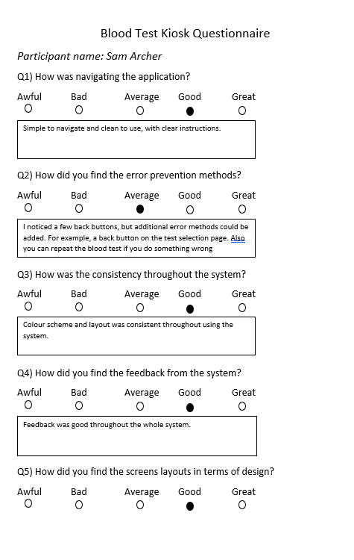
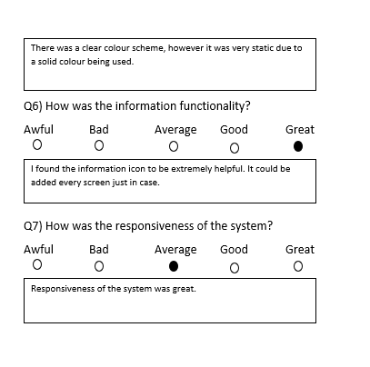

Evaluation of my feedback

The feedback provided suggests that the navigation of the system was ‘simple with clear instruction’. This shows that the design principle of visibility from Normans Principles was achieved as the user knew ‘what their options are and how to access them’ (15). Feedback also suggested that there was a level of error prevention methods implemented throughout the system meaning Nielsen’s principle of error prevention was achieved. However, the feedback also suggests further prevention methods need implementation. I will take this on board, as the error prevention principle aims to ‘eliminate error conditions’ (16) for users to see. Another point in the feedback given was the good amount of consistency. This shows that the design principle of Nielsen’s consistency and standards has been re-laid throughout the system.

The next feedback given was how the user found the tooltip icon ‘extremely helpful’. This was great as it shows the use of metaphors in the interface design was a success. However, they suggested that this tooltip would be added across the whole system as at times they got confused. This follows Norman's principle that ‘users are bound to become frustrated’ (15) if consistency is not followed. From watching the user, I also found that human factors such as memory were not a problem. Most memory recalls were either sensory or short. Long-term memory was only called for when asking for credit card information. Overall, the feedback was a success as it allowed me to see the changes that are necessary to improve the kiosk system.

Evaluation of feedback given.

The feedback given to Sam was both positive and negative. I liked the overall process of using the system and the feature of adding user details. It was consistent throughout and navigation was familiar to other systems I have used in the past. I could see he had considered design principles such as flexibility and responsiveness. However, some negative feedback was given. I advised the use of error prevention methods and he should look at the design principles of Schneiderman and Nielsen to do this. I also advised he used an alternative colour scheme more related to the purpose of the Kiosk.

Links to both prototype walkthroughs:
Edward Smith: https://www.youtube.com/watch?v=eJMtLJqOMOI
Sam Archers: https://www.youtube.com/watch?v=CgKCoN6S8v0

Software Prototype
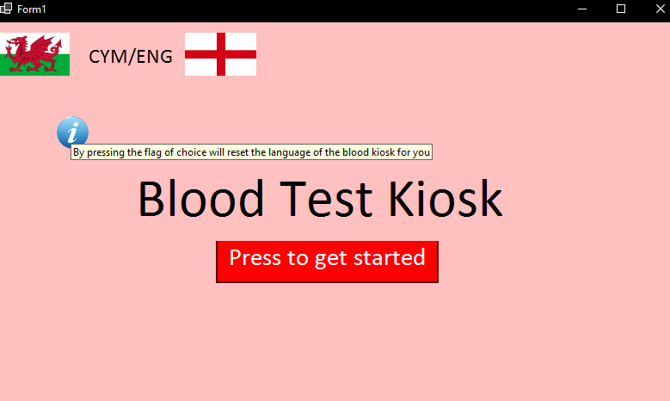
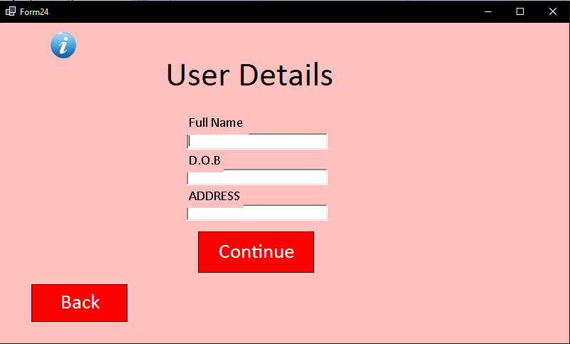
As you can see this form has been added, as the idea of having user details arrived after providing feedback for Sam. The design principle of Schneiderman of keep users in control, is done by creating the user details form this is because ‘users strongly desire the sense that they oversee the interface’ (14)
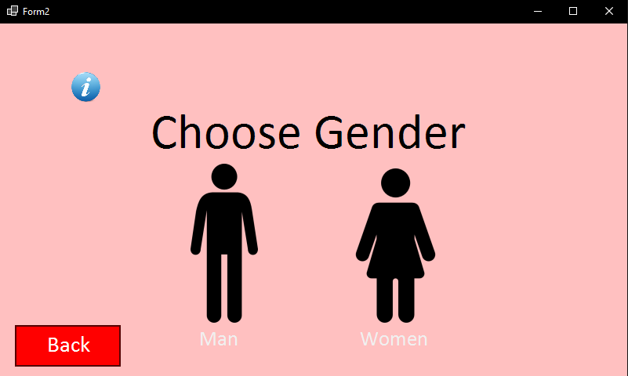
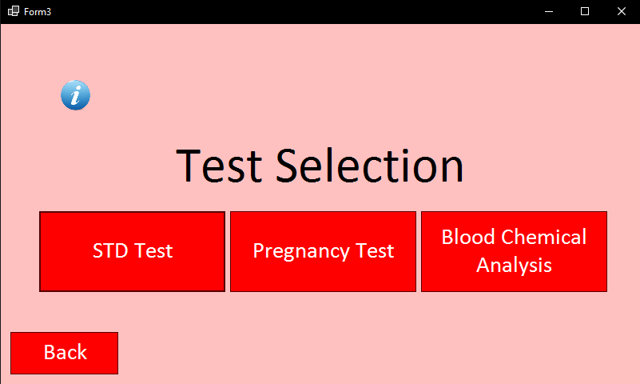
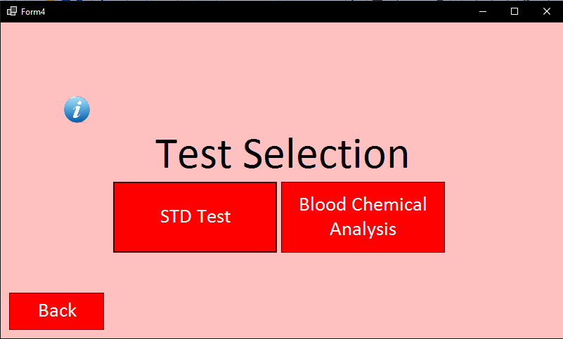
Another feedback element taken into action was the need for more error prevention methods. Now all screens that require decision making have back buttons implemented. Above you can see the back button, that was not there before. The design principle of Nielsen’s error prevention is now used throughout the application ‘eliminating error conditions’ (16).

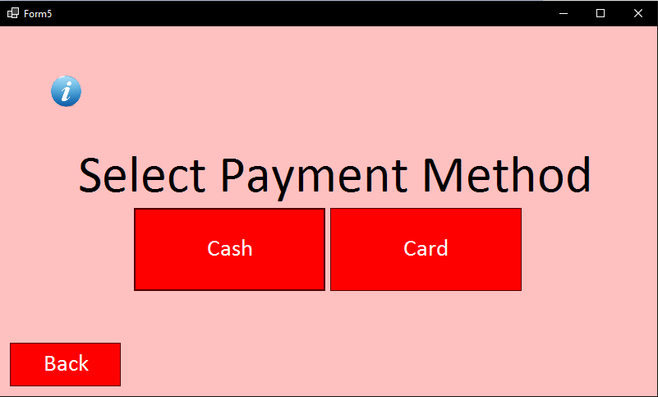
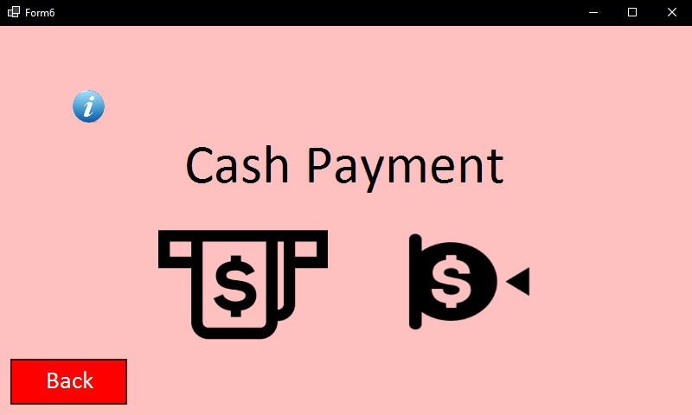
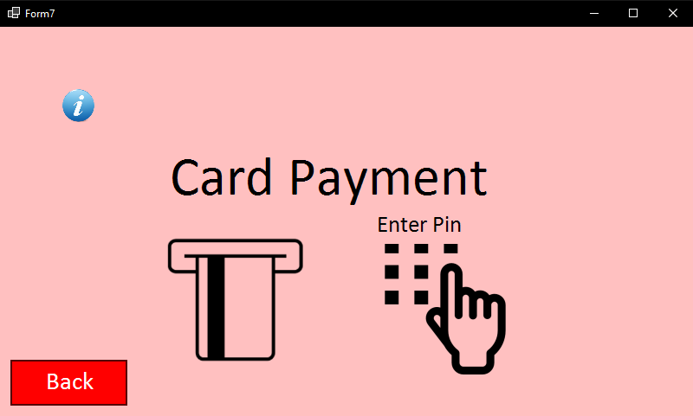
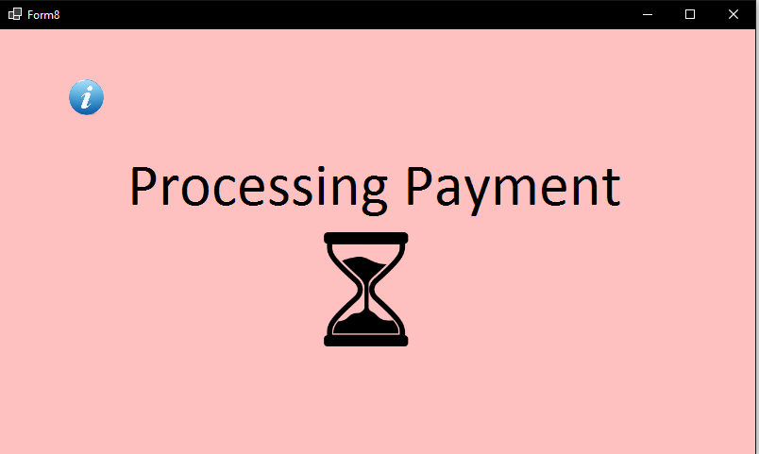
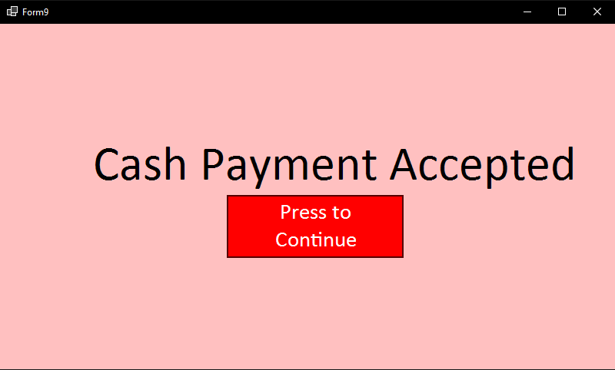

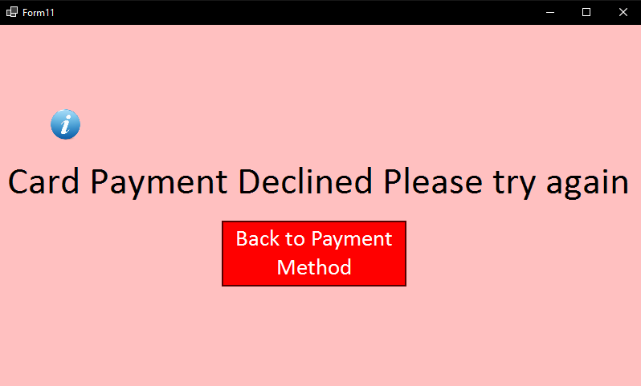
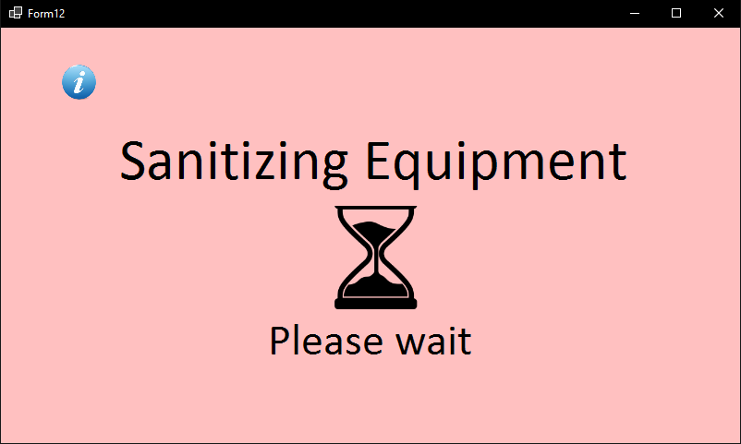
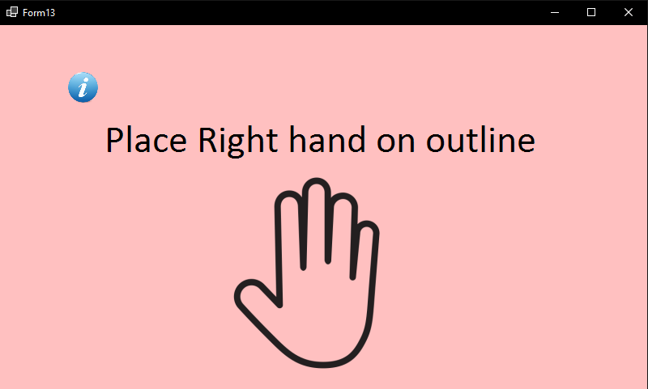
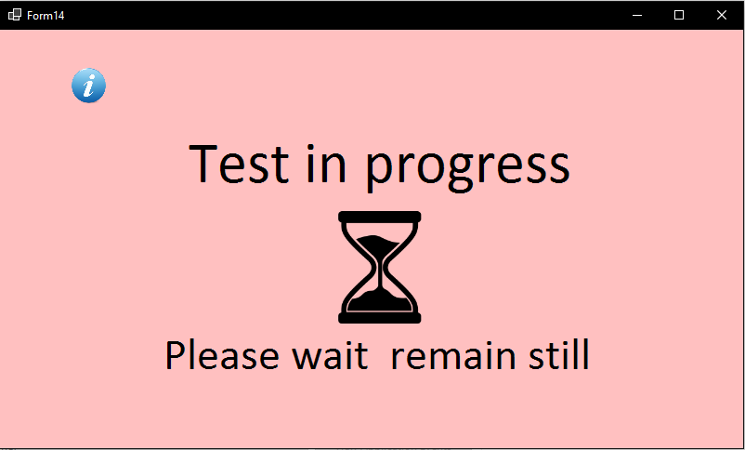

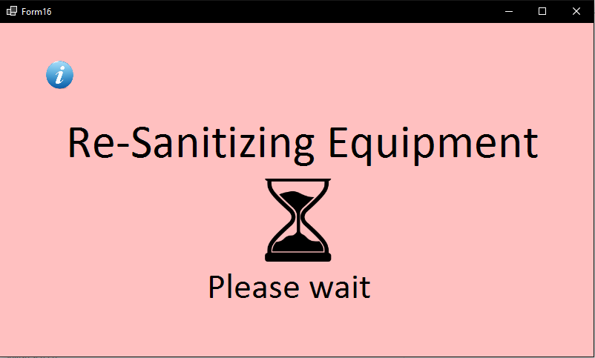
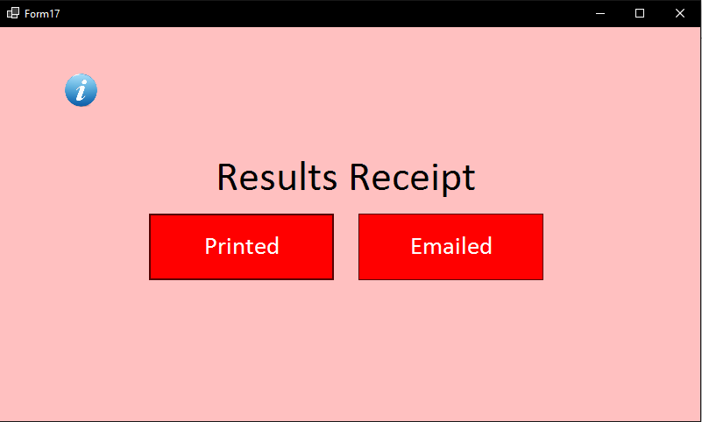
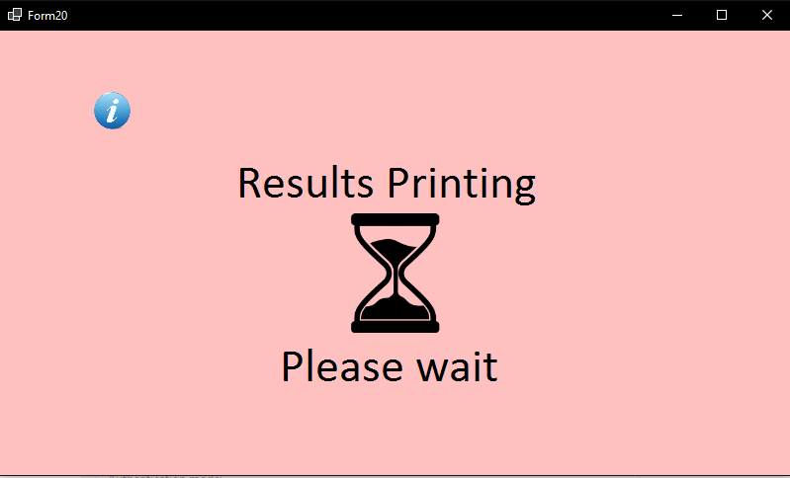
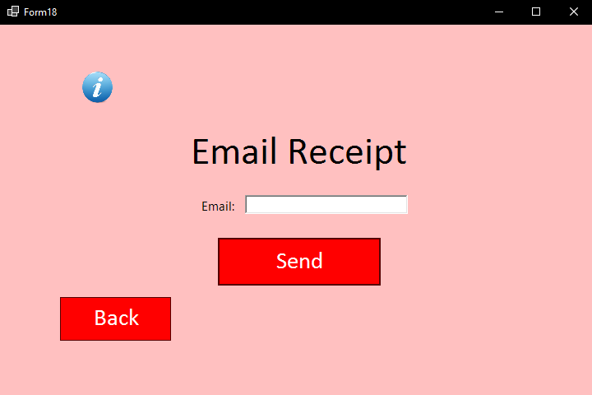
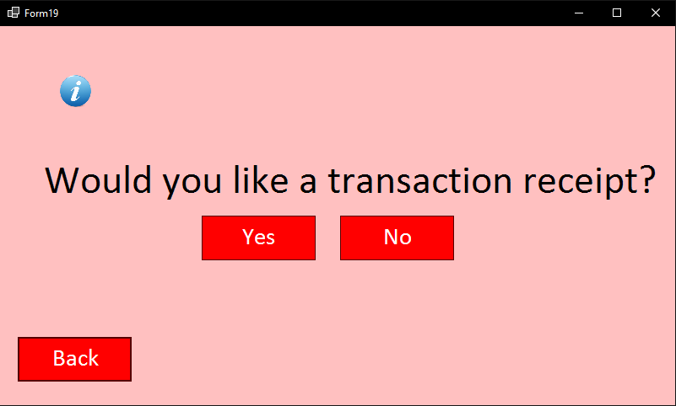
The last change made to the system as shown throughout these slides is the tool tip (I Icon) has now been added to mostly all screens, this was feedback from Sam. This is to prevent confusion and frustration whilst using the system.
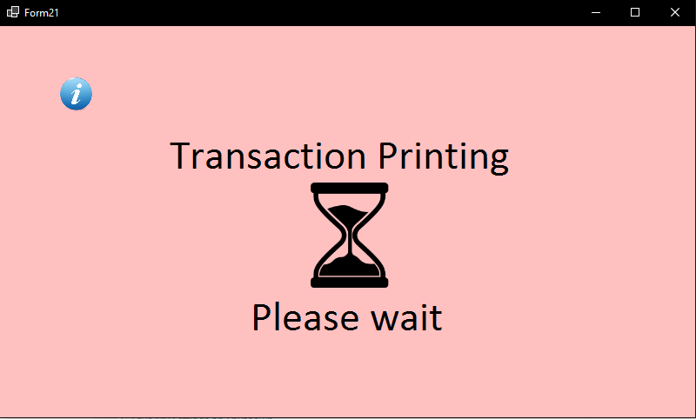


Overall Evaluation

The most successful stages of this project were the system design, feedback, and task analysis. The system design was well thought out in the planning stage, due to the effective use of the design principles of Dix, Norman, Nielsen, and Schneiderman. Following the feedback, changes were added to the software prototype to help the system meet user requirements. The task analysis stage of the system was extremely helpful. Creating hierarchical task analysis allowed a structure to be followed throughout the development of the system.

The area of the project that could be most improved is the understanding of human factors and how to apply this to system design. Although I have taken into consideration human factors in areas of system design, I believe understanding the human sensory system more would benefit the system's outcome. If I were to do the project again, I would additionally include more design principles in the system design, which would improve human-computer interaction. The final change I would make would be the consideration of human factors in the system design, this would improve usability and effectiveness of using the system.

Conclusion

This report has shown the creation and evaluation of a blood test kiosk system. The system design/prototype was successfully accomplished using design principles, human factors, and feedback. The key design principles used included familiarity, robustness, consistency, and responsiveness, which I believed played an important part in the human-computer interaction of the system. Human factors, with the use of metaphors, improved the usability of the system, through the connection of a familiar object to an unfamiliar object. The evaluation demonstrated that further improvements could be made to the human factors and design principles implemented. It also showed that using and giving feedback improved the overall system design.

Bibliography

1. Joshi A, Trout K. The role of health information kiosks in diverse settings: a systematic review [Internet]. Wiley Online Library. 2014 [cited 26 March 2021]. Available from: https://onlinelibrary.wiley.com/doi/full/10.1111/hir.12081

2. The Usability Engineering Life Cycle | Making the Business Case for User Interface Design | InformIT [Internet]. Informit.com. 2007 [cited 26 March 2021]. Available from: https://www.informit.com/articles/article.aspx?p=726420&seqNum=6

3. Figure 1. The usability engineering life cycle. From The Usability... [Internet]. ResearchGate. 2021 [cited 26 March 2021]. Available from: https://www.researchgate.net/figure/The-usability-engineering-life-cycle-From-The-Usability-Engineering-Lifecycle-by-D-J_fig1_284032327

4. Introduction to HCI [Internet]. Cs.bham.ac.uk. 2021 [cited 26 March 2021]. Available from: https://www.cs.bham.ac.uk/~rxb/Teaching/HCI%20II/intro.html

5. A Brief Introduction to Perception [Internet]. Core.ac.uk. 2017 [cited 26 March 2021]. Available from: https://core.ac.uk/download/pdf/236304229.pdf

6. The Study of Human Memory | Cognitive Psychology & Neuroscience [Internet]. The Human Memory. 2021 [cited 26 March 2021]. Available from: https://human-memory.net/the-study-of-human-memory/

7. What Is Memory? - The Human Memory [Internet]. The Human Memory. 2021 [cited 26 March 2021]. Available from: https://human-memory.net/what-is-memory/

8. The Properties of Human Memory and Their Importance for Information Visualization [Internet]. The Interaction Design Foundation. 2021 [cited 26 March 2021]. Available from: https://www.interaction-design.org/literature/article/the-properties-of-human-memory-and-their-importance-for-information-visualization

9. Sharp H. Interaction Design. 5th ed. Wiley & Sons Canada, Limited, John; 2019.

10. What is reasoning? Explain different types of reasoning with examples. [Internet]. Prof. Datta Shingate. 2021 [cited 26 March 2021]. Available from: https://dattashingate.wordpress.com/2019/02/18/3-what-is-reasoning-explain-different-types-of-reasoning-with-examples/

11. [Internet]. Diag.uniroma1.it. 2021 [cited 26 March 2021]. Available from: http://www.diag.uniroma1.it//leotta/interactiondesign/2017-2018/2-HCI_basics.pdf

12. METAPHORS [Internet]. Cs.stanford.edu. 2021 [cited 26 March 2021]. Available from: https://cs.stanford.edu/people/eroberts/courses/soco/projects/2001-02/hci/metaphors.htm

13. Important HCI metaphors [Internet]. Ics.uci.edu. 2021 [cited 26 March 2021]. Available from: https://www.ics.uci.edu/~kobsa/courses/ICS104/course-notes/metaphors.htm

14. Ben Schneiderman [Internet]. Cs.umd.edu. 2021 [cited 26 March 2021]. Available from: https://www.cs.umd.edu/~ben/goldenrules.html

15. What are Norman's design principles? [Internet]. Educative: Interactive Courses for Software Developers. 2021 [cited 26 March 2021]. Available from: https://www.educative.io/edpresso/what-are-normans-design-principles

16.[Internet]. 2021 [cited 26 March 2021]. Available from: https://www.interaction-design.org/literature/article/how-to-conduct-a-heuristic-evaluation-for-usability-in-hci-and-information-visualization

17. Dix, Finlay, Abowd, Beale. [Internet]. Hcibook.com. 2021 [cited 26 March 2021]. Available from: https://www.hcibook.com/e3-docs/slides/ppt/e3-chap-07.ppt

