Resonance

ACDA4006: Electrical & Electronic Principles

BEng Embedded Electronic Systems

Word Count: 2586 Student Number: 2204725

Contents

Title Page…………………….………………………...……………………………………………….1

Contents……………………………………………………..…………………………………………2

Abstract………………………………..…………………………..…………………………………..3

Introduction………………………………………..…………………………………………………..4

Simulated Test…………………………………..…………………………………………………..5-8

Practical Test…………………………….…………..……………………………………………9-12

Discussion………………………………………………………………………………………13-15

Conclusion………………………………….……………………………………………………..16

References……………………………..…………………………………………………………17

Abstract

This report details two test which were conducted. One test was conducted in a simulation software/CAD (Computer Aided Design); The other was conducted as a physical test with physical components and measuring tools. The test, in both cases, are measuring the voltage output of a circuit with an input from a signal generator set to different frequencies to identify the most efficient frequency the circuit operates at. Additionally, this report will compare the results collected after calculating essential figures to construct the graphs for a more effective visual representation. After the final discussions and conclusions from this report it was determined that the differences between the results collected from both tests can be identified as the added resistance of the wiring used in the practical test and the physical components having accuracy tolerances making any results found inaccurate. However, It was determined that practical tests are needed in the designing and testing stage of any circuit to identify the discrepancies detailed in this report or any other possible inaccuracies that may be discovered in other designed circuits.

Introduction

This report will record and analyse two tests which were conducted to show the differences in measurements between a simulated and then a practical test using a program and then physical components. Firstly, this report will detail the process of making the simulated circuit in a program and then with using physical components, then how the resultant measurements were recorded, then calculated, then finally plotted in a visual representation to fully be able to grasp the differences between the resultant results. These results will then be analysed, compared and discussed to understand any apparent differences between the tests, and why they may have occurred.

The circuit which is being designed and constructed is known as an LC circuit which is used to generate signals at a particular frequency or receiving a particular frequency of signal. These are used in many devices which involve signals for example oscillators and tuners and many more devices.[1] In the report the LC circuit will be tested to find the most efficient frequency the parameters of the circuit operates at, and therefore the frequency the circuit would be used to transmit or receive signals at in a device.

Simulated Test

A simulation of a circuit was conducted on an appropriate simulation program (Proteus). The task was to record the readings from a signal generator to compare the results with the results from a physical test conducted after. To achieve this, results were taken by measuring the output voltage of the circuit at different levels of frequency from the signal generator. The simulated circuit was built, as shown in figure 1, using a signal generator, a resistor set to 1000 ohms, a capacitor set to 1 micro Farad, an inductor set to 1 mili Henry and an oscilloscope.

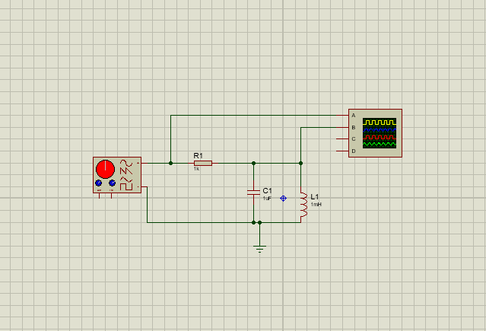
[Figure. 1]

The circuit was then ran on the software to produce the required results, using the oscilloscope function of the program. The results were measured by using the instruments shown below in figure 2; the results were recorded by changing the frequency of the supply from the signal generator, between the frequencies of 100Hz to 20kHz, at general intervals to be able to make an accurate final graph without using too many data points.

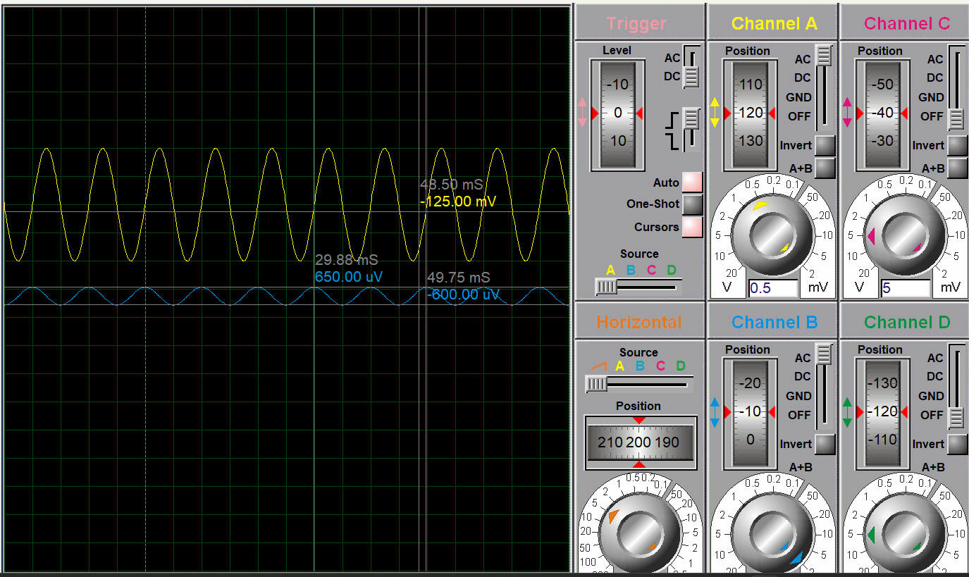
[Figure. 2]

The results were measured by using the cursors, as seen above, to measure the voltage of the output. The measurements were noted in an Excel spreadsheet in a table, as shown in figure 3. From the results of the output voltage the attenuation was calculated, this was achieved by dividing the voltage output by the voltage input. The results were further exploited to find the amplification half point by multiplying the attenuation data by 0.707 or 70.7%. The results were insufficient after initial testing and measuring, it was determined however that the data high point of the attenuation sat at 5000Hz, due to this, further results were measured above and below said frequency to show the steepness of the curve plotted from the results.

F (Hz) | Vin (V) | Vout (V) | Attenuation | Amp 1/2 point
100 | 2 | 1.25E-03 | 6.25E-04 | 4.42E-04
200 | 2 | 2.50E-03 | 1.25E-03 | 8.84E-04
500 | 2 | 6.40E-03 | 3.20E-03 | 2.26E-03
1000 | 2 | 1.33E-02 | 6.63E-03 | 4.68E-03
2000 | 2 | 3.00E-02 | 1.50E-02 | 1.06E-02
4000 | 2 | 1.38E-01 | 6.89E-02 | 4.87E-02
4900 | 2 | 1.10E+00 | 5.50E-01 | 3.89E-01
5000 | 2 | 1.93E+00 | 9.63E-01 | 6.80E-01
5200 | 2 | 8.10E-01 | 4.05E-01 | 2.86E-01
6000 | 2 | 1.75E-01 | 8.75E-02 | 6.19E-02
10000 | 2 | 4.25E-02 | 2.13E-02 | 1.50E-02
15000 | 2 | 0.02376 | 1.19E-02 | 8.40E-03
20000 | 2 | 1.68E-02 | 8.40E-03 | 5.94E-03
[Figure. 3]

These results gave a broad overview of the output voltage between the test boundaries to result in an accurate graph to represent the results of the simulation. The graph is showing the frequency of the input in Hertz (shown on the Y-axis) and the resultant attenuation of the output sine wave (shown on the X-axis in a logarithmic scale). This graph is shown below in figure 4.

[Figure. 4]
To measure the properties of the curve presented on the graph, the ‘Q factor’ will be measured. This is achieved by fining the amplitude half point and measuring the width at said point and comparing to the height of the high point from this measurement.

From the data collected in this test it is known that the data high point is at 5000Hz and the attenuation from this measurement is 9.63E-01 or 0.963. First this is multiplied by 0.707 to find the line at which to measure from which is 70.7% of the height of the curve. 0.963 x 0.707 = 0.680841 or 0.681 to 3dp. Then using the distance between other measurement data points the width at 70.7% of the height can be found at 130Hz, as shown below in figure 5, also known as the bandwidth. To find the Q factor then the frequency of which the high point figure was measured (5000Hz) is divided by the bandwidth just calculated. Resulting in 5000/130 = 38.46153846 or 38.462 to 3dp. The Q factor of this graph is 38.462.

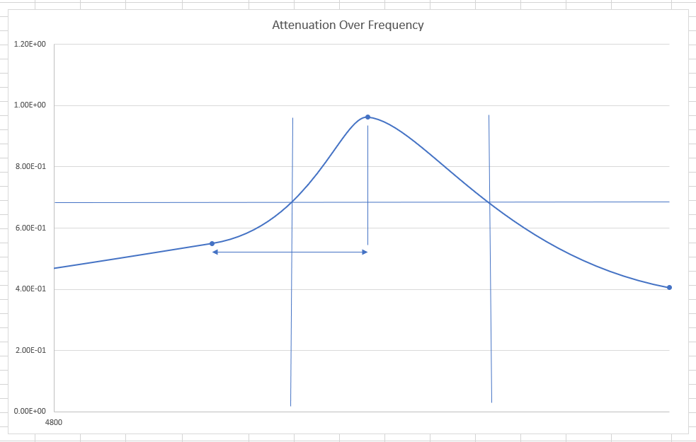
100Hz
130Hz
[Figure. 5]

Practical Test

Another test was conducted, using the same parameters and circuit configuration of the simulated test, by using physical components, a generator, a breadboard and an oscilloscope. As shown below in figure 6.

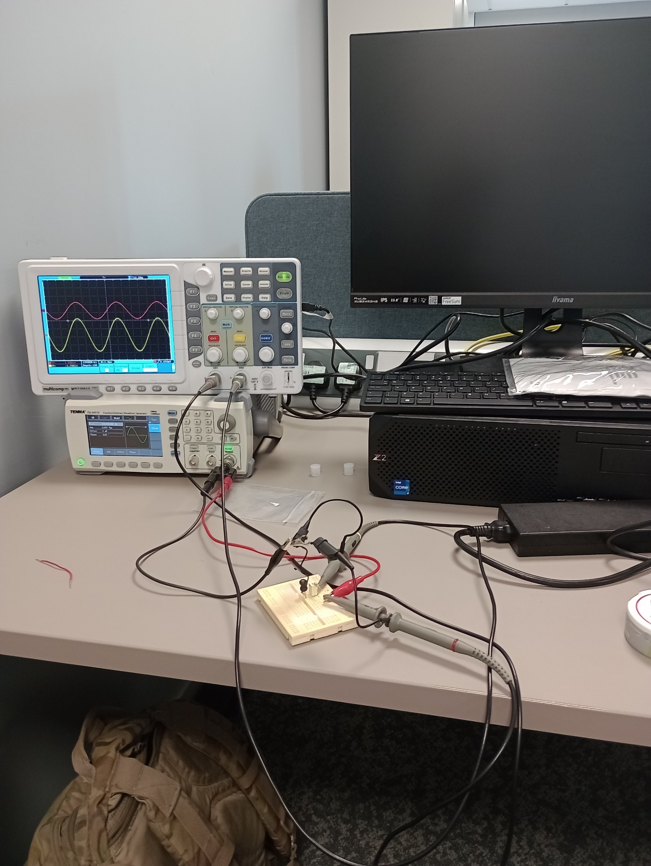
[Figure. 6]

The test was conducted by first laying the components (the resistor, capacitor and inductor) in a configuration matching the circuit diagram but using a breadboards design to most efficiently place them. Then the signal generator was set to the parameters required by the test and connected using wiring, then probes were attached to the same point as the simulated test but also connected to the ground wire along with the signal generators ground wire. By using the signal generator, the input frequency was set to the same data points as the simulated test and the resulting measurements of the output voltage were measured by using the measuring tool on the oscilloscope. And like before, in the simulated test the results were recorded in an Excel spreadsheet and used to calculate the attenuation and the amplification half point of the voltage outputs collected from the test. The resultant data was noted and calculated as shown below in figure 7.

F (Hz) | Vin (V) | Vout (V) | Attenuation | Amp 1/2 point
100 | 2 | 1.20E-03 | 6.00E-04 | 4.24E-04
200 | 2 | 2.33E-03 | 1.17E-03 | 8.24E-04
500 | 2 | 6.68E-03 | 3.34E-03 | 2.36E-03
1000 | 2 | 1.22E-02 | 6.10E-03 | 4.31E-03
2000 | 2 | 2.78E-02 | 1.39E-02 | 9.83E-03
4000 | 2 | 1.01E-01 | 5.05E-02 | 3.57E-02
4900 | 2 | 3.92E-01 | 1.96E-01 | 1.39E-01
5000 | 2 | 5.20E-01 | 2.60E-01 | 1.84E-01
5200 | 2 | 4.23E-01 | 2.12E-01 | 1.50E-01
6000 | 2 | 1.52E-01 | 7.60E-02 | 5.37E-02
10000 | 2 | 4.02E-02 | 2.01E-02 | 1.42E-02
15000 | 2 | 2.94E-02 | 1.47E-02 | 1.04E-02
20000 | 2 | 1.40E-02 | 7.00E-03 | 4.95E-03
[Figure. 7]

Then, as before, the attenuation data was plotted on a graph against the input frequencies the data was measured with. The graph is shown below in figure 8.

[Figure. 8]

The results above are shown as different to the results of the simulated test, however both results show the same highpoint of the attenuation at 5000Hz.

Similar to the simulated experiment the Q factor can be measured.

From the data collected in this test it is known that the data high point is at 5000Hz and the attenuation from this measurement is 2.60E-01 or 0.26. First this is multiplied by 0.707 to find the line at which to measure from which is 70.7% of the height of the curve. 0.26 x 0.707 = 0.184. Then using the distance between other measurement data points the width at 70.7% of the height can be found at 550Hz, as shown below in figure 9, also known as the bandwidth. To find the Q factor then the frequency of which the high point figure was measured (5000Hz) is divided by the bandwidth just calculated. Resulting in 5000/550 = 9.090909091or 9.091 to 3dp. The Q factor of this graph is 9.091.

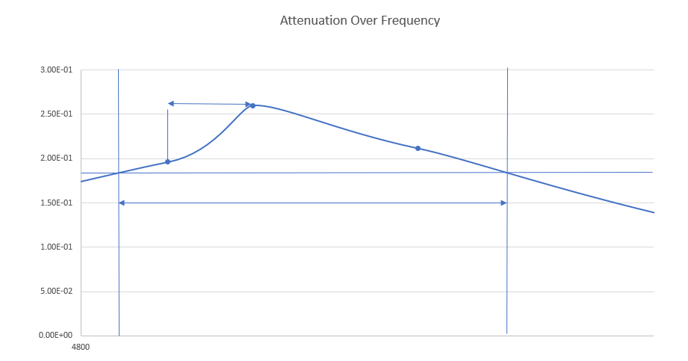
550Hz
100Hz
[Figure. 9]

Discussion

There were apparent differences in the found results, to fully represent the differences a graph was made which overlays both results in the same scale, this is shown below in figure 10.

[Figure. 10]
This graph shows the simulated test results as “Atten (SIM)” and the practical test data as “Atten (PRAC)”. As before, the Y-axis shown the Attenuation figure collected and the X-axis represents the frequency said attenuation was collected at.

What is the first apparent difference is how the practical test seems to show having a lower attenuation than the simulated results. After research in this topic the first explanation of this discrepancy is that the physical nature of the components adds additional resistance which would otherwise be overlooked in a simulated circuit; after this research it is determined that there are several variables in the resistance of a wire which is the material the wire is comprised of, the length of wire used, the diameter of the wire used and the heat of the wire during testing.[1] This would explain the differences in data and due to the program being unable to simulate the temperature of the test location and parameters of the wire used.

Typically, also, another problem in accuracy of physical tests is that the components of the circuit are not as accurate as the components in a model circuit in a form of CAD (Computer Aided Design). As mentioned before, there are present in this test a resistor, a capacitor and an inductor to make the total system components.

- A resistor has a wide tolerance of accuracy range and this will effect the final results, it is said that film resistors (the type of resistors that were used and implemented in this experiment) have a +-10% degree of tolerance in accuracy of resistance.[3] This would explain the discrepancies in the differences in results between the two tests. As if the resistance of the resistor was actually higher by 10% it would effectively be a 1100 ohm resistor instead of the specified 1000 ohm resistor. This would lower all resultant output voltage given the increased resistance within the circuit.

- Additionally, a capacitors the common accuracy tolerance is -20% to +80%[4]; This could make a massive discrepancy in the results of the physical test because the capacitor’s value could be anywhere between 0.8 micro Farads to 1.8 micro Farads. This statistic is far more influential in than the accuracy discrepancy in the present resistor, due to the vast range of potential inaccuracy.

- Inductors, however, can have a accuracy tolerance of +-20%[5]. This is, again, a more substantial potential inaccuracy than the resistors tolerances, so, therefore, can effect the results to a wide range of margin, comparing to the simulated circuit. This could mean that the inductors inductance could range from 0.8 mili Henrys to 1.2 mili Henrys.

These inaccuracies are very substantial. Suppose that all the components are minimizing the output voltage to the maximum degree of their tolerances will allow; this means that through addition (100%-10%-20%-20%) the total allowance, without factoring the additional resistance of the physical circuit connectors/wiring, could be 50%! This validates the differences in the testing of these two tests and explains, marginally, the magnitude of the differences in the results. This can be represented and shown with comparing one of the data points from both tests; for example, at 4900Hz the attenuation result in the simulated test is 0.55 and at the same datapoint the result in the practical test was 0.196. This shows that the practical test output is 35.6% of the value of the simulated test (0.195/0.55 = 0.3563636364). The additional percentage discrepancy of 14% can be explained by factoring the additional resistance of the wiring of the practical test, which would require additional research and testing to confirm/prove.

Another point of interest in comparison of the two tables of results is the magnitude of difference between the data high point comparison and any of the other data point comparison results, this results in a massive difference in the Q factor measurement (steepness of the curve of findings). For example, at 5000Hz (the data high point) the difference in results are massive as the simulated result at this data point is 3.7 times larger than that of the practical test result at this data point (0.963/0.26 = 3.703846154). However, in comparison at the 4000Hz data point the difference in magnitude is shown as the simulated data result is 1.3 times larger than the result collected from the practical test (0.0689/0.0505 = 1.364356436). On examination and research in this figure, it is deduced that this is due to the simulated results being more accurate and compatible to the test, given the accuracy tolerances earlier explained. Therefore, as this graph is showing at which frequency the circuits runs most efficiently (with as little resistance as possible), the test cannot run as efficiently in a practical setting.

Conclusion

In conclusion, after discussing the results, the two tests were compared and explained in why they showed different results. These main reasons of differences in the results collected are shown to be:

- Firstly, due to the unaccounted-for resistances of the wires/connectors present in the practical test which were not present in the simulated test. These resistances added together to present results which were far lower in voltage than the simulated which did not account for this.

- Secondly, as mentioned before the components accuracy tolerances provide a wide range of potential error in the findings of the practical test. To research and prove this would require further testing of the components used.

After comparing the conclusion made it is a strong assumption that the results should never have been predicted to be the same and furthermore the results from the practical should have been predicted to be lower in voltage before the tests were even conducted. Additionally, in future tests it should be assumed that practical tests will never be as accurate as simulated; however, it should be mentioned that, on reflection, the practical testing is more accurate due to it having all the variables of a real built circuit and should be used as a prototype to all electrical systems being designs to find all the discrepancies identified in this report.

References

[1] Wikipedia, LC Circuit. [Online]. Available: https://en.wikipedia.org/wiki/LC_circuit#:~:text=LC%20circuits%20are%20used%20either,is%20called%20a%20bandpass%20filter.

[2] Scott Precision Wire, The Resistance of Wire Explained. [Online]. Available: https://www.scottprecisionwire.com/the-resistance-of-wire-explained/#:~:text=Length%20of%20the%20wire%3A%20Resistance,wire%2C%20the%20higher%20the%20resistance.

[3] Electronics Tutorials, Resistor Colour Code. [Online]. Available: https://www.electronics-tutorials.ws/resistor/res_2.html#:~:text=Typical%20resistor%20tolerances%20for%20film,tolerance%20resistors%20being%20more%20expensive.

[4]. VITREK, MTI Instruments, Knowledge Centre. [Online]. Available: https://vitrek.com/mti-instruments/knowledge-center/capacitor-characteristics/#:~:text=In%20most%20cases%2C%20the%20tolerance,around%205%25%20%2D%2010%25.

[5]. MatrixTSL, Electronic Circuits and Components. [Online]. Available: https://www.matrixtsl.com/courses/ecc/index.php?n=Inductors.InductorSpecifications#:~:text=Inductors%20are%20usually%20produced%20with,the%20body%20of%20the%20inductor.

