Policing Mental Health – A critical analysis of police involvement in Mental Health calls within South Wales Police. Is it appropriate for police to be the first point of contact for persons having a mental health episode?

Ellis Arrowsmith
(Student ID: 1922407)
BSC (Hons) Professional Policing Practice.
March 2023

Acknowledgments
As I approach the end of my probationary period and my studies undertaken as an undergraduate with the University of Wales Trinity Saint David, I wish to give thanks and credit to those that have played an instrumental part in my ability to progress through this period and helped me in my work and studies.

Firstly, I would like to thank my dissertation supervisor, Dr Jonathan Edwards, who has provided me with the support, knowledge, and guidance in completing this project.

Secondly, I would like to express gratitude to the police and university staff that have helped, guided, coached, and tutored me to be the professional and positive constable that I am today. In addition to these, I wish to show my gratitude to my colleagues in work who have also played a significant role in supporting and helping me through this process.

Finally, I would like to extend a heartfelt thank you to my family. It’s difficult to condense the support that I have received from them these last three years however, they have helped, encouraged, supported, and motivated me to be the best I possibly can and for that, I cannot say anything other than thank you.

Declaration
This work has not previously been accepted in substance for any degree and is not being concurrently submitted in candidature for any degree.
Signed: Ellis. A
Date: 24/03/2023

STATEMENT 1
This dissertation is being submitted in partial fulfilment of the requirements for the degree of BA.
Signed: Ellis.A
Date: 24/03/2023

STATEMENT 2
This dissertation is the result of my own independent work/investigation, except where otherwise stated.
Other sources are acknowledged by footnotes giving explicit references. A bibliography appended.
Signed: Ellis.A
Date: 24/03/2023

STATEMENT 3
I hereby give consent for my dissertation, if accepted, to be available for photocopying and for interlibrary loan, and for the title and summary to be made available to outside organisations.
Signed: Ellis.A
Date: 24/03/2023

STATEMENT 4
I hereby give consent for my dissertation, if accepted to be available on the university’s IT system to those who have consent to use the system.
Signed: Ellis.A
Date: 24/03/2023

Abstract
This paper examines and investigates that research available, and the research conducted by the researcher in relation to the polices involvement with mental health calls within South Wales Police.
The paper looks to identify if the demand on police has changed in recent years and if so how. It also looks to ascertain if officers within South Wales Police feel that they have enough training to be able to effectively deal with mental health related calls and if they feel that they have everything they need to be able to do this correctly and in a way that would effectively safeguard people.
The paper utilises a questionnaire completed by 36 police officers of various ranks from South Wales Police to get their views and interactions with people suffering with their mental health.

Contents Table
Acknowledgments………………………………..………………………………………………………………………………2
Declaration………………………………………………………………..…………………………………………………………3
Abstract………………………………………………………..………………………………………………………………………4
Contents Table……………………………………..………………………………………………………………………………5
Chapter 1 – Introduction…………………………………..………………………………………………………………….7
1.1 Introduction…….……………………………………..………………………………..…………..……………7
1.2 Background/Literature Review………………………...…………………………………………………7
Chapter 2 – Literature Review………………………………………………………………………………………………9
2.1 Introduction………………………………………………………………………………………………………..9
2.2 Brief History………………………………………………………………………………………………………..9
2.3 Demand on Police in the last ten years……………………………………………………………..10
2.4 Public Views on Mental Health and Police Involvement…………………………………….11
2.5 Police Officer’s and Their Mental Health Training……………………………………………..12
2.6 Research Objective……………………………………………………………………………………………13
2.7 Chapter Conclusion……………………………………………………………………………………………13
Chapter 3 – Methodology…………………………………………………………………………………………………..14
3.1 Introduction………………………………………………………………….…………………….…………...14
3.2 Research Strategy……………………………………………………………………………………………..14
3.3 Data Collection…………………………………………………………………………..……..………..……15
3.4 Data Analysis……………………………………………………………….………….………………………..16
3.5 Limitation and Potential Problems……………………………………………….…………..……….17
3.6 Summary of Chapter………………………………………………………………………..………..……..17
Chapter 4 – Analysis of Results…………………………………………………………………………………………..18
4.1 Introduction……………………………………………………………………………….………….…………18
4.2 Participants…………………………………………………………………………………..………………….18
4.3 Mental Health Demand…………………………………………………………………………..………..19
4.4 Training……………………………………………………………………………………………………….……21
4.5 Equipment and Resources…………………………………………………………………………………22
4.6 Current Mental Health Legislation…………………………………………………………………….22
4.7 Conclusion…………………………………………………………………………………………………………23
Chapter 5 – Conclusion and Recommendations………………………………………………………………….24
5.1 Introduction………………………………………………………………………………………………………24
5.2 Objective Achievement……………………………………………………………………………………..24
5.3 Main Findings………………………………………………………………………………………….………..24
5.4 Recommendations………………………………………………………………………….………………..25
5.4.1 Recommendation One……………………………………………..………………………..25
5.4.2 Recommendation Two………………………………………………………………..………26
5.4.3 Recommendation Three…………………………………………………………….……….26
5.5 Limitations……………………………………………………………………………………………….……….26
5.6 Conclusion……………………………………………………………………………………………….……….26
Bibliography…………………………………………………………………………………………………………………………………….28
Appendices………………………………………………………………………………………………………………………………………34
Appendix One – Questionnaire……………………………………………………………………………………………34
Appendix Two – Questionnaire Responses………………………………………………………………………….37
Appendix Three – Proposal Form………………………………………………………………………………………..52
Appendix Four – Ethics Form……………………………………………………………………………………………….57

1.0 Chapter 1 - Introduction
1.1 Introduction
In recent years, police forces in both England and Wales have found themselves in an unprecedented predicament. The police have found themselves having to deal with and respond to incidents involving an increased number of persons who suffer with mental health issues or are themselves in a state of mental health crisis. Police have found themselves devoting several hours to someone who has found themselves in mental health crisis who need either medical care or a mental health assessment.

The demand placed on police in recent years has found police officers across England and Wales spending a lot of their policing time responding to and spending several hours with persons who are suffering from mental health issues. The mental health related calls that police are dealing with, according to West Midlands Police spoke of police officers spending up to 40% of their time dealing with mental health related call and incidents (West Midlands Police, 2020.)

The research that carried out is in relation to how much of officer’s time within South Wales Police is spent dealing with mental health and how the effect of budget cuts and reduced staffing has affected the ability for police to pre-emptively detect crime. With up to 40% of police officers time being spent dealing with mental health, this does not leave an overly adequate amount of time to deal with crime. When broken down over an average set of six shifts this equates to a maximum of 21.6 hours being spent dealing with mental health calls and not proactively detecting crime. This leaves 32.4 hours where officers are potentially able to deal with crime effectively however, this time does not include shifts of unsocial hours where victims of crime are less likely to be willing to speak.

This subject that has been chosen by the researcher is one in which they have first-hand experience in. This subject is one that is important in which the researcher believes more needs to be done to identify and support those suffering with their mental health.

1.2 Background/Literature Review
Unfortunately, mental health is something that can affect everyone. In an article written by Galderisi et al (2015) it defines mental health as “a state of well-being in which the individual realises his or her own abilities, can cope with the normal stresses of life, can work productively and fruitfully, and is able to make a contribution to his or her community.” Whilst this definition may not be representative of all persons suffering with mental health, it is widely accepted.

Mental health around the world is becoming a global concern and the amount of people who state that they suffer with a mental health condition is on the increase. There are several contributing factors to the changing of a person’s mental health including the current economic and social changes faced by people (Pitchforth et al, 2019)

There are many items of literature relating to the police interactions with mental health. One piece of literature that will be used as part of this dissertation project will be from HMICFRS (Her Majesty’s Inspectorate of Constabulary and Fire and Rescue Service). This body is responsible for reviewing every police force in England and Wales and regularly carry’s out inspections of policies and procedures carried out by either an individual force, or joint collaborations on national issues facing the current policing climate.

HMICFRS released a review of Policing and Mental Health (2018). This report is said to set out the findings of how collectively effective the 43 police forces who partook in the inspection were at protecting and supporting persons with mental health problems. The summary of the main findings for this report are that the police service is stepping in to fill in for mental health services in the three following scenarios the most:
Police are being utilised to take someone to hospital as there is no ambulance available.
Police are having to wait with someone experiencing mental health problems in hospital until a safe place is found.
Police are conducting welfare checks on a person where there is a concern for their safety.

Another piece of literature published mentioned above by West Midlands Police in 2020 has provided predictions for the volume of demand from mental health related police incidents. The piece also goes on to say that low level mental health is dealt with in day-to-day policing and is encountered by most officers. Whilst this report may be tailored towards West Midlands Police, aspects of the report can be interpreted as being relevant to most if not all police forces in England and Wales.

In an article that was written by Kane et al (2018), it highlighted a systematic review of the policing related mental health interventions that were available to police at the time. The review highlights that no just one approach is effective to policing mental health and highlights the need for a multi-faceted approach to policing and mental health.

There are several documented areas where police were involved within the mental health remit. The police are becoming more and more involved with persons suffering with mental health (Lawrence et al, 2021) however, there is some absence in literature as to whether officers feel they have the training to be able to deal with the persons’ they are meeting.
Chapter 2 – Literature Review
2.1 introduction
The chapter is purposed to review the available academic literature allowing the identification of the current information known about the polices involvement in mental health. This will also look to examine the available information as to any information in relation to the police being the first point of contact for mental health calls.

2.2 Brief History
Since the creation of the Mental Health Act of 1983 which gives police officers powers under sections 135 and 136, the police in England and Wales have had some involvement within the mental health remit (Puntis et al, 2018). Whilst most of this legislation relates to the treatment and detention of a person within hospitals and designated mental health units, the sections mentioned above are routinely used within policing to get people the help they need in a crisis (Mind, 2017).
In recent years, the police have found themselves to be the first point of contact for a person suffering with a mental health condition or a person in mental health crisis and that according to Adebowale (2013), a survey of Metropolitan Police Service (MPS) officers showed that officers were having frequent and regular contact with victims (39%), suspects (67%) and witnesses (23%) who were experiencing ill mental health in some form. It has also been cited that one in four people will experience a mental health related problem each year and that their contact with the police can be as witnesses, suspects or victims and even individuals who are detained under the Mental Health Act Section 136 (Kane et al, 2017).
Historically, the police do not have the best reputation when handling or dealing with mental health incidents. As a result of an independent report into mental health and policing of the MPS, twenty-eight recommendations were made with the majority of these set out to address the shortcomings in the performance of the police with this being the focus of the enquiry (Adebowale, 2013). Despite this reputation, the police have seen a general increase in the number of mental health calls that are being dealt with daily. An article published by West Midlands Police (2020) highlights that between 20% - 40% of police officers time is spent dealing with mental health related incidents. Whilst this information is not representative of policing in England and Wales, similar issues are faced across the policing network from force to force.
An article published by BACP (2021) also provides statistics in relation to the general public’s attitudes towards mental health and how these are changing. The published information suggests that of 6,305 adults asked, 90% of them stated that compared to 5 years ago, the topic of mental health has a higher public profile and 69% of people asked are more aware of the issues of mental health themselves. This information suggests that with more people thinking that the topic of mental health has a higher public profile, it is more recognised and more people are likely to seek mental health support.

2.3 Demand on Police in the last ten years
The demand on policing in the last ten years has increased between the years of 2012/13 to March of 2022. In the Police and Crime Commissioners annual report for 2012-13 completed by the Rt Hon Alun Michael (Michael, 2013), the data shows that the number of crimes recorded was 84,528 whereas according to the Office of National Statistics (2022) the number of crimes that were reported crime for the year ending March 2022 was 104,549 which excluding fraud related crimes.
Also, like recorded crimes, there has been a significant increase in the demand on mental health services. 367,594 mental health referrals were made in February of 2022 in England with this being a 76.6 percent increase compared to February 2020 prior to the COVID-19 Pandemic (Plewes, 2022). Whilst this data is not taken directly from mental health services in Wales, national media reporting has shown that this type of increase in referrals has occurred nationwide (Roxby, 2023).
The financial pressures on policing have been felt in a similar nature to other public services. This coupled with the diversity of the demand that the police face has meant an increase in non-crime related incidents. In an article published by Walley and Adams (2019), they highlighted the diversity of the demand as being 19% of incidents being reported were welfare, 18% were public nuisance, 17% were acquisitive crime and more prominent was that 28% of incidents reported were categorised as other which indicates that some of these incidents did not fall into a pre-determined category showing the varying non-crime demand police face. Whilst this article does not specifically mention mental health, it could fall into the category of reports listed as other. This could suggest that officers are finding themselves dealing with mental health however, it is not being categorised properly.
The demand on policing through mental health contact is estimated by Solar and Smith (2022) to be that approximately 87% more resources are likely to be used when a person involved has mental health issues compared to that of incident involving persons with non-mental health illnesses. The article also refers to the fact that police are spending a considerable amount of time with persons with mental health issues. There is increased demand and the police are dealing with incidents in ways that exacerbate rather than fix and resolve the problem. It is leading to people returning to police with mental health issues continually. The police are finding themselves in situations where they are dealing with incidents where they have a lack of or insufficient amount of training to be able to deal with an incident effectively and appropriately.
An article written by Solar and Smith (2022) also refers to the significant cuts that have been identified of officers that are carrying out front line duties where they would be able to deal with a mental health call. The demands on the police service from the public is not as high the current demand on the NHS and ambulance services across England and Wales. A news article published in 2022 by the Independent partially highlights the demand that the NHS is under and the fact that police are finding themselves acting as a substitute for the ambulance service (Dearden and Thomas, 2022). This meaning that police across the country are put in a position where they are responding to medical emergencies in place of or as well as the medical service. Whilst this does not directly relate to mental health, it can be reasonably expected that should ambulance staff not be able to respond to life threatening incidents like the example mentioned above, they are unlikely to be able to attend someone suffering with their mental health leaving police and other services to respond.

2.4 Public views on mental health and police involvement.
There is limited information with regards to the general public’s opinion on the police dealing with mental health, the way in which the matter is approached or how it should be approached, or even if the police are the correct agency to be the first point of contact in this field. There are a few scholarly articles online that provide opinion on the matter and as such there appears to be an area of uncertainty as to the public’s views on policing necessities and priorities surrounding mental health.
As part of one of the biggest reforms in policing to date, Sir Robert Peel’s policing principles provided 9 principles for officers to abide by to develop a police officer the public could trust (Lentz and Chaires, 2007). Whilst the general principles of Sir Robert Peel relate to upholding public trust, they could be seen to allow the public to have a say as to how we police and what they would like to see the police doing.
Since the COVID-19 pandemic, the demand on public service within England and Wales has increased substantially. There is an abundance of articles that show clearly that the demand on mental health services and how this has increased since the COVID-19 pandemic started (Hellstern and Robinson, 2023; Kalucy et al 2004; Monroe et al, 2022; Stroever et al, 2021; Sass et al, 2022). The subsequent loss of loved ones and the increased demand placed on the NHS services in England and Wales to treat and help persons suffering with COVID-19 has meant that many people have been left to deal with their own mental health alone. As well as this, it has increased the demand on police with more and more people seeking to get help during a time where there has been limited opportunities for this to be provided by the NHS.
According to the Independent (2022), the charity Mind stated that a cumulative result of underfunding combined with over whelming demand for mental health support has meant the waiting list for NHS patients waiting to receive community mental health care has increased in England to 1.2 million. The knock-on effect of this means that a person not receiving the mental health support that they need to prevent worsening and promote better mental health, is allowing the mental health to worsen potentially making them a risk to themselves (Colarossi and Eccles, 2003). It is at this point that police involvement may become necessary to provide immediate safeguarding for any individual. Early intervention at an early stage is likely to reduce the chances of a person suffering from mental health to become known to the police (Kelly et al, 2007). Not receiving prompt and early intervention according to Mental Health First Aid USA (2021), can lead to a more difficult recovery from a mental health illness. Where early intervention can be offered in the case of someone suffering from mental health, a member of the public who may not necessarily like the police or want to speak with and officer regarding a sensitive mental health issue could receive the support and treatment they need to get better mentally (Short et al, 2014).
A report by the charity Mind (2013) outlines that there have been both positive and negative interactions between the police and the persons that they deal with in relation to how they felt the police had treated them regarding their personal mental health situation. The report shows two accounts, one positive and one negative detailing the interactions they had with officers. The report outlines key factors to improve the quality of officer’s attendance at mental health calls in order to reduce the risk of further distress to a person as a result of the police dealing with the call. From this report, it can be determined that at the time, there was no single plan or approach to dealing with mental health and officers found themselves having to deal with calls such as this without any training or prior knowledge.

2.5 Police officer and their mental health training.
The number of incidents of mental health that the police are dealing with has increased in recent years. It has been questioned several times by organisations such as the Police Federation of England and Wales. At what point do the police stop being the police and become mental health social workers? There are arguments both positive and negative in relation to police receiving additional training to deal with mental health. Institutions like the police federation do not want the police to become mental health advisors however, the counter argument is that the potential for this to reduce police demand with additional training means that officers may be able to get back to proactive policing which with demand being as high as it is, can be difficult to undertake.
A paper published by Holloway (2018) examines what training police officers receive in relation to providing effective responses to mental health incidents, and explores how officers feel about attending mental health calls. The paper found that officers dealing with mental health calls did not have sufficient training to be able to deal with the calls safely and effectively. It was also found that officers did not feel that they were the most appropriate agency to be dealing with mental health calls and felt these calls were frequent and that there was a lack of co-ordination and support structure in place. The findings of this paper recommend that police officers are provided with effective training with the development of effective working relationships between outside agencies and the police.
The police find themselves dealing with mental health related calls frequently. In a research article written by Lane (2019), it highlights that approximately 14% of UK police incidents involve someone with a mental health concern. This paper also suggests that the UK police have faced high-profile criticisms over the handling of persons with mental health issues. This paper also sheds light on the fact that officers didn’t feel at the time that they were receiving adequate training to be able to deal with such cases.
Another journal written by Lamb and Tarpey (2018), also highlights the fact that officers are facing increasing organisational demand with limited opportunity for cross agency working to facilitate the support for a person suffering with mental health. The report also highlights that the ten officers that were asked, there appeared to be a consensus that they felt there was a lack of training in relation to mental health be reported by UK police officers.

2.6 Research Objectives
There are three proposed research objectives to focus on when carrying out this literature review and these are as follows:
- To ascertain if the demand on the police to deal with mental health calls has changed and whether this has increased, decreased, or stayed the same.
- To ascertain if officers dealing with mental health feel they have appropriate training to deal with mental health.
- To ascertain if officers feel they have the right equipment and legislation to respond to mental health related calls.

2.7 Chapter conclusion
To conclude, this part of the dissertation has highlighted to the researcher that there is an area of academic writing that provides good and detailed instruction with regards to the police involvement in mental health through legislation. However, where this legislation does not apply or cannot be applied, there does not appear to be a single point approach to the police dealing with mental health, especially when a person refuses to have treatment for it. There appears to be a lack of inter-service cohesion to determine the best course of action with limited availability for prior consultation with approved mental health professionals to help deal with mental health incidents.

Chapter 3 – Methodology
3.1 Introduction
This chapter of the dissertation will explore the method of which will be used to investigate the police involvement in mental health related calls and to try and answer the objectives of this study. The objectives in question are:
- To ascertain if the demand on the police to deal with mental health calls has changed and whether this has increased, decreased, or stayed the same.
- To ascertain if officers dealing with mental health feel they have appropriate training to deal with mental health.
- To ascertain if officers feel they have the right equipment and legislation to respond to mental health related calls.

The reason why the researcher has chosen to undertake this research is owing to the notable increase in mental health calls that have been reported and the amount of mental health issues that police are now dealing with daily. It has been reported within some noted literature that the police are finding themselves coming into contact more frequently with people suffering from mental health issues (Marsden et al, 2020; Rohrer, 2021; Scantlebury et al, 2017).

3.2 Research Strategy
There are several research methods that are available, and all have noted advantages that would be beneficial for answering the research questions. The other research methods that have been considered are focus groups, interviews, and a combination of these with questionnaires. Due consideration has been given to several different research methods however, to answer this research question, a questionnaire will be used. The researcher has chosen this method as it is the one that is the most practicable to complete with regard given to the time-consuming nature of the other research methods. Focus groups would mean that the researcher would have devote a significantly greater amount of time to be able to facilitate this on a short time scale to be able to complete the project. Likewise, interviews were discounted due to the time that would need to be applied to facilitate these which is not practicable in the circumstances. There are several advantages and disadvantages to the researchers chosen method however, the advantages in this case would outweigh the disadvantages. The disadvantages of using questionnaires would be that there is a lack of researcher to respondent interaction on a personal level as they would be sent out via the South Wales Police intranet. The advantage of using a questionnaire in this case would be that the researcher does not need to physically interact with the respondent and the respondent can also complete the questionnaire at a time convenient for them. Another advantage of the questionnaire being used is the low-cost impact to all involved. Whilst there is no reimbursement for completing the questionnaire, participants do not have to devote a large amount of time to completing the questionnaire (Jones et al, 2008).

The questionnaire will be primarily aimed at front line police officers, however, will not be restricted to this only. It will also be open to officers of any rank including those working within a specialised department within the police. These target officers have been chosen as it is felt that this will provide the best evidence to produce within the findings section of this research.

The aim is to have approximately 30 respondents to the questionnaire to be able to have a good knowledge base of information that can be considered representative of the vast majority of officer within South Wales Police.

The questionnaire will be circulated via email and will be put onto the police intranet for persons willing to complete the questionnaire to be able to do so. The more responses received from the questionnaire in this case, the better the data and more relatable the sample size will be. This method of dissemination allows for the questionnaire to reach the targeted number of respondents in a short period of time whilst also allowing for easy distribution.

3.3 Data Collection
Much of the data that the researcher will be taking from participants in this questionnaire will be quantitative data which will be published within graphs and tables to show the results from respondents to the questionnaire. However, the researcher will not limit the questionnaire to quantitative data only and will allow for qualitative data to be obtained.

The questionnaire designed by the researcher was made in such a way to include both open format and closed format questions. Open format questions were utilised to allow a range of topics to be explored. It allows the participants to provide their own information without suggestion as it would be in a closed format. There was a statistical benefit noted in research conducted by Friborg and Rosenvinge (2013) to the use of open questions within a questionnaire. Closed format question will also be used to obtain direct answers for questions that do not require further elaboration. This form of question will benefit in being able to easily present the findings and will ensure that respondents receive the same stimuli. The questions asked within the questionnaire were posed to answer the objectives of this research project. The questions used both open and closed were utilised to try and answer the research objectives that the researcher has identified.

The quantitative data will be obtained from asking participants to answer questions within specified ranges and selecting answers from a list in a multiple-choice format. Quantitative data will be obtained from some questions with a selection for “Other” with the option to provide an explanation of their answer. The researcher will also include a question within that allows participants to provide their own view on mental health policing and how they feel about this.

The questionnaire will be simple to allow participants to understand, consider their answers and to respond to these with ease. The questionnaire will not require people to conduct any prior reading and will be mainly their own experiences with mental health policing within South Wales Police.

Also with some questions, a Not Applicable or N/A option will be provided to prevent any false data being obtained from the data collection. This option on some of the questions that would affect the data retrieved in relation to the research objectives will prevent participants from providing false data that they may not know the answer to. As such, the N/A option will prevent any false data being attained providing a better credibility for the data attained.

The questionnaire will look to answer the objectives of this research project with the view to these being presented within the next chapter of this dissertation.

The identity of those answering the questionnaire will be kept anonymous as this is not a requirement and will not provide information to help answer the objectives. Also, with officers being anonymous answering these questions, they may feel more encouraged to answer questions honestly with no repercussions.

3.4 Data Analysis
Quantitative data will be presented in the form of different charts being utilised to present the data in an easy-to-read manner that can be openly interpreted by any person that sees it. This type of data will also be summarised in a short paragraph within the results chapter for each question that is asked to the participants. The quantitative data that is received will be presented using Google forms to show the responses to questions utilising pie charts to make the presenting of information easier to view.

Qualitative data will be read through, and trends will be looked for with these also being summarised with in the results chapter for each question asked. Qualitative data does not present as easy to read as quantitative data and as such may be interpreted differently than was otherwise intended by the participant. How this will be done will be by taking the key features of each of the qualitative answered questions and summarising them within paragraphs to make for easier reading. This will be done to ensure that no data is missed, and all information is included in the findings section of this research project.

3.5 Limitation and Potential Problems
The chosen method of retrieving data will inherently have some minor limitations, however, this can also be attributed to factors that are out of the control of the researcher. This research method, whilst allowing for people to answer question quickly and easily, may not change people’s willingness to take part due to general demand on officers working within the police service today. This potentially having an impact on the results attained from the questionnaire. Also, there are several hundred officers that are currently writing dissertation projects like this, and potential participants may have already filled in several others and may not be willing to complete another. This could lead to the number of respondents being less than what would be wanted. The research being conducted has some limitations owing to time needed to complete the study. This potentially having an impact on the scope of the research being carried out owing to this time restraint.
A problem that may affect the data retrieved is the COVID-19 pandemic. The recent pandemic has affected every person and more people have felt the strain of mental health whether this is due to isolation and being unable to see family. This will mean that a reasonable assumption can be made that mental health related demand will have increased meaning respondents who have policed the COVID-19 pandemic have seen an increase in mental health demand.

3.6 Summary of Chapter
In summary, both qualitative and quantitative question will be asked within the questionnaire allowing for a diverse response from respondents allowing for more varied data. The questionnaire appears to be the best method of getting the data with respondents being able to respond within a time frame that suits them. All data retrieved will be published with a view to this being as easy to read as possible for all.

4.0 Analysis of Results
4.1 Introduction.
This section is set out to analyse the results of the questionnaire that was provided to officers within South Wales Police. The questionnaire was designed so that it would not take up a large amount of officer’s time with time being taken to complete the questionnaire being between 5 – 10 minutes.

The questionnaire was prepared utilising Google Forms and was disseminated via the internal South Wales Police intranet called BoB. It is accessed by all officers across the South Wales Police force area. After this was posted, the questionnaire was answered by 36 individuals with all questions gaining a response. Four of the questions that were asked were qualitative whilst the other was quantitative. The questionnaire has gathered information in relation to police officers’ experiences with mental health.

4.2 Participants
Q1. Are you a serving officer of South Wales Police: This question was asked to identify any persons completing the questionnaire. All respondents stated that they were officers serving with South Wales Police.

Q2. How old are you: This question was asked to gauge the age of the respondents which all answered. The ages of respondents has can be seen on the graph seen in Figure 1.
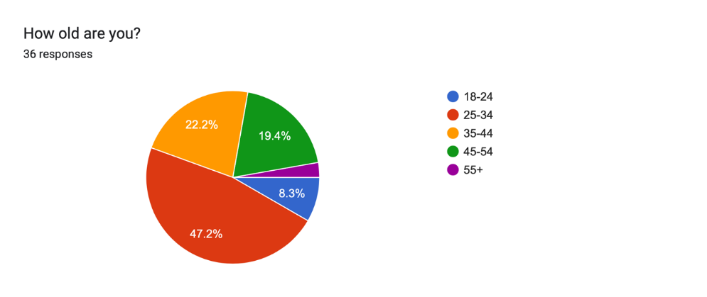
Figure 1: Graph showing ages of respondents.

Q3. How long have you served for the police (Including working for different forces): This question was asked to identify the levels of service that officers have throughout their policing career and not limited to South Wales Police only, being inclusive to service carried out in other forces. This can be seen in figure 2 below.
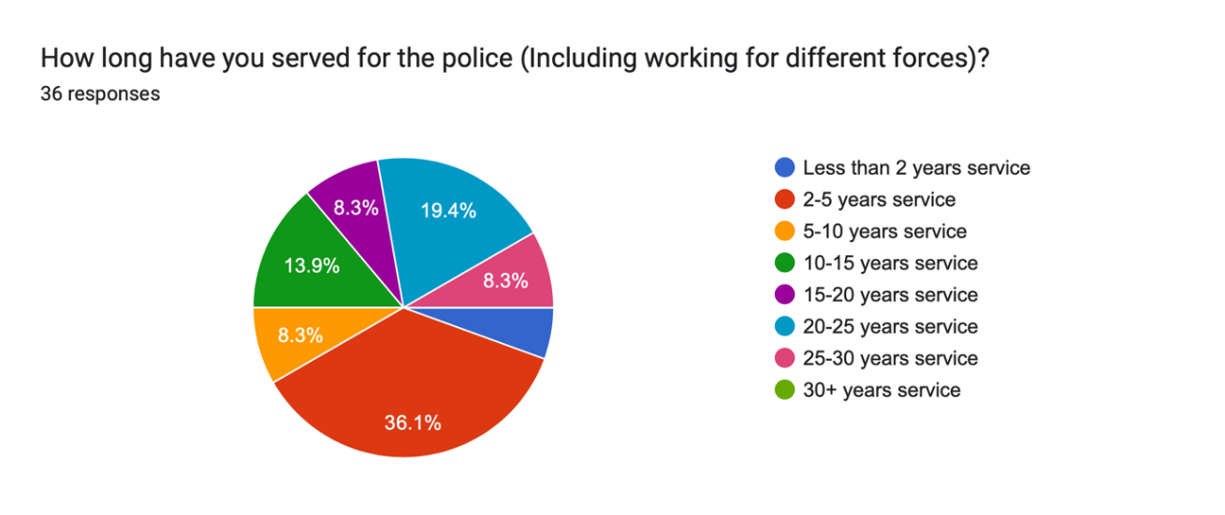
Figure 2: Pie chart showing length of service of respondents.

Q4. What is your current rank: This question was aimed to identify what the rank of the officers completing the survey were at the time of completion. The majority of respondents were PC’s as shown in the graph below.
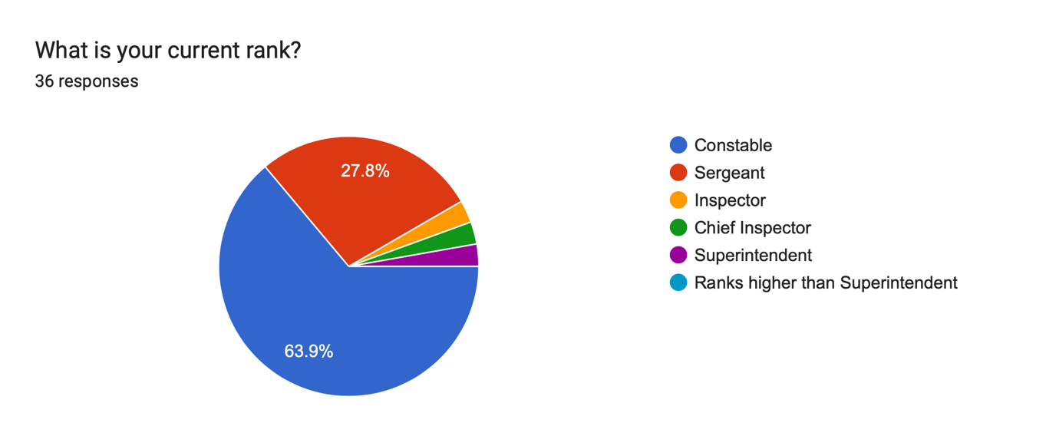
Figure 3: Pie Chart showing ranks of officer that completed the questionnaire

Q5. What is your gender: This question was asked to gauge the gender of officers that had completed the questionnaire. Most respondents stated that they were male with this being 75% of them and the remaining 25% stated that they were female with no other officer selecting the option of other.

4.3 Mental Health demand.

Q6. Has the demand on policing from mental health increased, decreased, or stayed the same since you have joined the police: This question was asked to gauge how people felt the current demand on police has changed since their own personal joining of the police. The options available to select in this case were: increased, decreased, or stayed the same. No option was provided to state other for this question. Most people (80.6%) selected that the demand had increased and with the remaining percentage (19.4%) selecting that it has stayed the same. No respondent selected that the demand had decreased.

Q7. Do you feel that the police are the most proportionate point of contact for someone suffering from a mental health crisis: This question was asked to determine whether respondents, being police officers of various ranks, felt that the police service was the best and most proportionate point of contact for someone in mental health crisis.
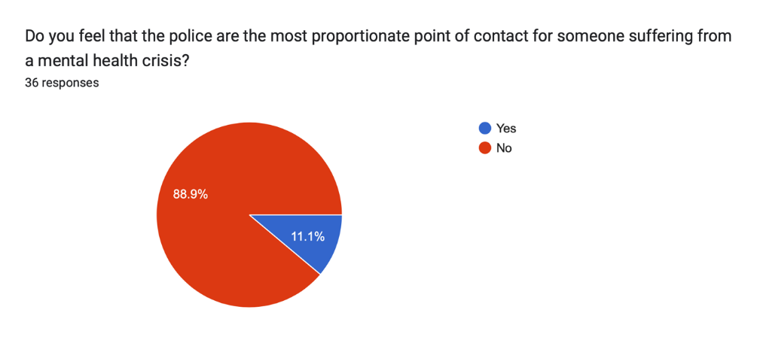

Figure 4: Pie Chart showing respondents as to whether they feel police are the most proportionate point of contact.

Q8 Following up to the previous question, if you answered no, who do you feel is the most proportionate agency to deal with mental health related calls? (List who you feel below): This question was qualitative to be able to gauge the feelings of the respondents on who they feel is most proportionate and allow them to provide their own answer to the question and not select from a list.

Most respondents, apart from two who selected N/A and a full stop, stated that they felt that the National Health Service, GP’s and Mental health charities would be the best point of contact for someone in mental health crisis including mental health professionals. However, two respondents stated that where there is a threat involving a weapon or someone states that are in possession of a weapon and intend to hurt themselves, then police may be the most proportionate initial contact however, care from mental health professionals should follow on from the police.

Q9. In an average working day, what percentage of your time is spent dealing with mental health where there is no criminality linked to the call: This question was asked in order to identify what amount of time officers spend on dealing with mental health calls where no criminality is identified at any time.

Respondents had the opportunity to select from 10% increments with the first being less than 10% of time with 13.9% selecting this option and 16.7% of people selecting 10% to 20% of time spent. 13.9% of respondents selected that they spent 20%-30% of time at these calls and 19.4% (the majority) stated that they spent 30%-40% of time at mental health calls. 13.9% of respondents stated that they spent 40%-50% of their time at mental health calls and 2.8% stated that they spent 50%-60% of time at mental health calls with no criminality involved. 8.3% of persons stated that they spent 60%-70% of their time dealing with mental health calls and finally, 2.8% stated that they spent 70%-80% of their time dealing with mental health calls with no respondent selecting any higher.

4.4 Training
Q10. Do you feel you are trained well enough to deal with Mental Health Calls: This question was aimed to identify if officers felt that they were trained well enough to be able to deal with calls relating to Mental Health.
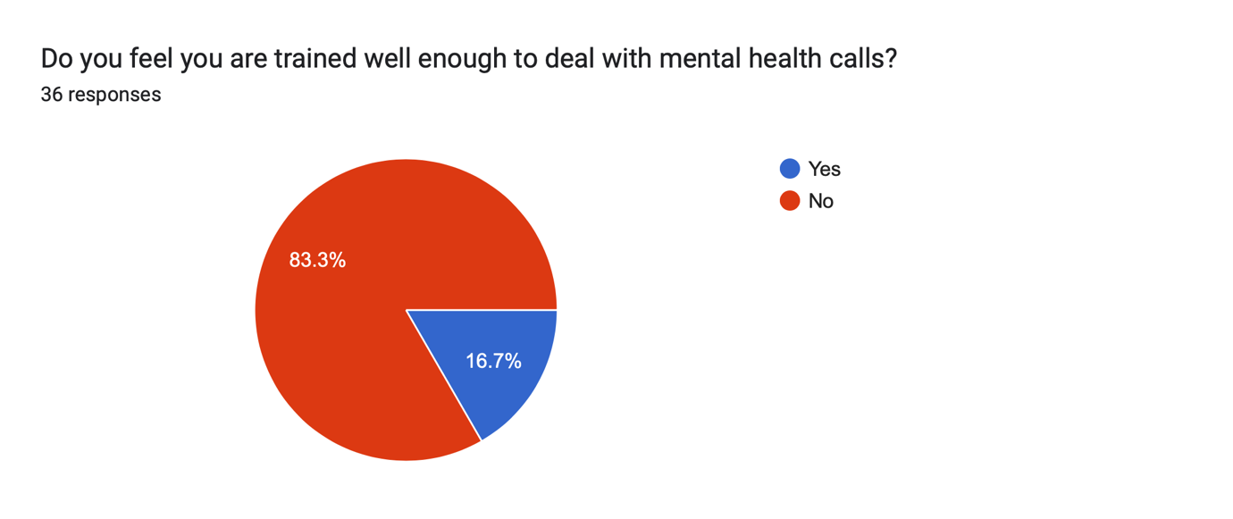
Figure 5: Pie Chart of respondents to training related question.

Q11. Please list what training, if any, you have received in relation to attending Mental Health related calls?

Respondents to this question listed several different training forms however, the majority only listed one each. Respondents stated that they had some training in their initial police training when starting and that this was in relation to police powers under the Mental Health Act 1983 which relates to section 136 and section 135 powers. A respondent stated that they have had some training in relation to ABD (Acute Behavioural Disturbance) during operational training and another stated that they were a trained police negotiator.

4.5 Equipment and Resources
Q12. Do you feel police have the necessary equipment to be able to deal with mental health calls?
The respondents were given the option to answer this question YES or NO with no other option to select other of not applicable. Most respondents (86.1%) selected NO whilst the remaining percentage of persons (13.9%) selected YES.

Q13. Do you feel that police have sufficient resources to be able to deal with Mental Health calls?
100% of respondents selected NO meaning that they feel that the police do not have the resources to be able to deal with mental health with no respondent selecting YES.

4.6 Current Mental Health Legislation
Q14. Is current Mental Health legislation for police, relevant and effective to allow police to respond to people suffering with Mental Health conditions?
The responses show that 61.1% of persons selected NO meaning that they felt legislation was not relevant or effective to be able to respond to persons suffering with Mental Health whilst the remaining 38.9% selected YES meaning they felt it was.

Q15. If no, what do you think could be changed to Mental Health legislation for police: This question was asked to gauge an understanding for what respondents felt would better allow them to deal with mental health calls and what changes to legislation would benefit their ability to effectively safeguard and get people help.

Respondents provided various suggestions for changes to legislation with the most mentioned one would be to give officers more powers in relation to Mental Health powers within a private dwelling. Other respondents stated either answered the question with N/A or stated that they felt that current legislation was enough. One respondent mentioned that they felt the Ambulance service and NHS should be given statutory powers in relation to mental health to be able to deal with persons suffering. Another respondent stated that police should have a maximum exposure time whilst at a place of safety and after which point, health care staff should take over from this point onwards.

Q16. If you could change anything about the way in which police deal with Mental Health related calls, what would this be: This question was asked to gain an understanding of what officers may want to change about the way in which the police deal with mental health calls.

Most respondents have stated that they would like to see more collaboration and a better working relationship with Mental Health services to determine a clear standard of operations to identify what police deal with and what the ambulance and mental health and medical staff take primacy over. Some respondents have asked for further support from other services and for police to not be dispatched to mental health calls altogether. Some respondents have mentioned that the police service may benefit from a reduced demand if a mental health car was set up by medical professionals to be able to deal with mental health calls. Respondents have also asked for less reliance on police to attend calls and one stated ‘for another agency to work 24 hours and attend instead of police.’

4.7 Conclusion
In conclusion, from the results gained from the questionnaire, officers on the front line do not feel that they are not the most responsible persons to be dealing with mental health related calls. All respondents stated that police do not have sufficient resources to be able to deal with mental health with the vast majority also agreeing that there is insufficient training to be able to effectively deal with these also. Almost 90% of respondents also stated that they felt that the police were not the most proportionate point of contact for calls that relate to mental health. However, the data obtained may not be attributed to the full SWP workforce owing to the vast number of officers within the force, and the limited respondents received. This research would benefit from a larger sample size.

There are several implicating factors that may have influenced only 36 responses having been received. These potentially being sickness, leave and shift patterns as well as individual officers not having time to complete the questionnaire owing to workload or other work-related demands. Another large factor that may implicate is the way in which the intranet is published. The area in which the post was made was to a timeline type text area where officers can post individual queries and questions. It is entirely possible that the questionnaire may have been further down in the timeline than an officer may be willing to go back to.

5.0 Conclusion and Recommendations
5.1 Introduction
The chapters before this have documented the introduction to this project, planning, research, available literature relating to policing mental health and the results obtained from the questionnaire provided. This chapter will look to highlight the findings and document recommendations as a result of the research conducted.
5.2 Objective Achievement
The primary objective of this research project was to ascertain officer involvement with mental health and if the police are the most appropriate first point of contact for persons having a mental health episode. The research objectives were as follows:
To ascertain if the demand on the police to deal with mental health calls has changed and whether this has increased, decreased, or stayed the same.
To ascertain if officers dealing with mental health feel they have appropriate training to deal with mental health.
To ascertain if officers feel they have the right equipment and legislation to respond to mental health related calls.
The objectives of this research project have been achieved by carrying out a review of the literature already published and available for review with previous studies that have been carried out highlighting areas of the police involvement with mental health. The literature documented also documents that the demand for mental health services has increased. Objectives two and three were primarily answered utilising the questionnaire provided to serving police officers within South Wales Police with some literature also aiding to achieve these objectives.

5.3 Main Findings
The research that has been conducted as part of this project is hoped to be used as aiding material for further research to be undertaken utilising both pre-existing literatures mentioned within the literature review of this dissertation and the findings of this project itself. This could aid in providing a better and more experienced service to the UK public and aid the police services in the UK to provide better response to persons in mental health crisis.

Firstly, from research carried out and utilising the literature available, it is reasonable to say that the majority of officers who took part in the questionnaire (80.6%) stated that they felt that the demand from mental health had increased with the majority of the 36 respondents (88.9%) stating that they did not feel that the police were the most proportionate point of contact for someone suffering from a mental health crisis.

Participants of the questionnaire also stated that the NHS, GP’s and mental health charities would be the best people to be able to deal with a person suffering with their mental health instead of the police. Most participants in the questionnaire (19.4%) stated that they spent between 30%-40% of their time working dealing with persons suffering with mental health. The increased demand was also documented in a review conducted by Sir Thomas Winsor (2021) who published a report regarding the effect of the pandemic and the demand on policing.

Secondly, research suggests that there is some training in identifying a mental health illness (Lamb et al, 2002; Borum, 2000), information that has been established from the participants of this questionnaire suggests that there is limited training for mental health. 83.3% of the 36 respondents to the questionnaire stated that they did not feel well enough trained to deal with mental health calls with most participants stating that they had some limited training in sections 136 and 135 of the Mental Health Act of 1983 and some stating that received some training within initial training. This would suggest that officer on the frontline do not feel well enough trained to deal with the mental health incidents they are called upon to deal with.

Finally, whilst there is little published research on current mental health legislation and its relevancy and how applicable it is to modern policing. The questionnaire showed that 80% of officers answered no when asked if they felt they had the necessary equipment or training resources to deal with someone in mental health crisis. Also, 100% of respondents stated that police do not have sufficient resources to deal with mental health calls. The questionnaire has also shown that 61.1% of respondents stated that current mental health legislation was not effective. However, the general qualitative feedback from this was that other agencies should be able to pick up where police legislation prevents officers from being able to do anything.

5.4 Recommendations
5.4.1 Recommendation One: To utilise this survey on a wider sample of officers.
The first and most obvious recommendation to make would be to complete a study on a larger scale to identify if the general findings of this study are relatable to a national level within policing in the UK. The questionnaire in this case took 36 respondents and was posted onto the SWP intranet for all officers to view. This operates as a news feed type of thread meaning that after a period, the post may not be available for officers to view. The questionnaire would potentially have gotten a better response if this had been sent directly to officers.
A larger demographic that incorporates different policing areas and officers from other forces within the UK would increase the validity and credibility of the research conducted.

5.4.2 Recommendation Two: Develop training for police officers surrounding mental health.
Although some training was stated to have been provided to police officers, it appears that the respondents felt as though the training they have received is inadequate for the role they have to perform.
As a result of this, a recommendation that would be suitable would be to develop further training for officer on mental health as was previously suggest by Ahern (2021).

5.4.3 Recommendation Three: Create a pathway for those in mental health crisis to be directed to partner agencies.

Police officers are NOT mental health professionals as has been shown within the results chapter of this research. Medical professionals such as GP’s, mental health nurses and crisis teams are trained in this area specifically and deal with persons in mental health crisis more often than police. They would be more aware and better suited to signpost and implement safeguarding measures long term to provide support to persons in need. As such, a suitable recommendation would be to develop a pathway for those in crisis to be directed to partners instead of the police or with a uniform approach to dealing with mental health. This would be supported by literature previously published by Puntis et al (2018) where the suggestion was made for there to be a co-response to persons suffering with mental illness.

5.5 Limitations
As with any study, there are limitations that would be out of the researcher’s control. The scope of research that can be conducted is limited owing to the time limit of the project itself with this needed to be completed in a nine-month period and a restriction to the word count. There are many different types of mental health illnesses (Lal et al, 2016) and as such, it varies in the amount of help that a person may need when they are in crisis. As a result, persons may only come into police contact when there is a real need for them to be protected. Further to this, there appears to be insufficient data available to firmly say what training police have in relation to mental health. These factors can all provide limitations to the research that has been conducted.

5.6 Conclusion
In conclusion, it is apparent that the need for mental health services is needed now more than ever. The needed for persons to receive support from services is clear however, questions have been raised as to whether, the first contact they receive for their mental health should be via the police. As outlined in the literature review section of this research, the amount of time that police are spending dealing with mental health related calls is increasing and something needs to be done so that persons suffering with their mental health, are getting the correct treatment and support. This study has shown that officers do not feel that they are well trained or well-equipped enough to be able to deal with most mental health calls that they are attending. With growing demands on policing, something needs to be done in order to either reduce demand, or, train the police to be able to deal with these types of calls effectively.

Bibliography
Adebowale, V. (2013). Independent Commision on Mental Health and Policing Report Available at: https://amhp.org.uk/app/uploads/2017/08/independent_commission_on_mental_health_and_policing_main_report.pdf (Accessed 20th October 2022)

Almalki, S. (2016). Integrating Quantitative and Qualitative Data in Mixed Methods Research--Challenges and Benefits. Journal of Education and Learning, [online] 5(3), pp.288–296. Available at: https://eric.ed.gov/?id=EJ1110464 (Accessed 23rd March 2023).

BACP (2021). Attitudes to mental health are changing, our research finds. [online] www.bacp.co.uk. Available at: https://www.bacp.co.uk/news/news-from-bacp/2021/8-october-attitudes-towards-mental-health-are-changing-our-research-finds/#:~:text=We%20found%20that%2090%25%20of. (Accessed 23rd March 2023)

Colarossi, L. and Eccles, J. (2003). Differential Effect of Support Provides on Adolescents’ Mental Health. [online] EBSCO Host. Available at: https://web-p-ebscohost-com.ezproxy.uwtsd.ac.uk/ehost/pdfviewer/pdfviewer?vid=0&sid=f29cbf4e-544e-40b6-b07a-d901e6318cf2%40redis (Accessed 23rd March 2023).

Dearden, L. and Thomas, R. (2022). Armed police being sent to cardiac arrest patients as NHS buckles under strain. [online] The Independent. Available at: https://www.independent.co.uk/news/uk/crime/nhs-crisis-armed-police-cardiac-arrest-b2138086.html. (Accessed 22nd March 2023)

Friborg, O. and Rosenvinge, J. (2013). A comparison of open-ended and closed questions - ProQuest. [online] www.proquest.com. Available at: https://www.proquest.com/docview/1272277302?accountid=130472&parentSessionId=623BrAHtAJznynHdzdporrSfmN3Li4Sq5tMsfIncGNY%3D&pq-origsite=primo (Accessed 23rd March 2023).

Galderisi, S., Heinz, A., Kastrup, M., Beezhold, J. and Sartorius, N. (2015). Toward a New Definition of Mental Health. World Psychiatry, [online] 14(2), pp.231–233. Available at: https://www.ncbi.nlm.nih.gov/pmc/articles/PMC4471980/ (Accessed 23rd March 2023).

Hellstern, R.B. and Robinson, W.D. (2023). The Impact of COVID-19 and Telehealth Services on Attrition Rates in Psychotherapy. Contemporary Family Therapy, 45(1). (Accessed 22nd March 2023).

HMICFRS. (2018). Policing and Mental health: Picking up the pieces. Available at: https://www.justiceinspectorates.gov.uk/hmicfrs/publications/policing-and-mental-health-picking-up-the-pieces/. (Accessed 12th August 2022)

Holloway, D. (2018) Do police officers receive sufficient training in mental health? A front line perspective of police officer’s attitudes and beliefs on attending mental health calls. Available at: https://repository.canterbury.ac.uk/download/e887ba5972654885d6ed30f9b3b75d3e2acc685d04bd89a20fea5ed674aea267/791561/Final%20thesis.pdf (Accessed 17th October 2022)

Jones, S., Murphy, F., Edwards, M. and James, J. (2008). Doing things differently: advantages and disadvantages of web questionnaires. [online] login.microsoftonline.com. Available at: https://www.proquest.com/docview/200782829?OpenUrlRefId=info:xri/sid:primo&accountid=130472 (Accessed 23rd March 2023).

Kalucy, R., Thomas, L., Lia, B., Slattery, T. and Norris, D. (2004). Managing increased demand for mental health services in a public hospital emergency department: A trial of ‘Hospital-in-the-Home’ for mental health consumers. International Journal of Mental Health Nursing, 13(4), pp.275–281. (Accessed 22nd March 2023).

Kane et al. (2017). Effectiveness of current policing-related mental health interventions in England and Wales and Crisis Intervention Teams as a future potential model: a systematic review. Available at: https://systematicreviewsjournal.biomedcentral.com/counter/pdf/10.1186/s13643-017-0478-7.pdf (Accessed 19th October 2022)

Kane, E., Evans, E. and Shokraneh, F. (2018). Effectiveness of current policing related mental health interventions: A systematic review. [online] Uwtsd.ac.uk. Available at: https://web-p-ebscohost-com.ezproxy.uwtsd.ac.uk/ehost/pdfviewer/pdfviewer?vid=0&sid=c330e65e-bac8-48d3-a836-a6bd906cc322%40redis. (Accessed 23rd March 2023).

Kelly, C., Jorm, A. and Wright, A. (2007). Improving Mental Health Literacy as a Strategy to Facilitate Early Intervention for Mental Disorders. Medical Journal of Australia, [online] 187(S7). Available at: https://www.mja.com.au/journal/2007/187/7/improving-mental-health-literacy-strategy-facilitate-early-intervention-mental (Accessed 23rd March 2023).
Lamb, V. and Tarpey, E. (2018). ‘It’s not getting them the support they need’: Exploratory research of police officers’ experiences of community mental health. The Police Journal: Theory, Practice and Principles, 92(4), pp.277–295.

Lane, R. (2019). ‘I’m a police officer not a social worker or mental health nurse’: Online discourses of exclusion and resistance regarding mental health‐related police work. [online] Uwtsd.ac.uk. Available at: https://web-p-ebscohost-com.ezproxy.uwtsd.ac.uk/ehost/pdfviewer/pdfviewer?vid=0&sid=53890f34-acac-4c69-8f28-494fbc425786%40redis (Accessed 23rd March 2023).

Lawrence, V., McCombie, C., Nikolakopoulos, G. and Morgan, C. (2021). Navigating the mental health system: Narratives of identity and recovery among people with psychosis across ethnic groups. [online] Science Direct. Available at: https://www-sciencedirect-com.ezproxy.uwtsd.ac.uk/science/article/pii/S0277953621003130 (Accessed 23rd March 2023).

Lentz, S. and Chaires, R. (2007). The Invention of Peel’s principles: a Study of Policing ‘textbook’ History. [online] Uwtsd.ac.uk. Available at: https://www-sciencedirect-com.ezproxy.uwtsd.ac.uk/science/article/pii/S0047235206001449 (Accessed 22nd March 2023).

Marsden, M., Nigam, J., Lemetyinen, H. and Edge, D. (2020). Investigating Police officers’ Perceptions of Their Role in Pathways to Mental Healthcare. [online] Uwtsd.ac.uk. Available at: https://web-p-ebscohost-com.ezproxy.uwtsd.ac.uk/ehost/pdfviewer/pdfviewer?vid=0&sid=2198d4e8-9fb1-49bb-95b8-df000d9c3b7b%40redis (Accessed 23rd March 2023).

Mental Health First Aid USA, (2021) The Importance of Early Intervention for People Facing Mental Helth Challenges. Available at: https://www.mentalhealthfirstaid.org/2021/06/the-importance-of-early-intervention-for-people-facing-mental-health-challenges/ (Accessed 26th September 2022)

Michael, A (2013). Annual report 2012-13. Available at: http://pcclivewww.blob.core.windows.net/wordpress-uploads/2012-13-Annual-Report.pdf (Accessed 20th October 2022)

Mind Charity, (2013) Police and mental health. How to get it right locally. Available at: https://www.mind.org.uk/media-a/2116/2013-12-03-mind_police_final_web.pdf (Accessed 12th October 2022).

Mind Charity, (2017) Police and mental health. Available at: https://www.mind.org.uk/information-support/legal-rights/police-and-mental-health/sections-135-136/#CanIChallengeThePolicesDecision (Accessed 20th October 2022).

Monroe, K.K., Rappaport, L.G., Oesch, J., Kullgren, K.A. and Malas, N. (2022). The Epidemic Within the Pandemic: Pediatric Mental Health Demands in the Setting of COVID-19. Clinical Pediatrics, 61(3), pp.228–231. (Accessed 23rd March 2023).

Office of National Statistics (2022). Crime in England and Wales: Police Force Area data tables. Available at: https://www.ons.gov.uk/peoplepopulationandcommunity/crimeandjustice/datasets/policeforceareadatatables (Accessed 14th October 2022).

Pitchforth, J., Fahy, K., Ford, T., Wolpert, M., Viner, R.M. and Hargreaves, D.S. (2018). Mental health and well-being trends among children and young people in the UK, 1995–2014: analysis of repeated cross-sectional national health surveys. Psychological Medicine, [online] 49(08), pp.1275–1285. Available at: https://www.cambridge.org/core/journals/psychological-medicine/article/mental-health-and-wellbeing-trends-among-children-and-young-people-in-the-uk-19952014-analysis-of-repeated-crosssectional-national-health-surveys/AB71DE760C0027EDC5F5CF0AF507FD1B (Accessed 23rd March 2023).

Plewes, J (2022) Analysis: the rise in mental health demand. Available at: https://www.nhsconfed.org/articles/analysis-rise-mental-health-demand (Accessed 15th October 2022)

Puntis, S., Perfect, D., Kirubarajan, A., Bolton, S., Davies, F., Hayes, A., Harriss, E. and Molodynski, A. (2018). A Systematic Review of co-responder Models of Police Mental Health ‘street’ Triage. [online] EBSCO Host. Available at: https://web-s-ebscohost-com.ezproxy.uwtsd.ac.uk/ehost/pdfviewer/pdfviewer?vid=0&sid=a26f356e-8862-40f4-ac25-bc4d584e5591%40redis (Accessed 23rd March 2023).

Rohrer, A.J. (2021). Law Enforcement and Persons with Mental Illness: Responding Responsibly. Journal of Police and Criminal Psychology, [online] 36(2). Available at: https://link-springer-com.ezproxy.uwtsd.ac.uk/article/10.1007/s11896-021-09441-2 (Accessed 23rd March 2023).

Roxby, P. (2023). Mental-health crisis from Covid pandemic was minimal - study. BBC News. [online] 9 Mar. Available at: https://www.bbc.co.uk/news/health-64890952 (Accessed 22nd March 2023).

Sass, C., Farley, K. and Brennan, C. (2022). ‘They have more than enough to do than patch up people like me.’ Experiences of seeking support for self‐harm in lockdown during the COVID‐19 pandemic. Journal of Psychiatric and Mental Health Nursing. [online] Available at: https://onlinelibrary-wiley-com.ezproxy.uwtsd.ac.uk/doi/full/10.1111/jpm.12834 (Accessed 22nd March 2023).

Scantlebury, A., Fairhurst, C., Booth, A., McDaid, C., Moran, N., Parker, A., Payne, R., Scott, W.J., Torgerson, D., Webber, M. and Hewitt, C. (2017). Effectiveness of a training program for police officers who come into contact with people with mental health problems: A pragmatic randomised controlled trial. PLOS ONE, 12(9), p.e0184377.

Short, T., MacDonald, C., Luebbers, S., Ogloff, J. and Thomas, S. (2014). The Nature of Police Involvement in Mental Health Transfers. [online] Uwtsd.ac.uk. Available at: https://web-p-ebscohost-com.ezproxy.uwtsd.ac.uk/ehost/pdfviewer/pdfviewer?vid=0&sid=17277c6a-e8eb-44c3-a4ea-10c27b3ea0e5%40redis (Accessed 23rd March 2023).

Stroever, S., Brett, C., Michael, K. and Petrini, J. (2021). Emergency Department Utilization for Mental Health Conditions before and after the COVID-19 Outbreak. [online] Science Direct. Available at: https://www-sciencedirect-com.ezproxy.uwtsd.ac.uk/science/article/pii/S0735675721002710 (Accessed 22nd March 2023).

Thomas, R. (2022) NHS fails on mental health care targets as waiting list rises to 1.2million. Available at: https://www.independent.co.uk/news/health/nhs-mental-health-waiting-list-b2145432.html (Accessed 22nd September 2022).

Walley, P and Adams M (2019) An evaluation of Demand Management Practiciesin UK Police Forces. Available at: https://www.open.ac.uk/centres/policing/sites/www.open.ac.uk.centres.policing/files/files/Outputs/An%20Evaluation%20of%20Demand%20Management%20Practices%20in%20UK%20-%20Final%20report.pdf (Accessed 23rd October 2022).

West Midlands Police. (2020). Predicting the volume of Demand from Mental Health related Police Incidents. Available at: https://www.westmidlands-pcc.gov.uk/wp-content/uploads/2021/02/14122020-EC-Agenda-Item-5c-Mental-Health-Deman-Investigation.pdf?x39505#:~:text=Mental%20health%20is%20becoming%20an,health%20related%20calls%20and%20incidents. (Accessed 13th August 2022)

Borum, R. (2000). APA PsycNet. [online] psycnet.apa.org. Available at: https://psycnet.apa.org/record/2000-02847-009 (Accessed 25th February 2023).

Lamb, H.R., Weinberger, L.E. and DeCuir, W.J. (2002). The Police and Mental Health. Psychiatric Services, [online] 53(10), pp.1266–1271. doi:https://doi.org/10.1176/appi.ps.53.10.1266.

Winsor, T. (2021). Pandemic has intensified vulnerability and increased demand on police. [online] His Majesty’s Inspectorate of Constabulary and Fire & Rescue Services (HMICFRS) – Home. Available at: https://www.justiceinspectorates.gov.uk/hmicfrs/news/news-feed/pandemic-has-intensified-vulnerability-and-increased-demand-on-police/#:~:text=As%20a%20result%2C%20many%20more (Accessed 25th February 2023).

Ahern, M. (2021). ‘Defunding’ The Criminality of Mental Illness by Funding Specialized Police Training: How Additional Training and Resources for Dealing with Mental Health will be Beneficial for all sides. [online] Uwtsd.ac.uk. Available at: https://www-proquest-com.ezproxy.uwtsd.ac.uk/docview/2639045256?pq-origsite=primo&accountid=130472 (Accessed 24th March 2023).

Lal, S., Nguyen, V. and Theriault, J. (2016). Seeking mental health information and support online: experiences and perspectives of young people receiving treatment for first-episode psychosis. Early Intervention in Psychiatry, [online] 12(3), pp.324–330. Available at: https://onlinelibrary-wiley-com.ezproxy.uwtsd.ac.uk/doi/full/10.1111/eip.12317 (Accessed 24th March 2023).

Appendix One – Questionnaire
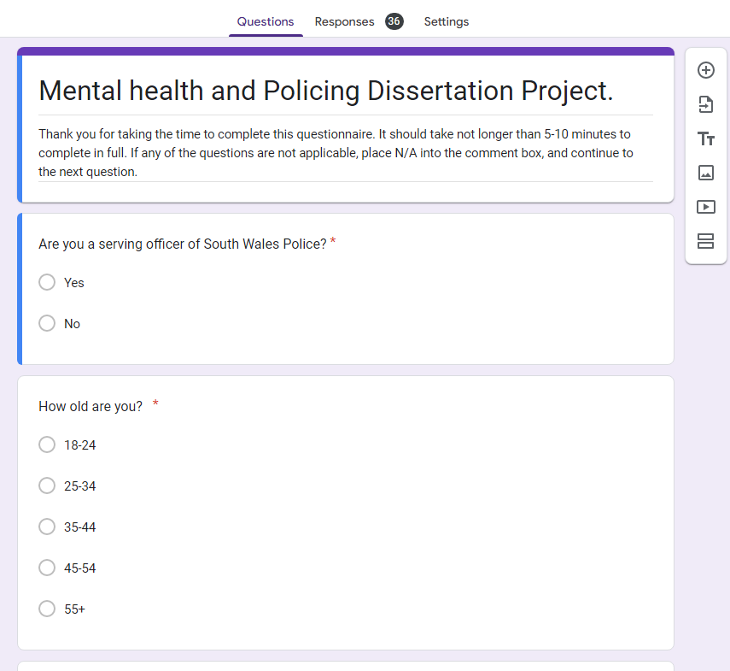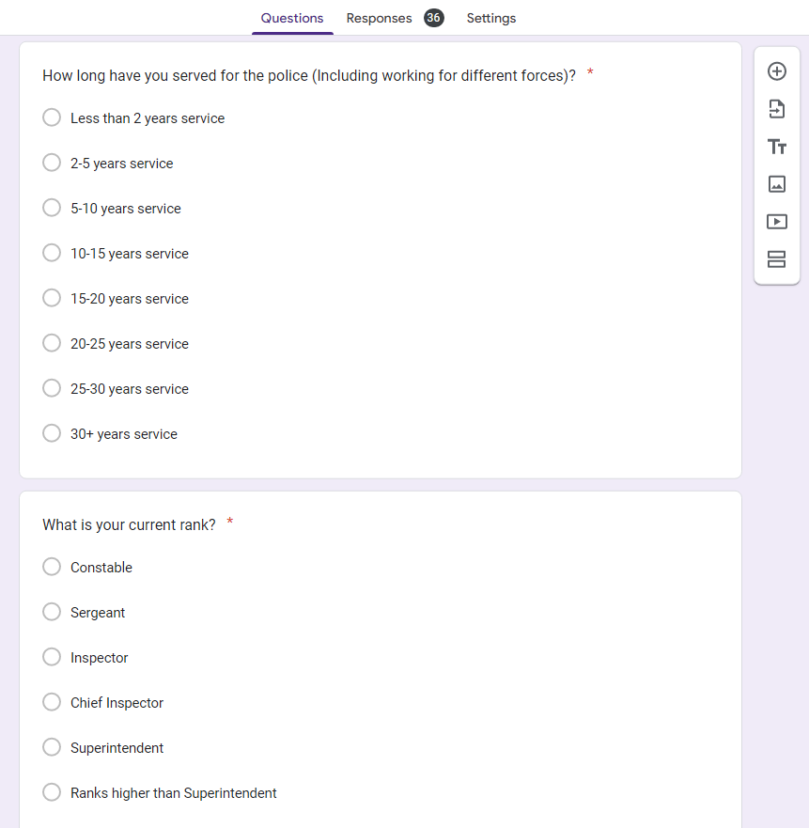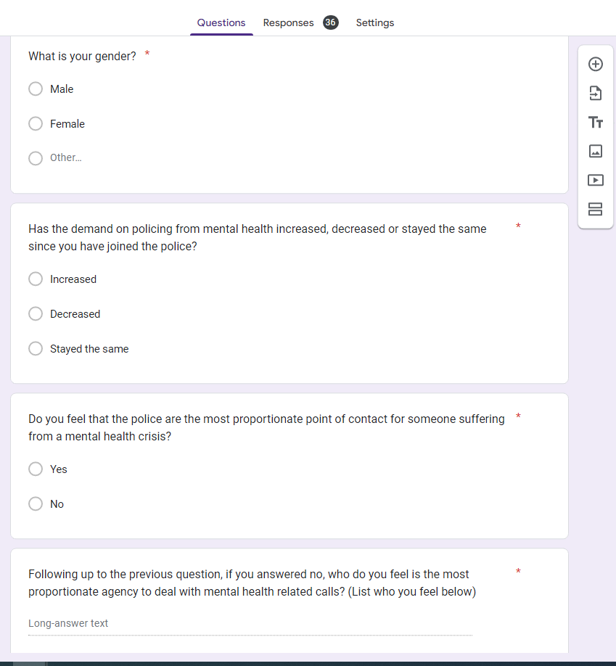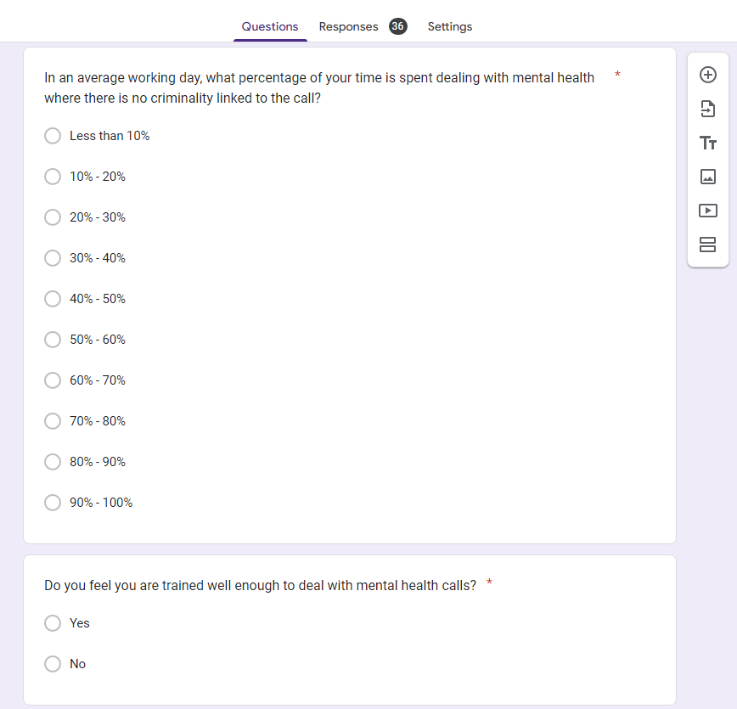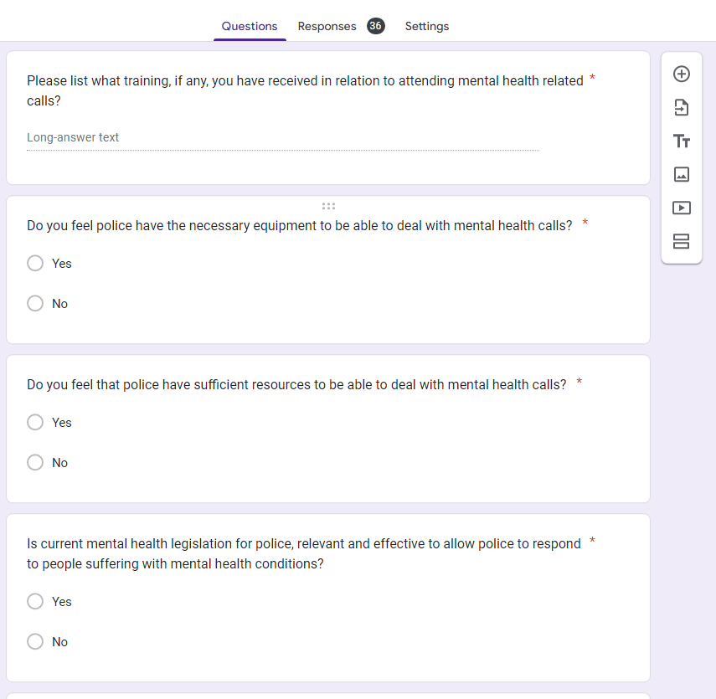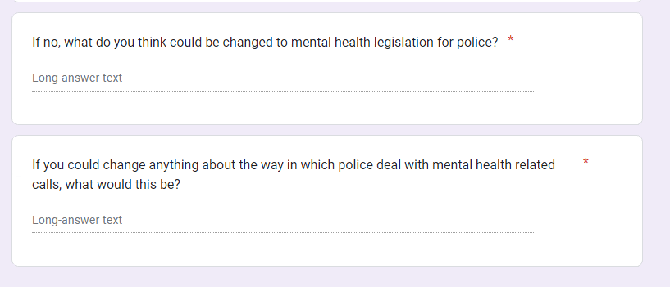

Appendix Two – Questionnaire Responses
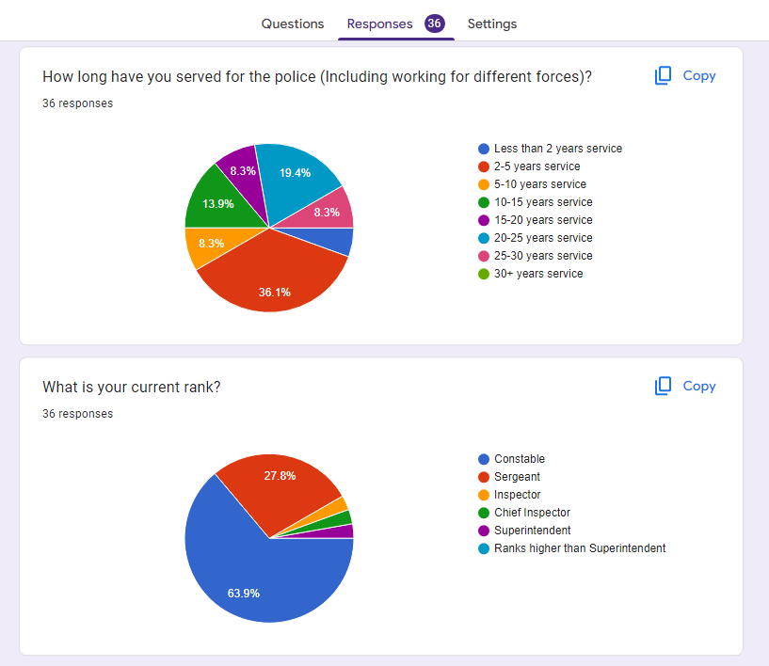
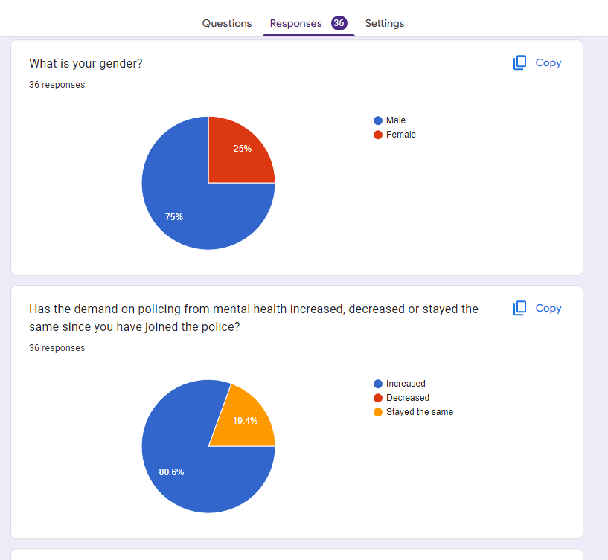
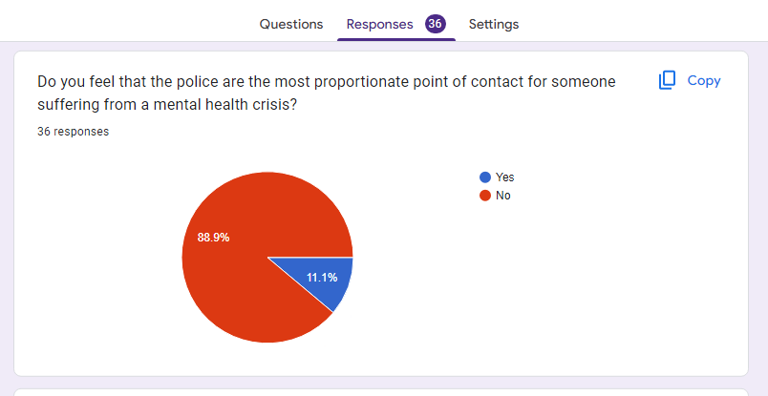
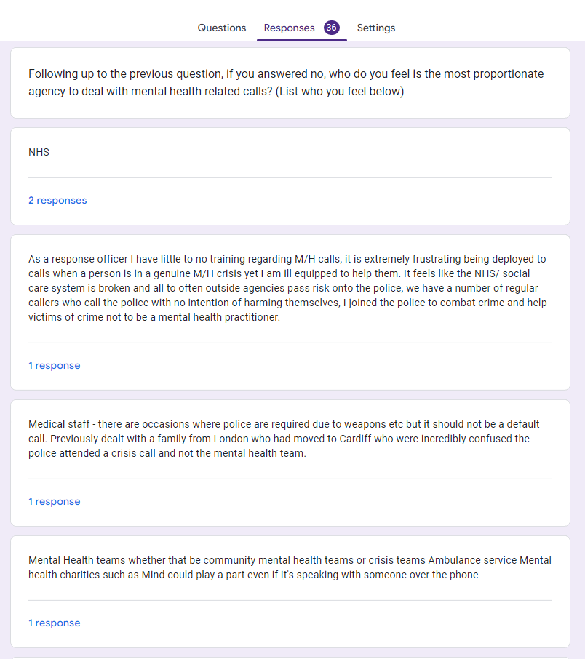
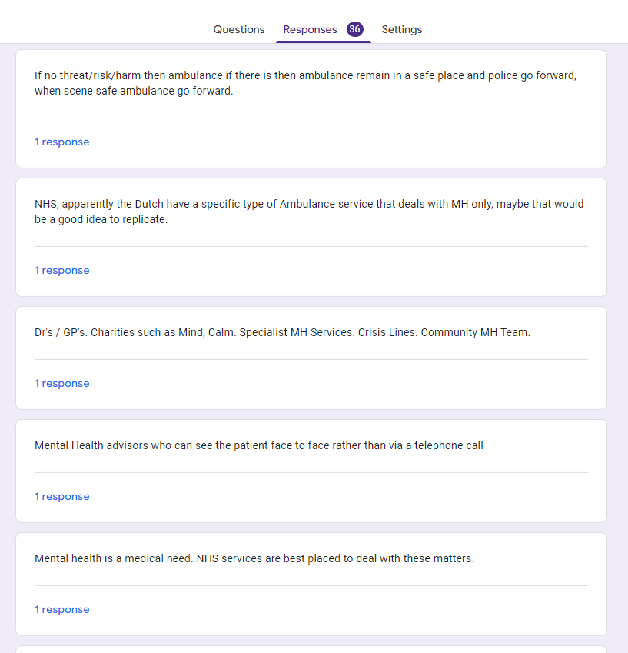
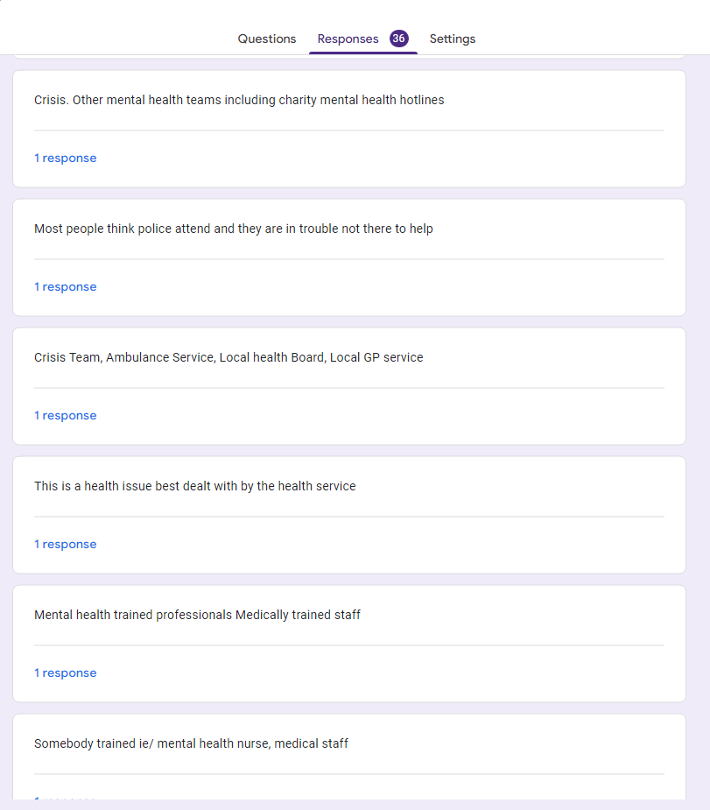
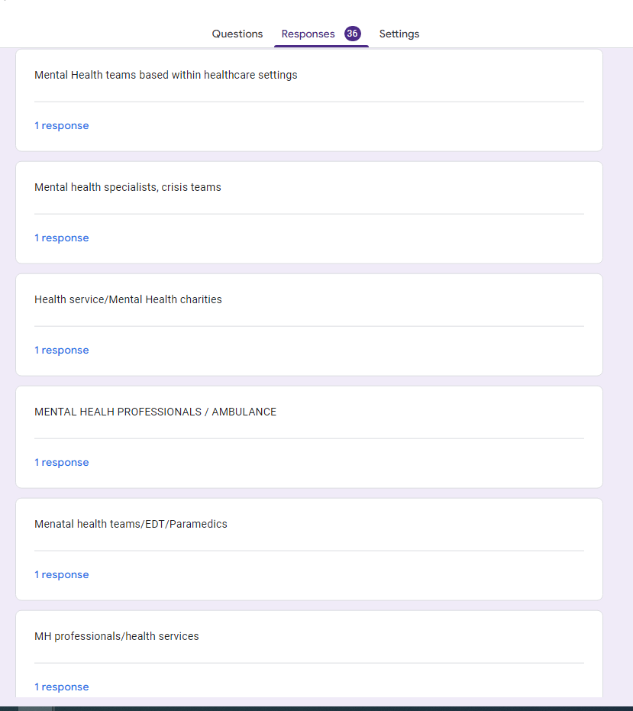
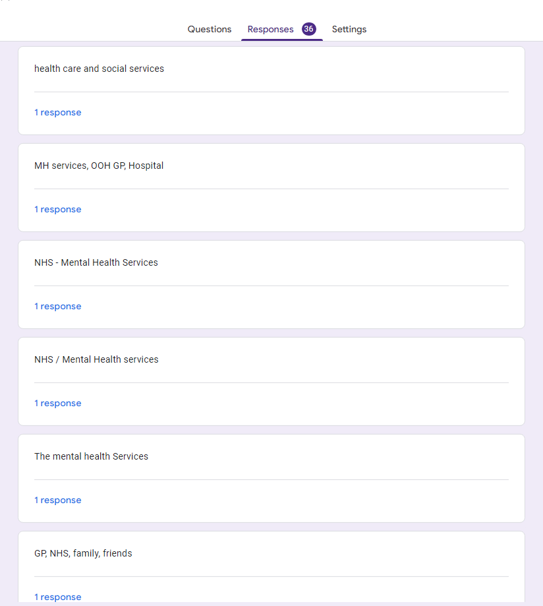
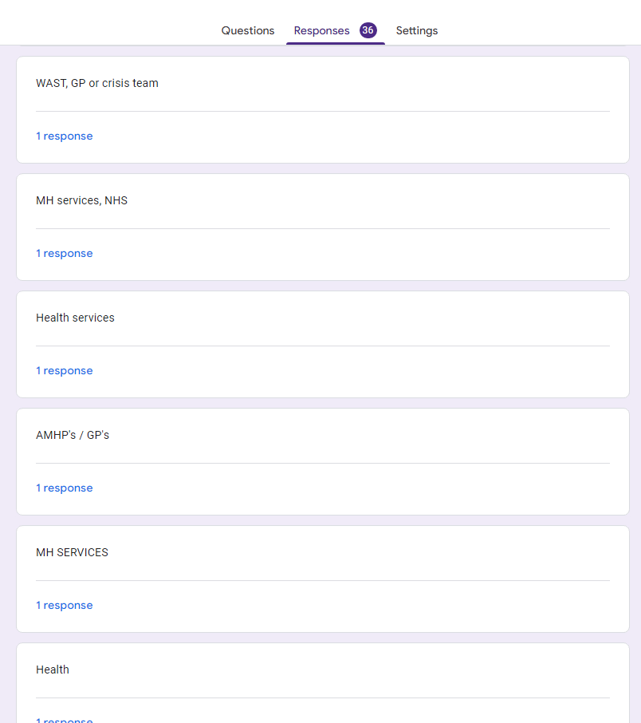

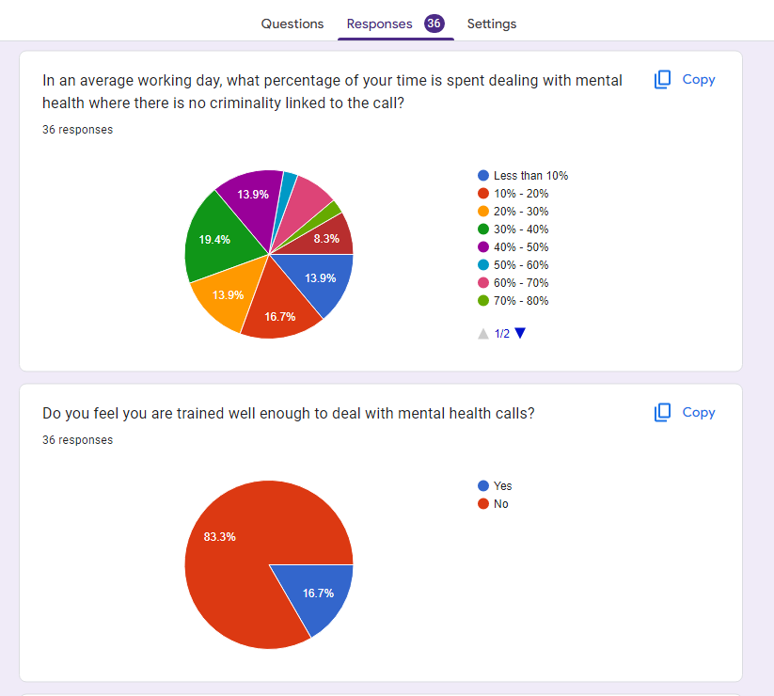
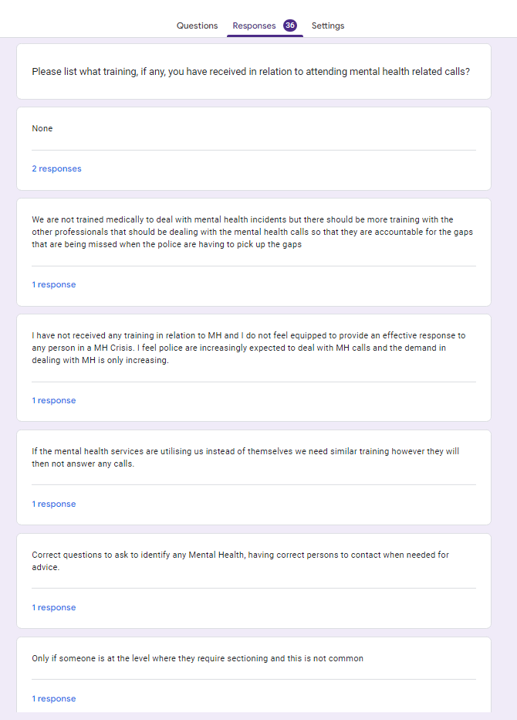
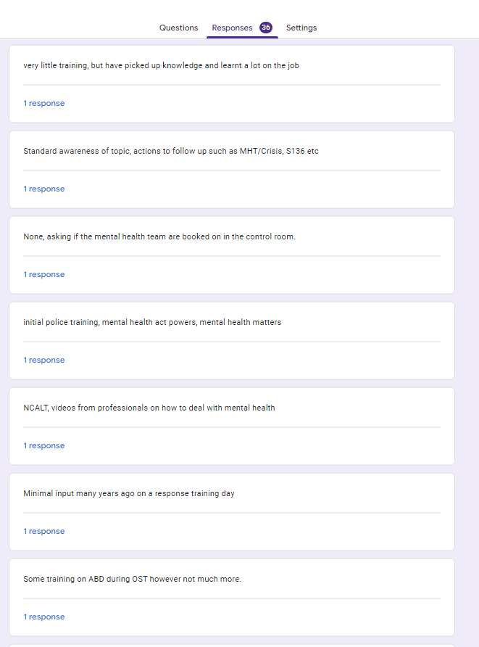
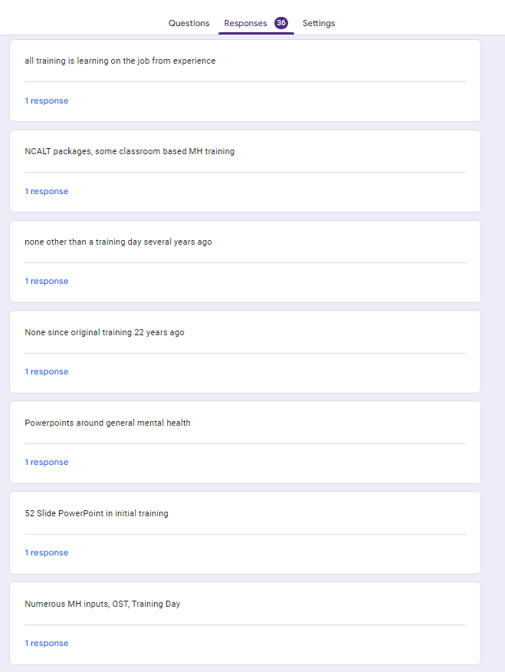



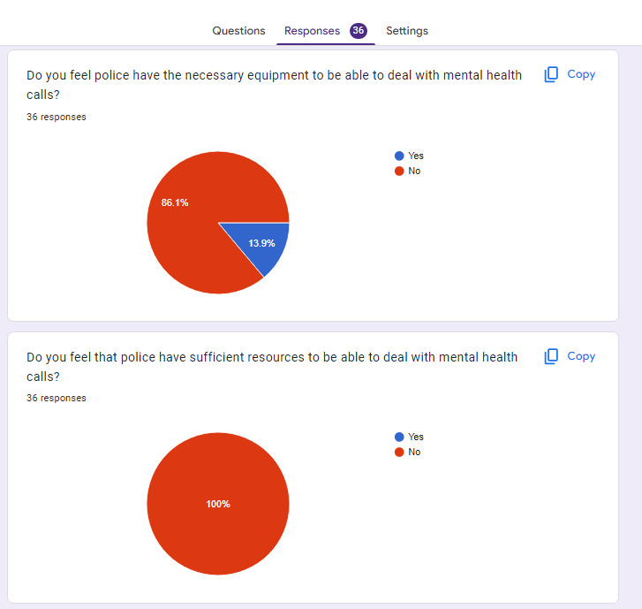
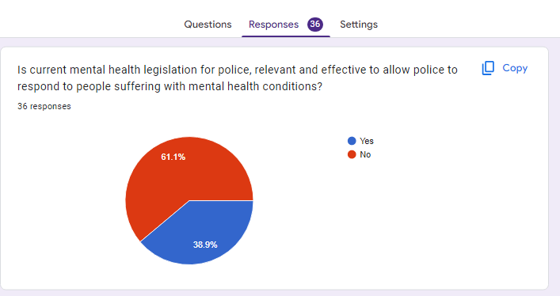
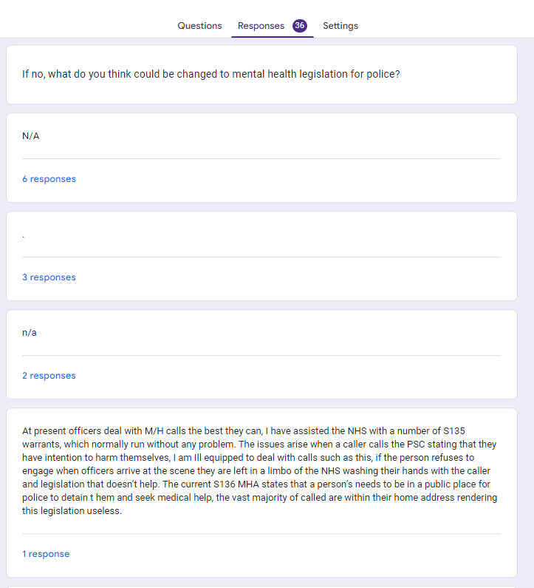
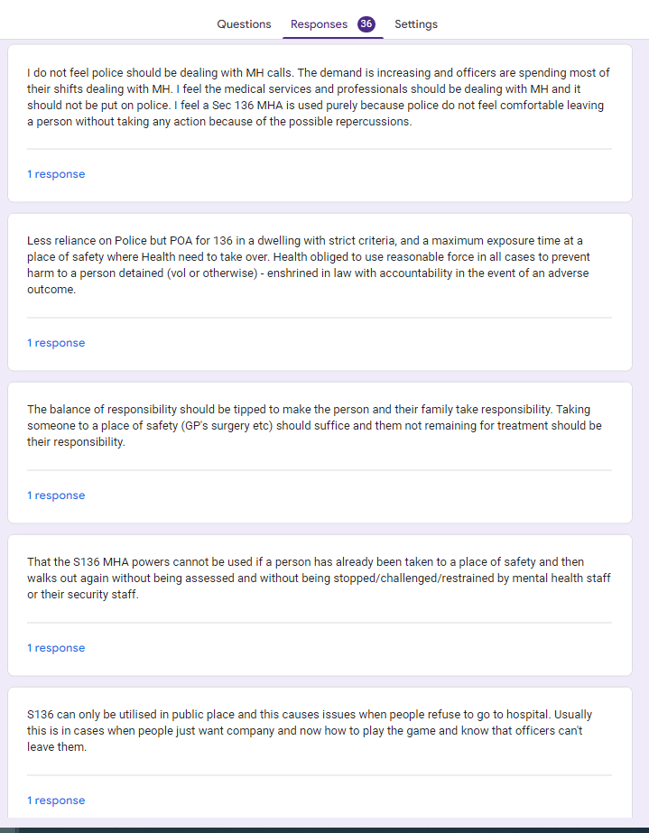
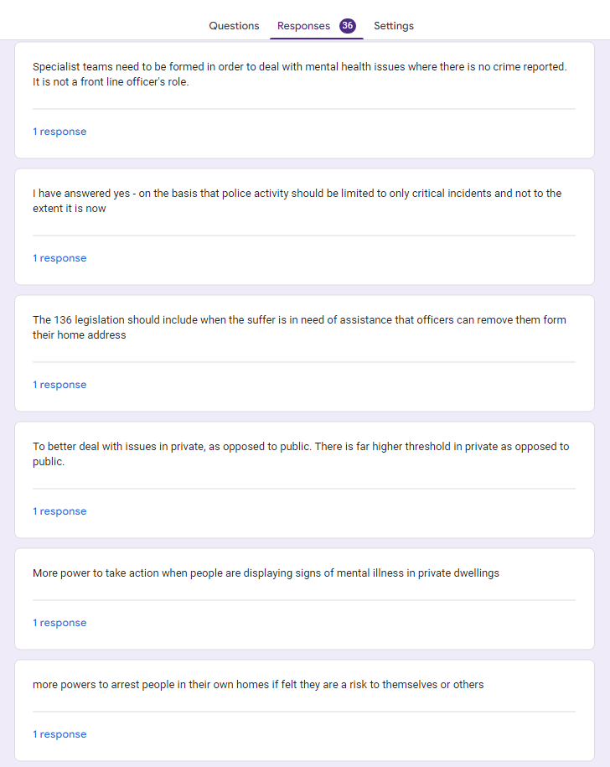
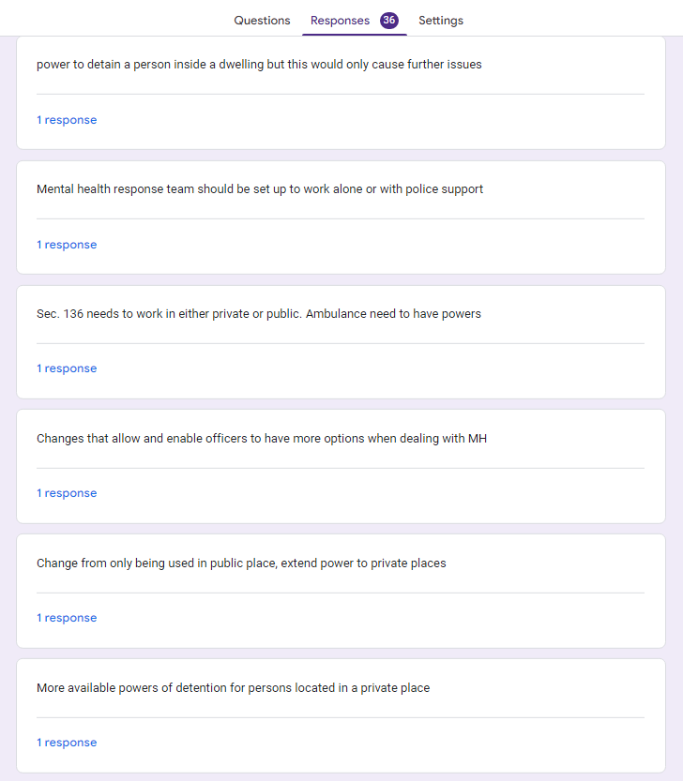
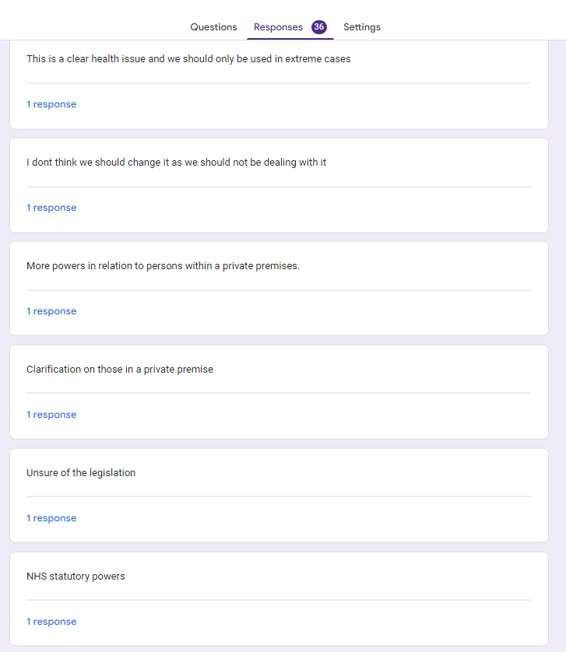
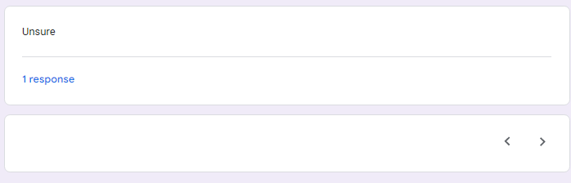
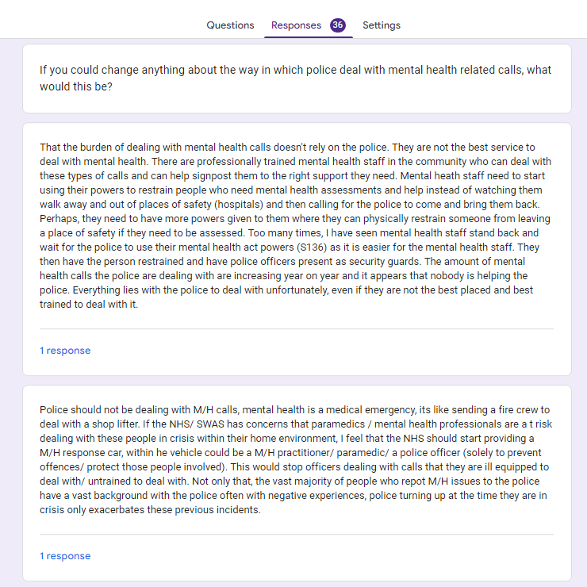
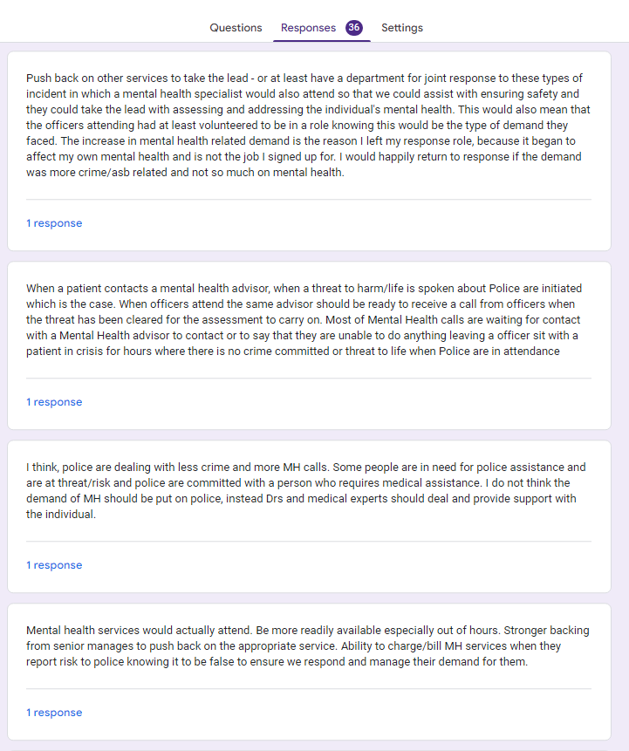
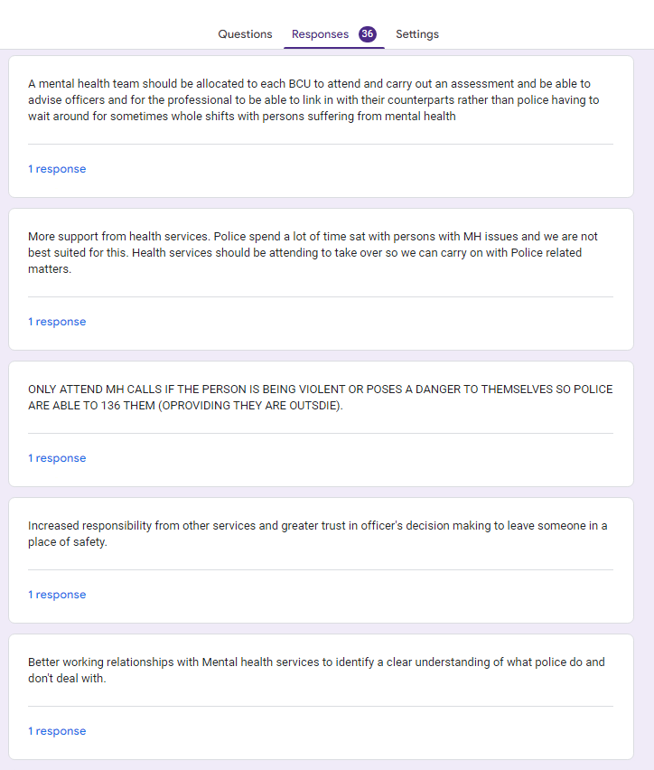
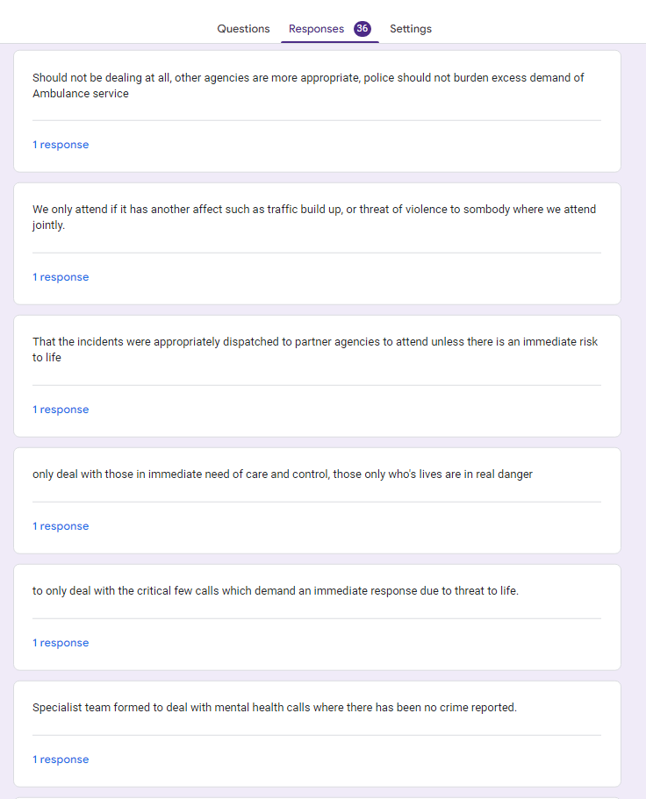
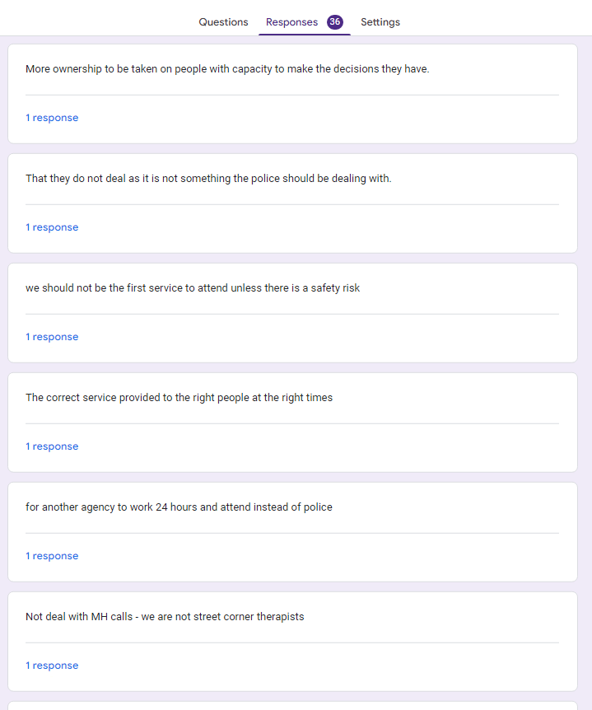
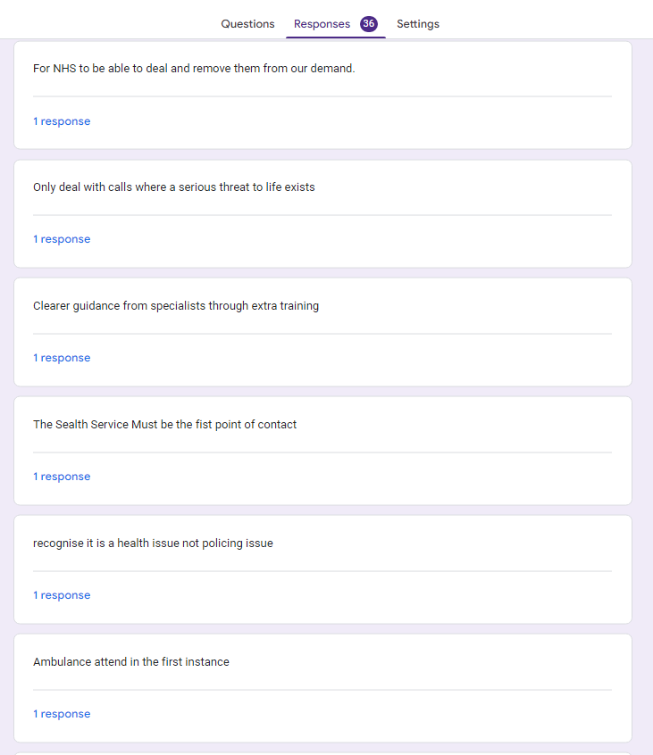


Appendix Three – Proposal Form


UNDERGRADUATE DISSERTATION
RESEARCH PROPOSAL FORM

Please complete the following research proposal and submit it to Turnitin.
Please get rid of the red writing for your final submission.

NAME:  Ellis Thomas Arrowsmith | STUDENT ID No.:  1922407
DRAFT RESEARCH TITLE QUESTION:

Policing Mental Health – A critical analysis of police involvement in Mental Health calls within South Wales Police. Is it appropriate for police to be the first point of contact for persons having a mental health episode?

INTRODUCTION:
In recent years, Police forces in both England and Wales have found themselves in an unprecedented predicament. The police have found themselves having to deal with and respond to incidents involving an increased number of persons who suffer with mental health issues or are themselves in a state of mental health crisis. Police have found themselves devoting several hours to someone who has found themselves in mental health crisis who needs either medical care or a mental health assessment.

The demand placed on police in recent years has found police officers across England and Wales spending a lot of their policing time responding to and spending several hours with persons who are suffering from mental health issues. The mental health related calls that police are dealing with, according to West Midlands Police spoke of police officers spending up to 40% of their time dealing with mental health related call and incidents (West Midlands Police, 2020.)

The research that is intended to be carried out is in relation to how much of officer’s time within South Wales Police is spent dealing with non-crime related mental health and how the effect of budget cuts and reduced staffing has affected the ability for police to pre-emptively detect crime. With up to 40% of police officers time being spent dealing with mental health, this does not leave an overly adequate amount of time to deal with crime. When broken down over and average set of six shifts this equates to a maximum of 21.6 hours being spent dealing with mental health calls and not proactively detecting crime. This leaves 32.4 hours where officers are potentially able to deal with crime effectively however, this time does not include shifts of unsocial hours where victims of crime are less likely to be willing to speak.

SUMMARY OF RESEARCH OBJECTIVES:
- To ascertain if the demand on the police to deal with mental health calls has changed and whether this has increased, decreased, or stayed the same.
- To ascertain if officers dealing with mental health feel they have appropriate training to deal with mental health.
- To ascertain if officers feel they have the right equipment and legislation to respond to mental health related calls.

LITERATURE REVIEW:
Unfortunately, mental health is something that can affect everyone. In an article written by Galderisi et al (2015) it defines mental health as “a state of well-being in which the individual realizes his or her own abilities, can cope with the normal stresses of life, can work productively and fruitfully, and is able to make a contribution to his or her community.” Whilst this definition may not be representative of all persons suffering with mental health, it is widely accepted.

Mental health around the world is becoming a global concern and the amount of people who state that they suffer with a mental health condition is on the increase. There are several contributing factors to the changing of people mental health including the current economic and social changes faced by people (Pitchforth et al, 2019)

There are many items of literature relating to the police interactions with mental health. One piece of literature that will be used as part of this dissertation project with be from HMICFRS (Her Majesty’s Inspectorate of Constabulary and Fire and Rescue Service). This body is responsible for the reviewing of every police force in England and Wales and regularly carry’s out inspections of policies and procedures carried out by either and individual force, or joint collaborations on national issues facing the current policing climate.

HMICFRS released a review of Policing and Mental Health (2018). This report is said to set out the findings of how collectively effective the 43 police forces who partook in the inspection were at protecting and supporting persons with mental health problems. The summary of the main findings for this report are that the police service is stepping in to fill in for mental health services in the three following scenarios the most:
- Police being utilised to take someone to hospital as there is no ambulance available.
- Police having to wait with someone experiencing mental health problems in hospital until a safe place is found.
- Conducting welfare checks on a person where there is a concern for their safety.

Another piece of literature published mentioned above by West Midlands Police in 2020 has provided predictions for the volume of demand from mental health related police incidents. The piece also goes on to say that low level mental health is dealt with in day-to-day policing and is encountered by most officers. Whilst this report may be tailored towards West Midlands Police, aspects of the report can be interpretated as being relevant to most if not all police forces in England and Wales.

In an article that was written by Kane et al (2018), it highlighted a systematic review of the policing related mental health interventions that were available to police at the time. The review highlights that no just one approach is effective to policing mental health and this highlights the need for a multi-faceted approach to policing and mental health.

There are several documented areas where police were involved within the mental health remit. The police are becoming more and more involved with persons suffering with mental health (Lawrence et al, 2021) however, there is some absence in literature as to whether officers feel they have the training to be able to deal with the persons’ they are meeting.

SUMMARY OF RESEARCH –SURVEY METHOD:
The researcher intends to provide police officers with a tailored questionnaire to find out their opinion on mental health as well as their interactions and if they feel they are trained enough to deal with mental health and, what training they have received. Whilst some of the information is of opinion, the researcher will also ensure that information that I received from officers via the questionnaire is of both a qualitative and quantitative nature.

Adopting this research method, would be appropriate to carry out to gain officers perceptions of the police involvement in mental health. Obtaining both quantitative and qualitative data will be beneficial in gaining as much information as possible to obtain as much information as possible on the subject and allow the researcher to be able to pinpoint areas where respondents may bring up areas the researcher may not have previously thought of (Almalki, 2016).

SUMMARY OF SAMPLING FRAMEWORK:
Th researcher intends to ask only police officers that are currently serving within South Wales Police to answer the questionnaire. All respondents will have to be over the age of 18 in order to complete the questionnaire and this will be manage via the questionnaires dissemination to potential respondents.

The persons that I am asking to participate within this research should not have an adverse effect from answering these questions and as such there should be no ethical concerns with regards to the health of the persons being asked to answer the questionnaire.

This group of people would be best to answer the research question and these are the officers that are policing mental health. They will be able to provide real data from being active within the field that can be used in order to obtain primary data from the respondents.

ETHICAL ISSUES:
At this time, I do not believe there are any ethical issues that will come of this research. The researcher will not be contacting persons who have come into contact with the police in relation to their mental health and no personal data will be requested from any respondents nor will they be asked to provide any information in relation to what they have dealt with or who they have come into contact with in the course of their duties.
TIME SCALE:
As this project is time restricted, time management and effective planning and working is key to ensuring its success and to ensure that as much information can be sought from research in a timely and effective space of time.

No | Dissertation Project. | 2022 - 2023
 | Dissertation Project. | Jul | Aug | Sept | Oct | Nov | Dec | Jan | Feb | Mar
1 | Proposal
 | Outline research, objective and methodology aims.
2 | Literature review
 | Carry out Research
 | Create questionnaire and provide to participants.
3 | Summary of findings and analysis.
 | Analyse questionnaire results
 | Review for any gaps in research
 | Collate and analyse feedback and draw conclusion.
4 | Submission Preparation
 | Review with project supervisor.
 | Proof reading and editing.
 | Submission.

I will have continued access to UWTSD online and in person libraries to conduct effective research as well as being able to utilise online forums, journals and professional papers to provide a full and informed dissertation paper.

Appendix Four – Ethics Form
APPLICATION FOR ETHICAL APPROVAL

In order for research to result in benefit and minimise risk of harm, it must be conducted ethically. A researcher may not be covered by the University’s insurance if ethical approval has not been obtained prior to commencement.

The University follows the OECD Frascati manual definition of research activity: “creative work undertaken on a systematic basis in order to increase the stock of knowledge, including knowledge of man, culture and society, and the use of this stock of knowledge to devise new applications”. As such this covers activities undertaken by members of staff, postgraduate research students, and both taught postgraduate and undergraduate students working on dissertations/projects.

The individual undertaking the research activity is known as the “principal researcher”.

Ethical approval is not required for routine audits, performance reviews, quality assurance studies, testing within normal educational requirements, and literary or artistic criticism.

Please read the notes for guidance before completing ALL sections of the form.

This form must be completed and approved prior to undertaking any research activity. Please see Checklist for details of process for different categories of application.

Delete the Guidance Notes at the end of the form BEFORE submitting your application

SECTION A: About You (Principal Researcher)
Full Name: |  | Ellis Thomas Arrowsmith
Tick all boxes which apply: |  | Member of staff: | ☐ | Honorary research fellow: | ☐
Undergraduate Student | ☒ | Taught Postgraduate Student | ☐ | Postgraduate Research Student | ☐

Institute/Academic Discipline/Centre: | Blue Light Academy.
Campus:
E-mail address: | 1922407@student.uwtsd.ac.uk
Contact Telephone Number:
For students:
Student Number: | 1922407
Programme of Study: | BSc (Hons) Professional Policing practice
Director of Studies/Supervisor: | Jonathan Edwards

SECTION B: Approval for Research Activity
Has the research activity received approval in principle?  (please check the Guidance Notes as to the appropriate approval process for different levels of research by different categories of individual) |  | YES | ☒ | NO | ☒
 |  |  |  | Date
If Yes, please indicate source of approval (and date where known): Approval in principle must be obtained from the relevant source prior to seeking ethical approval | Research Degrees Committee |  | ☐
 | Institute Research Committee |  | ☐
 | Other (write in) |  | ☒

SECTION C: Internal and External Ethical Guidance Materials
Please list the core ethical guidance documents that have been referred to during the completion of this form (including any discipline-specific codes of research ethics, and also any specific ethical guidance relating to the proposed methodology). Please tick to confirm that your research proposal adheres to these codes and guidelines.
UWTSD Research Ethics & Integrity Code of Practice | ☒
UWTSD Research Data Management Policy | ☒
 | ☐

SECTION D: External Collaborative Research Activity
Does the research activity involve collaborators outside of the University? |  | YES | ☐ | NO | ☒
If Yes, please provide the name of the external organisation and name and contact details for the main contact person and confirmation this person has consented to their personal data being shared.as part of this collaboration.
Institution
Contact person name
Contact person e-mail address

Has this individual consented to sharing their details on this form? |  | YES | ☐ | NO |  |  | ☒
Are you in receipt of a KESS scholarship? |  | YES | ☐ | NO |  |  | ☒
Is your research externally funded |  | YES | ☐ | NO |  |  | ☒
Are you specifically employed to undertake this research in either a paid or voluntary capacity? | Voluntary | YES | ☐ | NO |  | ☒
 | Employed | YES | ☐ | NO |  | ☒
Is the research being undertaken within an existing UWTSD Athrofa Professional Learning Partnership (APLP) | If YES then the permission question below does not need to be answered. | YES | ☐ | NO |  |  | ☒
Permission to undertake the research has been provided by the partner organisation | (If YES attach copy)  If NO the application cannot continue | YES | ☐ | NO |  |  | ☒

Where research activity is carried out in collaboration with an external organisation
Does this organisation have its own ethics approval system? | YES | ☐ | NO | ☒
If Yes, please attach a copy of any final approval (or interim approval) from the organisation

SECTION E: Details of Research Activity
Indicative title: | Policing Mental Health – A critical analysis of the police involvement in Mental Health calls within Swansea and Neath Port Talbot. Is it appropriate for police to be the first point of contact for persons having a mental health episode?
Proposed start date: | 15/08/2022 | Proposed end date: | 27/03/2023
Introduction to the Research (maximum 300 words)
Ensure that you write for a Non-Specialist Audience when outlining your response to the three points below:
- Purpose of Research Activity
- Proposed Research Question
- Aims of Research Activity
- Objectives of Research Activity
Demonstrate, briefly, how Existing Research has informed the proposed activity and explain
- What the research activity will add to the body of knowledge
- How it addresses an area of importance.
Purpose of Research Activity

In recent years, Police forces in both England and Wales have found themselves in an unprecedented predicament. The police have found themselves having to deal with and respond to incidents involving an increased number of persons who suffer with mental health issues or are themselves in a state of mental health crisis. Police have found themselves devoting several hours to someone who has found themselves in mental health crisis who needs either medical care or a mental health assessment.

The demand placed on police in recent years has found police officers across England and Wales spending a lot of their policing time responding to and spending several hours with persons who are suffering from mental health issues. The mental health related calls that police are dealing with, according to West Midlands Police spoke of police officers spending up to 40% of their time dealing with mental health related call and incidents (West Midlands Police, 2020.)

The research that is intended to carry out is in relation to how much of officer’s time within South Wales Police is spent dealing with non-crime related mental health and how the effect of budget cuts and reduced staffing has affected the ability for police to pre-emptively detect crime. With up to 40% of police officers time being spent dealing with mental health, this does not leave an overly adequate amount of time to deal with crime. When broken down over and average set of six shifts this equates to a maximum of 21.6 hours being spent dealing with mental health calls and not proactively detecting crime. This leaves 32.4 hours where officers are potentially able to deal with crime effectively however, this time does not include shifts of unsocial hours where victims of crime are less likely to be willing to speak.

(this box should expand as you type)
Research Question

Policing Mental Health – A critical analysis of the police involvement in Mental Health calls within South Wales Police. Is it appropriate for police to be the first point of contact for persons having a mental health episode where no crime is involved?

(this box should expand as you type)
Aims of Research Activity

- To ascertain if the demand on the police to deal with mental health calls has changed and whether this has increased, decreased, or stayed the same.
- To ascertain if officers dealing with mental health feel they have appropriate training to deal with mental health.
- To ascertain if officers feel they have the right equipment and legislation to respond to mental health related calls.

(this box should expand as you type)
Objectives of Research Activity

The objectives of this research activity are to develop an understanding of the police involvements in dealing with mental health and how this has a subsequent effect on crime in the community.

(this box should expand as you type)
Proposed methods (maximum 600 words)
Provide a brief summary of all the methods that may be used in the research activity, making it clear what specific techniques may be used. If methods other than those listed in this section are deemed appropriate later, additional ethical approval for those methods will be needed.
The researcher intends to provide police officers questionaries to find out their opinion on policing mental health and from a policing point of view, how much mental health they deal with. Whilst this information is of opinion, the researcher also intends to review literature relating to mental health calls received and whether there was a crime element to the call or if this was purely mental health related. This will also be ascertained via the use of the questionnaire.

Adopting this research method, would be appropriate to get quantitative and qualitative data from serving police officers within South Wales Police. The questionnaire does not intend to retrieve and personal information from respondents and as such, no real ethical problems have been identified by the researcher.

(This box should expand as you type)

Location of research activity
Identify all locations where research activity will take place.
Research will be conducted with the South Wales Police force are with persons engaging with the questionnaire being only serving members of South Wales Police.
(this box should expand as you type)
Research activity outside of the UK
If research activity will take place overseas, you are responsible for ensuring that local ethical considerations are complied with and that the relevant permissions are sought. Specify any local guidelines (e.g. from local professional associations/learned societies/universities) that exist and whether these involve any ethical stipulations beyond those usual in the UK (provide details of any licenses or permissions required). Also specify whether there are any specific ethical issues raised by the local context in which the research activity is taking place, for example, particular cultural and/or legal sensitivities or vulnerabilities of participants.
N/A

(this box should expand as you type)

Use of documentation not in the public domain: Are any documents NOT publicly available? | NO | ☒
 | YES | ☐
If Yes, please provide details here of how you will gain access to specific documentation that is not in the public domain and that this is in accordance with prevailing data protection law of the country in question and England and Wales.

(this box should expand as you type)

SECTION F: Scope of Research Activity
Will the research activity include: | YES | NO
Use of a questionnaire or similar research instrument? | ☒ | ☐
Use of interviews? | ☐ | ☒
Use of diaries? | ☐ | ☒
Participant observation with their knowledge? | ☐ | ☒
Participant observation without their knowledge? | ☐ | ☒
Use of video or audio recording? | ☐ | ☒
Access to personal or confidential information without the participants’ specific consent? | ☐ | ☒
Administration of any questions, test stimuli, presentation that may be experienced as physically, mentally or emotionally harmful / offensive? | ☐ | ☒
Performance of any acts which may cause embarrassment or affect self-esteem? | ☐ | ☒
Investigation of participants involved in illegal activities? | ☐ | ☒
Use of procedures that involve deception? | ☐ | ☒
Administration of any substance, agent or placebo? | ☐ | ☒
Working with live vertebrate animals? | ☐ | ☒
Other primary data collection methods, please explain in this box  For example, ‘focus groups’. Please indicate the type of data collection method(s) in this box and tick the accompany box. | ☐ | ☒
Details of any other primary data collection method:  (this box should expand as you type) | ☐ | ☒
If NO to every question, then the research activity is (ethically) low risk and may be exempt from some of the following sections (please refer to Guidance Notes).

If YES to any question, then no research activity should be undertaken until full ethical approval has been obtained.

SECTION G: Intended Participants
Who are the intended participants: | YES | NO
Students or staff at the University? | ☒ | ☐
Adults (over the age of 18 and competent to give consent)? | ☒ | ☐
Vulnerable adults? | ☐ | ☒
Children and Young People under the age of 18? (Consent from Parent, Carer or Guardian will be required) | ☐ | ☒
Prisoners? | ☐ | ☒
Young offenders? | ☐ | ☒
Those who could be considered to have a particularly dependent relationship with the investigator or a gatekeeper? | ☐ | ☒
People engaged in illegal activities? | ☐ | ☒
Others (please identify specifically any group who may be unable to give consent) please indicate here and tick the appropriate box. | ☐ | ☒
Other – please indicate here:  (this box should expand as you type) | ☐ | ☒

Participant numbers and source
Provide an estimate of the expected number of participants. How will you identify participants and how will they be recruited?
How many participants are expected? | At this time, a decided number of participants has not been confirmed however this could range anywhere between 20-30 police officers from South Wales Police and would be considered an acceptable sample size.  (this box should expand as you type)
Who will the participants be? | Adult professionals over the age of 18  (this box should expand as you type)
How will you identify the participants? | Participants will only have access to the questionnaire if they are a serving member of South Wales Police as this will only be able to be accessed if they have access to the South Wales Police Intranet.  (this box should expand as you type)

Information for participants: | YES | NO | N/A
Will you describe the main research procedures to participants in advance, so that they are informed about what to expect? | ☐ | ☐ | ☒
Will you tell participants that their participation is voluntary? | ☐ | ☐ | ☒
Will you obtain written consent for participation? | ☐ | ☐ | ☒
Will you explain to participants that refusal to participate in the research will not affect their treatment or education (if relevant)? | ☐ | ☐ | ☒
If the research is observational, will you ask participants for their consent to being observed? | ☐ | ☐ | ☒
Will you tell participants that they may withdraw from the research at any time and for any reason? | ☐ | ☐ | ☒
With questionnaires, will you give participants the option of omitting questions they do not want to answer? | ☐ | ☐ | ☒
Will you tell participants that their data will be treated with full confidentiality and that, if published, it will not be identifiable as theirs? | ☐ | ☐ | ☒
Will you debrief participants at the end of their participation, in a way appropriate to the type of research undertaken? | ☐ | ☐ | ☒
If NO to any of above questions, please give an explanation
(this box should expand as you type)

Information for participants: | YES | NO | N/A
Will participants be paid? | ☐ | ☒ | ☐
Is specialist electrical or other equipment to be used with participants? | ☐ | ☒ | ☐
Are there any financial or other interests to the investigator or University arising from this study? | ☐ | ☒ | ☐
Will the research activity involve deliberately misleading participants in any way, or the partial or full concealment of the specific study aims? | ☐ | ☒ | ☐
If YES to any question, please provide full details
(this box should expand as you type)

SECTION H: Anticipated Risks

Outline any anticipated risks that may adversely affect any of the participants, the researchers and/or the University, and the steps that will be taken to address them.

If you have completed a full risk assessment (for example as required by a laboratory, or external research collaborator) you may append that to this form.
Full risk assessment completed and appended? |  | Yes | ☐
 |  | No | ☒
Risks to participants
For example: emotional distress, financial disclosure, physical harm, transfer of personal data, sensitive organisational information
Risk to Participant:  No risk identified to any participant.  (this box should expand as you type) | How will you mitigate the Risk to Participant  (this box should expand as you type)
If research activity may include sensitive, embarrassing or upsetting topics (e.g. sexual activity, drug use) or issues likely to disclose information requiring further action (e.g. criminal activity), give details of the procedures to deal with these issues, including any support/advice (e.g. helpline numbers) to be offered to participants. Note that where applicable, consent procedures should make it clear that if something potentially or actually illegal is discovered in the course of a project, it may need to be disclosed to the proper authorities
Not applicable in this case.

(this box should expand as you type)
Risks to investigator
For example: personal safety, physical harm, emotional distress, risk of accusation of harm/impropriety, conflict of interest
Risk to Investigator:  N/A  (this box should expand as you type) | How will you mitigate the Risk to Investigator:  (this box should expand as you type)
University/institutional risks
For example: adverse publicity, financial loss, data protection
Risk to University:  At this time, I do not believe there are any ethical issues that will come of this research, however, being a serving police officer, the opportunity to display opinion and unintentional bias. I will limit and prevent this as much as possible by engaging with my project supervisor and ensuring an investigative mindset is adopted to fully explore all options.  (this box should expand as you type) | How will you mitigate the Risk to University:  (this box should expand as you type)

Disclosure and Barring Service
If the research activity involves children or vulnerable adults, a Disclosure and Barring Service (DBS) certificate must be obtained before any contact with such participants. | YES | NO | N/A
Does your research require you to hold a current DBS Certificate? | ☐ | ☒ | ☐

SECTION I: Feedback, Consent and Confidentiality
Feedback
What de-briefing and feedback will be provided to participants, how will this be done and when?
No de-briefing will be required of participants after completing the questions as these are not intrusive to a person’s personal circumstance.

(this box should expand as you type)
Informed consent
Describe the arrangements to inform potential participants, before providing consent, of what is involved in participating. Describe the arrangements for participants to provide full consent before data collection begins. If gaining consent in this way is inappropriate, explain how consent will be obtained and recorded in accordance with prevailing data protection legislation.
Participants in any questionnaire are not obliged to complete and only do so of their own free will. There is no requirement to fully complete and this can be stopped at any time.

(this box should expand as you type)
Confidentiality / Anonymity
Set out how anonymity of participants and confidentiality will be ensured in any outputs. If anonymity is not being offered, explain why this is the case.
No personal details will be asked of persons providing data to me as part of this project other than an age range and profession.

(this box should expand as you type)

SECTION J: Data Protection and Storage
In completing this section refer to the University’s Research Data Management Policy and the extensive resources on the University’s Research Data Management web pages (http://uwtsd.ac.uk/library/research-data-management/).
Does the research activity involve personal data (as defined by the General Data Protection Regulation 2016 “GDPR” and the Data Protection Act 2018 “DPA”)? | YES | NO
“Personal data” means any information relating to an identified or identifiable natural person (‘data subject’). An identifiable natural person is one who can be identified, directly or indirectly, in particular by reference to an identifier such as a name, an identification number, location data, an online identifier or to one or more factors specific to the physical, physiological, genetic, mental, economic, cultural or social identity of that natural person. | ☐ | X
If YES, provide a description of the data and explain why this data needs to be collected:
(this box should expand as you type)
Does it involve special category data (as defined by the GDPR)? | YES | NO
“Special category data” means sensitive personal data consisting of information as to the data subjects’ –  (a) racial or ethnic origin,  (b) political opinions,  (c ) religious beliefs or other beliefs of a similar nature,  (d) membership of a trade union (within the meaning of the Trade Union and Labour Relations (Consolidation) Act 1992),  (e) physical or mental health or condition,  (f) sexual life,  (g) genetics,  (h) biometric data (as used for ID purposes), | ☐ | X
If YES, provide a description of the special category data and explain why this data needs to be collected:
(this box should expand as you type)

Will the research activity involve storing personal data and/or special category data on one of the following: | YES | NO
Manual files (i.e. in paper form)? | ☐ | ☒
University computers? | ☐ | ☒
Private company computers? | ☐ | ☒
Home or other personal computers? | ☐ | ☒
Laptop computers/ CDs/ Portable disk-drives/ memory sticks? | ☐ | ☒
“Cloud” storage or websites? | ☐ | ☒
Other – specify: | ☐ | ☒
For all stored data, explain the measures in place to ensure the security of the data collected, data confidentiality, including details of password protection, encryption, anonymisation and pseudonymisation:
(this box should expand as you type)
All Data Storage
Will the research activity involve any of the following activities: | YES | NO
Electronic transfer of data in any form? | ☐ | ☒
Sharing of data with others at the University? | ☐ | ☒
Sharing of data with other organisations? | ☐ | ☒
Export of data outside the European Union or importing of data from outside the UK? | ☐ | ☒
Use of personal addresses, postcodes, faxes, emails or telephone numbers? | ☐ | ☒
Publication of data that might allow identification of individuals? | ☐ | ☒
Use of data management system? | ☐ | ☒
Data archiving? | ☐ | ☒
If YES to any question, please provide full details, explaining how this will be conducted in accordance with the GDPR and DPA (and/or any international equivalent):
(this box should expand as you type)
List all who will have access to the data generated by the research activity:
N/A

(this box should expand as you type)
List who will have control of, and act as custodian(s) for, data generated by the research activity:
N/A

(this box should expand as you type)
Give details of data storage arrangements, including security measures in place to protect the data, where data will be stored, how long for, and in what form. Will data be archived – if so how and if not why not.
N/A

(this box should expand as you type)
Please indicate if your data will be stored in the UWTSD Research Data Repository (see https://researchdata.uwtsd.ac.uk/ ). If so please explain. (Most relevant to academic staff)
N/A

(this box should expand as you type)
Confirm that you have read the UWTSD guidance on data management (see https://www.uwtsd.ac.uk/library/research-data-management/) | YES | ☒
 | NO | ☐
Confirm that you are aware that you need to keep all data until after your research has completed or the end of your funding | YES | ☒
 | NO | ☐

SECTION K: Declaration
The information which I have provided is correct and complete to the best of my knowledge. I have attempted to identify any risks and issues related to the research activity and acknowledge my obligations and the rights of the participants.

In submitting this application I hereby confirm that I undertake to ensure that the above named research activity will meet the University’s Research Ethics and Integrity Code of Practice which is published on the website: https://www.uwtsd.ac.uk/research/research-ethics/
Signature of applicant: | Ellis.A | Date: 15/08/2022

For STUDENT Submissions:
Director of Studies/Supervisor: |  | Date:
Signature: |  | Date:

For STAFF Submissions:
Academic Director/ Assistant Dean: |  | Date:
Signature: |  | Date:

Checklist: Please complete the checklist below to ensure that you have completed the form according to the guidelines and attached any required documentation:
☒ | I have read the guidance notes supplied before completing the form.
☒ | I have completed ALL RELEVANT sections of the form in full.
☒ | I confirm that the research activity has received approval in principle
☐ | I have attached a copy of final/interim approval from external organisation (where appropriate)
☐ | I have attached a full risk assessment (and have NOT completed Section H of this form) (where appropriate) ONLY TICK IF YOU HAVE ATTACHED A FULL RISK ASSESSMENT
☒ | I understand that it is my responsibility to ensure that the above named research activity will meet the University’s Research Ethics and Integrity Code of Practice.
☒ | I understand that before commencing data collection all documents aimed at respondents (including information sheets, consent forms, questionnaires, interview schedules etc.) must be confirmed by the DoS/Supervisor, module tutor or Academic Director.
☒ | I have deleted the guidance notes before submitting the PG2 for consideration

