

Name : Diyana Shapshalova

Student number : 1907713

Module Title: LCBB6002

A1

Assignment Title: International Financial Management
Module Lecturer’s name: Dr. Isaiah Oino

Table of Contents
Introduction 3
Unilever Dividend distribution policy 4
Analysis of efficient market hypothesis theory in the context of Unilever 7
Methods of appraising projects of Unilever 7
Conclusion 10
References 11

Introduction
International business finance means managing finance in international business environment. Now a days, role of IFM is increasing at rapid rate as companies are expending in market. This report will focus on identifying and analyzing significance of IFM principles and theories in Unilever plc. Challenges or issues which are faced by companies in international financial markets will be discussed along with examples. Dividend is defined as part of the profit that is distributed among shareholders of a company. The dividend distribution policy of Unilever plc will be enlightened in this report. Role and significance of one of the popular theories i.e., efficient market hypothesis theory will be discussed. Positive and negative points of various types of apprising project techniques will be discussed.

Unilever Dividend distribution policy
The dividend distribution policy indicates that helps to prepare the protocol to share or distribute the amount to the equity shareholder. This help to balance the dividend and the retained earnings. It aims to provide clarity on the dividend to the stakeholder which was given by the company. Unilever company deals in Fast moving consumer good sector like beauty products, food items, ice cream, soap, etc. its headquarter is in London (Singh, 2019, p. 9). This company is the largest producer of soap in most countries. It was founded in 1929 in the United Kingdom. The Unilever dividend distribution policy is very helpful for the stakeholders their information is transparent according to the company’s profit they provide the dividend to the stakeholder. This also signifies the growth of Unilever the more dividend means a positive effect for the company. Unilever company is providing dividends to stakeholders on a timely basis which may enhance its reliability. the dividend can be paid in 4 four intervals months March, June September, and December (Singh, 2019, p. 9).
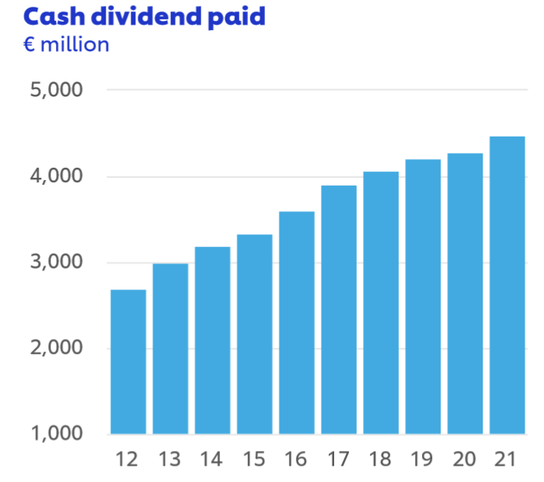
Figure 1 Unilever dividend
Source Unilever
The graph indicates the Dividend of the Unilever company. Since 2011 the dividend policy was continuously increasing. In 2016 the dividend ratio increased at a faster pace as per the previous year. Influencing the dividend rate indicates that the company has good financials.
There are two types of dividends provided by the company.
- Interim dividend
- Final dividend
The interim dividend policy is calculated based on the performance of the company during a specific period. Whereas the Final dividend is calculated year-wise on the performance of the Unilever company (Singh, 2019, p. 10).
The Board of Directors provides the recommendation of the dividend for Unilever so it can be sent to the annual general meeting for approval.
Unilever’s dividend yearly payout depends on the below factors
- The liquidity position of the company
- Disposable income
- Interim dividend
- Long-term investment and plans
- Strategy to modify the operation
External factors
- Influence the macro-economic environment
- Changes in market trends
- Expectations of the shareholders
The last dividend was paid by the Unilever company on 16 June 2022 i.e. 35.9p. the next dividend will be paid on 1 Sep 2022 (Singh, 2019, p. 9).
Unilever’s company forecasting accuracy is 94%
Date | Paid amount
16 June 2022 | 35.9p
22 March 2022 | 36.02p
01 Dec 2021 | 35.98p
08 Sep 2021 | 36.93p

The above table represents the dividend paid to the shareholder. Their forecasting is also matched with the paid divided which created the accuracy of 94%.
There are four types of dividend policy

- The first dividend policy of Unilever is the regular dividend, Unilever follows the same procedure to provide the dividend to their shareholder. If Unilever is getting the extra profit then they retain that extra profit but if Unilever is not able to get the profit during the year or getting a loss, still Unilever will provide the dividend to the shareholders. This can maintain the reliability and accountability of the company to the people. This company follows a strategy to maintain its integrity (Jinadu and Opeyemi, 2017, 66).
- The second dividend policy of Unilever is stable, Unilever company fixed the profit ratio to the shareholder. Even if the Unilever company is earning more profit or loss. This strategy is risky for the company, but they are following it just to get the people’s faith.
- The third dividend policy of Unilever is irregular, the board director will decide the rate of the dividend on the base of the profit earned by Unilever. Their decision may boost the confidence of the investor (Jinadu and Opeyemi, 2017, 65).
- The fourth dividend policy of Unilever is no dividend, the payout percent will be zero during profit or loss of the company. this policy can be used by Unilever because they have built faith among the investors.

Analysis of efficient market hypothesis theory in the context of Unilever
The efficient market hypothesis says that it is easy to get company information by analyzing the share price of any listed company. This also helps in knowing whether investors need to invest in the listed companies or not (Bouttour and Martinez, 2019). When the person wants to know the company position. They can easily get to know by analyzing the share price of the Unilever company. The efficient market hypothesis also helps for the trading of stocks at an affordable or fair market price. There are three ways of the efficient market hypothesis of Unilever company like weak, semi-strong, and strong (Kumar and Ruhi, 2019, p.329).
The weak hypothesis states that if the Unilever share price is less then people can assume the past analysis would be the same as the current. This can become a negative part of analyzing the data for the investors (Kumar and Ruhi, 2019, p.327). They should reach every aspect of Unilever while investing. Investors can check the lower circuit and upper circuit while researching the Unilever company stocks
Semi-strong theory of Unilever company depicts that investors cannot believe or take the action of disclosed information in achieving higher returns.
The third efficient market hypothesis theory of Unilever company said that there is some information that Unilever company can disclose to the public but there is some information that they don’t want to disclose to the public (Bouttour and Martinez, 2019). With strong efficiency, it depicts that it cannot give the entire information to the people, not possible to predict the future prices of the stock market.

Methods of appraising projects of Unilever
The appraising of projects indicated whether the project is feasible or not. It also informs about the cost-benefit of the project to know whether the project is cost-effective and beneficial for everyone. Investment appraisal evaluation is the strategy used by corporations and investors to judge whether the company’s investment is profitable or not. This includes the rate of return, net present value, etc. This would help to increase the company’s revenue by using the different methods of appraising. Every company wants to invest its money, this can be done when the company is selling more goods. Therefore, increasing the revenue will increase the investment of the company.
The key method of appraising method of Unilever
Economic Analysis: Unilever’s project should consider each and everything so that this could help to generate profit if the company. Unilever should have good quality raw materials the way they use the capital utilization so that Unilever can earn the maximum profit. Not only Unilever even other company wants to make the maximum profit by analyzing the input and output factors. Unilever predicts how much profit it can earn after analyzing its sales and demand.
Financial Analysis: it states that an entrepreneur uses their facilities to produce goods through labor and machines. Every company has fixed assets and working capital. Fixed assets are those assets that are tangible like land, machine, etc. the requirement of fixed is depend on the business. Unilever needed the land to boost their business so that they can earn the maximum profit and provide the goods to the final consumer (Alshamsi and Kahlout, 2022, p. 6). Working capital depicts the current assets are more than the current liability which indicated that the company is in profit.
Market Analysis: This is an important aspect of every company; it aims to sell goods and services in the market. There should be a positive marketplace where companies can earn a profit.
Unilever analyzes the market condition on that base they are selling their goods and services so that they can achieve the target of the company (Yahya, et.al., 2013, 29). Unilever has built but the repatriated market they to whom to sell the product and at what price. As in the market, there are different types of customers that need to handle so they can also buy the product. Unilever has built that reputation by understanding the customer need and perspectives through this they are targeting to achieve the objective of the company.

Need to do a sample survey may help to understand the customer whether are interested in the product or not (Tien, 2019, 6). Unilever does the surveys to check the taste and preferences of the customer so that they can modify the product and develop the product according to their needs and wants which may create a win-win situation.
Unilever adopts a survey of a new product before launching it to the customer so that they can analyze the prediction of whether the product will like by the customer or not. this technique helps a cost-saving of Unilever because before launching the product they get to know the market preferences.

Conclusion
This report discussed the importance of international financial management of the leading company i.e. Unilever. The above report also covered the meaning of dividends in the context of Unilever, this information helped to know the company’s performance so that investors can invest the money. If investors want to invest in any company, they may check the hypothesis that helped them to take the decision. The report discussed the project of Unilever by explaining its appraising method. In this way, it summarized that the Unilever project was feasible.

References
- Alshamsi, S. and Al Kahlout, H., (2022) Financial Statement Analysis of Unilever. Pp. 1-14. https://www.researchgate.net/profile/Haitham-Nobanee/publication/358043114_Financial_Statement_Analysis_of_Unilever/links/61ed8583dafcdb25fd475938/Financial-Statement-Analysis-of-Unilever.pdf
- Bouattour, M. and Martinez, I., (2019) Efficient market hypothesis: an experimental study with uncertainty and asymmetric information. Finance Contrôle Stratégie, (22-4). https://journals.openedition.org/fcs/3821
- Jinadu, A.G. and Opeyemi, M.F., (2017) Impact Of Capital Structure On Dividend Pay-Out Ratio In Unilever Nigerian Plc. Journal of Management Sciences, 15(1), pp.61-75. https://d1wqtxts1xzle7.cloudfront.net/54237119/Sahel_15_5_Second_Journal-with-cover-page-v2.pdf
- Kumar, S.V. and Ruhi, A., (2019) Efficient Market Hypothesis in the Indian Stock Market. International Journal of Management, Technology and Engineering, 9(7), pp.322-331. https://www.researchgate.net/profile/Sadanand-Vijay-Kumar/publication/338622493_Efficient_Market_Hypothesis_in_the_Indian_Stock_Market/links/5e201d8aa6fdcc10156c395f/Efficient-Market-Hypothesis-in-the-Indian-Stock-Market.pdf
- Singh, N.P. and Tandon, A., (2019) The effect of dividend policy on stock price: evidence from the Indian market. Asia-Pacific Journal of Management Research and Innovation, 15(1-2), pp.7-15. https://journals.sagepub.com/doi/pdf/10.1177/2319510X19825729
- Tien, N.H., (2019) Comparative analysis of multidomestic strategy of P&G and Unilever Corporation. International journal of foreign trade and international business, 1(1), pp.5-8. https://www.researchgate.net/profile/Nguyen-Tien-32/publication/338719379_Comparative_analysis_of_multi-domestic_strategy_of_PG_and_Unilever_Corporation/links/61c843e8d4500608166a984b/Comparative-analysis-of-multi-domestic-strategy-of-P-G-and-Unilever-Corporation.pdf
- Yahya, F., Ali, S.A., Mir, Z., Yaqoob, M. and Khan, U.A., (2013) Significant analysis for financial statements: an empirical study of national and unilever foods. Research Journal of Finance and Accounting, 4(1), pp.26-34. https://www.researchgate.net/profile/Farzan-Yahya/publication/257307289_Significant_Analysis_for_Financial_Statements_An_Empirical_Study_of_National_and_Unilever_Foods/links/0deec524dbf31a65e6000000/Significant-Analysis-for-Financial-Statements-An-Empirical-Study-of-National-and-Unilever-Foods.pdf

