Joanne Allen
2405880
HPAH7010

‘Constantine’s Reign: An Era of Tradition, Innovation or Both?’

The reign of the emperor Constantine the Great from 306-337 CE, while often celebrated for innovations, does mostly represent a continuation and adaption of deeply rooted traditions. This essay contends that even though there is a lean to an appearance of radical change, Constantine’s rulership fundamentally reinforced traditional Roman imperial practices, adapting to the empire’s changing needs rather than breaking with established architype. This essay will argue through critical analysis of literary sources like Zosimus and Eusebius, modern scholarship, such as, David Potter, Paul Stephenson, Noel Lenski, R Van Dam, alongside others and through numismatic and material evidence, that Constantine’s reign represented continuity with Roman tradition. The focus on material culture is of importance due to the bias of the literature from Zosimus and Eusebius.
This paper will focus its analysis on three key aspects of Constantine’s reign; the foundation and development of Constantinople as a new imperial capital and the imperial building programs; the emperor’s complex relationship with Christianity and traditional Roman religion as well as the administration of the empire. While Constantine’s role in the Roman army is of importance as it depicts continuity as well as social change, this assignment does not have the scope to cover every aspect of Constantine’s regime. Indeed, the above three focal points provide sufficient scope to analyse the proficiencies of his rulership. It is also worth noting that while Constantine’s reign spanned from 306 CE to 337 CE, he only achieved sole rulership following his victory over Licinius in 332 CE. The thirteen years of his solo rule from 324-337 CE brought about significant transformations to the empire’s structure and identity. However, it is important to note that his and the empire’s subsequent earlier years played a critical role in shaping his later period of governance.
This assignment will not focus on how keeping to traditional imperial factions helped the empire or indeed what happened next for Constantinople or Christianity under Constantine but will concentrate on the fact he did adhere to traditions and why. The Roman empire that Constantine inherited had endured what scholars often term the third century crisis. This turbulent period led Constantine’s predecessor Diocletian to establish the Tetrarchy, the rule of four, to prevent fragmentation, such as the separation that formed the Palmyrene and Gallic empires in the late third century CE (Potter, 2014, pp. 259-294). Constantine’s reign, then, must be understood within this context of political instability and the recent reforms implemented by Diocletian. The question becomes whether Constantine’s actions represent a continuation of Diocletian’s innovations, a return to earlier imperial traditions, or entirely new departures from established president.
Constantinople: New Capital, New Direction?
‘The town of Byzantium, a free state, formerly called Lygos…so great being the space of land that intervenes between the Adriatic Sea and the Propontis’
(Pliny Nat His 4.18.11).

One of the most significant and visibly innovative actions of Constantine’s reign was the establishment of Constantinople as the new imperial capital, previously called Byzantium, after his defeat of Licinius in 332 CE (Stephenson, 2011, p. 190). Licinius whom was the co-ruler with Constantine over the eastern half of the empire (Potter, 2015, p. 315). This decision to shift the empire’s centre from Rome to the Greek city formerly known as Byzantium represents what appears to be a break from tradition. However as Pat Southern states in ‘The Roman Army: A Social and Institutional History’ Rome for a long time had not been the Imperial focus (2007, p. 246). Furthermore, Constantine had already established himself with an administrative infrastructure in Nicomedia (Potter, 2015, p. 239). The most logical explanation for the location of this site, then, would be controlling the access between the Mediterranean and Black Seas, situated at the junction of Europe and Asia, would be that it offered significant advantages of trade that Rome could not. Nonetheless, Paul Stephenson in his book ‘Constantine: Unconquered Emperor, Christian Victor’ argues it was not due to trade that Constantine moved the centre to Constantinople, although this eventually did become favourable, but was more due to Constantine’s pragmatic way of ruling over both the halves of the empire (2011, p. 192; Southern, 2007, p. 247).
The Greek writer Zosimus, writing his Historia Nova around 498 CE, provides a more critical perspective on Constantine’s motivations. Though writing nearly two centuries after Constantine’s reign, requiring scholars to approach his account with appropriate caution, Zosimus likely had access to contemporary historical accounts that are now lost. However, his work offers a valuable counterpoint to the more positive portrayal found in Eusebius’ biography, see below, though his Pagan perspective and political bias must be considered when evaluating his claims (Matthews, 2012, pp. 411-428). According to Zosimus, Constantine sought to ‘build himself a palace’ away from Rome because he lacked support of the Senatus Populusque Romanus (Hist Nov 3.52). Zosimus, nonetheless does slightly contradict his own argument by later noting that Constantine some moved with the emperor to Constantinople (Hist Nov 3.53) suggesting some senatorial support for the move. Whilst, the archaeological evidence can complicate the understanding of Constantinople’s significance, for the city incorporated both Christian and Pagan elements in its design and public spaces. Zosimus, writes that Constantine constructed a hippodrome for chariot racing, reminiscent of Rome’s Circus Maximus, which he ‘embellished [with] the temples of Castor and Pollux’ (His Nov 3.53). The divine twins held significant status in Roman tradition and are mentioned in (Livy His 2.42). Castor and Pollux are also mentioned in the Acts of Paul (28.11) as the figureheads for the ship Paul is sailing in from Malta to Rome, so Constantine, could have been bringing in a Christian element, as well as a sign of leadership and safety. That said, the incorporation of Castor and Pollux into the new capitol’s hippodrome signals continuity with Roman Pagan practices associated with imperial authority. Zosimus additionally claims that Constantinople paralleled Rome, featuring temples to Rhea, mother of the Pagan gods, Rhea was worshipped in the same context as the Magna Mater, the great mother later synonymous with the Christian Mother Mary (His Nov 3.53; Potter, 2015, p. 260).
Eusebius, a Christian bishop, and Constantine’s contemporary biographer, presents the foundation of Constantinople with theological significance and less of a new Rome, claiming Constantine intended to be buried in the centre of Constantinople in what would be a Christian church (Life of Constantine 4.60). His account, therefore, leans heavily in favour of Christianity and must be subjected to scrutiny, as much as Zosimus. Nonetheless, there seems to be truth in this account, and his burial did take place in Constantinople. Raymond Van Dam in his book ‘The Roman Revolution of Constantine’ alludes to a blending of tradition and innovation. He notes ‘establishing his mausoleum within the Constantinople’ was Constantine’s attempt to blend tradition with his own ‘vision for the empire’s future’ (2007, P. 57; Lenski 2012, p.57).
The relocation of the imperial capital, then, reflects a continuation of established Roman practices and Constantine’s decision emerged from an already established precedent. Rees (2004, p. 135) persuasively states that the ‘The Tetrarchic system had already begun the process of decentralizing imperial power away from Rome,’ with Diocletian establishing Nicomedia as his eastern capital and Maximian using Milan rather than Rome as his primary residence in the west. This pattern extends further into Roman imperial history, the Antonine dynasty, emperors like Hadrian, in the second century, spent most of their reigns travelling the provinces, rather than residing in Rome (Birley, 2007, p. 85). Marcus Aurelius, for example, conducted the Marcomannic Wars from his base in the Carnuntum, as he writes in his Meditations (SHA Mar Aur 15-3: 18-3). From this perspective, Constantine’s claiming of Constantinople represents not innovation, but the logical culmination of a long-standing precedent already situated in imperial governance.
Whilst, Constantinople reveals Constantine’s adherence to traditional imperial practices, there is scholarly debate on whether Constantinople was made in Rome’s image or incorporated other cultural elements. David Potter argues in ‘Constantine: The Emperor’ that Constantinople adhered to traditions as well as showing an element of innovation but disagrees that Constantinople became the new Rome (2015, p. 263). Potter (2015, p. 263) states that Constantinople incorporated architectural influences such as ‘Syria [because of the] covered porticoes,’ yet this merely reflects the long-established Roman tradition of adopting and adapting provincial architectural styles (Kousser, 2015, p. 114). A practice dating back to the Republic when Roman generals brought Greek architectural influences into the capital, continued through into the empire with emperors like Hadrian (Kousser, 2015, p. 114). The naming of a city after an emperor was also not an uncommon occurrence before or throughout the imperial period. Cities such as Alexandria, Caesarea and Hadrian-polis after Hadrian established the precedents for imperial namesake cities (SHA Had 20.4; Boatwright, 2018, p. 192).Likewise, the layout of Constantinople mirrored Rome with its seven hills, forum, hippodrome, senate house, showing Constantine’s determination to replicate rather than reject Roman urban traditions (Figure 1; Basset, 1991, p.88). Another significant parallel with Rome and Constantinople was the grain dole, brought in from Egypt to feed 80,000 (Kelly, 2012, p. 10). Hitherto, grain from Egypt that had fed those in Rome, initiated by Augustus (Res Ges 5.3).
Imperial Building Programs: Traditional Forms, New Meanings
Building big imperial projects meant finding the right balance, they needed to be impressive enough to make a statement, but not so over the top they seemed wasteful (Elsner, 2018, p. 59)

Constantine’s extensive building program represents another area where tradition and innovation intersected during his reign. In this respect, he followed the precedent established by emperors like Augustus and Hadrian who had undertaken massive construction projects throughout the empire (Res Ges 20.4; Birley, 2010, pp.93-112). Augustus declared in his Res Gestae (20.4) that he had restored or constructed eighty-two temples in Rome, establishing the convention that emperors affirmed their authority through building projects. Constantine continued this tradition but redirected it toward new purposes. Krautheimer (1986, p. 39) suggests that though he restored traditional Roman structures, he also allocated significant resources toward Christian buildings. Krautheimer (1986, p. 39) further argues that Constatine was the first emperor to systematically build Chrisitan churches. Yet, Potter (2004, p. 314) claims Gallenius was responsible for the building of many churches throughout the eastern provinces earlier than Constantine. Constantine also seemed to adapt buildings for Christian worship that had already been designed for pagan worship by other emperors. Such as, the Basilica Nova of Constantine and Maxentius, which shows Constantine’s predecessor Maxentius as master builder on his own merit (Figure 2; Elsner, 2018, p. 60). Elsner (2018, p. 60) states that after Constantine’s defeat of Maxentius and therefore his control over Rome, he adapted and claimed many building projects as his own. Nonetheless, Johnson (2009, p. 176) correctly notes that Constantine’s Roman building program, whether adaption or foundational, respected the city’s traditional importance while also creating new centres for Christians that occasionally blurred the boundaries between Polytheism and Monotheism.
In Constantinople, Constantine’s architectural program similarly combined innovational aspects with a strong emphasis on tradition. The city according to Zosimus (His Nov 3.53) featured a forum reminiscent of those in Rome, as stated above, with temples dedicated to traditional deities like Rhea and the ‘fortune of Rome’. Likewise, the column erected in Constantine’s forum, modelled after Trajan’s column in Rome, depicted the emperor as Sol Invictus, maintaining associations with traditional solar imagery, as seen below, while potentially allowing for Christian interpretation (figure 3 & 4). These architectural choices suggest that Constantine sought to create continuity with Roman tradition even as he established new centres of imperial and religious authority.
Constantine and Christianity: Old Politics Disguised as Religion.
‘In hoc signo vinces’
(Eus Vit Con 1.28).

Constantine’s relationship with Christianity, fundamentally represents the continuation of traditional Roman religious pragmatism am imperial control over religious institutions. Roman emperors had always adapted religious practices to serve imperial needs, as evidenced by Augustus’ religious reforms, Aurelian’s elevation of the sun god and Diocletian’s association with Jupiter (Beard, North & Price, 1998, pp. 182-184; SHA Aur 4-5.5-6). Likewise, the earlier years saw the provinces implementing sacrifices to the imperial cult and the worship of the emperor, this enabled provincial aristocrats to maintain favourable relationships with the emperor, a practice which had occurred in eastern provinces in the empire (Cas His 51.20.6-7). Yet, his conversion, according to Lane-Fox (1986, p. 609) occurred at a moment when circumstances seemed least favourable, both politically and religiously, for embracing a new and marginal faith. While Van Dam, (2007, p. 6) claims Constantine’s leanings toward Christianity were often for systematic and political gain. The question, then, is why Constantine converted at such a time. Eusebius, portrays the emperor’s religious transformation as divinely ordained, drawing on parallels between Constantine’s life and that of Jesus, implying that the emperor was chosen to change the empire through Christianity (Life of Constantine 1.12). Eusebius, states that Constantine’s conversion to Christianity was due to ‘the aid of the divine spirit’ (Life of Constantine 1.12). The pivotal moment in this narrative occurs at the battle of the Milvian Bridge in 312 CE, where Constantine defeated Maxentius ‘one of the four Tetrarchs.’ Eusebius hyperbolically claims Constantine received a divine vision of a sign of a cross in the heavens around midday, brightly affirming the sign to conquer (Life of Constantine 1.28).
Nonetheless, contemporary evidence shows Constantine’s cautious approach to Christianity and the ongoing theme of the Sun god, Sol Invictus and Apollo still seem to take precedent. Indeed, the arch of Constantine, constructed to commemorate his victory over Maxentius, notably lacks any Christian imagery or references to Christ or the cross. Instead, it depicts, the emperor ‘sacrificing to Apollo’ and Apollo in his chariot (Figure 8; La Regina, 2007, p. 233). La Regina (2007, p. 233) argues that Hadrian’s original face had been replaced by Constantine’s in the scenes on the arch, suggesting that the emperor wished to associate himself with traditional Pagan practices. This material evidence seems to contradict Eusebius’ account of Constantine’s decisive turn toward Christianity. Marlowe (2006, p. 225) argues that this was not a new phenomenon and that deities associated with the sun had been worshipped by numerous emperors, suggesting that Constantine’s vision could be interpreted within existing imperial religious frameworks rather than representing a complete innovation. Whilst the Historia Augusta SHA, an anonymous imperial history of questionable reliability but valuable in understanding late antique perspectives, indicates that the emperor Elagabalus had previously attempted to introduce a sole divinity from Syria, in the form of the sun (SHA Elag 1.4). This source infers that Elagabalus was tolerant of forms of worship and accepted Christian worship (SHA Elag 3.11). While the historical accuracy of this account is dubious, it suggests that neither monotheistic tendencies nor the inclusion of Christianity within the imperial religious policy was entirely unprecedented.
Numismatic evidence provides additional insights into Constantine’s religious positioning. A silver medallion from 313 CE portrays Constantine wearing a helmet marked with the CHI-RHO symbol, seemingly confirming elements of Eusebius’ account of the divine vision (Figure 5; Lenski, 2006, p. 68). Nonetheless, other numismatic evidence portrays Constantine with the CHI-RHO and his vision of Christ, in the later 4th century CE (Odahl, 2013, p.106). Scholar Charles Odahl in his book ‘Constantine and The Christian Empire’ discusses Constantine in the Christian context, yet in the chapter of his defeat of Maxentius he discusses the event with imagery pertaining to almost a century later, whereas this is beneficial he is cementing his view that Eusebius’ writing on Constantine were verbatim (2013, p. 106). That said, he does offer numismatic evidence from Constantine’s reign, much of which, in the period 313 CE, depicts Constantine with the imperial bust and the ‘war eagle’ as well as the symbols S.P.Q.R, to indicate his relationship with the Senate and the Roman people, no hint of Christian imagery (Figure 6; Odahl, 2013, p. 106). Coins that depicted the emperor alongside Sol Invictus also circulated around 313-315 CE, and whilst this shows he maintained his public associations with traditional solar deities, Sol Invictus could also be mistaken for Christ. Potter (2015, p. 177) states that this imagery ‘clearly echoes the image that began to be publicized in the reign of Aurelian (Figure 7). Indeed, what it does depict is that Constantine kept in line with tradition, as seen with Aurelian, Elagabalus and other emperors of sole worship deities. Drake (2006, p. 338) proposes that what Constantine experienced was not Christ but the sun god, which was later re-interpreted with in a Christian framework. Suggesting that Constantine was aligning with the traditional precedent.
There is, however, evidence that Constantine was leaning to Christianity earlier. According to Zosimus, who offers and alternative less flattering explanation of Constantine’s so-called religious shift, Constantine killed his son over his alleged affair with his wife, which the traditional Pagan gods refused to absolve him of (His Nov 3.53). Consequently, the emperor turned to Christianity because the ‘Christian doctrine would teach him how to cleanse himself from all his offenses’ (His Nov 3.53). While this account almost certainly reflects later anti-Christian polemic, just as Eusebius offers pro-Christian, it illustrates the contested nature of Constanine’s religious motivations even in antiquity.
Constantine’s leaning toward Christianity can also be depicted in the Edict of Milan 313 CE, which granted religious tolerance to Christians throughout the empire, this represented a shift in imperial religious policy (Drake, 2006, p. 358). Yet, this edict did not establish Christianity as the state religion but rather instituted a policy of religious pluralism that allowed Christianity to exist alongside traditional practices (Drake, 2000, p. 199). Potter (2004, p.314) states that the Christians were previously accepted under one of Constantine’s co-emperor Gallenius’, who’s edict of restitution, proclaimed allegedly on his death bed in 311 CE, allowed the Christian’s to worship freely, going against the edict of Diocletian which stated that all peoples in the emperor should sacrifice to the imperial cult, a factor that many Christians refused (Armstrong, 1964, p, 4). Constantine’s religious policy, then, was less about promoting Christianity exclusively than about creating a new basis for imperial unity that could incorporate both traditional religion and Christianity (Drake, 2000, pp. 199-201).
Constantine’s religious policy appears increasingly strategic when considered alongside management of ceremonial and imperial imagery. Bardill (2012, p. 28) observes that Constantine retained many elements of traditional imperial representation while subtly introducing Christian symbolism in select contexts. This careful balancing act suggests that Constatine recognized the need to appeal to different factions within the empire, while slowly changing the empire’s beliefs, yet this was not a new phenomenon. Rather than rejecting tradition, Constantine’s religious policy, appears designed to uphold stability by guiding a gradual transition within existing imperial structures.
Administrative and Legal Reforms
‘Let no-one presume to kill his own slave with a weapon…for if anyone should dare to commit such as crime, he should be subject to the same punishment as one who kills a free man.’ (Cod Theo 9.14.1).

While this essay has primarily focused on Constantinople, material evidence and Christianity, Constantine’s administrative and legal reforms merit brief consideration as they further illuminate the balance between tradition and innovation during his reign (Dillon, 2012, p. 35). Following Diocletian’s restructuring of the imperial administration, Constantine maintained many of his predecessor’s innovations while introducing refinements and modifications (Stephenson, 2009, p. 100; Rees, 2004, p. 57). Constantine continued Diocletian’s separation of civic and military authority in the provinces, preventing governors from commanding troops directly and thus reducing the risk of usurpation (Stephenson, 2009, p. 100). However, he abandoned the Tetrarchy system of multiple co-emperors, returning to the tradition of a single Augustus ruling the entire empire (Ware, 2018, pp. 113-114). As Humphries (2007, p. 92) observes that Constantine simultaneously preserved Diocletian’s administrative innovations while reverting to a more traditional conception of singular imperial authority.
In the legal sphere, Constantine issued numerous constitutions addressing various aspects of Roman society, many of which reflected Christian influence while maintaining the fundamental structure of Roman law (Cod Theo 16.2.3). His legislation concerning slavery introduced greater protections for slaves and simplified the process of manumission, reflecting Christian humanitarian concerns while working within the established framework rather than abolishing the institution entirely (Potter, 2015, pp. 179-18; Armstrong, 1964, p. 5). Nevertheless, the contradiction and irony for the slaves was that if they committed a crime they were subjected to a punishment that had been frequently used for Christians. Similarly, whilst his laws regarding family relations may have strengthened prohibitions against sexual immorality and made divorce more difficult, the punishment for adultery was brutal and not fitting of the crime (Potter, 2015, pp.174-175 ) Yet, he did align Roman legal practice more closely with Christian moral teachings without completely overturning traditional legal structures (Potter, 2015, p. 175).
Conclusion
The reign of Constantine, when critically examined through the lens of Roman historical continuity, reveals itself as fundamentally traditional rather than innovative. What superficially appear as innovations consistently prove, upon closer analysis, to be strategic adaptions of established imperial practices to address the evolving needs of the empire. In establishing Constantinople as a new imperial capital, Constantine followed the well-established precedent of emperors governing away from Rome, while meticulously incorporating traditional elements of Roman urban planning and architectural symbolism. His engagement with Christianity represented not a departure from imperial religious policy but a continuation of the traditional Roman approach of religious inclusivity and imperial control over religious institutions.
What emerges from this analysis is an emperor firmly rooted in Roman tradition who skilfully adapted these traditions to the challenges of his era. As Harries (2012, p. 193) clearly states, Constantine’s significance lies not from creating a new empire, but from skilfully using existing Roman traditions to bring stability to an empire recovering from crisis. This traditionalist approach enabled Constantine to maintain imperial continuity while addressing contemporary challenges, avoiding the destabilising that true change could have triggered.
The evidence examined throughout this essay demonstrates that Constantine’s reign was largely based on traditional elements with only superficial changes to their external forms. Even his most apparently innovative actions, his support for Christianity and the establishment of Constantinople, were firmly grounded in established imperial practice of religious management and strategic governance. Constantine’s success stemmed precisely from his faithful adherence to proven Roman traditions rather than from revolutionary innovation.
Ultimately, due to the third century crisis, Constantine inherited an empire that required stabilisation through a return to traditional governance. Constantine proved to be a perceptive emperor who recognized that the empire’s strength lay in its established traditions, not in radical innovations. Whether through religious policy, his establishment of a new capital, or through governance, Constantine consistently demonstrated his commitment to Roman tradition, making his reign a successful example of adapting traditional Roman practices to the challenges of late antiquity rather than representing a complete break with the past. As this analysis has conclusively demonstrated, Constantine’s reign represents not the abandonment of the Roman traditions but their strategic preservation and adaptation for a new era.
WORD COUNT-3815

Bibliography
Primary Sources
Augustus. (2009). Res Gestae Divi Augusti: Text, Translation, and Commentary. Translated and edited by A. Cooley. Cambridge. Cambridge University Press.
Cassius Dio. (1987). Roman History. Trans, E. Cary. Loeb Classical Library. Cambridge, MA. Harvard University Press.
Codex Theodosianus. Harris, J. and Wood, I. (eds.). (1993). Codex Theodosianus. New York. Cornell University Press.
Eusebius (1999) Life of Constantine. Translated from the original Latin by A. M. Cameron and S. G. Hall. Clarendon Ancient History series, Oxford: Oxford University Press.
Julius Capitolinus. (2022). Marcus Aurelius. In: Magie, D. and Rohrbacher, D. (trans). Historia Augusta, Volume 1. Loeb Classical Library 139. Cambridge. Cambridge University Press.
Lampridius, A. (2022). Antoninus Heliogabalus. Historia Augusta Volume II. Translated by D. Magie and D. Rohrbacher. Loeb Classical Library 139. Cambridge, MA: Harvard University Press.
Livy. (2006). The History of Rome: Books 1-5. Trans. V. M. Warrior. Indianapolis. Hackett Publishing.
Pliny The Elder. (1855). The Natural History. Translated by John Bostock. London. Taylor and Francis.
Spartianus, A. (2022). Hadrian. In: Magie, D. and Rohrbacher, D. (trans.) Historia Augusta, Volume 1. Loeb Classical Library 139. Cambridge, MA: Harvard University Press.
Zosimus (1814) Historia Nova (New History). Translated from the original Latin by G.J. Vossius London: Green and Chaplin. The History of Count Zosimus, Sometime Advocate and Chancellor of the Roman Empire. Available at: https://archive.org/details/historyofcountzo00zosiuoft (Accessed 5th of May 2025).

Secondary Scholarship
Armstrong, G. T. (1964). Church and State Relations: The Changes Wrought by Constantine. Journal of Bible and Religion, 32(1), 1–7.
Bardill, J. (2012). Constantine, Divine Emperor of the Christian Golden Age. Cambridge. Cambridge University Press.
Bassett, S. G. (1991). The Antiquities in the Hippodrome of Constantinople. Dumbarton Oaks Papers, 45, 87–96.
Beard, M., North, J., & Price, S. (1998). Religions of Rome. Cambridge. Cambridge University Press.
Bellinger, A. R. (1967). The Age of Constantine: Tradition and Innovation. Report on the Dumbarton Oaks Symposium of 1966. Dumbarton Oaks Papers, 21, 287–289.
Boatwright, M. T. (2018) Hadrian and the Cities of the Roman Empire. Princeton University Press.
Brown, P. (1971). The World of Late Antiquity. London. Thames and Hudson.
Cameron, A. (1993). The Later Roman Empire. Cambridge, MA. Harvard University Press.
Drake, H.A. (2000). Constantine and the Bishops. The Politics of Intolerance. Baltimore. Johns Hopkins University Press.
Dillon, J. (2012). The Justice of Constantine, Law, Communication, and Control. United States. University Michigan Press.
Drake, H.A. (2006). The Impact of Constantine on Christianity, in N, Lenski (ed.) The Cambridge Companion to the Age of Constantine. Cambridge. Cambridge University Press.
Elsner, J. (2018). The Art of the Roman Empire, AD 100-450. Oxford. Oxford University Press.
Frothingham, A. L. “Who Built the Arch of Constantine? II: The Frieze.” American Journal of Archaeology, vol. 17, no. 4, 1913, pp. 487–503. JSTOR. Available at: https://doi.org/10.2307/497348.(Accessed 26 Apr. 2025).

Grig, L. and Kelly. (eds). (2012). Two Romes: Rome and Constantinople in Late Antiquity. Oxford Studies in Late Antiquity. Oxford. Oxford University Press.

Harries, J. (2012). Imperial Rome AD 284-363: The New Empire. Edinburgh. Edinburgh University Press.

Humphries, M. (2007). From Emperor to Pope? Constantine to Gregory,’ in P. Rousseau (ed.). A Companion to Late Antiquity. Oxford. Blackwell, pp. 89-107.

Johnson, M.J. (2009). The Roman Imperial Mausoleum in Late Antiquity. Cambridge. Cambridge University Press.

Krautheimer, R. (1986). Early Christian and Byzantine Architecture. New Haven. Yale University Press.

La Regina. A. (2007). Archaeological Guide to Rome. Milano. Mondadori Electa.
Lane-Fox, R. (1986). Pagans and Christians. In the Mediterranean World from the Second Century to the Conversion of Constantine. London. Penguin Books.
Lenski. N. (2006). The Cambridge Companion. The Age of Constantine. United States of America. Cambridge University Press.
Marlowe. E. (2006). Framing the Sun: The Arch of Constantine and the Roman Cityscape. The Art Bulletin, 88(2)v, 223-242.
Mathews, J.F. (2006). Zosimus and Constantine, ‘in N, Lenski (ed.) The Cambridge Companion to the Age of Constantine. Cambridge. Cambridge University Press, pp. 411-428.
Norton, D. (2006) The Bible. New York. Cambridge University Press.
Odahl, C. (2010) ‘Constantine and the Christian Empire’. Routledge.
Potter, D.S. (2015). Constantine. The Emperor. New York. Oxford University Press.
Potter, D.S. (2004). The Roman Empire at Bay, AD 180-395. London. Routledge.
Rees, R. (2004). ‘Diocletian and the Tetrarchy’. Edinburgh University Press.
Reitzenstein-Ronning, C. (2015). 'Performing Justice: The Penal Code of Constantine the Great', in Johannes Wienand (ed.), Contested Monarchy: Integrating the Roman Empire in the Fourth Century AD. New York. Oxford Academic.

Southern, P. (2001). The Roman Army. A Social Institutional History. Oxford. Oxford University Press.
Stephenson, P. (2009). Constantine. Unconquered Emperor: Christian Victor. London. Quercus.
Van Dam, (2007). The Roman Revolution of Constantine. Cambridge. Cambridge University Press.
Ware, C. (2018). Constantine, the Tetrarchy, and the Emperor Augustus. In Imagining Emperors in the Later Roman Empire, Leiden, The Netherlands: Brill.

Images
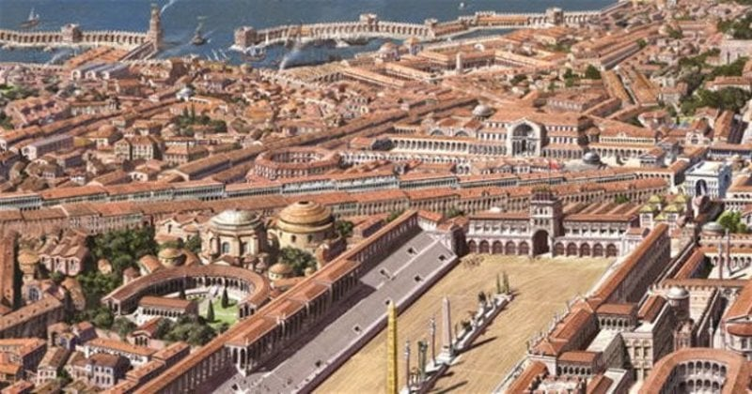
Figure 1, Constantinople in all its glory, looking very similar to the ancient city of Rome. Available at: https://greekreporter.com/wp-content/uploads/2018/05/kwnst2_iefimerida.jpg. (Accessed on the 8th of May 2025).
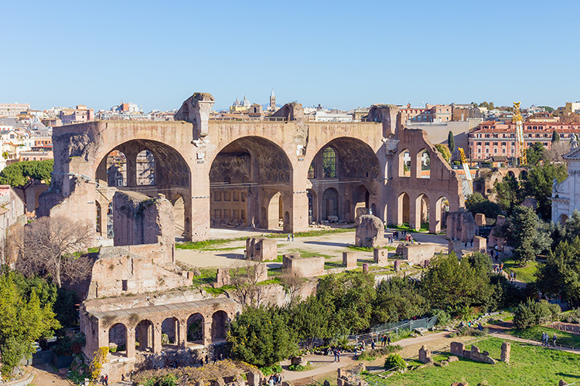
Figure 2, Basilica Nova of Constantine and Maxentius: Available at: https://www.historyhit.com/app/uploads/2020/11/Basilica-of-Maxentius-and-Constantine.jpg. (Accessed on the 7th of May 2025).

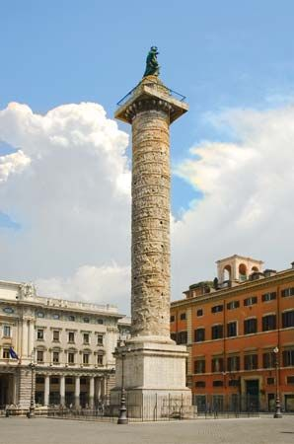
Figure 3, Column of Trajan in Rome: Available at: https://cdn.britannica.com/s:700x450/53/112153-004-2B8477EA.jpg. (Accessed on the 7th of May 2025).
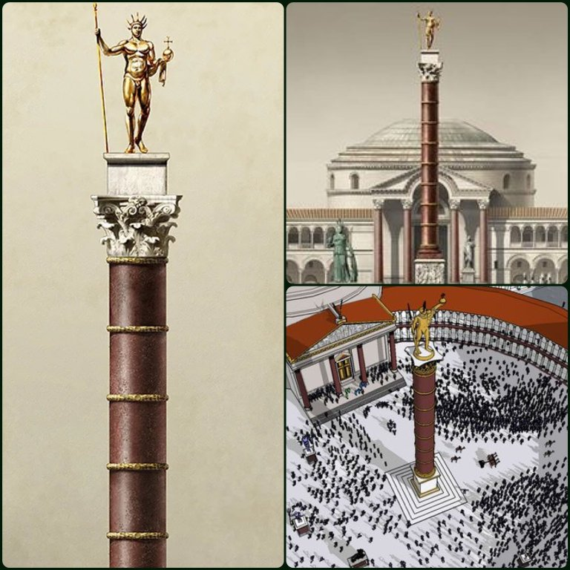
Figure 4, reconstruction of the column of Constantine as Sol Invictus: Available at: https://shadowsofconstantinople.com/wp-content/uploads/2024/05/gntm35zwcaawcoi.jpeg?w=768. (Accessed on the 7th of May, 2025).
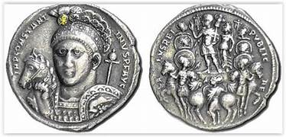
Figure 5, Constantine and CHI=-RHO imagery: Available at: https://www.unrv.com/image/constantinecoin.jpg. (Accessed on the 7th of ay, 2025).

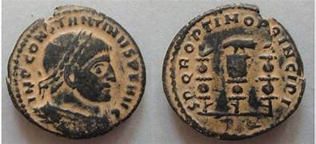
Figure 6 , Constatine: Available at: https://assets.romancoinshop.com/image/cache/a04/0001aa/S2051-constantine-1-768x350h.jpg. (Accessed on the 7th of May 2025).
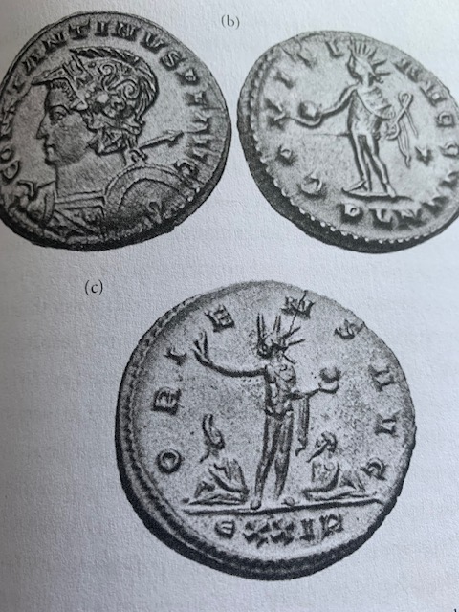
Figure 7, Constantine and Sol Invictus in Potter, D. (2015). ‘Constantine. The Emperor’. New York. Oxford University Press.
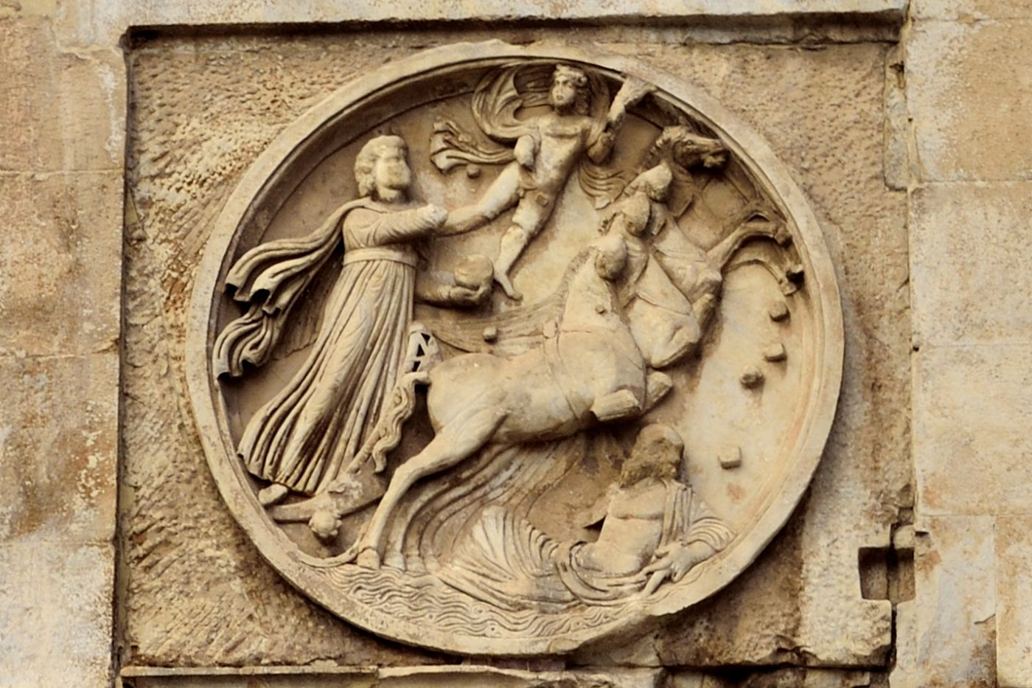
Figure 8, Apollo and his chariot on the Arch of Constantine: Available at: https://i.pinimg.com/originals/aa/7b/14/aa7b14f00e4742353e3d12bba3fb88fb.jpg. (Accessed on the 7th of May 2025).

