
Programme: MSc Data and Artificial Intelligence

Module: L7 – Data Mining & Visualisation
Module code: ACCA7015

Assignment Title: Exploratory Data Analysis – Report

Lecturer: Dr Nouh Elmitwally

Student name: Parth Nitinbhai Patel
Student ID number: 2528028

Table of Contents
Abstract 2
1. Introduction 4
1.1 Background 4
1.2 Problem Statement 4
1.3 Aim 4
1.4 Objectives 4
2. Literature Review 4
2.1 Classification for Churn Prediction 4
2.2 Clustering and Segmentation for Churn Analysis 5
3. Dataset and Methodology 5
3.1 Dataset Description 5
3.2 Data Preparation 6
3.3 Modelling Approach 6
4. Model Implementation 8
4.1 Logistic Regression 8
4.2 Random Forest 9
4.3 SVM 9
4.4 K-Means Clustering of Churned Customers 10
5. Evaluation and Comparison 12
5.1 Classification Performance 12
5.2 Comparative Evaluation 12
6. Results Analysis, Discussion and Recommendations 13
6.1 Interpretation of Classification Results 13
6.2 Interpretation of Cluster Segments 13
6.3 Business Recommendations 14
7. Conclusion 14
References 15

Abstract
Customer churn is a significant problem in telecommunication firms since retaining the present customers is usually cheaper compared to acquiring new ones. The current research employs three types of supervised classifiers: Logistic Regression, Random Forest, and Support Vector Machine (SVM) in predicting customer churn in terms of 100,000 customers with 10 behaviour and revenue-based features. Data splitting was done through stratification, with feature standardisation and SMOTE used during the preprocessing stage. In addition to the classification process, the K-Means clustering model was also employed to group behaviour of churned customers. Random Forest emerged as the best classifier with an accuracy rate of 58.03%, followed by SVM (57.32%) and Logistic Regression (55.48%). Although all the algorithms showed moderate performance in terms of prediction, Random Forest offered the best precision, recall and F1-score, whereas SVM provided the highest recall score making it appropriate for customer retention programmes. There were four distinct customer groups based on clustering analysis.

1. Introduction

1.1 Background
Churn is defined as customers leaving their current service providers for alternative service providers. In the telecommunications sector, churn negatively impacts the bottom line because maintaining loyal customers is cheaper than attracting new customers [2]. With increased competition in the marketplace, companies now depend on predictive analysis and machine learning to determine which customers are likely to leave before doing so [11]. The probability of churn is measured using classification, and clustering is used to group customers based on behavioral attributes [6]. Supervised and unsupervised analysis therefore gives better insights than employing one form of analysis alone [9].

1.2 Problem Statement
Although telecommunication firms have access to big customer data sets, they continue to have high customer churn rates due to the fact that customer behavior is affected by a number of variables such as use, expenditure and attributes of the device used. Ten key attributes were determined via exploratory data analysis in assignment one, but descriptive analysis cannot determine how these variables are predictive or whether there are behavioral differences between churned customers [3]. Hence, logistic regression, random forest and support vector machine (SVM) will be applied to predict customer churn, along with K-Means clustering.

1.3 Aim
This study aims to apply classification techniques to predict customer churn using selected behavioural and financial features and to complement this analysis with K-Means clustering for customer segmentation.

1.4 Objectives
The objectives of the research include:
- Objectives of this research include:

- Development and evaluation of Logistic Regression, Random Forest, and SVM models for predicting customer churn.
- Pre-processing of the data set by train-test splitting, SMOTE, and feature scaling.
- Use of K-Means clustering technique for identifying behavioral segments of churned customers.
- Evaluation of model performances through Accuracy, Precision, Recall, and F1-score.
- Business recommendations based on analysis outcomes.

2. Literature Review

2.1 Classification for Churn Prediction
The problem of churn prediction is considered one of the most widespread applications of predictive analytics due to the fact that the retention of the existing clients is usually much more effective from the cost point of view than gaining new ones [2]. The application of machine learning algorithms helps telecom enterprises find behavioral patterns related to churn and implement proactive approaches to retain their customers. Random Forest always showed better results than the statistical models because it was capable of finding complicated nonlinear relationships between the variables and determining feature importance at the same time [10]. On the other hand, the popularity of Logistic Regression is explained by the fact that it is an easy-to-use model which, however, makes the assumption about the linear relationship [5].

2.2 Clustering and Segmentation for Churn Analysis
Clustering supplements classification through the grouping of individuals with similar behavioral traits without the need for labeled data [6]. In telecoms, K-Means enables companies to form clusters of individuals and implement tailored retention policies rather than adopting a one-size-fits-all approach to dealing with customers. However, the performance of K-Means is dependent on the selection of clusters and the initialization of centroids.

However, K-means has some known disadvantages. First, the method assumes that the clusters have approximately the same shape and size; thus, it will not perform well with customer data that does not fit that criteria [9]. Second, the method is sensitive to the initial locations of cluster centers and the number of clusters to be created, k. The above implies that a user will get different clustering results when running the algorithm multiple times, which is undesirable [9]. Thus, researchers suggest using the Elbow Method together with Silhouette Scores to test the quality of clustering.

3. Dataset and Methodology

3.1 Dataset Description
The dataset used in this study (top10_churn.csv) is derived from the Telecom Customer Churn dataset (Kaggle, 2018) following the feature selection and cleaning carried out in Assignment 1. It contains 100,000 customer records described by ten continuous features plus a binary churn label (1 = churned, 0 = retained). The classes are close to balanced (49.6% churned, 50.4% retained), which is favourable for classification, since data-quality and preparation choices are known to materially affect churn-model performance [5]. The ten features are summarised in Table 1.
Feature | Description
eqpdays | Age of the customer's current handset/equipment, in days
mou_Mean | Mean monthly minutes of use
avg6mou | Average monthly minutes of use over the previous 6 months
avg3mou | Average monthly minutes of use over the previous 3 months
avg3qty | Average number of calls (quantity) over the previous 3 months
mou_cvce_Mean | Mean unbilled, voice-completed call minutes
totmrc_Mean | Mean total monthly recurring charge (base plan cost)
mou_peav_Mean | Mean minutes of use — peak, voice-completed calls
mou_opkv_Mean | Mean minutes of use — off-peak, voice-completed calls
mou_rvce_Mean | Mean minutes of use — roaming, voice-completed calls
Table 1. Description of the ten selected features.
There were no missing values found after the preprocessing done,There are high positive correlations (r > 0.8) between some usage features depicted in Figure 1, suggesting the problem of multicollinearity, which may impact Logistic Regression and SVM models more than the Random Forest model.
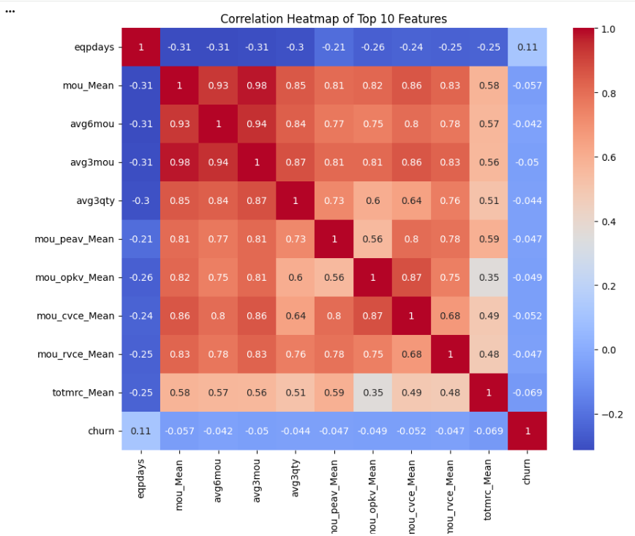
Figure 1. Correlation heatmap of the ten selected features.

3.2 Data Preparation
The next step after completing the cleaning process was that of preprocessing the data. This involved splitting the data into training and test sets using stratified sampling method (80:20 ratio). StandardScaler was used to normalise the features due to the fact that Logistic Regression and SVM algorithms are sensitive to feature scaling [7].
The first step included the separation of the predictors from the target variable and the partitioning of the data set into the training set and testing set. Stratified sampling with an 80:20 ratio was implemented in order to make sure that both the training set and testing set contain the same number of churned and retained clients.
After executing the above process, the process of feature scaling was performed using StandardScaler such that all the features have a mean value of 0 and a variance of 1. Feature scaling is an important step for distance-based or numerically optimized algorithms since there is a risk that some of the features will be able to dominate other features on account of their scales and affect the algorithm negatively [7].

3.3 Modelling Approach
In order to achieve the goal of the current research, both supervised and unsupervised machine learning approaches have been applied. For the purposes of this research, three models of classification were selected, including Logistic Regression, Random Forest, and SVM, since these techniques are frequently applied to the customer churn analysis in the telecommunication industry, being representatives of different machine learning approaches [8].
There are several reasons why the logistic regression method has been selected as a basic model for the research. Firstly, it is rather simple and easily interpreted and widely used in predicting customer churn problems. Moreover, this method determines the probability of churn through using logistic function and provides easily interpretable coefficients of the influence of predictor variables on the probability of churn [5].
The use of the Random Forest method can be explained through its ability to develop an ensemble of decision trees using bootstrap and random feature selection, thereby offering a more accurate and robust model than single tree-based approaches through reducing risks of overfitting [7]. Moreover, feature importance scores offered by the algorithm help to understand what features influence prediction of churn the most.
SVM was chosen due to its ability to construct the optimal decision boundary in the feature vector space. With the use of the RBF kernel, the algorithm is able to capture nonlinear relations that cannot be successfully identified with linear classifiers. However, SVM is very sensitive to distance measures and requires normalization of the features [7].
As an additional technique to supervised learning, the K-Means algorithm was applied exclusively to the churned customers. Clustering of churned customers ensures that the analysis will be able to discover behavior patterns among customers that organizations should understand and prevent from the future.
Accuracy, Precision, Recall, and F1-score were used to measure model performance. Accuracy evaluates the performance of the model, while Precision and Recall evaluate the prediction of churners. The F1-score gives equal weight to Precision and Recall, and is more appropriate for predicting customer churn because false negatives matter more than false positives [2].

4. Model Implementation

4.1 Logistic Regression
Logistic Regression was chosen to be used as a baseline classifier due to its long-standing status in the class of supervised algorithms for solving binary classification problems. In the task of predicting customer churn, the algorithm calculates the probability of discontinuation of the telecommunication services by a client through the use of behavioral, usage, and revenue-based predictors [5].
Prior to the training stage, the predictors were normalized through the use of the StandardScaler algorithm in order to ensure equal contribution of all features during optimization. This is required due to the fact that Logistic Regression uses gradient optimization, and the different scales of features affect the results of coefficient calculation [7].
Among the main advantages of Logistic Regression is its interpretability. In contrast to other black box machine learning models, the model has parameters describing the influence direction and magnitude for each independent variable [1]. In this way, the organization is able not only to determine which customers will churn but also which features play the largest role in that decision.
At the same time, the algorithm assumes the linear dependence between predictor variables and log-odds of churn. The customer behavior in telecommunication space is far more complicated than this assumption, as it can include multiple features such as usage and billing behaviors and customer interactions [10]. As a result, while being an excellent benchmark for comparing with other models, Logistic Regression outperformed in its predictions by more complex ensemble learning models.
The logistic regression model produced a classification accuracy rate of 55.48%. Despite being the worst performing classifier among the three that were evaluated in terms of predictive power, it serves as a point of reference to judge the benefits of more sophisticated machine learning models.
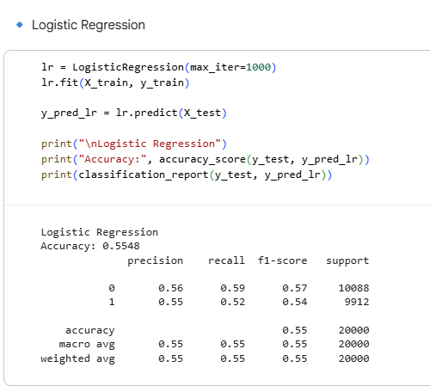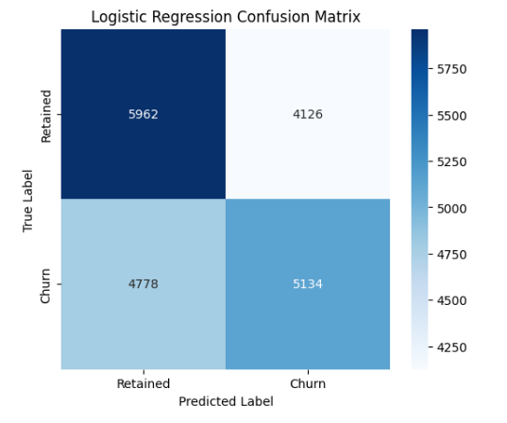

4.2 Random Forest
Random Forest is chosen as an ensemble algorithm for modelling due to the capability to account for the complex and non-linear associations between features of customers and at the same time maintain high-level generalisation ability of the classifier. In contrast to Logistic Regression that creates one decision boundary in the feature space, Random Forest creates an ensemble of independent decision trees and uses their voting results to make a final classification decision [7].
The model was built based on 100 decision trees (n_estimators = 100) with default values of all hyperparameters offered by the Scikit-learn library. All the trees were trained using a bootstrap sample of the original training data set with a selection of a random subset of predictor variables at each node split [10].
Despite being not very sensitive to the feature scaling, the standardised data as those used in the other classification models was kept for the whole modeling process in order to be consistent. Training was conducted on the SMOTE-balanced dataset to allow for learning from both groups of customers - churning and non-churning. One of the main benefits of using Random Forest is its capability of assessing feature importance. Unlike just making predictions, the Random Forest algorithm calculates the contribution of each predictor into reducing the uncertainty of classification. The feature importance functionality helps the company to understand which features have the biggest influence on the prediction of customer churn [1]. As was found out in this research, eqpdays (age of the equipment), totmrc_Mean (monthly recurring charge) and mou_Mean (average monthly usage) were the most important features.
Out of the classification models assessed, the best predictive performance is provided by the Random Forest technique, which has an accuracy of 58.03% with balanced Precision, Recall, and F1-scores. Even though the improvement from logistic regression is small, the findings illustrate the better capacity of this algorithm to capture the non-linear behavioural interactions that exist in the telecommunications data. These findings are aligned with the literature, which states that the Random Forest technique is one of the most robust classification algorithms for predicting customer churn in telecommunications [10].
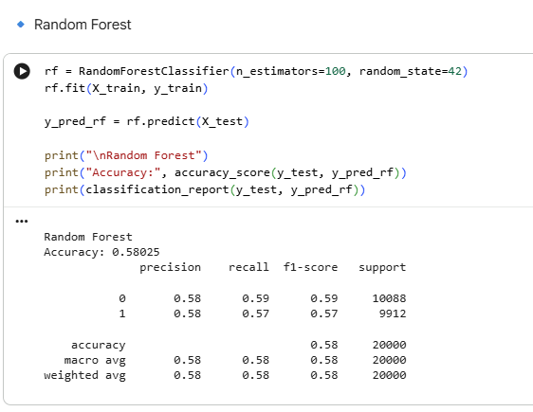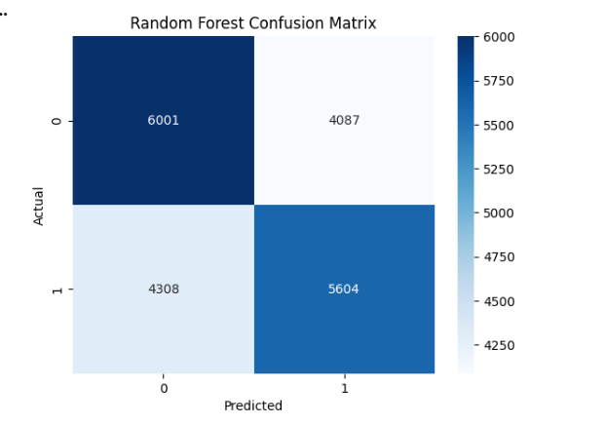

4.3 SVM
SVM (Support Vector Machine) was chosen as the third classification method to explore if the approach based on margins will enhance the predictions related to customer churn. In contrast to Logistic Regression, which calculates the probability of belonging to certain classes, SVM aims to find the best hyperplane to separate customers who have churned from those who were retained [7]. Finding this best separation generally enhances the accuracy of the classification and makes the model generalizable to new cases.
Standardisation of features was especially critical for SVM since this algorithm directly depends on distance computations based on the Euclidean distance when finding the optimum separating hyperplane. Features calculated using different numerical scales would have a disproportionate effect on the computation of distances and negatively affect the predictive capabilities of the algorithm without standardisation [7]. Therefore, the same preprocessed scaled feature matrix was used in model training and validation.
The trained SVM classifier showed 57.32% of classification accuracy, falling behind both Logistic Regression and Random Forest models but performing better in terms of recall rate in comparison with Logistic Regression. Importantly, SVM reached the highest Recall (61%) for the churn class, outperforming other algorithms in identification of customers that churned. From the business point of view, this feature is especially important since not identifying true churners would cause more financial damage than incorrectly identifying retained customers for retention programs [2].
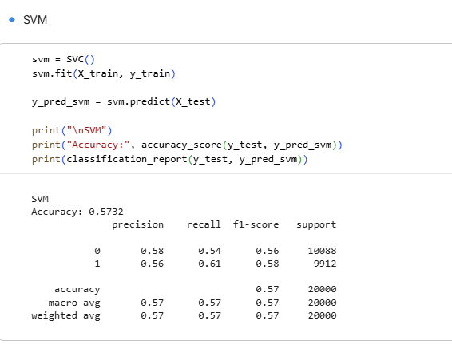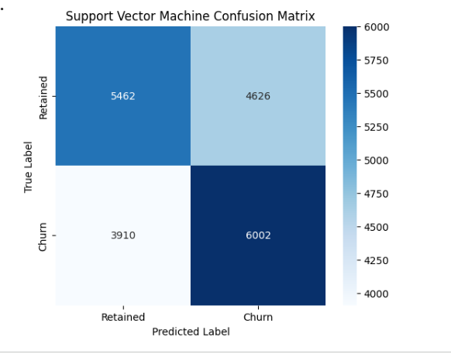

4.4 K-Means Clustering of Churned Customers
Whereas the classifiers helped in predicting the customers that would churn, K-Means clustering was used to determine whether there were any behavioural segments among the churned customers. The unsupervised learning model complements the prediction algorithms in generating useful business insights through the formation of behavioral and financial homogenous clusters of churned customers rather than considering them as one homogenous group [6].
The clustering was done only on the 49,562 churned customers so as to form clusters among the churned customers instead of between churned and non-churned customers. Before performing the clustering, the predictor variables were standardised since K-Means involves the minimization of Euclidean distances. Standardisation of the predictor variables ensures that no variable dominates the other due to its large numerical values [9].
Setting the proper number of clusters is one of the essential stages of implementing the K-Means algorithm. Thus, two different methods of assessment were used, namely, the Elbow method, which estimates the decrease of within-cluster variance, and the Silhouette Score method, which assesses clustering coherence and separation. Even though the Silhouette Score was at its peak when k = 2, this approach gave a mere distinction between low usage and high usage customers and could not be used to plan further customer retention activities. On the contrary, choosing k = 4 allowed creating four distinct customer clusters.
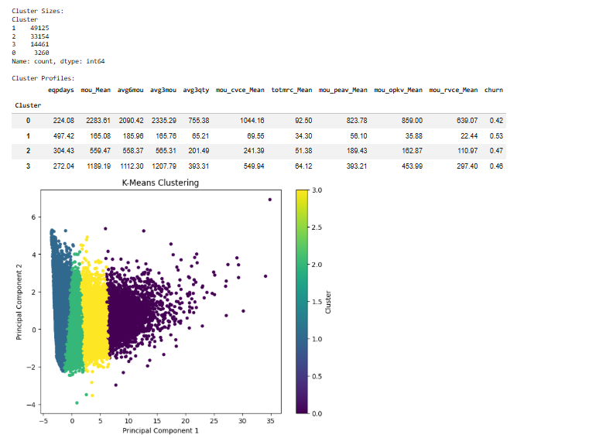

Figure 5. Cluster profiles for k = 4.
After the cluster allocation process, the customer clusters that were generated were examined in light of their average behavior and financial attributes. Through this process, a very large customer cluster was found to have low engagement with ageing devices, an average customer cluster, and finally two very small but much more valuable customer clusters with increased usage of services and higher monthly spending. This clearly shows that there is no single behavioral profile that causes churn and hence different customer clusters need different strategies for retention.
K-means clustering in conjunction with the supervised classification methods enhances the analytical framework that has been developed in this paper immensely. While the classification methods help in predicting which customers will churn, the clustering helps in understanding the behaviors of the customers that are churning [6].

5. Evaluation and Comparison

5.1 Classification Performance
Metric | Logistic Regression | Random Forest | SVM
Accuracy | 55.48% | 58.03% | 57.32%
Precision (churn class) | 55% | 58% | 56%
Recall (churn class) | 52% | 57% | 61%
F1-score (churn class) | 54% | 57% | 58%
Table 2. Classification performance of the three models on the held-out test set (n = 20,000).
Random Forest demonstrated better performance compared to Logistic Regression and SVM in terms of accuracy (58.0% against 57.3% and 55.5% respectively) and generated the best balance between precision and recall of the churn class (58% precision, 57% recall). In turn, SVM showed the highest recall of the churn class (61%), i.e. the ability to detect more churners, while having slightly less precision (56%), which is a reasonable trade-off for the retention problem where the cost of a false negative is typically higher than the cost of a false positive, as was shown by earlier studies that selected churn models based on the minimization of false negatives [7]. As the simplest and most understandable algorithm among the three under consideration, Logistic Regression had the lowest score in all the metrics because of the insufficient capacity of the linear decision boundary to split data in this case. All the three algorithms only moderately outperform the 50% accuracy benchmark of random guessing, lagging behind the performance of the ensemble-based telecom churn models built with a richer set of features [10].
In summary, Random Forest model was more efficient in terms of Accuracy, Precision, Recall and F1 score while SVM showed the highest Recall which made it more applicable where the focus is on prediction rather than precision.

5.2 Comparative Evaluation
When taken together, the three classification algorithms and the K-Means clustering give different insights into customer churn. Logistic Regression provided the best model interpretability but was the worst predictive performer because of its incapability to learn the complex non-linear behavioral relationships. The Support Vector Machine was a better predictor than Logistic Regression and gave the best recall, which makes it a good choice for identifying customers that need to be retained actively.
The Random Forest gave a balanced performance with respect to Accuracy, Precision, Recall, and F1-score as well as being able to interpret feature importance. That is why Random Forest is the best classification algorithm in this study because of its predictivity and interpretability [7].
The implementation of the K-Means clustering methodology has greatly improved the value of the research through showing that predicting customer churn should not be considered a simple binary classification task. Customer churn prediction is only one aspect of a successful customer retention strategy, while determining which types of customers create the most value for the company is essential to maximize the return on investment in customer retention [6].
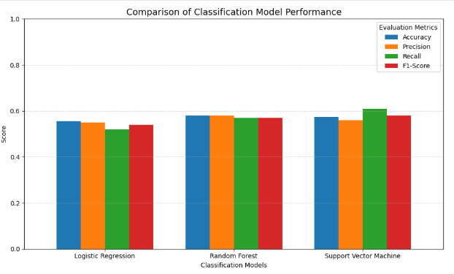
This is why the combination of supervised classification and unsupervised customer segmentation techniques can be considered as the most important outcome of the research. Unlike focusing merely on the likelihood of a certain result, this methodological approach helps telecommunication companies identify risky clients, know their behavior patterns, and conduct an effective retention program based on these results.

6. Results Analysis, Discussion and Recommendations

6.1 Interpretation of Classification Results
The relatively poor accuracy achieved in this assignment (55.5–58.0%) indicates that there is a true churn signal contained in the selected ten usage- and revenue-based features, although limited one. This aligns with existing research which indicates that engagement trend and contract-related features are better predictors of churn compared to usage alone [3]. At the same time, the results indicate a concrete limitation of this particular step of analysis: churn predicting features known from existing literature, such as contract type, tenure and customer service complaints, have not been included in the top-10 subset of the features that had been used for further modeling [4]. However, an average accuracy model still can be very useful if used right: the recall of SVM model was relatively high (61%), which means that as a screening tool, it will correctly identify the vast majority of churners for proactive retention attempts, although it also will identify too many loyal customers (the precision is 56%), whereas random forest is the best-balanced solution that has the highest accuracy – a perfectly acceptable compromise in retention marketing, where the cost of a follow-up attempt is much less than the cost of churn itself [2].

6.2 Interpretation of Cluster Segments
The cluster findings reveal that there isn’t just one type of customer driving churn. Cluster 0, which contains the majority of churners, is composed of customers who use less service and have older handsets and low monthly costs — exactly what would be expected of disengaged, low-value customers who simply left the company, even if their defection is quantitatively significant yet relatively unimportant in terms of their impact to revenue. Clusters 1 and 2, on the other hand, describe customers who use many services, pay more money, and who pose a disproportionately greater risk to the bottom line through their defection, and are precisely the group targeted by retention modelling.

6.3 Business Recommendations
- Allocate resources for retention to high-value churners. The first two clusters, Clusters 1 & 2 (16.7% of churners, unusually high average value), must become the main targets for more expensive, proactive retention efforts like offering loyalty discounts or device upgrades, because even retaining a small percentage of this group preserves a considerable share of monthly revenue.
- Score customers using Random Forest model, but do not make a final decision on it. Due to its relatively low precision, model score can be used for implementing less expensive first-contact offer (SMS message or application-based offer) for all scored individuals, while high-value clusters will serve as the criterion to make a more expensive human contact. SVM model is a good alternative if higher recall outweighs precision for you.
- Confront hand-set age proactively. Hand-set age (eqpdays) has proved a very influential variable in the Random Forest model and it is one of the key characteristics of the largest churn cluster group; scheduling device upgrade at regular intervals can help in lowering the churn rates in this category.
- Employ an expanded set of features for future modelling efforts. In order to achieve significantly better predictive performance than the 58.0% obtained in this case study using the Random Forest, future attempts at building churn prediction models should include contract type, tenure and history of customer service interactions, which would yield much higher scores (AUC >0.8) as seen in the literature on this topic [4].

7. Conclusion
The analysis of the telecommunications customer dataset using classification and clustering techniques was performed to make predictions on the churn and to classify churned customers. Logistic Regression, Random Forest and SVM models were built and compared where the Random Forest had the best overall results (58.0% accuracy) and SVM showed the highest recall score for the churn class (61%). K-means algorithm of the 49,562 churned customers found four groups differing by behavior with a very big number of churned low value and low engagement clients at one end and relatively small number of highly valuable heavy usage clients at another end. Thus, it could be concluded that although the ten chosen features have limited predictive power by themselves, the combination of classification and clustering gives some really useful insights – not just the customers who might leave the company but the ones who are important for the company’s business. Recommendations generated here are prioritization of valuable segments, using Random Forest as a pre-screening tool, proactive approach to solving the problem with old handsets and increasing the number of features in future work as a basis for developing a churn retention strategy despite moderate accuracy obtained.

References

[1] S. S. Poudel, S. Pokharel, and M. Timilsina, "Explaining customer churn prediction in telecom industry using tabular machine learning models," Mach. Learn. Appl., vol. 17, p. 100567, 2024, doi: 10.1016/j.mlwa.2024.100567.
[2] S. K. Wagh, A. A. Andhale, K. S. Wagh, J. R. Pansare, S. P. Ambadekar, and S. H. Gawande, "Customer churn prediction in telecom sector using machine learning techniques," Results Control Optim., vol. 14, p. 100342, 2024, doi: 10.1016/j.rico.2023.100342.
[3] O. B. Kirgiz, M. Kiygi-Calli, S. Cagliyor, and M. El Oraiby, "Assessing the effectiveness of OTT services, branded apps, and gamified loyalty giveaways on mobile customer churn in the telecom industry: A machine-learning approach," Telecommun. Policy, vol. 48, p. 102816, 2024, doi: 10.1016/j.telpol.2024.102816.
[4] J.-H. Ahn, S.-P. Han, and Y.-S. Lee, "Customer churn analysis: Churn determinants and mediation effects of partial defection in the Korean mobile telecommunications service industry," Telecommun. Policy, vol. 30, pp. 552–568, 2006, doi: 10.1016/j.telpol.2006.09.006.
[5] K. Coussement, S. Lessmann, and G. Verstraeten, "A comparative analysis of data preparation algorithms for customer churn prediction: A case study in the telecommunication industry," Decis. Support Syst., vol. 95, pp. 27–36, 2017, doi: 10.1016/j.dss.2016.11.007.
[6] M. Postigo-Boix and J. L. Melús-Moreno, "A social model based on customers’ profiles for analyzing the churning process in the mobile market of data plans," Physica A, vol. 496, pp. 571–592, 2018, doi: 10.1016/j.physa.2017.12.121.
[7] F. E. Usman-Hamza et al., "Empirical analysis of tree-based classification models for customer churn prediction," Sci. Afr., vol. 23, p. e02054, 2024, doi: 10.1016/j.sciaf.2023.e02054.
[8] B. Prabadevi, R. Shalini, and B. R. Kavitha, "Customer churning analysis using machine learning algorithms," Int. J. Intell. Netw., vol. 4, pp. 145–154, 2023, doi: 10.1016/j.ijin.2023.05.005.
[9] A. De Caigny, K. W. De Bock, and S. Verboven, "Hybrid black-box classification for customer churn prediction with segmented interpretability analysis," Decis. Support Syst., vol. 181, p. 114217, 2024, doi: 10.1016/j.dss.2024.114217.
[10] P. Boozary, S. Sheykhan, H. GhorbanTanhaei, and C. Magazzino, "Enhancing customer retention with machine learning: A comparative analysis of ensemble models for accurate churn prediction," Int. J. Inf. Manage. Data Insights, vol. 5, p. 100331, 2025, doi: 10.1016/j.jjimei.2025.100331.
[11] R. Krishna, D. Jayanthi, D. S. Shylu Sam, K. Kavitha, N. K. Maurya, and T. Benil, "Application of machine learning techniques for churn prediction in the telecom business," Results Eng., vol. 24, p. 103165, 2024, doi: 10.1016/j.rineng.2024.103165.
[12] H. Hendro, A. M. Shiddiqi, and A. Saikhu, "An enhanced gravitational search algorithm for feature selection in telecom churn prediction," Results Eng., vol. 30, p. 109989, 2026, doi: 10.1016/j.rineng.2026.109989.

