

MBA – Master of Business Administration In Banking and Finance

ONLINE PAYMENT OPPORTUNITIES: PAYPAL AND BITCOIN
Student ID: 2217290
Student Name: Asma Banu

Master’s Degrees by Examination and Dissertation
Declaration Form.
1. This work has not previously been accepted in substance for any degree and is not being concurrently submitted in candidature for any degree.
Signed: …………………………………………………….
Date…………………………………………………….
2. This dissertation is being submitted in partial fulfilment of the requirements for the degree of Master in Business Administration.
Signed …………………………………………………….
Date ………………………………………………………………….…………...
3. This dissertation is the result of my own independent work/investigation, except where otherwise stated.
Other sources are acknowledged by footnotes giving explicit references.
A bibliography is appended.
Signed candidate: ASMA BANU
Date: 17th October 2023
4. I hereby give consent for my dissertation, if accepted, to be available for photocopying, inter- library loan, and for deposit in the University’s digital repository
Signed (candidate): ASMA BANU
Date: 17th October 2023
Supervisor’s Declaration.
I am satisfied that this work is the result of the student’s own efforts.
Signed: ……Dave Coker ………………………………………………….
Date: ………………………18/10/23…………………………………...

Abstract
Chapter 1 of research mainly deals with introduction section, as it reflects the background of research, aims and objectives, and research significance. However, it has been found that rapid growth of internet derived several e-payments methods and online transactions. It consists with variety of payment methods such as PayPal, and Bitcoin to provide flexibility in transactions. Chapter 2 of research study delas with Literature review section, as it has been found that researcher used the theoretical frameworks as total acceptance model and diffusion of innovations to describe the rate of technologies adoptions. Similarly, the chapter has also highlighted the key issue of using PayPal along its implications for global transaction’s. In the third chapter, positivism philosophy has been used, and the main application of the philosophy can be seen as a more reliable and adaptable method that strengthens the research's findings by covering a wide range of situations in a relatively short amount of time. The researcher employed both a descriptive research design and a deductive research approach. With the creation of the fourth chapter, quantitative analysis was done, helping the researcher validate the replies received. The analysis has also helped to establish a rational grasp of and knowledge of PayPal and Bitcoin as online payment options in the present business climate. The final chapter mainly deals with an overall conclusion of the study and along with that it provided some potential recommendations.

Table of Contents
Chapter 1: Introduction 6
1.1: Introduction 6
1.2: Background of the study 6
1.3: Scope of the research 7
1.4: Research aim 8
1.5: Research objectives 8
1.6: Research questions 8
1.7: Research rationale 8
1.8: Structure of dissertation 9
Chapter 2: Literature Review 10
2.1: Introduction 10
2.2: Theoretical framework 10
2.3: Highlighting the issues and implications of using PayPal for global digital transactions 13
2.4: Analyzing the reasons why Bitcoin is still regarded as illegal in many countries across the globe 17
2.5: Evaluating the implications of Bitcoin on the global economy 20
2.6: Literature gap 23
2.7: Summary 23
Chapter 3: Research Methodology 24
3.1 Introduction 24
3.2 Research Philosophy 24
3.3 Research Approach 25
3.4 Research Design 26
3.5 Sampling Strategy 27
3.6 Data Collection Method 27
3.7 Data Analysis Technique 28
3.8 Ethical Consideration 28
3.9 Summary 29
Chapter 4: Results and discussions 30
4.1 Introduction 30
4.2 Quantitative analysis 30
4.2.1 Descriptive analysis 30
4.2.2 Inferential analysis 43
4.3 Discussion 50
4.4 Summary 52
Chapter 5: Conclusion and Recommendations 53
5.1 Introduction 53
5.2 Linking with Objectives 53
5.3 Future scope 56
5.4 Recommendations 56
References 57
Appendix: Survey questionnaire 61

List of figures
Figure 1: Factors of Diffusion of Innovation 9
Figure 2: Technology Acceptance Model 11
Figure 3: Digital payment technology 13
Figure 4: Number of Bitcoins in Circulation Worldwide 20
Figure 5: Survey Question 1 27
Figure 6: Survey Question 2 28
Figure 7: Survey Question 3 29
Figure 8: Survey Question 4 30
Figure 9: Survey Question 5 31
Figure 10: Survey Question 6 31
Figure 11: Survey Question 7 32
Figure 12: Survey Question 8 33
Figure 13: Survey Question 9 34
Figure 14: Survey Question 10 35
Figure 15: Survey Question 11 36
Figure 16: Survey Question 12 37
Figure 17: Survey Question 13 37
Figure 18: Survey question 14 38
Figure 19: Survey Question 15 39

List of tables
“Table 1: First correlation results” 41
“Table 2: Second correlation outcome” 43
“Table 3: Regression model result” 44
“Table 4: Anova” 45
“Table 5: Regression coefficient result” 46

Chapter 1: Introduction

1.1: Introduction
Digital payment transactions are the process of buying and selling goods and products or engaging in a financial transaction over the Internet. As mentioned by Monratet al., (2019), E-payment is a primary key function for any type of e-business owing to the exponential rise in their usage in the present era with the emergence of e-business. Simplicity in the mode of payments allows the customers, to save time and effort while increasing their purchase level. Thus, utilising various forms and devices payments like Bitcoin and PayPal have turned out to be highly convenient and exciting for consumers. This has intensified the buyer's and sellers' engrossment in a particular transaction. However, emerging e-payment systems are facing plenty of risks and challenges particularly fraud as it is the most critical threat observed to the e-business fields and creates potential losses (Zhang and Chen, 2019). The research study evaluates the different risks and challenges of e-payments for global digital transactions. The study contains the major implications of using PayPal and Bitcoin for global digital payments.

1.2: Background of the study
With the rapid growth of the internet and information technology many businesses are adopting e-payment methods, especially for money transactions, e-ticket booking, and online shopping, Digital payment methods are highly cost-effective owing to the efficient payment processing, and faster and accurate payment processing. Apart from that, it allows us to gain improved access to data, reporting, flexibility, and safety while making payments. As stated by Agur et al., (2020), higher savings opportunities can be gathered while integrating electronic payment methods in the business account payable methods on every invoice. However, online payments are subject to technical defaults as it is highly reliant on technology creating heavy bounce rates for businesses. There are many varieties of e-payment transaction methods are existed to facilitate ease of transaction with the most active level of security. On the other side, parallelly, cyber-attack strategies are increasing at the advanced level affecting the security protocols. The main contribution of the research study is providing a critical overview of the digital e-payment systems based on their advantages and challenges while focusing on PayPal and Bitcoin.
The availability of various online payment options like PayPal and Bitcoin has crafted countless opportunities for the firms to develop faster and have constantly undergone advancements developing them seamlessly. PayPal operates on a secure and open payment platform based on which business firms are likely to transact with their customers through technological devices and mobile phones. Alternatively, online payments aid businesses to provide their customers with a convenient payment experience. However, Bitcoin is a newly integrated network that promotes the development of an online payment system as well as regulation of digital money circulation across the world. As per the view of Dutta et al., (2020), the benefits of online payments for businesses often extend to the potential clients of the business as well. Though it is a bit counterintuitive online transaction payment mode for the business help in protecting the money of both the business and its clients. Online payment gateways are enforced to imply multiple security layers for the payments. This is usually done to ensure that the client's personal details are not leaked or stolen from the scammers.
Online payment methods have greatly changed in recent years, giving customers a variety of alternatives for making payments and managing their money. PayPal is a worldwide payment option since it is accessible in more than 200 countries and supports a wide range of currencies (Agur et al., 2020). Strong security procedures are used by PayPal to safeguard users' financial data. It gives buyer and seller safety and employs encryption technology to secure transactions. PayPal is frequently included as a payment option on websites and platforms, which improves consumer ease. Bitcoin transactions are visible on the blockchain, but because they are pseudonymous, they give some level of anonymity. Users have the option of transacting anonymously. Some people think of Bitcoin as a type of digital gold, that is, a store of wealth and a possible inflation hedge (Zhang and Chen, 2019). As an asset for investments with the potential for price growth over time, bitcoin has grown in popularity. For routine transactions, internet shopping, and business-related payments, PayPal works effectively. The benefits of Bitcoin, however, are its decentralisation and possibility for investment, but doing so needs a greater grasp of blockchain technology.

1.3: Scope of the research
The study is going to elaborate on the potential advantages and implications available to online payment opportunities. The contemporary academic overview associated with advent of the online payment opportunities while majorly focussing on PayPal and Bitcoin has been discussed. Online payment options foster better operational efficiency and are going to be the new normal phase in the forthcoming years. The study critically evaluates the major challenges of the payment options while engaging in global digital transactions.

1.4: Research aim
The aim of the research study is to critically evaluate the potential implications of online payment opportunities by referring to the case of Bitcoin and PayPal.

1.5: Research objectives
- To highlight the issues and implications of using PayPal as a global digital transaction
- To analyse the reasons why Bitcoin is still regarded as illegal in several countries around the globe
- To determine the implications of Bitcoin on the global economy

1.6: Research questions
Q1: What are the major issues and implications of using PayPal for global digital transactions?
Q2: Why is Bitcoin still regarded as an illegal currencyin several countries?
Q3: What are the implications of Bitcoin on the global economy?

1.7: Research rationale
During the selection of a payment processing platform, there are a lot of things that need to be figured out. There are numerous online payment methods that can plague the overall business along with “payment gateway security requirements” to ensure that the sensitive data of the customers and business are protected. While discussing the global transaction that incorporates currency conversation PayPal is not the best choice. The currency conversion rate is usually used by PayPal which might not be an appropriate choice. As mentioned by Zhang and Chen (2019), some of the most dangerous aspects of online payment systems are cyber security fraud and data breaches. Thus, with the leakage of the potential data, there is the highest possibility of leakage of confidential data and information. Based on the views of Dannenberg et al., (2020), there has been severe monetary loss owing to transaction errors or faults in the bank account misuse that leads to mistrust. While examining the customer satisfaction with the digital wallet there has been higher uncertainty and risk associated with the digital payment systems.
Thus, with the increasing services offered by Internet banking services have turned out to be a prevalent medium of money transactions. Apart from that, it can become a vital requirement in the present financial sector. The adoption rate of the electronic payment system is lower than its development rate owing to key issues like privacy safety, data security, leakage of information to third parties, and many more. These issues have a direct negative influence on the adoption rate of the electronic payment and the trust of its users.

1.8: Structure of dissertation
The entire dissertation consists of five chapters beginning with an Introduction, Literature review, methodology, findings and discussion, and conclusion. The introduction chapter provides a succinct background of the research topic along with the scope of the research. The aims and objectives help drive the entire research study while facilitating the development of the research methodology, data collection, analysis, and conclusion. The literature review chapter contains the theoretical discussion of the research objectives based on contradictory opinions of various authors. The accumulation of secondary sources of data for the research study will be done in the chapter that develops a strong base for completing the research.
The methodology chapter contains a discussion of the methodological aspects beneficial for the researcher to collect data and information. The chapter succinctly justifies the selection of the particular tools and techniques for the research study. The data analysis and findings contain the empirical data and information collected based on the mixed data collection methods. The conclusion chapter discusses the overall summary of the information collected from the literature review chapter and data analysis while linking them with the research objectives. The future scope of the study is also provided focusing on the major literature gaps identified in the current research study.

Chapter 2: Literature Review

2.1: Introduction
The literature review chapter encapsulates a theoretical discussion of the research objectives based on the contrasting viewpoints of various authors. The chapter vividly evaluates the research objectives based on the secondary sources of information and aids in drawing a profound conclusion at the end of the study. The contradictory opinions and viewpoints help in acquiring critical data and information from the previously conducted research works. The theoretical framework provides an alignment of the research topic and relevant theories with adequate means of secondary sources of data. The literature gap presents the main points that have not been covered in the current study while collecting secondary data.

2.2: Theoretical framework
Diffusion of Innovation (DOI)
The adoption of technological platforms for conducting monetary transactions and facilitation in the digital e-payment systems. Based on the research work of Lu and Hsiao (2022), the theory helps in explaining the pattern and trend at which the spread of information regarding new innovations is carried out. The theoretical framework describes that there is a definite relationship between perceived innovation attributes and the rate of adoption of the technologies. The theory helps in understanding the adoption behavior of the adopters as well as predicting the overall technological innovation. Based on the views of Turin et al., (2023), with the emerging technology, the role of online e-payment has a prominent role in the overall development of e-commerce. However, owing to the fault and increasing rate of challenges create a hindrance for the e-commerce sector. Furthermore, the observability of the rate of innovation is positively correlated to its rate of adoption.
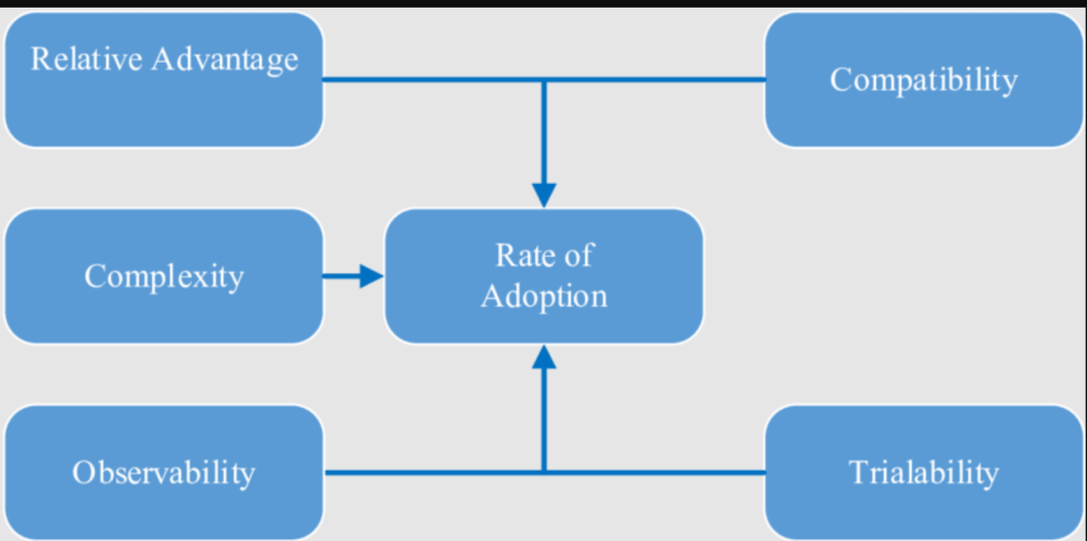
Figure 1: Factors of Diffusion of Innovation
(Source: Idris et al., 2021)
There are several factors that affect and influence the decision of the firm to adopt online transaction payments. These include relative advantage, compatibility, Trialability, complexity, and many more. As mentioned by Idris et al., (2021), the process of integrating new technologies will be highly complex due to the lack of trust and reliability, high risk, and uncertainty engaged with digital payment systems. Apart from this, the technical challenges such as privacy, security, fraud, design and communication issues, speed, reliability, disruptive technology, operation, and many more. Thus, the theory helps in addressing the linkage between the adoption rates of e-payment technology in global transaction payment facilities. The literature reveals that online payment is a growing payment method that has most probably replaced traditional payment methods. Thus, it is reasonable to consider that e-payment is an independent innovation process for most of the business.
Technology Acceptance Model (TAM)
According to the “TAM (Technology Acceptance Model), it has been observed that the actual utilisation of the technology is determined by the individual’s intention to use the technology. Based on the views of Goh and Sigala (2020), with the upsurge in the individual’s intention to deploy the technology it is highly observed that the consumption of the technology is used to a great extent. The implementation of the TAM model helps in evaluating the intention of the consumers in deciding their technological perception based on the influence of mental perceptions. As per the view of Sartipi (2020), perceived usefulness, as well as perceived ease of utilisation, is not always responsible for contributing equally to the predicted intentions. For example, from the customer's point of view, the economic disruption created by digital payment methods is mostly perceived as the disruption caused because of technological innovation in the present era.
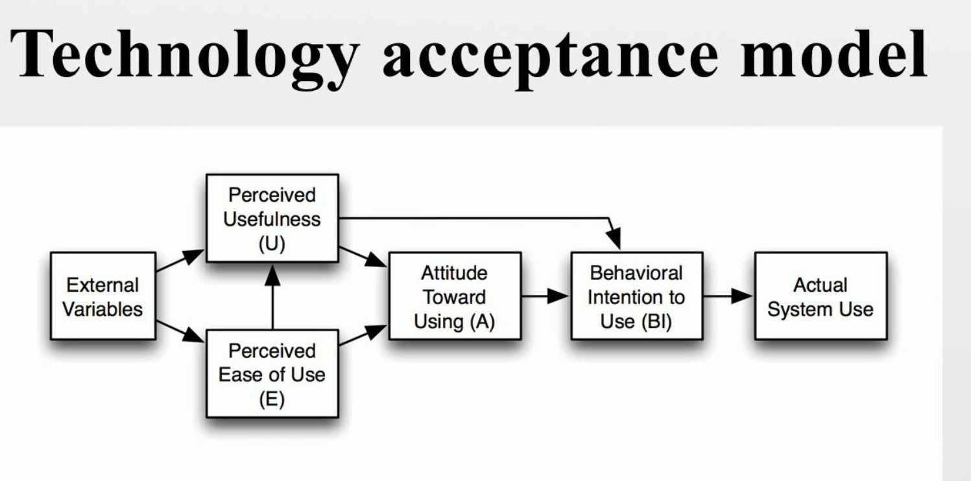
Figure 2: Technology Acceptance Model
(Source: Xu et al., 2023)
As compared to that of the traditional model of cash-related transaction that does not cause any potential harm to the customers. The initiation of the digital payment system such as digital wallets from banking institutions mainly carries a monthly fee for putting the payment technology in use. Based on the ideology of Xu et al., (2023), another economic issue that occurs with the integration of digital payment systems is the increasing rate of inflation owing to the increasing volatility of cryptocurrencies occurring in the speculative market. One of the social issues caused by the integration of digital payment systems is the lack of digital literacy as well awareness regarding digital payments which has created a major discouragement among people from adopting digital payment technologies.
Thus, the inclusion of TAM while managing the online payment methods can provide guidance to the individuals for understanding and accepting the technology in a pepper manner. As per the views of Goh and Sigala (2020), the subjective norms and the perceived benefits of the theory aid in the management and utilisation of technological innovation in a better way. Apart from that, the social impact and security pertaining to online transactions are managed well involving the customers as well as integrating the theoretical implementation. Considering the limitation, the total acceptance model is not a widely recognized term in the field of digital transactions and the evolving digital economy, finance, or business. However, the total acceptance of digital transactions could raise security concerns, as it might lead to increased fraud, hacking, and unauthorized access to financial data. Similarly, digital currencies and transactions determine inclusive and accessibility that is not accessible by everyone. Hence, it needs to identify the necessary technology or infrastructure to participate in digital transactions. Achieving the TAM model may require regulatory changes and the cooperation of international organizations.

2.3: Highlighting the issues and implications of using PayPal for global digital transactions
Khando (2022) stated that the issues that are highlighted are based on the sage of Traditional methods of digitalization. In this article, the digitalization aspect has been developed based on the financial industry. On the contrary, as stated by Cha (2023), PayPal is an international payment gateway that helps the user to electronically transfer funds using this system from two different countries' currencies. In the financial institution like in the banking sector, intercountry transactions can be benefited by using this digital payment system. In this article, the author has described the importance of the FSB system. It helps to regulate the significant activity that seeks stability in payment as well as promotes and develops complete information for the banking sector. International payment has many issues during implication. Constraint to the problem the potential issues are several.
PayPal for worldwide advanced exchanges offers a few benefits, including usability, wide acknowledgment, and money change capacities. The first issue is the Costs of Currency Conversion PayPal frequently uses its currency conversion rate, which may not be as advantageous as market rates. Users may incur hidden costs as a result, especially if they frequently transact internationally. While PayPal is generally acknowledged, it isn't accessible in all nations or may have restricted usefulness in certain locales. Users in nations where PayPal services are restricted may face difficulties as a result. Sometimes been frozen or restricted by PayPal without a clear explanation. For individuals and businesses that use PayPal for their financial transactions, this could be a significant issue. Concerning by Qian (2023) has stated that users have lots of benefits if this new transformation is adopted in international payment. The use of new technology like blockchain development will bring an overall difference in modern and traditional forms of payment. These issues can be mitigated if proper analysis of the problems can be done. Secondly, the issue stated by Foster (2021), is the Risk of Exchange Rate is impacted by changes in exchange rates for businesses that deal in multiple currencies and profit margins and financial stability. Users' risk management strategies may not always coincide with PayPal's automatic conversion. Other payment platforms and cryptocurrencies, which can offer lower fees, quicker transaction times, and features, are increasingly challenging PayPal.Another relevant issue stated by Foster (2021), is the barrier to Cross-border transactions in many countries' restrictions on cross-border transactions. The limitation to receive and send international funds is one issue using PayPal.
According to Foster (2021), the research paper has stated a robust understanding of macroeconomic impacts on the regulation of CBDCs and digital currency. The different aspects have been pointed to the recognition of CBDCs, it is mainly focused on different types of digital currency which is circulated globally. For instance, Bitcoin is one of the most popular cryptocurrencies which impacts the emerging economic factor.
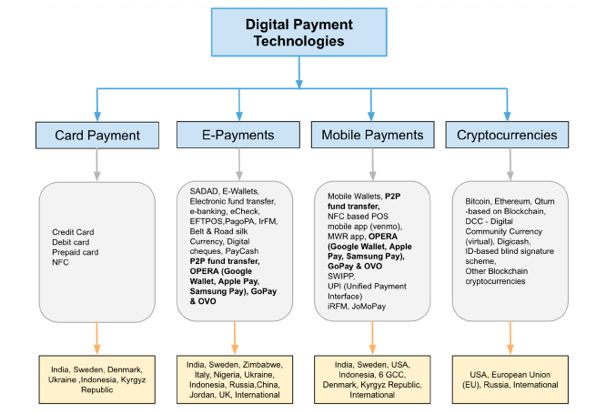
Figure 3: Digital payment technology
(Source: Khando, et al., 2022)
In contrast, Khando (2022) stated that modern-day transactions mainly shift from cash-based to new digital currency. As per the global report, non-cash transactions are the future and emerging technology that will help to reverse the payment system from cash to digital currency. Khando (2022) has also conveyed that there is an interrelation between finance and technology. Reviewing the empirical study, the author has put forward the benefits of using the new payment system.The new payment technology has enhances smoothing the functional activity to bring overall new types of development like e-payment, card payment, Cyptocurrency and mobile banking. The emerging transformation to new technology brings an enormous transformation which is mainly based on the financial market which reflects the impact in the global stage of the share market. Based on considering the issues, PayPal currency exchange rates may not be favorable because of hidden costs and charges engaged in international transactions. This might be highly disruptive for consumers and its cost protections. Moreover, investment in PayPal is heavily security to immune frauds, and phishing attempts. Based on the implication of using PayPal, enables financial inclusion by providing access to digital financial services for an individual, especially for those who do have access to traditional banking. Therefore, businesses should be careful of using PayPal or might use alternative methods of payment depending on specific needs.
Therefore, these are some issues that are highlighted which are reducing the Fintech product risk by improving the regulations. As stated by Стойка (2021), the outcomes of digital platform-based transactions are most effective. It has been analyzed that financial performance and innovation has reflected an important specialty in defining the basic functions that are used to evaluate the investment as well as manage the sustainability in leveraging this financial performance. To ensure promotion in the financial industry then the policies need to be evicted whereas the most important factor in the UK can be monitored. The policy regulation helps to develop new technology adoption which is enforced by Law and policies. Digital transformation, in the opinion of Cha (2023), defines a variable opinion expanding the business requires business digitalization which helps the individual to get access to many businesses. The process can help to expand the business. This technology adoption helps businesses but also enhances one country's economic stability. In the digitalization business, the expansion depends on economics against which to pursue and growth possibility to ensure gain knowledge about the market. The expansion of digital technology in the payment system
The new technology has many benefits as PayPal provides global digital transaction convenience and accessibility however, users ought to be aware of the potential issues and consequences, such as account restrictions, privacy concerns, fees, and costs associated with currency conversion. When conducting international transactions, it is essential to carefully consider these aspects and investigate alternative payment options based on individual or business requirements (Hipolito, et al., 2023). A significant obstacle to the expansion of the sharing economy is the absence of digital infrastructure in emerging economies. To address this, WTO partners need to normalize specialized means and internet business innovations across various nations. This can be accomplished through electronic installment frameworks, electronic marks, and electronic agreements. Exchange and specialized help from created nations can assist agricultural nations with finding worldwide principles and standards. Digital platform-based transactions have the potential to spread globally once they are standardized, enhancing long-term company performance.
To improve computerized stage calculations, firms need to aggregate huge information on earlier buying data, consumer loyalty, and customer ways of behaving. Big data can grow in volume as a result of market access liberalization, allowing businesses to improve existing algorithms or create new business models. In addition to that, the sustainable expansion of e-commerce necessitates well-thought-out control policies that address privacy and national security concerns.
It is critical to take note of that while certain nations have prohibited or confined Bitcoin, others have embraced it by creating administrative structures to administer its utilization. To facilitate autonomous digital platform-based transactions, WTO member countries must reach a comprehensive agreement on consumer protection, privacy, transparency, and business trust.

2.4: Analyzing the reasons why Bitcoin is still regarded as illegal in many countries across the globe
As stated by Bahamazava and Nanda (2022), bitcoin's lawful status shifts from one country to another, and keeping in mind that it isn't all around viewed as unlawful, it is to be sure prohibited or confined in certain countries. Monetary Concerns A few states stress that the broad reception of digital forms of money could subvert their public cash's solidness. The use of cryptocurrencies as a store of value or for large-scale transactions can put a country's financial system at risk due to their high volatility. Potential for Crime as conveyed by Bahamazava and Nanda (2022), Nowadays Cryptomarket have been exploited for illegal DarkWeb-like anonymity on the DarkNet market In 2018 Approximately 1 Billion USD was spent on DNMs worldwide trade where Bitcoin market has site and globally recognized in terms of digital currency.
So customers choose to buy illegal goods and services. After Covid19 lockdown the illegality and DNMs have increased subsequently. During COVID-19, the total trade was breaking through online mode so the scammers have set up excellence in online scamming, As Bitcoin and other cryptocurrencies were not commissioned some applications used these mediums of trading to raise funds. This open market which operated 24*7. So this non-regulated market apprehends criminals and forces them to do this vigorously (Makarov, and Schoar, 2021). Bitcoin has attracted criminal activities like money laundering, fraud, and facilitating transactions on the black market. This has driven a few legislatures to boycott or vigorously control Bitcoin to battle these exercises. Security for the Consumer As a relatively new and intricate technology, cryptocurrencies may not be fully appreciated by many individuals.
On the contrary, as stated by Sharma (2021), Bitcoin may be restricted by governments in some nations to safeguard consumers from potential fraud and scams. Problems with taxes are used to pay for public services, and because Bitcoin transactions are anonymous, it can be hard to collect taxes. A few nations might boycott Bitcoin or force severe guidelines to guarantee they can in any case burden pay and exchanges. According to Garett et al. (2023), there are many reasons Bitcoin's legal status varies from country to country, some governments view Bitcoin as a digital asset. Moreover, it has been bound by various regulations and policies to reduce the potential risks. Bitcoin is decentralized and disrupts the financial system. It could lead to huge capital or instability in financial markets by raising concern among governments. It has been criticized that the regulatory landscape surrounding Bitcoin is continually evolving. Some nations banned or restricted its use and others adopted progressive regulations to explore the various ways of integrating cryptocurrencies.
Absence of Control Bitcoin's decentralized natureimplies that state-run administrations can't apply a similar degree of command over it as they do over customary monetary frameworks. Governments that want to keep their control over the financial sector may be concerned about this lack of control. Tension on a global scale now and again, nations might confront global strain to boycott or limit digital currencies because of worries about cross-line monetary violations and illegal intimidation. Global associations like the Monetary Activity Team (FATF) have given rules for some nations to successfully direct digital currencies. In the opinion of Pandya (2019), stated Innovative Difficulties that adaptation of Cryptocurrency in a decentralized platform offers several advantages to the government in geet backed by currency.It helps the sovereignty for being unregulated and the most noble thing is that being decentralized provides the system with notable governing issues mitigation. Many countries have used Bitcoin as a currency exchange. In recent times commodities are being exchanged in terms of this currency.
Concerning the statement the author has also mentioned various factors that negatively impact the economy by using this cryptocurrency. As this currency is highly volatile and trading is not regulated the price of exchange is not fixed. It can diminish or it can flourish and extend to a high rate of profit to the trader. This new market potentially resembles several roles in cryptocurrency as the global economy changes.
According to Sharma (2021), innovation is an important factor in driving economic development. In terms of financial innovation technological progress has changed the system of payment. Cryptocurrency is one of the most important innovations that have changed the global scenery toward the payment system. Cash transactions and intercountry currency transfers have been peer-to-peer through electronic cash transfer systems. This new technology has helped the business to remove and bring close to global marketing challenges. The challenges of currency have been mitigated using this technology.
In this article, Sharma (2021) has interpreted the impact of cryptocurrency “Bitcoin” in the global financial model. This innovation helps to twilight the zone of currency and stock. As conveyed by Bahamazava and Nanda (2022), Bitcoin and cryptocurrency have provoked criminal activities in the country by illegal drug supply another service is paid in exchange for cryptocurrency. As this is not regulated the same currency is having difficulties in accepting currency. It has also conveyed that the original currency price and value will decrease if the digital currency is accepted. In some developing countries still notes and coin currency are most practiced as they are not able to afford the regulatory process of the cryptocurrency.
In the case of adoption, Pandya (2021) has conveyed the circumstances for adopting cryptocurrency. With the rise in pollution in the countries it is difficult to maintain an adequate amount of note and coin currency to distribute to the huge population, On the other hand, the cost of making notes affects the economy, like an increase in inflation, reading of taxation, as well as decentralization of government stakes. These are difficulties that need to be faced by the people. However, a cryptocurrency plays several roles in the blockchain maintenance process, a centralized platform for trading, and removing the barrier to the rate of exchange of currency when traders trade with different countries. Moreover, the currency has its value which fluctuates as in the market currency rate. This potentially affects getting paid through cryptocurrency which helps the trader to determine the trade deal within a country. For instance, the cryptocurrency is so volatile that the Bitcoin value has increased to 700% in just 12 months.

2.5: Evaluating the implications of Bitcoin on the global economy
Evaluation of Bitcoin on the global economy is a complex process as cryptocurrency is rapidly evolving its impact on the global economy. Such as debated by the economists, policymakers, and financial experts. As stated by Badea, and Mungiu-Pupӑzan (2021), bitcoin implication has extremely impacted on the economy Bitcoin’s extreme price volatility is well-known. While this has set out open doors for merchants and financial backers, it additionally presents a chance for a more extensive economy (Fabus et al., 2023). If a lot of people or organizations have a lot of money invested in Bitcoin, sharp price fluctuations can cause financial instability.
As stated by Turkay (2019), the positive aspect of tourism is the development of digital technologies has increased speed, cost reductions, profitability, customer satisfaction, standardization, and the provision of services by both large and small businesses all has positive effects on the market in the service process. In this way, revolutions in Industry like electronic commerce, object technology, digital advancements, and positive tourism developments contribute to tourism positively.
The benefits of the eco-framework that the Bitcoin economy, which is developing step by step, has been manageable and it is not difficult to reach to individuals are among its benefits. When viewed in terms of international tourism, one of the benefits is that individual from various nations can make purchases using the same currency and that the payment procedure is quick and simple. In this following analysis of the article, both aspects have been highlighted but mostly benefits of bitcoin in the global economy have been depicted. Like in businesses that operate in distinct parts of the ecosystem and only cooperatively and methodically with one another have emerged. E-wallet applications, mining pools, and a wide range of monetary handling are among the elements of these monetary forms.
In terms of the transition to digitalization and smart tourism, these features may be viewed as an advantage. Tourism also includes fares of traveling like in Airlines and buses (Alam, et al., 2021). Using Smart contracts allows travel agents, airlines, and travel agencies to carry out real-time transactions. Focusing on moment charging, and straightforwardness can make these contracts worthwhile for purchasers, makers, and specialists.
It is reasonable to assume that these technologies have the potential to be implemented in the tourism industry to reduce expenses and boost profits. In this case, implementing digital currency can enhance the tourism business in one's country. This function would help the implementation of Bitcoin in exchange for tickets to international tourism.
As per the viewpoint of Dai (2022), Bitcoin is compared with the Gold price. In the research, the substitute function of gold has been briefly conveyed. Evaluation of the strategy of safe inclusion in the economy and increased access to global financial markets could be facilitated by this. Remittances Bitcoin can be used to send money across borders, potentially saving money and time over traditional methods of money transfer. Individuals and developing nations' economies may benefit.
In the study of Badea and Mungiu-Pupӑzan (2021), the theoretical speculation has been integrated in the hope that its value will rise over time, many people purchase Bitcoin as a speculative investment. While this has given some people wealth, it has also raised concerns about speculative bubbles and capital misallocation. Regulatory Issues Governments and financial institutions face difficulties in enforcing regulations due to Bitcoin's pseudonymous and decentralized nature. Regulators are trying to figure out how to protect consumers, stop illegal activities like money laundering, keep financial stability, and keep innovation from being stifled all at the same time.
The technology of the Blockchain Past Bitcoin, blockchain innovation can disturb different businesses by giving secure, straightforward, and effective record-keeping frameworks. This could prompt expense reserve funds and further develop proficiency in areas, for example, store network the executives, medical care, and money. Energy Utilization Bitcoin mining consumes a lot of energy, raising worries about its ecological effect. This issue has prompted banters about the manageability of digital currency mining and could influence Bitcoin's drawn-out feasibility.
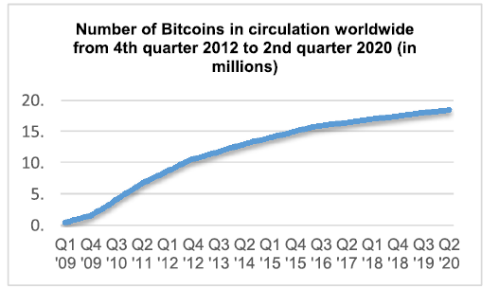
Figure 4: Number of Bitcoins in Circulation Worldwide
(Source: Badea andMungiu-Pupӑzan, 2021)
In the above graph the number of bitcoins from 2012 to 2020. During Covid 19 the Stability of the Big Picture Bitcoin's widespread adoption could affect macro-financial stability, particularly if it becomes a widely accepted means of exchange. Governments and central banks would need to adjust to this new monetary environment. Reserve currency worldwide A few defenders contend that Bitcoin could ultimately challenge the US dollar's status as the world's essential save money. However, this is highly speculative and would necessitate significant adjustments to the regulatory and financial infrastructure of the world. All in all, the ramifications of Bitcoin on the worldwide economy are as yet unfurling, and the drawn-out influence stays dubious.
As per the conveyed by Jain, et al., (2021), that Online payment is growing due to improved digital banking operations and the inclusion of international payment processes using online gateways. This has led to increased global transactions and cashless payments. Electronic money plays a crucial role in managing money value and accessibility. Web-based transactions are more dependent on these, as they are flexible and take only seconds or minutes to send and receive money.
However, complex electronic payment systems can pose challenges for new users. Despite these challenges, online payments have a significant positive influence on global transactions.Bitcoin, a virtual currency, has revolutionized the financial system by standardizing online payment operations and facilitating international transactions. However, its use of blockchain technology raises concerns about data theft. PayPal, a global platform for electronic transactions, has also gained a market position due to increasing demand. However, the lack of knowledge about digital money usage is causing problems in traditional payment processes. Despite its advantages, Bitcoin and PayPal face significant disadvantages, negatively impacting online payment transactions.

2.6: Literature gap
The major gap in the present literature found to be is that the research objectives have only focussed on the limitations and challenges of digital payment transactions. Analysing this point has surely helped in identifying the major threats and complexities that co-exist due to online payment methods. However, indicating the usefulness and advantages of online payment methods in the objective of the research study would have helped to collect more adequate data enhancing the outcomes of the research study. Apart from that, the challenges cover only the digital payment methods for global transactions. However, showing the challenges from the customer's point of view would have helped in collecting more informational content for the data analysis.

2.7: Summary
The entire summary is obtained from the theoretical discussion obtained from the various secondary sources of data. The theoretical implementation such as the “TAM (Technology Acceptance Model)” and “The theory of reasoned action (TRA)” has been aligned with the research topic. The increasing challenges of adopting PayPal and Bitcoin in the global transaction payment methods create strategic risks like the rate of the exchange rate, barriers cross border transactions, and technical faults. It has been obtained that Bitcoin is anonymously used for conducting transactions between account holders across the world. Owing to the lack of control it causes volatility and destabilisation in the monetary aspects.

Chapter 3: Research Methodology

3.1 Introduction
The chapter will highlight the methodological choices made by the research or collecting the data. A mixed method of Data Collection has been considered for collecting the data. In order to use different layers and aspect of research methodology the concept of research onion has been taken into consideration. Each layer of research onion and the chosen elementary have been identified. Justification for each element of research philosophy and approach as well as design has been given to align with the research objective and aim.

3.2 Research Philosophy
Research philosophy is the first layer of research onion that set out the basic belief of conducting a study guiding the execution and design of the research. Different research philosophy offer different way to understand the topic. An examination of research philosophy enables the student to choose the strategy that the researcher will take and how it will assist them in arriving at conclusions that will advance the current research work (Davidavičienė, 2018). Understanding the researcher's perspective on the subject and providing information that aids the study investigator in expanding the current research context are crucial tenets of the research philosophy. Research philosophy is a broadly classified into four types of positivism, realism, interpretivism and pragmatism. The objective collection of data and the use of measurable and quantifiable components in research are encouraged by the positivism research philosophy in order to further scientific knowledge.
The interpretivism research philosophy strongly emphasises the subjective reality embedded inside social contexts in order to create conclusions. Pragmatic decision-making by a single person in a circumstance that occurs in real life is the main emphasis of the pragmatism research philosophy. The premise of the realism research philosophy is that how people perceive reality has nothing to do with reality itself. Each research philosophy has its own significance and importance to collect and analyse the data as per the research objective. In the current study the positivism research philosophy has been considered by the researcher. Positive research philosophy is rooted in the belief that knowledge can be obtained through objective measurement and observation.
According to this philosophy the answer to the Research question in a study can be found by carefullyanalysing and measuring the data particularly the numerical valuation and information. The researcher has not considered interpretivism and pragmatism research philosophy because the otherwise the research would not have been able to explain the prediction to achieve the objective. Considering the positivism research of philosophy the researcher has been able to generate extremely supportive philosophy that evaluated different perspective about the preferences of online payment option by people. Based on the finding the researcher has been able to indicate the impact of the online payment and its opportunity associated with Bitcoin and PayPal on global transaction. The positivism research philosophy as a result has been able to answer the research aligning it with the objective.

3.3 Research Approach
Research approach is the second layer of research onion which is regarded as the procedure selected by the researcher for analysing collecting and interpreting the data. The research approach is correctly viewed as a way that the research scholar is considering aligning the study and executing it flawlessly in order to accomplish organisational achievement (Snyder, 2019). This approach also proves to be exciting for the researcher because it facilitates the evaluation, collection, and interpretation of data that aids in assessing the current research issue and effectively presenting its conclusions. In broad classification research approach is classified into deductive, inductive and abductive approach (Alharahsheh and Pius, 2020). The goal of the deductive research technique is to offer reasonable defences for any causal linkages that may emerge between ideas and variables throughout the course of a study. The inductive research technique is the best choice for qualitative investigations since observations direct the formulation of conclusions based on information obtained throughout the research process.
The major goals of the abductive research technique are the methodical formation of ideas via study and the evaluation of exceptional or uncommon empirical results in connection to diverse pre-existing cultural attitudes. In the current study the researcher has a chosen deductive research approach which is a type of approach where the researcher starts with theory or generalization and then tests it through data collection and observation. Down method of data collection and analysis is a followed by the research started by analysing the general idea about the topic and then tested through specific observation made from the views and opinion of authors and writer as well as the survey participant.
Considering the deductive research approach has helped the researcher in explaining the casual relationship between the concept and variables of the study. This feature of the deductive research approach have been extremely beneficial for the researcher as the researcher has been able to generate understanding about the theoretical assumptions behind the concept of growth of the online payment option in the form of PayPal and Bitcoin. The researcher also has been able to find subsequent opportunity by critically analysing and evaluating the benefits provided by the online payment option while closely attending to the research Arena. The selection of the inductive approach due to this reason was not suitable for the current study as it would not have been effective in up to address the research question.

3.4 Research Design
The ideal strategy for conducting a study, which enables the presentation of the study's findings and contributes to its advancement, is explained by the research design (Davidavičienė, 2018). The researcher can discover difficulties that develop in the research over time with the use of research design. An additional definition of research design is an overarching strategy that the researcher uses to demonstrate a logical approach to addressing and formulating research issues. The three main types of research designs are exploratory, descriptive, and explanatory. In a descriptive research design, a single event or scenario is methodically documented using study variables. An exploratory research design, on the other hand, is employed when there is little to no past study data available to serve as a reference while researching a certain topic. On the other hand, an explanatory study design is useful for analysing a phenomenon's recurring nature when there is initially only a basic understanding of it. A descriptive research design has been used by the researcher in the current study. Research Design is the third layer according to the concept of research onion that helps in identifying and evaluating the steps that can be followed by the researcher to analyse and collect the data.
In this case is choosing the descriptive research design has ensured in depth and systematic evaluation of the research problem and context (Bloomfield and Fisher, 2019). The researcher by reference to the descriptive design has been efficiently able to highlight the potential implication of the online payment option including the extended reference by the people towards Bitcoin and PayPal for making global transactions. The potential challenges and benefit in addition to the autobiography to the options for Bitcoin and PayPal have also been identify the by the researcher by clearly indicating the features of descriptive Research Design. It has been affective enough in answering the Research question and at the same time addressing the objective.

3.5 Sampling Strategy
In order to collect the data from the survey participant s and generated primary quantitative data a simple random sampling has been used by the researcher. In this sampling strategy the researcher randomly selected subset of a participant from a population. The randomly selected subject of participant included consumers using Bitcoin and PayPal for international transaction. Each member of the population where provided with equal chance of getting selected and 50 participants overall were selected. 25 participants used Bitcoin and other 25 used PayPal for making global transaction.

3.6 Data Collection Method
In broad classification the data collection method according to the research onion is classified into primary and secondary method of Data Collection. However when both types of Data Collection method are used it is referred as a mixed way of collecting data (Haven and Van Grootel, 2019). In this study a mixed method of Data Collection has been considered where the primary data collection method has been followed by conducting a survey on 50 users of PayPal and Bitcoin. The survey questionnaire was distributed among the survey participant by using Google form and in-depth perception from the survey participant was collected as the participants were best and about using Bitcoin and PayPal. A meaningful elaboration and critical analysis of the research topic was the done based on the perception of the participant. The sample size of the study was 50 participant among which 25 users of PayPal and Bitcoin where considered. The findings of the survey were a supported with the help of factual evidence and real data. The online Google form was created and it was the sent to them along with the participant information sheet and consent form.
In addition to that a secondary method of Data Collection was also used by the researcher as it is cost and time optimised way of collecting the data. The researcher due to this concern evaluated different publicly available sources of data (Ruggiano and Perry, 2019). The source of data included updated and valuable news article and website and authentic sources for data collection was used to such as the Guardian and the BBC or the information provided by Forbes. Other news articles and website that covered relevant information where also taken into consideration to understand the opportunity of online payment system at international level. Different Academy and the database included information from books and journal articles available at progressed and Google Scholar as well as Research Gate. Information shared by online University for enhancing the quality of the data General Body and generic information like the details about the author or number of citation among others.

3.7 Data Analysis Technique
Analysis of data helps in developing sound knowledge regarding the research topic as well as improves the understanding regarding the current scenario with respect to the variables. In this context, the concerned research has been analysed following the quantitative method of analysis that aligns with the data collection process as well. The researcher has integrated descriptive and inferential analysis method of the survey responses that further aligns with the deductive approach. Qualitative analysis method has not been considered as it does not support the researcher to verify the responses provided by the participants. However, with the quantitative analysis, both verification and a consistent result or interpretation of the data has been developed which contributed to the improved quality of the study.

3.8 Ethical Consideration
In order to make the data collection method ethically sound and effective following ethics have been considered by the researcher:
- None of the survey participant have been fourth either mentally or physically to participate in the study
- Information and consent form was a distributed among the participant before their participation
- Recently published data and journal articles or books having DOI number and ISBN have been considered for ensuring reliability and validity
- Appropriate credibility to the authors and writers through in text citation and references have been provided

3.9 Summary
The current research has been conducted under the light of positivism philosophy and the prime implication of the philosophy can be identified in the current study to be more reliable and flexible method empowering the outcome of the research by covering wide range of situation within comparatively a short period of time. A deductive research approach and a descriptive research design were both used by the researcher. The researcher additionally focused on data gathering and analysis to complete the study and provide findings that advanced the research topic. Furthermore, the analysis of the methodologies aided in their examination and improved the growth of the study.

Chapter 4: Results and discussions

4.1 Introduction
Quantitative analysis has been carried out with the development of this chapter which has assisted the researcher in validating the responses gathered. The analysis has further contributed in developing justified understanding and knowledge regarding the online payment methods of PayPal and Bitcoin in the current business environment. In this section, descriptive analysis of the survey questions has been conducted reflecting the development of graphs according to the responses of the customers with the help of Ms Excel. On the other hand, the section has included analysis of the responses through the execution of the statistical tests such as “correlation and regression”. However, the chapter includes discussion where similarities and differences between the primary survey findings of the study and the secondary literature review findings have been incorporated.

4.2 Quantitative analysis

4.2.1 Descriptive analysis
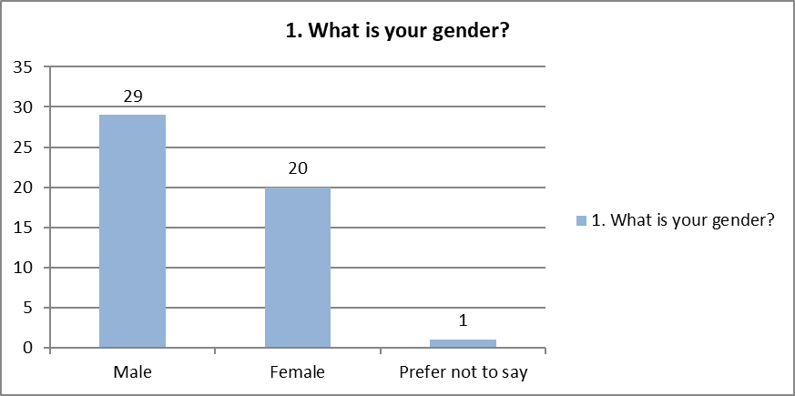
Figure 5: Survey Question 1
(Source: self-created)
The demographic question asked at the beginning pertains to seek regarding the gender revelation of the respondents involved in the survey. There were a total of 29 males and 20 females engaged in the survey program. Including 1 member who wanted to maintain the anonymity of their gender.
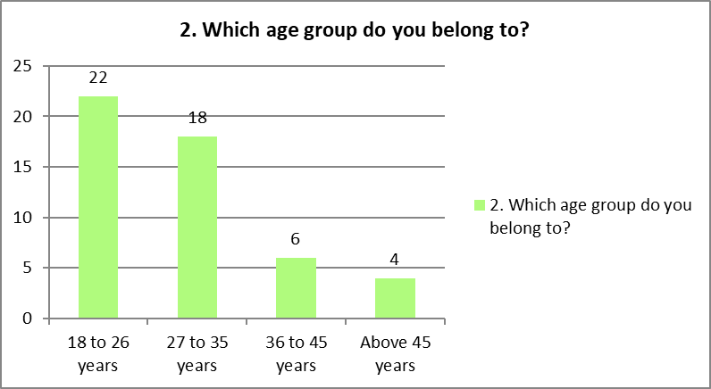
Figure 6: Survey Question 2
(Source: self-created)
The age group of the participants has been evaluated based on various age bars that will help in evaluating the age group of the population of the respondents involved in the survey. It has been determined that out of the 50 respondents, the maximum people were from the age group of 18 to 26 years who are regarded as the prominent users of online modes of payment for making transactions. There were 22 people belonged to this concerned group. Apart from that, there were 18 respondents that belonged from the age category of 27 to 35 years. This has been the second-highest count of the total respondents. In addition to that, there are 6 people who fell under the age group between 36 to 45 years. Only 4 respondents out of the 50 were evaluated to be above the age of 45 years and also the lowest users of online transactions due to the presence of technological accessibility.
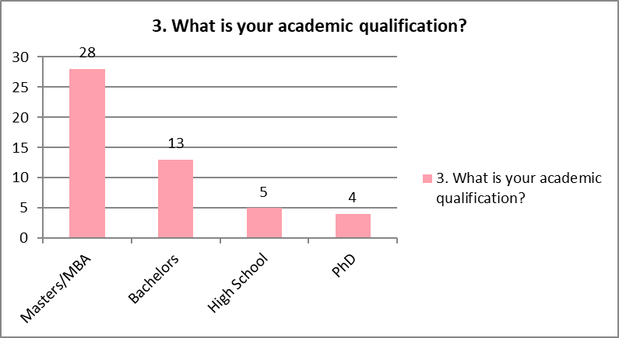
Figure 7: Survey Question 3
(Source: self-created)
The third question aimed to reveal the educational upfront of the individuals participating in the survey. It has been entailed using the four divisions of the academic levels such as high school, masters, Ph.D., and Bachelor's. The level of education helps to encapsulate how much respondents are able to adapt to the changing parameters of payment and transaction modes and understand its benefits. Thus, it has been evaluated that the maximum number of respondents who have pursued their master's degree is 28. On the other hand, it has been identified that 13 respondents have completed their graduation followed by 4 respondents completing their high school education and 4 Ph.D. holders. Taking into account the above graph, it can be considered that 5 of the 50 respondents had completed high school. Therefore, the maximum population is proficient and educated to acknowledge the benefits and disadvantages of online payment transactions.
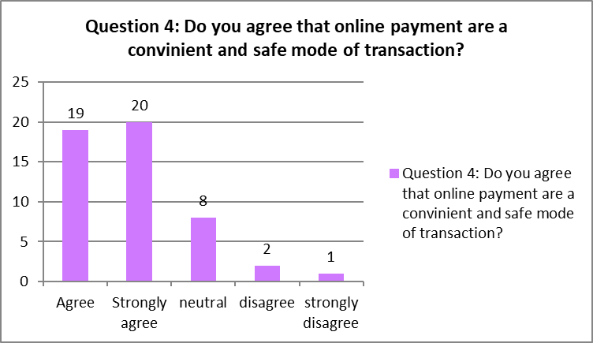
Figure 8: Survey Question 4
(Source: self-created)
The survey question has gathered the viewpoints from the users on whether they have gained accessibility of convenience and safer payment options while engaging in digital transactions. The options have been presented in Likert scale format used to obtain the answers from the respondents. There have been maximum positive responses from participants engaged in the survey agreeing to the fact that the establishment of online transactions has offered them a safer and more convenient mode of payment. There were 20 respondents strongly agreeing with the fact against 2 respondents who disagreed that online payment does not offer them a convenient and safer mode of transaction. In addition to that, 19 respondents agreed that they feel that online payments are a safe and convenient mode of transaction. While in the other hand, 1 of the respondents among the 50 strongly disagreed to the questions as they do not feel online payment is safe. Whereas there are 8 respondents that have a neutral perception towards the question denoting that online transactions have their own benefits and demerits.

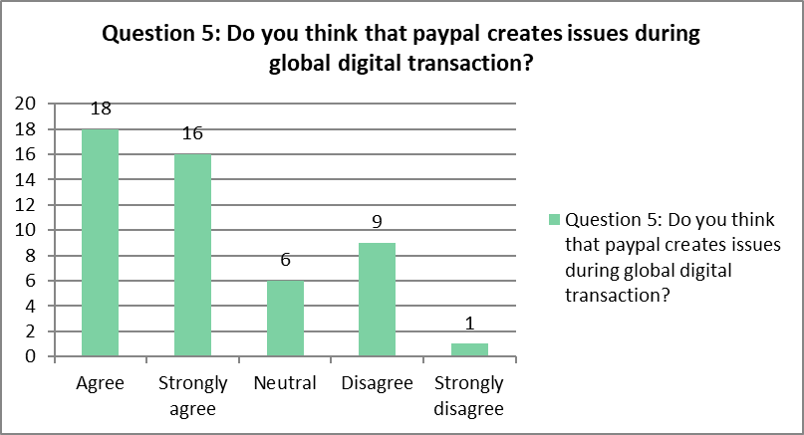
Figure 9: Survey Question 5
(Source: self-created)
The fifty respondents seek to gain an in-depth assessment of whether using PayPal creates issues during the time of global digital transactions. They have been asked whether if they felt issues while using PayPal for global digital transaction. It has been evaluated that 18 respondents have agreed to the option that it creates problems during the global online transaction. However, there were 9 respondents who stated the fact that there are no issues with PayPal for engaging in online transactions globally. There were 16 respondents who strongly agreed with the fact that they face problems while making transactions with PayPal. While in the other hand, 6 persons remain neutral whereas, one of the respondents strongly disagreed that PayPal creates any issues during the global digital transaction.
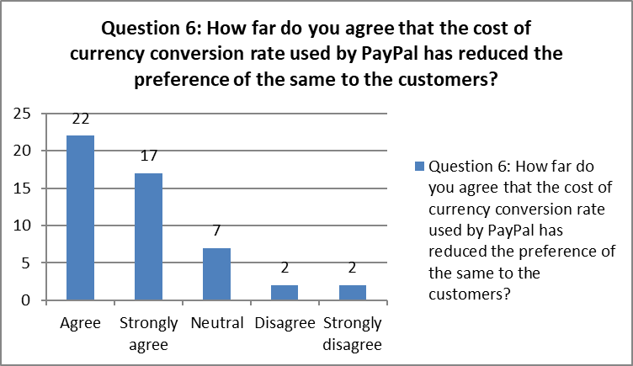
Figure 10: Survey Question 6
(Source: self-created)
The sixth question encapsulates whether the cost of the currency conversation rate applied by PayPal has decreased the preference of the customers. This has been 22 individuals have accepted the fact that PayPal has a higher rate of conversion rate that might not be feasible for the market rates. As a result, users are exposed to additional payment in case they frequently transact internationally. Apart from that, 17 respondents strongly responded to the fact that the additional charges have reduced the preference of the customers to frequently adopt PayPal as their international transaction. Two of the 50 respondents disagreed to the question along with those 2 respondents strongly disagreed to the question. On the other hand, 7 respondents remained neutral to the questions and did not put any views regarding the question.
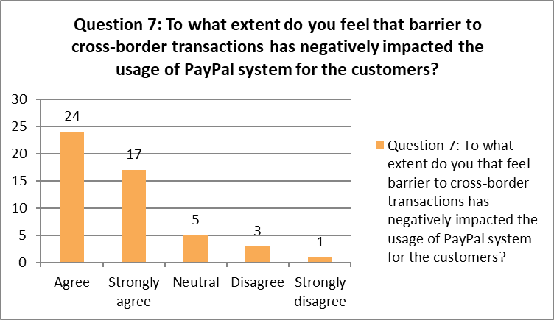
Figure 11: Survey Question 7
(Source: self-created)
The question has acquired information from its users about the barrier to across-border transactions that has massively affected the usage level of the PayPal system for their customers. There have been maximum responses that are 24 out of 50 from the participants on behalf of the factor that constraints and barriers for international transactions have reduced their utilisation and user interface. On the other side, 17 of the respondents said that they strongly agreed that they feel barrier to international trade that has significantly reduced the number of customers that use the PayPal system. Whereas one of the respondents strongly disagreed to the question and 5 of them did not put any view in this concerned question. Furthermore, 3 respondents disagreed with the fact that the constraint in the cross-border transaction has not affected the users of PayPal. Thus, it has been evaluated that the constraint in international transactions has negatively affected the usage of the PayPal system for their individual customers.
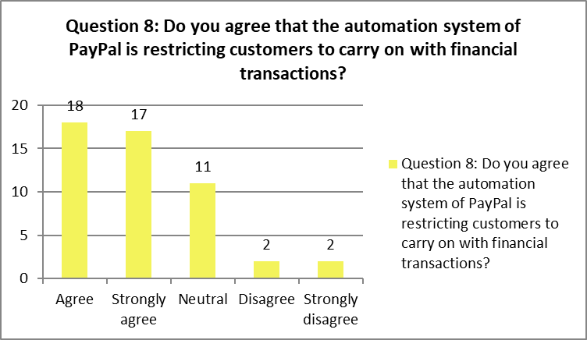
Figure 12: Survey Question 8
(Source: self-created)
The question seeks to acquire perceptions of respondents on whether the automation system in PayPal has created restrictions for the users to proceed with their financial transactions or not. There were a maximum number of responses collected on behalf of that yes the automation system puts a restriction on customers to carry out their financial transactions. Apart from that, there were 17 respondents who strongly agreed that the presence of the automation system under the system of PayPal is putting restrictions on customers to engage in financial procedures. Whereas 2 of the respondents disagreed to the to the question and other two respondents strongly disagreed to the question. Along with this, 11 respondents remained neutral to the fact that PayPal's automated system has put limitations on how consumers may move forward with their financial transactions.

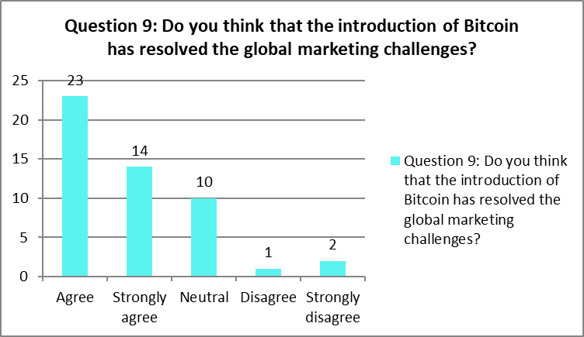
Figure 13: Survey Question 9
(Source: self-created)
The ninth question seeks to attain the perception of individuals whether the introduction of Bitcoin has helped in tackling the global market challenges or not. While collecting responses it has been developed that the maximum number of people has favoured the factor that the establishment of Bitcoin has helped in solving the global marketing issues. There are 23 respondents has have agreed followed by 14 who strongly agree. In addition to that, 10 participants had a neutral reaction to the factor. One of respondents disagreed to the question whereas two participants strongly agreed to this concerned question.
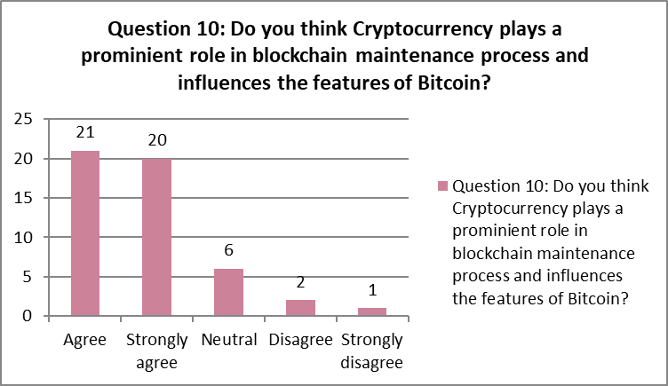
Figure 14: Survey Question 10
(Source: self-created)
While, attaining the knowledge of crypto currency has a prominent role in maintaining the blockchain process and influences the features of Bitcoin or not. There have been 21 respondents that have agreed to the question followed by 20 respondents that strongly agree to the question. Along with this, there are only 2 respondents who disagreed with the factor. 6 of the respondents think that cryptocurrencies play a prominent role in blockchain maintenance process and influences the features of Bitcoin.

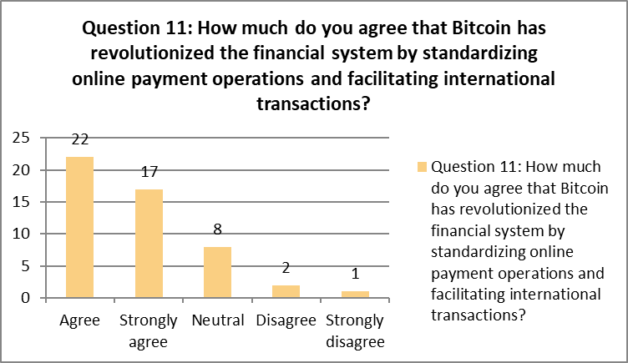
Figure 15: Survey Question 11
(Source: self-created)
The question pertains to seek whether the presence of Bitcoin has revolutionalised the financial system with standardisation in online payment operations. Therefore, it has been agreed by 22 participants that the establishment of Bitcoin has created revolutionalisation in the financial transaction fostering online payment operations and international transaction facilitation. Followed by this there were 17 respondents that strongly agreed contrarily to 1 respondent that strongly disagreed. 8 of the respondents remained neutral to this question while 2 respondents disagreed to the fact that with the standardised use of online payments brought about by Bitcoin, the financial system has undergone a change.

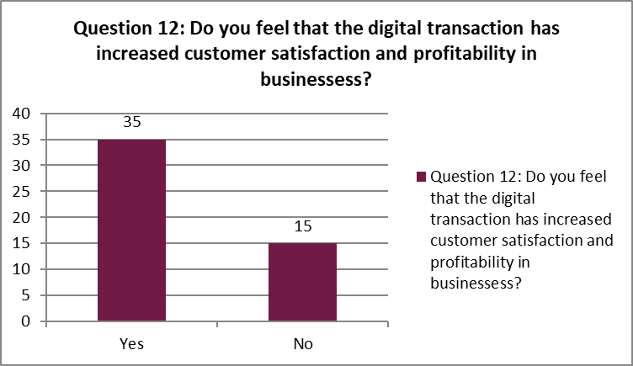
Figure 16: Survey Question 12
(Source: self-created)
The question has helped in acknowledging whether the technological adaption in the payment methods has created profitability and customer satisfaction for the businesses or not. There have been 35 respondents that have reacted to the factor that the evolution of digital mode and easy accessibility of payment options creates repeat purchases and induces profitability while providing higher customer satisfaction. While rest of the respondents disagreed to the concerned question.

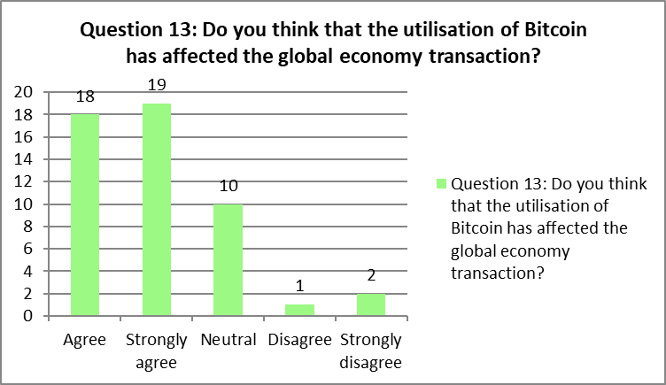
Figure 17: Survey Question 13
(Source: self-created)
The survey question seeks to attain the knowledge of whether the utilisation of Bitcoin has affected the global economy transactions or not. Thus, it has been strongly agreed by 19 respondents that bitcoin has created changes in digital economic transactions globally. Followed by 18 respondents who agreed contrary to 2 respondents who strongly disagreed with the factor. 10 of them remained neutral to the fact that utilisation of Bitcoin has affected the global economy transactions, while one respondent disagreed this fact.
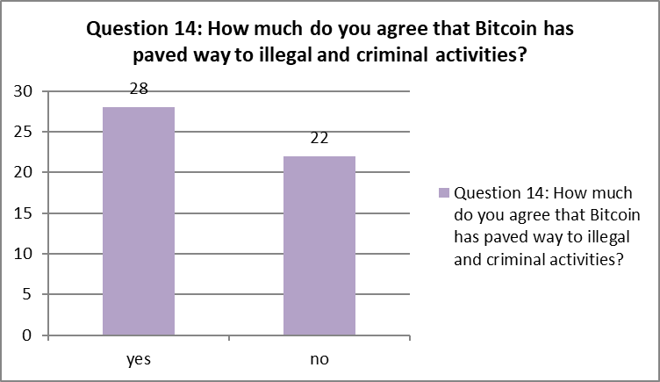
Figure 18: Survey question 14
(Source: self-created)
The question seeks to determine whether the presence of Bitcoin has paved way to illegal activities or not. Thus, it has been evaluated that 28 respondents have stated yes to the option against 22 respondents who feel that the introduction of Bitcoin has not paved the way to illegal activities.
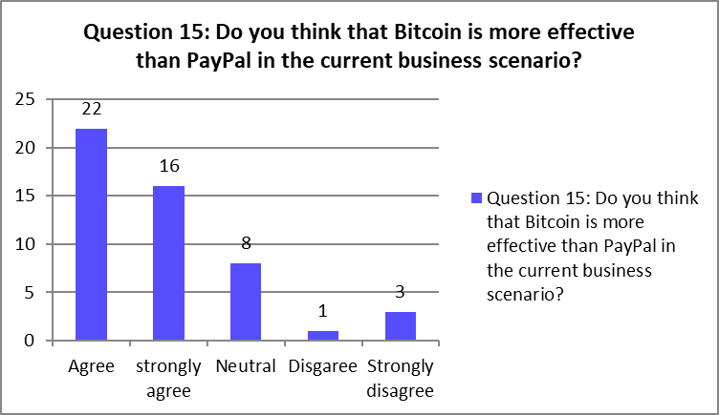
Figure 19: Survey Question 15
(Source: self-created)
The last survey question pertains seek the effectiveness of Bitcoin over PayPal in the recent business scenario and digital transactions across the world. Thus, while asking respondents there were more participants that have agreed to the factor that Bitcoin is beneficial over PayPal that is 22 respondents. However, there were 8 respondents who had a neutral opinion towards the factor that Bitcoin is advantageous over Paypal. On the other hand, 3 of the respondents strongly disagreed to the question and one respondent disagreed this opinion too.

4.2.2 Inferential analysis
Correlation
Correlation is the statistical test which contributes in verifying the relationship between two categories of variables known as “Dependent and independent variables”. It is the test that has established understanding regarding the current scenario regarding the digital payment options such as Bitcoin and PayPal reflecting transactions that are conducted internationally. The test has further reflected whether the variables covary with each other linearly or not thereupon analysing the depth of bond between the same. In this concerned research, two sets of correlation tests have been carried out where one the issues regarding the usage of PayPal has been analysed connecting it with the specific issues and the other one regarding the benefits of Bitcoin usage in the global market thereby aligning the particular benefits.
First correlation test
“Correlations
 |  | Issues with PayPal | Cost Of Currency Conversion Rate | Barriers To Cross Border Transactions | Automation system of PayPal
Issues with PayPal | Pearson Correlation | 1 | .900* | .931* | .831
Issues with PayPal | Sig. (2-tailed) |  | .038 | .022 | .081
Issues with PayPal | N | 5 | 5 | 5 | 5
Cost Of Currency Conversion Rate | Pearson Correlation | .900* | 1 | .991** | .955*
Cost Of Currency Conversion Rate | Sig. (2-tailed) | .038 |  | .001 | .011
Cost Of Currency Conversion Rate | N | 5 | 5 | 5 | 5
Barriers To Cross Border Transactions | Pearson Correlation | .931* | .991** | 1 | .913*
Barriers To Cross Border Transactions | Sig. (2-tailed) | .022 | .001 |  | .030
Barriers To Cross Border Transactions | N | 5 | 5 | 5 | 5
AutomationsystemofPayPal | Pearson Correlation | .831 | .955* | .913* | 1
AutomationsystemofPayPal | Sig. (2-tailed) | .081 | .011 | .030
AutomationsystemofPayPal | N | 5 | 5 | 5 | 5
*. Correlation is significant at the 0.05 level (2-tailed).
**. Correlation is significant at the 0.01 level (2-tailed).”
“Table 1: First correlation results”
(Source: Self-created)
The research has included a “pearson’s bivariate correlation test” that has helped in developing knowledge regarding the relationship shared between the variables. In this case, concerning the first correlation, opportunities or issues regarding the PayPal digital payment has been analysed following the data as per the survey responses. The “dependent variable” chosen for the test has been “issues with PayPal” which has been further linked with the ‘independent variables” such as “automation system of PayPal, cost of conversion rate of currency, and cross-border transaction restrictions or barrier”. With reference to the first table, the magnitude of the relationship between these variables has been analysed. The consideration of the “significance value” of each variable has been considered to prove whether the variables share a linear bond between them or not. On a specific note, the “sig (2-tailed)” value has been considered which has reflected on the “statistical significance” of the variables as well as the relationship.
As emerged from the results of correlation, the “significance value (p)” has been found to be .038, .022 and .081 for the “independent variables” such as “cost of currency conversion rate, barriers to cross-border transactions and automation system of PayPal” respectively. In this situation, it emerges that the p values of the variables have been lower than the benchmark score of 5% or .0005. This showcases that the “independent variables” are “significant statistically” and reflects a positive correlation with the “dependent variable”. In addition, it also implies an understanding that the strength of the relationship between the categories of variables has been strong as the p values have been potentially lower than 5%. Thus, it can be mentioned that there have been issues concerning the PayPal payment method with respect to international transactions.
Second correlation test
“Correlations
 |  | Effectiveness of Bitcoin compared to PayPal | Impact On Global Economy | Resolved Global Marketing Challenges | Revolutions Financial System
Effectiveness of Bitcoin compared to PayPal | Pearson Correlation | 1 | .951* | .985** | .992**
Effectiveness of Bitcoin compared to PayPal | Sig. (2-tailed) |  | .013 | .002 | .001
Effectiveness of Bitcoin compared to PayPal | N | 5 | 5 | 5 | 5
Impact On Global Economy | Pearson Correlation | .951* | 1 | .921* | .962**
Impact On Global Economy | Sig. (2-tailed) | .013 |  | .026 | .009
Impact On Global Economy | N | 5 | 5 | 5 | 5
Resolved Global Marketing Challenges | Pearson Correlation | .985** | .921* | 1 | .976**
Resolved Global Marketing Challenges | Sig. (2-tailed) | .002 | .026 |  | .004
Resolved Global Marketing Challenges | N | 5 | 5 | 5 | 5
Revolutions Financial System | Pearson Correlation | .992** | .962** | .976** | 1
Revolutions Financial System | Sig. (2-tailed) | .001 | .009 | .004
Revolutions Financial System | N | 5 | 5 | 5 | 5
*. Correlation is significant at the 0.05 level (2-tailed).
**. Correlation is significant at the 0.01 level (2-tailed).”
“Table 2: Second correlation outcome”
(Source: Self-created)
As per the second correlation, the “dependent variable” has been chosen as the “effectiveness of Bitcoin compared to Paypal” and the linked “independent variables” are “revolution in financial system, resolved global marketing challenges and impact on global economy”. In this regard, the p values of the variables have been found to be .013, .002 and .001 reflecting variables such as “impact on global economy, resolved global marketing challenges and revolutionised financial system” respectively. Furthermore, this implies an understanding that there has been a positive bond between the variables reflecting correlation. Moreover, the variables have been “statistically significant” depicting significant influence of the variables on the “dependent one”. However, the results of the correlation hereby indicates that Bitcoin has been more effective than PayPal has it has been capable in improving the overall transaction system around the globe thereupon improvising the Fintech services and the overall financial system.
Regression
The regression model is referred to as another potential statistical test that has been developed in this chapter to evaluate which of the “independent variables” related to Bitcoin has actually made it more effective compared to PayPal. The model has actually evaluated the depth of relation between the selected variables of the study thereby analysing the variation of the “independent variables”. Also, the regression test has helped in understanding the change in the “dependent variable” due to the changes in the “independent variable”. Concerning the regression test, for the current research, two variables have been chosen which has helped in identifying the relationship and influence of the same on the “dependent one”.
“Model Summary
Model | R | R Square | Adjusted R Square | Std. Error of the Estimate
1 | .995ª | .989 | .979 | 1.29060
a. Predictors: (Constant), Revolutions Financial System, Resolved Global Marketing Challenges”
“Table 3: Regression model result”
(Source: Self-created)
With respect to the regression test model, the overview result has been analysed with the depiction of the above matrix. In this case, it is of utmost importance to mention that following the linear relation between the variable’s group through the conduction of the correlation, a “linear multiple regression model” has been developed. As reflected above, the “prediction result of the dependent variable” of the research has been showcased along with the variability of the “independent variables”. In this regard, referring to the value of the “multiple coefficient of regression model” which is denoted by R, it has been found that the value has been .995. In other words, this reflects that the quality of prediction of the “dependent variable” has been 99.5% which indicates a sound prediction. On the other hand, with respect to the “R square column”, the value has reflected the variability of the “independent variables” with reference to the “dependent one”. The value depicted has been .989 or 98.9%.This means that the “independent variables” explains the “dependent variable” with a sound prediction variation of 98.9%.
“ANOVAª
Model |  | Sum of Squares | df | Mean Square | F | Sig.
1 | Regression | 310.669 | 2 | 155.334 | 93.257 | .011^{b}
1 | Residual | 3.331 | 2 | 1.666
1 | Total | 314.000 | 4
a. Dependent Variable: Effectiveness of Bitcoin compared to PayPal
b. Predictors: (Constant), Revolutions Financial System, Resolved Global Marketing Challenges”
“Table 4: Anova”
(Source: Self-created)
In this regression model, the Anova model has been included which has assisted in understanding whether the model has been perfect in evaluating the bond between the variables or not. Also, it has helped in understanding if the test has been appropriate for the selected dataset. In this regard, consideration of the F ratio equation has been done which is showcased as “F (2, 2) = 93.257, p < .0005”, which indicates that the regression model has been fit for the concerned study. The p value depicted has been found to be .011 which is also less than 5%. This further implies that the regression model has been effective in developing understanding if the Bitcoin payment system is actually more effective than PayPal or not.
“Coefficients
Model |  | Unstandardized Coefficients |  | Standardised Coefficients | t | Sig. | 95.0% Confidence Interval for B
 |  | B | Std. Error | Beta | t | Sig. | Lower Bound | Upper Bound
1 | (Constant) | .356 | .916 |  | .389 | .735 | -3.583 | 4.296
1 | Resolved Global Marketing Challenges | .344 | .329 | .352 | 1.046 | .405 | -1.070 | 1.758
1 | Revolutions Financial System | .621 | .323 | .648 | 1.923 | .194 | -.768 | 2.009
a. Dependent Variable: EffectivenessofBitcoincomparedtoPayPal”
“Table 5: Regression coefficient result”
(Source: Self-created)
Lastly, in the regression model, the analysis of the coefficient has been carried out which has actually helped in determining the variable that has mostly predicted the “dependent variable”. It has helped in understanding the rate of change in the “dependent variable” due to a rate of change in the “independent one". In this case, it can be said that the analysis of the prediction has been done considering the “beta values of the unstandardised coefficient” thereby evaluating the same with respect to the value of 0. Furthermore, it has been considered that out of the two variables, one variable has been constant when the other is changing. Additionally, it has been linked with the p values of each variable.
As depicted in the table, the “beta value” of the first variable which is “resolved global marketing challenges” has been found to be .344. This indicates that the value has been greater than 0 which reflects that there has been a positive change in the “dependent variable” due to a change in the independent one. Aligned with the p value, it has been found that the value has been less than 5% depicting .405 which further proves the positive influence. On the other hand, the “beta value” of the variable “revolutionised financial system” has been found to be .621 with a p value of .194. In this case, the value of the beta has been higher than 0 which reflects higher influence. This is the reason why the p value has been less than the first variable. Thus, according to the result, it can be thus stated that Bitcoin has been more effective as it changed the financial system compared to PayPal.

4.3 Discussion
The overall analysis of the survey has helped contribute to the vital data collection for online digital payment and its influence in the present business scenario. The maximum number of respondents in the survey were highly educated and had better eligibility to use online payment transactions. The responses collected from the participants have stated that the accessibility of PayPal is restricted in many countries owing to the hidden costs in the transactions and payments. Apart from that, the complexities of using PayPal for their financial transactions could be a significant issue for individuals.
On the other hand, the establishment of Bitcoin offers protection from fraudulent activities during digital transaction methods. It has been agreed by many participants that the initiation of Bitcoin has created revolutionisation in digital payment systems. It has facilitated online payment options and fostered international transactions (Ferdous et al., 2021). However, the chances of illegal activities in financial transactions have even emerged to be higher with the integration of the digital payment system which has majorly affected the financial system. The fact has been supported by the majority of the population participating in the survey. Furthermore, it has been identified that Bitcoin is a more effective and advanced payment option influenced by Cryptocurrency than PayPal (Akyildirimet al., 2020). Inherently, the higher usage of digital payment allows the customer to gain accessibility to convenient payment facilities and induces their repeat purchase and transaction. As a result, the profitability measures of businesses are highly influenced in a positive way.
Upon further analysis, it can be stated that customers have been facing significant issues reflecting the issues of increased cost or rate of currency conversion. It has also been found that the automation system has made it difficult for the customers to control the payment system which has further increased the challenges. On the other hand, the findings based on the statistical tests reflect an understanding that the effectiveness of the Bitcoin system of digital payment has been more than PayPal as it has helped the customers in making international transactions easily. Aligning with the opinion of Jain, et al., (2021), it can be stated that it has facilitated customers in increasing the number of digital payment systems thereby improving the overall fintech services. In addition to this, with the inclusion of the cryptocurrency, it has supported an innovative payment system which has improved customer satisfaction. However, it can be stated that it has been due to the positive changes in the global marketing processes that Bitcoin has been considered as more effective than PayPal.

4.4 Summary
The present chapter has included analysis of the primary data collected from 50 participants through a survey format. The descriptive evaluation with respect to graphs have reflected the positive responses of the customers with respect to Bitcoin whereas negative responses concerning PayPal. However, the statistical tests conducted have further reflected that the resolution to the global marketing challenges have been met by Bitcoin which has increased its usage in the current business market.

Chapter 5: Conclusion and Recommendations

5.1 Introduction
The present chapter of the study mainly deals with addressing the research objectives to meet the conclusion. The chapter highlighted the key facts and data to describe an opportunity for online payments by using platforms such as PayPal, and Bitcoin. In the regards with, the study identifies the main aim of the chapter to identify findings based on linking each objective of research. The overall research data and pieces of information have been collected through mixed methods. Hence, the survey has been made on 50 users of PayPal and Bitcoin by using the Google form. Similarly, the descriptive design has been considered to highlight the potential impacts of the study and fulfilment of research objectives. It has been summarized that the overall chapter highlighted the conclusion of using digital transactions such as Bitcoin, and PayPal. Hence, payment technology has enhanced smooth functional activity to bring the overall types of development of e-payments. This technology adoption helps business-to-country economic stability. It has been found through the linkage of objectives, the issue of using PayPal as a global transaction such as cost of currencies, and exchange rate risk. Similarly, there are various reasons highlighting the use of Bitcoin around the globe. Based on implication, Bitcoin enhances smart tourism facilities in the areas of travel agencies, and airlines.

5.2 Linking with Objectives
5.2.1 Highlighted the issue and implication of using PayPal as a global digital transaction
Considering digital transactions, using PayPal has several advantages but also identifies certain issues and implications that have been illustrated through findings. Due to limited accessibility, PayPal is not available anywhere, as it is widely accepted in many countries. Thus, the limited accessibility for an individual and business region where PayPal is not supported due to regulatory restriction also hinder PayPal's full functionality. The overall information based on the study has been gathered through surveys and responses from 50 users or participants to highlight the implications of using digital transactions. PayPal is involved in the cost of currency issues, as it charges fees for certain types of transactions such as currency conversion as well as cross-border payments. Similarly, digital transactions also involve the risk of the exchange rate, impacted by changes in the exchange rate for businesses to deal in multiple currencies and profit margins. Thus, fees can be relatively high, particularly for international transactions which can be a significant concern for companies with a global customer base. Through highlighting the issue, PayPal has been criticized for freezing users' accounts or holding funds without clear reasons, as it has been highly disruptive for the business.
Considering the implications, PayPal helps the business expand into international markets by providing familiar as well as trusted payment to increase sales and revenue. It provides convenience for consumers based on making payments and online purchases of products without sharing sensitive information. Additionally, using PayPal reduces cash dependency in regions with limited banking infrastructure, as it can be a security risk and hinder economic development. Furthermore, PayPal offers many benefits for global digital transactions, its essential users are aware of the implications associated with its use. Similarly, businesses also need to carefully consider the fees to provide accessibility in the target markets of the consumer.
5.2.2 identify the reason why using Bitcoin is still illegal in several countries around the globe
The significance of Bitcoin and other cryptocurrencies varies from one country to another. Considerably, several nations have imposed transactions or bans on using Bitcoin for various reasons. The present objectives have been illustrated by gaining information and facts by using a survey of 50 users and respondents to identify reasons for using Bitcoin and other cryptocurrencies. However, Bitcoin is a risky and speculative asset that could potentially harm citizens financially. Market volatility is also a main reason for the illegal use of Bitcoin, as traditional financial systems have led some governments to review the threats to nations' currencies. It has been identified that, after COVID-19 the overall trade has been breaking through online mode. However, the market is opened 24*7, and as a result of such non-regulated market activities, Bitcoin attracts many criminal activities such as money laundering, fraud, and facilitating a transaction.
Furthermore, governments such malicious activities in many countries like India and more, as it is because of lack of consumer protections for the cryptocurrency users. In addition to central banks, many countries are hesitant to embrace Bitcoin because it could undermine their ability to control or protect monetary policies. Similarly, some countries lack the necessary technology infrastructure and expertise to regulate or monitor cryptocurrencies effectively. This would generate a huge impact, as international organizations such as the Financial Action Task Force (FATF) have mainly recommended that countries implement strict regulations and policies based on combating money laundering and terrorist finances. Therefore, the government needs to maintain a huge focus on national security by protecting similar data regarding online transactions. It has been justified throughout liking objectives, cryptocurrencies mature, and the benefits of risk and uncertainties become higher. This is because some countries restricted the use of Bitcoin while others still adopted permissive regulations to integrate cryptocurrencies into financial systems. The overall facts and data sources have been relevant enough to meet or fulfill research objectives.
5.2.3 Determine the various implications of Bitcoin on the global economy
Considering the implications, Bitcoin is a decentralized currency that has evolved with various implications globally. Thus, the implications have been identified based on both positive and negative. However, through the implication of the theory “Technology Acceptance Model (TAM)” it has been observed that utilizing technology provides a positive effect on digital transactions. The theory or model helps in evaluating the intentions of consumers in deciding their technology perceptions to influence customer perception. The initiation of the digital transaction from a banking institution mainly identifies fees by technology. Considering the positive impacts, Bitcoin generates huge benefits for the economy, especially in terms of international tourism, as it allows the beneficiaries to make payments in any country while purchasing products. It provides a huge transition in smart tourism, using smart contracts for travel agents, airlines, and travel agencies has been able to carry real-time transactions.
Considering the negative implication, Bitcoin price is highly volatile making risky investments less stable store to traditional assets such as fiat currencies. However, the lack of consistent global regulatory standards for cryptocurrencies mainly creates uncertainty for businesses and investors. As a result, the regulatory bodies create huge changes or bans in different countries to impact the adoption of Bitcoin. Similarly, hacks and security have resulted in the loss of large amounts of Bitcoin, eroding trust in the technology. The increasing popularity of Bitcoin and other cryptocurrencies has led to huge currency to disrupt the traditional financial system. Additionally, the lack of consumer protections in the cryptocurrency space can leave investors vulnerable to fraud, scams, and disputes with little recourse. It has been identified through surveys and responses, that regulatory developments and technology advancement are adopted to integrate into the broader financial system. Therefore, the overall data and information gathered by quantitative analysis are relevant enough to meet research objectives.

5.3 Future scope
The study has created a mitigation technique for dealing with digital currencies while using PayPal and Bitcoin. However, the outcomes of the study mainly depend on the responses of various users or surveys based on security or cryptocurrency exchange and wallets are a significant concern. Thus, hacks and security breaches have resulted in the loss of large amounts of Bitcoin, eroding trust within technology. Based on technique, the research might need more responses or involvement of business managers based on future research. This might help the research to identify better ways to reduce the risk on exchange rates.

5.4 Recommendations
Digital currencies such as Bitcoin, and the PayPal platform involve addressing various technical, regulatory, and usability challenges. However, various strategies have been identified to enhance digital currencies.
- Implementing scaling solutions such as a lightning network to increase transactions throughout and reduce fees. This would make Bitcoin more efficient for everyday transactions.
- The federal government needs to enhance privacy features to protect users from identifying transactional details to maintain compliance with regulatory requirements. This has been done through using friendly wallets to improve security features. It makes it easier for non-technical users to manage their Bitcoins.
- The researcher might use secondary research methods to obtain more accurate results based on compliance and raise awareness about Bitcoin benefits, risks, and responsible usage.

References
Agur, I., Peria, S.M. and Rochon, C., (2020). Digital financial services and the pandemic: Opportunities and risks for emerging and developing economies. International Monetary Fund Special Series on COVID-19, Transactions, 1, pp.2-1.
Akyildirim, E., Corbet, S., Katsiampa, P., Kellard, N. and Sensoy, A., (2020). The development of bitcoin futures: Exploring the interactions between cryptocurrency derivatives. Finance Research Letters, 34, p.101234.
Alam, M.M., Awawdeh, A.E. and Muhamad, A.I.B., (2021). Using e-wallet for business process development: challenges and prospects in Malaysia.Business Process Management Journal, 27(4), pp.1142-1162.
Alharahsheh, H.H. and Pius, A., (2020). A review of key paradigms: Positivism VS interpretivism. Global Academic Journal of Humanities and Social Sciences, 2(3), pp.39-43.
Badea, L. and Mungiu-Pupӑzan, M.C., (2021).The economic and environmental impact of bitcoin. IEEE access, 9, pp.48091-48104.
Bahamazava, K. and Nanda, R., (2022). The shift of DarkNet illegal drug trade preferences in cryptocurrency: The question of traceability and deterrence. Forensic Science International: Digital Investigation, 40, p.301377.
Bloomfield, J. and Fisher, M.J., (2019). Quantitative research design.Journal of the Australasian Rehabilitation Nurses Association, 22(2), pp.27-30.
Cha, H., Kotabe, M. and Wu, J., (2023). Reshaping Internationalization Strategy and Control for Global E-Commerce and Digital Transactions: A Hayekian Perspective. Management International Review, 63(1), pp.161-192.
Chen, Y.J., Dai, T., Korpeoglu, C.G., Körpeoğlu, E., Sahin, O., Tang, C.S. and Xiao, S., (2020). Om forum—innovative online platforms: Research opportunities. Manufacturing & Service Operations Management, 22(3), pp.430-445.
Dai, M., Qamruzzaman, M. and HamadelneelAdow, A., (2022). An assessment of the impact of natural resource price and global economic policy uncertainty on financial asset performance: Evidence from bitcoin. Frontiers in Environmental Science, 10, p.897496.
Dannenberg, P., Fuchs, M., Riedler, T. and Wiedemann, C., (2020).Digital transition by COVID‐19 pandemic? The German food online retail.Tijdschriftvooreconomische en socialegeografie, 111(3), pp.543-560.
Davidavičienė, V., 2018. Research methodology: An introduction. Modernizing the Academic Teaching and Research Environment: Methodologies and Cases in Business Research, pp.1-23.
Dutta, P., Choi, T.M., Somani, S. and Butala, R., (2020). Blockchain technology in supply chain operations: Applications, challenges and research opportunities. Transportation research part e: Logistics and transportation review, 142, p.102067.
Fabus, J., Garbarova, M., Kremenova, I. and Vartiak, L., (2023), April.Analysis of the Possibilities of Implementing Bitcoin and Other Cryptocurrency Payments at the University.In Digital Marketing & eCommerce Conference (pp. 91-96). Cham: Springer Nature Switzerland.
Ferdous, M.S., Chowdhury, M.J.M. and Hoque, M.A., (2021). A survey of consensus algorithms in public blockchain systems for crypto-currencies. Journal of Network and Computer Applications, 182, p.103035.
Foster, K., Blakstad, S., Gazi, S. and Bos, M., (2021). Digital currencies and CBDC impacts on least developed countries (LDCs). The Dialogue on Global Digital Finance Governance Paper Series.
Garett, R., Emish, M. and Young, S.D., (2023).Cryptocurrency as a new method for participant compensation in research. Health Policy and Technology, 12(2), p.100746.
Goh, E. and Sigala, M., (2020).Integrating Information & Communication Technologies (ICT) into classroom instruction: teaching tips for hospitality educators from a diffusion of innovation approach.Journal of Teaching in Travel & Tourism, 20(2), pp.156-165.
Hipolito, R., Jhun Michael, A. and Limos-Galay, J.A., (2023).Analyzing the impact of online payments on business performance in San Jose, Occidental Mindoro.International Journal of Research, 11(10), pp.39-45.
Jain, A., Sarupria, A. and Kothari, A., (2020). The Impact of COVID-19 on E-wallet’s Payments in Indian Economy. International Journal of Creative Research Thoughts, 8(6), pp.2447-2454.
Khando, K., Islam, M.S. and Gao, S., (2022). The Emerging Technologies of Digital Payments and Associated Challenges: A Systematic Literature Review. Future Internet, 15(1), p.21.
L. Haven, T. and Van Grootel, D.L., (2019). Preregistering qualitative research.Accountability in research, 26(3), pp.229-244.
Lu, X. and Hsiao, K.L., (2022).Effects of diffusion of innovations, spatial presence, and flow on virtual reality shopping.Frontiers in Psychology, 13, p.941248.
Makarov, I. and Schoar, A., (2021). Blockchain analysis of the bitcoin market (No. w29396).National Bureau of Economic Research.
Monrat, A.A., Schelén, O. and Andersson, K., (2019). A survey of blockchain from the perspectives of applications, challenges, and opportunities.IEEE Access, 7, pp.117134-117151.
Pandya, S., Mittapalli, M., Gulla, S.V.T. and Landau, O., (2019). Cryptocurrency: Adoption efforts and security challenges in different countries. HOLISTICA–Journal of Business and Public Administration, 10(2), pp.167-186.
Qian, C., (2023) The Synergistic Power of Fintech and Digital Transformation. Highlights in Business, Economics and Management, 15, pp.169-174.
Ruggiano, N. and Perry, T.E., (2019). Conducting secondary analysis of qualitative data: Should we, can we, and how?.Qualitative Social Work, 18(1), pp.81-97.
Sakas, D.P., Giannakopoulos, N.T., Kanellos, N. and Migkos, S.P., (2022). Innovative cryptocurrency trade websites’ marketing strategy refinement, via digital behavior. IEEE Access, 10, pp.63163-63176.
Sartipi, F., (2020). Diffusion of innovation theory in the realm of environmental construction.Journal of Construction Materials, 1(4), pp.2-4.
Seddiqi, M.W. and Ibrahim, F., (2022). Bitcoin: The Decentralized Alternative to Cross-border Payments: What is Bitcoin position in cross-border payment market?.
Sharma, D., Verma, R. and Sam, S., (2021). Adoption of cryptocurrency: an international perspective. International Journal of Technology Transfer and Commercialisation, 18(3), pp.247-260.
Snyder, H., 2019. Literature review as a research methodology: An overview and guidelines. Journal of business research, 104, pp.333-339.
Turin, T.C., Kazi, M., Rumana, N., Lasker, M.A.A. and Chowdhury, N., (2023). Employing diffusion of innovation theory for ‘not missing the mass’ in community-engaged research. BMJ open, 13(8), p.e069680.
Turkay, B., Dıncer, F.I. and Dincer, M.Z., (2019). An evaluation of new values in economy and their impacts on future transformation in tourism.Procedia Computer Science, 158, pp.1095-1102.
Xu, S., Kee, K.F., Li, W., Yamamoto, M. and Riggs, R.E., (2023). Examining the Diffusion of Innovations from a Dynamic, Differential-Effects Perspective: A Longitudinal Study on AI Adoption Among Employees. Communication Research, p.00936502231191832.
Zhang, M.L. and Chen, M.S., (2019). China’s digital economy: Opportunities and risks. International Monetary Fund.

Appendix: Survey questionnaire
Question 1: What is your gender?
- Male
- Female
- Prefer not to say
Question 2: Which age group do you belong to?
- 18 to 26 years
- 27 to 35 years
- 36 to 45 years
- Above 45 years
Question 3: What is your academic qualification?
- Masters/MBA
- Bachelor’s
- High School
- PhD
Question 4: Do you agree that online payment is a convinient and safe mode of transaction?
- Agree
- Strongly agree
- Neutral
- Disagree
- Strongly disagree
Question 5: Do you think that paypal creates issues during global digital transaction?
- Agree
- Strongly agree
- Neutral
- Disagree
- Strongly disagree
Question 6: How far do you agree that the cost of currency conversion rate used by PayPal has reduced the preference of the same to the customers?
- Agree
- Strongly agree
- Neutral
- Disagree
- Strongly disagree
Question 7: To what extent do you that barrier to cross-border transactions has negatively impacted the usage of PayPal system for the customers?
- Agree
- Strongly agree
- Neutral
- Disagree
- Strongly disagree
Question 8: Do you agree that the automation system of PayPal is restricting customers to carry on with financial transactions?
- Agree
- Strongly agree
- Neutral
- Disagree
- Strongly disagree
Question 9: Do you think that the introduction of Bitcoin has resolved the global marketing challenges?
- Agree
- Strongly agree
- Neutral
- Disagree
- Strongly disagree
Question 10: Do you think Cryptocurrency plays a prominient role in blockchain maintenance process and influences the features of Bitcoin?
- Agree
- Strongly agree
- Neutral
- Disagree
- Strongly disagree
Question 11: How much do you agree that Bitcoin has revolutionized the financial system by standardizing online payment operations and facilitating international transactions?
- Agree
- Strongly agree
- Neutral
- Disagree
- Strongly disagree
Question 12: Do you feel that the digital transaction has increased customer satisfaction and profitability in businessess?
- Yes
- No
Question 13: Do you think that the utilisation of Bitcoin has affected the global economy transaction?
- Agree
- Strongly agree
- Neutral
- Disagree
- Strongly disagree
Question 14: How much do you agree that Bitcoin has paved way to illegal and criminal activities?
- Yes
- No
Question 15: Do you think that Bitcoin is more effective than PayPal in the current business scenario?
- Agree
- Strongly agree
- Neutral
- Disagree
- Strongly disagree

