

Module Name: Employability and Career Development

Module no: LCLM4005_ LON

Student Name: Melinda H Mercurio

Student ID:2518165

Lecturer: Sukhpreet Grewal
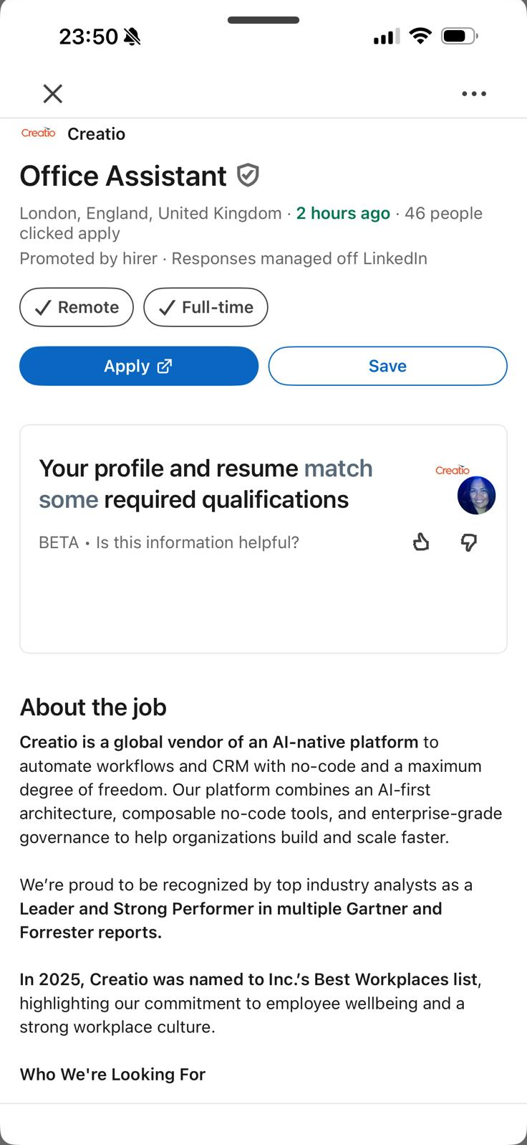
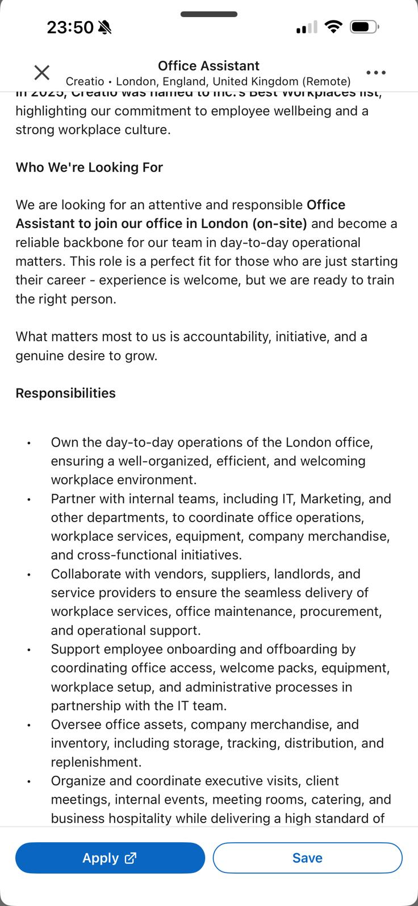
Melinda Hernandez Mercurio

2518165@student.uwtsd.ac.uk
https://www.linkedin.com/in/melinda-mercurio- 93476024a?utm_source=share&utm_campaign=share_via&utm_c
PROFILE
Highly organised First -year Business Management student with 20 years of experience as a Household Manager /Nanny. I have developed strong skills in scheduling, accurate record -keeping, confidential information management and professional communication. I combine this proven practical expertise with my growing academic knowledge of business processes. I am reliable, detail-oriented and eager to transfer my skills into an entry -level office assistant role to support smooth daily operation
EDUCATION & QUALIFICATIONS
University of Wales Trinity Saint Davies -London - BA Leadership-Management Skill Effective Teamworking, digital skills
Problem Solving and Decision-Making Sept 2028
My first -year modules have given me a solid grounding in core business principal
I have also studied communication covering how to write and clear a formal correspondence,
from this learning I have built a strong skill in suckered organisation and attention to detail
TESDA Philippines - NC 11 BARISTA (E) April 2021
This Course equips with the three main skill
Coffee preparation
Basic maintenance
Customer service
I learn how to dose temp, extract expresso and art for the latte
Manuel S Enverga University - College/ Humanities Humanity (1.5)
History (1.5)
Philosophy (1.2)
religious study (1) March,1994
I learn about the critical thinking common fields, history and about the existence knowledge values and reason
Canda National High School - High School the typical core curriculum, I learned English, mathematics, Social Studies March,1991
WORK EXPERIENCE
Household Manage/Nanny | Private Family Sep 2024 to Present
My employer is private businesswomen who runs her own business her business operates within Europe
- Managed complex, diaries, appointments, schedules with full accuracy
- Drafted clear correspondence and coordinated communication with external contacts
- Maintained detailed expenses /records, tracked budgets and original receipts
- Ordered supplies, monitored stocks levels and keep clear inventory
- Prioritised multiple tasks efficiently and meet all deadlines consistently
Nanny (Child minder) | Private Family Mar 2013 to Aug 2024
Both employers are worked in financial sector
- Managed daily routines, appointments and activity schedules accurately
- Handled confidential family and personal information with full discretion
- Keeps detailed records, logs and notes to share updates clearly with employers
- Coordinated communication with school, healthcare
- providers and other contact
- Planned activities organised resources and prepared materials in advance
- Adapted quickly to changing priorities and completed task reliably to deadlines
- Managed complex schedules and appointments accurately with zero missed commitments
- Handled highly confidential information with full discretion
- Tracked expenses and budgets preachily producing clear, accurate spending records
- Streamlined routines and workflows to support the employer´s busy schedule
- Built reliable working relationships with suppliers, services and external contacts
Household manage /nanny | Private family Jul 2007 to Jul 2013
Both employers are in the financial business very private, and they love to travel
- Coordinated travels arrangement, including bookings itineraries and documentation
- Planned and managed small events, gatherings and special occasions from start to finish
- Adapted quickly to change the priorities sand re planned
- Adhered strictly to data protection always od privacy standards
- Developed a standardised filling and record system that cut document search time significantly
- Managed schedules for multiple family members with 100% accuracy over several years
- Reduced time spent on routine admin tasks by introducing simple. consistent workflows
- Received consistent positive with long term suppliers securing reliable service and fair terms
Nanny | Saudi Arabian (Royal Family) Jan 2002 to Jul 2007
a high-profile family base in Saudi Arabia
- Managed structure daily, routines, activity schedules
- and appointments for the children
- Fallowed household rules, protocol and instruction consistently and reliably
- Maintained high standards of organization and attention in all tasks
- Maintained perfect confidentiality and professional conduct throughout my employment
- managed consistent, accurate records and updates to keep the parents fully informed
- Receptionist | Travel lodge Hotel Manila Apr 1994 to Jun 1996
it’s a hotel chain base in manila
- Welcome and registered the guests, processed booking and updated record accurately
- managed incoming calls, took clear messages and directed enquiries appropriately
- Handed payments, processed transactions and maintained accurate cash logs
- Responded to guest and visitor enquiries in a professional manner
- Kept reception areas and documentation organised and tidy all times
- Maintained high accuracy in bookings, payments and records
- Delivered friendly, efficient service. receiving positive
- feedback from the guests
- Developed strong proficiency in hotel booking system and office and office processes

ADDITIONAL INFORMATION
Training –
Short course Maternity nurse [2025],
financial literacy [2024],
Food and Beverage Service [2022],
Flower arrangement [2022],
Photography [2021],
Bartending [2021],
Basic Baking [2020],
First aid training [2016],
Basic computer [2010]

Languages –
Arabic.
English.
Tagalog.

INTERESTS
I Active in charity Organisation
Playing volleyball
Go to gym, music

REFERENCES
Available upon request
Creatio London Melinda Mercurio
Liverpool Street London 2518165
EC2M 7PY

18/07/2026

Dear Sir/Madam,
I am writing to apply for the Office Assistant role that advertised on LinkedIn. As a first year a Business Management student with an experience as a Household Manager and Nanny plus previous reception work, I bring a strong organisation, reliability and transferable administrative skills to support your team. I also enclosed my CV for your review.
Over my career, I mastered core office- relevant task, managing complex schedules and appointments, maintaining accurate records and paper works, handling confidential information with full discretion, and drafting clear professional communication. I have also processed expenses, tracked budget, coordinated travel bookings and used standard computer system experience that translate directly to daily management, filling data entry and general admin duties.
My time as a Receptionist at Travelodge built my confidence in welcoming visitors, managing enquiries and working efficiently in fast-paced environments. Currently studying business management at university, I am developing formal knowledge go business processes, I am proficient in Microsoft office and google workspace, quick to learn new system and committed to delivering accurate, high-quality work every day.
I am eager to bring dedication and practical experience at Creations and would welcome to discuss how I can help to keep your daily operation running smoothly
Thank you for considering my application
Yours Faithfully
Melinda Mercurio

