DEVELOPING WORKPLACE CRITICAL THINKING

UNIVERSITY OF WALES TRINITY SAINT DAVID

Grace Kindembe (1809717)
2019

Executive summary

The aim of this report is to critically identify and analyse management theories relevant to organisations while using a variety of case studies to support the argument. Three different theorist models have been described including different principles.
The difference between values, beliefs and attitude have been established and how these elements can impact an organisation positively or negatively.
Finally, an explanation about how these theories could contribute to an organisations
success while reflecting on values, beliefs and attitudes has been provided. Real case studies have been used to back up research.

Table of Contents
Terms of reference 3
Procedure 3
Introduction 3
TASK 1 4
1.1 Frederick Taylor theory 4
1.2 Henry Fayol theory 6
1.3 Max Webber theory 8
TASK 2 10
2.1 Good leadership skills 10
2.2 Dignity and respect: 11
2.3 Esprit de corps 11
2.3 Science, not rule of thumb 11
2.4 Formal selection 12
Conclusion 12
References 13
Appendix 15

Terms of reference

This report was requested by George Sandifer on October 2019. The purpose of the report is to analyse and develop critical thinking based on established theoretical models. It was written by Grace Kindembe and submitted online via Turnitin.

Procedure

Research was completed from online sources. Watching YouTube videos and reading academic journals. Great support was received from Beth.

Introduction

This report develops critical thinking. Identifying and analysing models of theories while using examples of organisations that apply the theories. Task 1 explains different management theories, how it all started and explains the importance of applying these theories in the workplace. Real organisations have been used as examples to describe how these theories are been implemented at work. The impact that these theories can produce interfering with personal values, belief and attitude have also been explained in detail.

TASK 1

Management theories are a set of general rules that helps managers to perform
their roles efficiently. Theories are an explanation to facilitate employees to effectively relate to the business goals and implement effective means to achieve a better result (Technofunk, 2012). Managers who apply theories to manage organisation must frequently balance principles with realities. Once managers apply theories, they will be able to prevent problems that may arise in the organisation. Contemporary theories of management tend to account for and help interpret the rapidly changing nature of today’s organisational environments (Yasin, 2004).
Management theories are important because:
- Theories provide a deep understanding of what people might experience. They also provide principles to determine what is most appropriate.
- Theories enable people to communicate effectively and create better relationships with different people.
- Theories make it possible and challenge us to keep learning about our world (Citeman, 2008).

There are three main categories for management theories: Classical Management Theory, Behavioural Management Theory and Modern Management Theory. These classifications represent different periods for management theories progression. In addition, each of these classifications hold multiple sub-theories.

Classical Management Theory focuses on executing and augmenting production. Behavioural Management Theory focuses gradually on human elements and viewing the workplace as a social environment. Modern Management Theory builds on the previous two theories, while combining modern scientific methods and systems thinking (Hashaw, 2019).

The main theories were developed by Frederick Taylor (1856-1915), Henry Fayol (1841-1925) and Max Webber (1864-1920). These theories represent the origins of modern management thinking and form the basis of many models. (Alan et al., 2005)

1.1 Frederick Taylor theory

Frederick Taylor is one of the earliest management theorists who created the scientific management theory. He is often compared to Fayol who developed the modern operational management theory (CFI, 2019). Frederick Taylor’s scientific management is also known as classical management theory.
Taylor’s four principles are as follow:
- Workers should replace working by “rule of thumb” common sense and simple habit. They should determine the most effective way to execute certain tasks and preferably use the scientific method.
- Managers should train workers and motivate them to work at maximum effectiveness rather than simply assigning them.
- Managers should provide instructions and supervise workers performance in order to ensure they are using the most efficient ways of working.
- Work should be allocated between managers and workers so that the managers have enough time to plan and train them. (Elisabeth, 2010)

Taylor suggests that all workers are motivated by money, he came up with the idea of “a fair day’s pay for a fair day’s work”. insinuating that if a worker did not achieve his task in a day, He does not deserve to be paid equally with the one who was highly productive. He also encourages the idea that employees and managers should work together in order to increase productivity (mindtool,2019).
Although Taylors’ theory seems to be beneficial to employers, the Trades Union congress report (2019) argued that workers can develop anti-social feelings due to financial reasons. This evidence is not always beneficial to all workers. (study.sagepub, 2019)
McDonald’s business is a good example of an organisation that still follows Taylors’ scientific management. McDonald's reward each worker when they meet objective goals. Rewards can come in many forms such as” employer of the month or “job well done!”. Taylor stated that if workers are not encouraged, this can lead to low productivity. McDonald's promote programs and use competitive wages. McDonald's also uses the “specialised training of staff” method to ensure that all staff meet their targets (Michael 2014).

1.2 Henry Fayol theory

Fayols’ theory is mainly based on how the management should interact with employees. There are 14 principles of management that Fayol believes should be applied at work. Every manager can choose how they want to apply these principles to suit the organisation. These principles were not created on the basis of experimentation (Kullabs 2019). Below is an image that represents Fayol’s 14 principles:
Henry Fayol Universal principles of management table.
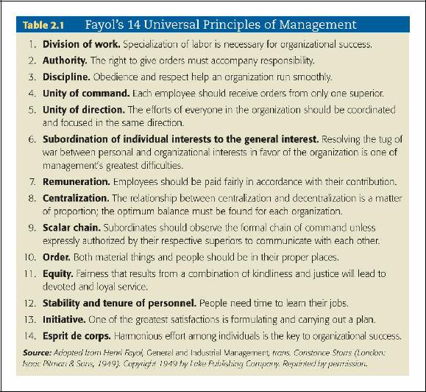

Image from culgooda.com (2019)

John (2002) disagrees with the fact that Fayol was primarily concerned with the level of work efficiency than the level of the task; with general management rather than departmental management or supervision, not focusing on details but the overall control of the organisation (John et al, 2002). Nevertheless, many organisations still follow Fayol’s principles. Fayol’s principles of management is considered to facilitate the organisation culture, promote the team concept, motivate employers through fair compensation. These concepts benefit to the organisation because many companies still uses hierarchical structure as model. Many organisations prefer putting together people with diverse skills rather than firing employees to work on their own (Sampson 2018).
Bellow is Fayol’s method applied by pizza Hut.

- Division of work: Pizza hut allows workers to build up experience and to progressively improve skills.
- Authority: Pizza hut has principles which must be strictly followed.
- Discipline: Managers should be able to demonstrate good leadership skills in order for the employees to obey.
- Unity of command: Only the senior manager should command the whole branch.
- Unity of direction: To be united, all employees should have one objective and follow directions
- Subordination of individual interest: Managers should recognise that Pizza hut goals are paramount.
- Remuneration: Employers should be payed to be motivated.
- Centralisation: Workers performance depend on the condition of the business.
- Scalar chain: This is all about hierarchy for unity of direction. In this matter, communication plays a vital role in the organisation
- Order: Everything should be rightly placed at Pizza hut both material and social order.
- Equity: Employers should treat each other’s with respect to avoid inequality.
- Stability of tenure of tenure of personnel: Employers will work better and if there is opportunity for career progression and keep the company reputation.
- Initiative: Managers should motivate employees to achieve high performance. This will allow all workers to show their initiative.
- Esprit de corps: Workers are required to work in harmony and managers should reward each workers merit without arousing any jalousies. They should also foster the morale of employees. (sidserve 2019)

1.3 Max Webber theory

Max Weber developed a theory called “Weber’s Theory of Bureaucracy” in 1947. He focuses on organisation structure, he named it ” Theory of Social and Economic Organization”. His strategy was to divide organisation into hierarchies and establish strong lines of authority and control. He suggests that organisations should develop extensive and detailed standard effective procedures to perform tasks in advance. He felt that the Western civilisation was changing from “value-oriented thinking to technocratic thinking” (McNamra, 2010, Olum, 2004). According to Weber, civilisation was changing with the technical effect at the cost of humanistic contents. He felt that workers should listen to management rules and with direct activities dictated by the organisational rules and regulations (Warwick, 1975; McNamra, 2010). Max Weber bureaucracy is identified by two elements: Organisational framework and public choice.

Today, many public sectors use the Theory of Bureaucracy. For instance, public choice theories are more focused on bureaucratic behaviours. They tend to be individualistic, atomistic and economic in their rules compare to many organisations (Niskanen, 1973).
Below are the five characteristics bureaucracies developed by Weber:
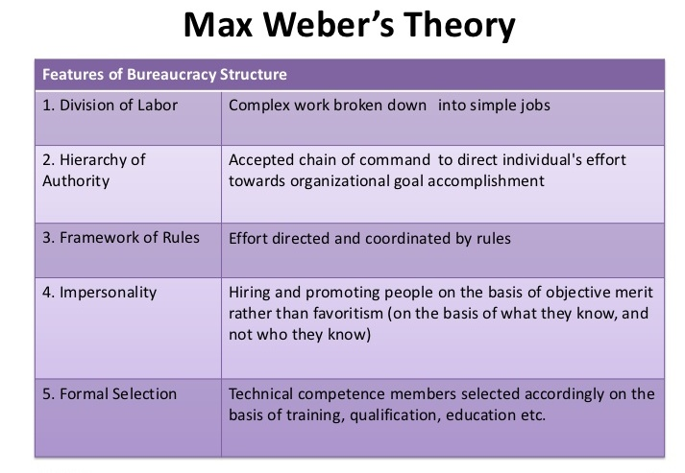

Image from Kullab.com (2018).

However, these theories can interact with our personal values, beliefs and attitude at work and this can bring a negative or positive impact if not practised correctly.

Mohan (2018) defines beliefs as the assumptions and convictions people hold to be true based on past experiences. Values are worthy ideas based on things, concepts and people. Finally, attitude is the way an individual behaves toward another. Attitude can be positive or negative and affect an individual choice of action and responses to problems.

According to Fayol, workers should treat each other with respect and dignity. This can help solve problems, avoid conflict and reduce stress among workers. In other terms, the way people treat each other at work can affect their personal values and morals. When people are not treated with respect this can bring a negative impact on their beliefs such as intellectual and spiritual and result in changes in behaviour.
Fayol also suggests that managers should have good leadership skills if they do not possess this skill, it can have a negative impact on employees’ performance and affect their attitude.
Taylor (1911), on the other hand, suggests that work should be allocated between managers and workers so that managers have enough time to plan and train them. Some people find it difficult being told what to do, and this can affect their attitude at work.

TASK 2

Theorists have long speculated on what type of management is suitable for employers in the professional setting. Each management theory develops ideas that provide a framework for effective management strategy and suit modern workplaces to motivate and bring out the best in employees (Bennet 2019).
There are many factors that can contribute to the success of an organisation:
Advantages of classical management:

- Classical management theory promotes better working conditions.
- Classical management theory increases the worker’s salary.
- Classical management theory creates a good relationship between managers. and employees.
- Classical management theory improves productivity.
- Classical management theory has clear structure for management. (Commerce mate 2019).

Division of labor is one important aspect of classical management. The division of labor lead to high productivity and help employers to specialize in one area.Such is the case for many fast food restaurant, warehouses and food chains. ( reference.2019)

2.1 Good leadership skills

Adam (2019) stated that: “Management is about persuading people to do things they do not want to do, while according to Rudolph (2016) leadership is about inspiring people to do things they never thought they could.”
There are aspects that can determine good leadership skills in an organisation which include: good qualities, emotional intelligence, objectives of leadership and the advantages of good leadership. Emotional intelligence is a very important skill in leadership as it allows the manager to be able to control his/her emotion and take into account other feelings or emotions. Such as being able to control anger and being sympathetic to other(Economic times. 2019).This can play a major role in the values of the organisation and lead to success.

2.2 Dignity and respect:

According to Noreen (2001) organisations need to put in place a range of integrated policies, structures and interventions in order to build a culture of respect. Organisation culture can promote or destabilise the dignity of the workers and influence their behaviour.

Research suggests that many leaders invest the majority of their time and energy in the company’s products and services instead of focusing on the quality of its culture, not knowing that culture drives everything that happens in an organization, either negative or positive (Chris 2015). According to a survey conducted by the Society for Human Resources Management (2014) respectful treatment of all employees at all levels was rated as “very important” by 72% of employees surveyed, making it the top contributor of job satisfaction. This insinuates that when employers treat each other with respect, they value each other which leads to higher productivity of the organisation.

2.3 Esprit de corps

Esprit de corps is a French phrase which means ” group spirit”. Fayol suggested that all employers should consider themselves as members of the organisation and be able to have a unity of strength. This principle impacts positively within an organisation. For instance, it results in great achievements at group goals, high morale within employers and good cooperation at work. (management diary 2019)
This principle is similar to one of Taylors’ principles harmony, not discord it plays a vital role in people’s values. It promotes higher morale, a sense of freedom and happiness between workers. However, this can cause concern if employers lack motivation (Mgt, 2019).

2.3 Science, not rule of thumb

This principle suggests that employers should not find themselves repeating the same old routine, rather they should be experimenting with new techniques and get creative which will make work much simpler and easier (Samisha, 2019) When employers learn new skills, it helps them fight boredom. There are more options to choose from and workers become more adaptable (Caba, 2018).

2.4 Formal selection

Weber said that workers should be hired based on their technical skills and expertise instead of ‘first come first selected’ basis. To get a promotion, an employee should be able to excel. This leads to better productivity and also adds to employee’s growth and satisfaction (Priya 2019).
When workers are able to implement their skills at work, they have a great sense of accomplishment and pride in their beliefs and this result in them being able to meet customer satisfaction.

Conclusion

To conclude, all theories beginning from classical theory complete each other. This theories are very importante because it allows workers to follow a structure and perform efficiently. Every organisation needs to apply theories management to follow a framework. This contributes to the advancement of the organisation and provide job satisfaction. Following theories motivate employers and result in higher productivity at work. However, some theories may not be suitable to apply in some organisations, and this can result in chaos. Therefore, it is very important for managers to understand all these theories and be able to implement the appropriate theory at work.

REFERENCES

Adams E (2019) online blog; 11 leadership qualities: available at: https://www.adamenfroy.com/leadership-qualities (accessed on the 15/12/2019)

Alan N et., al (2005) Managing services. Available at: https://books.google.co.uk/books?id=-KqzzL9Nsd0C&pg=PA23&dq=frederick+taylor+theory&hl=en&sa=X&ved=0ahUKEwiF7KLTlbLmAhVOUMAKHe2FCV0Q6wEIRDAD#v=onepage&q=frederick%20taylor%20theory&f=false (accessed on the 12/12/2019)

Bennet c (2019) Popular management theory decoded: available at: https://www.business.com/articles/popular-management-theories-decoded/ (accessed on the 16/12/2019)

CFI(2019) corporate finance institute.com. Available at:
https://corporatefinanceinstitute.com/resources/careers/soft-skills/management-theories/
(accessed on the 14/12/2019)

Chris E (2015) Talent management and HR ; online available at: https://www.tlnt.com/want-productive-engaged-team-members-create-workplace-dignity-and-respect/ (accessed on the 16/12/2019)

Citeman (2008): why study management theory? available at:https://www.citeman.com/4106-why-study-management-theory.html( accessed on the 12/12/2019)

Commercemates (2019) online available at : https://commercemates.com/classical-management-theory-advantages-and-disadvantages/ (accessed on the 15/12/2019)

Elisabeth Eyres (2010) Frederick Taylor and scientific management ; available at: https://www.mindtools.com/pages/article/newTMM_Taylor.htm (accessed on 13/12/2019)

Hashaw E(2019) Management theories and concepts at the workplace. Available at: https://smallbusiness.chron.com/management-theories-concepts-workplace-17693.html (accessed on the 12/12/2019)

Michael M (2014) scientific management of Mc Donald: available at:
https://michaelmarkadrianus.wordpress.com/2014/05/06/scientific-management-of-mcdonalds/ (accessed on the 14/12/2019)

John (2019) Benefit of respect in the workplace; online blog available at: https://blog.bonus.ly/6-transformative-benefits-of-respect-in-the-workplace (15/12/2019)

John C wood and Michael C wood (2002) Critical evaluations in business management online book. Available at: https://books.google.co.uk/books?

Kullabs (2019) Fayol administrative management theory; concept and principles. available at: thttps://www.kullabs.com/classes/subjects/units/lessons/notes/note-detail/4439 (accessed on the 13/12/2019)

Management diary(2019) Principle esprit de corps: Available online: https://mgtdiary.blogspot.com/2013/08/principle-espirit-de-corps_13.html (accessed on the 16/12/2019)

Mohan K (2018) The relationship between values, beliefs and attitude; available at: https://owlcation.com/social-sciences/Teaching-and-Assessing-Attitudes

Niskanen (1973) The efficiency of bureaucracy on the public sector: Available at: https://dergipark.org.tr/tr/download/article-file/211469 (accessed on the 14/12/2019).

Noreen T (2001) Building a culture of respect: managing bullying at work: published in 2001; online book’ available at; https://books.google.co.uk/books?id=ZK-TK-SOeBMC&printsec=frontcover&dq=dignity+and+respect+at+work&hl=en&sa=X&ved=0ahUKEwiSwrXL7bzmAhVUTBUIHePmDwYQ6AEIRDAD#v=onepage&q=dignity%20and%20respect%20at%20work&f=false (accessed on the 16/12/2019)

Olum. y. (2004). Modern management theories and practises [ebook] p.11. Available at: http://fac.ksu.edu.sa/sites/default/files/theories.pdf [Accessed 10 Dec. 2019].

Priya c (2019) Max weber bureaucracy theory. Available at: https://theinvestorsbook.com/max-webers-bureaucracy-theory.html (16/12/2019)

Rudolph P (2016) the quality of a good leader and the benefit of good leadership to an organisation. Online article, available at: https://pdfs.semanticscholar.org/3200/04474366e21900ddb17de93e557f1531af42.pdf (accessed on the 15/12/2019)

Samishka (2019) four important principles of scientific management: available at: http://www.yourarticlelibrary.com/management/4-important-principles-of-scientific-management/885 (accessed on the 16/12/2019)

Slidserve(2019) Henry Fayol principles followed by pizza hut: available at: https://www.slideserve.com/rafael/henry-fyol-principles-of-management-followed-by-pizza-hut (accessed on the 14/12/2019)

Sampson (2018): the advantages of Fayol’s principles of management :
https://smallbusiness.chron.com/advantages-fayols-principles-management-78162.html (accessed on the 16/12/2019)

Studysagepub (2019) Taylorism and the Scientific management model is still relevant today.;available at: http://study.sagepub.com/sites/default/files/annotated_model_essay.pdf (accessed on the 14/12/2019).
Technofunk (2012) management theories leadership-skills available at : https://www.youtube.com/watch?v=Ubxb9KUOQtI (accessed on the 11/12/2019)

The economic time (2019) Emotional intelligence: available at: https://economictimes.indiatimes.com/definition/emotional-intelligence (access on the 15/12/2019)

Appendix



