LEVEL 6 ASSESSMENT SPECIFICATION

Student name: | Kate Holmes | Student ID number: | 1800943
Programme: | Primary
Module: | Principles of Pedagogy
Module code: | M6X01438/C | Contribution to Overall Module Assessment (%): | 100%
Lecturer: | Siân Brooks | Internal Verifier: | Siân Brooks
Assignment Title: | ‘Describe a learning event which has happened during your recent school experience. Reflect upon what took place, connecting events to theories of learning and teaching. Make recommendations about how you could improve your own practice in the light of this. Produce a poster to illustrate how you would develop the elements of an effective learning environment.’ | Word count (or equivalent): | 5,000 or equivalent.
Submission deadline: | 17/10/18 (23.59) | Return date of provisional marks & written feedback: | 14/11/18
Submission method: | All written assessments, where practical and possible, must be submitted via Turnitin unless otherwise instructed by the Lecturer. (Please DO NOT put this assessment specification into Turnitin or it will match many similarities with other students’ submissions.)  Alternative submission method (if applicable):  Late submission of the assessment will result in a late penalty mark. Penalties for late submission: Up to one week late, maximum mark of 40%. Over one week late, 0%. Only the Extenuating Circumstances Panel may approve a change to submission dates.
Academic honesty / referencing: | Academic honesty is required. In the main body of your submission you must give credit to authors on whose research and ideas your work is based. Append to your submission a reference list that indicates the books, articles, etc. that you have used, cited or quoted in order to complete this assessment.
Student FEEDBACK FORM

Generic Assessment Criteria | Marks available | Marks  awarded
1. Engagement with Literature Skills
.
2. Knowledge and Understanding Skills

3. Cognitive and Intellectual Skills

4. Practical Application Skills

5. Transferable Skills for Life and Professional Practice

Assessment Mark (Assessment marks are subject to ratification at the Exam Board. These comments and marks are to give feedback on module work and are for guidance only until they are confirmed. ) | Late Submission Penalties (tick if appropriate) |  | %
 | Up to 1 week late (40% Max) |  | %
 | Over 1 week late (0%) |  | %
“Rewards are used to motivate children in the sense of encouraging them to keep learning and keep trying and to think…Rewards could raise children’s self esteem and so spur them on.” (Gipps et al, 2000, p.94)

For the purpose of this assignment, classroom observations were carried out within two Key Stage 2 classrooms over a two day Bridging event. I have chosen to take ethical considerations into account in accordance with Bera Guidelines and will refer to the Primary School in question as School X. School X is recognised by the Local Authority as being situated in an urban, deprived area of South Wales. It has achieved a Green category classification according to the Welsh Government four tier ranking system and currently has a 33.6% three year average of free school meals. The current Estyn report for School X, published in 2014, recognises “promotion of positive attitudes to learning and support of pupils efforts, with consistent praise and encouragement” (Estyn.gov.wales, 2014) and makes reference to appropriate reward systems. The school’s website promotes that “each child is encouraged to achieve their full potential” (Swansea-edunet.gov.uk).

During the Bridging event at School X, observations were made for one full day in a Year 6 class, and one full day in a Year 4 class. The purpose of these observations was to become aware of any significant event that took place that would reflect on the Principles of Pedagogy being studied. “Pedagogy involves bringing together learners to engage with ideas in early years settings and primary schools and using particular approaches to learning and teaching.”(Wyse and Rogers, 2016, p.166) . Gipps et al (2000) states that observations of pupils takes place in three stages; by ‘noticing’, ‘following’ and ‘watching’. ‘Noticing’ involves the things that teachers become aware of whilst being in the presence of children. This leads to the more focused method of ‘following’, where a child’s learning strategies are considered, and finally to ‘watch’ children over time to make judgements regarding the children’s learning and the National Curriculum Criteria. Throughout this process of observation Palaiologou (2008) explains that an accurate picture of a child’s development and behaviour can be given, inform planning and assessment and discover the children as individuals. In addition Fisher (2008) recommends that classroom observations are best made when the children are in a familiar learning context, in an environment that encourages their self-esteem and through a combination of working alongside an adult, in a group, and also independently. Due to the time constraints of my observation it was not possible to observe the same child in all these previously entitled situations and instead an opportunistic approach was applied to the observation. According to Drummond (1998), observing children as a practitioner involves getting close to their minds and feelings. As my observations were over a duration of only one day per class, it was not possible to build a significant rapport with the pupils, however every effort was made to be involved in activities and lessons and to work with the children as well as observe them. Palaiologou (2008) identifies this style of observation as ‘participant observation’ where the practitioner is involved in the activity and notes their findings after the event, as not to be distracted from the children and the activity. Drake (2009) concurs that it is not necessary to make recordings immediately during observations and suggests that making notes under ‘prompts’ is more appropriate than a pro forma, which can be an unproductive use of time. To this end, during the Bridging sessions I felt it was beneficial to become activity involved in the lessons. In doing so it was not practical to have pen and paper in hand at all times as I felt this would have been a distraction and may have prohibited the experience I wished to gain.
Figure 1 illustrates the table of prompts created and used during my observations, including headings of all the topics I wished to observe.
Figure 1
Questioning | Reward | Outdoor learning | Learning environment | Learning through play | Behaviour management | Other

Observation methods such as target child records, time sampling and sociograms are recognised by Papatheodorou (2012) as advantageous when collecting factual data that can be quantified. Had my observations been focused on a specific child or a single behaviour trait this may have been appropriate, however as my intention was to use a broad range of prompts, this method was not suitable. The Children’s Care, Learning and Development (CCLD) recognises that, although these methods are beneficial when observing a specific child closely for an allotted duration of time, it does restrict being able to broaden observations. Similarly the tick list method of recording information would have allowed more time for active involvement in lessons, however Fawcett and Watson (2016) suggest that this method is used for selective and structured observations, based on either time or events and is therefore restrictive to watching a preselective range. It was therefore decided that the tick list method would have been too specific and therefore not a an appropriate observation method. “Progress within a huge range of behaviours and skills can be assessed using checklists. However, checklists can result in missing important information if observations are limited to only those items on checklist.” (complexneeds.org.uk). As I did not gain experience in Foundation phase, it was not possible to make observation on learning through play or outdoor learning, as this approach to teaching appeared to be specifically used within Foundation phase within the School X.
A critical incident observed whilst in the Year 6 class related to findings gained through research undertaken prior to attending the School X which emphasised the use of praise within the setting. Following a lunch break, pupils sat on the class carpet as part of their daily routine where the afternoon register was taken. Pupils were asked by the teacher to stand if they had received a raffle ticket for Dojo points during the lunch period. At this point I started making narrative observations of the conversation and information that was being shared in the classroom. Papatheorou et al (2012) states that this method named ‘narrative observation’ provides a a detailed account of actions and contextual information. The class teacher explained that specific pupils within the school had been given the role of ‘corridor monitor’. During lunch breaks, these monitors are situated in the corridors and are responsible for reminding pupils of the school’s ‘sensible walking policy’ when travelling through the school building and are able to reward pupils who are adhering to this policy. This reward is provided in the form of a raffle ticket, and once given by the rewarded pupil to their class teacher, can be converted into a Dojo point.
Class Dojo systems have been commonly used throughout schools that I have previously worked in as a reward initiative for desired behaviours and outcomes. It is a positive classroom management program with more than 35 millions users. It assigns each pupil their own unique monster avatar, and allows points to be added to their monster as a reward for their achievements. “Teachers can encourage students for skill or value – whether it’s working hard, being kind, helping others or something else” (www.classdojo.com).
Figure 2, an illustration from Google images, provides an anonymised example of the Class Dojo website. Each character is displayed next to the relevant pupils name and their accumulative Dojo’s are clearly presented for the children and teaching staff to view on the classroom’s interactive board. Kranch et al (2017) describes Class Dojo software as a computer based Behaviour Management Chart where points can be rewarded to either an individual or the class and can also be removed as a result of negative behaviour. Their research found that the use of this computer based system significantly increased teacher’s positive per-child notation. Although there are very few peer-reviewed studies conducted on Class Dojo, contradictory research conducted by Singer (2014) identifies that some educators and parents criticise the Class Dojo website for attempting to bribe children with enticing graphics. It was also commented that the imagery and sound effects used on the website were non-conductive to learning. Cowley (2003 also) disputes the advantages of using a merit system form of reward such as Class Dojo by suggesting that, despite this being a commonly used reward systems, many pupils require a more tangible forms of reward. Through my experience it was apparent that the action of physically adding the point to the Dojo character had a tangible quality and the pupil seeing their total points increase appeared to create a great sense of achievement and motivation.
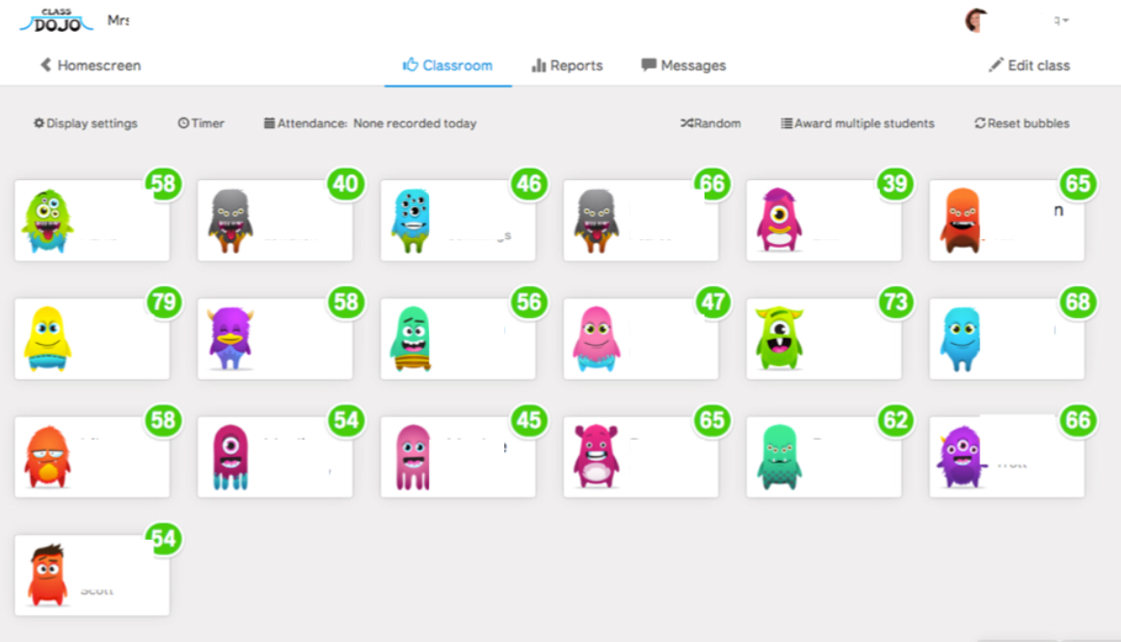
Figure 2

As illustrated in figure 3, Class Dojo allows children to be rewarded for specific tasks such as active listening or, in this case, hallway behaviour. The class teacher is able add or remove from this list as they feel appropriate, with the intention of encouraging the children to achieve desired outcomes in areas that may require specific attention. Researchers have addressed why it is necessary to be specific and clear to a pupil when giving praise or reward and this will be discussed later in the document. During the observation, the class teacher then appointed the highest Dojo point scoring pupils of the week to sit at the back of the carpeted area on chairs. The class teacher explained that as this was a year six class, the pupils took great pride in being the eldest in the school with the responsibility of setting an example to their younger piers. This view is supported by Trottier (2016) who confirms that older children prefer the responsibility of seating on a chair as opposed to the carpet and would therefore suggest that this is a positive motivational tool for the teacher to use.

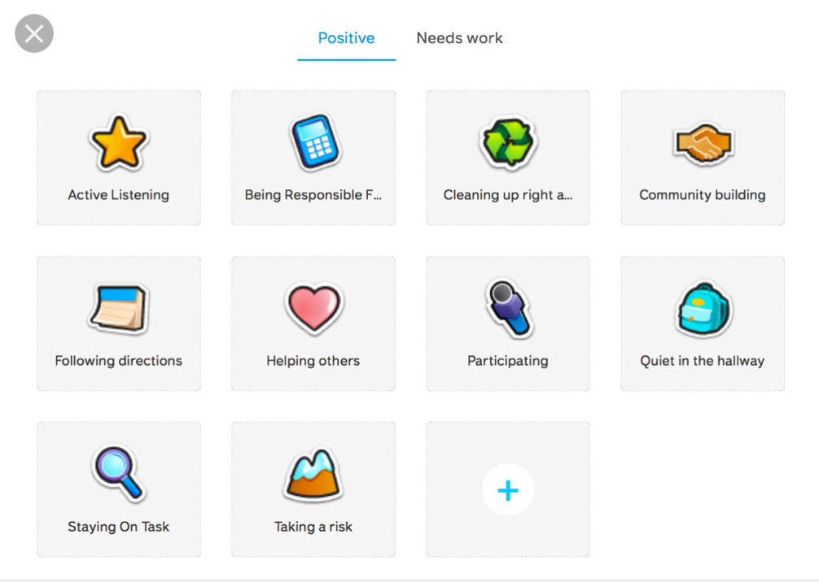
Figure 3

The teacher informed me that the positioning of the pupils on the chairs had become a “status” amongst the pupils. It appeared to make them feel superior, special and proud of there achievements and was a physical and tangible reminder to all class pupils that making efforts in a variety of aspects of their school life could result in this reward.

I have chosen to further research this event as praise and reward are strategies I’ve often used within the classroom environment. I have consistently promoted the use of praise and encouragement and consider this to be a topic of interest of which I wish to further enhance my understanding. My own practical experience can be linked to specific theorists and schools of though regarding behaviour, motivation, reward and outcome.

To further explore the use of praise and reward it is necessary to research how this concept links to learning theories and what evidence there is to suggest the use of reward is beneficial in a classroom environment.
Behaviourism is the main school of thought that supports learning through the use of praise and punishment influencers. According to Gray and MacBlain (2015), the main theorists linked to this branch of psychology are Pavlov (1849-1936), Thorndike (1874-1949), Watson (1878-1958 and Skinner (1904-1990). Historic research undertaken by Ivan Pavlov in the 1890’s consisted of ‘classic conditioning’ experiments on dogs. Huang et al (2016) discuss that Pavlov’s research found links between the laboratory technicians bell (neutral stimulus) and the dog’s food (stimulus) which caused the dog to salivate. Lopez et al (2007) identify the key factors of Pavlov’s experiment which found that although the bell on its own did not cause a response, when added with the dog food the dog would salivate. After repetitive conditioned experiments the conditioned response of the dog was to salivate every time it heard the bell, even without the presence of dog food. According to Powell (2001) these conditioned reflex techniques identified by Pavlov are still widely used modern psychology study’s of brain behaviour. Rilling (2000) recognises that Pavlov’s conditioning was further advanced by Watson who was interested in the psychoanalytical aspect of behaviour. McLeod (2018) states that Watson’s ‘instrumental conditioning’ experiments were able to prove that children could also be subject to classical conditioning and was able to influence their phobic behaviour though positive and negative reinforces. McLeod (2018) explains that this demonstrates the importance of teachers ensuring that pupils associate positive emotional experiences with learning to avoid phobias or negative feelings being linked to the classroom. Research by Saari (2016) proposes that Thorndike’s research established the principle of ‘Law of Effect’ whereby a behaviour which is followed by a positive consequence is more likely to be repeated, and a behaviour followed by an negative consequence is less likely to be repeated. Huang et al (2016) states that this developed the term ‘operant conditioning.’ Staddon (2017) explains how Thorndike’s views were further developed by Skinner who dismissed the limits of theory and introduced the concept of ‘reinforced behaviour’. This involves reinforced behaviour being repeated and behaviour which is not reinforced becoming less frequent.
Elements of work by these theorists can be identified in the main principles of The Class Dojo system that was observed in School X. This method of behaviour management allows teachers to influence children’s behaviour though use of reward (rewarding Dojo points) or punishment (removing Dojo points).
However there are many views that can further discuss the process of reward management in this context. Brophy (1981) cited by Docking (1991) refers to teachers praising solely for encouragement without informing the child what specific task or behaviour they have actually achieved. Through my observations it was evident that the Class Dojo system eliminated this issue. When adding a point to the system, the software program requests that a relevant category is selected before the Dojo point can be rewarded. For example if a child has tidied their desk, the class teacher would be able to add a Dojo point under the “cleaning up right” category. Further recommendations by Docking’s (1991) emphasise that praise should be given immediately after a pupil has made an achievement to ensure positive impact. During my observations it was also evident that the class teacher would carry an iPad when outside of the classroom, as this would allow her to access Class Dojo regardless of location and was therefore able to give immediate reward. Previous developmental studies mentioned by Docking (1991) suggest that children up to the age of seven in Foundation Phase have an overwhelming desire to please adults, hence responding well to praise from a teacher, however pupils of Key Stage 2 age are more concerned with the praise they receive from their peers. The use of ‘Corridor Monitors’ in School X provides the opportunity for praise across peer groups. Controversially, research conducted by Burnett (2001) however found that, although primary school age children want to be praised, the pupil’s most desired form of praise is not in the presence of peers. Whilst 91% of the 747 children questioned confirmed that they did wish to receive praise, 52% preferred to be praised discretely on an individual basis and only 32% wished to be praised loudly in the presence of peers. In schools where bad behaviour is common, pupils can often be cynical of rewards in front of peers as they are fearful of appearing needy (Cowley 2003). In addition, research conducted by Harrow and Holmes (1993) found that Key Stage 2 pupils perceived both private and public praise of equal dissatisfaction, and instead preferred the concept of “a special certificate, merit points, or a favourable letter home” (Harrow and Holmes, 193, p44). These research results support the findings of classroom observations in School X whereby the children at KS2 level appeared excited and motivated when their points were added to the Class Dojo. This view is also supported by Schultz et al (2000) who suggests that reinforcement will not be successful if children do not find a reward worthy of positive behaviour. Qualitative classroom research was conducted in 2010 by Burnett and Mandel to establish if the need for praise varies according to age. 56 pupils were interviewed and findings suggested that whilst younger students preferred praise directly relating to their ability, Key Stage 2 children prefer feedback linked to their effort. Docking (1995) developmental studies also demonstrates that Foundation Phase aged children have an insatiable appetite for feedback and encouragement accompanied by a tangible conformation such as a pat on the back.
Despite the overwhelming advantages of using praise and reward in the classroom, being “opportunistic” is key. It may be easier to find opportunities to praise high end achievers with constant positive behaviour, however teachers require vigilance to ensure the less obvious praise receivers are not forgotten. Merrett and Wheldall’s (1990) literature supports this view of rewarding consequences of behaviour, ‘positive reinforcers’, and suggest that classroom verbal praise as a form of social reinforcement is likely to increase the frequency of positive behaviour. This was identified throughout my observations in School X. Children who received verbal praise would display pride and motivation in their body language and and facial expressions, especially when received in front of their peers.
An alternative theory of classroom behaviour management is through the use of punishment. Merrett and Wheldall (1990) suggests that punishment can be achieved through the removal of positive consequences, known as ‘response cost’. School X adopted this method through the use of Dojo, as it is possible to remove Dojo points following an event of negative and unwanted behaviour by a pupil.
Limitations of the use of praise and reward systems are identified by Merrett and Wheldall (1990). It is discussed that teachers should avoid a significantly high use of either ‘positive reinforces’ or ‘response costs’ as this will cause the pupil to become less responsive, especially if they feel a positive reinforcer is too easily available. There are many academic studies into the use of praise and punishment within the Primary School Setting. Research, titled Observing Pupils and Teachers in Classrooms (OPTIC), was conducted in (1990). Trained observers recorded the frequency of both praise and disapproval given by primary school teachers as a response to pupils behaviours and academic work. Teachers responses to pupils academic work was three times more praise than disapproval, however when responding to pupils behaviour, teacher’s comments were nearly five times more disapproving than positive. These negative responses are thought to be counter-productive, as the children displaying disruptive behaviours are often doing so to gain a reaction from the teacher (Merrett and Wheldall, 1990). Taking these findings into account and considering my own classroom observation I would agree that certain unwanted behaviours, unless dangerous or disruptive to learning, can be ignored, or quickly corrected in a positive tone. Pupils certainly appear to respond well to praise, and it therefore appears crucial to also find opportunities to praise those pupils who display negative and unwanted behaviours when they are making efforts in their behaviour or work; reduce negative behaviour over time. When using praise and reward however it is crucial to choose rewards that the children are actually keen to achieve. This can be achieved through giving children the power to make choices and by allowing them to take responsibility for their own actions, (Cowley, 2003).
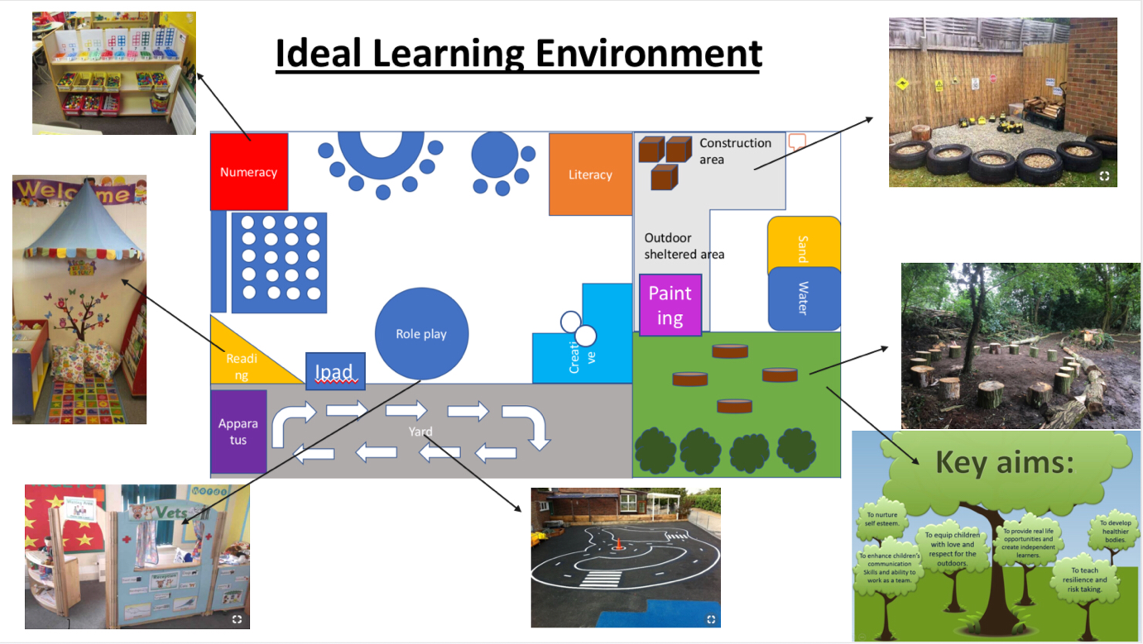
Figure 4

“A physical environment needs to appeal to children’s channels of learning – initially their senses…Both indoor and outdoor environments can tempt children into, or dissuade them from, learning.” (Bruce 2010, p64). Donaldson’s Review of the curriculum suggests that children want education to be “relevant and engaging with more practical lessons, more fun, more interactivity and more out of classroom activities.” (Donaldson, 2015, p17).
Through exploration of the above views and conducting theoretical research, the above digital poster and following commentary have been produced illustrating suggestions of an effective learning environment. The main areas consist of continuous provision, enhanced provision, outdoor and sheltered areas. All areas will also promote bilingualism through the use of common welsh words and phrases being displayed. Donaldson (2015) has raised concerns that the welsh language and culture has been overlook over recent years and therefore suggest making it a main focus in Wales new curriculum by implementing it throughout all areas of learning. The classroom has been designed for a reception/year 1 age pupils.

Numeracy Area
Children’s mathematical graphics begins with play and develops with written numbers and quantities. Children can be encouraged to develop these skills by being provided a low level numeracy display board in an area with resources to encourage a child to explore, think and play, Bruce (2010). Therefore this continuous provision area will include a display board showing reception age appropriate mathematical symbols, for example, number bonds to ten. Haylock and Cockburn (2017) identify that children require an understanding that a number can have three properties. An example of each type; Cardinal, nominal and ordinal, should be displayed to provide pupils with a visual representation and an understanding of what numbers actually mean. Cardinal numbers would be represented in the numeracy display area by having pictures of grouped objects, for example oranges. See Figure 5.

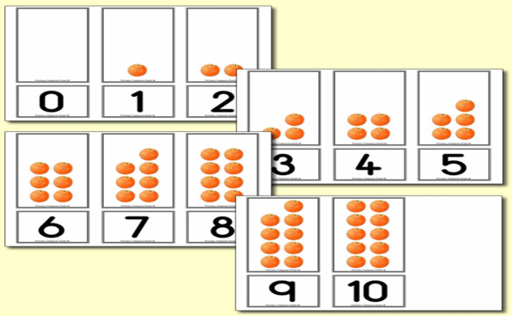
Figure 5

Ordinal numbers would be represented with a role play style elevator. The buttons would start at floor level -1 labelled basement, level 0, level 1 etc. This is supported by the Stable Order Principle by Gelman and Gallistel (1986) who concur that an order and arrangement of number is one of the main principles that govern and define counting. Nominal numbers can be represented through role play area outside as a bus station where buses are labelled with numbers that have no relationship or sequence. This also gives the pupils the opportunity to deal with money when paying the bus driver. Resources such as Numicon, blocks and hundred squares will be stored in this area and made accessible for pupils to ensure the classroom is a “purposeful mathematical environments” (Bruce 2010 p.174) where children have the opportunity to take part in every day activities where they have the opportunity to practise using currency or timetables. Displays in the numeracy area can further support this introduction to money through the use of Numicon, which enables children to identify the one pence coin having the value of one. Nye et al (2005) suggest that Numicon is a successful multi sensory tool based on the work of authors who emphasise the role of visual and tactile representation of numbers, which allows children to see the relationship between these numbers. See figure 6.
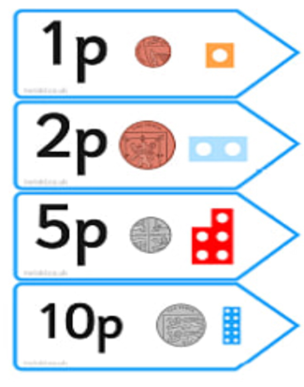
Figure 6

Outdoor provision
Bilton (2002) discusses the positive aspects of having both indoor and outdoor learning spaces that are viewed as one integrated combined environment, however research conducted by Gura (1992) identified some difficulties of outdoor learning. In the study, foundation phase children were observed to be actively engaged in an indoor activity until the outdoor area was made available. At this point these children abandoned what they were doing and a rushed outside. Bearing this theory in mind, a carousel system could be used to give allocated periods of time for each group of children to be outside. By doing so, this eliminates the “pull of a new area” (Bilton 2002, p.9). Bruce (2010) also states that children prefer to be in an outdoor learning environment that provides them with the continuous provision to develop their interests with scope for children to be able to take risks. Therefore the classroom has been designed to include continuous outdoor provision in the form of bikes, construction area and a forest school. Bilton (2002)suggests that learning the skill of riding a bike can provide a great sense of achievement, especially as not all children will have access to this resource at home. However the use of bikes should be considered carefully as using this provision in a small space can be a “frightening” experience for a young child. Staff monitoring could be used to avoid this and pupils should be encouraged to use basic rules whilst in the bike area such as direction of travel and appropriate speed to avoid creating a stressful environment. Moyles (2005) advises that children find it easier to learn and discover their abilities in the outdoors as the experience is often more play based, however as children get older the emphasis on outdoor learning decreases as education becomes more formal. As my Classrom plan is based on a Foundation Stage Year One class, the outdoor area has been designed with the above theory in mind. The construction area and outdoor painting areas are situated under a permanent shelter and can therefore be accessed without consideration for weather restrictions. The sand and water trays will be developed as an enhanced provision depending on the topic; for example during the “under the sea” topic, marine life figures will be added to the trays and activities will be set to include the use of these figures.

Forest school
Dickerson (2016) identified the Forest School concept as a philosophy originated in Sweden, where learning predominantly takes place outdoors. It offers a hands on experience whilst developing the holistic, physical, and emotional aspects of a child. Nawaz and Blackwell (2014) studied the benefits of providing a Forest School provision in schools. Their research indicates that attending forest school has no additional risk on children and, for children who attend over a prolonged, their academic, physical and social performance is improved. Lovell (2009) also emphasises the importance of the health benefits of children having access to a Forest School and recognises that increased levels of outdoor physical activity in schools can be achieved through this provision. Lovell’s research indicates that children were engaged in a higher intensity level of physical activity during Forest School sessions. Dickerson (2016) also identifies that a Forest School can also be used to promote environmental awareness.
As this evidence suggests, there is overwhelming literature and evidence to support the advantages of outdoor learning, specifically through the concept of a Forest School.

Reading corner
The Reading Corner would be promoted as a quiet space where pupils would go to read, either independently or with the teacher and a group as part of a shared reading activity where a variety of texts are modelled and discussed. “Shared reading is an essential step in the effective teaching of writing. In the course of reading a shared text with a class, you can, as well as focusing on teaching them how to read this text, also teach a deal about how the text is structured. A highly developed familiarity with the structure of a text is necessary if children are subsequently to write texts like this themselves.”(Medwell et al, 2014)
This relaxed and calm area can provide the environment required by some children who are sensitive to noise and benefit from having access to a quiet withdrawal area (Bruce, 2010).
Low shelving would be provided, as Wise and Rogers (2016) promote the importance of resources being easily accessible for pupils.

Role play area
Role play in the classroom allows children to learn about real life relationships and experiences through which language, literacy, writing, reading, speaking and listening can be developed. Role play areas can be based on a theme or on children’s interests (Drake, 2009). Involving children in the design and building of a role play area and displaying their work in the area can give them great self-esteem and a sense of belonging. The adults role during role play should be to focus the children by involving themselves in the socio-dramatic play activities that take place in role play (Moyles, 2005). However Hutt et al (1989) argues that adult involvement during role play is often very superficial.
By including a vet role play area, pupils would have the opportunity to develop their literacy and oracy skills through the task of writing prescriptions and appointments. Numeracy skills skills would be developed through clock reading, measurements of pet food as well as the empathetic social skills developed through caring for the animals. Giving pupils the opportunity to free play in this area is a crucial aspect to develop their learning through play. “One of the best and easiest pathways to a strong self concept is through play. Play offers opportunities to assist the child in all areas of development” (Taylor 1980, p.133, cited in Bilton, 2002, p.115)

To conclude, the observation and theoretical research conducted for the purpose of this document suggests that there is a strong correlation between reward and achievement. The behaviour observed in School X through the use of reward concludes that this Year 6 class in particular reacted well to the Class Dojo system. This can be related to the early research discussed in the document. Pavlov’s theory of a stimulus creating a response and Thorndike’s ‘Law and Effect’ involving pleasant consequences can certainly be recognised in a classroom environment. Research suggests that the behaviour of a child can be manipulated through reward and arguably this can ultimately provide and opportunity for teaching staff to have a strong influence on the outcome and level of motivation and achievement of their pupils. The benefits of including peer praise has also been discussed and the examples of ‘corridor monitors’ and use of the ‘chair reward’ discussed during the observation certainly suggests that this was a successful method used by School X. Although some of the research discussed poses that pupils prefer to receive praise privately, my observations in School X strongly suggest the opposite view as pupils appeared to thrive from peer praise or indeed teacher praise in the presence of peers.
Although teaching itself is critical to a child’s development, this document has also explored how the learning environment of a classroom can impact learning. Going forward during my practical teaching experience, I will carefully consider the classroom areas and the overwhelmingly strong benefits of involving outdoor learning in all curriculum areas. Consideration will be given to age appropriate praise, personal preference regarding how praise is received, and how resources and classroom areas can be used to motivate and inspire learning through strategically including curriculum outcomes into every day provisions, such as role play or forest school.
Recommendations for future observations would include the opportunity to observe Foundaiton level students, as well as Key Stage 2. As research discussed suggests that reward can be dependant on age, it would have been beneficial to gain a holistic view for the purpose of analysis and to contest theory regarding Foundation age pupils responding more favourably to verbal praise. The ‘participant observation’ method of observation provided successful findings and I would therefore suggest that this was the most suitable form of observation for this individual research.

References

Bolton H, (2002) Outdoor play in early years, 2nd edition, David Fulton Publishers

Bruce T (2010) Early Childhood A Guide for Students, 2nd edition, Sage

Burnett, P(2001) Elementary Students Preferences for Teacher Praise, Journal of Classroom Interaction, issue 1, vol 36

Burnett P, Mandel V (2010) Praise and Feedback in the Primary Classroom: Teachers’ and Students’ Perspectives, Australian Journal of Education and Development psychology. Vol 10, p.145-154

Cockburn A, Haylock D (2008) Understanding Mathematics for Young Children: A Guide for Teachers of Children 3-8, 4th edition, Sage publications

Cowley, S (2003) Getting the Buggers to behave, 2nd edition, Continuum

Dickerson C (2016), Enjoying Natural Spaces: Wearing Waterproofs and Wellies, The Kent Sussex Courier

Docking, J (1991) Managing Behaviour in the Primary School, David Fulton Publishers

Donaldson, G (2015) Successful Futures: Independent Review of Curriculum and Assessment Arrangements in Wales. Caerdydd: Llwyodraeth Cenedlaethol Cymru

Drake J (2009) Planning for Children’s Play and Learning, 4th edition, Routledge Publishers

Fawcett M, Watson D (2016) Learning through Child Observation, third edition, Jessica Kingsley Publishers

Fisher, J (2008) Starting from the Child, Teaching and Learning in the Foundation Stage, 4th Edition, Open University Press

Gelman R, Gallistel C, (1986) The child’s understanding of number, Harvard University Press

Gipps C, McCallum B, Hargreaves E (2000), What Makes a Good Primary School Teacher, Expert Classroom Strategies, Routledge

Gray C, MacBlain S (2015)Learning Theories in Childhood, 2nd edition, Sage publications

Gura, P, (1992) Exploring Learning: Young Children and Blockplay. London: Paul Chapman

Harrop A, Holmes M (1993) Teachers Perceptions of their Pupils’ views on rewards and Punishments, Pastoral Care in Education

Huang J, Ruan X, Naigong Y, Fan Q, Li J, Cai J (2016), ‘A Cognitive model Based on Neuromodulated Plasticity’ Computational intelligence and Neuroscience, issue 8, vol 2016

Hutt S, Tyler S, Hutt C, Christopherson H (1989) Play, Exploration and Learning: A Natural History of the Preschool, London Routledge Publishers

Kranch K, McCreery M, Rimel H (2017) Examining Teachers’ Behavioural Management Charts: a Comparison of Class Dojo and Paper-pencil Methods, Contemporary School Psychology , vol.21, iss.3, 267-275

Lopez G, Maj-Britt N, Engler H, Schedlowski M, (2007) Behaviorally Conditioned Enhancement of immune Responces, 4th edition, Elsevier academic Press

Merritt F, Wheldall K (1990) Positive Teaching in the Primary School, Paul Chapman Publishers

Moyles J (2005) The excellence of Play, 4th edition, Open University Press

Nawaz H, Blackwell S (2014) Perceptions about Forest Schools: Encouraging and Promoting Archimedes Forest Schools, Educational Research and Reviews, Vol 9, iss 15

Nye J, Buckley S, Bird G, (2005) Evaluating the Numicon system as a tool for teaching number skill to children with Down syndrome, Down syndrome News and Update, vol.5, iss.1

Papatheodorou T, Luff P, Gill J, (2012), Child Observation for Learning and Research, Routledge

Powell, D (2001) International Encyclopaedia of the Social and Behavioural Sciences

Rilling, M (2000) How the Challenge of Explaining Learning Influenced the Origins and Development of John B Watson’s behaviourism, vol 113, iss 2

Saari, A (2016) Knowledge Without Contexts? A Foundation Analysis of E.L Thorndike’s Positive Education Research, Studies in psychology and Education, vol 35, iss 6

Schultz W, Tremblay L, Hollerman J, (2000) Rewards Processing in Primate Orbitofrontal cortex and Basal Ganglia, Cerebral Cortex, vol 10, iss 3

Singer N (2014) Privacy Concerns for Class Dojo and other Tracking Apps for School children, School Tracking app wont Keep Data, The New York Times, 16 Nov

Staddon J (2017) Theoretical behaviourism, Behaviour and Philosophy, Cambridge centre for Behavioural Studies, vol 45

Trottier, Pat (2016) Relationships make the Difference, Pembroke Publishers

Wise D, Rogers S, (2016), A Guide to Early Years and Primary Teaching, Sage

http://webarchive.nationalarchives.gov.uk/20120202160858/http://www.cwdcouncil.org.uk/assets/0000/0574/CCLD_303.pdf

http://complexneeds.org.uk/modules/Module-2.4-Assessment-monitoring-and-evaluation/All/downloads/m08p110b/observational_methods.pdf

http://mitchellprek.weebly.com/blog/-five-reasons-why-i-love-class-dojo-and-you-should-too

www.Estyn.gov.wales

www.classdojo.com

https://assets.cdn.downsyndrome.org/pubs/a/updates-352.pdf

www.google.co.uk/url?sa=i&source=images&cd=&ved=2ahUKEwitroz20-DdAhVHVhoKHRQwCsYQjB16BAgBEAM&url=http%3A%2F%2Fplp-uab-studteaching.blogspot.com%2F&psig=AOvVaw36f1CQ4_PkO-F8vb-uYeRt&ust=1538325666288452

www.cimplypsychology.org/classical conditioning .html

www.Swansea-edunet.gov.uk

Images references

Figure 2:
http://mitchellprek.weebly.com/blog/-five-reasons-why-i-love-class-dojo-and-you-should-too

Figure 3:
Www.classdojo.com

Figure 4:
Www.pinterest.co.uk

Figure 5:
https://www.primarytreasurechest.com/teachingresources/orange-number-shapes-cards-0-10-fruit-resources.html

Figure 6:
https://www.twinkl.co.uk/resource/t-n-2622-number-shape-price-labels-with-coins

