

ASSESSMENT 1: A CONCEPTUAL ANALYSIS OF ENTERPRISE AND ENTREPRENEURSHIP
Module: Entrepreneurship
Module code: LCMB7004
Word count: 2511
Executive Summary
In this report, the aim is to discuss the conceptual foundation of enterprise, entrepreneurship, for-profit and not-for-profit organisations. In this regard, the critical analysis of the concept of entrepreneur and entrepreneurship from the perspective of an entrepreneur has been discussed. Apart from that, the skills, traits, characteristics, and motivation needed in an entrepreneur are also discussed. It gives a discussion on the theories of personality traits with related examples of Bill Gates. The critical evaluation of the comparison and contrast between non-profit not-for-profit and for-profit organisations have been done along with the beliefs and motivation of the entrepreneurs in these two organizations.

Table of Contents
1. Introduction 4
2. Conceptual foundation for enterprise and entrepreneurship 4
3. Critical analysis of concepts of entrepreneurs and entrepreneurship from the perspective of an entrepreneur 4
3.1 Overview of Enterprise and Entrepreneurship 4
3.2 Innovation and Entrepreneurship 5
3.3 Risk-taking and Entrepreneurship 6
3.4 Resilience and Adaptability in Entrepreneurship 6
3.5 Skills and knowledge required for entrepreneurship 6
3.6 Factors impacting entrepreneurial success 6
4. Conceptual foundation of theories of personality traits with example 7
4.1 The big five theory of Personality traits 7
4.2 The trait theory of Leadership 8
4.3 The Myers-Briggs Type Indicator 8
5. Traits, characteristics, motivation, and attributes of entrepreneurs 9
5.1 Traits 9
5.2 Characteristics 9
5.3 Motivations 9
5.4 Attributes 9
6. Conceptual foundations of for-profit and not-for-profit small organisations with examples 10
6.1 For-profit small organisations 10
6.1.1 Principles and Values 10
6.1.2 Example 10
6.2 Not-for-profit small organisations 10
6.2.1 Principles and Values 10
6.2.2 Example 11
7. Analysis and critical evaluation of for-profit and not-for-profit small organisations with examples 11
7.1 For-profit small organisations 11
7.2 Not-for-profit small organisations 11
7.3 Critical evaluation of for-profit and not-for-profit small organisations 11
8. Critical evaluation of values and beliefs of entrepreneurs in for-profit and not-for-profit small organisations with application 12
9. Conclusion 13
Reference List 14

List of Figures
Figure 1: Innovation and entrepreneurship 6
Figure 2: Big 5 Personality Traits 9
Figure 3: Basic principles and values of not-for-profit organizations 11
Figure 4: Not-For-Profit Organization 13

1. Introduction
This report aims to analyse entrepreneurship and enterprise in an in-depth manner by evaluating the clear understanding of the academic literature and theories in reference to traits, characteristics, attributes and motivations of an entrepreneur by giving adequate examples. Contrarily, it also compares and differentiates between for-profit and not-for-profit companies by giving good examples. In this context, the overview of entrepreneurship and the factors that affect the success of entrepreneurs has been given. The conceptual foundation of the theories of personality traits is also discussed. Moreover, this report explains the conceptual foundations of for-profit and not-for-profit organisations with examples.

2. Conceptual foundation for enterprise and entrepreneurship
It is an exploited maxim to manifest that the current business leaders require a breath of perception and depth of view not needed by their 19th-century precursors. Hence, the conceptual foundation of enterprise is the need for the expression of desire in direct support of the internal activities of a company (Olanrewaju et al. 2020). Enterprise is a project or an undertaking, particularly a critical one. The conceptual foundation of intrapreneurship has been transforming with time and location, and since the very initiation of the 20th century, they are encouraged by notions of risk, bearing, managerial skills, innovation, and leadership.

3. Critical analysis of concepts of entrepreneurs and entrepreneurship from the perspective of an entrepreneur

3.1 Overview of Enterprise and Entrepreneurship
Enterprise is a similar word for a for-profit company, yet it is most frequently aligned with entrepreneurial ventures. Individuals that have entrepreneurial success are frequently alluded to as an enterprise. There are different kinds of enterprises. an enterprise is explained as a legislative entity, having the right to implement businesses of its own, for instance, to enter into different agreements, on property, have liabilities, and implement bank accounts (Vedula et al. 2022). Hence, an enterprise can be a corporation, a non-profit institution, a quasi-corporation, or an unincorporated enterprise. A business enterprise includes manufacturing products and services in exchange for financial benefits.
Contrary to enterprise, entrepreneurship is the capability and readiness to create, arrange, and operate a business enterprise, together with any of its instabilities to create a profit. The most evident instance of entrepreneurship is initiating a new business. In economies, entrepreneurship linked with land, natural resources, labour, and capital can create a profit (Kraus et al. 2020). The entrepreneurial vision is also excellent by the discovery and risk-taking and is an unavoidable part of the capacity of a nation to succeed in an ever-changing global marketplace. also, there are 4 kinds of entrepreneurship found– small business, scalable start-up, social, and large company.

3.2 Innovation and Entrepreneurship
Entrepreneurship and innovation are closely aligned but are different concepts. While innovation includes creating something new, like a business model, product, service, or idea, entrepreneurship concentrates on turning a good perception into a viable opportunity for business. As per the views of Wadhwani et al. (2020), innovation is the initiation point for entrepreneurship, as it includes the creation of valuable perceptions. However, entrepreneurship goes further by bearing the risks and accountabilities of bringing those perceptions into the market and creating a successful business. Innovative entrepreneurship is critical for recognising emerging trends and the demands of the market, allowing organisations to create new and appealing products and services for the target customers.
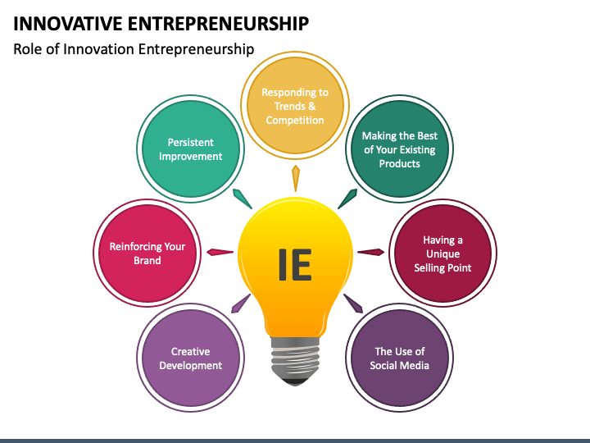

Figure 1: Innovation and entrepreneurship
(Source: Wadhwani et al. 2020)

3.3 Risk-taking and Entrepreneurship
As per Audretsch, and Moog (2022), in the rapidly changing environment of entrepreneurship, risk-taking is a critical factor that can create or destroy a business. Successful entrepreneurs need to analyse the significance of embracing risks and taking measures in the decisions that propel the business forward. Risk-taking in entrepreneurship includes stepping outside of the comfort zone, condemning the status quo and seizing market opportunities. in entrepreneurship, risk-taking includes evaluating the potential threats, analysing the potential effect, and making calculated risks that can give a favourable risk-forward ratio to a business – after all, most important opportunities have a factor of risk when they are adopted.

3.4 Resilience and Adaptability in Entrepreneurship
Entrepreneurship is a critical journey that frequently includes encountering setbacks, unexpected limitations, and failures. Resilience is a significant trait for entrepreneurs to create to a system overcome these issues and constantly move forward. Every entrepreneur requires to concentrate on creating resilience – the capability to stay on the line in a critical time to make setbacks (Weking et al. 2023). On the other hand, in the currently changing business environment, the capability to adapt become an important skill for an entrepreneur. Adaptability is closely aligned with resilience – the capability to bounce back from failures. By using adaptability, entrepreneurs and efficiently navigate uncertainties, grab opportunities, and create resilient businesses.

3.5 Skills and knowledge required for entrepreneurship
As per Chandra (2022), entrepreneurship can be extremely rewarding, yet it also comes with different risks. Hence, to remove this risk of failure, an entrepreneur needs to have several skills and knowledge. A great entrepreneur needs to be capable of efficiently communicating, concentrating, selling, learning, and strategising. Compatibility to constantly learn is not just the primary entrepreneurial skill but also an extremely valuable life skill. Among the skills, an entrepreneur needs communication, focus, business strategy, and so on. Contrarily, an entrepreneur needs to have knowledge of idea generation, product analysis, market research, and increasing necessary funds.

3.6 Factors impacting entrepreneurial success
There are five primary factors that are important for entrepreneurial success:
- Creativity – talent, motivation, and creativity to be capable to come up with new perceptions is important for entrepreneurial success (Mardievna, 2022).
- Determination – the capability to keep operating on the projects, even while in non-suitable circumstances is important for an entrepreneur.
- Flexibility – an entrepreneur needs to know the way to respond and adapt to the alterations that happen in the market and to the customer's demand.
- Vision – the capability to recognize and use strategies for the best probable results affects entrepreneurial success (Berger et al. 2021).
- Risk tolerance – the capability of an entrepreneur to take benefit of an opportunity will rely on risk tolerance.

4. Conceptual foundation of theories of personality traits with example

4.1 The big five theory of Personality traits
According to various personality psychologists, there are five basic personality dimensions, frequently alluded to as the big five personality traits. The traits are extraversion, openness, agreeableness, neuroticism, and conscientiousness (Ratten, and Usmanij, 2021). In this context, the case study of Bill Gates has been discussed.
Extraversion: Bill Gates has shown a remarkable social nature throughout his profession. Being a famous technology leader, Gates has been involved in different public speaking collaborations.
Openness: frequently featured by his visionary mindset and the capability to think more than the present, Gates’s forward-thinking approach towards automation and capability to forecast future trends and opportunities is the best example of openness (Pidduck et al. 2023).
Agreeableness: the philanthropic attempts of Gates and commitment are an example of agreeableness and kindness.
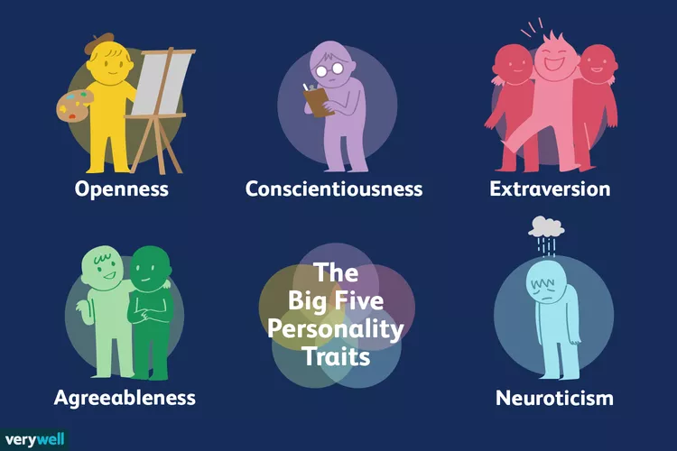

Figure 2: Big 5 Personality Traits
(Source: Qazi et al. 2020)
Neuroticism: since the agreeableness with Gates was higher, he never showed emotional instability or sadness in his character. Rather, he was always dedicated to making the best possible use of the resources (Qazi et al. 2020).
Conscientiousness: the careful attention of Bill Gates to detail and discipline concentration on attaining goals is the best example of Conscientiousness.

4.2 The trait theory of Leadership
The theory of trait leadership is the notion that leaders are born with a few features or trait. This theory of leadership is also alluded to as the theory of the Great Man of leadership. According to (Farny et al. 2019), this theory specifically concentrates on a few personality traits and features like self-confidence, intelligence, and maturity. In Bill Gates, one of the best traits found for leadership was vision. Bill Gates had a clear vision for the near future of automation, and he was capable to inspire and motivate others to share the same vision. Gates is also a demanding leader that anticipates excellence.

4.3 The Myers-Briggs Type Indicator
According to the views of Wu et al. (2019), MBTI is a self-help evaluation test that assists individuals to gain perceptions regarding the way they work and acquired. It is a model for connection building, creating positivism, and attaining excellence. The way to create a revolutionary technology giant, Microsoft’s, and then afterwards, the biggest private philanthropic foundation in the world, started with the Gates. Bill Gates is the representative introverted genius. As per the documentary of Gates, it was evident that he was more interested in reading, pondering, and thinking. also, Bill Gates is an example of a thinking individual. Gates has explained himself as extremely competitive, in a way that was extremely obsessive at times.
Hence, it is evident that Bill Gates shows INTP – A type of personality from the MBTI assessment. This type explains an individual that is energised by time only- introverted, concentrates on perceptions, rather than facts– intuitive, and makes decisions by logical reasoning– thinking and prefers flexible and organised- perceiving (Urban, 2020). This is the rarest type of personality, comprising over 3 to 5% of the world's population. At the core, it is proven that Bill Gates is a logician who strives on critical things and works in discipline. Bill Gates prides himself on his differing views and robust intellect.

5. Traits, characteristics, motivation, and attributes of entrepreneurs

5.1 Traits
Among the traits, an entrepreneur needs to be highly motivated, have a competitive spirit, willingness to fail, and strong leadership skills (Ahmed et al. 2022). For example, Bill Gates shows the personality traits of passion, and focus.

5.2 Characteristics
In the characteristics of an entrepreneur, there needs to be creativity, management, risk-taking, innovation, adaptability, decisiveness, team building, and leadership. Bill Gates had a few of the leadership characteristics as an entrepreneur such as creativity, education, risk, tolerance, and so on.

5.3 Motivations
there are different factors that lead entrepreneurs to motivate themselves, and these are our freedom, wealth, control, and impact (Fragoso et al. 2020). The achievement drive of Bill Gates was the biggest motivation factor that led him to do significant work.

5.4 Attributes
The biggest attributes of an entrepreneur are that they are innovative, risk-takers, hard-working, and people managers. The attributes that lead Bill Gates to be one of the most successful entrepreneurs are that he was a philanthropist, visionary, and highly competitive.

6. Conceptual foundations of for-profit and not-for-profit small organisations with examples

6.1 For-profit small organisations

6.1.1 Principles and Values
The values of for-profit small organisations are the concept that guides the company and the principles of the laws or regulations that lead them. Among the principles, the most popular ones are: to act with integrity, take accountability, innovate, be respectful, and seek excellence. Whereas, the business values are – growth, decision-making, business culture, environment, sustainability, and leadership.

6.1.2 Example
Examples of a few for-profit small organisations are: Grammarly, Spanx, Toms Shoes, and Skyscanner.

6.2 Not-for-profit small organisations

6.2.1 Principles and Values
The principles and values of small, not-for-profit organisations are equitable community, equality, innovation, well-being development, inclusion and diversity, and resource sharing.
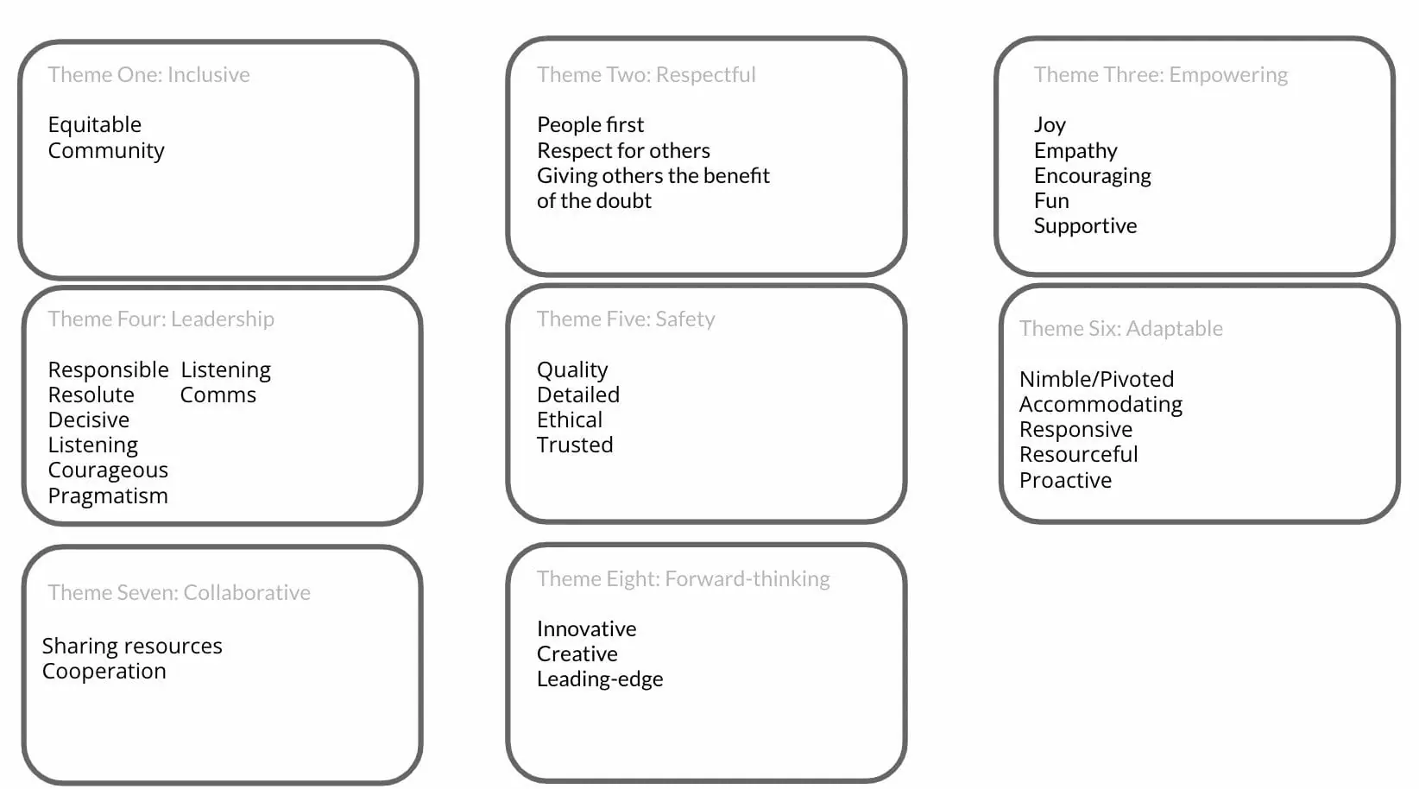

Figure 3: Basic principles and values of not-for-profit organizations
(Source: Fragoso et al. 2020)

6.2.2 Example
Examples of small not-for-profit companies include Red Cross, Habitat for Humanity, and United Way.

7. Analysis and critical evaluation of for-profit and not-for-profit small organisations with examples

7.1 For-profit small organisations
A for-profit organisation is one company that works with the aim of making a profit. Most businesses are this kind of organisation that serve their customers by selling different items that are good. The business owners achieve an earning from the profit and may also give it to shareholders and investors. Examples of for-profit companies or airlines, publishing, organisations, construction, companies, shipping companies, and restaurants (Farmaki et al. 2020).

7.2 Not-for-profit small organisations
A not-for-profit is similar to a non-profit organisation, which is one company that does not own revenue for its owners. All the capital earned through implementing the business functions or through donations goes right into operating the company. However, not-for-profit companies are not needed to work, for the advantage of public goods. This company can simply serve the aim of its members (Calza et al. 2020). A good instance is a sports club – the aim of the club is to exist for the enjoyment of its members. These companies need to apply for the status of tax exemption. it also means that the capital donated by a person to a not-for-profit company cannot be deducted from the tax returns of a person.

7.3 Critical evaluation of for-profit and not-for-profit small organisations
By critically evaluating both for-profit and not-for-profit organisations, it is evident, there are various differences between these two entities. One of the biggest comparisons between these organisations is the manner it raises capital (Ndofirepi, 2020). Conventionally, for-profit organisations ask investors for starting the company and in return, investors get profit. By contrast, the not-for-profits do not ask for investments and do not get a profit share. Also, a for-profit company is privately possessed that serves its customers to have revenue for survival. Contrarily, a not-for-profit company is a company that serves customers but does not have a profit aim.

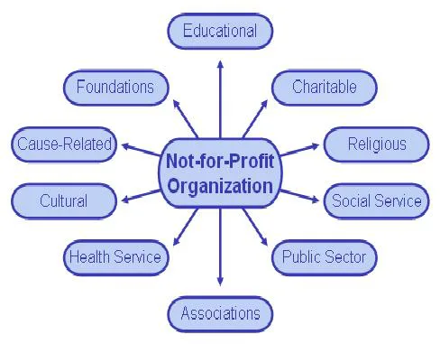

Figure 4: Not-For-Profit Organization
(Source: Ndofirepi, 2020)

8. Critical evaluation of values and beliefs of entrepreneurs in for-profit and not-for-profit small organisations with application
In for-profit organisations, entrepreneurs believe and value success. In a successful for-profit business, entrepreneurs give value to the target market. The more value the entrepreneur of the for-profit company communicates to its focus market, the more value it can enjoy (Mitchell, and Clark, 2019). Whereas, the entrepreneurs of a not-for-profit organisation believe that through their businesses, they can give value to a social cause in the community. In spite of a few differences, the entrepreneurs of both for-profit and not-for-profit companies believe in creating relationships. In for-profit companies, entrepreneurs try to build relationships with their clients and competitors. an example of an entrepreneur for a small for-profit organisation is Nina Devani who believed in making things happen after all challenges. On the contrary, in not-for-profit companies, entrepreneurs try to create a connection with the community for delivering successful results to a social cause (Mazorodze, and Buckley, 2020). An example of a not-for-profit company is Goodwill Industries. Reverend Edgar, the entrepreneur of Goodwill Industries believed in strong work ethics and valued self resilience.

9. Conclusion
From the discussions, in this report, it is evident that entrepreneurship and entrepreneurs are emerging concepts in the current business environment. Also, the success of an enterprise also depends on the beliefs, principles, values, traits, and characteristics of an entrepreneur. By analysing the case example of Bill Gates, it is evident that the theories of trait leadership are extremely important in analysing the behaviours that an entrepreneur needs to have to be successful. Also, by differentiating for-profit and not-for-profit organisations, it is also evident that both the company have their individual aims and values. From the critical evaluation, it can be concluded that the values and believes of entrepreneurs working in for-profit and not-for-profit companies are also different from each other.

Reference List
Ahmed, M.A., Khattak, M.S. and Anwar, M., 2022. Personality traits and entrepreneurial intention: The mediating role of risk aversion. Journal of Public Affairs, 22(1), p.e2275.
Audretsch, D.B. and Moog, P., 2022. Democracy and entrepreneurship. Entrepreneurship Theory and Practice, 46(2), pp.368-392.
Berger, E.S., Von Briel, F., Davidsson, P. and Kuckertz, A., 2021. Digital or not–The future of entrepreneurship and innovation: Introduction to the special issue. Journal of Business Research, 125, pp.436-442.
Calza, F., Cannavale, C. and Nadali, I.Z., 2020. How do cultural values influence entrepreneurial behavior of nations? A behavioral reasoning approach. International Business Review, 29(5), p.101725.
Chandra, Y., 2022. Non-fungible token-enabled entrepreneurship: A conceptual framework. Journal of Business Venturing Insights, 18, p.e00323.
Farmaki, A., Altinay, L., Christou, P. and Kenebayeva, A., 2020. Religion and entrepreneurship in hospitality and tourism. International Journal of Contemporary Hospitality Management, 32(1), pp.148-172.
Farny, S., Frederiksen, S.H., Hannibal, M. and Jones, S., 2019. A CULTure of entrepreneurship education. In Institutionalization of Entrepreneurship Research (pp. 38-59). Routledge.
Fragoso, R., Rocha-Junior, W. and Xavier, A., 2020. Determinant factors of entrepreneurial intention among university students in Brazil and Portugal. Journal of Small Business & Entrepreneurship, 32(1), pp.33-57.
Kraus, S., Breier, M. and Dasí-Rodríguez, S., 2020. The art of crafting a systematic literature review in entrepreneurship research. International Entrepreneurship and Management Journal, 16, pp.1023-1042.
Mardievna, S.G., 2022. WAYS TO DEVELOP ENTREPRENEURSHIP IN OUR COUNTRY. BARQARORLIK VA YETAKCHI TADQIQOTLAR ONLAYN ILMIY JURNALI, pp.902-905.
Mazorodze, A.H. and Buckley, S., 2020. A review of knowledge transfer tools in knowledge-intensive organisations. South African Journal of Information Management, 22(1), pp.1-6.
Mitchell, S.L. and Clark, M., 2019. Reconceptualising product life-cycle theory as stakeholder engagement with non-profit organisations. Journal of Marketing Management, 35(1-2), pp.13-39.
Ndofirepi, T.M., 2020. Relationship between entrepreneurship education and entrepreneurial goal intentions: psychological traits as mediators. Journal of Innovation and Entrepreneurship, 9(1), pp.1-20.
Olanrewaju, A.S.T., Hossain, M.A., Whiteside, N. and Mercieca, P., 2020. Social media and entrepreneurship research: A literature review. International Journal of Information Management, 50, pp.90-110.
Pidduck, R.J., Clark, D.R. and Lumpkin, G.T., 2023. Entrepreneurial mindset: Dispositional beliefs, opportunity beliefs, and entrepreneurial behavior. Journal of Small Business Management, 61(1), pp.45-79.
Qazi, W., Qureshi, J.A., Raza, S.A., Khan, K.A. and Qureshi, M.A., 2020. Impact of personality traits and university green entrepreneurial support on students' green entrepreneurial intentions: the moderating role of environmental values. Journal of Applied Research in Higher Education, 13(4), pp.1154-1180.
Ratten, V. and Usmanij, P., 2021. Entrepreneurship education: Time for a change in research direction?. The International Journal of Management Education, 19(1), p.100367.
Urban, B., 2020. Entrepreneurial alertness, self-efficacy and social entrepreneurship intentions. Journal of Small Business and Enterprise Development, 27(3), pp.489-507.
Vedula, S., Doblinger, C., Pacheco, D., York, J.G., Bacq, S., Russo, M.V. and Dean, T.J., 2022. Entrepreneurship for the public good: A review, critique, and path forward for social and environmental entrepreneurship research. Academy of Management Annals, 16(1), pp.391-425.
Wadhwani, R.D., Kirsch, D., Welter, F., Gartner, W.B. and Jones, G.G., 2020. Context, time, and change: Historical approaches to entrepreneurship research. Strategic Entrepreneurship Journal, 14(1), pp.3-19.
Weking, J., Desouza, K.C., Fielt, E. and Kowalkiewicz, M., 2023. Metaverse-enabled entrepreneurship. Journal of Business Venturing Insights, 19, p.e00375.
Wu, W., Wang, H., Zheng, C. and Wu, Y.J., 2019. Effect of narcissism, psychopathy, and machiavellianism on entrepreneurial intention—the mediating of entrepreneurial self-efficacy. Frontiers in psychology, 10, p.360.

