ReflectiVE summary
Creative Music Management

Callum Watts
MA Music Industry Entrepreneurship

In essence, a critical reflection is one of the most key aspects of personal and project development. The process of critical reflection allows one to develop their skillset and ideas, which is extremely key to both personal and professional growth. As Helyer states “reflecting on learning achievements can empower the learner to make intelligent decisions about how to move ahead with their learning needs. Working towards becoming a reflective practitioner enhances what a worker can bring to their job role, as well as the development of their future career plans” (Helyer, 2015). As stated, in order to develop with ones learning plans and career aspirations, it is important to look subjectively at work one has completed and evaluated it. Through this process, it is then possible to grow, develop and exploit gaps in the learner’s knowledge base. In turn, this will help the learner to highlight areas for further learning and research in order to grow to their full potential.
During this module, the group had to source an artist and create a single release plan for a hypothetical release. The group in question entailed Callum Watts, Catarina Pereira, Chiara Vahle and Franziska Uecker. The artist we sourced for this project was Chloë Rona, and as such the group proceeded to create a single release strategy for Chloë’s upcoming single ‘Fuel.’
During the project, my involvement was varied across the portfolio. Firstly, I sourced and created the remix as a collaboration. I created this under my production pseudonym of Seige alongside a producer I work with called Kaspian. I also contributed to the marketing plan and budgets to some extent, although these were not my primary involvements. I designed the online EPK and website, and as such built the branding for Chloë’s release. The branding was based upon the fonts and colour schemes from MusicGlue and then these were transposed across the entirety of the portfolio to maintain a cohesive outward facing impression.
During this project, we encountered various negative and various positive factors to reflect upon.
Firstly, our team management and distribution of tasks and responsibilities was undoubtedly a positive factor across this project. Task distribution is of vital importance to working in a successful team. If one team member feels they are contributing ‘all the work’ towards a project whilst another is not, this can lead to feelings of resentment and anger within the group. This, obviously, is far from optimal and healthy in a working environment, so accurate and adequate task distribution is needed. Throughout the project, the team were always kept occupied and every team member contributed something to each part of the portfolio. This fact, in turn, made sure each member of the team felt valued throughout, and each member felt their contributions were worthy and valuable to the project’s outcome. During this project, the team managed to even out the workload between the team members very effectively most of the time.
There were exceptions to this rule, however, and this was down to our communication skills. As any book on teamwork will state “effective communication is an important element of success for every organization…” (McIntosh, Davis and Luecke, 2008). At times poor wording and rushed communications could lead to ideological disparity and an increase in workload overall as a result. One example of this was the overall design aspects of the campaign. Due to poor communication within the team, we had one member working on the design for the marketing plan and another working on the design for the website. As the two members did not communicate effectively the team ended up with two vastly different design aspects across the campaign. “The most important thing to remember is that branding is the act of shaping perceptions with consistent action and images, and consistency in branding is the key” (Blogger, 2016). Based upon this and the team’s personal experiences in the music industry, and as consumers, the team knew it was vital to keep the brand unified across all platforms. As mentioned, the equivocal statements passed between the team led to this outcome, which invariably cost us more time during the project.
Despite our effective planning of time within the team, we struggled to execute tasks in good time which signifies poor time management within the team. In terms of the time-based deadline, we had all the materials together from Chloë and her team very early on, but our marketing plan and remix were not fully completed until a couple of days before the deadline itself. This undue pressure we placed upon ourselves by not managing our time correctly and staggering our workload across a wider time scale instead of short, intense outputs. Although this worked with the dynamic of the team in this instance, working with other individuals this may not always be possible. As such this is a negative aspect to reflect upon and attempt to change in future group projects. One way this might be possible is by creating a group schedule with time-based objectives. The team had a to-do list for this project, but the lack of time-based objectives meant some tasks were not deemed urgent and as such were postponed to a later date.
When completing tasks within the team we paid extremely fine attention to detail with all the tasks we were set. This could be seen as both a positive and a negative aspect upon reflection. Although the fine attention to detail meant the end products throughout were to a good standard, often they would take us a long while to do. Obviously, in a fast-paced industry like the music industry, time is of the essence. As Ari Herstand states “to build a successful music career requires a sh*t ton of time, effort, money and work” (Herstand, 2017) so obviously any time not spend fine combing a marketing plans graph placement could potentially be put to better use. However, when one does fine comb projects, one can be assured in their work and that the output is the best one has to offer. As often in the music industry, one only has one or two chances to impress and secure an investment deal or a record deal, this attention to detail could make all the difference. Upon reflection possibly striking a balance between attention to detail and doing so efficiently is the aspect the team should take from this project. That being said, despite the fine combing, the marketing plan has a few minor graphical errors which due to the time constraints, alongside the aforementioned reformatting to match the branding, doesn’t give the campaign the best outward facing impression. As aforementioned, these errors were very minor, however being the one responsible for these errors this is something to definitely focus on in future projects.
Something the team can be proud of and should take with them into future projects is the well-roundedness of the campaign. The team created a wide-scoped campaign that focused on multiple outcomes and goals instead of just one sole focus. Although the main goal was to provide sales and income of the single release, this was not our sole objective. Reviewing the plans, the team made this clear that this was not focused all around Chloë’s recorded music career, but boosting her presence both offline and online. As a team, we set out these aims at the very beginning of the campaign’s planning. We wanted this campaign to have the potential to boost both the artist and have the potential to be a profitable endeavour for the team and artist alike.

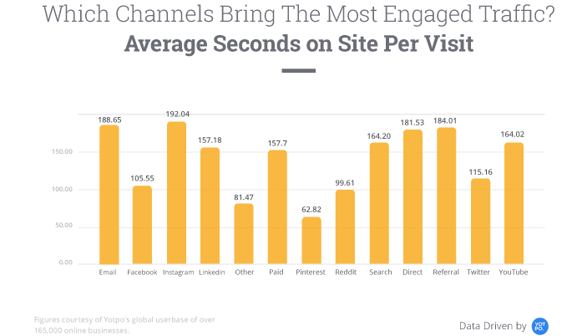
During the campaign, we made particular use of social media and online advertisements to promote the single release. Due to Chloë’s strong presence on Instagram, the team decided to focus as much of the advertising budget into advertisements on this platform. Chloë’s strong following alongside the fact that Instagram has the most engaged through traffic (as the chart below shows) meant this was a unanimous decision early on in our campaign planning. As Instagram has a high engagement rate based on the traffic it draws, coupled with MacArthy’s statement where he “dubbed Instagram ‘The World’s Most Powerful Selling Tool’” (MacArthy, 2016), advertising here is necessary for the promotion of any creative project. Due to Chloë’s existing strong presence on Instagram and the fact that “Facebook is losing appeal among teens and young adults” (Lomas, 2018) the potential growth on the platform off the back of this campaign provides a wealth of opportunities for Chloë’s future projects.
(Leibowitz, 2018)
The incorporation of a live show was a key aspect of the campaign. As anyone in the music industry can tell you, since the advent of the digital age, performing live and at shows is where an artist makes most of their money. As Chloë isn’t a regular performer, but regularly does fashion photography work, a collaboration with a brand close to her ideals was the logical next step. Music and fashion have long worked hand-in-hand, and in the digital age, this relationship has only blossomed. Sampson states that since the rise of social media “designers want to collaborate with seemingly more ‘everyday’ people who have large followings on platforms such as Instagram” (Sampson, 2016). Tying in Chloë’s Instagram presence with her connections in the fashion scene, the logical solution was to have a fashion show merge with a release show. The combination of music and fashion would allow for easy content creation for both Chloë and for the influencers which would be invited. This would increase the online presence of the campaign and of Chloë herself, which is only a benefit to the campaign.
In terms of online presence having a website is still a key aspect. A website serves as a central location for industry professionals and fans alike to source all aspects that they may need on an artist. If a website if successful, it will have links to all relevant outlets for merchandise and music, as well as exclusive content. In terms of this campaign the website was fairly strong, however, there is a lacking of original content and engaging media. This is an opportunity that the team should endeavour to capitalise on in the future. Despite this, even if you have a unique and engaging website it must be able to be found. It should be of critical importance that fans, both new and old alike, are able to locate the content and follow the path you wish their online traffic to take. SEO is of vital importance to this fact, and as King states “creating an effective SEO strategy…(takes) a long time to master” (King, 2009). Should we continue this campaign, this an opportunity the team would need to seize, using our existing collaborations and new material to engage consumers.
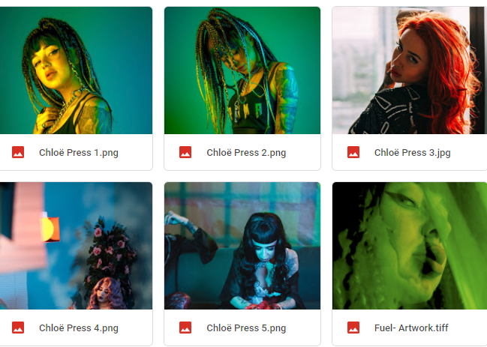
Throughout our campaign, we seized the opportunity to brand Chloë with a new direction based on previous photoshoots. Based around photos one and two the team based the branding around these styles and colour themes. These provided strong visuals and a strong design alongside this. However, as evidenced here, the team did not have time to organise a photoshoot to cohesively tie in these themes. This leaves the campaign looking rough and incomplete as Chloë exhibits four different hairstyles during the promotional shots we selected. Brand cohesion is important to garner a sense of trust and familiarity with fans and consumers alike. Brand identity “needs to remain consistent throughout in order to create good brand cohesion” (Sims, 2018). As Chloë’s brand isn’t consistent this provides a weakness in the outward marketing materials, but also provides an opportunity for future development in this section. However, if we had a team member with both the skillset and experience of using photo editing applications such as Adobe’s Photoshop, the team could have created this consistency in-house without the need for a secondary photoshoot.
If one of our team members was highly skilled in creating remixes and electronic music in a style except for drum and bass this would have been of major benefit to this project. Although the remix could potentially expose Chloë to a wider audience, and expand her career prospects at the same time, it does not match her usual themes. As Chloë is primarily an R&B artist whose themes revolve around love, loss and want, the nature of the remix does not particularly match these themes. In hindsight, perhaps a more ambient style of remix along similar styles to The Drunken Apaches and Djrum would have been more fitting to the overall aesthetic the team set out to create. It is worth noting the impact a good remix can have to a song’s success. “With the right songs or remixes, a solid promotional campaign in the clubs is a good way to launch new music” (Rutter, 2016). Perhaps this remix should have had more priority in the team’s workflow, and be used as one of the main marketing tools, not a supplementary aspect.
In hindsight also, the team should have created physical marketing to tie into the campaign. This does correlate with the aforementioned issues with time management. As our campaign does feature physical marketing, these should have been created and included with our portfolio. This does provide a further opportunity for this team to create physical marketing aspects and utilise these more in future endeavours.
Despite the various shortcomings illustrated in this reflection, it is worth noting that both the artist selection the team firmly believes paid dividends. In all aspects, Chloë provided high-quality media for us to work around and market. “It is perhaps obvious, but nevertheless important, to say that music video has never been so culturally visible and accessible as it is in this historical moment” (Railton, 2011). Railton, although writing in 2011, is still correct. With the rise of the behemoth, we know today as YouTube and the rise of algorithmic gating a good music video is critical. Algorithms embedded into social media outlets typically will only show consumers widely watched ‘liked’ or ‘reacted’ content. Thankfully, Chloë and the team at Kuki London were able to create a video of substantial quality that can be edited and reposted in various formats, both as teasers and as ‘shareable’ mediums.
To conclude, this portfolio does have various weaknesses that would need addressing in future creative endeavours. However, there are a lot of positive aspects one, and the team can take from this and use to grow and develop in the creative industries.

References
- Bhasin, H. (2018). The Importance of Delegation & why Delegation is important for managers. [online] Marketing91. Available at: https://www.marketing91.com/the-importance-of-delegation/ [Accessed 15 Jan. 2019].
- Blogger, G. (2016). The Importance of Consistency in Branding. [online] Blog.redrocketcreative.com. Available at: https://blog.redrocketcreative.com/the-importance-of-consistency-in-branding [Accessed 15 Jan. 2019].
- Helyer, R. (2015). Learning through reflection: the critical role of reflection in work-based learning (WBL). Journal of Work-Applied Management, [online] 7(1), pp.15-27. Available at: https://www.emeraldinsight.com/doi/pdfplus/10.1108/JWAM-10-2015-003 [Accessed 15 Jan. 2019].
- Herstand, A. (2017). How to make it in the new music business. Liverlight.
- King, M. (2009). Music marketing. Boston, Mass.: Berklee.
- Kitchen, T. and Mirza, T. (n.d.). Profitable social media marketing.
- Leibowitz, B. (2018). Instagram vs Facebook: Which Can Boost Your Business More?. [online] Dreamgrow.com. Available at: https://www.dreamgrow.com/instagram-facebook-advertising/ [Accessed 16 Jan. 2019].
- Lomas, N. (2018). Teens favoring Snapchat and Instagram over Facebook, says eMarketer. [online] TechCrunch. Available at: https://techcrunch.com/2017/08/22/teens-favoring-snapchat-and-instagram-over-facebook-says-emarketer/ [Accessed 16 Jan. 2019].
- MacArthy, A. (2016). 500 Social Media Marketing Tips. 2nd ed. UK: Andrew Macarthy.
- McIntosh, P., Davis, J. and Luecke, R. (2008). Interpersonal Communication Skills in the Workplace, Second Edition. AMACOM.
- Railton, D. (2011). Music Video and the Politics of Representation (Music and the Moving Image). Edinburgh University Press.
- Rutter, P. (2016). The Music Industry Handbook. 2nd ed.
- Sampson, C. (2016). Collaborative Creativity: Why the Fashion World is Working Together | NOT JUST A LABEL. [online] Notjustalabel.com. Available at: https://www.notjustalabel.com/editorial/collaborative-creativity-why-fashion-world-working-together [Accessed 17 Jan. 2019].
- Sims, M. (2018). Brand cohesion - why it's important and why you should have it.. [online] Foundation.agency. Available at: https://foundation.agency/branding/brand-cohesion/ [Accessed 17 Jan. 2019].
- StudyGuide, M. (n.d.). Principles of Delegation. [online] Managementstudyguide.com. Available at: https://www.managementstudyguide.com/principles_of_delegation.htm [Accessed 15 Jan. 2019].

